TWENTY-FIFTH SESSION OF THE GOVERNING COUNCIL/GLOBAL
MINISTERIAL ENVIRONMENT FORUM, NAIROBI, 16-20 FEBRUARY 2009
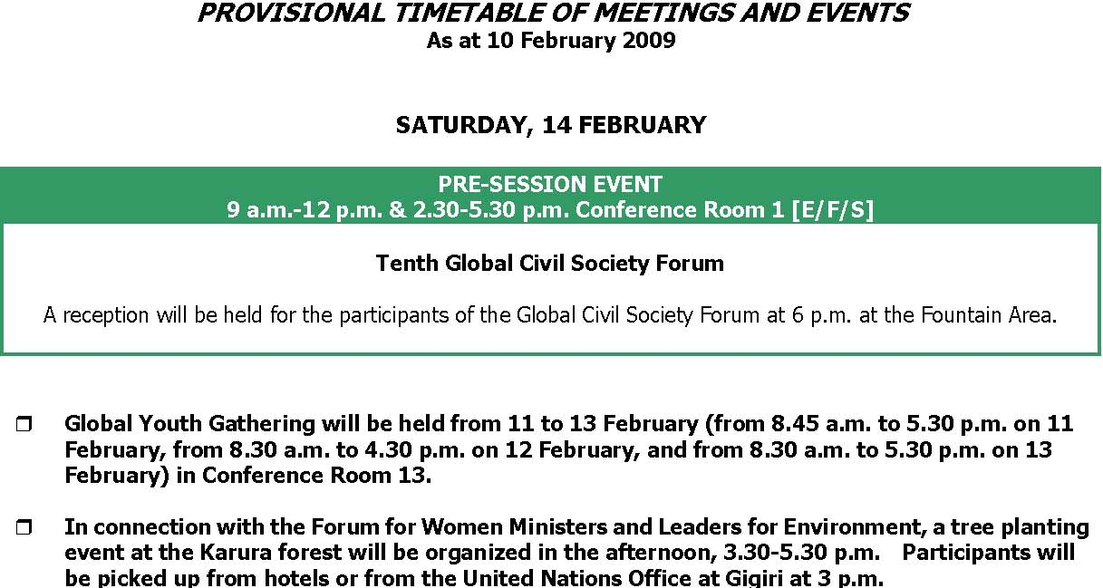
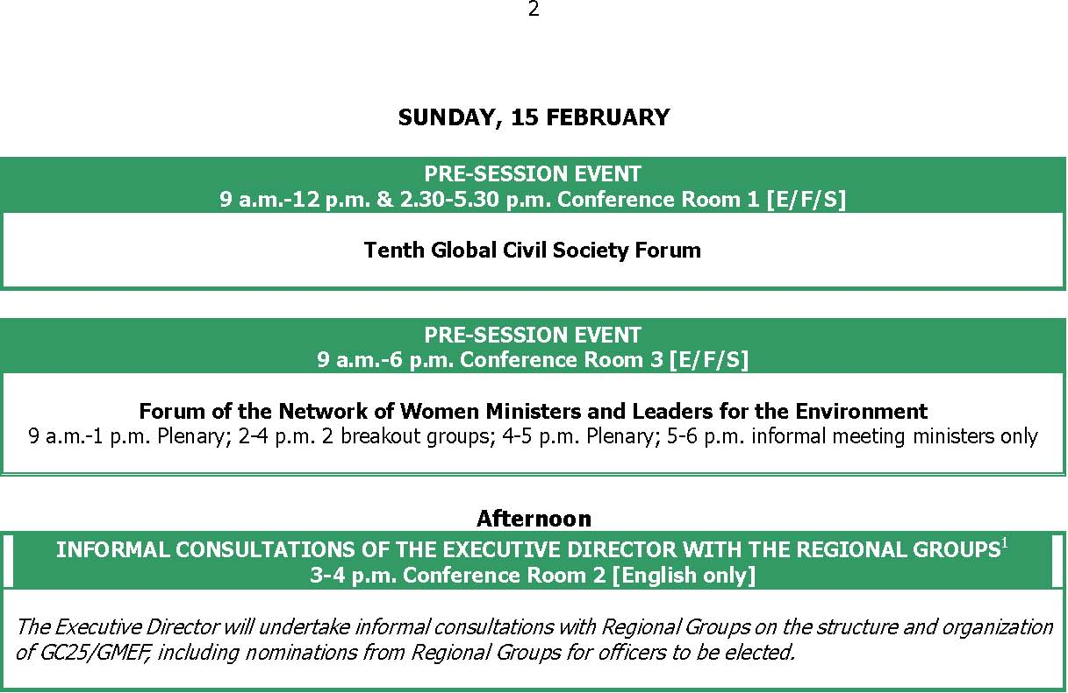
Each of the Regional Groups will hold group meetings at a date and time agreed by the respective Groups. For this purpose, meetings rooms are allocated for the use by each Group outside official meeting hours as
follows:
 | Sunday, 15 Feb |  | Monday, 16 Feb | Tuesday-Friday
 | Group 77 and China | CR2 | CR14 | CR2
 | African Group | CR2 | CR14 | CR2
 | Asian Group | CR7 | CR8 | CR3
 | Eastern and Central | CR5 | CR5 | CR5
 | European Group
 | Latin America and Caribbean | CR8 | CR9 | CR4
 | Group
 | Western European and | CR10 | CR10 | CR10
 | Others Group
 | European Union | CR10 | CR10 | CR10
 | JUSSCANZ | V-125 | V-125 | V-125
 | Arab Group | U-318 | U-318 | U-318

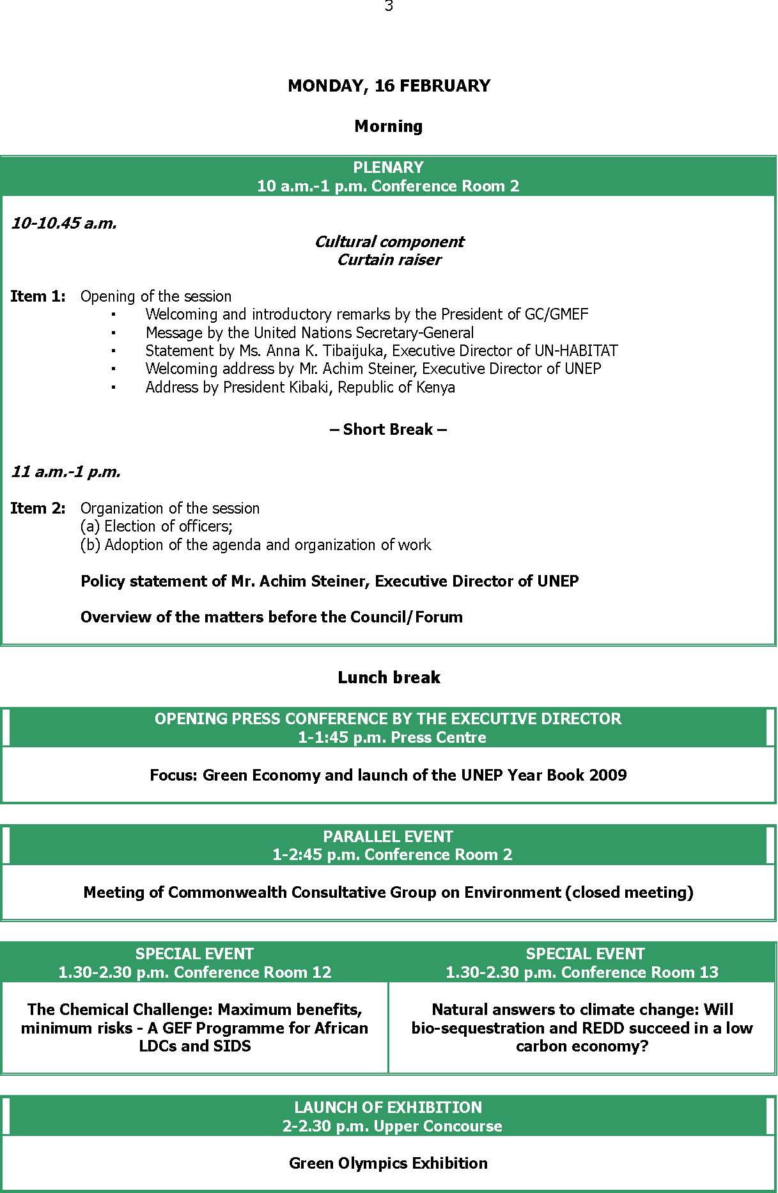
4
Afternoon
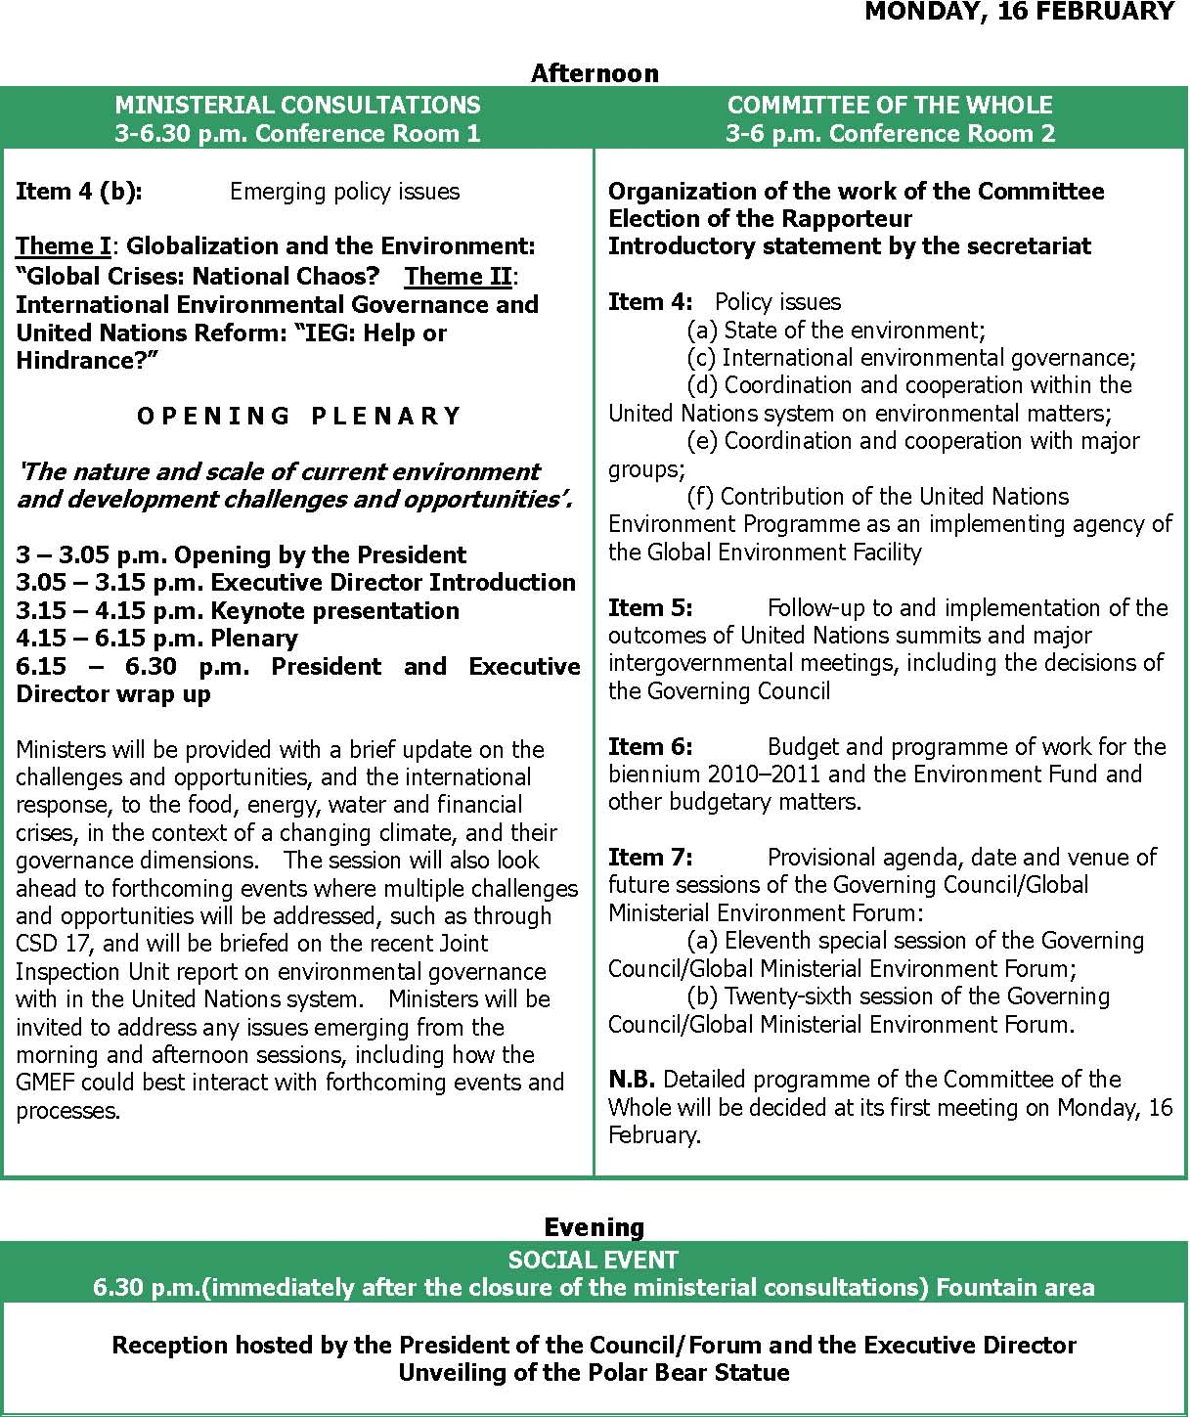
COMMITTEE OF THE WHOLE 3-6 p.m. Conference Room 2
Organization of the work of the Committee Election of the Rapporteur Introductory statement by the secretariat
Item 4: Policy issues
- (a) State of the environment;
- (c) International environmental governance;

- (d) Coordination and cooperation within the United Nations system on environmental matters;
- (e) Coordination and cooperation with major groups;
- (f) Contribution of the United Nations Environment Programme as an implementing agency of the Global Environment Facility

Item 5: Follow-up to and implementation of the outcomes of United Nations summits and major intergovernmental meetings, including the decisions of the Governing Council
Item 6: Budget and programme of work for the biennium 2010–2011 and the Environment Fund and other budgetary matters.
Item 7: Provisional agenda, date and venue of future sessions of the Governing Council/Global Ministerial Environment Forum:
- (a) Eleventh special session of the Governing Council/Global Ministerial Environment Forum;
- (b) Twenty-sixth session of the Governing Council/Global Ministerial Environment Forum.

N.B. Detailed programme of the Committee of the Whole will be decided at its first meeting on Monday, 16 February.

Evening
SOCIAL EVENT
6.30 p.m.(immediately after the closure of the ministerial consultations) Fountain area
Reception hosted by the President of the Council/Forum and the Executive Director Unveiling of the Polar Bear Statue
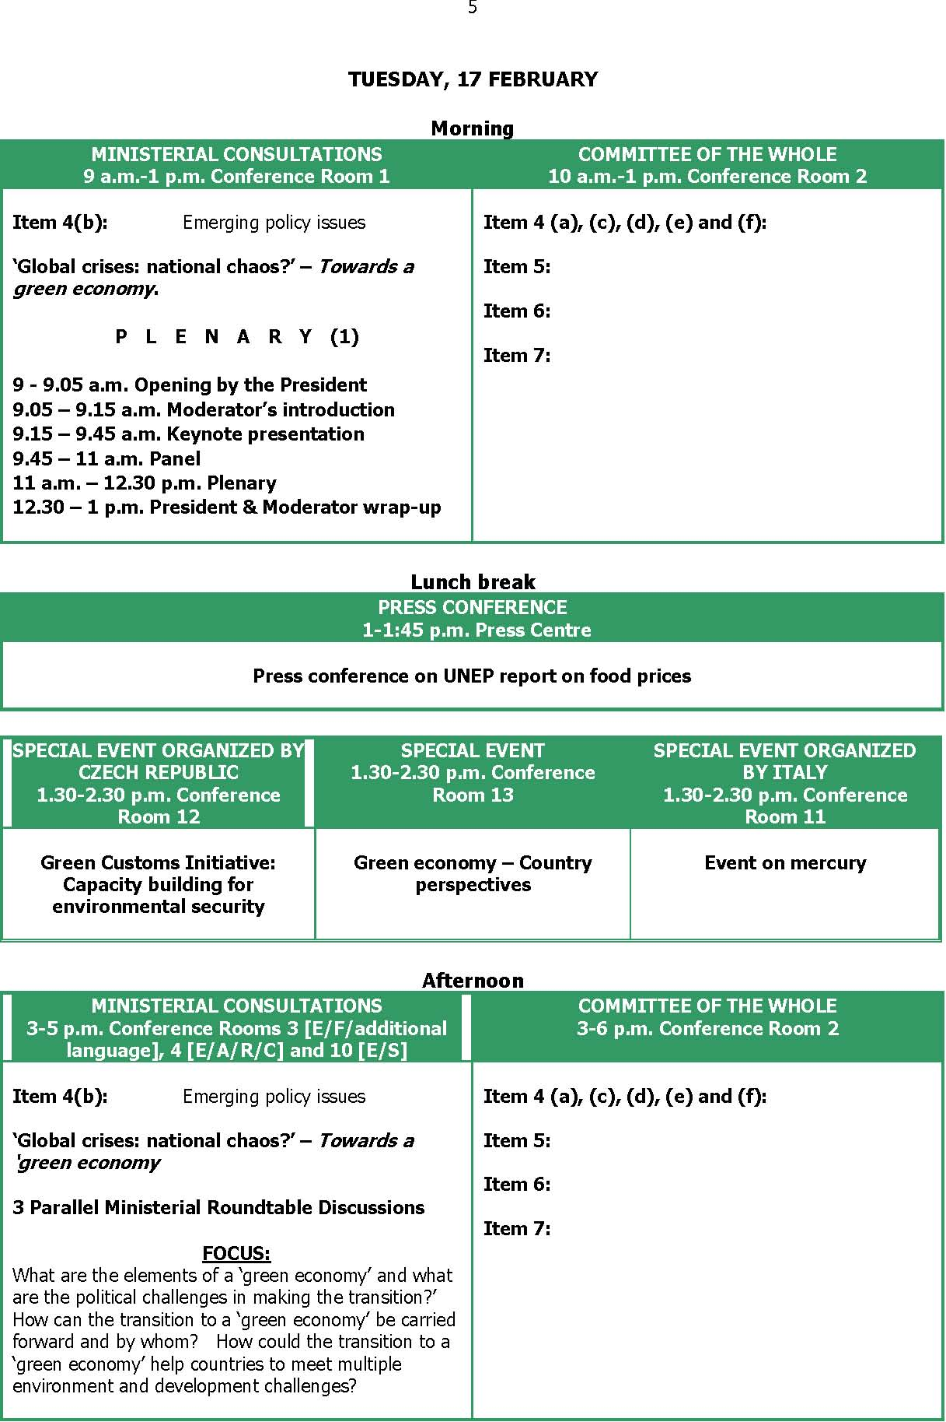
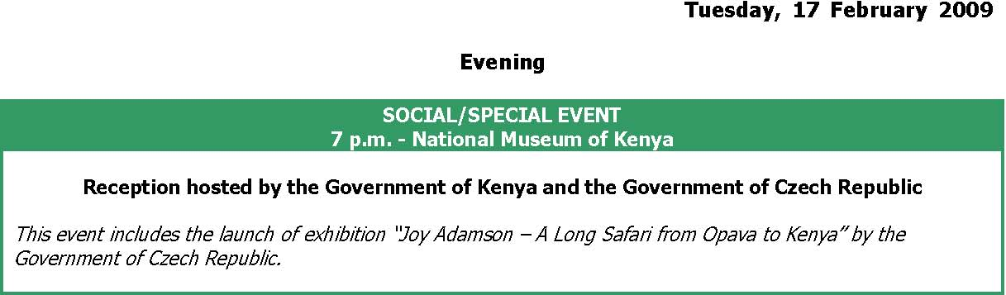
7 11
WEDNESDAY, 18 FEBRUARY Morning Item 4(b): E m e r gi ng pol i c y i s s u e s ‘Global crises: national chaos?’ – Coping with multiple challenges and capturingthe opportunities. P L E N A R Y (2) 9 - 9.05 a.m. Opening by the President 9.05 – 9.15 a.m. Moderator’s introduction 9.15 – 9.45 a.m. Keynote presentation 9.45 – 11 a.m. Panel 11 a.m. – 12.30 p.m. Plenary 12.30 – 1 p.m. President & Moderator wrap-up MINISTERIAL CONSULTATIONS 9 a.m.-1 p.m. Conference Room 1 SPECIAL EVENT 1.30-2.30 p.m. Conference Room 12 Building resource efficient economies and sustainable societies Czech Exhibition “Joy Adamson - A Long Safari from Opava toKenya” PRESS CONFERENCE 2.15-3 p.m. Press Centre The GEO Amazonia Press Conference | Item 4 (a), (c), (d), (e) and (f): Item 5: Item 6: Item 7: COMMITTEE OF THE WHOLE 10 a.m.-1 p.m. Conference Room 2 Lunch break PRESS CONFERENCE 1-1:45 p.m. Press Centre Press conference including launch of the Beijing post-Olympic assessment report SPECIAL EVENT 1.30-2.30 p.m. Conference Room 13 Towards a low-carbon future: Making the climate neutral case to the public LAUNCH OF EXHIBITION 2-2.30 p.m. Upper Concourse

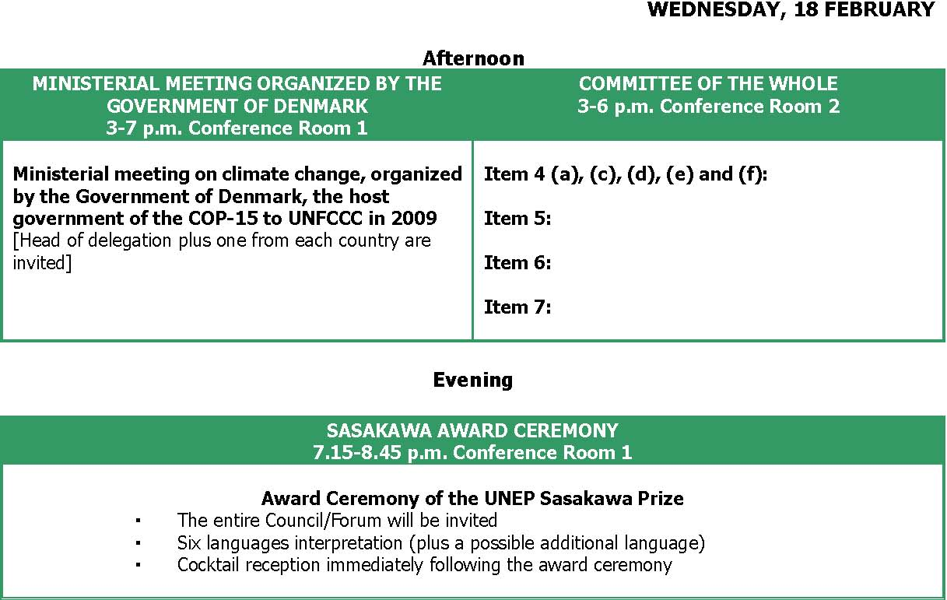
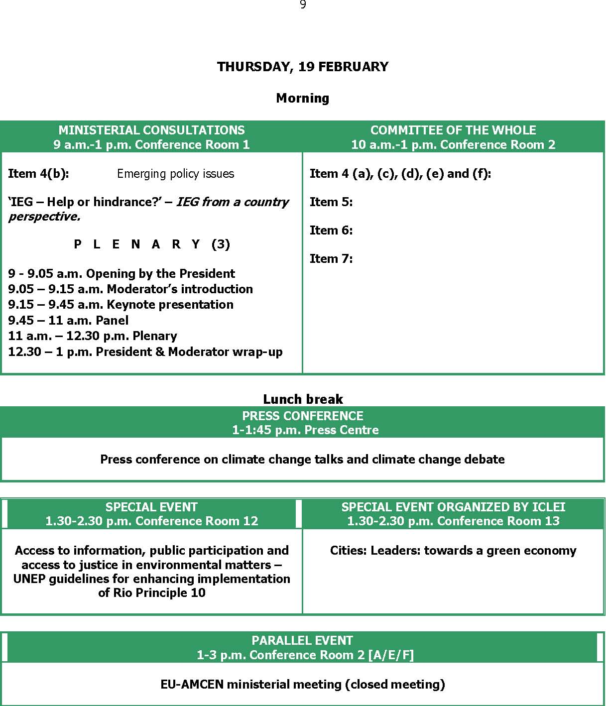
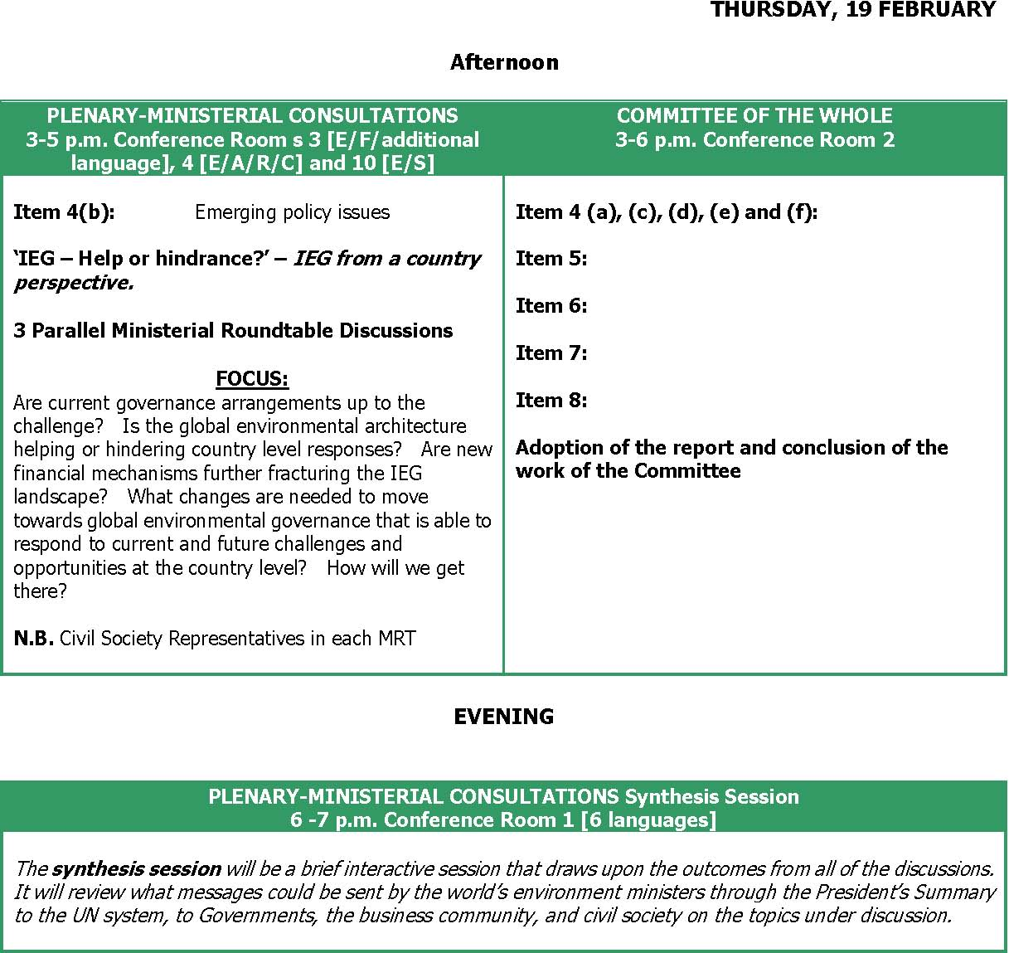

FRIDAY, 20 FEBRUARY Morning
PLENARY 9 a.m.-1 p.m. Conference Room 1
Report of the President on the outcome of the Ministerial Consultations
Adoption of the report of the Committee of the Whole
Adoption of decisions

Lunch break
PRESS CONFERENCE BY THE EXECUTIVE DIRECTOR 1-2 p.m. Press Centre
Focus: wrap up press conference
SPECIAL EVENT
SPECIAL EVENT
1.30-2.30 p.m. Conference Room 12
1.30-2.30 p.m. Conference Room 13
From conflict to peacebuilding: the role of
Agriculture and food security: Will the next natural resources and the environment revolution be more sustainable?

Afternoon
PLENARY 3-6 p.m. Conference Room 2
Item 3: Credentials of the representatives Item 8: Other matters Item 9: Adoption of the report Item 10: Closure of the session

SATURDAY, 21 FEBRUARY
FIELD EXCURSION Details to be decided
With a view to demonstrating the themes of GC-25/GMEF, a field excursion will be organized for interested delegates to the Olkaria geothermal plant in the Rift Valley. Detailed information, including the registration for participation, will be found in the Daily Journal.

