The National Capacity Self Assessment Report
2007.

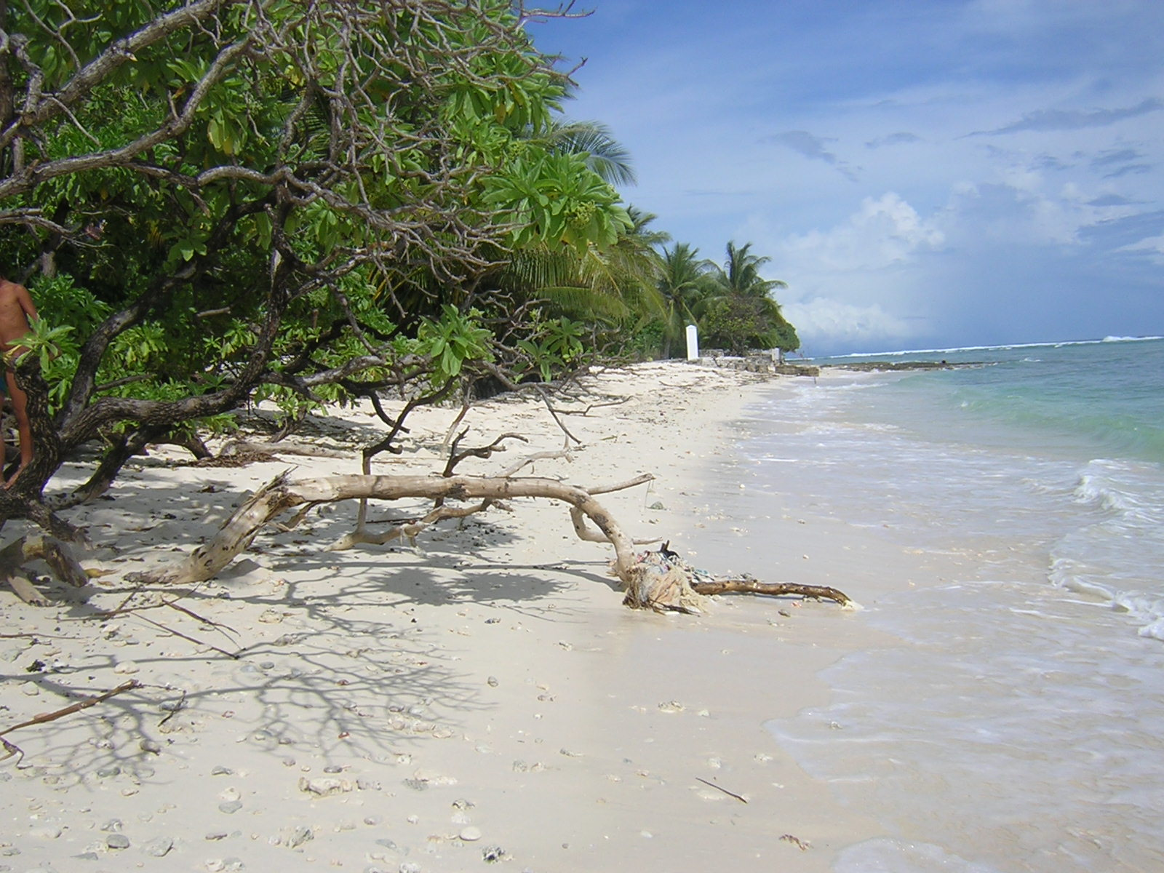
The National Capacity Self Assessment Project.

Prepared by Neri Tiaeke

For the Ministry of Environment Lands and Agriculture Development
Kiribati 2007

Table of Contents.

Title. Page.
--------------------------------------------------------------------------------------------
Table of Contents & Acknowledgement 1-3
Acronyms. 4
1.Executive Summary 5-9
2.Introduction 11
2 Introduction in a national context. 11-13
2.1 Geography. 11
2.2.Climate 12
2.3.Population 13
2.4.Flora and Cultural Utility 16
2.5.Terrestrial Fauna 16
2.6.Water Resources 16
2.6.1.Underground water source 17
2.6.2.Stored rainwater. 17
2.6,3.Desalination of sea water. 18
2.7.Land tenure 19
2.8.Traditional leadership 19
2.9. National Government System 19
3. Kiribati and the UNCCD 20
4. The NCSA and the GEF funded project in Kiribati 20
5. Objective of the NCSA 20
6. International Conventions and treaties signed by Kiribati 20
7. NCSA Methodology. 21
7.1. Stocktake 21
7.2. Thematic Assessment and Gap analysis. 22
8. Stocktake for the three conventions.(viz UNFCCC,UNCB, UNCCD 22
9. Progress in measures taken to combat degradation 22
9.1.Providing the NAP 22
9.2. Institutional Arrangement and coordinating mechanisms 24
9.3. Information management and dissemination 24
9.4. Legislative and regulatory framework 24
9.4.1.Environment Act1999 24
9.4.2. Local government Act1984 24
9.4.3.Public Utilities Ordinance 25
9.4.4.Special fund (waste material recovery) Act 2004 25
9.4.5.Public Health Ordinance. 1926 25
9.4.6. Customs Act2007 25.
9.4.7. Foreshore and Reclamation Ordinance 1977 25
9.4.8. Land Planning Ordinance 1988 26
10. Communication and Awareness Raising 26
11. Critical Land Degradation Issues in Kiribati. 26
11.1. Increasing Population Pressures on Land Degradation and Urbanization 26
11.2. Increasing role of Coastal Erosion 27
11.3. Improper Disposal of Waste and Pollutants. 27
11.4.Uncontrolled Mining of Beach Sand and Aggregates 28
11.5. Legislative and Regulatory Framework 29
11.6. Salt water Intrusion. 29
11.7.Land Clearing for Development 29
11.8. Rubbish burning and Bush Fires 30
12. Requirement or Environmental Issues that have been Addressed and those
That have not been Addressed. 31
12.1.National Strategies to Address Land Degradation. 31
12.2. Production of the National Action Programme. 31
12.3.Creation of a Coordinating Mechanism. 32. 12.4. Public Awareness Programme. 33
12.5.Remedial Plans to Ease Congestion and Overcrowding 33.
12.6. Legislative and Regulatory Framework 33
12.7. Improper Solid waste Disposal. 34
12.8. Recyclable Waste 34
12.9. Uncontrolled Mining of Beach Sand 35
12.10. Salt water Intrusion. 35
13. Strategies and Ministries Responsible for Implementing them. 36
14. Gaps Identified. 37
15. Root Causes of Gaps 37
16.Capacity Needs 38
16.1. Systemic 38
16.2.Institutional 39
16.3. Individual 40
17. National Capacity Self Assessment Training 40
18. Environmental Policies. 40
18.1. Economic Growth 40
19. Recommendations. 41
Annex 1. Requirements of UNCCD. 42
Annex 2. UNCCD COP Decisions 43
Annex 3. List of Persons Contacted. 43
Annex 4. Sample Questionnaire. 43-49
Annex 5. Logframe and Problem Tree for UNCCD. 50
Annex 6 Matrix of Outputs from Logframe 51
Annex 7 Table. 3 Levels of Capacity Needs and Obligations. 53
Annex 8 Table 4. Critical Issues and Constraints. 54.
Annex 9 Root causes of Unstable Land Management 55

The National Capacity Self Assessment Project.

Stock-take and Thematic Assessment Report.

ACKNOWLEDGEMENTS.

I wish to offer my gratitude to the following persons, organizations and groups for assistance rendered in the initial activities and in the course of drafting this report:-

I am moved to thank the staff of the Ministry of Environment Lands and Agricultural Development for their support and assistance in supplying the necessary information and for kindly offering essential equipment and items needed for the project .

My gratitude is due to persons for their willingness to supply information during personal interviews and for their valuable time.

I am indebted to my fellow consultants, for their time, cooperation and sharing of ideas during the various meetings and discussion sessions.

I also like to record my personal gratitude to GEF for providing funds for the implementation of the project.

I also wish to record my gratitude to government and non-governmental organizations for making documents available for use in the compilation of this report.

I am greatly indebted to persons who have voluntarily participated in personal discussions on the environmental issues raised during interpersonal contacts.

I like to offer my personal thanks to the NCSA Project Coordinator for allowing me to undertake the task of preparing the report. His continual guidance and advice have been helpful in collecting information and producing the NCSA report on UNCCD.

I should like to convey my special thanks to the participants of the NCSA workshops for their contributions and personal encouraging remarks during the workshops.

Last but not least, I am grateful to the Director and staff of the Environment & Conservation Division for rendering assistance in so many ways that have made the implementation of the project possible .

ACRONYMS.

AusAID | Australian Assistance for International Development
COP | Conference of the Parties
CBD | Convention on Biodiversity
GLUP | General Land Use Plan
GEF | Global Environment Facility
IMR | Infant Mortality Rate.
IDL | International Date Line
IWPK | International Waters Project in Kiribati
MELAD | Ministry of Environment Lands and Agricultural Development.
MISA | Ministry of Internal and Social Affairs
NAP | National Action Programme, National Action Plan
NCC | National Coordinating Committee
NCSA | National Capacity Self Assessment
NGO | Non-Government Organization
PCBs | Polychlorinated Biphenyls
PET | Polyethylene Therphthalate
PEIN | Pacific Environment information Network.
POPs | Persistent Organic Pollutants
PUB | Public Utilities Board
PVC | Poly-venyl Choride
SAPHE | Sanitation Public Health Environment

UNCBD | United Nations Convention on Biodiversity
UN | United Nations
UNDP | United Nations Development Programme
UNFCCC | United Nations Framework Convention on Climate Change

EXECUTIVE SUMMARY

Introduction.

The National Capacity Self Assessment project provides an opportunity for a national assessment of capacity needs that will strengthen the capability of government, communities and individual persons to implement the national activities and the obligations of the United Nations Convention to Combat Desertification (UNCCD).

The main objective of the NCSA is to perform a national capacity need assessment conducive to the successful implementation of the United Nation Convention to Combat Desertification (UNCCD) incorporating recommendations by indigenous population as stakeholders.

It is with hope that the report would portray a true picture of what is needed to develop national capacities to efficiently perform activities for the control of land degradation.

Information on Kiribati.

Kiribati is a country comprising of 33 islands situated in the Central Pacific Ocean. The islands and atolls which form the country are generally 3 metres above the mean sea level. Owing to their low elevation above mean sea level, they are prone to the destructive impacts of ocean waves and rising sea level.

The population as revealed by the 2005 census report was 84494 whereas the census carried out in 2005 recorded 92533.

The climate is of the Equatorial maritime type with average temperatures of 27 degrees Celsius and average annual rainfall of 200mm.

Flora and Fauna.

The flora is composed of coconut trees (Cocos nucifera), pandanus (Pandanus tectoris), breadfruit (Artocarpus species), and giant taro (Cyrtosperma chamissonis).

Native trees and plants provide essential material for housing, food, traditional medicine and sorcery besides affording shade and ground cover.

Pigs, dogs, land crabs and insects form the natural fauna of the country. Rodents such as rats introduced into the country are attacking coconuts and breadfruit causing economic problems.

Water Resources.

Since the country has no surface water resources, the country relies on underground water for domestic use. Well water is virtually polluted and therefore can only be made potable after boiling for not less than ten minutes. Rainwater is stored in tanks for drinking and for cooking.

The past and current water supply improvement projects funded by international donors have proved to be of immense importance as far as improving health as well as impeding land degradation.

Water desalination plants are installed in areas where they are most needed to supplement existing water supply. In islands that experience very low rainfall and occasional drought periods, desalination plants are recommended. Owing to its high maintenance cost, desalination of sea water is restricted to drought prone areas.

Land Tenure.

All lands in the Gilbert Group are privately owned, managed and developed by land owners. An I-Kiribati holds rights to real estate primarily land. The transfer of real property is from father to son and children. Registration of land and land owners is kept in a land register. Land courts take care of land disputes, transfers and sale. State lands are acquired through land reclamation and those that are located in uninhabited islands and atolls in the Phoenix and Line Islands.

Traditional Leadership.

Unimanes (old men) are traditional leaders and are respected by young people. Decisions pertaining to village and island administrative matters are made by a council of old men in a maneaba (village meeting house). In a family setting, the head of the family, normally the father, is the leader. The mother undertakes the leader’s role in the absence of the father.

The National Government.

In the event of becoming a Republic in 1979 Kiribati adopts a Westminster Parliamentary model with the Beretitenti (President) assuming the role of Head of State and Head of Government. Kiribati is a democratic country and member of the British Commonwealth.

The Parliamment (Maneaba ni Maungatabu) becomes the law- making body (Legislature) while the Cabinet ( Beretitenti, Ministers, and Attorney General ) is the executing agency. Law enforcement is within the Judiciary area of responsibility.

Kiribati and the UNCCD.

Kiribati’s commitment to the Convention was confirmed when Kiribati acceded and commenced implementing Convention’s obligations. Since then, the country has been attending and participated in the Conferences of the Parties (COPs) and other meetings of the Convention. The implementing activities to comply with the requirement of the Convention are taking place within the country. A national Action Plan (NAP) is being prepared and should be submitted to the Convention’s Secretariat sometime in July this year. A national capacity self assessment (NCSA) project is being undertaken in October and should be completed by the end of 2006. The Convention’s obligations and decisions of COPs are given in Annex.

The NCSA and other International Conventions.

The NCSA is undertaken to identify the most common and critical capacity needs of
Kiribati to comply with the requirements of the following International Conventions:
- The United Nations Forum Convention on Climate Change.(UNFCCC)
- The United Nations Convention on Biodiversity. (UNCBD)
- The United Nations Convention to Combat Desertification.(UNCCD)

As previously indicated the NCSA main objective is to produce a thematic assessment of the capacity requirement of the nation to thoroughly comply with the obligations of the three conventions namely UNFCCC, UNCBD and UNCCD. The main challenge is to develop synergies to determine the findings to support development of national capacities.

Kiribati is a signatory to the:

- United Nations Framework Convention on Climate Change.
- United Nations Convention on Biodiversity.
- United Nations Convention to Combat Desertification.
- Vienna Convention & Montreal Protocol to Control Substances that deplete the Ozone Layer.
- Basel Convention to control Transboundary Movement of hazardous waste and their disposal.
- Waigani Convention to control transboundary movement of radio-active and hazardous wastes.
- SPREP Convention.
- London Dumping Convention.
- World Heritage.
- Stockholm Convention on Persistent Organic Pollutants.
- Cartegena Protocol on Biosafety to the Convention on Biodiversity.

NCSA Methodology.

The process of NCSA consists essentially of :

Stocktake – determining all major environmental issue in Kiribati obtained from
research of existing literature, workshop reports and information obtained
from personal interviews.
-Issues that have been addressed by Kiribati.

Thematic Assessment (in 3 levels namely systemic, institutional, and individual:
- Those measures that Kiribati has not been able to address.
- Identification of gaps.
- Root causes of gaps.
- Capacity to fill gaps in three levels ( systemic, institutional, and individual).

The Major Environmental Issues in Kiribati.

The following environmental concerns in Kiribati are presented hereunder:

- Population Pressure in urban centres (Betio and Urban Tarawa ).
- Coastal erosion due to climate change and sea-level rise.
- Pollution by waste oil and other chemicals.
- Land pollution from poor management of solid waste.
- Sea water intrusion.
- Mining of beach sand and aggregates.
- Land clearing for developmental purposes.
- Burning of waste and debris.

Environment Issues that Kiribati has been Able to Address Including the Obligations of UNCCD.

- Providing the National Action Plan (NAP).
- Institutional arrangement and coordinating mechanism.
- Information management.
- Establish strategies and priorities within the framework of sustainable development and policies to combat desertification and pay special attention to the socioeconomic factors contributing to desertification process.
- Promote awareness and facilitate the participation of local population to combat desertification and mitigate the effect of drought.
- Population pressure resulting from urban influx of national population.
- Coastal erosion due impact of climate change and rising sea level.
- Pollution by waste oil and other chemicals.
- Land population from poor management of solid waste.
- Sea water intrusion.
- Mining of beach sand and aggregates.
- Land clearing in favour of other developments.
- Burning of waste and other debris.

Convention’s Obligations that Kiribati is Expected to Implement.

- Providing the National Action Plan (NAP).
- Institutional arrangement and coordinating mechanism.
- Information management and information.
- Legislative framework.
- Give due priority to combating desertification and mitigating the effect of drought.
- Establish strategies and priorities within the framework of Sustainable Development and policies to combat desertification and pay special attention to the socio-economic factors contributing to the desertification process.
- Promote awareness and facilitate the participation of local population to combat desertification and mitigate the effect of drought.

Gaps Identified and Translated into Capacity Needs of Government, Organizations and Individuals:

Incorporated into these gaps and capacity requirements are those that were identified using toolkits during the NCSA training workshop convened in December 2006.

Systemic:

There is need for :
1)The capacity of Government to seek and obtain funds through cofinancing
(bilateral or multilateral channels) to improve the capability of the nation to
support UNCCD in addition to what government can provide.
2)National capacity to formulate policy statement to indicate government’s
commitment and support of the project.
3)Capacity for strengthening regulatory mechanism as a means of providing
regulatory support of UNCCD activities.
4)Capacity for reviewing and amending Existing Environment Act of 1999 every
5 years to be reviewed and amendments made to make it supportive to the
implementation of UNCCD.
5)An effective coordination of activities is required among implementing
organizations both governmental and non-governmental.

Institutional.

- Training of human resources on land degradation issues should be afforded by responsible ministries, organizations, communities and organized groups.
- Clear identification of roles and responsibilities for each implementing organization in order to prevent unnecessary duplication of work.
- Strengthening of coordination of efforts is recommended as a means of improving cooperation among serving organizations.
- Acquisition of essential funding and equipment should be considered in the light of improving efficiency and efficacy of responsible personnel.
- Information network and communication system needs to be established for all responsible ministries.
- An efficient system of sharing and exchanging of data and information must be established among Governmental, non- governmental and private organizations.
- A communication network should be maintained for all organizations to foster sharing of ideas and preventing misunderstanding.

Individual.

There is great need to develop capacity on:-

- Promoting public awareness as a means of cultivating participation of communities and individuals in the project.
- Participation of communities and individuals in project’s activities. This will help greatly to nurture implementation apart from catalyzing progress.
- Motivational activities of individuals to participate in implementing activities. Motivation should be seen as an essential tool for enhancing involvement and participation of individuals in project’s programmes.
- Planting of trees that can survive on coastal areas to impede coastal erosion.
- Composting of organic waste rather than burning it.
- Promotion of appropriate technology for building construction so that the use of alternative aggregates may be used in place of crushed stone and gravel.

1. Introduction.

The implementation of the National Capacity Self-Assessment (NCSA) in Kiribati is an undertaking designed to achieve a clear explanation of methods adopted in order to identify a series of capacity building needs of the country to meet the requirements and obligations of the United Nation Convention to Combat Desertification (UNCCD). The relevant activities that support the implementation of the project have been formulated with the purpose of defining the most obvious systemic, institutional and individual capacity needs.

The overall and fundamental concept that underlies the project is that the capacity needs should be carefully determined at a national level by indigenous population with minimum external influence. As it is, it would stimulate local input by various stakeholders and perhaps reinforce participation of local communities in the project’s implementation phase. In this respect it would confirm a sense of ownership by the Government and Kiribati community in general.

Funding assistance obtained from the Global Environment Facility (GEF) has enabled the Government of Kiribati to embark on this very important project that will develop a thematic profile addressing the major needs, challenges and opportunities relevant for the development of the priority capacity needs of individual, communities and the national government to fulfill the obligations of the UNCCD.

2. Introduction and Information in the National Context.

2.1. Geography.

The Republic of Kiribati consists of 33 islands existing in three distinct groups namely the Gilbert Islands, the Phoenix Islands and the Line Islands. The islands are extremely isolated over an ocean area of 13 million square Kilometres. The islands are located in the Central Pacific covering a land area of approximately 823 square Kilometres covering a total ocean area of not less than 3.5 million square Kilometres.. The islands are located as far North as 4 degrees North and 11 degrees South Latitude to the South and 169 degrees and 150 degrees West Longitude.

The islands and atolls comprising the Republic of Kiribati are all coral limestone rising a mere 3 metres above sea level except Banaba which is an uplifted coral limestone. Owing to their structure and formation, the islands are very susceptible to destructive impacts of global warming and sea level rise. There is indeed land degradation taking place as a result of coastal erosion.

Harmful impacts of ocean surges and high tides occurring in the islands associated with climate change and sea level rise has caused great concern and has become a common topic for dialogue in regional and international forums and meetings.

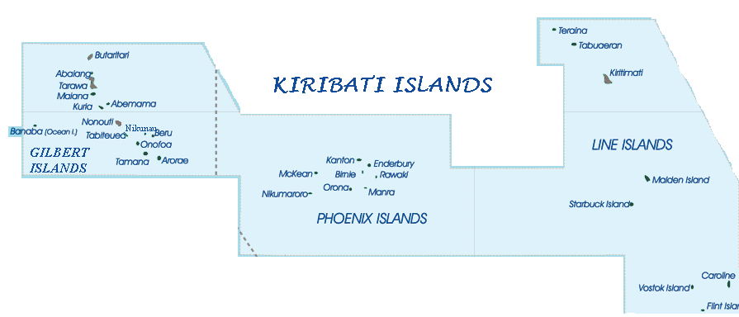
2.2.Climate.

ince Kiribati is situated within the dry belt of the equatorial oceanic climate zone, (McEnzie et al) rainfall is quite variable on a yearly basis. An Equatorial Tropical climate is predominant in the country. Rainfall for each island is varied and do not follow an established pattern all the year round. The average rainfall is 1000mm in the Southern drier islands whereas in the wetter Northern islands it is 3000mm. The general climate pattern is that characteristic of countries in proximity to the Equator. Daily temperature ranging from 26 degrees to 32 degrees Celcius are persisting. The lowest recorded was 22 degrees while the highest was 37 degrees.

Severe prolonged droughts with as little as 200millimetres of rain per year are common particularly in the Central and Southern Gilberts.(Mackenzie and Thaman 1990). The risk of drought is often high in the country with severity having been determined by extensive loss of crop trees grown along coast lines and sea water flooded areas.

2.3.Population

The population census of 2000 displayed a figure of 84494 as the total population. More than half of the population lives in urban areas of Tarawa. After the national census done in 2005 an increase in the population was noticed as the records showed that the total population of Kiribati is 92533. The distribution of population in the rural and urban areas is estimated as 56% live in the rural areas and 43% live in the urban centres of South Tarawa and Betio. (Source: National statics Division)

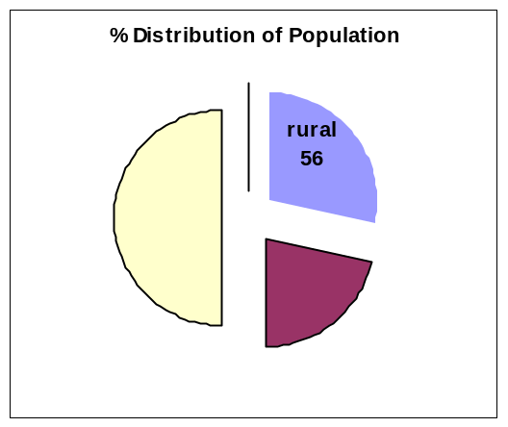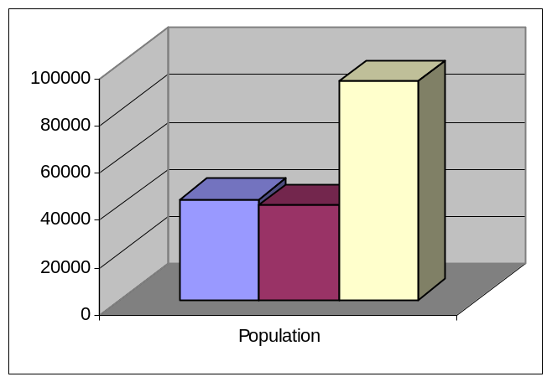

Number of persons living in rural
Percentage of total population. and urban areas.
(urban and rural)

An increase in the population is confirmed by considering the figures obtained from 2000 and 2005 national censuses which show the population as 84494 and 92533 respectively. Vital statistics obtained from 2005 census revealed the following figures presented in the table below:

The total number of females: 45921 (2005 Census).
Total Number of males: 45612 ( 2005 Census).

(Source: National Statistics Division)

Table 1. Demographic Data.

Population (census 2000) | 84494
2005 Estimate | 91000
Population Growth Rate | 1.69%
% of Population residing on Tarawa ( the capital) | 43%
Average Life expectancy (males) | 58.2 years
Average Life expectancy (females) | 67 years
Infant Mortality Rate (IMR) per thousand
Number of Households | 12609
Demographic Statistics ( copied from UNCCD Third National Report)

Real GNP per capita | AUD 1400
Nominal GNP per capita | AUD1902
Persons employed in the public sector for every 3 employed | 2 out of every 3
Percentage of households relying on copra as income source | 38%
Percentage of households depending on marine resources for livelihood | 80%
Kiribati is a Least Developed Country (LDC) by UN category

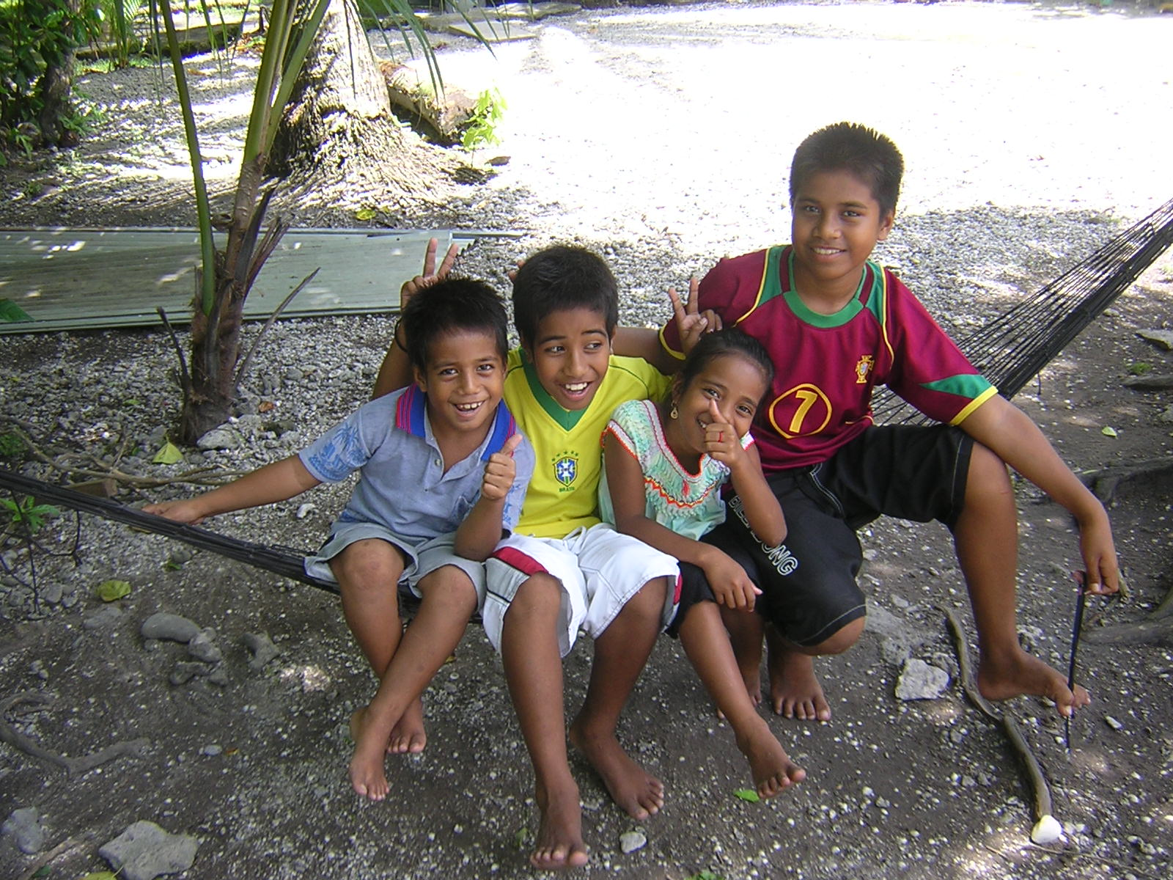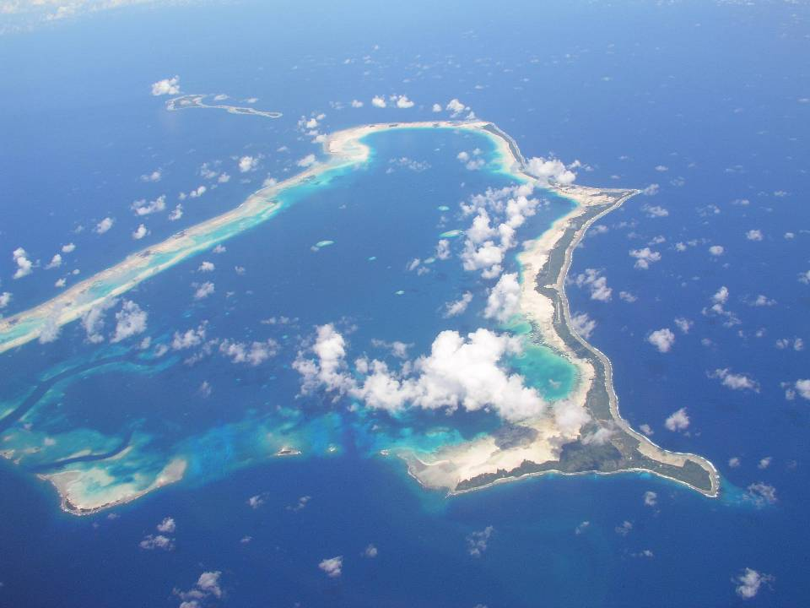
Children form a large portion of the population. An atoll from the air.(Lands division)

2.4 .Flora and its Cultural Utility.

Land Resources are very limited. By virtue of its poor soil, and low rainfall, the vegetation is primarily composed of coconut trees (Cocos nucifera,), pandanus (Pandanus tectoris), breadfruit (Artocarpus altilis), and babai (Cyrtosperma chamissonis). Other alien trees have been introduced to improve food supply.

The vegetation and flora of Kiribati constitute an important component of biodiversity that has an important place in the cultural, and ecological consideration of the country. Existing indigenous plants and trees such as te uri (Guettarda speciosa) and te itai
Calophyllum inophyllum) and many others are greatly valued within the subsistence economy.

The ecological functions provided by these plants include shade, animals and birds habitat, soil improvement, mulching materials, land stabilization, protection from winds and salt spray. ( First National Report to CBD).

Traditional foods and beverages, traditional medicines, ornaments, general construction materials, fuel wood, ceremony and rituals, magic and sorcery, body ornamentations are among the few uses of flora.

2.5. Terrestrial Fauna.

The indigenous land animals consist of birds, insects and land crabs (Mackenzie and Thaman). Pigs, dogs and rats are imported species introduced to the country via ships and aircrafts. The Polynesian rat (Rattus exulans) and ship rat (Rattus norvegicus) are causing economic problems in terms of crop destruction and transmission of rat-borne diseases. Their control involves significant drain on the country’s financial resources.

Pigs are valued for their traditional significance. Pork becomes an important food in feasts and ceremonial gatherings including weddings, funerals and family functions. Dogs are domestic animals that live within the homes acting as companions and keeping watch during night hours. Dog attacks are frequently experienced to intruders both at day and at night. Land crabs provide nutritious meat and source of cheap protein. On the third day after new and full moon, land crabs make their way in the early evening to the sea to shed eggs.

2.6. Water Resources.

2.6.1. Underground Water Source.

Due to their geological formation, there are no surface fresh water resources in the country. The only permanent fresh water resource is underground water in the form of a lens floating on the salt water which has a higher density. The depth of the lens depends on the width, elevation and shape of the island or atoll. Rainfall also determines the depth of the lens as well as the degree of withdrawal or use. Evaporation, transpiration and drainage in a seaward direction play a vital role in decreasing the volume of the lens. Recharge and replenishment of the lens is brought about by rainfall.

The improvement of underground water supply is associated with the construction of sanitary wells on outer islands and Tarawa under funding by several organizations including the World Health Organization, AusAID, and the European Community. Underground water source yields water of suspicious quality in terms of chemical and bacteriological content. As a precautionary measure, it is always advisable to boil underground water before drinking and using it for cooking.

2.6.2. Stored Rainwater.

As a means of improving water supply national water projects have been undertaken in islands using overseas aid funds. The objective of the project is to improve the quality and the availability of fresh water for drinking and cooking purposes. One important component of the project is the supply of rainwater tanks made of ferro-cement, poly venyl chloride (pvc) and concrete tanks.

The Sanitation Public Health project (SAPHE) that was implemented on South Tarawa and Betio provided opportunities towards a loan scheme for rainwater tanks for individual households, communities and organizations. The scheme contributed to a great degree to increasing the number of rainwater tanks on South Tarawa and Betio. The advantage of the project is an improved standard of sanitation, personal hygiene and reduced cases of water- borne diseases.

Rainwater contains impurities such as dissolved gases, dirt and other impurities as it passes through the atmosphere, roof, gutters and downpipes prior to entering the tank.
Eventhough rainwater is not as heavily polluted as underground water it should be not be regarded as safe for drinking unless it is subjected to boiling for not less than five minutes.

2.6.3.Desalination of Sea Water.

To partly solve the problem of fresh water shortage and to supplement existing supplies, desalination plants have been installed on Tarawa and Banaba. The disadvantage of the process is the high running cost resulting from rapid corrosion of machinery parts and high electricity consumption.

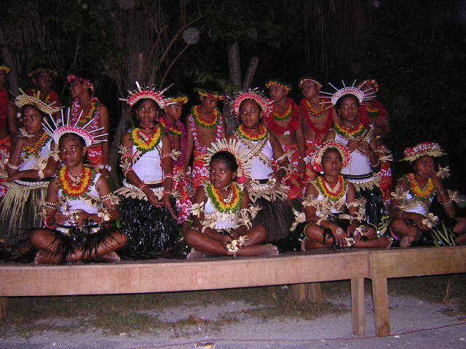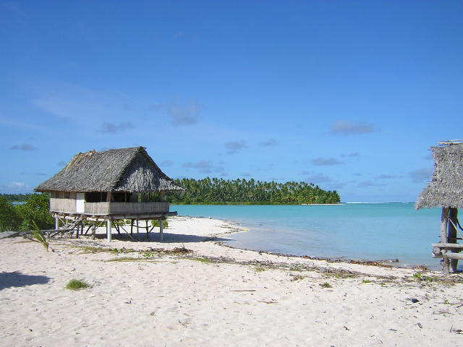
Children performing traditional dance Low lying atoll at high tide.

2.7. Land Tenure.

Land tenure is the way in which people obtain, use and distribute rights to land (Crocombe,1975).An I-Kiribati is entitled to own a piece of land and babai pits in addition to property inherited from parents. Each piece of land is determined by land boundaries marked by erected large boulders. When the owner dies, the lands are devided among the children and confirmed in a lands court. The first born male child is given a larger share and the rest is devided among the children with male children getting more than the female children. Customary land rights are held by individual for their lifetime, and on death the rights or interest passes to descendants of the former holder. ( Crocombe 1975) A record of land ownership is kept in a land register. A change in ownership of land is approved by the lands court. The same court settles land disputes. Appeals of lower court decisions are taken care of by High court and Court of Appeal.

2.8. Traditional Leadership.
Within a household, the father is the head. In the absence of the father, the mother undertakes the role of a leader. When the father and mother are non existent, the eldest man member of the family becomes the leader. In villages and islands, the traditional administrative power and decision making rests with a group of old men (unimane) in a maneaba.( a village meeting house). At the advent of local government administration system, an island is administered by an Island Council composed of the Chief Councillor, and village representatives called Councillors.

2.9. National Government System.

After achieving Independence status in 1997, Kiribati became a Republic. The Beretitenti who is elected from candidates nominated by members of the Maneaba ni Maungatabu (Parliament ) assumes the role of Head of state as well as Head of government.

The Maneaba ni Maungatabu ( Parliament) is a law- making body consisting of elected members representing every island within the Republic. The Cabinet comprising of The Beretitenti, Ministers and the Arttorney-General (ex-officio member) is the executing element .

The Judiciary is the law-enforcing arm of Government. The Court system operates in organized levels namely:

The Court of Appeal
The High Court
Magistrate Court.

3. Kiribati and the UNCCD.

Kiribati confirmed its commitment to the UNCCD by becoming a Party to the Convention in June1998.
The national focal point for the Convention is Tererei Abete-Reema, now the Director of Environment and Conservation Division of the Ministry of Environment Lands and Agricultural Development (MELAD). The Coordinating Mechanism is the National Coordinating Committee working closely with the National Coordinator. The Ministry of Environment Lands and Agricultural Development (MELAD) assumes the responsibility of overseeing the implementing activities of the Convention.

The country has since participated in every Conference of the Parties (COPs) and has
gradually implemented some of the Convention’s obligations together with decisions made during the COPs. An important achievement is the production of the National Action Plan (NAP) which is undertaken by the National Coordinating Committee. The NAP is scheduled to be completed in June and should undergo community and government consultation before being submitted to the Secretariat sometime in July 2006.

4. The NCSA and Other GEF funded Projects in Kiribati.

Kiribati is a signatory to the Convention on Biological Diversity (CBD), the United Nations Framework Convention on Climate Change (UNFCCC) and the United Nations Convention to Combat Desertification (UNCCD). The challenges of implementing the recommendations, decisions and programmes of this Convention stimulates interest at a national level. There is a realization, however, that capacity needs of the country have to be examined and strengthened in order for the country to be able to implement the requirements of the Conventions. In order to address this need, Kiribati has decided to be involved in the National Capacity Self Assessment project (NCSA). In implementing the project, Kiribati hopes to be in a position to conduct a thorough assessment and analysis of the national capacity needs, priorities and constraints with respect to meeting national and global environmental objective conducive to sustainable development.

NCSA is a project or a programme of work that will be done to bring about beneficial change. Its activities are cross- functional and adopt a multidisciplinary approach to successfully implement the necessary activities.

As for Kiribati, the NCSA is designed through a country driven consultative process in order to produce a national self assessment strategy for Kiribati that will enable her to properly address global environment issues.

5. Objective of the National Capacity Self-Assessment Project.

The development of thematic profile showing the major needs, challenges, and opportunities for capacity development in Kiribati is a vital move that will trigger the implementation of the Convention’s requirements. The thematic profile will reflect the national prevailing environmental issues, actions taken to address them as well as identifying the gaps that need to be filled.

The Objectives of the NCSA in Kiribati are:

> To carry out self assessment of the current capacity constraints to be able to address
global and local environmental issues.

>To review priority issues for action within the three thematic areas biodiversity, climate
change and land degradation.

> To identify needs for capacity building towards the implementation of the Convention.

> To establish baseline situation of the national capacity to implement these Conventions
and cross-cutting issues.

> To link country and international actions to the broader environmental management and
sustainable development framework.

> To catalyse targeted and coordinated action for future external and international
assistance.

6.International Conventions and Treaties Signed by Kiribati

Kiribati is a signatory to the following Conventions, and Treaties:-

1. U.N Framework Convention on Climate Change.
2. U.N Convention on Biological Diversity.
3. U.N Convention to Combat Desertification.
4. Vienna Convention and Montreal Protocol to Control Substances that Deplete the
Ozone Layer.
5. Basel Convention to Control Transboundary Movement of Hazardous waste and their
disposal.
6. Waigani Convention to Control the Transboundary Movement of Radioactive and
hazardous Waste.
7. SPREP Convention.
8. London Dumping Convention.
9. World Heritage.
10.Stockholm Convention on Persistent Organic Pollutants.
11.Cartagena Protocol on Biosafety to the CBD.

7. NCSA Methodology.

Generalized Objectives of Stocktake and Thematic Assessment:

- To identify priority environmental problems of the country through research of literature, interviews of stakeholders and conduction of community surveys and display findings.
- To prescribe national capacity needs to solve the identified environmental problems leading to Land Degradation.
- To make recommendations on how to undertake capacity development of Ministries, NGOs and individuals besides those that will assist in the implementation of UNCD in Kiribati.

The NCSA project consists essentially of:

7.1. Stocktake:-

The stocktake involves acquiring information on priority national environmental issues. These information are obtained through personal interviews of officers employed by relevant Government ministries, Non-Governmental organizations (NGOS) and individual stakeholders in addition to reviewing available literature. The stocktake includes identifying regional strategies that relate to the Convention requirements that the Kiribati Government has committed.
One aspect of the stocktake is the review of literature followed by consultation meetings with individuals and groups of stakeholders with a view to itemize the main environmental issues related to Land Degradation linking these with the Convention’s obligations. Decisions reached during the Convention Conference of the Parties (COP)
can be very useful in identifying future strategies to be implemented and to note amendments recommended during each COP.

7.2. Thematic Assessment and Gap Analysis.

The exercise consists of identifying environmental issues or Convention’s requirements that have been rectified by the country and noting those that have not been addressed.
This will provide details of gaps in the implementation of the Convention’s requirements. Root causes are then identified from which national actions will be formulated planned and implemented. The actions will become the capacity needs of the country.

Capacity needs are considered in three main categories or levels which are:

Systemic- showing policies, regulatory framework and strategies the country has adopted spearheading the implementation of the Convention’s obligations in the country.

Institutional – this explains and spells out the mandates and responsibilities of relevant
Government organizations, Non-governmental organizations (NGOs) and
other responsible bodies including church groups, youth groups, women’s
organizations and the like.

Individual – training and level of expertise, performance, incentives, communications,
staff turnover, vertical and horizontal communication channels,
awareness and level of understanding environmental issues.

The analysis will assist to identify capacity needs of the country to successfully control land degradation and to implement the obligations of the Convention (UNCCD).

8. Stocktake for the Three Conventions viz UNFCCC, UNCBD and UNCCD.

This process is accomplished by identifying issues that link the three Conventions and other national development strategies and other plans. A cross-cutting intervention is necessary to arrive at the common issues to all three Conventions. One common issue to the three Conventions is coastal erosion. Coastal erosion is causing land degradation in terms of loss of land due to the action of waves during spring tides and strong winds. Sea level rise has been causing waves to sweep over land and carrying sand back to the sea. Land degradation resulting from sea level rise reduces land area while destroying plants and trees which may be viewed as loss of biodiversity.

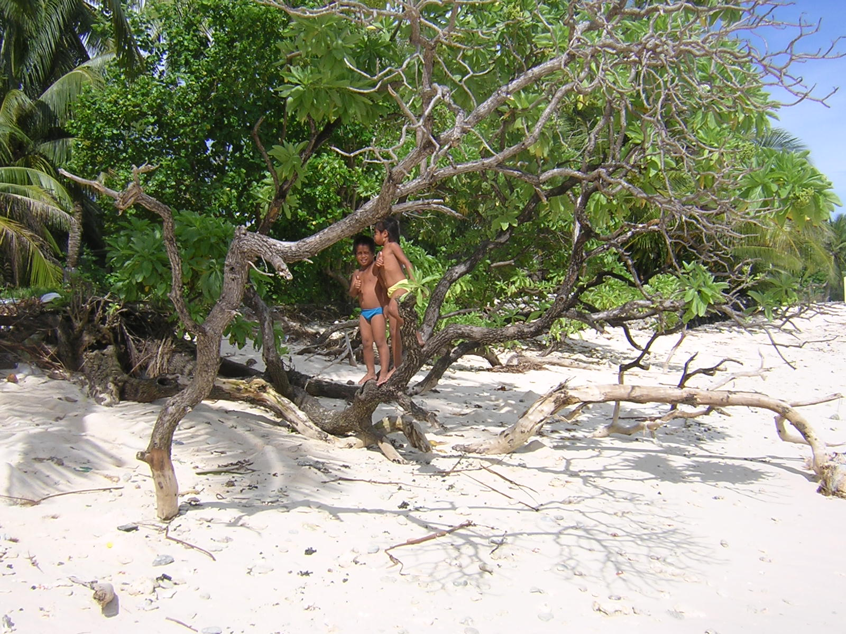
Costal erosion due to sea- level rise is one of the causes of land degradation
in Kiribati

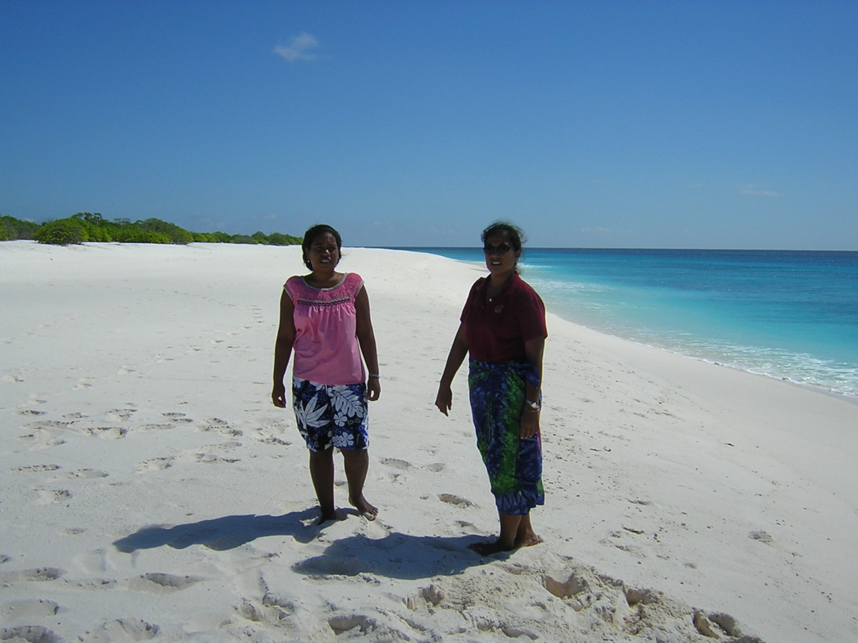
Sandy white beach at Poland village in Kiritimati Atoll

NCSA
REPORT
(on 3 Thematic areas)

CROSS-CUTTING
ISSUES
UNFCCC, UNCBD
UNCCD
STOCKTAKE
THEMATIC
ASSESSMENT
PROCESS FOR NCSA
National Capacity Self Assessment Procedure for UNCBD, UNFCCC and UNCCD

9. Progress in Measures taken to Combat Land Degradation and to Implement the Convention.

Strategies and Priorities Established within the Framework of the National Sustainable Development Plans and Policies.

9.1. Providing the National Action Plan (NAP)

Kiribati is in the process of developing a National Action Plan (NAP). With the assistance from the South Pacific Regional Environment Programme (SPREP) and funding provided by the United National Development Programme (UNDP), the preparation and production of the NAP by a committee comprising of experts and relevant stakeholders is in progress adopting various stages in its development. Consultations with Government and non-governmental stakeholders have been conducted at various levels to ensure a wide consultative process. Following its endorsement by the Cabinet and submission to the Secretariat, the NAP will be incorporated in the National Development Strategy.

9.2. Institutional Arrangements and Coordination Mechanism.

The Ministry of Environment Lands and Agricultural Development through the Environment and Conservation Division coordinates the process of developing the National Action Plan (NAP). The coordination of relevant activities within the various Government Ministries towards the drafting of the NAP promotes inter- organizational unity and mobilization of the various resources. The need to achieve involvement and participation of all Government ministries and the community is met by conducting national workshops in which decisions are reached through discussion / working groups. The involvement and participation in producing the NAP is an expression of ownership which is equally shared among individuals, groups and organizations.

The implementation of the NAP will be coordinated by the National Coordinating Committee (NCC). The NCC will be responsible for maintaining the implementation phase which consists of planning, awareness, coordination, consultation and national endorsement. The NCC will also be entrusted with the responsibility of preventing duplication of activities in the process of implementing the NAP and in other national strategies or action plans. The NCC is seen as a body to create and identify partners and to ensure a wide involvement and participation of relevant stakeholders.

9.3.Information Management and Dissemination.

Using funding provided by the European Union (EU) The Environment and Conservation Division of the Ministry of Environment Lands and Agricultural Development (MELAD) participates in the Pacific Environment Information Network (PEINP). Information on land use is fragmented and therefore difficulty in accessing information is noted.

Progress in establishing a database for the Ministry of Environment Lands and Agricultural Development is underway. An information network linking all Government Ministries is planned for the future to strengthen information management structure.

The PEIN facilitates the dissemination and sharing of information with other stakeholders, national and international organizations.

9.4. Legislative and Regulatory Framework.

No laws have been enacted to control land degradation. The legislative review mounted in 2004 confirmed this but identified the following laws as potential legislations for use in controlling land degradation in Kiribati:

9.4.1.Environment Act 1999 ( to be revised)

The Environment Act addresses two main categories namely:

Firstly, it requires the acquisition of a development consent by a developer prior to undertaking a prescribed development such as pesticide production and use. Secondly it ensures that a licence is obtained before any prescribed premises is established. This provision of the Act aims at controlling pollution from improper disposal of waste.

9.4.2. Local Government Act 1984.

The Act empowers the Minister to prescribe the functions of local councils. The Act also pronounces that local councils are vested with the responsibility of collection and disposal of waste in their respective areas of responsibility.

9.4.3. Public Utilities Ordinance 1977.

This Ordinance gives powers to the Public Utilities Board (PUB) to carry out the necessary functions required to maintain the supply of electricity, to collect and supply water and to manage the sewerage system on Bikenibeu, Bairiki and Betio.

9.4.4. Public Highway Protection Act 1989.

The purpose of the Act is to protect highways. The Act enables the establishment of the Highway Authority whose responsibility is to maintain and protect highways. There is a section in the Act that covers littering in public highways.

9.4.5. Special Fund (Waste Material Recovery) Act 2004.

The Act creates a system whereby prescribed materials are charged a deposit when they are imported into the country. A refund is paid when the material is returned to a recycling depot. The present system promotes the recycling of aluminium cans, PET bottles and lead-acid batteries.
9.4.6. Public Health Ordinance 1926.

The Ordinance establishes powers of the Minister to make regulations related to the water supply, litter, garbage and latrines. As noted, one of the regulations made under the Ordinance stipulates that all garbage and rubbish which can be readily destroyed by fire shall be so destroyed. In this context, burning of garbage or rubbish was recommended as one of the method of disposal. The shortfall of this regulation is now realized as burning of rubbish creates persistent organic pollutants (POPs). This particular portion of the Regulations should therefore be accordingly amended.

9.4.7. Customs Act 2005.

The purpose of the Customs Act is to control the importation and exportation of goods. A list of restricted and prohibited articles has been established under the Act. Custom officers examine goods that are brought into the country at international airports and sea ports.

9.4.8. Foreshore and Reclamation Ordinance 1977.

The Ordinance specifies that an area of sea that is alternatively covered and uncovered during low and high tide (foreshore) are the property of Government. The Minister may designate foreshore areas from which sand and gravel may be taken after obtaining a licence. This ordinance controls sand and aggregate mining.

9.4.9. Land Planning Ordinance 1998.

The Ordinance allows the establishment of the Central Land Planning Board (CLPB) that has powers to designate particular portions of land for specific use. The Board is required under the Ordinance to prepare a General Land Use Plan (GLUP).

10. Communication and Awareness Raising.

A continuing Awareness raising programme on Land Degradation has been implemented tackling causes of land degradation and mitigation measures on a national context. A cross sectional portion of the community including NGOs and the rural community participated in the programme thereby increasing the coverage of the programme.

At present there is no monitoring procedure to assess the effectiveness of the programme. Indicators have not been established for the purpose of monitoring the efficiency and effectiveness of the undertaking. The means of verifying the programme will be developed in the near future.

A communication adviser offered by AusAID is now available to assist in the Media and Public Awareness Unit of the National Action Programme. He will also assist in the development of a Communication Strategy for the NAP that will include key messages for delivery, information on the audience, roles and responsibilities, monitoring, establishing indicators and maintenance of the monitoring mechanism.

11. Critical Land Degradation Issues in Kiribati.

11.1. Increasing Population Pressure on Land due to Urbanization.

An influx of population to urban areas in Tarawa (the Capital Island) has given rise to enormous pressure on services such as solid waste collection and disposal system, water supply, sewage disposal, health services and other essential community services. Land resources are therefore exploited at a very fast rate resulting in their excessive use.

As a result of rapid increase in population, problems due to pollution of land, water and air has been experienced. Excessive exploitation and use of natural resources creates loss of biodiversity resulting in the reduction of valuable fruit trees and plants.

Seeking employment,education, business and better health care opportunities are among the reasons for outer island populations to be attracted to Tarawa. Emerging from increase in population and rapid urbanization on Tarawa are socio-economic problems which are listed hereunder:

- Increasing amount of solid and liquid waste polluting land surfaces, water lens and the surrounding marine environment and also creating a dangerous health risk to people.
- Very high exploitation of the terrestrial and marine biodiversity causing a marked decrease in the supply of fuel wood, food crops and marine resources.
- Excessive use of the thin layer of soil gives rise to decreased productivity of soil.
- Limited control of sea wall and building construction has negative effect on the coastal dynamics resulting in coastal erosion in many areas.
- Increasing demand for burial sites (cemeteries), recreational sites and agriculture will adversely affect the quality of land and subsequent loss of biodiversity.

11.2. Increasing Rate of Coastal Erosion due to the Effects of Wave Action and Current.

Sea level rise has been observed by people living along coastal areas in Kiribati. Huge waves during high tides cause sea water flooding and coastal erosion. The receding coastal line has always resulted in the loss of valuable coconut, pandanus trees substantial buildings and installations. In order to minimize the effect of coastal erosion sea walls are constructed along the shores. The use of coral rock for the construction of sea walls will rid coastal areas and fringing reefs of rocks and stones.

11.3. Improper Disposal of Waste and Pollutants.

Rapid population growth, increase in imported packaged items, increase in business activities is creating a threat on environmental status of atolls. Uncontrolled littering, indiscriminate dumping of solid waste, improper control and use of pollutants is a health risk to atoll dwellers. Seepage or leacheate from uncontrolled rubbish tips has been known to pollute lagoon waters and underground fresh water lens. The problem is more severe in Tarawa where solid waste disposal has not been successfully managed. Medical waste from the main hospital and village clinics consisting of used needles, chemical containers and expired pharmaceuticals have been disposed carelessly on roadsides and adjoining bushes.

Chemical pollutants such as waste oil, pesticides and chemical solvents have been found on unoccupied land. Domestic laundry and dishwashing detergents are used in large quantities on South Tarawa and Betio. These can cause future problems.

Even though persistent organic pollutants (POPs) have not been identified in Kiribati, there is a belief that some forms of POPs might be present in addition to those originating from burning of rubbish and wood fires. Minute quantities of Polychlorinated Biphenyls might be found in old electrical transformers on Banaba and Kanton. If this would be so, the problem has to be considered nationally in consultation with regional environmental organizations and neighbouring countries to adequately solve the problem in the region.

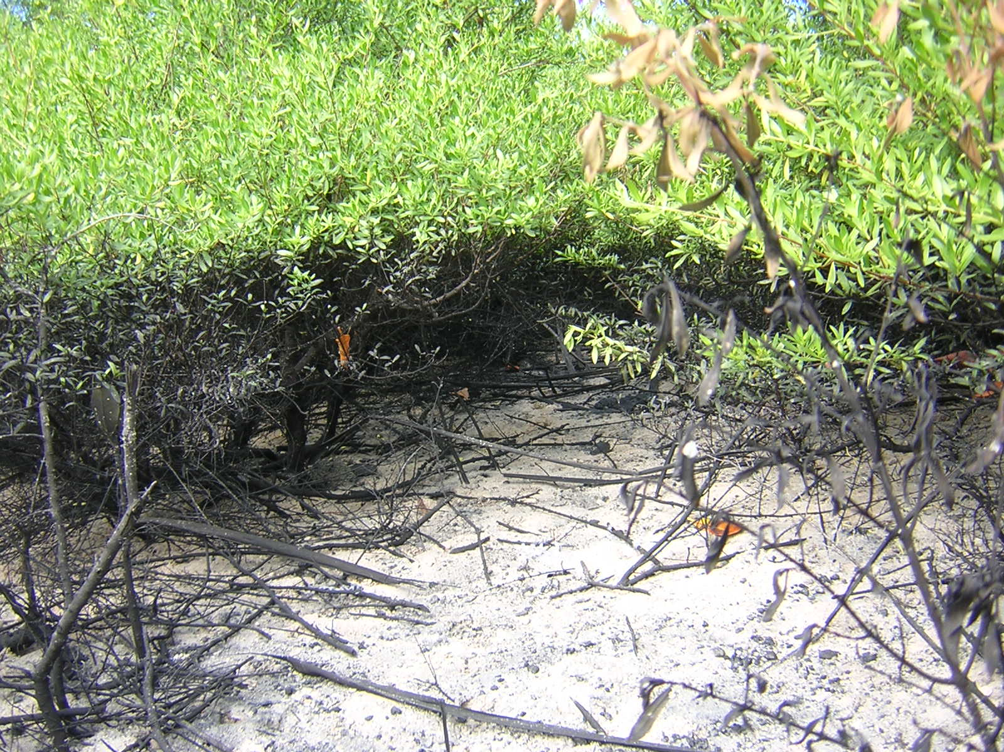

Land Pollution caused by the indiscriminate disposal of waste oil

11.4. Uncontrolled Mining of Beach Sand and Aggregates.

There is a great demand for raw materials to be used in construction works and for development purposes on South Tarawa and Betio. Beach sand and gravel are among the most needed ingredients for construction of buildings and installations. Mining activities along coastal areas particularly on Urban Tarawa are at an increasing rate that coastal erosion has been an everyday occurrence. Despite regular inspections by the staff of the Ministry of Environment, Lands and Agricultural Development, mining of beach sand and gravel on commercial basis is still in progress.

11.5. Legislative and Regulatory Framework.

To date, there are no specified laws and regulations for the control of land degradation. A legislative review to identify relevant national legislation to address land degradation indicated that certain laws may be applied to a certain extent to alleviate land degradation problems. Specific laws to regulate land degradation need to be drafted and enacted so as to streamline activities in the right direction. Whilst the Environment Act 1999 is undergoing amendments and Regulations being drafted, it might be an opportunity to expand the Act and Regulations so as to incorporate those that are relevant for land degradation issues.

11.6. Salt water Intrusion.

Rising sea levels and the presence of storm surges are the root causes of salt water flooding and intrusion into underground fresh water lens. In areas where access of sea water at high tides through breaks in the coast line, sea water is spread with an area destroying vegetation resulting in the creation of salt water marshes.

11.7. Land Clearing for Development.

Development activities are accompanied by clearing of land. The building of domestic or commercial buildings is preceded by clearing, leveling and surveying a piece of land intended for the purpose. The removal of trees and vegetation rids the area of ground cover exposing the land to erosion of top soil.

In urbanized regions of Tarawa, constant felling of trees and alteration of the topography of land by earth removal is a never ending process. Recent Government developmental projects implemented through bilateral and multilateral cooperation are taking their toll in the same direction. In spite of the recognition that deforestation is an unpreventable consequence of development, it must be controlled in a manner that it would not reach a state that will be regarded as tragic or threatening. Agricultural programmes pose the same problem but to a lesser extent. With modern agricultural practices introduced in the country, using organic material for improving soil fertility and mulching, agriculture programmes are now central to the control of land degradation.

11.8.Rubbish Burning and Bush Fires.

Occasional bushfires are generally encountered during dry periods when most of the ground cover namely grass and low bushes are dying due to dehydration. When this happens, fires can be caused by lighted cigarettes deposited on dry grass or from picnic fires.

Bush fires deprive land of essential soil trace elements that support plant growth and destroy enormous numbers of trees within the affected areas. This scenario is noticed on Kiritimati resulting in the destruction of birds’ habitat and loss of biodiversity let alone land degradation.

Burning of rubbish is by far the easiest means of disposing combustible rubbish. Usually huge heaps of organic rubbish from coconuts and pandanus are set on fire liberating dense smoke and flame. In this way nearby trees are destroyed by immense heat produced and flying ashes pollute the environment causing irritation to respiratory system in human beings and animals alike.

12. Requirements or Environmental Issues that have been Addressed and those that the People and Government have not.

12.1.National Strategies to Address Land Degradation Issues in Kiribati.

Being a Party to the Convention to Combat Desertification (Land Degradation) Kiribati is striving to fulfill and meet the requirements and obligations of the Convention.

In order to meet the desired goals and to implement the requirements of the Convention, the following long term strategies have been formulated and implemented:

In an attempt to verify and confirm its support for the Convention, the Government of Kiribati has taken immediate steps to formulate strategies that are relevant to the implementation of the Convention’s requirements and obligations.

12.2 Production of the National Action Programme.

A national project namely the National Action Plan is being implemented shouldering the responsibility of drafting the National Action Programme (NAP). The NAP is a plan prepared through participatory process and involved a series of national workshops attended by people of all walks of life including government officers, academia, representatives of women and youth groups. The draft NAP is undergoing the process of national endorsement consisting of community consultation, coordinating committee endorsement and lastly Cabinet’s final endorsement.

The NAP will, in essence, be designed so as to be compatible with the National Development Strategy.

12.3.Creation of a Coordinating Mechanism.

In the national interest, the implementation of all national documents including national action plans, strategies and national activities should be well coordinated in order to encourage and secure a national cooperation and participation. The NAP is no exception to the rule. A national Coordinating Committee comprising of representatives from relevant Government Ministries, Non – Governmental Orgnizations (NGOs), the private and public sector is a national coordinating mechanism for the production of the NAP.

An efficient coordination system encourages and promotes inter- sectoral cooperation,
let alone community involvement and participation. The coordination of activities has
much to prevent duplication of effort which in turn minimizes and enhances managerial and administrative processes.

12.4. Public Awareness Programme.

Great success in the area of awareness- raising is constantly maintained with funding
made available through a number of national and international projects that are
currently implemented in the country.

Public Awareness is one of the vital and prominent elements that should be
considered in the course of implementing National projects. Generally all awareness
programmes are done for all projects at any one time in order to save time and cost.
In this manner a wide coverage of awareness programme for all projects is maintained.

The involvement of women and youth groups in awareness programmes has been commendable in other projects. Tapping the potential contribution of women and youth in public awareness is being seriously considered.

12.5. Remedial Plans to Ease Congestion and Overcrowding due to Urbanization.

An innovative way to remedy congestion and overcrowding is taking shape in the form of growth centres as a step towards decentralization. As reported in the Islands Business News Bulletin, the rural development of the Ministry of Internal and Social Affairs has plans to establish “growth centres” away from Tarawa, the country’s capital and main urban centre. The growth centre concept has a direct link with the present government’s policy of equitable distribution of benefits.

An ongoing resettlement scheme is a sure way of widely distributing population to all uninhabited islands within the country.

A resettlement scheme at Temaiku when implemented will greatly alleviate population pressure on Betio and Bairiki.

12.6. Legislative and Regulatory Framework.

The existing Environment Act and Regulations act in some way to provide control over land degradation issues. There is still a need to expand the provisions in the Regulations to address land degradation problems.

Notwithstanding the fact that other national Acts could be used to control land degradation, it is necessary to devise specific Acts and Regulations for the purpose of adequately preventing land degradation and its unfavourable consequences.

12.7. Improper Solid Waste Disposal.

The problem of environmental pollution related to poor management of solid waste is acute in the main Urban areas of South Tarawa and Betio.

This grave concern is now being addressed in a number of ways. The International Waters Programme in Kiribati ( IWPK) has addressed the problem by implementing community awareness, competitions and other campaigns to motivate and encourage community’s and individual’s participation in the project. Training in waste sorting, composting and the use of the green bag for containment of unrecyclable and non- biodegradable refuse is in place. The support of the project by Urban Councils has considerable benefit in enhancing the success of the project. A further improvement in the implementation of the project is seen by the establishment of designated refuse disposal depots in both urban areas through an externally funded project.

An increase in the quantity of solid waste produced by urban population is being addressed by improving Urban waste collection and disposal systems. New landfills for Betio and Teinainano Urban Councils are now in operation handling all solid are non-biodegradable waste.

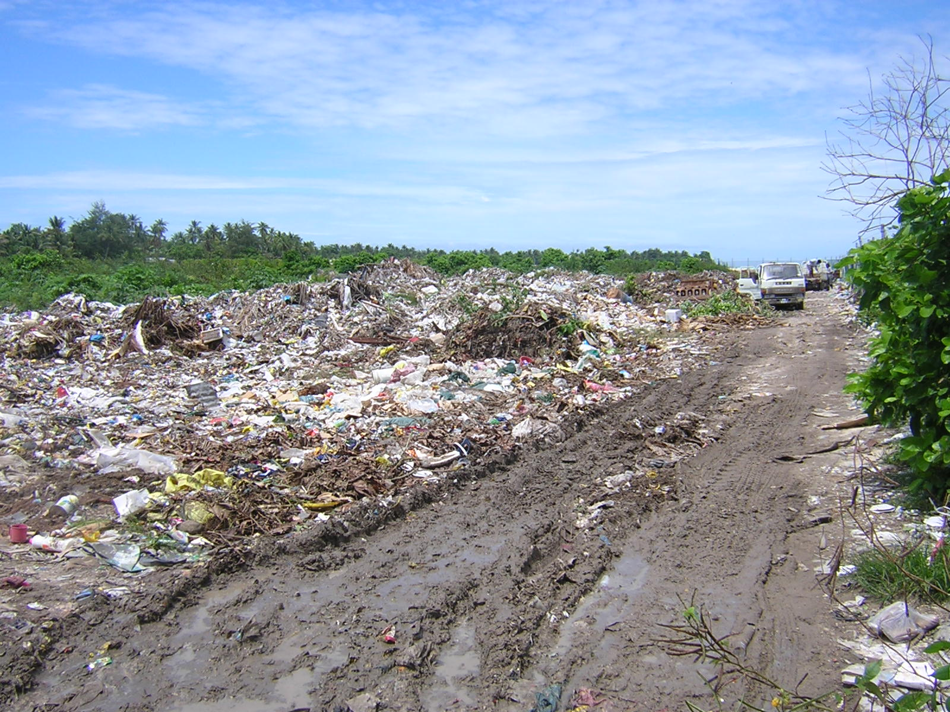
An example of Urban Landfill for Solid Waste Disposal.

12.8 Recycling of Recyclable Waste.

The recycling part of solid waste project provides for recycling of recyclable materials such as PET bottles, and aluminium cans.

Recyclable materials being carted to a recycling depot.
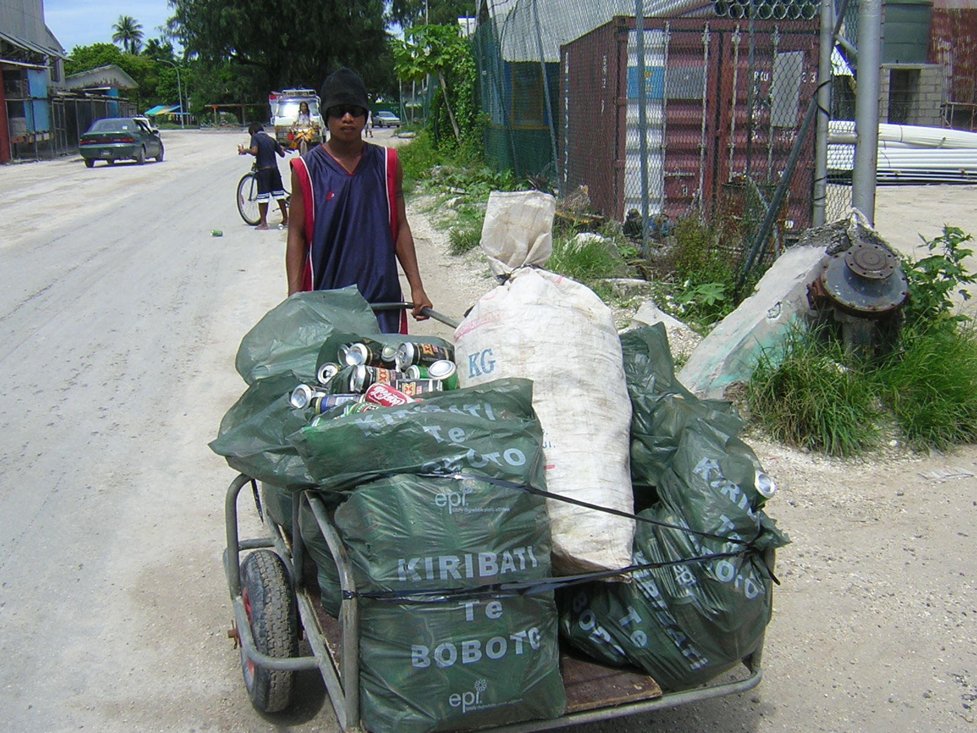

12.9. Uncontrolled Mining of Beach Sand and Aggregates.

Provisions in the Environment Act and Regulations provide ways and means of controlling mining of beach sand and aggregates. Enforcement of the Act is one aspect that needs attention on the part of implementing agency. Enforcement activities will demand strengthening human resources and supply of equipment. A proposed project that will provide aggregates by mining reef area at the North Western point of Betio and processing the ingredient for use in building works may alleviate the present problem.

12.10. Salt-water Intrusion.

The invasion of fresh water lens by salt water resulting from sea water flooding during spring tides, is viewed with concern. The tragedy this natural phenomenon creates is beyond the capability of an individual and the country to manage as it enkindles the utilization of vast resources that are not readily available in countries with economies in transition. Considering its fragile environmental stand, Kiribati is prone to repeated increased salinity of underground water supply. With receding coastlines and low rainfall, the situation is somewhat worsened. To date there are no substantial means of
solving the problem.

13. Strategies and Ministries responsible for implementing the strategies.

Each responsible Ministry is expected to formulate strategies for implementing
activities aimed at achieving identified goals related to UNCCD.

The strategies are tabulated below: Table 2. Strategies for Responsible Ministries.

MELAD | Production of NEMS, KEEP, POPS, NBSAP, Biosafety,  IWP, NAPA, PRAP, DSAP, Agroforestry
MISA | Growth Centres, Village Banks, Solid waste disposal.
MFED | SAPHE, CAP, Growth Centres
MPWU | Desalination plants, OICWS
MHMS | Population policy, Medical waste disposal plans
FSP | CBPE, Coral Garden Project, DPRRM
AMAK | Micro-credit- Economic empowerment
Community Based Initiative | Te Tongo Replanting.
Church Youth&Environment | Clean up days, Indigenous Tree replanting
Private Enterprises | Aluminium and PET recycling, Scrap metal recycling
14. Gaps Identified in the Implementation of UNCCD.

An analysis of the interviews undertaken as part of the stock-take activity,
confirmed that approximately 40% of the people interviewed were unable to offer adequate answers on land degradation issues. They indicated that they have not been exposed to any form of education or awareness on land degradation.

An assessment therefore on the subject is that there is a great need to strengthen and improve the basic knowledge of at least 40% of Kiribati population on land degradation problems and the actions to be taken to prevent and mitigate their effect.

Gaps that are invented are derived from a careful examination of the degree of accomplishment and assessment of the rate of implementation of the project, let alone inefficiency and other drawbacks inherent in the course of implementation. The identification of capacity needs is dependent on measure of success as depicted in national reports and other documents. The ideas, though may be unrealistic or contradictory to some but are as what can be visualized at the present time. Suggested capacity needs will hopefully be those that will improve management and implementation of UNCCD nationwide.
15.Root Causes of Gaps in Implementing Land Degradation.

The root causes are seen as listed: (further see Annex 7).

- Inadequate policies covering issues on land degradation.
- Incapability of responsible organizations (government and non-government alike)
- Inadequate human resources for implementation.
- Lack of supporting funds.
- Lack of skill and knowledge.
- Difficulty in obtaining regional and /or international assistance.
- Insufficient inter- organizational cooperation and coordination.
- Inadequate public awareness and motivational programmes.
- Inadequate legislation on land degradation.

Identification of gaps in the activities performed in order to comply with the requirements of the United Nations Convention to Combat Desertification ( Land degradation) involves taking into account the activities undertaken against those that should be targeted as implementing activities. Related to this, the capacities required in order to fully implement the obligations are identified. Capacities are further categorized as systemic, institutional or individual capacity needs. Gaps which are identified were, in other words, transformed into capacity needs that are presented in three levels as shown:

16.Capacity Needs.

16.1. Systemic. ( see Annex- Table 6 on Capacity needs)

- The country is in need of financial support from International Aid donors to allocate sufficient fiscal allotment to UNCCD implementation activities.
- A policy statement should be formulated to give more attention to land degradation and its remedial and preventative measures.
- A regulatory framework to regulate land degradation needs immediate actions related to its drafting and enactment.
- Government should accelerate the process of implementing population density reduction in Betio and Urban Tarawa.
- There is an immediate need to expand and amend other legislations that are supportive to the implementation of UNCCD.
- Training and educational opportunities should be sought for in-service training of human resources in order to strengthen their efficiency and efficacy in undertaking their roles and responsibilities for land degradation.
- The national government should consider offering financial support in addition to that provided in the project’s monetary provision. This will enhance the expansion of activities to the rural population as the concern is nationwide.
- Improvement of the national capacity for data collection, analysis, monitoring and integrated environmental assessment.
- Improved capacity for regional and international cooperation.
- The country should have the capacity to plan and implement plans for land degradation.

16.2. Institutional.

Each relevant government ministry and organization, non government organization, and the private sector have to consider improving their capacities in the following areas:

- In reviewing their strategies and capacity needs in order to be more capable of implementing their participatory roles for land degradation.
- In the consideration of strengthened monitoring activities in the area of land degradation.
- In amending their MOP so as to put more effort towards the implementation of land degradation.
- In instituting a training programme plan and to implement the plan for staff shouldering responsibility for land degradation.
- In encouraging and improving coordination of responsibilities in order to prevent duplication and conflict.
- Increase financial allocation for land degradation promotional activities.
- Improve participation in UNCCD planning and coordinating meetings.
- Development of staff training, the transfer of appropriate technologies and methodologies.
- Strengthen capacity for environmental research and in the area of land degradation.
- There is a need to engage tertiary institutions for capacity building and technology support programmes.
- Consider allocating sufficient financial resources for executing Ministry such as MELAD ( Environment & Conservation Division) as a means of improving the staff capacity to control land degradation.

16.3 Individual:

Capacity needs for individual person having some responsibility in project planning, monitoring and implementing environmental (land degradation) project are listed hereunder:

- Public awareness is an accepted undertaking to ensure the transfer of real messages and understanding. Training is required to make individuals capable of implementing the programme in an efficient manner and with confidence.

- Training and education of an individual pave the way to receiving essential knowledge pertinent to any special initiative or programme.

- Stakeholders should be given knowledge base of the project and other collective information.

- Decision making capabilities are relevant for building capacity of stakeholders.

- Capacity for self motivation and self reliance is essential in an individual engaged in the implementation process.

- Environmental audit training is required for stakeholders.

- Capacity to participate in planning, implementing and reviewing project.

- Education of children of school age on Land Degradation should be done

in schools having the curriculum designed to make this possible.

Successful implementation of environmental projects depends on having realistic, enforceable and appropriate legislation; strong institutions capable of designing, implementing, monitoring, and evaluating coordinated environmental activities and well trained, knowledgeable staff.(The world Bank). This long sentence necessarily refers to capacity needs of those vested with the responsibility of managing projects be it environmental or otherwise.

17.National Capacity Self Assessment Training Workshop in Kiribati.

A training workshop was convened at the Otintaai Hotel from Tuesday 5th to Thursday 8th December 2006. Supervising the workshop was Frank Wickam from the South Pacific Regional Environmental Programme ( SPREP).

The workshop aimed at offering training to national stakeholders and project personnel on NCSA methodology using tool kit in order to assess capacity needs for the three thematic areas namely Climate Change, Biodiversity and Land Degradation.

The identified capacities that have to be developed for the country is based on the use of logframe (problem trees toolkits) developed during the workshop. The outcomes and actions are identified from which capacities and action plans are eventually produced.

The logframe for Land Degradation is given in an Annex 5 to this report.

18.Environmental Policies.

The following environmental related policies are being considered by Government in consultation with every section of the national community:-

18.1 Environment.

Government shall address:

- potential social and economic impact of climate change.
- fragmentation of responsibilities for policies and actions affecting the environment.
- Urban local government lack capacity and motivation to perform required roles
- Public open spaces in South Tarawa are among the worst kept in the Pacific.

18.2 Land:

Government shall through its appropriate Ministry devise policies on:

- How to develop and enforce sustainable land use schemes in Tarawa and
- Kiritimati.

18.3 Economic growth.

Government shall develop policies to curtail:

- Growth of population that restricts income per head.
- Climate change that brings potentially costly risks to economic growth.
- Land degradation that causes loss of biodiversity.
- Inadequate awareness of critical environmental issues.
- Environmental pollution as a result of poor waste disposal options.
- Inadequate financial provision of Land Degradation control activities.
- Water supply shortage in the country.
- Unproductive agricultural practices rid soil of essential growth elements.
- Uncontrolled clearing of land for development purposes.
- Unsustainable land management options.

19. Recommendations as produced from past workshops exercises:-

- The NCSA report for UNCCD should be reviewed and updated every four years in order to be aligned with other national documents reviews.
- A local consultant should be appointed for the purpose of reviewing the NCSA report.
- The NCSA report should be subjected to a wide national consultation before being endorsed by the appropriate authorities and submitted as a national document.
- The Ministry of Environment should oversee the review of the report and assisted by relevant Government and Non-Governmental Organizations and other stakeholders.
- The NCSA should not be produced in isolation but rather be a component of the Thematic Assessment.

6. All policies, strategies and capacity needs should be instituted using a country-
driven and participatory approach.

7. The elements for capacity building such as public awareness, strengthening technical capacity, stakeholders’ full participatory approach, strengthening of institutional parameters, mobilizing human resources, promoting gender equity, upgrade communication links and legislative enforcement must be taken into consideration.

- A national effort to upgrade capacity of Ministries, NGOs and individual members of communities is urgently needed using funding from bilateral and mutilteral sources.

- Laws for the control of Land Degradation should be incorporated into the amended Environment Act and Regulations.

Bibliography

Atanraoi. P. 1995. CustomaryTenure and Sustainability in an Atoll Nation, the case of Kiribati. University of the South Pacific

Cole R.V et al 1986. Selected Issues in Pacific Island Development. National Centre for Development Studies, Australia National University.

Connell J. et al 1946. Planning the Future. Australian National University.

Crocombe . R.G 1987. Land Tenure in the Atolls. University of the South Pacific.

Environment and Conservation Division 2005. Third National Report on UNCCD.
(Unpublished)

Government of Kiribati.2005. The National Development Strategies 2004-2007.
Government Printery. Tarawa.

Government of Kiribati 2000. National Development Strategy 2000-2003. Government Printery Tarawa.

Government of Kiribati 2005. The UNCCD National Action Plan (unpublished).

Lambert. B. Kiribati Micro-individualism in Land Tenure in the Pacific.

Maude. H. E (edit).Pacific Islands Monograph Series No 7 Tungaru Traditions.
University of Hawaii Press. Hawaii.

Ministry of Environment Lands and Agriculture Development .Environment Act
1999. Gov’t Printery Tarawa

The World Bank1994. Making Development Sustainable. Washington D.C.

United Nations Environment Programme .2004. High level Open-Ended
Intergovernmental Working Group on and Intergovernmental Strategic Plan
forTechnological Support and Capacity Building. Kenya

Annex 1.

Requirements / Obligations of UNCCD.

Article 4. General Provisions.

- Development of coherent long term strategy at all levels.
- Adopt integrated approach addressing physical, biological and socio-economical aspect of the process of desertification and drought.
- Affected developing country Parties are eligible for assistance in the implementation of the Conventions.

Article 5.

Obligations of Affected Country Party:
- Give due priority to combating desertification and investigating the effect of drought and allocate adequate resources in accordance with their circumstances and capabilities.
- Establish strategies and priorities within the framework of sustainable development plans and policies to combat desertification and mitigate the effect of drought.
- Address underlying causes of desertification and pay special attention to the socioeconomic factors contributing to desertification processes.
- Promote awareness and facilitate the participation of local population to combat desertification and mitigate the effect of drought.
- Provide an enabling environment by strengthening as appropriate, relevant existing legislation and where they do not exist, enacting laws and establishing long term policies and action programmes.

ANNEX 2

COP Decisions:

Conference of the Parties (COPs) is the governing body and the supreme decision-making authority for the Parties to the convention.

Functions:

- reviewing regularly the implementation of the conventions and functioning of its subsidiary bodies and institutional arrangements.

COP 7. – held in Nairobi Kenya from 17th -28th October 2005

Decisions are not yet available.

COP 6.- held in Palacio de Convenciones in Havana Cuba from 25th
August to 5th September 2003.

COP dealt with:
- Designation of GEF as financial mechanism of UNCCD.
- Activities for promotion and strengthening of relationship with
Other relevant conventions and international organizations,
institutions and agencies.
- Enhancing the effectiveness of the committee on science and
- Technology (CTs)
- Follow up the World Summit on Sustainable Development.

The Global mechanism (GM) and members of the Facilitation Committee (FC) Jointly developed a business plan (BP) for 2003 -2006 which was endorsed by the Committee for the Review of the Implementation of the Convention (CRIC). The following objectives were provided by the BP:

- Mobilize financial measures to support UNCCD implementation
- Broaden the GM information system, knowledge and communication strategy.

Annex 3.

List of Persons contacted or interviewed.

Name | Organization / Address.
Ata Binoka | Agriculture Division.Tanaea
Kaka Ioane | Temaiku, Tarawa
Katieruru Mango | Noto, North Tarawa
Tangaki Kaitiata. | Keuea, Butaritari
Uarai Koneteti. | USP Teaoraereke South Tarawa.
Nei Toka Teekana. | FSP. Abarao. Tarawa
Mamau | PUB Bikenibeu.
Titiku Kakoroa | Bikenibeu, Tarawa
Tuabo Toromon | Bonriki,Tarawa
Boata Iabeta | Temaiku,Tarawa
Banian Temakau | Temaiku, Tarawa
Rokora Mareko | Buariki Onotoa
Botara Betaia | Bairiki,South Tarawa
Aratin Maeriua | Betio

Annex 4.

Sample of Questionnaire Forms.

The National Capacity Self-Assessment Project.

Land Degradation Questionnaires

Bongin Namakaina: ------/-----/2006

Aram: -------------------------------- Am Tabo: ---------------------------------
( Ae banin) ---------------------------------
---------------------------------
Aine/ Mane ( A ) ( M ).

Ririki ni Maiu. (____) te ririki.

Am Makuri :-------------------------------

Am tabo ni Makuri:----------------------

-----------------------------------------------

-----------------------------------------------

1.Ko a tia n ongongo taekan uruakin te aba? □ Eng □ I tuai.

2.Ko kangaa n ongo? ⁮Maroro ⁭ Reirei ⁮ tabeua riki

3. Kaoti anga ake a karika uruakin te aba.

- Kanakin te aba nte nao ao rikiraken rietan tari. ( katoto)
- ----------------------------------------------------------------------------------------
- ----------------------------------------------------------------------------------------
- ----------------------------------------------------------------------------------------
- ----------------------------------------------------------------------------------------
- ----------------------------------------------------------------------------------------
- ----------------------------------------------------------------------------------------
- ----------------------------------------------------------------------------------------
- ----------------------------------------------------------------------------------------

4. Tera makuri aika a karaoaki iroun te Tautaeka ni katoki kanganga aikai?

- Irakin bowin te aonaba ao ni kairoroia aban te aonaba ba a na katoki makuri ake a na karikirakea te kabuebue ao rikiraken rietan taari.(katoto)
- -------------------------------------------------------------------------------------------
- -------------------------------------------------------------------------------------------
- -------------------------------------------------------------------------------------------
- -------------------------------------------------------------------------------------------
- -------------------------------------------------------------------------------------------
- -------------------------------------------------------------------------------------------
- -------------------------------------------------------------------------------------------
- -------------------------------------------------------------------------------------------

5. Tera aia anga botaki ( aine, roronrikirake, Aro botaki riki tabeua) ni katoka te
kanganga aio?
- -------------------------------------------------------------------------------------------
- -------------------------------------------------------------------------------------------
- -------------------------------------------------------------------------------------------
- -------------------------------------------------------------------------------------------
- -------------------------------------------------------------------------------------------
- -------------------------------------------------------------------------------------------
- -------------------------------------------------------------------------------------------

6. Tera anga (rabakau, kaubai, ao anga ni boutoka aika a na karekea te kona) “capacity needs” iroun te Tautaeka ae riai n reke ba E aonga ni kona ni katoki kanganga aikai?

- -------------------------------------------------------------------------------------------
- -------------------------------------------------------------------------------------------
- -------------------------------------------------------------------------------------------
- -------------------------------------------------------------------------------------------
- -------------------------------------------------------------------------------------------
- -------------------------------------------------------------------------------------------
- -------------------------------------------------------------------------------------------
- -------------------------------------------------------------------------------------------
- -------------------------------------------------------------------------------------------
- -------------------------------------------------------------------------------------------

7. Tera anga ni karekea te kona (capacity needs of communities) nakoia botaki ba a na kona ni buoka katokan kanganga aikai?

- -------------------------------------------------------------------------------------------
- -------------------------------------------------------------------------------------------
- -------------------------------------------------------------------------------------------
- -------------------------------------------------------------------------------------------
- -------------------------------------------------------------------------------------------
- -------------------------------------------------------------------------------------------
- -------------------------------------------------------------------------------------------
- -------------------------------------------------------------------------------------------
- -------------------------------------------------------------------------------------------

8. Tera te atatai ke rabakau, ke anga ni karekea te kona ( capacity needs) iroun te aomata ba e na ibuobuoki ni katoki kanganga aikai?

- -------------------------------------------------------------------------------------------
- -------------------------------------------------------------------------------------------
- -------------------------------------------------------------------------------------------
- -------------------------------------------------------------------------------------------
- -------------------------------------------------------------------------------------------
- -------------------------------------------------------------------------------------------
- -------------------------------------------------------------------------------------------
- -------------------------------------------------------------------------------------------

Iai am taeka ae Ko kan anga ni irekereke ma te waki aei? Koroia i nano.

________________________________________________________________________
________________________________________________________________________________________________________________________________________________

________________________________________________________________________________________________________________________________________________________________________________________________________________________________________________________________________________________________________________________________________________________________________________________________________________________________________________________________________________________________________________________

Nakon: Te aomata are e kanoa te Booma aei.

Taiaoka ni kaboi titiraki akana i eta ao kaoka te booma nakon Neri Tiaeke ke kawakinna ba e a manga rikoaki mai iroum inanon kabanean wikin Okitoba.2006.

Ko bati n Raba n am ibuobuoki ao am tai ae Ko anga ibukin kakoro raoan te kakae aei.

Note:
The self-administered questionnaires are distributed to individual respondents and collected as soon as they are completed. Recorded responses are done by personal interviews and respondents’ answers were recorded by the interviewer.

Most of the interviewees and respondents are unemployed citizens. The interviews, in this case is to assess their knowledge on land degradation.

This will give us a baseline for further surveys of this nature in future. During the survey the number of respondents and interviewees is quite low, however, it gives a rough indication and therefore an assessment of how much land degradation awareness has been done to employed and unemployed citizens.

Public awareness is a recommended means of building capacity and education for people of all walks of life. This is therefore, a process that needs to be implemented throughout the project’s life. It is also understood that promotion of awareness is one of the obligations of the Party country as recommended by the Convention to Combat Desertification (Land Degredation).

Annex 5 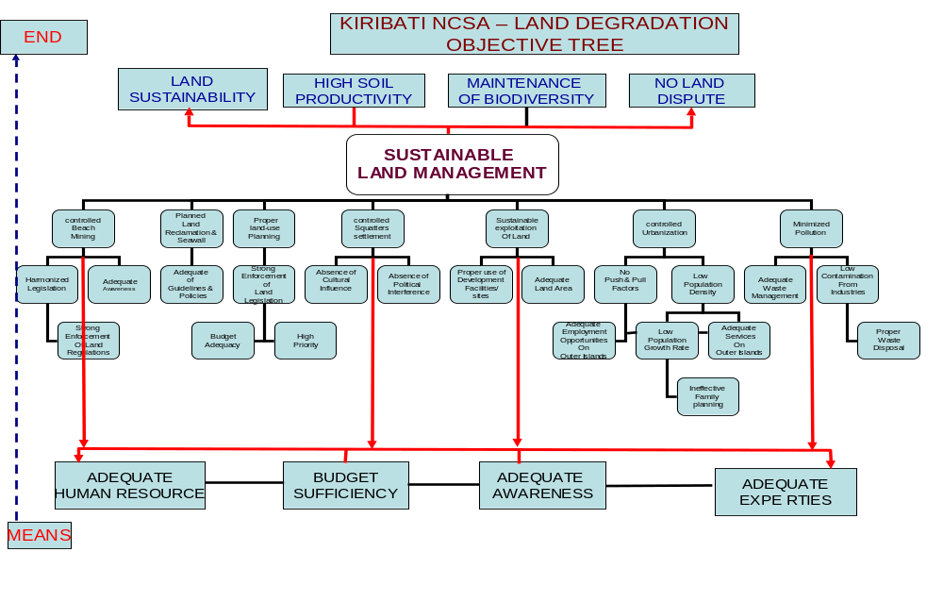

Logframe for Land Degradation

Outputs from the logframe assist in identifying the required actions to be performed. The actions can be turned into capacity needs..

Outputs  Or Actions. | Performance indicators | Means of verification | Assumptions and risks
1. Harmonized legislations for SLM | Legislation relating for SLM has been reviewed and formally harmonized | Copies of legislation have been endorsed. | Adequate human & financial resources.
2. Adequate level of awareness on SLM | 1.Surveys revealing increase level of awareness  2.Change of behavior and attitude | Report on change of behaviour and attitude, and level of awareness. | Sufficient monetary backing.
3. Effective enforcement of legislation | Surveys revealing stronger enforcement of SLM legislation | Records of prosecutions and verdicts | Adequate human resources.
4. Adequate guidelines and policies for SLM | Guidelines and Policies for SLM has been reviewed & endorsed | Copies of guidelines and policies are made available. | Availability of experts on policies.
5. Absence of unnecessary political interference | Existing legislation has been amended to discourage unnecessary political interference | Copies of legislation are made available for inspection. | Politicians are aware of the necessity for supporting SLM.
6. Proper use of development facilities/ sites | Onsite monitoring visits have been regularly conducted and developers have complied with development guidelines | Reports on site visits at regular intervals are produced. | Adequate manpower to monitor the use of development sites.
7. Adequate land area for  development purposes | Existing legislation need to be revised and amended. Land use policies have been formulated | Copies of land use legislation are being enforced. | Land reclamation is successful.
8. Reduced migration levels through improved decentralization | 1.Internal migration policies and regulations has been formulated  2. Growth Centers have been developed. | Enforcement of legislation is verified through prosecution report from police records. | Financial support is available
9. Controlled population density | Family planning policy has been revised. | Reports on birth rate have shown decreased birth rate and reduced increase rate of population. | Family planning programme is progressing well.
10. Improved waste management | Survey to show decrease in littering. | Report on survey showing that waste management is improving. | Financial resources are provided.
Annex 7
Table 3. Three Levels of Capacity Needs and Constraints.

Systemic | Institutional | Individual | Constraints
1. National Policy for land degradation control. | Formulation of strategies for land degradation. | Ability to draft policy or to support policy on land degradation. | It depends on political will and commitment.
2. Amendment of other supportive legislations to address land degradation | Enforcement procedure to be implemented. | Capability to draft laws to support land degradation. | Staff restrictions for legislation drafting.
3.Regulatory instrument to be created for land degradation | Expansion of MOP to include control measures of land degradation. | Knowledge on regulatory framework. | Insufficient work force for drafting Acts and Regulations.
4. Financial support through co-financing | Financial allocation and in-kind contribution . |  | Slow process of acquiring funds
5. Enhancing training opportunities locally or internationally | Provide suitable staff for training. | Acquire suitable expertise through training. | Unavailable funding and lack of personnel.
6. Population density control | Providing required personnel for implementation of resettlement scheme. | Ability to carry out policy on resettlement. | Lack of suitable laws and personnel.
7. Development of data collection, storage and sharing and interpretation | Commitment to provide trained persons. | Knowledge on data management. | Inadequate staff and commitment of ministries.
8. Enhancing International and Regional cooperation | Provide support for international cooperation. |  | Depends on political will and commitment
9. Acquiring support and cooperation of scientific or tertiary institutions | Invite support of scientific and tertiary institutions for research work. | Undergo tertiary training on research for land degradation. | Inaccessibility of science or tertiary institution.
10. Public awareness and Training. | Supporting awareness on land degradation and education of stakeholders. | Possess knowledge on land degradation and ability for planning. | Shortage of funding for training.
Annex 8.
Table 4. Critical Environmental Issues and Root Causes.

Environmental  Issues | Root Causes | Capacities Needed | Prioritization  (Ranking)
Increasing Population Pressure due to Urbanization. | Inadequate policy and legislation on urbanization.  Slow resettlement scheme. | Formulation and strengthening of legislation, urbanization policy and strategy. | 1
Coastal Erosion due to Climate Change and sea-level rise. | Uncontrolled mining processes. Lack of climate change adaptation measures. | Drafting of legislation and implementation of Climate Change Adaptation processes. | 1
Pollution from improper disposal of waste and chemicals. | Inadequate legislative instrument on proper disposal of waste and pollution by chemicals. | Pollution Control concerning that from improper disposal of waste and chemicals. | 2
Land Clearing for development. | Absence of specific laws on land clearing. | Effective and sustainable land management system. | 3
Salt water Intrusion. | Inadequate policy on coastal protection. | Coastal protection and Adaptation. | 4
Burning Waste and Debris. | Lack of knowledge on waste disposal. | Disposal of waste by sanitary landfill. | 5
Bush Fires. | Weak control of bush fires. | Prevention and control of bush fires. | 6
Mining of beach-sand and aggregate. | Inadequate enforcement of legislation. | Control measures on mining by enforcing legislation | 7
Burning of solid waste | Improper knowledge on disposal of solid waste. | Knowledge on correct disposal of solid waste | 8
Bush fires. | Inadequate control of bush fires when they happen. Ignorance in prevention of bush fires | Prevention measures and control of fires. | 9

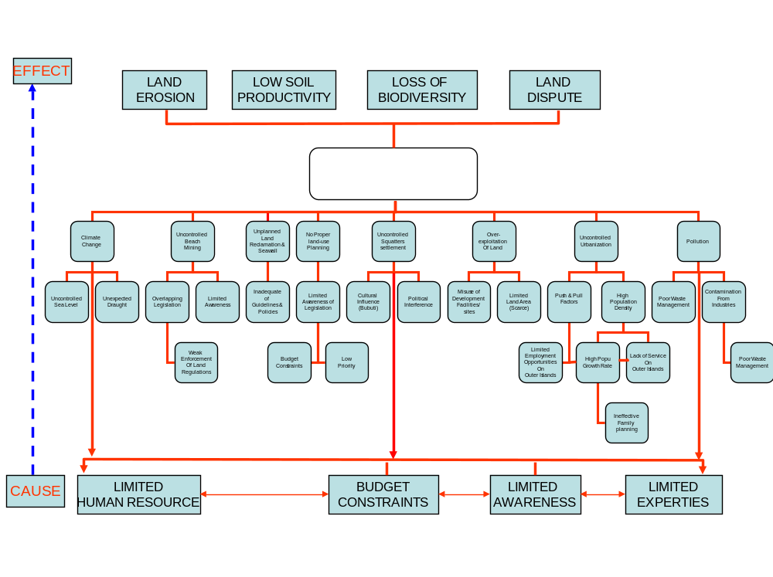
Root causes of Unsustainable Land Management

National Priorities and Country Party Obligations
To Address Capacity Building Needs.
Priority Environmental Issues | Root causes | Capacities Needed | National Obligations | Convention Obligations.
Increasing population pressure due to urbanization | Inadequate policy and legislation on urbanization. Slow resettlement scheme. | Strengthening and formulation of legislation for urbanization policy and strategies | Give priority for training on formulation of legislation and policy for urbanization. | Give priority to establishment of long term strategies at all levels.
Coastal erosion due to climate change and sea level rise. | Uncontrolled mining process. Lack of Climate change adaption measures. | Drafting of legislation and implementation of climate change adaptation measures | Training for legislation drafting and adaption measures. | Strengthen relevant legislation and enact laws.
Pollution from improper waste disposal and chemicals | Lack of legislative instrument on proper disposal of waste and chemicals | Pollution control on improper disposal of wastes and chemicals. | Capacity development for pollution control and proper disposal of chemicals. | Promote awareness and facilitate participation of local population.
Land clearing for development purposes | Absence of specific laws on land clearing | Effective and sustainable land management system | Develop capacity for sustainable land management | Allocate adequate resources.  Provide appropriate laws.
Salt water Intrusion | Inadequate policy on coastal protection | Coastal protection and adaptation. | Afford training on policies regarding coastal protection. | Establish strategies, and policies.
Burning wastes and debris. | Lack of knowledge for proper waste disposal | Disposal of waste by sanitary landfill. | Training on construction and maintenance of landfills. | Promote awareness and facilitate participation.
Bush fires | Weak control of bush fires | Prevention and control of bush fires | Training to be directed towards fire prevention and control measures. | Address underlying causes.
Burning of solid waste. | Improper knowledge on disposal of solid waste | Knowledge on proper disposal of solid waste. | Develop knowledge on solid waste disposal | Provide awareness and facilitate participation.

