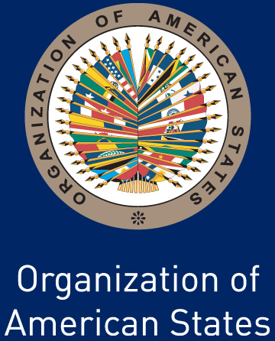
THE LECTURE SERIES OF THE AMERICAS
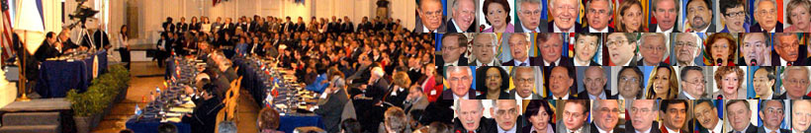
COMMEMORATES ITS FIFTH ANNIVERSARY
The Lecture Series of the Americas commemorates its fifth anniversary after its creation on September 29, 2004 by the OAS Member States to enrich the hemispheric debate on key issues of the Inter-American agenda.

Throughout the past five years, the series has inspired and informed a large and broad audience by bringing most distinguished leaders, scholars, and policy experts to the House of the Americas to discuss democracy and governance, social development and the fight against poverty, the protection and promotion of human rights, and the stregthenning of security.

Sponsored by Universidad San Martín de Porres from Peru, and other donors, the Lecture Series of the Americas emerged to respond to the need to provide a space for the exchange of views on how to tackle the main problems in the Americas and to maintain an ongoing regional dialogue with all sectors of society.

By addressing a full range of issues, from the challenges of globalization and the new roles of universities in the Hemisphere to the financial crisis, the Lecture Series of the Americas has enriched public debate and has contributed to the sharing of ideas and experiences on how to confront these challenges.

Since its inception, more than twelve thousand people have attended this live, free forum in the Hall of the Americas of the OAS in Washington, DC. Thousands more have participated in the program through its live web transmission in English and Spanish.

For more information on the Lecture Series, please visit www. oas.org/lecture

