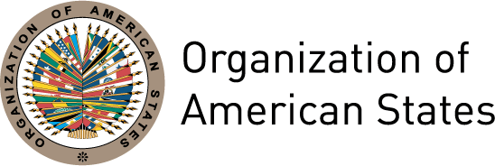
Haitian Diaspora Forum
March 21-23, 2010

Dear Member of the Haitian Diaspora,

In preparation for the Haiti Donors Conference in New York, the Organization of American States (OAS) and the Haitian Diaspora are organizing the Haitian Diaspora Forum: Contributing to a Strategic Plan for Reconstruction and Development in Haiti that will take place on March 21-23, 2010 at OAS headquarters in Washington, D.C.

The purpose of this Forum is for the Haitian Diaspora to come together to exchange views on the short-term recovery and long-term reconstruction and development efforts in Haiti. At this Forum, the Diaspora will also design a collaborative strategy that addresses key issues for an integral and sustainable development, particularly in two broad areas: 1) What kind of reconstruction and development plan needs to be developed in order to tackle the current challenges and to transform Haiti into a vibrant and functioning country with peace and prosperity; and 2) How will the Haitian Diaspora contribute to the implementation of the reconstruction and development plan?

This meeting will build on the efforts of the international community and the commitments set forth in the Ministerial Meeting on Haiti in Montreal, Canada on January 25, 2010 and the High-level Technical Meeting of Donor Countries to be held on March 16-17, 2010 in the Dominican Republic. The outcome of this Forum will be recommendations for the reconstruction and development plan and the design of a strategy on how the Haitian Diaspora will engage in capacity and nation building and relate to other international partners in this effort. The results of this Forum will be presented to the government of Haiti and participating governments and agencies in the forthcoming Haiti Donors Conference to be held at United Nations Headquarters in New York on March 31, 2010.

Please see the attached draft program of the Forum. To participate in this meeting, please fill out the online registration form before March 15, 2010. Keep in mind that due to space restrictions, no more than two representatives from each Diaspora organization will be allowed to participate. Also, please make sure to register yourself for the specific workshop to which you would like to contribute.

For more information regarding this meeting, please refer to the OAS Website at: www.oas.org or the OAS Civil Society Website at: www.civil-society.oas.org or contact the Department of International Affairs by telephone 202-458-3720, fax 202-458-6319 or email at civilsociety@oas.org.

Sincerely,

Irene Klinger
Director
Department of International Affairs
Secretariat for External Relations
Organization of American States

