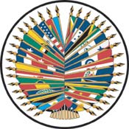
Secretariat for External Relations / Department of International Affairs
Inter-American Commission of Women

XXII OAS POLICY ROUNDTABLE
To launch the
Inter-American Year of Women:
Women and Power: for a World with Equality
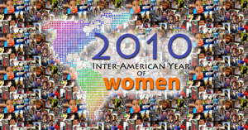
Thursday, February 25, 2010
3:00 pm - 5:30 pm
Hall of the Americas
17th Street and Constitution Ave. NW
Washington, DC 20006

3:00-3:20 pm Welcoming remarks by José Miguel Insulza, Secretary General, Organization of American States (OAS) and Wanda Jones, President of the Inter-American Commission of Women (IACW)

3:20-4: 45 pm Discussion panel moderated by Irene Klinger, Director, Department of International Affairs, Secretariat for External Relations, OAS:
Line Bareiro, Academic and Researcher - Centro de Documentación y Estudios de Paraguay
Irene Sandiford Garner, Senator – Office of the Prime Minister- Minister of State of Barbados
Cecilia López Montaño, Senator of the Colombian Congress
Otilia Lux de Cotí, Congresswoman - Guatemalan Congress
Patricia Mercado, former candidate to the Presidency of Mexico and President of Partido Alternativa Socialdemócrata
Jan Schakowsky, Representative (D-IL), United States House of Representatives (TBC)

4:45-5:15pm Question and answer session

5:15-5:30 pm Concluding remarks by Ambassador Carmen Moreno, Executive Secretary, Inter-American Commission of Women (IACW), OAS

Please RSVP by clicking on this link or sending an e-mail to SER-DIA@oas.org

