environmental impact assessment:
Application of Scientific tools

The previous Course D covered the terminology and procedural requirements for project-related environmental impact assessment (EIA). This course will detail some of the scientific tools that are commonly used in the implementation of an EIA. A hypothetical example of a pulp and paper mill in the Mekong River Basin (MRB) is used throughout to illustrate some practical EIA techniques, such as environmental monitoring, ecological risk assessment (ERA), and environmental modeling.

Introduction
Our hypothetical pulp and paper mill is an existing facility located in Cambodia on the banks of the Mekong River (Figure 1). The KL pulp and paper mill began operations in 1978, producing bleached paper products. The mill is situated on the river bank about 10 km upstream of two villages, and is surrounded by sub-tropical forest. The total area of the mill site is about 47 hectares. Daily mill production is estimated at about 470 to 484 air dried metric tonnes (admt)/day. The mill discharges between 5,900 and 10,000 m³/day of effluent into the Mekong River. A number of wildlife species including otter, several species of raptors and diving ducks reside in the study area. The KL mill is not the only industry in this reach of the river; a commercial fish aquaculture operation is located approximately 2 km upstream.
The owners of the KL mill have decided to increase pulp and paper production and propose to expand their mill into nearby agricultural and forested areas. The mill expansion will give rise to adverse environmental impacts. These impacts should be identified prior to construction to prevent and mitigate adverse effects when possible and to fully account for further irreversible loss of natural resources.

Socio-Economic Setting
The village closest to the KL mill is located on the east bank of the river approximately 10 km downstream A second village is located about 2 km further downstream on the west bank of the Mekong River. The combined population of both villages is about 4,000 people. The local people fish in the river year-round and plant a dry-season rice crop in the river floodplain. They also depend on the river for drinking and irrigation water. Average household size is six persons. Traditional fishing is the most important source of protein; some fish is sold at markets downriver, but most fish caught is for household consumption.
Villagers use the nearby forest for fuel and other purposes. The forest and the wildlife within it are of great cultural significance to the people.

Figure 1 Setting for hypothetical KL pulp and paper mill on the Mekong River
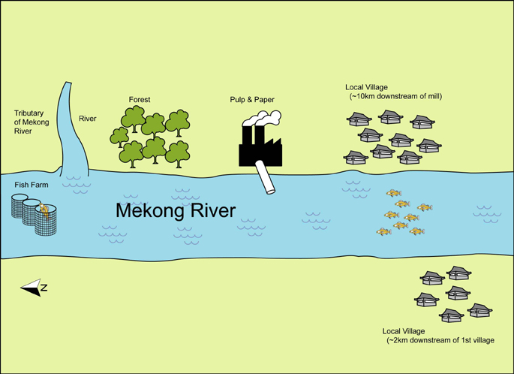

Aquatic Ecology
The waters that flow past the mill are high in nutrients and ammonia from the fish aquaculture operation, despite the influx of fresh water from the tributaries that flow into the river. The mill effluent and the river have not been regularly monitored. It is believed that the effluent contains fibrous particles, with a high pH and is relatively high in dioxins. Historically, the river was rich with diverse fish species, with catfish and carp being the most important for human consumption. Effluent-related effects on fish populations are suspected, but no studies have been undertaken. The biology and migration patterns of local fish species have not been carefully studied, but local knowledge confirms reductions in fish catches since the KL mill began operations.

Potential Impacts
The hypothetical KL mill example will highlight several environmental aspects which will be impacted through expansion of the mill: forests, air quality, and freshwater environments. Baseline studies should be performed to discover existing conditions and to aid in determination of the significance of the impacts. Environmental impacts which may arise with the mill expansion are summarized in the following sections.

Forests
- Deforestation
- Biodiversity and habitat loss
- Development of monoculture plantations if a portion of the site is reforested
- Loss of carbon fixing species
- Soil erosion
- Disturbances in soil nutrient and organic matter balances
- Disturbance in water balance
- Local wood becoming scarce and competition with fuel wood
- Potential archeological sites destroyed

Atmospheric
- Increased air emissions such as greenhouse gases further aggravating climate change
- Ozone depletion
- Toxic releases (acid rain)
- Particles and dust
- Noise
- Odour

Freshwater
- Discharges containing high levels of biochemical oxygen demand, suspended solids and organochlorines into the river
- Fish habitat could be altered through the addition of more wood debris and changes in flow of the river, and from heavy sedimentation during land clearing and site expansion
- Effluents causing chronic or acute toxicity to aquatic biota from chemicals such as sulphate, dioxins, cholorinated organic compounds
- Potential contamination of groundwater, drinking water and irrigation water
- Chemical spills and contamination, toxic releases from landfill wastes
- Solid and hazardous waste (e.g., dioxin, waste bark, sludge)
The KL pulp and paper mill discharges over 25,000 liters of waste water into the river for every air dried tonne of pulp produced. The amount of waste water is expected to increase with the expansion of the mill. Currently the liquid effluent is comprised of both organic and inorganic substances, as well as soluble and insoluble material. While some of this soluble material is removed as sludge, the majority enters the receiving water environment as particles and suspended solids. This material creates fibre mats and reduces sunlight penetration, which affects both the benthic community and fish habitat.
The liquid effluent from the mill also contains chlorinated organics. Bacterial breakdown and oxidation of chemicals result in depletion of dissolved oxygen available for aquatic life and high biochemical oxygen demand (BOD). The chlorinated organics include absorbable organic halogens (AOX) that are absorbed by active carbon such as dioxins and furans, and residual organic compounds that may act as nutrients. Dioxins tend to bioconcentrate from water to aquatic animal tissue and then biomagnify up the food chain. All of these parameters and their associated impacts on the receiving environment will increase with the higher effluent discharge volumes that will accompany the mill expansion.

Socio-Economic
- Land tenure or traditional rights, forest dweller’s needs, traditional land ownership patterns and agriculture practices not met
- Displacement of villagers due to insufficient fish harvests
- Potential for new jobs
- May stimulate local economic and infrastructure growth
With the expansion and construction of our hypothetical mill, noise, particles and dust being released to the environment are concerns for nearby villagers in the short-term. Forests will be logged, roads built, and local traffic will increase. If the mill is upgraded and fitted with air scrubbers, many of the process gases will be eliminated.
While the some of the local people are excited by the potential of new jobs and the influx of money to improve local infrastructure and schools, villagers are concerned about the possibility of displacement due to loss of traditional lands and fuelwood, as well as decreased fish supplies.

Next Steps
The scenario developed above for our hypothetical KL pulp and paper mill expansion will be expanded in the following lessons as we explore the application of selected EIA scientific tools.

