DEFINING THE ENVIRONMENT OF
THE MEKONG RIVER BASIN¹

How should we define ‘environment’, ‘ecosystems’ and ‘ecological processes’? We commonly refer to the natural environment as something outside of our particular system (i.e., outside of human social systems). The natural environment comprises air, water, minerals, solar energy, plants and animals that support human existence. Populations of plants and animals within a particular habitat and their interactions with the air, water, minerals, and solar energy are natural communities known as ecosystems.
Ecological processes cleanse air and water, determine climate and weather patterns, and enable ecosystems to regenerate.
Ecosystems evolve over time and involve several distinct stages of development. Each system is separate but influences and is influenced by other larger and smaller ecosystems. Together, the numerous ecosystems of the earth and the interactions among them make up the biosphere.
The ecosystems within the Mekong River Basin (MRB) include riparian habitats along the riverbank, intermittently flooded delta, mangrove swamps and coastal areas, and forests which are home to an incredible number and variety of species. The riparian countries of the MRB are China (PRC), Myanmar, Lao PDR, Thailand, Cambodia and Vietnam. China’s Yunnan province and Myanmar constitute the Upper Mekong Basin while the Lower Mekong Basin (LMB) comprises Lao PDR, Thailand, Cambodia and Vietnam as shown in Figure1.
Seven distinct landforms have been characterized in the MRB:
- Lancang River Basin, Yunnan
- Northern Highlands (Lao PDR, Myanmar, Thailand
- Korat and Sakon Plateaux (Thailand)
- Eastern Highlands (Lao PDR, Vietnam)
- Southern Uplands (Cambodia)
- Lowlands (Cambodia, Lao PDR, Vietnam)
- Coastal Area (Vietnam, Cambodia).
These areas are further divided up into a patchwork of sub-basins and watersheds.

Hydrology of the Mekong River Basin
Hydrologic conditions, or the cycle of water inflows and outflows within the MRB, are extremely important for the maintenance of the Basin’s structure and function. Basin hydrology affects the type and abundance of wildlife and plant species, the availability of nutrients to the system as a whole and its productive capacity. Even though the hydroperiod of the Basin has dramatic seasonal and year-to-year

¹Information provided in this lesson text is extracted in part from the MRC (1997).

fluctuations, it remains the major determinant of ecosystem functions. Figure 2 illustrates the major components and their pathways of the Basin’s hydrology.
The Mekong River originates in the Tangula Shan Mountains located on the edge of the Tibetan plateau. At 4,880 km in length, the Mekong is the longest river in Southeast Asia and is the 12th longest river in the world. The MRB comprises a catchment area of approximately 795,000 km² making it the 21st largest river basin in the world. Total run-off from the basin is 475,000 million m³ annually; the 8th highest river run-off in the world.
Flow contributions from MRB riparian countries vary widely depending on catchment area. Lao PDR contributes the highest flow at 35% of total flow from a catchment area constituting 25% of the total Basin. In comparison, Myanmar contributes only 2% of total flow from a catchment area of 3%.
Surface water flows in the Mekong River are largely driven by climatic conditions occurring during the wet and dry monsoon seasons. Large differences in flow levels in the river are apparent between seasons, particularly in downstream sections of the river.
Elevated water levels in the Mekong River generally occur from September to November, with low water levels occurring from February to March. The flood season extends from June to December when approximately 85-90% of total annual discharge occurs.
Peak flows are observed in September, accounting for 25-30% of total annual discharge. In comparison, monthly flows during the dry season account for only 1-2% of total annual flow.

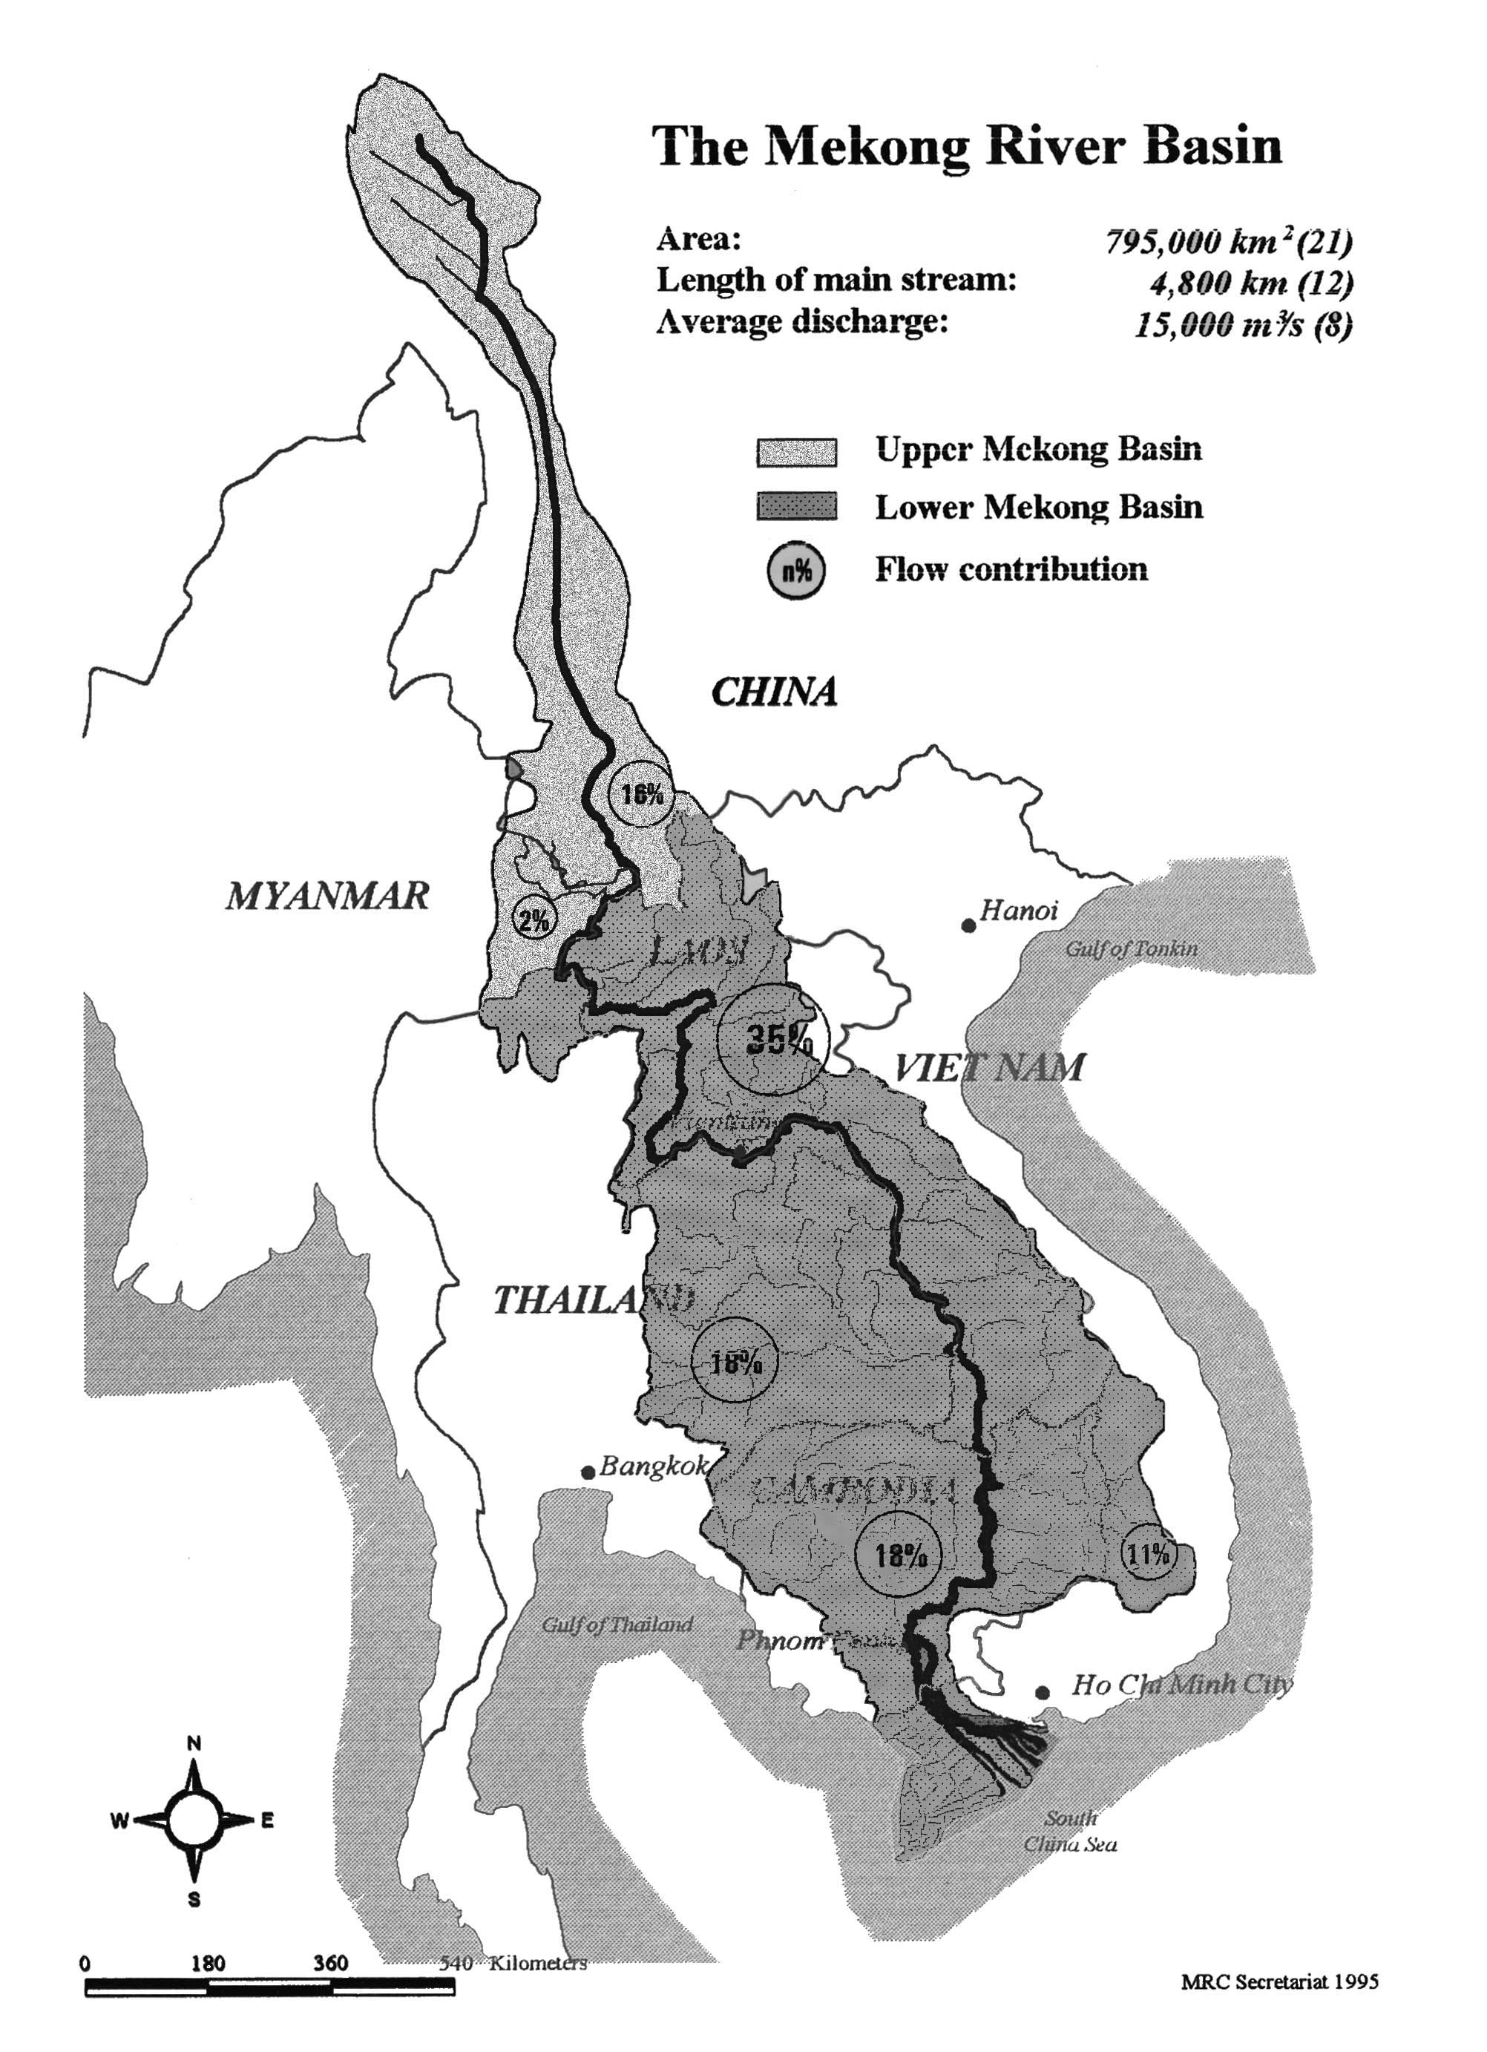
Figure 1 The Mekong River Basin

Floods annually inundate large areas of southern Cambodia and Vietnam - approximately 30,000 km² of the Basin below the Great Lake and confluence of the Mekong and Tonle Sap rivers at Phnom Penh.
The Great Lake and Tonle Sap River act as natural flood regulators in the LMB by decreasing the flood peak at the onset of the flood season and by increasing flow during the dry season. During the flood season, high flows in the Mekong River cause a reversal of the flow in the Tonle Sap River resulting in large increases in volume in the Great Lake and inundation of its surrounding swamp forests.

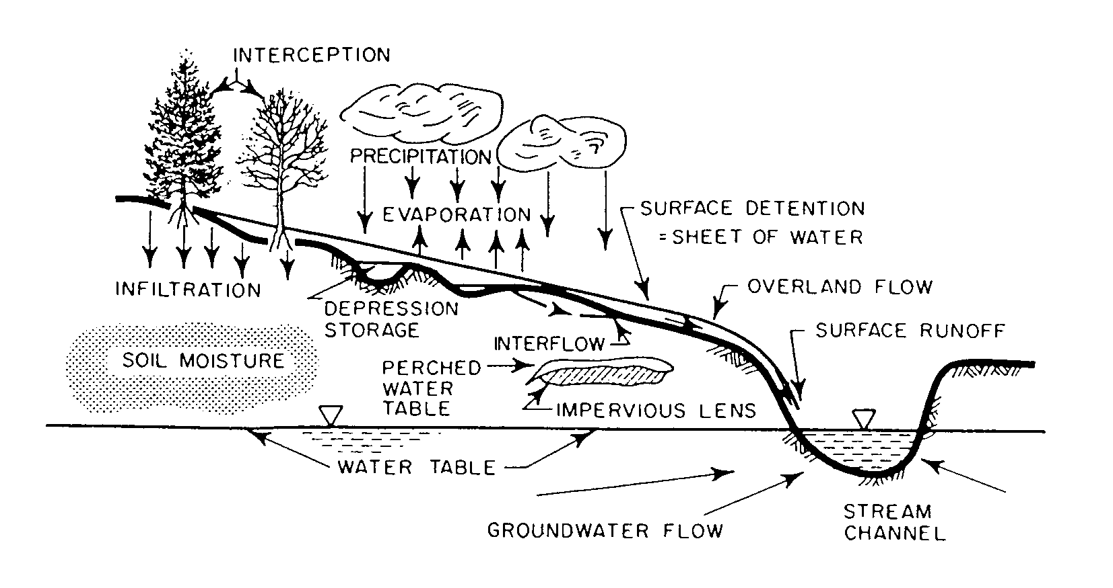
Figure 2 Conceptual model of the hydrologic cycle: major components and their pathways

During the dry season, the Great Lake discharges into the Tonle Sap River, which drains into the Mekong River and supplements low flows in the Mekong by approximately 16%.
Positive effects of flooding include the enrichment of agricultural lands through the deposition of alluvial sediments and enhancement of fisheries (e.g., the flooded forests of the Great Lake are very important as fish spawning grounds).
The Mekong’s hydrology is subject to natural changes in precipitation which can cause either drought or flooding in some riparian countries (e.g., the present drought in Thailand which is affecting irrigation and urban water supply). Undesirable flash flooding also occurs in the Basin with Cambodia and low-lying flood-prone areas of southern Vietnam being most vulnerable to severe floods.

Ecological Resources
of the MRB
The MRB is home to thousands of species of rare and endangered plants and animals. The richness and variety of ecosystems within the watershed are among some of the highest in the world. These ecosystems are vulnerable and under severe pressure as the population and industrialization of the Basin increase. Ecological resources currently at risk include:
- Terrestrial Flora
- Terrestrial Fauna
- Aquatic Fauna
- Wetlands
- Special Ecosystems (The Great Lake, the Tonle Sap and the Plain of Reeds)
- Biodiversity and Endangered Species.

Terrestrial Flora
Terrestrial forest types within the Basin include monsoon forests, lowland evergreen forests, montane, and mixed coniferous forests and sub-alpine forests.
Terrestrial ecosystems in the Basin are being degraded as forest coverage, which supports much of the biodiversity, declines. Commercial logging, fuelwood collection, expanding agriculture and war have all contributed to loss of forest area within the Basin. Forest cover has declined most significantly in the LMB, with remaining coverage estimated at only 27% of land area.
In addition to declines in overall forest coverage, many remaining forest areas are of comparatively poor quality, with reduced biomass density and availability of commercial timber (e.g., in Lao PDR, it is estimated that only 10% of the remaining forest areas are commercially viable).
High-grading practices involving selective cutting of high-value species for export contribute to the decline of high-density forest. Improved access to remote areas via logging roads leads to further logging (often illegal) of remaining marginal species.
There is a lack of reliable information on the quantity and quality of remaining forested areas in the MRB. Problems in estimating coverage of productive forested areas include:
- Lack of uniformity in classification system where land classified as ‘forest’ may be shrubland of little ecological or economic value. Monoculture forest (e.g., Eucalyptus) is classified as forest but offers minimal ecological value; supporting low biodiversity.
- Illegal and unmonitored logging in remote areas leads to inaccuracies in official estimates of forest coverage.
- Expense of using modern assessment technologies such as remote sensing to complete accurate forest inventories. Access to remote locations also complicates the task of ground-truthing to confirm forest type.

Terrestrial Fauna
The MRB supports numerous populations and high terrestrial fauna species diversity. Although data are limited for remote areas of the Basin, a Mekong River Commission (MRC) survey indicated that at least 212 species of mammals, 696 species of bird and 213 species of reptiles and amphibians are present, with new species being discovered every year.
Wildlife populations in the MRB are increasingly under pressure and are being adversely affected by development activities and unsustainable hunting. Capture of many animals for domestic consumption, medicinal purposes and for export markets represents a serious threat to populations and biodiversity in the Basin.

Aquatic Fauna
The MRB supports significant aquatic fauna in terms of species composition and diversity. An estimated 1,300 species of fish are distributed throughout a variety of habitats found in the Basin (Jensen, 2000).
Distinct habitat types used by different fish species during their life cycles are:
- The estuarine zone of the Mekong River Delta which supports both resident species and diadromous species which seasonally migrate upstream to spawn in brackish or freshwater habitats.
- Upstream waters of the Mekong River support many freshwater species (e.g., Cyprinidae, Siluridae, Claridae).
- Inland water tributaries of the Mekong River in northeast Thailand, Lao PDR and wetlands in Cambodia represent important breeding and nursery habitats for numerous fish species including many ecologically and economically important species.
Shrimp species found in the Mekong River include the freshwater giant prawn (Macrobrachium rosenvergii) which migrate from freshwater to brackish and estuarine waters to spawn. Other species also spawn in estuarine waters of the Mekong River during the March to August period. Harvesting of shrimp is an increasingly important economic activity in the MRB, especially for the export market.
Limited data is available on fisheries populations in the MRB, making it difficult to assess impacts of harvest pressures or habitat destruction and degradation from development activities.

Wetlands
Wetlands comprise a wide variety of permanently and temporarily wetted areas such as coastal foreshore, tidal and subtidal zones, estuarine marsh, river channels and tributaries, wetted rice fields, flooded crops, natural lakes, and man-made reservoirs. Dominant wetland habitats in the MRB are shallow lakes, ponds and swamps which are filled with rainfall or flooded either permanently or seasonally.
Wetland habitats of greatest ecological importance in the MRB are:
- The Great Lake and Tonle Sap system in Cambodia
- The Plain of Reeds in Cambodia and Vietnam
- Melaleuca leucadendron forests in Vietnam
- The Chi and Mun River systems in Thailand
- The Mekong Delta.
Wetland functions include: water storage; storm protection and flood mitigation; shoreline stabilization and erosion control; groundwater recharge; groundwater discharge; retention of nutrients and sediments; and stabilization of local climatic conditions, particularly rainfall and temperature.
Wetlands provide highly productive spawning and nursery habitat for a wide variety of aquatic and terrestrial populations in the MRB – supporting ecologically and economically important fish and crustacean populations which are a major protein source for humans in riparian countries. Wetland foodchains also support rare and endangered mammals, reptiles, amphibians, and resident and migratory birds.

The Great Lake and Tonle Sap River
This ecosystem is of high significance both ecologically and economically in the MRB.
The flooded forest surrounding the Great Lake is critical to the system’s biological productivity. Development pressures on the forest for the production of fuelwood and charcoal and conversion to agricultural land are of high concern.
Temporal comparisons of remote sensing data indicate that forest cover has been significantly reduced in the last 20-30 years; from approximately 1 million hectares to 361,700 hectares of flooded forest and 157,200 hectares of degraded forest and associated vegetation.
The unique hydrology of the system makes it extremely important for a large number of resident and migratory fish species. About 40 commercially-important species depend on the system. Recruitment from the system supports fisheries in the Mekong River as far upstream as Yunnan province in China.
Over-exploitation of fish from the Lake, widespread use of destructive harvesting methods, and loss and degradation of habitat are likely all contributing to observed reduced capture rates for several species and a predominance of smaller size classes. Inadequate recruitment rates for some species (e.g., large river carp, Catlacarpio siamensis) raise concerns of irreversible population declines.
The system also provides a refuge for a wide variety of birds. Several breeding colonies of large water birds use the system, including some endangered species which are believed to use the areas as breeding grounds (e.g., the Eastern Saurus crane, Grus antigone sharpii).

The Plain of Reeds
The Plain of Reeds is a transboundary ecosystem, covering approximately 700,000 hectares in Vietnam and 300,000 hectares in Cambodia. The area is predominantly flat lowlands which are subject to seasonal flooding with vast areas being inundated from July through January. During the dry season, the Plain almost completely dries out with the exception of scattered ponds and swamps.
Highly productive agricultural, forestry and fisheries resources are supported by this system. The Plain supports a complex assortment of flora including submergent, emergent and floating plants, large grassland communities and scattered forest (e.g., Melaleuca forests) and woodlands. Biodiversity is high with these habitats supporting many fish and bird species while providing a number of valuable products such as timber, fuelwood, capejut oil, and honey.
During the flood season, the Plain supports a large number of fish species which migrate from upstream areas to spawn and rear. Some species such as the shrimp Macrobrachium represent an important fishery which is harvested in large quantities at the end of the wet season.
The Plain also supports many water birds including some endangered winter migratory species such as the Eastern Saurus crane, which are attracted by the rich feeding habitat.
Conservation and development issues are complicated by the high acid sulphate soils found in large parts of the Plain. Important development activities such as treatment of moderately acid-sulphate soils and water diversion from the Mekong River to drain low pH water when flood waters recede combined with construction of raised beds to plant crops have allowed a rapid increase in rice production in the Vietnamese area of the Plain. However, these must be balanced with conservation of severely acid-sulphate soils and maintenance of the natural flooding regime to maintain forest cover to ensure that biodiversity is maintained.

Coastal Ecosystems
The Mekong Delta coastline is about 650 km in length, of which 350 km borders the South China Sea and 300 km borders the Gulf of Thailand.
The South China Sea coastline is characterized by nine large river estuaries, sand dunes, tidal marsh and mangrove forests.
The Gulf of Thailand coastline is divided into two distinct segments: the first consisting of large tidal marshes and rich mangrove forests with the second consisting of poor mangrove, narrow tidal marsh and some minor uplands.
Estuaries of the Mekong Delta are particularly important in supporting many shrimp and fish species which depend on the rich habitat and abundant food for spawning and rearing. The life cycles of many economically-important shrimp species depend closely on environmental conditions in the estuaries where spawning takes place in shallow coastal waters with larvae moving with the tides to sheltered brackish water areas to grow before returning to the sea on reaching maturity. These species are vulnerable to biological, chemical and physical disturbance in the estuary ecosystem.
The total current area of mangrove forests of the MRB is estimated to be 120,000 ha. Coastal mangrove habitats are critical as breeding and nursery areas for a variety of fish, crab and shrimp species. They also support a number of insects and aquatic organisms that nourish numerous species of fish, birds, reptiles and amphibians.
Coastal forest ecosystems serve as natural barriers to the erosive effects of wave action on the shoreline. An important consequence of the loss of wetland and coastal forest ecosystems is the rapid erosion of shorelines, with resulting impacts on coastal communities and agricultural activities. Increasing populations in the coastal zone with accompanying aquaculture and agriculture activities and urban and industrial development has led to the accelerating destruction of mangrove wetlands and coastal forests.

Biodiversity
All countries in the MRB have high biodiversity. Taken together, MRB riparian countries support thousands of fauna and flora species which are unique to the region.
Cambodia is considered to have the best preserved biodiversity and richest wetland system, containing mammals and bird species extirpated from other MRB countries. Lao PDR ranks second, despite having lower species diversity, due to the large untouched areas of the country. Thailand ranks third due to its small pockets where extremely high biodiversity is found. Vietnam also supports moderately high biodiversity, particularly in it’s southern wetlands and remote forests in the Central Highlands.
Areas with the richest biodiversity are generally located along country borders, reflecting their inaccessibility and remoteness. Biodiversity ‘hot spots’ include:
- The border triangle of Cambodia, Lao PDR, and Vietnam
- Along the Lao PDR and Vietnam border
- Along the Cambodia and Thai border
- The border quadrangle of Lao PDR, Myanmar, Thailand and Yunnan
- Along the Lao PDR and northeastern Thai border.
Data on biodiversity are often inaccurate or incomplete, complicating the task of determining the extent to which biodiversity has been impacted by human activities and economic development. Although exact numbers are not available, current information suggests that biodiversity throughout the Basin is declining. Biodiversity is increasingly threatened by:
- Habitat destruction caused by shifting cultivation, the spread of permanent agriculture and plantation forests
- Increased logging pressure on forests
- Indiscriminate and uncontrolled hunting both for food and trade in wildlife products
- Habitat fragmentation where incremental losses of habitat destroys migratory corridors or reduces the feeding range of terrestrial populations.
Table 1 includes a small sampling of species endemic to the MRB. The Endangered/Critically Endangered status listed for some species is based on available data (WCMC, 1997). Species termed Resident are known to be endemic to the region; the species is either not in danger or data may not exist to determine whether the species is in peril.

Table 1 Some representative animal species of the MRB
Animal | Common Name | Scientific Name | Status
Birds | Eastern Saurus crane  Greater adjutant  White-eared night heron  Asian dowitcher  Anhinga  Spot-billed pelican  Vietnamese pheasants | Grus antigone sharpei  Leptoptilos dubius  Gorsachius goisagi  Limnodromus semipalmatus  Anhinga melanogaster  Pelacanus philippensis  Lophura hatinhensis  Lophura imperialis | Endangered  Endangered  Critically endangered  Common (migratory)  Common (resident)  Vulnerable  Endangered  Endangered
Mammals | Great black squirrel  Dolphins  Finless porpoise  Macaque  Tonkin snub-nosed monkey  Kouprey | Ratufa bicolor  Delphinus spp.  Neophocaena phocaenoides  Macaca mulatta  Pygathrix avunculus  Bos sauveli | Resident  Resident  Resident  Resident  Critically Endangered  Critically Endangered
Reptiles | Python spp.  Monitor lizard  River terrapin  Estuarine crocodile  Water snakes | Python molurus  Python reticulatus  Varanus sp.  Batagur baska  Crocodylus porosus  Enhydris spp. | Resident  Resident  Resident  Endangered  Resident  Resident

