ANNEX 01 – Pictures – Trip to Brazil – Training of the Trainers Oct 2006
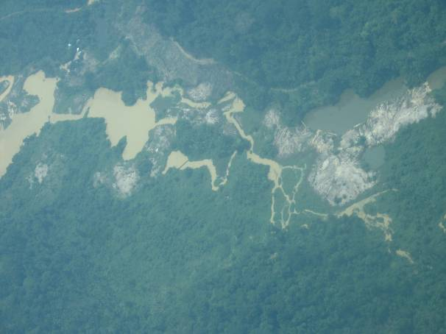

01 –Crepori river / siltation and mercury
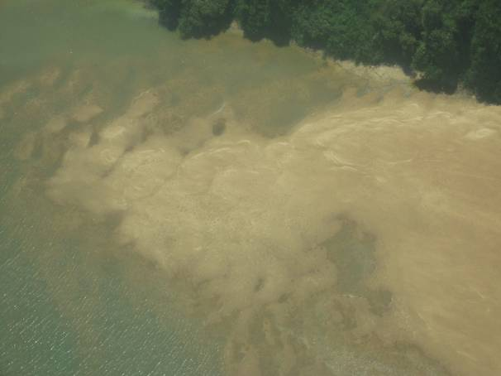

02 – Effects of siltation – Crepori river
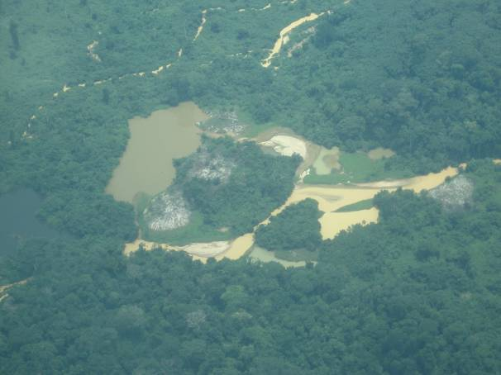

03 –Marupa river- siltation and mercury
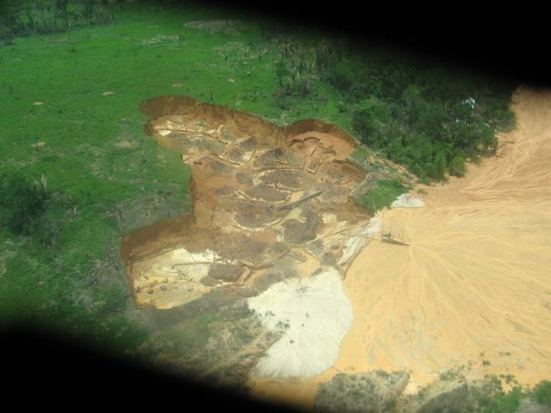

04 – Sediments released directly in the rivers
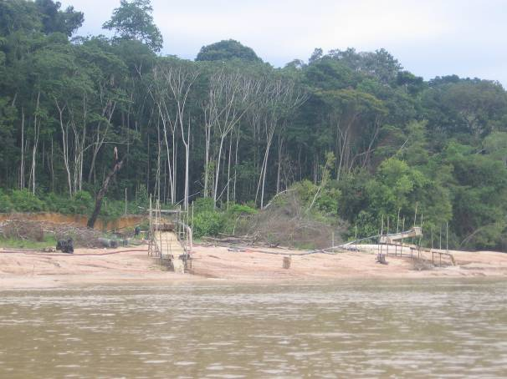

05 – Sediments released into the rivers
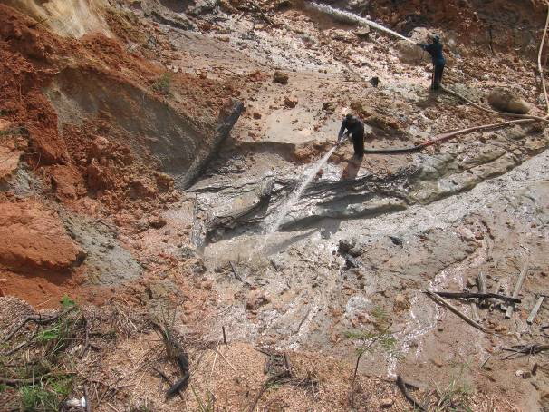

06 – Hydraulic pumps – effects on siltation

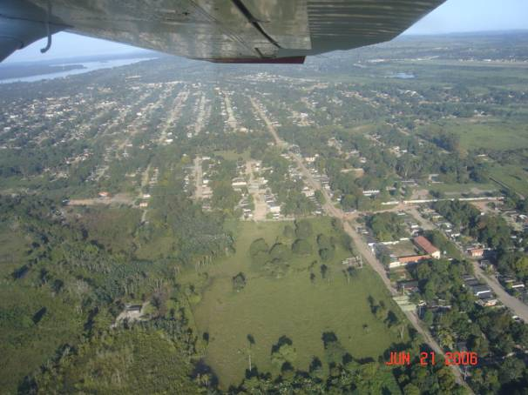

07 – City of Itaituba
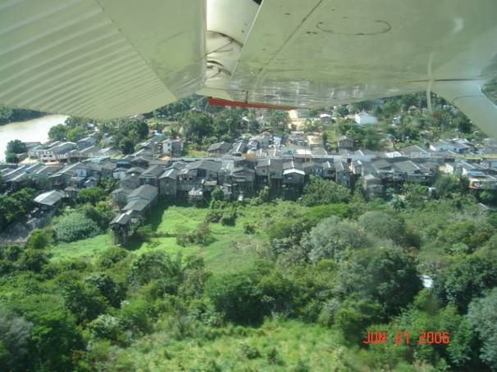

08 – Mining Community of Creporizao

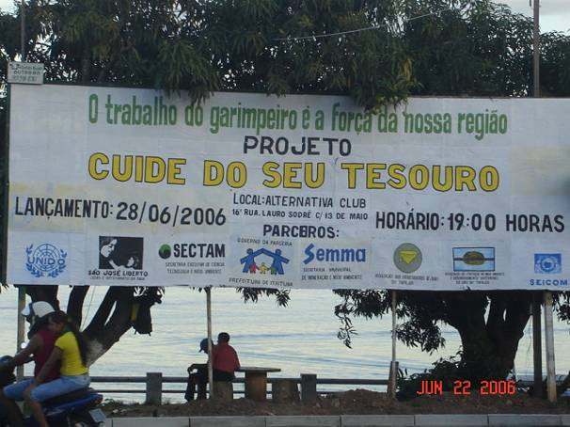

09 – Advertising campaigns - partnerships

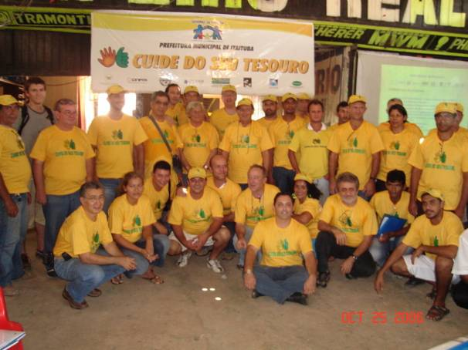
10 – Traineers & authorities, 60 participants

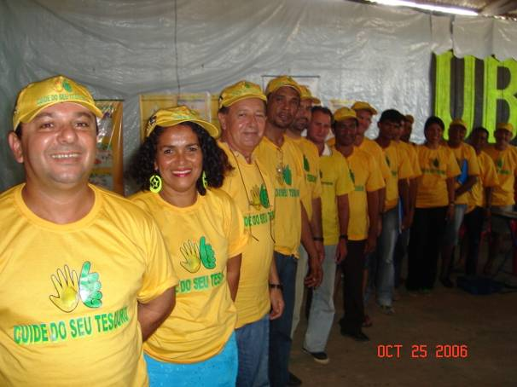

11 – Group of trainers or multipliers
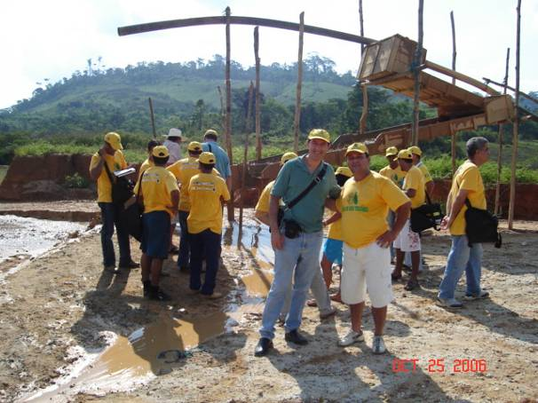

12 – Practical lessons in the field

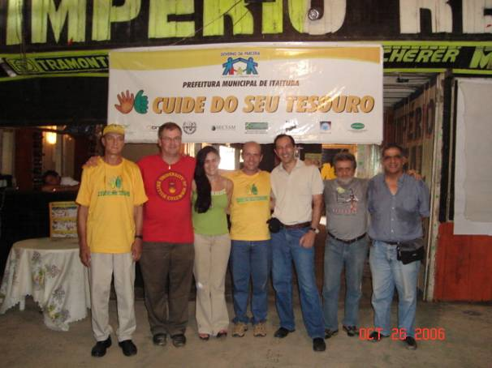
13 – Instructors and garimpo’s owners
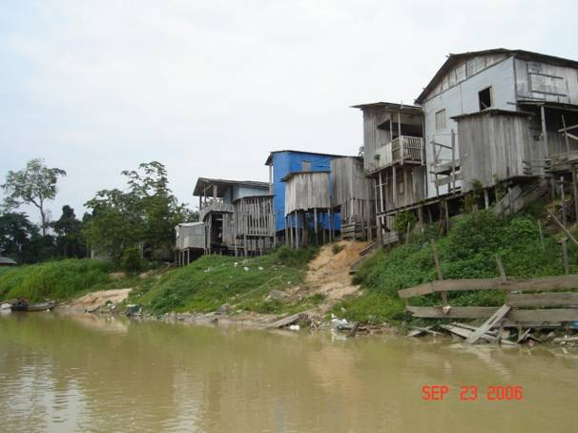

14 - Village of Cabacal –mining community
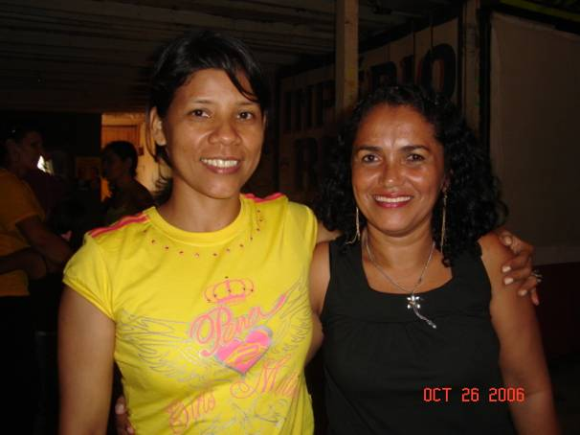

15 – Some trainers are women
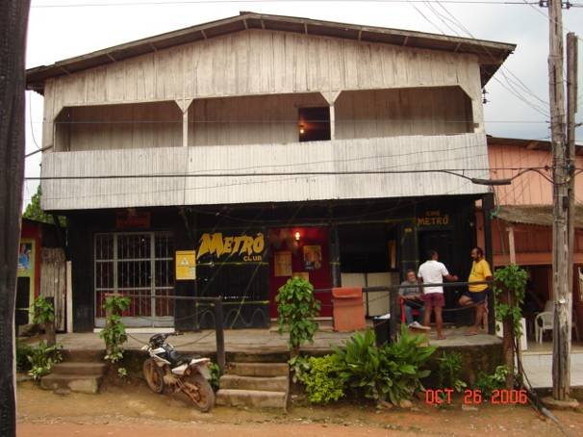

16 – Facilities for classes

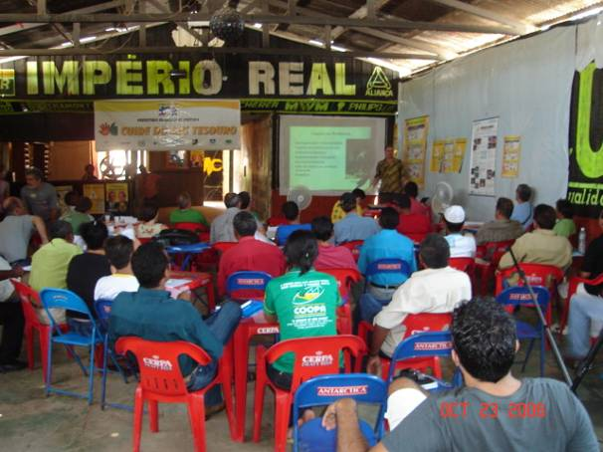
17 – Classes for TOT
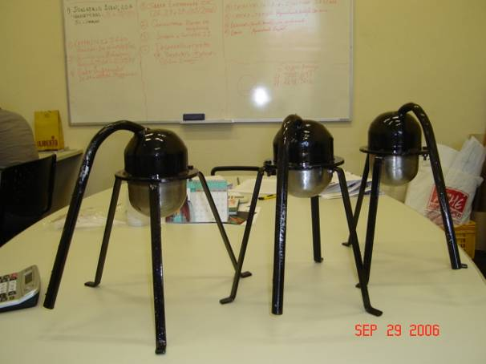

18 - 100 retorts like these will be donated

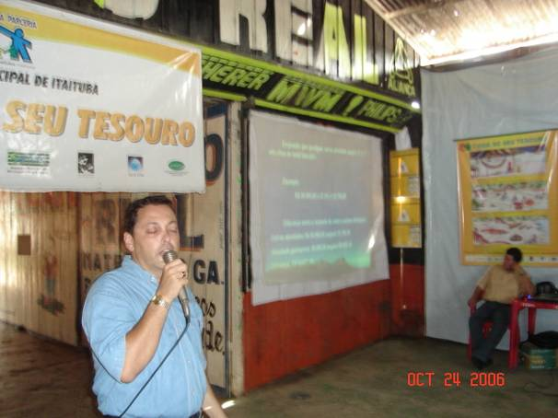
19 – Itaituba Mayor rep. Mr Dirceu Sobrinho

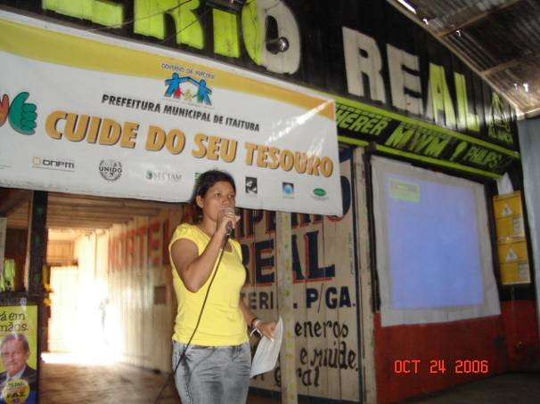
20 – Miners Association’s Pres. Mrs Jandira

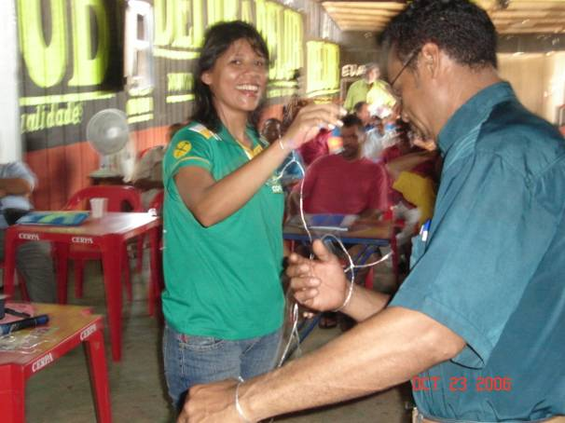
21 –Special activities to improve interactions

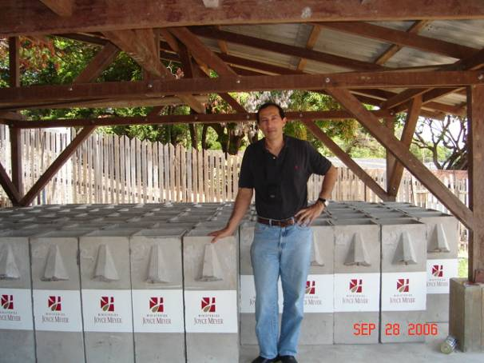
22 – Biosand filters to be tested in garimpos
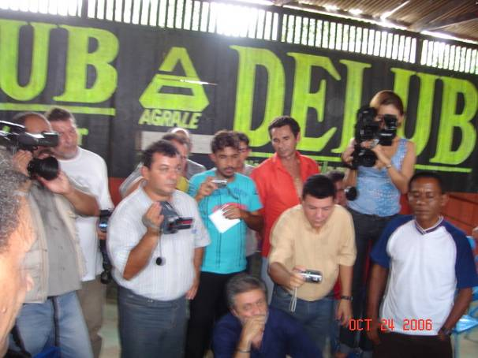

23 – Everything well documented

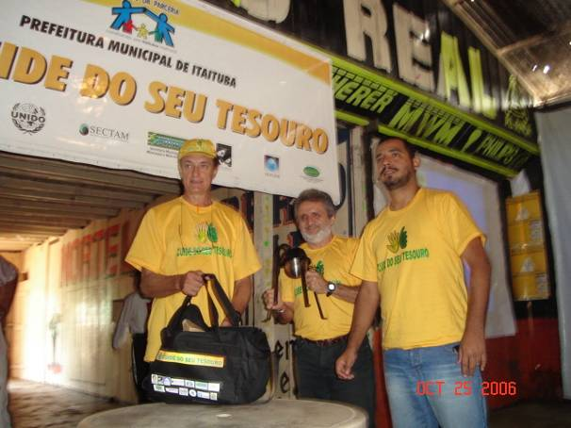
24 – Kits with T-shirts, retorts and bags

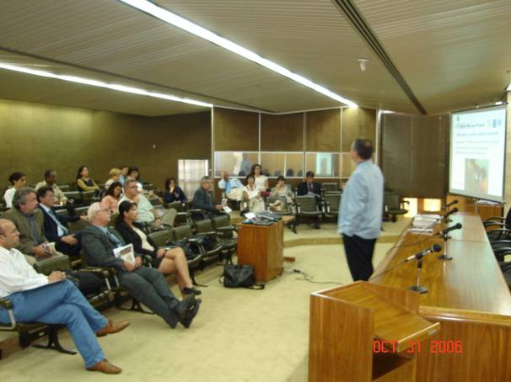
25 –Workshop with authorities in Brasilia

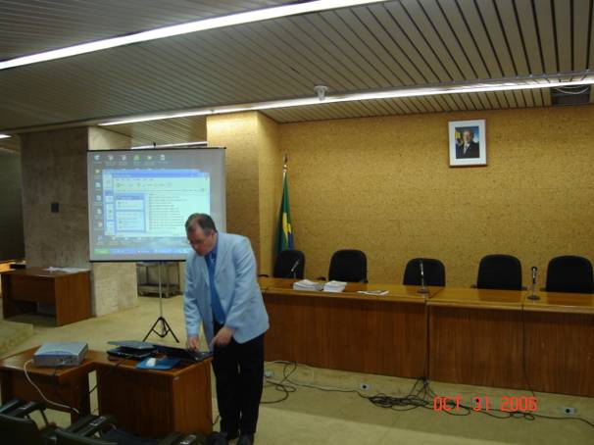
26 – Marcello’s lecture in Brasilia

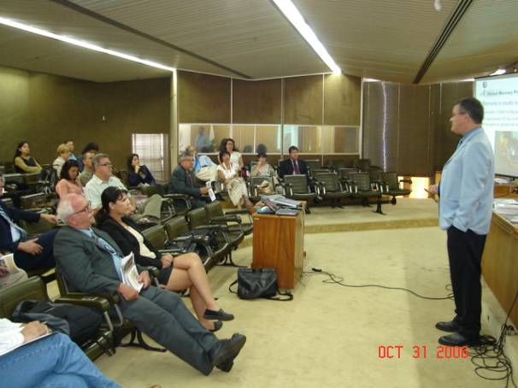
27 – Debate on environmental legislation

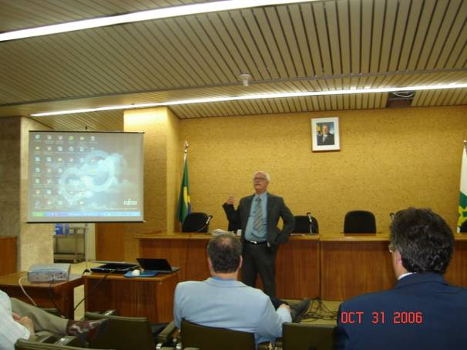
28 – Director Claudio Scliar opens meeting

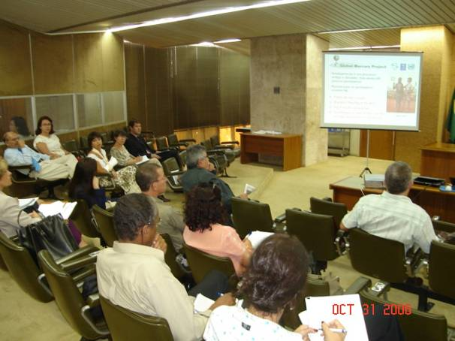
29 – Meeting organized by SGMMME
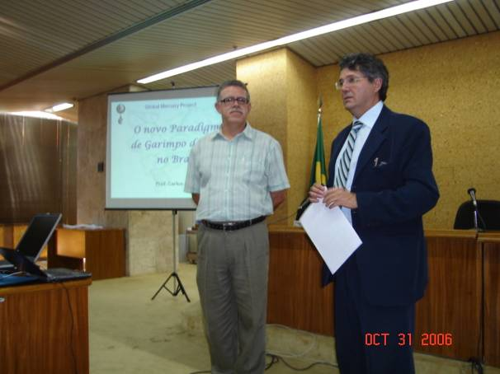

30 – Prof. Carlos shows Tapajos mapping

