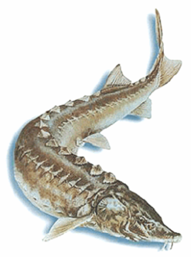
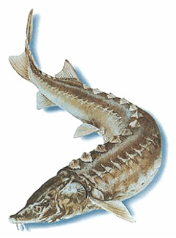
PRESS RELEASE

29 September 2005

The EU-TACIS Sustainable Management of Caspian Fisheries Project (SMCFP)*,
based in Baku, Azerbaijan, is planning to hold three workshops in Iran
between 8th and 16th October 2005.

Iranian National Fish Population Dynamics Workshop, Tehran. 8-9 Oct.
The first meeting is a national Fisheries Population Dynamics Workshop. Its purpose is to provide the Iranian scientists and administrators, mainly from the Iranian Fisheries Research Organisation in Tehran, with knowledge of additional stock assessment and fisheries management tools which might be of use in work on Caspian Sea fish stocks. Similar workshops have already been held in Baku for Azerbaijan scientists and in Almaty for Kazakhstan scientists. As in the earlier workshops, they will be led by project consultants, Dr Andy Payne and Dr Georgi Daskalov.

Regional Workshop on Assessing Stocks and Advancing Regional Sustainable Management Policies for Sturgeon. Ramsar. 10-13 Oct.
In this regional meeting it is hoped to develop the project from a general appraisal of regional knowledge and expertise, initially assessed during a regional meeting in Baku in October 2004, towards the common ground needed to consider regional approaches to stock assessment and management plans.

National scientists and managers from within the region, representing Azerbaijan, Kazakhstan, Russia, Turkmenistan and Iran, are expected to attend at SMCFP expense, alongside international personnel from CITES (the Convention on International Trade in Endangered Species of Wild Fauna and Flora) and FAO (the Food and Agriculture Organisation of the United Nations).

It is anticipated that progress made in Ramsar will be built upon for a final regional management meeting, possibly in Almaty, Kazakhstan, in February 2006.

The four day agenda includes Day 1, during which presentations of national and international views of progress to date will be made; Day 2 which will provide SMCFP staff with the opportunity to suggest ways forwards; and Day 3, which will be assigned to five working groups, each discussing an element of the complex issues of regional fisheries management and control. The final half day will be spent discussing and agreeing the reports from the working groups and the meeting’s key scientific outputs.

Fisheries Regional Advisory Group (FRAG). Tehran. 15-16 Oct.
The Fisheries Regional Advisory Group (FRAG) is an element of the UNDP Caspian Environment Programme, and is under the technical management of SMCFP, with CEP providing the Secretariat. This, the second meeting of the FRAG will be held in the CEP offices in Tehran, and will discuss the progress of SMCFP, the results of the Ramsar Workshop, and the direction of further fisheries activities in the region which this and other projects could usefully take.

Nationally appointed FRAG representatives from Azerbaijan, Kazakhstan, Russia, Turkmenistan and Iran have been invited to attend at SMCFP expense, and will be joined by CITES, FAO and WB/GEF (World Bank/Global Environment Facility) representatives.

*Note for Editors:
The Sustainable Management of Caspian Fisheries Project is funded by EU-TACIS. It started in June 2004 and will complete its activities in June 2006. The project is based in Baku, Azerbaijan. Its purpose is to enable the recovery and conservation of endangered fish stocks (especially sturgeon) in the Caspian Sea, through strengthening national capacities in fisheries research and management; helping develop regional management guidelines; and advising on regulatory systems. The project is executed by Landell Mills Limited, Trowbridge, UK.

For more information on the project, please contact
Dr Nick Willoughby,
Team Leader, SMCFP
Tel: +994 12 4971 785 / 4938 003
E-mail: nwilloughby@caspian.in-baku.com

