Caspian Environment Programme
CEP-SAP Project

Operational Monitoring of Anomalous Algae Bloom (AAB)
in the Southern Caspian Sea
using Remote Sensing Technique

This report was prepared by Dmytro Solovyov, Marine Hydrophysical Institute (MHI), Ukraine, in framework of the contract with the Caspian Environment Programme carried out in period August-September 2006.
Main activity was focused on organization of receiving and processing MODIS images for the Southern Caspian Sea in near real time. The processing of MODIS images includes Chl-a and WLR (Water Leaving Radiation) calculations. Near real time receiving and processing of the SST (Sea Surface Temperature) images for the Southern Caspian Sea were done.
The delivery of images to CEP PCU was organized through FTP exchange. Special ftp site was organized on MHI server DVS.NET.UA. Each day, after image receiving and processing, maps of the calculated parameters (WLR, Chl_a concentration and SST) were placed on the site with specific names. It allowed easy to download maps for CEP Web site. Screenshot of the AAB web page at the CEP Web Site is shown on the Fig 1.
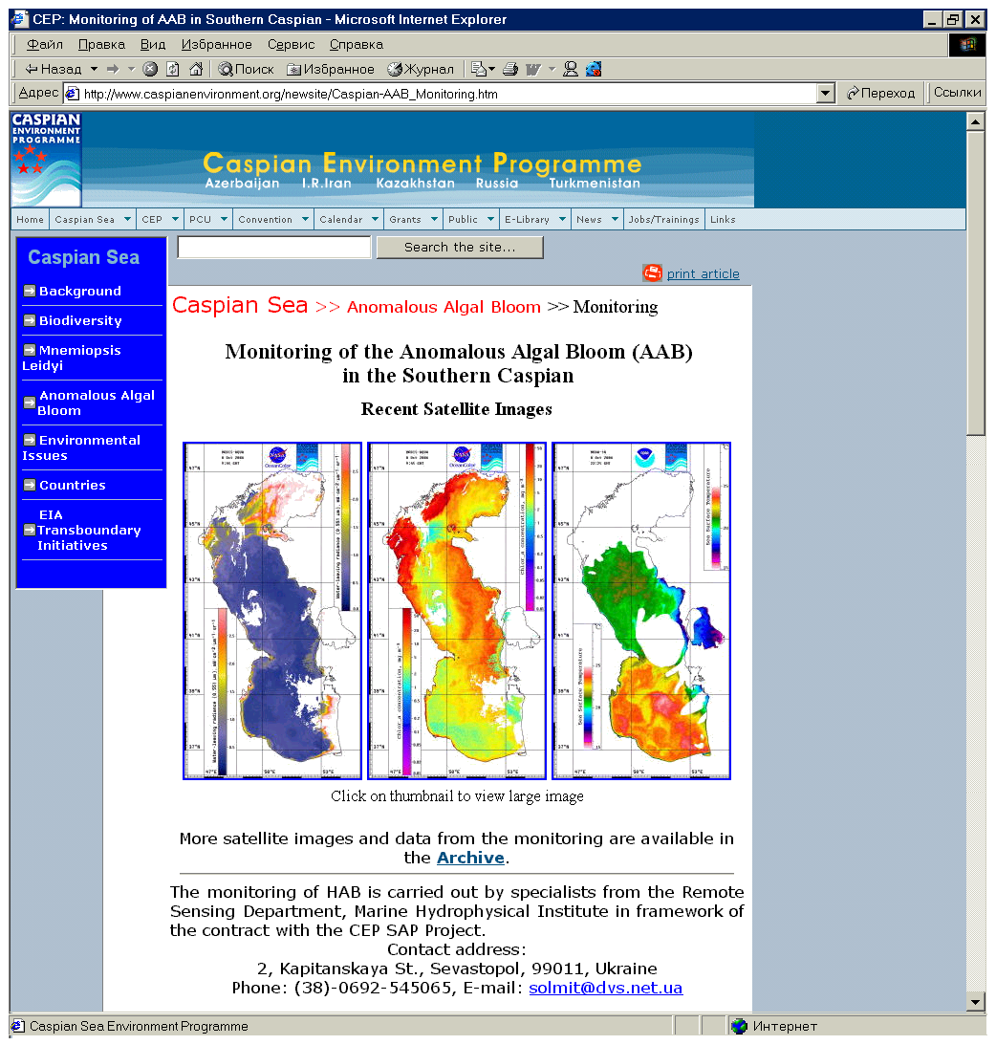
Fig 1. Sample of the CEP screenshot during monitoring period
List of received and processed SST and MODIS images
All cloud free MODIS Aqua and AVHRR data were processed for August – September 2006.
Totally 20 passes of the MODIS and 76 passes of the AVHRR were processed for August –September 2006. Samples of the calculated maps are presented on Fig 2. Dates and number of the processed images are presented in the Table 1. All maps were produced for the area 46-55E and 36-48N with spatial resolution 0.01 deg on latitude and 0.0143 deg on longitude.
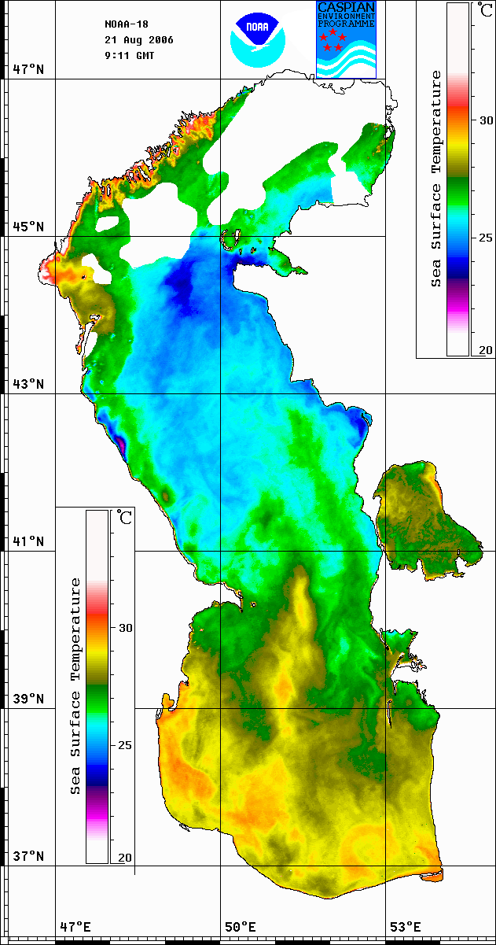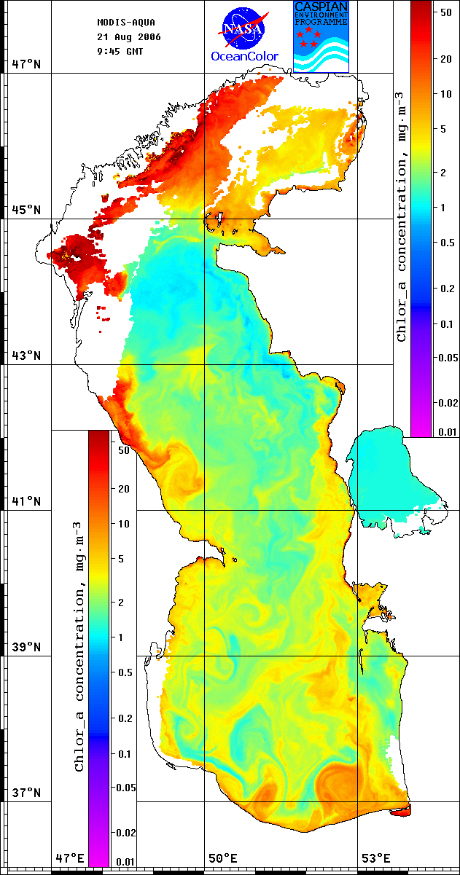
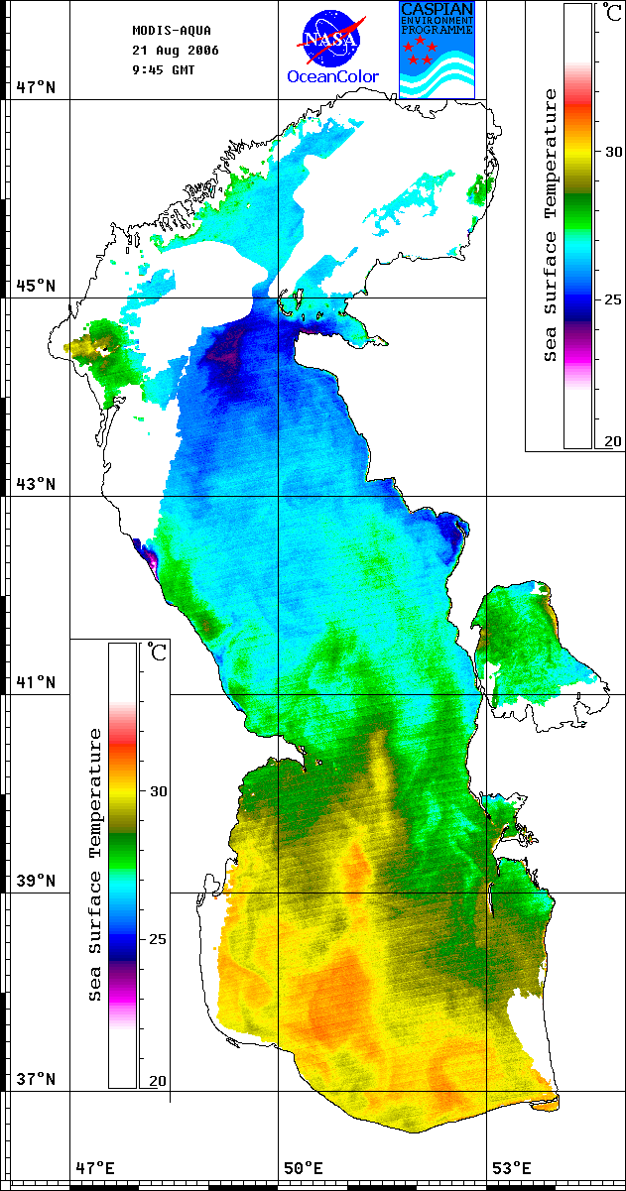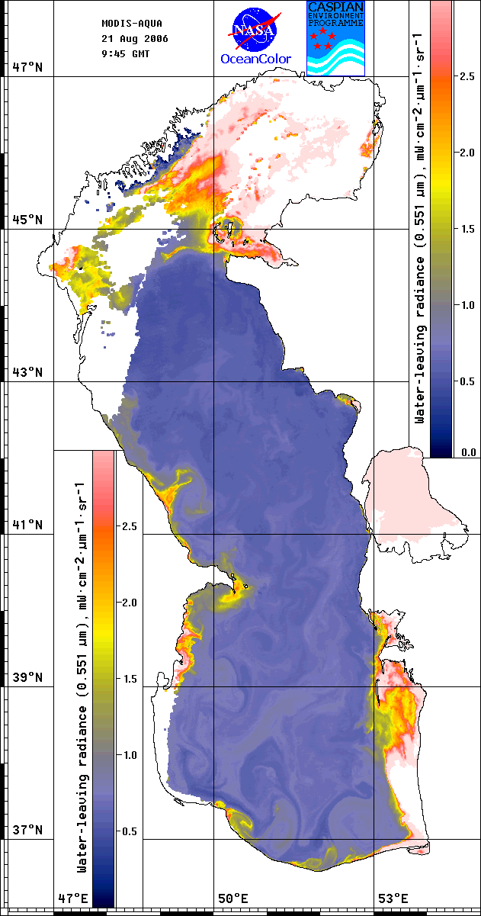

Fig 2. Samples of the SST, WLR and Chlorophyll a maps for August 21, 2006
Table 1. List of processed images in the frame of AAB monitoring
Date | NOAA daytime | NOAA nighttime | MODIS-AQUA
01.08.06 |  | +
02.08.06 | +
03.08.06 | +
04.08.06 |  | +
05.08.06 |  | +
06.08.06 |  | +
07.08.06 | +
08.08.06 | + | +
09.08.06 | +
10.08.06 |  | + | +
11.08.06 | + |  | +
12.08.06 |  | + | +
13.08.06 | + | +
14.08.06 | + | + | +
15.08.06 | +
16.08.06 | +
17.08.06 | + | + | +
18.08.06 | + | + | +
19.08.06 | + | + | +
20.08.06 | + | + | +
21.08.06 | + | + | +
22.08.06 | + | +
23.08.06 | +
24.08.06 | +
25.08.06 |  | +
26.08.06 |  | +
27.08.06 | +
28.08.06 | + | +
29.08.06 |  | +
31.08.06 | + | +
01.09.06 | + | +
02.09.06 | + | + | +
03.09.06 | + | +
04.09.06 | + | + | +
05.09.06 |  | +
06.09.06 |  | + | +
07.09.06 |  | +
08.09.06 | +
09.09.06 | +
10.09.06 | +
11.09.06 | +
12.09.06 | +
14.09.06 | +
15.09.06 | + |  | +
18.09.06 | + |  | +
19.09.06 | + | + | +
20.09.06 |  | + | +
21.09.06 |  | +
22.09.06 |  | + | +
23.09.06 | +
24.09.06 |  | + | +
25.09.06 | + | +
26.09.06 | +
27.09.06 |  | +
28.09.06 | + |  | +
29.09.06 | + | + | +
30.09.06 | + | +
Description of phenomena (events) observed in the Southern Caspian during the period of monitoring, paying attention on AAB event and its characteristics.
AAB was not observed in investigated area during August – September 2006. Fig 3 demonstrates Chlorophyll and WLR variation for the area 37-38N and 51-52E during period June 2005-September 2006. Well seen the absence of the significant changes in parameters for summer 2006. One of the reasons for AAB absence may be different in comparison with 2005 wind condition affected on the mixing of upper layer. Mixing intensity in the upper layer is proportional to wind velocity cube.
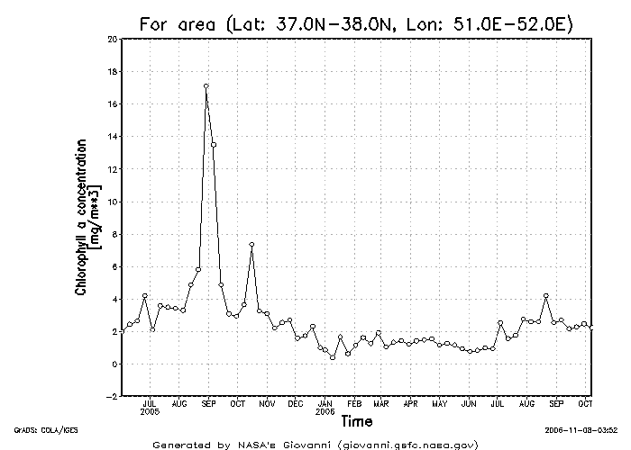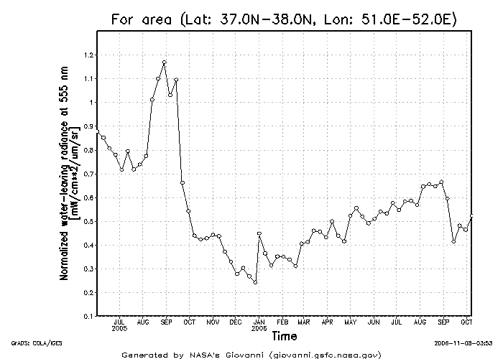
Fig 3. Time series of the Chlorophyll a concentration and WLR555.

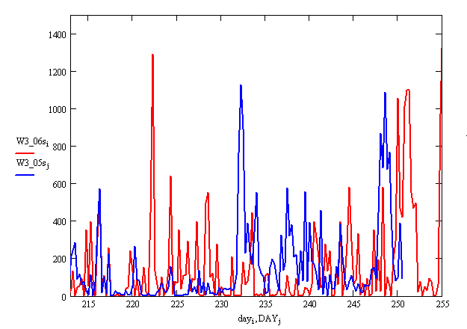
Fig 4. Time series of the cubed NCEP wind (m^3/s^3)for the point (38N,51E) vs day of the year, for 2005 – blue line, and for 2006 – red line.
Fig 4 demonstrates cubed NCEP wind time – series for 2005-2006 years. Interval between 213 and 231 days of 2005 was characterized by low values of V^3 and this induced appropriate for bloom conditions. Events with strong mixing were more frequent in 2006.
Fig 5. SST time series (averaged for area 31-32 N, 51-52E) for 2005 – red line and 2006 – blue line
SST (8 days mean) nighttime MODIS AQUA time series for 2005 and 2006 are presented on Fig 5.
All optical images well detect systems of the mesoscale eddies executed mixing processes in the area of study. Eddies structures are not clear mapped into the thermal images due to the heating of the upper layer.
Summary1
Regular SST, WLR and chlorophyll satellite monitoring did not detect AAB events in Southern Caspian. Possible reason of this is stronger wind mixing comparing to 2005 year.
Recommendation on improving the monitoring technique
There were gap in obtaining MODIS Aqua images of suitable quality due to the sun glitter effect. Such lost of the MODIS Aqua data can be compensated by processing Level 1 data of the MODIS Terra to be included into monitoring program.

