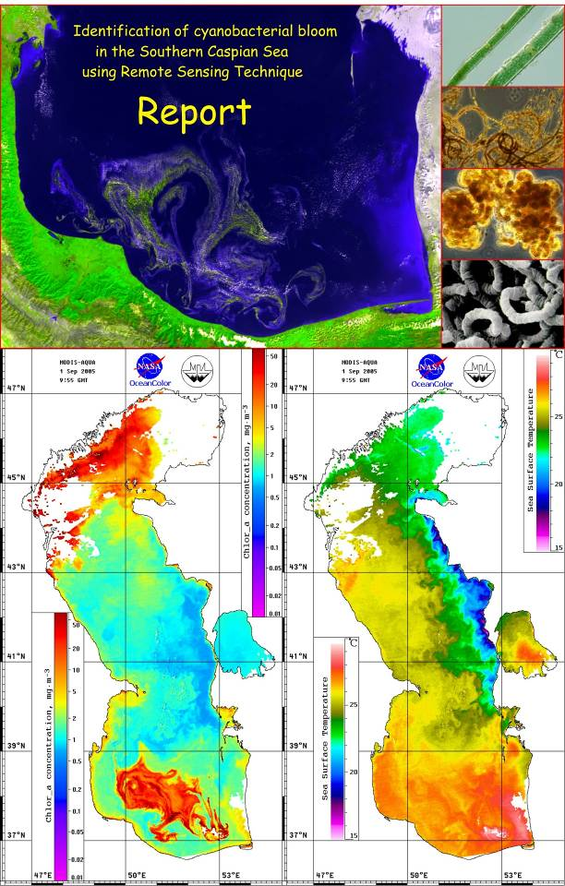
Identification of the extent and causes of cyanobacterial bloom in September-October 2005 and development of the capacity for observation and prediction of HAB in the Southern Caspian Sea using
Remote Sensing Technique

This report was prepared by Dmitry Soloviev in framework of the contract with the Caspian Environment Programme.
Background
During the first phase of the GEF-supported project a Transboundary Diagnostic Analysis (TDA) and a Strategic Action Programme (SAP) were formulated. The primary objective of the ongoing CEP-SAP project is to support the countries to consolidate and begin to implement the SAP, including filling gaps in information and developing capacity in the region for SAP implementation and project execution. “Conservation of biodiversity” was identified as one of the SAP environmental quality objectives with the aim to arrest biodiversity erosion due to anthropogenic impacts.
Outcome A of the CEP-SAP project concerns the quantitative assessment of habitat loss in the Caspian and its coastal zone and verification of critically threatened areas and the establishment of standardized monitoring methodology programme for the Caspian Sea. Currently the design of monitoring protocols and specifications is under way with the contract for implementing this activity awarded to Ecological Consulting Services Ltd. (UK).
In September 2005, Caspian Environment Programme received information from the Department of Environment of the Gilan Province (I.R. Iran) about an unusually large cyanobacterial bloom in coastal waters of the south-western Caspian Sea. This report is based on studies conducted by Iranian Fisheries Research Organization (IFRO) and is the first report about the cyanobacterial bloom of this size in the Caspian Sea. Based on morphological characteristics, IFRO ascribed the bloom to be blue-green algae of Nodularia genus, which needs further proof. There were also unconfirmed data on fish death in the adjacent area.
Development of HAB is the result of interactions between physiological and ecological characteristics of the species as well as physicochemical processes in the water column. They usually occur at the end of summer-beginning of fall. Increased concentrations of dissolved phosphorus in surface waters usually trigger bloom development and increased eutrophication pressure in many instances is its cause.
Objectives:
The main objectives of this work are (1) to characterize the temporal and spatial extent of cyanobacterial bloom in the Southern Caspian and (2) initiate capacity building measures for observation and prediction of future HAB occurrence/s in the Southern Caspian Sea. These goals will be achieved by integrating biological information with remote-sensing data. This work covers only the Remote Sensing part of the project.

Introduction: Cyanobacteria HAB and its impact on ecosystem
Cyanobacteria blooms and properties are well described in the scientific literature and special sites like:
http://www-cyanosite.bio.purdue.edu/
http://www.hc-sc.gc.ca/ewh-semt/water-eau/drink-potab/cyanobacteria-cyanobacteries_e.html
http://www.bchealthguide.org/healthfiles/hfile47.stm
Here we only make short review of the Cyanobacteria properties and it impact on ecosystem on the base of mentioned data sources. Cyanobacteria is the scientific name for blue-green algae, or "pond scum." The first recognized species were blue-green in color, which is how the algae got their name. Species identified since range in color from olive-green to red.
Cyanobacteria are found worldwide in both marine and freshwater habitats. Blue-green algae in small numbers are a natural part of the water system. In large numbers, the algae spoil the water because of malodor and form thick scum on the water (increasing the viscosity and composition), and as a result cause the water to be distasteful. Decaying algae consume oxygen in the water, so fish may die as a result of oxygen deprivation. Also, a dense algal bloom floating on the surface may potentially alter the benthic community underneath by shading it from the sun and altering the community's ecological system.
Cyanobacterial toxins are the naturally produced poisons stored in the cells of certain species of cyanobacteria. These toxins fall into various categories. Some are known to attack the liver (hepatotoxins) or the nervous system (neurotoxins); others simply irritate the skin.
Iranian Fisheries Research Organization (IFRO) based on morphological characteristics ascribed the bloom 2005 to be blue-green algae of Nodularia..
The organism responsible for this bloom was later described as Nodularia spumigena and the toxin has since been isolated and characterized (Rinehart et al., 1988*) as Nodularin.
The structure of nodularin is related to the potent cyclic heptapeptide hepatotoxins, the microcystins, but differs in that nodularin is composed of only five amino acids in the peptide ring. Not only are the structure of these two cyanobacterial toxins similar, but they both show the same hepatotoxic effect through the potent inhibition of protein phosphatases and similar IC₅₀ and LD₅₀ values.

*Rinehart, K. L., K. Harada, M. Namikoshi, C. Chen, and C. A. Harvis. 1988. Nodularin, microcystin and the configuration of Adda. J. Am. Chem. Soc. 110(25):8557-8558.

Recent satellite systems and sensors
Recent satellite sensors like AVHRR and MODIS allow to obtain information 4-8 times per day in the optical and infrared ranges with spatial resolution 0.25-1km. Main technical specification of the MODIS and AVHRR present in tab.1-2. Estimated by satellite data surface water parameters like SST, chlorophyll concentration, water leaving radiation (WLR) give information about the marine ecosystem current state and variability. Multispectral approach and using the multiplatform data are used for detection algorithms for HAB.
Table 1.

MODIS Technical Specifications
Platform Characteristics: | Inclination -- 98°  Orbital Period -- 99 minutes  Semi major axis -- 7085 km  Eccentricity -- 0.0015  Repeat Time -- 16 days  Quasi repeat time -- 2 days
Orbit: | 705 km, 10:30 a.m. descending node (Terra) or 1:30 p.m. ascending node (Aqua), sun-synchronous, near-polar, circular
Scan Rate: | 20.3 rpm, cross track
Swath Dimensions: | 2330 km (cross track) by 10 km (along track at nadir)
Telescope: | 17.78 cm diam. off-axis, afocal (collimated), with intermediate field stop
Quantization: | 12 bits
Spatial Resolution: | 250 m (bands 1-2)  500 m (bands 3-7)  1000 m (bands 8-36)
Design Life: | 6 years

Primary Use | Band | Bandwidth¹ | Spectral  Radiance² | Required  SNR³
Land/Cloud/Aerosols  Boundaries | 1 | 620 - 670 | 21.8 | 128
Land/Cloud/Aerosols  Boundaries | 2 | 841 - 876 | 24.7 | 201
Land/Cloud/Aerosols  Properties | 3 | 459 - 479 | 35.3 | 243
Land/Cloud/Aerosols  Properties | 4 | 545 - 565 | 29.0 | 228
Land/Cloud/Aerosols  Properties | 5 | 1230 - 1250 | 5.4 | 74
Land/Cloud/Aerosols  Properties | 6 | 1628 - 1652 | 7.3 | 275
Land/Cloud/Aerosols  Properties | 7 | 2105 - 2155 | 1.0 | 110
Ocean Color/  Phytoplankton/  Biogeochemistry | 8 | 405 - 420 | 44.9 | 880
Ocean Color/  Phytoplankton/  Biogeochemistry | 9 | 438 - 448 | 41.9 | 838
Ocean Color/  Phytoplankton/  Biogeochemistry | 10 | 483 - 493 | 32.1 | 802
Ocean Color/  Phytoplankton/  Biogeochemistry | 11 | 526 - 536 | 27.9 | 754
Ocean Color/  Phytoplankton/  Biogeochemistry | 12 | 546 - 556 | 21.0 | 750
Ocean Color/  Phytoplankton/  Biogeochemistry | 13 | 662 - 672 | 9.5 | 910
Ocean Color/  Phytoplankton/  Biogeochemistry | 14 | 673 - 683 | 8.7 | 1087
Ocean Color/  Phytoplankton/  Biogeochemistry | 15 | 743 - 753 | 10.2 | 586
Ocean Color/  Phytoplankton/  Biogeochemistry | 16 | 862 - 877 | 6.2 | 516
Atmospheric  Water Vapor | 17 | 890 - 920 | 10.0 | 167
Atmospheric  Water Vapor | 18 | 931 - 941 | 3.6 | 57
Atmospheric  Water Vapor | 19 | 915 - 965 | 15.0 | 250
Surface/Cloud  Temperature | 20 | 3.660 - 3.840 | 0.45(300K) | 0.05
Surface/Cloud  Temperature | 21 | 3.929 - 3.989 | 2.38(335K) | 2.00
Surface/Cloud  Temperature | 22 | 3.929 - 3.989 | 0.67(300K) | 0.07
Surface/Cloud  Temperature | 23 | 4.020 - 4.080 | 0.79(300K) | 0.07
Atmospheric  Temperature | 24 | 4.433 - 4.498 | 0.17(250K) | 0.25
Atmospheric  Temperature | 25 | 4.482 - 4.549 | 0.59(275K) | 0.25
Cirrus Clouds  Water Vapor | 26 | 1.360 - 1.390 | 6.00 | 150(SNR)
Cirrus Clouds  Water Vapor | 27 | 6.535 - 6.895 | 1.16(240K) | 0.25
Cirrus Clouds  Water Vapor | 28 | 7.175 - 7.475 | 2.18(250K) | 0.25
Cloud Properties | 29 | 8.400 - 8.700 | 9.58(300K) | 0.05
Ozone | 30 | 9.580 - 9.880 | 3.69(250K) | 0.25
Surface/Cloud  Temperature | 31 | 10.780 - 11.280 | 9.55(300K) | 0.05
Surface/Cloud  Temperature | 32 | 11.770 - 12.270 | 8.94(300K) | 0.05
Cloud Top  Altitude | 33 | 13.185 - 13.485 | 4.52(260K) | 0.25
Cloud Top  Altitude | 34 | 13.485 - 13.785 | 3.76(250K) | 0.25
Cloud Top  Altitude | 35 | 13.785 - 14.085 | 3.11(240K) | 0.25
Cloud Top  Altitude | 36 | 14.085 - 14.385 | 2.08(220K) | 0.35
¹ Bands 1 to 19 are in nm; Bands 20 to 36 are in µm
² Spectral Radiance values are (W/m² -µm-sr)
³ SNR = Signal-to-noise ratio
⁴ NE(delta)T = Noise-equivalent temperature difference
Table 2
AVHRR Bandlist and Typical Use
Channel Number | Resolution at Nadir | Wavelength (µm) | Typical Use
1 | 1.09 km | 0.58 - 0.68 | Daytime cloud and surface mapping
2 | 1.09 km | 0.725 - 1.00 | Land-water boundaries
3A | 1.09 km | 1.58 - 1.64 | Snow and ice detection
3B | 1.09 km | 3.55 - 3.93 | Night cloud mapping, sea surface temperature
4 | 1.09 km | 10.30 - 11.30 | Night cloud mapping, sea surface temperature
5 | 1.09 km | 11.50 - 12.50 | Sea surface temperature

Data and methods
For Caspian Sea HAB 2005 investigation we used MODIS Level 1 QKM, HKM and 1KM data from Distributed Active Archive Center (DAAC) NASA Goddard Earth Sciences (GES) Data and Information Services Center (DISC), Level2 data from Oceancolor Web GSFC (http://oceancolor.gsfc.nasa.gov), AVHRR data processed on Marine Hydrophysical Institute (MHI) receiving station and MODIS mapped SST from Physical Oceanography Distributed Active Archive Center (PO.DAAC) (http://podaac.jpl.nasa.gov). Additionally NCEP wind data were used for characterization of the situation in HAB area. Software developed in Remote sensing department of MHI and Visat BEAM 2.3 tools (http://www.brockmann-consult.de/beam/) were used for data processing.
MODIS Chl-a, SST and WLR maps were calculated for the area of the Caspian Sea (36°-48°N, 46°-55°E) with spatial resolution 0.01° – latitude, 0.0143° – longitude, corresponding approximately 1.1x1.1km. AVHRR SST and albedo maps were calculated for the same area. “True color” images were created on the base of WLR and albedo data for better detection of the bloom area. MHI software was used for masking and creation of the geographical and values scales. Samples of the data (images and digital values) are on the enclosed DVD (see DVD description in Annex).

Review the 2005 algal bloom characteristics in the Southern Caspian Sea
Strong cyanobacteria bloom occurred in the southern part of the Caspian Sea in the beginning of the second decade of the August developed and existed until the end of the September. Development of the bloom process was very fast – image for August 8 did not registered significant scattering but on the image for August 12 wide area with strong scattering was observed. On the MODIS image for August 15 (fig. 1) bloom area looks like wide stripes in the periphery of the systems of eddies over the bottom slope, but on the image for September 1 (fig.2) bloom area looks like big spot with area ~ 20,000 square km. In the med of September bloom area looks like stripes on the periphery of the eddies and is registered until end of September.
Maximum concentrations estimated from scattering observed in September 10, 16, and 17.
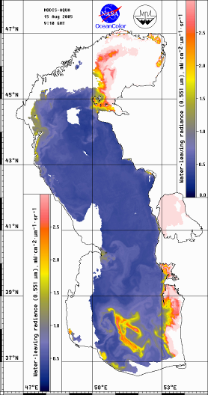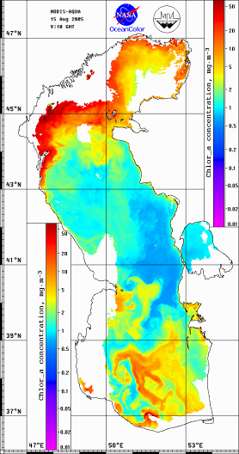
Fig.1. WLR551 and chlorophyll-a concentration maps for August 15, 2005
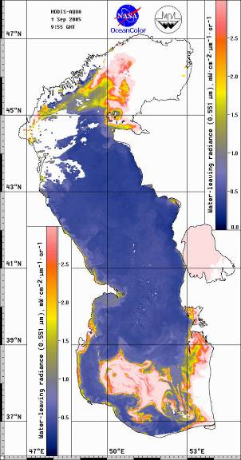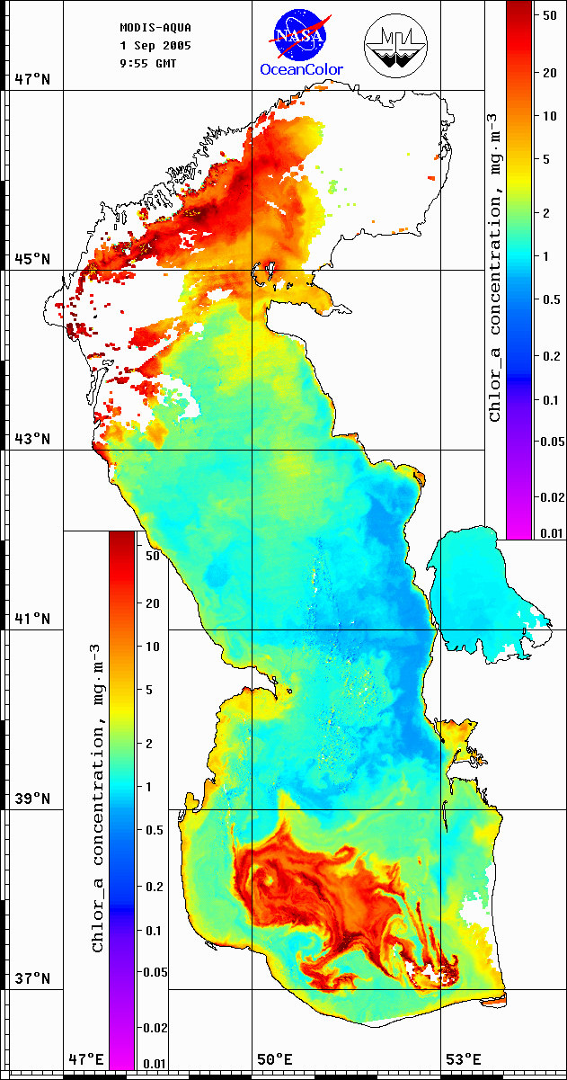
Fig.2. WLR551 and chlorophyll-a concentration maps for September 01, 2005

Analyzis of satellite images for the presence of chlorophyll a and mapping of SST (Sea Surface Temperature)
All cloud free MODIS Aqua and AVHRR data were processed for August – September 2005.
Registered in the bloom area values of Chl-a concentration exceed 50 mg/m³. Unfortunately NASA algorithms for MODIS data don’t process data in the bloom area (fig.3) in maximum phase and interpret situation like clouds. So, correct estimation of the Chl-a concentration was unavailable for med of September. MODIS 250 m image for Sept 10 (fig.4) demonstrates maximum phase of the bloom.
Totally 18 passes of the MODIS and 167 passes of the AVHRR were processed for August –September 2005.
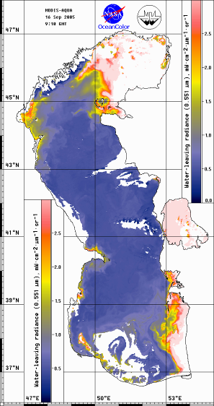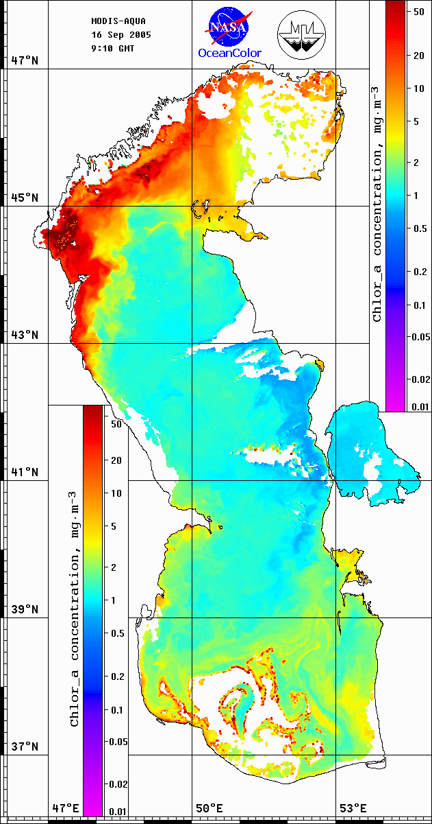
Fig.3. WLR551 and chlorophyll-a concentration maps for September 16, 2005
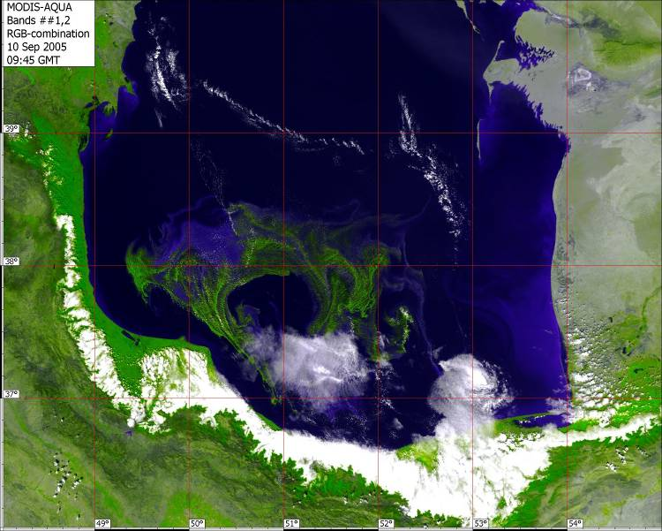
Fig.4 – True color map for MODIS 250 m data for September 10, 2005

Spectral response of the cyanobacteria bloom in WLR
Floating particles of cyanobacteria are concentrated near surface and significantly change optical properties of the Water Leaving Radiation (WLR) registered by optical sensors.
Spectral response of the bloom areas is characterized by extremally high values of the WLR in green, red and IR ranges of spectrum. Spectral dependence of the WLR and normalized on WLR 551 nm spectrums for bloom area and surrounding waters are shown on the fig.5 for Sept 1. Specific shape of the spectrum may be used for development HAB detection algorithms. Concentration of the cyanobacteria in upper thin layer so high, that we registered significant signal even for the wavelength 1.2 μm (Channel#5 MODIS HKM), there radiation formation layer ~ 1 cm due to the high water absorption of the radiation.
To compare shape of the spectrum with known Nodularia bloom we used data for the Baltic Sea. Fig.5c – demonstrates normalized WLR spectrums obtained in the Baltic Sea during Nodularia bloom - July 4, 2005. Typical image is shown on the fig.5d. So, high values of the (WLR551 – WLR488) may be used as predictor of the blue–green HAB.
Note. Satellite derived WLR will be different from “in situ” measured for the bloom area due to the errors in atmospheric correction related with non zero surface signal in near IR range. But for the simplification and repeatability we used typical NASA WLR product. Methods of atmospheric correction for non-zero surface signal in near IR range are complex and not solved yet problem.
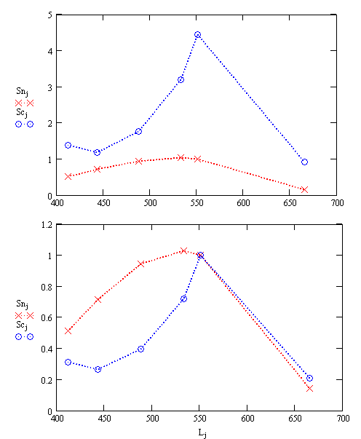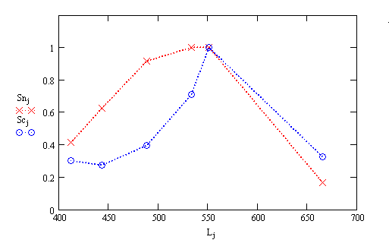
Fig.5. Spectral dependence of the WLR551 for bloom area Sc and surrounding waters Sn (a) normalized on WLR 551 nm spectrums (b) for September 01, 2005, South Caspian Sea;
normalized WLR spectrums obtained in the Baltic Sea, July 4, 2005 (c)

Analysis of satellite images during the same/close period in previous five years for comparison
Analyze satellite images MODIS and AVHRR during the same/close period in previous five years did not detect strong anomalous bloom in the area of interest. Totally more than 130 MODIS and 720 AVHRR images were processed. As an example fig.6 demonstrates typical distribution of the WLR 551 and Chl-a concentration for September 03, 2003. More images are provided on the enclosed DVD.
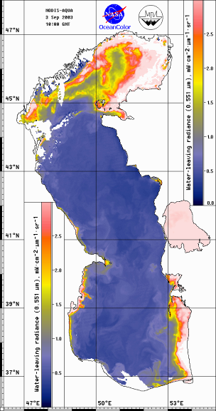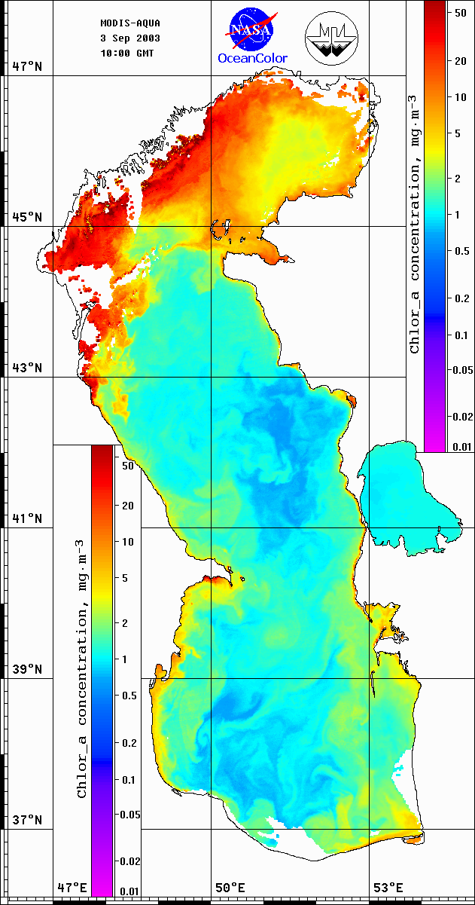
Fig.6. WLR551 and chlorophyll-a concentration maps for September 03, 2003

Table 3 contains examples of digital values of Chl-a, SST and WLR in Southern Caspian extracted from selected September images in years 2002 - 2205. Area1 in the table belongs to the HAB area in 2005. It should noted that for more correct inter-annual comparison spatial and time averaging procedures should be applied, but such investigation is beyond of scope of the current work.
Table 4
Values of Chl-a, SST and WLR in the Southern Caspian in September

 | Area 1 |  |  | Area 2
 | Chl-a | SST | WLR | Chl-a | SST | WLR
2002 | 18.8 | 26.0 | 0.86 | 2.29 | 25.2 | 0.66
2003 | 6.5 | 23.5 | 0.48 | 4.62 | 24.2 | 0.52
2004 | 14.0 | 25.8 | 0.52 | 3.87 | 24.5 | 0.44
2005 | >100 | 28.5 | >5.0 | 1.89 | 26.3 | 0.56
Where:
Area 1 is a point with coordinates 38.20 N 50.93 E
Area 2 is a point with coordinates 39.23 N 51.53 E
Analysis of satellite images during year cycle (monthly averages or the best images by the middle of each month, preferably for year 2005) for comparison
The best images for each month of the 2005 were processed. Fig.7a,b presents samples of Chl-a concentration maps and SST for 2005. Table 4 represents values of Chl-a, SST and WLR inside and outside of HAB area for comparison.
Table 4
Values of Chl-a, SST and WLR inside and outside of HAB area

 | Area 1 |  |  | Area 2
 | Chl-a | SST | WLR | Chl-a | SST | WLR
January | 0.89 | 11.7 | 0.34 | 0.80 | 12.3 | 0.36
February | 1.20 | 10.4 | 0.32 | 1.14 | 10.9 | 0.32
March | 0.95 | 11.0 | 0.38 | 1.20 | 10.6 | 0.38
April | 1.43 | 12.2 | 0.50 | 1.20 | 11.2 | 0.40
May | 1.43 | 18.7 | 0.64 | 1.35 | 19.1 | 0.62
June | 1.92 | 26.2 | 0.82 | 1.07 | 23.0 | 0.50
July | 0.85 | 27.9 | 0.54 | 0.67 | 26.7 | 0.52
August | 76.25 | 27.7 | 2.76 | 1.01 | 26.7 | 0.46
September | >100 | 28.5 | >5.0 | 1.20 | 26.3 | 0.56
October | 2.16 | 25.3 | 0.50 | 1.43 | 24.5 | 0.40
November | 3.07 | 17.6 | 0.36 | 2.89 | 17.8 | 0.36
December | 1.61 | 15.8 | 0.18 | 1.43 | 14.3 | 0.24

Where:
Area 1 is a point inside of HAB with coordinates 38.20 N 50.93 E
Area 2 is a point outside of HAB with coordinates 39.23 N 51.53 E
Values corresponding to HAB event are highlighted.
Note: standard NASA algorithms can not estimate properly Chl-a values for HAB event.

Fig.8 demonstrates plate of the monthly mean SST for 2001-2005 years. Well seen higher temperatures in May-August 2005 with respect to previous years.

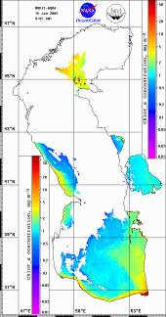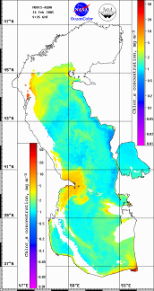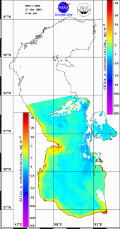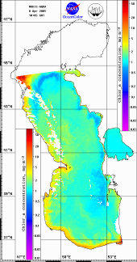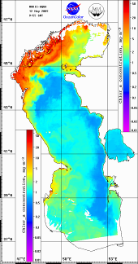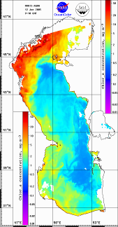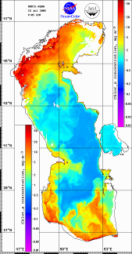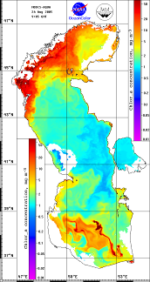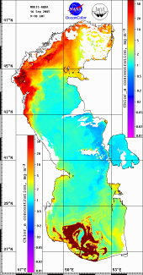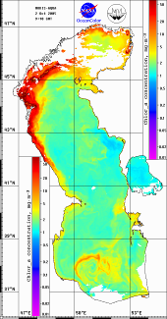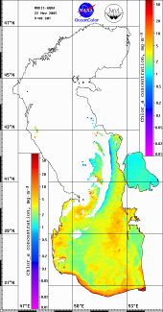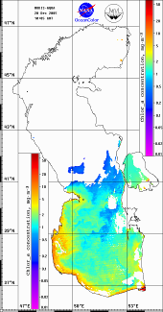
Fig.7a – Samples of the chlorophyll-a concentration for 2005
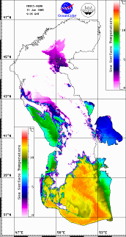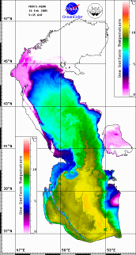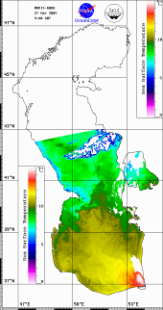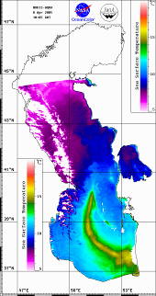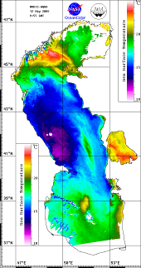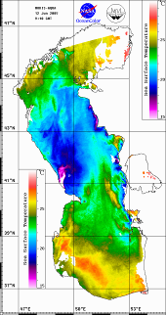
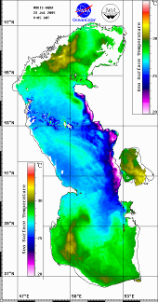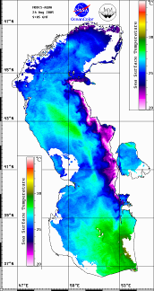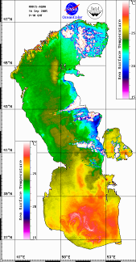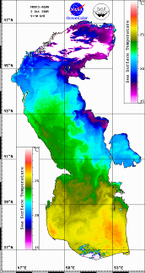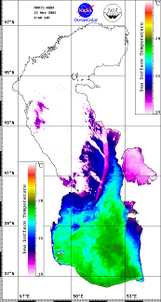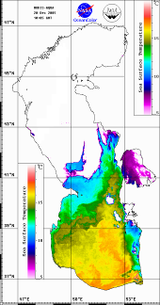
Fig.7b – Samples of the SST maps for 2005
2005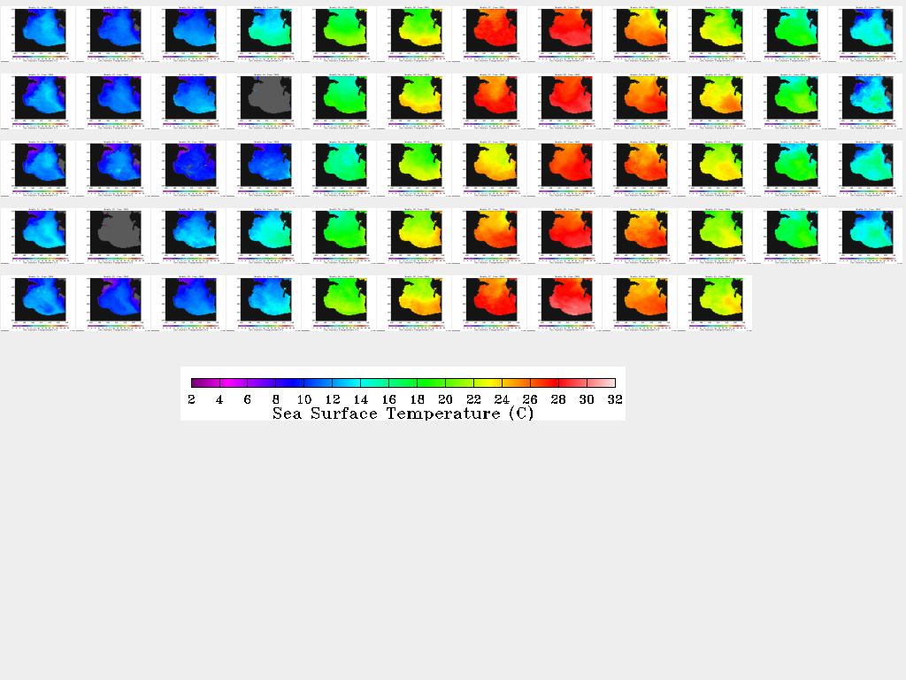
MONTHLY MEAN DAYTIME MODIS SST FROM PODAAC JPL
COLUMNS – MONTHS JANUARY – DECEMBER
ROWS - YEARS 2001-2005

Fig.8 – Plate of the monthly mean SST for 2001-2005 years.

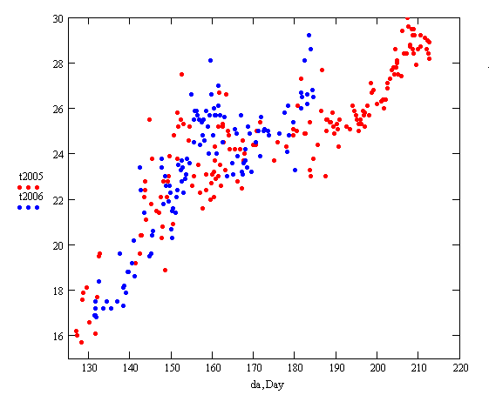
Fig.9. SST variability for 2005 and 2006 in the point (51°E, 38.2°N) versus Julian day of year

Fig.9 is temperature variability for 2005 and 2006 in the point (51°E, 38.2°N), note that 2006 year is warmer than 2005 and if this tendencies will be saved it may be one of the reasons for new occurrence of HAB in 2006. Second necessary condition – low wind during period 5-10 days.

Combining and interpretation of remote sensing results with other available related data
NCEP wind data with spatial resolution 1x1 geographical degree and temporal interval 6 hours were used for study the situation before during and after bloom event.
Analysis of the NCEP wind data and SST data for August – October 2005 demonstrates possible reason for the bloom occurrence. Fig.10 show variability of the SST and Wind for the point 51°E 38°N. Wind and SST data were smoothed for period ~ 3 days. Well seen interval from August 7 to August 21 with very low wind condition and correspondingly low turbulent mixing in upper layer. This led to the strong heating of the upper layer and increasing of the SST up to 30°C.

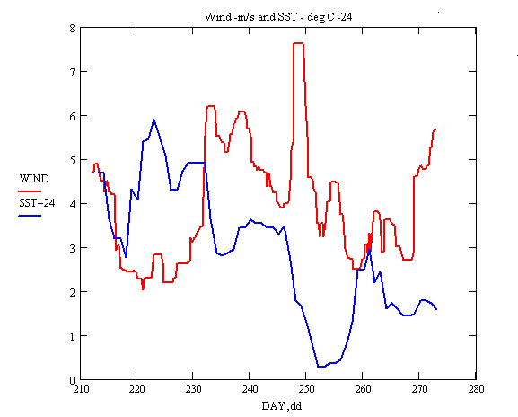
Fig.10. NCEP wind (m/s) and AVHRR SST (deg C – 24) variability for August – September
2005 for the point (51°E, 38°N) versus Julian day of year

Such situation strongly decreases oxygen flux from atmosphere and may be reason of death for typical phytoplankton. Rising of the phytoplankton concentration in upper layer induces the increasing of the sun light absorption and formation of the thin daily thermocline. Bloom manifestation in the SST pattern is well detected in the SST map for September 17 like the areas with high temperature (fig.11). Temperature difference with surrounding waters exceeds 4°C.
Note that nighttime temperature in the bloom area is lower with respect to bloom free zones. So, bloom waters are faster heating and faster cooling during the daily cycle. Variations of the SST along cross-section via bloom area for daytime and nighttime presented on fig.12.
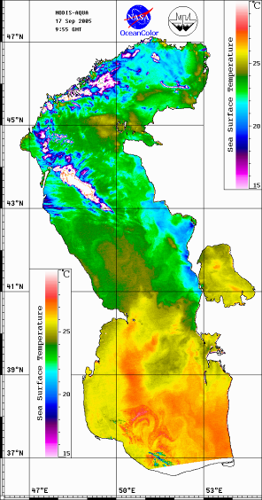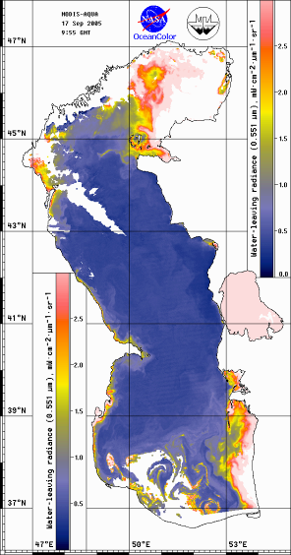
Fig.11. SST and WLR551 maps for September 17, 2005
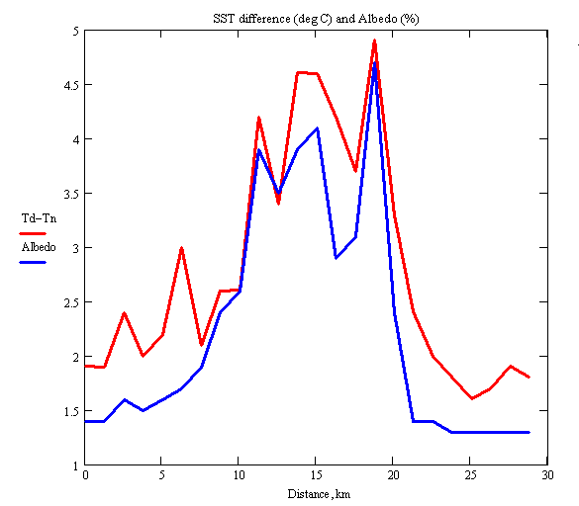
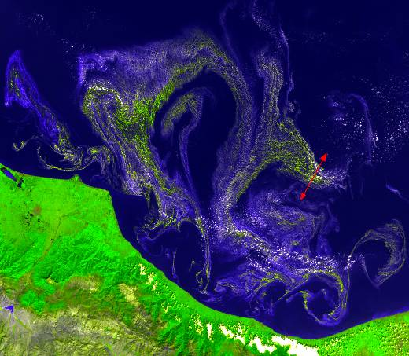
Fig.12. Day–night time SST difference (deg C) along cross-section and corresponding
albedo (%) for September 16, 2005

Summary
HAB occurred in the southern open part of the Sea very fast during period 10 -13 August as result of wind speed weakness and surface heating. HAB area increased and reached the 20000 km² for September 1. Until September 17 shape of the HAB area was transformed by the system of mesoscale eddies. Before September 5-6 HAB was concentrated in open part of the Sea, but after some eddies induced jets transported HAB to the coastal area. After September 17 area of the HAB is decreased and HAB is looked like jets on the periphery of eddies. Last weak footprints of the HAB were observed in the open part of the see on the image for October 2.
HAB was well detected as the area with high WLR in red and near infrared range. WLR spectrum in HAB area has a specific shape. As a preliminary algorithm for blue – green bloom detection in deep waters may be used the next criterion (WLR551 – 1.5*WLR488) > 0. Map of the bloom area calculated by this criterion is presented on fig.13 for September 1, 2005.
Estimated by the typical MODIS NASA algorithm values of Chl-a concentration exceeded 50 mg/m³ in the bloom area with surrounding values 1-3 mg/m³.
Comment: Typical chl-a algorithm did not estimate concentration for maximum faze of the bloom due to high scattering in near IR range and filtering data as clouds.
Note that the buoyancy of the Nodularia is variable parameter and biomass can be concentrating near surface (floating species) or distributed in the water body (neutral or sinking).
So, in this case term “concentration” did not applicable for description biomass due to different and unknown vertical distributions of species.
Direct estimation of biomass and Chl-a concentration is difficult due to the absence of algorithms and direct relation between WLR and biomass. Special study for inter-comparison of satellite data with “in situ” measurements should be done for solving this problem. As the indirect parameter of the HAB intensity may be used value of albedo in second channel of AVHRR.
Taking into account high values of water absorption coefficient in this spectral range (~0.1cm⁻¹) only high concentration of the light scattering species in thin ~10cm layer can change albedo.
For HAB area albedo reached 8.2% in the zones of maximum concentration, typical values of albedo outside HAB zone ~1%.
HAB strongly changed thermal regime – daily SST variation exceeds 5°C in bloom area.
High temperature and low wind condition during 2 weeks of August may be interpreted as the main reasons for HAB occurrence.
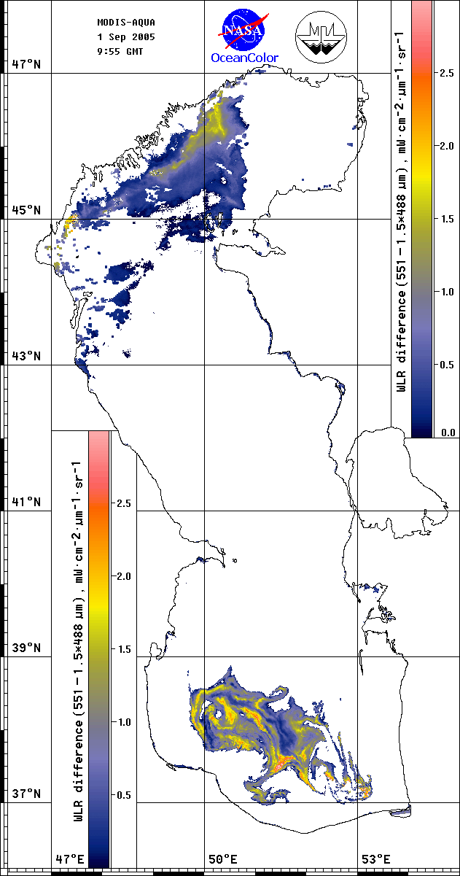
Fig.13. Map of bloom area detection algorithm application

Recommendation
Observed in 2005 strong Cyanobacteria Bloom is unique phenomenon with regional scale. Its influence on Caspian marine ecosystem is significant and don’t investigated yet.
We recommend to carry out operational monitoring of the Southern Caspian Sea during August – October 2006 with using MODIS and AVHRR satellite data and available meteorological information. It will be the next step for better understanding of such HAB, detecting possible reasons of occurring and predictors.

Acknowledgments
The MODIS data used in this study were acquired as part of the NASA's Earth-Sun System Division and archived and distributed by the Goddard Earth Sciences (GES) Data and Information Services Center (DISC) Distributed Active Archive Center (DAAC).
List of Figures
Fig.1 – WLR551 and chlorophyll-a concentration maps for August 15, 2005
Fig.2 – WLR551 and chlorophyll-a concentration maps for September 01, 2005
Fig.3 – WLR551 and chlorophyll-a concentration maps for September 16, 2005
Fig.4 – True color map for MODIS 250 m data for September 10, 2005
Fig.5 – Spectral dependence of the WLR551 for bloom area Sc and surrounding waters Sn (a)
and normalized on WLR 551 nm spectrums (b) for September 01, 2005, South Caspian Sea, normalized WLR spectrums obtained in the Baltic Sea, July 4, 2005 (c)
Fig.6 – WLR551 and chlorophyll-a concentration maps for September 03, 2003.
Fig.7a,b – Samples of the chlorophyll-a concentration and SST maps for 2005
Fig.8 – Plate of the monthly mean SST for 2001-2005 years.
Fig.9 – SST variability for 2005 and 2006 in the point (51°E, 38.2°N) versus Julian day of year.
Fig.10 – NCEP wind (m/s) and AVHRR SST (deg C -24) variability for August – September
2005 for the point (51°E, 38°N) versus Julian day of year.
Fig.11 – SST and WLR551 maps for September 17, 2005.
Fig.12 – Day–night time SST difference (deg C) along cross-section and corresponding
albedo (%) for September 16, 2005.
Fig.13 – Map of bloom area detection algorithm application.
Annex
DVD description

Caspian Sea DVD-disk contains satellite data for 2002-2005 years

MODIS data: SST, Chl-a, WLR (6 wavelengths) – raster digital format, GIF images,
ASCII files and Level-2 initial files which have been used to derive above parameters.
Totally 1064 digital, 1064 gif maps, 399 ASCII files and 133 Level-2 files.

AVHRR data: SST – GIF images. Totally 746 GIF images.

Also disk contains 14 high resolution MODIS images illustrating HAB evolution in 2005.

DVD structure

Root directory contains 4 subdirectories: 2002, 2003, 2004, 2005 for corresponding year.
Every from these subdirectories contains two subdirectories: AVHRRSST and MODIS
with appropriate data.

Subdirectory AVHRRSST contains GIF images which derived from NOAA-AVHRR.
Every GIF file in this subdirectory is named according this rule:
YMMMDDNZ.GIF
where:
Y means last digit of year
MMM – month
DD – day
N –satellite identifier
0,2 – NOAA-18 (night and day time passes)
1,3 – NOAA-12 (morning and evening time passes)
4,5 – NOAA-15 (morning and evening time passes)
6,7 – NOAA-16 (night and day time passes)
8,9 – NOAA-17 (day and night time passes)
Z – sign of region according local classification (Caspian Sea)

Every subdirectory MODIS contains 4 subdirectories: BZ2, SST, CHL, WLR
BZ2 contains initial Level-2 files packed by bzip2 (http://www.bzip.org)
Every from subdirectories SST, CHL, WLR contains subdirectories BIN, DAT, GIF
BIN – data in raster digital format
DAT – data in ASCII format for SST, Chlorophyll and WLR (551 mkm) files
GIF – data in GIF format

Name convention for MODIS files.
All names of MODIS files have the same structure: YYMMDDFF.EXT
where
YY – year
MM – month
DD – day
FF – set the type of derived parameter in appropriate file
ZT – Sea surface temperature
ZC – Chlorophyll A concentration
41 – Water-leaving radiance in channel 0.412 mkm
44 – Water-leaving radiance in channel 0.443 mkm
48 – Water-leaving radiance in channel 0.488 mkm
53 – Water-leaving radiance in channel 0.531 mkm
55 – Water-leaving radiance in channel 0.551 mkm
66 – Water-leaving radiance in channel 0.667 mkm
EXT – file extension
0 or 10 – extension of SST binary files
R – extension of WLR binary files
L – extension of CHL binary files
DAT – extension of ASCII files
GIF – extension of GIF files

All files in subdirectory BIN have the following structure:
header part – 450 bytes
data part – 631*1201 bytes
Longitude 46-55 E, step by longitude 1/70 degree
Latitude 36-48 N, step by latitude 1/100 degree
Image size 631*1201 pixels

Header part structure

0..1 Day : Byte; // acquisition day
1..2 Month : Byte; // acquisition month
2..4 Year : Integer; // acquisition year
4..5 Channel : Byte; // channel identifier
5..6 THour : Byte; // acquisition hour
6..7 TMin : Byte; // acquisition minutes
7..13 Latitude : Real; // latitude of lower left corner
13..19 Longitude : Real; // longitude of lower left corner
19..25 DX : Real; // step of map by longitude
25..31 DY : Real; // step of map by latitude
31..33 NRows : Integer; // number of rows
33..35 NCols : Integer; // number of columns
35..39 Temp : Integer; // additional info
39..40 SB : Byte; // sign of file type
40..450 ………………………………. // reserved field

Data part structure

Values in files wrote line by line beginning from upper left corner of the map.

Conversion formulas for extracting real values
SST = count/10 + delta, where delta is the number in file-extension
WLR = count/50
CHL = 10^(count/39.41 – 2)
where count means byte value in binary file.

List of NOAA-AVHRR SST GIF files.

Year 2002

2FEB227Z.GIF 2JUL011Z.GIF 2SEP027Z.GIF
2MAR067Z.GIF 2JUL017Z.GIF 2SEP037Z.GIF
2MAR107Z.GIF 2JUL022Z.GIF 2SEP054Z.GIF
2APR277Z.GIF 2JUL023Z.GIF 2SEP057Z.GIF
2APR292Z.GIF 2JUL027Z.GIF 2SEP086Z.GIF
2MAY172Z.GIF 2JUL080Z.GIF 2SEP094Z.GIF
2MAY173Z.GIF 2JUL087Z.GIF 2SEP096Z.GIF
2MAY183Z.GIF 2JUL090Z.GIF 2SEP105Z.GIF
2MAY187Z.GIF 2JUL097Z.GIF 2SEP117Z.GIF
2MAY246Z.GIF 2JUL102Z.GIF 2SEP147Z.GIF
2MAY277Z.GIF 2JUL107Z.GIF 2SEP157Z.GIF
2MAY280Z.GIF 2JUL112Z.GIF 2SEP167Z.GIF
2MAY281Z.GIF 2JUL117Z.GIF 2SEP176Z.GIF
2MAY287Z.GIF 2JUL187Z.GIF 2SEP245Z.GIF
2MAY303Z.GIF 2JUL192Z.GIF 2SEP264Z.GIF
2JUN043Z.GIF 2JUL197Z.GIF 2SEP266Z.GIF
2JUN047Z.GIF 2JUL202Z.GIF 2SEP286Z.GIF
2JUN050Z.GIF 2JUL207Z.GIF 2SEP287Z.GIF
2JUN057Z.GIF 2JUL212Z.GIF 2SEP297Z.GIF
2JUN112Z.GIF 2JUL217Z.GIF 2SEP307Z.GIF
2JUN113Z.GIF 2JUL307Z.GIF 2OCT117Z.GIF
2JUN117Z.GIF 2AUG016Z.GIF 2OCT197Z.GIF
2JUN153Z.GIF 2AUG026Z.GIF 2OCT298Z.GIF
2JUN157Z.GIF 2AUG067Z.GIF 2NOV046Z.GIF
2JUN162Z.GIF 2AUG097Z.GIF 2NOV057Z.GIF
2JUN163Z.GIF 2AUG136Z.GIF 2NOV185Z.GIF
2JUN165Z.GIF 2AUG137Z.GIF 2NOV187Z.GIF
2JUN166Z.GIF 2AUG146Z.GIF 2NOV189Z.GIF
2JUN167Z.GIF 2AUG147Z.GIF 2NOV196Z.GIF
2JUN237Z.GIF 2AUG196Z.GIF 2NOV199Z.GIF
2JUN242Z.GIF 2AUG205Z.GIF 2NOV206Z.GIF
2JUN243Z.GIF 2AUG234Z.GIF 2NOV217Z.GIF
2JUN247Z.GIF 2AUG237Z.GIF 2NOV239Z.GIF
2JUN256Z.GIF 2AUG247Z.GIF 2NOV247Z.GIF
2JUN257Z.GIF

Year 2003

3JAN048Z.GIF 3JUN069Z.GIF 3JUL035Z.GIF 3SEP026Z.GIF
3JAN098Z.GIF 3JUN076Z.GIF 3JUL037Z.GIF 3SEP028Z.GIF
3FEB037Z.GIF 3JUN085Z.GIF 3JUL046Z.GIF 3SEP034Z.GIF
3MAR317Z.GIF 3JUN087Z.GIF 3JUL056Z.GIF 3SEP039Z.GIF
3APR019Z.GIF 3JUN108Z.GIF 3JUL058Z.GIF 3SEP046Z.GIF
3APR187Z.GIF 3JUN117Z.GIF 3JUL067Z.GIF 3SEP056Z.GIF
3APR188Z.GIF 3JUN149Z.GIF 3JUL068Z.GIF 3SEP057Z.GIF
3APR244Z.GIF 3JUN166Z.GIF 3JUL098Z.GIF 3SEP067Z.GIF
3MAY016Z.GIF 3JUN177Z.GIF 3JUL108Z.GIF 3SEP068Z.GIF
3MAY026Z.GIF 3JUN178Z.GIF 3JUL115Z.GIF 3SEP118Z.GIF
3MAY037Z.GIF 3JUN205Z.GIF 3JUL125Z.GIF 3SEP236Z.GIF
3MAY047Z.GIF 3JUN215Z.GIF 3JUL126Z.GIF 3SEP237Z.GIF
3MAY114Z.GIF 3JUN226Z.GIF 3JUL205Z.GIF 3SEP257Z.GIF
3MAY116Z.GIF 3JUN255Z.GIF 3JUL215Z.GIF 3SEP259Z.GIF
3MAY137Z.GIF 3JUN257Z.GIF 3JUL288Z.GIF 3SEP267Z.GIF
3MAY138Z.GIF 3JUN266Z.GIF 3JUL318Z.GIF 3SEP278Z.GIF
3MAY148Z.GIF 3JUN267Z.GIF 3AUG016Z.GIF 3SEP286Z.GIF
3MAY167Z.GIF 3JUN268Z.GIF 3AUG026Z.GIF 3SEP288Z.GIF
3MAY197Z.GIF 3JUN276Z.GIF 3AUG037Z.GIF 3OCT055Z.GIF
3MAY257Z.GIF 3JUN278Z.GIF 3AUG047Z.GIF 3OCT076Z.GIF
3MAY266Z.GIF 3JUN289Z.GIF 3AUG048Z.GIF 3OCT084Z.GIF
3MAY268Z.GIF 3AUG079Z.GIF 3OCT087Z.GIF
3AUG086Z.GIF 3OCT108Z.GIF
3AUG108Z.GIF 3OCT116Z.GIF
3AUG117Z.GIF 3OCT117Z.GIF
3AUG119Z.GIF 3OCT137Z.GIF
3AUG145Z.GIF 3OCT148Z.GIF
3AUG166Z.GIF 3OCT225Z.GIF
3AUG167Z.GIF 3NOV017Z.GIF
3AUG169Z.GIF 3NOV187Z.GIF
3AUG176Z.GIF 3NOV205Z.GIF
3AUG199Z.GIF 3NOV237Z.GIF
3AUG217Z.GIF 3NOV238Z.GIF
3AUG267Z.GIF 3NOV267Z.GIF
3AUG276Z.GIF 3DEC139Z.GIF
3AUG277Z.GIF
3AUG287Z.GIF
3AUG288Z.GIF
3AUG289Z.GIF
3AUG307Z.GIF

Year 2004

4JAN087Z.GIF 4APR019Z.GIF 4JUN014Z.GIF 4AUG026Z.GIF 4OCT016Z.GIF
4JAN089Z.GIF 4APR021Z.GIF 4JUN035Z.GIF 4AUG028Z.GIF 4OCT017Z.GIF
4JAN097Z.GIF 4APR055Z.GIF 4JUN037Z.GIF 4AUG029Z.GIF 4OCT018Z.GIF
4JAN168Z.GIF 4APR057Z.GIF 4JUN057Z.GIF 4AUG047Z.GIF 4OCT026Z.GIF
4JAN205Z.GIF 4APR066Z.GIF 4JUN064Z.GIF 4AUG055Z.GIF 4OCT028Z.GIF
4JAN208Z.GIF 4APR067Z.GIF 4JUN068Z.GIF 4AUG057Z.GIF 4OCT029Z.GIF
4JAN216Z.GIF 4APR068Z.GIF 4JUN069Z.GIF 4AUG058Z.GIF 4OCT036Z.GIF
4JAN218Z.GIF 4APR069Z.GIF 4JUN109Z.GIF 4AUG067Z.GIF 4OCT038Z.GIF
4JAN224Z.GIF 4APR077Z.GIF 4JUN137Z.GIF 4AUG068Z.GIF 4OCT039Z.GIF
4JAN229Z.GIF 4APR085Z.GIF 4JUN138Z.GIF 4AUG108Z.GIF 4OCT085Z.GIF
4JAN235Z.GIF 4APR088Z.GIF 4JUN144Z.GIF 4AUG126Z.GIF 4OCT087Z.GIF
4FEB047Z.GIF 4APR095Z.GIF 4JUN146Z.GIF 4AUG145Z.GIF 4OCT089Z.GIF
4FEB084Z.GIF 4APR098Z.GIF 4JUN147Z.GIF 4AUG147Z.GIF 4OCT098Z.GIF
4FEB086Z.GIF 4APR099Z.GIF 4JUN148Z.GIF 4AUG148Z.GIF 4OCT106Z.GIF
4FEB089Z.GIF 4APR106Z.GIF 4JUN149Z.GIF 4AUG156Z.GIF 4OCT118Z.GIF
4FEB096Z.GIF 4APR108Z.GIF 4JUN195Z.GIF 4AUG157Z.GIF 4OCT119Z.GIF
4FEB097Z.GIF 4APR109Z.GIF 4JUN199Z.GIF 4AUG158Z.GIF 4OCT126Z.GIF
4FEB099Z.GIF 4APR116Z.GIF 4JUN205Z.GIF 4AUG188Z.GIF 4OCT127Z.GIF
4FEB148Z.GIF 4APR128Z.GIF 4JUN237Z.GIF 4AUG246Z.GIF 4OCT196Z.GIF
4FEB157Z.GIF 4APR135Z.GIF 4JUN239Z.GIF 4AUG248Z.GIF 4OCT198Z.GIF
4FEB168Z.GIF 4APR137Z.GIF 4JUN247Z.GIF 4AUG275Z.GIF 4OCT199Z.GIF
4FEB179Z.GIF 4APR138Z.GIF 4JUN268Z.GIF 4AUG306Z.GIF 4OCT203Z.GIF
4FEB186Z.GIF 4APR139Z.GIF 4JUN307Z.GIF 4SEP037Z.GIF 4OCT206Z.GIF
4FEB206Z.GIF 4APR145Z.GIF 4JUL011Z.GIF 4SEP045Z.GIF 4OCT208Z.GIF
4FEB207Z.GIF 4APR147Z.GIF 4JUL016Z.GIF 4SEP047Z.GIF 4OCT209Z.GIF
4FEB208Z.GIF 4APR148Z.GIF 4JUL018Z.GIF 4SEP058Z.GIF 4OCT216Z.GIF
4FEB227Z.GIF 4APR149Z.GIF 4JUL037Z.GIF 4SEP095Z.GIF 4OCT217Z.GIF
4FEB247Z.GIF 4APR157Z.GIF 4JUL073Z.GIF 4SEP096Z.GIF 4OCT249Z.GIF
4FEB256Z.GIF 4APR185Z.GIF 4JUL079Z.GIF 4SEP097Z.GIF 4OCT257Z.GIF
4FEB265Z.GIF 4APR186Z.GIF 4JUL086Z.GIF 4SEP106Z.GIF 4OCT259Z.GIF
4FEB266Z.GIF 4APR187Z.GIF 4JUL087Z.GIF 4SEP107Z.GIF 4OCT278Z.GIF
4FEB275Z.GIF 4APR188Z.GIF 4JUL097Z.GIF 4SEP108Z.GIF 4OCT283Z.GIF
4FEB277Z.GIF 4APR217Z.GIF 4JUL098Z.GIF 4SEP197Z.GIF 4OCT288Z.GIF
4FEB286Z.GIF 4APR218Z.GIF 4JUL117Z.GIF 4SEP204Z.GIF 4OCT289Z.GIF
4MAR205Z.GIF 4APR247Z.GIF 4JUL138Z.GIF 4SEP207Z.GIF 4OCT296Z.GIF
4MAR207Z.GIF 4APR275Z.GIF 4JUL148Z.GIF 4SEP209Z.GIF 4OCT298Z.GIF
4MAR209Z.GIF 4APR279Z.GIF 4JUL158Z.GIF 4SEP215Z.GIF 4NOV208Z.GIF
4MAR214Z.GIF 4APR289Z.GIF 4JUL159Z.GIF 4SEP217Z.GIF 4NOV209Z.GIF
4MAR218Z.GIF 4MAY029Z.GIF 4JUL167Z.GIF 4SEP218Z.GIF 4NOV217Z.GIF
4MAR224Z.GIF 4MAY063Z.GIF 4JUL169Z.GIF 4SEP226Z.GIF 4NOV219Z.GIF
4MAR226Z.GIF 4MAY068Z.GIF 4JUL176Z.GIF 4SEP227Z.GIF 4NOV223Z.GIF
4MAR227Z.GIF 4MAY073Z.GIF 4JUL267Z.GIF 4SEP228Z.GIF 4NOV227Z.GIF
4MAR228Z.GIF 4MAY077Z.GIF 4JUL277Z.GIF 4SEP236Z.GIF 4NOV249Z.GIF
4MAR235Z.GIF 4MAY079Z.GIF 4JUL278Z.GIF 4SEP238Z.GIF 4NOV253Z.GIF
4MAR238Z.GIF 4MAY086Z.GIF 4JUL307Z.GIF 4SEP239Z.GIF 4NOV256Z.GIF
4MAR239Z.GIF 4MAY107Z.GIF 4SEP244Z.GIF 4NOV257Z.GIF
4MAR246Z.GIF 4MAY109Z.GIF 4SEP246Z.GIF 4NOV259Z.GIF
4MAR264Z.GIF 4MAY123Z.GIF 4SEP247Z.GIF 4NOV285Z.GIF
4MAR268Z.GIF 4MAY124Z.GIF 4SEP248Z.GIF 4NOV287Z.GIF
4MAR269Z.GIF 4MAY127Z.GIF 4SEP255Z.GIF 4NOV289Z.GIF
4MAR278Z.GIF 4MAY177Z.GIF 4SEP267Z.GIF 4NOV297Z.GIF
4MAY183Z.GIF 4SEP268Z.GIF 4NOV299Z.GIF
4MAY187Z.GIF 4SEP277Z.GIF 4NOV307Z.GIF
4MAY188Z.GIF 4SEP278Z.GIF 4DEC014Z.GIF
4MAY196Z.GIF 4SEP286Z.GIF 4DEC016Z.GIF
4MAY197Z.GIF 4SEP287Z.GIF 4DEC017Z.GIF
4MAY199Z.GIF 4SEP288Z.GIF 4DEC018Z.GIF
4MAY215Z.GIF 4SEP289Z.GIF 4DEC036Z.GIF
4MAY217Z.GIF 4SEP297Z.GIF 4DEC038Z.GIF
4MAY243Z.GIF 4SEP299Z.GIF 4DEC046Z.GIF
4MAY244Z.GIF 4SEP305Z.GIF 4DEC047Z.GIF
4MAY246Z.GIF 4SEP307Z.GIF 4DEC049Z.GIF
4MAY251Z.GIF 4SEP308Z.GIF 4DEC056Z.GIF
4MAY256Z.GIF 4DEC087Z.GIF
4MAY257Z.GIF 4DEC104Z.GIF
4MAY263Z.GIF 4DEC108Z.GIF
4MAY265Z.GIF
4MAY266Z.GIF
4MAY267Z.GIF
4MAY268Z.GIF
4MAY278Z.GIF
4MAY313Z.GIF
4MAY318Z.GIF

Year 2005

5JAN135Z.GIF 5JUL012Z.GIF 5AUG012Z.GIF 5OCT020Z.GIF
5FEB167Z.GIF 5JUL014Z.GIF 5AUG019Z.GIF 5OCT022Z.GIF
5MAR277Z.GIF 5JUL018Z.GIF 5AUG058Z.GIF 5OCT024Z.GIF
5APR066Z.GIF 5JUL022Z.GIF 5AUG072Z.GIF 5OCT025Z.GIF
5APR086Z.GIF 5JUL042Z.GIF 5AUG083Z.GIF 5OCT029Z.GIF
5APR146Z.GIF 5JUL048Z.GIF 5AUG088Z.GIF 5OCT030Z.GIF
5APR216Z.GIF 5JUL058Z.GIF 5AUG102Z.GIF 5OCT032Z.GIF
5APR226Z.GIF 5JUL062Z.GIF 5AUG106Z.GIF 5OCT035Z.GIF
5MAY086Z.GIF 5JUL065Z.GIF 5AUG108Z.GIF 5OCT038Z.GIF
5MAY116Z.GIF 5JUL072Z.GIF 5AUG109Z.GIF 5OCT040Z.GIF
5MAY229Z.GIF 5JUL073Z.GIF 5AUG110Z.GIF 5OCT048Z.GIF
5MAY239Z.GIF 5JUL080Z.GIF 5AUG138Z.GIF 5OCT132Z.GIF
5MAY296Z.GIF 5JUL088Z.GIF 5AUG139Z.GIF 5OCT152Z.GIF
5JUN048Z.GIF 5JUL092Z.GIF 5AUG140Z.GIF 5OCT162Z.GIF
5JUN083Z.GIF 5JUL098Z.GIF 5AUG149Z.GIF 5OCT240Z.GIF
5JUN089Z.GIF 5JUL105Z.GIF 5AUG150Z.GIF 5OCT242Z.GIF
5JUN092Z.GIF 5JUL128Z.GIF 5AUG152Z.GIF 5OCT245Z.GIF
5JUN094Z.GIF 5JUL138Z.GIF 5AUG160Z.GIF 5OCT250Z.GIF
5JUN097Z.GIF 5JUL142Z.GIF 5AUG172Z.GIF 5OCT252Z.GIF
5JUN098Z.GIF 5JUL145Z.GIF 5AUG179Z.GIF 5OCT255Z.GIF
5JUN099Z.GIF 5JUL149Z.GIF 5AUG182Z.GIF 5OCT258Z.GIF
5JUN102Z.GIF 5JUL150Z.GIF 5AUG229Z.GIF 5OCT260Z.GIF
5JUN103Z.GIF 5JUL152Z.GIF 5AUG230Z.GIF 5OCT262Z.GIF
5JUN108Z.GIF 5JUL153Z.GIF 5AUG237Z.GIF 5OCT269Z.GIF
5JUN109Z.GIF 5JUL159Z.GIF 5AUG239Z.GIF 5OCT272Z.GIF
5JUN110Z.GIF 5JUL160Z.GIF 5AUG240Z.GIF 5OCT278Z.GIF
5JUN112Z.GIF 5JUL170Z.GIF 5AUG250Z.GIF 5OCT282Z.GIF
5JUN115Z.GIF 5JUL172Z.GIF 5AUG262Z.GIF 5OCT285Z.GIF
5JUN128Z.GIF 5JUL178Z.GIF 5AUG268Z.GIF 5OCT289Z.GIF
5JUN138Z.GIF 5JUL189Z.GIF 5AUG269Z.GIF 5OCT302Z.GIF
5JUN147Z.GIF 5JUL192Z.GIF 5AUG272Z.GIF 5OCT308Z.GIF
5JUN155Z.GIF 5JUL199Z.GIF 5AUG279Z.GIF 5OCT310Z.GIF
5JUN160Z.GIF 5JUL202Z.GIF 5AUG282Z.GIF 5NOV012Z.GIF
5JUN162Z.GIF 5JUL210Z.GIF 5AUG318Z.GIF 5NOV018Z.GIF
5JUN168Z.GIF 5JUL218Z.GIF 5AUG319Z.GIF 5NOV019Z.GIF
5JUN178Z.GIF 5JUL228Z.GIF 5DEC149Z.GIF 5NOV183Z.GIF
5JUN189Z.GIF 5JUL229Z.GIF 5DEC202Z.GIF 5NOV185Z.GIF
5JUN192Z.GIF 5JUL230Z.GIF 5SEP018Z.GIF 5NOV188Z.GIF
5JUN195Z.GIF 5JUL235Z.GIF 5SEP035Z.GIF 5NOV190Z.GIF
5JUN202Z.GIF 5JUL238Z.GIF 5SEP038Z.GIF 5NOV192Z.GIF
5JUN293Z.GIF 5JUL239Z.GIF 5SEP048Z.GIF 5NOV200Z.GIF
5JUN298Z.GIF 5JUL240Z.GIF 5SEP049Z.GIF 5NOV202Z.GIF
5JUL249Z.GIF 5SEP099Z.GIF 5NOV208Z.GIF
5JUL252Z.GIF 5SEP100Z.GIF 5NOV212Z.GIF
5JUL260Z.GIF 5SEP109Z.GIF 5NOV214Z.GIF
5JUL275Z.GIF 5SEP110Z.GIF 5NOV218Z.GIF
5JUL279Z.GIF 5SEP112Z.GIF 5NOV219Z.GIF
5JUL280Z.GIF 5SEP122Z.GIF 5NOV222Z.GIF
5JUL282Z.GIF 5SEP128Z.GIF 5NOV228Z.GIF
5JUL289Z.GIF 5SEP129Z.GIF
5JUL292Z.GIF 5SEP130Z.GIF
5JUL302Z.GIF 5SEP132Z.GIF
5JUL309Z.GIF 5SEP138Z.GIF
5JUL310Z.GIF 5SEP139Z.GIF
5JUL315Z.GIF 5SEP140Z.GIF
5JUL318Z.GIF 5SEP142Z.GIF
5SEP149Z.GIF
5SEP150Z.GIF
5SEP160Z.GIF
5SEP162Z.GIF
5SEP168Z.GIF
5SEP169Z.GIF
5SEP178Z.GIF
5SEP179Z.GIF
5SEP182Z.GIF
5SEP210Z.GIF
5SEP219Z.GIF
5SEP232Z.GIF
5SEP239Z.GIF
5SEP240Z.GIF
5SEP242Z.GIF
5SEP245Z.GIF
5SEP248Z.GIF
5SEP250Z.GIF
5SEP252Z.GIF
5SEP258Z.GIF
5SEP259Z.GIF
5SEP260Z.GIF
5SEP262Z.GIF
5SEP268Z.GIF

List of MODIS Chlorophyll GIF files

020813zc.gif 030815zc.gif 040811zc.gif 050115zc.gif
020814zc.gif 030816zc.gif 040814zc.gif 050216zc.gif
020815zc.gif 030818zc.gif 040815zc.gif 050327zc.gif
020817zc.gif 030819zc.gif 040817zc.gif 050408zc.gif
020819zc.gif 030825zc.gif 040820zc.gif 050512zc.gif
020820zc.gif 030826zc.gif 040824zc.gif 050611zc.gif
020821zc.gif 030827zc.gif 040829zc.gif 050612zc.gif
020822zc.gif 030829zc.gif 040830zc.gif 050619zc.gif
020823zc.gif 030831zc.gif 040831zc.gif 050628zc.gif
020824zc.gif 030901zc.gif 040902zc.gif 050629zc.gif
020831zc.gif 030902zc.gif 040903zc.gif 050707zc.gif
020902zc.gif 030903zc.gif 040904zc.gif 050708zc.gif
020903zc.gif 030904zc.gif 040905zc.gif 050714zc.gif
020904zc.gif 030905zc.gif 040909zc.gif 050715zc.gif
020905zc.gif 030910zc.gif 040918zc.gif 050721zc.gif
020906zc.gif 030911zc.gif 040919zc.gif 050722zc.gif
020909zc.gif 030912zc.gif 040920zc.gif 050723zc.gif
020911zc.gif 030916zc.gif 040921zc.gif 050728zc.gif
020916zc.gif 030918zc.gif 040922zc.gif 050730zc.gif
020917zc.gif 030923zc.gif 040923zc.gif 050731zc.gif
020918zc.gif 030926zc.gif 040925zc.gif 050807zc.gif
020920zc.gif 030927zc.gif 040927zc.gif 050808zc.gif
020922zc.gif 030928zc.gif 040928zc.gif 050811zc.gif
020923zc.gif 030930zc.gif 040929zc.gif 050815zc.gif
020925zc.gif 031005zc.gif 040930zc.gif 050818zc.gif
020926zc.gif 031006zc.gif 041001zc.gif 050824zc.gif
020927zc.gif 031007zc.gif 041002zc.gif 050827zc.gif
020929zc.gif 031009zc.gif 041008zc.gif 050831zc.gif
020930zc.gif 041009zc.gif 050901zc.gif
021002zc.gif 041011zc.gif 050903zc.gif
021006zc.gif 041016zc.gif 050905zc.gif
021008zc.gif 041020zc.gif 050907zc.gif
021011zc.gif 050910zc.gif
021013zc.gif 050915zc.gif
050916zc.gif
050917zc.gif
050924zc.gif
050925zc.gif
051002zc.gif
051014zc.gif
051122zc.gif
051220zc.gif

List of MODIS WLR and SST files is similar with the names on this disk according mentioned above naming convention.

