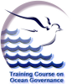 |  | International Ocean Institute - Malta Operational Centre  University of Malta  C/o 43/1 Valley Road, Birkirkara, BKR 10, Malta  Tel/Fax: +356 21 440972; Email: ioi-moc@um.edu.mt  http://www.capemalta.net/ioimoc | 

COURSE ANNOUNCEMENT

The International Ocean Institute is pleased to announce the training course on

REGIONAL OCEAN GOVERNANCE FOR THE MEDITERRANEAN AND EASTERN EUROPEAN COUNTRIES

14 November – 16 December 2005

University Malta

Sponsored by

Accredited by the University of Malta

Run by the IOI-Malta Operational Centre
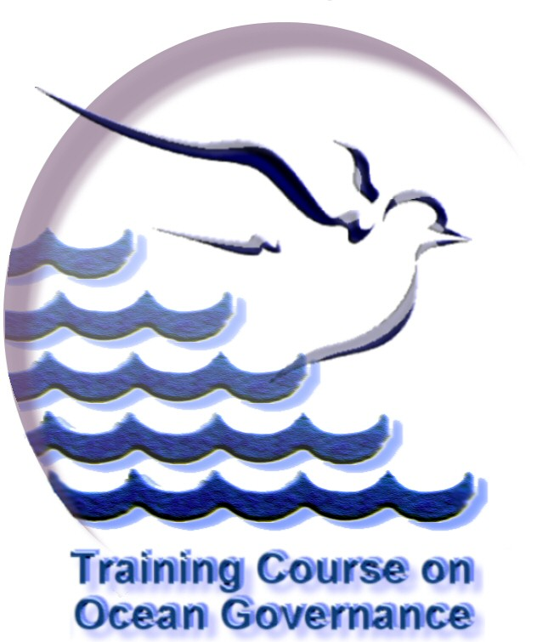

Course Presentation
This course focuses on the need to align the practice of ocean governance with the evolving global environment in the light of advances in science and technology. It takes a holistic approach, emphasizing the linkages between the natural, social and economic sciences which shape the development of sustainable governance of the Mediterranean, Black, Baltic and Caspian Seas.

This course will consist of 6 modules, presented over a five-week period. Topics covered include:

- Global Ocean Governance Framework
- Operationalisation of Ocean Governance
- Governance of the Mediterranean Sea
- Governance of the Black, Baltic and Caspian Seas
- Conflict Management and Consensus-Building
- Application of Foresight Strategy on Regional Governance

It is specifically designed to benefit mid-career professionals, government officials, educators, researchers and civil society participants, preferably with coastal/marine-related responsibilities. Preference will be given to candidates from developing countries of the Mediterranean and Eastern European countries.

Targeted participants
Candidates should preferably have an undergraduate degree in a field relevant to marine affairs and science. They must be nominated and sponsored by an appropriate Government entity, university or equivalent educational institution or by a national or regional organisation. A working knowledge of English is essential.

Applicants from developed or EU countries (except Eastern European countries) will be considered only if they are fully funded or are registered at the University of Malta as graduate students.

Course Application: Applicants should register their interest in the course by submitting the online Preliminary Interest Form. (http://capemalta.net/ioimoc/course/apply.html). Applicants are subsequently requested to send full details in an application form (including the Participant Nomination and Medical Form). The preliminary and full application forms can be accessed from http://capemalta.net/ioimoc/course , or by writing to the Course Coordinator.


Course Fee: US$6000, covering accommodation, daily allowance for meals, course delivery materials, all bench fees, use of university facilities, participation in field trips and social programme organised as part of the course.

Scholarships: Limited scholarships covering fully or in part the expenses of the course are available.

