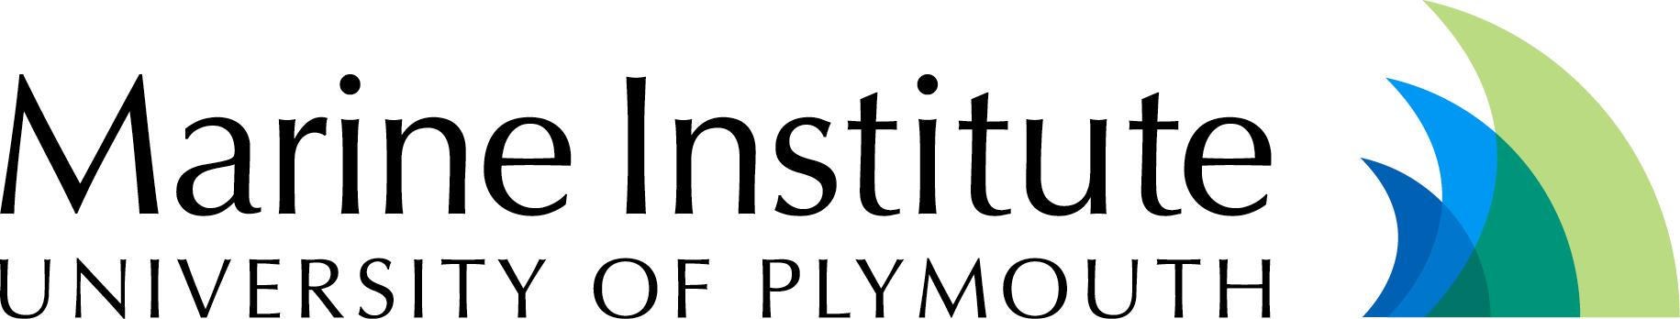
Marine Institute
University of Plymouth,
Drake Circus,
Plymouth
PL4 8AA
United Kingdom

Tel + 44 (0)1752 233719
Fax + 44 (0)1752 233039

www.plymouth.ac.uk/marine


“a world leading institute that provides multidisciplinary
expertise in marine research, education and innovation”
the Marine Institute

- has been formed to consolidate the ongoing marine activities in the Faculties of Science, Technology and Social Science & Business of the University of Plymouth.

- has over 160 high level researchers involved in regional, European and international projects.

- provides multi-disciplinary research, covering areas as diverse as marine biology, chemistry and geology, marine and coastal engineering, maritime policy, shipping and logistics.

- encourages synergies between research and teaching to meet the needs of more than 1500 students pursuing marine and maritime courses.

- is highly relevant to the social, economic and environmental development of the world’s coasts and shelf seas.
European Joint Masters in Water and Coastal Management at the University of Plymouth 2007/8

For overseas Graduate students seeking funding – closing date 1st December 2006
- An innovative 18 month programme, taught in English, which integrates river-basin and coastal management
- Full funding available for graduate students from outside Europe under the European Union’s ERASMUS MUNDUS scheme
- Run jointly between the Universities of Plymouth, UK, Algarve in Portugal, Bergen in Norway and Cadiz in Spain.
- All students must spend time at least two of the above Universities
- More information and application forms can be downloaded from http://www.research.plymouth.ac.uk/marine

For overseas researchers and academics – closing date 1st December 2006
- A scholarship scheme to enable scholars to travel to one of the partner Universities to work for three months
- Funded by the European Union’s ERASMUS MUNDUS scheme http://ec.europa.eu/education/programmes/mundus/index_en.html
- Application forms from http://www.ualg.pt/EUMScWCM/ to be sent to Prof Alice Newton, University of Algarve

