THE SUSTAINABLE DEVELOPMENT PLAN OF CHAYGARAGASHLI COMMUNITY

Devechy Region
Azerbaijan Republic
2005 - 2008

2005

Table of Contents

The history and description of the village 3
The preparation process of the plan 4
Prospects of the community 4
Task necessary to solve 5
Strengths and weaknesses of the community 5
Work plan 6
Alternative scenario 6
Conclusion 7
Attachment 1. Financial support required from donors 8
Attachment 2. Questionnaire 10

The history and description of the village
- The community lives on the territory, which 1 km far from the Caspian Sea. The village named Chaygaragashli is 15-16 km far from the center of the region. This village is the part of the territorial-administrative union of Golgushchu. There are 6 villages on this territory. Valvalachay River run by the village. The village municipality governs this region. The forest area situated between Chaygaragashli village and the Caspian Sea belongs to the Divichi forestry. Chaygaragashli borders with Xachmas in the north. During many years water supply problem is not still solved on this territory (Gelgushchu, Xalilli, Liman, Ajigaragashli and Sarvan villages). Despite the fact that several times there were made artesian wells this well soon become unfit for use.
- Villages situated on this area have communication with the authorities, organizations and institutions of the region.
- The situation is as following:
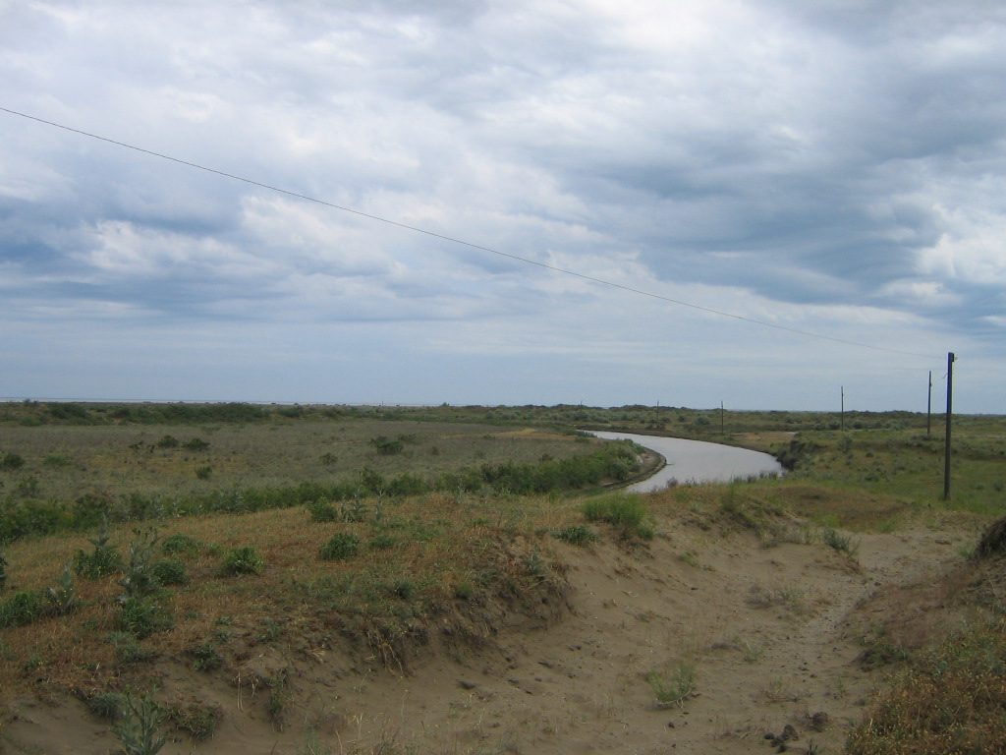
i) Drinking water has been bringing by cars to the region. Most of the inhabitants are busy with fishing.
ii) There were highway along the Caspian Sea on this territory between Chaygaragashli and Ajigaragashli villages. Chaygaragashli village was found at the end of the 18th and beginning of the 19th centuries. Until the middle of 20th century population was mainly busy with cattle-breeding and vegetable growing. Farming and fishing began to develop here later.
iii) Population of Chaygaragashli village is 463 people.
237 of them are female and 226 male.
Age structure:
under 16 years: 145
16–35 years: 140
35 – 60 years: 138
over 60 years: 40

The agricultural products’ production especially vegetable growing was developing until 1990 on the territory of the community. Today nobody is busy with vegetable growing in Chaygaragashli village. In 1970 there were organized fish farms on the territory of the village. No one of these fish farms is working now. After the disintegration of the Soviet Union the population of the village is busy with cattle breeding and crops growing. There is a buffalo farm in the village.

The preparation process of the plan

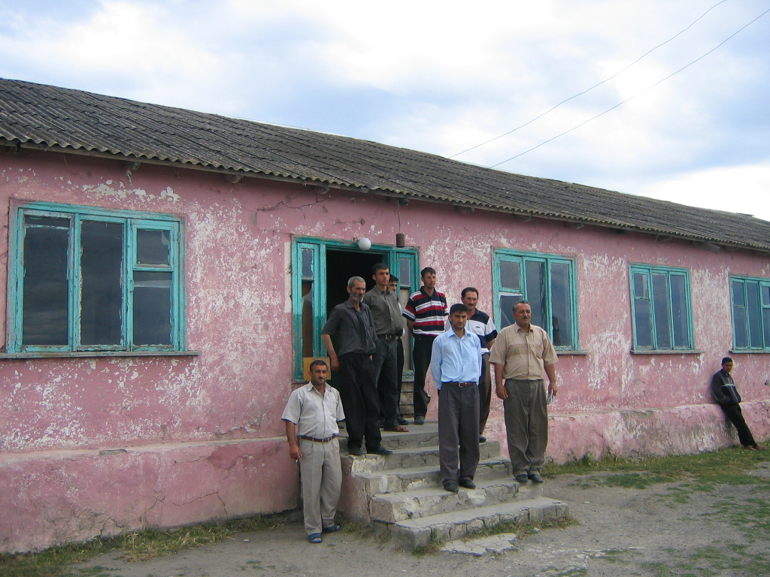
The chairman and the members of municipality, head of local executive power, the elders of the village and community members took part in the development of the community plan. All participants are fully confident that solving all existing problems will solve the most important problem – unemployment.

Prospects of the community

We want to liquidate the unemployment and to stop the resettlement of the village residents. We want to see the improvement in education system. We would like to have good medical service. The fact that our village is situated on the coastal area is a good to develop the tourism here. Existence of sea air and healthy sand on the seashore give the chance to build a small seaside hotel. Another prospect is to repair the neglected buildings of the farms built during the Soviet period and to turn over them to the village farmers for creation new cattle-breeding and sheep-breeding farms. To prevent the mass fishing in the Caspian Sea there can be created alternative pond fish farm with the perspective to expand in future. This is the main question for protection the Caspian Sea. Building the bridge on the Valvalachay River running through the village is one of the main tasks. This is very important to connect the inhabitants of the village with the neighboring villages and Xachmas region. Helping the local businessmen to open the business will create new work places.

Task necessary to solve

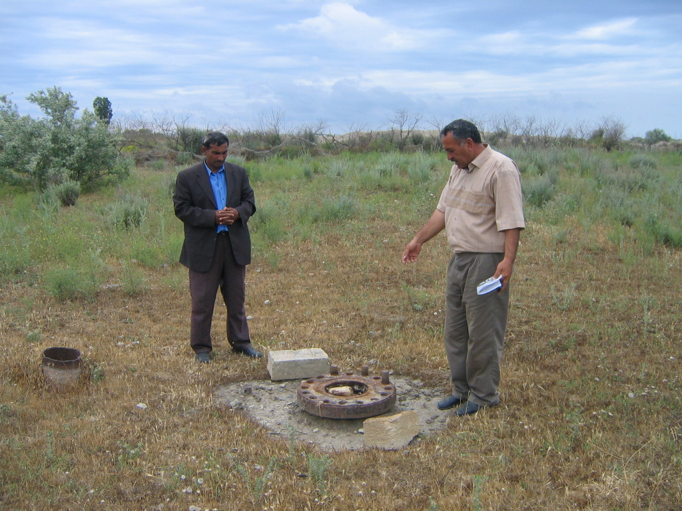
1. Liquidation of unemployment
2. Creating new work places
3. Development of pond fish farm
4. Increasing the level of health service
5. Increasing the level of education system
6. Organization of agrotechservice
7. Building the bridge through the Valvalachay River
8. Protect the environment

Strengths and weaknesses of the community

Strength | Weakness
Existence of high – skilled teaches in Chaygaragashli village. | The building of the school is too old and it requires heavy repair. Necessity to provide the school with the appropriate equipment.
Availability of several artificial lakes on the territory of the village. Existence of fish-breeding specialists. | Absence of financial resources to create the fish-breeding farm.
Existence of old sheep-breeding and cattle-breeding farms on the territory of the village. | Absence of financial resources to buy the cattle.
Existence of health service specialists in the village. | The first-aid station is situated in the old neglected building. Absence of medical equipment.
Every member of the families in the village was given a land plots. There is a possibility to develop the agriculture. | Absence of agricultural machinery. Necessity to provide the farmers with small tractors and other auxiliary equipment.
Existence of the road to the Xachmas region. | Absence of the bridge to cross the Valvalachay River.
Existence of weaving looms for carpet production. | Absence of financial resources to purchase the machinery for carpet production.

Work plan

These activities will be realized during 2006-2008 years.

# | Work name | Period | Executor
1. | Building 4 additional class rooms for the school | 2006 | Municipality
2. | Organization of fish farm | 2006-2008 | Municipality
3. | Organization of cattle-breeding and sheep-breeding farms | 2006-2008 | Municipality
4. | Building a first-aid station | 2006-2008 | Community
5. | Opening “Agrotechservice” | 2006-2008 | Municipality
6. | Building a bridge | 2006 | Municipality
7. | Opening a division for carpet production | 2006-2008 | Community

Alternative scenario

- If the repair of school doesn’t take place and additional classrooms don’t build the level of education will decrease. The school will keep aloof from the computerization and the knowledge level of the future generation will be low.
- If the artificial fish farm is not created the population of the village will continue to fish in the Caspian Sea. In the case of organization a pond fish farm 15-20 people will get a job.
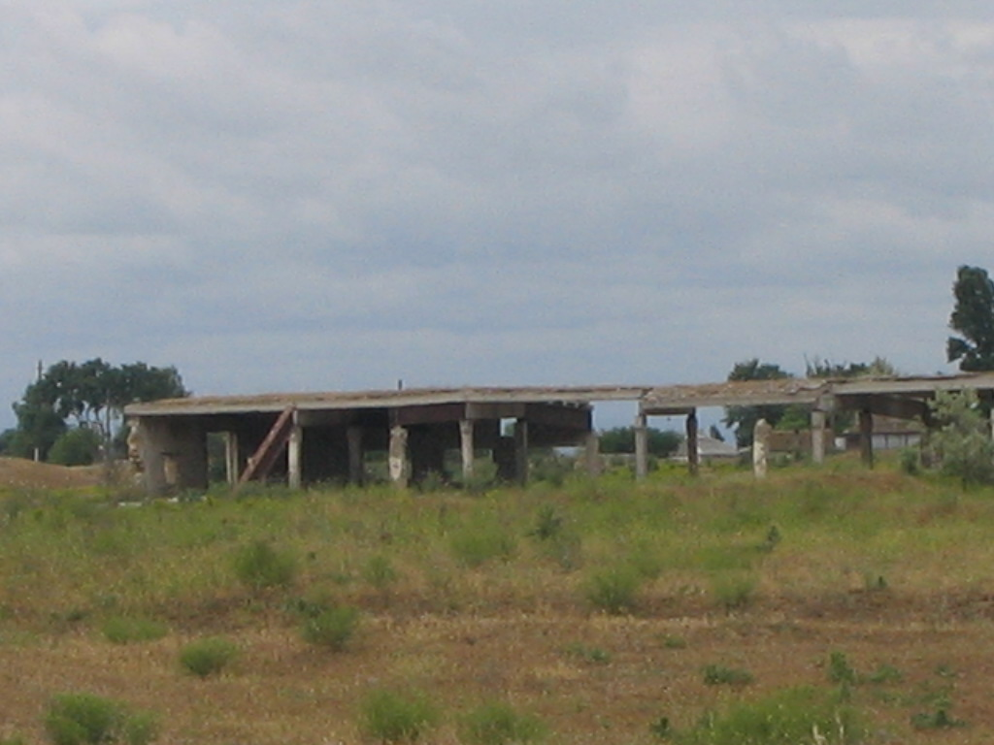
- If the financial resources are not received for cattle and sheep breeding development the existing farms will become out of use and the unemployment problem will not be solved. If the financial funds are allocated 15-20 people will get a job.
- If the first-aid station is not build the inhabitants of the community will stay without medical service as now. If the station is build the high skilled medical specialists will work here and the problem with the quality of medical service will be solved.
- If the “agrotechservice” facility is not organized the land plots gave by the government to the people will not be cultivated. The inhabitants of the village will not be able to be busy with their main activity – crops and vegetable growing.
- If the bridge through the Valvalachay River is not build the inhabitants of the village will not be able to deliver meat and milk products to Xachmas markets. People of the village have to spend 3 times more time to get to Xachmas region.

Conclusion

During the preparation process of the Sustainable Development Plan of the Community of Chaygaragashli village there were displayed the capacity that the city has to provide its sustainable development. Due to the fact that involvement of the most part of the population, specialists from different fields, businessmen and municipality members it was easy to competently determine the main strategic directions. It is important to note the assistance of IMC consultants and the region authorities.

One of the main goals of the preparation the plan is achieved – the document about sustainable development of this region was prepared for the first time in the history of this village. And it means that realization of such kind of projects will not be the priority of the region authorities; every village will be interested in this project? So the sustainable development plan of this village will be carry out for the prosperity of the villages and future generation.

Attachment 1. Financial support required from donors

1. Building 4 additional class rooms for the school

Cost of the project 17.000 000 (seventeen mln manat)
3 035 Euro; US $3 541

Leader of the project Tahir Abdulov

Community | Municipality | Donor
 | 5% | 95%

2. Organization of fish farm
Cost of the project 14.000 000 (fourteen mln manat)
2 500 Euro; US$ 2 916
Leader of the project Vugar Aliyev

Community | Municipality | Donor
 | 20% | 80%

3. Organization of cattle-breeding and sheep-breeding farms
Cost of the project 28.000 000 (twenty eight mln manat)
5 000 Euro; US$ 5 833
Leader of the project Bahtiyar Aydamirov

Community | Municipality | Donor
 | 20% | 80%

4. Building a first-aid station
Cost of the project 12 000 000 (twelve mln manat)
2 142 Euro; US$ 2 500
Leader of the project Guba Hasanova

Community | Municipality | Donor
 | 5% | 95%

5. Opening “Agrotechservice”
Cost of the project 30.000 000 (thirty mln manat)
5 357 Euro; US$ 6 250

Leader of the project Mammed Mammedov

Community | Municipality | Donor
 | 5% | 95%

6.Building a bridge
Cost of the project 11.000 000 (eleven mln manat)
1 964 Euro; US$ 2 291

Leader of the project Oruc Bagirov

Community | Municipality | Donor
5% | 5% | 90%

7. Opening a division for carpet production
Cost of the project 10.000 000 (ten mln manat)
1 785 Euro; US$ 2 083
Leader of the project Mahira Hasanova

Community | Municipality | Donor
5% | 5% | 90%

Attachment 2. Questionnaire

Questionnaire

Needs Assessment for Inhabitants of Devechy administrative region, Azerbaijan

This questionnaire is designed to study social and educational needs of inhabitants of Devechy region. This questionnaire is anonymous; omit indication of your name, please.

1. Gender: M F

2. What age group do you belong to? 20-25 26-35 36-45 45-65 65+

3. What village do you live in? __________________________________________________

4. Do you consider yourself to be disadvantaged and vulnerable? Yes No
If “yes”, explain ______________________________________________________________
___________________________________________________________________________

5. Do you belong to any minority groups? Yes No
If “yes”, explain ______________________________________________________________
___________________________________________________________________________

6. Choose what fits best to the description of your socio-economic status:

I am very needy I am needy, but can make both ends meet I am well-off

7. Do you personally experience any of the following socio-economic difficulties:
- Unemployment
- Low wage
- Bad labor conditions
- Poor infrastructure in your village (supply of water, gas, availability of daycare, schools etc.)
- Poor health makes your employment difficult or impossible

8. Do any of the following problems exist in your village?
- Problems in social and recreational area
- Problems with poor environmental conditions
- Insecurity and high criminal activity
- Problems with housing
- Problems with service delivery
- Problems with transportation and bad roads condition
- Business environment is not favorable for self-employment; rayon administration abuses its power creating harsh conditions especially for a business start-up

9. Could decline of fishing in the Caspian Sea cause any of the above mentioned problems?
Yes No

10. Did you ever think about becoming self-employed or starting your own business?
Yes No

11. Did you ever think about starting a community-based business with people from your village?
Yes No

12. What do you think you need to become self-employed?

Knowledge/skills Seed money Connections Skills & Money

13. What knowledge and skills do you think you need to start and run a business? _______________
______________________________________________________________________________

Thanks for your participation!

