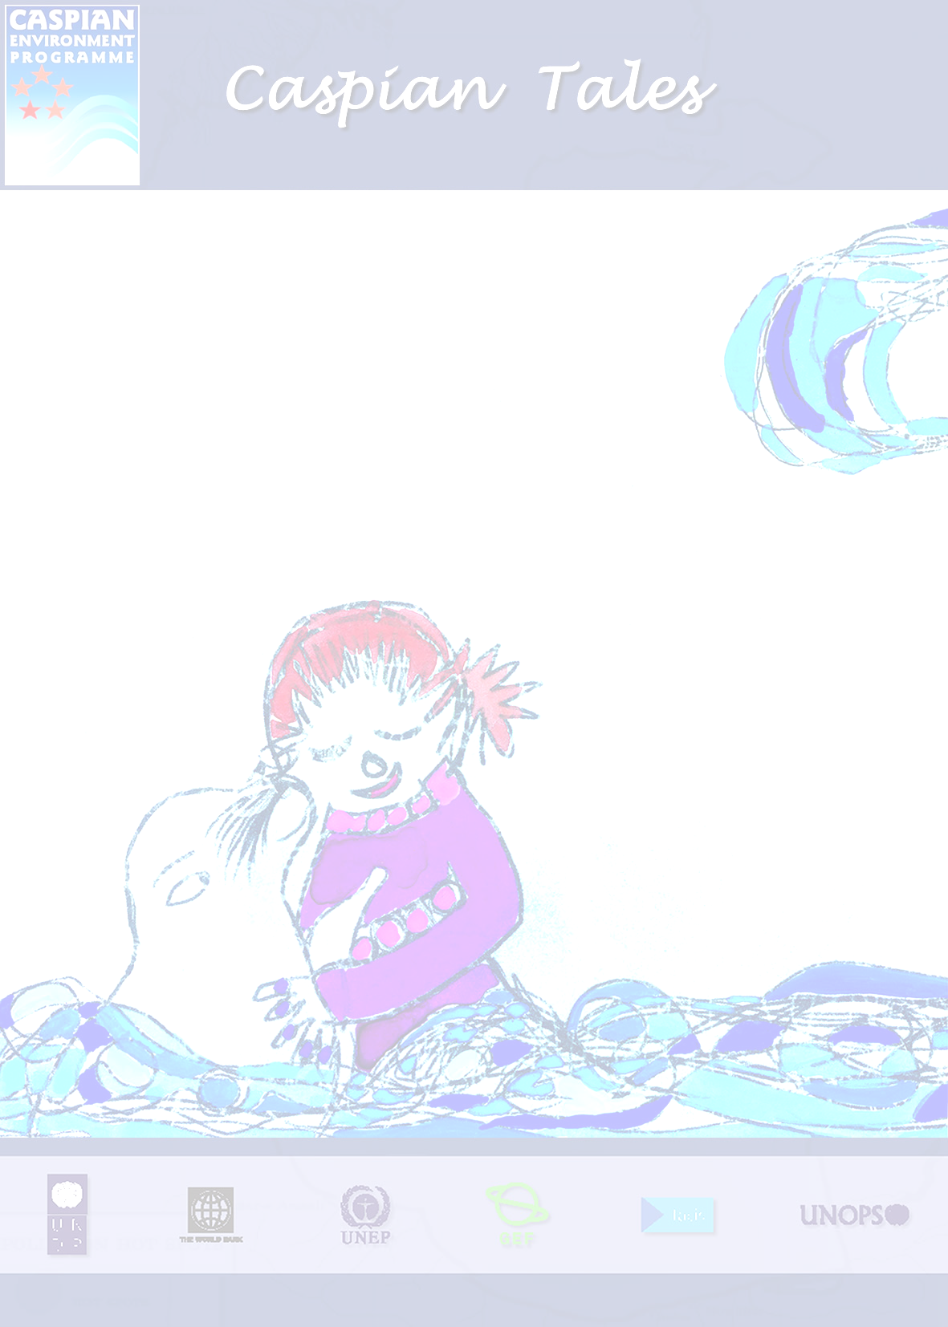

The present book is a collection of stories, legends, poems and folkloric fictions about the Caspian Sea in the Republic of Azerbaijan, Islamic Republic of Iran and the Russian Federation. These tales are gathered by three Micro Environmental Grant Projects supported by CEP in the aforesaid countries. Sardarov Elchin, Esmaeil Nateghi Kajani and Nelly V. Terekhova are the grantees who have undertaken this endeavor in the Azerbaijan Coastal region, Iranian Caspian provinces and the Caspian region of Dagestan, respectively.
The Folkloric stories are the connecting bridge between the present and the past. These are often passed on to the next generations verbally with only few available in written. It is therefore important to preserve these in order to protect and preserve the cultural identity of ethnic groups and nationalities. The identification of Caspian folkloric stories is an endeavor for the protection of the Caspian cultural heritage.
Some of these stories are about the Caspian Sea, its environment and the interaction of local people with the Sea. Familiarization of children and the young generation with the Caspian stories would encourage them to think about the importance of Caspian Sea in their own lives and how they can protect this valuable body of water and its rich resources.
Last but not the least, the collection of these stories is a showcase a common heritage shared by all the people living near the Caspian Sea to create a link between the diverse cultures of this region.

