Caspian Biodiversity
Information System

User Manual
Contents

1 Introduction 2
Information system goals 2
Database structure 2
General outline of user interface 4
2 Taxonomic information 6
Species checklist 6
Ecologo-taxonomic groups 6
Taxonomic tree 7
Search species 8
Species checklist edit 9
Add new taxon 9
Edit taxon 12
Edit additional species information 12
Add synonym 13
3 Auxiliary information 14
Parameters 14
Methods 14
Organizations 15
Persons 15
Ships 15
Habitats 16
Biotopes 17
Sites 17
4 Data retrieval 18
Simple search 18
Advanced search 19
5 Mapping 20
Creating biological maps 20
Creating environmental maps 21
6 Time-series 22
Creating biological time-series graphs 22
Creating environmental time-series graphs 22
7 Data input 23
Manual data input and edit 23

1 Introduction

Information system goals

The Caspian Biodiversity Information System serves for the storage and visualization of the biological, ecological and reference information of the Caspian Sea basin.

Access to the information is realized through the Internet by means of any Web-browser. Means of permissions provide the different levels of the data access – from a common user level to an administrator level.

The system is destined for raw data processing, it does not contain generalized information such as long-term estimations or maps from various atlases.

The system provides tools for the preliminary analysis of the raw data: creating spatial distribution maps, time-series graphs, calculating basic biodiversity indices.

To carry out more detailed and trustworthy data analysis the wide range of the additional information: taxonomic, geographical, methodic etc is provided.

Database structure

The general structure of the database is designed in such a way:

- to reduce as much as possible the variety of the data types both biological and environmental;
- to include in future new data types without complication;
- to provide the wide range of the data queries taking into account integration of various sources;
- to optimize data retrieval in an effort to efficient system functioning.

The database is built on relational principle on the basis of the Microsoft SQL Server 2005 and consists of more than 30 tables linked to each other by means of the primary and foreign keys, see Fig. 1.1. Space-time binding is realized by tables Stations and GeoSites (coordinates and geometrical shape of land sites). Geographical and geological information is located in tables Habitats и Ecotops (general types of the habitats and biotopes). Tables Datasets, Transects, Ships, Countries, Agencies, Persons contain general information. Tables Documents, Category, FileType provide access to every possible complementary documents concerned with specific data. Tables Parametrs and Methods include all the variables measured and various methods applied. Quality assessment is carried out on the basis of the quality checks contained in the table Qcodes. The biological part of the database consists of the tables Taxons (taxonomic information), BioData (raw biological data), Samples, Stages, Sizes, Collections. The table EnviromData serves as the environmental part of the system.
Figure 1.1. The general structure of the database

General outline of user interface

The main menu of the information system consists of five large sections: Information, Data, Maps, Time-series, Input. The general outline of the user interface is shown on Fig.1.2.

Fig. 1.2 The general outline of the user interface

Cruises
Sites
Search

Biology
Physics
Chemistry

Biology
Physics
Chemistry

Biology
Physics
Chemistry

Information Data Maps Time-series Input

Species checklist
Parameters
Methods
Organizations
Persons
Ships
Habitats
Biotopes
Sites

Information section

- Species checklist – species information by two kinds of the presentation: taxonomic tree and the list of the species by ecologo-taxonomic groups. Also the species search tool by name is located here.
- Parameters – lists of the biological, physical and chemical variables stored in the database;
- Methods – lists of the methods with subdivision on sampling, fixation, processing, sedimentation and others;
- Organizations – lists of the research institutes and other organizations which provide data;
- Persons – information on persons which provide data;
- Ships – information on ships which used for data collection;
- Habitats – types of the habitats based on general geographical features;
- Biotopes - types of the biotopes based on geographical and geological features;
- Sites – lists of the geographical sites where data were obtained;

Data section

- Cruises – data retrieval from lists of the research vessel cruises;
- Sites – data retrieval from lists of the sites with regular observations;
- Search – more comprehensive data retrieval by different criteria.

Maps section

- Biology – creating spatial distribution maps of the biological variables, for example species abundance;
- Physics – creating spatial distribution maps of the physical variables, for example temperature;
- Chemistry – creating spatial distribution maps of the chemical variables;

Time-series section

- Biology – creating time-series graphs of the biological variables;
- Physics – creating time-series graphs of the physical variables;
- Chemistry – creating time-series graphs of the chemical variables;

Input section

- Biology – input, uploading and editing biological data;
- Physics – input, uploading and editing physical data;
- Chemistry – input, uploading and editing chemical data;

2 Taxonomic information

Species checklist

The species checklist may be presented in two kinds: as a taxonomic tree and as the list of the species by ecologo-taxonomic groups.

Ecologo-taxonomic groups

Choose the Information command in the main menu and click Eco-tax groups in the menu at the left side of the window.

This tabular form subdivides species by ecologo-taxonomic groups such as Zooplankton, Phytoplankton, Benthos, Fishes, Plants, Birds, Mammals. The example of such a presentation is depicted on Fig.2.1.

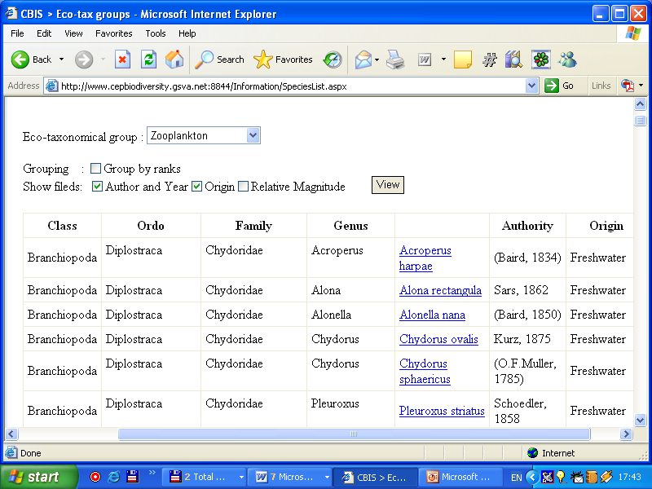

Figure 2.1 The form of the species checklist by ecologo-taxonomic groups

The selection of the ecologo-taxonomic group is executed in the drop-down list Eco-taxonomic group. The appearance of the species list and the amount of the columns is controlled by the following check-boxes:

Group by rank – the names of the taxonomic levels are not repeated;
Author and Year;
Origin - freshwater, brackish etc.
Relative magnitude – widespread, common etc.

The species list can be saved as XLS-file (Microsoft Excel). Click the button Export at the bottom side of the window.
If you select one of the species in the column Species the window of the detailed species description is opened, see Fig. 2.2.

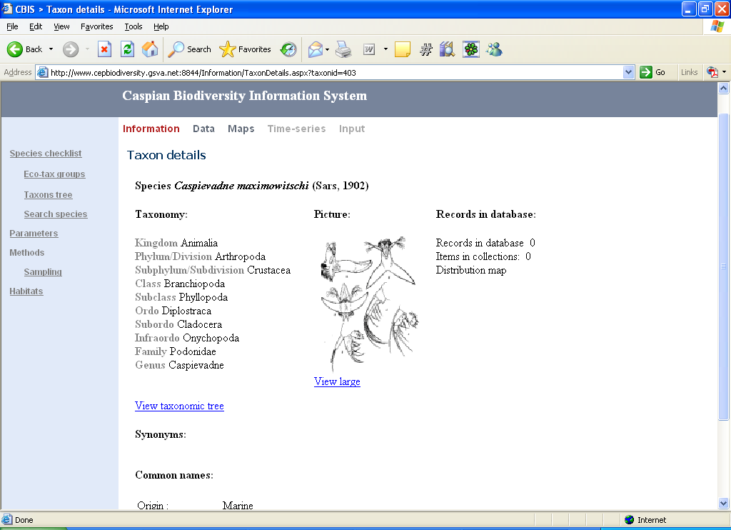

Figure 2.2. The window of the detailed species description.

In this window, besides species description, the following commands are available:

View taxonomic tree – to show the taxonomic tree expanded on the selected taxon;
Records in database – to show all the records in the database for the selected taxon;
Distribution map – mapping the locations of all the records in the database for the selected taxon.

Taxonomic tree

Choose the Information command in the main menu and click Taxons tree in the menu at the left side of the window.

The presentation of the species list in the view of the expanded tree lets clearly depict taxonomic hierarchy on levels from kingdom to species. Expanding individual branches is possible on any level (node). Near a taxon name an icon is placed to determine easy the taxon rank. - Kingdom, - Class, - Family, - Genus, - Species. The example of the expanded taxonomic tree is shown on Fig. 2.3. If you click on terminal nodes, i.e. on species, the window of the detailed species description is opened, see Fig. 2.2.

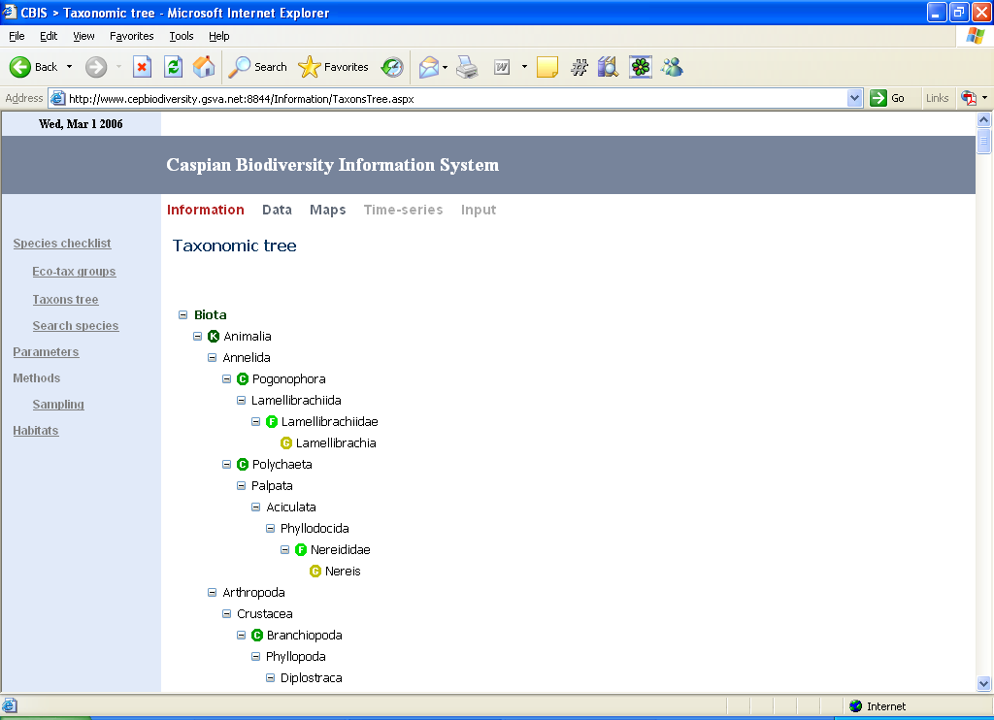

Figure.2.3 The example of the expanded taxonomic tree

Search species

Choose the Information command in the main menu and click Search species in the menu at the left side of the window.
This form means for species searching by name, Fig.2.4, it lets to enter both a full species name and a part of the name on same principle as search the whole by it’s part. The system searches and offers the list of the species which are of the specified correspondence with the string entered.

User can choose between a Scientific name and a Common name and assign the kind of the correspondence between the string to enter and possible species names:

Begins with – the species name must begin with the input string;
Contains – the species name must contain the input string;
Ends with (Заканчивается на) – the species name must end with the input string;
Is in full – the species name must fully coincide with the input string.

Searching may be confined by additional criteria: ecologo-taxonomic Group, Origin and registering in Red books.

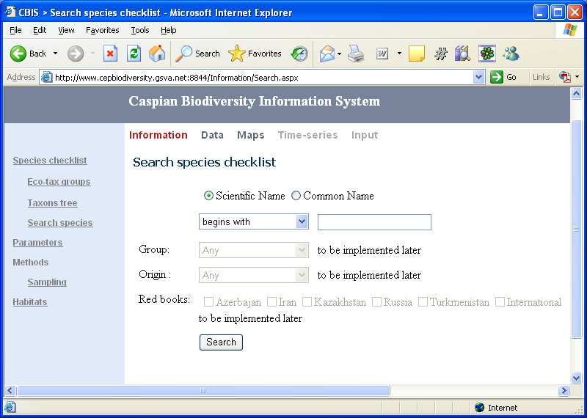

Figure 2.4 The species searching form.

Species checklist edit

All biological data records contain the link to the position in the taxonomic tree. User can’t add biological data record if there is no corresponding taxon in the database. Taxonomic tree edit operation is available only in the Administrator mode in the specially designated form.

There are several modes of the species checklist edit operation:

Add new taxon

Before adding new taxon it is necessarily to check whether the new name already presents in the database. There are two ways to do this. Either you browse the taxonomic tree (see Taxonomic tree) or you search by name (see Search species).

Example: You want to add a new name: Example marinum (Smith, 1850).

After searching this name you find out that the name is not present in the species checklist. However, before you add the name, you need to repeat the search procedure to be sure the genus Example is present in the database. If genus Example is not also present then continue the search until you find the closest parent. It can be genus, family, class or higher rank taxa. In other words, you can add a taxon only downward direction, i.e. from a “parent” to a “child”.

Figures 2.5-2.12 illustrate adding and editing the Caspian species checklist by the example of Skeletonema subsalsum (Cleve-Euler) Bethge, 1928.

Search the nearest “parent” taxa. This is genus Skeletonema. Click the button Add child taxa.

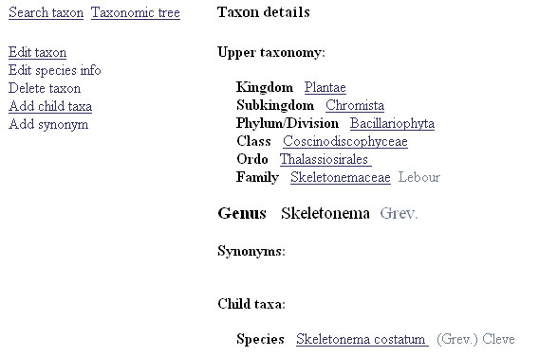

Figure 2.5 Adding new taxon.

Then the form for entering the main characteristics of the taxon is open:

Rank – choose the rank of the new taxa from the dropdown list. Only ranks below the rank of the parent taxa are available, Fig. 2.6.
Taxon scientific name: - enter the scientific name of the taxon in the text box right to the rank dropdown list. Keep in mind that for the species you should enter only the epithet. In our case it will be “subsalsum”. The same rule should be followed while inserting subspecies, variety, subvariety, forma, subforma.
Author and year – in our example, (Cleve-Euler) Bethge, 1928
TSN: Integrated Taxonomic Information System – Taxonomic Serial No ITIS, if available.

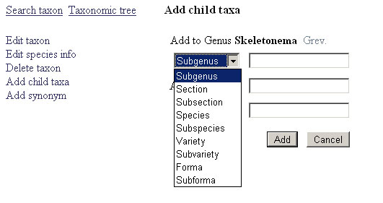

Figure 2.6 Choosing taxon rank.

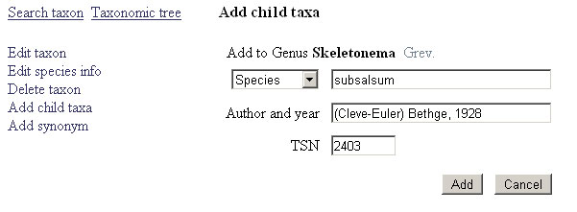

Figure 2.7 Entering main taxon characteristics

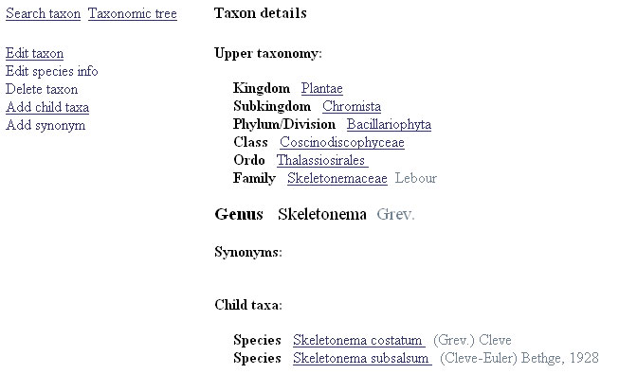

Figure 2.8 The result of adding new taxon

After you have filled all entry fields, Fig. 2.7, click the button Add to insert taxa to the database or Cancel to return to the parent taxa page. After new taxa has been added the system returns to the parent taxa page and you’ll see the Child taxes section at the bottom of the page with new taxa Skeletonema subsalsum (Cleve-Euler) Bethge, 1928, Fig. 2.8.

Edit taxon

To edit a taxon go to the taxon record and click the button Edit taxon. You can change the rank, scientific name, author and year, TSN fields. Only ranks below the rank of the parent taxa are available. Changes will be written into the database after clicking the button Update, Fig.2.9.

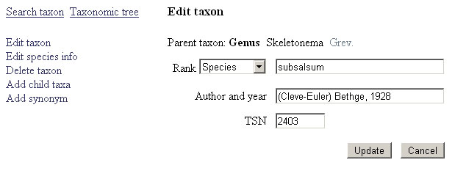

Figure 2.9 Editing taxon

Edit additional species information

When taxa with the rank below or equal species was inserted into the database, you should enter additional species information. To do this operation, click the button Edit species info. The following entry fields will be available, Fig.2.10:

Group - zooplankton, phytoplankton, benthos etc.;
Origin - freshwater, brackish etc.;
Relative magnitude – widespread, common etc.;
Distribution areas – Northern Caspian, Middle Caspian;

Changes will be written into the database after clicking the button Update.

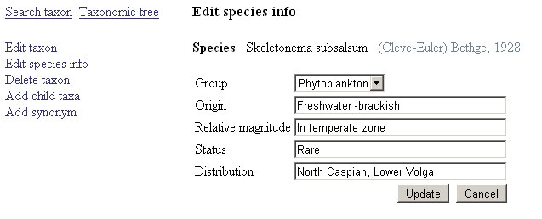

Figure 2.10. Additional species information editing.

Add synonym

To add synonym click the button Add synonym. This operation is available only for the taxa of the species rank or below.

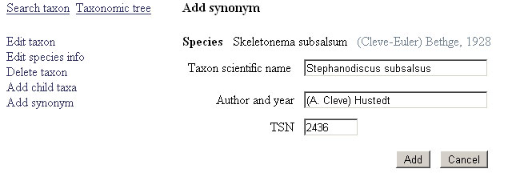

Figure 2.11 Adding synonym

Later fill in text entry fields similar to the topic Add new taxon:

Taxon scientific name – e.g. Stephanodiscus subsalsus;
Author and Year - e.g. (A.Cleve) Hustedt;
TSN – e.g. 2436.

After clicking the button Add the system writes information into the database and returns to the previous level where you see the result of adding synonym in the Synonyms section at the bottom of the window, Fig. 2.12.

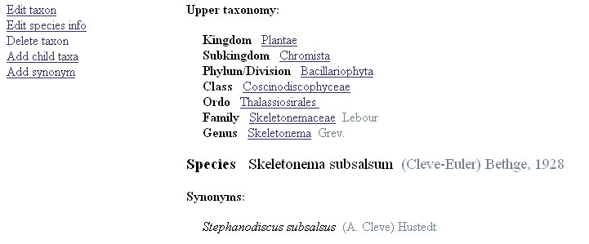

Figure 2.12 The result of adding synonym.

3 Auxiliary information

Parameters

Choose the Information command in the main menu and click Parameters in the menu at the left side of the window.

The database contains the information of the different parameters or variables both biological and environmental, for example, abundance, biomass, temperature, oxygen etc. Parameters are presented as lists aggregated for the biological, physical and chemical variables together with units, Fig.3.1. New parameters can be added to the system.

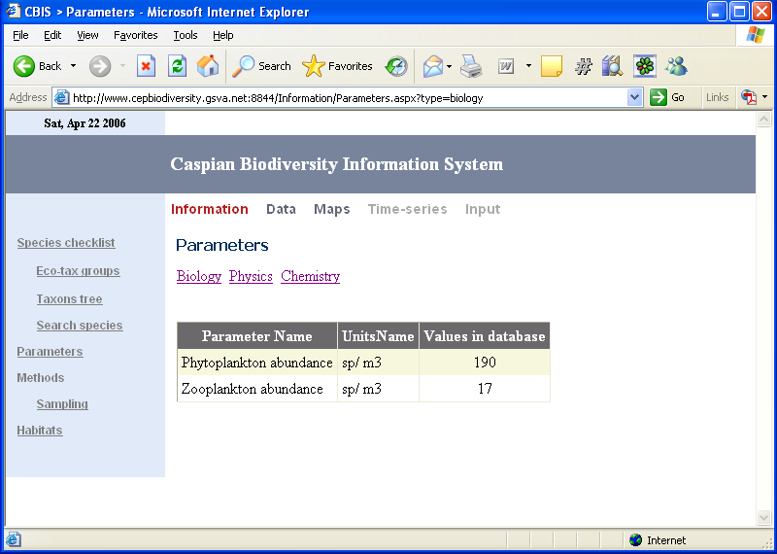

Figure3.1. The form of the parameters presentation.

Methods

Choose the Information command in the main menu and click Methods in the menu at the left side of the window.

Information can be obtained by various methods: sampling, fixation, processing, sedimentation and others. The form of the methods presentation encloses names of methods, methods description and picture (if available), Fig 3.2.

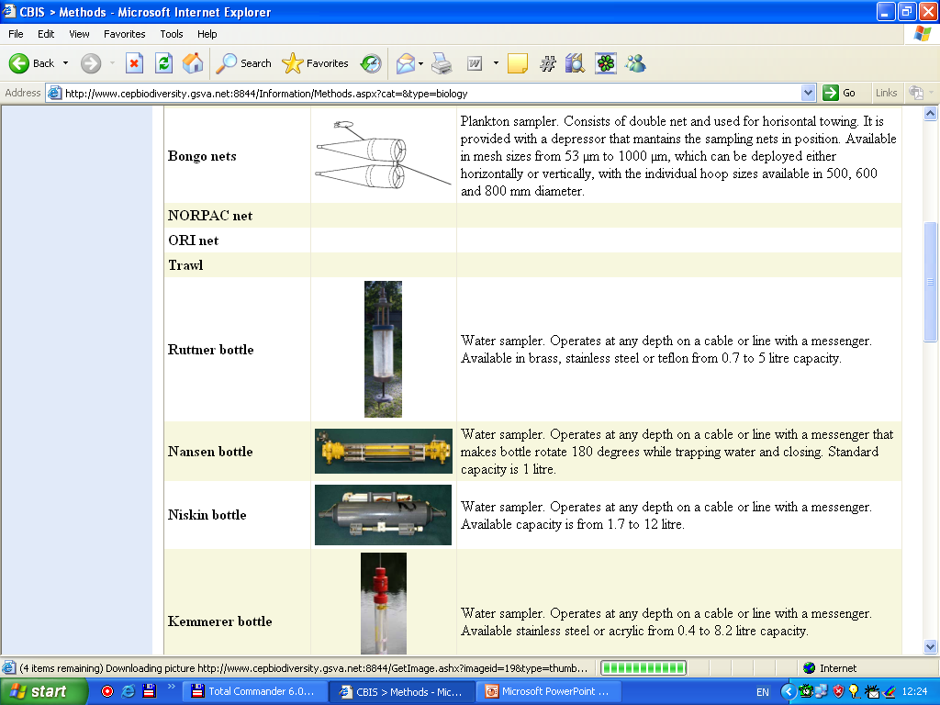

Figure3.2. The form of the sampling method presentation.

Organizations

Choose the Information command in the main menu and click Organizations in the menu at the left side of the window.

Persons

Choose the Information command in the main menu and click Persons in the menu at the left side of the window.

Ships

Choose the Information command in the main menu and click Ships in the menu at the left side of the window.

This form, Fig.3.3, provides information on ships which used for data collection. Information can include the following: Ship name, Dimensions, Displacement, Owner and others. Entry to the form also is available from the window with cruises list, see section Data retrieval.

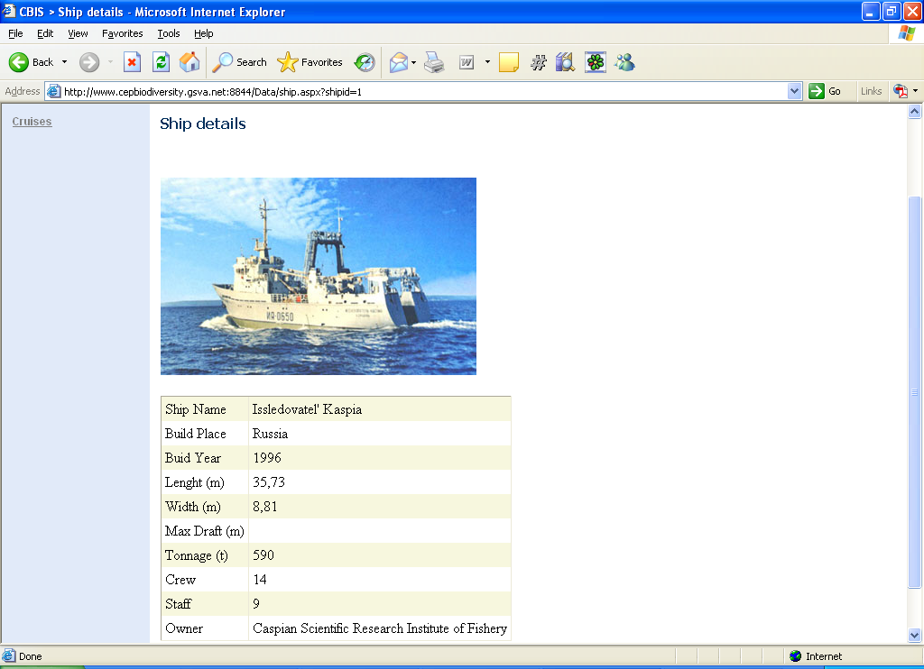

Figure 3.3.The ship information form.

Habitats

Choose the Information command in the main menu and click Habitats in the menu at the left side of the window.

This form, Fig.3.4, contains the types of the habitats by general geographic features such as deltas, coastal dunes, lagoons etc, according to The Coastal Systems of Europe (http://www.coastalguide.org/typology/typrcol.html.)

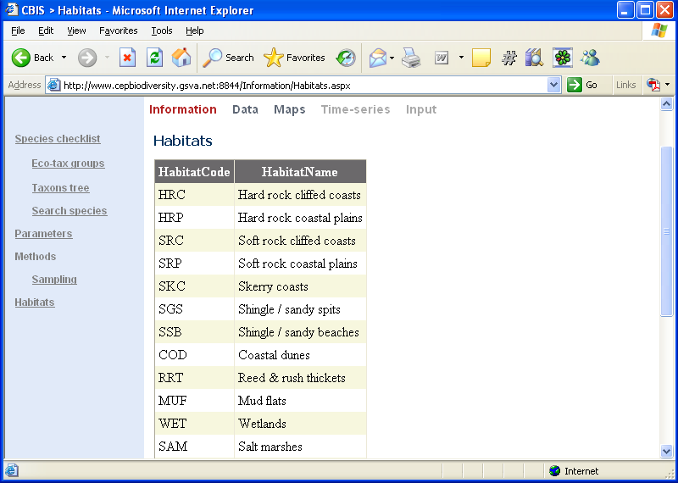

Figure 3.4 The habitats information form.

Biotopes

Choose the Information command in the main menu and click Biotopes in the menu at the left side of the window.

Sites

Choose the Information command in the main menu and click Sites in the menu at the left side of the window.

4 Data retrieval

Simple search

The simple search of the data is realized by selection in the research cruises list or in the list of sites where regular observations were conducted.

Choose the Information command in the main menu and click Cruises in the menu at the left side of the window.

After the choice of the cruise the window with the a list of implemented stations is open, Fig.4.1. The list of stations consists of the following information: station name (number), coordinates, date and time, measured variables, amount of measurements and depths of measurements. After click on the station name (the first column) the window of the selected station data is open, Fig. 4.2. It presents raw station information in digital and graphical view.

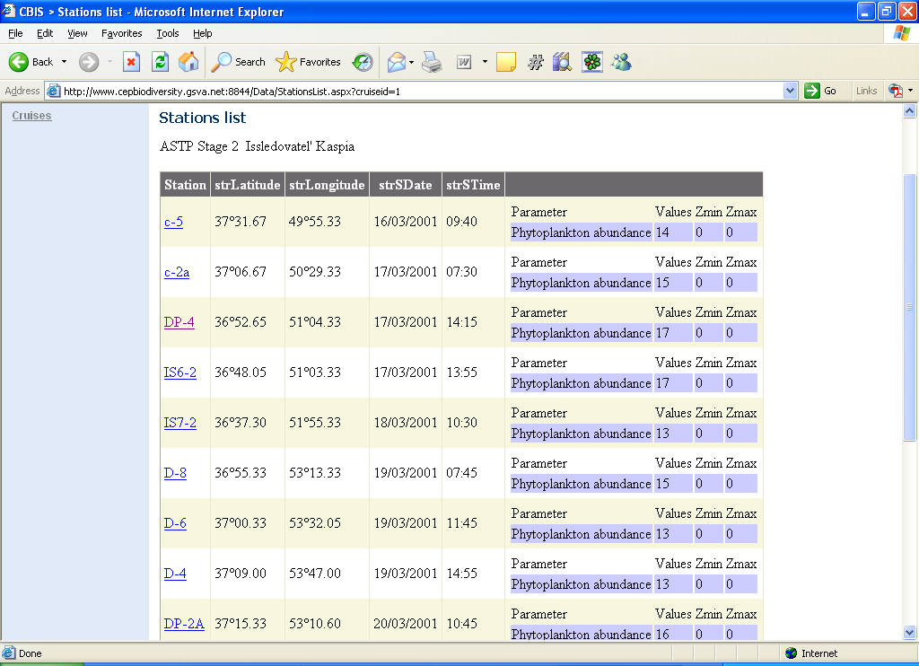

Figure4.1. The window with the stations list of the selected cruise.

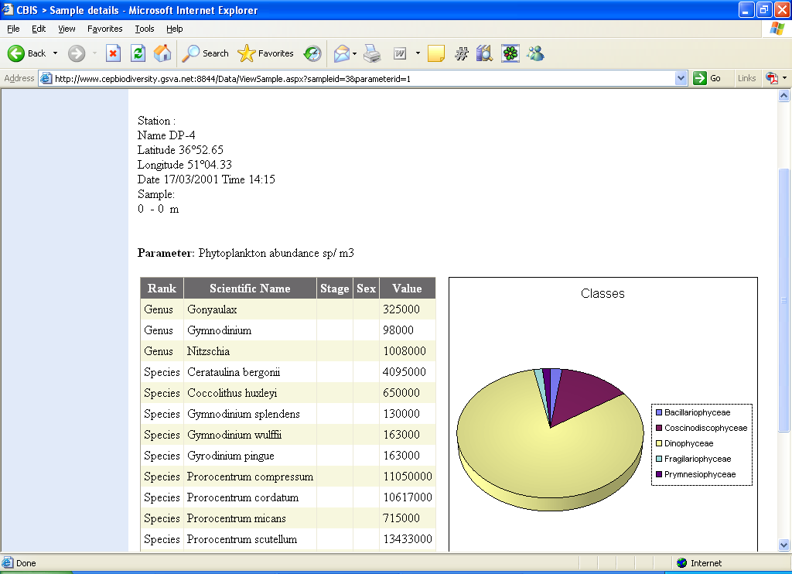

Figure 4.2. The window of the selected station data.

Advanced search

Choose the Information command in the main menu and click Search in the menu at the left side of the window.

With the help of this form user can search information by comprehensive set of criteria, embraced most of the database fields. They can include coordinates, time period, parameter, sampling method, institution, biotope, site and others.

5 Mapping

The system allows to create maps, the spatial distributions of the different data queries in the view of the symbols placed on a geographical chart of the Caspian Sea.

Creating biological maps

Choose the Map command in the main menu and click Biology in the menu at the left side of the window.

In the form for creating maps, Fig. 5.1, user must choose the taxon, parameter, time period, depth range. Information input takes place in the following controls:

Scientific name – the full scientific name (species, family etc);
Look up – search taxon name by an incomplete input string, in similar manner as in the topic Search species of the section Taxonomic information;
Look up in tree – search taxon name by the taxonomic tree created on the basis of the taxons stored in the database;
Parameter – choose biological parameter, for example, abundance;
Choose in the three-position radio-button:
- No estimations – no calculation additional characteristics;
- Contribution to total – the taxon contribution to the total sum of all the taxons (%);
- Amount of species –amount of species for this taxon (genus and higher);
Date – the date period in the format of day/month/year, e.g. 21/06/1981;
Layer – the depth range, m.

If a species name was not entered the map will be created, e.g. abundance, as the sum of all the taxons at every station (probe).

After clicking the button View map the map window is open, Fig.5.2, where variable values is shown at every station by digits and relative symbol size. While the mouse moves across the map, decimal coordinates are represented at the left bottom corner of the window. When positioning cursor on a station symbol, information on the station name, coordinates, date and time will emerge in corresponding text boxes at the right side of the window. To refuse from showing digital values over the symbols click the check-box Show values. When double-clicking on a station symbol the window of the detailed station information is open.

Map operations lie in the following:

Zoom In – press the right mouse button inside the map and choose Zoom In. Or press Ctrl and select a region by the left mouse button;
Zoom Out - press the right mouse button inside the map and choose Zoom Out. To return initial map scale choose Original View;
Scrolling (Pan) - press Alt while dragging the map.

If the map does not appear at all you need to install the Adobe SVG Viewer. Click the link SVG viewer at the top right side of the window and choose in the Adobe Web-site the component which corresponds your operating system (for MS Windows - English Win 98-XP).

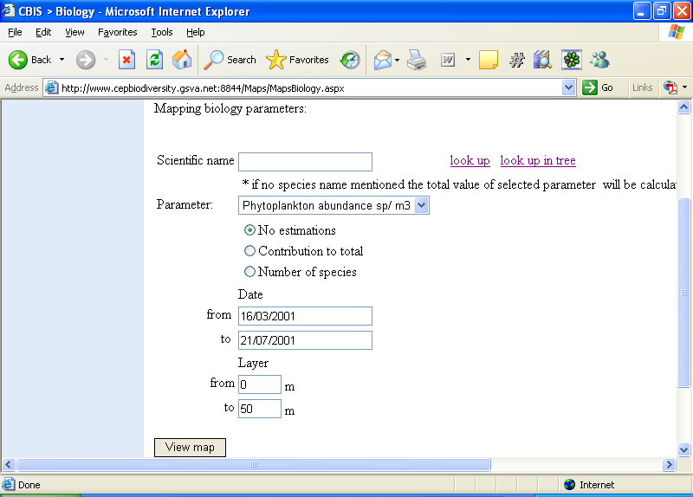

Figure 5.1 The form of the input information for biological map creating.

Figure 5.2 The biological maps window.

Creating environmental maps

Choose the Maps command in the main menu and click Physics or Chemistry in the menu at the left side of the window.

Creating environmental map is similar to creating biological map with the exception of choosing taxon and biological estimates.

6 Time-series

Creating biological time-series graphs

Choose the Time-series command in the main menu and click Biology in the menu at the left side of the window.

For creating time-series graph user must choose the taxon, parameter, geographical area, depth range. Information input takes place in the following controls:

Scientific name – the full scientific name (species, family etc);
Look up – search taxon name by an incomplete input string in a similar manner as in the topic Search species in the section Taxonomic information;
Look up in tree – search taxon name by the taxonomic tree, created on the basis of the taxons stored in the database;
Parameter – choose the biological parameter, for example, abundance;
Layer – the depth range, m.

Geographical area can be restricted by bound coordinates (minimal and maximal latitude and longitude) or by choosing the specific site from a list.

If a species name was not entered the time-series graph will be created, e.g. abundance, as the sum of all the taxons at every station (probe).

After clicking the button Show graph the graph window is open. The Y-axis contains values and the X-axis contains dates accordingly.

Creating environmental time-series graphs

Choose the Time-series command in the main menu and click Physics or Chemistry in the menu at the left side of the window.

Creating environmental time-series graph is similar to creating biological graph with the exception of choosing taxon.

7 Data input

Manual data input and edit

Choose the Input command in the main menu. This operation is available only in the Administrator mode.

Most of the records in the database can be added, deleted, updated in the edit form shown on Fig.7.1 It consists of two parts: the Master table located at the left which contains only the main fields for quick navigation and the associated Detailed form at the right where all the data fields are displayed. Each record in the master table is accompanied by a link Select selecting that row and linking it with the detailed form. The example of input and editing cruise stations is shown below.

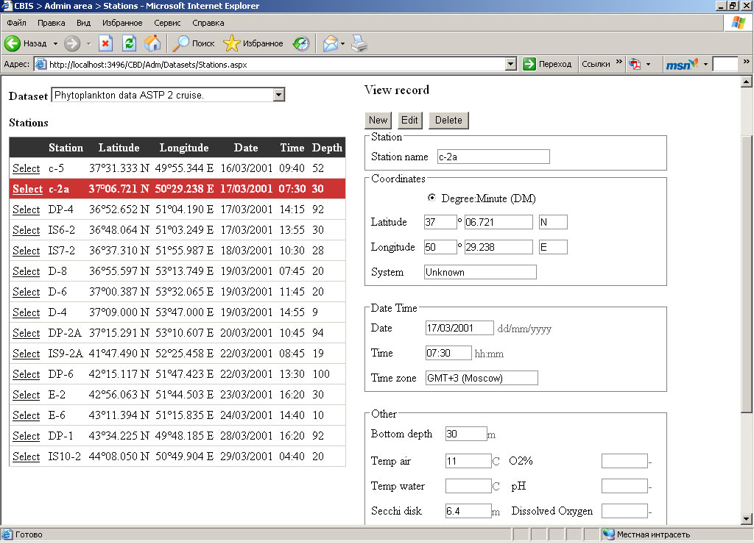

Figure 7.1 The form of the data input and editing.

There are several modes of this form operation:

Empty data mode – no rows in the master table are selected, only the button New is available, Fig 7.2. After clicking New button the switch to Edit mode occurs;
View mode – a row is selected in the master table, associated information is displayed in non-editable fields of the detailed form, updating is not available.

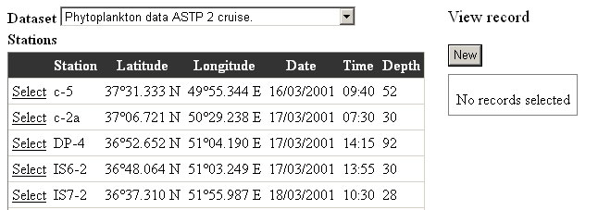

Figure 7.2 Empty data mode.

Edit mode – a row is selected in the master table, after clicking the button Edit or New user can enter information in fields of the detailed form, Fig.7.3. After the finish of editing click on the button Update or Insert.

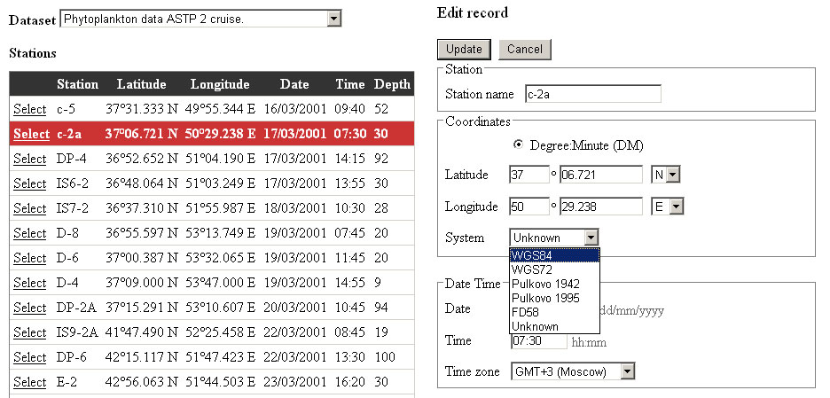

Figure 7.3 Edit mode

The system checks whether all the fields are filled and whether formats are correct. In case of mistakes (for example, 01/14/2001 instead of 14/01/2001) error messages appear where appropriate, Fig.7.4. User should correct mistakes and once more click the button Update or Insert.
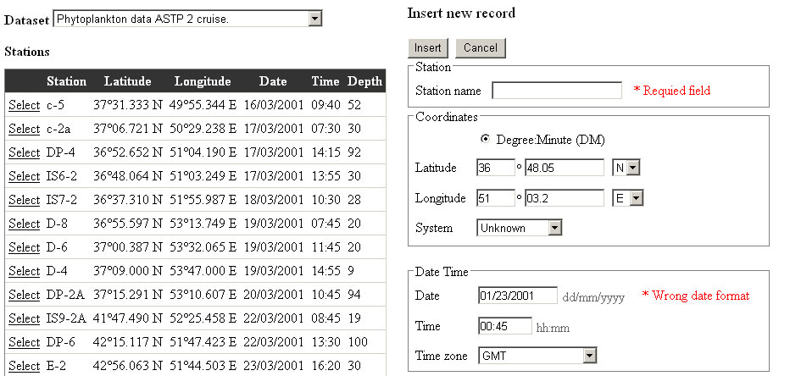

Figure 7.4 Error messages while editing.

Delete mode – a row is selected in the master table, after clicking the button Delete the system asks the confirmation on record deleting, Fig. 7.5.

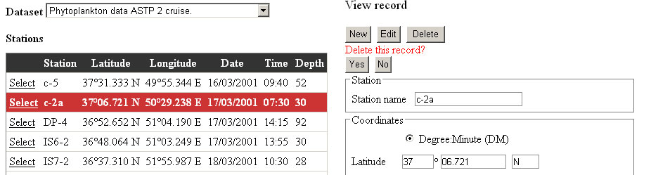

Figure 7.5 Deleting record.

