Monday 22nd May

09:30-11:00 Introduction and overview of workshop

Opening Statement

It is our pleasure to invite Dr Faig Askerov, Associate Environmental Director of BP, and manager of BP’s Environmental Monitoring Programme, to make an opening statement to this workshop

Introduction

This workshop is intended to initiate the process of collecting and using environmental information in support of the overall aim of understanding and protecting the biodiversity of the Caspian region, and in particular of the Caspian Sea.

The workshop will be interactive – each topic will be introduced and described, the key issues will be highlighted, and then participants will be encouraged to provide their comments and recommendations. Methods presented and discussed here should be regarded as working drafts only – the aim is to reach consensus agreement between the participants on the final details of each method.

Working draft proposals for the methods are contained in the document ‘Monitoring Protocols and Specifications’, which also provides a discussion of the main issues related to each type of monitoring. It should be noted that we do not aim to cover in detail all the forms of monitoring described in this document. It is our aim to focus primarily on two aspects of marine monitoring – the benthos and the plankton. These ecological communities are crucial to the health and sustainability of the Caspian ecosystem; in line with the modular approach described below, this will provide a manageable and achievable beginning to an integrated monitoring programme which is expected to develop in complexity and comprehensiveness over a period of years.

At each stage of the workshop, forms will be distributed to list the parameters and procedures under discussion. Participants will be requested to indicate their view on each item listed – in most cases this will either be acceptance of the proposal, or their own proposal for an alternative.

It is emphasised that the primary purpose of this workshop is to

- identify and agree methodologies which will make the implementation of a consistent, coordinated regional monitoring programme possible and practical
- provide training in the use of the information system, to enable participating scientists to make effective use of the monitoring data in work related to biodiversity

It is not the purpose of this workshop to provide practical training in the collection and processing of environmental samples. In field work, experience is essential for the collection of quality samples and the generation of quality data. Theory alone is not sufficient. The only realistic way to gain experience is to work as part of a skilled team. It is assumed that most, if not all, participants have either already acquired such experience, or will be working as part of a team which has such experience.

Purpose and focus of workshop

This workshop has five primary aims:

- to establish a ‘modular’ approach to developing an integrated multi-national monitoring programme
- to establish the principles of harmonised monitoring methods and design, and the associated technical assurance and control processes
- to review, discuss and agree common standards for aquatic monitoring methods and design
- to exchange preliminary information on objectives and approaches for terrestrial monitoring
- to introduce participants to the structure and use of the biodiversity information system

Modular approach

Biodiversity monitoring can be an intensive and expensive process, and a fully-comprehensive programme for the Caspian region would require a very large commitment of funds and resources by all the Caspian states. It is therefore proposed to adopt a modular approach, in which the first stages of the programme focus on limited, achievable objectives in areas of common interest and concern to all States. Once the first stage of the programme is fully and successfully operational, the countries can give consideration to expanding the programme to include a wider range of habitats and ecotopes.

We propose that, initially, the focus should be on implementing a standard marine monitoring programme for ‘standard’ habitat types. This will enable all countries to generate comparable data, with the benefit that when the data are combined the opportunity to identify ecological trends will be maximised.

Harmonisation of methods and design

It is important to recognise at the outset that no methods give absolute information. The data we receive are always dependent on the methods adopted. If each country uses different methods, or even variants of the same method, their data will not be directly comparable. This could interfere severely with our ability to correctly identify and interpret changes and trends, and could therefore lead to the wrong conclusions being drawn. Harmonisation of methods is therefore an essential initial stage in the process of implementing a regional biodiversity monitoring programme.

The data generated by the regional monitoring programme will form the core of the biodiversity information system, and it is essential that

- the data are comparable and
- that it is possible to verify that the data are comparable

The reason for this is that these data will be used over a period of many years, to assess ecological changes and trends. At any point in the future, scientist using the data may note interesting features, which may have important implications. These scientists may need to confirm the methods used to generate the data, before they can draw conclusions about these features. The only way to reliably achieve this is for all data providers

- to follow agreed written methods,
- to include checks on precision and accuracy, and
- to submit the data with a formal confirmation of the methods with reference to the relevant documentation
- to clearly document in detail any deviation from the written method, and to submit this documentation with the data

Review, discussion and agreement of common standards

The technical part of the workshop will proceed as follows:

- Each aspect of monitoring will be introduced in turn
- A basic technical specification for methodology will be provided
- This technical specification will be discussed by all participants, and any suggested alternatives will be noted and discussed
- The implications of specific technical issues will be considered
- If consensus is reached, a draft final specification for each method will be proposed

It is not the intention of the workshop to impose specific methodologies on countries. The aim is to promote consideration and discussion of the possible methodologies, and to reach agreement on standard methods for use in the regional monitoring programme.

Marine monitoring

The marine environment is the common heritage of the Caspian states, and it is proposed that this should be the focus of the first module of the regional monitoring programme. Although the Caspian Sea has many different habitats, it is a single body of water subject to common threats and pressures. Multi-national monitoring is therefore more easily integrated, and will generate data which are complementary and which will provide a strong basis for assessing the status of the Sea and the impacts of the threats and pressures.

This does not imply that other habitats (coastal, terrestrial, rivers and lakes) are not important. It is simply that an initial focus on the marine environment provides the best initial opportunity to coordinate monitoring activity between countries with maximum mutual benefit.

Terrestrial monitoring

The Caspian Coastal Sensitive Sites Consortium has begun the identification and preliminary monitoring of sensitive coastal sites. This has the initial purpose of ‘ground truthing’ existing information, and of providing an updated assessment of the status of these sites. Constraints of time and resource mean that these initial assessments are primarily qualitative – that is, they are habitat descriptions rather than detailed assessments of community composition, biomass or production. However, qualitative methods can be of great value, especially when assessing changes in the areas occupied by particular ecotopes, and in assessing the overall health of ecotopes. We are pleased, therefore, that a representative of the Consortium will be presenting a summary of their methodology on Wednesday afternoon.

Immediately preceding the Consortium presentation, Natalie Ogar will present a session on quantitative terrestrial monitoring, which will include an assessment of the use of satellite imagery as a monitoring tool.

11:30-13:00 Aims of information system and monitoring

The primary aim of the information system is to provide support to the process of sustaining Caspian biodiversity. It is intended to achieve this by placing reliable, quantitative data in a location where it can be easily accessed and used by environmental specialists throughout the Caspian region.

The primary aim of the monitoring programme is to generate data to put into the information system. The most important aspect of monitoring is to generate consistent and reliable time-series of data, from which trends can be inferred, and from which threats can be identified.

The main and most important aim of the information system is to provide a dynamic tool for assessing the status of the Caspian environment, and identifying trends in the status. While the system will also hold historical information, it is essential to recognise that much of this information may no longer be relevant to the current and future situations, and that we can only hope to understand and manage threats to the ecosystem by continuously generating new and reliable data.

This is an important principle. Our ability to detect trends depends mainly on the monitoring which is done now and in the future, and on the methods used to carry out the monitoring. In some instances, historical information may give us a useful perspective, but it is equally possible that historical information may mislead us – especially when it is not possible to formally confirm the methods used, or their precision and reliability.

We also have to bear in mind that historical information represents many thousands of years of individual effort, over more than a century. The full Caspian species list developed for CEP was more than 500 pages, including several thousand species. This list has been reviewed, to limit it to those species which can be confirmed as true Caspian residents, but is still very long. It is essential to recognise that, in any single year of monitoring, we can not hope to find more than a small fraction of all these listed species. This raises the question: how can we then detect changes in biodiversity, and what changes would be detectable? If the species list for one year includes (for instance) only 10% of the species on the ‘master’ list, does this mean that 90% of species have disappeared? In practical terms, it is the case that we might need to monitor for many years just to record one instance of a particular species on the list.

The preceding paragraph indicates that we need to be very careful about using historical data to compare and interpret the results of present or future monitoring activities. The only trends or changes we can identify with confidence are those based on comparable data sets, and the aim of implementing an integrated programme is to generate comparable data sets. It is clear that a single survey, or a single year’s monitoring, will not detect all the species present in a list developed over many decades. Since we cannot expect routine monitoring to provide a complete picture of all the species present, we will need to consider ways in which to use the data constructively. Simply comparing presence and absence of species, or the number of species, between new and historical data will not give us useable information.

Cooperation and coordination between countries is an essential pre-condition for success. This needs to cover issues such as:

- Coordination of methods and technical assurance
- Agreement on the habitat types to monitor
- Agreement on the timing and frequency of monitoring
- Agreement to place results in the information system in a timely manner

If at least some minimum aspects of marine monitoring are fully coordinated, the result will be that we can combine the results into a large data set which will permit more sensitive, reliable, and informative interpretation. This will in turn strengthen our ability to understand the status and stresses of the Caspian ecosystem, and to identify the most appropriate environmental management strategies to sustain its diversity.

14:00-15:30 The Basics of Monitoring: Method Harmonisation

Why harmonise methods?

The primary reason is that all methods, especially those used for environmental monitoring, are approximations. They do not, and cannot, provide a complete picture of the subject, but can at best reveal only a part of it. Different methods will reveal different parts, and even apparently small differences between methods may influence the results obtained.

To take the example of benthic sampling: this has two critical aspects:

- the choice of sampling device, and in particular the area and depth it samples
- the choice of sieve size used for separating the benthic organisms from the sediment

The larger the grab size, the more likely it is to capture rare or sparsely distributed organisms. If different organisations use different grab sizes, therefore, the species lists they generate will also be different. The consequence would be that different data sets might show apparent differences in biodiversity between surveys, although in reality these differences were simply a consequence of variation in methods.

The choice of sieve size is equally important. Separating organisms from sediment is an unavoidable requirement before any taxonomic work can be done. For practical reasons, the sieve cannot be too small, or it will not pass sufficient sediment. A sieve size of 0.5 mm is often used as a practical minimum, but this will of course not capture all macrobenthic organisms, and in particular will not capture all juvenile organisms. A sieve size of 0.45 mm might seem very similar, but it is likely to retain more (and smaller) organisms than a 0.5 mm sieve, and may result in higher estimates of species richness and abundance. The choice of sieve size is a practical trade-off – the larger the sieve, the more sediment is passed but fewer organisms are retained. The smaller the sieve, the more organisms are retained, but more sediment is also retained. If more sediment is retained, then the efficiency with which organisms can be picked out of the sediment will be reduced (ie, a smaller percentage of the total organisms present will actually be recorded).

There is, in practical terms, no perfect answer to the above constraints. The choice of method affects the results, and the results will never provide a complete or absolute picture. Whatever method is chosen, it will include some form of bias. If the bias differs between countries or organisations, then we will not be able to distinguish between the effects of bias and real spatial or temporal trends. In order to be able to compare data between places and times, we therefore have to ensure that (as far as possible) all the results have the same bias. We cannot eliminate bias, so we have to control it.

Precision and resolution versus cost and resource

The preceding section makes it clear that there is a trade-off between the amount of information we can get from samples, and the practicality of doing so. By taking thousands of samples, and spending thousands of man-hours processing them, we could maximise the information gained. In the real world, sampling and analysis needs to be matched to the resources and funding available – and to the timescale within which information needs to be made available and used.

The ‘law of diminishing returns’ also applies – the quality of information does not increase linearly with the amount of effort. However, it is expensive and time-consuming to try to determine precisely what the optimum level of effort is. It is necessary to work within the limitations of the technical and financial resources available, and to ensure that the effort is sustainable – one year of very high resolution data is of less value than 10 years of consistent, lower resolution data in meeting the aim of identifying and characterising trends. This is where coordination has enormous value – by beginning with a consistent approach to marine benthos and plankton monitoring, we can generate a large combined data set relatively rapidly. This allows us to learn lessons rapidly, and to more quickly identify the opportunities for optimisation.

Workshops and proficiency testing

As we have noted, the selection of methods can have a significant effect on the results obtained. The minimum requirement for generating data which are comparable is

- the use of standard written procedures
- a system for regulating the production, circulation and amendment of the procedures (to ensure that all parties are always using the most recent, agreed, version)
- a declaration of compliance with the submission of each data set or
- a declaration and description of any deviation from the methods when submitting data

If this minimum requirement is met, then future users of the information system will be able to either confirm that data sets can be combined, or to identify any reasons why one data set should not be compared directly with another. In other words, all the information required to identify any variable effect of method will be available to all users of the data.

Meeting these minimum requirements is not sufficient in itself, however. As data are accumulated and experience of a coordinated programme is gained, there will be a periodic need to evaluate methods, and if necessary to modify them to improve the quality of information. Method evaluation and assessment can be done most effectively by means of periodic workshops, which would bring together the scientific and technical specialists responsible for each country’s monitoring effort.

Modification of methods should never be undertaken without careful evaluation and planning; although improvements in data quality are always desirable, it is also essential to ensure that comparability of data is maintained. Sudden or substantial changes in methodology can, if not carefully considered, lead to changes in results which can easily be misinterpreted. Any change MUST be thoroughly validated before being implemented, and workshops are the best way in which to achieve the validation process:

- the potential impact of the change MUST be quantified – what effect will it have on the values of (and the relationship between) the parameters which are the subject of the method?
- The need for formal intercalibration between the original method and the modified method, and the implementation of a ‘transitional’ period of monitoring during which both methods will be used side-by-side

Workshops are also an essential tool in areas where there is a need for judgement, or where there may be uncertainty. In relation to the proposed initial programme, the key area in this respect is taxonomy. This is for a number of reasons:

- different taxonomists may use different sources or follow different traditions in describing and naming taxa
- not all organisms (especially invertebrates) can easily be ‘fitted’ into published descriptions (ie, they may have major similarities with described species, but small morphological differences also)
- some taxa may be distinguishable, but cannot be identified to species because the taxonomist lacks experience of the relevant biological group, or because they do not have access to appropriate taxonomic literature (in this case, the taxonomist may assign a code to the taxon, but needs some means of subsequently verifying its correct name)

These issues can all most easily be resolved by periodic taxonomy workshops. Taxonomists attending these workshops will be able to bring specimens from their most recent surveys, and to compare and discuss these specimens. Once agreement has been reached on the correct description and name of a taxon, a representative specimen can be selected, confirmed, and then added to central and national reference collections. Workshops will therefore serve to ensure consistency and reliability in taxonomy across the whole region. They will also provide the opportunity to identify the existence of distinct subspecies or regional populations of taxa, and to clearly document the range of morphological variability associated with key species. This will help to ensure that any observed ecological trends or changes are free of confusion with taxonomic uncertainty.

In summary, workshops are a key way in which experience can be shared and consolidated.

Proficiency testing is generally most useful and applicable for chemical analysis, but also has a role to play in biological investigations. The aim of proficiency testing is to provide all participating laboratories with ‘blind’ identical subsamples, and to identify methodological compliance through statistical analysis of the results. It should never be expected that all laboratories will obtain exactly the same result using the same method; statistical analysis will permit a realistic estimate of the precision and accuracy of the method, and will also enable any ‘outlier’ laboratories to be identified. The identification of outliers is particularly important, since if this is not done their data may lead to a misinterpretation of spatial or temporal trends in overall biodiversity indices and data.

In the context of the proposed initial stages of the monitoring programme, two forms of proficiency testing are appropriate:

- efficiency of biological sample processing
- accuracy and consistency of taxonomic identification
- 16:00-17:30 The Basics of Monitoring: Data Quality Assurance

What is quality assurance? Why is it important?

This term is often misunderstood. Scientists often feel that it questions the quality of their data. This is not what is intended by the term. To underline this, we prefer to use the terms

‘Technical assurance’ and

‘Technical control’

Technical (quality) assurance is simply a means of ensuring that data and procedures are recorded in a systematic and comprehensive way, so that future users of the data can clearly and independently confirm that the data were produced in compliance with specified and detailed procedures. To put it very simply – if there is no independently verifiable evidence of how data were generated, they should not be accepted for general use or for inclusion in the information system. Those responsible for a particular data set will of course be in no doubt about their compliance with specified methods, but if this information remains only in their heads then in ten years time we will have no way to check.

A standardised approach to data recording makes verification and checking much easier. It is recommended that all participating organisations should use standard data forms for all work. Many scientists have a preference for recording data in lab books, but there are a number of drawbacks to this:

- the data will be recorded in a variety of inconsistent formats, and in variable detail
- the data may not be legible to anyone but the author
- the data are bound in volumes, and are difficult to extract and to collate

The use of standard forms ensures that

- all relevant data are recorded in a consistent format (although scientists will still be free to record any additional data in lab books for their own purposes)
- the data are easily collated and copied, so that a central record can be maintained
- it is also easier to transcribe the data into an identical electronic format, which would make it possible to upload the records along with the corresponding data

Each standard form will also have provision for recording any deviation from the currently agreed and adopted method. This will allow data users to immediately identify any factor which might affect the comparability of the data, and to take this into account when analysing combined data sets.

Technical control refers to the use of standard reference or calibration materials, and to the use of taxonomic texts and keys. These are the tools which are used to check the accuracy and precision of the data. Such tools may be part of the routine operation of many organisations; for the purposes of the regional monitoring programme, it is important that participants agree the use of a common set of technical control methods.

Technical control and assurance procedures also have benefits for the internal work of each participating organisation. By providing a complete audit trail for each study or survey, they make it easier to detect and correct errors before data are uploaded into the information system.

Tuesday 23rd May

09:30-11:30 Aquatic monitoring: Sediment sampling methods

In this session, we will consider the key aspects of sampling marine sediments and benthic communities.

Grab and core sampling

Benthic monitoring is constrained by the fact that the habitat under study is not directly accessible, and must be remotely sampled. This is often technically difficult (eg, in very deep water) and expensive (due to vessel costs). Consequently, the number and size of samples which can be collected is generally rather limited.

A variety of sediment sampling instruments exist. These include standard ‘grabs’ (van Veen, Day, etc) as well as a variety of core sampling devices designed to obtain undisturbed sediment profile samples. There are practical constraints on the size and weight of device which can be deployed from survey vessels; most marine sampling devices have a sampling area of approximately 0.1 m², and will collect sediment to a depth of between 10 and 20cm.

It is recommended that the monitoring programme should standardise on the use of gravity-operated van Veen-type grabs. These are of robust and simple design, are reliable in operation, and can easily be deployed from a variety of vessel types. Experience with monitoring in Azerbaijani waters indicates that these devices can successfully sample soft sediments to a depth of at least 400m.

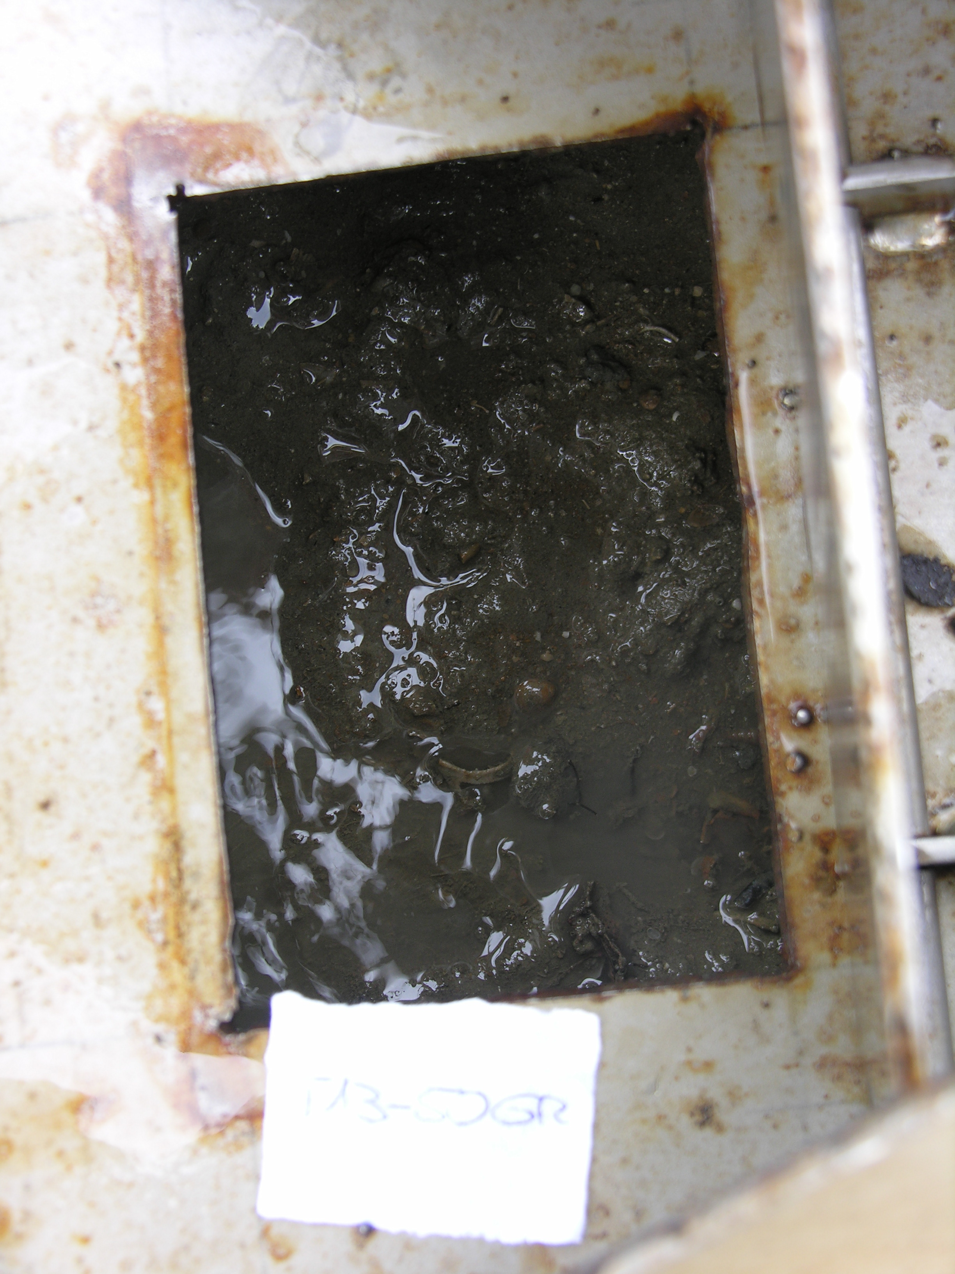
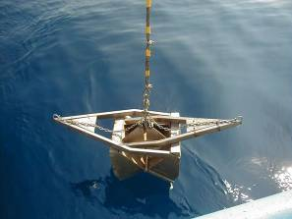

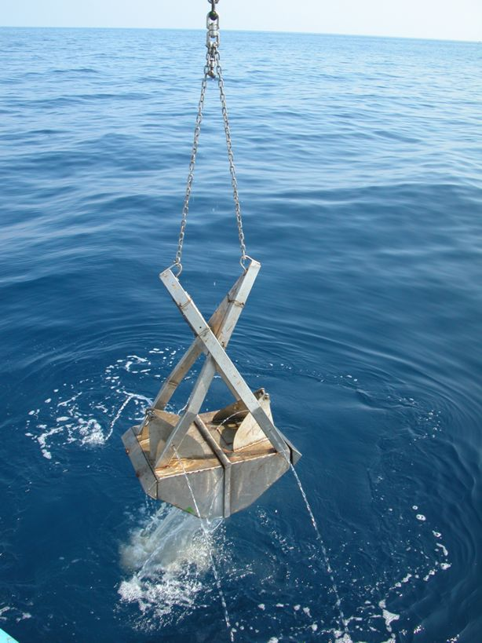

The images above illustrate a van Veen type grab before and after deployment. The grab has ‘doors’ in the upper surface, which

- minimise the ‘bow wave’ on landing, by allowing water to pass through the grab as it descends and
- permit relatively undisturbed samples for chemical analysis to be taken from the sediment before emptying the grab

Number, location and replication of samples

These are key aspects of monitoring design. Decisions about the number, location and replication of samples depend partly on the objectives of a survey, and partly on the depth of water and the resources available. Sampling in deeper water is time-consuming (it may take 30 minutes per sample in water deeper than 400m, and ‘failed’ samples will take longer to repeat), and may mean that fewer samples can be collected during a cruise.

For the purposes of the proposed initial marine monitoring programme, the primary objective will be to gain as much information as possible about the benthic biology of selected habitats which are representative of key ecotopes. Except in very shallow water, it is only practicable to routinely sample soft bottom sediments; however, the communities in such sediments

- represent a significant proportion of the invertebrate diversity of the Caspian
- contribute a significant amount of biomass to production and to the support of higher organisms such as fish and seals
- are in intimate contact with a substrate which often acts as a ‘sink’ for contaminants, and will therefore reflect the impacts of pollution (especially of organic pollutants)

A programme designed to sample soft bottom sediments at a range of depths and latitudes is therefore well suited to supporting and developing a good understanding of biodiversity status and trends.

Since the primary aim will be to characterise the biological diversity of selected habitats, rather than to ‘map’ variation in community structure within the areas, the objective should be to obtain as comprehensive a species list as possible on each sampling occasion. The number of sampling stations will depend on the size of the area, while the number of replicates will depend on the ‘patchiness’ of the habitat. A sampling area may range from a few km across, to several tens of km across.

The most important requirement is to establish the point at which additional effort does not significantly increase the number of species observed. To answer this question, it is useful to look at some empirical observations. The following observations are taken from baseline benthic studies conducted by BP over the period 1998-2005:

Species list versus frequency of occurrence of species

The following tables summarise the overall number of taxa in the major groups which have been observed in surveys carried out in the two contract areas (Azeri-Chirag-Guneshli and Shah Deniz) operated by BP. These tables indicate that only a small proportion of species occur in more than 50% of samples, and that most species were found only a small number of times. We can see from this that, even with substantial monitoring effort and expenditure, for most species there is a relatively small probability of being found in any one sample or survey. The corollary is that it is necessary to monitor consistently over long periods of time to ensure that the list of species is reasonably representative of the true diversity of the area being studied.

ACG Contract Area

Group | Number of species
Group | Common | Not common | Total
Polychaetes | 6 | 3 | 9
Oligochaetes | 10 | 5 | 15
Gastropods | 15 | 33 | 48
Cumacea | 7 | 14 | 21
Bivalve | 2 | 4 | 6
Amphipods | 17 | 33 | 50

About 180 invertebrate species have been recorded in the Contract Area, the pipeline corridor and at Sangachal Bay between 1995 and 2002. Of these, 107 species occur infrequently (in less than 5% of all stations sampled), and only about 50 species could be considered reasonably common.

Shah Deniz Contract Area

Group | Number of ‘species’
Group | Common | Not common | Total
Polychaetes | 5 | 1 | 6
Oligochaetes | 9 | 7 | 16
Gastropods | 6 | 21 | 27
Cumacea | 9 | 8 | 17
Bivalves | 5 | 10 | 15
Amphipods | 21 | 33 | 53

About 145 invertebrate species have been recorded in the Contract Area between 1998 and 2001. Of these, 85 species occur infrequently (in less than 5% of all stations sampled), and only 60 species could be considered reasonably common.

More stations or more replicates per station?

The following table summarises the relationship between number of species and the numbers of stations and replicates in a series of benthic surveys. What this table shows (and is more clear in the following graph) is that within this data set there is very little relationship between the number of samples and the total number of taxa recorded. The smallest total number of samples was 15 (three replicates at each of 5 stations) and it appears that this number of samples is sufficient to achieve a ‘plateau’ in species number.

Year | Location | No. stations | No. replicates | Total no. samples | Average taxa per station | Total no. of taxa
1995 | ACG baseline | 24 | 5 | 120 | 20 | 69
1998 | Chirag | 15 | 3 | 45 | 18 | 56
1998 | EA 1a | 5 | 3 | 15 | 19 | 58
2000 | Chirag | 15 | 3 | 45 | 18 | 53
2001 | GCA7 | 17 | 3 | 51 | 20 | 56
2001 | CA | 19 | 3 | 57 | 20 | 60
2002 | EA | 15 | 3 | 45 | 20 | 58
2003 | WC | 15 | 3 | 45 | 19 | 63
2004 | ACG regional | 12 | 5 | 60 | 21 | 65
2004 | Chirag | 16 | 3 | 48 | 20 | 50
2004 | CA | 21 | 3 | 63 | 29 | 63
2005 | WA | 21 | 3 | 63 | 30 | 58

The majority of the surveys listed above were within small areas (radius of 1-2 km), but two were wide-area surveys covering 60km by 10 km. Although these data are not conclusive, the ‘ideal’ number of samples would seem to lie between about 20 and 60.

It seems from the above that the total number of samples is more important than the number of stations, at least for localised surveys. This probably reflects the ‘patchy’ nature of invertebrate population distribution, together with practical constraints on the positioning of a grab for sample replication. Especially in deep water, a series of ‘replicate’ samples are likely to be distributed over an area 30-50 m across; this is probably considerably larger than the typical ‘patch’ size for most species, with the consequence that in many cases ‘replicate’ samples are not true replicates, but are quasi-independent.

The next question is – how should samples be distributed between stations (how many replicates per station)? There are practical advantages in minimising the number of stations, especially when sampling in deeper water, since this avoids the need to re-position the vessel a large number of times. The preceding table also shows the average number of taxa per station – note that this is mostly about one-third of the total number of taxa recorded in the survey. The following figures are taken from a study carried out by BP as part of the Shah Deniz baseline study in 1998. At two stations, ten replicate samples were taken. These graphs provide an indication of the relationship between number of replicates and number of taxa recorded:

What the left graph shows is that at one station, the number of species increases rapidly between one and 3 replicates, and that with 3 or more replicates 80% of the total number of species were captured. The right graph shows a slightly different picture, partly because these samples were taken at a location which was historically contaminated and had only half the number of species. Here, the number of species does not begin to reach a plateau until 5 replicates have been taken.

Overall, a pragmatic rule might be that, if you have 10 or more stations, then 3 replicates per station is sufficient; if you have 5 stations, then 5 replicates would be advisable. The left graph above suggests that 10 replicates at a single location will be sufficient to capture most of the species present in a larger area, but this is not an advisable strategy unless you are certain that you are sampling a homogeneous area.

It is most important to recognise that, under typical sampling conditions,

- samples at a single station will ‘contain’ roughly one-third to half of the species likely to be recorded within the entire survey
- any single survey, using standard methods, is likely to record only about one-third of the species which will be recorded in a series of surveys undertaken over a period of years or decades

This means that we cannot expect to use the species lists from individual surveys as a direct indication of biodiversity. Within the constraints of costs and practicality, it is not possible to capture every species in every survey. This is partly a limitation of the available methods, and it is partly a consequence of natural biological processes – success in reproduction and recruitment for each species varies from year to year, and we cannot expect all species to be present ‘above the detection limit’ on all survey occasions. There are two key consequences of this:

- it is essential to implement a long-term and sustainable monitoring effort, since this is the only way we can expect to obtain a comprehensive picture of species diversity
- we need to ensure that the data are used in an appropriate way – not just to examine long lists of species, but more importantly, to look for trends and interactions which might reflect the type of environmental processes which are most likely to affect biodiversity. In other words, we need to use the data to look for indirect indications which could be indicators for, or be predictive of, changes in biodiversity

Verification of location – use of GPS and DGPS

The importance of precise station location information depends on whether the aim of monitoring is to map patterns and gradients of distribution within a survey, or more simply to characterise the biology of the survey area.

The former aim requires more precise station location, since the relative position of the stations is important in identifying gradients. The primary difference between GPS and DGPS is accuracy – GPS has an accuracy of about 15-20m, which DGPS (which uses a local beacon to augment satellite information) has a positioning accuracy of about 1-3m. For most purposes within the context of a regional marine monitoring programme, GPS accuracy will be sufficient, and is easy to achieve using relatively cheap handheld instruments.

For the purposes of biological characterisation of a study area, it is NOT necessary to precisely re-visit exactly the same locations on each successive survey. It is sufficient to ensure that the necessary number of stations are distributed within the study area. For reasons mentioned above, even if the survey vessel is precisely located, there is always variation in the actual location of the grab on the seabed, so most attempts to exactly re-visit sample locations are technically unsuccessful.

It is extremely important, however, that a GPS location for each sample in each survey is recorded and uploaded to the information system together with the survey data. This will assist future users to map particular features over time and space with minimum difficulty and minimum error.

Survey log

A detailed log must be maintained for each survey, describing

- Time arrived at station
- Time sampling began
- Start and end time for each individual replicate
- Formal verification of acceptance of each sample (preferably accompanied by a confirmatory photograph of the sample)
- Records of all failed samples

The log should also record the identity of the vessel and the survey team (including roles, responsibilities and institutional affiliation), port of departure, and any ‘down time’ due to weather or equipment failure.

Sample labelling and identification

All samples should be labelled uniquely and consistently, and the survey log should record the identification code for each sample. The ability to track a sample from the point of collection to the final delivery of the data is an essential element of the technical assurance process.

Valid and invalid samples

Sampling should follow a written procedure which includes formal criteria for sample acceptance. The majority of grab (as distinct from core) sampling devices rely on two ‘jaws’ penetrating the sediment, and closing at the penetration depth to enclose the sample. The presence of stones or gravel in the sediment may prevent the jaws from closing, with the result that a substantial fraction of the sediment will wash out as the grab is retrieved to the vessel. Each grab sample should be inspected, and the sample should only be accepted if the jaws are closed and at least 75% of the depth of the grab contains sediment. The condition of the sample must be formally recorded in the survey log, and if possible a photographic record taken (with sample label visible) to confirm the status of the sample. Compliance with this requirement is essential, to provide assurance to data managers and users that the data derived from the sample are of an acceptable standard.

After the grab sampler has been secured on board, the upper doors are opened and the sample is examined for acceptability as follows:

- the sampler is not overfilled, which could be indicative of sample loss;
- overlying water is present indicating sample integrity;
- the sediment surface appears to be relatively undisturbed; and
- the desired sample depth has been achieved (ideally, at least 1 or 2 cm should remain at the bottom of the sampler after the upper layer has been subsampled).

Processing of macrobenthic samples on board the vessel

It is common practice to separate macrobenthos from samples on board the vessel, before fixation and preservation. This will require

- a receptacle into which to decant and wash the sample, and a chute to convey the washed material into a sieve
- a sieve of sufficient diameter to prevent loss of material. It is proposed to standardise on a sieve mesh of 0.5 mm (square mesh, measured on side of aperture not on diameter)
- containers of sufficient size to contain the material retained on the sieve (a volume of 5 litres is practical, since it is often the case with Caspian sediments that large amounts of shell debris are retained on the sieve)
- sufficient preservative to ensure that the material retained on the sieve can be fully permeated. It is recommended to use 4% formalin (1:10 dilution of 40% formaldehyde in seawater) as the preservative. A suitable stain should be added to the formalin before use; staining of organisms will make the subsequent task of picking and sorting easier and more efficient. It is recommended that all organisations use the same stain, to minimise any bias in sorting efficiency between laboratories

Subsampling for physical and chemical analysis

Subsamples for physical analysis should not be taken from any sample intended for biological analysis, since the removal of any sediment material could bias estimates of macrobenthos community composition and abundance. Separate samples must be taken for physical and chemical analysis.

No specific precautions are required for subsamples intended for physical analysis. Subsamples may be collected with any suitably-sized spatula or small core.

Although chemical analysis of sediments is not a primary aim of the initial programme, individual organisations may wish to take samples for immediate analysis, or for storage and subsequent analysis by specialist laboratories. There is considerable value in building up a ‘library’ of sediment samples, as long as these can be securely stored for extended periods of time.

If sample acceptability criteria are met, overlying water is carefully siphoned off (if the water is turbid, it could be allowed to settle out for a short period). During or before the sample material is removed, field measurements and observations should be noted and recorded, if required. Field measurements may include sample depth, pH, Eh (redox), specific conductivity, pore water salinity and field screening for grain size. Observations may include a determination of visual/textural soil characteristics and descriptions of visible infauna, the presence of debris, and evidence suggesting the presence of contaminants.

For subsampling, a sample aliquot is collected to the appropriate sediment depth and placed in a mixing container, such as a stainless steel bowl. It is recommended that sample aliquots be collected with stainless steel utensils such as spoons, spatulas, or ‘cookie cutters’ although PTFE (Teflon) implements may be substituted. Sample material should be thoroughly homogenized prior to splitting into separate sample containers. If sample aliquots are to be collected from multiple sampler deployments, the stainless steel bowl containing the sediment should be covered between deployments to minimize contamination from the immediate environment and stored in an ice chest or cooler. A successful sampler deployment with a 0.1-m2 Van Veen grab will yield enough material from the upper 2 cm to fill about three 250 ml containers.

Avoidance of cross-contamination

Proper cleaning of both sampling equipment and containers will enhance the representativeness of a sample by ensuring that detectable analytes are sample-related rather than equipment-related.

The following procedures for cleaning sampling equipment are general and can be used successfully in most sampling situations.

Field decontamination of sediment sampling equipment and associated utensils should be conducted between sampling stations by scrubbing with a brush and phosphate-free detergent solution to remove excess sample material. All equipment should then be thoroughly rinsed with clean in situ water, using either a clean hose while on deck, or by repeatedly submersing the equipment overboard. It is desirable to give the sample-handling utensils a secondary rinse with analyte-free water. At contaminated sites with high concentrations of organic compounds, a solvent rinse may also be necessary prior to the final analyte-free water rinse.

The most suitable detergents would be those that leave the least amount of residue behind, especially residue containing analytes that could bias sample results. A disinfecting detergent may be required if, sampling equipment will be used for collection of samples for biological analysis.

For projects where sediments are expected to be relatively clean, solvent or acid decontamination in the field is not recommended due to the potentially hazardous nature of these chemicals; their introduction into the sampling environment should consequently be avoided. At more contaminated sites, particularly where organic contamination is expected to be high, it is acceptable to use methanol, acetone, or a 50:50 acetone/hexane mix as a rinse for sampling utensils, as these solvents pose less of a threat to personnel and the environment. Decontamination with solvents should always be performed on an open deck of a vessel or outdoors if on land. If trace metals analysis is to be performed on samples, a weak dilution of nitric acid (10 percent HNO3) may be used as a rinse. All solvent and acid rinses should be followed by thorough rinses with analyte-free water. All decontamination fluids that include solvents or acid rinses should be properly contained and not allowed to enter the environment. Evaporation of small amounts of residual solvent into the air is acceptable.
A tiered approach may be taken to equipment decontamination for sediment sampling when the expected level of contamination is known in advance.

If the sediment represents ambient conditions, decontamination may consist of merely scrubbing the sampling equipment to remove residual sediment followed by a thorough rinsing with in situ water.

If the sediment is slightly contaminated, decontamination may consist of scrubbing with a water and phosphate-free detergent mixture, followed by rinses with in situ water and analyte-free water. If the sediment is heavily contaminated, decontamination may consist of scrubbing with a water and phosphate-free detergent mixture, a rinse with in situ water, rinses with solvents and/or acids, and a final rinse with analyte-free water.

Another option would be to have additional sets of precleaned sampling utensils on board so that a fresh set could be used at each new sampling station. Advantages are that decontamination could be conducted under more controllable conditions on shore, cleaning time would be minimized between stations and there would be little onboard need for solvents and/or acids.

Field decontamination of water sampling bottles should consist of thoroughly rinsing the bottle analyte-free water followed by a thorough in situ rinsing.

Sediment sample containers, preservation and transportation

The following table provides an indication of suitable container types and preservation methods for sediment samples collected for different parameters. All containers should be cleaned prior to mobilisation of the survey. The cleaning process should be documented to provide formal confirmation that results are unbiased by container contamination.

For trace metals analysis, new sample containers should always be used. Sample containers and lids should be thoroughly cleaned with a phosphate-free detergent solution, thoroughly rinsed with metal-free water, soaked for 24 hours in 20 percent HNO3 or 50 percent HCl, and rinsed with metal-free water. The acids used should be of at least reagent-grade purity.

Sample containers and lids used for semivolatile analysis should first be washed with a phosphate-free detergent solution, followed by thorough rinses with hot tap water and analyte-free water. The last step should be an acetone rinse, then a final rinse using high purity methylene chloride. The lids should be in place on the container during this rinse step (solvent in the container with the lid tightly screwed down) because the solvents may rinse ] plastic from the interior screw threads onto the Teflon lining. Firing of glass containers at approximately 350°C for 4 hours may be substituted for the final solvent rinse only if precautions are taken to avoid contamination as the container is dried and cooled. For analysis of volatile organic compounds, sample containers, screw caps, and cap septa (silicone vapour barriers) should be washed with a phosphate-free detergent, rinsed once with tap water, rinsed at least twice with analyte-free water, then dried at greater than 105°C. A solvent rinse should generally be avoided because it may interfere with the analysis, although a methanol rinse may be acceptable.

Parameter | Minimum Sample Size (g wet wt.) | Container | Preservation Technique | Holding Time
Particle Size | 100 to 150 | Glass or Polyethylene | Refrigerate, 4°C | 6 Months
Total Solids | 50 | Glass or Polyethylene | Freeze, -18°C Refrigerate, 4°C | 6 Months 14 Days
Total Volatile Solids | 50 | Glass or Polyethylene | Freeze, -18°C Refrigerate, 4°C | 6 Months 14 Days
Total Organic Carbon | 25 | Glass or Polyethylene | Freeze, -18°C Refrigerate, 4°C | 6 Months 14 Days
Oil and Grease | 100 | Glass | Freeze, -18°C Refrigerate, 4°C | 6 Months 28 Days
Total Sulfides | 50 (a 250 ml sample for 5 ml Zn Acetate) | Glass or Polyethylene | Refrigerate, 4°C (2 N Zn Acetate - 5 ml) | 7 Days
Acid Volatile Sulfides | 50 | Glass (no headspace protect from O2) | Refrigerate, 4°C | 14 Days
Total Nitrogen | 25 | Glass or Polyethylene | Refrigerate, 4°C | 28 Days
Biochemical Oxygen Demand | 50 | Glass or Polyethylene | Refrigerate, 4°C | 7 Days
Chemical Oxygen Demand | 50 | Glass or Polyethylene | Refrigerate, 4°C | 7 Days
Volatile Organics | 50 | Glass (no headspace) | Refrigerate, 4°C | 14 Days
Semivolatile Organics | 100 | Glass | Freeze, -18°C Refrigerate, 4°C | 1 Year  14 Days
Organotins | 100 | Glass | Freeze, -18°C Refrigerate, 4°C | 1 Year  14 Days
Methyl Mercury | 100 | Teflon or Glass | Freeze, -18°C | 28 Days
Mercury | 50 | Polyethylene, Glass (LDPE) or Teflon | Freeze, -18°C Refrigerate, 4°C | 28 Days  28 Days
Metals | 50 | Polyethylene (LDPE) | Freeze, -18°C Refrigerate, 4°C | 2 Years 6 Months
Microbiology | 100 | HDPE (Autoclaved) | Refrigerate, 4°C | 24 Hours
Bioassay | 7 Litres | Glass or Polyethylene | Refrigerate  Protect from light | 2 Weeks

12:00-13:00 Aquatic monitoring: Water sampling methods

Water sampling for determination of chemical composition is not a primary focus of this workshop. This is partly because the chemical analysis of brackish water is complex and expensive, and partly because issues related to water contamination are being addressed by other, specifically-designed, projects. However,

- it is of value to determine some basic physical parameters, and nutrient levels, since these have direct relevance to the status of plankton populations and
- it may be of value to other projects and programmes to request that biodiversity surveys take additional samples for their use

In-situ sampling – traditional methods and CTD

Where possible, data should be obtained on in situ water temperature, salinity and dissolved oxygen concentration using a multi-probe device. A range of devices are available; it is essential that all detectors are calibrated before each use, and that the calibration process is fully documented.

Some devices also measure turbidity, which may be useful in lakes, rivers and coastal waters. In shallow waters, an approximate measure of water clarity can also be obtained using a Secchi disk.

Some measure of light penetration at different wavelengths is also useful, especially in support of studies intended to investigate primary production processes in detail.

Water bottles

The main objective of water column sampling is to obtain representative samples from discrete depths at an established sampling point. Water column samples are usually collected with some type of water bottle sampler. These samplers typically consist of a cylindrical tube with stoppers at each end, along with a closing device that is activated from the surface by a messenger or an electrical signal. Niskin, Van Dorn and Kemmerer samplers are some of the samplers most commonly used.

Multiple water samplers may be either sequentially attached to a hydrowire so that several discrete depths can be sampled during one cast, or they may be mounted on a rosette-type frame, which allows replicate sampling at the same depth. Water samples may also be collected with a pump, the intake of which has been deployed to a known and desired sampling depth.

Regardless of the sampler type, it should have sufficient capacity to supply adequate volume for the tests required. It is also important for inner surfaces that come in contact with the sample to be made of inert, noncontaminating materials.

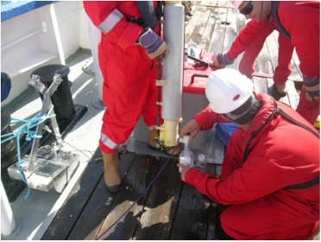

Zooplankton

It is recommended that zooplankton sampling should be carried out using double coarse and fine nets equipped with flowmeters. A double net arrangement is illustrated below. Mesh size should be standardised – 200-305 um would be appropriate for adult zooplankton, while mesh in the range of 50-100 um is more suitable for meroplankton and the developmental stages of holoplankton.

Samples taken for Mnemiopsis enumeration should be taken at low towing speeds, and the material should be preserved in 2% formalin. Samples taken for other zooplankton should use a tow speed of < 3 knots, and the samples should be preserved in 4% formalin.

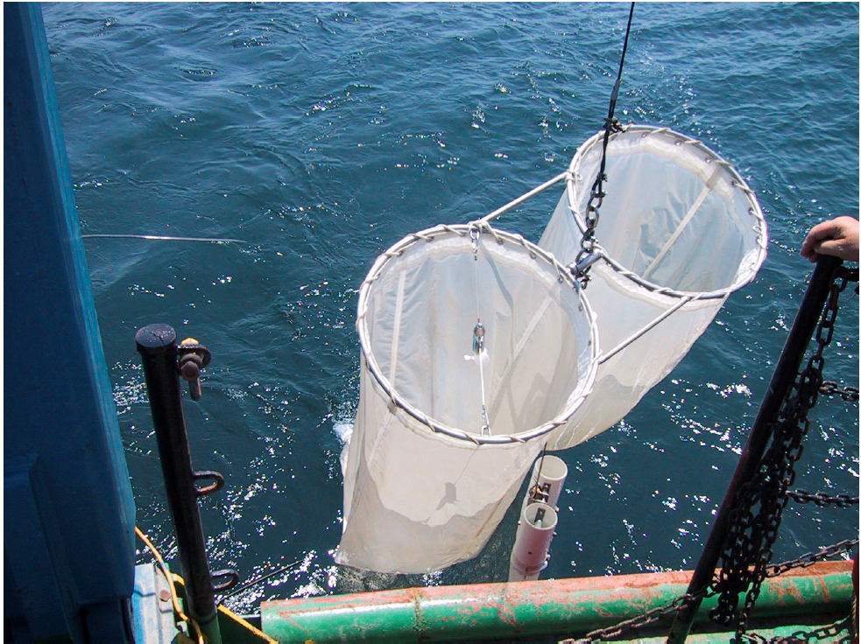

Phytoplankton and preservation

Some phytoplankton will be captured and retained on 50 um nets, but the results will be qualitiative rather than quantitative. Quantitative samples should be collected in sample bottles as described for water sampling. Samples should be preserved in Lugol’s iodine.

Chemical samples – containers and preservation

Parameter | Minimum Sample Size (ml) | Container | Preservation Technique | Holding Time
Alkalinity | 100 | Glass or Polyethylene | Refrigerate, 4°C | 14 Days
Total Hardness | 100 | Glass or Polyethylene | Refrigerate, 4°C HNO3 to pH<2 | 6 Months
Total Phosphorous | 50 | Glass or Polyethylene | Refrigerate, 4°C H2SO4 to pH<2 | 28 Days
Orthophosphate | 50 | Glass or Polyethylene | Refrigerate, 4°C Filter on Site | 48 Hours
pH | 25 | Glass or Polyethylene | None | Analyze Immediately
Salinity | 200 | Glass or Polyethylene | None | 28 Days
Turbidity | 100 | Glass or Polyethylene | Refrigerate, 4°C | 48 Hours
Total Suspended Solids | 1,000 to 4,000d | Glass or Polyethylene | Refrigerate, 4°C | 7 Days
Dissolved Oxygen Winkler | 125 | Glass Bottle with Glass Top | Fix with MnCl2 and Alk. Iod. (2 ml ea.) | 8 Hours (store in the dark)
Dissolved Oxygen Probe | 125 | Glass Bottle with Glass Top | None | Analyze Immediately
Ammonia - N | 100 | Glass or Polyethylene | Refrigerate, 4°C H2S04to pH < 2 | 28 Days
Nitrite - N | 100 | Glass or Polyethylene | Refrigerate, 4°C | 48 Hours
Nitrate - N | 100 | Glass or Polyethylene | Refrigerate, 4°C | 48 Hours
Silica | 100 | Polyethylene | Refrigerate, 4°C | 28 Days
Chlorophyll a | 25 to 1,000d | Glass or Polyethylene (dark) | Store filters frozen 20°C in the dark | 28 Days
Volatile Organics | 80 | Glass -2 40 ml vials No Headspace | Refrigerate, 4°C HCl to pH<2 | 14 Days
Semivolatile Organics | 1,000 to 2,000 | Glass | Refrigerate, 4°C | 7 Dayse
Total Mercury and Diss. Mercury | 500 | Teflon or Glass with Teflon Cap | Refrigerate, 4°C, HNO3to pH<2 | 28 Days
Total Metals and Diss. Metals | 1,000 | Polyethylene or Teflon | Refrigerate, 4°C, HNO3to pH<2 | 6 Months
Microbiology | 500 | HDPE  (autoclaved) | Refrigerate, 4°C | 24 Hours

14:00-16:00 Aquatic monitoring: Sample processing

Macrobenthos and meiobenthos

The primary focus of studies within the initial monitoring programme will be on the macrobenthos. However, individual institutions are encouraged to also study the meiobenthos if they have the resources and expertise to do so. Recommendations on meiobenthic methods would be welcomed, and the possibility of adding this component to the programme will be discussed if sufficient participants are interested at this stage. Inclusion of meiobenthic studies should not, at this stage, be at the expense of macrobenthic studies. It is better to fully and effectively implement one aspect of monitoring now, than to compromise the results by attempting to include too many elements. Success in one element will provide encouragement to proceed to other elements in due course; failure as a result of attempting too much at once will put the programme at risk.

Sieving or flotation to remove from sediment

As mentioned in a preceding session, it is common practice to separate organisms and sediment offshore, and to preserve the organisms before return to the laboratory. While it is possible to preserve an entire sample offshore, the presence of large amounts of sediment will impair the efficiency of preservation, and will also require very much larger volumes of formalin.

Sorting

The amount of time required to sort organisms from the sediment residue will depend largely on the amount of sediment material retained on the sieve. If large amounts of shell debris is present, the total volume of sample may be up to 5 litres. Under such circumstances, pre-staining of the biota will make it easier to observe and remove individual organisms.

The sample should be processed in white trays, marked with gridlines to assist the sorter to keep track of which parts have been examined. Large samples should be processed in several batches. Sufficient material should be placed in the tray at one time to lightly cover half of the area; material can then be moved gradually from one side to the other, removing organisms as they are encountered.

Efficiency of sorting is rarely 100%, especially when a large amount of coarse residual sediment is present. Efficiency should be routinely tested, by independently re-checking 10% of samples after sorting has been completed. This will provide an objective check of efficiency, and will also increase the accuracy of estimate for very small organisms such as ostracods and gastropods, which may not stain as vividly as the soft-bodied organisms.

Identification

Taxonomic identification is a process for which experience is essential. It takes time to acquire familiarity and expertise in the morphological characteristics of the various taxonomic groups, and it also takes time to become sufficiently familiar with the characteristics of individual species to be able to identify them by sight. Taxonomy is usually a time-consuming process, and benthic samples may take anywhere between 2 hours and 12 hours to process, depending on the amount of residual sediment present, the abundance of organisms, and the diversity of species in the sample. If the taxonomist is inexperienced with particular taxonomic groups and has to make frequent reference to published keys, the time required can be even longer.

Occasionally, a taxonomist may be able to observe that a distinct species is present, but may not be able to unambiguously assign a name using available keys. In this case, the taxon should be assigned a temporary code name, for future comparison and resolution.

All organisms identified should be grouped by species, and placed in labelled vials. These vials represent the primary raw material of the survey, and should either be securely stored in the laboratory or should be placed in a central regional ‘library’.

All raw counts should be recorded on standard forms, and should be

- stored securely within the laboratory
- copied, and the copies sent to a central library

The raw records should clearly identify the survey, sample, sample size, and sample location in sufficient detail that the results can be re-constructed if necessary at a later date.

Phytoplankton

Phytoplankton may be identified under a compound microscope, or (preferably) using a settlement chamber and an inverted microscope

Zooplankton

One of the advantages of a double net sampling system is that the contents of one net can be used for taxonomic purposes, and the contents of the other net can be used for biomass estimates (either settled wet volume, dry weight or carbon/nitrogen content depending on the resources available).

For taxonomic purposes, if the sample is large it may be split using a device such as a Motoda splitter or a Stempel pipette. Whichever device is used, the sample must be well-mixed first. Before splitting or identification, a standard record form should be prepared, on which the sample details and the splitting process are recorded. The fraction of the sample actually examined must be accurately recorded.

Once the sample has been split, the contents should be placed in a counting tray (eg Bogorov tray) and systematically examined. Specimens requiring detailed examination should be removed using a fine pipette, and placed either

- in a Petri dish under a binocular microscope with a magnification of at least 200x if it is necessary to dissect out particular appendages or structures
- in paraffin or propylene phenoxetol on a slide under a compound microscope

As for macrobenthic taxonomy, species which cannot immediately be assigned a name should be assigned a temporary code number. Example specimens of all taxa should be retained in clearly labelled vials.

Setting up and maintaining taxonomic reference collections

For macrobenthos and zooplankton, it is very important to prepare a comprehensive survey reference collection. This collection represents the complete taxonomic diversity for the survey, and is an essential requirement. A specimen of each taxon must be placed in this collection. Where numbers are sufficient, additional specimens of each taxon should also be placed in a ‘master’ reference collection for each laboratory, and in a regional master collection. These two master collections (laboratory and regional) represent respectively the cumulative taxonomic diversity for particular locations and for the Caspian as a whole.

The master reference collections (especially the regional collection) also serve the purposes of training and reconciliation. If all laboratories ensure that they provide specimens of each species identified to the master collections, this provides a resource which junior scientist can use to develop their skills, and which experienced taxonomists can use to resolve conflicts and differences in identification between laboratories. The master collections will also facilitate the process of confirming the identification and description of any new species or subspecies, as well as detecting the existence of regional sub-populations.

It is recommended that regular regional taxonomic workshops should be held, with the purposes of ensuring

- that taxonomic identification is consistent between laboratories
- the combined expertise of the region can be used to identify any taxa which have been temporarily assigned code numbers
- that any regional variation in morphology within taxa is clarified and quantified
- that the results of a) to c) are incorporated into revisions of taxonomic texts

Sediment physical properties

Sediment physical properties are the primary focus of the initial phase of the regional monitoring programme. The reason for this is that much of the work will be carried out in areas which are not subject to significant pollution, and that the physical structure of the sediment is an important factor in determining its ability to support macrobenthic species of different types.

The key physical properties of sediments from an ecological perspective are:

- particle size distribution
- organic contents
- carbonate content

Particle size distribution can be measured and represented in a variety of ways. The least biased method is probably optical or laser measurement, since these methods can be tuned to record particle sizes in very small increments. However, these instruments can be expensive to purchase and maintain, and probably generate more detail than is actually required from a biological perspective.

A standard sieve sequence is sufficient to characterise the structure of sediment for biological purposes. The precise sieve mesh intervals are not strictly important; what is important is that the sequence should be geometric, and that the final sieve should have a mesh size corresponding to the conventional upper limit for silt and clay (commonly, 63 um). Standard sediment processing methods sometimes use chemical treatment (eg sodium hexametaphosphate) to disaggregate particles. While this is relevant from a geological perspective, it is neither necessary nor useful for biological purposes.

An alternative to the use of sieves is the use of hydrometers. Standard methods are available which permit the size classification of sediment in a single operation. These methods are adequate from a biological perspective, and have the advantage that it is not necessary to weigh each separate fraction.

Sediment chemical properties

This aspect of analysis is not of priority interest in relation to the preliminary objective of establishing a regional biodiversity monitoring programme. It is recommended that, where samples are taken for chemical analysis, they should be retained frozen until such time as they can be analysed locally or forwarded to a regional specialist laboratory. In cases where there is specific interest in contamination with heavy metals or non-volatile organics, freeze-drying is recommended as the most reliable method for long-term stabilisation of samples.

16:30-17:30 Aquatic monitoring :Data processing

The entire process of sampling and data collection has only one purpose – to make information available to environmental scientists and managers for their use in the sustainable management of Caspian biodiversity. While the data may also be of purely scientific interest, this is of secondary importance within the context of the proposed monitoring programme.

Standardisation of data formats

Standardisation of data formats has one primary purpose – to ensure that data can be uploaded to the information system with minimum effort and with minimum error. The sooner that reliable data are available to users, the sooner it will be possible to process the data, define environmental status, and identify trends.

Selection of data processing objectives

There are two basic approaches to processing data

- exploration of data, looking for patterns and trends which will improve our understanding
- analysing data with a priori expectations, and applying pre-defined criteria

These can also, less neutrally, be described as

- learning from the data
- imposing our own preconceptions on the data

Whatever has been learned in the past, we need to bear in mind that we do not actually know how relevant this is to the present situation, and that we need to be able to use new data effectively and independently.

The simplest approach is to use well-established and traditional measures such as diversity and evenness indices. However, these have some serious limitations. First, they tend to have very low precision, and in an environment such as the Caspian where there are relatively few representatives of the major taxonomic groups, precision is invariably poor. Secondly, diversity indices do not take account of the species which are actually present; two samples or surveys may have identical diversity indices but have no species in common. So we have to decide what is important – is it simply species richness, or are we concerned about the presence and absence of particular species. Does it matter if 50 species have disappeared from an area, and have been replaced by 50 different species? If the answer is yes, then we need to use diversity indices with great caution, and only after a thorough examination of the data. It is very dangerous to draw conclusions from ‘black box’ indices, and these should never be the primary or only measure of diversity.

The reality is that we need to accumulate reliable time-series of data, and then to examine these data in considerable detail, before we can be confident about identifying the most useful and appropriate ways of representing and interpreting them. Any index or indicator must be validated by formal demonstration of its reliability through analysis of data derived from the monitoring programme. If an index cannot be validated on the basis of programme data, then logically it cannot be relied on to provide a meaningful indication of biodiversity status or trends.

One aspect of Caspian benthic ecology which requires careful consideration is the very patchy nature of the distribution of many taxa. Added to this is the fact that many of the more common and important species may have more than one generation per year. The consequence is that there are large natural fluctuations in the abundance and distribution of individual species, and corresponding large fluctuations in the composition of communities. This means that, in many habitats, it may not be possible to draw useful conclusions from changes in community composition. So, in practice, it may not be possible to assign significance to situations where diversity remains constant but species composition does not. In monitoring in the waters of Azerbaijan, we have seen a 50% species turnover within a period of 3 years in some locations. Despite this high level of change, diversity did not decrease, and the representation of all the major taxonomic groups was maintained. This is what we mean by learning from the data – while there may be limitations to the use of diversity indices, it is quite possible that large fluctuations are natural and that such indices may in fact be the only approach available. We cannot draw conclusions about the value of diversity indices in any way but through an objective assessment of accumulated data.

Types of data processing methods and software

The first point to make in this section is that the information system is primarily a repository of information, equipped with the tools to enable users to easily extract the data they require. For reasons stated above, it is NOT recommended that the information system should at this point in time have significant data processing capability built in. This should only be considered once sufficient data have been gathered and analysed to fully validate particular analytical methods.

Standard software and methods are widely available for the calculation of basic univariate indices such as diversity and evenness. However, these methods do not allow us to easily assess actual differences in species composition between samples or between surveys, over space or over time. To make such comparisons, it is necessary to have available a range of multivariate analytical tools. These fall within the general categories of ordination and classification. Both approaches are useful, but two warnings are necessary

- these methods are tools for data exploration, rather than for drawing conclusions – they are best used for hypothesis generation, not for hypothesis testing
- they are generally designed to reveal patterns, but (because they are computational methods) they will tend to show something even when no pattern is present

So, multivariate methods are valuable tools in the process of looking for meaning in data, but should not be relied on as the primary definition of meaning in data.

A range of standard univariate and multivariate methods will be demonstrated during the visit to the Caspian Environmental Laboratory. These methods are implemented through two internationally-available software packages, and it is recommended that participating laboratories should standardise on one of these packages.

