Information management system design (draft)

Contents

1. General structure of database 3
1.1 General information 4
1.1.1 Space-time data binding 4
1.1.2 Methods, parameters and quality assessment 4
1.1.3 Agency and expedition information 5
1.1.4 Geographical information 6
1.1.5 Access to complementary documents 7
1.2 Biological information 8
1.2.1 Marine planktonic data 9
1.2.2 Marine benthic data 9
1.2.3 Ichtyology and fisheries data 9
1.2.4 Birds 9
1.2.5 Seals 9
1.2.6 Terrestrial vegetation 9
1.2.7 Herbariums and zoological collections 9
1.2.8 Taxonomy 10
1.3 Environmental information 11
1.3.1 Oceanographic and meteorological data 12
1.3.2 Chemical and contaminant data 12
2. Data input 12
2.1 External datasets downloading 12
2.2 On-line data input 12
3. Output information 12
3.1 Data access and selection 12
3.2 Calculated variables and estimates 12
3.3 GIS component 12
4. Technical implementation 15

General structure of database

Figure1. General structure of the Caspian biodiversity database

General structure of the Caspian database is designed in such a way to reduce maximal possible variety of data type both biological and environmental into the minimal but adequate structure to include new data types in future. Other task of database structure is to provide wide range of data queries taking into account union of various sources and need of complex query optimization for the information system efficiency.

The database consists of more than 20 tables linked to each other by means of primary and foreign keys, see Fig.1. Space-time binding is realized by the tables Stations and GeoSites. Geographical information on habitats is located in tables Habitats and Ecotopes. Tables Datasets, Transects, Ships, Countries, Agencies contain general information. Tables Documents, Category and FileType provide access to every possible complementary documents concerned with data. Parametrs and Methods list the whole of variables which the database holds. Quality assessment is carried out on the base of quality checks containing in the Qcodes table. Biological part of the database consists of Taxons, BioData, Samples, Stages and Weights. The EnviromData table represents environmental part of the system.

General information

1.1.1 Space-time data binding

Table Stations serves as space-time binding for all data records measured both at sea and at land fixed locations (link with the table GeoSites).

Table 1. Structure of the table Stations

Field name | Physical data type | Allow NULLs | Description
StationID (PK) | int identity | Not allowed | Station identifier
StationName | char(10) | Not allowed | Name of station
Latitude | Float | Allowed | Latitude (decimal)
Longitude | Float | Allowed | Longitude (decimal)
DateTime | Datetime | Not allowed | Date and time
TransectID (FK) | Int | Allowed | Reference to the table Transects
DataSetID (FK) | Int | Allowed | Reference to the table Datasets
CruiseID (FK) | Int | Allowed | Reference to the table Cruises
EcotopID (FK) | Int | Allowed | Ecotope category, reference to the table Ecotops
GeoSiteID (FK) | Int | Allowed | Reference to the table GeoSites
AgencyID (FK) | Int | Allowed | Reference to the table Agencies
BottomDepth | Real | Allowed | Bottom depth
HabitatID (FK) | Int | Allowed | Habitat category, reference to the table Habitats
QCodeID (FK) | Int | Allowed | Quality Check, reference to the table QCodes

Comments: hereinafter PK-primary key, FK-foreign key, U1-unique value. I1-composite key

1.1.2 Methods, parameters and quality assessment

All the variables types both biological (abundance, biomass, presence etc) and environmental (sea level, pH, temperature etc) are included into the table Parametrs. Each parameter can be measured by several methods which table Methods contains. Detailed method description can be done in extra linked documents. Set of quality checks or assessments is located in the table QCodes

Table 2. Structure of the table Parametrs

Field name | Physical data type | Allow NULLs | Description
ParametrID (PK) | int identity | Not allowed | Parameter identifier
ParametrName | nvarchar(4000) | Not allowed | Name of the parameter

Table 3. Structure of the table Methods

Field name | Physical data type | Allow NULLs | Description
MethodID (PK) | int identity | Not allowed | Method identifier
MethodName | nvarchar(8000) | Not allowed | Name of the method
ParametrID (FK) | int | Not allowed | Reference to the table Parametrs
QCodeID (FK) | int | Allowed | Quality Check, reference to the table QCodes
DocumentID (FK) | int | Allowed | Reference to the table Documents

Table 4. Structure of the table QCodes

Field name | Physical data type | Allow NULLs | Description
QCodeID (PK) | int identity | Not allowed | Quality check identifier
QCodeDesc | nvarchar(500) | Not allowed | Quality check description
DocumentID (FK) | int | Allowed | Reference to the table Documents

1.1.3 Agency and expedition information

Information on countries, agencies (institutions, organizations), ships, cruises, transects (denominated), datasets is held in tables of the same name.

Table 5. Structure of the table Countries

Field name | Physical data type | Allow NULLs | Description
CountryID (PK) | int identity | Not allowed | Country identifier
CountryName | nvarchar(50) | Not allowed | Name of the country

Table 6. Structure of the table Agencies

Field name | Physical data type | Allow NULLs | Description
AgencyID (PK) | int identity | Not allowed | Agency identifier
AgencyName | nvarchar(500) | Not allowed | Name of the agency
CountryID (FK) | int | Allowed | Reference to the table Countries
Address | nvarchar(500) | Allowed | Address of the agency
DocumentID (FK) | int | Allowed | Reference to the table Documents

Table 7. Structure of the table Ships

Field name | Physical data type | Allow NULLs | Description
ShipID (PK) | int identity | Not allowed | Ship identifier
ShipName | nvarchar(50) | Not allowed | Name of the ship
CountryID (FK) | int | Allowed | Reference to the table Countries
AgencyID (FK) | int | Allowed | Reference to the table Agencies
DocumentID (FK) | int | Allowed | Reference to the table Documents

Table 8. Structure of the table Cruises

Field name | Physical data type | Allow NULLs | Description
CruiseID (PK) | int identity | Not allowed | Cruise identifier
CruiseName | char(50) | Not allowed | Name of the cruise
AgencyID (FK) | int | Allowed | Reference to the table Agencies
ShipID (FK) | int | Allowed | Reference to the table Ships
DateBegin | datetime | Allowed | Date of the cruise beginning
DateEnd | datetime | Allowed | Date of the cruise ending
NumberOfStations | int | Allowed | Number of stations
DocumentID (FK) | int | Allowed | Reference to the table Documents

Table 9. Structure of the table Transects

Field name | Physical data type | Allow NULLs | Description
TransectID (PK) | int identity | Not allowed | Transect identifier
TransectName (U1) | nvarchar(50) | Not allowed | Name of the transect
DocumentID (FK) | int | Allowed | Reference to the table Documents

Table 10. Structure of the table DataSets

Field name | Physical data type | Allow NULLs | Description
DataSetID (PK) | int identity | Not allowed | Dataset identifier
DataSetName | nvarchar(1000) | Not allowed | Name of the dataset

1.1.4 Geographical information

Two tables divide habitats primary and secondary categories. Habitats holds primary ones: marine offshore, marine nearshore, coastal terrestrial, inland terrestrial, rivers, estuaries, lagoons etc. Ecotops holds secondary categories: a set of ecotopes or characteristic sediment / soil / community types. Table GeoSites defines specific geographical sites with fixed location attributes and habitats categories above.

Table 11. Structure of the table Habitats

Field name | Physical data type | Allow NULLs | Description
HabitatID (PK) | int identity | Not allowed | Habitat identifier
HabitatName | nvarchar(500) | Not allowed | Name of habitat category
DocumentID (FK) | int | Allowed | Reference to table Documents

Table 12. Structure of the table Ecotops

Field name | Physical data type | Allow NULLs | Description
EcotopID (PK) | int identity | Not allowed | Ecotope identifier
EcotopName (U1) | nvarchar(500) | Not allowed | Name of ecotope
DocumentID (FK) | int | Allowed | Reference to table Documents

Table 13. Structure of the table GeoSites

Field name | Physical data type | Allow NULLs | Description
GeoSiteID (PK) | int identity | Not allowed | Identifier of the geographical site
GeoSiteName | char(500) | Not allowed | Name of the geographical site
Latitude | float | Not allowed | Latitude (decimal)
Longitude | float | Not allowed | Longitude (decimal)
HabitatID (FK) | int | Allowed | Habitat category, reference to table Habitats
DocumentID (FK) | int | Allowed | Reference to table Documents

1.1.5 Access to complementary documents

Documents organization structure allows storing complementary documents of different types: Word Document, PDF, graphic and multimedia files. The necessary document type can be added by user or database administrator. All documents are organized in hierarchical categories, so this structure looks like files and folders on hard disk. This structure enables the more useful representation of documents.

Linking documents with database is realized by means of keys DocumentID and three specialised tables Documents, Category and FileType. Different tables such as Cruises, Methods, QualityCodes, Taxons etc. can have a number of references to the documents. To solve this problem a set of association tables should be introduced into database. They are not shown in general structure (Fig.1) to simplify database structure report.

To make reference material accessible as a stand-alone component, special scripts (commercial or freeware) can be used to perform a search on the contents of the documents.

Table 14. Structure of the table Documents

Field name | Physical data type | Allow NULLs | Description
DocumentID (PK) | int identity | Not allowed | Document identifier
CategoryID (FK) | int | Not allowed | Reference to the table Category
FileTypeID (FK) | int | Not allowed | Reference to the table FileType
FileName | char(100) | Not allowed | Name of the file
Title | char(100) | Not allowed | Title of the document
Version | Int | Not allowed | Version number
Date | datetime | Not allowed | Date of the document
DocumentDescription | char(100) | Allowed | Description of the document (abstract)
Author | char(100) | Allowed | Name of author
Language | char(10) | Allowed | Language

Table 15. Structure of the table Category

Field name | Physical data type | Allow NULLs | Description
CategoryID (PK) | int identity | Not allowed | Category identifier
ParentID (FK) | int | Allowed | Reference to the parent category
CategoryPath | char(255) | Not allowed | Path to the category directory
CategoryDescription | varchar(8000) | Allowed | Description of the category

Table 16. Structure of the table FileType

Field name | Physical data type | Allow NULLs | Description
FileTypeID (PK) | int identity | Not allowed | File type identifier
FileType | char(10) | Not allowed | File type
FileTypeDescription | varchar(8000) | Allowed | File type comment

1.2 Biological information

Biological part of the information system consists of tables Taxons, BioData, Samples, Stages, Sizes and Weights. Tables BioData and Samples have been filling up as data come in. Main capacity of the Taxons, Stages and Weights should be completed before the system operation. Weights table destines for biomass calculation on the basis of abundance, taxon and stage data.

Table 17. Structure of the table Samples

Field name | Physical data type | Allow NULLs | Description
SampleID (PK) | int identity | Not allowed | Sample identifier
StationID (FK) | int | Not allowed | Reference to the table Stations
SampleName | char(50) | Allowed | Name of the sample
UpperDepth | float | Allowed | Upper depth of sampling
LowerDepth | float | Allowed | Lower depth of sampling
SubSampleName | char(50) | Allowed | Name of the subsample

Table 18. Structure of the table BioData

Field name | Physical data type | Allow NULLs | Description
SampleID (FK, I1) | int | Not allowed | Reference to the table Samples
TaxonID (FK) | int | Not allowed | Reference to the table Taxons
StageID (FK) | int | Allowed | Reference to the table Stages
ParametrID (FK, I1) | int | Not allowed | Reference to the table Parametrs
Value | mvarchar(255) | Not allowed | Value of the parameter
MethodID (FK) | int | Allowed | Reference to the table Methods
SizeID (FK) | int | Allowed | Reference to the table Sizes
QCodeID (FK) | int | Allowed | Quality Check, reference to the table QCodes

Table 19. Structure of the table Stages

Field name | Physical data type | Allow NULLs | Description
StageID (PK) | int identity | Not allowed | Stage identifier
StageName (U1) | char(50) | Not allowed | Name of the stage
TaxonID (FK) | int | Allowed | Reference to the table Taxons

Table 20. Structure of the table Sizes

Field name | Physical data type | Allow NULLs | Description
SizeID (PK) | int identity | Not allowed | Size identifier
TaxonID (FK) | int | Not allowed | Reference to the table Taxons
Lower | float | Not allowed | Lower limit of size range
Upper | float | Allowed | Upper limit of size range

Table 21. Structure of the table Weights

Field name | Physical data type | Allow NULLs | Description
TaxonID (FK) | int | Not allowed | Reference to the table Taxons
StageID (FK) | int | Not allowed | Reference to table Stages
SizeID (FK) | int | Allowed | Reference to table Sizes
Weight | float | Not allowed | Weight

Entering biological data is similar for all the biological data types: choosing taxon, parameter, method, realizing space-time binding through tables Samples, Stations and inserting value into the BioData table. Different types of data will differ by various parameters and methods.

1.2.1 Marine planktonic data

Possible parameters: abundance, biomass, presence of species.
Possible methods: horizontal tow, vertical tow, diagonal tow.

1.2.2 Marine benthic data

Possible parameters: abundance, biomass, presence of species.
Possible methods: various grabs.

1.2.3 Ichtyology and fisheries data

Possible parameters: abundance, biomass, presence of species, length, weight, condition indices.
Possible methods: acoustic survey, catch-effort.

1.2.4 Birds

Possible parameters: abundance, presence of species.
Possible methods: transect or site observation.

1.2.5 Seals

Possible parameters: abundance, presence of species.
Possible methods: transect or site observation.

1.2.6 Terrestrial vegetation

Possible parameters: abundance, presence of species.
Possible methods: transect or quadrat sampling.

1.2.7 Herbariums and zoological collections

Need to be discussed and analyzed.

1.2.8 Taxonomy

The overall goal of the taxonomy part is to create searchable and browsable taxonomy tree of the Caspian Sea organisms and to serve as reliable reference for all biological data records.

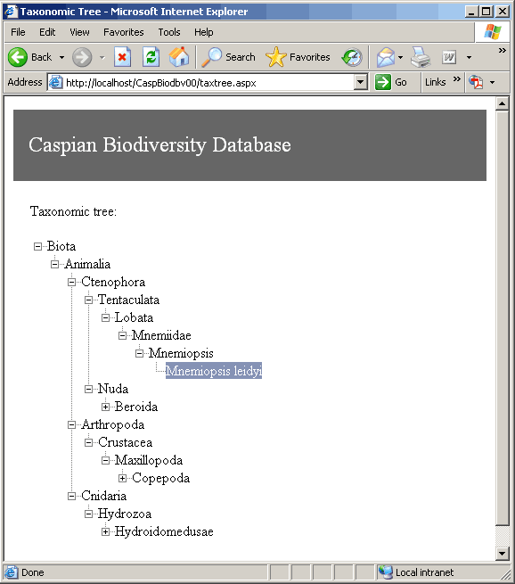

Figure 2. Example of a taxonomic tree in a web browser.

If while importing datasets or entering data records in the database user finds out that the taxonomic tree doesn’t contain necessary taxon name, he should place it in the taxonomic tree as accepted name or synonym. Only after this step the data can be placed into the database. It should prevent appearance of the species out of the taxonomic tree.

Set of taxonomic levels should be preset, for example according to the ERMS (European Registry of Marine Species), Table 22. It doesn’t mean that the user should use all levels to add species to the taxonomic tree. For example the following set of levels can be used to add Mnemiopsis leidyi (Kingdom, Phylum, Class, Ordo, Family, Genus, Species).

Table 22. Levels of taxonomy according to the ERMS.

1 Kingdom  2 Subkingdom  3 Phylum/Division  4 Subphylum/Subdivsion  5 Superclass  6 Class  7 Subclass  8 Infraclass | 9 Superordo  10 Ordo  11 Subordo  12 Infraordo  13 Section  14 Subsection  15 Superfamily  16 Family | 17 Subfamily  18 Tribe  19 Subtribe  20 Genus  21 Subgenus  22 Section  23 Subsection  24 Species  25 Subspecies
Table 23. Structure of the table Taxons

Field name | Physical data type | Allow NULLs | Description
TaxonID (PK) | int identity | Not allowed | Taxon identifier
TaxonName (U1) | mvarchar(50) | Not allowed | Name of the taxon
TaxonAuthority | mvarchar(50) | Allowed | Name of the taxonomist authority
AuthYear | int | Allowed | Year of the definition
TaxonDesc | mvarchar(4000) | Allowed | Taxon description (XML file)
RankID (FK) | int | Not allowed | Reference to the table Ranks
Lft | int | Not allowed | Pointer
Rght | int | Not allowed | Pointer
AcceptedTaxonID (FK) | int | Allowed | Reference to accepted TaxonID in case of synonyms
EcologicalGroup | int | Allowed | Eco-taxonomical group
Origin | int | Allowed | Taxon origin

Table 24. Structure of the table Ranks

Field name | Physical data type | Allow NULLs | Description
RankID (PK) | int identity | Not allowed | Taxonomic rank identifier
RankName | nvarchar(50) | Not allowed | Name of the taxonomic rank (species, genus, etc)

Information stored for each taxon divided into two categories:

- Which are important for various queries and data selections: eco-taxonomical group (bacterioplankton, phytoplankton, zooplankton etc), origin (Caspian autochthons, Caspian Estuarine etc). This kind of information is stored in the database table fields.

- Which are stored as a description only: relation to temperature, food spectrum etc. The species description is suggested to be stored as XML file. Patterns which can be included in the species description should be revised by the consultants. In future the structure of the description DTD file can be easily modified; some of patterns can be added or marked as out of use.

The structure of the table makes use of “Nested Sets” method to store the hierarchical structure of the taxonomical information.

1.3 Environmental information

Environmental part of the system consists of the only table EnviromData linked in contrast to BioData simpliciter with Stations.

Table 25. Structure of the table EnviromData

Field name | Physical data type | Allow NULLs | Description
StationID (FK) | int | Not allowed | Reference to the table Stations
ParametrID (FK) | Int | Not allowed | Reference to the table Parametrs
Value | mvarchar(255) | Allowed | Value of the parameter
Depth | float | Allowed | Value of the depth
QCodeID (FK) | int | Allowed | Quality Check, reference to the table QCodes
MethodID (FK) | int | Allowed | Reference to the table Methods
Entering environmental data is similar for all the abiotic data types: choosing parameter, method, realizing space-time binding through table Stations and inserting value into the EnviromData table. Different types of data will differ by various parameters and methods.

1.3.1 Oceanographic and meteorological data

Possible parameters: temperature, salinity, sea level, humidity, river runoff, wind velocity etc.
Possible methods: tide gauge, thermometer, CTD-probe, weather vane etc.

1.3.2 Chemical and contaminant data

Possible parameters: pH, dissolved oxygen, nutrients, silicates, chlorophyll etc.
Possible methods: various chemical methodologies

Data input

2.1 External datasets downloading

External dataset downloading wiil be carried out by suitable utilities depending on available archive dataset structures.

2.2 On-line data input

It is intended that on-line data input will be the main way to enter data into the database especially on the basis of monitoring program. Web forms with input fields and drop-down menus being designed will deliver entering data to corresponding tables.

Output information

3.1 Data access and selection

Selecting and extracting data will be realized by means of database queries based on combination any fields of tables described above. This might be time series or spatial distributions for a particular taxonomic group for a particular site or area for a particular parameter, method, agency, country for a particular time period and others. Resulting dataset can be represented as a spreadsheet (Fig.3), a graph (Fig.4,5) or a map (Fig.6). Corresponding query Web forms are being designed.

3.2 Calculated variables and estimates

It is planned to provide following calculated variables and estimates: biomass, population structure, average yearly and monthly values, basic divercity indices, age/size distribution (Fig.4,5)

3.3 GIS component

GIS component realized on basis of MapServer (University of Minnesota) destines for data query spatial distributionf presentation. It uses mapping system in ArcView (ESRI) format developed during preceding CEP projects (Fig.6).

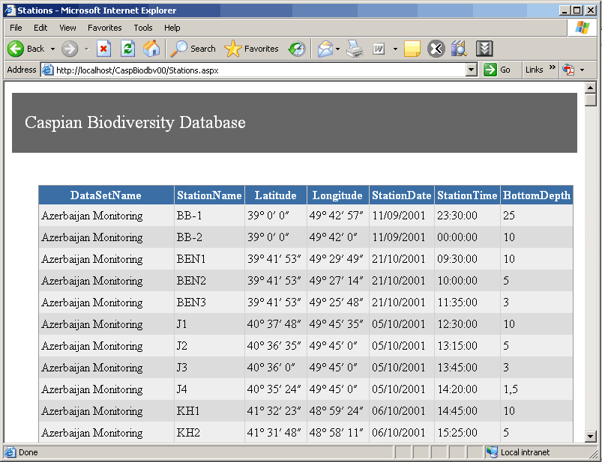

Figure 3. Example of a data selection in form of a spreadsheet.
.

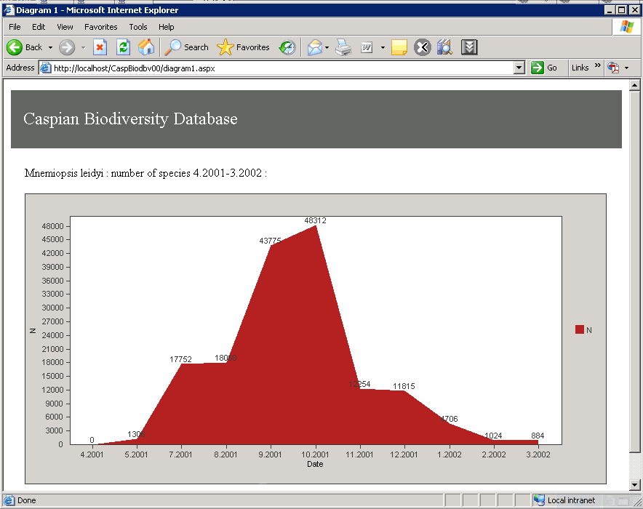

Figure 4. Example of seasonal cycle calculation.

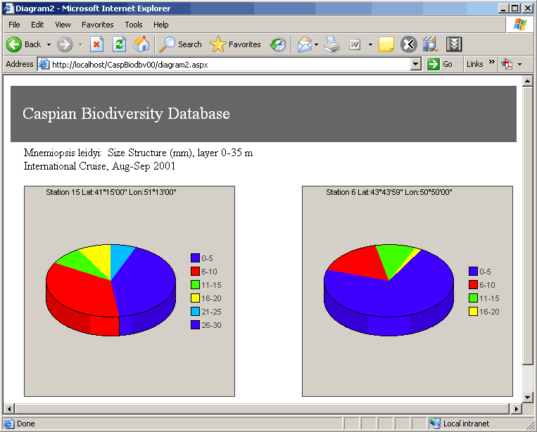

Figure 5. Example of a size distribution calculation.

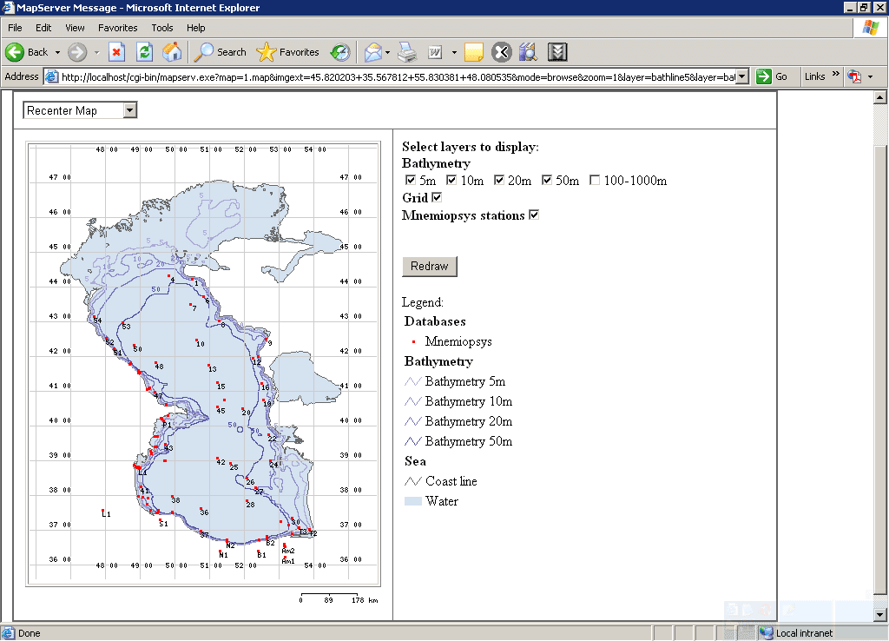

Figure 6. Example of a stations spatial distribution map.

Technical implementation

Software for this project will be developed based on Microsoft Solutions - Windows Server and ASP.NET – new progressive Web technologies. It helps make very flexible and scalable applications based on Web. The Internet Information Server 6.0, the Web server included in Windows Server 2003, provides enhanced security and a dependable architecture that offers application isolation and greatly improved performance with higher overall reliability and uptime.
SQL Server 2005 includes many new technologies: native XML capabilities, full .NET Common language runtime support, OLAP, and integration with Visual Studio – making them easier to build, deploy, and manage.

Table 26. Software requirements

Type | Name | Price | Quantity | Comments
Software for database and application server in CEP DataCenter
Operation System for Application Server | Windows Server 2003 Web Edition with Internet Information Server 6.0 and .NET framework | approximate $399 for commercial usage | 1 | Using for Web and Application Server. Main Server for User requests. Web Server product, no Client Access Licenses (CAL) required
Operation System for DataBase Server | Windows Server 2003 Standard Edition | approximate $999  for commercial usage | 1 | Server for Database system. Includes 5 CALs (User or Device, chosen after purchase)
Database System | Microsoft SQL Server 2005 Standard Edition | approximate  $667 US per server  $146 US per device  We need one connections.(667+146) | 1 | Prices for MS SQL Server 2000, MS SQL Server 2005 now available as community preview version and will be available as retail version in November 2005
Software for Development
Tools for developing web application and developer version of Windows 2003 server and MS SQL Server | Visual Studio 2005 Professional Edition with MSDN Professional subscription | approximate $1,199 for commercial usage | 1 | Subscriptions for one year

Table 27. Hardware requirements:

Type | Quantity | Comments
Application server (Web server and business logic(BI)) | 1 | One or two Intel processor head server with large amount of system memory (2Gb-4Gb) and small HDD (100Gb)
Database server | 1 | High availability and high performance disk subsystem is more important for database server. The storage size depends on the data amount and must be scalable.  Also backup system is necessary.

Comments: software and hardware requirements were made to satisfy monitoring program demands.

For further development following steps should be undertaken in cooperation with the CEP IT officer and data information manager.

- Assess available hardware and software
- Assess the available connectivity between the geographic location of work sites and remote sites.
- Assess net available bandwidth and latency.
- Analyze performance, availability, and scalability requirements of services.
- Analyze data and system access patterns.
- Analyze security considerations.

