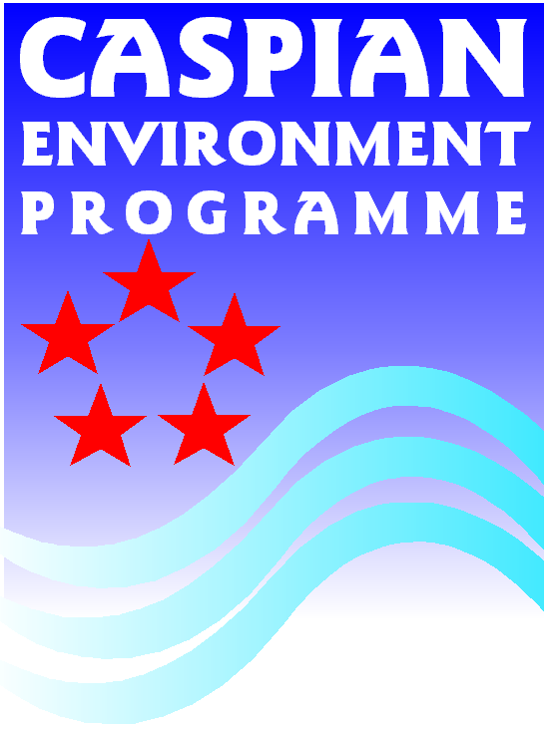

Review Questionnaire: Government structure for the management of biodiversity and natural resources in the countries of the Caspian Region

Please fill in questionnaire below

1. Government organizations involved with Biodiversity
1.1. Which Ministries are responsible for the following sectors related to biodiversity | Environmental Policy, planning & legislation
 | Nature Conservation, Biodiversity, wildlife
 | Fisheries
 | Forestry
 | Oil extraction/exploration
 | Agriculture
 | Coastal Development
 | Tourism
1.2. What are the linkages between different ministries? (e.g. are there any coordination mechanism between different ministries?)

1.3. Which agencies are involved in the following activities related to biodiversity of the Caspian region (mention in brackets under which ministry it belongs) | Environmental policy and legislation
 | Environmental Impact Assessment
 | Designation of Protected Areas
 | Management of Protected Areas
 | International Environmental obligations/agreements (CBD, CITES, IUCN Red-list etc.)
 | Fisheries development & Management
 | Agriculture planning and development
 | Sustainable Tourism/Eco-tourism
 | Biodiversity Impact monitoring
 | Biodiversity Trend monitoring
 | Enforcement

2. Organisation (organigram)
2.1. Organigram related to Environmental Policy and Legislation (including designation of Protected Areas):
2.2. Organigram related Environmental Impact Assessment & Impact Monitoring (including linkages to non-governmental institutions (NGO, private sector, research organizations etc.):

2.3.Organigram related to Management of Biodiversity/Natural Resources and Protected Areas (including linkages to NGOs, private sector, local communities) :

