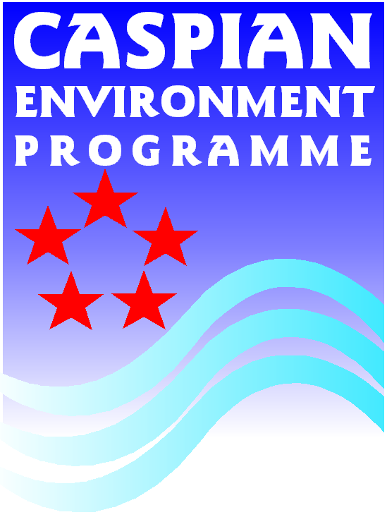

Review Questionnaire: Organizations involved with biodiversity Conservation & Natural Resources Management in the Caspian Region

Please fill in questionnaire below for each relevant organisation

1. General Information
Name of the organization
Head of the organization

Address

City

State

Country

Post code

Telephone

Fax

Email

Website
Contact person
2. Type of Organization
Type | Government Private Public
Area of Responsibility | National Environmental Policy
Area of Responsibility | National Environmental Legislation
Area of Responsibility | Designation of Protected Areas
Area of Responsibility | Management of Protected Areas
Area of Responsibility | Environmental Impact Assessment
Area of Responsibility | Biodiversity Monitoring
Area of Responsibility | Resource Management & Utilization (e.g. fisheries)
Area of Responsibility | Research
Area of Responsibility | Education
Area of Responsibility | Public services
Area of Responsibility | Law enforcement
Area of Responsibility | Tourism/recreation
Area of Responsibility | Others (specify):
Organigram (illustrating where the organization fits into the overall management structure):

3. Bibliography
List of biodiversity-related data & information available at institution (data sets, scientific papers, reports, maps, etc.) |  | Available as:
Guidelines for completion of Bibliography:
- for scientific papers, published/unpublished reports, the following information should be included: Title, author, year of completion, relevance/linkage to Caspian biodiversity (may be obtained as separate summary)

- for data sets: description of data (including data collection methods, origin), validation of data (origin, reliability)

- for maps: author, year of preparation, origin and reliability of data illustrated on map

