CASPIAN ENVIRONMENT PROGRAMME

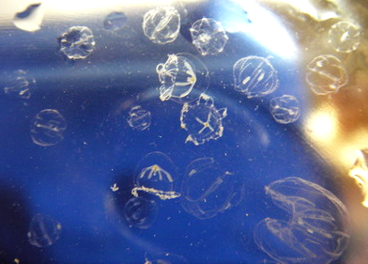

Photo courtesy of V. Nazarenko

Monitoring study of Beroe ovata and Mnemiopsis leidyi
in the Southern Caspian
Summer-Autumn 2005

Final Report

Prepared by H. Negarestan and T. Shiganova
Edited by T. A. Shiganova

December 2005

Executive Summary

- The monitoring study of BO and ML was carried out during four months from August till November 2005 in the southern Caspian by the three countries: Republic of Azerbaijan, I.R. Iran and Turkmenistan. The main objectives of this study were (i) to investigate possible presence of BO in the southern Caspian Sea and (ii) to set up regional program for monitoring BO and ML in coastal waters of the three southern Caspian countries.

- In order to facilitate coordination in methodology, develop sampling guidelines and reporting requirements, a Coordination meeting was held in Tehran in July 2005 and scientific coordinator of the study from I.R. Iran took part in the sampling cruise in Azerbaijan. CEP provided necessary BO and ML monitoring equipment to the three Caspian countries by the first quarter of 2006. Final meeting to discuss results of the study was held in Tehran in December 2005.

- Sampling took place during every third week from August till November 2005 in every country at 8 stations along two transects. Ctenophores were sampled using a 500 μm net with the opening mouth between 30 and 50 cm. Samples were taken by vertical towing from bottom to the surface at water depths less than 20 m. At deeper stations two layers were sampled to study ctenophore vertical distribution. Ctenophore abundance and size groups measurements have been directly after sampling according to the agreed methodology. Together with ctenophore measurements, station depth and temperature and in Azerbaijan and I.R. Iran salinity, pH and dissolved oxygen have been measured too. All data were entered into monitoring data sheets and transferred into electronic form for storing in the CEP Mnemiopsis Database.

- BO was not observed in the Caspian Sea during the surveys.

- According to 2005 data ML reached higher abundance than those recorded for the Black Sea during ML peak period (1989-1995). Small-size animals dominated the population (70-90% of species were less than 10 mm). Maximum abundance of ca. 8,400 ind.m⁻² was observed in Bay of Turkmenbashi (Turkmenistan), whereas the absolute recorded peak in the Black Sea was 7,600 ind.m⁻² in autumn 1989. In 2005, the maximum ML biomass of 1,300 g m⁻² was observed at the Noshahr transect (I.R. Iran), which is less than the Black Sea historic maximum of 4,600 g m⁻² during autumn 1989 in the open Black Sea due the smaller size of the Caspian ML. No stabilization of ML abundance and biomass is observed in the Caspian Sea during last several years.

- During August-September 2005 ML abundance in the southern Caspian varied from 872 ind.m⁻² in Azerbaijan waters to 2,544 ind.m⁻² in Turkmenistan. Peak of abundance was observed in September in most areas with the maximum in Turkmenistan waters (mean of 2,544 ind.m⁻² and maximum of 8,400 ind.m⁻² in Bay of Turkmenbashi). The lowest abundance in the southern Caspian was found along northern stations in Azerbaijan waters and varied from 872 to 1,272 ind.m⁻². ML abundance decreased in all studied areas but in Azerbaijan in November. The highest numbers of ML of about 1,800-2,000 ind.m⁻² in October-November were observed at the southern stations along Iranian coast off Anzali and Noshahr.

- The negative impacts of the increased numbers of ML enhanced by the ongoing eutrophication such as the appearance of the first coastal bloom of cyanobacteria in the southern Caspian Sea, the increasing phytoplankton biomass (remote-sensing data and in situ measurements), decreased zooplankton biomass and loss of zooplankton species diversity, the records of new invasive species, structural changes and dramatic drops of kilka fisheries – all stress the need to control ML populations in the Caspian Sea as urgent as never before.

- The only feasible control of ML propagation in the Caspian Sea is the introduction of BO. In order to mitigate the ML impact, the urgent authorization of such introduction from all Caspian countries is highly recommended.

- In order to confirm propagation and growth of BO larvae in the Caspian Sea water a closed mesocosm controlled experiment in the Caspian Sea with the participation of the representatives of the five Caspian countries is needed.

- The existing ML monitoring program of all littoral states has to be continued, including nutrient, plankton and benthic parameters dynamics measurements.

- It is recommended that CEP facilitate training in ecosystem monitoring if necessary.

- There is a need to continue the revision of national and regional legislations regarding the intentional introduction of species into the Caspian Sea.

- It is acknowledged that there is a need to continue work within the IAA (Inter Agency Agreement) between the CEP and IMO with regard to the assessment of the extent of aquatic species transfer through ballast water, sediments and ships fouling and means of controlling these transfers into and out of the Caspian Sea.

Content

1. Introduction 5
1.1. Background 5
1.2. Literature Review 6
1.3. Objectives 6
2. Material and Methods 7
2.1 Scope of the work 7
2.2 Sampling design 7
2.2.1 Sampling in Azerbaijan 8
2.2.2 Sampling in Iran 8
2.2.3 Sampling in Turkmenistan 9
2.3 Identification of Beroe ovata and Mnemiopsis leidyi 10
2.3.1 Identification of Beroe ovata 10
2.3.2 Identification of Mnemiopsis leidyi. 13
2.4 Methodology for M. leidyi measurements 15
2.4.1 Design of sampling 15
2.4.2 Measurements of M. leidyi 15
2.4.3 Calculations of M. leidyi biomass and abundance 15
2.4.4 Beroe ovata or unknown gelatinous organism measurements 16
2.4.5 Other measurements in the stations 16
2.5 Duration and plan of the study 16
2.6 Participants 18
3. Results 21
3.1. Beroe ovata and other gelatinous organisms 21
3.2. Mnemiopsis leidyi 20
3.2.2. Size classifications Error! Bookmark not defined.
3.2.3. Temporal variations Error! Bookmark not defined.
3.2.3.1. October 2005 Error! Bookmark not defined.
3.2.3.2. November 2005 Error! Bookmark not defined.
4. Discussion and concluding remarks Error! Bookmark not defined.
4.1. Beroe ovata and other gelatinous organisms 28
4.2. Mnemiopsis leidyi 28
4.2.1. Spatial distribution Error! Bookmark not defined.
4.2.2. Temporal variations Error! Bookmark not defined.
References. 29
Annex A.Ctenophore MONITORING DATA SHEET 31

1. Introduction
  - Background
The Caspian Environment Programme (CEP) represents a partnership between the five littoral states: Azerbaijan, Islamic Republic of Iran, Kazakhstan, Russian Federation and Turkmenistan and international partners - the EU, UNDP, UNEP, and the World Bank. The overall goal of the CEP is to promote sustainable development and management of the Caspian environment in order to obtain the optimal long-term benefits for the human population in the the region. Sustainable human development and management will protect human health, maintain ecological integrity and support the region's economic and environmental viability for future generations. The first phase of the CEP was conducted from 1998 and continued by extending of the programme into the phase-II.
During the first phase of the Caspian Environment Programme (CEP), one of the priority areas of work was alien invasive species and their impact on the biodiversity of Caspian Sea. Particular attention was paid to the ctenophore species, Mnemiopsis leidyi, which has become invasive in the Caspian in recent years. Several studies of M. leidyi in the Caspian Sea confirmed that it has negative impacts on the Caspian ecosystem and fisheries (Negarestan et al. 2001a, 2001b, Shiganova et al. 2001, Kideys et al. 2001).
As a mitigation measure to control and reduce the negative impacts of M. leidyi, it has been proposed to introduce another ctenophore, Beroe ovata, which feed exclusively on M. leidyi. This is based on experiences from the Black Sea, where studies have indicated that the accidental introduction of B. ovata significantly reduced the number of M. leidyi and in turn its negative impacts.
Based on these studies and data of experiments performed in the Caspian Sea water on possibilities of B. ovata survival in the Caspian Sea water and to control population of M. leidyi, the CEP Steering Committee Meeting in November 2004 requested the CEP/PCU to compile all existing information related to M. leidyi and B. ovata and submit it to all the five Caspian countries. The goal of this activity was to facilitate a regional consensus on the introduction of B. ovata, giving the countries a period of 3 months to review the information and make the decision. This information was provided to the countries by January 2005.
At the second meeting of the Biodiversity and Invasive Species Regional Advisory Group (BISRAG) in Almaty, Kazakhstan, in April 2005, some countries still were not able to make a decision regarding the introduction of B. ovata. Instead, it was agreed to undertake a one-season monitoring study of important portal areas of the Southern Caspian with the aim to clarify whether B. ovata already occurs in the Caspian as it is expected to be arriving with ballast water along the same routes as M. leidyi. This could at the same time also encourage the Caspian countries to continue to implement monitoring of M. leidyi and B. ovata in the future.
Every research team has presented detailed report on fulfilled work before the Final Meeting of the Project Team on “Monitoring study of Beroe ovata and Mnemiopsis leidyi in the southern Caspian Sea in August-November 2005” held on 19-20th December 2005 in Tehran, I.R. Iran. These reports are incorporated here.
All data obtained in framework of this study were accumulated in CEP PCU and provided to Scientific Coordinator for analysis and interpretation. Scientific Coordinator in consultancy with the International Advisor and research team leaders has compiled the final report. Main conclusions of the study were presented at the 2005 Annual Steering Committee Meeting.

Literature Review
In the 1980s, the introduction of a new species (a lobate ctenophore, Mnemiopsis leidyi) into the Black Sea radically affected the whole ecosystem (Kideys, 1994; Shiganova, 1997 and 1998; Vinogradov, 1989). This species had a negative impact on the zoo-planktivorous fish of the Black Sea. The impact was most severe on the dominant anchovy Engralius encrasicolus ponticus feeding, zooplankton dynamics as well as consumption of pelagic eggs and small larvae. The explosive development of Mnemiopsis leidyi was one of the most important reasons for the sharp decrease of anchovy and other pelagic fish stocks in the Black Sea (Kideys 1994; Shiganova, 1997; Shiganova & Bulgakova, 2000).
In a meantime, the possibility of its introduction into other neighboring sensitive ecosystems, notably the Caspian Sea, has been mentioned (Dumont 1995; GESAMP 1997). And, as expected, this ctenophore was reported to occur in the Caspian Sea by November 1999 (Esmaeili et al., 2000, Ivanov et al., 2000; Shiganova et al., 2001).
Ivanov et al. (2000) suggested that the ctenophores were transported with ballast water taken aboard in the Black Sea or the Sea of Azov (where M. leidyi occurs during warm months) and released after ballast-loaded ships passed through the Volga-Don Channel and the shallow freshwater North Caspian Sea, into the saltier Central or South Caspian.
Due to the damage observed in the Black Sea, there has been a fast response over the presence of M. leidyi in the Caspian Sea. Since it is a voracious predator on zooplankton, both, abundant small pelagic fishes feeding on zooplankton and top predators feeding on planktivorous fishes such as the Caspian Seal (Phoca caspica) would be under significant threat (Kideys et al., 2001; Shiganova et al., 2004).
In this study, the abundance and biomass of Mnemiopsis leidyi and possible presence of Beroe ovata were studied in order to gather information on the population size and ecology of the invading ctenophore; for evaluation of its dynamics in the coastal regions along the southern Caspian Sea in summer and autumn 2005.

Objectives
The major objectives of this study were as follows:
- to investigate possible presence of Beroe ovata in the Caspian Sea, particularly in the Southern Caspian;
- to conduct monitoring of M. leidyi in the Southern Caspian in coastal waters of Azerbaijan, I.R. Iran and Turkmenistan from August to November 2005;
- to procure equipments for monitoring studies;
- to develop recommendations for the future studies and action plan on Mnemiopsis leidyi and Beroe ovata.

- Material and Methods

Scope of the work
The scope of the work comprised series of sampling along fixed transects done monthly in main portal areas of all 3 countries during the period of 4 months starting in August 2005 and finishing in November 2005 using the same methodology.

Sampling design
In order to investigate possible presence of B. ovata in ballast waters of ships coming to the Caspian Sea from Black or Azov Seas, in each country two transects were chosen next to a main port of the country (Figure 1).
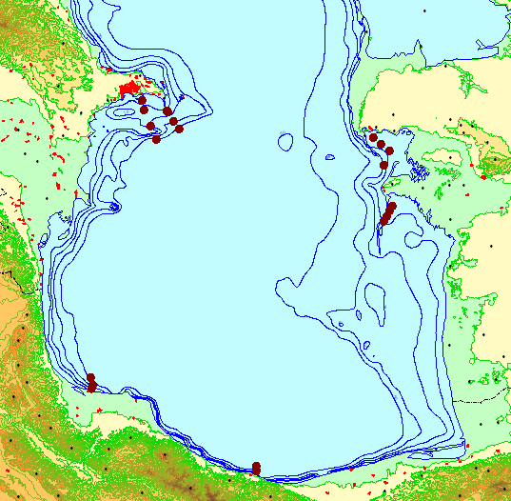
Figure 1. Map of the southern Caspian Sea and location of the sampling sites

At depths of 5, 10, 20 and 50 m on each transect, plankton tows were conducted (Figure 2). At shallow stations of Turkmenistan transects sampling down to 20-50 m was not feasible.
In order to obtain comparable data from the three countries, sampling took place almost simultaneously on or around 22nd day of each month at all transects.
Plankton nets were supplied to Azerbaijan and Turkmenistan by CEP with the assistance of IFRO (I.R. Iran) in order to have similar sampling equipment.

Sampling in Azerbaijan
Transects and stations
Azerbaijan
Transect | Station | Latitude | Longitude | Depth
1. Shakhov Shoal | 1 | 40°12'00" | 50°23'00" | 5
1. Shakhov Shoal | 2 | 40°11'20" | 50°24'10" | 10
1. Shakhov Shoal | 3 | 40°05'50" | 50°28'10" | 20
1. Shakhov Shoal | 4 | 40°01'00" | 50°32'40" | 50
2. Makarov Bank | 1 | 40°18'00" | 50°04'00" | 5
2. Makarov Bank | 2 | 40°12'00" | 50°06'00" | 10
2. Makarov Bank | 3 | 40°03'00" | 50°11'00" | 20
2. Makarov Bank | 4 | 39°55'00" | 50°15'00" | 50

Sampling was done along 2 transects in southern direction from sites Shakhov Shoal and Makarov Bank at stations with depths of 5, 10, 20 and 50 m. Sampling sites were located in the shallow coastal zones with a predominance of fine sediments with clayey and sandy bottom sediments. The bottom sediments nearby Makarov Bank are harder and covered with intact and broken mollusk shells. Geomorphology of the northern sampling area is gently sloping, whereas bottom relief in the southern part is irregular with sharp hollows and slopes around Makarov Bank, which is a still active mud volcano. Sampling was done onboard RV Alif Hajiev or a motorboat in the shallow areas.

Sampling in Iran

I.R. Iran
Transect | Station | Latitude | Longitude | Depth
3. Anzali | 1 | 37°29'00" | 49°29'31" | 5
3. Anzali | 2 | 37°29'20" | 49°28'59" | 10
3. Anzali | 3 | 37°30'30" | 49°29'43" | 20
3. Anzali | 4 | 37°35'07" | 49°28'37" | 50
4. Noshahr | 1 | 36°40'50" | 51°29'50" | 5
4. Noshahr | 2 | 36°40'51" | 51°29'58" | 10
4. Noshahr | 3 | 36°41'30" | 51°29'47" | 20
4. Noshahr | 4 | 36°43'44" | 51°30'14" | 50

In this study, spatial and temporal distributions of M. leidyi were studied along two transects (Anzali and Noshahr) in the southern (Iranian) coasts of the Caspian Sea during July, September, October and November 2005. Each transect had four stations located at 5, 10, 20 and 50 m water depths.
The sampling site of Anzali was situated in a shallow coastal zone with predominance of fine sandy sediments. The bottom nearby Noshahr bank is more hard and covered with boulders. The slope is steep. Bottom relief in the western part of the Anzali sampling transect is gently sloping sharply deepening in the south-eastern direction. In the south-west, the bottom slope flattens. Sampling was done onboard RV Guilan or motorboat in the shallow areas.
Mnemiopsis leidyi was sampled using a 500 μm mesh METU net (diameter 50 cm with a large bucket suitable for M. leidyi). Samples were obtained via vertical towing from the bottom to the surface at all stations. At deeper stations towing was done in two steps: from 50 to 20 and from 20 to 0 m.
At the end of each tow, the net was washed off and the collector was passed into a container to calculate ctenophores. The ctenophores were sorted in length groups of 0-5 mm, 6-10 mm, 11-15 mm and so on, for size measurements (Kideys and Shiganova, 2001). The density of Mnemiopsis leidyi (both as per m² and in m³) was calculated from the diameter of the net and the tow depth.

Sampling in Turkmenistan

Turkmenistan
Transect | Station | Provisional coordinates
Transect | Station | Latitude | Longitude | Depth
5. Bay of Turkmenbashi | 1 | 39°55'00" | 53^{о}00'00" | 6
5. Bay of Turkmenbashi | 2 | 39°51'00" | 53^{о}06'00" | 6
5. Bay of Turkmenbashi | 3 | 39°47'00" | 53^{о}12'00" | 6
5. Bay of Turkmenbashi | 4 | 39°38'00" | 53^{о}09'00" | 12
6. Alaja-Ogurchinskiy | 1 | 39°18'00" | 53°18'00" | 5
6. Alaja-Ogurchinskiy | 2 | 39°13'00" | 53°15'00" | 10
6. Alaja-Ogurchinskiy | 3 | 39°09'00" | 53°12'60" | 10
6. Alaja-Ogurchinskiy | 4 | 39°05'00" | 53°10'36" | 10

Sampling sites were situated in the Bay of Turkmenbashi where port is located and along the transect along the Southern Cheleken Shoal to Ogurchinskiy Island. The maximum station depth was 12 m. Sampling sites were situated in the shallow coastal zones with predominance of fine sediments with clayey and sandy contents. Sampling was done from the a motorboat.

Identification of Beroe ovata and Mnemiopsis leidyi

Identification of Beroe ovata
According to their morphology the representatives of Beroidae are the simplest ctenophores. The body is mitten-shaped, wider at the oral end and not tapered at the aboral end; with a length to width (l/n) ratio of 1.1-1.2. Lateral compression of the body marked. Young specimens are wider at the oral and aboral ends of the body. Beroe ovata has a wide-flaring mouth (Figure 2-4) which enables the animal to obtain food without depending on tentacles to capture prey.

These ctenophores generally have a pink colour, with largest adults colored more intensely with a brown tinge. The size of large specimens in the Black Sea is from 81 to a maximum of 162 mm with mean length of 40-70 mm. The mouth opening is wide and the ectodermal portion of the stomach (stomodeum) is voluminous. The polar- plate surrounding the sense organ at the aboral pole is fringed with a row branched papillae. There are ciliated areas upon the walls of the stomodeum near the mouth. The axial funnel-tube which extends upward to the sense-organ is deeply cleft so that 2 lateral vessels extend upward to the 2 apical excretion-pores on the sides of the pole-plate; 8 meridional canals and 2 paragastral canals. The meridional canals lie under the 8 rows of ciliary combs (Figure 5); the 2 paragastral canals extend down the middle of the broad sides of the animal and 8 meridian canals may be placed in communication one with another by means of an anostomosing network of side branches, thus establish a circum oral canal system, which are characteristic for Beroe ovata. While studying live Black Sea ctenophores, it was found that both sides the lateral tubes of the meridional canals can anostomose with each other and with the paragastral canals, which do not have own diverticulas. In accordance with these features the new ctenophore of the Black Sea was considered to have originated from the Atlantic northern American coast.

Beroe ovata is remarkably phosphorescent. The seat of the phosphorescence is confined to the rows of locomotive flappers. In the sea while ctenophore swimming the green light along meridional canals emitted from the eight phosphorescent ambulacums is clearly visible.
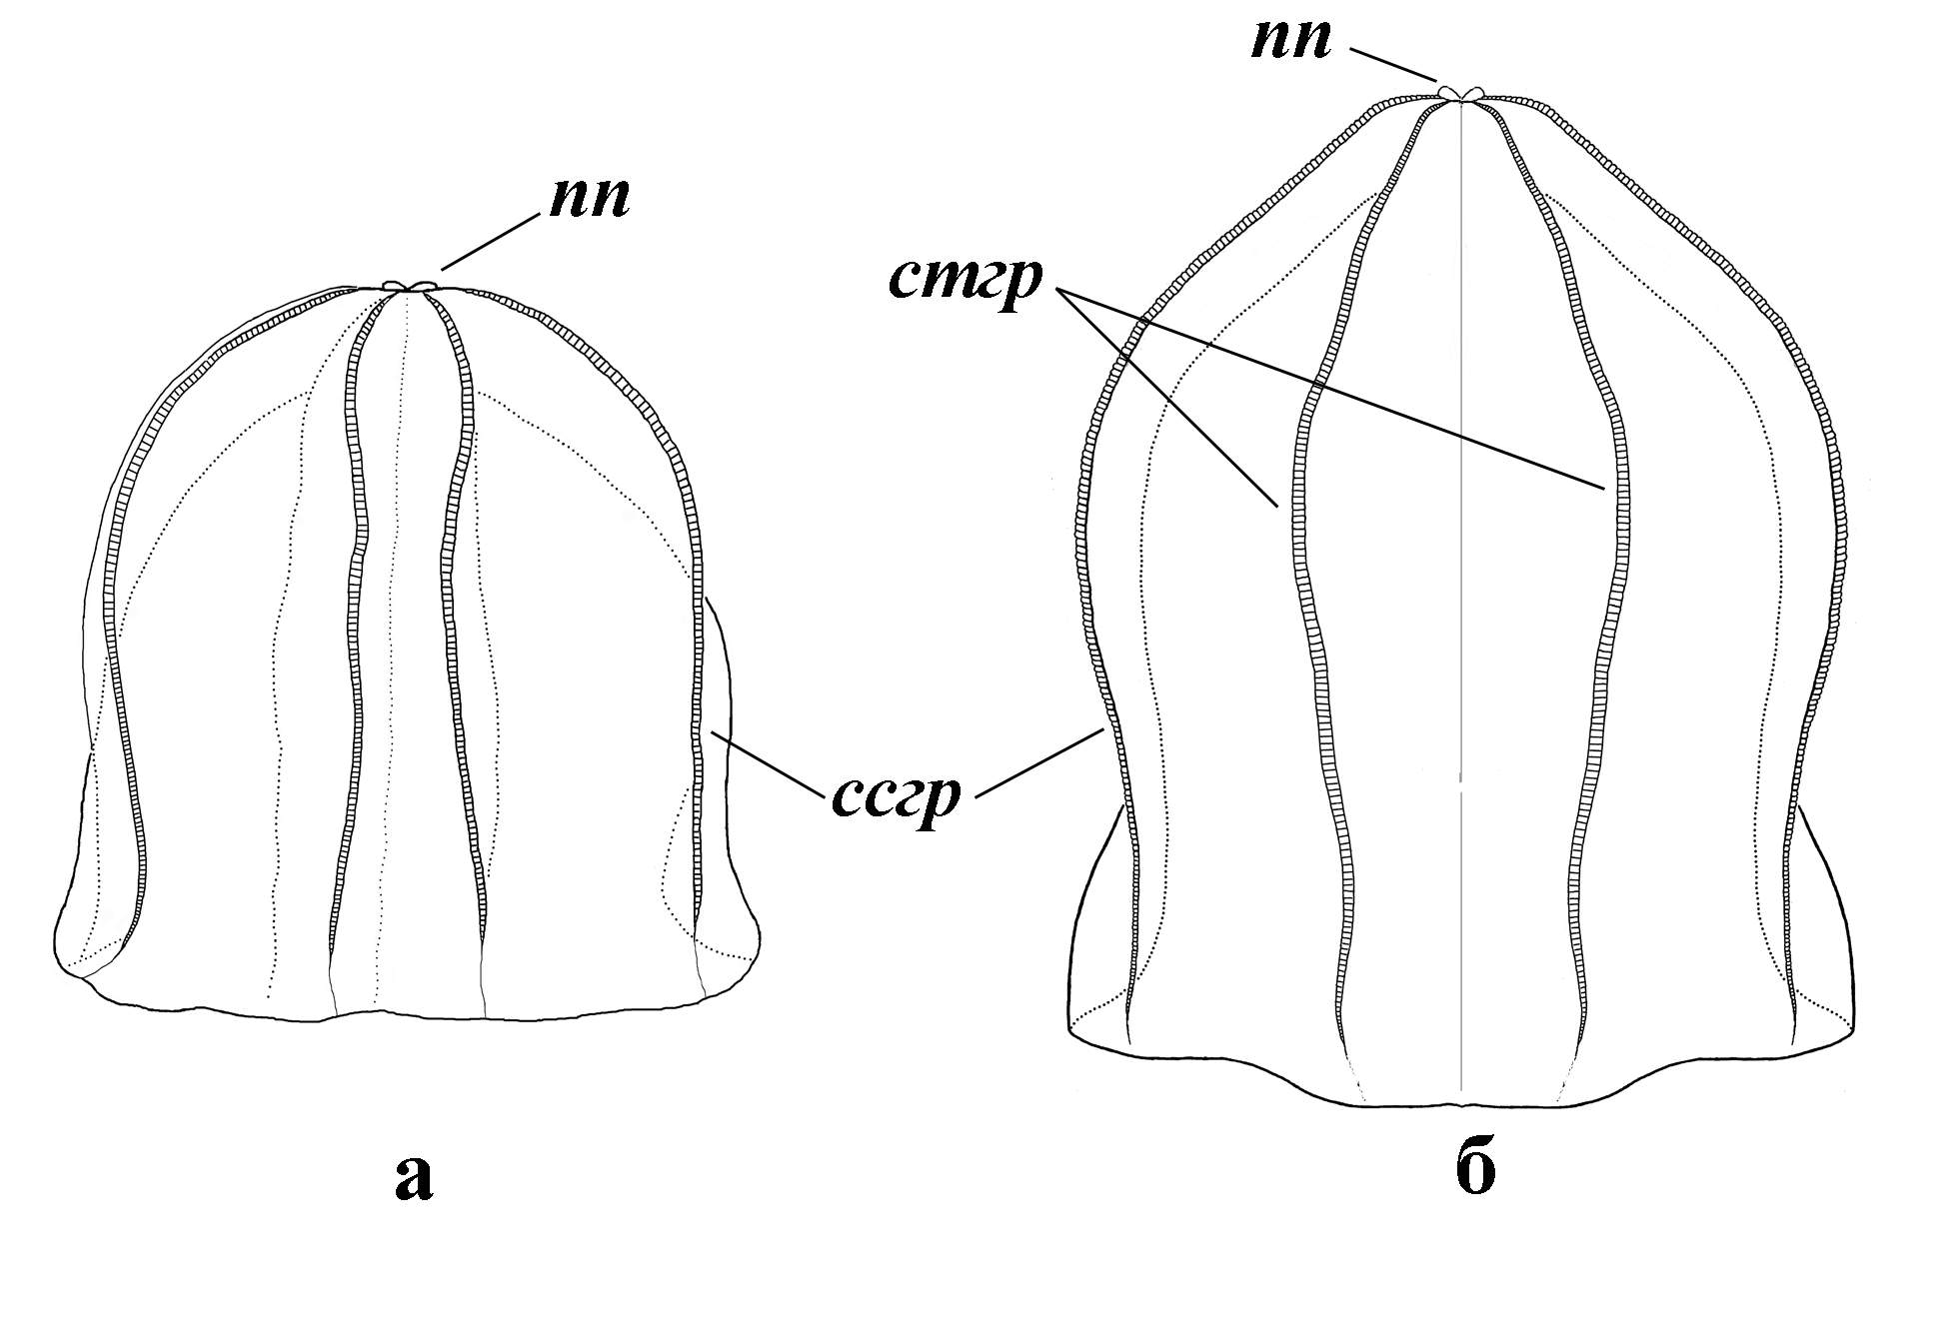
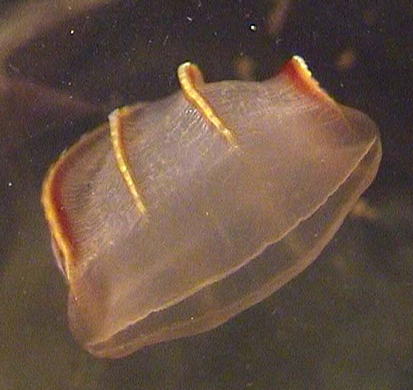
Figure 2. Morphology of adult Beroe ovata (after Seravin et al., 2000) a - with round shape of aboral part, б - a little conic shape of aboral part, nn - polar pores; cmгр –subtenticularal cilia row, ccгз - subsagital cilia row

Figure 3. Adult individual of Beroe ovata (photo of T. Shiganova)

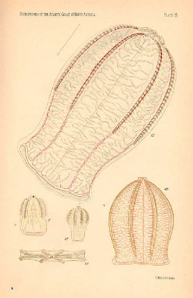
Figure 4.Representatives of Beroidae
Figure 5. Ovae (1-4), embryo and larva of Beroe ovata (most photos were made by scientists of Ecological Institute of Caspian Sea, Sari, Iran)
Beroe ovata is hermaphrodite with gonads situated along meridional canals. The freshly spawned egg (size 0.8-1.0 mm) is surrounded by a reflective meshwork (Figure 5), which disappears in the first hour after shedding, while a thick gelatinous layer swells around the egg. The egg pronuclear remains in the cortex below the polar bodies. The unfertilized egg has a glass-like appearance.

Identification of Mnemiopsis leidyi
Descriptions and pictures of Mnemiopsis leidyi from the Caspian Sea are given for comparison with Beroe ovata.
Mnemiopsis leidyi is a lobate ctenophore from the class Tentaculata, order Lobata, family Mnemiidae Esch. It has two large and motive oral lobes ( and 7).

Figure 6. Anatomy of Mnemiopsis leidyi 1- aboral organ; 2- subtentacular row of comb flappers; 3- subsagital row of comb flappers; 4- auriculus; 5- subsagital tube; 6- translobal tube; 7- tentacular tube; 8-
lobe
(drawing of T. Shiganova, Shiganova, 2000)

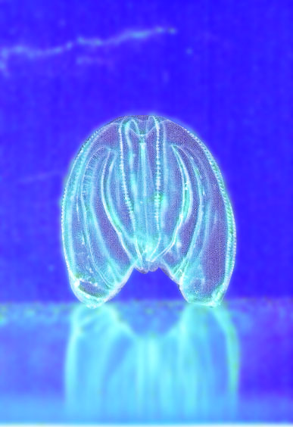

Figure 7. Mnemiopsis leidyi (Photo of T. Shiganova and A. Kamakin)

M. leidyi has two oral lobes, which derivative of the ctenophore body (spherosome). Four smaller lobes –auricules are situated under the principal two oral lobes. The oral lappets carry tentacular rings. Its central part is situated above the lips of the mouth crevice. Both "lips" are extremely contractible. Some specimens of this ctenophore collected in the Black Sea have small papillae on their body surface, same as had been described from American waters.
Ctenophore M. leidyi has also 8 meridional canals. Subsagital and subtentacular canals are situated in pairs. After every couple of subsagital canals follows a couple of subtentacular canals.

The mean length of Caspian Mnemiopsis with lobes, estimated for the whole Caspian in July is 14.9 ± 3.1 mm, mean wet weight 0.97 ± 0.32 mg, while the maximal size recorded was 65 mm with lobes, maximal wet weight 7.2 mg. This is considerably below the range recorded in the Black Sea in summer, in July (mean length 60.6 ± 39 mm, mean weight 15.1 ± 14.2) and maximal length 137 mm, weight 35 mg and largest individual was found 180 mm in early August in the southern Black Sea (Shiganova et al., 2004).

Mnemiopsis leidyi is remarkably phosphorescent. In the sea while ctenophore swimming the blue light along meridional canals emitted from the eight phosphorescent ambulacums is often visible.

M. leidyi is also hermaphrodite. Ovae of M. leidyi are smaller in size, have diameter of 0.2-0.3 mm, and larva has tentacles (Figure 8)

Figure 8. Development of Mnemiopsis leidyi, A- newly laid egg; B- embryo with tentacles, about 30 hours old and still within the egg envelope; C- newly hatched embryo about 30 hours old, the animal is now in the Cydiippiae stage; D- Side view of an embryo about 32 hours old, showing muscular strands (drawing from Shiganova, 2000)

Methodology for M. leidyi measurements

Design of sampling
At each station, ctenophores were sampled using a 500 μm mesh size closing net (diameter 50 cm opening mouth suitable for B. ovata and M. leidyi). Samples were collected by vertical towing from the bottom to the surface for all stations, except the deepest stations (50 m). The depth of sampling stations was measured with correction for angle of haul. At the deepest stations, two layers were sampled: (1) one sample from depth interval 50 -20 m (a closing deviser was used to close the net on the way back at the depth of 20 m); and (2) one sample from depth interval 0-20 m.

Measurements of M. leidyi
Since fixation of gelatinous organisms is problematic, measurements were done as soon as possible after sampling. After the net was taken on board, its content was placed into a jar. Then the samples were examined for presence of any unusual gelatinous animals, if any of them was found, it would be separated and placed in a jar or aquarium with Caspian Sea water.
If there were less than 50 individuals in the sample; all M. leidyi were sorted out to size groups on Petri dish using a ruler. At least 10 individuals of each size group were measured with lobes (total length) to obtain mean length for each size group. Number of individuals in each size group were counted and entered into table. Also a sub-sample after removing ctenophores for measurements was examined under a magnifying glass or binocular microscope for examination of smallest individuals and ovae. Sampling methodology was coordinated during the meeting held on 27-28 August 2005 in Tehran, I.R. Iran.
Additionally, ten individuals from each size group were measured for displacement volume to obtain a wet weight of Mnemiopsis leidyi. In some cases when it was not possible to measure displacement volume, the calculated equation was used (see below).
If the number of individuals in the sample was numerous (more than 50 individuals), a sub-sampling was collected: The M. leidyi sample was suspended in known volume (e.g. 1 litre) of seawater and sub-sample of a smaller volume was taken with a beaker (e.g. 100 ml volume). Then sub-sample was processed according to the above described method, and results (M. leidyi numbers) were magnified per ratio between sample and sub-sample volume (10 in the example).

Calculations of M. leidyi biomass and abundance
Abundance sp/sample was calculated as sum of number of individuals in each size group.
Abundance sp/m² was calculated with the following formula:
${\text{Ab}}_{{\text{sp}}/m2}=\frac{\text{Ab}}{S_{{\text{Net}}_{\text{mouth}}}}$, where $S_{{\text{Net}}_{\text{mouth}}}$ is square of net mouth
Abundance sp/m³ was calculated with the following formula:
${\text{Ab}}_{{\text{sp}}/m2}=\frac{{\text{Ab}}_{{\text{sp}}/m2}}{D−D}$, where:
D_{l} and D_{u} are the lower and upper sampling depths correspondingly.
M. leidyi biomass for every size group was calculated with the following formula:
$\text{Bm}=\text{Ab}⋅0\text{.}\text{0011}⋅L^{2\text{.}\text{.}\text{34}}$, where L is an average length for size group estimated from measured individuals.
Biomass (g/sample) was calculated as a sum of biomasses of all size groups. Biomass per square metre of the surface area (g/m²) and biomass per volume of seawater (g/m³) were calculated in the same way as corresponding abundances. A specially developed Excel spreadsheet was provided to all survey participants to ease calculations.

Beroe ovata or unknown gelatinous organism measurements
Beroe ovata was not observed but some unknown gelatinous organisms were photographed, and counted.

Other measurements
The following measurements were done:
- Station’s depth
- State of the weather (Wind)
- Degree of roughness of the Sea
- Sea water temperature
- Sea water salinity.

In addition to these measurements, Azerbaijan team measured
- Transparency (Secchi disk depth)
- Disolved Oxygen
- pH

Duration and plan of the study
The monitoring study of M. leidyi and B. ovata was carried out during 4 months starting in August 2005 and finishing in November 2005. It was expected that the first half of sampling period would overlap with the peak of M. leidyi abundance in the Caspian Sea, therefore, the plan was to observe its peak and declining trend. The study was planned in a way that if there were any B. ovata in Caspian Sea, it would be at its most abundance during the study period.
Sampling took place around the third week of each month (22 and 25 of August, 18 and 22 of September, October and November).
A coordination meeting was essentially needed to ensure that the same sampling methodology is used in all 3 countries, which in turn would ensure compatibility of obtained data and results. The Iranian Fisheries Research Institute (IFRO) is implementing M. leidyi monitoring programme during last 4 years and has a great experience in sampling methodology. During the Coordination meeting, held in Tehran 27-28 July 2005, IFRO specialists have provided useful information about sampling and identification of B. ovata for scientists from two other participating countries. In addition to this meeting, the International Advisor provided useful information on the identification of B. ovata and M. leidyi. The Scientific Coordinator also took part in a sampling cruise in Azerbaijan.
Since sampling is conducted in the three south Caspian countries by local scientists with different types of vessels and equipment, although particular care has been given to the harmonization of the work, some differences may still be present in the work of the three countries. For example, due to technical reasons Iran was not able to sample in August, so there was no choice but to use data obtained in July for Iran. Also the net used by Turkmenistan had a smaller diameter which was taken into account in calculations.
In order to coordinate the final report and discuss results of the study, a final meeting of the project team has been organized on 19-20th December 2005 in Tehran. This final report came as a result of discussions during this meeting.

Participants
The monitoring study of BO and ML was carried out during four months from August till November 2005 in the southern Caspian by the three countries: Republic of Azerbaijan, I.R. Iran and Turkmenistan.

Research teams of each of 3 Southern Caspian countries are presented in the following tables.
Research team of Azerbaijan
No | Name | Role in team | Organization | Position | Contact details
1 | Mehman Akhundov | Team leader | Azerbaijan Fishery Institute | Director | E-mail: azfiri@azeurotel.com  m.akhundov@azeurotel.com  Tel./Fax: (99412) 496 3037;  Tel.: (99412) 496 2280
2 | Tamara Zarbalieva | Researcher | Azerbaijan Fishery Institute | Deputy director | E-mail: azfiri@azeurotel.com  Tel./Fax: (99412) 496 3037;  Tel.: (99412) 496 2280
3 | Neimat Hasanov | Researcher | Azerbaijan Fishery Institute | Scientist | E-mail: azfiri@azeurotel.com  Tel./Fax: (99412) 496 3037;  Tel.: (99412) 496 2280

Research team of I. R. Iran
No | Name | Role in team | Organization | Position | Contact details
1 | Hossein Negarestan | Team leader | Iranian Fisheries Research Organization (IFRO) | Head Division of Marine Ecology of Caspian Sea | Address: No. 297, West Fatemi St., Tehran, Iran  Phone: +98 (21) 6945143  Fax: +98 (21) 6420732  Email: hosseinnegarestan@yahoo.com
2 | Abolghasem Roohi | Member of team | Ecology Institute of Caspian Sea | Comb jelly researcher | E-mail: roohi_ark@yahoo.com

Research team of Turkmenitan
No | Name | Role in team | Organization | Position | Contact details
1 | Berdi Berdiev | Team Leader | Khazar State Reserve | Deputy director | Тел.8-(993)-00243- 2-23-18
2 | Viktoria Nazarenko | Hydro-biologist | The Regional Environmental Centre for Central Asia (REC CA) | National Coordinator | Тел. 8-(993)-0066-32-51-16,  E-mail: VNazarenko@carec.kz,
3 | Sergey Gaponchik | engineer | HNPO “RIF” | Head of “Aquaculture” Centre | Тел.8-(993)- 00243-2-02-86  rifus@online.tm
4 | Ruslan Boyko | technician | TPNZ | Operator | Тел.8-(993)-00243-1-42-97

Scientific coordinator of this study has been selected at the Coordination Meeting held in Tehran, I.R. Iran, 27-28 August 2005. The meeting recommended to engage an International Adviser for this study. Engagement has been done by CEP PCU, which contacted possible candidates at the first half of August, 2005.
Coordinators
No | Name | Role | Organization | Position | Contact details
1 | Dr. Hossein Negarestan | Scientific Coordinator | Iranian Fisheries Research Organization (IFRO) | Head Division of Marine Ecology of Caspian Sea | Address: No. 297, West Fatemi St., Tehran, Iran  Phone: +98 (21) 6945143  Fax: +98 (21) 6420732  Email: hosseinnegarestan@yahoo.com
2 | Dr. Tamara Shiganova | International Adviser | P.P.Shirshov Institute of Oceanology of Russian Academy of Sciences (SIO RAS) | Senior Scientist, Laboratory of pelagic ecosystem functioning | Address: 117997 Moscow, 36 Nakhimovsky prospekt, Russia  Tel.: +7 (095) 1292327  Fax: +7 (095) 1245983  e-mails: shiganov@sio.rssi.ru; shiganova_tamara@list.ru
Scientific coordinator was responsible for the preparation of work plan, consulting of participants regarding methodology of sampling, providing help in identification of B. ovata, interpretation of data and information, and preparation of final report.
International Adviser prepared a detailed guideline for monitoring with the assistance of Scientific Coordinator and provided evaluation for research and for the final report.

- Results

  - Beroe ovata and other gelatinous organisms

During field surveys no specimen of Beroe ovata has been observed. Other gelatinous species belonging to Hydromedusae family were recorded in the coastal area of Turkmenistan in September 2005. They were most probably belong to species Blackfordia virginica and Moerisia enigmatica. Individuals of one of these species Blackfordia virginica are presented on the cover page (identification made using the photo by Dr. Shiganova T.A.)

3.2. Mnemiopsis leidyi

Seasonal dynamics of M.leidyi populations

The lowest abundance of 872 ind.m⁻² was observed off Anzali in July. Since August the abundance in all studied areas but in Azerbaijan began to increase. The average abundance in Azerbaijan waters in August was not higher than 1,256 ind.m⁻² (Fig.10). In September 2005 M.leidyi abundance reached peak in all other studied areas of the southern Caspian with the maximum mean value of 2,544 ind.m⁻² and absolute maximum of 8,400 ind.m⁻² in Turkmenistan in Bay of Turkmenbashi. In October the abundance was still high only in Iranian waters, off Nooshar area it was even higher than in September (2006 ind.m⁻²). In Turkmenistan waters, the abundance decreased in October – November (Fig.10). M.leidyi abundance increased again in November in western transects in Azerbaijan and in Anzali lagoon (1,272 and 1806 ind.m⁻², respectively ) (Fig.10).

Fig. 10. M.leidyi abundance (ind.m⁻²) and biomass (g.m⁻²) seasonal variation in studied areas.

The maximum of biomass was found in Noshahr (1267 g/m²) at the deepest station in October. Turkmenbashi Bay waters had the minimum biomass of 1.63 g/m⁻² at the shallowest station in November. Lower biomass was recorded during all months along Azerbaijan coast and minimal one was recorded there in November.

Seasonal biomass variations were as following: peak of biomass along Azerbaijan coast was observed in September-October, in both areas of Iran – in October, and along Turkmenistan coast – in August. Lowest biomass was recorded in all areas in November due to the predominance small size individuals after the elimination of large individuals after reproduction (Fig. 10).

It is well known that M.leidyi abundance depends on temperature (Shiganova et al, 2001). As an example, the relationships for two study areas are shown in Fig. 11. In Turkmenian area with high temperatures in August-September the abundance was the highest and decreased with decreasing temperature. However, in Azerbaijan a dependence of M. leidyi abundance on temperature was not found.

Fig.11. Relationship between M.leidyi abundance and surface water temperature.

According to seasonal variations of M.leidyi sizes, the minimal individuals (<5 mm) were observed in Anzali area in July; probably reproduction was not active yet there. But since August the numbers of small size individuals increased greatly in all areas, particularly in Iranian and Turkmenian waters, which showed the peak of reproduction. Reproduction continued during the investigation period including November. In northern areas: in Azerbaijan and Turkmenistan waters, a share of larvae even increased in November. Although it could probably be due to transfer with water from the southern part. The second largest size group were individuals of 6-10 mm length. The biggest individuals (41-45 mm) occurred only in July-August and were not abundant (Fig.12).

Fig.12. Seasonal variation of M.leidyi size group in studied areas.

Spatial and vertical distribution

The highest abundance of M.leidyi was recorded in southern Iranian waters, the lowest in the northwestern part of Azerbaijan. In coastal waters of Turkmenistan and in Turkmenbashi Bay, the abundance was also high with latter having the maximal numbers. The highest numbers of smallest individuals occurred in the shallowest waters in all studied areas during all period of surveys (Fig.13 and 14).

Fig.13. Spatial distribution of M.leidyi size fractions at Azerbaijan transects

Fig.14. Spatial distribution of M.leidyi size fractions at Iranian transects

The tows subdivided by layers were made only above the depth of 50 m. Thus we don’t have data on the vertical distribution at shallow stations. According to our previous study (Shiganova et al., 2001, 2004), M.leidyi individuals occurred at all depths with the highest numbers in the upper layer. At stations with depth less than 50 m, higher numbers occurred also in the upper layers (Fig. 15 and 16).

Fig.15. Vertical distribution of M.leidyi in Azerbaijan waters at deeper stations

Fig.16 Vertical distribution of M.leidyi in Iranian waters at deeper stations

- Discussion and concluding remarks
  - Beroe ovata and other gelatinous organisms

The absence of B. ovata in the samples indicates that there are no individuals of this species in the Caspian Sea so far.

Other gelatinous invaders from the Black Sea such as hydromedusae Blackfordia virginica and Moerisia enigmatica were found during the survey in Turkmenistan waters.

  - Mnemiopsis leidyi

Comparing data of M.leidyi abundance in 2005 with the data of previous years, one may conclude that the M.leidyi population size has not decreased in the Caspian Sea (Fig. 17).

Fig.17. Interannual M.leidyi abundance (ind.m⁻³) in August (Shiganova et al.2004).

Comparing data of the present study with those of the Iranian Fisheries Research Organization (IFRO) in 2004, it is obvious that the population of M. leidyi has even increased slightly in 2005.

In addition comparing data obtained in 2005 for the Caspian Sea with the Black Sea data during peak of development, we may conclude M.leidyi abundance in 2005 was higher than the abundance recorded for the Black Sea during M.leidyi peak period in 1989. Small-size animals dominated the population comprising 70-90% of individuals. Maximum abundance of ca. 8,400 ind.m⁻² was observed in Bay of Turkmenbashi (Turkmenistan), whereas the absolute recorded peak in the Black Sea was 7,600 ind.m⁻² in autumn 1989 (Vinogradov et al., 1989). In 2005, the maximum M.leidyi biomass of 1,300 g m⁻² was observed at the Noshahr transect (I.R. Iran), which is less than the Black Sea historic maximum of 4,600 g m⁻² during autumn 1989 in the open Black Sea (Vinogradov et al., 1989) due smaller size of the Caspian M.leidyi.

Active reproduction was recorded in all areas during the study period from July to November. Such long active reproduction in late autumn was not recorded in the Black Sea, although the highest abundance was estimated in October 1989. As a result the peak of development of M.leidyi in the Caspian did not passed yet. The reported decrease in abundance observed in 2003 was probably connected with climatic factors (Shiganova, unpublished).

Given the data obtained during the survey, no stabilization of M.leidyi abundance and biomass is observed in the Caspian Sea over the last several years.

The negative impacts of the huge numbers of M.leidyi enhanced by the ongoing eutrophication such as the appearance of the first coastal bloom of cyanobacteria in the southern Caspian Sea, the increasing phytoplankton biomass (remote-sensing data and in situ measurements), decreased zooplankton biomass and loss of zooplankton species diversity, the records of new invasive species, structural changes and dramatic drops of kilka fisheries – all stress the need to control M.leidyi populations in the Caspian Sea as urgent as never before.

Recommendations

- The only feasible control of M.leidyi propagation in the Caspian Sea is the introduction of Beroe ovata. In order to mitigate the M.leidyi impact, the urgent authorization of such introduction from all Caspian countries is highly recommended.

- In order to confirm propagation and growth of Beroe ovata larvae in the Caspian Sea water a closed mesocosm controlled experiment in the Caspian Sea with the participation of the representatives of the five Caspian countries is needed.

3. The existing M.leidyi monitoring program of all littoral states has to be continued, including nutrient, plankton and benthic parameters dynamics measurements.

References

Kideys A. E., Finenko G. A., Arashkevith A, Shiganova T. A. Roohi A., Tabari M. R., Rostamian M., Javanshir A., Mirzajani A. R., Bagheri S., Negarestan H. and Parafkandeh F. 2003. Propagation experiments with Beroe ovata in Caspian Sea water in Autumn 2002. Brief Report. A report p
Seravin L. N., Shiganova Т. А., Luppova N. E. 2002. A hisory of study ctenophore Beroe ovata (Ctenophora, Atentaculata, Beroida) and some specific features of its Black Sea representative. Zool. Jour., 81 (10): 1193-1201.
Shiganova T. A., Dumont H., Sokolsky A. F., Kamakin A. M., Tinenkova D. & Kurasheva E. K. 2004. Population dynamics of Mnemiopsis leidyi in the Caspian Sea, and effects on the Caspian ecosystem. Eds. Dumont, H., T. Shiganova & U. Niermann – The Ctenophore Mnemiopsis leidyi in the Ponto-Caspian and other aquatic invasions - NATO ASI Series, 2. Environment-. Kluwer Academic Publishers: 71-111.
Shiganova T.A. 1997. Mnemiopsis leidyi abundance in the Black Sea and its impact on the pelagic community. In "Sensivity of the North, Baltic Sea and Black Sea to antropogenic and climatic changes" Sp.Volume. Еd. E. Ozsoy and A.Mikaelyan. Kluwer Acad. Pub.p.117-130.
Shiganova T.A. 1998. Invasion of the Black Sea by the ctenophore Mnemiopsis leidyi and recent chanches in pelagic community structure. Fisheries Oceanography –Globec Special Issue Ed.Steeve Coombs.p.305-310
Shiganova T. A., Mirzoyan Z. A., Studenikina E. A., Volovik S. P., Siokou-Frangou I., Zervoudaki S., Christou E. D., Skirta A. Y., and Dumont H Population development of the invader ctenophore Mnemiopsis leidyi in the Black Sea and other seas of the Mediterranean basin.// Marine Biol.. 2001. 139 P.431-445.
Vinogradov, M. E., E. A Shushkina., E. I; Musaeva & P. Y. Sorokin,1989. Ctenophore Mnemiopsis leidyi (A.Agassiz) (Ctenophora: Lobata) – a new settler in the Black Sea. Oceanology 29: 293-298.

Shiganova T.A., Dumont H. J., Sokolsky A. F., Kamakin A. M., et al. Population dynamics of Mnemiopsis leidyi in the Caspian Sea, and effects on the Caspian ecosystem // Aquatic Invasions in the Black, Caspian and Mediterranean Seas./ Eds. H.Dumont, T.Shiganova, U.Niermann / Kluwer Acad. Publish., 2004. P. 71−111.

- Ctenophore MONITORING DATA SHEET
M. leidyi MONITORING DATA SHEET
Sample No
Transect
Station:
Date
Time
Lower Depth (m):
Upper Depth (m)
Net mesh size
Net diameter
T(1m)
S(1m)
pH(opt)
DO(opt)
 | Length (mm) | Number in haul | Length (mm) | Number in haul | Length (mm) | Number in haul | Length (mm) | Number in haul | Length (mm) | Number in haul
 | 0-5 |  | 0-5 |  | 0-5 |  | 0-5 |  | 0-5
 | 6-10 |  | 6-10 |  | 6-10 |  | 6-10 |  | 6-10
 | 11-15 |  | 11-15 |  | 11-15 |  | 11-15 |  | 11-15
 | 16-20 |  | 16-20 |  | 16-20 |  | 16-20 |  | 16-20
 | 21-25 |  | 21-25 |  | 21-25 |  | 21-25 |  | 21-25
 | 26-30 |  | 26-30 |  | 26-30 |  | 26-30 |  | 26-30
 | 31-35 |  | 31-35 |  | 31-35 |  | 31-35 |  | 31-35
 | 36-40 |  | 36-40 |  | 36-40 |  | 36-40 |  | 36-40
 | 41-45 |  | 41-45 |  | 41-45 |  | 41-45 |  | 41-45
 | 46-50 |  | 46-50 |  | 46-50 |  | 46-50 |  | 46-50
 | 51-55 |  | 51-55 |  | 51-55 |  | 51-55 |  | 51-55
 | 56-60 |  | 56-60 |  | 56-60 |  | 56-60 |  | 56-60
 | 51-55 |  | 51-55 |  | 51-55 |  | 51-55 |  | 51-55
 | 56-60 |  | 56-60 |  | 56-60 |  | 56-60 |  | 56-60
Comments:

List of participants from Turkmenistan:

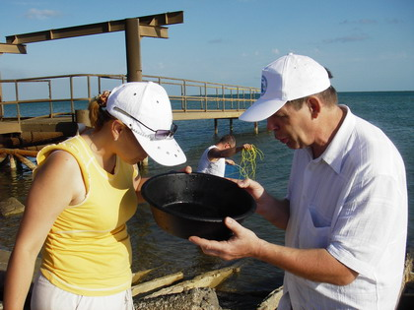
:
№ | Name | Function in the group
1 | Berdyev Berdy | Head of the Group
2 | Nazarenko Victoria | Hydrobiologist
3 | Gapochnik Sergey | Engineer
4 | Boyko Ruslan | Technician
5 | Antonenko Oxana | Technician

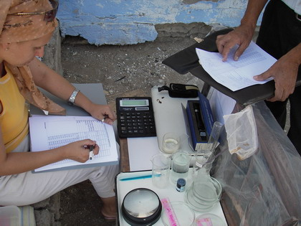

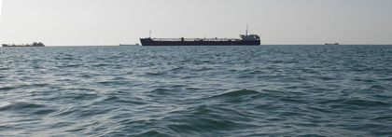

REFERENCES:

Ivanov, P. I., A. M. Kamakim, V. B. Ushivtzev, T. Shiganova, O. Zhukova, N. Aladin, S. I. Wilson, G. R. Harbison & H. J. Dumont, 2000. Invasion of Caspian Sea by the comb jellyfish M.leidyi leidyi (Ctenophora). Biological Invasions 2: 255-258.

Kideys A. E., Finenko G. A., Arashkevith A, Shiganova T. A. Roohi A., Tabari M. R., Rostamian M., Javanshir A., Mirzajani A. R., Bagheri S., Negarestan H. and Parafkandeh F. 2003. Propagation experiments with Beroe ovata in Caspian Sea water in Autumn 2002. Brief Report. A report p
Seravin L. N., Shiganova Т. А., Luppova N. E. 2002. A hisory of study ctenophore Beroe ovata (Ctenophora, Atentaculata, Beroida) and some specific features of its Black Sea representative. Zool. Jour., 81 (10): 1193-1201.
Shiganova T. A., Dumont H., Sokolsky A. F., Kamakin A. M., Tinenkova D. & Kurasheva E. K. 2004. Population dynamics of Mnemiopsis leidyi in the Caspian Sea, and effects on the Caspian ecosystem. Eds. Dumont, H., T. Shiganova & U. Niermann – The Ctenophore Mnemiopsis leidyi in the Ponto-Caspian and other aquatic invasions - NATO ASI Series, 2. Environment-. Kluwer Academic Publishers: 71-111.
Shiganova T.A. 1997. Mnemiopsis leidyi abundance in the Black Sea and its impact on the pelagic community. In "Sensivity of the North, Baltic Sea and Black Sea to antropogenic and climatic changes" Sp.Volume. Еd. E. Ozsoy and A.Mikaelyan. Kluwer Acad. Pub.p.117-130.
Shiganova T.A. 1998. Invasion of the Black Sea by the ctenophore Mnemiopsis leidyi and recent chanches in pelagic community structure. Fisheries Oceanography –Globec Special Issue Ed.Steeve Coombs.p.305-310
Shiganova TA and Bulgakova YV 2000 Effect of gelatinous plankton on the Black and Azov Sea fish and their food resources. ICES Journal of Marine Science 57: 641-648.
Shiganova T. A., Mirzoyan Z. A., Studenikina E. A., Volovik S. P., Siokou-Frangou I., Zervoudaki S., Christou E. D., Skirta A. Y., and Dumont H Population development of the invader ctenophore Mnemiopsis leidyi in the Black Sea and other seas of the Mediterranean basin.// Marine Biol.. 2001. 139 P.431-445.
Vinogradov, M. E., E. A Shushkina., E. I; Musaeva & P. Y. Sorokin,1989. Ctenophore Mnemiopsis leidyi (A.Agassiz) (Ctenophora: Lobata) – a new settler in the Black Sea. Oceanology 29: 293-298.

Shiganova T.A., Dumont H. J., Sokolsky A. F., Kamakin A. M., et al. Population dynamics of Mnemiopsis leidyi in the Caspian Sea, and effects on the Caspian ecosystem // Aquatic Invasions in the Black, Caspian and Mediterranean Seas./ Eds. H.Dumont, T.Shiganova, U.Niermann / Kluwer Acad. Publish., 2004. P. 71−111.

