5th February 2009

Invitation to the ASCLME Second Steering Committee Meeting

Dear Colleague,

I am pleased to invite you to the Second Steering Committee Meeting of the UNDP GEF Agulhas and Somali Current Large Marine Ecosystem Project. This meeting is being hosted by the kind generosity of the Government of the Seychelles and will be held from the 9th-11th March 2009. I am also very pleased to be able to inform you that we will be holding this meeting in parallel with our Sister Project, WIO-LaB. The three Projects will come together for a combined meeting on the 9th to discuss matters of coordination and opportunities for shared activities. This will therefore be a joint meeting of the ASCLME and WIO-LaB Steering Committees but also with representation from SWIOFP. The ASCLME and WIO-LaB Projects will then hold independent meetings on the 10th and 11th March.

Attached is a preliminary Agenda for this meeting along with the current list of invited participants. As always, travel and hotel costs for Permanent Steering Committee Members will be covered by the Project, Observers will need to cover their own costs. As you no doubt understand, the logistics for arranging a meeting of this nature are complex and very time-consuming so we would greatly appreciate it if you could please confirm your attendance as early as possible so that we can make the appropriate arrangements and provide you all with any assistance needed by way of formal confirmations or assistance with Visas.

We would like to draw your attention to certain Agenda items that are of high priority

- Review and endorsement of 2009 Work-plan and Budget
- Review and endorsement of revised project Logical Framework (particularly the indicators which will be used by the Evaluators to judge Project performance)
- Review and adoption of amended/additional Project activities

We will be sending out a package of documentation to each National Focal Point very shortly for your consideration so that you can review these prior to their discussion in the meeting.

The last year has been a very challenging and exciting one and this Steering Committee meeting should prove to be both highly informative and interesting so I personally look forward to the various presentations, discussions and the feedback from the Steering Committee members.

With highest regards and thanks,

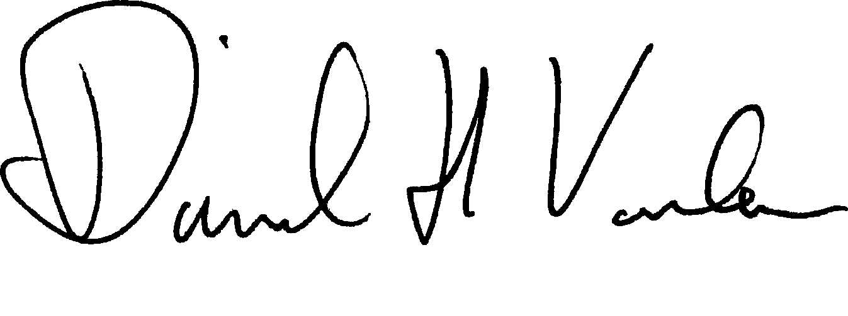

David Vousden,
ASCLME Project Director

