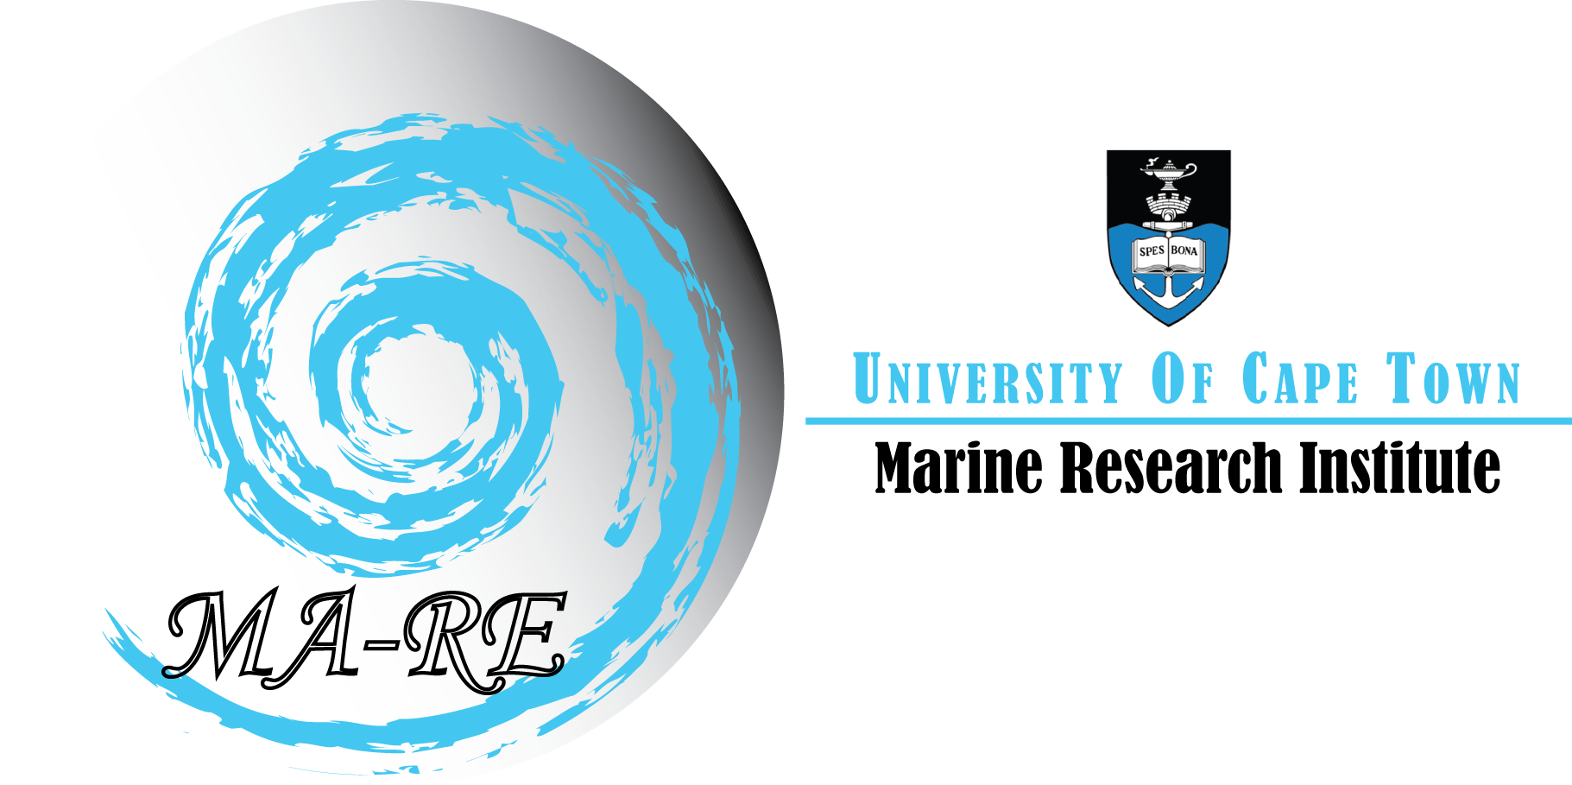
MA-RE Institute
University of Cape Town
Private Bag X3
Rondebosch, 7701
South Africa

Telephone (021) 650 3283 / 5312
Fax (021) 650 3283
E-mail: ma-re@uct.ac.za
Web: www.ma-re.uct.ac.za

ASCLME Training Project Purpose and Background:

An integral component of the ASCLME project involves training and capacity building. The training course provides an introduction on the basic principles, concepts, methods and technologies applied in collection of near-shore oceanographic and biological data. In my opinion, the training course is extremely well structured programme offering trainees an excellent grounding in theoretical “classroom” oceanography followed by hands-on training in data collection, analysis and survey planning. All 10 trainees performed extremely well throughout the course.

My involvement in the ASCLME training course has been threefold.

WEEK 1: LECTURE SERIES – OCEAN TOOLS
The objective of the Ocean Tools series of lectures was to provide the ASCLME trainees with an understanding of analytical skills in ocean data analysis and manipulation.
This lecture series was divided into three components:

1. Introduction to data acquisition techniques

1.1 Tools of the trade – an overview of oceanographic equipment.
1.2 Data acquisition software – advantages and limitations.
1.3 Ensuring data quality – Calibration, filtering, aligning and bin averaging data processes.

2. Introduction to Ocean Data View

2.1 Getting started
2.2 What data can be used and the necessary formats.
2.3 Data availability.
2.4 Import/export functions and troubleshooting.

3. Data analysis

3.1 Visual displays of hydrographic data.
3.2 Exercises using WOCE, drifter, float, current meter data, ADCP.
3.3 Exercise in interpreting regional ocean processes from select hydrographic datasets.

This was very much a “hands on” lecture series. The mornings were taken up with lectures on marine instrumentation, the need to design and implement regional observing systems, the problems concerning post-cruise data processing as well as advantages and limitations for each instrument. Trainees were then given time to design a simple cruise plan based on the equipment known to them.

A second component of the lecture series was for the trainees to familiarise themselves with Ocean Data View and using data collected during the WOCE era draw a number of oceanographic plots such as TS profiles, scatter plots, cruise maps, vertical sections etc..
The trainees were given a number of exercises in which a two WOCE surveys had to be drawn up and analysed.

WEEK 2: SHIP-BASED - ST HELENA BAY MONITORING LINE

The aim of this component, following a week of lectures, was for the trainees to gain a practical level of knowledge in acquiring and processing of hydrographic and biological data. A 3 day cruise onboard the F.R.S. Africana was planned. The aim of the cruise was to overlap the training of the ASCLME trainees with a current monitoring project in St Helena Bay. The aim of this project is

- To regularly monitor the general oceanography and plankton in St Helena Bay.
- To collect phytoplankton, microzooplankton and mesozooplankton on a transect starting off Elands Bay in 30m of water and finishing in a depth of 1000m.
- To collect data on temperature, salinity, dissolved oxygen and fluorescence with the Seabird CTD
- To collect predatory fish stomach contents to determine the presence of pre-recruit forage fish.
- To demonstrate Acoustic identification of pelagic species and the collection of high resolution multi-frequency data for species identification. Possibly midwater trawl on a target.
- To demonstrate bottom trawl gear and trawling operations.
- To demonstrate fish identification and general biology.

During this cruise the students received the following practical training:

- Pre-station checks – trainees were shown how to get the CTD ready, cock all Niskin bottles and ensure that all valves were closed.

- Log keeping – trainees had to make sure that a correct log, recording station position, time and date, sounding and atmospheric conditions, was kept for each station.

- CTD acquisition software – following CTD deployment, trainees were given the task of overseeing the acquisition software, ensuring that all 12 bottles were closed at pre-determined depths, communicating with both the winch operator and bridge. Once back on deck, samples for dissolved oxygen and plankton analysis were taken by each trainee from the rosette and analysed.

- Post-station processing – CTD processing software allows the operator to clean up and filter the CTD data. Following the cast, steps were taken by the trainees to process the data into an ODV format. To achieve this, the data had to first be averaged into single 1 m bins, converted from binary to ascii format, any spikes removed and to compensate for the pitch and roll of the ship during the deployment.

Throughout the previous week the trainees received lectures on oceanographic instrumentation and the steps necessary to take to (a) collect the data and (b) process into an ODV format. Participation in this cruise enabled each trainee to put into practice the information learnt the previous week. Unfortunately, gale force winds and swell > 5 m resulted in the survey being cancelled and only 4 stations and a single mid-water trawl were occupied.

WEEK 3: FALSE BAY FIELD TRIP

A 5 day False Bay boat based field trip was organised as a follow on from the cruise. The ASCLME office had bought a YSI handheld CTD/data logger and the aim of this week was for the trainees to gain experience in boat-based work using this new instrument.

Trainees were divided into 2 groups.

Day 1 and 2 - Trainees spent each day getting hands on experience in operating the YSI CTD and carrying out net tows in the lee of Smitswinkel Bay. During this period, each group were trained in the correct procedures of lowering a CTD by hand, the optimal rate at which the CTD should be lowered, the correct procedure in keeping a station logbook, as well as down loading the data from the data logger into the Ecowatch software. In addition, at each CTD cast the trainees, under the guidance of Pierre Malan, operated both a vertical and horizontal net trawl and analysed phytoplankton obtained during each cast.

Day 3 and 4 – Trainees spent each day collecting CTD and BONGO data along the Simons Town - Rooiels monitoring line, which is occupied by IMT. The large opening of False Bay exposes the basin to external influences such as sub-tidal sea level fluctuation and current reversals that occur in the SE Atlantic Ocean. Previous studies have produced sufficient data to investigate the occurrence of remote wind forcing but insufficient data exists on the exact response of this bay to this remote forcing. This line comprises of a total of 9 CTD stations across the mouth of False Bay and aims to better understand the combined role physical processes such as tides, wave activity, variation in wind direction and strength have on the general circulation of the Bay. In doing so, IMT hope to establish the role seasonality and in particular changes in wind stress between Summer and Winter months have on the circulation path within the bay.

As part of the training cruise, a total of 7 CTDs and net trawls to a maximum depth of 70 m were deployed each day across the mouth of False Bay.

Day 5 - This was the final boat day and each group was given an exercise to map the freshwater influx of the Elsies River into Glencairn Bay. Trainees were given a free reign to plan a suitable survey grid that would establish the extent and character of the fresh/brackish water plume extending into the bay. The trainees were encouraged to work as a team in their survey work. At each survey between 8 and 11 CTDs were deployed within the Bay area, surface oxygen samples were collected and fixed at each station and 2 net tows were conducted across the river mouth. The following week was given to writing up the data into a research report - see accompanying reports.

EQUIPMENT RECOMMENDATIONS

YSI CTD 600 XLM – This is an extremely simple CTD to use. The basic handheld interface shows changes in temperature and salinity as the cast is underway. The necessary commands to activate and deactivate the data logger, save or download data are extremely user-friendly resembling a cell-phone styled touchpad. The YSI software “Ecowatch” is very user friendly and none of the trainees experienced any problems in learning this quickly. Once the data had been downloaded the trainees then plotted and analysed the data in ODV.

Ocean Data View (ODV) - Ocean Data View, is a multiple-variable graphical analysis and display package for oceanographic station data (station metadata, temperature, salinity, nutrients, others), compatible with several commonly used international marine data formats. Station charts, station data profiles, multi-variable scatter plats, section profiles, and surface plots can be created easily within a user-specified physical layout. Plotted data is easily gridded and/or contoured in nearly all views. This is an extremely simple programme to learn and the trainees had absolutely no problems in getting to grips with the import of the data they had collected during the boat survey. A major advantage of this software is that it is free to all institutes and can be easily downloaded off the web.

Nets – Again no difficulty was encountered during each deployment.

Oxygen Titrations – Dissolved oxygen samples were collected on the last day. Each sample was “fixed” and analysed back in the Oceanography lab.

CONCERNS

The ASCLME office needs to establish, prior to the training course, the nature of boat-based work for each country and to develop an oceanographic “toolbox” in line with their needs. We have drawn up an equipment “wish-list” that should be purchased prior to the next training programme.

In addition, the YSI CTD, although a very simple device to use, houses only the minimum sensors i.e. temperature, depth and Salinity. Should the countries and their institutes be interested in pollution studies, estuarine or mangrove research/monitoring, turbidity or productivity studies then it is essential that more sensors are available to the trainees. Additional sensors that should be included in the package are dissolved oxygen and turbidity.

The connection between the CTD interface and the PC is an old com1 port. Most modern laptops do not have an available com1 port having been replaced by a USB. To ensure that the data can be downloaded from the CTD I would strongly recommend that each CTD package come with a Com1-USB converter – I would imagine such a cable would be difficult to purchase in some African countries.

EQUIPMENT SUGGESTIONS

Pierre Malan and I have put together a wish list that the ASCLME office should consider for future training programmes.

Plankton

- Plankton nets - The best would probably be a mini bongo with a 200micron mesh. This could be hauled vertically or obliquely using a hand winch. A surface drift net which could be deployed over the side of a small boat.
- A hand winch with about 200 meters of 5mm wire. Should be able to be mounted on a small boat, probably clamped to the rail.
- A “backpack” water tank of the type used by firefighters. This could provide water pressure for washing down plankton nets.
- Squeeze bottles for formalin
- Sample containers – best would be 350 ml screw top jars.
- Waterproof paper labels
- A plankton concentrator, best made of PVC pipe with plankton net glued over one end.
- Spare plankton netting of the same mesh as the nets.
- A small secchi disc for light studies

Oxygen

- 1 to 5 ml disposable syringes for dispensing MnCl₂ and NaOH+KI
- Winkler equipment including a self zeroing burette, chemical containers, including a container with a pressure bulb for pumping reagent into the burette.
- A reagent box set – dealing with reagents on a rocking boat is difficult and requires a number of hands to prevent the bottles from spilling and breaking. A box with the reagents bottles strapped that can be clamped onto the side of the boat would be ideal for this work.
- Small Niskin bottle and rope of up to 50 m.
- Rope markers
- Spare messengers
- Oxygen tubes
- Small digital thermometer
- Spare plastic bottles

Temperature

- A Crawford Bucket
- Spyglass

General

- Assorted buckets
- Waterproof bins for packing equipment
- An echosounder that can be mounted on a small boat. Battery operated with a transducer that can, if necessary, be put overboard on a pole.
- GPS
- Solar battery charger for GPS and echosounder batteries.

Report by I.J. Ansorge and Pierre Malan

