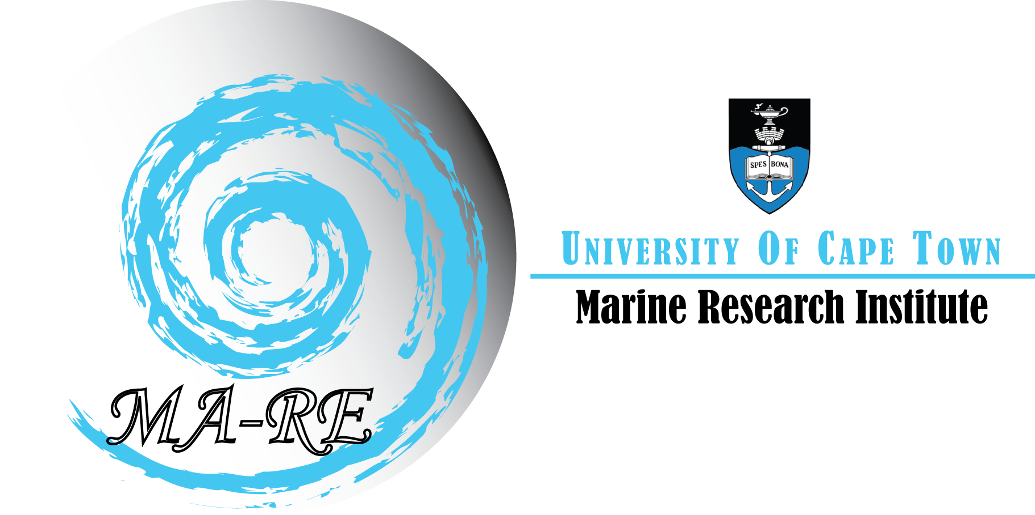
MA-RE Institute
University of Cape Town
Private Bag X3
Rondebosch, 7701
South Africa

Telephone (021) 650 3283 / 5312
Fax (021) 650 3283
E-mail: ma-re@uct.ac.za
Web: www.ma-re.uct.ac.za

MA-RE Institute – ASCLME Oceanographic
Training Course & Cruise (DRAFT II)
23 June – 16th July 2008
Venue: Zoology Building – Seminar Room 1

Course Component:

Day 1: (23 June)
Introductory lectures

8:15 – 8:30
Welcome and Introductions

8:30 – 9:25
Frank Shillington
- Insights gained from the BCLME activities
- Oceanographic sampling strategies - E.g. aliasing, synoptic coverage etc
- An introduction to geostrophy
Suggested reading: Emery, W.J., Thomson, R.E., 1998. Data analysis in physical oceanography. Pergamon, Elsevier, Oxford, 634pp

9:30 – 10:25
Johann Lutjeharms
THE GREATER AGULHAS CURRENT SYSTEM
- The Agulhas Current system consists of the Agulhas Current proper, its sources in the West Indian Ocean and its outflows into the South Atlantic and the South Indian Oceans. In this lecture all these components are dealt with and placed into context. These include the South Equatorial Current, the East Madagascar Current, Mozambique Eddie, the Agulhas Current, the Agulhas retroflection, Agulhas Rings and the Agulhas Return Current.

10:30 – 10:45
Tea & Coffee

10:45 – 13:00
Mike Lucas
- Phytoplankton taxonomy, biomass and productivity (For more information – see below)

13:00 -14:00
Lunch

14:00 - 15:00
George Philander
- Global Climate Change & How to build a habitable planet

15:00 - 16:30
Howard Waldron
- Dissolved oxygen titration in the Lab
- Brief overview of the Train-Sea-Coast Programme

Day 2 & 3 (24-25 June)
9:00 – 13:00
Isabelle Ansorge (For more information – see below)

- Introduction to techniques in which hydrographic data is acquired and quality assured.
- Introduction to Ocean Data View and the analysis of hydrographic data.

14:00 – 16:00
- Learning and Working with Ocean Data View (Computer Lab)

Day 4 & 5 (26-27 June)

26th June
9:00 – 10:00
Warwick Sauer
- Fisheries Management

10:00 – 10:15
Tea

10:15 – 13:00
Christo Whittle
- Introduction to marine remote sensing

13:00 – 14:00
Lunch

14:00 – 16:00
- Introduction to marine remote sensing (Computer labs)

For more information – see below

27th June
9:00 – 10:00
Johann Augustyn
Ecosystem Approach to Fisheries

10:00 – 10:15
Tea

10:15 – 13:00
Christo Whittle
- Introduction to marine remote sensing (contd.)

13:00 – 14:00
Lunch

14:00 – 16:00
- Introduction to marine remote sensing (Computer labs)

For more information – see below

Conference Component:

29 June – 4 July
SAMSS – Kramer Building – UCT Middle Campus

1 July
Afternoon- Leave UCT at 13:30
14:00 – 16:00
- Fish Identification and Biology – at Marine and Coastal Management

Cruise & Write-up Component:

7 – 13 July
Nansen Cruise

Sharon du Plessis
Fish Identification and biology

Isabelle Ansorge, Pierre Malan & Christo Whittle
The aim of this component will be for students to gain a practical level of knowledge in the acquiring and processing of hydrographic data. An oceanographic feature such as an Agulhas Current filament identified prior to the cruise from remote sensing will be surveyed during the time available. Equipment available will comprise of CTD, XBT, ADCP, surface drifters and ARGO floats. In addition, students will learn sampling and analysis techniques for dissolved oxygen, salinity, nutrients (Silicates, phosphates, nitrates and nitrites) and chlorophyll. Students will be expected to make use of their ODV training to interpret all hydrographic data collected during this survey.
Topics covered by this cruise component will include:
- Design, planning and execution of a scientific survey off Cape Town.
- Deployment and operation of equipment and instrumentation.
- Real-time acquisition and processing principles and sequence.
- The importance of correct sampling techniques, real-time data control and quality assurance.
For more information – see below

14 July
Field trip to SADCO (CSIR) and IMT (Simon’s Town)

15 – 16 July
Write Up of the cruise
Write up on SAMSS conference – Topic “What are your thoughts, opinions and insights on the SAMSS conference in relation to your training”

Deadline for submission of both the cruise report and the SAMSS report – 31 July 2008 to Pavs Pillay (Pavs.pillay@uct.ac.za)

16 July (Lunch Time)
Finger Lunch, Closing and Certificate presentation

Data Acquisition and Ocean Tools Module
Convenor – Dr I.J.Ansorge

Ocean Tools is a dedicated training module aimed at providing emerging scientists with invaluable experience of life onboard a research vessel while also providing the practical and analytical skills necessary to conduct scientific operations in an offshore environment. This module will comprise of a 2 day course followed by a 7 day hydrographic research cruise onboard the RV Fridtjof Nansen. The objectives of this course are to provide students with an understanding of analytical skills in ocean data analysis and manipulation, as well as to gain hands on experience in collecting, sampling and interpreting data collected at sea.
The investment in training will have knock on benefits for scientific research and development organisations, while further enhancing available employment opportunities for emerging African scientists on both a national and international level.
This module is divided into three components:

                - Introduction to techniques in which hydrographic data is acquired and quality assured.
                - Introduction to Ocean Data View and the analysis of hydrographic data.
                - Shipboard training onboard the RV Fridtjof Nansen and write up of the cruise data.

Sections 1 and 2 of the course will be composed of 3 hour theory lectures in the morning followed by afternoon practical sessions in which students will familiarise themselves with ODV.

1. Introduction to data acquisition techniques

1.1 Tools of the trade – an overview of oceanographic equipment (CTD, Floats, ADCP, XBT etc.).
1.2 Data acquisition software – advantages and limitations.
1.3 Ensuring data quality – Calibration, filtering, aligning and bin averaging data processes and the effects
of pitch and roll on CTD data collection.

2. Introduction to Ocean Data View (ODV)

1. Getting started
1.1 What data can be used and the necessary formats from ascii to netcdf.
1.2 Data availability – WOCE, ARGO, Coriolis, AVISO.
1.3 Exploring web based a database – who is doing what and where.
1.4 Import/export functions and troubleshooting.

2. Data analysis
2.1 Profile/scatter plots, TS diagrams, cruise plans, bathymetry, physical sections and distribution plots.
2.2. How interpretive is ODV – matching ODV to hand drawn sections and profile plots.
2.2 Exercises using WOCE, drifter, float, current meter data, ADCP.
2.3 Exercise in interpreting regional ocean processes from select hydrographic datasets.

3. Shipboard training onboard the RV Fridtjof Nansen and write up of the cruise data

The aim of this component will be for students to gain a practical level of knowledge in the acquiring and processing of hydrographic data. An oceanographic feature such as an Agulhas Current filament identified prior to the cruise from remote sensing will be surveyed during the time available. Equipment available will comprise of CTD, XBT, ADCP, surface drifters and ARGO floats. In addition, students will learn sampling and analysis techniques for dissolved oxygen, salinity, nutrients (Silicates, phosphates, nitrates and nitrites) and chlorophyll. Students will be expected to make use of their ODV training to interpret all hydrographic data collected during this survey.

Topics covered by this cruise component will include:
  - Design, planning and execution of a scientific survey off Cape Town.
  - Deployment and operation of equipment and instrumentation.
  - Real-time acquisition and processing principles and sequence.
  - The importance of correct sampling techniques, real-time data control and quality assurance.
Furthermore, students will be required to analyse and write up all hydrographic data collected at sea into a final cruise report and if possible a short publication for a scientific journal.

Phytoplankton Taxonomy, Biomass and Productivity
Convener: Mike Lucas

Students will be introduced to the diversity of phytoplankton taxa and the most important groups (eg diatoms, phytoflagellates, coccolithophores. Furthermore, global distribution of phytoplankton (from satellite imagery) will be described and an outline of the major controls on phytoplankton production – viz light, macro-nutrients (N, P, Si), micronutrients (Fe) and grazing by zooplankton will be presented. Also something about measurements of primary production using 14C radio-isotopes will be mentioned.
The concept of the “biological carbon pump” will be introduced and also why this is important in the context of global climate change; explaining how phytoplankton productivity by diatoms in particular can export carbon into the deep ocean. Finally a brief outline of the three different phytoplankton scenarios with respect to climate change: 1) ocean acidification and coccolithophores, 2) nitrogen fixers and dust transport, 3) Southern Ocean diatoms and iron fertilization will be covered.

Introduction to Satellite Marine Remote Sensing

Convenor: Christo Whittle

Introduction to Satellite Marine Remote Sensing will compliment the Ocean Tools module presented by Dr Ansorge. This synergy will also demonstrate the interdependence of in situ and satellite data when attempting to provide the best possible 3-D picture of oceanographic features. The module will provide a brief introduction in the principles and applications of satellite marine remote sensing. It is aimed at providing marine scientists of varying backgrounds with the necessary tools to incorporate satellite oceanography products in the planning and execution of a marine research expedition. Although the research expedition will focus on a mesoscale oceanographic phenomenon, the demonstrated advantages of tools providing vast spatial coverage with a high temporal frequency at a relatively low cost, should encourage emerging African marine scientists to incorporate these products in large marine ecosystem monitoring and management.

The module will have three components:
- Fundamentals of satellite oceanography
- A practical introduction to image analysis and image processing using the Bilko software package.
- Shipboard analysis and interpretation of near-real time satellite data to facilitate in situ sampling strategy.

The initial theory and practical lectures will be spread over two days. Each morning will be comprised of two hour theory sessions followed by three hour practicals in the afternoon.

- Theory component: Fundamentals of satellite oceanography:
  - A brief history…
  - Earth observation, the big picture…
  - Definition of Remote Sensing
  - Breakdown of the remote sensing process
  - Oceanographic satellite data resources
  - Some applications of remote sensing products

- Lab component: Image analysis and feature interpretation with Bilko
  - Brief introduction to satellite imagery and image analysis techniques: loading different file formats, histograms, stretches, palettes, image rectification, scattergrams, formulae, filters…
  - Investigating the Benguela Upwelling System with MODIS and Envisat ocean colour and sea surface temperature data.

- Planning and execution of research project:
  - Shipboard training aboard the RV Fridtjof Nansen and write up of the cruise data and complimentary remote sensing analysis – An oceanographic feature such as an Agulhas Current filament identified prior to the cruise from remote sensing will be surveyed during the time available.

