28th February 2013

To: Policy Advisory Committee Members, ASCLME and SWIOFP Steering Committee Members and National Focal Points

Subject: Amended Draft of the Western Indian Ocean Large Marine Ecosystems Strategic Action Programme

Dear Colleagues,

As agreed at the recent 3rd Policy Advisory Committee meeting in Johannesburg (22nd February 2013) we have now amended the Strategic Action Programme as requested and would now like to circulate it (attached) for your final comments and approval before we send the document formally to the countries for their consideration for endorsement at the Ministerial level.

Also, as further requested by the 3rd Policy Advisory Committee, please find attached a copy of the country comments and proposed amendments arising from the National Consultations process. The amendments and changes were captured in the last document as presented to the 3rd PAC and have therefore been addressed and this National Consultations document act as a means of confirmation. National identifications have been removed in case of any sensitivity.

The 3rd PAC further requested an updated timetable showing deadlines for PAC endorsement as well as PIF (Project Identification Form) endorsement and this is also attached

I would draw your attention to two substantive and important additions in the Statement of Endorsement for the PAC (highlighted in that Statement). These refer to a decision made at this week’s SWIOFC Special Session whereby the countries have agreed to reforming the Commission from an Advisory Body to a full Managerial body. There is a further statement reflecting the intention to incorporate the ecosystem approach into all participating country’s national fisheries management plans. SWIOFC asked that these statements be add to the SAP and they significantly strengthen national commitments to appropriate ecosystem-based reforms and therefore provide enormous justification now for seeking further funding from GEF.

Finally we would respectfully remind you of the decision of the PAC to confirm your agreement and endorsement of this SAP document as being ready for submission to the ministerial level for signature. The PAC agreed that this would happen within 2 weeks of re-circulating and we would therefore be grateful if we could receive your acceptance of this draft as of 15th March.

As always, allow us to take this opportunity to express our thanks for all the effort and hard work committed by the PAC, as well as the ASCLME Steering Committee, SWIOFP Steering Committee and Special Session of SWIOFC. Please do not hesitate to contact ourselves for any further clarification, advice or assistance.

Kind regards,

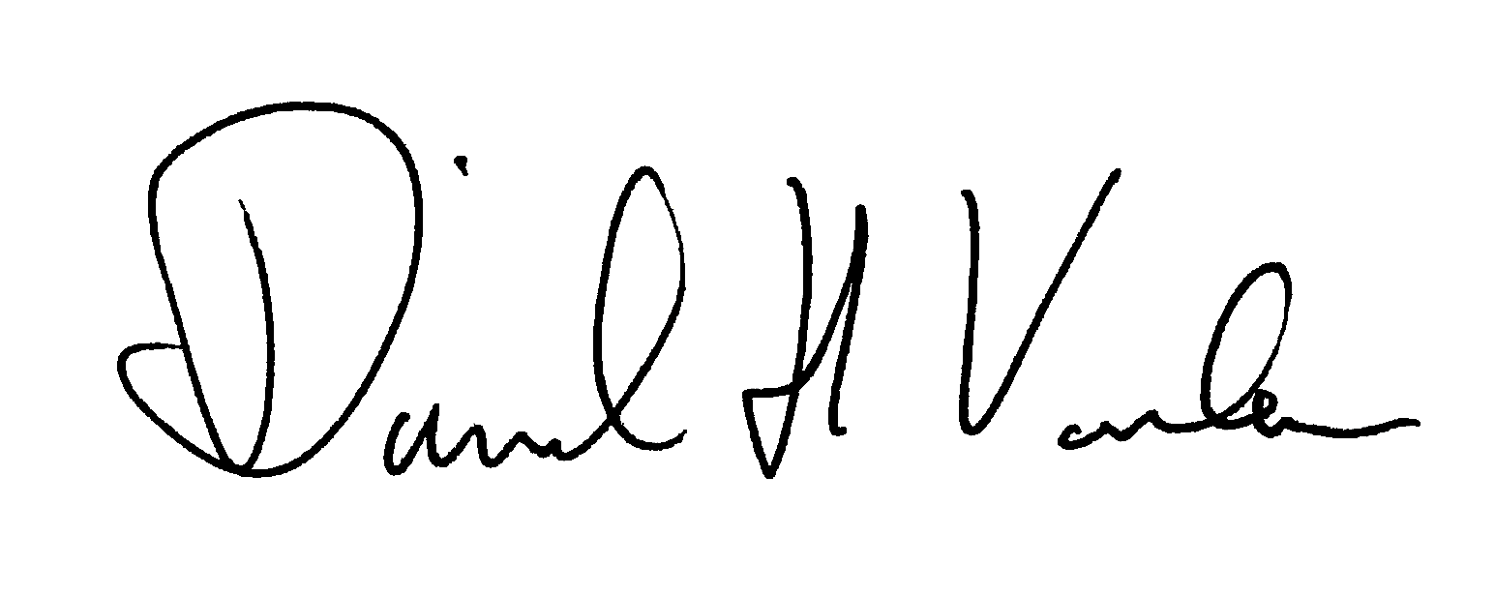 | 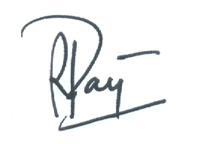
David Vousden  Regional Director,  ASCLME-UNDP-GEF | Rondolph Payet  Regional Executive Secretary  SWIOFP- World Bank

