Analysis of Benguela Dynamical Variability and Assessment of the Predictability of Warm and Cold Events in the BCLME

Report No 3

RAF/00/G32 – Benguela Current Large Marine Ecosystem

31/07/2004

Compiled by Dr. Pierre Florenchie

for

United Nations Office for Project Services

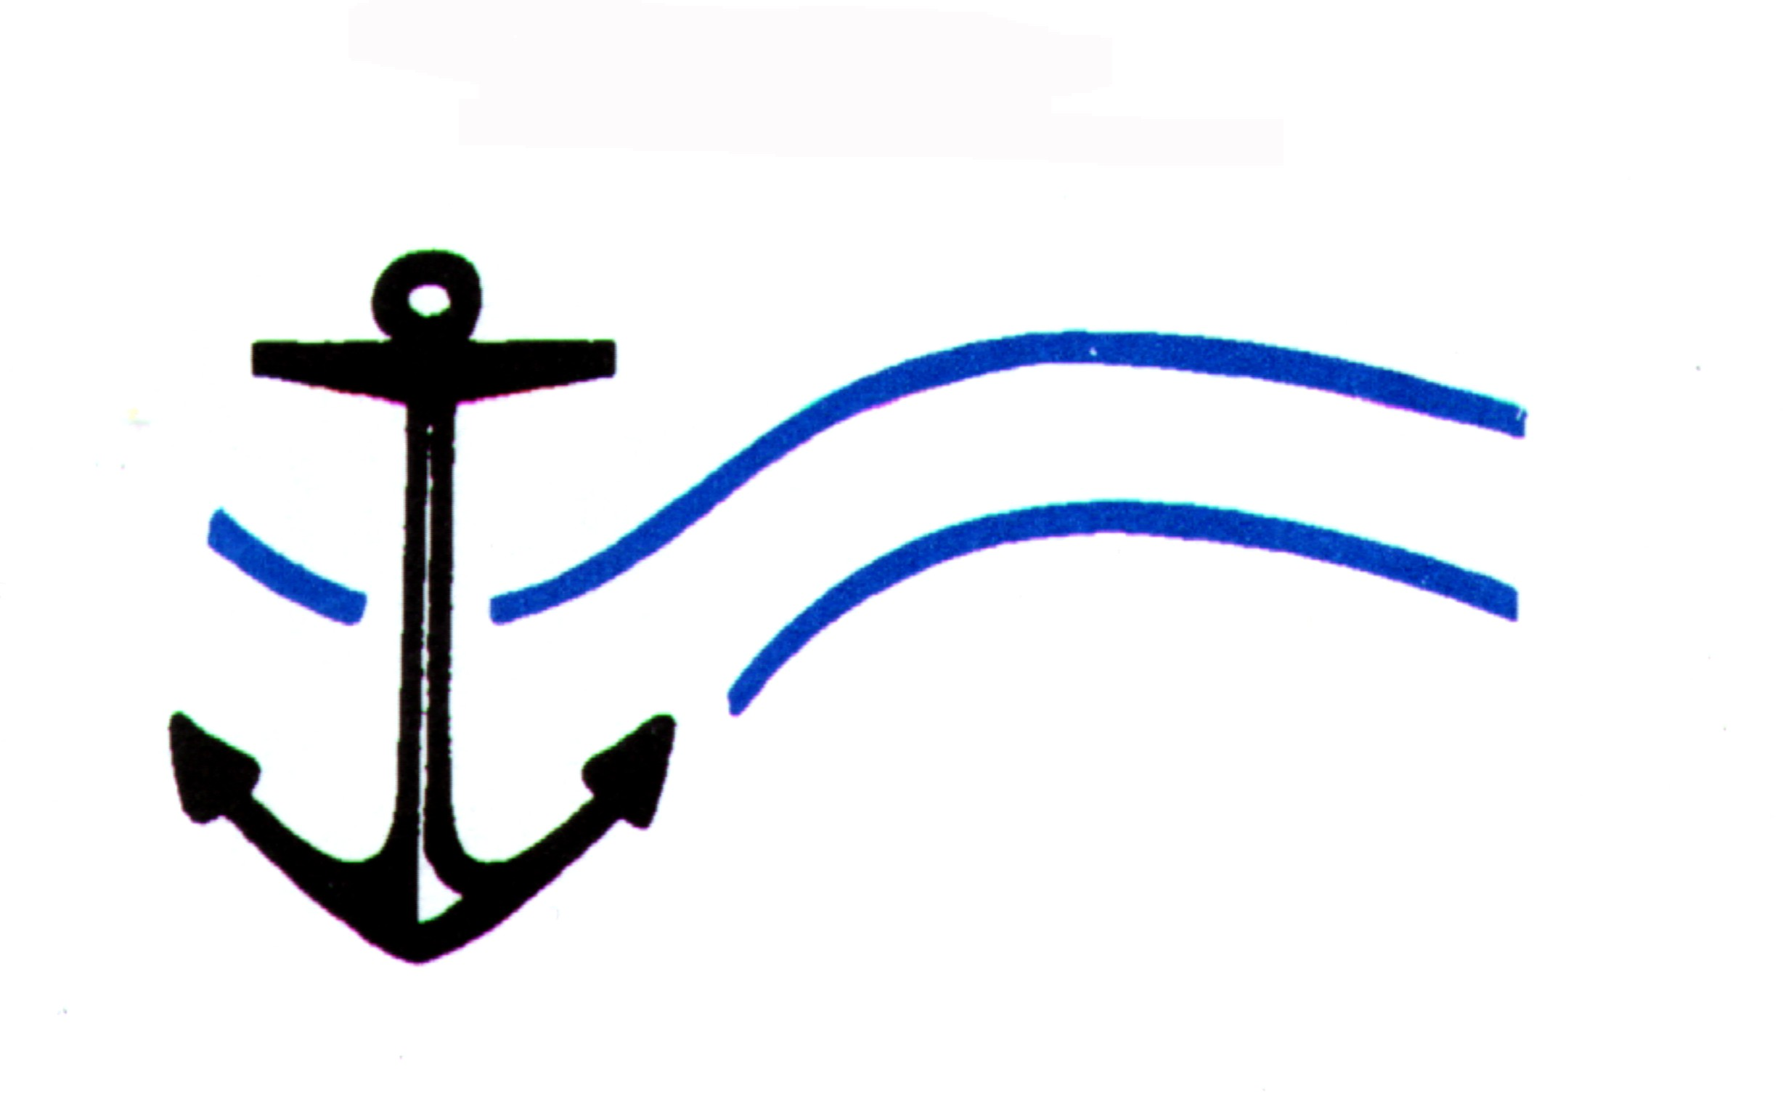
Centre for Marine Studies  University of Cape Town | Oceanography  University of Cape Town

Executive Summary

The consultant submits to UNOPS the report No. 3. Adopted time for delivery is 2004/07/31 but some delays occurred in the delivery of the modelling platform (June-July 2004). This report describes in detail Dr. Florenchie’s activities under the contract for the last 6 months and the progression of the project as initially planned point by point. The first section describes the installation of the modelling platform in the Department of Oceanography and the simulations performed using the ROMS coastal model and its downscaling system AGRIF. Results have been presented during the LUCORC workshop held in Cape Town (28-30th July 2004). Section two provides a description of the new CLIPPER experiment for the South Atlantic ocean. It includes a preliminary analysis of the coastal circulation in the Lüderitz cell area. The document “Numerical model investigation of circulation features in the Angola Basin” has been attached to the report. It corresponds to the Masters Thesis by Jenny Veitch under the supervision of the consultant and is part of the capacity building and training aspect of this BCLME project. In this report, OPA model outputs have been used to study the Angola Dome. The paper entitled “Evolution of Interannual Warm and Cold Events in the South-East Atlantic Ocean” has been published in the Journal of Climate in July 2004 with the consultant as the first author. Attached is a reprint of this paper. The paper entitled “The Source of Benguela Niños in the South Atlantic” published by the consultant as the first author in Geophysical Research Letters (June 2003) received the 2004 Stanley Jackson Award as the best publication in South Africa in atmospheric and oceanographic sciences.

Table of Contents

Executive Summary………………………………………………….…………….. 2
1. Modelling Platform and the ROMS-AGRIF experiment……………………… 4
1.1 Set up process……………………………………………………………… 4
Miscellaneous problems encountered at this stage and future
developments…………………………………………………………….… 5
1.2 First simulations on the platform using ROMS - AGRIF………………. 6
1.2.1 Zooming with AGRIF into a specific area: the Angola-Benguela
Frontal Zone (ABFZ)……………………………………………… 6
Results of the simulation..………………………………………. 8
    - Orange River outflow simulated with ROMS-AGRIF….……… 10
Perspectives……………………………………………………….. 18
2. The New CLIPPER experiment - The Lüderitz Cell………………………… 19
Using Clipper outputs to study the Lüderitz Cell barrier…………………… 20
Model climatological velocity fields…..………………………………………. 20
Circulation at Surface layers, 0 to 30m (lev01)……………………………… 20
Circulation at 40m depth (lev04)……………………………………………… 22
Circulation at 80m and 130m depths (lev07 and lev10)…….……………… 22
Circulation at 230m and 350m depths (lev13 and lev15)………..………… 23
Circulation at 570m depth (lev17)……………………………………………. 24
3. Conclusion - Perspectives........…………………………………………..…... 25
4. References……………………………………………………………………… 26
5. APPENDIX A…………………………………………………………………… 26
6. APPENDIX B…………………………………………………………………… 26

1 – Modelling Platform and the ROMS-AGRIF experiment

The modelling platform was installed in the Oceanography Department in June-July 2004 with the help of Jeremy Main, a UCT engineer directly involved in the setup and maintenance of the platform. The platform includes two computational servers (Itchy and Scratchy) and a storage machine (Bart) – (see report No 2 for more information). Its feasibility and its computational capacity were tested by the consultant and Dr. P. Penven from IRD (Institut de Recherche et Développement - France) via several experiments using the ROMS model and the down-scaling tool AGRIF in various configurations. Thanks to collaboration between UCT and IRD, Dr. Pierrick Penven has joined the Oceanography Department in July 2004 and his expertise concerning the ROMS model and coastal modelling will be an asset for the BCLME project. In terms of storage ability, outputs from the new CLIPPER experiment which constitute a massive amount of data could be saved via ftp on Bart.

1.1 – Set up process

A room was specifically allocated in the department for the three machines of the modelling platform. The two computational servers and the storage machine generate a lot of heat. In order to maintain a reasonable and adequate temperature all year long (especially in summer), the room was equipped with air conditioning. Technicians have built up a local cable network in the department which connects users directly to the computer room from their offices. This is a key aspect of the whole system in terms of efficiency and comfort for the users. As a result the consultant, other scientists involved in the BCLME, invited scientists from foreign groups or students trained in the frame of this project, have access to the platform from their own computers. Most technical aspects of the set up have been taken over by Jeremy Main. He is now in charge of the maintenance of the installation and plays the role of system administrator (root). The principle of the system is the following: all the data, programs and model routines are put on Bart with a direct access from the computational servers (Itchy and Scratchy). Users log in the whole system via Itchy or Scratchy and go on Bart. As a result all programs are launched on Bart while calculations involve only the CPUs of Itchy and Scratchy (2 each). Outputs are stored on Bart. A main aspect of the system is the transparency between the three machines.

The ROMS-AGRIF package (latest version) has been successfully installed on the platform and compiled. Outputs from the last CLIPPER experiment which represent a huge amount of data could also be stored. With the help of the administrator, the consultant has created accounts on the platform for multiple actors contributing to the BCLME at different levels. Below is a list of current users:

- Jeremy Main: root administrator
- the consultant (UCT-BCLME): ROMS simulation and access to CLIPPER data
- Dr. Pierrick Penven (IRD): modelisation, our ROMS’s expert
- Jenny Veitch (UCT- BCLME Masters Student): access to OPA and observation data
- Nicolette Chang (UCT- PhD student): ROMS simulation
- Dr. Pedro Monteiro (UCT-BCLME): access to CLIPPER data at this stage
- Dr. Remy Tailleux (UCT): access to various data sets
- Dr. Chris Reason (UCT-BCLME): simulation
- Frank Colbert (UCT BCLME - PhD student): simulation, access to CLIPPER data

This list is not exhaustive but access will be restricted to a limited number of users to preserve the efficiency of the system.

Miscellaneous problems encountered at this stage and future developments

Various technical problems occurred in July during the set-up process. Some of them concerned internal aspects of the two machines and could not be solved immediately. For instance the consultant had a problem to unlimit the stacksize of Itchy and Scratchy. Put simply, it means that the machines did not work at 100% of their capacity during a simulation. Some computers are built this way and ordinary UNIX commands (like “limit stacksize unlimited”, …) are unable to solve the problem. The kernel of the computer has to be modified. This should be solved by the administrator within a few weeks. Another aspect concerned the RAM of the two computational servers. It had been fixed to 1 Gb for each machine during the purchase process but it appears to be a limiting factor for our experiments (especially when AGRIF is used). In order to improve the performances of the servers, it has been decided that the RAM would be extended to 2 Gb which represents the upper limit for 32-bits processors. Another problem concerns the compilers installed on Itchy and Scratchy. Some of the latest developments on specific ROMS routines will require newer versions and they should be replaced in time.

1.2 – First simulations on the platform using ROMS-AGRIF

ROMS is the Regional Ocean Model System. This is a sigma coordinates model and it is particulary well adapted to coastal simulations: vertical resolution is independent of depth. ROMS is used by various teams around the world for coastal modelling. It is very beneficial to the BCLME since it involves and allows international collaborations. Dr. Pierrick Penven has already joined the Department of Oceanography at UCT and the consultant is in contact with Dr. Laurent Debreu who developed the AGRIF (Adaptative Grid Refinement in Fortran) system. He will visit us at UCT next year. Other scientists like Dr. Patrick Marchiesello (UCLA–IRD) should also be invited soon to UCT as international specialists of ROMS and coastal modelling.
The AGRIF system is a nesting capability added to ROMS to increase locally near-shore horizontal resolution. It has been tested successfuly at UCLA by Dr. Debreu and the team of Prof. MacWilliams in various simulations along the coast of California with ROMS. On an operational level and in cooperation with the US Navy and the City of Los Angeles, ROMS and AGRIF have been used by the same team to track domestic pollution from the existing outlet pipe in the Bay of Los Angeles (see below Figure 8). Using AGRIF requires excellent computational performances since it increases substantially the volume of calculations.

At this stage two main simulations have been carried out by the consultant using the modelling platform during the two last weeks of July. The first involves the AGRIF downscaling system, the second focuses on the outflow of the Orange River in the Ocean thanks to a recent option added to ROMS. Both preliminary studies have been presented during the BENEFIT / BCLME Lüderitz Upwelling Cell Orange River Cone (LUCORC) Workshop held in Cape Town (28-30th July 2004).

1.2.1 – Zooming with AGRIF into a specific area: the Angola-Benguela Frontal Zone (ABFZ)

The overall domain can include a number of embedded sub-domains. Following the principle of “Russian dolls”, each subdomain shows an increased grid resolution by a factor of 3 or 5 compared to the preceding one. The choice of the factor is optional but has to be 3 or 5 for numerical reasons specific to AGRIF.

In this first experiment, the number of sub-domains is limited to one, and the factor between the two grids is 3. The resolution of the “parent grid” (PG) is 1/6° (~18 kms) and the resolution of the “child grid” (CG) is 1/18° (~6kms). The time-step in the sub-domain is divided by the same factor, i.e. 3, to take into account the higher resolution. It implies of course that the computational cost of the whole simulation increases substantially and it limits the size and number of sub-domains. For instance, an area with 9 original grid points (3x3 matrix) will turn into a subdomain with 49 points when the factor is 3. With a time step divided by 3, the computational weight is increased by (49/9)*3~16. For an infinite grid, the cost tends to be multiplied by 18.

At this stage of the experiment, information goes from the PG to the CG only. There is no feedback from the CG to the PG. In other words, the PG does not “see” the sub-domain. Calculations are performed over the overall domain on the 1/6° grid in a classical way. At each time step, outputs of prognostic variables from the parent model are extracted along the open boundaries of the CG and interpolated to match the high resolution grid. The model runs 3 time steps in the CG, each of them being equal to dt/3. The last time step corresponds to the PG next time step.

Parent model → Child model then Parent model → Child model
t1 t2 → t10 t11 t12 t13 then t2 t3 → t20 t21 t22 t23

with (t2 - t1) = dt, t2 = t10, (t10 - t11)=dt/3 and t13=t3.

Two different types of topography can be chosen for the subdomain: one coming from the Etopo-2 data file (1/12°) interpolated or extrapolated at the resolution of the child grid, or one being a simple interpolation of the topography used in the parent domain. The first one will include new topographic features that had been smoothed over the PG while the second is identical to the PG one. The advantage of the second option is that there is no gap between the two topographies at the open boundaries. With the first one, the topography gains in realism but the adjustment between the two topographies can generate some artificial features or current instabilities. For instance, a narrow canyon that had been completely smoothed in the PG will appear abruptly in the CG at the border between the two domains. To avoid this kind of anomalies, a buffer zone exists between the two grids allowing a progressive transition from one domain to the other. In this experiment, the topography of the subdomain is simply interpolated from the topography of the parent grid.

The total domain extends from 6°S to 32°S, and from 1°E to the African coast. The sub-domain extends from 12.5°S to 20°S, and from 6°E to the coast. It includes the Angola-Benguela Frontal Zone (ABFZ). A Matlab program has been written to simplify the implementation of AGRIF into ROMS. The creation of the subdomain simply requires:
- four points to delimitate the subdomain
- the creation of an initial condition file over the sub-domain
- the creation of an interpolated surface forcing file
- the creation of an interpolated topographic file

These files are created automatically by a Matlab routine.

Surface forcing like winds and various surface fluxes is interpolated from the COADS climatology. Forcing for the lateral open boundaries and the initial conditions comes from the Levitus world ocean Atlas for the PG and it is interpolated from PG outputs for the CG.

Results of the simulation

The model ROMS has been run on the parent grid only during the spin-up process, i.e. 2 years, to reduce the computational cost. Then the ABFZ zoom has been introduced in the simulation using the AGRIF system. Two simulations have been carried out so far (3 years and 1 year). The computational cost increased by a factor of about 5 compared to the first years without AGRIF. The cost of the information transfer between the two grids is nearly negligable. Problems have been encountered with the stacksize limit and many outputs were lost when AGRIF was added: the computational machines could not deal with the amount of outputs to store during the simulations. Calculations would stop completely when the model had to save some outputs with a “Bus Error” message. It took us a while to understand the origin of the problem. As mentioned above, this technical problem will be solved soon by our engineer. It is worth noting that the two computational machines are potentially adapted to such big simulations, but some internal specifications have to be modified. Nevertheless, some monthly outputs of the one-year simulations could be saved. Temperature and salinity fields are presented at two different levels:

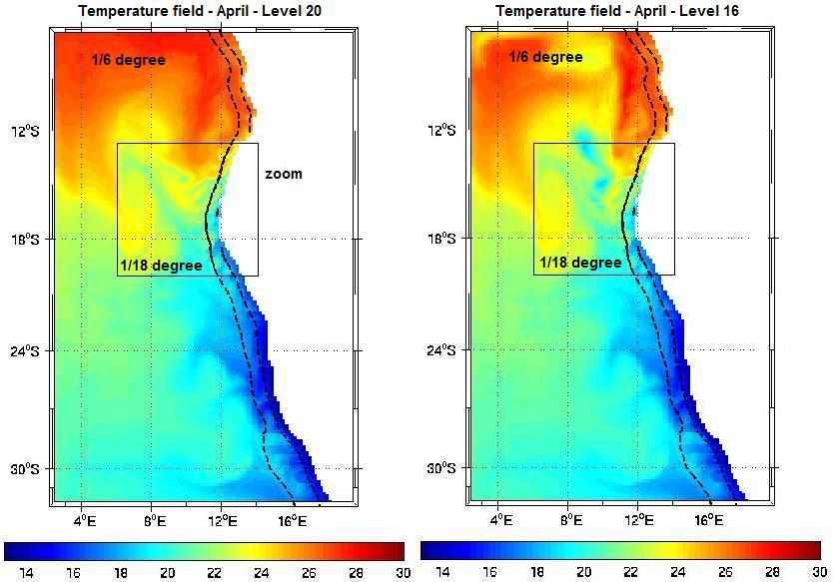

Figure 1: Monthly temperature fields in April at level 20 (surface) (left panel) and at level 16 (right panel).

The dark lines along the coast correspond to a given depth. The continuity between the two domains reveals that the same topography has been used.

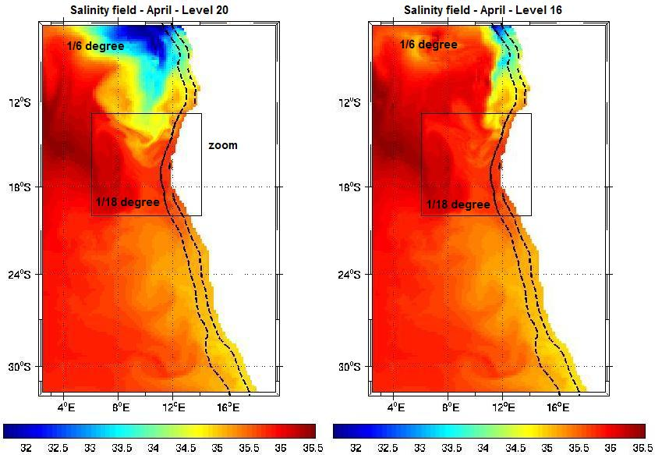

Figure 2: Monthly salinity fields in April at level 20 (surface) (left panel) and at level 16 (right panel).

These first simulations with AGRIF allowed the consultant to test the machines and to get used to the ROMS-AGRIF system. Zooming will be carried out in different areas, for instance the area of the Lüderitz cell, or the Orange River mouth. As a result, the consultant will be able to provide different BCLME actors with local outputs at a relevant resolution. To illustrate the approach followed by the consultant, the following paragraph deals with simulations involving the outflow of the Orange River into the ocean.

1.2.2 – Orange River outflow simulated with ROMS-AGRIF

Recently, a number of optional routines have been developed and added to ROMS-AGRIF. They include, among others, passive tracers, Lagrangian floats and river outflows. The Orange River mouth is located about 200kms south of the Lüderitz cell at 28.5°S (figure 3). The Lüderitz cell constitutes an environmental barrier between the northern and southern Benguela system. The physical mechanisms that generate the barrier are still unknown and investigating the whole area constitutes a key issue for the BCLME. In the next months AGRIF will be used to solve locally very high resolution processes. In this preliminary experiment the outflow of the Orange River has been reproduced.

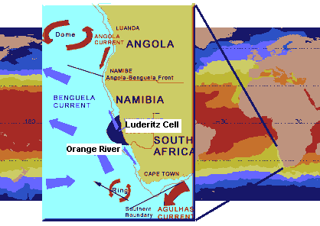

Figure 3: Schematic description of the Angola-Benguela area.

The transport, temperature and salinity of the river outflow are determined by the user and written in a script before the simulation. The number of sources are theoretically not limited. The depth of the river at it mouth is also fixed by the user. One source of fresh water is represented by one coastal grid point. If the resolution is high enough, it is possible to reproduce the width of the mouth by taking a few consecutive points instead of one. The transport will be divided between the different points. The estuary of the Orange River is about 1km in size and 1 point will be used to represent it. In this experiment AGRIF has not been used and the resolution is fixed at 1/6 degree for the whole domain which extends from 6°S to 32°S and from 3°S to the coast. Forcing is identical to the simulation described in 1.2.1.

The key questions are:
- how far sediments can be advected from the coast?
- what direction the plumes of sediments are taken?
- what is the impact on salinity and temperature?

In February 1988, the flow of the Orange River into the ocean increased dramatically with a peak estimated at 8500 m³.s⁻¹ in response to high rainfall (Shillington et al., 1990). Transport is usually much weaker according to some observations. Figure 4 shows monthly discharge means during an average year.

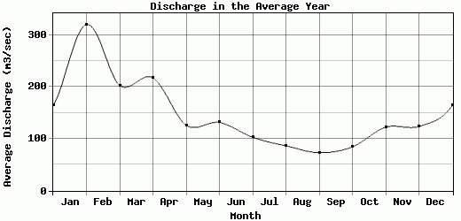

Figure 4: Discharge of the Orange River into the ocean (from the Centre for Sustainability and the Global Environment – Station Aliwal North).

In this experiment the transport is constant with a value of 1000 m³.s⁻¹ for the first 18 months and reaches a value of 2000 m³.s⁻¹ until the end of the simulation. The temperature of the fresh water is 25°C and salinity is zero. Once again, a two-year spin-up is first carried out to reach a reasonable mean state over the whole domain. Then three years and a half of simulation are performed with the Orange River outflow.

Figures 5-1, 5-2 and 5-3 show the advection and diffusion of a passive tracer every 6 months. Surface currents are superimposed on the pictures.
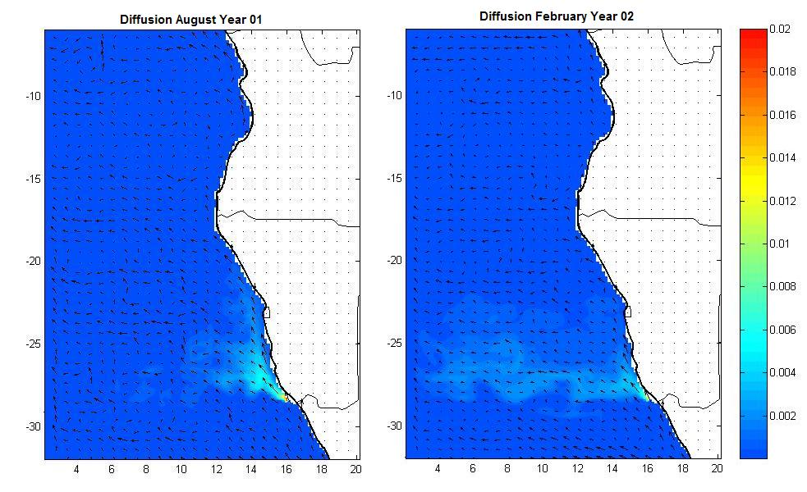

(5-1)
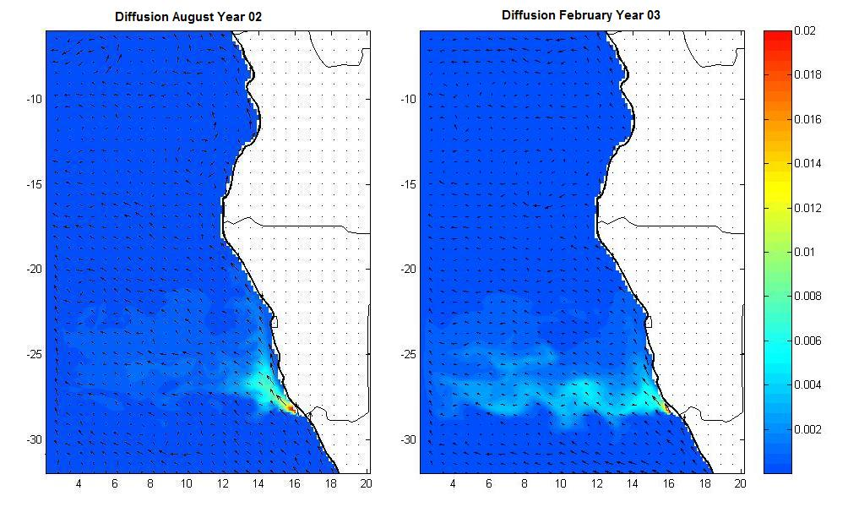

(5-2)
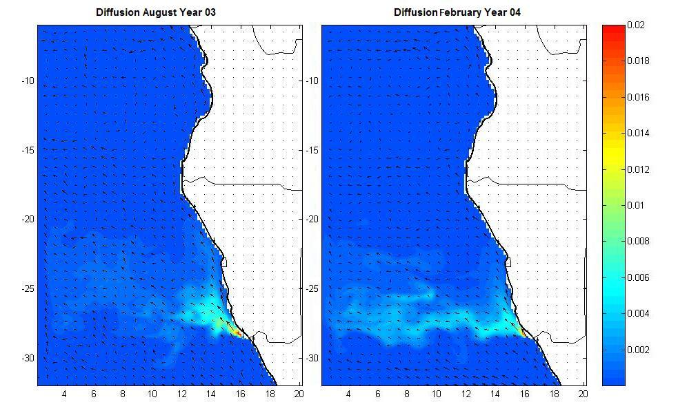

(5-3)

Figures 5-1, 5-2 and 5-3: Passive tracer with an Orange River outflow of 1000 m³.s⁻¹ (Fig. 5-1) and 2000 m³.s⁻¹ (Figs. 5-2 and 5-3).
When the tracer leaves the Orange River mouth, its concentration is maximum and equal to 1. Far away from the mouth, the deep blue colour corresponds to a concentration equal to zero. The figures reveal that concentration levels drop very quickly from the source. They also show a clear seasonal cycle: in austral winter the tracer is advected northwestward and remains closer to the source and the coast. In summer the outflow plume takes a westward direction with lower concentration near the coast and the tracer is noticeable as far as 4°E. As a result floods occurring in winter and summer may have very different impacts on the environment. However one must keep in mind that the concentration levels are extremely low in the open ocean. The colour scale was chosen to underline visually the advection. A realistic colour scale spanning the [0,1] interval indicates relevant concentration levels in the vicinity of the river mouth only. This is confirmed by Figure 6 showing the impact of fresh water on salinity levels. The Orange River outflow affects the ocean salinity in a rather limited area north of the mouth of the river.

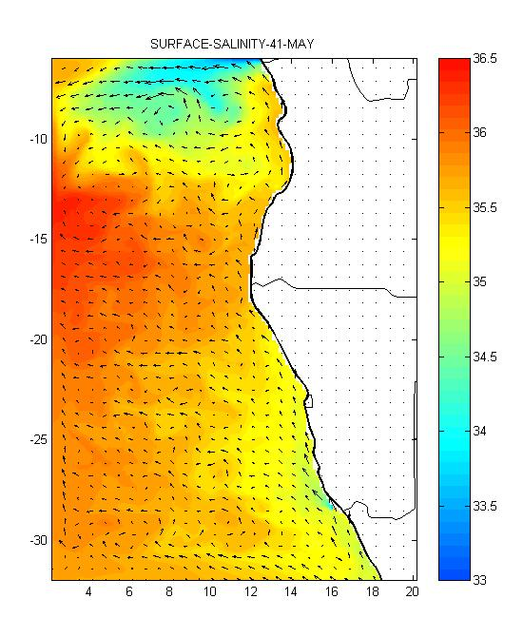
Figure 6: Surface salinity levels in May, Year 04.

Figures 7.1 and 7.2 show a zoom over the area in August (Year 03) and February (Year 04).

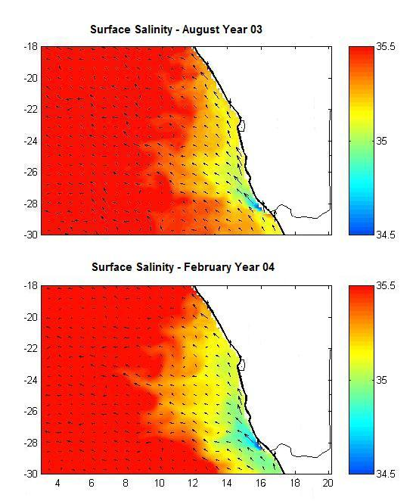
Figures 7.1 and 7.2: Surface salinity levels in August Year 03 and February Year 04.

In both cases fresh water from the river is advected in a northwest direction and is embedded in a fresher water pool extending along the coast. This fresh pool might be associated with upwelled Antarctic Intermediate Water (AAIW) which constitutes a minimum of salinity in the water column. Once again the impact of the outflow shows a seasonal cycle with enhanced westward advection in summer.

Perspectives

Within the next months, AGRIF will be applied to this area with at least two embedded subdomains. This approach will allow us to understand the dynamics of the river discharge in the ocean and its interaction with the environment. Major floods will be reproduced as well as the regular seasonal transport cycle of the Orange River. The Congo River is also known to have a major impact on water characteristics along the coast of Angola and its outflow in the ocean will also be simulated. Tracking sediments from the mouth of rivers could also be relevant for mining industries, showing the operational aspect of such an approach. As far as pollution is concerned the Lagrangian floats option in ROMS-AGRIF system was used in the Bay of Los Angeles to follow pollution particles from the city outlet pipe (Figure 8 - extract from the consultant’s LUCORC presentation in July 2004 – Cape Town). This experiment illustrates as well the possibility offered by the ROMS-AGRIF system on an operational level.

Figure 8 (Courtesy of Dr. P. Marchesiello)

Two large scale model outputs have been stored on BART and they will be used in the next 6 months to force the regional model and to provide the initial conditions: the CLIPPER outputs with a 1/6° resolution and the ORCA5 outputs with a 0.5° resolution.

2- The new CLIPPER experiment – The Lüderitz Cell

In September 2003, the consultant participated in a workshop on coastal modelling in Brest, France (see report No. 2). This workshop presented the consultant with the opportunity to meet key scientists involved in the CLIPPER project and to discuss the results of the experiment. Analyses performed by the consultant in 2003 on the model outputs had revealed that the CLIPPER high-resolution simulation of the Atlantic Ocean failed to reproduce the interannual variability of the ocean in the eastern tropical South Atlantic Basin. The 1995 Benguela Niño, the 1996 warm and the 1997 cold anomalies were poorly simulated with CLIPPER while these three events were correctly reproduced with the OPA/TOTEM configuration (see reports 1 and 2). For instance during the 1997 event the sea level showed a positive anomaly in the eastern equatorial Atlantic with CLIPPER while observations indicated a negative one. The two projects (CLIPPER and OPA-TOTEM) are based on the same original model (OPA) but they have different horizontal and vertical grids. OPA-TOTEM uses ERS winds while CLIPPER is forced with ECMWF winds. Both models use the same ECMWF heat fluxes. After the presentation of these results by the consultant it was decided by the leaders of the CLIPPER project to launch new simulations using ERS winds. A new parameterisation of lateral mixing based on former studies had to be introduced to improve the realism of the equatorial undercurrent. Four laboratories have been involved: LPO (Brest), LEGI (Grenoble), LODYC (Paris) and LEGOS (Brest). Dr. Anne-Marie Treguier from LPO (chief scientist of the CLIPPER project) acquired a supplement of 1,800 hours on the IDRIS super-calculator in Paris in November 2003. The first three years of the simulation (1990-1992) corresponding to the spin-up period was performed in December 2003-January 2004. The simulation period (1993-2000) was carried out during the first months of 2004. The Department of Oceanography at UCT has been associated with the new CLIPPER experiment as an official collaborator. As a result, the consultant had access to the new CLIPPER outputs in June. All data have been stored on BART via FTP from the LEGI in Grenoble. This process required two weeks to be completed. The first analyses of sea temperature have been performed and interannual variability was correctly reproduced by the model along the coast of southern Africa.
Using CLIPPER outputs to study the Lüderitz Cell barrier

The LUCORC workshop in Cape Town was dedicated to the Lüderitz Cell (LC) which constitutes a biological discontinuity in the Benguela Current ecosystem. It separates its southern and northern parts and presents a physical barrier to the movement of certain fish and plankton species. It affects temperature and salinity characteristics, chlorophyll levels, etc., but its surface expression is masked by intense upwelling and mixing. Little is known about the mechanisms that generate the barrier, maintain it and break it down.
A number of questions were raised during the workshop which need to be answered:
- what are the mechanisms involved in generating, maintaining and breaking it down?
- does the barrier exhibit temporal/seasonal variability?
- what is the influence of the poleward current on the barrier?
- what are the typical scales of the system?
- are the opening and the closing of the barrier predictable (if they occur)?

Model climatological velocity fields
An analysis of the CLIPPER velocity and temperature fields has been performed at different depths (from the surface to 350m) along the coast of southern Africa. It tends to confirm that the Lüderitz area constitutes a sort of transition between different regimes along the coast.

Circulation at Surface layers, 0 to 30m (lev01)
The shelf circulation appears to be dominated by a narrow coastal current flowing northward throughout the year from about 30°S to the ABFZ near 18°S. Its intensity is higher during austral summer and lower from June to August. However the coastal area between 26°S and 22°S is somewhat different: the northward flow is less intense and it exhibits a weaker seasonal cycle. The current experiences an abrupt change just north of Lüderitz. From 30°S to about 26°S the maximum velocity in the core of the current remains constant, with a value of about 25 cm/s in summer. At 26°S the speed drops abruptly to maximum values of about 15 cm/s and the current intensity becomes irregular until 22°S. North of 22°S speeds start increasing again.

Figure 2.1 below is a schematic representation of the model circulation at the surface (Fig 2.1.a – Lev 01) and at a 40m depth (Fig 2.1.b – Lev 04).

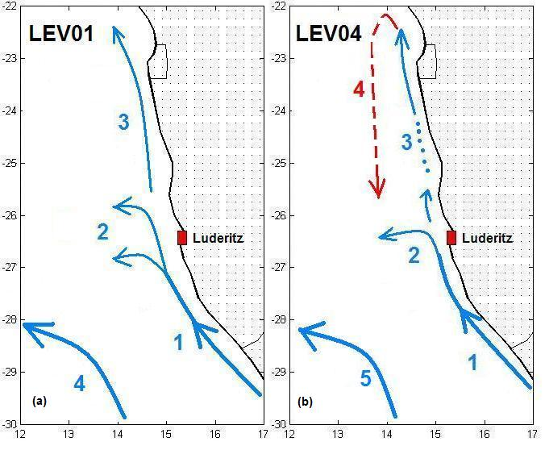
Fig 2.1: Schematic circulation reproduced by the model at the surface (a) and at 40 m (b).

Figure 2.1.a is representative of the coastal circulation throughout the year. However the northward coastal current (1 and 3 on the figure) is weaker during austral winter. The current is always stronger south of Lüderitz (branch 1). Then it bifurcates partly westward (branches 2) leading to a decrease of its transport and intensity north of 26°S. The orientation of the coast also changes near Lüderitz from northwest to north. Windstress in the area shows a regular northwestward direction throughout the year and it is stronger in summer south of 26°S. As a result, the surface discontinuity observed in the coastal current at 26°S might originate from the orientation of the coast, the wind field strength and its direction. The westward circulation in (4) does not seem to interact with the coastal circulation pattern.

Circulation at 40m depth (lev04)
The circulation at 40m is generally identical to the surface although weaker (Figure 2.1.b). The maximum current speed in branch 1 is about 20 cm/s in summer. The northward coastal current experiences a similar seasonal cycle with minimum intensity during austral winter. The discontinuity at 26°S is still present. The dotted line of branch 3 means that the current is not always clearly defined. The main change in Figure 2.1.b shows a new seasonal pattern in the circulation that occurs twice a year in February-March and October: a poleward current centred at 14°E develops off shore in the north and reaches a latitude of about 25/26°S at its maximum in October (branch 4). The dotted arrow indicates that the current is not permanent throughout the year. Its temperature is about 4°C higher than the coastal current with slightly higher salinity levels. It does not seem to interact much with the northward current.

Circulation at 80m and 130m depths (lev07 and lev10)

Figure 2.2 presents schematic diagrams based on the model circulation at 80m and 130m depths for the same area. Dotted arrows indicate that the current is intermittent and shows some seasonal variability.
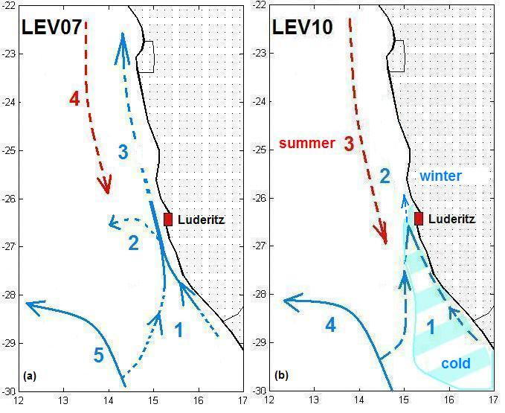Fig 2.2: Schematic circulation reproduced by the model at 80m (a) and at 130 m (b) depths.
Main changes start to occur in comparison with the surface layers. The northward coastal current is much weaker with maximum speeds of about 10 cm/s and it is not as clearly identifiable. It still shows a seasonal cycle but its intensity is higher in July and August, instead of summer. Branches feeding the current south of Lüderitz (1) are unstable and not well defined. Despite this, the northward current still reaches its maximum intensity in the Lüderitz area. The southward current (branch 4) intensifies in comparison with the upper levels and is now noticeable from September to April. It exhibits two maxima in October and March respectively. On these occasions the current meets the westward branch (2) of the coastal current near 26°S. It is more saline than the surrounding water and its temperature is about 2°C higher than the coastal water temperature.
The circulation diagram of figure 2.2.b confirms the new circulation patterns encountered at level 04 and 07 with a marked seasonal shift. It divides the whole area in two separated domains: from September to March, the circulation is dominated by a southward flow north of Lüderitz (branch 3). This flow develops along the coast as well and the northward current (branch 2) disappears. The southernmost extent of this flow occurs in February (26°S) and in October (27.5°S) with maximum speeds of about 10 cm/s. From April to August, the situation is somewhat reversed and there is no more poleward flow. The cold northward current intensifies in the south (branch 1) with speeds of about 5 cm/s. It reaches the Lüderitz area and its intensity north of 26°S remains very weak.
At this depth, the Lüderitz area operates as a natural border between two opposed seasonal regimes, a northern one associated with warmer and more saline waters flowing southward from October to March, a southern one associated with cold and fresher waters flowing northward from April/May to August. The cold pool shown on figure 2.2.b underlines the fact that along the coast the Lüderitz area constitutes a transition between the warm and the cold regimes. Temperature in the cold pool is about 10/11°C whereas it is about 13°C north of 26°S. The cold pool appears to be a permanent feature with a fairly regular shape and size throughout the year.

Circulation at 230m and 350m depths (lev13 and lev15)

At deeper levels the circulation along the shelf is poleward almost throughout the year with maxima occurring in February and October. Speeds are of the order of a few centimetres per second. The two diagrams on figure 2.3 illustrate the circulation at 230m and 350m depths.

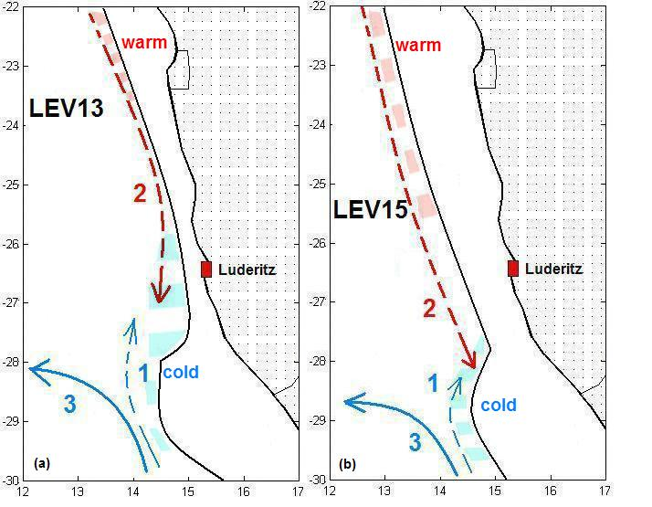

Fig 2.3: Schematic circulation reproduced by the model at 230m (a) and at 350 m (b) depths.

The poleward current brings warmer waters south of the Lüderitz area until 28°S where it reaches the cold pool. At this depth this permanent feature is less developed and its temperature is about 2°C lower than the poleward flow temperature. The northward current along the shelf (branch 1) develops in winter with very low speeds. Once again the current represented by the branch 3 does not seem to interact with it.

Circulation at 570m depth (lev17)

The circulation is dominated by the permanent northwestward flow associated with relatively warmer water masses (red arrow). Along the coast, a poleward coastal current develops from July to September during the winter period. Its maximum southward extent occurs in August: it meets the northward dominant flow near 30°S and retroflects northward.
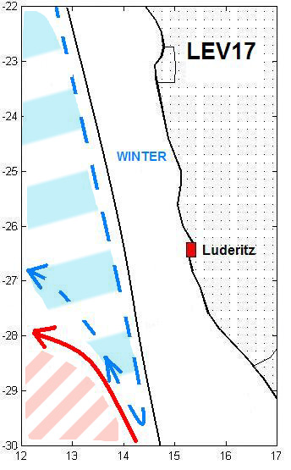
Fig 2.4: Schematic circulation reproduced by the model at 575m depth.

In terms of temperature the whole area can be divided in two persistent parts: north of the warm current (red arrow) the water is about 1.5 degrees colder compared to the south (respectively 5.5 and 7°C). Temperatures do not change much during the year.

3- Conclusion - Perspectives

This study based on the CLIPPER outputs illustrates the approach followed by the consultant. Model outputs can contribute in a decisive way to our understanding of the dynamics and thermohaline structures in the ocean. Numerical simulations and in-situ observations constitute two complementary approaches. Data remains essential to validate models but models can provide substantial information at various scales (basin-scale, meso-scale, regional scale) and over long periods of time. Moreover their financial cost is negligible in comparison with oceanographic surveys. The ROMS-AGRIF model is also an essential tool. Thanks to the new modeling platform, researchers from the BCLME and adjacent regions now have the ability to launch their own regional simulations addressing specific issues. For instance:
- experimenting with wind forcing to study its impact on local mechanisms
- modifying the topography to understand its effect on coastal circulation
- increasing dramatically the Orange River outflow to simulate the effect of a major flood in the ocean, etc.

ROMS-AGRIF is also a key tool for educational training in programming and modeling. In the next six months, the consultant will launch a series of simulations to further investigate the western coast of southern Africa involving a number of students, drawn from BCLME countries currently based at UCT, in these experiments.

4 – References

Shillington, F.A., Brundrit, G.B., Lutjeharms, J.R.E., Boyd, A.J., Agenbag, J.J. and Shannon, L.V. (1990) The coastal current circulation during the Orange River flood 1988. Royal Society of South Africa. Transactions, Vol. 47, no 3, pp 307-330.

5 – Appendix A: “Evolution of Interannual Warm and Cold Events in the South-East Atlantic Ocean”, Florenchie et al. 2004: Attached

6 – Appendix B: Master Student (Jenny Veitch) Thesis Report: Attached separately

