The extension of PIRATA in the South East Atlantic

FINAL REPORT

Compiled by Mathieu Rouault

Department of Oceanography , University of Cape Town

June 2007

Executive summary 3
1 Deployment and recovery 4
2 Mooring and instruments description 6
3 Data 7
4. Results 8
5 Trouble shooting 14
6 Dissemination of knowledge 14
7 Conclusion 16

Executive summary

THE BCLME PIRATA ATLAS BUOY KIZOMBA was deployed at about 6°S - 8°E at 4 100 m depth during the AMMA-EGEE 5 cruise on the 27th June and was recovered during the AMMA-EGEE 6 cruise on the 9th June 2007. Data were displayed on the web at http://www.pmel.noaa.gov/pirata/display.html. The mooring was fitted with a current meter/temperature sensor, five temperature/conductivity sensors deployed at 1, 10, 20, 40 and 120 m depth, five temperature sensors deployed at 60, 80, 100, 140 and 180 m depth, and two temperature/pressure sensors deployed at 300 and 500 m depth, as well as anemometer, air temperature and humidity probes, short wave solar radiation probe and rain gauge.

The PIRATA program (Brazil, France, USA) has deployed and maintained, since 1997, an array of 12 ATLAS buoys with the objective of monitoring, describing and understanding the evolution of sea surface temperature, upper ocean thermal and saline structure, net heat budget, air-sea fluxes of momentum, latent and sensible heat and fresh water in the tropical Atlantic. This is similar to TAO in the Pacific Ocean the observing system deployed to study and forecast the El Nino Southern Oscillation (ENSO). The KIZOMBA buoy is the south eastern extension of the PIRATA array of moorings in the tropical Atlantic.
The oceanic and meteorological observations are transmitted to shore via satellite and are available in real-time on the Internet. They are communicated to the Global Telecommunication System and readily available for ocean and weather prediction models.

The ultimate objective of PIRATA is real-time ocean monitoring to enable resource prediction in the adjacent countries. An extension of PIRATA in the South East Atlantic (PIRATA SEE) has application to marine ecosystem processes, fisheries-environment interaction, climate variability and forecasting. Besides gaining information on the physics of the seasonal cycle of sea surface temperature, ocean surface heat content and other key parameters, this demonstration project shows that ATLAS moorings can be used to monitor oceanic warm events detrimental to society as they approach the region. Abnormal warm events are detrimental to fisheries and are associated with above average rainfall and floods over Angola and Namibia. Preliminary results are presented in this report with evidence of an intrusion of low salinity water from the northwest that could be the first evidence of Congo River water ever measured in situ. Furthermore, an interesting feature of the seasonal cycle is present in the data and a large scale warming in the Tropical Atlantic was picked up in the data from April to May 2007. The KIZOMBA data were available in real time through Argos and were used in the CORIOLIS system that is providing initial conditions to operational oceanographic models, thus upgrading forecasting capacity of the region. PIRATA SEE data were assimilated in the operational ocean model Mercator, as well as in the national weather forecast model (ECMWF, MeteoFrance). PIRATA SEE was a one year demonstration project that is already proven successful and this should pave the way to a permanent observatory in the Tropical South east Atlantic, a data void area. The mooring will be calibrated, refurbished and ready for deployment for the next available cruise in the region.

1 Deployment and recovery

THE BCLME PIRATA ATLAS BUOY, KIZOMBA, was deployed at 05° 58.661 S; 07° 59.524 E at 4 100 m depth during the AMMA-EGEE 5 cruise on the 27th June 2006. The mooring was successfully recovered on the 9th June 2007 during the EGEE 6 cruise.

The mooring is fitted with a current meter/temperature sensor, five temperature/conductivity sensors deployed at 1, 10, 20, 40 and 120 m depth, five temperature sensors deployed at 60, 80, 100, 140 and 180 m depth, and two temperature/pressure sensors deployed at 300 and 500 m depth. Other sensors fitted include anemometer, air temperature and humidity probes, short wave solar radiation probe, rain gauge, and a current meter Sontek: D204 equipped with a temperature sensor at 13 m.

Data are transmitted through Argos and displayed in real time on the web at http://www.pmel.noaa.gov/pirata/display.html where it can also be downloaded. The data are also made available to the Global Telecommunication System (GTS) to be used as initial conditions in ocean and weather forecast models.

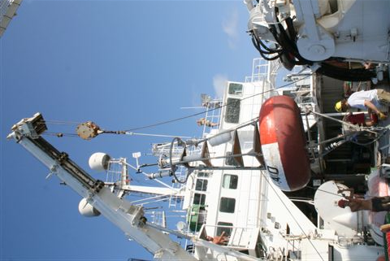
Figure 1: Deployment of the KIZOMBA mooring on the Atalante on the 27th June 2006

The Mooring ID is PM614A, the Anchor drop date/time (gmt) is (06/27/2006 - 17:29), the sounder depth is 4 100 m, the final scope is 0.985 and fly-by position, 05° 58.661 S, 07° 59.524 E. The serial numbers of sensors are presented in Table 1.

Ptt |  | Tube |  |  | Wind |  | ATRH |  | Rain | SWR |  | Release
790 |  | 606 |  |  | 63911 |  | 34279 |  | 745 | 32403 |  | 8242 / SN: 022180
SSC | TC1 |  | TC2 | T3 |  | T4 |  | T5 | TC6 | T7 | T8 | TP9 | TP10
12231 | 12125 |  | 13988 | 13949 |  | 13950 |  | 13951 | 13351 | 13952 | 13953 | 13986 | 13987

Table 1: Serial numbers of sensors

EGEE is being undertaken as part of the international AMMA programme (Multidisciplinary Analysis of the African Monsoon), dedicated to the study of the water cycle over West Africa, by investigating and forecasting monsoons and their impact on local populations. EGEE is the oceanographic component of AMMA and is being conducted under the joint scientific responsibility of four French public-sector members of the Mercator public interest group (CNRS, IFREMER, IRD and Meteo-France). EGEE is also part of the Tropical Atlantic Circulation Experiment (TACE), a program endorsed by CLIVAR. Various measurements, available to the public, have been made during the EGEE 5 cruise, including CTD, ADCP, meteorological, and radiosonde. Argo floats were also deployed along 6˚ S.

2 Mooring and instruments description

The KIZOMBA mooring is a standard next generation Atlas buoy. It is a 2.3 m diameter fiberglass-over-foam toroid, with an aluminum tower and a stainless steel bridle. When completely rigged, the system has an air weight of approximately 660 kg, a net buoyancy of nearly 2 300 kg, and an overall height of 4.9 m. The electronics tube is approximately 1.5 m long, 0.18 m in diameter, and weighs 27 kg. The buoy can be seen on radar from 4-8 miles depending on sea conditions. The mooring was shipped at the end of February 2006 from Seattle, USA to Lome, Togo. The electronics were air freighted to the same destination. Table 2 presents the type of sensors used on Atlas moorings and lists their accuracies.

Table 2: Parameters measured, types of sensors used on Atlas moorings and accuracies.

Measurement | Sensor type | Manufacturer and model |  | Resolution | Range | Accuracy
Wind speed | Propeller | R. M. Young: 05103 |  | 0.2 m s-1 | 1-20 m s-1 | ±0.3 m s-1 or 3%
Wind direction | Vane | R. M. Young: 05103 |  | 1.4° | 0-355° | 5° - 7.8°
Air temperature | Pt-100 RTD Resistance | Rotronic Instrument Corp.: MP-100 | 0.04°C |  | 14-32°C | ±0.2°C
Relative humidity | Capacitance
Relative humidity | Capacitance | Rotronic Instrument Corp.: MP-100 | 0.4 %RH |  | 0-100 %RH | ±2.7 %RH
Downwelling shortwave radiation | Pyranometer | Eppley Laboratory: PSP |  | 1.3 W m-2 | 700 W m-2  0-1600 W m-2 | ±2%
Sea surface temperature | Thermistor | PMEL: Standard SST sensor using YSI thermistor 46006 |  | 0.001°C | 14-32°C | ±0.03°C
Sea surface temperature | Thermistor | PMEL: Current meter mooring SST sensor using YSI thermistor 46006 |  | 0.001°C | 14-32°C | ±0.01°C
Subsurface temperature | Thermistor | PMEL: Standard sensor using YSI thermistor 46006 |  | 0.001°C | 6-32°C  (2-35°C) | ±0.09°C
Subsurface temperature | Thermistor | PMEL: Mini Temperature Recorder using YSI thermistor 46006 |  | 0.001°C | 6-29°C | ±0.01°C
Subsurface temperature | Thermistor | EG&G VACM |  | 0.001°C | 1-31°C | ±0.05°C
Subsurface temperature | Thermistor | EG&G VMCM |  | 0.006°C | 1-31°C | ±0.05°C
Subsurface temperature | Thermistor | Sea Data TR-2, TDR-2 |  | 0.01°C | 1-31°C | ±0.05°C
Sea surface and subsurface temperature | Thermistor | Sea Bird Electronics: SBE16, SBE37 |  | 0.001°C | 1-31°C | ±0.003°C
Salinity | Internal field conductivity cell | Sea Bird Electronics: SBE16 (Seacat) |  | 0.0001 S m-1 | 3-6 S m-1 | ±0.02 psu
Water pressure | Transducer | Paine: 211-30-66001 |  | 0.03 psi | 400-800 psi | ±0.25%
Ocean current | Savonious rotor and vane | EG&G VACM |  | 0.005 cm s-1  2.8° | 2-300 cm s-1 | ±3-7 cm s-1,  ±5.6°
Ocean current | Orthogonal Propellers | EG&G VMCM |  | 0.01 cm s-1  1.4° | 0.9- 340  cm s-1 | ±3-7 cm s-1,  ±2.5°

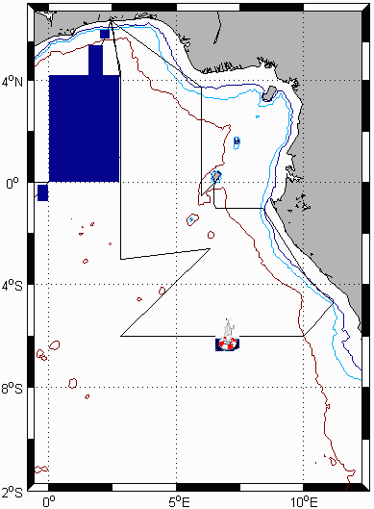

Figure 2: EGEE 5 cruise track in June 2006 with position of deployed KIZOMBA mooring.

PIRATA (Brazil, France, USA) has deployed an array of 12 ATLAS buoys, between 1997 and 2001, with the objective of monitoring, describing and understanding the evolution of sea surface temperature, upper ocean thermal and saline structure, net heat budget, air-sea fluxes of momentum, latent and sensible heat and fresh water in the tropical Atlantic. This is similar to TAO in the Pacific Ocean, the observing system deployed to study and forecast the El Nino Southern Oscillation (ENSO). Extensions to this PIRATA mooring array are being added.

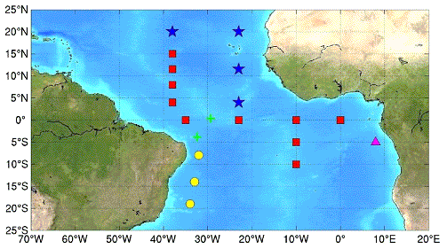

Figure 3: Status of the PIRATA array of Atlas Moorings. Original array (red), South West extension (yellow), South East extension (purple) and Northeast extension (blue)

3 Data

The PIRATA Project provides near-real-time daily-averaged surface and subsurface data from all ATLAS moorings in the Tropical Atlantic as well as a data display and web interface to plot and download data and derived quantities. ATLAS moorings transmit daily mean values from the previous day and the most recent hourly surface meteorological observations. Higher resolution data (10 mn average) are recorded onboard the moorings and are made available after mooring recoveries, which are scheduled on an annual basis. Real-time updates of daily mean data displays are presented on the PIRATA web pages on a daily basis.

In addition, information such as: daily mean ocean temperature; up to 4 hourly surface wind; relative humidity; and air temperature observations are made available to the Global Telecommunications System (GTS) by Service Argos. This information is primarily for use by operational data centers and forecast centers around the world. Hourly surface messages (winds, air temperature, relative humidity, and sea surface temperature) and daily averaged subsurface messages (ocean temperatures) are available in WMO code form FM 18-X BUOY with bulletin header SSVX08 KARS. Surface messages are generated whenever Argos receives a satellite pass, typically 2-4 times per day for ATLAS moorings. The subsurface temperature data are available on the GTS as daily averages with a time stamp of 0000z at the end of the average period. Only one subsurface message per day per buoy is available. As part of the data quality monitoring, PMEL identifies and communicates information about which data should not be submitted to the GTS or displayed on their web sites. In turn, Argos makes available to PMEL data which are submitted to the GTS, and PMEL compares these data for consistency checks with data processed at PMEL.

4. Results

The following figures, 4 to 7 were plotted, using daily average data available in near real time through Argos, on the PIRATA web site of PMEL, NOAA. These figures show time series of various parameters measured or estimated from the measurements of the Atlas mooring ”KIZOMBA” as it is displayed on the website in real time which can be accessed by clicking on the furthest east mooring, using the link, http://www.pmel.noaa.gov/pirata/display.html.

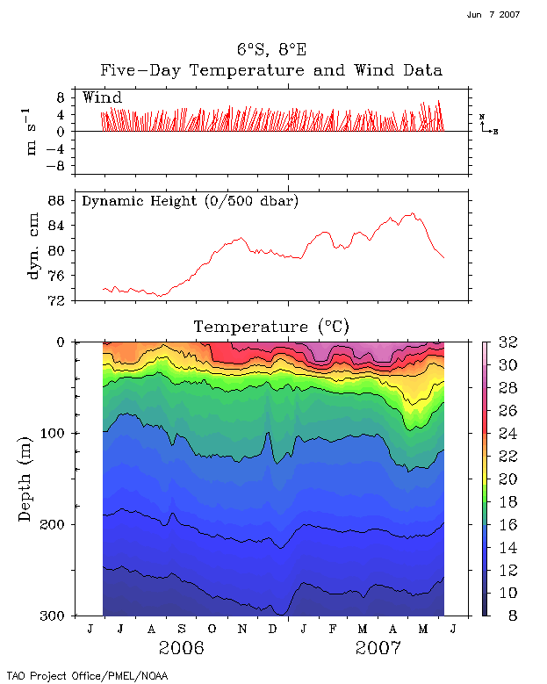
Figure 4: From top to bottom: daily averaged wind data, derived dynamic height and upper ocean temperature from 27th June 2006 to 5th June 2007.

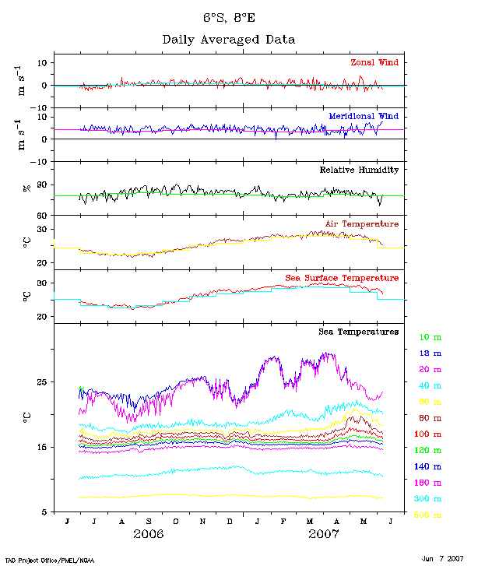

Figure 5: Daily meteorological and ocean temperature data. From top to bottom: Zonal wind, meridional wind, relative humidity, air temperature, sea surface temperature, ocean temperature at 10, 13, 20, 40, 60, 80, 100, 120, 140, 180, 300 and 500 m from 27th June 2006 to 5th June 2007.

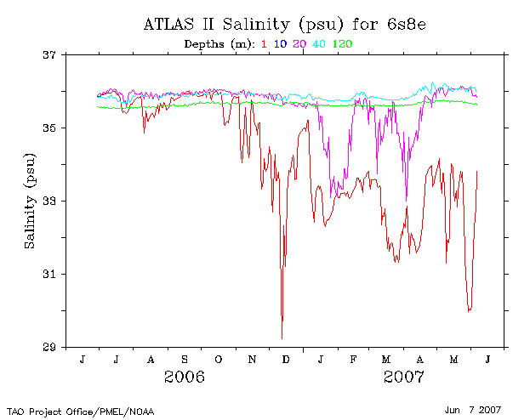

Figure 6: Daily salinity data at 1, 10, 20, 40 and 120 m depth from 27th June 2006 to 5th June 2007.

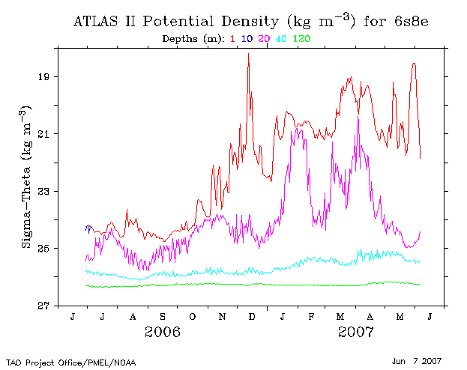

Figure 7: Daily derived potential density (kg.m³) data from 27th June 2006 to 5th June 2007

It is also possible to plot data directly on the display and delivery web site, other quantities that are not displayed automatically. It is recommended to use the web browser Mozilla Firefox. There are actually two locations to do so:
http://www.pmel.noaa.gov/tao/disdel/disdel-pir.html and
http://www.pmel.noaa.gov/tao/data_deliv/deliv.html

This website offers the choice of plotting averaged monthly, five days, daily and high resolution 10 minute datasets. All PIRATA moorings can also be plotted on the same graph for one parameter to allow comparisons and look at the propagation of an anomaly along the Equator, and then its propagation towards the Angolan coast at the same time. Anomalies from the mean are also offered. For instance, one can plot and download calculated quantities such as depth of the 20˚ C isotherm that marks the base of the thermocline, heat content of the upper ocean or currents. Variations in the depth of the thermocline are crucial to understand variations in sea surface temperature.

Real time daily data downloaded in ascii format were used to produce figure 8. It shows an intrusion of low salinity warm water flowing in a southwesterly direction of up to 40 cm/s quite steady from the 15 – 30th July 2006.

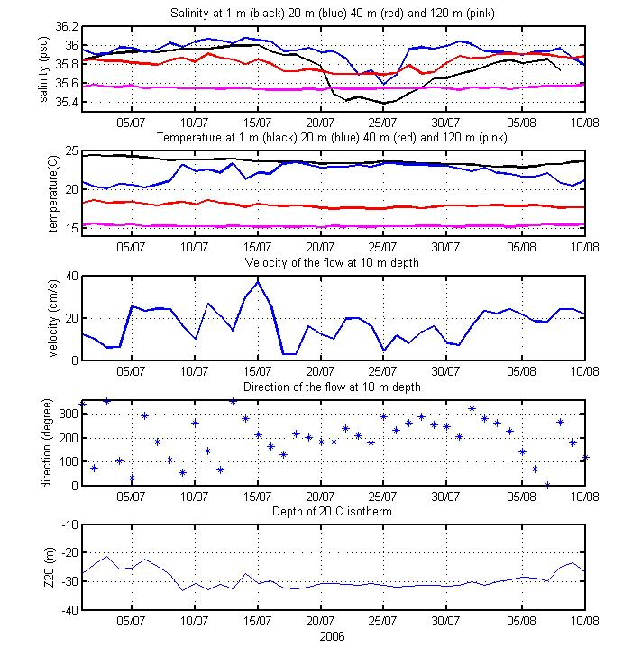
Figure 8: From top to bottom. Salinity at 1, 20, 40 and 120 m depth, temperature at the same depth, direction and velocity of the flow measured at 10 m depth and depth of the thermocline (20˚C isotherm).

The next figure shows the annual cycle of selected parameters derived from the daily dataset.

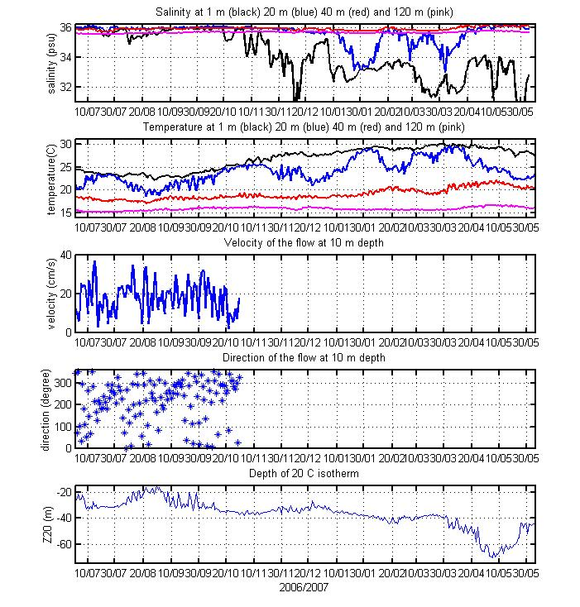
Figure 9: Annual cycle of selected parameter: From top to bottom. Salinity at 1, 20, 40 and 120 m depth, temperature at the same depth, direction and velocity of the flow measured at 10 m depth of the thermocline (20˚ C isotherm).

The surface salinity seems conspicuous. Due to the well known problem of fooling at the surface, the salinity sensor at 1 m is known to drift after a few months but it should be possible to recalibrate the salinity. The seasonal cycle is quite interesting with sea surface temperature increasing from September to March then decreasing, and the upper ocean temperature at 20 m showing several periods of decrease and increase. Increase of wind speed along the Equator in October, especially to the west of the dateline, and subsequent wave dynamics, shallow the thermocline. This helps to cool the upper ocean via vertical mixing of colder water while the surface fluxes contribute to warming the sea surface temperature. Of great interest is the deepening of the thermocline (Z20, bottom of figure 9) in April and May 2007. While the sea surface temperature decreases due to the seasonal cycle of surface fluxes, the depth of the thermocline increases and the upper ocean temperature increases. Indeed the temperature at 40 m to 100 m increases whilst the surface temperature (SST, temperature at 13 m and 20 m) decreases. It is interesting to note that the SST started to be abnormally warm in the east tropical Atlantic and Angola at a period corresponding to that event (Figure 10) and that the wind decreased along the equator prior to that event along the Equator (figure 11). So it seems that the KIZOMBA mooring can pick up the large scale variation that are linked to warm events in the Angola Benguela system.

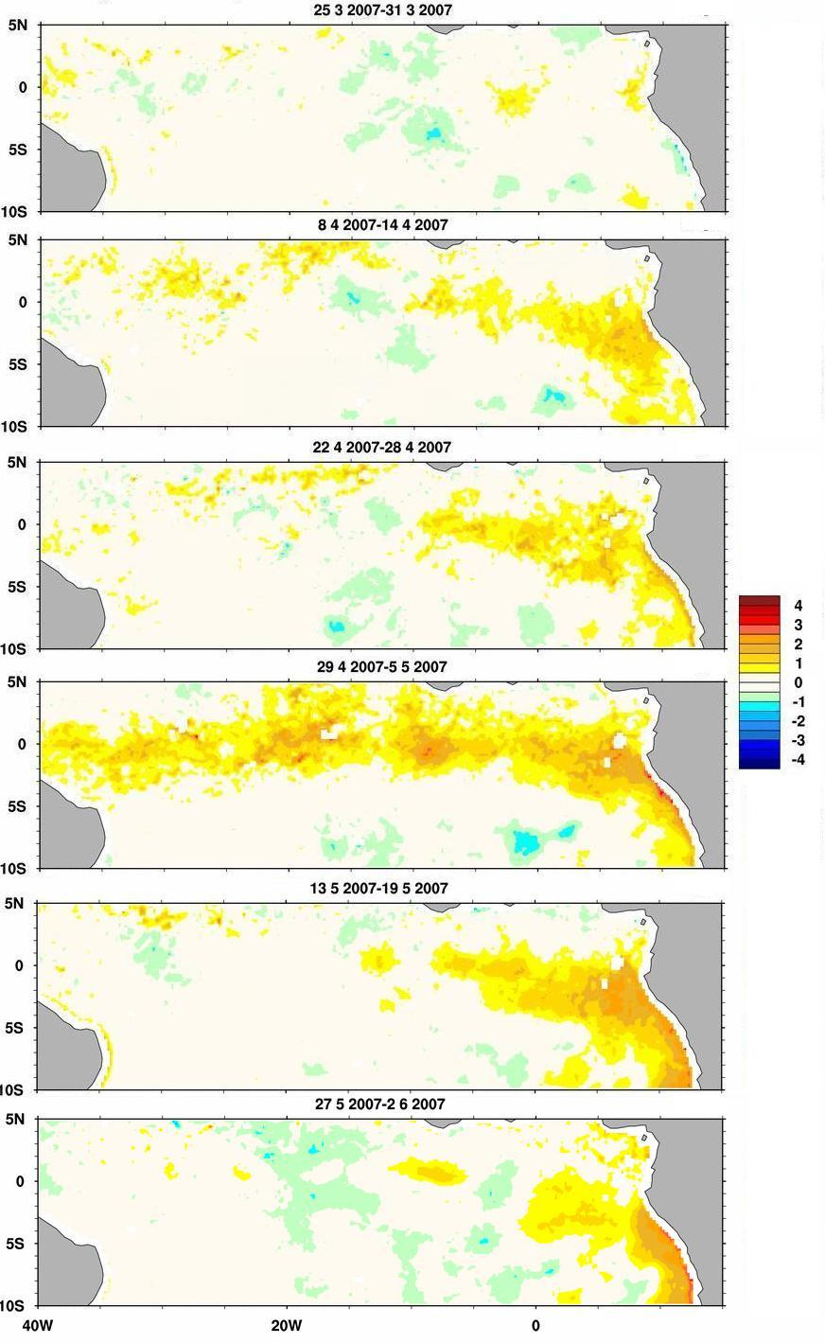
Figure 10: Weekly TMI TRMM SST anomaly from a running monthly mean (1998-2006) from the end of March to the beginning of June 2007

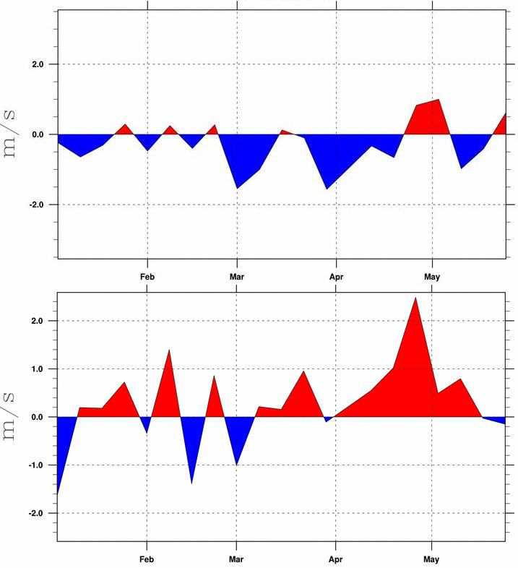

Figure 11: Wind speed anomaly from a running monthly mean (1999-2006) along the equator in 2007. Top: Domain 40° W 15° W 1° N 1° S. Bottom domain 15° W 10° E. 1° N 1° S. Positive anomalies is a reduction in the easterly trade winds or an increase in the westerly component of the wind. This figure is produced on the BCLME SEIS web site at http://seis.bclme.org/

5 Trouble shooting

The incoming short wave radiation sensors failed after a few days. The temperature/salinity probe at 10 m failed after 10 days and the current meter failed in November 2006.

6 Dissemination of knowledge

Oral presentations

Rouault M, (2006) First results from the PlRATA South East extension 'Kizomba'
Mooring, 26 September 2006, SANCOR seminar, Cape Town, South Africa

Rouault M, (2006) First results from the PlRATA South East extension 'Kizomba'
Mooring, SASAS Conference, 5/6 October, Bloemfontein, South Africa

Rouault M, (2006) First results from the PlRATA South East extension 'Kizomba'
Mooring, PIRATA workshop, 3-5 November 2006, Miami, USA.

Publications

Rouault M, (2006) First results from the PlRATA South East extension 'Kizomba'
Mooring, GLOBEC newsletter, October 2006 pp 80-81.

Rouault M, (2006) The PlRATA South East extension , SANCOR newsletter, October 2006.

7 Conclusion

The data seems promising with evidence of an intrusion of low salinity water from the northwest that could be the first evidence of Congo River water measured in situ. Furthermore, an interesting feature of the seasonal cycle is present in the data and a large scale warming in the Tropical Atlantic was picked up in the data from April to May 2007.

The KIZOMBA data are available in real time through Argos and are already used in the CORIOLIS system that is providing initial conditions to operational oceanographic models, thus upgrading forecasting capacity of the region. PIRATA SEE data are assimilated in the operational ocean model Mercator, as well as in the national weather forecast model (ECMWF, MeteoFrance).

The PIRATA display and delivery web site mentioned earlier can be used to download or plot data from all PIRATA moorings and therefore eastward movements of perturbations can be followed along the equator and then towards the African coast and the KIZOMBA mooring.

There is now a need to buy a second mooring including cost of transport and operation to replace the equipped mooring, immediately after it is recovered.. As the sensors and first mooring will be sent back to Seattle for calibration and refurbishment, a second mooring will ensure continuity of the measurements. Failure to do so will interrupt the measurements for a year as the PIRATA mooring needs to be replaced every year and this could be also be a problem for further endorsement by PIRATA committee and collaboration with IRD in the region.

IRD seems keen to carry on the collaboration to deploy/recover/replace a PIRATA mooring at that location in the future. They will have a ship semi permanently in the tropical Atlantic. However at the last PIRATA workshop held at Miami in November the IRD has expressed its intention of replacing the mooring at almost no cost to the BCLME should the USA accept to care for a PIRATA mooring at 23 West, usually the responsibility of IRD. There is also a possibility to add oxygen sensors at a cost of 7000 US $ each.

The first results of the extension project are already very well received and we hope that PIRATA will agree to endorse a proper pilot project. This extension project will be evaluated by the PIRATA SEE committee. The results and prospectives will be presented at the next PIRATA meeting, which will be held jointly with the AMMA/EGEE/TACE conference in November 2007 in Germany.

