Analysis of Benguela Dynamical Variability and Assessment of the Predictability of Warm and Cold Events in the BCLME

Report n°5

RAF/00/G32 – Benguela Current Large Marine Ecosystem
20/12/2005

Compiled by Dr. Pierre Florenchie

for

United Nations Office for Project Services


Centre for Marine Studies  University of Cape Town | Oceanography  University of Cape Town

Summary

The consultant submits to UNOPS the report N°5. This report describes in detail Dr. Florenchie’s activities under the contract for the last 6 months and the progression of the project as initially planned point by point. The first section describes the results of a new numerical experiment using the ROMS model to simulate the equatorial dynamics. This experiment is a simple process study of the equatorial variability of the Atlantic ocean: the model is first forced using climatological wind stress from COADS and ERS for 10 years. Once the spin-up phase is achieved, “artificial” zonal wind anomalies are introduced in the model to analyse the dynamical response of the ocean to the perturbations. Section 2 concerns a simulation along the coast of Angola and Namibia. The ORCA05 model outputs and real wind observations have been used to force the ROMS model along its open boundaries and at the surface over a period from 1993 to 2000. Master student Tiago Queiroz has started to analyse the results of the first experiment under the supervision of the consultant. His master work is part of the capacity building and training aspect of the BCLME project.

1- Process study of the equatorial variability

1-1 Introduction

This work concerns two key aspects of the BCLME program: the set-up of an early warning system for warm events (Benguela Niños) and the poleward intrusion of low oxygen waters along the west coast of southern Africa. It is still not clear if these two events are always linked. It is believed today that Benguela Ninos are related to wind anomalies in the area of the ITCZ. An abnormal decrease/increase of trade winds above the equatorial Atlantic seems to trigger downwelling/upwelling Kelvin waves that propagate eastward and then poleward along the coast of Angola. Downwelling Kelvin waves displace the Angola/Benguela front southward and create an intense coastal warm pool between 10 and 20°S. It is also known that Kelvin waves induce a variation of current speeds as they propagate. This characteristic raises the question of a possible relationship between abnormal coastal flows of LOWs and the occurrence of Benguela Niños/Niñas. This matter will be analysed in the near future.

Using numerical simulations for the early warning system:

The early warning system should include two different approaches:
- a statistical and empirical approach based on our knowledge and understanding of the physics involved in a specific event
- an approach based on global forecasting systems (NLOM, MERCATOR, …) that provide users with general information on the future state of the ocean

The first approach will be developed locally and as such will involve scientists and students from the BCLME. This approach is itself two-fold:
- based on observations
- based on model simulations

The ocean tends to keep the memory of an initial state at a given date much longer than the atmosphere does because it is less chaotic. This means that triggering events may continue to affect the ocean (via a chain of mechanisms) weeks after they have disappeared. This is particularly true for Benguela Niños. But other factors could play a key role in preconditioning the ocean prior to the event since wind anomalies do not always produce Benguela Niños (1996 for instance). Unfortunately these important elements are not always accessible via classical observations. Hence the statistical and empirical approach based on observations only may be limited. Using a numerical model to simulate the equatorial ocean variability allows one to integrate part of these “invisible” or unknown factors and to reproduce the preconditioning of the system. Realistic initial conditions can then be used for simulations in which the ocean, forced by climatological winds, may keep the memory of the initial state long enough to reproduce an abnormal event despite the climatological forcing. The schema below summarizes the strategy that could be followed locally using a numerical model:

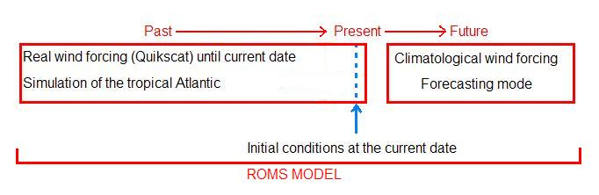

However the first step consists of testing the ability of the model to reproduce realistically the equatorial dynamics. First the model has been forced using climatological winds. Then we have analysed its response to articial wind anomalies along the equator.

The model sensitivity to different climatological wind forcings (COADS and ERS) has been evaluated. ERS wind speeds have been interpolated on the model grid (0.5°) and turned into wind stress to force the model. Artificial wind anomalies have been computed over the equator and introduced in the ERS climatological files. The response of the model to these anomalies (stronger or weaker zonal winds than usual) have been analysed. Preliminary results concerning the COADS forcing were presented by the consultant in the BCLME report N°4. This work has been partly achieved by Masters student, Tiago Queiroz, in the framework of the capacity building. The student initially was required to learn Matlab and Unix language. Then he had to be able to manipulate various file format, like Netcdf. Matlab, Unix and Netcdf formats are key aspects in the management of the ROMS tool. Tiago Queiroz also became familiar with the equatorial dynamics in order to be able to analyse the model outputs.

Four simulations of the equatorial Atlantic ocean using ROMS have been conducted:
- 10-year simulation using COADS climatological wind stress and starting from rest (see report 4)
- 10-year simulation using ERS climatological wind stress and starting from rest (Simulation #1 – this report)
- 1-year simulation following simulation#1 with the introduction of an artificial positive zonal wind anomalies from January to March (Simulation #2)
- 1-year simulation following simulation#1 with the introduction of an artificial negative zonal wind anomalies from January to March. (Simulation #3)

Results from experiment #2 have been compared to the climatological temperatures from the World Ocean Atlas 2001. This dataset has a global coverage with a 2° horizontal resolution. Sea temperatures have been extracted at various depths for comparison. The domain of the experiments is represented below. It extends from 15°S to 10°N and from 58°W to 16°E.

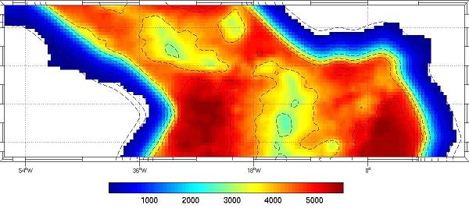

Figure 1.1: Domain of the simulations and topography 15°S to 10°N and from 58°W to 16°E

This domain was chosen in order to be able to track the propagation of sub-surface anomalies across the basin. The simulations were made with a 0.5 degree resolution. The vertical resolution is 30 levels in σ-coordinates. The topography comes from ETOPO-2.

Spin-up

Figure 1.2 show the averaged kinetic energy and its evolution during the 10 years of the second experiment. The model reaches stability after roughly a two-year spin-up period.

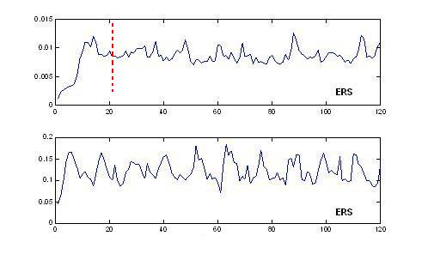
Figure 1.2: Evolution of the monthly total averaged kinetic energy (top) and surface-averaged kinetic energy (bottom) from the 10-year ERS simulation.

1-2 Results

1-2-1 Simulation with ERS climatological wind stress

During the COADS experiment it had been noted that globally the model simulates quite realistically the structure of the thermocline along the equator and the cold tongue area in July (see report 4). However a few important aspects of the thermocline structure were not well reproduced:
- the vertical temperature gradient was too weak
- the dome shape along the coast of Africa was missing
- the thermocline was too deep

Figure 1.3 represents equatorial sections of temperature from the ERS experiment respectively in January and July and compared with Levitus2001. The 20°C isotherm has been underlined to visualize the core of the thermocline. The vertical structure of the thermocline and its seasonal variability is improved when using ERS climatological wind stress instead of COADS. The depth of the 20°C isotherm matches more closely the Levitus data. This might be due to the facts that ERS winds tend to be stronger than COADS winds in the eastern side of the basin and that their initial resolution is higher (1° instead of 2°). As a result the curl of the wind inducing equatorial upwelling is better resolved and stronger.
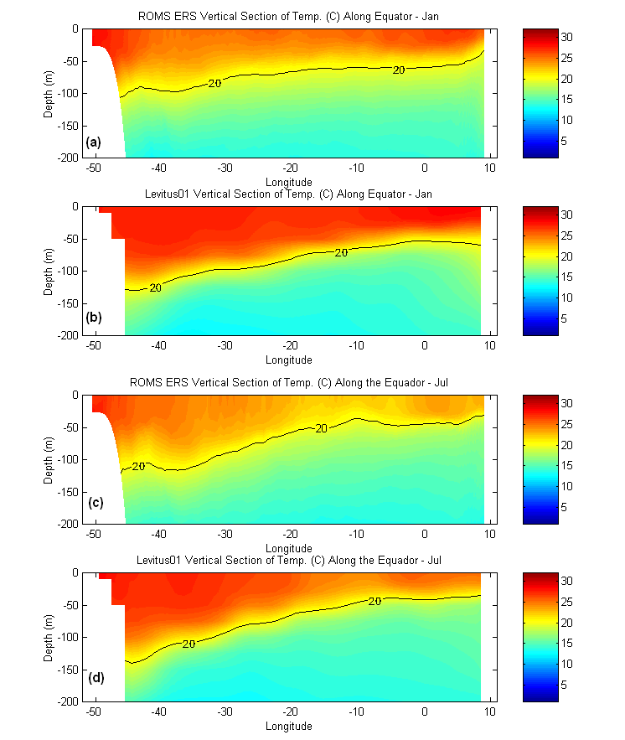
Figure 1.3: Vertical section of temperature along the equator from the simulation#1 (a, c) and from Levitus2001 (b, c) in January and July.
However we note in the western side of the basin that the model thermocline is not deep enough, especially in early Austral summer. A comparison between QUIKSCAT and ERS winds shows that ERS winds tend to be stronger in the eastern side of the basin and weaker in the western side. An experiment using QUIKSCAT climatology will be launched for comparison. The lifting of the isotherms associated with the seasonal equatorial upwelling in winter (cold tongue) is very well represented by the model. Like in the COADS experiment, the deepening of isotherms observed near the African coast in summer is missing. Model temperatures tend to be too low in the mixed layer throughout the year. As a result the vertical gradient associated with the thermocline is reduced. This problem could be partly improved by increasing the vertical resolution from 30 to 50 levels in future experiments. The COADS heat flux conditions at the surface also need to be examined.

The horizontal distribution of temperature at different depths tends to confirm that the model is too cold along the equator, especially in summer, as can been seen on Figure 1.4. Similar results were obtained using COADS winds. At depths the situation changes somewhat. The model is still too cold in the western side of the basin in summer whereas it is too warm along the coast of Angola (figure 1.5). All these issues will have to be resolved. New experiments with similar forcings are to be launched with higher vertical and horizontal resolutions. QUIKSCAT climatological winds are going to be used. It is worth noting that the CLIPPER model based on OPA (a classical layered model) tend to show similar results at the surface when forced by ERS winds.

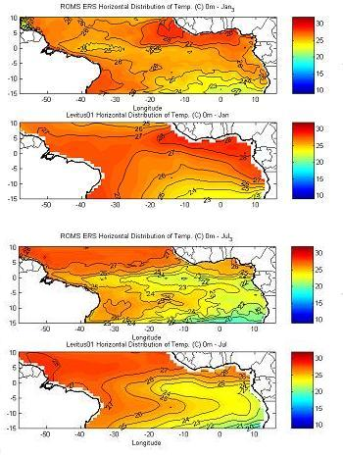
Figure 1.4: Sea surface temperature in January (top) and July (bottom) from the ERS-experiment and Levitus2001.

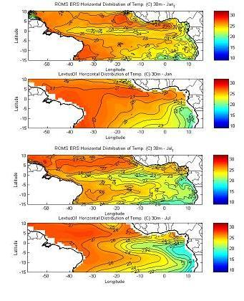
Figure 1.5: Temperature at a 30 meter depth in January (top) and July (bottom) from the ERS-experiment and Levitus2001.

The discrepancy at depth in the east could be explained by an overestimated Equatorial Under Current (EUC) in the model: strong winds enhance the strength of the EUC which in turn brings warm waters further to the east and the south-east regions.

1-2-2 Introduction of artificial zonal wind anomalies in ERS climatology

In this section the results obtained during the ERS-CLIM, ERS-WEAK and ERS-STRONG simulations are compared. Various temperature and velocity fields are displayed to provide a global picture of the results. Transports along the equator will also be discussed.

ERS-WEAK simulation

In the ERS-WEAK simulation, an artificial wind relaxation is applied to the ERS climatology from January to March. The zonal wind strength has been reduced by 50% in January and March and by 75% in February, in agreement with typical observed anomalies. The wind is back to the climatology from April to December. The duration of the simulation is one year. The modification concerns an area extending from the coast of Brazil to 8°W and from 6°S to 6°S. The months and the location of the anomalies correspond roughly to what is observed prior to a Benguela Niño. Figures 1.6 and 1.7 show equatorial vertical sections of monthly averaged temperature from both the ERS-CLIM and ERS-WEAK experiments.

The response of the model to the wind relaxation is very quick. A deepening of the thermocline can already be observed near 30°W in January. Then the thermocline deepens further eastward with a maximum in March when the 20°C isotherm becomes nearly horizontal throughout the basin at a depth of about 80 meter.

Figure 1.6: Equatorial section of temperature from the ERS-CLIM experiment (top) and the ERS-WEAK experiment (bottom) in January.

In April (Figure 1.7) the thermocline starts moving back to its seasonal position but remains deeper than usual. In July the situation is nearly back to normal. It is worth noting that the situation is reversed near the coast of Brazil: the thermocline tends to become shallower. The meridional axis around which the thermocline “oscillates” seems to be located between 40 and 30°W.

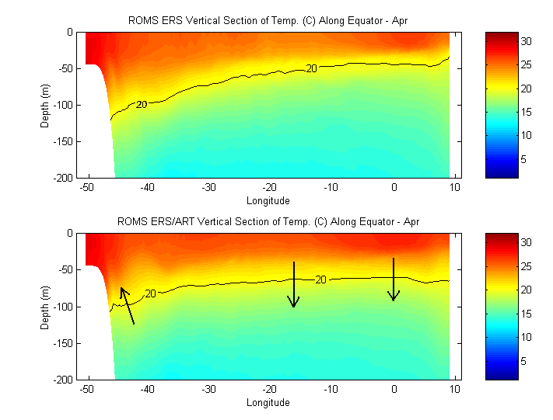

Figure 1.7: Equatorial section of temperature from the ERS-CLIM experiment (top) and the ERS-WEAK experiment (bottom) in April.

The eastward deepening of the thermocline induces the propagation of warm temperature anomalies from January to April, as can be seen on Figure 1.8. In March the core of the warm anomalies shows maximum values largely above 2°C between 15°W and 5°E and between 40m and 60m depths. In April temperature anomalies show similar values but they are located eastward along the African coast.
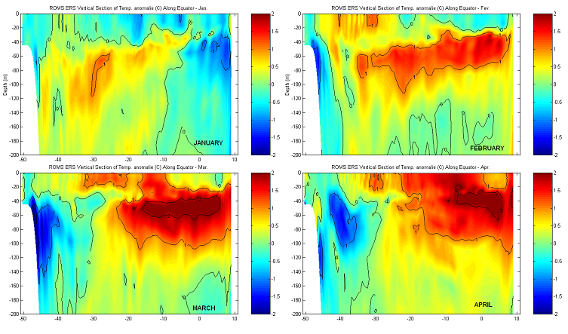

Figure 1.8: Propagation of warm temperature anomalies along the equator from January to April during and after a zonal wind relaxation.

ERS-STRONG simulation

In this simulation zonal winds are strengthened over the same area by 50% in January and March and by 75% in February. The response of the model appears to be quick and in some aspects opposite to the ERS-WEAK experiment.

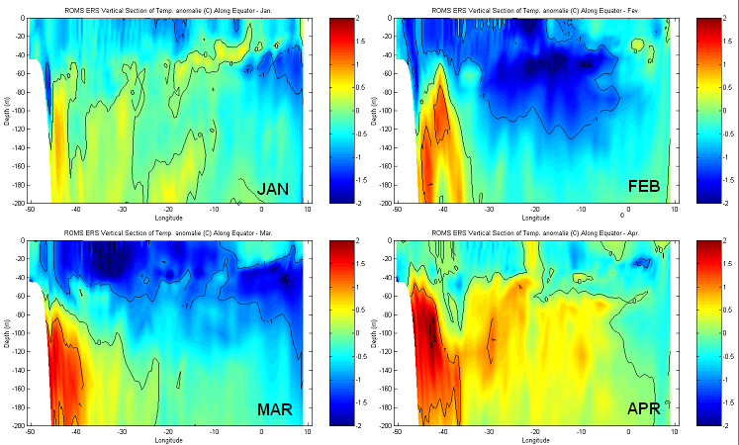

Figure 1.9: Cold anomalies during and after an increase of zonal winds.

Cold temperature anomalies are generated along the equator. In contrast with the ERS-WEAK experiments they tend to affect the surface in the western part of the basin. We also note that subsurface warm anomalies develop in the western basin and propagate towards the African coast within just one to two months. The ERS-WEAK simulation also reproduces similar anomalies but they do not propagate and reach the surface with the same strength. It seems that wind anomalies trigger a chain of cold and warm events with smaller amplitude that affect the whole basin for a few months.

1-3 Conclusion

Results from the 3 simulations are encouraging. They show that the model is able to reproduce the thermocline structure along the equator. They confirm the link between equatorial temperature anomalies and zonal wind anomalies over the central and western basin. A positive anomaly (weaker winds) induces warm anomalies whereas a negative anomaly (stronger winds) creates cold anomalies. The way the anomalies from both experiments propagate appears to be different. Warm anomalies remain below the surface while they propagate eastward. The propagation of cold anomalies is less obvious and they tend to outcrop along the equator.

Similar experiments are going to be conducted using QUIKSCAT climatological wind stress for comparison and ERS windstress from 1993 to 2000 to test the ability of the model to reproduce actual events (the 1995 Benguela Niño and the 1997 cold events). The vertical resolution will be increased from 30 to 50 sigma-levels. The last step will consist of testing the ability of the model to reproduce real events using realistic initial conditions and climatological wind forcing. The ERS-WEAK and ERS-STRONG experiments tend to show that wind anomalies keep influencing the model months after their appearance. The following four experiments will be conducted. These will consist of first forcing the model with realistic winds until December 1994, January 1995, February 1995 and March 1995. The model will then be run in a free mode for a few months, i.e. forced with climatological winds only. Its ability to reproduce the 1995 Benguela Niño will be tested in each case.

As far as the LOWs are concerned, the analysis of the model response to wind changes in terms of surface and subsurface currents by Masters student Tiago Queiroz is still in progress. Preliminary results suggest a strong and delayed response of the equatorial undercurrent to wind anomalies that could have a strong impact on the LOWs southward transport.

2- Forcing ROMS with ORCA 0.5

This numerical experiment concerns a simulation along the coast of Angola and Namibia. The ORCA05 global model outputs and ERS wind observations have been used to force the ROMS model along its open boundaries and at the surface over a period from 1992 to 2000. The purpose of the experiment is to test the ability of the ROMS model to reproduce locally realistic temperature and current anomalies in the Angola/Benguela frontal zone. The domain extends from 5°S to 25°S and from 0°E to the coast of Africa. Horizontal resolution is 1/6° whereas 32 sigma-levels are used for the vertical resolution.

2-1 Temperature anomalies

Model anomalies have been calculated using a climatology from 1993 to 2000. Figure 2.1 shows detrended sea surface temperature anomalies from the model averaged over the ABA (10°S/20°S, 8°E-coast) and compared with OI-SST anomalies on figure 2.1:

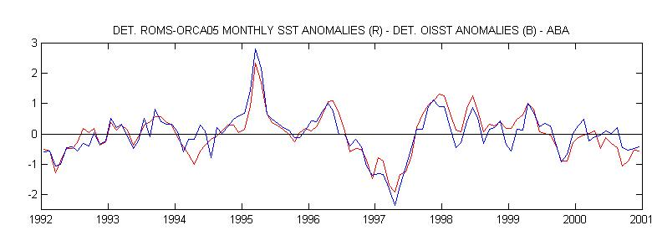
Figure 2.1: SST anomalies reproduced by the ROMS model (red) and observed by satellite (blue) from 1992 to 2000.

The agreement between the model and observations is remarkable. Figures 2.2 and 2.3 show the temperature anomalies associated with the 1995 Benguela Niño at the surface and at 45 meters from January to March. They confirm the results obtained with OPA and with CLIPPER: Equatorial subsurface temperature anomalies propagate southward along the coast of Angola and eventually outcrop in the Angola/Benguela frontal zone where they create an intense warm pool.

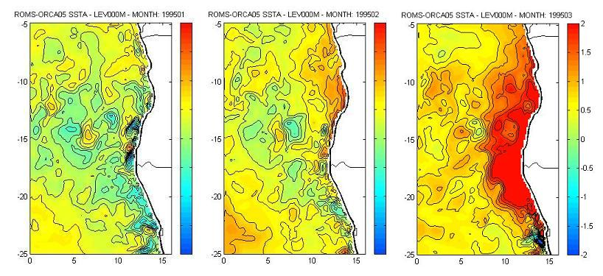
Figure 2.2: ROMS temperature anomalies from January to March 1995 at the surface

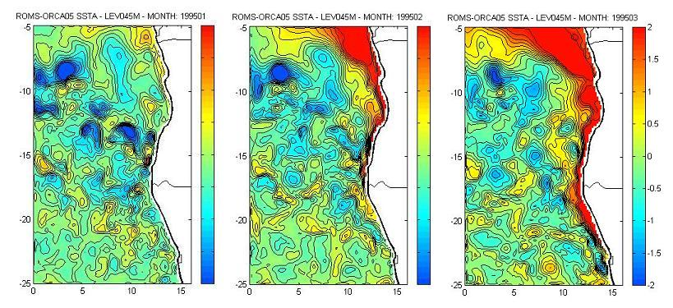
Figure 2.3: ROMS temperature anomalies from January to March 1995 at a 45meter depth

2-2 Circulation at the surface and at 45 meter depth

In this section we describe the current anomalies associated with the occurrence of temperature anomalies along the coast. Once again zonal and meridional speed anomalies are calculated from the 1993-2000 climatologies. Figure 2.4 and figure 2.5 show the meridional anomalies of the current respectively at the surface and at a depth of 45 meters from January 1995 to March 1995. Arrows represent the actual currents.

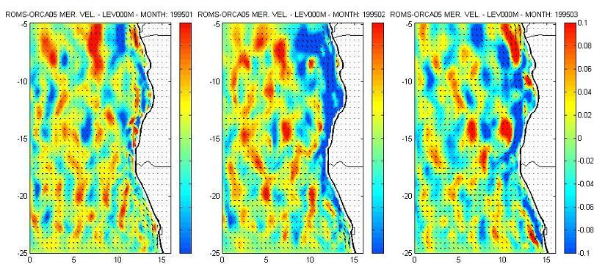
Figure 2.4: Meridional anomalies of currents at the surface from January to March 1995.

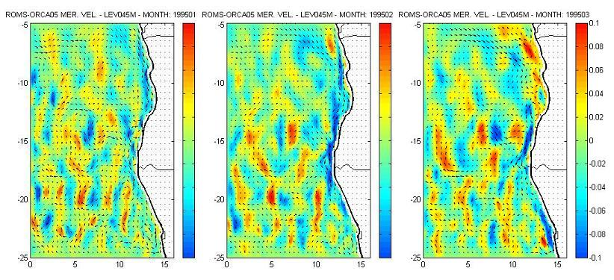

Figure 2.5: Meridional anomalies of currents at a 45 meter depth from January to March 1995.

Figures 2.4 and 2.5 show an intensification of the poleward current along the coast of Angola as far south as 25S, especially in February. However current anomalies develop mainly at the surface with maximum values of the order 0.2 m/s whereas temperature anomalies propagate below the surface, as can be seen on Figure 2.3. This result suggests that southward advection of equatorial warm waters is not the main source of the 95 Benguela Nino. It is known that Kelvin waves can induce a modification of the surface velocity fields as they propagate. Figure 2.4 tends to confirm that it was the case during this warm event.

Further analyses of the relation between temperature anomalies and current anomalies in the Angola/Benguela frontal zone have to be conducted. Results will be compared to CLIPPER outputs. Currents at greater depths are going to be examined in the perspective of LOWs events. The work will be presented in the BCLME report No.6.

