Progress Report on EV/LOW/02/01 Project

RAF/00/G32 – Benguela Current Large Marine Ecosystem

Compiled by Dr Pedro Monteiro

24 March 2004

for

BCLME
United Nations Office for Project Services

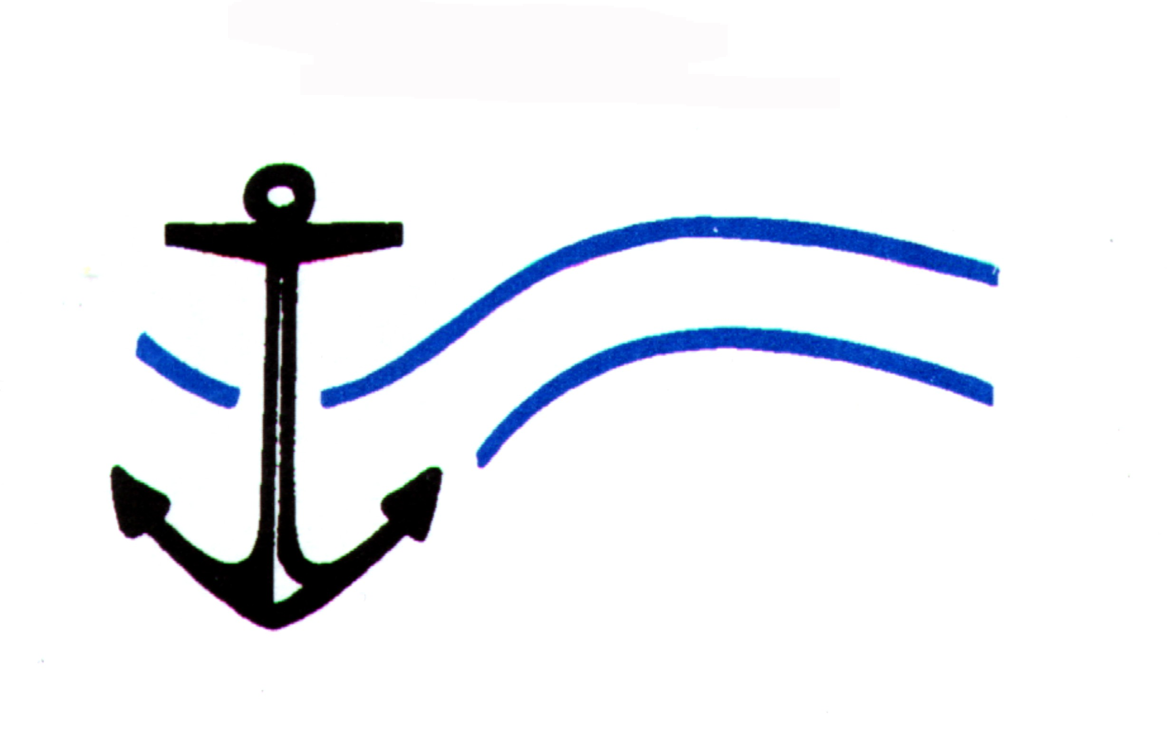
Centre for Marine Studies  University of Cape Town | Oceanography  University of Cape Town

Project Team

Project Leader: Dr Pedro M.S. Monteiro, CSIR
Project Partner: Anja van der Plas, Appointed by MFMR, Namibia
Project Partner: G.W. Bailey, Appointed by MCM, South Africa
Project Partner: To be appointed by IIM, Angola
- Scope of Phase 1a-b

Phase 1a: Comprehensive review:

The historical oxygen data sets for the Benguela exist in four main space – time categories:

- Oceanographic survey historical period pre-war and 1950’s – 1970’s which emphasised regional / basin scale sampling but with virtually no time domain component.
- Regional fisheries – environment surveys which were undertaken mainly in South Africa and to a more limited extent in Namibia since the 1960’s which although having sampling scales dictated by fisheries survey grids also had a seasonal or at least interannual repetition.
- The SARP and subsequent monthly monitoring lines which begin to resolve the sub-seasonal variability while still providing a cross shelf measure of extent or intensity of events. These data sets have been collected for the past five to ten years in the southern Benguela and since 1998 off Namibia and only occasionally off Namibia in Angola.
- Most recently, the high-resolution time series data sets of sub-thermocline oxygen variability, which provide a clearer indication of the underlying physical and biogeochemical forcing that results in ecologically significant Low Oxygen Water conditions. Such time series exist for at least one year in both the Southern and central Benguela but not, to the best of our knowledge, in the Angolan system.

These data sets are located in a wide number of regional institutional databases, SADCO and international archives. These distributed databases, will need to be comprehensively searched. The scope of the search and retrieval of data in this project will be limited to those data that are already available in some level of digital formatting. It will not include those historical data, which are still archived in analogue or hardcopy records. The outputs of this first phase of the work plan will be:

An interim report including the meta database information

Phase 1b: Archiving of the data sets

The acquired data will be stored in SADCO and the meta-data base will be lodged in the Benefit system.

- Approach and core responsibilities

The aim of the study is to differentiate the relative importance of remote forcing vs local forcing giving rise to LOW variability. The objective of the study is not only to review the existing data and literature but also to provide new understanding on the factors that drive oxygen variability.

The approach as set out in the proposal is to initially separate the two forcing scales and address them separately by linking hypothesis testing to the sampling scales.

- Remote forcing: Use survey data (fisheries, process studies, monthly monitoring. etc)
Hypothesis: LOW originates from remotely sourced water.
- Local forcing: Use mooring data and Monthly Monitoring data (where overlap)
Hypothesis: LOW originates from local forcing events
The focus of this study is in developing a time series analysis approach with all the data sets. The following data sets we defined as being necessary for the study so provide the understanding on the temporal and spatial dynamics of oxygen variability over the BCLME region.

- Mooring data sets (hourly records)
- Anchor Stations (1 month long)
- Monthly Monitoring (1999 – 2003)
- Interannual variability of cross shelf sections (1960 – 2003)
- Interannual variability of bottom oxygen concentrations over the BCLME (1960 – 2003)

Special focus to be given to the following time periods:

- 1980-85 (Benguela. Nino: 1982)
- 1990-95 (Namibian and St Helena Bay 1994 event)
- 1999 –2003 (2000, 2002 events)

The data analysis workplan is being implemented in two parallel efforts aimed specifically to test and reject the two main hypotheses. The local forcing hypothesis is being tested using data sets 1 – 3 whereas the remote forcing hypothesis is being tested using data sets 3 – 5. The objective of this approach was to select the data sets with the sampling scale most appropriate to the hypothesis. The work is being undertaken by the following partnerships:

Remote forcing hypothesis:

South Africa: GW Bailey
Namibia: A. van der Plas
Gulf of Guinea P. Monteiro / F. Duncan

Local forcing hypothesis

BCLME: P Monteiro / A van der Plas

Literature and Critical Review

P Monteiro

- Summary of Progress

Overall the project is on schedule for the revised deadline of end May. Progress has been good given the difficulties encountered in sourcing the required data sets. It is expected that the data sets will be lodged in SADCO by 30 September 2004. Working with geographically separated partnerships has presented special problems in respect of data analysis but a good degree of commonality of analysis was achieved through ongoing communication.

Of particular note has been the improved understanding of the relationship between external forcing and local response, particularly the role of physics, which has raised several encouraging avenues to develop a predictive capacity.

This emphasis of this project has shifted from a review orientation to one which will provide advances on present level of understanding.

- Sourcing of the required data: completed

- Analysis of the data:

Angola basin characteristics: completed
Variability in the Angolan shelf: underway
Variability in the Namibian shelf: completed
Variability in the South African shelf: completed

3: Final report

- Is being prepared to suit the format of Progress in Oceanography where it is expected to be submitted.
- The write up phase is being led in the following way:
  - Introduction / review / approach Bailey
  - Methods Monteiro
  - Results: van der Plas
  - Discussion Monteiro
  - Synthesis Monteiro

Project team meetings have occurred in Swakopmund (Ms van der Plas cannot travel)

February 2 – 4 (develop new methodology, analysis and discussion)
March 8 - 10 (test wider use of methodology)
March / April 31 – 2 (finalise report / publication structure and contents)
April 28 – 30 (finalise the publication)

- Red Flags

The lack of response from the Angolan IIM has been most disturbing in terms of attaining the objectives and the spirit of the BCLME. Urgent assistance is required to at least understand what the underlying difficulties are.

