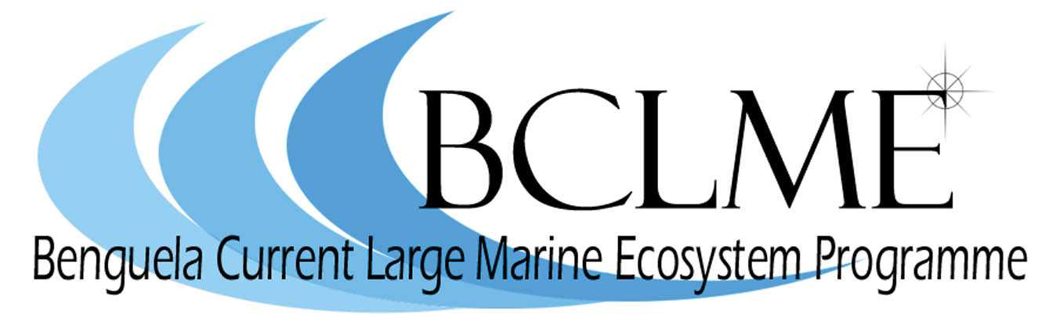

REPORT OF THE BCLME SOUTHERN BOUNDARY WORKSHOP

C.D. van der Lingen, L. Hutchings, G.B. Brundrit, D.A. Byrne, C.M. Duncombe Rae, M.D. Durholtz, I. Hunter, J.R.E. Lutjeharms, L.V. Shannon and L.A. Staegemann

TABLE OF CONTENTS

Introduction 2

SESSION 1: Ecology of the Southern Boundary region and impacts
on the living marine resources of the BCLME 3
Review of Existing Knowledge 4
Identification of Gaps and Prioritization of Research 10

SESSION 2: Large scale forcing of the Southern Boundary region and
links to the BCLME 13
Review of Existing Knowledge 13
Identification of Gaps and Prioritization of Research 19

SESSION 3: Impacts on maritime operations at the Southern Boundary
of the BCLME 21
Review of Existing Knowledge 21
Identification of Gaps and Prioritization of Research 22

Transboundary influences of the Southern Boundary on the BCLME 25

Framework for action 26

Concluding Remarks 28

Acknowledgements 28

Programme of the BCLME Southern Boundary Workshop 29

List of participants 33

List of presentations on CD ROM 40
INTRODUCTION

The Benguela Current Large Marine Ecosystem (BCLME) Programme is a multi-sectoral initiative by Angola, Namibia and South Africa to facilitate the integrated management, sustainable development and protection of the Ecosystem. It is funded by the Global Environmental Facility (GEF) through the United Nations Development Programme with financial and in-kind contributions by the three member countries.

The southern boundary of the BCLME is rather loosely defined, but is generally accepted as being in the vicinity of the Agulhas Retroflection area which lies south of Africa. In the BCLME Programme’s Strategic Action Programme (SAP) the southernmost extent of South Africa’s Exclusive Economic Zone (EEZ; approximately 38° 20΄S) was taken as the southern boundary – extending as far as 27°E.

To date the BCLME Programme has given scant attention to this key external boundary, as at the time of planning the Programme it was considered that the South African part of the ecosystem was adequately researched and the physics, chemistry and biology of the area well understood. Shifts in living resources and changes in their abundance during the past five or six years have shown that this is not the case. It is essential that the state of knowledge and understanding of this part of the ecosystem should be re-examined within the context of the greater LME and its management. It is also essential that this re-examination take place prior to the conclusion of the GEF intervention phase of the Programme in 2007 and the inception of the envisaged Benguela Current Commission. It should be noted that recent advances in the understanding of the southern boundary area have largely been made outside the BCLME Programme framework (such as modeling, remote sensing, and ship studies of the Agulhas Current and its retroflection, rings, filaments etc. and their impact on the South Atlantic), while it is now accepted that the processes on the Agulhas Bank (the main spawning area of several Benguela fish species) are not properly understood. Moreover the Agulhas – Somali Current LME Programme is due to commence in 2006 and building appropriate links with the latter is likewise a priority for the BCLME.

An international workshop to address these issues was held in Cape Town from 3-5 May 2006, and was attended by 80 participants representing scientists and managers from the three member countries, and also scientists from Denmark, France, and the USA. The focus of the BCLME Southern Boundary Workshop (SBWS) was to examine the influence of processes at the BCLME’s southern boundary on the utilization and sustainable management of resources of the Large Marine Ecosystem. The SBWS had the following specific objectives:

- Review recent advances in knowledge and understanding of the southern boundary area of the BCLME;
- Re-assess existing knowledge and hypotheses – physical, chemical and biological – which have management implications;
- Examine the role played by the southern part of the system in the greater LME, with respect to fluctuations in and maintenance of resources;
- Assess the level of our understanding of physical, chemical and biological processes on the Agulhas Bank and the impact of these processes on the west coast region of the southern Benguela;
- Document important gaps in knowledge;
- Gain consensus on priority issues facing both BCLME management and science in respect of the southern boundary;
- Build further links between the BCLME and ASCLME Programmes; and
- Deliver a product that will be a useful guide for researchers and managers over the next five years.

The SBWS comprised oral presentations made in plenary followed by specialist discussion groups for each of three sessions, namely:
- Session 1: Ecology of the Southern Boundary region and impacts on the living marine resources of the BCLME;
- Session 2: Large scale forcing of the Southern Boundary region and links to the BCLME; and
- Session 3: Impacts on maritime operations from the Southern Boundary of the BCLME

Presentations covered a range of topics and provided an overview of a specific field pertinent to the southern boundary region (e.g. studies on pelagic fish abundance and distribution patterns in Session 1; the influence of the Agulhas Current on the Agulhas Bank in Session 2; and metocean prediction in support of maritime operations in Session 3) in order to meet particularly objective 1 but also some of the other objectives listed above. The Specialist Sessions built on the presentations by identifying important gaps in knowledge and suggesting and prioritizing appropriate lines of research to fill such gaps. The titles and authors of presentations are provided in the SBWS Programme that forms part of this report, and the presentations themselves are provided on the associated CD. This report provides a synthesis of the presentations and specialist discussion groups, under the headings Review of Existing Knowledge, and Identification of Gaps and Prioritization of Research, respectively, for each of the three sessions of the SBWS, compiled by the Convenors and Rapporteurs of each session. In addition, the report briefly describes transboundary influences of the Southern Boundary region on the BCLME, and concludes by proposing a framework for action required to address research gaps for both scientific and management purposes, and indicates financial considerations and likely relevant organizations for such action.

This report does not represent a consensus viewpoint from participants (indeed, some issues were contentious) but is intended to capture the essence of presentations made and discussions held at the SBWS; hence reference to published literature is not made in the text. However, those wishing for more detailed (and referenced) reading matter are directed to the South African Journal of Science, Vol. 90 No. 3, 1994, for papers describing research on the Agulhas Bank that arose from the workshop held in 1992 to synthesize knowledge on the physical, chemical and biological characteristics of the Agulhas Bank; and also to Vol. 14 of the Large Marine Ecosystems series, entitled “Benguela: Predicting a Large Marine Ecosystem”, edited by L.V. Shannon, G. Hempel, P. Malanotte-Rizzoli, C. Moloney, and J. Woods, to be published by Elsevier in 2006.

SESSION 1: ECOLOGY OF THE SOUTHERN BOUNDARY REGION AND IMPACTS ON THE LIVING MARINE RESOURCES OF THE BCLME

The aim of this session was to provide a synopsis of current understanding of the Agulhas Bank and the Southern Boundary region, from physics to upper trophic levels. Fourteen presentations were given during the session comprising descriptions of physical and biological processes (from both observations and modeling studies); overviews of plankton, commercially important living marine resources (including small pelagic fish, large pelagic fish, hakes and other demersal species, squid, rock lobster and line fish), and avian and marine mammal predators in the Southern Boundary region; and an overview of turtles to the east of the boundary.

Review of Existing Knowledge

The Agulhas Bank is hugely important for the functioning of the southern portion of the BCLME as it appears to be a major spawning ground for a large number of dominant organisms (including pelagic fish, squid, and rock lobster) and an important feeding ground for large predators (including tunas, birds and turtles). The productivity, enrichment mechanisms and transport and retention pathways are critical components to the ecological well-being of the southern Benguela. The recent eastward shift in pelagic fish and west coast rock lobster and the spectacular increase in pelagic fish biomass in 2000-2001 (see below) has added considerable importance to understanding the links between physical driving forces, primary productivity, and the response of zooplankton, pelagic fish and top predators in the southern boundary region of the BCLME.

The main driving forces of primary productivity in the southern boundary region include:

- “Classic” temperate zone mixing and stratification;
- Episodic wind mixing;
- The passage of internal waves;
- Coastal wind-driven upwelling;
- Divergence driven upwelling;
- Shelf-edge upwelling or upwelling in shear-edge eddies
- Meanders, filaments and plumes of the Agulhas Current;
- The cold ridge; and
- Diffusion through the thermocline.

All of these mechanisms were described but the relative importance of each mechanism was not quantified due to critical gaps in measurements or understanding, many of which were originally outlined in the reviews of the early 1990s that focused on the Agulhas Bank. Nevertheless, much progress has been made in certain fields, particularly hydrodynamic modeling which, despite the exceptionally difficult boundary conditions, can now reproduce the major hydrological features of the southern boundary region. Coastal wind-driven and divergence-driven upwelling, the cold ridge and enrichment along the shelf edge off the central and eastern Bank, were superimposed on a seasonal mixing and stabilization regime reminiscent of a typical temperate zone cycle. The source of the cold central water which underlies the warm upper mixed layer was contentious, with some insisting it originated from the Port Alfred divergence-driven upwelling cell at 27°E and others maintaining a source slightly further west, in the Plettenberg Bay to St Francis Bay area at 23-25°E. The persistence and seasonality of the cold ridge, and the concept of shelf-edge upwelling by shear-edge eddies, were also subject to debate and conjecture. However, when the Agulhas Current was “dammed” in a modelling experiment, cold central water (including the cool ridge) disappeared from the shelf environment, indicating a strong role for the Current in determining the productivity of shelf waters. Satellite ocean colour imagery was useful in examining the seasonal surface features of phytoplankton, describing a perennial, moderately productive near-coastal strip, a broadening of the productive zone in the vicinity of the cold ridge at 22°S with maximum values in March to June each year, a late summer to early autumn peak in surface productivity on the inshore western Agulhas Bank, and a semipermanent divergence-driven upwelling off Port Alfred to East London. However, the known frequent occurrence of subsurface chlorophyll maxima over summer months during stratification implies that the phenomena and processes are not fully understood and additional seasonal studies of subsurface measurements are required.

Zooplankton communities in the southern boundary region are more diverse than along the west coast, but paradoxically are strongly dominated by a single species of a large copepod, Calanus agulhensis, which has a centre of dispersion over the cold ridge and possibly the Port Alfred upwelling cell. In years when the cold ridge is prominent, this copepod is more strongly retained on the central Agulhas Bank. Growth rates, behaviour, and productivity of this key species have been linked to phytoplankton and temperature changes and to changes in pelagic fish abundance. This animal is clearly important as a food source for a variety of pelagic fish and squid paralarvae, but seasonal changes over the central and eastern Bank are not adequately described due to a lack of sampling effort. Large numbers of predatory and gelatinous zooplankton are also present and their ecological role needs further investigation. Studies of small crustaceans suitable for food of first-feeding pelagic fish are urgently needed to evaluate the suitability of the Agulhas Bank as a nursery area for pelagic fish recruits, in the light of the recent dramatic eastward shift in the distribution of sardines and anchovy.

The Agulhas Bank is an important spawning ground for many species of small pelagic fish, but it would appear that anchovy (Engraulis encrasicolus) and sardine (Sardinops sagax) recruits are not very abundant over the Agulhas Bank relative to the west coast, in contrast to red-eye round herring (Etrumeus whiteheadi). Individual-based models coupled to hydrodynamics indicate sufficient retention on the eastern and central Bank, yet survey results indicate poor anchovy and sardine recruitment there. There is also recent evidence for winter (June-July) spawning of sardines on the central Agulhas Bank in patches of high concentrations of phytoplankton, again emphasizing the need for better seasonal coverage of the Agulhas Bank in terms of environmental sampling. The eastward shift in pelagic fish species, particularly sardine (see Figure 1), is poorly understood and four hypotheses are currently considered:

- Discrete substocks of sardine, with depletion by fishing of the west coast substock;
- Environmental mediation, with increased productivity on the Agulhas Bank;
- Natal homing, resulting from a particularly successful year class; and
- Interspecific competition with anchovy, forcing sardines out of the preferred western Agulhas Bank area.

The Southern Boundary region is an important spawning ground for both shallow water hake (Merluccius capensis) and deep water hake (M. paradoxus). Spawning by the former probably occurs primarily over the shelf (<200m) whereas that by the latter probably occurs off the shelf. The nursery grounds for both species are located off the west coast and fish move southwards onto the Agulhas Bank as they grow, although large deepwater hake are also found off the west coast. Some other demersal fish species such as angler fish (Lophius vomerinus), horse mackerel (Trachurus trachurus) and jacopever (Helicolenus dactylopterus) show a similar separation between juvenile and adult distributions, with larger fish found primarily in the Southern Boundary region. Hake dietary spectra change from the west to the south coasts, being dominated by crustaceans, cephalopods, and mesopelagic fish species (Lampanyctodes spp. and Maurolicus spp.) off the west coast, and by anchovy, horse mackerel and red-eye round herring off the south coast. No evidence for an eastward shift by hake, or any other demersal fish species, has been observed.
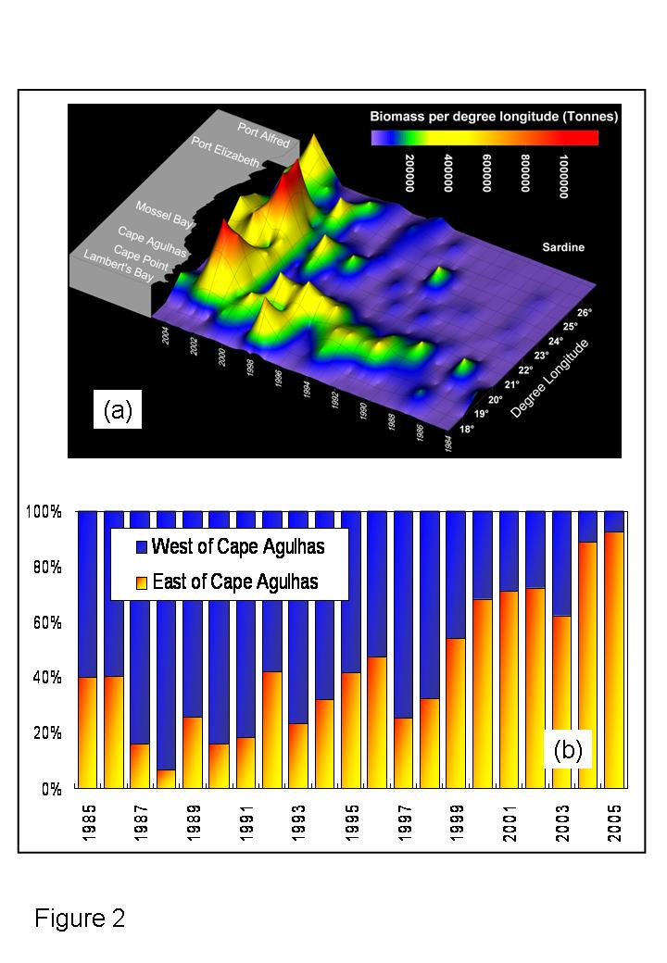
Figure 1: Changes in the distribution of sardine in the southern boundary region through time, showing (a) biomass (tonnes) of sardine by degree longitude along a linearized South African coastline as observed during annual spawner biomass 1984-2005; and (b) the percentage contribution to the total biomass of sardine to the west and east of Cape Agulhas as observed during annual spawner biomass 1985-2005. See presentation entitled “Small pelagic fish” by J. Coetzee et al.

Squid (Loligo reynaudii) spawn principally in the inshore waters of the eastern Agulhas Bank and spread westwards as larvae and juveniles. Their distribution and abundance is highly erratic and linked to temperature, turbidity, and currents. Intrusions of the Agulhas Current onto the Bank and strong advective events which carry shelf water far offshore may greatly influence survivorship. There are surprisingly no apparent responses in squid catches or squid population patterns to the high forage fish biomass associated with the sardine (and anchovy) eastward shift. The early life history stages are not well understood and survival, feeding success and vertical migratory behaviour of squid paralarvae need to be addressed.

Two species of spiny rock lobster exist in the Southern Boundary region. The west coast rock lobster (Jasus lalandii) extends from Namibia to Port Elizabeth, but commercial quantities were previously only found on the west coast. Recently, a dramatic southwards and eastwards shift in distribution has occurred (see Figure 2) with substantial effects on the inshore ecosystem on the western Agulhas Bank, with numbers of sea-urchins and abalone declining sharply. Both environmental and fishery pressures have been implicated in the shift. Rock lobster walkouts on the west coast in the St Helena Bay area have increased over the past few decades, in response to low oxygen events associated with harmful algal blooms, while the intensive pressure on resources may have resulted in serial depletion of west coast stocks. However, fishing pressure does not explain the sharp increase in adult rock lobster abundance east of Cape Point in recent years, so it would appear likely that some environmental factor is the primary reason for the shift. Increased southerly winds leading to increased primary productivity and more deposition of organic matter is one explanation for the increase in low-oxygen-induced walkouts in St Helena Bay, although further data analysis is required to test this.

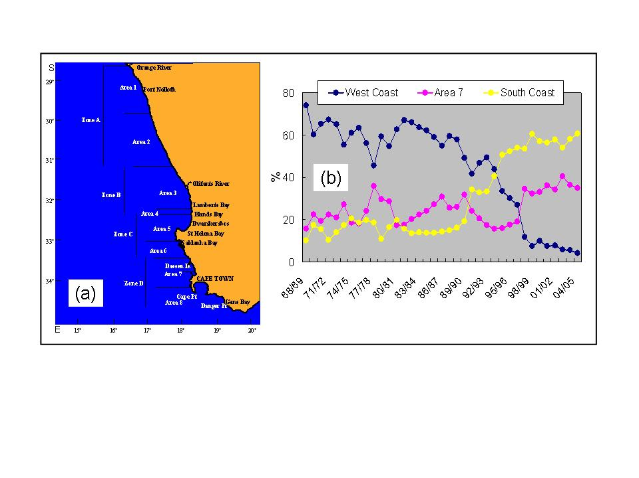
Figure 2: Changes in the distribution of west coast rock lobster in the southern boundary region through time, showing (a) a map indicating the division into fishing areas and zones for west coast rock lobster; and (b) the percentage contribution to total catches of rock lobster caught off the west coast (Areas 1-6), Area 7, and the south coast (Area 8) for the period 1969-2004. See presentation entitled “Southern Boundary Workshop: Rock lobster Jasus lalandii, Palinuris gilchristi” by A.C. Cockcroft.

The deep water lobster (Palinurus gilchristii) displays an across-shelf migration, with small individuals inshore on the western Agulhas Bank and progressively larger individuals further east. Interestingly, the population at Port Alfred on the extreme eastern edge of the Agulhas Bank appears to be a separate sub-stock of the population. Larval drift and recruitment to the parent population is unknown, but may be either retention on the Agulhas Bank for a 3-4 month period or a recirculation in the SW Indian Ocean. There is no evidence of an eastward shift in deep water rock lobster.

Linefishing has increased dramatically over the Agulhas bank in recent years, associated with improvements in vessels and navigation technology. There have been shifts in species targeting from long-lived, slow growing, benthic sparid species to fast growing piscivorous species, and a shift to targeting offshore reefs and pinnacles as inshore areas became depleted. Only silverfish (also called carpenter; Argyrozona argyrozona) appear to be moderately resistant to exploitation. A high proportion of the reproductive output of this species comes from the central Agulhas Bank and the Tsitsikama Marine Protected Area, and two separate nursery grounds appear to exist, one on the eastern Agulhas Bank near Port Elizabeth and a second off the deep reefs off Cape Agulhas, with older fish spreading eastwards and westwards. Given the failure of conventional means to arrest the decline in linefish stocks, a marine protected area (MPA) on the outer Agulhas Banks would be extremely beneficial to a wide range of threatened and depleted species.

Upper trophic levels appear to respond to changes in thermal structure and abundance of forage fish on the Agulhas Bank, with declining populations and/or nesting success on the west coast and increased abundance and/or foraging on the south coast. Albacore tuna (Thunnus alalunga) considered to be of Atlantic origin appear to be declining, while yellowfin tuna (T. albacares) from the Indian Ocean stocks are increasing, possibly in response to the eastward shift in forage fish.

Changes in bird populations in the Southern Boundary region include recent eastward extensions of the breeding range of Hartlaub’s gull (Larus hartlaubii) and crowned cormorant (Phalacrocorax coronatus) and the development of a new African penguin (Spheniscus demersus) colony just east of Cape Agulhas. Increases at eastern colonies of kelp gull (L. dominicanus), crowned cormorant, swift terns (Sterna bergii), and Cape gannet (Morus capensis), but not African penguins, have been observed, in contrast to decreases at western colonies of bank cormorant (P. neglectus), Cape cormorant (P. capensis), African penguin, and Cape gannet. Gannet trends match the eastward shift of sardine; bird foraging areas closely match the shallow-thermocline, high-chlorophyll areas (such as the cold ridge, Port Alfred and the shelf edge) that are favoured by sardine, and gannet diet has been dominated by sardine in recent years. Penguin trends in the Western Cape are likely influenced by the reduced availability of pelagic fish there arising from the eastward shift, and Cape cormorant trends are also likely to be impacted by avian cholera and by predation.

Marine mammals utilize the Agulhas Bank in a number of ways; as a boundary area, a calving ground and as a feeding region. Dolphins appear to be separated between warm-water and cool-water species roughly at Cape Point, while Southern Right Whales (Eubalena glacilis), recovering at about 7% per annum from very low numbers represent a conservation success story. They mostly use the region for calving, and return to sub-Antarctic waters to feed, although some feeding is suspected off the west coast during prolonged stays of a few individuals in St Helena Bay. Only a small proportion of the seal (Arctocephalus pusillis) population lives along the south coast, with expansion probably limited by disturbance of potential mainland sites by intensive human habitation. Curiously, seals on the south coast appear to be declining, not expanding as colonies on the west and south-west coasts are doing. This may be due to low recruitment into the adult population or high adult mortality. Seals generally feed on pelagic fish and hake and foraging distributions match fishing activities to a large extent, resulting in interactions.

Of interest are events on the warm-water (eastern) side of the boundary region, and leatherback turtles, which generally inhabit the Indian Ocean, were shown via satellite tracking to transit extensively through the boundary region. Loggerheads by contrast tend to swim northward from nesting beaches in KwaZulu Natal. Leatherbacks may on occasion even forage on the west coast as far as Namibia. Several turtle species are accidently caught and drown in pelagic long-line fishing for tuna and sharks off the east and west coasts, and given the extreme longevity of most turtle species, this can have a major effect on turtle population sustainability. Both the management programs described in the Indian Ocean Memorandum of Understanding (MoU) and the African Atlantic MoU should be implemented to minimize mortalities of turtles.

Modeling of biological processes in the Southern Boundary region includes empirical models based on field observations, and modeling products derived from first principles, e.g. nutrient-phytoplankton-zooplankton relationships driven by the hydrodynamic models. Several levels within the food web can be modeled, for example:

- Primary production;
- Secondary production;
- Animal population processes (recruitment, mortality); and
- Food web (trophic interaction) models.

First principles primary production models show promising outputs which are similar to observations, with some discrepancies linked to stratification and wind forcing, i.e. the physical aspects of the models need improvement. Similarly, the secondary production models depend on the physics and behavioural aspects of the zooplankton, such as vertical migration. Several promising IBM models linked to hydrodynamics have been developed to assess the effects of spawning area and water currents on recruitment success of anchovy and sardine, which link behavioural, spatial and physical measurements. Finally there are ecosystem models based on trophic links or animal size, which describe interactions on the Agulhas Bank. However these models cannot be balanced as there are the advective transport to the west coast and the return migration components which need to be incorporated, or spatially and temporally-explicit models have to be built for the spawning and juvenile habitat areas on the Agulhas Bank and the inshore west coast. Several empirical models of primary productivity and zooplankton distribution have also been constructed and utilized for determining the likelihood of anchovy recruitment success.

Of major interest to the SBW was the hypothesis that the eastward shift in many different resources (particularly small pelagic fish species and west coast rock lobster) was associated with some form of long-term change related to climate variability. Coastal upwelling on both shorelines is primarily a wind-driven phenomenon, while the Agulhas Current per se is a classical western boundary current induced by integrated wind stress curl in the SW Indian Ocean. Hence, changes in the strength and patterns in winds may produce increasing thermal and productivity gradients in the Southern Boundary region, with warmer water from the SW Indian Ocean juxtaposed with more vigorous upwelling. This could lead to the scenario where changes in the inshore-offshore thermal gradient appear to be linked to the changes in distribution of pelagic fish (see Figure 3).

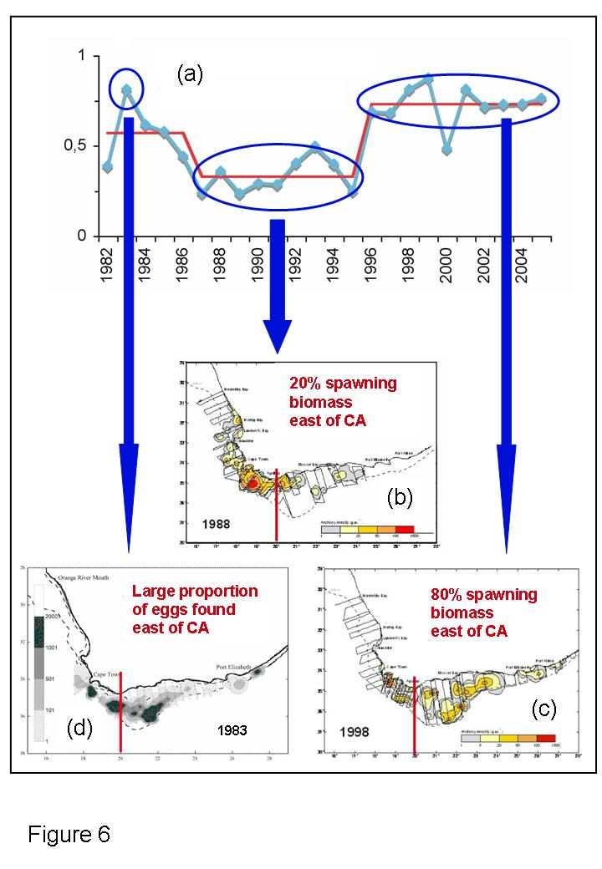

Figure 3: (a) Time-series of the annual difference in SST between the offshore and coastal regions of the central Agulhas Bank showing a period of lower SST difference (1987-1995) that coincided with anchovy spawner distributions that were primarily to the west of Cape Agulhas as seen in 1988 (b); a period of higher SST difference (1996-present) that coincided with anchovy distributions that were primarily to the east of Cape Agulhas as seen in 1998 (c); and a year (1983) of higher SST difference (1983) that coincided with an anchovy egg distribution where most of the eggs were found to the east of Cape Agulhas (d). See presentation entitled “Environment-fish relationships: processes and variability - A focus on anchovy life history and recent changes” by C. Roy et al.

Identification of Gaps and Prioritization of Research

Initial discussions during the Ecology of the Southern Boundary Region Specialist Session were concerned with assessing progress that had been made in filling perceived gaps in knowledge of the ecology of commercially-exploited living marine resources on the Agulhas Bank that were identified during the 1992 Agulhas Bank workshop, many of which still remain. These gaps include the following:

- Uncertainty of the effects of meanders and eddies of the Agulhas Current on ecological processes on the Agulhas Bank, and of advective losses from the Agulhas Bank shelf to the open ocean;
- Poor estimation of volume flux and retroflection position variability of the Agulhas Current and its effects on shelf biota;
- Limited or no available time series of mixing/stratification;
- A lack of seasonal data for almost everything;
- Limited knowledge about early life history stages of fish between Cape Agulhas and Algoa Bay;
- Minimal knowledge regarding predation on fish eggs and larvae;
- A lack of understanding about large scale shifts in fish populations across the shelf;
- Limited knowledge on the interactions between predatory fish and prey populations; and
- A lack of knowledge on the ecological role of gelatinous zooplankton, small crustaceans and euphausiids.

Many of the hypotheses and conclusions described in the Review of Existing Knowledge section are drawn from various surveys that cover very limited periods of the year, and short term events, such as flooding of the Agulhas Bank with Agulhas Current surface water, could have drastic effects that are missed by surveys. Such events must have profound impacts on the shelf biota, and these will most likely not be detected during routine sampling operations such as research surveys, highlighting the need for data at a higher temporal resolution than is presently obtained.

Subsequent discussions were directed at formulating a series of specific key questions that would synthesise ideas concerning information gaps and requirements. These key questions could be specified within an investigative framework comprising two broad issues concerning the influence of physical processes on the ecology of living marine resources in the southern Boundary region. The first issue concerns the physical processes of the Agulhas Bank system and its links to the west coast, while the second issue concerns how these physical processes and links may have changed over time. While the first issue is entirely related to physical processes, the second incorporates a strong biological component. A third issue closely associated with this framework is the implications of these possible changes in the functioning of the system to resource management in the BCLME.

Issue # 1: How does the Agulhas Bank system work?
Specifically, what controls circulation patterns and productivity on the Agulhas Bank? Productivity is considered here in a broad sense that incorporates both primary and secondary production, with the intention of identifying what makes the area a suitable spawning (and possibly nursery) area for fish and other marine resources.

Key questions:
- What are the major drivers (and their relative importance) of production on the Agulhas Bank?
- What is the source of the cool ridge and cold bottom water on the shelf?
- What is the influence of the Agulhas Current on the surface waters of the Agulhas Bank? What role is played by the inflow of warm surface water from shear-edge plumes, and the offshore loss of productive shelf water beyond the shelf edge? Can this be quantified and what contribution do they make to the water budget of the Agulhas Bank?
- What are the implications of circulation patterns on transport/retention of biological products?
- What is the difference in the transport duration of larvae from the Central and Eastern Agulhas Bank versus the Western Agulhas Bank? What are the implications in terms of behavioural adaptations of larvae?

Approach:
- Analyse existing data to identify processes that can be assessed using field studies, models or remote sensing.
- Conduct modelling studies and design process studies to test hypotheses regarding drivers of productivity.
- Look at the “nutrient pumps” on the Agulhas Bank (e.g. coastal upwelling, cool ridge, divergence-driven upwelling, upwelling at the shelf edge or in shear-edge eddies) and assess their relative importance in terms of productivity.
- A significant proportion of the primary production on the Agulhas Bank occurs at the sub-surface chlorophyll maximum. P-I (photosynthesis-incident irradiance) curves should therefore be further developed to convert satellite-derived, surface chlorophyll concentrations into total primary production.

Issue #2: What has changed in the Agulhas Bank system (and the west coast system) through time?
Productivity on the Agulhas Bank appears to have changed through time, but what controls the variability in production processes?

Key questions:
- Have there been changes in the behaviour of the Agulhas Current (volume flux, induced upwelling at Port Alfred, shear-edge eddy and meander plume formation, and the location of retroflection) through time and can these be linked to productivity and the distributional changes in resources?
- Have there been changes in transport and/or retention processes through time on the Agulhas Bank?
- Has there been a change in habitat suitability of the west coast (e.g. increased occurrence and extent of low oxygen water, changes in productivity, temperature etc.)?
- Has the relative importance of the productivity-drivers changed through time?
- Has there been an increase in primary and secondary productivity/biomass on the Agulhas Bank in recent years?
- If so, does the temporal pattern in productivity match observed distributional changes of resources (small pelagic fish, rock lobster etc)?
- Have there been changes in zooplankton abundance/composition on the west coast versus the Agulhas Bank over time that could be related to predation by small pelagic fish species? Have there been corresponding (causative?) changes in phytoplankton community composition?
- With the Eastern Agulhas Bank becoming more productive, have small pelagic fish shown changes in their spawning behaviour? (e.g. prolonged spawning seasons because fish are in generally better condition)

Approach:
- Conduct retrospective analyses to examine changes in behaviour of the Agulhas Current.
- Conduct retrospective analyses and process studies that examine the persistence, seasonality and intensity of processes linked to productivity such as the intensity of upwelling at Port Alfred, the occurrence and extent of the cool ridge and upwelling in shear-edge eddies or shelf-edge upwelling on the Agulhas Bank.
- Update and analyse time-series of particle size spectra and plankton community structure routinely collected during research surveys on the Agulhas Bank.

Issue # 3: If the functioning of the Agulhas Bank has changed, what are the implications of this for the management of resources in the BCLME?

Key questions:
- Are events in the Southern Boundary region linked to events further north in the rest of the BCLME (e.g. decline of sardine and rock lobster in the northern Benguela, northward movement of M. paradoxus, decline in upwelling in the LUCORC region, persistent warming in the ABFZ, decline in fish stocks in Angola, shifts in the distributions of major resources away from the LUCORC (Lüderitz cell – Orange River Cone) transboundary region)?

SESSION 2: LARGE SCALE FORCING OF THE SOUTHERN BOUNDARY REGION AND LINKS TO THE BCLME

The aim of Session 2 was to examine the forcing of processes on the Agulhas Bank, variability of the Agulhas Current, and how the Agulhas Bank and Agulhas Current interact with the rest of the BCLME. Four presentations were given during the session, including an overview of the Agulhas Current and its influence on the Agulhas Bank; descriptions of South Atlantic and Southern Ocean processes relevant to the Southern Boundary region and exchanges between these regions; large scale temporal and spatial variability of the Southern Boundary region; and modeling of the Agulhas Current and adjacent areas.

Review of Existing Knowledge

Large scale forcing of the southern boundary of the Benguela Current and the Benguela upwelling regime can come from two directions: from the South Atlantic subtropical gyre or from the South Indian Ocean. Forcing from the west could conceivably come from variation in the South Atlantic Current. Recent results from a US field programme in the South Atlantic, not yet available at the time may answer many of the uncertainties about the South Atlantic Current expressed at the workshop. We therefore resist the temptation to speculate in this document. Forcing from the South Indian Ocean can be effected through the actions of the Agulhas Current.

The Agulhas Current has a known effect on the Benguela upwelling regime of southern Africa’s west coast in a number of ways. First, by facilitating leakage of Indian Ocean water into the South East Atlantic through the shedding of Agulhas rings, it contributes to the water masses in the Cape Basin that are then available for upwelling. Second, surface leakages of warm Agulhas Current water in the form of Agulhas filaments contribute to the intensity of the upwelling front. Third, and probably of most direct impact, the Agulhas Current generates upwelling of cold water onto the Agulhas Bank (although whether upwelling is due to the Agulhas Current itself, changes in bathymetry, divergence of the Current at the shelf edge, or forcing by the bottom Ekman boundary layer remains controversial) thus contributing to the vertical stratification and the nutrient supply on the Bank. What is known about these three processes (interocean leakage from rings, presence of filaments, generation of upwelling) and their functioning?

Agulhas ring shedding
The Agulhas Current proper is fully constituted somewhere near 28° S, along the east coast of the province of KwaZulu-Natal of South Africa. Here the continental shelf is narrow and the course of the current very stable. This is true for the whole of what might be considered the northern Agulhas Current extending downstream as far as Port Elizabeth, at the eastern end of the Agulhas Bank (Figure 4). An intermittent meander in the trajectory of the Agulhas Current known as the Natal Pulse has a considerable effect on the circulation of the adjoining shelf region. The nature of the Agulhas Current changes dramatically adjacent to the Agulhas Bank. From the latitude of Port Elizabeth the southern Agulhas Current exhibits a range of meanders on its shoreward side. These meanders generate shear-edge eddies and attendant warm plumes that move with the current and influence the upper waters of the shelf in this region. The average trajectory of the current follows the shelf edge, thus lying farther and farther from the coastline (see Figure 4), until the tip of the Agulhas Bank is passed. The current continues south-westward into the South Atlantic until it retroflects.

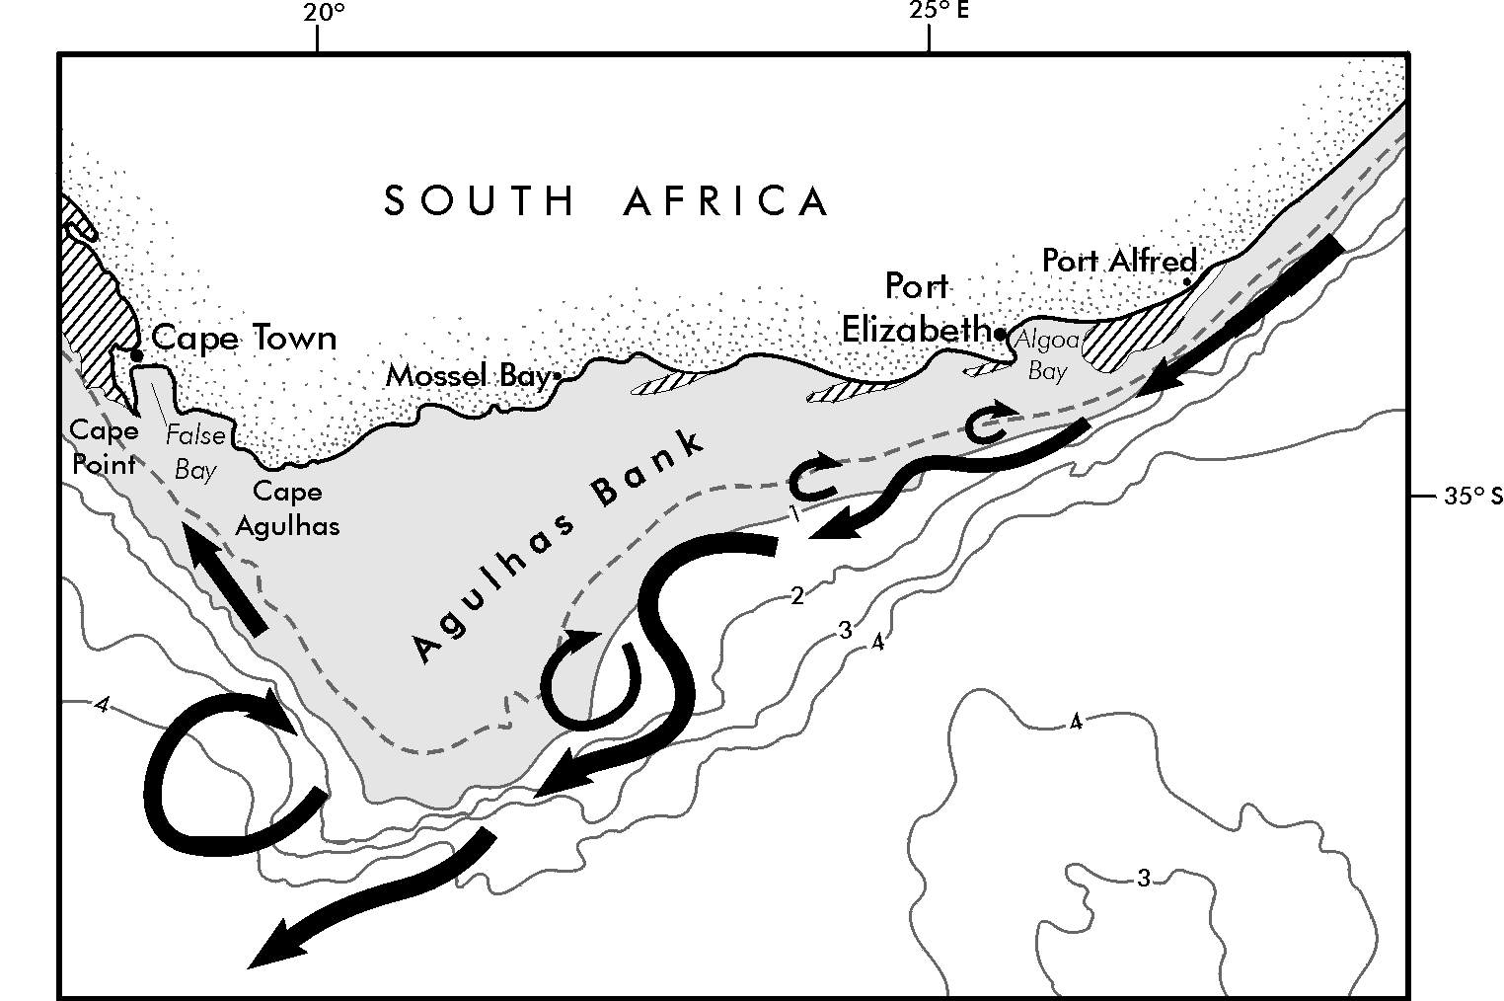

Figure 4: Bathymetry of the continental shelf off the south coast of South Africa and its major circulatory elements. Areas shallower than 1 km are shaded; the broken line denotes the 200m isobath, and upwelling sites are shown by hatching.

The Agulhas Retroflection exhibits the highest levels of mesoscale variability in the world ocean. This is due to the manner in which the retroflection loop occludes, intermittently forming large Agulhas rings that then drift off into the South Atlantic. The shedding frequency may be largely determined by the advent of Natal Pulses. It has been suggested that these rings may interact with the coastal upwelling on South Africa’s west coast, but analyses of the tracks of such rings indicates that such interaction must be a rare exception. Most rings spend some time in the vicinity of where they were shed, losing a substantial part of their energy, mass, heat and salt through water mass exchange with other anticyclones and cyclones during the initial period. The part of the flow not involved in ring formation, the Agulhas Return Current, which forms the southern limb of the Agulhas Retroflection, transports water eastward along the Subtropical Convergence. These deep-sea components of the greater Agulhas system are downstream of the Retroflection and in the Indian Ocean and therefore do not have a direct influence on the upwelling regime of the BCLME.

Agulhas Current filaments
Once past the southern tip of the Agulhas Bank, the core of the Agulhas Current moves offshore (Figure 4), but some of the plumes that have been generated by shear-edge eddies along the bank’s eastern side may be drawn along the edge of the western Agulhas Bank as Agulhas filaments.

Agulhas filaments are relatively shallow features (~ 50 m) and may carry warm surface water as far as the coastal upwelling zone. To date there has been only occasional evidence that warm surface water from these filaments may intrude over the shelf in a fashion analogous to that of plumes adjacent to the eastern Agulhas Bank. Why Agulhas filaments are drawn so rapidly equatorward is also not entirely clear. This has been assumed to be due to passing Agulhas rings. Such filaments associated with the passage of Agulhas rings may be responsible for concentrating spawning products and moving it northward to where shelf-edge processes can move it to the nursery areas. Alternatively, surface waters of Agulhas Current and Agulhas Bank origin are driven to the northwest by prevailing southerly winds, with strong convergence on the WAB leading to the formation of jet currents there, as has been previously demonstrated.

There is strong evidence that there is a tendency for the circulation off the south western Agulhas Bank to be cyclonic, which would lead to currents at the shelf edge moving poleward rather than equatorward. Modelling and hydrographic observations now suggest that this is due to a cyclonic eddy driven by the Agulhas Current in the lee of the Agulhas Bank. The discrepancy between an equatorward shelf-edge jet and a poleward movement driven by an Agulhas Bank lee eddy has not yet been resolved.

Agulhas Bank
The Agulhas Bank forms the triangular continental shelf south of Africa (Figure 4). The bank measures about 500 km east to west along its (widest) northern edge, and about 250 km north to south from shore to tip. A shallow region, the Alphard Rise, constitutes the border between the western and the eastern Agulhas Bank that, as a result of this partition, have distinctly different characteristics. This is exemplified by the contrasting sedimentary nature of the eastern and western Agulhas Bank which places the western bank squarely in the province of the Benguela upwelling system. On the eastern side of the bank the warm waters of the southern Agulhas Current follow the shelf edge (Figure 4) with meanders that grow in amplitude downstream. The attendant plumes in general are shallow features, but may eventually spread their warm water over large parts of the adjacent shelf. By contrast, on the western side of the Agulhas Bank the sluggish Benguela drift carries cold water equatorward, but this is complicated by the presence of the above-mentioned lee eddy, the recurrent passage of Agulhas rings and the intermittent presence of Agulhas filaments.

If the theoretical portrayal of western boundary currents holds, wherever such a current moves from a narrow shelf past a wider shelf a degree of upwelling should be experienced. This is not purely an artefact of the divergence of the current. This kind of upwelling has been observed south of Madagascar and at the northern corner of the Natal Bight. It has also been observed along the Agulhas Bank.

Thermal infrared imagery from satellite shows that an upwelling cell of this nature is centred off Port Alfred (Figure 5). On average it is about 30 km wide and extends 180 km along the edge of the current. The temperature-salinity relations of this water imply that it is upwelled onto the shelf from offshore waters deeper than 400 m and this has been confirmed by hydrographic observations in the region. Nitrate values in the upwelling cell can exceed 20 μmol/l at 100 m, whereas they are less than 5 μmol/l on the adjacent shelf.

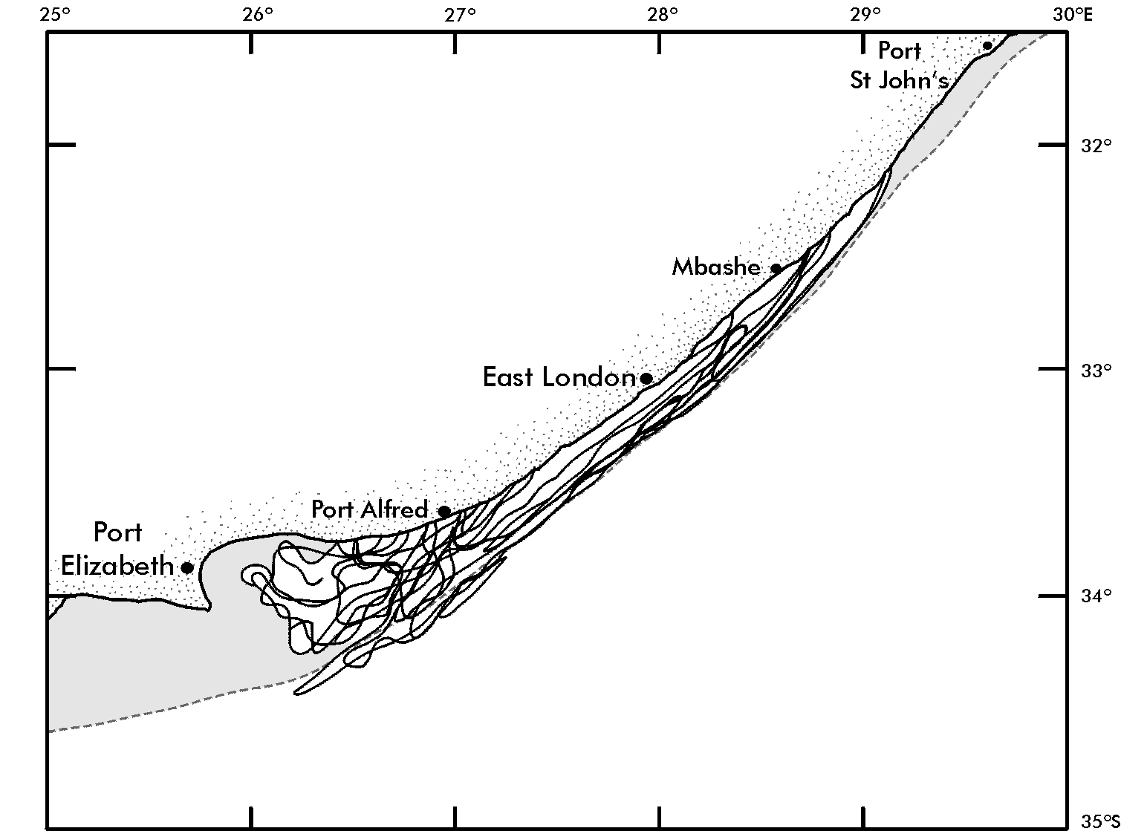
Figure 5: An ensemble of outlines of cold water of the Port Alfred upwelling cell inshore of the Agulhas Current, using the outcropping of the 17 ˚C isotherm as an indicator. The 200 m isobath is shown as a dotted line and the shelf inshore of this isobath is shaded.

The Port Alfred upwelling cell may furthermore have considerable implications for the Agulhas Bank as a whole. First, it forms one of the three main physical/chemical provinces of the bank. The others are the greater part of the shelf and the coastal upwelling regime of the western Agulhas Bank. Despite the sparse, heterogeneous distribution of hydrographic stations available these provinces are well-defined. Second, this upwelling cell water provides a source of water colder than 10 ˚C for the entire Agulhas Bank. It has been hypothesized that the input of cold water along the bottom intensifies seasonal thermoclines over the bank, which are found to be unusually strong. Although it has previously been surmised that this cold water is upwelled inshore of the Agulhas Current along the entire eastern edge of the bank, little direct evidence of this phenomenon has been found to date. In fact, almost all hydrographic sections across the bank show that the shelf-edge water colder than 10 ˚C occurs only in the vicinity of Port Alfred. If this upwelling cell plays such a crucial role in the stratification of the whole Agulhas Bank, how persistent is it?

Regrettably, there are no data to address this important question. Surface observations show that it is present almost 50% of the time, but this surface outcropping may be largely wind dependent, as has been observed at sea. The limited hydrographic data available show that the presence of upwelled water at depth seems considerably more enduring.

Much has been made of the ridge of cold water (< 10 ˚C) that overlies the 100 m isobath over much of the eastern Agulhas Bank. This ridge is evident in temperature sections across the Bank; at times it crops out, producing areas of cold water at the sea surface over the Bank. It has been proposed that this ridge of cold, nutrient-rich water originates in the Port Alfred upwelling cell. From below it enhances the thermal stratification of the water column over most of the Bank and brings nutrients onto the full extent of the shelf. These nutrients are not available to the phytoplankton throughout the year, but follow an annual cycle dependent on the level of stratification.

Observations show that the subsurface chlorophyll-a peak is closely associated with the behaviour of the seasonal thermocline. During the winter months, storm winds and convection mix the upper water column to depths of 75 m or more (Figure 6); in summer fewer extreme wind events and increased insolation establish a seasonal thermocline that may be at 50 m or deeper. Summer winds have been shown to be too weak to break down the seasonal thermocline. The winter mixing of the water column raises the temperature of the bottom water in winter, being warmest in July. All this is normal for shelf regimes in the subtropics. On the Agulhas Bank, however, this typical seasonal stratification pattern is intensified by cold water upwelling from below (Figure 6). The seasonal thermocline/nutricline thus established is about twice as strong as would normally be expected.

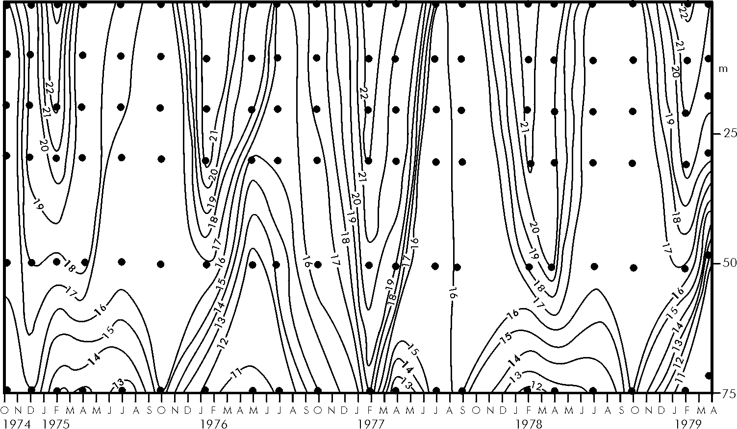

Figure 6: Time series of the temperature profile for a hydrographic station on the central Agulhas Bank. Dots indicate standard depths at which nutrient samples were taken.

The seasonal cycle of the water column is evident in the temperature/salinity characteristics of the Agulhas Bank. In spring, the sea surface temperature (SST) range on the western and central Agulhas Bank is restricted to 14 – 18 ˚C and salinity to 35.0 - 35.5 ‰, whereas in winter, SST ranges from 10 to 23 ˚C and salinity from 34.6 to 35.8 ‰. Nutrient levels follow a similar pattern. Over the eastern Agulhas Bank, average summer sea surface temperatures range between 21 – 26 ˚C, representing the horizontal offshore gradient towards the Agulhas Current. In winter this range is reduced to 16 – 19 ˚C. In summer the average temperature difference between the water at the surface and at 80 m depth can be as high as 11 ˚C, while in winter the highest gradient is 5 ˚C. Nevertheless the seasonal thermocline on the eastern Bank is usually shallower and better developed compared to that of the western part of the Bank.

The movement of the waters of the eastern Agulhas Bank can be placed into three categories identified by the position in the water column: the surface Ekman layer, the near-bottom layer and the rest of the water column. The surface Ekman layer moves largely with the wind. Comparison of the movement of a drifter with progressive wind stress vectors rotated 35˚ to the left has demonstrated this. Analyses of ships’ drift show no distinct patterns or seasonal cycles. Since the dominant wind directions are parallel to the coast, the surface water layer will follow suit. The bottom waters, where they have been measured, move largely parallel to the isobaths and in the same direction as the waters of the Agulhas Current. The movement of the rest of the water column is more complex. It has been shown that the highest energies on the shelf are to be found at inertial periods. Low-frequency (net) bottom motion consists of the residual drift after inertial and tidal currents have been removed.

As mentioned above, the major characteristic of the Agulhas Current along the shelf edge of the eastern Agulhas Bank is the presence of shear-edge eddies of various sizes. These eddies move downstream with the current and are most prevalent in the concave part of the shelf edge. The presence of such eddies inverts the shelf-edge current that is usually dominated by the Agulhas Current. Cold water is upwelled in the core of these cyclonic features and it has therefore been surmised that they are instrumental in bringing this cold water onto the shelf, although this has been observed infrequently. Warm water plumes associated with these shear-edge features bring warm water onto the shelf, enhancing the shelf thermocline.

Along the west coast, wind-driven coastal upwelling normally starts at Cape Point, although contiguous upwelling occurs between Cape Agulhas and Cape Point for about 10% of the time. Vertical stratification is most strongly developed in summer, due to the uplift of cooler Central Water and the alongshore advection of warm surface water from the Agulhas Current and the Agulhas Bank. This is reminiscent of the cycle of stratification over the central Agulhas Bank (Figure 6). Nutrients move closer to the surface in spring and summer, causing a modest spring bloom, but do not penetrate the thermocline until vigorous mixing to a depth of 60-80 m in winter. Over the rest of the western Agulhas Bank the stratification appears to be much weaker than over the eastern Bank. The uplift of the isopycnals towards the coast over this shelf region is naturally evident in the distribution of nutrients with high values covering a greater part of the shelf than over the eastern Agulhas Bank.

The prevailing currents on the western Agulhas Bank are in a north-westerly direction in summer; in winter those along the southern parts of this coastline may be south-eastward. Water characteristics are the same above the thermocline as on the eastern Agulhas Bank, but below the thermocline the waters are slightly less salty and have lower nutrient loads. This has been taken as evidence that this water has an Atlantic rather than an Indian Ocean origin and that the bottom water here on average moves in a south-easterly direction. Nevertheless, inertial currents may still be the dominant movements on shorter time scales.

Along the far eastern side of the Agulhas Bank the likelihood of an intrusion of warm surface water from the adjacent Agulhas Current right to the coast may be high. Under southerly wind conditions water from warm surface plumes can reach the coastline, causing a temperature rise of 3 ˚C or more in surface water. They may also cause a distinct layering in offshore water. The coastal morphology plays a secondary role in the manner in which offshore events may influence the water masses or circulation at the coast. At certain locations, such as Algoa Bay at Port Elizabeth (see Figure 4), the winds may create very localized circulation patterns within the bay.

To sum up: the shelf waters of the Agulhas Bank may be placed into three physico-chemical provinces according to the influence of the Agulhas Current. These are: the Port Alfred upwelling cell, the coastal upwelling of the western Agulhas Bank and, third, the wider shelf outside the immediate influence of the Agulhas Current. The Port Alfred upwelling cell may be permanent at depth, with a surface outcropping driven by local winds. Cold, nutrient-rich water is brought onto the shelf here and may spread over the greater part of the Agulhas Bank. There is a high likelihood that this inflow of bottom water is the driving force for the very intense seasonal thermoclines over the wider shelf region. The northward advection of warm Agulhas plumes is assumed to play a minor role. The upwelling on the western Agulhas Bank is a seasonal phenomena and forms part of the greater Benguela upwelling system.

Identification of Gaps and Prioritization of Research

The above review identifies a large number of elements of the circulation and behaviour of the southern boundary of the Benguela system that are poorly known or inadequately understood. A short list of such remaining questions is instructive.

- How important is the interaction of upwelling filaments and passing Agulhas rings?
- What role do Agulhas filaments play in the characteristics of surface waters in the Benguela upwelling regime?
- Is it possible to quantify large, secular changes to the system and to create reliable indices for this? Can such changes be monitored, for example by remote sensing?
- Is large scale variability in the system forced externally or internally?
- How persistent and influential is the purported jet along the western shelf edge of the Agulhas Bank?
- What role do tides play in the system, especially at the shelf edge? Is there, for example, tidal rectification on the Bank?
- How important are the undercurrents of the Benguela upwelling regime and of the Agulhas Current to the system? Are they connected and do they form a key link between the two systems?
- How important are sub-mesoscale processes to the southern boundary of the Benguela regime and can they be quantified?
- What is the process that causes the cold ridge of bottom water on the Agulhas Bank and how is it maintained? Is it a transient or a persistent feature?
- What are the key components of the water budget of the Agulhas Bank: warm plumes from Agulhas shear-edge eddies, upwelled water in such eddies at the shelf edge, bottom water from the Port Alfred upwelling cell, coastal upwelling at headlands or shear-edge eddy intrusions?
- How does the meandering of the Agulhas Current affect the flux of nutrients onto the Agulhas Bank? This encompasses the Natal pulses and also the possibility that there are other mechanisms responsible for delivering nutrients onto the shelf.

From an ecological perspective, the knowledge/information needs can be summarised as follows:

- Mechanisms/processes relevant to the formation and maintenance of the Agulhas Bank cool ridge, shelf edge upwelling and formation of cold bottom water on the Bank
- Water movement over the Agulhas Bank, inflow and outflow (including the inshore areas)
- Variability of the Agulhas Current, filament formation and ring shedding
- Variability in the southern Benguela Current region (and the shelf edge jet)
- Bottom/shelf edge transport/undercurrent and continuity with the Agulhas undercurrent
- Port Alfred upwelling dynamics and fate of water

Many of these needs and questions can be grouped into three main categories and addressed via the “packages” as follows, in priority order. Cost implications of each are expressed using $ signs ($$$ = expensive, $$ = moderately expensive, $ = relatively inexpensive)

- Agulhas Bank Physics ($$$)

This package will address the three dimensional water movements, system variability and driving processes on the Agulhas Bank, including inflow and outflow (cf Good Hope Jet and key link to the West Coast region of the southern Benguela). Aspects will include:

- physics of the cool ridge
- cold bottom water formation/dynamics
- shelf-edge processes, including the Port Alfred upwelling
- impact of tides etc.

It is anticipated that this package will be executed using a mixture of modelling, in situ measurements (ships, moorings, floats/gliders), remote sensing and a re-analysis of historic data. A key step in the proposed development process will be a SMALL expert workshop/think tank which will include international oceanographers who are experts in physical oceanography and ecology of bank systems (cf the Georges Bank in the North Atlantic).

Potential funding could come from:

- BCLME Programme
- ASCLME Programme
- Oil and gas industry (partnerships)
- MCM (in kind, via provision of ships)

- Large-scale Variability ($)

This package will address the large-scale ‘forcing” of the southern boundary area and will include a “monitoring” component. As such it will integrate with the BCLME’s SEIS and EEWS initiatives and the ASCLME priorities. Aspects to be covered will include:

- ring shedding
- filaments
- Sub-Antarctic pulses
- Agulhas Current and Benguela Current variability and “leakages”
- atmospheric forcing (large scale) of the key modes of variability
- climate variability/change issues

It will be executed using readily available large data sets (including those derived from remote sensing), modelling, and limited in situ measurements (e.g. XBT lines to support altimetry-derived products etc)

Potential funding could come from

- BCLME Prgramme
- ASCLME programme
- Government institutions and industry.

- Undercurrents and shelf-edge transport ($$)

The presence of undercurrents along the continental slope of both the south-western and south-eastern side of southern Africa is now well-established. The possible role of these undercurrents in linking the two systems is not known. The influence these undercurrents may have on the circulation of the adjacent shelves has also not been studied. It may be that they have no effect on the shelves, but until such time as this is properly investigated one will not know this. This is an area of profound ignorance to which it behoves us to pay closer research attention. A proposal is to be submitted to the US NSF to study the undercurrent in the Central Benguela near Lüderitz using gliders. This effort should be supported locally in whatever manner is most appropriate.

Potential sources of funding might include:

- MCM (in kind, via ships)
- US NSF

SESSION 3: IMPACTS ON MARITIME OPERATIONS FROM THE SOUTHERN BOUNDARY OF THE BCLME

The principal objective of this session was to assess the nature of the impacts on maritime operations in the BCLME from trans-boundary influences at its southern boundary. Attention then turned to operational issues, in particular to the means to forecast the influences and the actions needed to mitigate their impacts. It should be noted that, whilst the main influence from the southern boundary is on the nearby Agulhas Bank, there are effects on maritime operations in the entire BCLME.

Review of Existing Knowledge

The area of the BCLME to the south of South Africa is characterised by the wide continental shelf of the Agulhas Bank, and the warm Agulhas Current flowing strongly along the shelf edge and retroflecting back from the Atlantic into the Indian Ocean. It is a harsh environment making maritime operations expensive and risky. The area regularly comes under the influence of deep low pressure weather systems and their accompanying high wave fields propagating equatorwards from the Southern Ocean. Indeed these high wave fields can, on occasion, negatively influence maritime operations well up the entire west coast of Africa.

It should also be noted that the effect of extreme maritime weather is exacerbated as it passes over the warm waters of the Agulhas Current. This is in addition to the dangerous freak waves that can occur whenever long swell opposes the flow of the Agulhas Current. For reasons of safety, the heavy shipping traffic passing between the Atlantic and Indian Oceans is constrained to move between the coast of South Africa and the prevalence of bad weather to the south. However, it should be recognised that increasingly attractive economic opportunities are leading to offshore industries pushing ever southward into deeper and riskier waters.

It is the responsibility of the South African Weather Service to provide metocean forecasts for METAREA VII, which surrounds sub-Saharan Africa and extends down to Antarctica. These forecasts draw on remotely sensed data from satellites and observations from drifting buoys and fixed platforms such as the MossGas platform at the edge of the Agulhas Bank 120km south of Mossel Bay. These observations are assimilated into operational forecast models from global agencies such as NOAA and value adding vendors such as BuoyWeather.

Identification of Gaps and Prioritization of Research

The following operational issues and actions were identified in this Session:

- Shift of fishing operations from the west coast to east of Cape Agulhas (see Fig. 7)
This has brought fishing operations, vessels and crew, further from their home ports and familiar operating environments into the hazardous area south of South Africa. As well as encountering more extreme weather and working conditions, there are other operating risks. The sinking of FV ‘Lyndsay’ on 8 May 2005, with the loss of 14 crew is an example of the possible consequences when there is increased trawler activity in the busy shipping lanes which cross the Agulhas Bank.

- Forecasting of ‘Rogue’ Waves
This is linked to the above but possibly with more serious implications relating to hull damage on loaded oil tankers. Nevertheless fishing vessels have capsized in 'freak' (or extreme) wave conditions. Although wave/current interaction is more likely to result in casualties north-east (upstream) of the Agulhas Bank, the likelihood of hazardous cargo reaching the Bank is high. The South African Weather Service has been issuing abnormal wave warnings for over nine years (and in this period there have been very few Agulhas Current casualties) but the system can be improved.

- Operational Oil Spill Drift Models
The OILMAP model, previously run by the CSIR, is no longer available for use in oil spill drift predictions as part of oil spill contingency planning. There is no doubt of the need for such a capability in the waters of the Agulhas Bank, as some 120 million tons of oil are transported across the Bank each year. Indeed the area has been recognised in the new 'Special Area' zonings of the International Maritime Organisation. Futher offshore, the South African Weather Service has the responsibility for the Marine Pollution Emergency Response Support System in METAREA VII. It was noted that such a system has other valuable uses in safety at sea, such as predicting the drift of containers lost overboard (~ 10 000 per annum globally) and search and rescue operations.

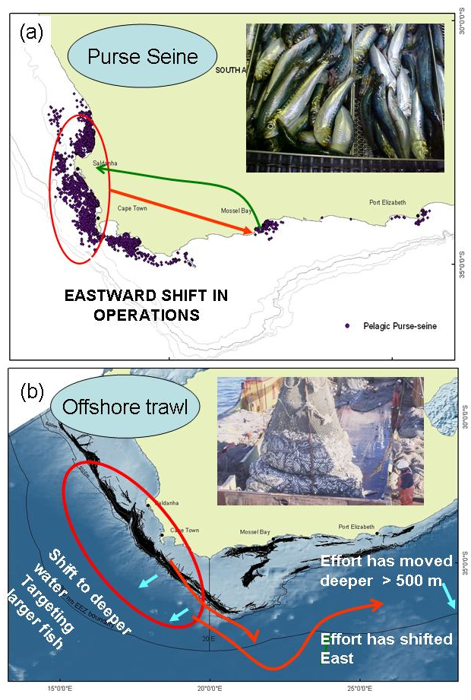
Figure 7: Schematic showing the eastward shift in (a) purse-seine fishing operations for sardine, and (b) the eastward and offshore shift in offshore trawl fishing operations for hakes. See presentation entitled “Trends in offshore fishing effort off the South African coast” by D. Japp and S. Wilkinson.

- Sea State Impacts up the West Coast of Africa
Although the Workshop focused on the Agulhas Bank and the southern boundary of the BCLME, it was decided to include consideration of the heavy south and south-westerly swell, generated in the South Atlantic and Southern Oceans, that impacts on the whole of the west coast and adjacent waters, right up Africa. This high energy input affects coastal and offshore operations, and poses problems for the coastal diamond industry of South Africa and Namibia, and the offshore oil and gas industry of Angola and the countries to the north. It is also responsible for serious coastal erosion along the soft muddy coasts of West Africa. Such studies will provide the opportunity for research project interaction between the BCLME and the Guinea Current Large Marine Ecosystem.

- Better Observations
Formal reports from voluntary observing ships are declining in number and there is increasing reliance on automated and satellite-based data. Sentinel stations need to be established at locations of relevance to economically important coastal and offshore industries, as part of a regional coastal ocean observation network. It should be noted that the exploitation of offshore oil and gas fields is moving into deep water (over 2000m deep). Observational data needs to be available from these stations in real-time mode, in order to be assimilated into the operational forecast models of the atmosphere and ocean environments (see Fig. 8), and to be available for the many hindcast studies requested by the maritime industry. The idea of creating an ocean portal for the whole region as part of the extended capabilities of the Southern Ocean Data Centre for Oceanography was strongly supported.
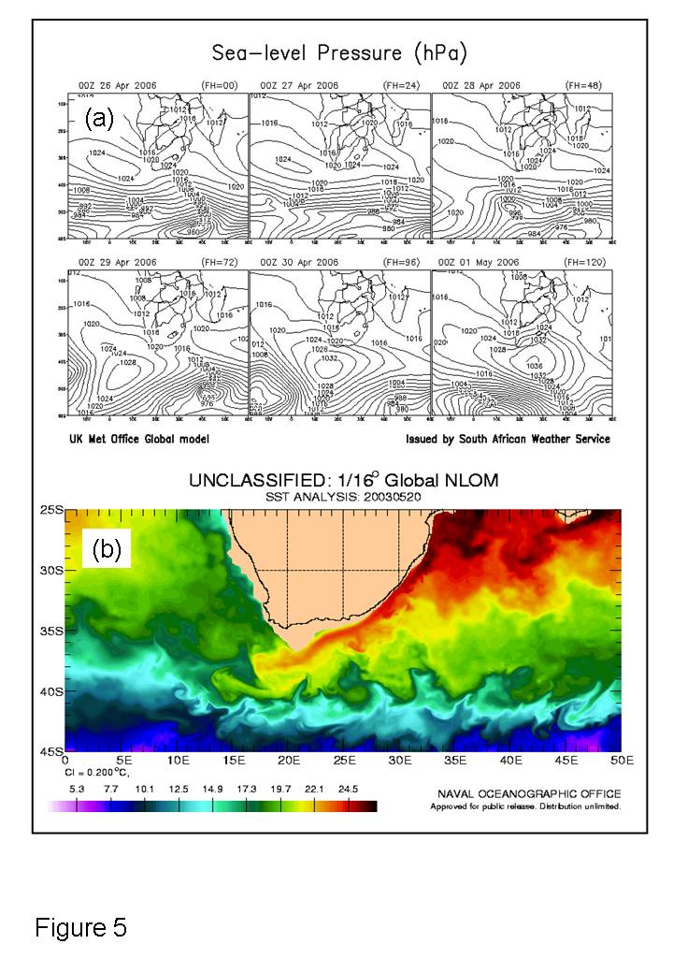
Figure 7: Examples of metocean forecasting showing (a) predicted sea level pressure (for a 6-day period from 26th April to 1st May 2006); and (b) sea surface temperature (for 20th May 2003). See presentation entitled “Metocean analysis and prediction in support of maritime operations” by I. Hunter.

- Environmentally-sensitive Areas
Many years ago, the then SFRI covered the whole South African coast in their series on Coastal Oil Spill Contingency Plans, which focused on site specific responses. It was reported at the Workshop that M&CM propose updating this information. Such a new series should include all processes, coming from the sea, that could possibly result in damage to the coastal environment, including tropical and extra-tropical storms and tsunamis. A GIS format would extend the usefulness of the new series for the mitigation of impacts and the recognition of particularly sensitive coastal areas. It was noted that the other BCLME countries also need to prioritise the development of such 'electronic atlases'.

In summary, there are five recommendations for future action.

- Improve the collection and dissemination of observations for use in forecast models to serve the needs of the growing offshore industries of the BCLME.
- Draw up GIS atlases of sensitive coastal areas which are vulnerable to the impacts of marine pollution and severe maritime weather events.
- Revive the national oil spill contingency planning capability, and support this endeavour through a suite of relevant operational forecast models.
- Continue to improve maritime safety in the increasingly congested shipping lanes across the Agulhas Bank.
- In collaboration with the GCLME, investigate the value of an early warning system for extreme sea states moving up the west coast of Africa from the southern boundary of the BCLME.

TRANSBOUNDARY INFLUENCES OF THE SOUTHERN BOUNDARY OF THE BCLME ON THE BENGUELA SYSTEM

The major oceanic feature of the southern boundary forcing the BCLME is the Agulhas Current system. This system consists of the Agulhas Current and the Agulhas retroflection, together with associated cyclonic and anticyclonic eddies, rings, and filaments of Agulhas water impinging both directly and indirectly on the shelf and slope regions of the Benguela upwelling regime. The Agulhas Current influences conditions on the Agulhas Bank, a major spawning area supplying the nursery areas in the southern Benguela. Water in filaments from the Agulhas Current impinges on the slope and shelf of the western Agulhas Bank, affecting the shelf-edge currents (the shelf-edge jet) which carry the spawn from the Bank to the nursery areas of the west coast. Direct influence of the Agulhas Current on shelf and slope conditions in the southern and central Benguela is provided through the shedding of Agulhas rings from the Agulhas retroflection. Rings or eddies shed from the Agulhas Current and retroflection may directly influence the upwelling front of the Benguela at the slope, or be dissipated in the Cape Basin bringing about more or less subtle changes in the background water characteristics in this part of the SE Atlantic Ocean. These changes would most directly influence the surface, Central and Intermediate Waters. Since the Central Waters provide the water which is upwelled at the coast, the influence of the Agulhas Current salt and heat content can be felt.

The Central Benguela upwelling regime has recently received more attention because of its perceived function as a barrier or gate, limiting and controlling exchange between the northern and southern Benguela. The poleward undercurrent at the slope and shelf edge in the central Benguela (BPUC) has been identified as an important though little understood component of this exchange, influencing amongst other things the oxygen content of the upwelled water on the shelf. There remains uncertainty about the continuity of the BPUC in the central Benguela and the presence of a slope undercurrent around the Agulhas Bank is completely unknown. This is a potentially important component of exchange across the southern boundary of the Benguela upwelling regime, possibly continuous with the Agulhas Undercurrent.

- Monitoring Opportunities (1)
The environmental forcing exercised by the influence of the Agulhas Current on the conditions of the Agulhas Bank are transmitted to the BCLME through the shelf and slope exchanges on the western Agulhas Bank, essentially through a "bottleneck" at the Cape Peninsula. This conduit is sampled periodically by two monitoring lines that sample across the shelf; the Sardine/Anchovy Recruitment Programme (SARP) monitoring line located off Hout Bay, and the St Helena Bay monitoring line (SHBML). Minimal extension of the sampling procedures used on these lines can greatly increase their utility (e.g. sampling to the bottom, or at least to below the Antarctic Intermediate Water) and provide environmental parameters to estimate the influence of Agulhas Current on the Benguela upwelling system.

- Monitoring Opportunities (2)
Direct interaction between an Agulhas ring and the Benguela upwelling system was observed in 1989. In general, however, satellite altimetry data suggests that the usual pathway of Agulhas rings is far from the upwelling front. The influence of Agulhas rings on the water properties in the Cape Basin is, nevertheless, substantial, but questions concerning the frequency, magnitude, variability, and position of interactions are all largely unanswered. The interaction is seldom seen in AVHRR imagery (the surface signature is rapidly dissipated); in satellite altimeter data (features are at the detection limit and the upwelling component of the interaction is not discernable in the data); or in model output (model results seldom resolve eddies adequately, and models have difficulty correctly generating the source of the Agulhas rings or their frequency). A combination of SSH, SST and model results together with statistical techniques such as principal components and harmonic analysis could improve the ability to detect the interaction between Agulhas rings and the Benguela upwelling. Such analysis would be economically more achievable than large field programmes.

FRAMEWORK FOR ACTION

While there may be a perception from some of the comments embodied in this report that there may not have been significant advances in knowledge and understanding of the southern boundary area of the BCLME since the Agulhas Bank Workshop which took place in 1992, it is clear from the presentations made and discussions at the SBWS that there exists a substantial body of new information about the system and how it has changed in time and in space over the past two decades. Examination of the outputs of the specialist sessions does, however, indicate that there are still some serious gaps in our understanding of how the Agulhas Bank system works and the role which the processes and variability in the southern boundary and adjacent areas plays in the greater Benguela region. It is not feasible to implement all of the research and action priorities identified in the specialist sessions. We have therefore developed a framework for incremental action which we believe will be both effective and achievable within the temporal and financial limits of the BCLME programme.

There are in fact three main foci which emerge. These are:

- Gaining a proper understanding as to how the Agulhas Bank system functions;
- Examining the changes which have been recorded in the environment and in the resources within the context of change in the overall BCLME, the drivers of variability and change, and the management implications of ecosystem change; and
- Operational requirements – monitoring, modelling and assessment on a variety of time and space scales.

The proposed action framework is as follows:

- Agulhas Bank functioning:

Step 1: Hold a small workshop or think-tank involving local scientists and invited international oceanographers and ecologists who are experts in bank/shelf systems (e.g. those familiar with the Georges Bank in the North Atlantic). This workshop would then lay the foundation for future work, its prioritisation and execution, international collaboration and possible co-financing. Potential sources of funding for the workshop would be BCLME and ASCLME Programmes. Time table: August 2007.

Step 2: Phased implementation of the appropriate observational (in situ – ships, moorings, gliders - and satellite remote sensing) programme, re-analysis of historic information and application of modelling sensu latu. Potential sources of funding might include BCLME and ASCLME Programmes, oil and gas industry, fishing industry, MCM (a major beneficiary – provision of ships time), and international partners. Time table: 2007 – 2010.

- Ecosystem variability and change in the BCLME:

There is considerable interest among both scientists and managers in all three countries in the BCLME region in the subject of ecosystem variability and change, and accordingly it would be inappropriate to examine the southern boundary area in isolation, but rather as part of a larger investigation.

Step 1: Plan and hold an expert workshop dealing with ecosystem variability and change in the BCLME and its management implications. This is overdue and can conveniently be executed in partnership with one or more workshops which will address climate change issues in the BCLME and adaptation to climate change. Potential funding for the workshop could come from the BCLME Programme, the partner Climate Change Adaptation PDF/B fund and regional organisations. Time table: First half of 2007.

Step 2: Follow up action coordinated by the BCC and the individual countries. Time table: 2007 - ?

- Operational requirements:

For maritime operations these are clearly indicated as outputs of the Specialist Session 3. For the living marine resources and ecosystem per se, the action required clearly falls within the scope of the BCLME State of Ecosystems Information System (SEIS) and Environmental Early Warning Systems (EEWS) initiatives.

Step 1: Follow up on the proposals from Session 3 and ensure that those developing SEIS and EEWS (and the BCC which will be the executing agency for these) are aware of the needs and incorporate these in their planning/execution. Funding requirements are minimal and can mainly be covered in house by the interested and affected parties. Time table: Immediate.

Step 2: Operationalise. The user pays principle should apply. The initiative should be coordinated by the BCC with industry involvement. Time table: 2007 ongoing.

CONCLUDING REMARKS (Dr M. O’Toole, Chief Technical Advisor, BCLME)

The Southern Boundary Workshop is the third in a series of focused scientific discussions and interactions on transboundary regions of the BCLME that have important implications for resource and environmental management. The area of interest covers the region of the southern Benguela from the Aghulas Bank, east to Port Elizabeth. The first of these workshops were held in April 2004 in the Orange River – Lüderitz Cone region (LUCORC), a transition zone between southern Namibia and the northern Cape. The second was a workshop held in April 2006 on the Angola Benguela Front region, an important mixing and production region between northern Namibia and southern Angola. The objectives of these transboundary workshops are to review the historical and recent knowledge of the biology and ecology of fisheries, the oceanographic processes, biodiversity and environmental interactions including impacts of offshore maritime activities on the ecosystem. Gaps in knowledge and key management questions were also identified and prioritized so that a frame work for action could be developed to ensure sustainable development and the implementation of an ecosystem approach to ocean management.

The Southern Boundary workshop achieved much of these objectives and has generated a very valuable synthesis of information, identified gaps in knowledge and prioritized research and monitoring, all of which are provided in this report. Key recommendations are given in a concise summary which identifies the issues and actions that need to be addressed in order to put in place an effective resource management and environmental monitoring strategy for this very important region of the southern Benguela Current Large Marine Ecosystem.

ACKNOWLEDGEMENTS

The authors wish to thank the BCLME for providing the impetus and funding for holding the SBWS. We express our gratitude to all those who participated in the SBWS, in particular those who gave presentations, for their interest and enthusiasm which resulted in a successful workshop. Cristina Cicognani is warmly thanked for her untiring and efficient organisation and control regarding administration of the SBWS.

APPENDIX 1

SOUTHERN BOUNDARY WORKSHOP
PROGRAMME

3rd to 5th May 2006
Breakwater Lodge, Cape Town, South Africa

Day 1 (3rd May): 08:30 – 17:00

08:00 – 08:30 Registration and tea/coffee

08:30 – 08:35 Welcome: Dr Michael O’Toole

08:35 – 08:40 Opening: Dr Monde Mayekiso

08:40 – 10:20 Session 1: Ecology of the Southern Boundary region and impacts on the living marine resources of the BCLME (Convenors: Dr Larry Hutchings and Dr Carl van der Lingen)

AIM: Overview of current understanding of the Agulhas Bank from physics to upper trophic levels.

Chairman: Dr Carl van der Lingen
- Physical processes on the Agulhas Bank and implications for living marine resources: an overview (Mike Roberts; 08:40 - 09:00)
- Physical models for the Agulhas Bank and the Southern Benguela (Pierrick Penven et al; 09:00 – 09:20)
- Mechanisms stimulating primary productivity in the Agulhas Bank boundary region (Larry Hutchings et al; 09:20 - 09:40)
- Zooplankton on the Agulhas Bank (Jenny Huggett et al; 09:40 – 10:00)
- Small pelagic fish (Janet Coetzee et al; 10:00 – 10:20)

10:20 – 11:00 Tea/coffee

11:00 – 13:00 Session 1 (continued):
Chairman: Dr Larry Hutchings

- Large pelagics in the Southern Boundary of the BCLME (Craig Smith; 11:00 – 11:20)
- Spatial trends in the ecology of demersal resources (Frances le Clus et al; 11:20 – 11:40)
- Squid and allies on the Agulhas Bank (Marek Lipinski; 11:40 – 12:00)
- Rock lobster: Jasus lalandii, Palinuris gilchristi (Andy Cockcroft; 12:00 – 12:20)
- Linefish (Steve Brouwer et al; 12:20 – 12:40)
- Seabirds in the Southern Benguela region (Rob Crawford et al; 12:40 – 13:00)

13:00 – 14:00 Lunch

14:00 – 15:00 Session 1 (continued):
Chairman: Dr Carl van der Lingen
- Marine mammal predators (Herman Oosthuizen et al; 14:00 – 14:20)
- Distribution of marine turtles around Southern Africa: SA Status Report (Ronel Nel; 14:20 – 14:40)
- Biological modelling of processes on the Agulhas Bank (Coleen Moloney; 14:40 – 15:00)

15:00 – 15:40 Tea/coffee

15:40 – 17:00 Session 2: Large scale forcing of the Southern Boundary region and links to the BCLME (Convenors: Professor Johann Lutjeharms, Dr Deidre Byrne and Dr Isabelle Ansorge)

AIM: Forcing of processes on the Agulhas Bank (AB) and Agulhas Current (AC) variability, and how the AB and AC interact with the rest of the BCLME.

Chairman: Professor Johann Lutjeharms
- The Agulhas Current; its retroflection, variability and influence on the Agulhas Bank (Johann Lutjeharms; 15:40 – 16:00)
- The Agulhas-South Atlantic Thermohaline Transport Experiment (ASTTEX): Implications for monitoring the Benguela ecosystem (Deidre Byrne et al; 16:00 – 16:20)
- Large scale temporal and spatial variability (Mathieu Rouault; 16:20 – 16:40)
- The Agulhas-Benguela transition: A key region for large-scale ocean circulation and climate (Pierrick Penven et al; 16:40 – 17:00)

17:30 – Social event arranged at The Treadmill, Breakwater Lodge
Day 2 (4th May): (08:30 – 17:30)

08:00 – 08:30 Tea/coffee

08:30 – 10:10 Session 3: Impacts on maritime operations from the Southern Boundary of the BCLME (Convenor: Professor Geoff Brundrit)

AIM: Assess the nature of and the means to forecast the impacts on maritime operations in the BCLME from trans-boundary influences at its southern boundary.

Chairman: Professor Geoff Brundrit
- Extreme events in the maritime domain of the Southern BCLME (Marten Grundlingh/Geoff Brundrit; 08:30 - 08:50)
- New Metocean Technologies in support of marine industries (S. Bilski/Craig Matthyssen; 08:50 - 09:10)
- Metocean Analysis and Prediction in support of Maritime Operations (Ian Hunter; 09:10 - 09:30)
- Environmental information requirements for protection of sovereign rights (Carl Wainman; 09:30 - 09:50)
- Trends in offshore fishing effort off the South African coast (David Japp; 09:50 - 10:10)

10:10 – 10:40 Tea/coffee

10:40 – 11.00 Invited Address

Chairman Dr Mick O'Toole
- Environment - fish relationships: Processes and variability (Claude Roy et al; 10:40 – 11:00)

11:00 – 17:30 Specialist Sessions - Breakaway Rooms

Note: Detailed approaches and plans, questions to be addressed, key participants, presentations, actions, etc should be provided by the relevant Session Convenors at the start of each session. The overview presentations on Day 1 and 2 will help guide and focus the discussions.

Specialist Session 1: Ecology of the Southern Boundary region and impacts on the living marine resources of the BCLME (Convenors: Dr Carl van der Lingen and Dr Larry Hutchings)

Specialist Session 2: Large scale forcing of the Southern Boundary region and links to the BCLME (Convenors: Professor Johann Lutjeharms, Dr Deidre Byrne and Dr Isabelle Ansorge)

Specialist Session 3: Impacts on maritime operations from the Southern Boundary of the BCLME (Convenor: Professor Geoff Brundrit)

Note: Specialist Session 3 will have a special presentation.
- Managing natural disasters in the Gulf of Guinea through effective data and information management and early warning system (Geoff Brundrit et al)

This session will end at 17:15 Day 2, Thursday (4th May)

Report backs: These will take place in plenary (5 minutes per session) and will enable appropriate inter-session interaction. It is also envisaged that some participants will move between Specialist Sessions when appropriate.

11:00 – 12:45 Specialist Sessions
12:45 – 13:00 Report back to plenary
13:00 – 14:00 Lunch
14:00 – 15:00 Specialist Sessions continued
15:00 – 15:30 Tea/coffee
15:30 – 17:15 Specialist Sessions continued
17:15 – 17:30 Report back to plenary

Day 3 (5th May): (09:00 – 13:00)

Continuation of Specialist Sessions 1 and 2 (if necessary) and Session 4

08:30 – 09:00 Tea/coffee
09:00 – 10:00 Continuation of Specialist Session 1
10:00 – 10:40 Tea/coffee
10:40 – 12.45 Report back to plenary; Session 4 (Synthesis and the way ahead)
12:45 – 13:00 Closure of Workshop. Dr Mick O'Toole
13:00 - Lunch

Session 4: Synthesis and the way ahead. (Chairpersons: Professor Vere Shannon and Dr Carl van der Lingen)

AIM: This session will involve a small working group comprising the Workshop Leaders, Convenors and Rapporteurs of the Specialist Sessions, as well as a small number of invitees from each of the Sessions. This group will synthesize and prioritize outputs from the Specialist Sessions, develop the framework and assign responsibilities for the products (Workshop document, CD, etc) emanating from the BCLME Southern Boundary Workshop.

APPENDIX 2
SOUTHERN BOUNDARY WORKSHOP, 3rd - 5th May 2006
Breakwater Lodge, Cape Town, South Africa
PARTICIPANT’S DETAILS

NAME | ADDRESS | Tel No/Fax No Cell NO | Email Address
ABDURAHMAN, Nuraan | DEAT, MCM, 7th Floor, Private Bag X 2, Roggebaai, 8012 | 09 27 21 402 3503 Tel  09 27 21 402 3367 Fax | nuraan@deat.gov.za
AKKERS, Theresa | DEAT, MCM, 6th Floor, Private Bag X 2, Roggebaai, 8012 | 09 27 21 402 3574 Tel  09 27 21 402 3618 Fax | takkers@deat.gov.za
ANSORGE, Isabelle | UCT, Oceanography Dept, Rondebosch 7700 | 09 27 21 650 3280 Tel  09 27 21 650 3979 Fax | ansorge@ocean.uct.ac.za
ATTWOOD, Claire | Media Liaison Officer, Free Lance  12 Hillcrest Road, Muizenberg, 7945 | 09 27 21 788 3500 Tel  083 290 7995 Cell | cattwood@mweb.co.za
BALL, Richard | South Coast Rock Lobster Association | 09 27 21 421 5368 Tel | jpope@marpro.co.za
BARTHOLOMAE, Chris | MFMR, NatMIRC, P.O.Box 912, Swakopmund, Namibia | 09 264 64 410 1111 Tel  09 264 64 410 1155 Tel  09 264 64 404 385 F | Cbartholomae@mfmr.gov.na
BARLOW, Ray | DEAT, MCM, 2nd Floor, Private Bag X 2, Roggebaai, 8012 | 09 27 21 402 3327 Tel  09 27 21 425 6976 Fax | rgbarlow@deat.gov.za
BILSKI, Sidney | Metocean Services International, 1 Gabriel Road, Plumstead, 7800 | 09 27 21 797 5554 Tel  09 27 21 797 5553 Fax | sidney@metocean.co.za
BLAMEY, Laura | UCT, Zoology Department, Rondebosch 7700 | 09 27 21 650 3616 Tel  09 27 21 650 3301 Fax | lblamey@botzoo.uct.ac.za
BOYD, Alan | DEAT, MCM, 2nd Floor, Private Bag X 2, Roggebaai, 8012 | 09 27 21 402 3307 Tel  09 27 21 421 7406 Fax  083 412 3965 Cell | ajboyd@deat.gov.za
BRUNDRIT, Geoff | UCT, Oceanography Dept, Rondebosch 7700 | + 27 21 650 4324 Tel  + 27 21 650 3979 Fax | brundrit@ocean.uct.ac.za
BROUWER, Steve | DEAT, MCM, 5th Floor, Private Bag X 2, Roggebaai, 8012 | 27 21 402 3034 Tel  27 21 421 7405 Fax | sbrouwer@deat.gov.za
BYRNE, Deirdre | School of Marine Sciences, University of Maine  Orono, ME 04469-5741, USA | 091 207 581 4324 Tel  091 207 581 4990 Fax | dbyrne@umeoce.maine.edu
CEDRAS, Riaan | Student, Zoology Dept, UWC  (Prof Mark Gibbons) | 09 27 21 959 2475 Tel  09 27 21 959 2312 Fax | 2320648@uwc.ac.za
COCKCROFT, Andy | DEAT, MCM, 5th Floor, Private Bag X 2, Roggebaai, 8012 | 09 27 21 402 3132 Tel  09 27 21 421 7406 Fax | cockcrof@deat.gov.za
COETZEE, Janet | DEAT, MCM, 5th Floor, Private Bag X 2, Roggebaai, 8012 | 09 27 21 402 3176 Tel  09 27 21 421 7406 Fax | jcoetzee@deat.gov.za
CRAWFORD, Robert | DEAT, MCM, 5th Floor, Private Bag X 2, Roggebaai, 8012 | 09 27 21 402 3140 Tel  09 27 21 421 7406 Fax | Crawford@deat.gov.za
D' ALMEIDA, Graça | MFMR, NatMIRC,  P.O.Box 912, Swakopmund, Namibia | 09 264 64 410 1000 Tel  09 264 64 404 385 Fax | gdalmeida@mfmr.gov.na
DRAPEAU, Laurent | IRD , DEAT, MCM, 5th Floor, Private Bag X2, Cape Town | 09 27 21 402 3515 Tel  09 27 21 421 7406 Fax | ldrapeau@deat.gov.za
DUNCOMBE RAE, Chris | School of Marine Sciences, University of Maine  Orono, ME 04469-5741, USA | 091 207 581 4411 Tel  091 207 581 4990 Fax | duncombe@umeoce.maine.edu
DURHOLTZ, Deon | DEAT, MCM, 5th Floor, Private Bag X 2, Roggebaai, 8012 | 09 27 21 402 3179 Tel  09 27 82 873 1769 cell  09 27 21 421 7406 Fax | durholz@deat.gov.za  durholtz@webmail.co.za
FAIRWEATHER, Tracey | DEAT, MCM, 5th Floor, Private Bag X 2, Roggebaai, 8012 | 09 27 21 402 3256 Tel  09 27 21 421 7406 Fax | tracey@deat.gov.za
FARRE, Ruth | Hydrographic Office - Superintendent Tidal Information: MS  Private Bag X 1, Tokai, 7966 Superintendant | 09 27 21 787 2911 S/B  09 27 21 787 2403 Tel | hydrosan@iafrica.com
FIDEL, Quilanda | INIP, CIP- Namibie, Angola  Instituto de Investigação Marinha, Ministerio das Pescas, Republica de Angola | 09 244 923 520 539 Cel  09 244 923 489 350 Tel  09 244 264 266 125 Offi | fisofide@gmail.com  qfidel@supernet.ao  fisofide@hotmail.com
FIELD, John | UCT, Zoology Dept, Rondebosch 7701  Gilly - Sec to John and Colleen | 09 27 21 650 3612 Tel  09 27 21 650 3301 Fax  650 3613 Tel | jgfield@pop.uct.ac.za
FLORENCHIE, Pierre | UCT, Oceanography Dept, Rondebosch 7700 | 09 27 21 650 5316 Tel  09 27 21 650 3979 Fax | Pierre@ocean.uct.ac.za
FLYNN, Bradley | Student, Zoology Dept, UWC  (Prof Mark Gibbons) | 09 27 21 959 2475 Tel  09 27 21 959 2312 Fax | 2317181@uwc.ac.za
FRONEMAN, William | Rhodes University, Zoology & Entomology Dept, Private Bag x 94, Grahamstown, 6140 | 09 27 46 603 8533 Tel  09 27 46 622 8959 Fax | w.froneman@ru.ac.za
GIBBONS, Mark | UWC, Zoology Dept, Private Bag X17, Bellville, 7535, South Africa. | 09 27 21 959 2475 Tel  09 27 21 959 2312 | mgibbons@uwc.ac.za
GRANT, Donald | West Coast Rock Lobster Association  P.O.Box 2066, Cape Town, 8000 | 09 27 21 425 2727 Tel  09 27 21 425 4734 Fax | safish@new.co.za
GRUNDLINGH, Marten | CSIR, P.O.Box 320, Stellenbosch, 7599 | 09 27 21 888 2520 Tel  09 27 21 888 2693 Fax | mgrundli@csir.co.za
HUGGETT, Jenny | c/o North Island Company Ltd  Angel Fish Quay, Bayside Marina, Roche Caiman, Mahe, Seychelles | +248 242 587 Tel  +248 596 418 Cell | jennyhuggett@iafrica.com
HUNTER, Ian | South African Weather Service  Private Bag X097 Pretoria 0001 | 012 367 6032 Tel  012 367 6042 Fax  082 162 weatherlilne | ian@weathersa.co.za  www.weathers.co.za
HUTCHINGS, Larry | DEAT, MCM, 5th Floor, Private Bag X 2, Roggebaai, 8012 | 402 3109 Tel  421 7406 Fax  082 829 3900 Cell | lhutchin@deat.gov.za  www.environment.gov.za
JAPP, Dave | Fisheries & Oceanographic Support Services cc  CapFish SA (PTY) Ltd  P.O.BOX 50035 Waterfront, 8002 | 09 27 21 780 1101 Tel  082 788 6737 Cell  09 27 21 425 2161 Tel  09 27 21 425 1994 Fax | jappy@iafrica.com  www.capfish.co
JARRE, Astrid | Danish Institute for Fisheries Research  UCT, Zoology Dept, Rondebosch 7700 | 09 27 21 650 3616 Tel  09 27 21 650 3301 Fax | ajt@dfu.min.dk
KAINGE, Paulus | MFMR, Natmirc, P.O.Box912, Swakopmund, Namibia | 09 264 64 410 1124 Tel  09 264 64 404 385 Fax | pkainge@mfmr.gov.na
KIRKMAN, Steve | DEAT, MCM, 5th Floor, Private Bag X 2, Roggebaai, 8012 | 09 27 21 402 3433 Tel  09 27 21 421 7406 Fax | skirkman@deat.gov.za
KUSKE, Cathy | BCLME, PCU Office, Windhoek, Namibia  P.O.Box 40728, Ausspannplatz, Windhoek, Nam | 09 264 61 24 6806 Tel  09 264 61 24 6803 Fax | cathy@bclmenamibia.org
LAMONT, Tarron | UCT, Oceanography Dept, Rondebosch 7700 | 09 27 21 650 3286 Tel  09 27 21 650 3979 Fax | tlamont@ocean.uct.ac.za
Le CLUS, Frances | DEAT, MCM, 5th Floor, Private Bag X 2, Roggebaai, 8012 | 09 27 21 402 3163 Tel  09 27 21 421 7406 Fax | fleclus@deat.gov.za
LETT, Christophe | UCT, Oceanography Dept, Rondebosch 7700 | 09 27 21 650 5315 Tel  09 27 21 650 3979 Fax  078 189 7830 cell | clett@ocean.uct.ac.za  christophe.lett@ird.fr
LIPINSKI, Marek | DEAT, MCM, 5th Floor, Private Bag x 2, Roggebaai, 8012 | 09 27 21 402 3148 Tel  09 27 21 421 7406 Fax | Lipinski@deat.gov.za
LUTJEHARMS, Johann | UCT, Oceanography Dept, Rondebosch 7700 | 09 27 21 650 3279 Tel  09 27 21 650 3979 Fax | johann@ocean.uct.ac.za
MAKHADO, Newie | DEAT, MCM, 5th Floor, Private Bag X 2, Roggebaai, 8012 | 09 27 21 402 3137 Tel  09 27 21 421 7405 Fax | amakhado@deat.gov.za
MATTHYSSEN, Craig | Lwandle Technologies, 82 Harfield Road, Kenilworth, 7800 | 083 473 6772 Cell  09 27 21 794 0313 Tel  09 27 21 794 0815 Fax | lwandletech@iafrica.com  www.lwandle.co.za
MAWELA, Sandile | DEAT, MCM, 7th Floor, Private Bag X 2 Roggebaai, 8012. Communications | 09 27 21 402 3028 Tel  09 27 21 421 7406 Fax | smawela@deat.gov.za
MAURIHUNGIRIRE, Moses | LMR Activity Centre, Director,  c/o Natmirc, Strand Street, Swakopmund, Namibia | 09 264 64 410 1106 Tel  09 264 64 410 1188 Fax | mmaurihungirire@benguela.org
MAYEKISO, Monde | DEAT, MCM, Deputy Director- General  Private Bag X 2, 7th floor, Roggebaai, 8012, RSA | 09 27 21 402 3018 Tel  09 27 21 82 771 8900  09 27 21 419 6942 Fax  082 784 6985 Marianne | mmayekiso@deat.gov.za  mlouw@deat.gov.za
MILAGRE, Tito | INIP, Benguela Lab, Angola |  | Nkluyeye@hotmail.com  To pass on to Tito
MOLONEY, Coleen | UCT, Zoology Dept, Rondebosch, 7700  Sec: Gilly | 09 27 21 650 2681 Tel  09 27 21 650 3301 Fax  09 27 21 650 3613 Tel | cmoloney@egs.uct.ac.za
MORANT, Pat | CSIR, P.O.Box 320 Stellenbosch 7599 | 09 27 21 888 2480 Tel  09 27 21 888 2693 Fax | pmorant@csir.co.za
NEL, Ronel | UPE, Biology Dept. Port Elizabeth | 082 872 8786 Cell | ronel.nel@nmmu.ac.za
OOSTHUIZEN, Herman | DEAT, MCM, 5th Floor, Private Bag x 2, Roggebaai, 8012 | 09 27 21 402 3189 Tel  09 27 21 402 7406 Fax | oosthuiz@deat.gov.za
O'TOOLE, Mick | BCLME, Programme Co-ordinating Unit  P.O.Box 40728, Ausspannplatz, Windhoek, Nam | 09 264 61 24 6806 Tel  09 264 61 24 6803 Fax  09 264 81 129 0830 Cell | otoole@bclmenamibia.org
PENVEN, Pierrick | UCT, Oceanography Dept, Rondebosch 7700 | 09 27 21 650 5315 Tel  09 27 21 650 3979 Fax | penvenp@ocean.uct.ac.za
POPE, John | South Coast Rock Lobster Association | 09 27 21 419 4424 Tel | jpope@marpro.co.za
REASON, Chris | UCT, Oceanography Dept, Rondebosch, 7700 | 09 27 21 650 5311 Tel  09 27 21 650 3979 Fax | cjr@egs.uct.ac.za
ROBERTS, Mike | DEAT, MCM, 2nd Floor, Private Bag X 2, Roggebaai, 8012 | 09 27 21 402 3318 Tel  09 27 21 425 6976 Fax  082 496 4190 | mroberts@deat.gov.za
ROUAULT, Mathieu | UCT, Oceanography Dept, Rondebosch 7700 | 09 27 21 650 3607 Tel  09 27 21 650 3979 Fax | rouault@ocean.uct.ac.za  www.egs.uct.as.za/~rouault/piratamilestones.html
ROY, Claude | Centre IRD de Bretagne  BP 70 -29280 PLOUZANE FRANCE | 0933 2 98 22 4500 Tel  0933 2 98 224501 Sec  0933 2 98 224514 Fax  0933 6 60 83 6337 Cel | claude.roy@ird.fr  http://www.brest.ird.fr/
SARDINHA, Maria | BEHP Activity Centre, Director, BCLME  c/o INIP, Luanda, Angola | 09 244 222 309 330 Tel  09 244 923 50 8200 Cell | bclme.behp@nexus.ao
SHANNON, Lynne | DEAT, MCM, 5th Floor, Private Bag X 2, Roggebaai, 8012, South Africa | 09 27 21 402 3171 Tel  09 27 21 421 7406 Fax | lshannon@deat.gov.za
SHANNON, Vere | International Oceanography Consultant  UCT, Oceanography Dept, Rondebosch 7700 | 09 27 21 650 5314 Tel  09 27 21 650 3979 Fax | vshannon@ocean.uct.ac.za
SHILLINGTON, Frank | UCT, Oceanography Dept, Rondebosch 7700 | 09 27 21 650 3278 Tel  09 27 21 650 3979 Fax | shill@ocean.uct.ac.za
SIKITI, Gloria | DEAT, MCM, 6th Floor, Private Bag X 2, Roggebaai, 8012 | 09 27 21 402 3022 Tel  09 27 21 402 3618 Fax | gsikiti@deat.gov.za
SIMS, Peter | DEAT, MCM, Off Shore Research  P.O.Box 58, Mosselbay, 6500 | 09 27 44 690 3500 Tel  09 27 44 690 3041 Fax  082 772 0174 cell | petesims@mweb.co.za
STAEGEMANN, Leslely | BCLME , EVAC, c/o MCM, 5th Floor, Room 507, Private Bag X 2, Roggebaai, 8012. | 09 27 21 402 3418 Tel  09 27 21 402 3351 Fax  09 27 72 611 8422 Cell | bclmeevg@deat.gov.za
SMITH, Craig | DEAT, MCM, 5th Floor, Private Bag X 2, Roggebaai, 8012 | 09 27 21 402 3156 Tel  09 27 21 421 7405 Fax | csmith@deat.gov.za
TARR, Rob | DEAT, MCM, Private Bag X 2, Roggebaai, 8012  5th Floor | 09 27 21 402 3130 Tel  09 27 21 421 7406 Fax | rtarr@deat.gov.za
TCHIPALANGA, Pedro | INIP, CIP- Namibie, Angola  Instituto de Investigacao Marinha  Ministerio das Pescas  Republica de Angola | 09 244 923 520 539 Cel  09 244 923 489 350 Tel  09 244 264 266 125 Offi | ptchipa@supernet.ao
TSOTSOBE, Sakhile | DEAT, MCM, Biological Oceanography, Sea Point Research Aquarium | 09 27 21 430 7006 Tel  09 27 21 434 2144 Fax | stsobs@deat.gov.za
UNDERHILL, Les  Ornithologist | UCT, Dept of Statistical Sciences, Rondebosch 7700 | 09 27 21 650 24237 Tel  09 27 21 650 3434 | lgu@maths.uct.ac.za  lgu@adu.uct.ac.za
VAN BLOMMESTEIN, Bevan | Student, Zoology, UWC  (Prof Mark Gibbons) | 09 27 21 959 2475 Tel  09 27 21 959 2312 fax | 230169@uwc.ac.za
VAN DER LINGEN, Carl | DEAT, MCM, 5th Floor, Private Bag X 2, Roggebaai, 8012, South Africa | 09 27 21 402 3168 Tel  09 27 73 146 7285 Cell  09 27 21 421 7406 Fax | vdlingen@deat.gov.za
VAN DER MERWE, Elizabeth | Student, Zoology, UWC  (Prof Mark Gibbons) | 09 27 21 959 2475 Tel  09 27 21 959 2312 fax | 2538521@uwc.ac.za
VERHEYE, Hans | DEAT, MCM, Research Aquarium, Sea Point  Private Bag X 2, Roggebaai, 8012 | 09 27 21 430 7015 Tel  09 27 21 434 2144 Fax  09 27 82 570 3906 Cell | hverheye@deat.gov.za
WAINMAN, Carl  Naval Oceanographers | Institute of Maritime Technology  P.O.Box 181, Simonstown, 7995 | 09 27 21 786 8100 Tel  09 27 21 786 3634 Fax | ckw@imt.co.za
WILKE, Chris | DEAT, MCM, 5th Floor, Private Bag X 2, Roggebaai, 8012 | 09 27 21 402 3123 tel  09 27 21 421 7405 Fax | cwilke@deat.gov.za
WILKINSON, Sarah | Capricorn Fishing and Monitoring  P.O.BOX 50035 Waterfront, 8002 | 09 27 21 511 8484 Tel  09 27 21 511 6989 Fax | jappy@iafrica.com
WHITTLE, Christo | UCT, Oceanography, Rondebosch 7700 | 09 27 21 650 3286 Tel  09 27 21 650 3979 Fax  082 771 9620 Cell | whittle@ocean.uct.ac.za

LIST OF PRESENTATIONS ON CD-ROM

A. Welcoming Address (M. O’Toole, CTA, BCLME Programme)

B. Ecology of the Southern Boundary Region
1 Physical processes on the Agulhas Bank and implications for living marine resources: an overview (M. Roberts)
2 Physical models for the Agulhas Bank and the Southern Benguela (P. Penven et al)
3 Mechanisms stimulating primary productivity in the Agulhas Bank boundary region (L. Hutchings et al)
4 Zooplankton on the Agulhas Bank (J. Huggett et a)
5 Small pelagic fish (J. Coetzee et al)
6 Large pelagics in the Southern Boundary of the BCLME (C. Smith)
7 Spatial trends in the ecology of demersal resources (F. le Clus et al)
8 Squid and allies on the Agulhas Bank (M. Lipinski)
9 Rock lobster: Jasus lalandii, Palinuris gilchristi (A. Cockcroft)
10 Linefish (S. Brouwer et al)
11 Seabirds in the Southern Benguela region (R. Crawford et al)
12 Marine mammal predators (H. Oosthuizen et al)
13 Distribution of marine turtles around Southern Africa: SA Status Report (R. Nel)
14 Biological modelling of processes on the Agulhas Bank (C. Moloney)
C. Large Scale forcing of the Southern Benguela Region
- The Agulhas Current; its retroflection, variability and influence on the Agulhas Bank (J. Lutjeharms)
- The Agulhas-South Atlantic Thermohaline Transport Experiment (ASTTEX):
Implications for monitoring the Benguela ecosystem (D. Byrne et al)
- Large scale temporal and spatial variability (M. Rouault)
- The Agulhas-Benguela transition: A key region for large-scale ocean circulation and climate (P. Penven et al)

D. Impacts on Marine Operations
- Extreme events in the maritime domain of the Southern BCLME (M. Grundlingh/G. Brundrit)
- New Metocean Technologies in support of marine industries (S. Bilski/C. Matthyssen)
- Metocean Analysis and Prediction in support of Maritime Operations (I. Hunter)
- Environmental information requirements for protection of sovereign rights (C. Wainman)
- Trends in offshore fishing effort off the South African coast (D. Japp)
- Managing natural disasters in the Gulf of Guinea through effective data and information management
and early warning system (R. Folorunsho et al)

E. Invited Address
- Environment - fish relationships: Processes and variability (C. Roy et al)

