ASSESSMENT OF HISTORICAL OCEANOGRAPHIC DATA AVAILABLE OFF NAMIBIA FROM SADCO

By Fiona Duncan

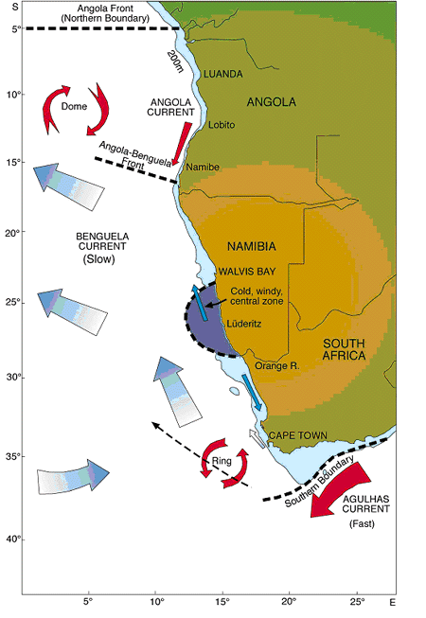
Benguela Current region showing bathymetric features and surface currents.

ABSTRACT

This report is an assessment of the historical oceanographic data held by SADCO. The focus is on the region off the Namibian coast. The aim was to explore what and how much data is available, where it is available and what it can be used for. This was done by looking at various aspects of the data, such as data density and sections or profiles constructed from the data. Part of the project was to help transfer the assessment and the methodology to the Angolan partners. During the assessment, the data and results were discussed with Frank Shillington, Pedro Montero and Chris Duncombe Rae.

TABLE OF CONTENTS

ABSTRACT 1
TABLE OF CONTENTS 2
1. INVENTORY OF THE DATA 4
1.1 INTRODUCTION 4
1.2 CONTENTS OF THE NEW FILES 5
1.2.1 OSD File 5
1.2.2 SADCO File 6
1.2.3 MBT File 7
1.2.4 XBT File 8
1.2.5 CTD File 9
1.3 CONTENTS OF THE COMBINED FILES 11
1.3.1 ALL File 11
1.3.2 ALLsm File 12
1.3.3 ALL-MBT File 13
2. METHODOLOGY 14
2.1 OBTAINING AND OPENING THE FILES 14
2.2 BASIC COMMANDS IN ODV 14
2.2.1 MENUS USED IN ODV 14
Main Menu 14
Pop Up Menus 15
2.2.2 THE DIFFERENT MODES 15
Map mode 15
Station mode 15
Scatter mode 16
Section mode 16
Surface mode 16
2.2.3 VARIOUS COMMANDS IN ODV 16
2.3 IMPORTING THE FILES INTO ODV 17
2.3.1 IMPORTING THE ORIGINAL FILES 17
2.3.2 IMPORTING THE COMBINED FILES 18
Importing the ALL file 18
Importing the ALL-MBT file and the ALLsm file 18
2.4 MANIPULATION OF THE DATA IN ODV 19
2.4.1 SELECTING THE NAMIBIAN REGION 19
2.4.2 OBTAINING TIME RANGES 19
2.4.3 OBTAINING CRUISE, STATION AND SAMPLE INFORMATION 19
2.4.4 CALCULATING AVAILABILITY OF VARIABLES 20
2.4.5 CHECKING ON QUALITY OF DATA IN DIFFERENT FILES 20
2.4.6 DEEPEST SAMPLE DEPTH AND PERCENTAGE OF SAMPLES PER DEPTH RANGE 21
2.4.7 COMPARING THE NW AND SE BASINS 22
2.4.8 CREATING SECTIONS IN Section Mode 22
2.4.9 CREATING SURFACE PLOTS 23
2.4.10 REMOVING THE VALUE 1e+010 FROM THE ALL-MBT FILE 23
2.4.11 TO GET TOTAL NUMBER OF STATIONS PER YEAR AND BREAKDOWN INTO MONTHS 23
2.4.12 OBTAINING OXYGEN AVERAGES 24
2.4.13 DRAWING UP THE GRID 24
3. DISCUSSION 26
3.1 GENERAL 26
3.1.1 VARIABLE AVAILABILITY 26
3.1.2 QUALITY OF THE DATA 26
3.2 SCATTER PLOTS 27
3.2.1 TEMPERATURE 27
3.2.2 SALINITY 29
3.2.3 OXYGEN 30
3.2.4 NITRATE 32
3.2.5 PHOSPHATE 33
3.2.6 TEMPERATURE/SALINITY DIAGRAM 34
3.2.7 COMPARISON OF THE NW AND SE BASINS 35
3.3 SECTIONS 36
3.4 SURFACE PLOTS 38
3.5 COMBINED FILES 39
3.5.1 DISCUSSION OF THE ALL-MBT FILE 39
3.5.2 NUMBER OF STATIONS PER YEAR AND BREAKDOWN INTO MONTHS 40
3.6 OXYGEN DEPTH AVERAGES 41
3.7 GRID 42
4. PROBLEMS AND RECOMMENDATIONS 43
4.1 WORKING WITH THE FILES 43
4.2 MISSING DATA VALUES 43
4.3 QUALITY FLAGS 44
4.4 BATHYMETRY DATA 44
4.5 GENERAL 44
5. GLOSSARY 46
6. REFERENCES 47
7. APPENDIX 48
7.1 TEMPORAL DISTRIBUTION PLOTS OF THE COMBINED FILES 48

1. INVENTORY OF THE DATA

1.1 INTRODUCTION

The CD received from SADCO consists of seven files. Five of these files are maps detailing the various cruises. The CD also has two zipped files on it, and these contain five text files in total, with the data corresponding to the stations on the maps. The text files and maps share the same names, namely NamOSD, NamSADCO, NamMBT, NamXBT and NamCTD. A value of 1e+010 was used where data was missing (these values were later removed, see Methodology section for how and the Problems and Recommendations section for why). All the files cover both the Angolan and Namibian region of the Benguela current (from the equator to 30°S, and from the coast out to approximately the 0° line of longitude) off the African coast. Since this assessment is only on the Namibian data, the Angolan data was removed from the files (see Methodology section) and new files were created. The area covered by the new files extends from 15°S to 30°S with the same longitude range as the original files. The contents of the new files are detailed below, and referred to as OSD, SADCO, MBT, XBT and CTD respectively to avoid confusion with the original files.

Throughout this report reference is made to various graphs, PowerPoint presentations, files etc. For convenience reasons, these were saved in specific directories, under the directory “Report files”, and the reader has to manually open them. It was not practical to include them in the report as they make the report too large to work with or to move around. Originally, they were associated to the report via hyperlinks, but as the report file and directories are moved around and saved to CD etc., these hyperlinks are no longer valid. It is suggested that once the report has been saved on a computer that these hyperlinks are reinstated to make for easier reading and access to the diagrams referred to. There are four different directories namely Files (containing Excel spreadsheets, a text file and a MS Word document), PowerPoint (containing various presentations), Profiles (containing one profile) and Sections (containing one section best viewed using MS Paint).

To see a diagrammatic breakdown of the station files on the CD and the new and combined files created, open the PowerPoint presentation “BREAKDOWN OF CD.ppt”.

1.2 CONTENTS OF THE NEW FILES

These five new files were created from the original files on the disc, but they only contain the Namibian region. It was decided to include the Angola Benguela front so the new files are from 15°S to 30°S. All five files contain the cruise label, station label, station type, date, time, longitude, latitude, bottom depth, depth of sample and temperature. Other variables contained within the files are mentioned below. A table (Table 1) has been drawn up to show the percentage of data that is available for each variable within each file. The bottom depth is often reported as zero, but this is mostly where the bottom depth is not known, and there are values for variables extending through the water column at these points. Thus it is not possible to use the bottom depth value to determine the bathymetry of the region. Some files contain data that extends very far down the water column, to approximately 5500m, but only a few stations have such data. Table 2 shows various characteristics of the different files.

1.2.1 OSD File

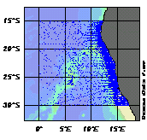
Map 1. Stations included in the OSD file.

The data in this file is supposedly from the World Data Centre, which has a variety of sources. The file contains the variables mentioned above as well as salinity, oxygen, phosphate, silicate, nitrate, pH, chlorophyll, alkalinity, NO₂ +NO₃, pCO₂ and tCO₂ values. The availability of data for these variables varies. The time range of this data set is from 1862 to 1995. Up until 1948, very little research was done, with only 13 years containing data and the number of stations recorded during these years is below 50 for each year. Between 1948 and 1985 the number of stations measured differs greatly from year to year. For example, during 1968 there were over 400 stations researched, whereas during the 1950’s there are four years containing no data. The 1960’s saw an increase in research, but this decreased slightly during the 1970’s. 1985 to 1989 showed a drastic increase in numbers, up to just above 1000 stations for one year. After this, the numbers once again decrease to below 150 stations per year. With respect to months, most data was obtained during January, with almost 1500 stations being measured in this month. February, March, August and November are all similar and around 1000 stations. The remaining months are lower than this and June is the lowest with approximately 400 stations.

The total number of cruises contained in this file is 240, with 8843 stations recorded and 76415 samples taken. The lowest sample depth is 5647.6m, although almost all the samples were taken above 1000m. The sampling for this file covers the whole of the area defined above, but there is a definite concentration of stations along the coastline. The quality of the data in this file is mostly good, with a small amount being marked as questionable and bad. There is no data with unknown quality.

1.2.2 SADCO File

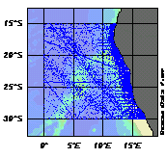
Map 2. Stations included in the SADCO file.

SADCO Holdings provided this data from their database. In addition to the variables mentioned above, the file contains salinity, oxygen, phosphate, silicate, nitrate, nitrite and deepest observation depth data. The time range of this file is from 1921 to 2000. During the first 14 years, up until 1955, the number of stations recorded each year is not evenly distributed. Many years contain no data while two years recorded between 250 and 500 stations. Research was done every year between 1955 and 1999 (inclusive), excluding 1981. The amount of research done every year is fairly variable, and mostly below 500 stations per year. From 1984 to 1988, the stations per year exceed 500, and reach a maximum of just above 1250. The largest portion of the research was done during January when approximately 2750 stations were measured. February follows with about 2000 stations, and March with approximately 1300. The rest of the year ranges between about 700 and 1000, except for September, which shows around 400 stations.

The stations in this file cover most of the area defined above as the Namibian region. More sampling was done along the coastline, but the concentration is not as high as in the OSD data. There appears to be a higher density of stations off the coast than in the OSD data. The file contains 338 cruises. The number of stations researched is 13176, and 771457 samples were taken. The deepest sample depth is 5619.0m, with almost 20% of the samples occurring below 1000m. All the data in this file was marked with unknown quality flags.

1.2.3 MBT File

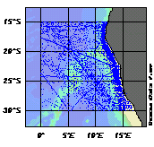
Map 3. Stations included in the MBT file.

This file contains Mechanical Bathythermograph (MBT) data. This is a relatively old method of obtaining data, and supposedly not so accurate. No variables, other than the ones mentioned above, were included. The time range for this data is from 1944 to1990. The bulk of the research done using this equipment occurred between 1965 and 1975, where up to approximately 1000 stations were recorded during both 1968 and 1971. Before this time, the maximum number of stations researched in one year is approximately 350. After 1975 the maximum is approximately 725 recorded in 1984. In terms of how many stations were measured in which months, the range is between 600 and 1100 stations per month. The highest numbers occur in June and May, while January, July and September are at the bottom of the range.

The intensity of sampling off the coastline appears to be very similar to that of the SADCO file. There is a concentration of stations along the coastline that are denser than those of the SADCO and OSD data, but this concentration covers a smaller area and is not right on the coast. This file’s deepest sample is at 601.0m, thus all samples were taken above 1000m. A total of 228 cruises were made with 9400 stations recorded and 171300 samples collected. This file contains no data of unknown quality. Most of the data was considered to be good data, with a very small amount of questionable and bad data. This description of the quality of the data is considered to be questionable due to the inaccuracy of the equipment used.

1.2.4 XBT File

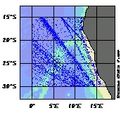
Map 4. Stations included in the XBT file.

The data for this file was obtained using Expendable Bathythermographs (XBT). This is electronic equipment that takes measurements approximately every metre down the water column. The accuracy of this equipment is considered better than that of a MBT, but not as good as CTD data. This file contains only the data mentioned above. The time range of this data is from 1968 to 2001. There is a peak in the data in the early 1970’s with 200 stations being measured in 1972. Between 1975 and the early 1980’s, there was a decrease in the amount of sampling done. From 1982 onwards, there is an overall increase in the number of stations recorded per year, although some years are quite a bit higher than others. The highest figure occurs in 1997 where approximately 360 stations were recorded. Compared to the other files, the number of stations recorded per month for this file are relatively evenly distributed, with a range of 200 to 400 stations per month. May is the highest with almost 400, and September the lowest with just above 200. The remaining months are between 250 and 350 stations per month.

This file consists of 621 cruises, but only 3614 stations. Fewer stations per cruise were researched than in the above files, and yet a total of 1668794 samples were taken. This shows that the amount of samples taken at each station was very high, although the deepest sample was only at 1858.0m and less than 1% of the samples were below 1000m. Thus this file contains a dense concentration of data in the shallower waters. Unlike the other files, the XBT data does not show a concentration of stations along the coastline. The research is spread over the entire Namibian region. There are small areas containing more stations than others, especially one extending diagonally across the designated region. These concentrations appear to correlate with shipping lines. A small amount of questionable and bad data was found in this file, but the majority was flagged as being good.

1.2.5 CTD File

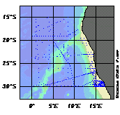
Map 5. Stations included in the CTD file.

This file contains data from Conductivity, temperature and depth probes (CTD). This equipment is considered to be extremely accurate. As well as the variables mentioned above, the file also contains salinity and oxygen data. The CTD data time range is from 1973 to 1995. The distribution is not very even, although the maximum number of stations is only just above 100 for 1987. Up until 1983, there were very few stations recorded. Approximately 80 stations were recorded per year from 1983 up to and including 1985. 1986 and 1988 are around 40, with 1991 closer to 30 and 1993 almost at 50. The remaining years are below 20 stations per year. The peak with regards to number of stations per month occurs in January with approximately 130 stations. There is an overall decrease throughout the rest of the year, although March, May, July, September and December are higher than the months preceding them. The lowest recording is in November with no stations for that month.

This file contains the least amount of cruises and stations, only 48 and 573 respectively. There were, however, 913298 samples collected. The deepest sample was taken at 5532.9m. The CTD data is the only data with more samples below 1000m than above 1000m. This shows that the distribution of data is much more even throughout the water column than in the other files. Due to there being much fewer stations, their distribution on a surface level is very uneven. There is a slight concentration of stations towards the south of the Benguela Current. Except for the oxygen values, the data for the CTD file was mostly good with a small portion being questionable and bad. The oxygen data was approximately 55% good and 45% questionable and bad. A check was done to see what portion was actually bad, but this amount was negligible. Thus the oxygen data was 45% questionable.

VARIABLE | OSD | SADCO | MBT | XBT | CTD | ALL
Temperature | 95.9% | 99.8% | 98.2% | 93.3% | 98.5% | 96.30%
Salinity | 83.2% | 45.7% |  |  | 81.0% | 32.09%
Oxygen | 51.0% | 26.3% |  |  | 32.4% | 14.94%
Phosphate | 35.7% | 2.3% |  |  |  | 1.24%
Silicate | 21.9% | 1.9% |  |  |  | 0.86%
Nitrate | 20.8% | 0.8% |  |  |  | 0.61%
Nitrite |  | 1.9% |  |  |  | 0.41%
PH | 0.6% |  |  |  |  | 0.04%
Chlorophyll | 7.7% |  |  |  |  | 0.33%
Alkalinity | 0.3% |  |  |  |  | 0.01%
NO₂ + NO₃ | 0.9% |  |  |  |  | 0.02%
pCO₂ | 0.4% |  |  |  |  | 0.01%
tCO₂ | 1.3% |  |  |  |  | 0.03%
Deepest Observation Depth |  | 100% |  |  |  | 21.42%

Table 1. Approximate percentages of variable availability in the five new files as well as the combined file ALL (the quality of the data is good or unknown). Where there are no values, there is no data for that variable.

File Name | Time Range (inclusive) | Deepest Sample | Number of Cruises | Number of Stations | Number of Samples | % Samples above 1000m | % Samples below 1000m
OSD | 1862 - 1995 | 5647.6m | 240 | 8843 | 76415 | 93.90% | 6.10%
SADCO | 1921 – 2000 | 5619.0m | 338 | 13176 | 771457 | 81.93% | 18.07%
MBT | 1944 – 1990 | 601.0m | 228 | 9400 | 171300 | 100.00% | 0.00%
XBT | 1968 – 2001 | 1858.0m | 621 | 3614 | 1668794 | 99.75% | 0.25%
CTD | 1973 – 1995 | 5532.9m | 48 | 573 | 913298 | 27.78% | 72.22%

Table 2. Different characteristics and statistics for the five new data files.

1.3 CONTENTS OF THE COMBINED FILES

In order to obtain an overall view of the data, the five “new files” were combined in various ways. The first combined files (ALL and ALLsm) consisted of all five “new files”. The area covered is the Namibian region (as defined above). The ALL and ALLsm files are the same with respect to density and spread of stations, with a much higher concentration along the coastline on the shelf, and the rest of the stations showing definite shipping lines. Another file called ALL-MBT was created which included all of the “new files” except the MBT file. This file shows very similar coverage to the other two combined files. The depth range for all three files is 0m to 5647.6m. Since the MBT file’s deepest sample is at 601m, the exclusion of this file does not alter the data below this point. To see the temporal distribution plots for the ALLsm file and the ALL-MBT file, refer to the Appendix.

1.3.1 ALL File

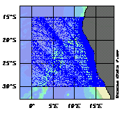
Map 6. Stations included in the ALL file.

The time range for this file is from 1862 until the end of 2001. Up until 1950, very little research was done. Most of the stations recorded included only surface data, or sometimes one measurement far down the water column. 1948 saw the highest number of stations being recorded for this period, but the deepest sample was at 123m. 1950 to 1955 showed an increase in station numbers with the deepest sample at 2940m, but most samples were still in the upper 300m. From 1956 to 1961 there was a small peak in research being done, up to 723 stations in 1957. The next peak occurred between 1963 and 1975, with 1968 and 1971 recording 1691 and 1734 stations respectively. The third and largest peak was between 1981 and 1991, with 1987 showing the maximum of 2659 stations. The years in-between these peaks have varying numbers of stations. With respect to seasons, there is a relatively even spread, except for summer which has a total of 11640 stations. The other seasons are between 7200 and 8800 stations each. The months in summer are also very variable with 5329 stations in January and 2212 stations in December.

The quality of the data can be seen in Chart 1. For ten of the variables, the largest portion of the data is flagged as good. Nitrite and deepest observation depth both contain 100% unknown quality as they are only from the SADCO file (for which all the data was marked as unknown). Both pH and chlorophyll have a larger portion of unknown data than good data. The availability of variable data in this file is shown in Table 1. A total of 1446 cruises covering 35606 stations are included in this file. The number of samples taken is 3601264.

Chart 1. Data quality percentages of total number of samples per variable for the ALL file.

1.3.2 ALLsm File

This file was created after examining the density of the data for the various variables in the ALL file. It was decided to only include the temperature, salinity, oxygen, nitrate and phosphate data. The creation of a file with less variables included meant that it was easier and quicker to work with the file in ODV. The temporal distribution of this file is the same as that of the ALL file, since only certain variables were excluded, not any whole stations.

The quality of the data is exactly the same as the ALL file, except that certain variables are excluded. The same applies to variable data availability. Since no stations were excluded in this file, the number of cruises, stations and samples remains the same as the ALL file.

1.3.3 ALL-MBT File

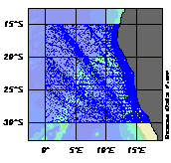
Map 7. Stations included in the ALL-MBT file.

This file is the same as the ALLsm file, except that the data from the MBT file was not included. This means that this file only contains temperature, salinity, oxygen, nitrate and phosphate data. Values of 1e+010 that were inserted into the file to represent missing data were removed from this file. By excluding the MBT file, the percentages for temperature in Chart 1 are altered by a maximum of 1% and thus the quality of the data in the ALL-MBT file is very similar to that of the ALL file (except that some of the variables are not included). When examining the variable data availability it was found that the figures are very similar to that of the ALLsm file. The figures differ by a maximum of 1.6%, but most are below 1%.

Since the MBT file is excluded, 9400 stations were also excluded and thus the ALL-MBT file contains only 26206 stations. The number of cruises included is 1222 with 3429964 samples. The temporal distribution plot of the ALL-MBT file is the same as that of the ALL file before 1944 and after 1990. Between these two years, the plots are very similar with the main difference being that the peak between 1963 and 1975 is seriously depleted and hardly noticeable. The maximum during this period is approximately 750 stations in 1971. The small peak between 1956 and 1961 and the largest between 1981 and 1991 are slightly different but are still clearly visible.

2. METHODOLOGY

2.1 OBTAINING AND OPENING THE FILES

Dr M. Grundlingh (SADCO Manager) composed a CD containing historical oceanographic data off the Namibian and Angolan coasts. The data has various sources identified in the Description of Data section. The files were unzipped and opened using WordPad. An attempt was made to open these files as Excel Spreadsheets, but the files are too large. These files were saved as text documents and then imported into Ocean Data View (ODV), which was used to analyse the data. This program can be used as an interactive exploration tool, and it also provides graphical displays of the data. How the files were imported and manipulated is detailed below.

2.2 BASIC COMMANDS IN ODV

This section is aimed at providing a very basic outline of how to work with ODV and is focused on the processes used in this assessment. For a more detailed guide to using ODV refer to the User Guide for Ocean Data View provided with the program. This guide can be accessed by selecting Help Topics from the Help menu at the top of the screen while ODV is running.

2.2.1 MENUS USED IN ODV

Main Menu

The main menu is found along the top of the screen and has seven choices, namely File, Collection, Configuration, Import, Export, Utilities and Help. Left click over any one of these to open them.

Pop Up Menus

There are three types of popup menus, namely the plot, map and background popup menus. To bring up the plot popup menu, right click over the plot you want to edit. This menu allows the user to change the ranges of the variables being viewed, redraw or save the plot, alter the appearance of the plot, change the variables being displayed, define a patch, draw isopycnals, obtain statistics, copy all plot values to the clipboard or to add a graphics object.

For the map popup menu, right click over the map. From this menu the user can change the area covered by the map, redraw or save the map, specify selection criteria for the data being displayed, alter the display of the map, define a section, select a station by name or number, copy map values to the clipboard or add undersea features (gazetteer) or graphic objects to the map.

The background popup menu can be used to alter, clear, redraw, print or save the layout of the canvas, to define derived or iso-surface variables, add graphics objects, to switch between the different modes (used for different plots) or to exit ODV. To access this menu, right click on the background between any of the plots.

2.2.2 THE DIFFERENT MODES

To switch between the different modes, choose the mode required off the background popup menu. The modes are briefly described below.

Map mode

This mode creates a full-page station map. It can be used to produce high quality cruise maps including natural features and graphics objects or station numbers and cruise labels. The map popup menu outlined above can be used in this mode.

Station mode

The screen layout for this and the remaining modes includes a station map and one or more data plot windows. X/Y plots for selected stations can be produced in this mode. To select a station, left click on the station in the map, or use the map popup menu to specify the cruise and station labels.

Scatter mode

This mode can be used to produce X/Y/Z plots. The Z variable is displayed as colour at each X/Y point. These plots contain all data points from all the stations shown on the map. The Z variable can be displayed as the actual data view or as a continuous gridded field.

Section mode

A specific section can be selected in this mode. Property distributions along the section can be displayed as well as property/property plots for all the stations within the selected sections, or even geostrophic velocities perpendicular to the cross-section. This mode also allows for Z variables, and all plot types available in Scatter Mode can be displayed.

Surface mode

Surface mode allows the user to display the property distribution of a variable on a surface of constant values of another variable. For example, the user can ask for the temperature values at a depth of 1000m. The surfaces are defined in 3D (longitude, latitude and depth) and the mode produces a map or maps of the area showing the iso-surface. It is also possible to produce property/property plots for the given surface.

2.2.3 VARIOUS COMMANDS IN ODV

- Changing plot variables – from the plot popup menu, choose the variable to be changed (x, y, or z). From the list provided chose the required variable.
- Changing the layout of the canvas – from the background popup menu select Graphics Layout. A new screen appears with a grid on it. Right-click on each window to open the menu for making alterations to that window. Double left-click anywhere on the screen to accept the changes made. Once complete, choose accept off any of the menus.
- Changing variable range – select Set Ranges from the plot popup menu. A screen appears with the ranges of the variables. Alter the relevant variable and click OK.
- Obtaining statistics on plots - click on Extras and Statistics from the plot popup menu. A window appears containing various statistics. nPts (bottom right) shows the number of points with values for that specific variable.
- Saving plots or maps – on plot/map popup menu select Save Plot/Map As, type in a file name and save as a .png, .jpg or .eps file. To save the entire screen choose Save Canvas As from the background popup menu and enter a file name as for plots or maps.

2.3 IMPORTING THE FILES INTO ODV

2.3.1 IMPORTING THE ORIGINAL FILES

In order to examine the data it was necessary to import the data into ODV. The text file must be in a specific format as defined in the User Guide for Ocean Data View (for an example of this format, open the text file “import text.txt”). In this case, TAB was used as a column separation character. A quality flag (QF) was included for each of the measured variables and a value of 1e+010 was used to denote missing data. Importing was done by running the program (ODV), clicking on the File menu and selecting New. A window appeared in which the name of the file being created was typed. The window was closed by selecting Save. A new window came up and .var, .o4x or .txt file as template was selected from the list of options. Choosing this option means that the program will define the variables for the collection from the first line of the text file that the user selects. One of the various saved text files was selected and the command was executed by clicking on Open. ODV then produced a map on the otherwise blank screen.

The next step in importing was to select the Import menu and to choose ODV SpreadSheet. In the window that appeared, the same text file as selected for the variables was opened. All the variables under Source File in the Variable Association box had an * next to them showing that they were all associated with the variables listed in the Target Collection. Pressing Open completed the command. The number of stations imported was then displayed on the screen as well as a map showing where all the stations are. This process was repeated for all five of the original files, and they were named OSD, SADCO, MBT, XBT and CTD (see glossary for definitions).

2.3.2 IMPORTING THE COMBINED FILES

Importing the ALL file

For a collection containing the data from all five files the same process was followed, but with a slight variation. The SADCO file contained some different variables to the other files. The units for some of the nutrients in this file also differ. These units are μg atom/l, which are equivalent to μmol/l. Thus these different variables had to be added to the variable list. First, the variables from the OSD file were imported as the template, and then the stations from the OSD file were imported as detailed above. The different variables were added by clicking on Add/Delete Variables under the Collection menu followed by inputting the variable name and units. Once all the new variables were entered, the file was imported. While importing it was necessary to assign the variables, with different but equal units, to each other. The remaining three files were also imported to complete the collection referred to as ALL. Once all five files had been imported, the Namibian region was selected (see Manipulation).

Importing the ALL-MBT file and the ALLsm file

This collection contains all the new files except the MBT file (see Discussion section for reasons), and was created in the same was as the ALL collection. The only variables imported into this file were depth, temperature, salinity, oxygen, nitrate and phosphate. This was done by firstly choosing the OSD file to define the variables. Before importing any of the data, the variables that were not going to be imported were deleted using the Add/Delete Variables command from the Collection menu.

Some of the files contain values of 1e+010 where data is missing. These values were removed from the ALL–MBT file (see Manipulation). This is a lengthy process and was only done after deciding that this was the file to use for analysis.

The ALLsm file was imported in the same way as the ALL-MBT file, with the same variables being included. The only difference between these files is that the MBT file was imported into the ALLsm file.

2.4 MANIPULATION OF THE DATA IN ODV

2.4.1 SELECTING THE NAMIBIAN REGION

The focus of this project is the Namibian region. It was decided to include the Angola Benguela front, thus the data set would extend from approximately 15°S to approximately 30°S. The data provided contained more than just this section. The relevant area was selected in ODV using the Selection Criteria function from the map popup menu, and by specifying the domain according to the above latitude values (using a negative sign to represent south). Invert Selection was then chosen, showing the region that was not considered part of the Namibian region. This subset was deleted using the Delete Station Subset function under the Collection menu. For efficiency in searching for and selecting various stations, Sort and Condense was selected under the Collection menu. This function orders the collection in a specific way. This process was applied to every new collection created.

2.4.2 OBTAINING TIME RANGES

In order to see the time range of each file, a temporal data distribution plot was created for each file by clicking on Temporal Distribution under the Utilities menu. The plot appears, and can either be saved or printed. In this case, the plots were saved and viewed using GSview. They were later copied as bitmap files from GSview, so that they could be included in the report. The temporal distribution plots were opened in GSview. Copy was selected under the Edit menu and the plot was then pasted in Paint for editing or directly into MS Word. The temporal distribution plots for the Combined Files ALLsm and ALL-MBT have been included in the appendix.

2.4.3 OBTAINING CRUISE, STATION AND SAMPLE INFORMATION

The cruise, station and sample details are stored in an inventory file created by ODV when the data is imported into a collection. As the collection is altered, so the inventory file is updated. To view this file, it was selected from the directory where all the collection data is saved. The file extension is .inv and the file name is the same as the collection name. The file was opened into MS Word. The number of cruises, stations and samples contained in that collection was shown on the second line.

2.4.4 CALCULATING AVAILABILITY OF VARIABLES

To obtain the availability of the different variables, Scatter Mode was selected in ODV (from background popup menu). A plot was drawn for each variable contained within the file (variable on x axis, depth on the y axis), and the range was set for each variable. A check was done to see if there were any outliers outside of this range using the Find Outliers function from the Utilities menu. The variable in question was chosen from the list provided, and a range selected. (For some variables, the value 1e+010 was used to denote where data was not available. When finding outliers, these values are picked up as outliers. In such a case, a realistic range for that variable was selected.) Statistics for each plot were obtained. These statistics report the number of points with values for that specific variable. This number was compared to the total number of samples (found in the inventory tables produced by ODV) contained within each file. Thus a percentage can be obtained by dividing the number of points (for a specific variable) by the number of samples taken in that particular file. The quality flags of the variables used to obtain the availability were either good or unknown.

Equation used (for Table 1):
$$\left(\frac{\text{number of variable values}}{\text{total number of samples}}\right)×\text{100}$$

This formula provides the percentage of samples (per variable) containing data present with respect to the total number of samples taken.

2.4.5 CHECKING ON QUALITY OF DATA IN DIFFERENT FILES

Each file was opened up separately. Under Selection Criteria, and Sample Selection, the data quality filter was marked as all (this includes good, unknown, questionable and bad quality flags). The scatter plots for each variable were drawn up, and the statistics on each plot obtained. This shows how many samples were taken with any type of quality flags. Then good and unknown were selected from the Selection criteria menu, and the same process repeated. Again the process was followed selecting only good. To calculate what percentage of the total number of samples had a specific quality flag, the following equation was implemented:
$$\left(\frac{\text{number of }x\text{ values with quality flag }y}{\text{total number of samples}}\right)×\text{100}$$
where x represents the variable being examined (e.g. temperature) and y is the quality flag being examined (e.g. good).

To determine how many samples had unknown or questionable and bad quality flags, the following formulas were used (using the percentages obtained from the equation above):
(Good and Unknown) – Good = Unknown
All – (Good and Unknown) = Questionable + Bad

This process was repeated for all the New Files, while the formula below was used to obtain a percentage of the samples (per variable with a specific quality flag) present with respect to the total number of samples containing data for that specific variable (only applied to the ALL file):
$$\left(\frac{\text{number of }x\text{ values with quality flag }y}{\text{number of }x\text{ values with quality flag all}}\right)×\text{100}$$
where x represents the variable being examined (e.g. temperature) and y is the quality flag being examined (e.g. good).

These results were noted in the Inventory of the Data section under each file, and a chart (Chart 1) was drawn up to represent the ALL file.

2.4.6 DEEPEST SAMPLE DEPTH AND PERCENTAGE OF SAMPLES PER DEPTH RANGE

To find out at what depth the deepest sample was taken, Find Outliers was selected from the Utilities menu. The variable depth was chosen, and ODV automatically showed the range under Accepted Range. This was checked by altering the values given, and ODV then showed which samples had been excluded. The largest number is the deepest sample depth.

In order to compare how many samples were taken in shallow water versus deeper water, it was decided to use the 1000m-depth level as a reference level. For each file, a depth versus depth plot was drawn up. This variable was used as it has 100% availability in every file (each entry must contain a depth level in order to be imported). Using Sample Selection from the Selection Criteria (map popup menu), the depth range 0m to 999.99m was selected. Examining the statistics for the plot showed the number of points contained in this range. The process was repeated for the range 1000m to 9999m. For each range, the numbers of points in the range were divided by the number of samples for the file, and a percentage was obtained.

2.4.7 COMPARING THE NW AND SE BASINS

Scatter Mode was selected while the ALLsm file was open. To compare the different sides of the Walvis Ridge, it was necessary to select these areas separately. From the map pop up menu, Selection Criteria was selected. Domain was chosen, and the function polygon used from this menu. This allows the user to outline the relevant area. The Walvis Ridge was used as a divider between the two areas. The NW (Angolan) Basin was selected first, and profiles were drawn up for this region. To work with the SE (Cape) Basin, Invert was enabled under the Selection Criteria menu. Temperature/Salinity diagrams were also produced for each basin.

2.4.8 CREATING SECTIONS IN Section Mode

In producing a section for the different files, the bathymetry is not correct as often a value of zero was used as the bottom depth where the bottom depth was not known. In order to see the bathymetry in some sections, Define Section and Change Characteristics were chosen off the map popup menu. Under Bathymetry, ETOPO was chosen. This imported pre-recorded bathymetry of the region (see Problems and Recommendations section for possible errors and suggestions). The depth range was set to 0m to 1000m due to the lack of data below this point.

In order to see the seasonal components of the data, sections for each season were composed. This was done using the Selection Criteria function from the map popup menu. Each season was specified under the Date/Time section and two sections brought up, one with only good data and another with good and unknown data (quality of data chosen under Sample Selection). It was decided to define summer as December, January and February, while winter included June, July and August. Autumn and spring fell in-between these two seasons. The various sections were saved as .jpeg files and used in PowerPoint slides for comparison. The Date/Time function was also used to examine specific years separately.

VG Gridding was used to display the sections. It was decided that this was the best way to display the data, as the data is inhomogeneous since it comes from so many different sources at different times. The x and y Scale-Lengths were set to 20. This option is chosen from the plot popup menu under Display Options. For more details on how VG gridding is applied to the data refer to the User Guide for Ocean Data View available as part of the ODV program.

2.4.9 CREATING SURFACE PLOTS

Surface plots were created using Surface Mode, which automatically produces four surface plots. To change the variables being displayed, Iso-Surface Variables was selected off the background pop up menu. New variables were added by changing the depths e.g. temperature was selected on the left, and the depth value was changed to 200m. Left clicking on add added the new variable to the list. The process was repeated for various depths and variables. Clicking on O.K. allows the program to calculate the new iso-surface variables. The variables displayed are changed in the same way as those for plots in Scatter Mode. These plots were used to compare variables at different depth levels.

2.4.10 REMOVING THE VALUE 1e+010 FROM THE ALL-MBT FILE

A value of 1e + 010 was inserted in the files where data was missing. Once it was decided to use the ALL-MBT file for assessment, these values were removed from the file. Find Outliers was selected from the Utilities menu. The variable in question was selected from the list. If the range was up to 1e+010, then the range was reset as the maximum value to 1e+009, and the process was initiated by clicking on OK. ODV brought up these values as outliers and showed how many there were. Inspect and Edit Outliers was selected from the options, followed by clicking on OK. A new screen was produced and Delete Value was chosen followed by Apply to All. ODV then deleted all these values from the file. This is a very lengthy process, which is why it was only applied to this file.

2.4.11 TO GET TOTAL NUMBER OF STATIONS PER YEAR AND BREAKDOWN INTO MONTHS

These figures were obtained by selecting each year separately using Selection Criteria while the ALL file was open (in any mode except Surface Mode). Once a year had been selected, Extras and Clipboard Copy were chosen from the map popup menu. A Microsoft Word document was opened, into which the data was pasted. The pasted data was then reselected and pasted as Unicode text into Excel. This document shows the number of stations for that year. The number of stations per month for each year were then calculated and put into another spreadsheet.

2.4.12 OBTAINING OXYGEN AVERAGES

To obtain oxygen information either the ALLsm file or the ALL-MBT file can be used in Scatter Mode. The MBT file does not contain oxygen data and thus has no influence on the results. It was decided to breakdown the water column in two different ways. The first depth range was from 0m to 1000m, which was divided into 100m sections, and the average for each section was obtained. This was done by creating plots with oxygen on the x-axis and depth on the y-axis, and setting the depth range to 0m to 99.99m. The statistics on the plot were then obtained and recorded in an Excel Spreadsheet. The process was repeated for the next section, namely 100m to 199.99m and so on down to 1000m (the last section being 900m to 1000m).

The second breakdown of the water column was into 1000m sections, thus the first section extended from 0m to 999.99m, the second from 1000m to 1999.99 etc. The same statistics were obtained and also recorded in a table in Excel. For both breakdowns, two tables were drawn up, one containing the statistics for data with good quality flags and another with the statistics for data with good and unknown quality flags. The two tables for each breakdown were then used to create graphs. From the graphs the general trend of the oxygen means can be seen, and a comparison between the different qualities can be made.

2.4.13 DRAWING UP THE GRID

The file ALL-MBT was opened in ODV. Using Selection Criteria from the map pop up menu, the domain was defined in 1° blocks. The first block was defined from 0° to 0.9999°E and 15° to 15.9999°S. Extras and Clipboard Copy were selected from the map pop up menu. The values extracted were pasted into an Excel spreadsheet. The number of stations in that block were listed, and this number was inserted into the grid. Although this is an accurate method of obtaining the number of stations per 1° block, it is quite time consuming. Another slightly faster method is described below. A combination of the two was used to obtain the grid values.

The file ALL-MBT was opened in ODV. Using Selection Criteria from the map pop up menu, the domain was defined as a column 1° across. The first column was defined across as 0° to 0.9999°E and downwards as 15° to 30.9999°S. Extras and Clipboard Copy were selected from the map pop up menu. As with the first method, the values were pasted into an Excel spreadsheet. In Excel, Data Analysis was used from the Tools menu. A histogram was used to represent the data. This was done by using the latitude co-ordinates as the input range. The latitudes co-ordinates are negative to show that they are south of the equator. The bin range was predefined as –15 to –30 to cover all the latitudes (this is done by typing the bin range values into a column and then selecting the values as the bin range). An output range was selected as any free space in the worksheet. Excel produces a table that shows the frequency of values within each of the latitude blocks. These frequencies were transferred into the grid. This process was repeated for the remaining columns, the next column being defined as 1° to 1.9999°E with the same latitude range as the first column.

The same was done using the longitude values, and was used to double check the values obtained from the latitude co-ordinates. The domain selected in ODV extended from 0° to 17.9999°E, and a 1° block down, the first extending from 15° to 15.9999°S. The values were pasted into Excel as done above. Again a histogram was drawn up, but the longitude values needed to be altered first. All of them required a negative sign in front of them in order for them to be included in the right bin. This is because a number is included in a bin if it is equal to or less than the bin number. According to the grid that was already established, it was necessary that the number be included in a bin if it was bigger than or equal to that bin number. By changing all the values to negative, this could be done. The bin range for the longitude values was defined as 0 to –17. A histogram was drawn up as above, using the negative values as the input range and the bin range just mentioned.

3. DISCUSSION

3.1 GENERAL

After examination of the various combined files, it was decided to use the ALL-MBT file for the assessment of the data (see Discussion of the ALL-MBT File for reasoning). Some analysis had already been performed before this decision was made, using the ALL or ALLsm files. For each task performed, it is stated which file was used for the results.

3.1.1 VARIABLE AVAILABILITY

The different files each contain various amounts of data for the different variables (Table 1). When these files are combined, these percentages are even lower (see ALL in Table 1). Since there is too little data to be of use, some of the variables become irrelevant for this assessment. (The data density is too low to be an accurate representation of the area). After examining the ALL file, it was decided to only include the temperature, salinity, oxygen, nitrate and phosphate data as these variables were considered to be either the most useful and/or showing fairly high density.

3.1.2 QUALITY OF THE DATA

When importing data into ODV it is necessary to associate a quality flag with the data. The data provided already included these quality flags. ODV has four types of quality flags. They are good, unknown, questionable or bad. For this assessment it was decided to combine questionable and bad since both types of quality are not desirable, and this data was therefore disregarded for examination. The data with good quality flags is thus of most interest, but that with unknown quality cannot be ignored, especially since the entire SADCO file is marked as unknown. To ignore the unknown quality data would mean excluding the SADCO file from the assessment.

3.2 SCATTER PLOTS

Scatter plots were drawn up for each of the new and combined files. These plots show the trends for the variables and any anomalies that are present. Below is a general description of the patterns evident in the scatter plots and unusual values are pointed out. The combined file ALLsm was used to see the overall patterns, but any unusual data found was traced back to the new files. The CTD file shows the tidiest profiles with very little deviation from the expected profiles. All the profiles show a “branching” pattern below 4000m. For more details on this see Comparison of the NW and SE basins. Only the temperature profile was influenced by the XBT and CTD files as they only contain temperature data. The same applies to the CTD file with respect to nitrate and phosphate.

The profiles obtained were not particularly tidy, although it must be remembered that the data covers a fairly large area, is from various times of the year as well as different years, and was measured by a variety of equipment.

3.2.1 TEMPERATURE

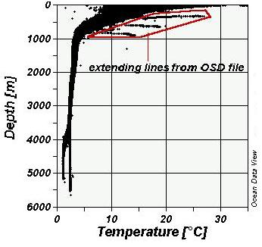
Profile 1. Temperature profile for the ALLsm file using good quality data, showing abnormalities from the OSD file.

The temperature profile, using both good and unknown data quality, shows a relatively rapid decline in temperatures down to approximately 1000m, ranging from temperatures of 30°C at the surface down to temperatures between 3°C and 5°C at 1000m. From 1000m down to the deepest sample the temperatures decrease slowly to 1.5°C. Near the surface there are some values between –1.5°C and 7°C. These values are mostly from the SADCO file and are flagged as unknown quality, and are thus not reliable and should probably be disregarded. The deepest sample in this temperature range is present at 734m and is also from the SADCO file. Within the SADCO file there is one station that is unusual and stands out. This station has a portion that extends beyond the typical profile. This portion ranges between 517 and 1484m and has a temperature range of 9.6°(at depth) to 14.5°C (517m), and was recorded in January 1993. Since there is only one station showing such results it is most likely incorrect.

A number of lines extending from the profile are visible, and are from the XBT file. It was thought that perhaps these lines could be filtered out by selecting only the good data, but they were still visible. These lines show the temperature to be quite high or increasing at depth (for e.g. up to 14°C at 880m). This is highly unlikely and thus this data is considered to be incorrect. Being flagged as good and part of the XBT file, this data is also clearly visible in the ALLsm file. Using only the good data makes the profile much cleaner excluding the extending lines from the XBT data, although it must be remembered that the good data contains no samples from the SADCO file.

Temperature values from the MBT file deviate slightly from the profile formed by the other files. For a description of these deviations see Discussion of the ALL-MBT File. Only a few other data values are found outside the profile area for the good quality data, and these are believed to be incorrect and perhaps due to miscalculations. The CTD temperature profile showed no significant outliers even when using good and unknown data quality and probably results from the accuracy of the equipment.

3.2.2 SALINITY

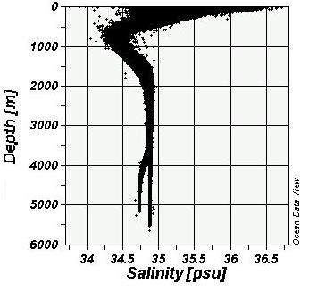
Profile 2. Salinity profile for the ALLsm file using good quality data.

As with the temperature profile (using good and unknown data), the salinity values show a rapid decrease down to about 750m with salinity values as high as 37.2psu on the surface and values between 34psu and 34.7psu at 750m. From 750m down to approximately 2000m there is a more gradual increase in salinity values. At 2000m the values range from 34.77psu to 34.96psu. From here down to the deepest observation depth, the salinities remain within this range, except for where the profile splits and the values decrease to 34.73psu at approximately 5220m. (See Comparison of the NW and SE basins for more details on this split in the profile).

Many salinity values below 34psu are present at the surface, and are from the OSD and SADCO files. Since all the data of SADCO file is flagged as unknown, it is impossible to filter the data further using ODV. Most of these values are definitely garbage and were thus disregarded, especially since quite a few of them have the value of –9.99psu. Although considered irrelevant, the sampling dates for these values coincide with La Nina years, namely 1988, 1995, 1996 and 1999. When the collection is filtered and only good data included, a few of these low salinity values remain. Most of these low salinity values (lowest 30.5psu) are near the mouth of the Orange River, although a couple are quite far from the coast and are probably incorrect. This could be due to the data not being filtered well enough. The values near the river mouth could be due to the fresher, less saline water from the river. The dates of these samples are mostly before 1960 and could also be due to inaccuracy of the equipment used.

A salinity value of 39.88psu is present at 400m. The data quality is unknown and the value is from the SADCO file. Again this is probably bad data as it is a very high value for salinity in this region. The CTD file only showed one unusual value of 31.6psu at the surface far off the coast.

3.2.3 OXYGEN

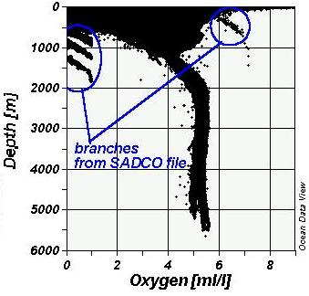
Profile 3. Oxygen profile for the ALLsm file using good and unknown quality data, showing the branches of low oxygen.

The range of values (excluding abnormalities) at the surface for good and unknown data is 0ml/l to 11ml/l. When only good quality data is included, the highest value is 9ml/l. From the surface down to 1200m, the profile shows both an increase (from 0ml/l) and a decrease (from 11ml/l) in values so that the profile becomes more defined and the oxygen values range between 3.3ml/l and 4.5ml/l. Branches of low oxygen are present between the surface and 2000m, and are discussed below. From 1200m down to 2000m, the values increase to range between 4.75ml/l and 5.6ml/l. The oxygen values remain within this range down to the deepest observation depth, showing very little activity between 2000m and 5650m.

Abnormal values of 99.9ml/l are present at the surface and below 1500m. Other values of approximately 34.8ml/l are present at the surface down to 100m. All these values are from the SADCO file, and thus all have unknown quality, and are considered to be spurious. There are also values of –0.99ml/l at the surface, which correlate with the negative salinity values and reinforce that they are incorrect. In addition to these abnormal values, the SADCO file contains branches of low oxygen data down to 1800m. These stations were recorded in July 1999 and are between 16°S and 17°S and less than 1° off the coast (approximately 10.5°E). The other files do not support this data, but their time ranges do not include 1999. Such values seem impossible, but there are 19 stations that show these low values between 500m and 2000m in 1999, although they are all part of the same cruise. Perhaps all the oxygen values for that cruise were calculated incorrectly. Another unusual branch is present from the SADCO file and ranges from 200m to 720m with oxygen values of 5.94ml/l and 6.94ml/l respectively. These values were recorded relatively close to the coast, and as with the other branches, there are numerous stations that show this data, but they are all from the same cruise in 1966.

The OSD file shows very low oxygen values down to 400m, and the CTD file also shows such values between 150m and 300m. According to Chris Duncombe Rae, this is a global phenomenon as the most decomposition occurs at 300m thus decreasing oxygen levels. Both files show these values occurring within 1° of the coastline and this suggests that more activity is occurring here on the shelf than in the rest of the defined region. The dates of these samples were examined, but no definite pattern could be seen. The low CTD values appear to correlate with El Nino years, but on closer inspection it became obvious that there was very little oxygen data for the years in-between, and thus no comparison could be made. It was also suggested that at particular times of the year the algal blooms that occur on the shelf are responsible for this low oxygen data.

In filtering the profile for all the files to only include good data, the branches of low oxygen disappear as well as the abnormal values mentioned above. This is expected as the data was from the SADCO file and all values were marked as unknown. The rest of the profile remains almost the same as when using good and unknown quality data. The OSD and CTD profiles show little or no change when only including the good data. Oxygen levels are usually lower below the thermocline due to biological demand and limited replenishment from the air. Higher oxygen values found at depth are normally as a result of colder water, with high oxygen concentration, sinking below the warmer water.

3.2.4 NITRATE

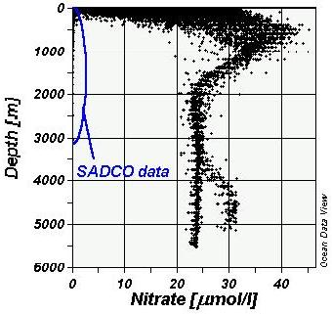
Profile 4. Nitrate profile for the ALLsm file using good and unknown quality data, showing the low nitrate values at depth from the SADCO file (units are μmol/l which are equal to μg atom/l).

The SADCO file data does not fit the profile well, as it shows surface values down to 100m as ranging between 0μg atom/l and 5.2μg atom/l. This profile shows values close to 0μg atom/l down to a depth of about 3050m. The SADCO profile was considered to be spurious, and was thus disregarded from the assessment by filtering out the unknown quality data. The nitrate profile only consists of OSD data. The surface range is between 0μg atom/l and 32.2μg atom/l. There is a general increase in values between the surface and approximately 500m (up to 46.7μg atom/l). By 2000m, the values decrease to range between 22μg atom/l and 27μg atom/l. By the deepest observation depth, the range is between 22μg atom/l and 25μg atom/l, except for the one branch of the profile, which shows nitrate values between 27.8μg atom/l and 31.3μg atom/l just below 5000m. This branch consists of AABW (Antarctic Bottom Water) that flows into the Cape Basin from the south. It contains more nutrients as they haven’t been used up and have sunk with the fresher, colder water. (See Comparison of the NW and SE basins).

3.2.5 PHOSPHATE

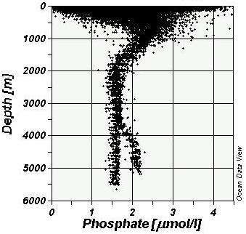
Profile 5. Phosphate profile for the ALLsm file using good and unknown quality data (units are μmol/l which are equal to μg atom/l).

The profile for phosphate displays very similar characteristics to the profile for nitrate. The surface values range from 0μg atom/l to 5.89μg atom/l, with a couple of values higher and up to 10.14μg atom/l, which are from the SADCO file. At about 1000m, these values converge into a range between 1.9μg atom/l and 2.8μg atom/l. These values then decrease to a range of 1.35μg atom/l to 1.9μg atom/l at 2000m. The range stays the same down to the deepest observation for the one branch of the profile, while the other branch shows an increase to a range of 1.95μg atom/l to 2.2μg atom/l. This is AABW as described for the nitrate profile. When the unknown quality data is removed, the only visible difference is the absence of the higher values at the surface. These values are high, considering the South African Water Quality Guidelines (1995) state a West coast average of 53μg/l and 47 ± 1.6μg/l in upwelled water, which converts to 1.7μg atom/l and 1.5μg atom/l respectively. Most of the surface values are above this average, and appear to have been recorded along the coastline. They could be due to waste products in the water such as sewage discharge or agricultural run-off.

There is a relationship between the nitrate and phosphate values as stated in the South African Water Quality Guidelines (1995). This relationship is a ratio of 15:1 (NO₃:PO₄). In the upper 100m, the ratio seems to be closer to 10:1, but as the profiles become more defined at depth, the ratio of 15:1 is definitely applicable.

3.2.6 TEMPERATURE/SALINITY DIAGRAM

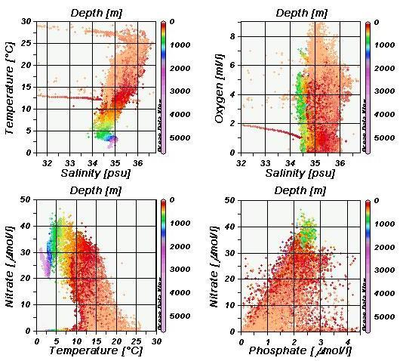
Profile 6. Various profiles for the ALLsm file using good and unknown quality data (some units are μmol/l which are equal to μg atom/l).

The ALL-MBT file using good and unknown quality data was used to produce these diagrams. In addition to a T/S diagram, O/S, NO₃/T and Nia/PO₄ plots were also produced. All the diagrams do not show well defined profiles, as they all contain a great deal of scatter. The general trend of the T/S diagram is fairly typical, although abnormalities are visible. The O/S diagram shows no real structure. The NO₃/T profile shows a similar pattern to the T/S diagram with a NO₃ maximum at approximately 500m with temperatures around 6°C. The NO₃ maximum does not correlate with the PO₄ maximum as would be expected from the ratio relationship between the two nutrients. This relationship should produce a linear profile between the two nutrients, but the Nia/PO₄ profile does not show this clearly.

3.2.7 COMPARISON OF THE NW AND SE BASINS

When looking at profiles for each variable in any of the combined files, a certain pattern can be seen. From approximately 3500m downwards, each profile branches into two definite forks. It was found that these forks correlate with each other and are most likely caused by the Walvis Ridge. The ridge forms a barrier and doesn’t allow the colder AABW (Antarctic Bottom Water) to flow further northward into the Angolan Basin. The pattern shows lower salinity, temperature and oxygen being associated with higher nutrients at depth in the Cape Basin. This description matches the description of AABW. The nutrients in this water have been retained due to a lack of activity, and have sunk to lower depths, explaining the increase in nitrate and phosphate at depth.

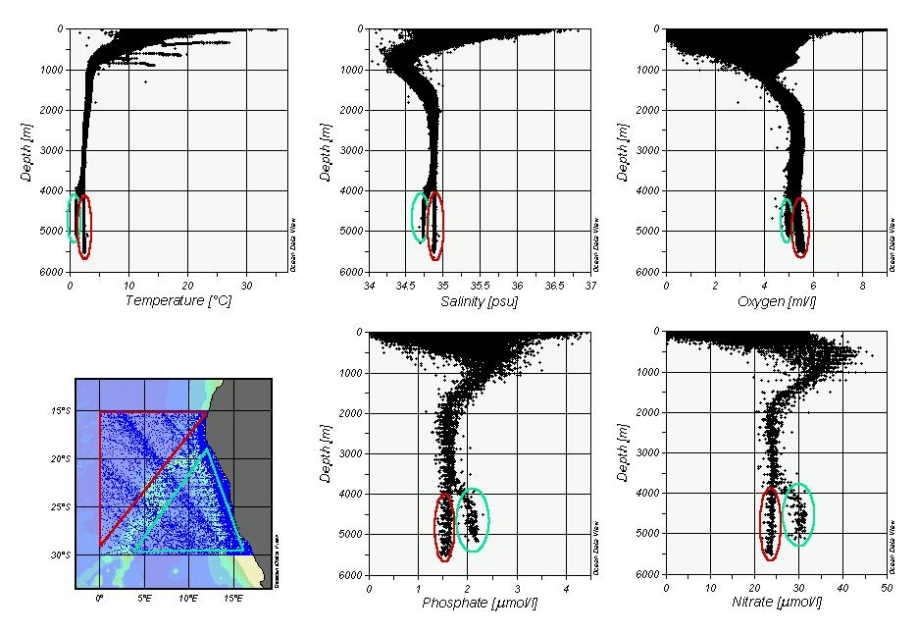
Diagram 1. Definite branches at depth for variables in the ALLsm file. Cyan symbols are correlated to the south-eastern (Cape Basin) portion of the map. Red symbols are associated with the north-western (Angolan Basin) section.

Temperature/Salinity diagrams were produced for each basin to see any differences. The Cape Basin clearly shows the presence of AABW, while the Angolan Basin does not contain this water mass. To view the different profiles, open the profile “Profiles-basins.jpg”.

3.3 SECTIONS

Due to a limited amount of data below 1000m, the focus of the sections is on the data in the upper 1000m. If an interest exists in the data below 1000m, it is suggested that the data from the CTD file be used for examination, as this file contains the most information and is the most accurate. The bathymetry of the region could not be determined from the data, and since the focus is on the upper 1000m, the bathymetry for the region is not that relevant. As a matter of interest, however, the Walvis Ridge is present in some of the sections, and was made visible using the Etopo data as described in the Methodology section under Creating sections in Section Mode. The bathymetry becomes relevant when looking at coastal sections, but various problems were experienced when using the Etopo data (see Problems and Recommendations section), and thus the bathymetry was excluded.

When looking at the sections from the ALL-MBT file, temperature is the only variable that produces relatively decent sections. It must be noted that these are not typical sections as the data is temporally averaged (contains data from various years). The missing data points appointed with a value of 1e + 010 and unknown quality obliterate the other data when included in the sections (due to gridding and the fact that there are so many more of these points than proper data points). These sections improve when the data of unknown quality is excluded, but it must be remembered that the entire SADCO file is marked as unknown and thus no data from this file is included. These values were removed from the ALL-MBT file to increase the quality of the sections. Even when using the good and unknown quality data, as well as all the months of the year, the other variables besides temperature still do not include enough data to produce reliable sections. When the months are broken down into seasons, the sections become even more disjointed.

To obtain an idea of the density of the data, a couple of random sections were created using the ALL-MBT file including all the years and all the months. The same sections were then broken down into seasons, and for the examples discussed below, refer to the PowerPoint presentation “ALL-MBT1.ppt”.

The data quality of these sections is good and unknown. In the top left hand corner of each slide is the slide number. The map shows where the section has been taken from. The section on the top right includes all the months. The four sections below show the split into seasons, and the months included are displayed underneath each section. The slides show six sections chosen at random in an attempt to cover the whole area. All the sections show jagged isotherms as a result of including all the years.

Slide 1 does not show much as the isotherms are relatively horizontal. There is warmer water present on the western side as it is closer to the equator. The seasonal components do not contain enough data for reasonable analysis. Slide 2 crosses the Angola-Benguela front and shows warm water across the entire surface of the section. The surface isotherms dip slightly towards the continent suggesting a southward flow along the coast. All the seasons except winter support this. Slide 3 covers the southernmost portion of the data set. All the isotherms slant up towards the continent and this is evident in all the seasons. This shows a northward flow, which would be the Benguela Current. The seasonal components of this section show better data coverage than the previous sections. An unusual patch of warm water is present under 200m at 16°E, but when only the good quality data is used, this patch disappears. This is probably bad data as only one station reported such temperatures. Slide 4 is of a transect further north which also exhibits isotherms slanting up, although not as sharply. Slide 5 shows a north-south cross-section of the area. In general the isotherms slant down towards the south, especially in the deeper layers, suggesting a westerly flow. This is possibly due to the South Atlantic gyre, which would cause a flow diagonally across the cross-section. The seasonal sections show a similar pattern. The isotherms in slide 6 show a slight rise in the south within the upper 400m, which would imply a flow towards the coast. This section was along a line that appears to be a shipping line that contained more stations than the other sections, although the summer section does not show good coverage.

All the seasonal components show a similar pattern with the warmest surface temperatures occurring in summer and autumn, although this warmer surface layer extends deeper in autumn. In contrast, winter and spring show the coldest surface temperatures with spring having the deeper surface layer. In general the sections show warmer surface temperatures off the coast and in the more northerly regions.

An attempt was made to look at the temperature data for various consecutive years. The years chosen were those which contained the greater number of stations per year. These sections contain even less data than the sections mentioned above, and a reasonable, reliable comparison could not be made. To see the diagrams please refer to the PowerPoint presentation “ALL-MBT8 84-89.ppt”. It covers the years 1983 to 1989 from the ALL-MBT file using both good and unknown quality data. The station depths were included but they do not show the true bathymetry of the section. It was decided to use a section along the coast where the greatest data density occurs, and the x-axis shows distance, with 0km being the start of the section in the north.

3.4 SURFACE PLOTS

The ALL-MBT file using good and unknown data quality was used to produce the various surface plots. To see these plots, refer to the PowerPoint presentation “ALL-MBT sfc plots.ppt”.

Surface plots were created to look at variables at different depths. The depths chosen were the surface, 200m, 500m and 1000m. The temperature plots showed warmer water on the surface in the northwest region. At 200m and 500m, the warmer water was in the southwest section. This finding is supported by slide 5 mentioned under Sections above. The section shows the warmer layers extending deeper down in the southern region. Perhaps the South Atlantic gyre flow is responsible for forcing the isotherm down in this area. The plot at 1000m shows an influx of cooler water to the south along the coast, although this plot is quite disjointed.

The salinity surface plots show higher values in the surface waters decreasing with depth. On the surface, the higher values are closer to the equator and off the coast. As more evaporation occurs closer to the equator, this is expected. Some of the lowest values are found on the coast at the mouth to the Orange River, as was described under Salinity in the Scatter plots section. At 200m, the higher values are found in the southwest corner with the lowest values still near the river mouth. The values are dispersed throughout the region at 500m. At 1000m, the lower values are found further off the coast and are probably due to Antarctic Intermediate Water. The salinity range decreases with depth, which was also evident in the salinity profile.

The oxygen surface plots are much more sparse than the temperature and salinity plots. The surface values are fairly high (oxygen levels increased due to interaction with the atmosphere and wave action), with the highest being recorded along the coast. At 200m, 500m and 1000m, the same pattern can be seen with the lowest values in the north, and the highest in the south or southwest region. The lowest values are found at 200m, and they also extend over a large area spreading down the coast.

The phosphate and nitrate surface plots show bad data density. As a general interpretation, the plots show higher values near the coast. At 200m and 500m, these higher values can also be detected in the north of the region. The highest values are found on the 500m plot.

3.5 COMBINED FILES

3.5.1 DISCUSSION OF THE ALL-MBT FILE

The reason for excluding the MBT data (in creating the ALL-MBT file) is because even though the quality of the file is flagged as mostly good, it is believed that this data is rather inaccurate. The depth range of the file is very shallow and the temperature resolution is not good. In creating this new separate collection it was possible to compare it to the ALL file. The only difference is in the temperature values as the MBT file only contains temperature data. Removing this file only changes the upper 601m in the water column, as this is the deepest sample depth for the MBT file. The ALL-MBT file has 9400 stations less then the ALL file.
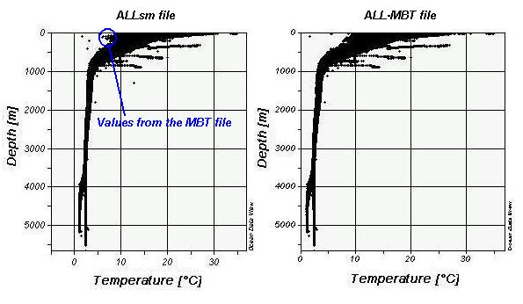
Profile 7. Comparison of the temperature profiles for the ALLsm file and the ALL-MBT file using good quality data.

In comparing the two files it was found that the most visible difference in the scatter plots of the two different files occurred within the upper 200m of the water column. Extra points from the MBT file were present in this area, ranging between approximately 6 and 9°C. These extra points cause a deviation from the profile formed by the combination of the other four files. Another three points appear to be definite outliers, one at 201m and 3.2°C, another at 401m and 2.9°C and the last one at 1300m and 12.8°C. There are other points from the MBT file that seem to match the profile, and they are found near the surface and range between 27°C and 31°C. The rest of the MBT points fall within the profile and are not visible on the scatter plots.

Excluding the MBT file means removing less than 5% of the total samples of the ALL file. Since removing this file has such a small impact but increases the quality of the data, it was decided that the ALL-MBT file would be used for the assessment. For comparison, the same sections were created using each file and examined. The visible difference was considered negligible. Having decided to use the ALL-MBT file, the values of 1e+010 that were used to denote blank fields were removed. Better quality sections and surface plots could now be obtained. If these values are not removed various problems occur (see Missing Data Values under Problems and Recommendations).

3.5.2 NUMBER OF STATIONS PER YEAR AND BREAKDOWN INTO MONTHS

To see the table that was created, open the “ALL yrs – months.doc” file. The ALL file was used to create this table and was intended for a general overview of how many stations there are per year and into which months they fall. Colours were applied to the table to represent the different seasons (dark green for summer, light brown for autumn, dark brown for winter and light green for spring). The most stations (over 11000) are recorded during summer. Autumn is the next highest with approximately 8700 stations. Winter is just below 8000 stations, and spring is the lowest with about 7200 stations. This breakdown is also visible using the temporal distribution plot for his file, but the table gives exact numbers.

3.6 OXYGEN DEPTH AVERAGES

The ALLsm file was used for this analysis. Bulk statistics were obtained that are spatially and temporally averaged. Two graphs were created from the analysis covering different depth ranges and both including statistics for good data and statistics for good and unknown data. The graphs show the average oxygen values for each section that the range was broken down into. To view these graphs open the file “Mean Oxygen Graphs.xls”.

The first range was from 0m to 1000m and broken down into 100m sections. Graph 1 shows that the lowest oxygen values for the good data occurred between 300m and 400m, and for the good and unknown data, the minimum was between 100m and 200m. Both data series decrease quite rapidly to their minimums and then show a gradual increase that stabilises out at 1000m. The standard deviations for both data qualities decrease with depth, with the good data standard deviations ranging from 1.6 at the surface to 0.4 at 1000m. The standard deviations for the good and unknown data decrease from 2.0 at the surface to 1.3 at 1000m.

The range for Graph 2 was from 0m to the deepest observation depth (approximately 5500m). This range was broken down into 1000m sections. This graph was averaged over greater depth ranges, and thus the decrease in values within the upper few hundred metres is not visible. The graph shows an overall increase in mean oxygen values from the surface down to between 2000m and 3000m. The values remain relatively stable throughout the rest of the water column. The good and unknown quality data means are lower than those for the good quality data during the increase, but are almost exactly the same for the rest of the range. As with the first graph, the standard deviations decrease with depth. The good data standard deviations range from 1.5 to 0.1, and the good and unknown data standard deviations range from 1.9 to 0.2, both from the surface down to the deepest observation depth.

The good and unknown mean oxygen values are consistently lower than those of the good quality data in the upper 1000m. Below 1000m the means are much more similar. Perhaps most of the unknown quality data values fall within the upper 1000m thus only affecting this portion of the graphs.

3.7 GRID

A 1° by 1° grid was created using the ALL-MBT file to show the data density of the area. The grid was too wide to fit in this document. To view it please open the file “ALL-MBT GRID.xls”.

As discussed in the inventories of the different files, the greatest density of stations is found along the coastline, especially in the south, and the grid supports this. The grid shows how unevenly the stations are spread over the whole area. The last latitude range of 30° to 30.9999° actually only contains values at a latitude of 30°S, as this was the range defined for the Namibian region. Thus the values in this last range are not a true representation for the 1° by 1° blocks in which they are contained.

4. PROBLEMS AND RECOMMENDATIONS

4.1 WORKING WITH THE FILES

The files present on the CD are so large that they presented great problems in attempting to open them. As mentioned in Methodology, the files could not be completely opened in Excel. As a result, the only way to examine the data was to import it into ODV. A pre-requisite for working with these files is a computer with reasonable resources. This assessment was performed on a Pentium 4. It was found that older computers with less memory were too slow to work with the data.

4.2 MISSING DATA VALUES

A value of 1e+010 was used in the original text files to denote where data was missing. This value is obviously beyond the range of good data, but when it is present and the user selects the full range function from the plot pop up menu, ODV includes these values in the plot. In the case of the scatter plots, the user has to manually define the range of the variable to exclude these values. When dealing with sections and using both good and unknown data, ODV attempts to show these values on the sections and surface plots, and since VG Gridding is used, these values can obliterate other relevant data. If only good data is selected, these values are excluded as they have been marked as either unknown or bad data. Although it is possible to remove these values from the data set (see Manipulation under Methodology), this is a very lengthy process. It is suggested that in the future a blank field be used to denote missing data (also accepted by ODV), or if a numerical value is used, that it be marked as data with bad quality.

4.3 QUALITY FLAGS

With respect to quality flags, it is suggested that effort be made to assign the relevant flags to future samples for easier assessment of the data. Various samples in these files were marked as unknown. The assessor does then not know whether this data has not been filtered well, or whether it is reliable or not. In extreme cases there could be some values that deviate from the expected profiles and are disregarded due to being marked as unknown, when they could actually be reliable data depicting an anomaly.

4.4 BATHYMETRY DATA

The recorded bottom depths for the files are not always correct and are thus not reliable to use to obtain the bathymetry of the region. In some cases the Etopo data set was used to see the general outline of the bathymetry, but this did not always correspond with the data, especially in the coastal region. It was found that including the Etopo data close to the coast sometimes resulted in data points being blocked out by the superimposed bathymetry data. If the original data is used instead of VG gridding, then the original data is superimposed on the bathymetry data, but they still do not match. A suggestion was made to rather use Terrain Base, which contains more recent and accurate bathymetry data.

For comparison between a coastal section using no bathymetry and the same section using the Etopo data set, open the section “ALL-MBT Sect8.jpg”.

4.5 GENERAL

ODV is based on the northern hemisphere, and thus when using “winter” under the Selection Criteria, it is not correct for the southern hemisphere. The months were selected manually, with December, January and February representing summer, March, April and May representing autumn etc. If more than one station is present at exactly the same position (i.e. same longitude and latitude), ODV only represents one of them.

The data is not evenly spread over the years and seasons as shown by the temporal distribution plots and the table showing the breakdown into years and months. Any analysis done using all the years produces results that are scattered in both space and time. Although there appears to be a reasonable number of stations in each 1° by 1° block of the grid, the data density seems too low for some of the analysis, especially the sections. Many variables contained in the original files were excluded from assessment due to a lack of data. It is believed that the data is not good for seasonal decompositions or inter-annual comparisons, and care should be taken when drawing conclusions regarding these. If more data could be obtained and added to these data sets, the density would be increased and perhaps more reliable. It is also suggested that more research be done on the low oxygen values that were reported at 200m to see if more can be understood about this phenomenon.

5. GLOSSARY

Combined files – files created by combining various “new files”
ALL File – combination of all the new files including all available variables
ALLsm – combination of all the new files but excluding variables with low data availability
ALL-MBT – combination of all the new files excluding the MBT file and excluding variables with low data availability
Ghostscript – program for interpreting PostScript page description language used by laser printers
GSview – graphical interface program for Ghostscript
New files – files created from the original files only covering the Namibian region
OSD File – new file created from the NamOSD file
SADCO File – new file created from the NamSADCO file
MBT File – new file created from the NamMBT file
XBT File – new file created from the NamXBT file
CTD File – new file created from the NamCTD file
ODV – Ocean Data View, an oceanographic exploration program used to assess the historical data
Original files – files obtained on a CD from SADCO with data from the Angolan and Namibian region
NamOSD – contains data from the World Data Centre
NamSADCO – contains data from the SADCO Holding’s database
NamMBT – contains Mechanical Bathythermograph (MBT) data
NamXBT – contains Expendable Bathythermograph (XBT) data
NamCTD – contains Conductivity, temperature and depth probe data

6. REFERENCES

Department of Water Affairs and Forrestry. (1995). South African Water Quality Guidelines for Coastal Marine Waters. Volume 4: Mariculture.

Deutsch, L. P. (2003) writer of Ghostscript artofcode LLC http://www.cs.wisc.edu/~ghost/doc/AFPL/get800.htm

http://www.bclme.org/about/region.asp

Lang, R. (2003) writer of GSview at Ghostgum Software Pty Ltd. http://www.cs.wisc.edu/~ghost/gsview/get44.htm

Schlitzer, R. (2002) Ocean Data View, http://www.awi-bremerhaven.de/GEO/ODV.

7. APPENDIX

7.1 TEMPORAL DISTRIBUTION PLOTS OF THE COMBINED FILES

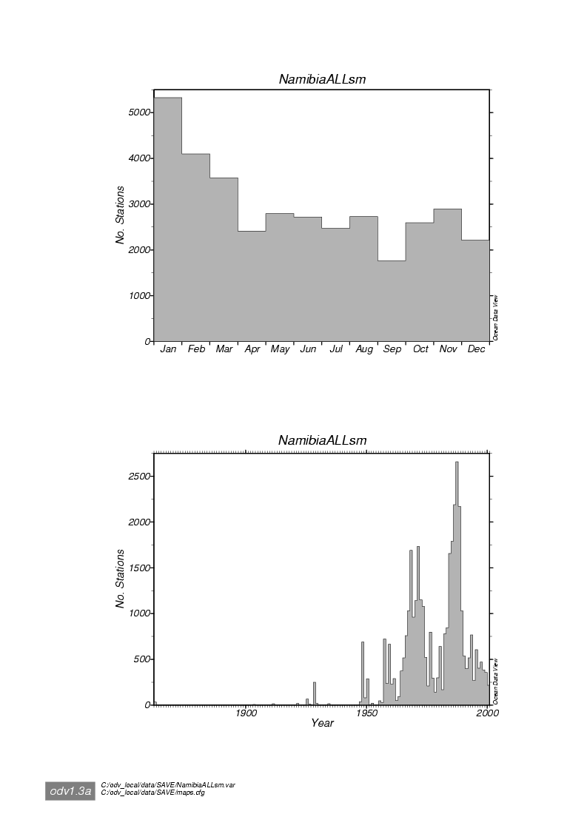
Plot 1. Temporal distribution plot of the ALLsm file showing distribution of stations over months (top) and years (bottom).
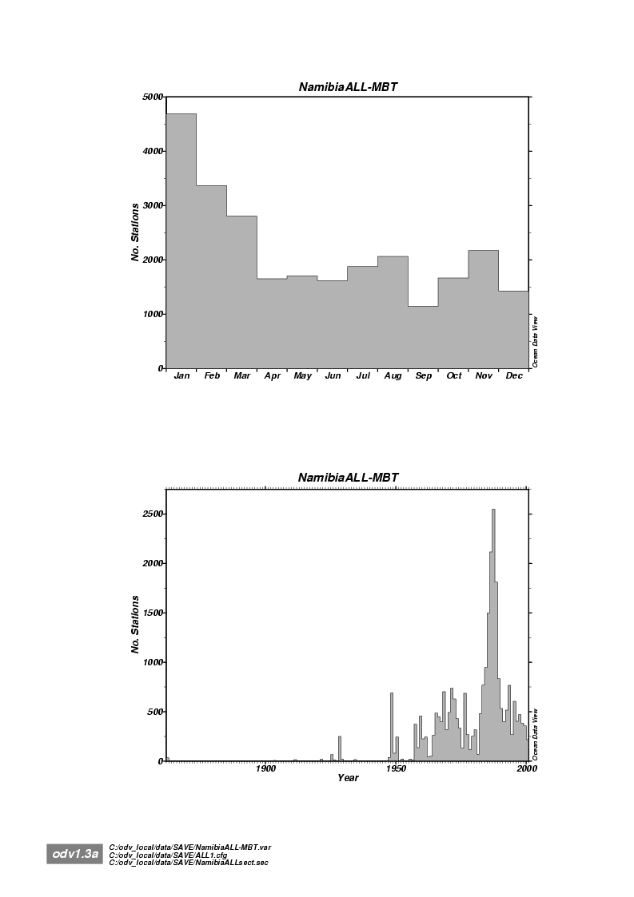

Plot 1. Temporal distribution plot of the ALL-MBT file showing distribution of stations over months (top) and years (bottom).

