ASSESSMENT OF HISTORICAL OCEANOGRAPHIC DATA AVAILABLE OFF NAMIBIA FROM SADCO – EXECUTIVE SUMMARY

By Fiona Duncan

1. Background and motivation for assessment

The focus of this assessment is the region off the Namibian coast. Historical oceanographic data was obtained from SADCO. The aim was to explore what and how much data is available, where it is available and what it can be used for. The motivation was to see if this data was reliable and could be used to help understand environmental anomalies in the Benguela region. The assessment looked at various aspects of the data, such as data density and sections or profiles constructed from the data. These were used to draw conclusions on the reliability of the data. On completion of the project the intention was to help transfer the assessment and the methodology to the Angolan partners. The Angolan partners could then carry out a similar assessment on the historical oceanographic data for the region off the Angolan coast.

2. Objectives of the assessment

The objectives specified for this project were to:
- Assess the SADCO oceanographic data inventories in the Namibian region.
- Set up a suitable geographic based grid to show the density of the data (depending on the nature of the data inventories).
- Derive suitable climatologies for the data (e.g. temperature/salinity diagrams, oxygen depth averages and variability).
- Write up a comprehensive report.
- Transfer this product and the technology used to the Angolan partners.

3. Major results

The original data supplied by SADCO consisted of five separate files, with data ranging from 1862 to 2001. The data in these files was marked with quality flags. One of the files had all the data marked as unknown data quality. This presented a problem to determine which data was reliable and which should be disregarded. This emphasises that all data should be marked with relevant quality flags so that definite conclusions can be drawn from the data.

The five separate files were combined to analyse all the data together, but the mechanical bathythermograph file was excluded as it only contains temperature data and the accuracy of the equipment and interpretation of the data is not good. Inaccuracies occurred in the positioning of the glass inside the MBT, as well as when it was placed in the glass reader. The glass was read by eye, and thus the readings were influenced by personal interpretation. It is also not known if the MBT data was calibrated or not. Considering these factors, it was decided that the resolution of the MBT data was not sufficient to be included in the analysis.

It was found that the greatest density of stations is along the coastline, especially in the south. Over the remainder of the area, the stations are not spread evenly, but are concentrated in commercial shipping routes. The data contained numerous variables, but not all of these were examined in the assessment. Only those that were considered most useful and/or showed fairly high density were included. The density of stations over the area can be seen by the map below.
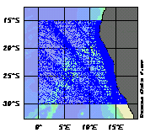
Diagram 1. Map showing the distribution of all the stations over the Namibian region.

The data obtained from SADCO was measured with expendable bathythermographs, mechanical bathythermographs and conductivity, temperature, depth probes, which differ in accuracy. The CTD profiles were definitely the most precise, while others, (such as data from expendable bathythermographs), showed a fair amount of noise. The profiles for the variables were relatively normal, with most outliers being disregarded as bad data. On the oxygen profile, a number of branches of low oxygen at depth are visible. Initially it was thought that these values were incorrect, but there are 19 stations that show these low values, although all the stations were from the same cruise and perhaps the equipment was faulty. Low oxygen values were also found at depths between 150m and 300m, which is supposedly normal, as the most decomposition occurs at 300m thus decreasing the oxygen levels.

All the profiles of the variables show a “branching” pattern below 4000m. One branch correlates with the Cape Basin while the other correlates with the Angolan Basin. This is due to Antarctic Bottom Water (AABW) present in the Cape Basin, which is prevented from flowing north into the Angolan Basin by the Walvis ridge. Thus the two water masses present below 4000m in the different basins have different characteristics.

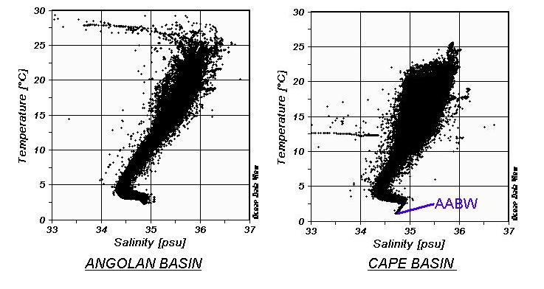
Diagram 2. Temperature/salinity diagrams of the Angolan and Cape basins showing the different characteristics caused by the lack/presence of AABW.

Vertical sections, with depth on the y-axis, latitude on the x-axis and temperature displayed as the z variable, were produced in order to see the density of the data in specific areas. It was found that only temperature produced reasonable sections, although these were also fairly disjointed. The sections were broken down into seasons to see seasonal variability, but these components do not contain enough data for reasonable analysis. When sections for specific years were created, the sections displayed even less data and reasonable, reliable comparisons could not be made. Only in areas of high sampling frequency (e.g. close to the coast) would there be enough information for evaluating changes over time.

Surface plots, which show the horizontal variation of variables across selected depth horizons, were created. More observations were made in the surface layers, and as the depth increases, the sample density decreases. Temperature and salinity produced the best surface plots showing reasonably expected patterns. The temperature plots show the warmer water extending deeper down in the southwest section. The salinity plots show the lowest values near the mouth of the Orange River, and in general the salinity values decrease with depth, as would be expected. The oxygen plots are quite sparse, with the lowest values being found at 200m extending over a large area spreading down the coast. The phosphate and nitrate plots show very low data density, but as a general overview it appears that the higher values occur near the coast, with the highest being at 500m.

Looking at the number of stations per year and the breakdown into months, it was found that most stations were sampled during summer, followed by autumn and then winter, with spring containing the lowest number of stations.

Oxygen averages were obtained for specific depth ranges. When using good and unknown quality data, the mean oxygen values are consistently lower than when using only the good quality data in the upper 1000m. Below 1000m the means are much more similar. Both types of data show a similar pattern of a rapid decrease in oxygen values down to approximately 300m, and then a gradual increase that stabilises out around 3000m.

4. Conclusions

When using this data for comparisons or analysis, it must be remembered that this data is both temporally and spatially averaged. The data is not evenly spread over the years and the region has a relatively low level of high-quality data coverage. Thus profiles drawn including all the data do not necessarily represent the entire area. If the data is to be used, it should be done so with caution, noting that the data is not sufficient for assessing variability on seasonal, inter-annual and decadal scales. The Benguela Current Large Marine Ecosystem Programme will hopefully substantially improve on this baseline.

