The extension of PIRATA in the South East Atlantic

Mid term report

Mathieu Rouault

Department of Oceanography , University of Cape Town

27th September, 2006

1 Deployment 2
2 Mooring and instruments description 4
3 Data 6
4. First Results 7
5 Trouble shooting 12
6 Dissemination of knowledge 12
7 Conclusion 12

1 Deployment

THE BCLME PIRATA ATLAS BUOY KIZOMBA was deployed at about 6°S - 8°E at 4100 m depth (05° 58.661 S ; 07° 59.524 E) during the AMMA-EGEE 3 cruise on the 27th June 2006. The mooring is fitted with a current meter, 5 temperature/conductivity sensors deployed at 1, 10, 20, 40 and 120 meters depth, 6 temperature sensors deployed at 13, 60, 80, 100, 140 and 180 meters depth and 2 temperature/pressure sensors deployed at 300 and 500 meters depth. Other sensors fitted are an anemometer, air temperature and humidity probe, short wave solar radiation probe and rain gauge.

Data are transmitted through Argos and displayed in real time on the web at http://www.pmel.noaa.gov/pirata/display.html where it can also be downloaded. The data are also made available to the Global Telecommunication System (GTS) to be used as initial conditions in ocean and weather forecast models.

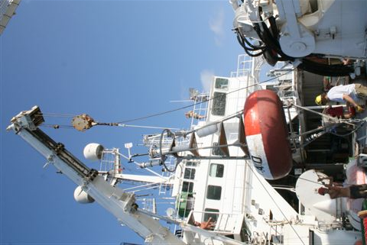

Figure 1: Deployment of the KIZOMBA mooring on the Atalante on the 27th June 2006

The Mooring ID is PM614A, the Anchor drop date/time (gmt) is (06/27/2006 - 17:29), the sounder depth is 4 100m, the final scope is 0.985 and fly-by position, 05° 58.661 S ,07° 59.524 E . The serial numbers of sensors are presented in Table 1. The mooring is fitted with additional sensors; a temperature/conductivity sensor deployed at 10 m (TC11: 13991) and a current meter Sontek: D204 equipped with a temperature sensor at 13 meters.

Ptt |  | Tube |  |  | Wind |  | ATRH |  | Rain | SWR |  | Release
790 |  | 606 |  |  | 63911 |  | 34279 |  | 745 | 32403 |  | 8242 / SN: 022180
SSC | TC1 |  | TC2 | T3 |  | T4 |  | T5 | TC6 | T7 | T8 | TP9 | TP10
12231 | 12125 |  | 13988 | 13949 |  | 13950 |  | 13951 | 13351 | 13952 | 13953 | 13986 | 13987

Table 1: Serial numbers of sensors

EGEE is being undertaken as part of the international AMMA programme (Multidisciplinary Analysis of the African Monsoon), dedicated to the study of the water cycle over West Africa, by investigating and forecasting monsoons and their impact on local populations. EGEE is the oceanographic component of AMMA and is being conducted under the joint scientific responsibility of four French public-sector members of the Mercator public interest group (CNRS, IFREMER, IRD and Meteo-France). EGEE is also part of the Tropical Atlantic Circulation Experiment (TACE), a program endorsed by CLIVAR. Various measurements, available to the public, have been made during the EGEE 3 cruise, including CTD, ADCP, meteorological, and radiosonde. Argo floats were also deployed along 6˚ South.

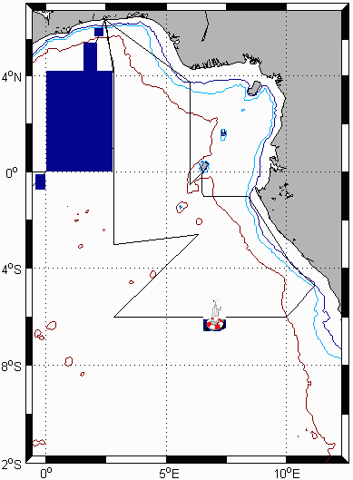

Figure 2: EGEE 3 cruise track in June 2006 with position of deployed Kizomba mooring.

2 Mooring and instruments description

The KIZOMBA mooring is a standard next generation Atlas buoy. It is a 2.3 m diameter fiberglass-over-foam toroid, with an aluminum tower and a stainless steel bridle. When completely rigged, the system has an air weight of approximately 660 kg, a net buoyancy of nearly 2300 kg, and an overall height of 4.9 m. The electronics tube is approximately 1.5 m long, 0.18 m in diameter, and weighs 27 kg. The buoy can be seen on radar from 4-8 miles depending on sea conditions. The mooring was shipped at the end of February 2006 from Seattle, USA to Lome, Togo. The electronics were airfreighted. Table 2 presents the types of sensors used on Atlas moorings and lists their accuracies.

Table 2: Parameters measured, types of sensors used on Atlas moorings and accuracies.

Measurement | Sensor type | Manufacturer and model |  | Resolution | Range | Accuracy
Wind speed | Propeller | R. M. Young: 05103 |  | 0.2 m s-1 | 1-20 m s-1 | ±0.3 m s-1 or 3%
Wind direction | Vane | R. M. Young: 05103 |  | 1.4° | 0-355° | 5° - 7.8°
Air temperature | Pt-100 RTD Resistance | Rotronic Instrument Corp.: MP-100 | 0.04°C |  | 14-32°C | ±0.2°C
Relative humidity | Capacitance
Relative humidity | Capacitance | Rotronic Instrument Corp.: MP-100 | 0.4 %RH |  | 0-100 %RH | ±2.7 %RH
Downwelling shortwave radiation | Pyranometer | Eppley Laboratory: PSP |  | 1.3 W m-2 | 700 W m-2  0-1600 W m-2 | ±2%
Sea surface temperature | Thermistor | PMEL: Standard SST sensor using YSI thermistor 46006 |  | 0.001°C | 14-32°C | ±0.03°C
Sea surface temperature | Thermistor | PMEL: Current meter mooring SST sensor using YSI thermistor 46006 |  | 0.001°C | 14-32°C | ±0.01°C
Subsurface temperature | Thermistor | PMEL: Standard sensor using YSI thermistor 46006 |  | 0.001°C | 6-32°C  (2-35°C) | ±0.09°C
Subsurface temperature | Thermistor | PMEL: Mini Temperature Recorder using YSI thermistor 46006 |  | 0.001°C | 6-29°C | ±0.01°C
Subsurface temperature | Thermistor | EG&G VACM |  | 0.001°C | 1-31°C | ±0.05°C
Subsurface temperature | Thermistor | EG&G VMCM |  | 0.006°C | 1-31°C | ±0.05°C
Subsurface temperature | Thermistor | Sea Data TR-2, TDR-2 |  | 0.01°C | 1-31°C | ±0.05°C
Sea surface and subsurface temperature | Thermistor | Sea Bird Electronics: SBE16, SBE37 |  | 0.001°C | 1-31°C | ±0.003°C
Salinity | Internal field conductivity cell | Sea Bird Electronics: SBE16 (Seacat) |  | 0.0001 S m-1 | 3-6 S m-1 | ±0.02 psu
Water pressure | Transducer | Paine: 211-30-66001 |  | 0.03 psi | 400-800 psi | ±0.25%
Ocean current | Savonious rotor and vane | EG&G VACM |  | 0.005 cm s-1  2.8° | 2-300 cm s-1 | ±3-7 cm s-1,  ±5.6°
Ocean current | Orthogonal Propellers | EG&G VMCM |  | 0.01 cm s-1  1.4° | 0.9- 340  cm s-1 | ±3-7 cm s-1,  ±2.5°

PIRATA (Brazil, France, USA) has deployed an array of 12 ATLAS buoys, between 1997 and 2001, with the objective of monitoring, describing and understanding the evolution of sea surface temperature, upper ocean thermal and saline structure, net heat budget, air-sea fluxes of momentum, latent and sensible heat and fresh water in the tropical Atlantic. This is similar to TAO in the Pacific Ocean, the observing system deployed to study and forecast the El Nino Southern Oscillation (ENSO). Extensions to this PIRATA mooring array are being added.

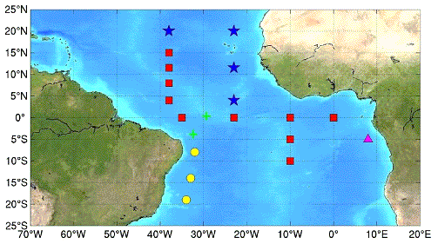

Figure 3: Status of the PIRATA array of Atlas Mooring. Original array (red), South West extension (Brazil), South East extension (purple) and Northeast extension (blue)

3 Data

The PIRATA Project provides near-real-time daily-averaged surface and subsurface data from all ATLAS moorings in the Tropical Atlantic as well as a data display and web interface to plot and download data and derived quantities. ATLAS moorings transmit daily mean values from the previous day and the most recent hourly surface meteorological observations. Higher resolution data (10 mn average) are recorded onboard the moorings and are made available after mooring recoveries, which are scheduled on an annual basis. Real-time updates of daily mean data displays are presented on the PIRATA web pages on a daily basis.
In addition, information such as: daily mean ocean temperature; up to 4 hourly surface wind; relative humidity; and air temperature observations are made available to the Global Telecommunications System (GTS) by Service Argos. This information is primarily for use by operational data centers and forecast centers around the world. Hourly surface messages (winds, air temperature, relative humidity, and sea surface temperature) and daily averaged subsurface messages (ocean temperatures) are available in WMO code form FM 18-X BUOY with bulletin header SSVX08 KARS. Surface messages are generated whenever Argos receives a satellite pass, typically 2-4 times per day for ATLAS moorings. The subsurface temperature data are available on the GTS as daily averages with a time stamp of 0000z at the end of the average period. Only one subsurface message per day per buoy is available. As part of the data quality monitoring, PMEL identifies and communicates information about which data should not be submitted to the GTS or displayed on their web sites. In turn, Argos makes available to PMEL, data which are submitted to the GTS and PMEL compares these data for consistency checks with data processed at PMEL.

4. First Results

The following figures were plotted, using daily average data available in near real time through Argos, on the PIRATA web site of PMEL, NOAA. Results from the mooring show a intrusion of low salinity warm water flowing in a southwesterly direction of up to 40 cm/s quite steady from the 15 – 30th July 2006..

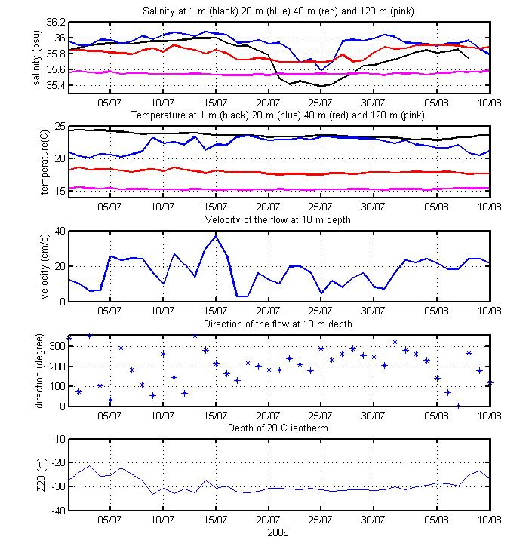
Figure 4: From top to bottom. Salinity at 1, 20, 40 and 120 meter depth, temperature at the same depth, direction and velocity of the flow measured at 10 meters depth and depth of the thermocline (20˚C isotherm).
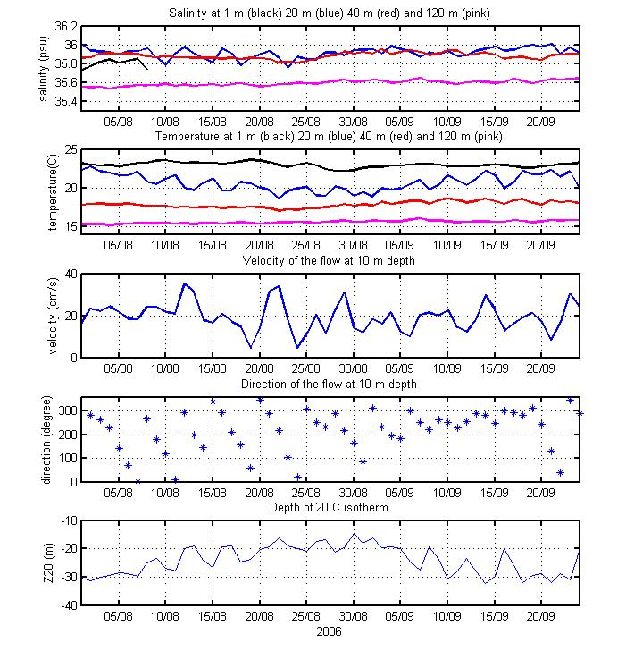

Figure 5: From top to bottom. Salinity at 1, 20, 40 and 120 meter depth, temperature at the same depth, direction and velocity of the flow measured at 10 meters depth and depth of the thermocline (20˚ C isotherm).

Figures 6 to 8 show time series of various parameters measured or estimated from the measurements of the Atlas mooring ”KIZOMBA” as it is displayed on the website.

Figure 6: Daily upper ocean temperature, wind data and derived dynamic height
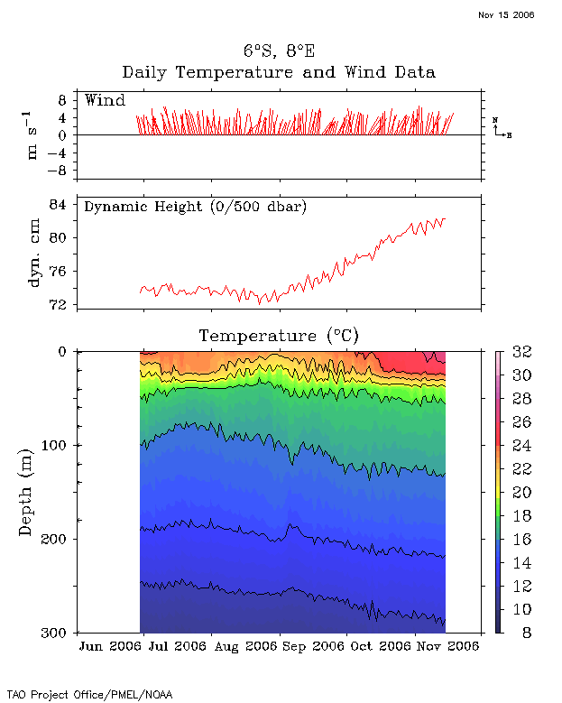

Figure 7: Daily meteorological and ocean temperature temperature data
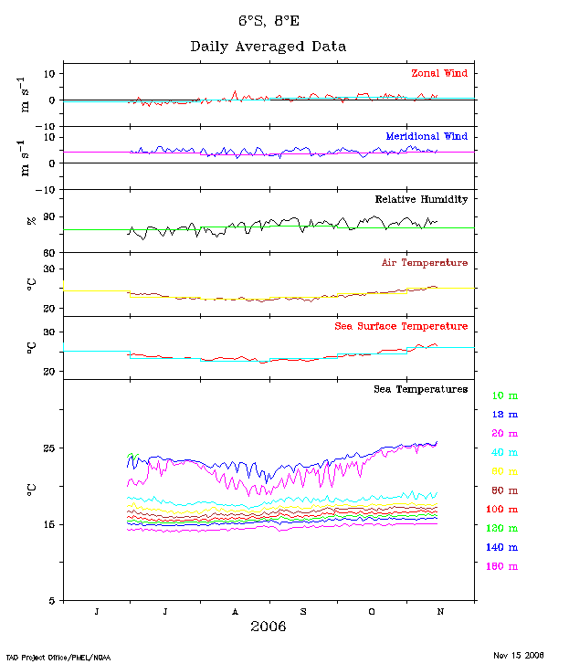

Figure 8: Daily salinity data at 1, 10, 20, 40 and 120 meter depth.

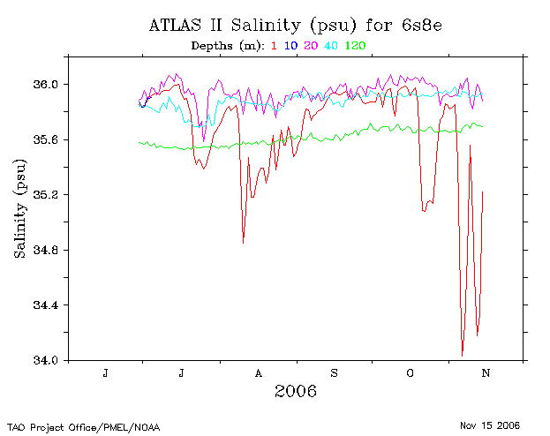

Figure 9: Daily derived potential density (kg.m³ in psu) data
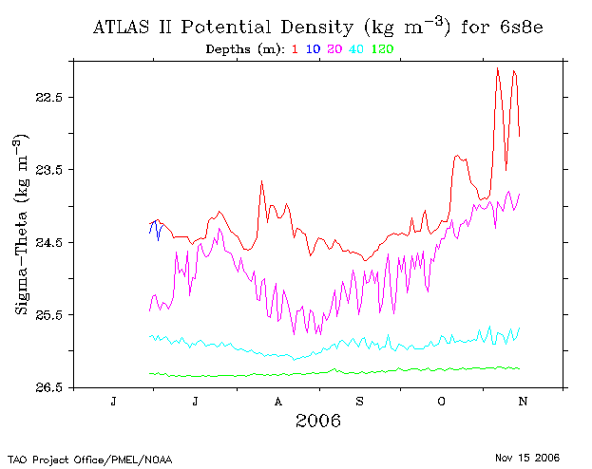

It is also possible to plot derived quantities such as the depth of the 20˚ C isotherm that marks the base of the thermocline. Variations in the depth of the thermocline is crucial to understand variations in sea surface temperature. The PIRATA display and web site mentioned earlier can also be used to download or plot data from the other PIRATA moorings and therefore eastward movements of perturbations can be followed along the equator, towards the coast and the Kizomba mooring.

5 Trouble shooting

The incoming short wave radiation sensors failed after a few days. The additional temperature/salinity probe at 10 meters failed after 10 days.

6 Dissemination of knowledge

Oral presentations

Rouault M, (2006) First results from the PlRATA South East extension 'Kizomba'
Mooring, 26 September 2006, SANCOR seminar, Cape Town, South Africa

Rouault M, (2006) First results from the PlRATA South East extension 'Kizomba'
Mooring, SASAS Conference, 5/6 October, Bloemfontein, South Africa

Rouault M, (2006) Status of the PlRATA South East extension 'Kizomba'
Mooring, PIRATA workshop, 3-5 November 2006, Miami, USA.

Rouault M, (2006) First results from the PlRATA South East extension 'Kizomba'
Mooring, PIRATA workshop, 3-5 November 2006, Miami, USA.

Publications

Rouault M, (2006) First results from the PlRATA South East extension 'Kizomba'
Mooring, GLOBEC newsletter, October 2006 pp 80-81.

Rouault M, (2006) The PlRATA South East extension , SANCOR newsletter, October 2006.

7 Conclusion

The first 4 months of data seems promising with evidence of an intrusion of low salinity water from the northwest that could be the first evidence of Congo River water there. Also an interesting feature of the seasonal cycle not well documented is present in the data in September.

The Kizomba data are available in real time through Argos and are already used in the CORIOLIS system that is providing initial conditions to operational oceanographic models, thus upgrading forecasting capacity of the region. PIRATA SEE data are assimilated in the operational ocean model Mercator, as well as in the national weather forecast model (ECMWF, MeteoFrance).

There is now a need to source a further US$85 000 to replace the mooring, immediately after it is recovered during the EGEE cruise in May 2007, with a backup/replacement mooring, As the sensors and first mooring will be sent back to Seattle for calibration and refurbishment, a second mooring will ensure continuity of the measurements. Failure to do so will interrupt the measurements for a year as the PIRATA mooring needs to be replaced every year. IRD has agreed to carry on the collaboration with BCLME to deploy/recover/replace any PIRATA mooring at that location in the future. They will have a ship semi-permanently in the tropical Atlantic in the near future

However at the last PIRATA workshop held at Miami in November this year, the IRD has expressed its intention of replacing the mooring at almost no cost to the BCLME should the USA accept to care for a PIRATA mooring at 23 West, usually the responsibility of IRD. In that case one will have only to pay for the transport (US $5 000) instead of a mooring + transport. There is also a possibility to add oxygen sensors at a cost of US $7 000 each. The first results were very well received and PIRATA has agreed to extend the one year demonstration program to a several year pilot program.

