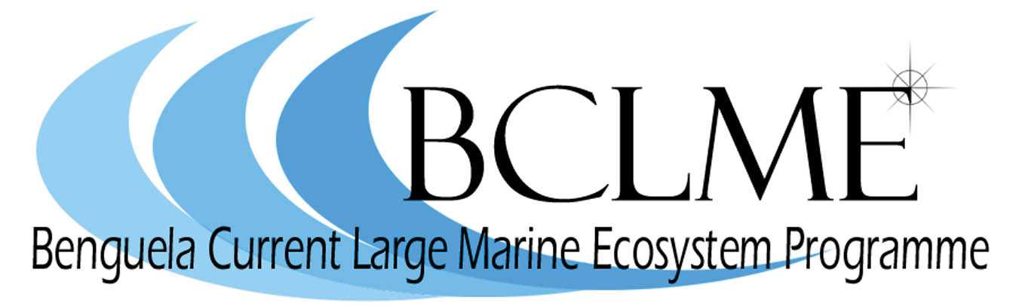

Retrospective Analysis of Plankton Community Structure in the Benguela Current Large Marine Ecosystem (BCLME), to provide an Index of Long-term Changes in the Ecosystem

Second Progress Report

Prepared by Dr Hans M. Verheye
DEA&T - Marine & Coastal Management – Cape Town

10 March 2005

BCLME Project Reference Number: EV/PROVARE/02/05

Contact person:  Dr Hans Verheye  Tel: +27(0)21-430 7015  Fax: +27(0)21-434 2144  Email: hverheye@deat.gov.za | Report prepared for:  Benguela Current Large Marine  Ecosystem Programme




Introduction

Several of the world’s productive upwelling regions of the eastern boundary current systems have experienced substantial, decade-scale food web changes over the past four to five decades. These changes are not only reflected in extensive fluctuations in pelagic fish yields and regime shifts of fish populations (Lluch-Belda et al. 1989, 1992, Schwartzlose et al. 1999). They are also manifested in long-term variations in the abundance, distribution and species composition of plankton (see Perry et al. 2004 and references therein) on which these fish, at one or another stage of their life history, are relying for their successful growth and recruitment.

In the southern part of the BCLME off South Africa, an initial retrospective analysis of plankton samples collected over five decades in the pelagic fish recruitment area of St Helena Bay on the West Coast has shown a significant increase in zooplankton, accompanied by marked changes in its community structure (Fig. 1), which coincided with changes in the recruitment and abundance of anchovy Engraulis encrasicolus and sardine Sardinops sagax (Verheye et al. 1998, Verheye and Richardson 1998, Verheye 2000).

While extensive plankton collections exist for the central/northern BCLME off Namibia (referred to as the SWAPELS collections – South West African Pelagic Egg and Larval Surveys), to date no equivalent retrospective analysis has been undertaken there. As a consequence, it has not been possible to quantify (suspected) large changes in this part of the ecosystem (but see Hansen et al. 2005). A pilot programme of retrospective analysis of zooplankton off Namibia, focussing on a limited number of SWAPELS transects and years has, however, recently been initiated through the BENEFIT Programme (e.g. Tsotsobe et al. 2003, 2004; Mainoane 2003).

The overall objective of this BCLME project is therefore to extend and fast-track the abovementioned BENEFIT pilot programme so that changes in the entire BCLME region over the past 50 years can be properly documented and quantified. The provision of such baseline and time-series is crucial in the assessment of natural (climate change) and anthropogenically forced changes (fishing activities) in the ecosystem. Knowledge of such past changes is a prerequisite for sustainable ecosystem management in the future, and forms the subject of several global initiatives such as GLOBEC (Global Ocean Ecosystems Dynamics) and GOOS (Global Ocean Observing System), the protocols of which are largely followed in the BCLME.

Figure 1. (top) Time-series of copepod abundance (diamonds) and dry mass (squares) in St Helena Bay, 1951-1999. (bottom) Community structure (%) of crustacean zooplankton during periods of sardine and anchovy dominance. Redrawn from Verheye et al. (1998) and Verheye and Richardson (1998).
The primary focus of this BCLME project is on the retrospective analysis of a representative amount of samples collected during the monthly SWAPELS surveys between the Cunene River (17ºS) and Lüderitz (26ºS) off the Namibian coast during the 1970s and 1980s (Fig. 2).
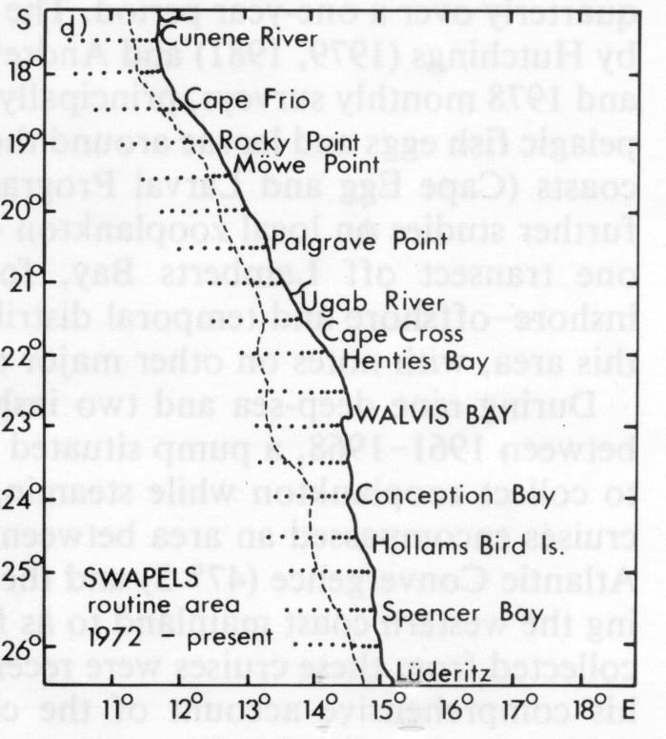
Figure 2. Map showing the cross-shelf transects and station positions sampled monthly during the SWAPELS programme, 1972-1989 (from Shannon and Pillar, 1986)

The analysis of this enormous collection (approximately 20 000 samples), which is housed at MCM’s sample store in Cape Town, involves students pursuing degrees at BSc, MSc and PhD level, and is backed up by technical assistance of a contracted sample analyst. Cataloguing and curation of this sample collection, for which partial funds were previously obtained from the Envifish and VIBES/IDYLE programmes in recognition of its scientific value, is continued by a contracted sample curator. Ultimately, the SWAPELS long-term time-series data will form an important component of the comprehensive inventory of plankton and ancillary hydrographic and fisheries data archives in the BCLME region, which is to be established by a contracted data manager. This regional database will allow relationships between indices of upwelling and demographic parameters of zooplankton and pelagic fish to be examined, with the primary focus on decade-scale variability and ecosystem change.

Progress to date

1. Administrative update

The agreement between UNOPS and BENEFIT for the execution of this BCLME project was signed on 16 March 2004. The work plan covering the activities for the first year (2004) made provision for a number of tasks, which are listed in Table 1. The status of progress made with regard to the recruitment and appointment of human capacity, on which the project relies heavily, is summarized in Table 1.

Table 1. Overview of project tasks and summary of progress status

TASK | STATUS
1. Sample analysis
- recruitment of 1 B.Sc.(Hons) student (Mr I. Kauvee)  - analysis of ca. 180 samples from 1983 (north and south of Lüderitz upwelling cell) completed, forming basis for Honours project on “Observations on the composition of the copepod community either side of the Lüderitz upwelling cell” | Studies at University of the Western Cape have been completed (2004) and the degree to be awarded on 8 April 2005.
e. recruitment of 1 Ph.D. student (Ms F. Cazassus)  f. samples targeted for analysis: samples from 2 months  (upwelling vs quiescence) every year at 3 stations on  9 transects, forming basis for PhD project entitled  “Spatio-temporal variability of the zooplankton of the  northern Benguela Current ecosystem, 1972-1989” | Ongoing; student has been provisionally admitted to the Univ. of Cape Town; the drafting of a 3-year PhD project proposal is near completion
- recruitment of 1 sample analyst (Mr F. Kotze)  - analysis of samples from 1978-1983 on Walvis Bay line (at 23˚S) has been completed and data have been used in reconstruction of long-term trend (1959-2002) | Analyst appointed 1 August 2004; so far, more than 200 zooplankton samples have been analysed and species abundances and station information captured
2. Training
- identification of training opportunities is ongoing;  taxonomy course (Tunisia, July 2005) fully subscribed;  other options are being explored, with the invitation of  international experts to run a regional workshop later in  2005 being the most cost-effective option. | MSc student enrolled to take course in biostatistics; registered to attend SAMSS (4-7 July 2005) and present paper on Honours Project research results;
3. Curation of sample collections
j. recruitment of 1 sample curator (Mr P.H. de Vos) | Curator appointed 1 August 2004; more than 5 500 samples curated and catalogued
4. Preparation of data archives for transfer to SADCO
k. recruitment of 1 data manager | Three applications received, from which IOI-SA was selected and contracted for 1 year (14 March 2005 - 13 March 2006)

Mr Ignatius Kauvee, a technician at the University of Namibia (UNAM), registered for a B.Sc.(Hons) degree at the University of the Western Cape (UWC), Bellville, Cape Town (supervisors: Prof. M.J. Gibbons & Dr H.M. Verheye), during 2004. He successfully completed his studies and the degree will be awarded on 8 April 2005. His BSc(Hons) project examined the possible role of the Lüderitz upwelling cell as an environmental barrier within the Benguela Current region. He will present his research results, which are summarized elsewhere in this report, at the forthcoming 12th Southern African Marine Science Symposium (SAMSS) in Durban during 4-7 July 2005. He is in the process of preparing a manuscript (under the same title, with Prof. Gibbons and Dr Verheye as co-authors), which will be submitted for publication as a Note or Short Communication in African Journal of Marine Science.

In February 2005, Mr Kauvee successfully registered for a M.Sc. degree (by dissertation) at the University of Cape Town (UCT) (supervisors: Dr C.L. Moloney & Dr H.M. Verheye). He is in the process of drafting his thesis project proposal, which will focus on a comparative study of some aspects of the population dynamics (e.g. distribution, abundance, production, mortality, resource partitioning) of two dominant copepods (Calanoides carinatus and Rhincalanus nasutus) in the northern Benguela. To that extent, he will analyse SWAPELS samples collected between Lüderitz and the Cunene River mouth. Simultaneously, he will obtain data on the abundance and distribution in time and space of all other zooplankton taxa. This information will therefore directly contribute to the overall objective of this BCLME project, viz. the establishment of baseline information and time-series data documenting and quantifying changes in the BCLME region over the past 50 years.

The recruitment of the PhD candidate, Ms Fabienne Cazassus, from France, has been ongoing since late 2003. This proves to be a lengthy process in itself, which has been further hampered by recurrent electronic mailing problems between the candidate and her local supervisors (Dr C.L. Moloney & Dr H.M. Verheye). The drafting of a comprehensive PhD project proposal, which is one of the prerequisites for the admission of foreign students to the University of Cape Town, has however advanced to such a stage that Ms Cazassus has recently been admitted provisionally as a PhD student at UCT’s Zoology Department. The objectives of her research will be: (i) to examine spatial patterns in the distribution and community structure of zooplankton relative to hydrographic features and processes on the Namibian shelf; (ii) to examine temporal fluctuations in the abundance and species composition of coastal zooplankton off Namibia during the period 1972-1989; (iii) to explore whether bottom-up and/or top-down mechanisms were responsible for the shaping of coastal zooplankton communities off Namibia during this period; and (iv) to explore possible explanations for the observation of opposite long-term trends in the zooplankton of the Benguela Current (increasing over the past 5 decades) and other eastern boundary current systems (declining over the same time window; Fig. 3).
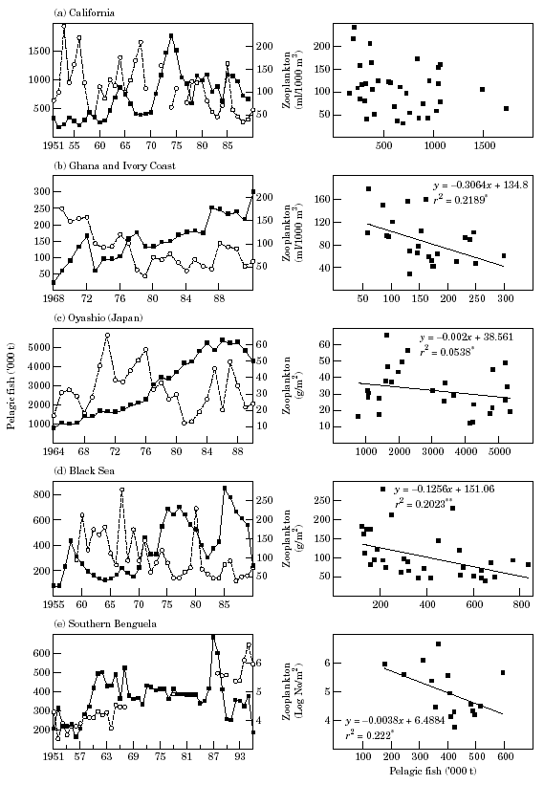
Figure 3. Time-series of (left panels) annual catches of pelagic fish (solid squares) and annual mean abundance, or biomass, of zooplankton (open circles), and (right panels) the relationship between the two: (a) California Current, (b) Guinea Current, (c) Oyashio district of the Tohoku Sea area off Japan, (d) Black Sea, and (e) southern Benguela Current off South Africa. Lines in right panels indicate significant regressions (*p<0.05, **p<0.01) (from Cury et al. 2000).

Both the sample analyst, Mr Ferdinand Kotze, and the sample curator, Mr Philip de Vos, were contracted with effect from 1 August 2004, and substantial progress has since been made in respect of the maintenance and analysis of a most valuable historical sample collection from the monthly SWAPELS cruises. Thus far, some 5 500 SWAPELS zooplankton samples have been curated (condition checked, topped up with formalin, and relabelled) and catalogued, thus continuing the important work that was initiated in the past under the auspices of NatMIRC and MCM, with partial funding provided by the Envifish and VIBES/IDYLE programmes. In addition, over 200 SWAPELS zooplankton samples, collected on transect 70 off Walvis Bay during the period 1978-1983, have already been analysed under the microscope. All the data on species composition and abundance, together with station information (as well as limited hydrographic data), are continually being captured in a specially designed spreadsheet, which converts raw counts for each taxon (species, sex, developmental stage) to number and biomass (dry mass and carbon mass) per unit of volume (m³) and surface area (m²).

The position of Data Manager was advertised in mid-January 2005 and three applications were received. The successful applicant is International Ocean Institute – Southern Africa (IOI-SA), an NGO based at the University of the Western Cape (UWC) in South Africa. Its experience with the development and maintenance of databases takes place under the auspices of its Biodiversity and Informatics Programme. Recognizing the need for sound knowledge of marine and coastal diversity and ecology in order to achieve sustainable use of resources, IOI-SA develops informatics and networking systems for the dissemination and sharing of ocean and coastal information, and for effective decision support. IOI-SA has been contracted for one year, starting mid March 2005, and a first scoping meeting was held between the Project’s PI (Dr H. Verheye) and the Directors of IOI-SA (Dr K. Prochazka) and BENEFIT (Dr N. Sweijd). While most of the workload will be carried by IOI-SA’s scientist and software programmer, postgraduate students will be involved for the standardization of data obtained from the various data sources. The use of students for this component of the work provides them with an important opportunity to gain some work experience in the field of their interest, and to meet individuals working in the fields of marine biology, oceanography, marine management and the meeting of these with the world of IT. The direct benefits of this capacity building to the marine science and marine management community are twofold: (i) students exposed to particular fields during vacation jobs often choose that field for further studies and even life-long careers, and (ii) providing students with such employment and an important source of income encourages a positive view of marine science in general, increasing their willingness to remain in the field.

Furthermore with regard to training and capacity building, the 5-day comprehensive training course in the biology and systematics of copepods, which is to be held prior to the 9th International Conference on Copepoda in Hammamet, Tunesia in early July 2005, proves to be perceived worldwide as a very popular workshop. As a result, the workshop is already fully subscribed and there are no more vacant spaces for BCLME candidates. Alternatively, international experts in the field of zooplankton taxonomy will be brought into the region (e.g. Dr J. Bradford-Greeve from Australia, and/or Dr A.C. Pierrot-Bults from The Netherlands; both are associated with the Census of Marine Zooplankton project of the global Census of Marine Life programme - CoML). A regional training workshop will be organised later in 2005, targeting students and technicians from Angola, Namibia and South Africa. Limited funding is available within this BCLME project’s budget, so additional funds will be sought from BENEFIT, the Sloan Foundation (also funding CoML activities of that nature) and the various research institutions in the region.

2. Scientific progress

The research of I. Kauvee’s BSc (Hons) project tested the hypothesis that the presence of a semi-permanent discontinuity associated with regular upwelling in the vicinity of Lüderitz acts as an environmental barrier, preventing the exchange of biota to either side. Previous observations supporting the existence of such barrier affecting primarily macrozooplankton (ichthyoplankton and euphausiids) and fish, include the works by Schülein (1974), O’Toole (1977), Badenhorst and Boyd (1980), Crawford (1980), Boyd and Cruickshank (1983), Boyd and Hewitson (1983), Crawford et al. (1983), Le Clus (1985), Shannon (1985), Shannon and Pillar (1986), Crawford et al. (1987), and Barange et al. 1992. Kauvee’s study examined the effect of the discontinuity as a potential barrier to the mesoscale distribution and exchange of copepods between the northern and southern Benguela subsystems.

SWAPELS samples collected on two transects to the north and two to the south of Lüderitz during January, February and November 1983, the only year that this survey also visited the region south of Lüderitz (but not in November), were analysed (Fig. 4). In total, 14 families and 19 species of copepod were identified (Table 2). All species, except for Corycaeus sp., Microsetella sp., Clausocalanus sp., Ctenocalanus sp., Nanocalanus minor, Candacia sp., Eucalanus sp. and Aetidius sp., were found in all months examined. Parvocalanus sp. and Paracalanus sp. formed 36% of total abundance, and Calanoides carinatus 34%, and all three were widely distributed, with the latter species found in almost all samples analysed.
Figure 4. Map showing the selected sampling stations during SWAPELS 1983.

Table 2: List of species of Copepoda, identified from the samples collected during January, February and November 1983.
Order | Family | Genus | Species
Calanoida | Calanidae | Calanoides | C. carinatus
 |  | Nannocalanus | N. minor
 | Paracalanidae | Paracalanus  Parvocalanus | Paracalanus sp.  Parvocalanus sp.
 | Eucalanidae | Eucalanus | E. hyalinus
 |  | Rhincalanus | R. nasutus
 | Clausocalanidae | Clausocalanus | Clausocalanus sp.
 |  | Ctenocalanus | C. vanus
 | Aetideidae | Aetidius | Aetidius sp.
 | Euchaetidae | Euchaeta | E. marina
 | Metridinidae | Metridia | M. lucens
 | Candaciidae | Candacia | C. bipinnata
 | Acartiidae | Paracartia | P. africana
 | Centropagidae | Centropages | C. branchiatus
Cyclopoida | Oithonidae | Oithonia | Oithonia spp.
Harpacticoida | Ectinosomatidae | Microsetella | M. rosea
 |  |  | M. norvegica
Poecilostomatoida | Oncaeidae | Oncaea | Oncaea sp.
 | Corycaeidae | Corycaeus | Corycaeus sp.

Three hydrographic regimes were identified based on surface temperature and salinity characteristics (Fig. 5): (i) persistent upwelling near Lüderitz; (ii) fairly uniform conditions north of Lüderitz with onshore advection of warm water at about 25°30’S; and (iii) less uniform conditions in the south.
Figure 5. Horizontal distribution of sea surface temperature (top) and salinity (bottom) during January, February and November 1983.

There was a gradient in copepod abundance, with highest densities north of 25°30’S and lowest densities south of 26°S, in the vicinity of Lüderitz (Fig. 6).
Figure 6. Contour maps showing (top) the density distribution (No m⁻³) and (bottom) the species diversity (from measurements of the Shannon-Wiener univariate diversity index using PRIMER software) of copepods during January, February and November 1983.

Bray-Curtis similarity and cluster analyses (using PRIMER software) revealed two distinct clusters, roughly separating samples collected to the south (Group I-A) and to the north (Group I-B) of Lüderitz (Fig. 7). The latter had the highest diversity coupled with low density and comparatively high ambient temperatures. Other levels of clustering, which reflect differences in copepod density and diversity in relation to environmental parameters, are summarized in Table 3. The environmental parameters, which best explained the structure of copepod assemblages between samples, were identified using the BIOENV procedure of PRIMER, and included surface temperature, surface salinity, longitude and latitude. The SIMPER analysis of PRIMER was used to identify the species responsible for the aggregation of similar groups in clusters (results not shown here).

Figure 7. Dendogram of percent Bray-Curtis similarity between all samples. Samples are identifiable by month (January (J), February (F), November (N)), transects ((A, B, C, D)) and distance from the coast (station number1-9).

Table 3: Mean copepod assemblage and environmental characteristics of each cluster identified in Figure 7.
Level | Cluster | N | Density  (ind. m⁻³) | Diversity Index (H´loge) | Temp  (ºC) | Salinity  (‰) | Long.  (ºE) | Lat.  (ºS) | Month
I | A | 4 | 219 | 1.70 | 18.40 | 35.16 | 14.20 | -27.00 | 1.8
I | B | 55 | 723 | 1.09 | 15.35 | 35.06 | 14.28 | -25.23 | 1.9
II | A | 24 | 725 | 0.94 | 15.19 | 35.02 | 14.60 | -25.50 | 2.3
II | B | 31 | 722 | 1.20 | 15.49 | 35.09 | 14.04 | -25.01 | 1.6
III | A | 15 | 1020 | 0.69 | 14.93 | 35.00 | 14.68 | -25.63 | 2.5
III | B | 9 | 235 | 1.35 | 15.62 | 35.05 | 14.46 | -25.28 | 2.1
III | C | 24 | 799 | 1.16 | 15.72 | 35.12 | 13.93 | -24.87 | 1.80
III | D | 7 | 457 | 1.32 | 14.69 | 35.02 | 14.43 | -25.50 | 1.14
IV | A | 8 | 812 | 0.47 | 14.84 | 35.07 | 14.75 | -25.56 | 2.1
IV | B | 7 | 1257 | 0.95 | 15.04 | 34.92 | 14.60 | -25.71 | 2.9
IV | C | 4 | 391 | 1.29 | 15.45 | 35.02 | 14.23 | -25.50 | 2.75
IV | D | 5 | 110 | 1.41 | 15.75 | 35.06 | 14.64 | -25.90 | 1.60
IV | E | 2 | 216 | 0.87 | 15.46 | 35.02 | 13.98 | -24.50 | 1.00
IV | F | 22 | 852 | 1.19 | 15.75 | 35.12 | 13.92 | -24.91 | 1.86
IV | G | 4 | 653 | 1.20 | 13.69 | 34.95 | 14.43 | -25.50 | 1.00
IV | H | 3 | 196 | 1.47 | 16.02 | 35.11 | 14.43 | -25.50 | 1.33
V | A | 5 | 1216 | 1.64 | 15.31 | 35.16 | 14.17 | -25.30 | 1.6
V | B | 16 | 750 | 1.07 | 15.91 | 35.10 | 13.84 | -24.81 | 1.9
Data in italics and bold indicate significant differences at P<0.1 and P<0.05 (Kolmogorov-Smirnov test) between characteristics of samples (A and B), (C and D), (E and F), and (G and H) within any given level of similarity (I-V). The number of samples within each cluster is also shown (n).

Distinct assemblages were observed, which displayed clear alongshore and cross-shelf distribution patterns. Assemblages to the north of Lüderitz were dominated by C. carinatus, those to the south by Paracalanus sp. and Parvocalanus sp. Although a barrier appeared to be present, its exact position was not able to be established from this limited study because of the coarse resolution of the station grid used. Future studies should therefore adopt a finer-resolution station grid, whereby the latitudinal distance between transects is reduced.

One of the spin-offs of this Honours project is that part of the data contributes directly to the long-term time-series dataset that is being established for the northern Benguela region. Thus far, the focus of this time-series study had been on the reconstruction of a time-series of zooplankton off Walvis Bay, historically one of the main fish spawning areas in the region. The Walvis Bay time-series, in its present state (Fig. 8), is a compilation of data (biovolume, expressed as settled volume in ml m⁻²) obtained from a number of sources. These include: (i) published literature (Kollmer 1963, Hansen et al. 2005), (ii) ongoing post-graduate thesis work under the aegis of BENEFIT (Tsotsobe et al. 2003, 2004, T. Mainoane unpubl. data), (iii) NatMIRC’s current environmental monitoring programme (R. Cloete, unpubl. data), and (iv) results from the present BCLME project, including Mr Kauvee’s data and those continually being generated by the sample analyst.

Despite the large gaps in the dataset, this time-series of zooplankton biovolume nevertheless reveals some interesting features, which appear to be common to both the northern and southern subsystems of the Benguela Current ecosystem. Notwithstanding substantial within-year variability (which is not necessarily of seasonal nature; Fig. 8a) and despite considerable interannual fluctuations (Fig. 8b), which often characterize datasets of this nature, zooplankton biomass in the northern Benguela appears to have increased at least 5-6 fold over the past 4-5 decades. This trend is similar to the 10-fold increase in zooplankton biomass observed in the southern Benguela (see Fig. 1; Verheye et al. 1998).

Figure 8. Time-series of (a) monthly and (b) annual means of zooplankton biomass (biovolume, expressed as settled volume) within 35 nautical miles from the coast off Walvis Bay during the past five decades, re-constructed from published and unpublished data (see text). Samples with an exceptionally high settled volume, which was due to either excessive phytoplankton contamination or the dominance of gelatinous zooplankton or large specimens of euphausiids, were not considered.

In addition, recent work off Walvis Bay by Hansen et al. (2005) suggests that there are also long-term, decade-scale changes in the structure (species dominance) of the northern Benguela zooplankton community (Table 4), as has been observed in the southern Benguela (see Fig. 1; Verheye et al. 1998). More detailed analysis of the data will reveal whether these changes in the northern Benguela are driven from the bottom up and/or the top down, as has been suggested by Verheye and Richardson (1998) and Verheye (2000) for the southern Benguela.

Table 4. Long-term changes in dominance of calanoid copepod species off Namibia over the past four decades (from Hansen et al. 2005)

Years of sampling | 1961, 1962 | 1976 | 1985, 1986, 1988 | 2000
Rank:  1 | Calanoides carinatus | Calanoides carinatus | Calanoides carinatus | Metridia lucens
2 | Paracalanus “parvus” | Paracalanus “parvus” | Rhincalanus nasutus | Calanoides carinatus
3 | Metridia lucens | Metridia lucens | Metridia lucens | Rhincalanus nasutus
4 | Centropages brachiatus | Paracalanus scotti | Centropages brachiatus | Centropages brachiatus
5 | – | R. nasutus*  C. brachiatus* | – | –
Reference | Unterüberbacher  (1964) | Brenning  (1985) | Timonin et al.  (1992) | Hansen et al.  (2005)

* both species equally dominant

.

Literature cited

Badenhorst A., and A.J. Boyd 1980. Distributional ecology of the larvae and juveniles of the anchovy Engraulis capensis Gilchrist in relation to the hydrological environment of South West Africa, 1978/79. Fish Bull. S. Afr. 13:83-106.

Barange, M. Pillar, S.C. and L. Hutchings 1992. Major pelagic borders of the Benguela upwelling system according to eupausiid species distribution. S. Afr. J. mar. Sci. 12: 3-17.

Boyd, A.J. and R.A. Cruickshank 1983. An environmental basin model for West Coast pelagic fish distribution. S. Afr. J. Sci. 79 (4): 150-151 (Extended Abstract).

Boyd, A.J. and Hewitson 1983. Distribution of anchovy larvae off the west coast of southern Africa between 32º 30´ and 26º 30´, 1979-1982. S. Afr. J. mar. Sci. 1: 71-75.

Brenning, U. 1985 – Structure and development of calanoid populations (Crustacea, Copepoda) in the upwelling regions off North West and South West Africa. Beiträge zur Meereskunde 52: 3-33.
Crawford, R.J.M.1980. Seasonal patterns in South Africa’s Western Cape purse seine fishery. Journal of Fish Biology. 16(6):649-664.

Crawford, R.J.M., Shelton, P.A. and L. Hutchings 1983. Aspects of variability of some neritic stocks in the southern Benguela system. In Sharp G.D. and Csirke J. (eds), Proceedings of the expert consultation to examine changes in abundance and species composition of neritic fish resources. San José, Costa Rica, 18-29 April 1983. FAO Fish. Rep. 291(2):407-448.

Crawford, R.J.M., Shannon L.V. and D.E. Pollock 1987. The Benguela Ecosystem. The major fish and invertebrate resources. In Oceanography and Marine Biology. An Annual Review 25. Barnes (Ed.) Aberdeen; University Press: 353-505.

Cruickshank, R.A. 1983. Ecology of pilchard and anchovy shoals of Namibia. S. Afr. J. Sci. 79: (4): 147-149 (Extended Abstract).

Cury, P., Bakun, A., Crawford, R.J.M., Jarre-Teichmann, A., Quinones, R., Shannon, L.J. and H.M. Verheye 2000 – Small pelagics in upwelling systems: patterns of interaction and structural changes in “wasp-waist” ecosystems. ICES J. mar. Sci. 57: 603-618.

Cushing, D.H. 1990 – Plankton production and year-class strength in fish populations: an update of the match/mismatch hypothesis. Adv. Mar. Biol. 26: 249-293.

Hansen, F.C., Cloete, R.R. & H.M. Verheye 2005 – Seasonal and spatial variability of dominant copepods along a transect off Walvis Bay (23˚S), Namibia. Afr. J. mar. Sci. 27 (in press)

Kollmer, W.E. 1963 – The pilchard of South West Africa. Notes on zooplankton and phytoplankton collections made off Walvis Bay. Investl Rep. Mar. Res. Lab. S. W. Afr. 8: 78 pp.

Le Clus, F. 1985. The spawning of anchovy, Engraulis capensis Gilchrist, off South West Africa. M.Sc. Thesis University of Port Elizabeth: [v] + 202 pp.

Lluch-Belda, D., Crawford, R.J.M., Kawasaki, T., MacCall, A.D., Parrish, R.H., Schwartzlose, R.A. and P.E. Smith 1989 – World-wide fluctuations of sardine and anchovy stocks: the regime problem. S. Afr. J. mar. Sci. 8: 195-205.

Lluch-Belda, D., Schwartzlose, R.A., Serra, R., Parrish, R., Kawasaki, T., Hedgecock, D. and R.J.M. Crawford 1992 – Sardine and anchovy regime fluctuations of abundance in four regions of the world oceans: a workshop report. Fish. Oceanogr. 1(4): 339-347.

Mainoane, T. 2003 – Changes in zooplankton abundance, species composition and distribution patterns in the north-central Benguela region: a 1984 Benguela Niño effect? M.Sc. project proposal; BENEFIT/University of Cape Town, 5 pp.

O’Toole, M.J. 1977. Investigations into some important fish larvae in the South East Atlantic in relation to the hydrological environment. Ph.D thesis. University of Cape Town: pagination discontinuous, 8 sections + supporting papers.

Perry, R.I., Batchelder, H.P., Mackas, D.L., Chiba, S., Durbin, E., Greve, W. and H.M. Verheye 2004 – Identifying global synchronies in Marine zooplankton populations: issues and opportunities. ICES J. mar. Sci. 61: 445-456.

Schwartzlose, R.A., Alheit, J., Bakun, A., Baumgartner, T.R., Cloete, R., Crawford, R.J.M., Fletcher, W.J., Green-Ruiz, Y., Hagen, E., Kawasaki, T., Lluch-Belda, D., Lluch-Cota, S.E., MacCall, A.D., Matsuura, Y., Nevarez-Martinez, M.O., Parrish, R.H., Roy, C., Serra, R., Shust, K.V., Ward, M.N. and J.Z. Zuzunaga 1999 – Worldwide large-scale fluctuations of sardine and anchovy populations. S. Afr. J. mar. Sci. 21: 289-347.

Schülein, F.H. 1974. A review of the S.W.A pelagic fish stocks in 1973. In Cape Cross Programme (Phase I). Internal Report Sea Fisheries Institute, South Africa: 8 pp.

Shannon, L.V. 1985. The Benguela ecosystem. 1. Evolution of the Benguela, physical features and processes. In Oceanography and Marine Biology. An Annual Review 23. Barnes, M. (Ed.). Aberdeen; University Press: 105-182.

Shannon, L.V. and S.C. Pillar 1986 – The Benguela ecosystem: Part III: Plankton. Oceanogr. Mar. Biol. Ann. Rev. 24: 65-170.

Timonin, A.G., Arashkevich, E.G., Drits, A.V. and T.N. Semenova 1992 - Zooplankton dynamics in the northern Benguela ecosystem, with special reference to the copepod Calanoides carinatus. In: Benguela Trophic Functioning. Payne, A.I.L., Brink, K.H., Mann, K.H. and R. Hilborn (Eds). S. Afr. J. mar. Sci. 12: 545-560.

Tsotsobe, S., Verheye, H.M. and M. Gibbons 2003 – Seasonal, interannual and inter-decadal variability in total zooplankton biomass in the northern Benguela. Annual Symposium of the Zoological Society of South Africa (ZSSA)/South African Society of Aquatic Sciences (SASAqS), University of Cape Town, June 2003.

Tsotsobe, S., Verheye, H.M. and M. Gibbons 2004 – Spatio-temporal variation in the abundance and community structure of the major copepod species in the northern Benguela. Annual Conference of the Australian Marine Sciences Association, Hobart, Tasmania, Australia, July 2004.

Unterüberbacher, H.K. 1964 – Zooplankton studies in the waters off Walvis Bay with special reference to the Copepoda. Investl Rep. Mar. Res. Lab. S. W. Afr. 11: 42 pp + Plates 2-36.

Verheye, H.M. 2000 – Decadal-scale trends across several marine trophic levels in the southern Benguela upwelling system off South Africa. Ambio 29(1): 30-34.

Verheye, H.M. and A.J. Richardson 1998 – Long-term increase in crustacean zooplankton abundance in the southern Benguela upwelling region (1951-1996): bottom-up or top-down control? ICES J. mar. Sci. 55(4): 803-807.

Verheye, H.M., Richardson, A.J., Hutchings, L., Marska, G. and D. Gianakouras 1998 – Long-term trends in the abundance and community structure of coastal zooplankton in the southern Benguela system, 1951-1996. In Benguela Dynamics: Impacts of Variability on Shelf-Sea Environments and their Living Resources. Pillar, S.C., Moloney, C.L., Payne, A.I.L. and F.A. Shillington (Eds). S. Afr. J. mar. Sci. 19: 317-332.

