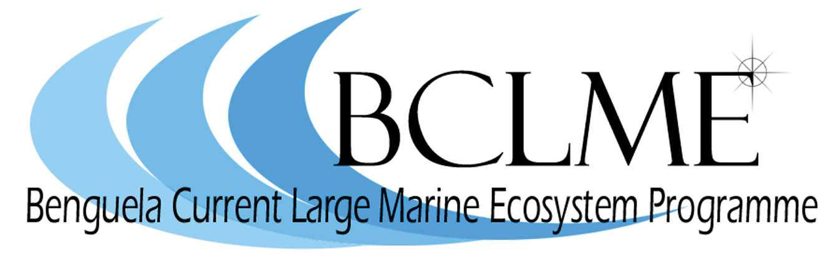

Retrospective Analysis of Plankton Community Structure in the Benguela Current Large Marine Ecosystem (BCLME), to provide an Index of Long-term Changes in the Ecosystem

First Progress Report

Prepared by Dr Hans M. Verheye
DEA&T - Marine & Coastal Management – Cape Town

03 August 2004

BCLME Project Reference Number: EV/PROVARE/02/05

Contact person:  Dr Hans Verheye  Tel: +27(0)21-430 7015  Fax: +27(0)21-434 2144  Email: hverheye@deat.gov.za | Report prepared for:  Benguela Current Large Marine  Ecosystem Programme




Introduction

Several of the world’s productive upwelling regions of the eastern boundary current systems have experienced substantial, decade-scale food web changes over the past four to five decades. These changes are not only reflected in extensive fluctuations in pelagic fish yields and regime shifts of fish populations (Lluch-Belda et al. 1989, 1992, Schwartzlose et al. 1999). They are also manifested in long-term variations in the abundance, distribution and species composition of the plankton (see Perry et al. 2004 and references therein) on which these fish rely at one or another stage of their life history for their successful growth and recruitment.

In the southern part of the BCLME off South Africa, an initial retrospective analysis of plankton samples collected over five decades in the St Helena Bay area has shown a significant increase in zooplankton, coinciding with changes in the recruitment and abundances of anchovy Engraulis encrasicolus and sardine Sardinops sagax (Verheye et al. 1998, Verheye and Richardson 1998, Verheye 2000, Cury et al. 2000). While extensive plankton collections exist for the central/northern BCLME off Namibia (referred to as the SWAPELS collections – South West African Pelagic Egg and Larval Surveys), no equivalent retrospective analysis has been undertaken there. As a consequence, it has not been possible to quantify (suspected) large changes in this part of the ecosystem (but see Hansen et al. 2004). A pilot programme of retrospective analysis of zooplankton off Namibia, focussing on a limited number of SWAPELS transects and years has, however, recently been initiated through the BENEFIT Programme (e.g. Tsotsobe et al. 2003, 2004; Mainoane 2003).

The overall objective of this BCLME project is therefore to extend and fast-track the abovementioned BENEFIT pilot programme so that changes in the entire BCLME region over the past 50 years can be properly documented and quantified. The provision of such baseline and time-series is crucial in the assessment of natural (climate change) and anthropogenically forced changes (fishing activities) in the ecosystem. Knowledge of such past changes is a prerequisite for sustainable ecosystem management in the future, and forms the subject of several global initiatives such as GLOBEC (Global Ocean Ecosystems Dynamics) and GOOS (Global Ocean Observing System), the protocols of which are largely followed in the BCLME.
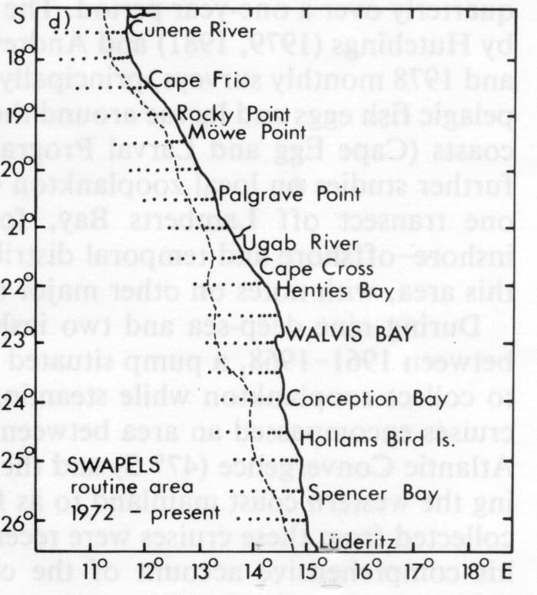The primary focus will be on the retrospective analysis of a representative amount of samples from the monthly SWAPELS collections between the Cunene River (17ºS) and Lüderitz (26ºS) off the Namibian coast during the 1970s and 1980s (Fig. 1), through student involvement (at BSc, MSc and PhD levels) with the assistance of a contracted sample analyst. Cataloguing and curation of the sample collections housed at MCM’s sample store, for which partial funds were obtained in the past from the Envifish and VIBES/IDYLE programmes, will continue. A long-term time-series database will be established following a comprehensive inventory of plankton and ancillary hydrographic and fisheries data archives available in the region. Relationships between indices of upwelling and demographic parameters of zooplankton and pelagic fish will be examined, with the primary focus on decade-scale variability and ecosystem change.

Figure 1: Map showing the cross-shelf transects and station
positions sampled monthly during the SWAPELS programme,
1972-1989 (from Shannon and Pillar, 1986)
Progress to date

Since the signing on 16 March 2004 of the agreement between UNOPS and BENEFIT for the execution of this BCLME project, progress to date has been made primarily with regard to the recruitment and appointment of human resources, on which the project relies heavily. The work plan covering the activities for the first year made provision for the following tasks:

TASK | STATUS
1. Sample analysis:
a. recruitment of 1 B.Sc.(Hons) student | studying at UWC
b. recruitment of 1 Ph.D. student | ongoing
c. recruitment of technical support staff (1 sample analyst) | appointed
2. Training:
d. identification of training opportunities | ongoing
3. Curation of sample collections
e. recruitment of 1 sample curator | appointed
4. Preparation of data archives for transfer to SADCO
f. recruitment of 1 data manager | to be advertized

Mr Ignatius Kauvee, from Namibia, registered for a B.Sc.(Hons) degree at the University of the Western Cape, Bellville, Cape Town, at the beginning of 2004. So far, he has completed the theoretical part of the course and is now ready to start with his project work. This will include microscopic analysis of a small selection of zooplankton samples from the SWAPELS collection, thereby focussing on the Walvis Bay region, historically one of the main fish spawning areas. His results will directly contribute to the long-term time-series dataset for this region, which is currently being established from data obtained under the BENEFIT-funded pilot project mentioned earlier. This preliminary decade-scale time-series of annual mean zooplankton biovolume, expressed as settled volume (ml m⁻²) – a crude estimate of biomass – is a first attempt at reconstructing a time-series of zooplankton off Namibia over a period of four decades (Fig. 2). It indicates that zooplankton levels within 30 nautical miles from the coast off Walvis Bay declined two-fold over the first two decades, from roughly 200 ml m⁻² in the late 1950s (from Kolmer 1963) to about 100 ml m⁻² in the late 1970s (Tsotsobe et al. 2003, 2004), after which biomass levels increased 4- to 6-fold during the next two decades, from ca. 100 ml m⁻² in 1981 (Tsotsobe et al. 2003, 2004) to 400-600 ml m⁻² in 2000 and thereafter (R. Cloete, NatMIRC, pers. comm.).

Figure 2: Preliminary time-series of annual means of coastal
zooplankton biomass (settled volume) off Walvis Bay during the
past five decades, re-constructed from published (Kolmer 1963)
and unpublished data

The recruitment of the Ph.D. candidate, Ms Fabienne Cazassus, from France, has been ongoing since late last year, and proves to be a rather lengthy process. This is largely attributable to the elaborate registration requirements of students – notably at Ph.D. level – at the University of Cape Town and partly also to visa requirements. On the other hand, recruiting Mr Ferdinand Kotze as a part-time sample analyst and Mr Philip de Vos as the sample curator was a comparatively smooth process. Both have recently been contracted with effect from 1 August 2004 and work has already started with vigour. Terms of reference for the position of data manager have been drawn up and the position will soon be advertised in the region.

Good progress has also been made in respect of the identification of appropriate zooplankton taxonomy training opportunities for students and technical support staff. Through the PI’s association with the Census of Marine Zooplankton (CMarZ), a project of the Census of Marine Life (CoML) programme, zooplankton scientists, students and technicians from the region will be able to participate in a number of international training workshops. These taxonomically-focussed meetings will address the need for additional expertise in the identification of selected zooplankton groups. For instance, prior to the 9th International Conference on Copepoda in Hammamet, Tunesia in July 2005, there will be a 5-day comprehensive training course in the biology and systematics of copepods, which form the bulk of most zooplankton communities and are the focus of this project. The course, which will be sponsored by the World Association of Copepodologists and held at the University of Bizerta, Tunisia, will comprise a mixture of lectures by leading specialists, laboratory-based practical sessions and informal, problem-solving discussions; tuition will be free of charge.

Literature cited

Cury, P., Bakun, A., Crawford, R.J.M., Jarre-Teichmann, A., Quinones, R., Shannon, L.J. and H.M. Verheye 2000 – Small pelagics in upwelling systems: patterns of interaction and structural changes in “wasp-waist” ecosystems. ICES J. mar. Sci. 57: 603-618.

Cushing, D.H. 1990 – Plankton production and year-class strength in fish populations: an update of the match/mismatch hypothesis. Adv. Mar. Biol. 26: 249-293.

Hansen, F.C., Cloete, R.R. & H.M. Verheye 2004 – Seasonal and spatial variability of dominant copepods along a transect off Walvis Bay (23˚S), Namibia. Afr. J. mar. Sci. 26 (in press)

Kollmer, W.E. 1963 – The pilchard of South West Africa. Notes on zooplankton and phytoplankton collections made off Walvis Bay. Investl Rep. Mar. Res. Lab. S. W. Afr. 8: 78 pp.

Lluch-Belda, D., Crawford, R.J.M., Kawasaki, T., MacCall, A.D., Parrish, R.H., Schwartzlose, R.A. and P.E. Smith 1989 – World-wide fluctuations of sardine and anchovy stocks: the regime problem. S. Afr. J. mar. Sci. 8: 195-205.

Lluch-Belda, D., Schwartzlose, R.A., Serra, R., Parrish, R., Kawasaki, T., Hedgecock, D. and R.J.M. Crawford 1992 – Sardine and anchovy regime fluctuations of abundance in four regions of the world oceans: a workshop report. Fish. Oceanogr. 1(4): 339-347.

Mainoane, T. 2003 – Changes in zooplankton abundance, species composition and distribution patterns in the north-central Benguela region: a 1984 Benguela Niño effect? M.Sc. project proposal; BENEFIT/University of Cape Town, 5 pp.

Perry, R.I., Batchelder, H.P., Mackas, D.L., Chiba, S., Durbin, E., Greve, W. and H.M. Verheye 2004 – Identifying global synchronies in Marine zooplankton populations: issues and opportunities. ICES J. mar. Sci. 61: 445-456.

Schwartzlose, R.A., Alheit, J., Bakun, A., Baumgartner, T.R., Cloete, R., Crawford, R.J.M., Fletcher, W.J., Green-Ruiz, Y., Hagen, E., Kawasaki, T., Lluch-Belda, D., Lluch-Cota, S.E., MacCall, A.D., Matsuura, Y., Nevarez-Martinez, M.O., Parrish, R.H., Roy, C., Serra, R., Shust, K.V., Ward, M.N. and J.Z. Zuzunaga 1999 – Worldwide large-scale fluctuations of sardine and anchovy populations. S. Afr. J. mar. Sci. 21: 289-347.

Shannon, L.V. and S.C. Pillar 1986 – The Benguela ecosystem: Part III: Plankton. Oceanogr. Mar. Biol. Ann. Rev. 24: 65-170.

Tsotsobe, S., Verheye, H.M. and M. Gibbons 2003 – Seasonal, interannual and inter-decadal variability in total zooplankton biomass in the northern Benguela. Annual Symposium of the Zoological Society of South Africa (ZSSA)/South African Society of Aquatic Sciences (SASAqS), University of Cape Town, June 2003.

Tsotsobe, S., Verheye, H.M. and M. Gibbons 2004 – Spatio-temporal variation in the abundance and community structure of the major copepod species in the northern Benguela. Annual Conference of the Australian Marine Sciences Association, Hobart, Tasmania, Australia, July 2004.

Unterüberbacher, H.K. 1964 – Zooplankton studies in the waters off Walvis Bay with special reference to the Copepoda. Investl Rep. Mar. Res. Lab. S. W. Afr. 11: 42 pp + Plates 2-36.

Verheye, H.M. 2000 – Decadal-scale trends across several marine trophic levels in the southern Benguela upwelling system off South Africa. Ambio 29(1): 30-34.

Verheye, H.M. and A.J. Richardson 1998 – Long-term increase in crustacean zooplankton abundance in the southern Benguela upwelling region (1951-1996): bottom-up or top-down control? ICES J. mar. Sci. 55(4): 803-807.

Verheye, H.M., Richardson, A.J., Hutchings, L., Marska, G. and D. Gianakouras 1998 – Long-term trends in the abundance and community structure of coastal zooplankton in the southern Benguela system, 1951-1996. In Benguela Dynamics: Impacts of Variability on Shelf-Sea Environments and their Living Resources. Pillar, S.C., Moloney, C.L., Payne, A.I.L. and F.A. Shillington (Eds). S. Afr. J. mar. Sci. 19: 317-332.

