EV/PROVARE/02/05 – Appendix A

Retrospective Analysis of Plankton Community Structure in the Benguela Current Large Marine Ecosystem (BCLME), to provide an Index of Long-term Changes in the Ecosystem

Progress report of the Data Manager on development of the inventory and database for plankton data in the Benguela Current
Submitted by the International Ocean Institute, Southern Africa

5 August 2005



In March 2005, the International Ocean Institute, Southern Africa (IOI-SA) was contracted by BCLME Project EV/PROVARE/02/05 “Retrospective analysis of plankton community structure in the Benguela Current Large Marine Ecosystem (BCLME), to provide an index of long-term changes in the ecosystem” to develop an inventory and database of plankton data for the BCLME. This report details progress to date.

Definition of the area of interest
It was necessary at the outset to define the BCLME area of interest as far as the plankton inventory and database were concerned. It was decided to use the area covered by SADCO which is somewhat larger than the area strictly defined by the BCLME, resulting in more comprehensive coverage of data than the BCLME region. The area of interest was thus defined as extending between 10ºN and 80ºS, and between 30ºW and 70ºE (Figure A). Data will thus span the BCLME region as well as the wider South-East Atlantic, and into the Indian and Southern Oceans. This will permit analysis not only within the BCLME itself, but will also allow comparison with adjacent systems, substantially enhancing the interpretive value of the BCLME data.

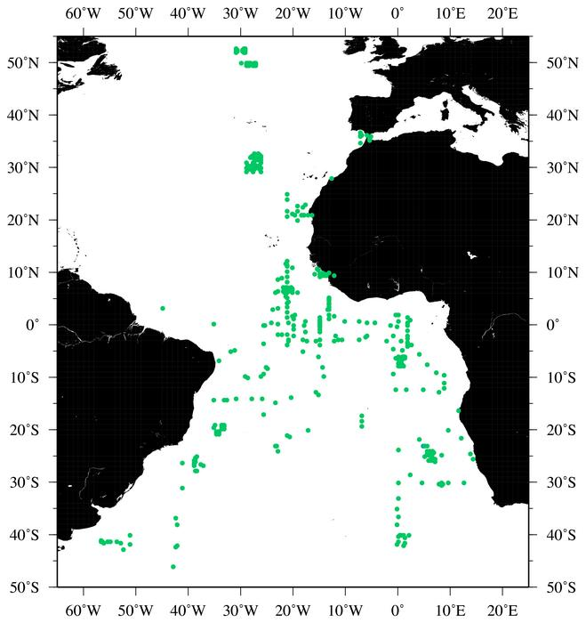
To 80ºS
To 70ºE

Figure A. Map indicating the area covered by the BCLME Plankton Inventory and Database.

Identification of data fields
IOI-SA met with SADCO to discuss the existing data table structure for the plankton database. The following tables provided by SADCO are designed to link to the main SADCO inventory, although they are not linked at present.

These tables were shown to Dr Larry Hutchings of MCM, who provided some useful insights into some of the data fields, and how these could be improved. Dr Hutchings’ comments have been added as annotations in italics to the table. Further input from other plankton researchers will be sought regarding the comprehensiveness of these data fields.

plaphy table
Name | Description | Unit | Example values
code | unique identifier for record – system generated |  | 105
station_id | unique station identifier – system generated |  | EMD000112
device_code | plankton sampling device code – actual device should be given (link to sampling_device table) |  | -44 = N100/70
method_code | sampling method code – actual method should be given (link to analytic_method table) |  | 1 = unknown
standard_code | link to ref_standard table |  | 1 = unknown
subdes | substation qualifier, e.g. hw, lw, etc |  | SEA
spldattim | sampling date and time |  | 1974-06-03 11:08:00
spldep | sampling depth |  | 0.1
spldis | not sure, but the field has values 50, 926 and 1853.  Distance, for continuous pump samples |  | 926
splvol | sample volume | litres | 0.9
meshsz | net mesh size | Microns | 200
ddbiom | discrete depth sampling biomass | g dry mass / m³
netflo | water flow through net  Also require volume filtered | m / s | 1.029
Phaeop  Chla would be preferable | Phaeophytin  Chlorophyll would be preferable | μg / l | no values
Phycell  * See note below table | phytoplankton cells | μg / l  no. cells/ l would be preferred | no values
prodty | productivity | μg / m³ / hr | no values
towatt | net attitude | n/a | OBLIQUE  HORIZONTAL  SURFACE
trawl_vol | sample volume (trawl) | units | no values
vpbiom | vertical profile biomass | g dry mass / m³ | no values
zoobio | zooplankton biomass | g dry mass / m³ | no values
* Number of cells is not always straight forward. Data derived using Coulter Counter techniques, for example, provide the numbers of cells within size classes rather than total counts.

platax table
Name | Description | Unit | Example values
plaphy_code | code as in plaphy table |  | 105
taxcod | unique taxonomic code | coded | 02022011002001
taxcom |  |  | unknown  ACTINULA LARVAE  CRAB ZOEAE
taxlev | taxonomic level |  | 6
taxcnt | no of specimens found |  | 31

taxdir table
Name | Description | Unit | Example values
taxcod | unique taxonomic code | coded | 02022011002001
phylum | taxonomic description |  | ARTHROPODA
class | taxonomic description |  | CRUSTACEA
order1 | taxonomic description |  | COPEPODA CALANOID
family | taxonomic description |  | Calanidae
genus | taxonomic description |  | Canthocalanus
species | taxonomic description |  | pauper
lowid | lowest identifier of creature |  | Canthocalanus pauper
This table does not make any provision for including data on moult stages or on sex of individuals.

taxcomm table
Name | Description | Unit | Example values
taxcod | unique taxonomic code, link to taxdir table | coded | 02020318014001
common_name | common name for species |  | Knysna Crab

taxauth table
Name | Description | Unit | Example values
taxcod | unique taxonomic code, link to taxdir table | coded | 02020915018001
taxauth | authority |  | 90/T002 90-08-08 LD

The following four data tables also form part of the plankton database, but are not dealt with in detail here as SADCO has yet to supply the descriptors of these.

Plachl table
Name | Description | Unit | Example values
Chla
Chlb
Chlc

Plapes table
Name | Description | Unit | Example values
DDE
DDT
Dieldrin
Lindane
PCB
TDE

Plapol1 table
Name | Description | Unit | Example values
Arsenic
Cadmium
Chromium
Cobalt
Copper
Iron
Lead
Manganese
Mercury
Nickel
Selenium
Zinc

Plapol2 table
Name | Description | Unit | Example values
Aluminium
Antimony
Bismuth
Molybdenum
Silver
Titanium
Vanadium

Architecture of the SADCO plankton database
The architecture of the SADCO plankton data follows a logical, hierarchical structure of linked tables (Figure B).

Station

Plaphy

Plachl
Plapes
Plapol1
Plapol2
Platax

Taxdir
Taxcomm
Taxauth

Figure B. Architecture of the SADCO plankton database.

Plankton records currently held by SADCO
The plankton database at SADCO currently contains data primarily from the CSIR in Durban. There are currently very few records in the plankton database (Table A).

Table A. Numbers of records currently held within the SADCO plankton database.

Table name | Number of records
Plaphy | 180 (from 178 stations)
Plapes | 38
Plapol1 | 23
Plpol2 | 0
Plachl | 0
Platax | 3361
Plaphy codes (unique) | 180

A note on the capacity of SADCO to host the BCLME plankton inventory and database
During the meeting with SADCO on 9 June 2005, it was made clear to IOI-SA that, while the architecture and the data tables exists for the plankton database, no functionality is currently in place for the plankton database at SADCO. SADCO thus has no mechanisms for entering, querying or retrieving data from the system. Building this functionality requires programming input. Since the mandate of SADCO does not currently extend to plankton data, resources from outside of SADCO’s usual funding will be required to develop such functionality. This presents a potentially important stumbling block in the development of the BCLME plankton inventory and database, and must be addressed if these products are going to be of any use to the region.

MCM data
Inventories of MCM data have already been compiled by Dr Betty Mitchell-Innes and updated by Dr Hans Verheye, and copies of these inventories have been acquired. Although these are descriptive in nature, and do not supply the necessary metadata themselves, they provide clear guidance on the extent of plankton data held by MCM and advice on accessing these data. The following tables extracted from the reports of Dr Mitchell-Innes (updated by Dr Verheye) summarize the data held by MCM.

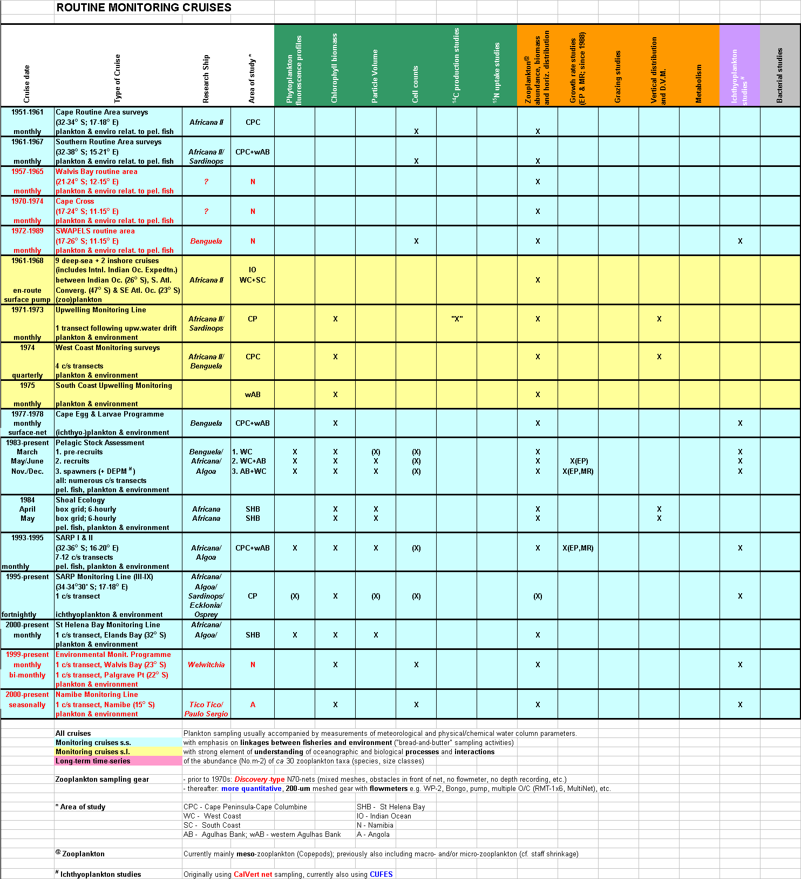
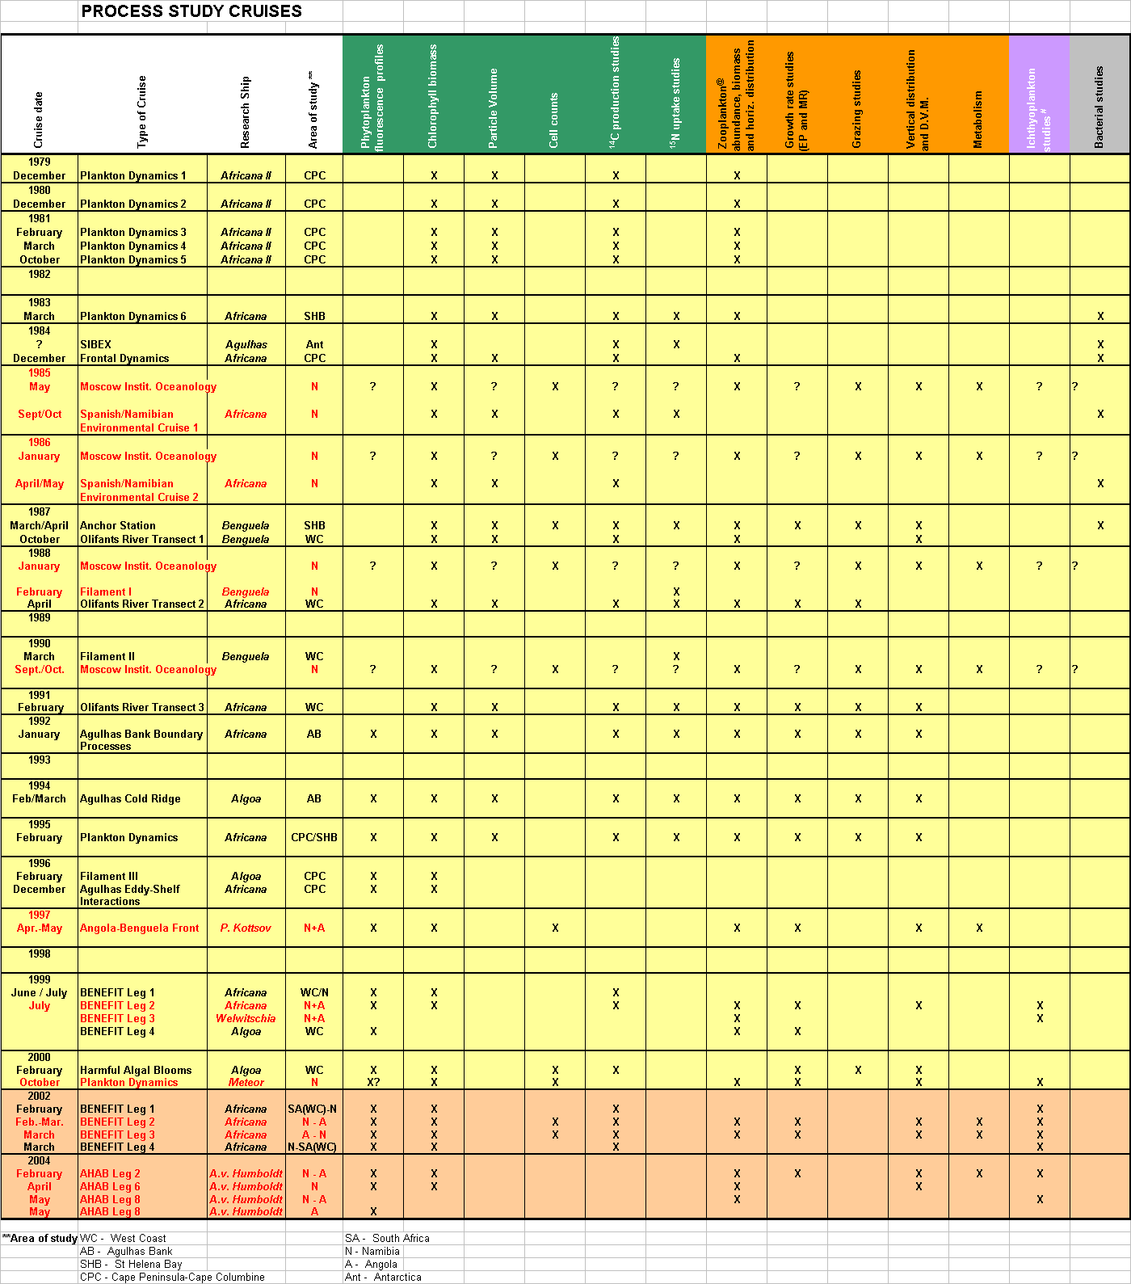
Namibian data
Preliminary discussions have been held with staff of the Ministry of Fisheries and Marine Resources in Namibia. A visit to Swakopmund to speak to Namibian plankton researchers will be planned later in 2005.

Angolan data
A visit to Luanda is planned by Dr Kim Prochazka for 13-16 September 2005 to make enquiries regarding data held in Angola. She will be accompanied by Dr Neville Sweijd, Director of BENEFIT, and they will be hosted by Mr Nkosi Luyeye, Director of INIP. The assistance of Mr Luyeye will be invaluable in providing introductions and insights into possible sources of data in the country. Where possible, meetings with key individuals will be set up prior to arriving in Luanda.

Russian data
Substantial data sets gathered by Russian scientists working in the BCLME region exist. One of these datasets, that belonging to the Institute of the Southern Seas in the Ukraine, is freely available via the internet on the COPEPOD database (Coastal and Oceanic Plankton Ecology, Production and Observation Database) hosted by NOAA. These data can be downloaded from the website at http://www.st.nmfs.gov/plankton/intro/index.html. The data consist of 23 Excel files spanning the central and southern Atlantic between 1963 and 1989. The files contain the following fields:

SHIP/CRUISE, YEAR, MONTH, DAY, TIMEloc, LATITUDE, LONGITUDE, UPPER_Z, LOWER_Z, MESH (size), IT IS_TSN, GPDB_BGC, BSC, T, COUNT/BIOMASS, UNITS, QF, SCIENTIFIC NAME, RECORD_ID, DATASET_ID

The 23 files contain a total of 162 769 records (Table B). Not all of these fall, however, within the BCLME region as defined in this project. It remains necessary to extract those data pertinent to the BCLME region.

Table B. Numbers of records contained within the 23 data files belonging to the Institute of the Southern Seas, Ukraine.

File | Number of records
90AK-640901_AK7_1 | 1785
90AK-641029_AK7_2 | 2418
90AK-641204_AK7_3 | 1254
90AK-650115_AK7_4 | 1202
90AK-650220_AK7_5 | 3324
90ML-630317_ML13 | 9640
90ML-630905_ML14 | 12507
90ML-640514_ML15 | 1964
90ML-700125_ML24 | 5428
90ML-700827_ML25 | 1302
90ML-730202_ML27 | 17610
90ML-760429_ML30 | 14956
90ML-770630_ML32 | 10764
90V2-781216_PV05 | 14276
90V2-811210_PV11 | 11766
90V2-820724_PV13 | 24915
90V2-841218_PV18 | 2816
90V2-851211_PV20 | 2392
90V2-861018_PV21 | 1880
90V2-870717_PV24 | 3187
90V2-981007_PV29 | 4548
90VE-701108_AV03 | 11533
90VE-741106_AV09 | 1302
Total records | 162769

We are lead to understand that there is another dataset comprising the “Russian data”. Discussions with local plankton researchers indicate that there were attempts to sell this second data set to the countries of the BCLME region some years ago, without success. Although preliminary enquiries have been made concerning these data, we have not yet been able to ascertain any precise information regarding these data. It thus remains necessary to identify the owner of this dataset before attempts can be made to repatriate these data.

The fact that attempts have already been made by the data owners to sell the data to the BCLME countries some years ago suggests that it is highly unlikely that the data will simply be handed over to the BCLME countries now. Nevertheless, efforts will be made to acquire the metadata so that this database is reflected in the BCLME plankton inventory. If time permits, efforts may also be made through diplomatic channels to repatriate these data to the BCLME countries.

Literature search
A literature search has been initiated in order to identify databases and data sources through publications and authors. The literature search is being done by an MSc student at the University of Cape Town. Where possible, copies of the publications will be acquired, and the bibliography plus the compiled publications will form an additional product of the inventorying work.

