Analysis of Benguela Dynamical Variability and Assessment of the Predictability of Warm and Cold Events in the BCLME

Report No. 2

RAF/00/G32 – Benguela Current Large Marine Ecosystem

31/01/2004

Compiled by Dr. Pierre Florenchie

for

United Nations Office for Project Services


Centre for Marine Studies  University of Cape Town | Oceanography  University of Cape Town

A - Executive Summary

The consultant submits to UNOPS the report N°2 following the schedule originally adopted (time for delivery is 2004/01/31). This report describes in detail Dr. Florenchie’s activities under the contract for the last 6 months and the progression of the project as initially planned point by point, in particular the new configuration of the high resolution regional model ROMS and the first regional simulations with idealized forcing. First section is a summary of the Eastern Boundary Upwelling Modelling Workshop held in Brest in September 2003 that has been compiled by the consultant. Section two provides a description of the ROMS model and its downscaling system (AGRIF). It includes also the specifications of the modelling platform system that has been purchased in the frame of the BCLME. Section three presents the preliminary configuration of the modellisation experiment and the result of the first simulations conducted with ROMS along the western coast of Africa at different resolutions with idealized forcing. Section four is dedicated to a preliminary study of the Angola dome using various datasets and OPA model outputs. One document “Seasonal and interannual fluctuations of the Angola Benguela frontal zone (ABFZ) using high resolution satellite imagery from 1982 to 1999” has been attached to the report. It corresponds to a paper which first author is the master student Jenny Veitch and that has been submitted to the International Journal of Remote Sensing. As part of the capacity training aspect of the BCLME, Jenny Veitch was also involved in the study concerning the Angola dome (section 4). The student Pedro Tchipalanga has completed his master and is now back in Angola. A paper entitled “Evolution of Interannual Warm and Cold Events in the South-East Atlantic Ocean” has been accepted for publication by the Journal of Climate with the consultant as the first author. It follows a document presented in the report n°1 concerning the variability of the South Atlantic ocean. It has been deeply modified and improved. It also includes a new analysis of ocean-atmosphere flux exchanges over the South Atlantic ocean during anomalous events. This document is of course available at your request.

Table of Contents

A - Executive Summary 2
1 – Summary of Eastern Boundary Upwelling Workshop 4
1.1 – Introduction 5
1.2 – Work progress and first results (IRD/IDYLLE, UCT, MCM) – Benguela area 5
1.3 – Future development 6
1.4 – Description of projects and programs 7
1.5 – Planned actions and resources between the different partners (UCT, BCLME, IDYLE, LODYC, LPO, UCT, MCM) 10
1.6 – Conclusions 12
References: 13
2 – Presentation of the ROMS model and the modelling platform 14
2.1 – Introduction 14
2.2 – Description of the ROMS model 15
2.3 – Modelling platform specifications 18
3. - Configurations of the regional model ROMS and first simulations using an idealized forcing 19
3.1 - Three configurations: 1/3° (a), 1/6° (b) and 1/12° (c) resolutions 19
3.2 - Outputs from the 3 idealized simulations 20
3.3 – Conclusions 23
4 - A Study of the Angola Dome – Preliminary results 25
4.1 - Introduction 25
4.2 - Description of the model 26
4.3 - Climatological temperature and salinity fields from the OPA model 27
4.4 - Climatological velocity fields associated with the Angolan dome from the OPA model 30
4.5 - Sea level climatology from TOPEX-Poseidon altimetry data 34
4.6 - Impact of local wind forcing via Ekman pumping 35
4.7 - Impact of local net heat fluxes 36
Conclusion 36
References 37
APPENDIX 1 38

1 – Summary of Eastern Boundary Upwelling Workshop

held at Research and Development Institute (IRD), Brittany, France, 18-19 September 2003.

Abstact:

The consultant has attended the workshop in order to develop cooperation between the BCLME, UCT and various partners involved in coastal modelling of upwelling areas around the world. A lot of technical aspects concerning the use of the ROMS coastal model have also been discussed.

Participants :
Claude Roy (IRD/IDYLE), Yves Dupenhoat (LEGOS) , Alain Colin de Verdière (UBO), Vincent Echevin (IRD/LODYC), Olivier Aumont (IRD/LODYC), Pierrick Penven (IRD/IDYLE), Patrick Marchesiello (IRD/IDYLE), Eric Machu (UCT), Pierre Florenchie (UCT/BCLME), Laurent Debreu (LMC), Sabrina Speich (UBO/LPO), Bruno Blanke (LPO), Steven Herbette (JRC-Italie), P. Rivière (LEMAR), P. Pondaven (LEMAR), H. Ludos Ayina (LOS/IFREMER).

IRD: Research and Development Institute
IFREMER: French institute for the exploitation of the sea
BCLME : Benguela Current Large Marine Ecosystem – UNOPS
LOS: Spatial oceanography laboratory
LEMAR: Marine environment laboratory
UBO: University of Brittany
LPO: Oceanic physics laboratory
LEGOS: Spatial geophysical studies and oceanography laboratory
IDYLE: Interactions and Spatial Dynamics of renewable resources in upwelling Ecosystems (A French-South African Co-operation Research Programme).

1.1 – Introduction

This workshop follows the agreement achieved during the Humboldt meeting held in Lima (Peru - March 2003) between the IRD and various partners working on eastern boundary system modellisation (i.e. upwellings of Benguela, Humboldt and Canaries). Participants in Lima had chosen to share scientific tools and skills. As a result, it has been decided to organize workshops on a regular basis, during which technical aspects as well as scientific strategies will be discussed. The first workshop was held at the IRD centre of Brittany on the 18th and 19th of September 2003. This document is a synthesis of the various discussions and decisions.

1.2 – Work progress and first results (IRD/IDYLLE, UCT, MCM) – Benguela area

The modeling program of the Benguela area started with the VIBES project (Viability of exploited pelagic fish resources in the Benguela Ecosystem). The fisheries related question that it aims to answer is ‘what are the transport and retention processes affecting the recruitment of small pelagic fishes in the south Benguela area ?’ The Benguela upwelling system off southwestern Africa is productive but also highly dispersive. Sardine and anchovy adapted their own reproduction strategy in spawning outside the upwelling area, on the Agulhas bank. However, larvae and juvenile fishes are found concentrated in the feeding ground of the St Helena bay. A trapping process is therefore needed within this environment favourable to their development.

A series of idealized barotropic experiments has been realised to reproduce the main caracteristics of the St Helena Bay, i.e. a northward current driven by wind and interacting with a cape and a broadening of the bank. A cyclonic recirculation is produced by the cape, controlled by bottom friction and by the generation of stationary bank waves [Penven et al.(2000)]. A lagrangian float allowing a measurement of the time taken by a fluid particule flowing from the upstream boundary has been introduced to quantify the retention process.

A realistic high-resolution ocean model ROMS has been developed to simulate the transport from the spawning area towards the Benguela upwelling system [Penven et al.(2001)]. Despite a climatological atmospheric forcing with little variability, the model reproduces a strong mesoscale variability. A lagrangian float has been introduced in the model to represent the distribution of eggs spawned on the Agulhas bank. It reveals the presence and efficiency of the Good Hope jet as the transport mechanism. If mesoscale activity is not explicitly resolved, the float tends to drift offshore under the action of the wind, resulting in very few eggs reaching St Helena Bay. On the contrary, eddy activity can counteract this offshore drift.

Model outputs have been used to force a lagrangian IBM model allowing to track eggs and larvae (Individual Based Model). The purpose of the IBM experiment is to illustrate an adaptative assumption for reproduction strategies [Mullon et al.(2002)], to test the effects of floatability on recruitment success [Parada et al.(2003), Mullon et al.(2003)] and to quantify the relative importance of various environmental factors (season, spawning area, etc...) on the eggs advection towards St Helena Bay.

New ERS winds have then been used to test their impact on the southern Benguela area [Blanke et al.(2002)]. According to this experiment, sea surface temperature (SST) variability on the Agulhas bank is mainly related to local wind fluctuations, while SST variability is also linked to the open ocean circulation along the western coast bank. The respective roles of eddy activity, low frequency and intra-monthly wind fluctuations have been diagnosed. Last but not least, the model appears to be in good agreement with observations, which confirms the utility of such a tool to study anomalous events in the Benguela system.

1.3 – Future development

- Development of a new model

A new model of the Benguela upwelling system has been developed. Resolution of Agulhas current dymanics has been a key issue, since this current is one of the mightiest currents of the world (velocities as high as 2 m/s). It retroflects off the Cape of Good Hope, and generates the largest ever observed eddies (diameter over 300 km). The correct simulation of such highly energetic eddies by a coastal model is a difficult task. An intermediate resolution model (1/6°) was first used. Depending on the quality of model outputs, the model resolution might be increased in order to adequately simulate processes involving finer scales.

- Inshore-offshore exchange in St Helena Bay

Eulerian and lagrangian studies performed by the IDYLE group in these last years presented a good description of the transfer processes from the Agulhas bank to St Helena bay. However it is still unclear how larvae can migrate from the Colombine jet, downwards to the bottom of St Helena Bay. Instability processes, coastal waves, upwelling relaxation, swimming, etc... might explain such a migration. The modeling tool will be used to verify various assumptions.

- Influence of small-scale wind structures in the southern Benguela system

Numerous publications have related the specific dynamics in St Helena Bay to small-scale spatial wind patterns. Too few data are available along the coastal band to study these phenomena. In collaboration with EGS (Environmental and Geographical Science, UCT) it has been suggested to use a very high resolution atmospheric model to force the ocean model and compensate for the lack of data.

- Influence of the Agulhas current on the coastal jet and instability processes in the southern Benguela system

The presence of the powerful Agulhas current makes the Benguela system very unique. This current may influence the upwelling dynamics. For instance, warm water originating from the retroflection may pinch and sharpen the upwelling front. It is suggested to conduct a series of experiments in order to test this hypothesis.

1.4 – Description of projects and programs

- Modelling and forecasting Benguela Ninos (BCLME)

The area of study includes Angola, Namibia and South Africa. According to a tropical ocean model of the South Atlantic, temperature anomalies originate in the western and central equatorial Atlantic ocean at depth. These anomalies are triggered by a relaxation of trade winds and then propagate as Kelvin waves below the surface eastward along the equator until they reach the African coast. Then they reflect into coastal waves propagating southward and become visible at the surface along the coast of Angola and Namibia during several months [Florenchie et al. (2003)]. Therefore a high-resolution coastal model (ROMS) spreading from the equator to about 25°S will be developed to obtain a detailed description of the phenomenon and its impacts. A main problem concerns the choice of a large-scale model to force the coastal model along its open boundaries (OCCAM, ... ?).

- Dynamic/ecosystem coupled models in the Benguela area (IRD/ IDYLE, UCT, MCM)

Coupled experiments using a realistic low-resolution configuration have to be carried out. Two NPZD-like (Nitrate, Phytoplankton, Zooplankton and Detritus) ecosystem models have been compared : the NPZD and N-2P-2Z-2D-2 models. It appears necessary to take into account the two phytoplanktons to represent correctly the offshore gradient of chlorophyll. Simulating the Agulhas current correctly is also essential : the phytoplankton distribution along the Agulhas bank is badly reproduced because the current seems to be trapped along the bank. It is planned to assimilate chlorophyll satellite data, to estimate various parameters using twin experiments and to study processes at meso and smaller scales. Monthly sections of data may be available for validation.

- Humboldt system dynamics (IRD / LODYC [a, c] – IRD / IDYLE and IMARPE [b]):

(a) Two modelling studies on the circulation have been conducted, one using the OPA model and the latter with the regional model ROMS. Outputs reproduce reality quite well, especially with the ROMS model (output parameters such as variability of sea level, coastal wave speeds, maximum intensity of the undercurrent). However a more precise validation has to be undertaken using comparisons with in situ observations (sections, current-meter moorings), in collaboration with COPAS (Centre for Oceanographic Research in the South-Eastern Pacific) for the northern part, and IMARPE (Instituto del Mar del Perú) for the southern part of the upwelling. Under consideration are the following projects: 1) biogeochemical coupling, in order to illustrate and analyse the structure and variability of the area of minimum oxygen, in the frame of the SHOC program (Humboldt System Oxygen and Circulation), 2) preparation of the SHOC survey in 2005, and 3) applied studies for fisheries in collaboration with IMARPE.

(b) A high resolution model (1/9°) of the upwelling system of Peru has been configured [Penven et al.(2003)]. Its domain spreads from 20°S to 3°N and from 90°W to 70°W. As a result it explicitly solves the eastern equatorial dynamics, the Peru current system and the interactions between the two. A stream function, showing the non-divergent component of yearly-mean surface currents has been derived from the model outputs. It seems to reproduce the actual circulation very realistically. The subsurface circulation is also in good agreement with the real ocean. The model seasonal cycle has been compared to observed SST data from AVHRR (Advanced Very High Resolution Radiometer – NOAA/NASA) and to altimeter data. Because interannual variability is not solved, this simulation can be used as a basis for future work. A study concerning eddy activity shows that the model reproduces eddies that get larger towards the equator. This is related to the increase of the Rossby internal radius towards the equator.

(c) Dynamic and biogeochemical coupling in the Humboldt system
The coupling experiment is based on two coupled models, PISCES/OPA and FASHAM/ROMS, using simplified configurations, with low resolution (0.5°). The PISCES/OPA configuration has closed boundaries along 100°W, 5°S and 45°S, and sponge layers (i.e. no actual open boundaries). However the resulting circulation is in rather good agreement with observations over the area, and surface spatial patterns and variability of chlorophyll compared well with climatology from Seawifs data. The FASHAM/ROMS coupled model is more realistic in terms of dynamics, but the surface chlorophyll level is overestimated in the coastal zone and offshore because of a bad tuning of parameters. Some problems could be related to the advection scheme in ROMS.

- Canary Islands upwelling project (IRD/IDYLE)

A study of mesoscale circulation, from decadal to higher frequency variability, will be conducted using the ROMS model. The influence of the NAO could be investigated. Coupled simulations with the ecosystem will be performed, including some high resolution wind forcing using the MM5 outputs.

1.5 – Planned actions and resources between the different partners (UCT, BCLME, IDYLE, LODYC, LPO, UCT, MCM)

- Dynamic and biogeochemical coupling:

Various ecosystem models have been already coupled with the dynamic ROMS model (NPZD, N2P2Z2D2 and other models from UCLA, including the carbon and oxygen cycles). Each model appears to have its own purpose, for instance to study the influence of dynamics on the ecosystem (NPZD), or the biogeochemical processes (PISCES). Nevertheless each project is not limited to the use of a single model. It is planned to keep the models available and equally updated for each project.

- Dynamic model

A reference version of ROMS will be archived at the IRD centre. This version will be available to all ROMS users involved in this collaboration. It will include the ultimate development of ROMS : lagrangian floats, tide forcing, updated versions, etc...

- Visualisation tools

Various Matlab programs will been designed for ROMS to prepare the forcing, the initial and boundary conditions, the bathymetry, etc... A document explaining these programs will be available online, with diagnostic and visualisation tools for the model outputs.

- Forcing :

One group (LOS/IFREMER) develops its own products in terms of heat flux and wind, using for instance satellite scatterometer data for winds (ERS, NSCAT, Quickscat). Such products offer the advantage to be more realistic compared to atmospheric model outputs (ECMWF, NCEP).
Available products are the following :
- ERS : 1°, weekly
- Quickscat : 0.5°, daily
- High resolution products especially designed for the Gulf of Guinea under the auspices of the AMMA project (multidisciplinary analysis of the African monsoon).

Wind validation is performed over an entire oceanic basin. Data from meteorological buoys located offshore are sometimes used, but coastal winds remain problematical. A precipitation product is also available, but validation has not been done yet. Two different approaches are possible : the first consists in using coherent forcing fields from models (ECMWF, NCEP). The second is to take forcing fields from different sources and therefore not necessarily coherent (for instance wind from ERS and flux from NCEP). It is not clear yet which one is the best. Bulk formulas are required in both cases. Another approach has been suggested : a relaxation term towards SST is included in the flux equation. It then becomes ambiguous to validate the model dynamic via SST. As a conclusion, it appears that various options will have to be tested within the MERCATOR project to force a global model.

Another study using the model ROMS considered the response of the simulated California upwelling to forcing from various wind fields : a COADS climatology (0.5°, ship data), a NCEP climatology based on a global low-resolution model, a "climatology" based on QUICKSCAT data (1999-2000), a climatology from the regional COAMPS model. An analysis of wind curl structures shows that the NCEP model and the COADS data are very smoothed. On the other hand small-scale structures appear with COAMPS, with local maxima occurring in the vicinity of assimilated or interpolated data in the model (smart interpolation). It seems that best results are obtained using the QUICKSCAT forcing. It also appears that a good knowledge of wind stress within a 10km-wide band off the coast is crucial because of the sharp drop of the wind in this zone. To get such information it might be necessary to use atmospheric meso-scale models like MM5 (NCAR) and to mix their outputs with QUICKSCAT data to obtain the adequate forcing, with the right accuracy both offshore and at the coast [Chao et al. (2003)]. A MM5-like simulation will be conducted for a test period of one month to evaluate the impact of small spatial wind structures over each upwelling area. The assessment will be achieved in boreal spring 2004 and it will be decided if MM5 products are adequate for a high resolution experiment.

- Various large scale models are available to force the regional models and to provide the initial conditions. The TOTEM configuration is based on the OPA model (LODYC) for the tropical Atlantic ocean. It has been shown that this configuration gave good results to reproduce Benguela Niños. On the other hand, the CLIPPER configuration (1/6°, also based on OPA) failed to reproduce them, maybe because the former configuration used ERS winds while the latter used ECMWF winds to force the model. Results from the global ORCA2° and ORCA0.5° (OPA) experiments have not been analysed yet in the eastern tropical Atlantic ocean. A climatology based on ORCA2° outputs have been tested in the Pacific ocean (1992-1996). An interannual simulation has been carried out but still needs to be analysed. Outputs from the ORCA2° and ORCA0.5° configurations should be available from the LODYC. Climatological outputs from the OCCAM model (1/4°) can be used directly to initiate and force the ROMS model with specifically created numerical tools and programs.

- Satellite data (SST, SeaWifs, altimetry) :

Each team works on its own data set and it would be valuable to merge them into a more comprehensive compilation.

- MERCATOR project :

As noted above a key issue concerns the use of a global model to force the regional model at its open boundaries and to provide the initial state. The POG (Prototype Ocean Global) model has a rigid lid and it will be necessary to calculate a free surface to initiate ROMS. Experiments have shown that it is relatively easy to increase the resolution of ROMS (from 1/4° to 1/12° for instance). It is planned to start a configuration of ROMS with a 1/4° grid (like POG) and then to progressively increase the resolution. A MERCATOR workshop in October 2003 will provide details concerning the extraction of POG outputs, the testing period and the forcing.

1.6 – Conclusions

Next meeting is scheduled in March 2004. By this date the following should be in place :
  - a website with the ROMS tools
  - a website with a reference ROMS version available to all users
  - validation and availability of biogeochemical models (NPZD and PISCES coupled with ROMS)
  - downscaling test results with MM5 for the 3 areas
  - preliminary initialisation/forcing experiments with ROMS and POG over a one-month period

References:

Blanke, Bruno, Claude Roy, Pierrick Penven, Sabrina Speich, James McWilliams, and Greville Nelson, 2002: Linking wind and interannual upwelling variability in a regional model of the southern Benguela. Geophys. Res. Lett., 29, 10.1029/2002GL015718.
Chao, Yi; Li, Zhijin; Kindle, John C.; Paduan, Jeffrey D.; Chavez, Francisco P., 2003. A high-resolution surface vector wind product for coastal oceans: Blending satellite scatterometer measurements with regional mesoscale atmospheric model simulations, Geophys. Res. Lett. Vol. 30 No. 1, 10.1029/2002GL015729.
Florenchie P., J.R.E. Lutjeharms, C. J. C. Reason, S. Masson and M. Rouault, 2003: The source of Benguela Niños in the South Atlantic Ocean, Geophy. Res. Lett., 30, 10, 1505, doi: 10.1029/2003GL017172.
Mullon C., Cury, P. and Penven, P. 2002. Evolutionary Individual-Based Model for the Recruitment of the Anchovy in the southern Benguela. Can.J. Fish. Aquat. Sci. 59 : 910-922.
C. Mullon, P. Freon, C. Parada, C. Van Der Lingen, J. Huggett. 2003. From particles to individuals: modelling the early stages of anchovy (Engraulis capensis/encrasicolus) in the southern Benguela . Fisheries Oceanography; Volume 12, Issue 4-5, Page 396
Parada, C., C.D. van der Lingen, C. Mullon et P. Penven, 2003. Modelling the effect of buoyancy on the transport of anchovy (Engraulis capensis) eggs from spawning to nursery grounds in the southern Benguela: an IBM approach, Fish. Oceanogr., 12, 170-184.
Penven, P., C. Roy, A. Colin de Verdière et J. Largier, Simulation and quantification of a coastal jet retention process using a barotropic model, 2000, Oceanol. Acta, 23, 615-634.
Penven, P., C. Roy, J.R.E. Lutjeharms, A. Colin de Verdière, A. Johnson, F. Shillington, P. Fréon et G. Brundrit, A regional hydrodynamic model of the Southern Benguela, 2001, S. Afr. J. Sci., 97, 472-476. Penven , P., J. Pasapera, J. Tam, et C. Roy, Modelling the Peru Upwelling System average circulation and seasonal cycle, 2003, Globec International News Letter, sous presse.

2 – Presentation of the ROMS model and the modelling platform

2.1 – Introduction

As noted in the report n°1, the regional modelling project consists in simulating the evolution of oceanic circulation and parameters (temperature, salinity, etc…) along the coasts of Angola, Namibia and South Africa. The aim is to understand the oceanic variability at different depths and scales in the domain of study and its origin (remote or local). High resolution modelling has a lot of applications for the BCLME and will lead us towards operational oceanography, like the implementation of an early warning system. This work requires the implementation of a suite of nested hydrodynamic configurations thanks to the AGRIF system (Adaptive Grid Refinement In Fortran). It has been shown by former studies that a grid of 5 km is a minimum resolution to reproduce correctly the instabilities associated with a coastal upwelling cell. The consultant has implemented the last version of the Regional Ocean Modelling System (ROMS) model for the coastal modelling in the BCLME. The OCCAM and the POG model outputs will be used to force the regional model. The preliminary simulation experiments described here used idealized forcing. Due to some delays in the delivery of the computational capability system for the BCLME, simulations have been performed on the Atlantic PC, which specifications have been described in the report n°1. However this computer appears to be quite limited in terms of computational capacity when high resolution simulations are performed. Such simulations will be carried out over a long-time period when the platform will be operational. It should occur within the next weeks.

2.2 – Description of the ROMS model

The Regional Ocean Model System (ROMS) is a free-surface, hydrostatic, primitive equation ocean model that uses stretched, terrain-following coordinates in the vertical and orthogonal curvilinear coordinates in the horizontal. It has been expanded to include a variety of new features including high-order advection schemes; accurate pressure gradient algorithms; several subgrid-scale parameterizations; atmospheric, oceanic, and benthic boundary layers; biological modules; radiation boundary conditions; and data assimilation. For computational economy, the hydrostatic primitive equations for momentum are solved using a split-explicit time-stepping scheme which requires a special treatment and coupling between barotropic (fast) and baroclinic (slow) modes. A finite number of barotropic time steps, within each baroclinic step, are carried out to evolve the free-surface and vertically integrated momentum equations. In order to avoid the errors associated with the aliasing of frequencies resolved by the barotropic steps but unresolved by the baroclinic step, the barotropic fields are time averaged before they replace those values obtained with a longer baroclinic step. A cosine-shape time filter, centred at the new time level, is used for the averaging of the barotropic fields. In addition, the separated time-stepping is constrained to maintain exactly both volume conservation and constancy preservation properties which are needed for the tracer equations. Currently, all 2D and 3D equations are time discretized using a third-order accurate predictor (Leap-Frog) and corrector (Adams-Molton) time-stepping algorithm which is very robust and stable. The enhanced stability of the scheme allows larger time steps, by a factor of about four, which more than offsets the increased cost of the predictor-corrector algorithm. In the vertical, the primitive equations are discretized over variable topography using a stretched terrain-following coordinates. The stretched coordinates allow increased resolution in areas of interest, like thermocline and bottom boundary layers. The default stencil uses centred, second-order finite differences on a staggered vertical grid. This class of model exhibits stronger sensitivity to topography which results in pressure gradient errors. These errors arise due to splitting of the pressure gradient term into an along-sigma component and a hydrostatic correction. The numerical algorithm in ROMS is designed to reduce such errors. In the horizontal, the primitive equations are evaluated using boundary fitted, orthogonal curvilinear coordinates on a staggered Arakawa C-grid. The general formulation of curvilinear coordinates includes both Cartesian (constant metrics) and spherical (variable metrics) coordinates. Coastal boundaries can also be specified as a finite-discretized grid via land/sea masking. As in the vertical, the horizontal stencil utilizes a centred, second-order finite differences. However, the code is designed to make the implementation of higher order stencils easily. ROMS has various options for advection schemes: second- and forth-order centred differences; and third-order, upstream biased. The later scheme is the model default and it has a velocity-dependent hyper-diffusion dissipation as the dominant truncation error. These schemes are stable for the predictor-corrector methodology of the model. There are several subgrid-scale parameterizations in ROMS. The horizontal mixing of momentum and tracers can be along vertical levels, geopotential (constant depth) surfaces, or isopycnic (constant density) surfaces. The mixing operator can be harmonic (3-point stencil) or biharmonic (5-point stencil).

The vertical mixing parameterization in ROMS can be either by local or nonlocal closure schemes. The local closure scheme is based on the level 2.5, turbulent kinetic energy equations whereas the nonlocal closure scheme is based on the K-profile, boundary layer formulation. The K-profile scheme has been expanded to include both surface and bottom oceanic boundary layers. In addition, there is a wave/current bed boundary layer scheme that provides the bottom stress and sediment transport which become important in coastal applications. Currently, the air-sea interaction boundary layer in ROMS is based on a bulk parameterization.

The data assimilation in ROMS is via a multivariate, intermittent Optimal Interpolation (OI) scheme in which observations and model data are melded together taking into account errors in the observations and prediction. This data assimilation scheme is very efficient and inexpensive, but it is sub-optimal.

ROMS is a very modern code and uses C-pre-processing to activate the various physical and numerical options. The code can be run in either serial or parallel computers. The code uses a coarse-grained parallelization paradigm which partitions the computational 3D grid into tiles. Each tile is then operated on by different parallel threads. Originally, the code was designed for shared-memory computer architectures and the parallel, compiler dependent, directives (OpenMP Standard) are placed only in the main computational routine of the code. An MPI version of the code is currently being developed and in the future both shared- and distributed-memory paradigms will coexist together in a single code.

ROMS has extensive pre- and post-processing software for data preparation, analysis, plotting, and visualization. The entire input and output data structure of the model is via NetCDF which facilitates the interchange of data between computers, user community, and other independent analysis software.
More information and references can be found on the following sites:
http://marine.rutgers.edu/po/index.php?model=roms&page=
http://ono.ucsd.edu/roms-ecpc/

- ROMS Embedded Gridding – the AGRIF package
In order to obtain local solutions at high resolution while preserving the large-scale circulation at affordable computational cost, a nesting capability has been integrated into ROMS. It is based on the AGRIF (Adaptive Grid Refinement in Fortran) Fortran 90 package based on the use of pointers. AGRIF is an adaptive mesh refinement package. It has been Written in Fortran 90 for the integration of full adaptive mesh refinement features within an existing multidimensional finite difference model written in the Fortran language (contact: Laurent.Debreu@imag.fr). In the following example, AGRIF has been included in an ocean model in order to reach a very high resolution in the bay of Los Angeles and to study the transport of sediments and pollutants. The picture represents the surface temperature on the root grid resulting of a series of embedded grids of increasing resolution. Simulations were performed by Patrick Marchesiello (UCLA - IRD) using the ROMS model.
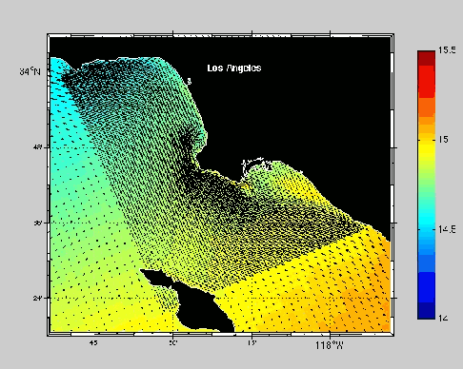

2.3 – Modelling platform specifications
- Storage device and gateway machine: This machine is an Intel(R) Pentium(R) 4 CPU 2.66GHz with 256Mb RAM with an Adaptec 29160UW SCSI Adapter and 3 x 1000 bps network adapters. A 3-ware IDE RAID controller integrates 8 x 250Gb drives to a 1.75 Tbyte striped RAID-5 file server with an SCSI attached SuperDLT 10 tape (320/160Gb) backup library. The OS installed is a stock standard Slackware-9.1.

- Two computational servers: These are two Dual Intel(R) Xeon(TM) CPU 3.06GHz 32-bit processors, each with 1Gb RAM and 26Gb local scratch space and NFS mount access to the 1.75 Tbyte disk volume on BART. Each machine in powered by Slackware Linux v9.1 which includes gcc v3.2.3 and libc v2.3.2. and is commanded by GNU Linux kernel 2.4.23 Symmetrical Multi-Processor version. Additionally Intel(R) Fortran Compiler v7.1 is also installed

- Networking interconnect is achieved via a 24 port 3Com 3c17300 Gigabit switch.

- A single UPS ensures a clean power supply and buffer time for clean shutdowns upon power supply failure.

3. - Configurations of the regional model ROMS and first simulations using an idealized forcing

3.1 - Three configurations: 1/3° (a), 1/6° (b) and 1/12° (c) resolutions

To perform a simulation using ROMS, the modeller needs to provide a whole set of data in a specific format: horizontal grid, topography, surface forcing, lateral boundary conditions. The topography used here is etopo2 with a 1/12° resolution (http://dss.ucar.edu/datasets/ds759.3/data/doc_1). It is extracted over the domain and interpolated to the grid using a routine called make_grid.m. Surface forcing including winds and various surface fluxes is interpolated from the COADS climatology (http://www.cdc.noaa.gov/coads/index.shtml) using a routine called make_forcing.m. The last pre-processing step consists in generating the files containing the information for the lateral open boundaries and the initial conditions from Levitus world ocean Atlas using the make_clim.m routine.

As mentioned above, the computational capacity of the Atlantic PC allowed the consultant to perform the first regional simulations at different resolutions for limited periods: 3 months (a), 2 month for (b) and 1 month for (c). The time step has been adjusted to fit the horizontal resolution: from 1 hour for the first configuration to 900s for the third one. It implies of course that the increase of the resolution results in a non-linear increase of the CPU time. The domain has been extended northward and eastward compared to previous experiments concerning the Southern Benguela area. In the first configuration the northern border of the domain reaches the coast of Guinea in order to limit the number of open boundaries. It extends from 28°S to 10°N, and from 1°E to 17°E. In the second and third configurations (respectively 1/6° and 1/12°) the domain extends from 28°S to 2°S, and from 1°E to 17°E. The domain has been reduced in the (b) and (c) configurations to limit the CPU time. Figure 3.1 illustrates the three different grids obtained.

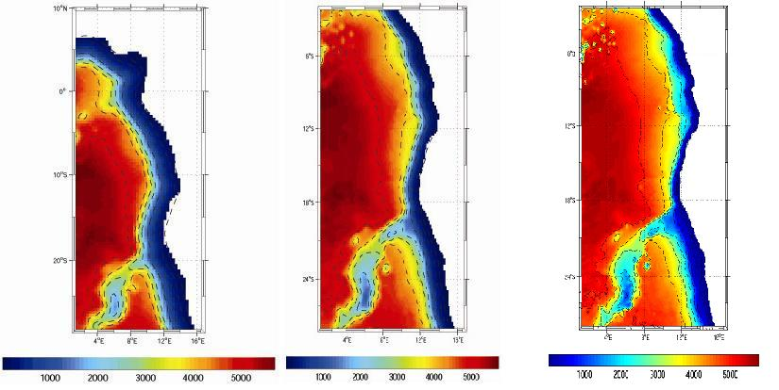
(a) (b) (c)
Figure 3.1: The different configurations for the preliminary experiments with 3 resolutions (1/3°, 1/6° and 1/12°).

3.2 - Outputs from the 3 idealized simulations

Figures 3.2 and 3.3 represents snapshots of the surface temperature and salinity fields at various instants. At this stage, the shortness of the period of the simulations does not allow to make any comment or further analysis concerning the quality of the outputs. On top of that initial condition for the velocity field is at rest. The spin-up of the model can take a few years of simulation, until the averaged kinetic energy over the domain becomes stable. However the purpose of such experiments was to become familiar with the implementation of the model and the tuning of various parameters (time step, resolution, size of the buffer zone, bottom and lateral viscosity, etc…). The imminent introduction of the modelling platform is going to improve greatly our ability to perform longer runs.

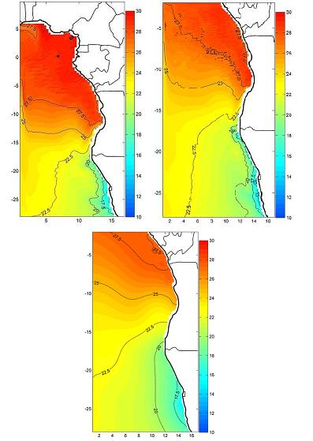

Figure 3.2: Snapshots of the temperature fields on March 15 with 1/3° (top left panel), on February 15 with 1/6° (top left panel) and on January 20 with 1/12° (Bottom panel).

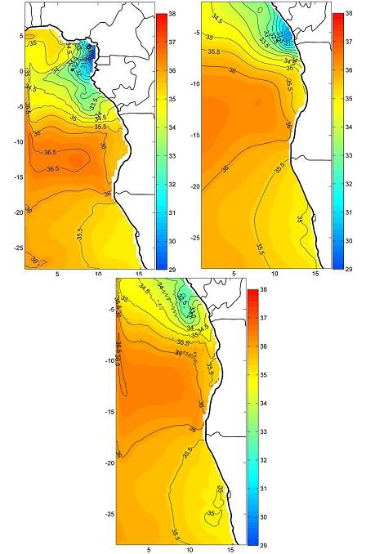

Figure 3.3: Same as figure 3.2 but salinity fields.

3.3 – Conclusions

The first idealized simulations with ROMS have been successful. Next steps of the numerical experiments will consist in:

- implementation of the modelling platform. It includes the installation of ROMS (and AGRIF) on the computational servers with the adequate compilers (Fortran + C). A Matlab license has been purchased specifically for these machines.

- configuration of the model involving realistic forcing at the surface (ERS and Quikscat winds, etc…).

- adaptation of the OCCAM model outputs to force the open boundaries (POG should be available hopefully later in 2004). The OCCAM has already been used successfully in other experiments involving ROMS.

- About OCCAM:

The OCCAM project has developed two high resolution (1/4 and 1/8 degree) models of the World Ocean - including the Arctic Ocean and marginal seas such as the Mediterranean. The project is being carried out by researchers at the Southampton Oceanography Centre in collaboration with colleagues from the Universities of East Anglia and Edinburgh. OCCAM is a primitive equation numerical model of the global ocean. It is based on the GFDL MOM version of the Bryan-Cox-Semtner ocean model but includes a free surface and improved advection schemes.
Geographic Coverage: Full Globe, 1/4 lat x 1/4 long
Depths: 36 levels, 20m thick near surface, 255m at 5500m.
Time: 14 year simulation
The OCCAM model is run on two simultaneous grids: one grid is a spherical longitude-latitude grid with uniform spacing that covers the Southern, Pacific, Indian and South Atlantic Oceans. A second, uniformly spaced, spherical grid is used for the North Atlantic and Arctic Oceans. This second grid is rotated, relative to the first, such that its "poles" lie on the geographical equator with its "equator" lying along the geographical meridian at 38° (see figure below). The adaptation of the outputs into one single data sets require the use of several programs provided by the OCCAM team called the OCCAM coordinate translator. A data selector allows to extract the data needed.

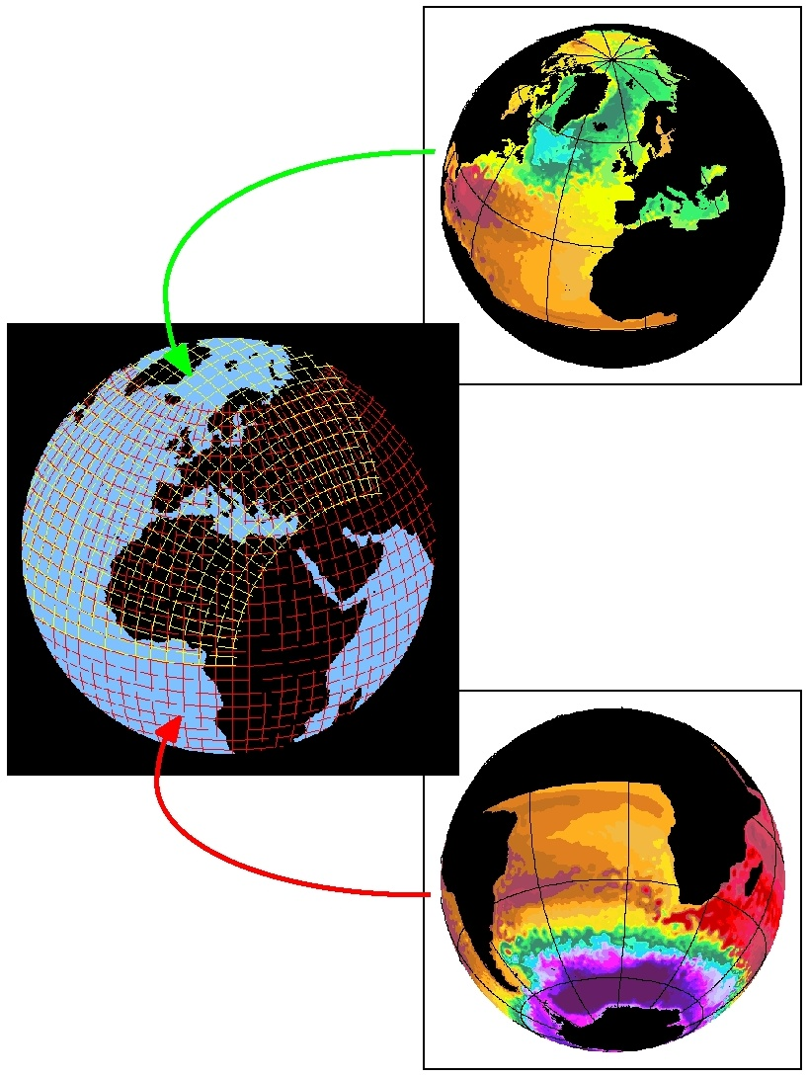

4 - A Study of the Angola Dome – Preliminary results

Study conducted by Pierre Florenchie and Jenny Veitch (Master student)
January 2004

abstract:

In this preliminary study we have used the outputs of the tropical version of the OPA model to investigate the existence and seasonal variability of the Angola dome. We find that the Angola dome is a subsurface feature limited to the mixed layer. It corresponds to an elevation of the thermocline of nearly 30 meters. It is not forced by local wind but results from the divergence of the zonal flow at the surface. It shows a strong seasonal cycle with a maximum in June-July. Its expression the rest of the year is much weaker as it drifts southeastward. It might explain the difficulty to identify such a feature using sparse in-situ data.

4.1 - Introduction

A cold dome in the eastern South Atlantic ocean has been described by a few authors. It is referred to as the Angola dome. So far two other domes have been catalogued: the Costa Rica and the Guinea domes. However the existence of the Angola dome still remains uncertain, and little is known about it (Voituriez 1981). Its temperature signature at the surface is very weak, and the cyclonic circulation related to it is rather sluggish. It might be a seasonal feature. As a result, oceanic observations in the area of the dome are difficult to interpret. Using in-situ data Gordon and Bosley (1991) resolved a cyclonic gyre near 13°S 5°E confined to the upper 300m with a velocity maximum at 50m. Another study (Yagamata and Izuka; 1995) describes a seasonal feature located near 10°S 9°E at 45m with a maximum in austral winter. It is associated with the cyclonic turn of the SECC. According to Levitus (1982), it becomes visible during spring and summer when warm water near the equator progresses southward along the coast and reaches the Angola front at the northern border of the dome (Shannon, 1987).
In this preliminary study, we have used the outputs of the OPA model at various levels to investigate the existence, the structure and the seasonality of the Angola dome in the eastern Atlantic sector. We have also carried out analyses using ERS winds, Topex/Poseidon altimeter data and sea surface heat fluxes from the 40-year NCEP/NCAR reanalysis (Kalnay et al., 1996) over the South Atlantic Ocean. This investigation will address the following questions:

- what are the spatial and temporal scales of the Angola dome ?

- what are the underlying mechanisms driving the dome ?

4.2 - Description of the model

In order to investigate the vertical and horizontal structures of the ocean below the surface, we have studied outputs from a tropical ocean model, the "OPA" version 8 OGCM developed at Laboratoire d'Océanographie Dynamique et de Climatologie (LODYC) (Madec et al. 1999). This version of OPA solves the primitive equations assuming the Boussinesq and hydrostatic approximations, the incompressibility hypothesis and the use of a rigid lid boundary at the sea surface. Simulations were performed at LODYC with the "TOTEM" configuration in which the grid has a relatively high resolution (0.33º maximum near the equator in the zonal and meridional directions) covering the oceans between 45ºS and 45ºN. The vertical grid has 30 levels and a resolution of 10 m from the surface to 150 m, which decreases significantly after 600 m. There is no restoring term in temperature and salinity between 20ºS and 20ºN. Outside of this belt, a linear restoring term is applied towards the monthly mean temperature and the seasonal salinity fields of Levitus (1982). This restoring term is applied only under the mixing layer with a time constant decreasing from 250 days at 20º to 30 days along the northern and southern boundaries of the domain. The Brünt-Väisälä frequency is used to compute the turbulent kinetic energy (TKE) which determines the vertical mixing coefficients. In this simulation, the fresh water flux is introduced as a pseudo salt flux. It is prescribed as a boundary condition on vertical diffusion flux of salinity. To avoid unrealistic temperature drift induced by the heat forcing biases and model deficiencies, a relaxation of SSTs of the first layer at 5 m toward observed SSTs is added to the ECMWF heat flux. A complete description of this model is available in Maes et al. (1998). The model is forced by daily wind stress, net surface solar radiation, net surface heat flux and net freshwater flux (evaporation minus precipitation). Except for the net freshwater flux, these fields are taken from the European Centre for Medium-Range Weather Forecast (ECMWF) reanalysis (1979-1991), ERA-15 (Gilson et al. 1999). Comparisons of the ERA-15 precipitation with different climatologies led to the choice of CMAP precipitation (Xie and Arkin, 1998) for the freshwater flux boundary condition (Masson et al. 2002). Evaporation, linked to the latent heat flux, is taken from ERA-15. From 1992, ERS wind stress data are used instead of ERA 15 and from 1994 heat forcing fluxes and the evaporation are extracted from ECMWF analyses.

4.3 - Climatological temperature and salinity fields from the OPA model

Model outputs have been analysed from the surface to a depth of 329 meters. The 23 first layers have been used: 5m, 15m, 25m, 35m, 45m, 55m, 65m, 75m, 85m, 95m, 105m, 115m, 125m, 136m, 147m, 159m, 172m, 187m, 205m, 232m, 270m, 329m. Then a climatology has been calculated over the 1982-1999 period for all levels. Plots of the temperature fields reveal that the thermocline raises strongly during austral winter, creating a cold tongue under the surface at a depth of about 50m. In June and July the subsurface expression of the dome is maximum and it is centred near 0°E 2°S, far north of the location indicated by previous studies. However it covers a large area from nearly 10°W to the African coast, and from the equator to about 7°S. In August the subsurface cold pool begins to move southeastward and its signature becomes weaker until March when it seems to dissipate near 7°S 8°E. As a result, the Angolan dome is reproduced by the model most of the year, with a strong seasonal modulation in terms of location and intensity. Figure 2.1 shows the temperature field in June at a depth of 45m, whereas figure 2.2 is a vertical section of the mean temperature field along 5°E in June.

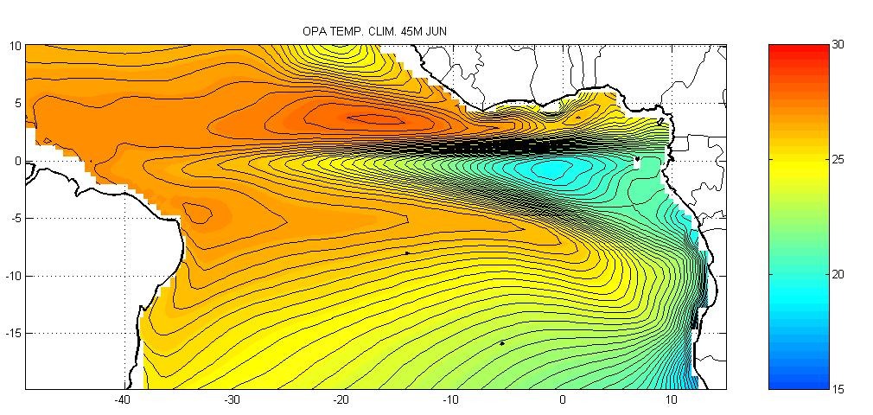

Figure 2.1: Model mean temperature field in the 45m layer in June

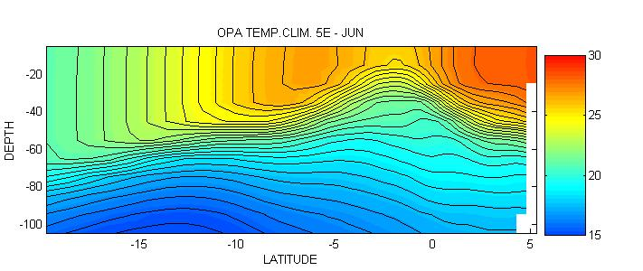

Figure 2.2: Vertical section of the model mean temperature field in June along 5°E

The horizontal temperature anomaly at 45m associated with the lifting of the thermocline reaches a value of about 10°C. We also note that the vertical expression of the dome is limited to the depth of the thermocline: isotherms below 70m do not show a similar vertical displacement. The salinity field corresponding to the Angola dome is illustrated in figure 2.3.

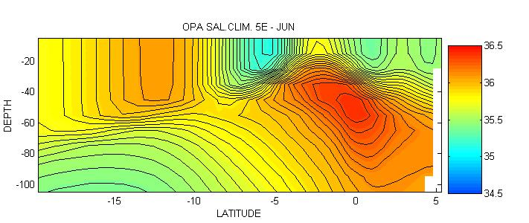

Figure 2.3: Mean salinity field in June from the model along the 5°E transect.

Water mass inside the dome shows a maximum of salinity in comparison to surrounding waters. A few months later the Angolan dome is located near 7°S 7°E (figures 2.4 and 2.5).

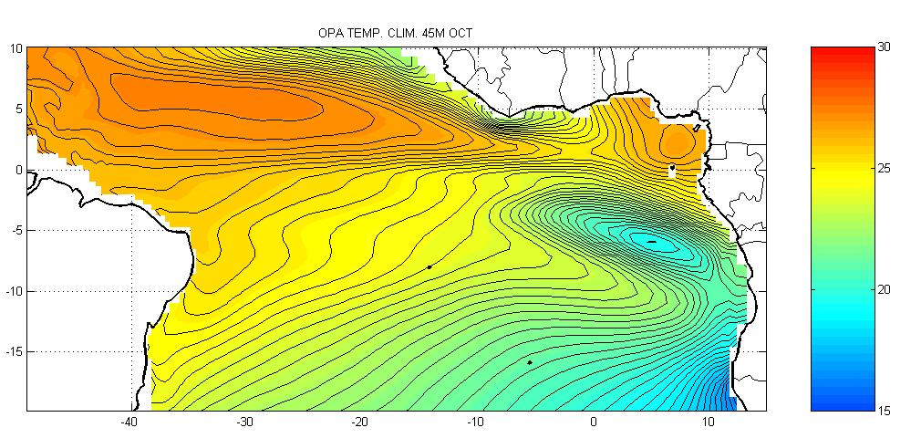

Figure 2.4: Mean temperature field from the model in October at 45m

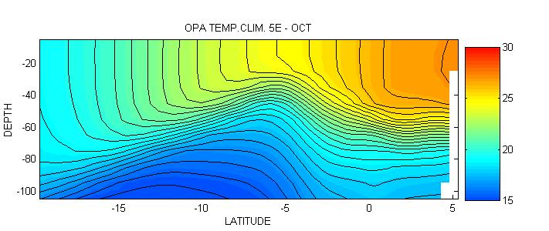

Figure 2.5: Vertical section of the mean temperature in October along 5°E

Once again, the thermocline shows an upward displacement in October, but the field of salinity does not indicate a maximum associated with the dome (not shown). Hence the dome should not be related to a specific water mass. It corresponds rather to a dynamical pattern, drifting and evolving in the southeast Atlantic ocean all year long.

4.4 - Climatological velocity fields associated with the Angolan dome from the OPA model

Climatological velocity fields have been computed from the model outputs within the first 23 layers. At the surface, the equatorial circulation across the basin is dominated by a westward current which shows a strong intensification during austral winter. In the eastern part of the basin, the current reaches a maximum in June and July, coincident with the appearance of the Angola dome (fig3.1). A second peak appears in November and December. At 45m, the situation is more complicated: from January to April the equatorial circulation is mainly eastward. Then from June to August, the circulation reverses to be westward. From September to October the main current in the eastern part of the basin is southeastward (fig3.2). Such a circulation could explain the southward drift of the dome throughout the year. In November and December the circulation is mainly westward in the same area.

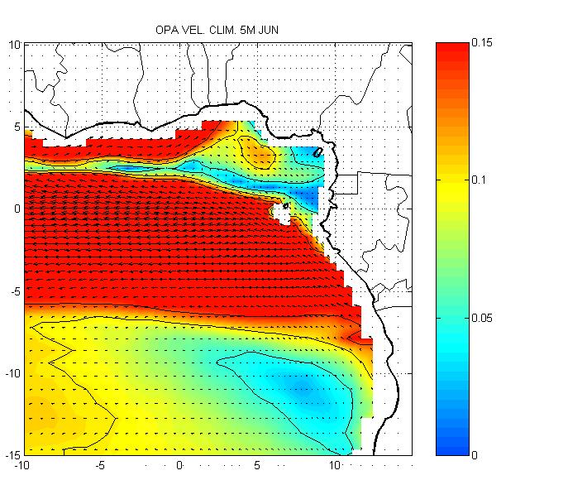
Figure 3.1: Mean velocity field at 5m in June
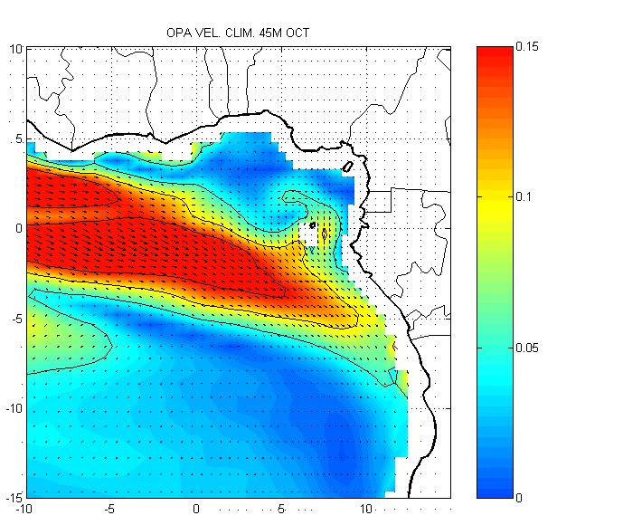
Figure 3.2: Mean velocity field at 45m in October

The following figure (fig 3.3) shows the zonal component of the current at depth along a 5°E transect in October. The negative value indicates a westward current. It becomes evident from this plot that the Angola dome is closely related to a maximum of westward flow above the thermocline, in the mixed layer (see figure 2.2). In October, the vertical section does not show any significant feature associated with the dome. It tends to indicate that the Angolan dome is created in June and is advected southward by the end of the year.

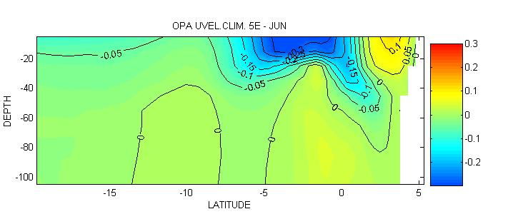

Figure 3.3: Vertical section of zonal currents along the 5°E transect in June

In order to understand the exact nature of the relation between the Angolan dome and the circulation, we have computed the horizontal divergence of the climatological velocity fields in the area. The horizontal divergence reaches a maximum at the surface from May to July with a maximum in June in the area of the dome. Figure 3.4 shows that it is associated with a convergence at the basis of the mixed layer.

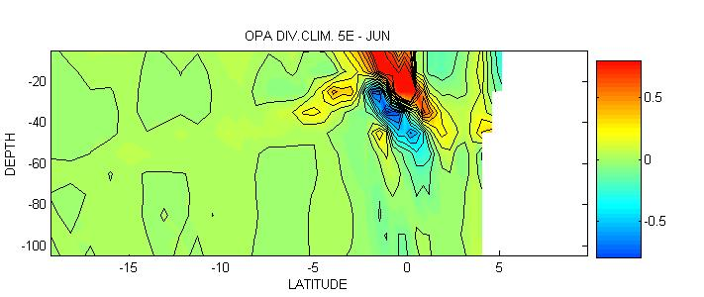

Figure 3.4: Horizontal divergence of the mean climatological velocity field in June along 5°E.

The mechanism driving the Angola dome in June could be explained using the following diagram on figure 3.5:
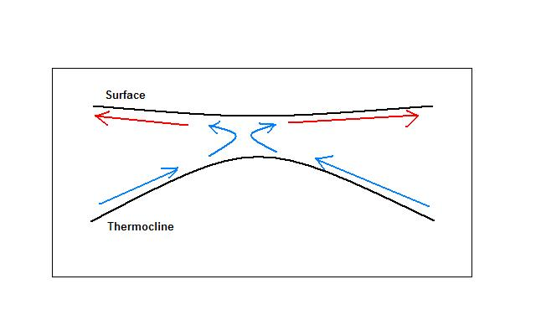
Figure 3.5: Mechanism driving the Angolan dome below the surface

The divergence of the flow at the surface induces an upward vertical displacement of water in the mixed layer which lifts the thermocline. At the basis of the mixed layer, a convergence of the flow completes the vertical cell. Further calculations show that the divergence near the surface is related mainly to the zonal circulation, while the convergence below the surface is linked to the meridional circulation. Later in the year, the divergence of the flow is much weaker, and should not account for the existence of the Angolan dome. According to our study, the dome observed the rest of year is either the result of another mechanism, or the same dome reproduced by the model in June and advected southeastward by the surrounding circulation.

4.5 - Sea level climatology from TOPEX-Poseidon altimetry data

Satellite Topex/Poseidon sea level (SL) measurements used here cover the period from 1992 to 2000 with a 5-day temporal resolution and a 1-degree spatial resolution. A monthly Topex/Poseidon sea level climatology has been computed over the South Atlantic from October 1992 to January 2001 to identify the signature of the Angola dome in terms of sea level. Figure 4.1 shows the mean level in October in the eastern Atlantic. 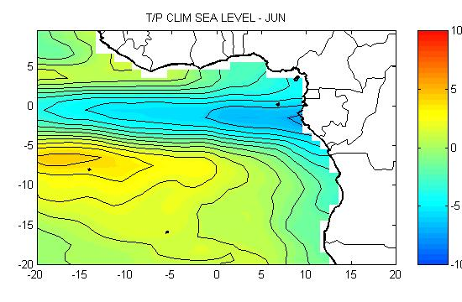
Figure 4.1: Mean sea level from T/P in June

As expected from the mechanism described in the last paragraph, the sea level is depressed from June to August in the area corresponding to the Angola dome. Nevertheless it is difficult at this stage of the analysis to attribute the sea level lowering to the Angola dome alone. It may be related to basin-wide mechanisms involving the intensification of trade winds over the equatorial ocean, the resulting intensification of westward flow as well as the eastward propagation of downwelling Kelvin waves toward Africa. The following paragraph is dedicated to local forcing via Ekman pumping.

4.6 - Impact of local wind forcing via Ekman pumping

ERS1 and ERS2 zonal and meridional monthly wind speed climatologies available on a 1-degree spatial grid have been computed over the period 1991-2000. Then Ekman pumping as been calculated to estimate the vertical velocity in the mixed layer associated with the local wind. The curl of the wind in the eastern Atlantic shows very little seasonal variability and it is unlikely that it would generate in June the Angola dome. Figure 5.1 illustrates the mean Ekman pumping in June and October.

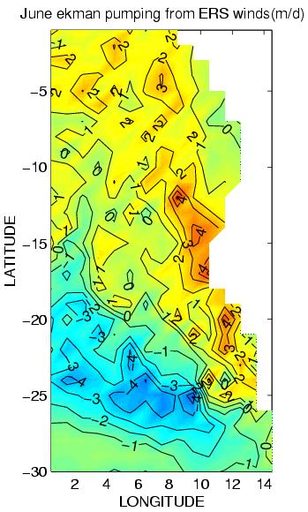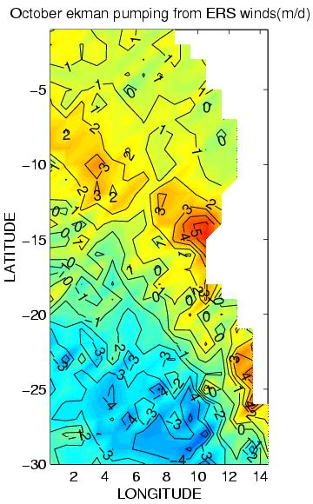

Figure 5.1: Mean Ekman pumping from ERS wind in June and October

However we note the intensification of the northwestward trade wind across the basin in winter.

4.7 - Impact of local net heat fluxes

In this section, we consider whether the Angola dome described here may have been contributed to by local air-sea heat flux exchanges as well as by ocean dynamical processes. To address this aspect, we have carried out an analysis of sea surface heat fluxes from the 40-year NCEP/NCAR reanalysis (Kalnay et al., 1996) over the South Atlantic Ocean. Net heat flux climatology has been computed over the period 1980-2000. No specific pattern in the area of the Angola dome in the eastern Atlantic seems able to explain its existence or development during the year. Net heat flux shows locally a rather small seasonal cycle. Figure 6.1 illustrates the mean net heat flux in June over the South Atlantic basin.
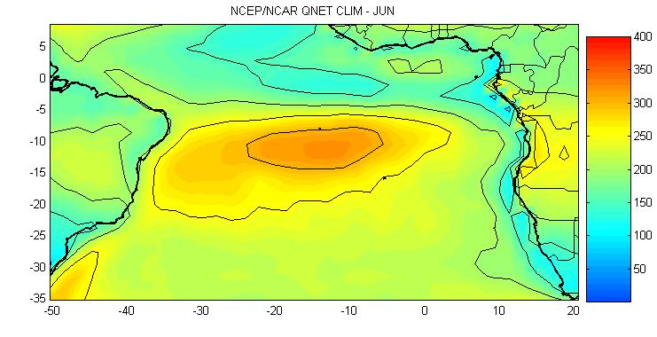
Figure 6.1: Mean net heat flux in June – W/m2

Conclusion

The Angola dome has been clearly reproduced by the model OPA. According to the model outputs, it shows a clear seasonal variability with a very strong and large subsurface signature in June centred near 0°E 2°S. The dome corresponds to an elevation of the thermocline creating a horizontal temperature anomaly of about 10°C. Its expression is limited to the upper 50 meters. It seems to be advected by the southeastward currents, and its signature remains visible under the surface most of the year. According to our preliminary study, it is not forced by local winds via Ekman pumping, nor by local ocean-atmospheric exchanges. It is rather the result of a dynamical process: the divergence of the surface zonal flow, associated with an elevation of the thermocline and a meridional convergence at the basis of the mixed layer. Next step of the study will be to identify the various components of equatorial currents (SEC, SECC, etc) contributing to the Angola dome, and its interannual variability: for instance, do Benguela Ninos have an impact on the Angola dome? High resolution simulations with the ROMS model will contribute to this analysis and will enable us to understand all the mechanisms involved in the existence of this feature.

References

Gordon A.L. and K.T. Bosley, Cyclonic gyre in the tropical South Atlantic Ocean, Deep-Sea Research, 38, 323-343, 1991.
Kalnay E., M. Kanamitsu, R. Kistler, W. Collins, D. Deaven, L. Gandin, M. Iredell, S. Saha, G. White, J. Woollen, Y. Zhu, M. Chelliah, W. Ebisuzaki, W.Higgins, J. Janowiak, K. C. Mo, C. Ropelewski, J. Wang, A. Leetmaa, R. Reynolds, Roy Jenne, and Dennis Joseph, 1996: The NCEP/NCAR, 40-Year Reanalysis Project., Bull. Amer. Meteor. Soc., 77, 437-471.
Levitus S., Climatological Atlas of the World Ocean GFDL, NOAA, N13, 1982.
Madec G., P. Delecluse, M. Imbard and C. Levy, 1999, OPA 8.1 Ocean General Circulation Model reference manual, Internal report number XX, Institut Pierre-simon Laplace (IPSL), Paris, XX.

Shannon L. V., J.J. Agenbag and M.E.L. Buys, Large and mesoscale features of the Angola-Benguela Front, S. Afr. J. Mar. Sci., 5, 11-34, 1987.
Voituriez B., Sous courants equatoriaux nord et sud et formation des domes thermiques tropicaux, Oceanologica Acta, 4, 497-506, 1981.
Yamagata T. and S. Iitzuka, Simulation of tropical thermal domes in the Atlantic, J. Phys. Oceanography, Vol 25, N9, 1995.

APPENDIX 1

Seasonal and interannual fluctuations of the Angola Benguela Frontal Zone (ABFZ) using high resolution satellite imagery from 1982 to 1999.

J.A. Veitch*ª, P. Florenchieª and F. A. Shillingtonª

Submitted to the International Journal of Remote Sensing.
2003-11-6

ªDepartment of Oceanography, University of Cape Town, Rondebosch 7701, South Africa. Fax : +27 21 650 3979

*Author for correspondence, e-mail: veitch@ocean.uct.ac.za, tel : +27 21 650 3625
Seasonal and interannual fluctuations of the Angola Benguela Frontal Zone using high resolution satellite imagery from 1982 to 1999.
J.A. VEITCH*§, P. FLORENCHIE§, F. A. SHILLINGTON§
§Department of Oceanography, University of Cape Town, Rondebosch 7701, South Africa.

Abstract. 18 years of high resolution satellite sea surface temperature (SST) data are used to analyse the surface expression of the Angola- Benguela Frontal Zone (ABFZ). The ABFZ is the convergence zone of the southward- flowing Angola Current and the northward extent of the Benguela upwelling regime. Although it has already been investigated a number of times in the past, the analyses within this report benefit from the extensive, high- temporal and spatial resolution of the data, made possible by satellite remote sensing. It is identified as a region of closely- spaced isotherms or, more specifically, a region of consistently steep SST gradients. Using the steep SST gradients indicative of the frontal zone, seasonal and interannual variability of the ABFZ (including characteristics such as width, offshore extent, orientation and intensity) are examined. Aside from a long-term intensification of the front, interannual variability of the ABFZ is also shown to be affected by warm and cool anomalies that occur periodically in the south-east Atlantic Ocean. Such anomalies and the reaction of the frontal zone to them are discussed.

*e-mail: veitch@ocean.uct.ac.za

1. Introduction
The extensive upwelling regime off the west coast of southern Africa is an integral component of the successful fishing industry that exists there and as such it was documented as early as 1902 (Schott). The northern boundary of the upwelling regime is called the Angola-Benguela Frontal Zone (ABFZ). It corresponds to the convergence of the southward flowing warm Angola current with the cold water upwelled in the Benguela area. Despite several similarities with coastal processes in the Southeast Pacific, the ABFZ seems to be a specific feature of the southeast Atlantic. From visual analysis of weekly averaged AVHRR satellite sea surface temperature (SST) images of the period between 1982 and 1985, Meeuwis and Lutjeharms (1990) concluded that the region of closely-spaced isotherms with SST gradients of between 1°C per 28km and 1°C per 90km best described the position of the front. Using this method, they found that during their study period the surface expression of the frontal zone was between 15°S and 18°S and that steep SST gradients extended to a distance of 250km offshore. Nevertheless the authors expressed some concern about the accuracy for both location and resolution of the SST measurements.
Using various types of data sets, Shannon et al. (1987), Meeuwis and Lutjeharms (1990) and Kostianoy and Lutjeharms (1999) have all shown that the mid-frontal position fluctuates seasonally and lies furthest south during austral summer months. Meeuwis and Lutjeharms (1990) noted that the frontal zone is best defined in austral summer with steeper meridional SST gradients than in winter. They also observed the front to extend further offshore during spring and summer than during winter. Using a long time-series (1908-1985) of the monthly mean of in situ SST data from various sources for 6 salient areas in the South-East Atlantic, Taunton-Clark and Shannon (1988) studied interannual SST anomalies in the region of the ABFZ and showed that major warm events occurred along the coast of Angola and Namibia with a periodicity of about 10 years. The similarity of these events with the Pacific El Niño phenomenon was first noted by Schott (1931) (cited in Shannon et al., 1986) and Shannon et al. (1986) coined the term ‘Benguela Niño’ to describe these Atlantic events. Taunton-Clark and Shannon (1988) found evidence of the occurrence of Benguela Niños in 1908, 1923, 1934, 1950, 1964, 1974 and 1984, while the major event of 1995 has been documented by Gammelsrød et al. (1998) and Florenchie et al. (2003). Although Benguela Niños recur on a decadal cycle, minor warm anomalies have been observed throughout the record and appear to develop regularly in the ABFZ. Major cool anomalies also occurred over the last 20 years in 1982, 1983 and 1997 in the same area (Florenchie et al., 2003).
Within this study, a high-resolution satellite SST data set spanning 18 years (1982- 1999) is used to present a more accurate description of the seasonal and interannual variability of surface thermal characteristics of the frontal zone. Long term trends within the ABFZ are also investigated. The lengthy period of consistently high resolution data allows for the calculation of a more precise climatology from which a more reliable analysis can be made of the typical surface expression of the frontal zone. A further advantage of this data set is that it includes both the 1984 and 1995 Benguela Niño events as well as several warm and cool anomalies. Perturbations to the surface thermal characteristics as well as the location of the frontal zone as a result of these events will be investigated. Therefore, this paper addresses (and, in some cases, revisits) the following questions:

- Where is the ABFZ located?
- How wide is it?
- What is its seasonal signal?
- What is its offshore extent and orientation?
- Has the surface thermal expression of the ABFZ been subject to any long term trends?
- What is the impact of major SST perturbations on the frontal zone?

The following section describes the data set and methods of analysis used for this study. In section 3.1 seasonal SST fluctuations along various transects are investigated. In section 3.2 abnormal events that occur across the frontal zone as well as long term SST trends are studied for the 18 year period. In section 3.3 their ensuing impacts, particularly within the frontal zone, are briefly analysed.

2. Data and Methods
The Envifish data set of the monthly mean sea surface temperature (SST) values for the period from January 1982 to December 1999 were used for this study. The SST data are obtained from the 5-channel Advanced Very High Resolution Radiometers (AVHRR) on board the NOAA -7, -9, -11 and -14 polar orbiting satellites. The data was collated for the Cloud and Ocean Remote Sensing around Africa (CORSA) project of the Marine Environment Unit of the Space Applications Institute of the Joint Research Centre of the European Commission. The mean monthly data are mapped on a rectangular projection grid of 1000x775 pixels representing the area from the equator to 40°S and from 2°W to 29°E which includes the region of the ABFZ. There are 25 pixels per degree of latitude and longitude and the corresponding nominal ground resolution is 4.5km. Figure 1 shows mean monthly SSTs for May 1985 with the region of the ABFZ demarcated by a yellow box. The darker shades of grey correspond to lower SSTs.

[Insert figure 1 about here]

From comparisons with in situ data (COADS) and data from another AVHRR product (Pathfinder) it was found that Envifish SSTs from September 1992 to August 1994 were up to 2.5°C warmer than both the COADS and Pathfinder data sets. This was corrected by removing the mean of the elevated values from the erroneously high period and replacing it with the mean of the SSTs outside of it (January 1982 to August 1992 and September 1994 to December 1999).
In order to capture the frontal zone realistically, and because the coast in the region of the ABFZ changes orientation quite markedly and is not strictly meridional, it was decided that transects parallel to the coastline would be analyzed in order to include the coastal upwelling features: a meridional transect will cut through the upwelling regime a short distance south of the frontal zone regardless of proximity to the coast and is likely to lead to misinterpretation by taking into account only a limited part of the coastal upwelling regime.
A transect at a distance of 30km offshore was found to be optimal to study the surface thermal expression of the front. Closer inshore, features such as the embayment at Baia dos Tigres (±16.5°S) affected the SST plots, while further offshore the ABFZ becomes more diffuse. The seaward extent and offshore characteristics of the ABFZ was then investigated from transects 100km, 250km, 500km and 700km offshore.
18 years of monthly mean sea surface temperatures (SSTs) were extracted from the Envifish data set along the various transects and were used to calculate SST climatologies, interannual SST anomalies (SSTAs) and SST climatological gradients. The SSTAs were detrended to remove any long-term tendency. Because we made the assumption that the front runs perpendicularly to the transects, the SST gradients corresponding to the front may be slightly underestimated, especially offshore. For clarity within the plots of the gradient, which were very noisy, it was decided to first smooth the SSTs meridionally by averaging every five pixels. Temperature gradients were then calculated between every three pixels from the equator to 30°S. Although weekly composite data are also available from the Envifish data set, mean monthly data were used as they produce a more complete data set as a result of much of the cloud cover being removed by averaging over a longer period of time. Nevertheless, it was necessary to firstly identify the ‘gaps’ in the data due to cloud cover, which correspond to a flag value of 8°C. For all pixels assigned with flag values an interpolated SST was calculated by taking the spatial average of the first two pixels with valid data on either side of the flag value. The process was iterated until all missing values were replaced.

3. Results

3.1. Climatology

As the confluence of the warm Angolan Current and the cool Benguela upwelling regime, the ABFZ is characterized by a striking change of SST across its boundaries associated with steep gradients. For this reason, a climatology of SST gradients has been calculated along various transects from the equator to 30°S to investigate the seasonal location, width and displacement of the frontal zone. Figure 2 represents the climatological SST gradient at a distance 30 km offshore. The ABFZ is evident as the most distinct region of consistently steep SST gradients at about 16°S. In order for the front to be explicitly isolated and identified, it was decided that gradients that exceeded 1°C per 60km would be indicative of the frontal zone. This lower value was chosen by visual analysis of Hoffmoller plots of SST gradients in the frontal zone. It appears from figure 2 that the width of the frontal zone fluctuates seasonally with an average of about 1.1° of latitude (roughly 120km) in winter and 1.5° of latitude (about 170km) in summer. At its narrowest in August (±60km) it spans between 16°S and 16.5°S while at its widest in December (±210km) it lies between 15.5°S and 17.5°S. A notable displacement of the northern and southern boundaries of the frontal zone occurs at the onset of winter. The boundaries appear to fluctuate out of phase: as the northern boundary moves southwards, the southern boundary is displaced northwards. Similarly, as the northern boundary shifts northwards at the onset of summer, the southern boundary moves southwards. From January to April the seasonal width of the ABFZ is remarkably constant. The range of latitudes through which the northern boundary moves annually is 0.5° (or about 50km) whereas the southern boundary moves through 0.83° of latitude (approximately 92km).

[Insert figure 2 about here]

Figure 2 shows us that steepest SST gradients are prevalent during summer (±1°C per 34km), whilst during winter the ABFZ is characterized by weakest gradients (±1°C per 40km). This appears to be somewhat counter-intuitive as a narrower front is expected to have steeper SST gradients and vice-versa. However, in this case a significantly greater range of temperatures is present in the frontal zone during summer than during winter resulting in the ABFZ being defined by consistently steep SST gradients over a broader region and weaker SST gradients that persist over a much narrower zone in winter. Therefore, in terms of both width and steepness of SST gradients, the ABFZ is unequivocally most intense during summer.

The core of the ABFZ has been defined as the position between its northern and southern boundaries (the mid-frontal position), which, in most instances, corresponds to the region of steepest SST gradients within the frontal zone. Other than a weak southward shift in June and July and an equally small northward displacement in August and September, the mid-frontal position remains very steady throughout the year and its mean location is approximately 16.4°S. At the mid-frontal position the steepest temperature gradient occurs in January and is of the order of 1°C per 27km, while weakest gradients of about 1°C per 54km occur at the mid- frontal position in August.

Evident in figure 2 are other zones of significantly steep SST gradients. North of the front, two zones of alternating positive and negative gradients from south to north seem to be directly related to river discharges and are situated at about 6°S and 9°S, coincident with the mouth of the Congo and the Coanza Rivers respectively. In this area heaviest rainfall occurs in summer leading to greater discharge rates at the mouth of these rivers. However, the temperature of the river water contrasts more with the ambient SST during winter than during summer, resulting in the steeper temperature gradients seen on figure 2. A detailed analysis of the yearly mean SST gradients along the coast tends to indicate a northward flow of Congo River discharge. The zone of strongly negative SST gradients at 27°S is persistent throughout the year, although significantly weaker during winter months (figure 2). It is related to an abrupt northward cooling of coastal SSTs corresponding to the Lüderitz upwelling cell which extends from Luderitz to about 20°S. It is active for 95% of the year, slackening off in autumn (Meeuwis and Lutjeharms, 1987).

The origin of steep SST gradients in two other zones as seen in figure 2 (at approximately 12.5°S and as a banded feature between about 22.5°S and 24°S) is still unclear. The feature at 12.5°S for instance might be related to local river discharges. On the other hand, we note that in both areas the orientation of the coastline is markedly changed by prominent bays.

Figure 3 represents the climatology of the SSTs from the equator to 30°S at a distance of 30km offshore with the mid-frontal position overlaid. The mid-frontal position corresponds to the core of the ABFZ. The mean temperature at the core of the frontal zone is 20.7°C in summer and 18°C in winter showing a mean seasonal range of 2.7°C throughout the year. However, at the northern boundary the difference between the mean winter and summer temperature is 3.6°C (from 23.1°C to 19.5°C) and at the southern boundary it is a mere 1.8°C (from 18.9°C in summer to 17.12°C in winter). The disparity of the annual range of temperatures at these three locations within and encompassing the ABFZ may be related to differing seasonal fluctuations that operate in the regions north and south of the ABFZ: the latter is related to quasi-permanent wind-driven upwelling cells which tend to inhibit SSTs seasonal signal along the coast. A calculation of the standard deviation of the SST climatology along the transect reveals two distinct areas, north and south of 20°S. In the northern area until about 3°S, the seasonal SST variability shows high values with a maximum at the frontal zone and a distinct minimum near the Congo River mouth at about 6°S. South of 20°S and along the Lüderitz cell, the seasonal variability is much lower with the minimum of the entire transect situated near Lüderitz at 27°S. Conversely, seasonal SST gradient variability along the transect shows two distinct maxima at 27°S and 6°S. Congo River discharge, as well as upwelling dynamics south of the ABFZ maintains a relatively constant temperature of coastal waters in those areas throughout the year. This is in contrast with the surrounding waters that experience normal seasonal fluctuations. As a result, these two areas show low seasonal SST variability but induce strong seasonal SST gradient variations.

[Insert figure 3 about here]

The temperature range between the northern and southern boundaries of the frontal zone is, on average, 4.1°C in summer and 2.4°C in winter. The much larger temperature range across the frontal zone in summer complies with the fact that in summer when the front is widest, SST gradients are steepest. Table 1 summarizes the thermal characteristics of the ABFZ discussed in the previous section at a distance 30km offshore.

[Insert table 1 about here]

Climatologies of the SSTs and of the SST gradients at distances of 100km, 250km, 500km and 700km offshore as well as the standard deviation of the SST gradients (not shown) were similarly investigated in order to establish the offshore extent of the ABFZ. At 100km offshore the ABFZ is present between ±12.5°S and 17.25°S and has typical SST gradients of about 1 °C per 100 km. Steepest gradients occur in the region 15°S – 17.25°S during spring and autumn and are weakest during winter. Average temperatures in the frontal zone are 22.5°C in summer and 20.6°C in winter. Other than a brief and slight southward movement during spring, the position of the front remains very stable throughout the year. The ABFZ is present at 250km as a diffuse, but nonetheless distinct region of consistently steeper SST gradients that is relatively stable and exists between 12°S and 16°S. Typical SST gradients in this region are in the range of 1°C per 112km and again, are slightly elevated during spring and summer. During summer the average temperature in the frontal zone is 23.2°C and in winter it is 21.3°C. At 500km offshore SST gradients in the region between 12°S and 16°S are low (±1°C per 164km), but are consistently higher than the surrounding area and are significantly steeper during spring and summer. This indicates that there is a weak frontal signal at this distance offshore all year round, with a slight intensification during spring and summer. The average temperature within this zone is 22.7°C and 20.1°C in summer and in winter respectively. 700km offshore, a region of slightly elevated SST gradients, exists between about 8°S and 15°S during spring and summer. This suggests that vestiges of the frontal zone, though very weak, extend further offshore during summer months than during winter.
The above analysis shows that the ABFZ remains a distinct feature throughout the year up to at least 250km offshore, but with increasing distance offshore the frontal zone becomes significantly more diffuse. At 500km and 700km offshore evidence of the frontal zone is very weak, other than during spring and summer when slightly steeper SST gradients are present within the frontal zone, thus implying that the ABFZ extends further offshore during spring and summer than during winter.
The fact that the zonal area encompassing ABFZ appears to move northwards with distance offshore implies that it is oriented in a roughly northwesterly direction from the coastline, as could be seen on figure 1.

3.2 Warm and cold events and long term trends along the transects
Figure 4 is a plot of the actual SSTs from the equator to 30°S of the transect 30km offshore for the 18-year period with the approximate location of mid-frontal position (as described in the section 3.1) overlaid. The 22°C and 16°C isotherms are also overlaid in an attempt to isolate variability of the regimes to the north and to the south of the ABFZ. During ‘normal’ years the mid-frontal position seems to act as a barrier to the southward and northward extents of 22°C and 16°C water respectively. Therefore, unusual southward warming across the mid-frontal position that occurs periodically can be easily identified on figure 4.

[Insert figure 4 about here]

Particularly severe warm intrusions occurred during the Benguela Niños of 1984 and 1995 when the 22°C isotherm penetrated across the mid-frontal position to about 22°S and 24°S respectively in late summer. Minor southward incursions of warm water took place in 1986, 1988, 1996 and 1999, mostly in March/April, but in most instances the 22°C isotherm did not penetrate further than 18°S. Following the 1995 major warm event, unusually warm water prevailed within the frontal zone, other than during the April 1997 cold event when water within the ABFZ was abnormally cool in summer. Cold years in which the southerly extent of the 22°C was unusually far north, at about 16°S, correspond to extended events in 1982, 1983 and again in 1997.
From figure 4, a general warming trend is evident and appears to have affected both the Angolan and Benguela systems. A plot of the mean annual SSTs for the regions north (equator- 15.4°S), south (17.6°- 30°S) and within the ABFZ (15.5°S – 17.5°S) (not shown) indicates the disparity between the warming trend in these three areas. The long-term increase in annual mean temperature for the study period was 3°C to the north of the frontal zone, 2.5°C within the frontal zone and only 1°C south of it. A similar plot of the mean annual SSTs of offshore transects (not shown) shows that the long- term warming trend is not merely a coastal phenomenon as it prevails offshore, however it is less extreme and the discrepancy of the temperature increase north, south and within the frontal zone is smaller. Although the ABFZ is something of a barrier to the seasonal southward penetration of warm water, it does not appear to be an obstacle to the long term warming trend. This suggests that the warming tendency is an extensive phenomenon that occurs throughout the southeast Atlantic.
Detrended SST anomalies from the equator to 30°S of a transect 30km offshore for the period from 1982 to 1999 are illustrated in figure 5. Evident in this plot are the major warm SST anomalies of the 1984 and 1995 Benguela Niños. Other minor warm anomalies occurred in 1986, 1988, 1991, 1996, 1998, and 1999. They are all associated with the unusually far southward extent of warm water across the ABFZ previously mentioned. Major cool anomalies of 1982/83 and 1997 are also apparent and are conversely associated with a southward limit of the 22°C isotherm that does not penetrate past the mid-frontal position. Similar to all events is that the most extreme temperature anomaly appears within the region of the frontal zone. Standard deviation of SSTAs in this region validates this as it illustrates that the most extreme variability of anomalies along the transect occurs within the ABFZ, the maximum being situated at 17°S. This result suggests meridional shifts of the frontal zone during warm or cold events inducing strong SST anomalies in the area.

[Insert figure 5 about here]

SSTAs of the 30km offshore transect have been averaged in the region of the frontal zone (15.5°S to 17.5°S) and over the regions north and south of it. They further corroborate that the most extreme anomalies (both positive and negative) occur within the frontal zone and that during both the 1984 and the 1995 Benguela Niños, maximum positive anomalies of the order about 3.5°C transpired. Positive anomalies in excess of 2°C persisted within the frontal zone from January until December during the 1984 episode, but only from February to April during the 1995 event. Although the former event lasted considerably longer than the latter, the southward extent of the 1995 warm anomaly was greater than during 1984 incident (25°S as opposed to 23°S). Although the minor warm anomalies of 1986, 1988, 1991, 1996 and 1998 produced temperature increases in the frontal zone that were comparable to major anomalies, anomalies to the north and south of the ABFZ were less significant and did not exceed +1.5°C. The major cool events of 1982/83 and 1997 correspond to average temperature decreases within the frontal zone of about 2.5°C and 4°C. For both cool events, the average negative anomaly is most severe in the frontal zone and more intense to the north than to the south of it.
Standard deviations of SSTAs from the equator to 30°S, at distances of 100km, 250km, 500km and 700km offshore were calculated (not shown). They give an indication of the location of the most extreme temperature perturbations of each offshore transect. The region of most variability for all transects at all distances offshore coincides with the location of the ABFZ and, like the frontal zone, broadens and moves progressively northwards offshore. SST anomalies within the frontal zone at 250km, 500km and 700km offshore show that the warm and cool anomalies persist until at least 500km offshore. By 700km offshore only the smallest traces of the major warm anomalies exist, but they do not stand out as major positive anomalies. The 1997 cool anomaly is the only extreme event recorded at closer inshore locations that remains significant at 700km offshore.

3.3 Response of the ABFZ to warm and cold events
A plot of the gradient of SSTs through time from the equator to 30°S (figure 6) of a 30km offshore transect shows that although the position of the frontal zone has remained relatively stable throughout the 18 year period, the region of steep SST gradients indicative of the frontal zone has broadened progressively. The widening of the frontal zone is possibly related to the long term warming trend which is stronger to the north of the front than to the south of it (hence the increasing intensity of the front). The two bands of steep SST gradients that exist mainly during summer months at about 22.5°S and at 25°S are evident throughout the 18 year period. From a preliminary visual inspection of figure 6 it appears that during the major warm anomalies of 1984 and 1995, these regions experience a severe strengthening of SST gradients. On the other hand, SST gradients in the region defined as the frontal zone seem to weaken during the major warm episodes.

[Insert figure 6 about here]

SST gradients have been averaged over the frontal zone and between 22°S to 25°S. These plots validate that during major warm anomalies the SST gradients weaken in the frontal zone and are significantly steepened in the region to the south of it, thus implying that the ABFZ shifts or spreads southwards by approximately 8° (±896km) during major warm anomalies. The southward displacement of the frontal zone is observed during not only major, but also minor warm anomalies. The peak of the warm anomaly generally occurs about a month prior to both the weakening of SST gradients in the ABFZ and to the strengthening of the gradients to the south of it. Therefore, the warm anomalies take about a month to affect the position of the ABFZ. Other than a slight weakening of temperature gradients in both the frontal zone and in the zone to the south of it, the ABFZ is not notably affected by cool anomalies.
Hoffmoller plots of the SST gradients from the equator to 30°S for the 18 year period for distances of 100km, 250km, 500km and 700km offshore (not shown) reveal that the long term broadening and southward displacement of the ABFZ has persisted until a distance of at least 700km offshore, although the long term tendencies become less notable with distance from the coast. SST gradients averaged in the ABFZ and in the zone south of it between 22°S and 25°S at the same offshore distances indicate that the ABFZ is similarly affected by warm and cool anomalies up to at least 700km offshore. SST gradients in the frontal zone weaken and strengthen between 22°S and 25°S during warm anomalies, but are not notably affected by cool anomalies. However, with increasing distance from the coast the SST gradients in each of the regions are modified by a smaller degree.

4. Summary of results and concluding remarks
- The ABFZ is a region of consistently steep surface temperature gradients (> 1°C per 60km) and is a permanent feature whose width fluctuates seasonally. 30km offshore it exists approximately between 16°S and 17°S in winter and between 15°30’S and 17°S in summer. It is therefore broader in summer (spanning ±1.5° of latitude) than in winter (±1° of latitude).
- The northern and southern boundaries of the ABFZ fluctuate independently of one another. In winter the northern boundary moves southwards while the southern boundary moves northwards, the converse happens at the onset of summer.
- The mid-frontal position is a relatively stable feature, and is situated at approximately 16.4°S. Because it is generally situated in the region of steepest temperature gradients within the frontal zone, it can be thought of as the core of the ABFZ.
- Average temperatures at the core of the frontal zone are 20.7°C in summer and 18°C in winter. The temperature range across the ABFZ is 2.4°C in winter and 4.2°C in summer. The greater range of temperatures in summer ties in with the fact that the warm regime to the north of the ABFZ experiences more seasonal variability than the cool regime to the south.
- SST gradients in the frontal zone are steepest in summer (1°C per 34km) and persist over a wider zonal area. In winter, although the ABFZ remains apparent, the SST gradients indicative of the front are weaker (1°C per 40km) and are prevalent over a narrower region than during summer. This rather unexpected relationship between temperature gradients and width is a consequence of the fact that a far greater range of temperatures intrudes into the ABFZ from the north during summer than from the south during winter.
- With increasing distance offshore the ABFZ broadens and moves northwards and the SST gradients within it weaken. The front remains a distinct feature throughout the year up to a distance of 250km offshore, but up to at least 700km offshore vestiges of it can only be identified during spring and summer. The ABFZ therefore extends further offshore during spring and summer.
- The northward displacement of the frontal zone with increasing distance offshore implies that the front has a northwesterly orientation. This is verified by figure 1, which is a grey-scale plot of the SSTs in the region of the frontal zone.
- Both major and minor warm anomalies tend to displace the frontal zone southwards to a banded frontal region between 22°S and 25°S, with a lag of about a month. This region seems to act as a ‘barrier’ to the southward intrusion of warm water and therefore might limit the southward extent of anomalies. Other than a slight weakening of temperature gradients, cool anomalies do not significantly affect the ABFZ.
- Although the warm anomalies persist until at least 700km offshore, they are markedly less severe, particularly by 700km from the coast. Despite the progressively weaker anomalies offshore, the ABFZ is similarly affected by them as it is closer inshore.

Future studies could take this work further by extending the data set in order to include more major warm events thereby improving the analysis of frontal zone responses to Benguela Niños. Also, an extended data set would provide a more representative climatology. The temporal resolution could be improved by using the mean weekly data available from the Envifish data set.

Acknowledgements
The sea surface temperature data set was made available by the Space Applications Institute, Joint Research Centre (JRC) of the European Commission, as a development of a scientific collaboration agreement between NASA and JRC named ‘NASA-JRC AVHRR remote sensing collaboration’. This is a contribution to the Benguela Current Large Marine Ecosystem (BCLME) study of environmental variability. J.A.V. and P.F. acknowledge funding from the BCLME.

References
FLORENCHIE P., J.R.E. LUTJEHARMS, C. J. C. REASON, S. MASSON and
ROUALT, M., 2003, The source of Benguela Niños in the South Atlantic Ocean. Geophysical Research Letters, 30(10), 12.1- 12.4.
GAMMELSRØD, T., BARTHOLOMAE, C. H., BOYER, D. C., FILIPE, V. L. L.
and O’TOOLE, M. J., 1998, Intrusion of Warm Surface Water along the Angolan-Namibian Coast in February 1995: The 1995 Benguela Niño. South African Journal of Marine Science, 19, 41-56.
KOSTIANOY, A. G. and LUTJEHARMS, J. R. E., 1999, Atmospheric Effects in the
Angola-Benguela Frontal Zone. Journal of Geophysical Research, 104(9), 20 963-20 970.
MEEUWIS, J.M. and LUTJEHARMS, J.R.E., 1987, The Extent and Variability
of South-East Atlantic Upwelling. South African Journal of Marine Science, 5. 51-62.
MEEUWIS, J. M. and LUTJEHARMS, J. R. E., 1990, Surface Thermal
Characteristics of the Angola-Benguela Front. South African Journal of Marine Science 9, 261-279.
SCHOTT, G., 1931, Relation entre la position latitudinale de la zone de
Convergence Intertropicale et la temperature de surface de la mer dans l’Atlantique tropical. Veille Climatique Satellitaire. Bull. 9, 34-36.
SHANNON, L. V., BOYD, A. J., BRUNDRIT, G. B. and TAUNTON-CLARKE,
J., 1986, On the existence of an El Niño-type Phenomenon in the Benguela System. Journal of Marine Research, 44, 495- 520.
SHANNON, L. V., AGENBAG, J. J. and BUYS, M. E. L., 1987, Large- and
Mesoscale Features of the Angola-Benguela Front. South African Journal of Marine Science, 5, 11-34.
TAUNTON-CLARKE, J. and SHANNON, L.V., 1988, Annual and Interannual
Variability in the South-East Atlantic during the 20th Century. South African Journal of Marine Science, 6, 97- 106.

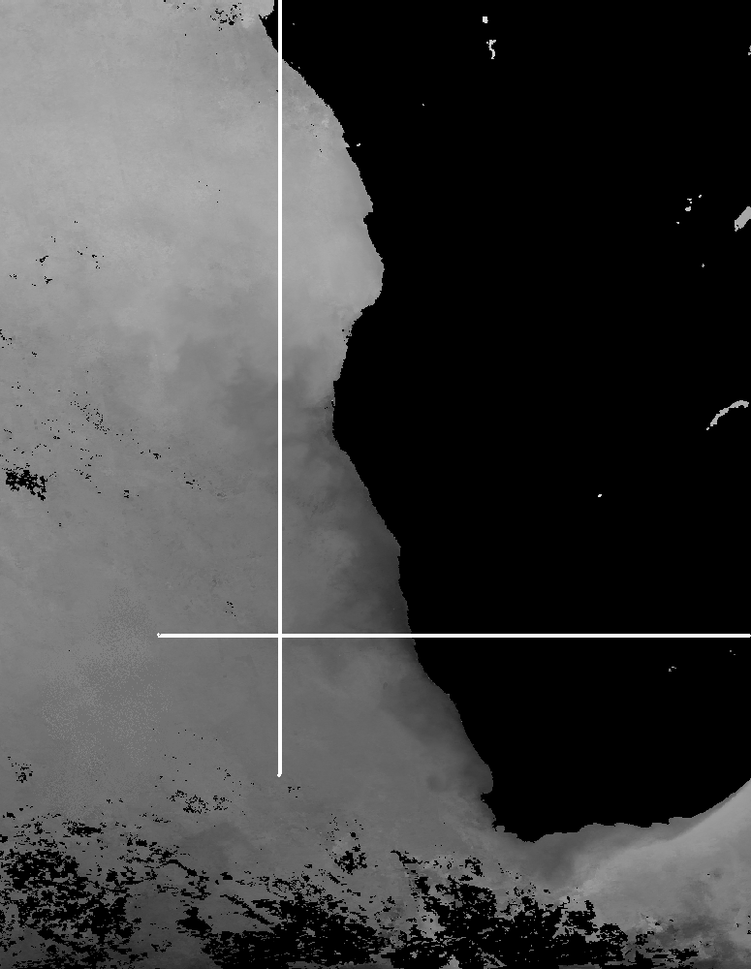
30°S
10°E

figure 1. Mean monthly SSTs for May 1985 with the region of interest demarcated by a yellow box. The darker shades of grey correspond to lower SSTs.

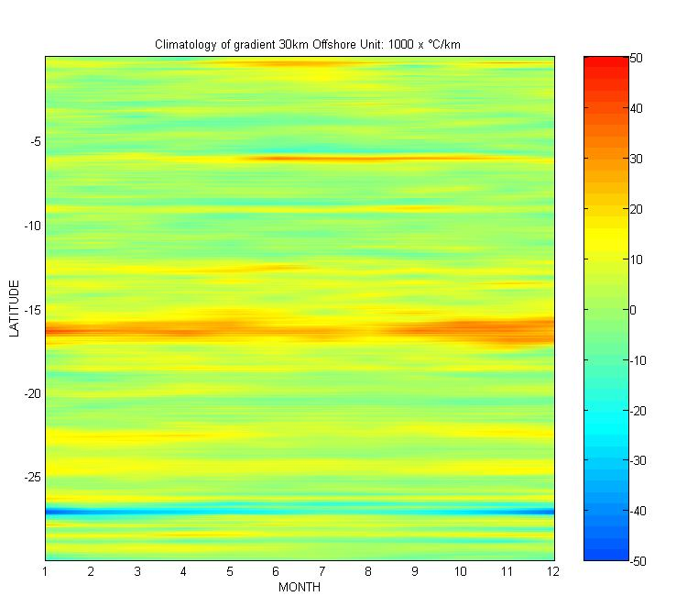

figure 2. Climatology of SST gradients of a transect 30kms offshore extending from the equator to 30°S.

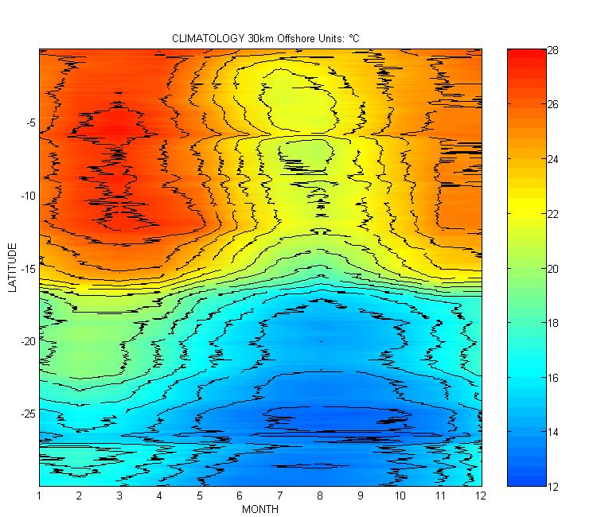

figure 3. Climatology of SSTs of a transect 30km offshore extending from the equator to 30°S with the mid-frontal position overlaid.

Season | Boundary | Position | Width | Mean SST | Temperature range across  boundaries | Mean SST gradient at the MFP*
Summer | North | 15.5°S | 1.5°  (±170km) | 23.1°C | 4.2 °C | 1°C per 34 km
Summer | South | 17°S | 1.5°  (±170km) | 18.9°C | 4.2 °C | 1°C per 34 km
Summer | MFP* | ±16.45°S | 1.5°  (±170km) | 20.7°C | 4.2 °C | 1°C per 34 km
Winter | North | 16°S | 1°  (±115km) | 19.5°C | 2.4°C | 1°C per 40 km
Winter | South | 17°S | 1°  (±115km) | 17.1°C | 2.4°C | 1°C per 40 km
Winter | MFP* | ±16.4°S | 1°  (±115km) | 18°C | 2.4°C | 1°C per 40 km

table 1. Thermal characteristics of the ABFZ at a distance of 30km offshore (MFP = Mid-frontal position).

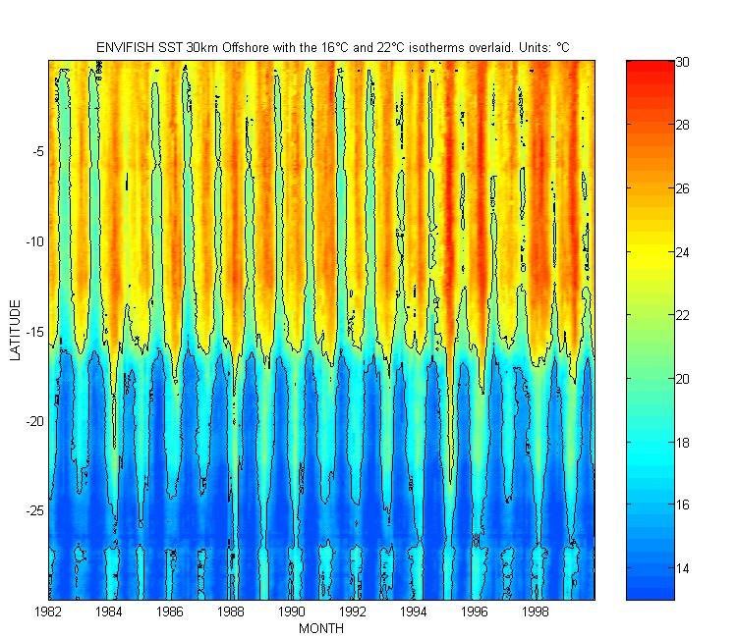

figure 4. Hoffmöller plot of the SSTs of a transect 30km offshore extending from the equator to 30°S for the period from January 1982 to December 1999.

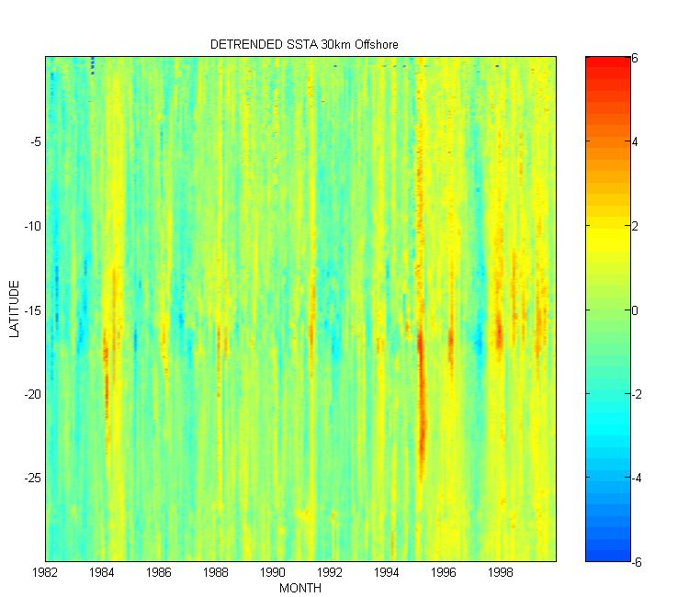
figure 5. Hoffmöller plot of the SSTAs of a transect 30km offshore extending from the equator to 30°S for the period from January 1982 to December 1999.

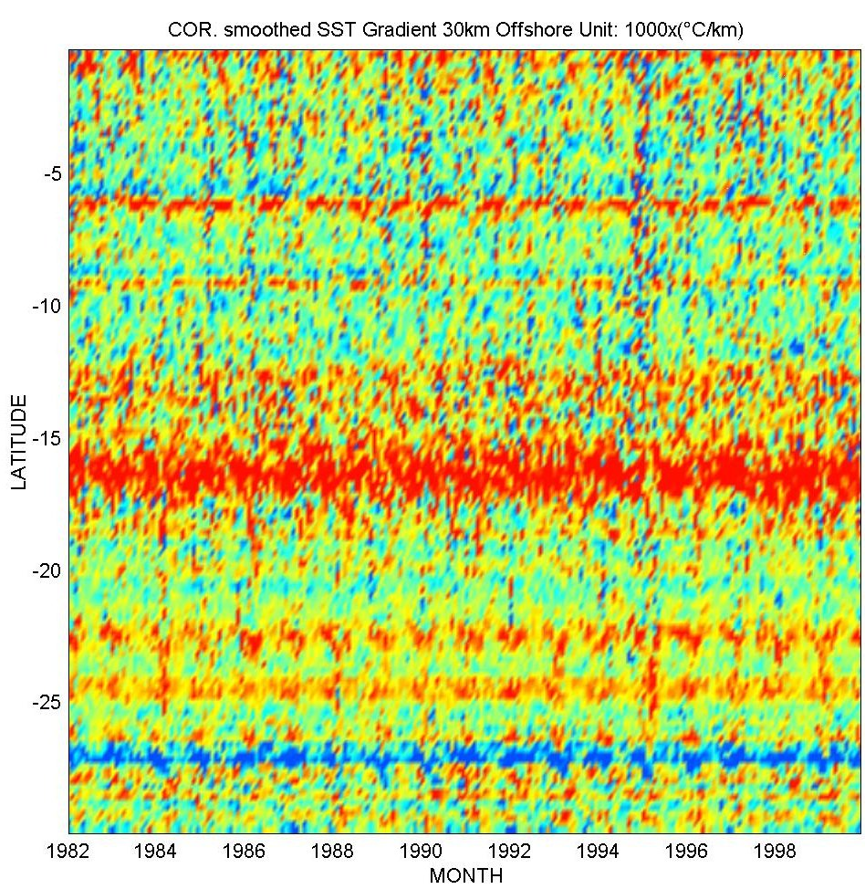
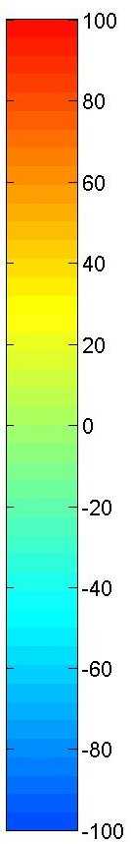

figure 6. Hoffmöller plot of the SST gradients of a transect 30km offshore extending from the equator to 30°S for the period from January 1982 to December 1999.

