Analysis of Benguela Dynamical Variability and Assessment of the Predictability of Warm and Cold Events in the BCLME

Report n°1

RAF/00/G32 – Benguela Current Large Marine Ecosystem

31/07/2003

Compiled by Dr. Pierre Florenchie

for

United Nations Office for Project Services


Centre for Marine Studies  University of Cape Town | Oceanography  University of Cape Town

The consultant submits to UNOPS the report N°1 following the schedule originally adopted (time for delivery is 2003/07/31). This report describes in detail Dr. Florenchie’s activities under the contract for the last 6 months and the progression of the project as initially planned point by point. First section provides an inventory of various observations and model outputs chosen and stored to conduct the study during the last 6 months, as well as forthcoming acquisitions. Section two is dedicated to the regional and large models chosen to simulate in the future the oceanic variability. An exhaustive study of the oceanic variability along the coast of southwestern Africa and its predictability as well as its impacts on the environment has been performed using various observations and OPA model outputs. Sections three to six present the main results concerning this analysis. Two attached documents complement this analysis. Part of this work has involved the collaboration of various scientists from UCT, IRD and LODYC (sections 3 and 4). Two students have been trained by Dr. Pierre Florenchie to use respectively AVHRR SST data and Topex/Poseidon sea level measurements in their studies of the Angola/Benguela variability: Jenny Veitch from South Africa and Pedro Tchipalanga from Angola (sections 5 and 6). Their training included the use of Matlab, programming, learning of Unix, analysis of data and scientific literature review. The complete description of Jenny Veitch’s work can be found at the end of the report in annexe B. Section seven is a discussion on the forthcoming work steps for the next 6 months.

1 – Storage and inventory of observations and model outputs

Acquisition of in-situ and satellite measurements or model outputs of various oceanic parameters (currents, temperature, salinity, winds, sea level, etc…) is a priority for EVAG. These measurements allow us to describe and understand the physics of coastal oceanic variability and to validate numerical models (see annexes A and B at the end of the document). Most data are today directly available from different web sites (COADS, NCEP, PODAAC, JPL, ECMWF…). Some specific products imply an explicit collaboration with foreign teams or scientists. Thanks to a co-operation with Dr. S. Masson from LODYC (Laboratoire d’Oceanographie Dynamique et de Climatologie - Paris), we have had access to the outputs of the OPA (Ocean Primitive Equation) model, in its tropical version of the South Atlantic ocean from 1979 to 1999. Dr. B. Barnier from LEGI (Laboratoire des ecoulements geophysiques et industriels - Grenoble) provided us with the outputs of the high resolution Clipper model (1/3°) over the South Atlantic area from 1979 to 2000. Another co-operation has started with Dr. Alberto Piola from UBA (University of Buenos Aires). He will give us access to his historical XBT data collection (1990-2002) covering all the South Atlantic (see figure below). Personal contacts with scientists at JPL (Jet Propulsion Laboratory - USA) like Dr. Tony Lee or Dr. Claire Perigaud will guarantee us access to the last products of French/American satellite Jason as well as the outputs of the ECCO (Estimating the Circulation and Climate of the Ocean) experiment.

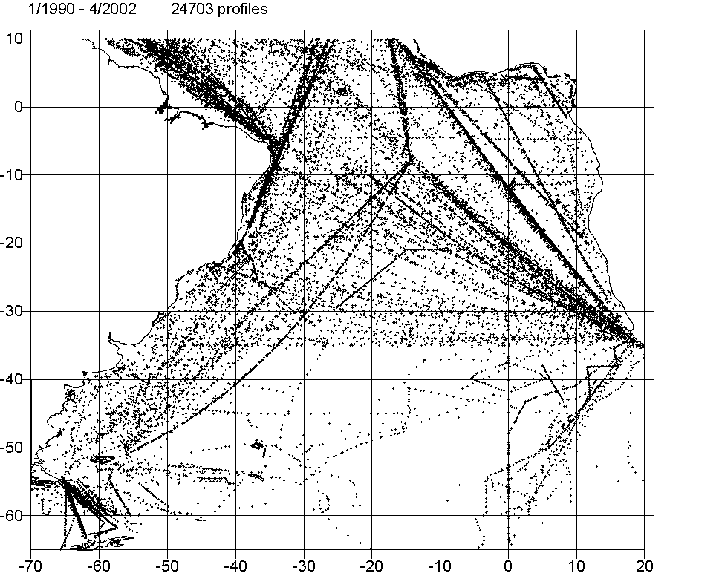

The storage at UCT of such a large amount of data implies the acquisition of suitable hardware. A 200GB hard drive PC (named Atlantic – please find the specifications below) has been purchased and allows an easy access for local students and scientists.

In terms of training and capacity building, data acquisition is also a key issue. It leads progressively students to a real autonomy. First, students are asked to update data on a regular basis. It obliges them to get connected via internet to numerous data providers on the network, which means that they learn where and how they can access the information they need (what data center, how to download data, etc…). These data have different origins and may be written with different formats. Students learn how to recognise them and how to read and visualise the data. They have to make various calculations (climatology, interannual anomalies, standard deviation, etc…) that imply the use of scientific software such as Matlab, and to learn machine language such as Unix (the PC works under Linux).

Data stored on the Atlantic machine:

- Topex/Poseidon satellite sea level measurements (weekly, worldwide, 1° res., 1992-2002) http://podaac.jpl.nasa.gov/
- OI-SST, blend of in-situ and satellite observations (weekly/monthly, worldwide, 1° res., 1981-2001) http://www.nodc.noaa.gov/dsdt/oisst/
- ERS1/ERS2 winds (weekly, worldwide, 1° res., 1991-2000) http://www.ifremer.fr/
- ENVIFISH AVHRR SST (monthly, Angola/Benguela area, 4.5km res., 1982-1999), http://www.pml.ac.uk/pml/envifish.htm
- OPA model outputs, Temperature, Salinity, Currents, (weekly, South Atlantic area, variable grid, 5m – 100m depths), http://www.lodyc.jussieu.fr/
- NCEP winds (monthly, 2.5° res., worldwide, 1945-2001), http://www.emc.ncep.noaa.gov/
- GI-SST (monthly, worldwide, 1° res., 1949-2002), http://badc.nerc.ac.uk/home/
- TRMM SST (weekly, Angola/Benguela area, 35km resolution, 1998-2002) http://www.ssmi.com/

Climatologies and interannual anomalies have been computed for each data set.

Data to be acquired:

- Jason sea level measurements – Direct contact with the JPL team and web site information: http://podaac.jpl.nasa.gov/jason/
- Historical XBT data from UBA over the South Atlantic, http://www-atmo.at.fcen.uba.ar
- ECCO outputs, http://oceans-www.jpl.nasa.gov/oceans

Training and Capacity building: Two Master students from UCT (Jenny Veitch from South Africa and Pedro Tchipalanga from Angola – Advisor: Dr Pierre Florenchie) have been working respectively with AVHRR SST observations and Topex/Poseidon sea level measurements for their Master projects. Both students have been taught Matlab (scientific software) to write their own programs and to analyse the data. To access them on the linux PC, they had also to learn Unix. Complete project of Jenny Veitch is attached at the end of the document. Pedro’s project will be presented later.

Computer “Atlantic” specifications:

Case , sound, cd, …: Emerald 845grgl B/Unit Aud Vga + CD utp

Mother board: DSP-40053

Video card: MS8894-060 Ti4200 128MB
processor: CPU-30100, INTEL P4 2.53B Northwood PROCESSOR

Hard drive: HDD-20185, Western Digital 200GB 7200rpm 8MB Cache
ram: TMS-30065, 512MB DDR PC333 - TS64MLD64V3F5
network card: PCI COMBO NIC

Note: the PC’s performances allow us to run a regional ocean model as well.

2 – Inventory of Models

The regional modelling project consists in simulating the evolution of oceanic circulation and parameters (temperature, salinity, etc…) along the coasts of Angola, Namibia and South Africa. The aim is to understand the oceanic variability at different depths and scales in the domain of study and its origin (remote or local). High resolution modeling has a lot of applications for the BCLME and will lead us towards operational oceanography, like the implementation of an early warning system. This work requires the implementation of a suite of nested hydrodynamic configurations. It has been shown by former studies that a grid of 5 km is a minimum resolution to reproduce correctly the instabilities associated with a coastal upwelling cell. A key question is to find the suitable regional model for simulation and prediction, as well as the large scale model outputs required in particular to force the open boundaries of the regional model. For instance, Benguela Niños appear to be initiated in the western and central equatorial Atlantic and need to be correctly reproduced by the large scale model. Such events then propagate eastward and affect the eastern side of the basin with important environmental impacts. As a result, the transmission of the signal from the large scale model into the regional model is a key issue, as well as its downscaling.
This project will use the Regional Ocean Modelling System (ROMS) model for the coastal modelling in the BCLME. This model has been developed and tested with success at UCLA (Dr. P. Marchesiello, Dr. P. Penven) to simulate the circulation along the Californian coast. It is actually in the process of being implemented to reproduce various upwelling areas around the world (Peru, Canaries) by a number of scientific teams. A crude version of ROMS has already been implemented over a limited area of the Benguela upwelling by Dr. Penven at UCT in 2000. It appears that this model is particularly adapted for the various tasks of BCLME given its advanced nesting capabilities, in particular with biochemical models. The model offers also the possibility of downscaling over a particular area during a simulation. High resolution simulations will allow us to understand the impacts of remote sources of variability (like Benguela Niños) as well as local ones on ocean dynamics, biota and environment. The domain of the existing version of ROMS will be extended northward and eastward. Validations of model outputs will be carried out via comparison with observations stored at UCT.
The large scale model chosen to force the ROMS model will be the POG model (Prototype Ocean Global based on the OPA model) designed specifically to force coastal models. This choice represents a unique opportunity to launch a close co-operation between local scientists and students with internationally renowned scientists from IRD (Institute of Research and Development - France) and LPO (Laboratoire de Physique des Oceans - France) in the frame of the MERCATOR project. This projects involves also a number of scientists from CNES (Centre National d’Etude Scientifique), CNRS (Centre National de Recherche Scientifique), IFREMER and IRD. The purpose of this project is to provide high resolution outputs from their global model (POG – 0.25 degree resolution) to users of coastal models in the upwelling areas of Peru, Canaries and Benguela. Outputs will be interpolated according to our regional configuration. It will allow us to set initial conditions at a chosen time (i.e. not based on a climatology) and to force the regional model from this initial instant. The feasibility of the coupling between the global ocean model and our regional model will be investigated. One main point will be to set up numerical tools to interpolate large scale outputs, topography data and surface forcing on the grid of the regional model. After a test experiment to validate the results, runs will be carried out over longer period to study the interannual and decadal variability. This co-operation will also help us to bring additional expertise from outside: numerical modelers specialised in coastal modelling with ROMS will come at UCT by the beginning of 2004 (Dr. P. Penven from IRD for instance). This co-operation will reinforce the links between local modellers and international teams and uplift the regional community to international standards in the field of modelling.
Training is an important component of the modelling project. We will have to develop the human capacity and skills at different levels: running models, analysing outputs, validating the models.

3 The source of Benguela Niños in the South Atlantic Ocean
The complete version of the analysis of section three can be found in annexe A.
(see figures at the end of section)

The intermittent occurrence of anomalous warm events in the upwelling regions of the Pacific - El Niños - has been intensively studied. Pacific Niños have striking effects on the local ecosystem, hence on the fisheries, and on rainfall. Similar dramatic events have been observed in the South Atlantic off the coasts of Angola and Namibia and named Benguela Niños. They tend not to occur in unison with their Pacific counterpart and may thus have unrelated forcing mechanisms. Using an ocean general circulation model forced by real winds and verified with satellite data, it is shown that Benguela Niños are generated by specific wind stress events in the west-central equatorial Atlantic, and progress from there as subsurface temperature anomalies that eventually outcropped only at the south-west African coast. These results suggest that it now may be possible to predict the occurrence of these disruptive events with a lead-time of 2 months.
3.1. Introduction
The Benguela upwelling system of the south-eastern Atlantic extends from the southern tip of Africa to the Angola-Benguela Front at about 19º S [Shannon and Nelson, 1996; Meeuwis and Lutjeharms, 1990]. The location of this front varies with season [Meeuwis and Lutjeharms, 1990] and with short-term wind stress patterns over the South Atlantic [Kostianoy and Lutjeharms, 1999]. Poleward intrusions of warm water from the Angolan Current sporadically breach the frontal zone [Gammelsrød et al., 1998] and extensively disrupt the normal spatial distribution of cold water of the coastal upwelling system [Mohrholz et al., 2001] to the south. Two such events notable for their exceptional intensity and persistence at the sea surface occurred in 1984 [Shannon et al., 1986] and 1995 [Gammelsrød et al., 1998]. They caused severe reductions in pelagic [Boyer et al., 2001] as well as benthic organisms, and also brought about a significant increase in rainfall over adjacent land masses [Rouault et al., 2003]. They were unrelated to local wind anomalies [Shannon et al., 1986] and their characteristics below the sea surface remain largely unknown. The geographic extent of these perturbations in the surface temperature field was substantial, but limited to a characteristic region at the Angola-Benguela front [Shannon and Nelson, 1996].
3.2. Observations and model outputs
3.2.1. Observations
Figure 1 depicts the sea surface temperature anomalies associated with the 1995 warm event and calculated from the Optimal Interpolated Sea Surface Temperature (OI-SST) data [Reynolds and Smith, 1994]. An investigation of surface temperatures in both the Angolan Current and the Benguela upwelling system during the 1995 event shows that the temperature anomaly in fig. 1 was due to a poleward shift in isotherms near the coast, especially east of 7.5º E. The 29º C isotherm was found near 15º S, about 10º latitude south of its average position in March. The 25º C isotherm was 4º south of its mean position. The resulting anomaly represented a maximum increase of 5º C near 17º S. This anomaly therefore was not due to unusual temperatures in either of the two bordering systems, but rather to warm water moving poleward across the Angola-Benguela front on this occasion. The same was true of the 1984 event.
3.2.2. Model outputs
Satellite data facilitates study the surface expression of Benguela Niños, but no similar data set exists with which to investigate this phenomenon below the surface. We have therefore studied the 1984 and the 1995 Benguela Niños using OI-SST data and matched this to products of the OPA version 8 OGCM. This model solves the primitive equations assuming the Boussinesq, rigid lid and hydrostatic approximations [Madec et al., 1999]. The model is forced by daily wind stress, net surface solar radiation, net surface heat and freshwater fluxes. With the exception of the net freshwater flux, these fields are taken, for the 1979-1992 period, from the European Centre for Medium-Range Weather Forecast (ECMWF) reanalysis (1979-1991), ERA-15 [Gilson et al., 1999]. Comparisons of the ERA-15 precipitation with different climatologies led to the choice of CMAP [Xie and Arkin, 1998] precipitation product for the freshwater flux boundary condition [Masson et al., 2002]. From 1992, ERS wind stresses are used instead of ERA 15. From 1994, heat fluxes and the evaporation are extracted from ECMWF analysis. It is important to emphasize that the model SST fields are controlled via a relaxation term towards observed SST in the air-sea heat budget equation. Hence it is expected that the model near surface temperature will be in rather good agreement with Reynolds SST data. However, a good correlation is also found with sea surface height anomalies from satellite altimetry. This gives us confidence that the model also replicates the subsurface nature of these events accurately. Thus, even if model sea surface temperatures have less freedom to evolve, the other model results (subsurface temperature for instance) will give very useful insight into the mechanism and source of the warm events.
Fig. 2 shows a time series of temperature from both the OI-SST and the OPA. It is evident that a number of warm events have occurred since 1982, but that the surface expression of the 1984 and 1995 events was indeed extreme. The duration of the events was highly variable, ranging from 4 months to a full year. Warm events before 1997 tended to reach a maximum between March and April. The traces (fig. 2) demonstrate that the OPA model reproduces the surface anomalies well. The subsurface history of the 1984 Benguela Niño in this model is shown in fig. 3.
The first four panels portray the temperature anomaly at various depths on 20 March 1984 when it was best developed at the sea surface (viz. fig. 2). The difference between the anomaly field at 5 and at 25 m is small, reflecting the influence of the model surface boundary condition. At 45 m, a large anomaly is located at a latitude of 3º to 7º S and between 0º and 11º E. It is remarkable that the core temperature of the main anomaly was 3º C at each depth. The corresponding velocity field (not shown here) shows a direct connection between the anomalies. Whereas the velocities in the Gulf of Guinea at 5 m were towards the north-west, thus showing no connection to the temperature anomaly at 15º S, at 45 and 75 m they were south-eastwards, linking the anomalies. This suggests that the anomalies originated near the equator, west of 0º E, at a depth exceeding 50 m, moved from there poleward along the south-west coast of Africa and outcropped between 15º and 20º S to form the Benguela Niño of 1984. The model’s portrayal of the 1995 Benguela Niño demonstrates a very similar sequence of events. These results imply that Benguela Niños are not limited to the Angola-Benguela frontal zone, but are large-scale events, extending meridionally from the equator to the latitude of 20º S along the African west coast. They furthermore are not restricted to the sea surface, but are evident in deeper layers as well. In order to find the source of the 1984 event, the simulation of this thermal anomaly was followed back in time. This is shown in the additional panels of Fig. 3.
Here the anomaly is shown at depths at which it was most intense at intervals before it reached the coast. It can be traced back to a longitude of 30º W, just south of the equator, where it was found at the beginning of January 1984. At this time it extended poleward to 4º S and had a maximum thermal divergence from the mean of 3º C. Two weeks later it was found between 20º and 10º W and 8 days later its core had moved to 5º E. By the end of January it had reached the coast and had started its advance poleward. Two aspects of the propagation stand out: first, that the temperature of its core remained largely undiminished between 2º-3º C; second, that its progress eastward was about 150 km/day (1.7 m/s) and remained entirely zonal until it reached the coast of Africa. Such a propagation rate agrees with the theoretical phase speed of an equatorial internal Kelvin wave. The period from inception till the anomaly breached off south-eastern Africa was 2 months; it then lasted for six months. The portrayals in fig. 3 show that the thermal anomaly moved from 100 m to lesser depths as it progressed east and then southwards. Figure 4 illustrates the subsurface propagation of temperature anomalies along the coast of Africa in March 1984. The 1995 event reveals a very similar sequence.
It is clear that the anomaly started off in the western equatorial Atlantic at the bottom of the mixed layer. In its zonal progression it consistently moved into shallower water until it was located at about 45 m depth on reaching the coast of Africa near the equator. Its core then stayed at depth on moving poleward along the coast until it reached a latitude of 15º S where it outcropped as the Benguela Niño of 1984 (Fig 4.). In comparing the track of this anomaly with the depth of the thermocline in the equatorial Atlantic it becomes clear that the core of the anomaly followed the thermocline closely, consistently lying at the depth of the 23º C isotherm. The observed hydrographic data show that the thermocline lies between the 25º to 18ºC isotherms in the equatorial Atlantic and that it shallows from 120 to 40 m in going from west to east, nearly identical to that simulated by the model. The model temperature anomalies track the shoaling thermocline across the equatorial Atlantic.
These temperature anomalies are therefore associated with displacements of the thermocline in the west-central equatorial Atlantic. They could come about as a result of the sudden modification of the tradewinds [Carton and Huang, 1994]. We have scrutinised the records and found that changes of between 25 to 50% in the average windstress for this region are responsible for creating the required thermocline displacements. Both 1984 and 1995 Benguela Niños were preceded by such a relaxation of zonal wind stress. Figure 5 represents the correlation between OI-SST anomalies averaged over the ABA and zonal wind stress anomalies calculated at each point over the central Atlantic with a time lag such that the correlation between the two fields is maximised. It reveals the existence of a specific region between 30 and 20ºW, slightly south of the equator, with a correlation above 0.55 and a corresponding time-lag of the order of one to two month between these winds and SST anomalies in the ABA. This result supports the suggestion that Benguela Niños originate from wind stress relaxation in the western tropical Atlantic.
3.3 Conclusion
Our investigation has considered the 1984 and 1995 major Benguela Niños as well as a number of smaller ones. All follow roughly the same progression with only small deviations from the development of the 1984 event. A distinct difference between the underlying structure of the Benguela Niño and that of the El Niño in the Pacific is that the thermocline never outcrops in the eastern equatorial Atlantic. The model evidence suggests that perturbations generated on the thermocline in the west-central equatorial Atlantic propagate along the African coastline as downwelling Kelvin waves and only outcrop when they meet the upward sloping isotherms of the Benguela Current and the Benguela upwelling system. The rather invariant duration of the progression of these thermal anomalies suggest that it may now be possible to predict Benguela Niños. Because of the large impacts on regional fisheries and rainfall, such predictions would have significant economic and societal benefits.
References
Boyer D.C., H.J. Boyer, I. Fossen, A. Kreiner, Changes in abundance of the northern Benguela sardine stock during the decade 1990-2000, with comments on the relative importance of fishing and the environment, S. Afr. J. mar. Sci., 23, 76-84,2001.
Carton J.A., B. Huang, Warm events in the Tropical Atlantic, J. phys. Oceanogr., 24, 888-903, 1994.
Gammelsrød T., C. H. Batholomae, D.C. Boyer, V.L.L. Filipe, M.J. O’Toole, Intrusion of warm surface water along the Angolan-Namibian coast in February-March 1995: the 1995 Benguela Niño, S. Afr. J. mar. Sci., 19, 51-56, 1998.
Hirst C., S. Hastenrath, Atmosphere-ocean mechanisms of climate anomalies in the Angola-tropical Atlantic sector, J. Phys. Oceanogr., 13, 1146-1157, 1983.
Gilson J.K., P. Kallberg, S. Uppala, A. Hernandez, A. Nomura, E. Serrrano, ECMWF Re-Analysis project report series. 1. ERA-15, (version 2), ECMWF, 1999.
Kostianoy A.G., J. R. E. Lutjeharms, Atmospheric effects in the Angola-Benguela Frontal Zone, J. geophys. Res., 104, 20963-20970, 1999.
Madec G., P. Delecluse, M. Imbard, C. Levy, OPA 8.1 Ocean General Circulation Model reference manual, in Internal report number XX, Institut Pierre-simon Laplace, Paris, 1999.
Masson S., P. Delecluse, J. P. Boulanger, C. Menkes, A model study of the Seasonal variability and formation mechanisms of barrier layer in the eastern equatorial Indian Ocean, J. Geophys. Res., 10.1029/2001JC000832, 2002.
Meeuwis J.M., J. R. E. Lutjeharms, Surface thermal characteristic of the Angola-Benguela front, S. Afr. J. mar. Res., 9, 261-279, 1990.
Mohrholz V., M. Schmidt, J. R. E. Lutjeharms, The hydrography and dynamics of the Angola-Benguela Frontal Zone and environment in April 1999, S. Afr. J. mar. Res., 97, 199-208, 2001.
Rouault M., P. Florenchie, N. Fauchereau,
C.J.C. Reason, South east tropical Atlantic warm events and southern African rainfall, Geophys. Res. Lett., Vol. 30 No. 5, 2003.
Reynolds R.W., T.M. Smith, Improved global sea surface temperature analyses using optimum interpolation, J. Climate, 7, 929-948, 1994.
Shannon L.V., A. J. Boyd, G. B. Brundrit, J. Taunton-Clark, On the existence of an El Niño-type phenomenon in the Benguela system, J. mar. Res., 44, 495-520, 1986.
Shannon L.V., G. Nelson, The South Atlantic: present and past circulation , edited by G. Wefer W. H. Berger, G. Siedler, D. J. Webb, pp. 163-210, Springer-Verlag, Berlin, 1996.
Xie P., P. A. Arkin, Global monthly precipitation estimates from satellite-observed outgoing longwave radiation, J. Climate, 11,137-163, 1998.
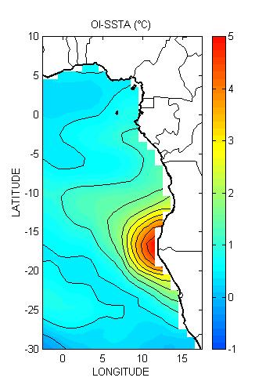
Figure 1. The monthly anomaly (ºC) of sea surface temperature for the Benguela Niño of March 1995, according to thermal infrared data from satellite (OI-SST).

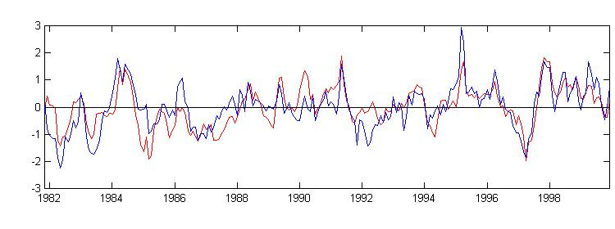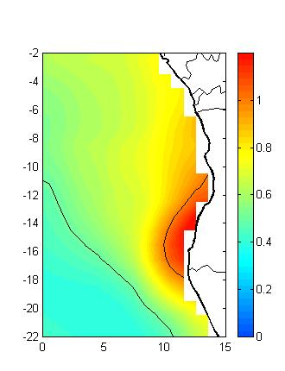
MODEL SSTA OI-SSTA
Figure 2. The temporal history of sea surface temperature anomalies (ºC) (left hand panel) spatially averaged from 10 to 20º S, and from 8º E to the coast of south-western Africa (see area on right hand panel), according to thermal infrared imagery and the model. This area corresponds to the location of sea surface temperature anomalies associated with Benguela Niños (viz. fig. 1). The distinct signals for the 1984 and 1995 Benguela Niños are indicated by arrows. The right hand panel shows the standard deviation of OI-SST anomalies from 1982 to 1999 (ºC).

MODEL TEMPERATURE ANOMALIES - 30/03//1984
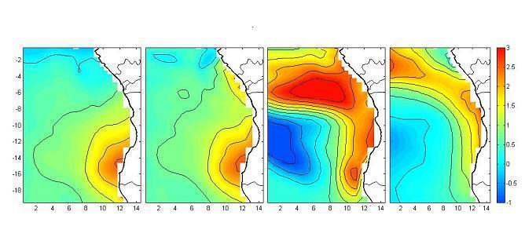
5m
25m
45m
75m
10/01/1984
25/01/1984
10/02/1984

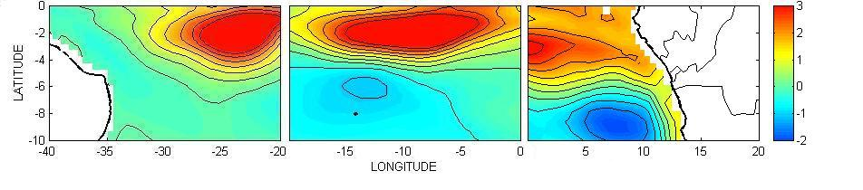
100m
75m
45m

Figure 3. Following the simulated 1984 anomaly back to its source. The upper panels show the anomalies at different depths from the Gulf of Guinea polewards on 03/30/1984; the lower panels the movement across the equatorial South Atlantic. Note the dates and the depths represented in each panel.

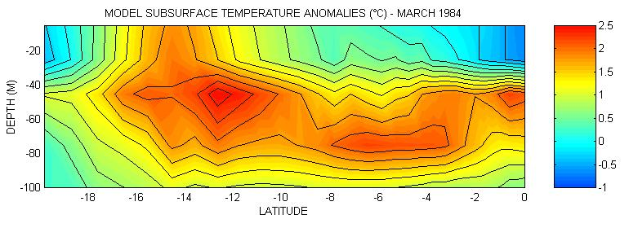
Figure 4. Vertical section showing the meridional distribution of model monthly mean temperature anomalies along the coast of south-western Africa in March 1984.

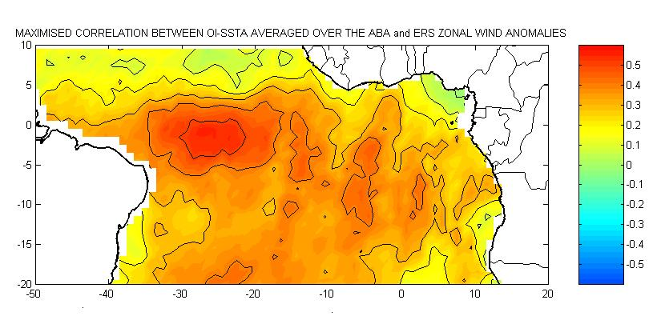

ABA
Figure 5. Maximised correlation between OISST anomalies averaged over the ABA and ERS zonal wind anomalies over the South Atlantic for the period 1992 to 2000.

4. Impacts of major anomalous episodes on Southern African rainfall

(see figures at the end of section)

Intrusions of warm equatorial water in the South East Atlantic Ocean off Angola and Namibia may be linked with above average rainfall along the coast of those countries but sometimes also with inland areas of southern Africa e.g. Zambia. During the 1984, 1986, 1995 and 2001 warm events, above average rainfall occurred near the sea surface temperature (SST) anomalies and extended inland from the coast to an extent that appeared to depend on the intensity of the regional moisture convergence and atmospheric circulation anomalies. Rainfall over western Angola / Namibia is greatest for those events for which the local circulation anomalies act to strengthen the climatological westwards flux of Indian Ocean sourced moisture across low latitude southern Africa and which flow anticyclonically over the warmest SST off the northern coast thereby weakening the mean southeasterly moisture flux away from Africa over the SE Atlantic. The significance of the warm events occurring during the February to April period is that this is the time when SST reaches its maximum in the annual cycle (up to 28ºC off northern Angola) and this favours more intense local evaporation and convection and a greater impact on late austral summer rainfall. A good understanding of these warm events is essential for assessing impacts on regional rainfall, agriculture and fisheries and for improving seasonal forecasting in this region.

4.1 Introduction

The influence of the tropical Atlantic Ocean on Brazilian and West African rainfall has been the subject of various studies but little has been done to understand the possible links between SST anomalies in this basin and southern African rainfall during the peak rainy season of austral summer and autumn. A recent example of the potential tropical Atlantic influence on southern Africa occurred during March to May 2001 when SST was anomalously warm in the South East Atlantic Ocean and several countries in the region experienced well above average rainfall and floods which led to significant loss of life and damage. Hirst and Hastenrath (1983) first established a positive correlation between South East Atlantic coastal SST and Angolan coastal rainfall for late summer (March-April) using data from 1940-1975. Subsequently, Nicholson and Entekhabi (1987) found that during warm South East tropical Atlantic events, above average rainfall occurred along the Angolan (6-17.5ºS) and Namibian (17.5-29ºS) coasts as well as inland.
Shannon et al. (1986) identified Benguela Ninos in 1934, 1963, 1984. Local rainfall impacts during these events included heavy rainfall (1934, 1963) and flooding (1984) in the usually arid Namibian coastal area. In addition to rainfall impacts, the warm events may also significantly influence local fisheries because of the associated depression of the thermocline and large surface and sub-surface temperature anomalies (Binet et al., 2001). For example the strong 1995 warm event had a strong influence on local fish distribution and abundance in Angolan and Namibian coastal waters.

Following on from the earlier work of Hirst and Hastenrath (1984) and Nicholson and Entekhabi ( 1987), recent satellite and NCEP re-analysis data have been used to better understand the impact of recent warm events in 1984, 1986, 1995 and 2001 on late summer (FMA) rainfall and moisture flux in the southern African / South East Atlantic region. It should be noted however, that the major source of moisture for austral summer rainfall over southern Africa is the western Indian Ocean (Figure 1) and therefore that these events can only act as a local perturbation to the secondary source of southern African moisture from the South East Atlantic. The moisture flux from the primary western Indian Ocean source and the secondary tropical SE Atlantic source tends to converge over northern Angola / southern Congo basin on average during this season. However, the atmospheric circulation anomalies during the warm events may sometimes allow the influence of these events to be felt well inland from the Angolan / Namibian coastal region.

4.2 Data and mean conditions

Monthly data from the 1º resolution 1982-2001 Optimal Interpolation SST (OI SST - derived from in situ and satellite observations) of Reynolds et al. [1995] are used to document the SST warming during the events. The 2.5º resolution 1979-2001 Global Precipitation Climatology Project (GPCP) [Huffman et al., 1997] and NCEP re-analysis datasets [Kalnay et al., 1996] are used to assess the rainfall and circulation anomalies. The former is a combination of gauge measurements and satellite estimates and gives the best available coverage in the tropical South Atlantic / southern African region. Of major interest here is the moisture flux and Figure 1 shows the mean FMA flux integrated between the surface and 300 hPa and calculated using NCEP wind speed and humidity re-analyses for 1949-2001. It can be seen that the flux is offshore (easterly) along the northern Namibian and southern Angolan coasts but along- or onshore for northern Angola. It is argued below that the position and intensity of the anomaly to this mean moisture flux relative to the SST anomaly helps determine whether the rainfall impacts are mainly confined to the South East Atlantic and neighbouring coastal Angola / Namibia (e.g., 1995) or extend over inland southern Africa (e.g., 1986).

4.3. Rainfall anomalies during warm events

We have selected warm events that occurred since 1982 in February, March and April (FMA) because the SST anomaly is more likely to impact the atmospheric instability, rainfall and moisture transport during the season when the mean SST is highest. At this time, the associated heat content of the upper ocean is enhanced and this can then impact on the rainfall. Depending on the direction of the prevailing wind, the SST expression of the warm event is not necessarily representative of its impact. Calculations of the SST standard deviation reveals that a maximum of variability is located between 8°E and the southwest coast of Africa between 10°S and 20°S. This area corresponds to the SST anomaly expression of Benguela Niños. Fig. 2.a shows the spatial extent of the SST anomalies for late austral summer (FMA) for the four recent events of 1984, 1986, 1995 and 2001. The other panels show regional precipitation and moisture flux anomaly for these events. 1995 is the most extreme event in terms of SST. There is a general pattern of maximum warming near 17ºS and it tends to occur in late austral summer.
The spatial extent of the FMA precipitation anomalies derived for the four events can be seen in Fig. 2.b. Due to strong precipitation gradients in Southern Africa and surrounding oceans, this figure plots the FMA precipitation anomalies divided by the FMA standard deviation at each grid point. Monthly precipitation anomalies during the recent warm events seem to have persisted from November to March 1984, February to April 1986, December 1994 to March 1995 and March to April 2001. Fig. 2.b suggests that there is a relatively homogeneous rainfall response (at least in the western Angolan / Namibian region) to the warm events in which seasonal anomalies of up to 2 standard deviation occur near the SST anomalies and neighboring land areas. This finding is consistent with the earlier work by Hirst and Hastenrath (1983) and Nicholson and Entekhabi (1987).

4.4 Moisture flux

Of course the rainfall in Southern Africa is highly dependent on the general circulation and rainfall anomalies do not necessarily appear for each month of the warm event. While increased rainfall in the Angolan / Namibian coastal region is a common feature for each case shown in Fig. 2.b, the magnitude of the anomaly and their spatial distribution further inland over Southern Africa varies between events. To understand these rainfall impacts better, the integrated tropospheric moisture flux is examined below to see where the precipitation anomalies may originate from.

Fig. 2.c shows the anomaly from the mean FMA moisture flux integrated from the surface to the 300 hPa level. This is to be examined with Fig. 1, the mean FMA integrated moisture flux. Fig. 2.c indicates that for each event there is also a significant feature imposed on the mean easterly moisture flux in the Angolan/ Namibian region. The largest precipitation anomalies in western Angola/Namibia occur for those events for which this circulation feature is anticyclonic, thereby enhancing the flow over the warmest SST off the Angolan coast, and linked across low latitude southern Africa to enhanced inflow from the tropical South West Indian Ocean (1984, 1986). On the other hand, for the 1995 and 2001 events, the local circulation anomaly was cyclonic and there was a reduced moisture flux from the western Indian Ocean.

Thus, for the 1995 event, the SE Atlantic SSTA was largest but the inflow into Angola/Namibia from the Indian Ocean was weaker than average and the rainfall was enhanced only by the Atlantic source. For the 2001 event, there was relative convergence in southern Zambia and northern Zimbabwe between the onshore moisture flux over north west Angola from the SE Atlantic SSTA and that coming from the Indian Ocean. Hence, the largest precipitation anomalies occurred over central southern Africa with those in western Angola/Namibia influenced only by the SE Atlantic moisture flux. By contrast, the moisture flux from the Indian Ocean across low latitude southern Africa was enhanced in 1984 and 1986 with relative convergence over western Angola/Namibia. This, together with the increased evaporation and more unstable lower atmosphere over the warm SE Atlantic SSTA, led to relatively large precipitation anomalies in this region.

In summary, it appears that the influence of the SST anomalies in the tropical SE Atlantic on Angolan and Namibian rainfall is enhanced if the easterly inflow of moisture from the western Indian Ocean is greater than average. Local evaporation and enhanced instability in the region of the SE Atlantic SST anomalies therefore act to increase the precipitation derived from the Indian source rather than providing a dominant source of moisture. The local circulation anomaly in the Angola/Namibia region then serves to weaken the climatological export of moisture from southern Africa out over the Atlantic Ocean seen in Figure 1. For 1984 and 1986, where this regional feature is anticyclonic, this also serves to weaken the southeasterly mean moisture flux and relative divergence over the coastal ocean. As a result, there is greater entrainment of relatively moist air near the warm SSTA and enhancement of rainfall. On the other hand, for 1995 and 2001, the cyclonic anomaly actually increases the mean southeasterly flux over the waters off Namibia and hence there is less entrainment of moist air off the warm SSTA and the rainfall increase over western Namibia / Angola is not as great as that for 1984 and 1986.

4.5. Conclusion

The occurrence of warm events in the tropical SE Atlantic during late austral summer at the time of maximum annual SST can amplify local atmospheric instability, evaporation and rainfall. These events are associated with above average rainfall over the tropical SE Atlantic and western Angola / Namibia. If the large scale circulation is favorable, then the precipitation anomalies may extend further into southern Africa. Examination of the moisture fluxes suggested that the size of the rainfall anomalies in western Angola / Namibia is influenced by the local circulation anomaly imposed on the mean easterly flux of moisture into this region from the western Indian Ocean. All events show an anomaly that serves to weaken the offshore export of moisture out over the eastern Atlantic. However, for those cases (1984, 1986) for which the easterly flux from the Indian Ocean is enhanced and for which the local anomaly acts to weaken the mean southeasterly flux over the coastal waters, the resulting precipitation enhancement is greater than for those cases (1995, 2001) where this southeasterly flux is strengthened.

While warm events may be associated with unwelcome floods along the Angolan and Namibian coast, increased rainfall elsewhere can sometimes alleviate droughts in other regions of Southern Africa. These rainfall impacts, together with those on Benguela fisheries and the fact that they are an oceanographic phenomenon with relatively long lead times, suggests that better monitoring of the tropical SE Atlantic region is important and could have significant societal benefits. Monitoring of the warm event upstream could provide an early warning forecast system that could be beneficial to both agriculture and fisheries.

References
Binet, D, Gobert B. and L. Maloueki, El Niño-like warm events in the Eastern Atlantic (6°N, 20°S) and fish availability from Congo to Angola (1964-1999). Aquat. Living Resour. 14, 99–113 (2001).
Carton, J.A. and B. Huang, Warm events in the tropical Atlantic. J.Phys. Oceanogr. 24, 888–903 (1994).
Delecluse, P., Servain, J., Levy, C., Arpe, K, and L. Bengsston. On the connection between the 1984 warm event and the 1982-1983 ENSO, Tellus, 46a, 448-464 (1994).
Gammelsrød, T., Bartholomae, C.H., Boyer, D.C., Filipe, V.L.L. and M.J. O’Toole, Intrusion of warm surface layer along the Angolan– Namibian coast in February–March: the 1995 Benguela Niño. S. Afr. J. Mar. Sci. 19, 41–56 (1998).
Kalnay, E., and Co-authors, The NCEP/NCAR, 40-Year Reanalysis Project. Bull. Amer. Meteor. Soc., 77, 437–471 (1996).
Hirst, A.C. and S. Hastenrath, Atmosphere-ocean mechanisms of climate anomalies in the Angola–Tropical Atlantic sector, J. Phys. Oceanog., 13, 1146–1157 (1983).
Huffman, G. J., R. F. Adler, P. Arkin, A. Chang, R. Ferraro, A. Gruber, J. Janowiak, A. McNab, B.Rudolf, and U. Schneider, The Global Precipitation Climatology Project (GPCP) Combined
Precipitation Data Sets", Bull. Amer. Meteor. Soc., 78(1), 5-20 (1997).
Mohroltz, V., Schmidt, M. and J.R.E Lutjeharms, The hydrography and dynamics of the Angola-Benguela Frontal Zone and environment in April 1999. South African Journal of Sciences, 97, 199-208 (2001)
Nicholson, S.E. and D. Entekhabi, The nature of rainfall variability in equatorial and southern Africa: Relationships with SST along the southwestern coast of Africa. J. Clim. and Applied Meteorology, 26, 561–578 (1987).
Reason, C.J.C., R.J. Allan, J.A. Lindesay and T.J. Ansell, ENSO and climatic signals across the Indian Ocean basin in the global context: Part I, Interannual composite patterns, Int. J. Climatol., 20, 1285-1327.
Reynolds, R. W. and T. M. Smith, Improved global sea surface temperature analyses using optimum interpolation. J. Climate, 7, 929-948 (1994).
Servain, J., Busalacchi, A. J., McPhaden, M. J., Moura, A. D., Reverdin, G., Vianna, M., and S.E. Zebiak, A Pilot Research Moored Array in the Tropical Atlantic (PIRATA). Bull. Amer. Meteor. Soc., 79, N° 10, 2019-2031 (1998).
Shannon, L.V., Boyd, A.J., Brundrit, G.B. and J. Taunton-Clark, On the existence of an El Niño-type phenomenon in the Benguela system. J. Mar. Res., 44, 495–520 (1986).
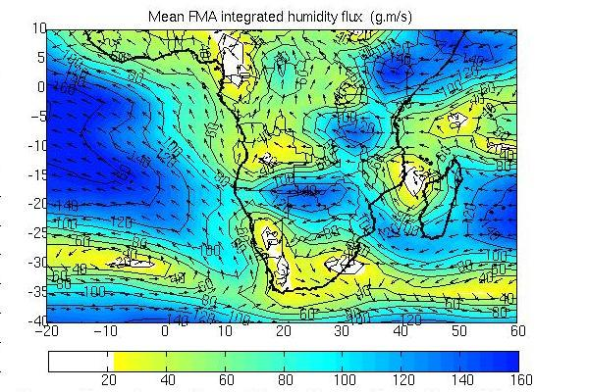
Fig. 1: Mean 1968-2001 FMA integrated moisture flux from the surface to 300 Hpa. (g/kg.m/s)

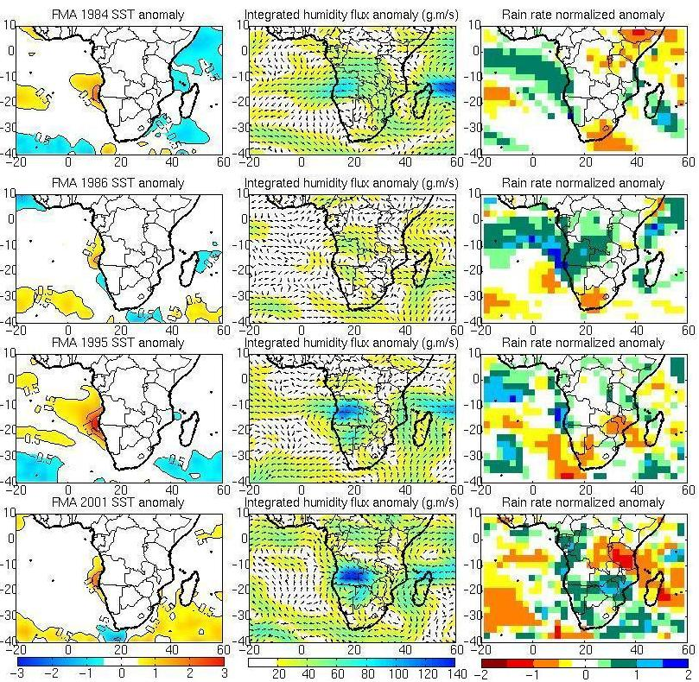
(adg) (beh) (cfi)

Fig. 2: Left: mean FMA SST anomalies for 1984 (a); 1986(d) 1995(g) and 2001 (j) isocontour at 0.5°C, 1.5°C and 2.5°C. Middle: mean FMA integrated moisture from the surface to 300 hPa flux anomalies for 1984 (b), 1986 (e) 1995 (h) and 2001 (k) in g/kg.m/s. Right: mean FMA rain rate normalized anomalies for 1984 (c), 1986( f) 1995 (i) and 2001 (l).

5. Seasonal and interannual fluctuations of the Angola/Benguela Frontal Zone (ABFZ)
The complete version of the analysis of section five can be found in annexe B.

5.1 Description of the data

The Envifish data set of the monthly mean sea surface temperature (SST) values for the period from January 1982 to December 1999 were used for this study. The SST data are obtained from the 5-channel Advanced Very High Resolution Radiometers (AVHRR) on board the NOAA -7, -9, -11 and -14 polar orbiting satellites. The data was collated for the Cloud and Ocean Remote Sensing around Africa (CORSA) project of the Marine Environment Unit of the Space Applications Institute of the Joint Research Centre of the European Commission. The mean monthly data are mapped on a rectangular projection grid of 1000x775 pixels representing the area from the equator to 40°S and from 2°W to 29°E which includes the region of the ABFZ. There are 25 pixels per degree of latitude and longitude and the corresponding nominal ground resolution is 4.5km. From comparisons with in situ data (COADS) and data from another AVHRR product (Pathfinder) it was found that Envifish SST's from September 1992 to August 1994 were up to 2.5°C warmer than both the COADS and Pathfinder data sets. This was corrected by removing the mean of the elevated values from the erroneously high period and replacing it with the mean of the SST's outside of it (January 1982 to August 1992 and September 1994 to December 1999). In order to capture the frontal zone realistically, and because the coast in the region of the ABFZ changes orientation quite markedly and is not strictly meridional, it was decided that transects parallel to the coastline would be analysed in order to include the coastal upwelling features: it appeared that a meridional transect cuts through the upwelling regime a short distance south of the frontal zone regardless of proximity to the coast and is likely to have led to misinterpretation by taking into account only a limited part of the coastal upwelling regime.

A transect at a distance of 30km offshore was found to be optimal to study the surface thermal expression of the front. Closer inshore, features such as the embayment at Baia dos Tigres (±16.5°S) affected the SST plots, while further offshore the ABFZ becomes more diffuse. The seaward extent and offshore characteristics of the ABFZ was then investigated from transects 100km, 250km, 500km and 700km offshore.

18 years of monthly mean sea surface temperatures (SST's) were extracted from the Envifish data set along the various transects and used to calculate SST climatologies, interannual SST anomalies (SSTA's) and SST climatological gradients. The SSTA's were detrended to remove any long-term tendency. For clarity within the plot of the gradient which was very noisy, it was decided to meridionally smooth the SST by averaging every five pixels. Hence the meridional resolution Then temperature gradients were obtained between every third pixel from the equator to 30°S. We made the assumption that the front runs perpendicularly to the transects. Therefore the actual SST gradients may be slightly underestimated, especially offshore.

Although weekly composite data are also available from the Envifish data set, mean monthly data were used as they produce a more complete data set as a result of much of the cloud cover being removed by averaging over a longer period of time. Nevertheless, it was necessary to firstly identify the ‘gaps’ in the data due to cloud cover, which corresponded to a flag value of 8°C. For all pixels assigned with flag values an interpolated SST was calculated by taking the spatial average of the first two pixels with valid data on either side of the flag value.

5.2 Results

The ABFZ is a region of consistently strong surface temperature gradients (> 1°C per 60km) and is a permanent feature whose width fluctuates seasonally. 30km offshore it exists approximately between 16°S and 17°S in winter and between 15°30’S and 17°S in summer. It is therefore broader in summer (spanning ±1.5° of latitude) than in winter (±1° of latitude).
The northern and southern boundaries of the ABFZ fluctuate independently of one another. In winter the northern boundary moves southwards while the southern boundary moves northwards, the converse happens at the onset of summer. The mid-frontal position is a relatively stable feature, and is situated at approximately 16.4°S. Because it is generally situated in the region of steepest temperature gradients within the frontal zone, it can be thought of as the core of the ABFZ. Average temperatures at the core of the frontal zone are 20.7°C in summer and 18°C in winter. The temperature range across the ABFZ is 2.4°C in winter and 4.2°C in summer. The greater range of temperatures in summer ties in with the fact that the warm regime to the north of the ABFZ experiences more seasonal variability than the cool regime to the south.
SST gradients in the frontal zone are steepest in summer (1°C per 34km) and persist over a wider zonal area. In winter, although the ABFZ remains apparent, the SST gradients indicative of the front are weaker (1°C per 40km) and are prevalent over a narrower region than during summer. This rather unexpected relationship between temperature gradients and width is a consequence of the fact that a far greater range of temperatures intrudes into the ABFZ from the north during summer than from the south during winter. With increasing distance offshore the ABFZ broadens and moves northwards and the SST gradients prevalent within it weaken. The front remains a distinct feature throughout the year up to a distance of 250km offshore, but up to at least 700km offshore vestiges of it can only be identified during spring and summer. The ABFZ therefore extends further offshore during spring and summer.
The northward displacement of the frontal zone with increasing distance offshore implies that the front has a northwesterly orientation. Both major and minor warm anomalies tend to displace the frontal zone southwards to a banded frontal region between 22°S and 25°S, with a lag of about a month. This region seems to act as a ‘barrier’ to the southward intrusion of warm water and therefore might limit the southward extent of anomalies. Other than a slight weakening of temperature gradients, cool anomalies do not significantly affect the ABFZ. Although the warm anomalies persist until at least 700km offshore, they are markedly less severe, particularly by 700km offshore. Despite the progressively weaker anomalies offshore, the ABFZ is similarly affected by them as it is closer inshore.

 | limits | position | width | mean SST | temperature range across  boundaries | mean SST gradient at the MFP*
summer | North | 15.5°S | 1.5°  (170km) | 23.1°C | 4.2 °C | 1°C per 34 km
summer | South | 17°S | 1.5°  (170km) | 18.9°C | 4.2 °C | 1°C per 34 km
summer | MFP* | 16.45°S | 1.5°  (170km) | 20.7°C | 4.2 °C | 1°C per 34 km
winter | North | 16°S | 1°  (115km) | 19.5°C | 2.4°C | 1°C per 40 km
winter | South | 17°S | 1°  (115km) | 17.1°C | 2.4°C | 1°C per 40 km
winter | MFP* | 16.4°S | 1°  (115km) | 18°C | 2.4°C | 1°C per 40 km
Table 1. Thermal characteristics of the ABFZ at a distance of 30km offshore (MFP = Mid-frontal position).
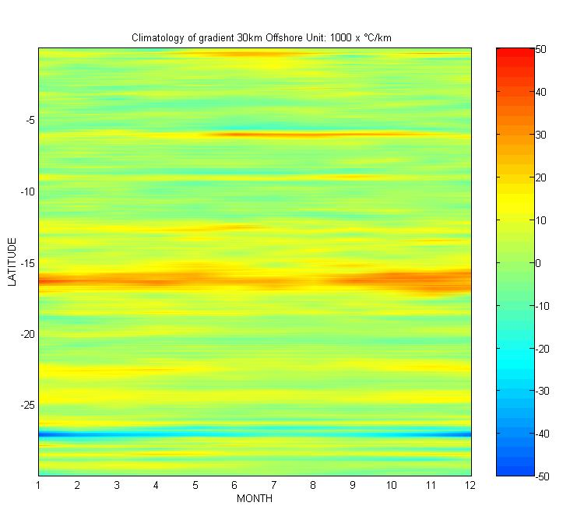
Fig.1. Climatology of SST gradients of a transect 30kms offshore extending from the equator to 30°S.

6. Sea level anomalies associated with warm and cold events along the Angolan coastal zone

6.1 Introduction

Observations of sea level and sea surface temperature have been analysed and compared in the area over the last 10 years. The seasonal cycle of sea surface temperature is characterised by a warm period with a maximum in February/March and a cold period centred in August. The sea level shows a different seasonal cycle with two maximum, respectively in March/April and October/November and a minimum in July/August. Monthly SL and SST interannual anomaly signals show similar evolutions during both warm and cold events. This is supported by calculated correlation coefficients between the two time series, and the best value of correlation is found with a lag time of about one month: sea level anomalies are leading the SST interannual variations. The relationship between sea level height, sea surface temperature and zonal and meridional components of wind was also examined. This relationship was found significant, but not in such a marked fashion as between sea level and sea surface temperature.

Until now, all various possible mechanisms driving these warm events and their predictability have not been explored and despite its scientific interest, the Angolan coastal zone is still a poorly researched area. This study is a good base for possible future work in the region. There is also a possibility for a future update of this work since the in situ data for sea level in the Angola coastal zone is not yet available. In the present study the relationship between sea level height and sea surface temperature during the warm and cold events along the Angola coastal zone has been examined as well as their relationship with zonal and meridional components of wind.
6.2 Results
The sea level was highly correlated with the sea surface temperature along the entire Angolan coast from 1992 to 2001, with less significance where the shelf is narrow, between 8°S – 9°S and 12.5°S – 15°S. Although it is known that winds are a major driving force of currents and upwelling and Benguela Niños, correlations between wind and sea surface temperature and between wind and sea level were not so clear. The best relationship between the Sea level anomalies and the Sea surface temperature anomalies during the warm and cold events was found when the anomalies were correlated with a one-month lag (where sea level anomalies lead sea surface temperature anomalies). The sea level is higher than long term mean during the warm events and lower during winter and cold events. The results proved the hypothesis that “positive anomalies of sea level can be an indicator of warm events in the Angola coastal zone and negative anomalies of sea level can be an indicator of cold events”. The two important aims: first, to describe the relationship between sea level height and sea surface temperature during the warm and cold events along the Angola coastal zone, and secondly, to learn and improve local skills to use Matlab software, were achieved. Finally, much additional work remains to be done before powerful answers can be reached on the details of the relationship between sea level height associated with warm and cold events along the Angola coastal zone and the entire area of south east Atlantic, since very little is reported about this relationship. Continuing this work in future may better demonstrate that sea level can be used as a valid indicator of occurrence the warm and cold events.
7. Discussion

After analysing the oceanic variability of the Angola/Benguela area with a number of datasets (Observations, model outputs), the next step of this project is to implement the regional model along the coast of Angola, Namibia and South Africa in the next 6 months. This regional model will be later forced with the outputs of a large scale model. At this stage, the ROMS and the POG models seem to be particularly well adapted to our purposes and have been retained. We have already received at UCT the last version of ROMS on a CD-rom. The new configuration has now to be implemented (domain, topography, surface forcing, resolution). In a early stage, we plan to compile and run the ROMS model on the Atlantic PC. It will be first forced with a climatology at its open boundaries. Preliminary simulations results will be presented in 6 months, according to the UNOPS schedule. A few points deserve special attention at this stage of the project:

- the acquisition of data (observations, model outputs) is not complete. Other products will be acquired when available (Jason for instance). Dataset maintenance implies a continuous monitoring of updated products on the network.
- the question of the choice of the large scale model to force the regional model (ROMS) is still open: other models or model outputs (ECCO for instance) might prove to be better adapted to our needs. Simulations using large scale model outputs to force the coastal model are only scheduled for next year.
- a number of factors may influence and modify the number and identity of students involved in the project: personal trajectories, skills, job offers, …
- the model ROMS will be run at a first stage on the Atlantic PC. As soon as the modeling platform will be set up, the model will be transferred on a more powerful machine.
- the analysis of the oceanic variability in the Angola/Benguela area, its predictability and impacts on the environment gave rise to two publications (one in which the consultant is the first author and the other one second author), one paper accepted pending some revisions (first author), and another paper to be submitted (second author).

