ANNEXE B

Surface Thermal Characteristics of the Angola Benguela Frontal Zone (ABFZ) from 18 years of Satellite Data.

Master Report – UCT

Jenny Veitch and Pierre Florenchie

Abstract

18 years of satellite sea surface temperature (SST) data are used to analyze the surface expression of the Angola- Benguela Frontal Zone (ABFZ). The ABFZ is the convergence zone of the southward- flowing Angola Current and the northward extent of the Benguela upwelling regime. It is identified as a region of closely- spaced isotherms or, more specifically, a region of consistently steep SST gradients. Throughout the period of study, the mid-frontal position remained relatively stable and was situated at about 16°15’S in winter and 16°S in summer. The frontal zone is broader by about 1° of latitude in austral winter than in austral summer. At a distance of 30km offshore the frontal zone is situated between 15°S and 17.5°S in winter and between about 15.5°S and 17°S in summer. Further offshore the frontal zone becomes more diffuse (i.e. weaker SST gradients over a broader region) and the mid-frontal position is situated more northwards than its position inshore, implying a northwesterly orientation of the ABFZ. At a distance of 250km offshore the front is situated between 15°S and 17°S. At a distance of 30km offshore the frontal zone is characterized by SST gradients of 1°C per 20-33km in winter to 1°C per 11- 15km in summer and corresponding temperature ranges across the frontal zone of 4°C and 5°C respectively. The average temperature in the frontal zone is 22.5°C in summer and 18°C in winter. From Hoffmöller plots of SSTs and SSTAs for the 18 year period, warm anomalies are observed in 1984, 1986, 1988, 1991, 1995 and 1998/99 and cool periods are identified in 1982/83, 1992 and 1997. The warm events of 1984 and 1995 have been distinguished as Benguela Niño events due to their similarity to the El Niño phenomenon off the coast of Peru. Both the 1984 and 1995 warm events experienced a southward penetrating warm anomaly that reached its most southern extent (23°S and 25°C respectively) in March, coincident with the southward intrusion of Angolan water. The 1984 event experienced elevated temperatures of 5°C to 6°C, which lasted for about 6.5 months, whereas the temperature anomaly of the 1995 lasted for a couple of weeks less than that and the anomaly was an increase in temperature of about +6°C to +8°C. All of the minor warm anomalies reached their maximum disturbance later in the year and, in most cases, in phase with the seasonal upwelling event in winter. Both of the major cool events are associated with an anomalous upwelling event between December and March from about 15.5°S to 23°S and cooler water than usual flowing southwards. The major warm events cause a southward displacement of the ABFZ to between 22°S and 25°S about a month after the peak disturbance. The warm anomalies persist until at least 500km offshore, but the marked southward displacement occurs only until a distance of 100km offshore. The cool anomalies persist only to a distance of between 100km to 250km offshore, but do not significantly affect the position of the ABFZ.
Background

The extensive upwelling regime off the west coast of southern Africa is an integral component of the successful fishing industry that exists there and as such it was documented as early as 1902 (Schott). The distinct northern boundary of the upwelling regime converges with the southward flowing Angola Current. This zone of convergence is the Angola- Benguela Frontal Zone (ABFZ).
It has been shown that the position of the front is best defined as the region of steepest temperature gradients between the Angola and Benguela systems. From visual analysis of Gosstcomp satellite sea surface temperature (SST) images, Meeuwis and Lutjeharms (1990) concluded that the region of closely-spaced isotherms with SST gradients of between 1°C per 28km and 1°C per 90km best described the position of the front. Using this method, they found that the surface expression of the frontal zone was between 15°S and 18°S and that steep SST gradients extended to a distance of 250km offshore.
From analysis of the steep SST gradients indicative of the frontal zone, seasonal variations of the front have been studied in detail by Shannon et al.(1987), Meeuwis and Lutjeharms (1990) and Kostianoy and Lutjeharms (1999). All have noted that the mid-frontal position fluctuates seasonally within about 2° of latitude. Meeuwis and Lutjeharms (1990) noted that the frontal zone was most clearly developed in austral summer with steepest SST gradients. In winter the front was less distinct with weaker temperature gradients. The front was observed to extend further offshore during the spring and summer than during winter when the cold Benguela upwelling regime penetrates northwards.
Using in situ data from the South African Data Centre for Oceanography (SADCO) and satellite SST data from the NOAA-9 and Nimbus-& satellites, Shannon et al. (1987) showed that the front extends to a depth of 200m, but is particularly noticeable in the upper 50m, and that the thermal surface expression, identified as the zone of maximum horizontal temperature gradient, is representative of the subsurface location. Because of this, the use of only satellite SST data in studies of the ABFZ is justified.
From a long time-series (1908- 1985) of SST in the region of the ABFZ, Taunton- Clark and Shannon (1988) concluded that anomalous warm events have occurred throughout the environmental record with a periodicity of about 10 years. The similarity of these warm events with the El Niño phenomenon that occurs off the coast of Peru was first described by Schott (1931) and subsequently by several others, amongst whom was Shannon et al. (1986) who coined the term ‘Benguela Niño’ to describe El Niños Atlantic counterpart. Taunton-Clark and Shannon (1988) found evidence of the occurrence of Benguela Niños in 1908, 1923, 1934, 1950, 1964, 1974 and 1984. Although the Benguela Niños recur on a decadal cycle, minor warm anomalies have been observed throughout the record and appear to occur more frequently. Major cool anomalies have also been documented and also appear to occur every 10 years.
Within this report, satellite SST data spanning 18 years from 1982- 1999 are used to investigate the seasonal and interannual variability of surface thermal characteristics of the frontal zone. Also, the nature of the warm and cool anomalies will be described in detail and the response of the ABFZ to such episodes will be monitored.

Data and Methods

The data used for this study are from the envifish data set and are monthly mean sea surface temperature (SST) values for the period from January 1982 to December 1999. The SST data are obtained from the 5-channel Advanced Very High Resolution Radiometers (AVHRR) on board the NOAA -7, -9, -11 and -14 polar orbiting satellites. The data was collated for the Cloud and Ocean Remote Sensing around Africa (CORSA) project of the Marine Environment Unit of the Space Applications Institute of the Joint Research Centre of the European Commission. The mean monthly data are mapped on a rectangular projection grid of 1000x775 pixels representing the area from the equator to 40°S and from 2°W to 29°E. There are 25 pixels per degree of latitude and longitude and the corresponding nominal ground resolution is 4.5km.
From comparisons with in situ data (COADS) and data from another AVHRR product (Pathfinder) it was found that envifish SST data from September 1992 to August 1994 was up to 2.5°C warmer than both the COADS and Pathfinder data sets. This was corrected by removing the mean of the elevated values from the erroneously high period (September 1992 to August 1994) and replacing it with the mean of the SSTs outside of it (January 1982 to August 1992 and September 1994 to December 1999).
Matlab software was used to process the envifish data and to extract monthly sea surface temperature (SST), a climatology, interannual SST anomalies (SSTAs) and SST gradients. The SSTAs were calculated by subtracting the climatology from the actual SSTs. In order to remove the long-term warming tendency, the SSTA data were detrended using Matlab software. The SST gradients were obtained by calculating the difference in temperature between two chosen points along the transect. The values obtained were then smoothed in order to aid visualization. The gradients were calculated under the assumption that the front runs perpendicularly to the coast. Since this is not always the case, the SST gradients are likely to be slightly underestimated, especially offshore. The 18-year based climatology was created by calculating the mean of SST for each month from January to December.
Although weekly composite data are also available from the envifish data set, mean monthly data were used as it produces a more complete data set as a result of much of the cloud cover being removed by averaging over a longer period of time. Nevertheless, it was necessary to firstly identify the ‘gaps’ in the data-set due to cloud cover and then to fill them by interpolation. Where SST values were equal to the flag value of 8°C, which corresponds to a missing data, a NaN (Not-a-Number) was assigned. The NaN values were filled by spatially averaging the first pixels on either side of it that contained valid data.
Rather than analyzing a meridional one, a transect following the coast was found to better represent the frontal zone, the regions to the north and particularly the upwelling regime to the south of the ABFZ. It appeared that a meridional transect might cut through the upwelling regime a short distance south of the frontal zone regardless of proximity to the coast near the ABFZ and is likely to lead to misinterpretation by taking into account only a limited part of the coastal upwelling regime.
A distance of 30km offshore for the coastal transect was found to be optimal to study the coastal expression of the front. The frontal characteristics are distinct at this distance without any interference from coastal features.
The seaward extent of the ABFZ was investigated from transects 100km, 250km, 500km and 700km offshore.
In order to easily visualize the warm and cool events, monthly sea surface temperature anomalies were spatially averaged along the 30km offshore transect between 10°S and 20°C and plotted against time (Figure 4.4.2). The time-series was detrended in order to remove the overall warming trend. An annual average of the SST for the frontal zone and for the regions north and south was calculated in order to remove the seasonal signal and to observe the long-term trends of each area separately (Figures 4.2.2 and 4.2.3).

RESULTS

The ABFZ

Seasonality and location

Figure 1 is the climatology of the SSTs from the equator to 30°S of a transect 30km offshore and it shows that the region of closely-spaced, zonally-oriented isotherms, indicative of the ABFZ, lie between 15°S and 17.5°S. The average temperature within the frontal zone ranges from 18°C in winter to 23°C in summer. A definitive characteristic of the ABFZ is its relatively extreme temperature range, which varies, in general, from 5.5°C in summer to 4° in winter.

The dominant mode of variability both to the north and to the south of the ABFZ is a strong seasonal signal. North of the frontal zone, seasonal heating and cooling results in the southward penetration of warm Angolan water (>22°C) from August to March over about 10° latitude and its rapid northward retreat from May to August. A region of elevated SSTs exists throughout the year at about 6°S and is likely to be due to input from the Congo River.

The ABFZ is bounded to the south by the Benguela upwelling regime, which brings cold water (<16°C) to the surface particularly during winter when upwelling-favourable winds prevail in this region. The major upwelling event begins in March, but intensifies and moves northwards markedly in April. The most northerly extent of the intense seasonal upwelling is at about 17.5°S and occurs in August. The upwelling then begins to subside and cool water retreats southwards, most rapidly during November. Despite the distinct seasonal upwelling signal south of the front, the Luderitz upwelling cell (+-27° S) persists throughout the year due to prevailing southerly winds in that region. The permanently cool water off Luderitz can be identified in Figure 1.
20
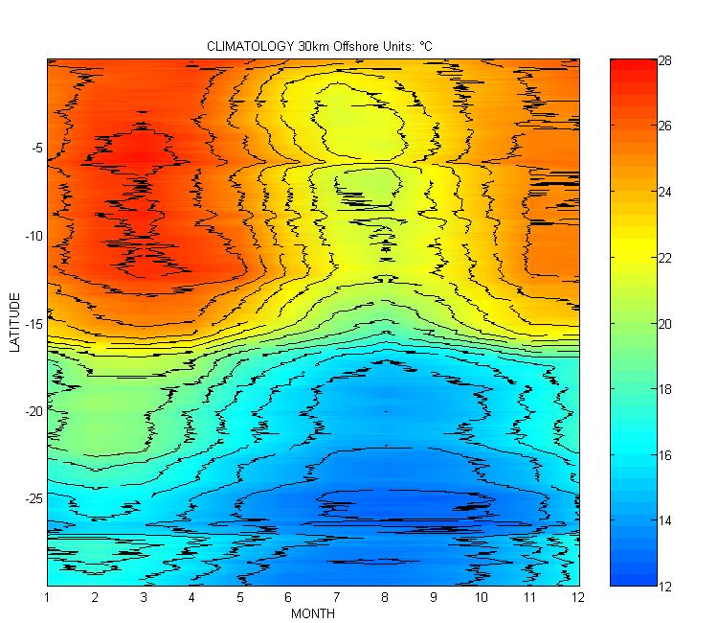
22

Fig. 1. Climatology of SSTs of a transect 30km offshore extending from the equator to 30°S.

An inherent feature of the ABFZ is the extreme temperature contrast between its boundaries. For this reason, a plot of the SST gradients in the area of interest explicitly identifies the location of the front. Figure 2 is a climatology of the SST gradients calculated from the 18 years of data, encompassing the same area of the climatology of SSTs (Figure 1). The ABFZ is immediately evident as the region of consistently steep SST gradients between 15°S and 17.5°S.
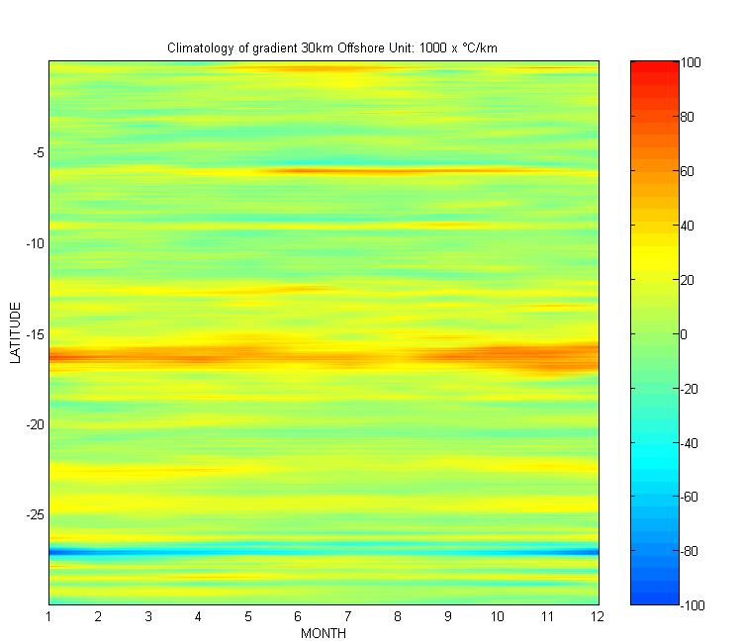

Fig. 2. Climatology of SST gradients of a transect 30km offshore extending from the equator to 30°S.

In terms of the steepness of SST gradients, the ABFZ is most intense between September and April and least intense from May to August. Although the position of the front remains relatively stable throughout the year, its width varies seasonally and the mid-frontal position fluctuates only slightly. Between September and December very steep SST gradients of the order of 1°C per 14km persist from 15.25°S to approximately 17°S. The SST gradients steepen (1°C per 11km -12.5km) from January to April, but exist in a narrower region, between 15.5°S to 16.5°S. In winter the SST gradients in the frontal zone are weakest (1°C per 20- 33km), particularly during June and July and is broadest, existing between 15°S to 17.5°S. Table 1 shows that although the width of the front varies from 1° to 2.5° of latitude, the mid-front position fluctuates seasonally between only 0.25°. In winter the mid-frontal position moves southwards by 0.25° to 16.25°S from its most northerly position of 16°S in summer.

Table 1. Thermal characteristics of the ABFZ at a distance of 30km offshore.

 | Position | Temperature Range | Mean Temperature | Width | Mid- Frontal Position | Range of SST Gradients
January - April | 15.5°S - 16.5°S | 20.5°C- 25°C | 22.75°C | 1 ° | 16 °S | 1°C per 11-12.5km
May - August | 15°S - 17.5°S | 16°C - 20°C | 18°C | 2.5° | 16.25° S | 1°C per 20- 33km
September - December | 15.25°S – 17°S | 20°C - 23°C | 21.5°C | 1.75° | 16.125°S | 1°C per 12.5- 15.5km⁻¹

Two other zones of significantly steep SST gradients worthy of note exist at 6°S and 27°S (Figure 2), coincident with the mouth of the Congo River and the Luderitz upwelling cell respectively. Steepest gradients at 6°S are from April to November. The zone of strongly negative (i.e. warming southwards) SST gradients that correspond to the Luderitz upwelling cell at 27°S is least intense in winter when upwelling in this region is at a minimum. The steepest SST gradients occur in spring and summer and roughly correspond to the upwelling maximum that occurs between October and December.

Offshore extent and orientation
The climatology of SSTs at distances of 100km, 250km, 500km and 700km offshore were also created but are not shown. From these plots it appears that the strong upwelling event during winter occurs until at least 100km offshore, but there is little evidence of it at 250km offshore. The cool cell south of 15°S during winter at a distance of 250km offshore is likely to be a result of seasonal cooling, as the temperature does not drop below 17°C. However, a cell of cool water (<16°C) exists from about 25°S until at least 30°S, which may be upwelled at that position or upwelled water from closer inshore that is advected seawards during winter. At 500km and 700km offshore there is no sign of upwelling; the minimum temperature of 17°C in winter, south of 23°S and 25°S respectively, is likely to be merely a result of seasonal cooling. North of 15°S the pattern of seasonal heating and cooling is similar, except that isotherms become more widely spaced (i.e. the range of temperatures decreases) with distance offshore. The region of closely-spaced isotherms that are definitive of the ABFZ is less distinct and is wider further offshore, but by 500km the isotherms are regularly spaced and the zonal banding of isotherms that indicate a front is not present.
Hoffmöller plots of the climatology of the SST gradients at distances of 100km, 250km, 500km and 700km offshore (not shown) illustrate that the ABFZ is less intense (i.e. weaker temperature gradients persisting over a broader region) with increasing distance from the coast. 100km offshore the ABFZ is present between ±12.5°S and 17.25°S and has typical SST gradients of about 1°C in 20- 40km. Steepest gradients occur in the region 15°S – 17.25°S during spring and autumn and are weakest during winter. Other than a brief and slight southward movement during spring, the position of the front remains very stable throughout the year. The ABFZ is present at 250km as a diffuse, but nonetheless distinct region of consistently steeper SST gradients that is relatively stable and exists between 12°S and 16°S. Typical SST gradients in this region are in the range 1°C in 25- 50km⁻¹ and are slightly elevated during spring and summer. At 500km offshore SST gradients in the region between 12°S and 16°S are low (±1°C per 50km), but are consistently higher than the surrounding area, thus indicating that there is a weak frontal signal at this distance offshore. 700km offshore, a region of consistently elevated SST gradients exists between about 8°S and 15°S during spring and summer. This suggests that vestiges of the frontal zone, though exceptionally weak, extend further offshore during summer months than during winter.
The fact that the ABFZ appears to move northwards with distance offshore implies that it is oriented in a roughly northwesterly direction.

Interannual Variability
Figure 3 is a plot of the actual SSTs from the equator to 30°S of a transect 30km offshore for the 18 year period. The 22°C and 16°C isotherms are overlaid in order to highlight the movement of the warm Angolan water and the cool water originating from the Benguela upwelling regime. The ABFZ lies between these two distinct bodies of water and, aside from unusually warm or cold episodes its position appears to have remained relatively stable throughout the period of study. The dominant mode of variability in this region is clearly the seasonal signal, but periodic irregularities occur that are worthy of investigation.
Figure 3 reveals the abnormally far southward penetration of warm water, most markedly during 1984 and 1995, but also evident in 1986, 1988 and 1991 and, other than 1997, the period from 1995 to1999 is consistently warmer than usual. These warm anomalies can be roughly quantified by taking note of the southward extent of the 22°C isotherm, which is usually situated at approximately 17°S. The most southerly position of the 22°C isotherm was 22°S in 1984, 18°S in 1988 and 23°S in 1995. The extended warm period from 1995 to 1999 (with the exception of 1997) resulted in a southern extent of, on average, 18°S of the 22°C isotherm Both the 1984 and 1995 warm intrusions are followed by a less intense upwelling cycle in winter, suggested by the fact that the 16°C isotherm does not migrate as far north as its usual (and relatively consistent) northward extent of about 16°S. During the winter upwelling of 1984 the 16°C isotherm reaches only as far north as ±17.5°S and during the winter of 1995 it extends to ±17°S. The SSTs remain notably warm north of the ABFZ during the winters of 1984 and 1995. A significant difference between the warm episodes of 1986, 1988 and 1991 and those of 1984 and 1995 is that the former are followed by winter upwelling of typical intensity. The warm episode in the middle to late nineties appears to be a general warming trend and as such the winter upwelling cycles are consistently weak and do not extend as far north as usual; the 16°C isotherm extending to only ±17°S on average.
Cooler SSTs than usual are evident during 1982, 1983, 1992 and 1997. These ‘cool’ years are associated with the southward penetration of abnormally cool water and a relatively intense winter upwelling event.
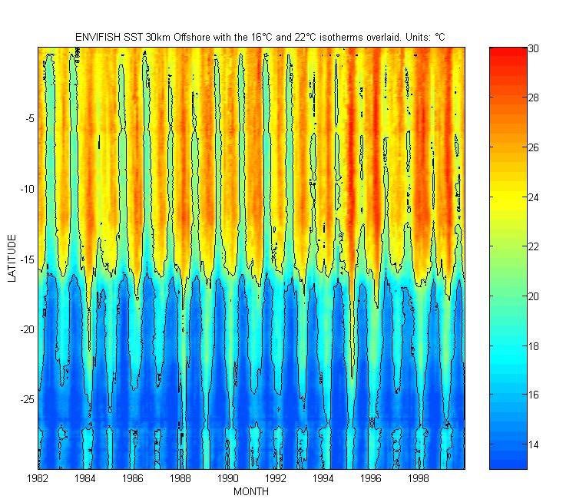

Fig. 3. Hoffmöller plot of the SSTs of a transect 30km offshore extending from the equator to 30°S for the period from January 1982 to December 1999.

Long-term trends
From Figure 3, a general warming trend is evident and appears to have affected the both the Angolan and Benguela systems. Figure 4 is a plot of the mean annual SSTs for the regions north (equator- 14°S), south (18°- 30°S) and within the ABFZ. It shows the major anomalies as well as the warming trends for each sector. The annual mean temperature north of the frontal zone increased by 3°C, within the frontal zone it increased by 3.5°C, while an increase of only 1°C occurred in the Benguela upwelling regime. For both systems, a marked increase in temperature seems to have happened between 1992 and 1995. A similar plot of the mean annual SSTs of a transect 250km offshore (not shown) shows that the frontal zone and the region north of it experienced a temperature increase of 2°C over the 18 year period, while south of the frontal zone an overall warming of 1°C was noted. From a study of variability in the south- east Atlantic during the 20th century conducted by Taunton-Clark and Shannon (1988), an overall warming of 1°C was noted between the 1920’s and 1985.

Fig. 4. Plot of the mean SSTs of a 30km offshore transect in the regions of the frontal zone and those to the north and south of it, for the period from January 1982 to December 1999.

Anomalies
The SSTAs from the equator to 30°S of a transect 30km offshore for the period from 1982 to 1999 are illustrated in Figure 5. The two major warm events or, Benguela Niños, of 1984 and 1995 are obvious and correspond to strongly positive SSTAs that extend far south of the ABFZ. The warm events of 1986, 1988, 1991, 1996, 1998 and 1999 previously described, correspond to positive SSTAs north of and within the frontal zone, but do not extend south of the ABFZ. The major cool events during this period, namely the 1982, 1983, 1992 and 1997 events, correspond to the distinct negative anomalies in the region of the frontal zone.
Shannon et al. (1986) described the 1984 warm event in detail and concluded that similarly extreme positive anomalies occur about once every ten years. The decadal cycle of the major warm events or Benguela Niños has since been substantiated by analysis of a long time series of SST data by Taunton-Clark and Shannon (1988). Though Figure 5 shows only 18 years of data, the recurrence of major positive anomalies is consistent with the decadal cycle revealed in previous studies.
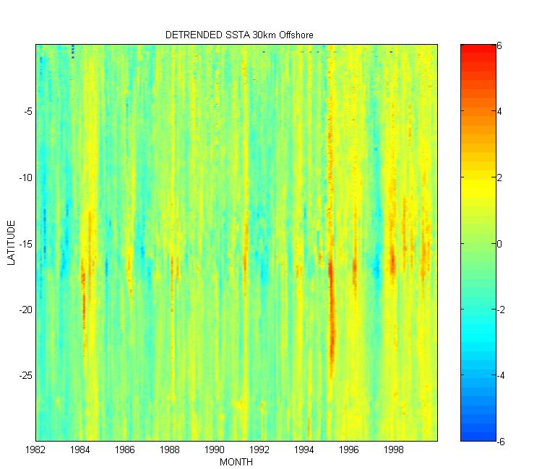
Fig. 5. Hoffmöller plot of the SSTAs of a transect 30km offshore extending from the equator to 30°S for the period from January 1982 to December 1999.

Figure 6 is a timeseries of the detrended monthly mean SSTAs in the region of the frontal zone (10°S to 20°S) of a transect 30km offshore. The major warm anomalies of 1984 and 1995 are evident and both experienced an average positive anomaly of about 3°C, but the positive anomaly of 1984 seems to have persisted for longer. The minor warm anomalies of 1986, 1988, 1991, 1996, 1998 and 1999 produced temperature increases of between 1.5°C and 2.5°C. The major cool events of 1982/83 and 1997 involved temperature decreases of 2°C and 3°C respectively, while the minor
cool events were associated with negative anomalies of about -1.5°C.
Hoffmöller plots of SSTAs from the equator to 30°S, at distances of 100km, 250km, 500km and 700km offshore (not shown) give an indication of the seaward extent of the anomalies identified in Figure 5. The warm anomalies of 1984, 1995, 1996, 1998 and 1999 persist until at least 700km offshore, but they are substantially less intense and are far less extensive than closer inshore. The major cool anomalies of 1982/ 83 and 1997 extend to between 100km and 250km offshore and remain fairly intense until at least 100km from the coast.

Fig. 6. Plot of the mean SSTAs between 10°S and 20°S of a transect 30km offshore extending from the equator to 30°S for the period from January 1982 to December 1999.

1984 and 1995 Benguela Niños
Although the Benguela Niño events of 1984 and 1995 were similarly severe, differences existed between the surface thermal characteristics of each. Despite these differences, it has been shown by Shannon et al., (1986) that the forcing mechanism of the major events are similar and Carton and Huang (1994) distinguishes them from the anomalies that are less extreme and not considered to be major, such as the warm event of 1988.
Figures 7(a) and (b) show the SSTs of a 30km offshore transect (equator to 30°S) for the periods November 1983- October 1984 and November 1994- October 1995 respectively. In terms of SSTs, the 1984 and 1995 events are very similar, except that the anomalous southward displacement of Angolan water appears to have lasted longer in 1984, but extended further south in 1995.
For both events, the displacement characteristics of the 22°S isotherm will be used to investigate the southward penetration of the unusually warm water. At the limit of its southerly displacement in March 1984, the 22°C isotherm was situated at 22°S. During the 1984 event the 22°C isotherm began its northerly retreat in March and by May it was situated at approximately 16°S. From May it began to move southwards once again to a position of 17.5°S in June at which point it began its final northward retreat. The 1984 Niño therefore effectively occurred as a ‘double-event’, this is in agreement with the findings of Shannon et al., (1986), who, from sea-level and satellite data, found that though the major intrusion commenced its retreat in April, in situ data indicated that SSTs off Walvis Bay remained unusually high until at least August. Because the warm intrusion of 1984 lasted for longer, it encroached on the upwelling regime, thereby suppressing the northward extension of cool, upwelled water. The most northerly extent of intense upwelling (indicated by the 16°C isotherm) was 20°S and occurred in August.
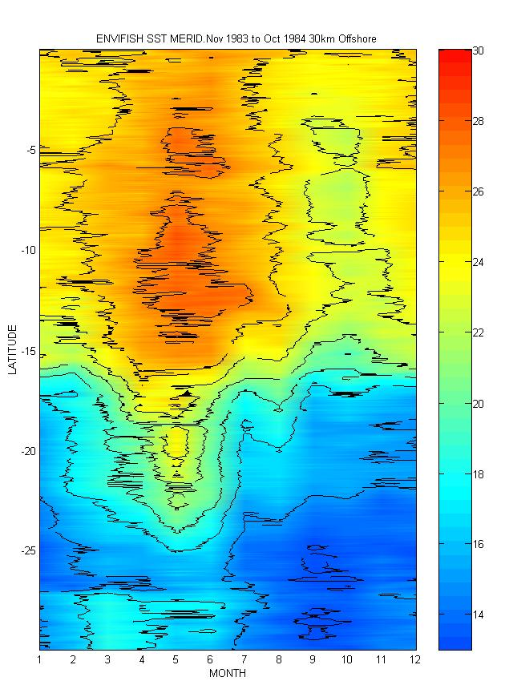
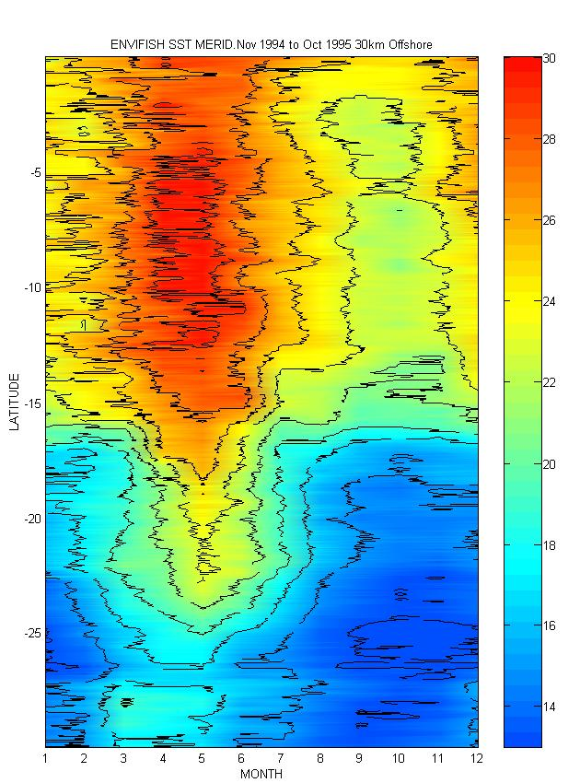

Fig. 7(a) and (b). Hoffmöller plots of the SSTs of a transect 30km offshore extending from the equator to 30°S for the period from November 1983 to October 1984 and from November 1994 to October 1995 respectively.

The most conspicuous difference between the 1984 and 1995 Benguela Niños is that the latter appears to have extended further south, but to have persisted for a shorter period of time than the 1984 event. The movement of the 22°C isotherm as seen in Figure 7(b) substantiates this. Like the 1984 event, its southerly extent is during March but it is situated at 23°S. It retreats steadily northwards from March and by May it is as far north as15°S. Because it does not encroach as much into the period of upwelling as the 1984 event, cool, upwelled water penetrates as far north as 18°S in August.
Figure 8 is a plot of the mean monthly SSTs in the frontal zone for the 1984, 1995 and 1988 warm events as well as the climatology of the mean monthly SSTs. A similar pattern is evident for both events, whereby the mean temperature in the frontal zone is highest in March, drop fairly rapidly until May and then increase again until June at which point they drop relatively steadily, with a minimum in July and from there a gradual increase. In 1984 the mean temperature in the frontal zone in March was about 25°C and in July it was approximately 18°C, while the slight temperature maximum in June had a mean temperature of 22°C. The mean temperature in the frontal zone during March 1995 was 27°C, dropping to about 19.75°C by May and decreasing gradually until August, aside from a slight temperature maximum of 20°C in June. The major perturbation during the 1995 event was therefore more extreme than during 1984 and occurred from January to April. From May to December, although the temperatures did not quite approximate a ‘normal situation’ they dropped markedly. Although the 1984 event also experienced greatest temperatures from January to April, its temperatures did not decrease as notably and the mean temperatures in the frontal zone remained warmer from May to October than during the 1995 event. The warmer temperatures in the frontal zone in the winter of 1984 validate the fact that the warm intrusion inhibited the northward advance of cool, upwelled water, more so than during the 1995 event.

Fig. 8. Plot of the mean SSTs in the frontal zone of a transect 30km offshore extending from the equator to 30°S for the period of the warm anomalies of 1984, 1988 and 1995. Also plotted is the climatology of the mean SSTs in the frontal zone.

Figures 9(a) and (b) show the SSTAs of a transect 30km offshore for the periods from November 1983 to October 1984 and November 1994 to October 1995. Figure 9(a) shows the ‘double-event’ that occurred in 1984 and shows that positive anomalies of between +5°C and +6°C existed until approximately 23°S in March. The warm anomaly of 1995 was stronger and temperatures were elevated by about 6 to 8°C as south as 25°S in March.
Figure 10 is a plot of the monthly mean SSTAs in the frontal zone (15°S- 17.5°S) 30km offshore for both of the major warm events and for the minor warm episode of 1988. From this plot it is evident that the positive anomaly in the frontal zone in 1984 lasted for about 6.5 months (about mid-January to August), while the 1995 warm anomaly lasted for 6 months from about mid- January to mid-July. Although the 1984 event lasted for only a couple of weeks longer than the 1995 event, its positive anomalies from May to August were significantly higher.

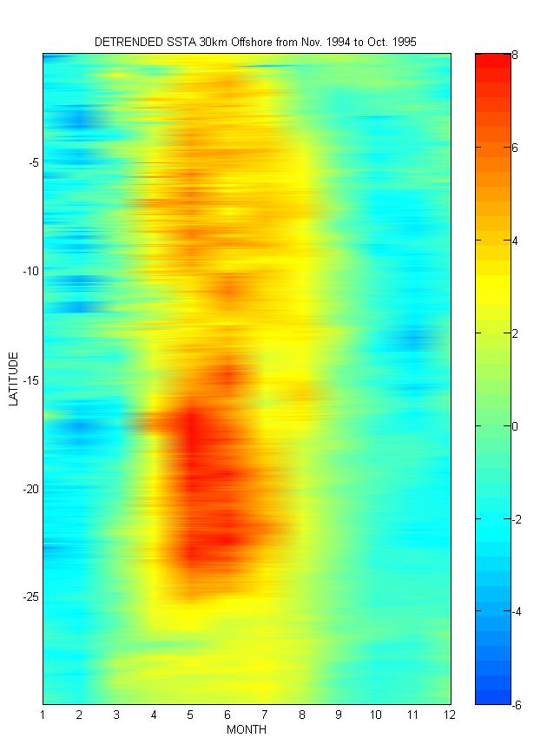
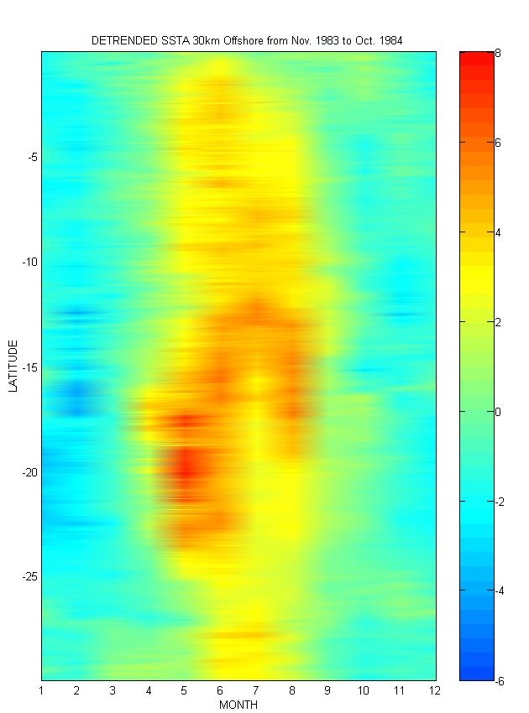
Fig. 9(a) and (b). Hoffmöller plots of the SSTAs of a transect 30km offshore extending from the equator to 30°S for the period from November 1983 to October 1984 and from November 1994 to October 1995 respectively.

Fig. 10. Plot of the mean SSTAs in the frontal zone of a transect 30km offshore extending from the equator to 30°S for the period of the warm anomalies of 1984, 1988 and 1995.

Minor Warm Events
From a Hoffmöller plot of the SSTAs from November 1987 to October 1988 (not shown) and from Figure 10 it can be seen that the peak of the major positive SST anomaly of 1988 occurred in May. The Hoffmöller plot shows that the warm anomaly in May was most pronounced within the frontal zone and north of it. Prior to this however, unusual warming is evident south of the frontal zone between January and April but seems to be an isolated event as the anomaly does not extend north of the frontal zone. The implication of this is that the forcing mechanism of the first anomaly is likely to be locally driven, while the latter, more intense anomaly is probably forced by a similar mechanism to the Benguela Niño events, but slightly later in the year. This has been shown by Carton and Huang (1994). Because the major anomaly that occurred later in the year did not extend very far south, it does not appear to have inhibited the winter upwelling regime, which appears to have resulted in very typical cool temperatures within the frontal zone (see Figure 8).
Plots of the SSTAs during the anomalously warm period in the mid- to late- 1990’s, save 1997, (not shown) show that in each case the region of greatest positive anomaly exists north of the frontal zone and peaks later in the year and for a shorter period than the Niño events.
A significant feature and common to all of the minor warm events is that they occurred later in the year than the major events i.e. out of phase with the seasonal southward advance of the Angola Current. Florenchie et al., (2002) speculated that this might be the reason why none of the minor warm anomalies evolved into a full-blown Benguela Niño event.

Major Cool Anomalies: 1982/83 and 1997
The cool event that persisted from 1981 to 1983 has been documented by several authors including Walker (1987) who, using principle component analysis (PCA) identified the maximum southward expression of the cool anomaly to exist at about 26°S. He also found that the cool anomaly did not extend offshore, but that the SSTs offshore were in fact higher than normal. The fact that the cold anomaly seems to have been confined to the region of upwelling brought Gillooly and Walker (1984) to the conclusion that it was the result of an abnormal eastward protrusion of warm surface water. Also using PCA, Walker (1987) was able to conclude that the cool anomaly was not related to intense equatorial winds, but rather to more local tropical atmospheric forcing. At the time of the cool event of 1981 to 1983 a warm event occurred on the South African West coast as reported by Walker et al., (1984). Gillooly and Walker (1984) linked the warm event to the unusually far north position of the Subtropical Convergance (STC) and the South Atlantic High.

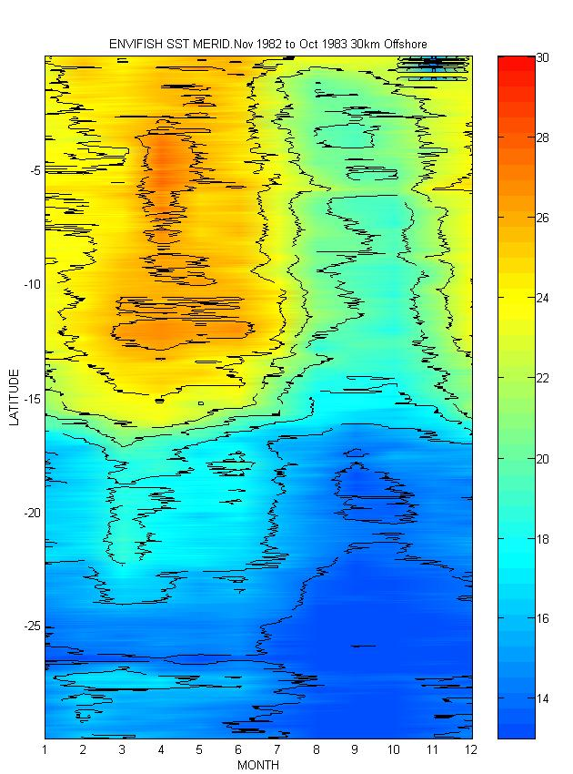
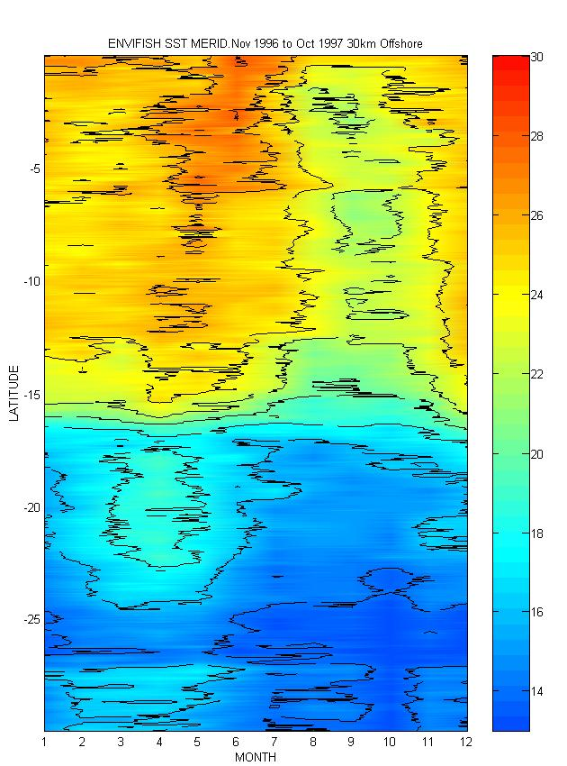
Figures 11 (a) and (b) are plots of the SSTs 30km offshore of a transect from the equator to 30°S for the periods November 1982 to October 1984 and November 1996 to October 1997 respectively. For both of the cool events the 22°C isotherm does move further south than about 16.5°S and its most southerly extent is not distinct, but remains consistent for a few months. At the time of the southward penetration of warm Angolan water during the summers of 1982/83 and 1996/7, water south of the frontal zone is abnormally cool and the water moving southwards is about 2°C cooler than usual. Both events therefore seem to be related to an anomalous upwelling event just south of the frontal zone from December to April. The cool water south of the frontal zone between December and April is not evident in similar SST plots of the same transect 250km offshore (not shown), thus validating the fact that the source of the cold water is an unusual coastal upwelling event.
Fig. 11(a) and (b). Hoffmöller plots of the SSTs of a transect 30km offshore extending from the equator to 30°S for the period from November 1982 to October 1983 and from November 1996 to October 1997 respectively.

Figures 12 (a) and (b) are plots of the SSTAs 30km offshore of a transect from the equator to 30°S for the periods November 1982 to October 1984 and November 1996 to October 1997 respectively. They indicate that the maximum intensity of both cool anomalies occurred during summer, winter and spring and that the negative anomaly was weakest during autumn.

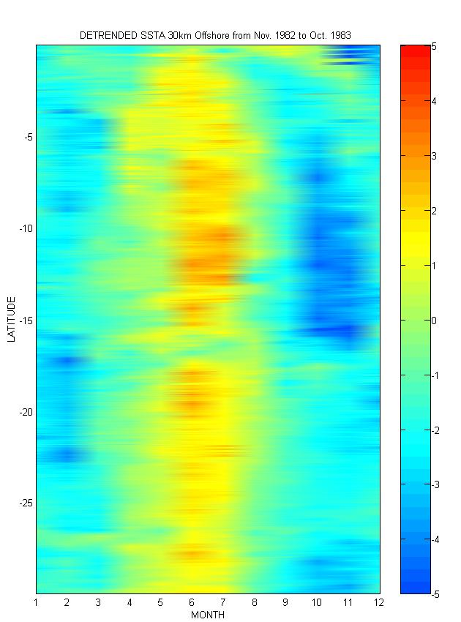
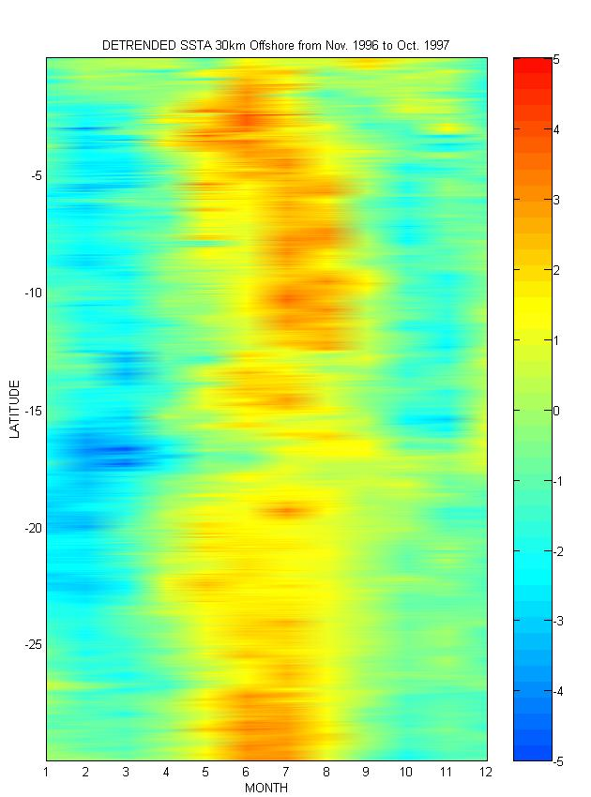
Fig. 12(a) and (b). Hoffmöller plots of the SSTAs of a transect 30km offshore extending from the equator to 30°S for the period from November 1983 to October 1984 and from November 1994 to October 1995 respectively.

Figures 12 (a) and (b) and Figure 13 show that the negative anomaly during the 1982/83 cool event persisted from November to mid- February and from June to December, but the most extreme temperature minimums occurred in December (-2.75°C) and in September (-3.4°C). The 1996/97 cool anomaly began later in the year and was present from December to March and from mid- July to mid- September. Two notable minimums occurred in January (-3.25°C) and in late August (-1.25°C). Perhaps a significant difference between these two events is that the former experienced greatest negative anomalies later in the year, while the latter had its most extreme temperature decrease at the beginning of the year. Another feature worthy of note is the fact that the two temperature minimums of the cool anomaly of 1996/97 differ by 2°C, while the temperature range of the two minimums of the 1982/83 event is only about 0.65°C. The implication of this is that the 1982/83 was more persistent than the 1996/97 event.

Fig. 13. Plot of the mean SSTAs in the frontal zone of a transect 30km offshore extending from the equator to 30°S for the period of the cool anomalies of 1982/83 and 1997.

Response of the ABFZ to anomalies
A plot of the gradient of SSTs through time from the equator to 30°S (Figure 14) of a 30km offshore transect shows that despite episodic warm and cool events and a long-term warming trend, the position of the front is very stable between 15°S and 17.5°S. Figure 14 substantiates that the SST gradients within the frontal zone have a seasonal signal and are more intense in summer than in winter. Although the position of the frontal zone has remained relatively stable, the region of steep SST gradients indicative of the frontal zone has broadened slightly. The widening of the frontal zone is possibly related to the long term warming trend and the fact that it is more extreme to the north of the front than to the south of it.

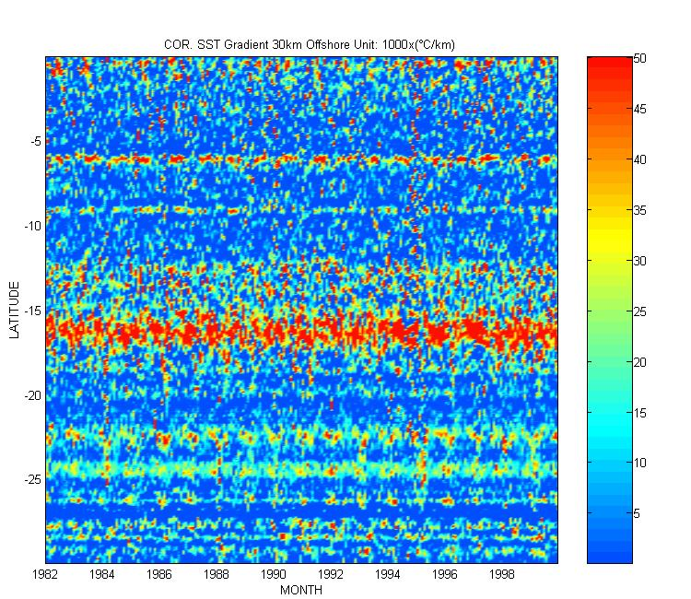
Fig. 14. Hoffmöller plot of the SST gradients of a transect 30km offshore extending from the equator to 30°S for the period from January 1982 to December 1999.

The only major perturbations to the position of the frontal zone occurred during the warm events of 1984, 1988, 1995 and 1998/99. A weakening of the SST gradients in the frontal zone is evident in Figure 14 as well as a marked increase in SST gradients in the region of between 22°C and 25°S for the duration of all of the warm events. Figure 15 is a plot of the mean SST gradients in the frontal zone during the warm episodes of 1984, 1988 and 1995 and the mean SST gradients of the climatology is also plotted. It substantiates that the warm anomalies resulted in a considerable weakening of the temperature gradients between 15°S and 17.5°S, particularly at the time of the most extreme southward extent of the anomaly (March for the 1984 and 1995 events and February for the 1988 episode). The fact that the SST gradients intensified between 22°S and 25°S during the warm events is verified by Figure 16, which is a plot of the mean SST gradients in this area for the period of the warm anomalies. The steep gradients in this region occur about a month after the most southward extent of the anomaly and the corresponding SST gradient minimum within the ABFZ and persist for at least 7 months. The implication of this is that the major warm events cause an extreme southward displacement (±7.5° of latitude) of the frontal zone that occurs about a month after the anomaly. On the other hand, the major cool events tend to confine the region of steepest temperature gradients to a relatively small area and effectively result in a more intense (i.e. narrower with steeper SST gradients) frontal zone.

Fig. 15. Plot of the mean SST gradients in the frontal zone of a transect 30km offshore extending from the equator to 30°S for the period of the warm anomalies of 1984, 1988 and 1995. Also plotted is the means SST gradient of the climatology of the same region.

Plots of the SST gradients for several offshore transects show that the position of the frontal zone is stable, but becomes more diffuse (i.e. weaker SST gradients over a broader region) with distance offshore. It extends further offshore during summer months and there are signs of it up to at least 700km seaward. Like the situation inshore, during the major warm events, SST gradients in the ABFZ weaken, and SST gradients steepen in the region between 22°S and 25°S. The major cool anomalies do not extend to 250km offshore, therefore the intensity of the SST gradients in the ABFZ offshore remain stable.
Fig. 16. Plot of the mean SST gradients in the region from 22°S to 25°S of a transect 30km
offshore extending from the equator to 30°S for the period of the warm anomalies of 1984, 1988 and 1995. Also plotted is the means SST gradient of the climatology of the same region.

Figure 17 is a plot of the mean SST gradients in the frontal zone and the region 22°S to 25°S as well as the mean SSTAs in the frontal zone for the 18 year period. It validates that during the major warm anomalies the SST gradients in the frontal zone weaken and become steeper about 7.5° south of it. Also it shows that during the cool anomalies the mean SST gradients both in the ABFZ (15°S to 17.5°S) and between 22°S and 25°S weaken substantially.
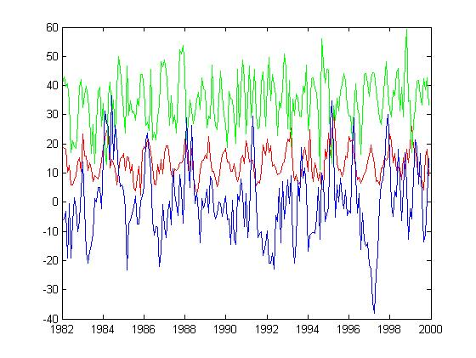
Time-series of the monthly mean SST gradients in the frontal zone and between 23°S and 25°S (in green and red respectively) and monthly mean SSTAs in the frontal zone (blue).
Time (months)
Gradient ( 1000x°C.km⁻¹), Anomaly (°C)

Fig. 17. Time-series of the monthly mean SST gradients in the frontal zone and between 23°S and 25°S (in green and red respectively) and monthly mean SSTAs in the frontal zone (blue).

SUMMARY OF RESULTS AND CONCLUDING REMARKS

- The ABFZ is a region of consistently strong surface temperature gradients and is a permanent feature whose width fluctuates seasonally. 30km offshore it exists approximately between 15°S and 17°30’S in winter and between 15°30’S and 17°S in summer. It is therefore broader in winter (spanning ±2.5° of latitude) than in summer (±1.5° of latitude).
- The mid-frontal position is situated at approximately 16°15’S in winter and moves northwards slightly in summer to about 16°03’S.
- Temperatures at the mid-frontal position range from 19°C in winter to 23°C in summer. The temperature range across the ABFZ is 4°C in winter and 5.5°C in summer.
- SST gradients in the frontal zone are steepest when the front is narrow in summer and weakest during winter when the front is broadest. In summer typical SST gradients are of the order of 1°C per 14km and in winter they are ± 1°C per 25km.
- When the front is at its most intense during summer, signs of it can be noted up to 700km offshore. However, it is more diffuse, i.e. weaker SST gradients over a broader region, with distance offshore. Up to at least 100km offshore it is relatively distinct during winter and summer, but by 250km it becomes even more diffuse and is clearly evident only during spring and summer.
- The front moves northwards with distance offshore, it therefore has a north-westerly orientation.
- Major and minor warm anomalies tend to displace the frontal zone southwards to a region between 22°S and 25°S, with a lag of about a month. Although the warm anomalies persist (though less severely) until at least 500km offshore, the marked southward displacement of the ABFZ occurs only up to a distance of 100km offshore.
- The cool anomalies persist to between 100km to 250km offshore and do not significantly affect the position of the ABFZ.

Future studies could take this work further by extending the data set in order to include more major warm events thereby improving the analysis of frontal zone responses to Benguela Niños. Also, an extended data set would provide a more representative climatology. The temporal resolution could be improved by using the mean weekly data available from the Envifish data- set. Though the causal mechanism for the anomalies were not within the scope of this work, the inclusion of equatorial wind-stress data and sea-level data would provide a clearer picture of the sequence of events that lead up to Benguela Niños and the ensuing effect on the frontal zone.

REFFRENCES

- Boyd, A. J. and Agenbag, J. J. 1984: Seasonal Temperature and Salinity Trends off Central Namibia between 1978 and 1983 with Particular Reference to the Cool Winter of 1982. S. Afr. J. Sci., 80, 77-79.

- Carton, J. A. and Huang, B., 1994: Warm Events in the Tropical Atlantic. J. Phys. Oceano., 24, 888-903.

- Crawford, R. J. M. and Shannon, L. V., 1988: Long term changes in the distribution of fish catches in the Benguela. In Long Term Changes in Marine Fish Populations. Wyatt, T and M. G. Larrañeta (Eds). Vigo; Instituto de Investigaciones Marinas de Vigo: 449-480 (Proceedings of a symposium held in Vigo, November 1986).

- Citeau, J., Guillot, B., Lae, R. and Therpenier, M. 1984: Warm and Cold Oceanic Events in the Tropical Atlantic and their relationship with the Intertropical Convergence Zone. Tropical Ocean-Atmos. Newsletter, 23, 19-20.

- Florenchie, P., Reason, C., Lutjeharms, J.R.E and Musson, S. 2002: Warm and Cold Events in the SE Atlantic (submitted to J. Geophys. Res.)

.
- Gammelsrǿd, T., Bartholomae, C. H., Boyer, D. C., Filipe, V. L. L. and O’Toole, M. J. 1998: Intrusion of Warm Surface Water along the Angolan-Namibian Coast in February 1995: The 1995 Benguela Niño. S. Afr. J. mar. Sci., 19, 41-56.

- Gillooly, J. F. and Walker, N. D. 1984: Spatial and Temporal Behaviour of Sea-surface Temperatures in the South Atlantic. S. Afr. J. Sci., 80, 97-100.

- Hisard, P. 1980: Observation de résponse de type ‘El Niño’ dans l’Atlantique tropical oriental- Golf de Guinée. Ocean. Acta., 3, 69-78.

- Jury, M. R. and Courtney, S. 1995: Climatic Determinants of Benguela SST Variability. Cont. Shelf. Res., 15, 1 339- 1354.

- Kostianoy, A. G., 1996: Use of satellite data for the analysis of the fronts of the S.E. Atlantic (with as example the Angola- Benguela Frontal Zone) (In Russian), Issled. Zemli Kosmosa, 4, 77- 86.

- Kostianoy, A. G. and Lutjeharms, J. R. E. 1999: Atmospheric Effects in the Angola-Benguela Frontal Zone. J. Geophys. Res., 104(9), 20 963-20 970.

- Kuderskiy, S.K. and Strogalev, V.D. 1973: The Angola Current in the tropical zone of the S.E. Atlantic Ocean (In Russian), Tr. Atl. Nauchno-Issled. Inst. Ryb. Khoz. Okeanogr., 51, 5-13.

- LeClus, F., 1985: Effects of a warm water intrusion on the anchovy fishery in Namibia. Colln scient. Pap. Int. Commn SE. Atl. Fish. 12(1):99-106.

- McLain, D.R., Brainard, R.E. and Norton, J.G. 1985: Anomalous Warm Events in Eastern Boundary Current Systems. Rep. Calif. Coop. oceanic Fish. Invest. 26: 51-64.

- Meeuwis, J. M. and Lutjeharms, J. R. E. 1990: Surface Thermal Characteristics of the Angola-Benguela Front. S. Afr. J. Sci., 9, 261-279.

- Merle, J. 1980: Variabilité thermique anuelle et interanuelle de l’Ocean Atlantique equatorial Est. L’hypothése dun ‘El Niño’ Atlantique. Ocean Acta, 3, 209-220.

- Mohrholz, V., Schmidt, M. and Lutjeharms, J. R. E. 2001: The Hydrography and Dynamics of the Angola-Benguela Frontal Zone and Environment in April 1999. S. Afr. J. Sci., 97, 199-208.

- Picaut, J. 1985: Major Dynamics Affecting the Eastern Tropical Atlantic and Pacific Oceans. CalCOFI Rep., 26, 41-49.

- Picaut, J. 2001: Chapter 4: Tropical Ocean Variability. Satellite Altimetry and Earth Sciences (Academic Press), 217-233.

- Ruiz-Barradas, A., Carton, J. A. and Nigam, S. 2000: Structure of Interannual-to-Decadal Climate Variability in the Tropical Atlantic Sector. J. Climate, 13, 3 285-3 296.

- Servain, J., Legler D., Picaut, J., Verbeque, V. and Seva, M. 1985: Oceanic Variability and Wind Stress Forcing in the Tropical Atlantic Ocean. IAMAP/IAPSO Joint Assembly, 5-16 August 1985, Honolulu, HI, Paper 06-16.

- Shannon, L. V., Boyd, A. J., Brundrit, G. B. and Taunton-Clark, J. 1986: On the existence of an El Niño-type Phenomenon in the Benguela System. J. mar. Res., 44, 495- 520.

- Shannon, L. V., Agenbag, J. J. and Buys, M. E. L. 1987: Large- and Mesoscale Features of the Angola-Benguela Front. S. Afr. J. mar. Sci., 5, 11-34.

- Shannon, L. V. and Agenbag, J. J. 1990: A Large-Scale Perspective on Interannual Variability in the Environment in the South-East Atlantic. S. Afr. J. mar. Sci., 9, 161-168.

- Taunton-Clark, J. and Shannon, L.V. 1988: Annual and Interannual Variability in the South-East Atlantic during the 20th Century. S. Afr. J. mar. Sci., 6, 97- 106.

- Walker, N. D., Taunton-Clark, J. and Pugh, J. 1984: Sea Temperatures off the South African West Coast as Indicators of Benguela Warm Events. S. Afr. J. Sci., 80, 72-77.

- Walker, N. D. 1987: Interannual Sea Surface Temperature Variability and Associated Atmospheric Forcing within the Benguela System. S. Afr. J. mar. Sci., 5, 121-132.

