PIRATA South East Extension Feasibility Study.

RAF/00/G32 – Benguela Current Large Marine Ecosystem

December 2003

Mathieu Rouault

for

United Nations Office for Project Services


Centre for Marine Studies  University of Cape Town | Oceanography  University of Cape Town

Table of Contents

Executive Summary 6
1. Background 8
2. Techniques and operation 13
2. 1 Introduction 13
2.2. Loading 13
2.3. Assembling and testing 14
2.4. Recovering 15
2.5. Deploying 16
2.6. Conclusion 16
3. Science 18
3.1 Relevance to regional climate and applications 18
3.2 Scientific objectives 32
3.3 Data management 32
4. Implementation and resource 33
4.1 Countries and groups involved. 33
4.2 - Identification of infrastructure needed for implementation 35
4.2.1 - Ship time 35
4.3 Schedule of implementation 36
4. 4 Funding requirements/cost justification for plan A 36
4.4.1 ATLAS cost 36
4.4.2 PMEL handling (calibration, refurbishment). 37
4.4.3 Sea (floats and weight hard cores) and air (electronic) transportation of the material (from Seattle to South Africa’s harbours and return) 37
4.4.4 Customs and Agent fees 37
4.4.5 Petty work at local lab (paints, tools) 37
4.4.6 Human travels per-diems for the 4 yearly cruises 37
4.4.7 Technical Training (e.g. from CT to Seattle, travel + per-diems) 37
4.4.8 Administration cost (secretary, communication) 38
4.4.9 Participation to PIRATA meetings 38
4.4.10 Ship time 38
4.4.11 People Salary and student grants 38
4.4.12 Publications 38
4. 5 Funding requirements/cost justification for plan B 39
4.5.1 ATLAS cost 39
4.5.2 PMEL handling (calibration, refurbishment). 39
4.5.3 Sea (floats and weight hard cores) and air (electronic) transportation of the material (from Seattle to South African harbours and back) 39
4.5.4 Customs and Agent fees 40
4.5.5 Petty work at local lab (paints, tools) 40
4.5.6 Human travel and per-diems for the 2 yearly cruises 40
4.5.7 Technical Training (e.g. from CT to Seattle, travel + per-diems) 40
4.5.8 Administration cost (secretary, communication) 40
4.5.9 Participation to PIRATA meetings 40
4.5.10 Ship time 40
4.5.11 People Salary and student grants 40
4.5.12 Publications 41
4.6 Identification/source of funding 41
5. Alternative solutions. 42
6 Cost benefit analysis 43
7. Review of PIRATA-SEE white paper. 45
8. Acknowledgement 52
9. Bibliography 53
Appendix 1: 2003 scientific publications and oral presentations 57
Appendix 2: 2003 capacity building. 59
Appendix 3: 2003 in kind contribution 60

Table of FIGURES

Figure 1: A typical ATLAS mooring array. 10
Figure 2: Status of PIRATA in 2003, circulation along sigma 25 and location of proposed South East Extension at 5ºS-8ºE and 10ºS-11ºE. (Background made by Alban Lazar from Lazar et al, 2002). 12
Figure 3: Left panels: contribution of incoming short wave radiation (thin red line), outgoing long wave radiation (thin purple line), latent heat flux (thin dark blue line), sensible heat flux (thin light blue line), vertical and horizontal oceanic processes (green line), net heat flux (red line) to the yearly cycle of cooling or warming of the ocean surface layer (black line). Units is in C per month, top: northern proposed mooring, 5ºS-8ºE, bottom: southern proposed mooring, 10ºS-11ºE. Right panel: modelled and observed surface temperature. (Alban Lazar, personal communication). 21
Figure 4: Mean sea surface temperature (1982-2002) for March, June, September and December and proposed location of ATLAS moorings at 5ºS-8ºE and 10ºS-11ºE. 22
Figure 5: February to April mean sea surface temperature (top) and total rainfall for coastal and offshore Angola (bottom) and North Namibia. SST is averaged in domain [8°S-17.5°S; 8°E-Coast]; bottom: Total rainfall (mm) averaged in [7.5°S-15.5°S; 7.5°E-15°E]; 23
Figure 6: Top, mean FMA SST anomalies from 1979 to 2002 off coastal, offshore Angola/North Namibia; bottom: Total FMA rainfall anomalies (mm), same domain as in Figure 5. 23
Figure 7: Mean 1968-2001 January, February, March and April integrated moisture flux from the surface to 300 H pa from NCEP reanalysis (g/kg.m/s). 27
Figure 8: Left: mean FMA SST anomalies for 1984 (a); 1986(d) 1995(g) and 2001 (j). 28
Figure 9: Sum of subsurface model temperature anomalies between 5 and 100m depths from December 94 to March 95. Courtesy of Pierre Florenchie (Florenchie et al. 2003 (b)) 29
Figure 10: Sum of subsurface model temperature anomalies between 5 and 100m depths from December, January, February and April 84. Courtesy of Pierre Florenchie (Florenchie et al. 2003 (b)) 30
Figure 11: From top to bottom: Anomalies for 1979 - 2003 mean February-March-April in sea level atmospheric pressure (NCEP), total rainfall (GPCP), sea surface temperature (Hadley SST), latent heat flux (NCEP), wind speed (NCEP), meridional wind speed, zonal wind speed for the region 5º S 15º S 7.5º E 15º E. 31

Executive Summary

PIRATA (Brazil, France, USA) has deployed between 1997 and 2001, an array of 12 ATLAS buoys with the objective of monitoring, describing and understanding the evolution of sea surface temperature, upper ocean thermal and saline structure, net heat budget, air-sea fluxes of momentum, latent and sensible heat and fresh water in the tropical Atlantic. The oceanic and meteorological observations are transmitted to shore via satellite and are available in near real-time on the Internet. They are communicated to the Global Telecommunication System and readily available for ocean and weather prediction models. The ultimate objective of PIRATA is real-time ocean monitoring to enable resource prediction in the adjacent countries.

An extension of PIRATA in the South East Atlantic (PIRATA SEE) at key locations around 5ºS-8ºE and 10ºS-11ºE would have applications to marine ecosystem processes, fisheries-environment interaction, climate variability and forecasting, all very relevant to the strategic objectives of the BCLME. It will provide much needed capacity building and training. Besides gaining information on the physics of the seasonal cycle of sea surface temperature, ocean surface heat content and other key parameters, ATLAS moorings could be used to monitor Benguela Niños as they approach the region. Benguela Niño events are detrimental to fisheries and are associated with above average rainfall and floods over Angola and Namibia. Floods have an impact on the transport, refrigeration, retail and insurance industries linked to fisheries. If the large-scale circulation is favourable, then the precipitation anomalies may extend further into southern Africa. These impacts on fisheries, together with those on rainfall (risk of flood) and the fact that Benguela Niños are an oceanographic phenomenon with relatively long lead times, suggests that better monitoring of the tropical SE Atlantic region is important and could have significant societal benefits.

The extension project, PIRATA SEE, will be the essential part of any ocean forecasting system that aims to be beneficial to society. The data will be used to validate satellite measurements and ocean model output. It will be used as the initial condition for operational ocean models developed in South Africa, Europe and the USA.

The project will provide a very interesting return on investment. Technically, the extension project is feasible (Chapter 2). It is scientifically justified (Chapter 3) but relatively costly (Chapter 4) and vandalism cannot be ignored. Although an ATLAS mooring costs US $50 000, a 5 year project would cost US $600 000 for two moorings. A two year demonstration project involving one site would cost US $220 000 at most. Alternative solutions for real time monitoring of subsurface conditions are far more expensive than an ATLAS mooring. Most important, these do not come with technical support, maintenance and calibration of sensors as would be the case with ATLAS mooring and participation to the PIRATA project.

Due to the problem of potential vandalism, it is recommended that the project should proceed incrementally. One could start with a demonstration project involving one site only, initially without meteorological instruments. In that case the mooring will be fitted with underwater sea surface temperature and conductivity sensors, 3 temperature/conductivity sensors to be deployed at 20, 40, 120 meter depth, 5 temperature sensors to be deployed at 60, 80, 100, 140, 180 meter depth and 2 temperature/pressure sensors to be deployed at 300 and 500 and one current meter at 60 meters. If no vandalism occurs within 6 months we could maintain the site and add on the meteorological device. If no vandalism occurs within the first year, that achievement could promote access to complementary funding to occupy the second proposed mooring location.

Chapter 1 describes the PIRATA concept while chapter 2 describes the requirements to deploy and recover an ATLAS mooring. Chapter 3 describes the scientific rationale for the location of the moorings and shows the scientific objectives of the extension project. Chapter 4 is a tentative implementation and resource plan. It gives an indication of cost involved. Chapter 7 presents reviews by a leading international researcher of a PIRATA SEE white paper submitted to the PIRATA committee at their request to assess the adequacy of the extension project. Chapter 5 presents the alternative solutions and chapter 6 the cost benefit analysis. Details of capacity building, publications, oral presentations, in kind contribution is found in appendices.

This work was done in consultation with researchers from Angola, Namibia and South Africa and also from Brazil, France, USA and Zambia.

1. Background

During 1994, NOAA (U.S.A.) completed the installation of a system of 70 ATLAS instrumented buoys (Figure 1) in the Pacific Ocean. The buoys were developed specifically to understand ocean processes under the surface of the sea and air-sea interactions responsible for the El Niño Southern Oscillation-ENSO phenomenon. This implementation was part of the TOGA research Program, whose duration went on for ten years (1984-1994). This Program was conceived to complement an ocean observing system oriented for climatic forecasts in the Pacific, which started in 1975 with the tide gauge observing system (sea level). To coordinate this international collaboration in the Pacific, with participation of Japan, Korea, and France, the Tropical Atmosphere Ocean (TAO) Project Implementation Pane (TIP), was created under the auspices of the International Oceanographic Commission (IOC). This observing ocean system was considered unique due to the fact that the sub-surface ocean conditions, as well as some of surface conditions (i.e. radiative budget, latent and sensible heat fluxes, net heat budget, precipitation rates, relative humidity, air temperature) could not be monitored adequately from space. The prioritisation of areas to be monitored were chosen on the basis of the qualitative understanding of ENSO, obtained through tide gauge data series analysis, ocean and atmosphere circulation models, which suggested that the phenomenon in question was limited between 5 N and 5 S. Currently, there is a certain rank of predictability (6 months in advance) of a new El Niño, in part due to the maintenance of that ocean observing system, which requires operations of buoy replacement annually, done in collaboratively by the participants. These buoys, built in the Pacific Marine Environmental Laboratory (PMEL/NOAA) are a proprietary model, however not commercial, called ATLAS (Figure 1). This kind of buoy is also known as “TAO Buoys”.

When the “TAO Array” was completed, the new focus of the TIP was to stretch this observing system over other tropical oceans (Atlantic or Indian Oceans). The necessary requirements for a decision included:

- Who were the available partners willing to pay the bill and launch the buoys?
- What ocean processes would require a deeper understanding in order to improve climate and ocean forecasts, with positive impact on the societies of the international future partners? That is, what was the demand for new scientific understanding of the ocean-atmosphere interactions and real time monitoring of key parameters that would justify investments of time and interest in the scientific community?
- What would be the geometry of the new system?

The scientific requirement already existed, based in the pioneering discoveries of Moura and Shukla (1981), relating droughts and floods over the Northeast Brazil (Nordeste) with SST anomalies in the tropical Atlantic. This work suggested the existence of oceanic processes (the inter-hemispheric SST gradient also called the tropical Atlantic dipole) in the Atlantic, as responsible for the dry and wet spells over the Nordeste. More recently, Nobre and Shukla (1996) deepened the empirical knowledge about the surface phenomena, suggesting that the meridional mode of coupled ocean-atmosphere variability is the dominant mode over the tropical Atlantic in interannual and longer time scales. During the TIP meeting held in Fortaleza, in September of 1995, it was then concluded that there was sufficient scientific evidence to justify the extension of the Pacific TAO array over the tropical Atlantic Ocean. An ad-hoc committee was then formed, with the task to propose an implementation plan for a pilot phase of the observing system to be presented to the potential participants and financing institutions in a meeting marked for February of 1996 in Natal, Brazil. The implementation plan was completed in time for the Natal meeting, in 1996, and was accepted by all parties involved. This included the commitment of ship time support from DHN and the commitment of INPE to pay for six buoys that would be in the charge of Brazil. The French committed themselves to pay for and launch six other ATLAS systems, while the Americans agreed to build all 12 systems to be paid for by Brazil and France, in addition to one replacement unit for each ATLAS system of the array. The commitment assumed by Brazil also included the installation and maintenance of 2 tide gauges and 3 meteorological data collecting platforms (DCP) in Fernando de Noronha Islands and Saint Peter Saint Paul Rocks. The observing system was called PIRATA (Pilot Research Moored Array in the Tropical Atlantic). A summary of the plan can be found in Servain et al. (1998). The implementation plan was accomplished thus far. The pilot phase was very successful, as the return data flow of most buoys was satisfactory, with problems of vandalism occurring only in the eastern portion of the Basin. Over the western portion of the array, there has been practically no vandalism.
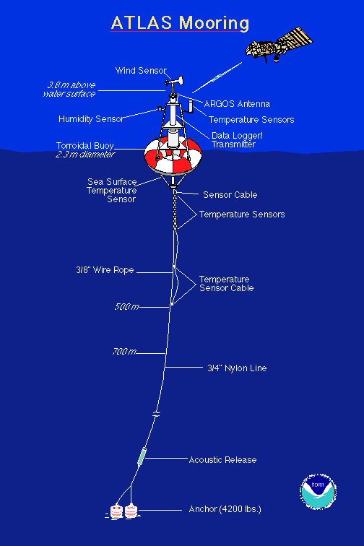

Figure 1: A typical ATLAS mooring array.
As the pilot phase of the PIRATA project neared completion, several countries in the Atlantic Basin proposed three extensions to the original backbone. These extensions are; the Northeast Extension (NE), the Western Extension (WE) and the Southeast Extension (SE) the latter of which this document is about. PIRATA meetings tailored to discuss each of the proposed extensions have been organized since 2000. The PIRATA Memorandum of Understanding (MoU) was signed between the institutions representing Brazil (INPE), France (IRD), and the USA (NOAA/OGP), during the PIRATA-8 meeting in Paris, in September 2001, which made the project official in the three PIRATA founding countries. Presently in its consolidation phase, the PIRATA Project original array configuration is an equatorial line and two meridional lines, one along the 38º W meridian from the equator to 15º N, and the other along the 10º W meridian from the equator to 10º S (Figure 2) and maintained jointly by Brazil (INPE and DHN), France (IRD and Meteo-France) and the USA (PMEL-NOAA/OGP). The ocean observations along with meteorological observations are transmitted to shore via satellite by Service Argos and are available in near real-time on the Internet and via World Meteorological Organization’s Global Telecommunication System (GTS). These buoys enable scientists to learn more about how variations in sea temperatures, winds and other climate variables affect the tropical Atlantic region. They are also used in operational models used for climate and weather forecasting (CPTEC, Brazil, ECMWF, Europe, MétéoFrance, NCAR USA, FUNCEME, Brazil), to calibrate parameters estimated from satellite remote sensing and for initial conditions for operational ocean models.

The ultimate objective of PIRATA is real-time ocean monitoring to enable resource prediction in the adjacent countries. An extension of PIRATA in the South East Atlantic would have applications to marine ecosystem processes, fisheries-environment interaction, and rainfall forecast and climate variability. The PIRATA-SEE project involves the participation of several institutions from Angola, Namibia and South Africa, tasked with the logistics, operation, and deployment of two ATLAS buoys in the tropical waters off Angola. The countries of the region would join the PIRATA partnership of countries, presently Brazil, France and the United States of America, and would contribute to and benefit from the total effort on PIRATA.

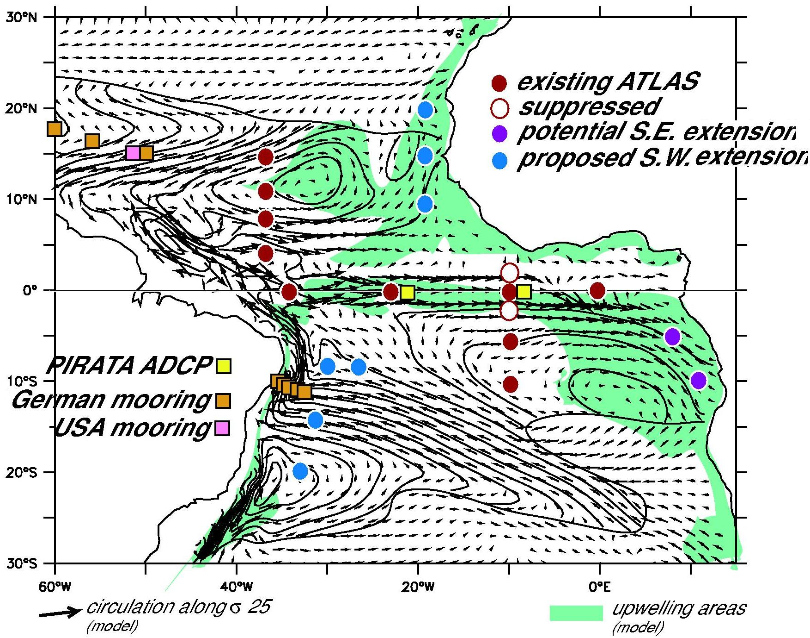

Figure 2: Status of PIRATA in 2003, circulation along sigma 25 and location of proposed South East Extension at 5ºS-8ºE and 10ºS-11ºE. (Background made by Alban Lazar from Lazar et al, 2002).

2. Techniques and operation

2. 1 Introduction

In December 2002 I flew to Dakar, Senegal to board a French research vessel and participate in the PIRATA FR 11 cruise. The main mission of this cruise was to recover and replace five ATLAS moorings in the Tropical Ocean Atlantic. My goal was to assess what it takes to recover and deploy an ATLAS mooring, to understand what are the technical requirements and constraints.

2.2. Loading

Operations started when the first 67 cubic meter container arrived in a truck near the N/O Suroit, a 60 meters IFREMER French research vessel. Although the first of two containers arrived at 12 p.m., it was only possible to start unloading at 16 p.m. because of custom officials late arrival, delay in securing a fork lift to put the container down the truck near the ship’s crane and conflict between fuelling the ship and crane operation. The two containers contained four ATLAS moorings and a spare system: upper tower (2 meter high, 2 meter base diameter, 150 kg), buoys (2 meters diameter, 1 meter high, 300 kg), lower underwater tripod (50 kg, 1 meter high with a 150 kg weight for stabilization of the mooring), anchors (an anchor is made with 5 train wheel weighting 2.2 tons), acoustic releases, chains, steel wires, cables, tapes, nuts and bolts, shackle, nylon ropes, American tools and other assorted equipment. Some of the sensors arrived separately by plane and others were in the containers: anemometer, air temperature and humidity probe, pyranometer (short wave radiation), rain gauge, sea surface temperature and conductivity, 3 temperature/conductivity sensors to be deployed at 20, 40, 120 meter depth, 5 temperature sensors to be deployed at 60, 80, 100, 140, 180 meter depth and 2 temperature/pressure sensors to be deployed at 300 and 500 meters. After the last sensor at 500 meters there is a mandatory 300 meters of steel wire to prevent shark and fish bites from cutting the nylon ropes that are used to link the upper part of the mooring to the anchor and acoustic release system (60 meters length). An appropriate length of nylon rope is used to keep a scope of 0.985 and a specific tension. This is calculated as a function of depth. The minimum length of a mooring is 1060 meters.

It took 3 hours, a dozen persons and a good crane to load everything on the ship. The N/O Suroit is well suited for PIRATA deployment with a large platform at the rear near the A-frame that will be used in conjunction with a crane to deploy and recover moorings. Recommended project personnel is two to five; interior work space: 200 FT²+; interior storage: 200 FT²+; Exterior storage area: two moorings…300 FT²+; one moorings…225 FT²+; capstan/purse winch: 18 inch diameter drum, 40 meter/minute line speed, continuous duty; lifting capacity: crane, 6500 pounds/2000 pounds, A-frame 15 000 pounds; mooring tackle: 7 inches sheave diameter; narrow beam echo sounder; GPS navigation; S-band radar; manoeuvrability: bow thrusters, twin screws; speed 11-12 knots.

2.3. Assembling and testing

During the 4 days of transit, Linda Stratton, (NOAA, PMEL), Brian Lake, (NOAA, PMEL) and Fabrice Roubaud (IRD) had plenty of time to assemble the first mooring, install and test the sensors that are connected to a central cylindrical housing. The sensors sampling, averaging, storing and transmission is done in the housing. High-resolution underwater temperature sensors are stored internally. Linda and Brian are well-trained PIRATA operators. Fabrice is a relatively new player but after two PIRATA cruises and a two months training period at PMEL (Seattle), he already knows what it takes to install, deploy and recover a PIRATA mooring. The chief scientist Jacques Grelet (IRD) also spent two stays at PMEL and participated in most of the former PIRATA cruises.

The mooring transmits the data signal to a satellite via an ARGOS system. We hear transmissions on the ship directly via Telonics Satellite uplink receiver. They also tested the sensors of the 4 other moorings. At times they needed a crane and some of the crew to move the mooring. When mounted and lying at a 45-degree angle, the mooring occupied a space of about 5 by 2 meters. A special testing program is used to get high-resolution sampled data for 12 hours before switching to operational mode. In operational mode, data are sampled on the hour every 10 seconds for 6 min, averaged and stored within the mooring. This hourly data is kept within the mooring and recovered after a year. The daily mean is sent via ARGOS and available in real time on the PIRATA web site. Assembling the mooring, installing and testing the device takes about 12 hours for 2 qualified persons and when installed the system has to be tested for a day. This is to ensure that the daily mean is properly received at the receiving end of operations, at PMEL, and that the hourly data are properly stored within the mooring.

It is possible to add an air pressure sensor, a pyrgeometer (incoming long wave radiation) and a few current meters to the system. Ocean colour, oxygen or other special measurements can be done but this data will not be sent via Argos or sampled by the PIRATA system. It will need modified towers and mooring, extra time for installing and testing the sensors and another technician from the Institute willing to carry this out. Nevertheless extra measurements can be done and have been done.

2.4. Recovering

The ATLAS mooring was in sight at 19h00, 30 min before darkness. The acoustic release was triggered successfully. Three passes were carried out nearby to check current and wind speed and direction. There was a strong 1 knot current and 10 to 15 knots wind with a 2 meters large period swell. A rubber duck was sent to take Brian onto the mooring to recover the meteorological sensors. When this was completed at 20h30, the ship stern was positioned near the mooring. The buoy was brought closer to the ship under the A-frame using a rope sent to the ship by the rubber duck crew. The ship was in line with respect to the mooring cable and moved slowly (1 knot) forward. The bulky and heavy buoy (5 by 2 meters and 600 kg) was lifted on board with the A-frame. Two ropes were used on the buoy side to keep the buoy balanced and undamaged. Bringing the mooring to the rear of the ship and securing it is a delicate operation. We had 3 competent crew members headed by the boson, 3 technicians, the chief scientist and 2 helpers all equipped with helmet, gloves and safety boots. Good communication was maintained between the bridge and operations. When secured, the mooring, (still bearing all underwater sensors, 1000 meters steel wire, 4000 meter nylon ropes, acoustic release, shackles, swivels and chains), was retrieved with the buoy and connected to the ship before being connected to the capstan and rewound, another delicate operation. The remaining meteorological sensors and the central cylinder containing the high-resolution data, datalogger, modem and Argos transmission system was taken out. In another delicate operation requiring 4 competent crews, the help of the technicians and numerous tools (the shackles, nuts and bolt having spent a year in the water), we started pulling off the cable, taking out the various underwater probes. The cables were neatly rewound and we pulled out two sections of steel wire and 5 sections of nylon ropes; all connected with shackles and swivels that have to be carefully taken out. The last section is a chain with the acoustic release. We were finished at 02h00. A standard recovery log sheet is used to assess the state of the mooring and sensors. 2 underwater temperature probes were missing from the mooring (at 20 and 60 meters) and the surface conductivity sensor fouled.

2.5. Deploying

We started the next day at 06h00, just after 4 hours of sleep, to be ready for deployment at dawn (07h00). The mooring was put over the side of the ship with the crane; the first section of cable already plugged in. New wire rope for the top 700 meter piece was used, and the same nylon ropes from the previous recovered mooring. It was also moored at the same position. The exact bathymetry of the position was known from previous cruises and the N/O Suroit’s echo sounder (5 meter accuracy is recommended). For a new mooring, it is recommended to check the bathymetry of the point where the anchor seats. Failure to do so could lead to the mooring being anchored at the incorrect depth. This will interfere with mooring tension and depth of underwater sensors and lead to possible loss of the entire mooring. Good communication between the capstan operation and the technicians who install the sensors and connect the different sections of cable and nylon rope is essential. At 10h00 all sensors, cables and ropes where deployed and the mooring towed to the correct position. We installed the acoustic release, the last chain and connected the mooring to the 2.2 tonne anchor. Again a special procedure is used for that final operation. When everything was ready, we waited to be at the right position. When reaching the bottom the anchors will move about one third of the total mooring length towards the buoy and the buoy will go forward two third of the way towards the anchor. When everything is stabilized the position of the mooring is checked. A standard deployment log sheet is used.

2.6. Conclusion

Installing, testing, deploying and recovering an ATLAS mooring involves hundreds of different operations. This provides an excellent opportunity for all-round training and capacity building for technicians and crew members. Students would also learn a lot and can be used as assistants. Procedures have been well tested and improved over 15 years during TAO and PIRATA. There is a great deal of detail involved. Great care must be used when moving, installing, recovering or deploying the mooring. It would take participation in two or three PIRATA or TAO cruises and training at PMEL (Seattle) before a technician would be able to do the operations without supervision. Invitations to participate in TAO or PIRATA cruises as well as a training period at Seattle (PMEL, NOAA) were proposed by NOAA and IRD. Other operations such as recovering current meter moorings, interpreting acoustic Doppler current meter data and CTD are usually also done during the cruise and could provide an extra source of training. It is recommended to have two competent technicians on board. Jacques Servain from IRD has offered to send IRD technicians during a potential pilot phase of PIRATA SEE extension. IRD now has a pool of competent technicians. It is not the difficulty of the operations but more the detail and numerous operations involved that make the deployment and recovery complex. A large platform at the rear of the ship, a good crane and A-frame in the same proximity, a good echo sounder, a well trained crew and sufficient lead-time to install and test the sensors on the mooring before deployment is essential.

3. Science

3.1 Relevance to regional climate and applications

The Benguela Angola current system exhibits strong interannual variability. Warm oceanic events of Angola and Namibia called Benguela Niños (Shannon et al., 1986) are linked to decreased fish recruitment, sardine anchovy mackerel seals cormorant mortality, offshore migration of hake (Boyer et al 2001). Although Benguela Niños are part of the natural variability of the ecosystem, fishing the usual quotas of already depleted fish stocks during Benguela Niños could lead to species extinction or replacement by others species. Moreover the warming in the area since the 90’s (Figure 6) is a reason of concern for Fisheries and must be investigated. In Namibia in 1994/5, the sardines were pushed southwards and subject to much higher mortality from the vessels based in Walvis Bay, or they succumbed to high temperatures in the confines of Baia de Tigres. In either case the low population strength of sardines for several years resulted in severe losses for the Namibian pelagic fishery.

ATLAS mooring is also justified and much needed to monitor and study the seasonal cycle of ocean surface temperature and heat content as well as meteorological conditions in the region. The seasonal cycle dominates the variability of the tropical Atlantic (Philander, 1990). Figure 3 shows the contribution of various physical processes to the variation of sea surface temperature at the location of the proposed extension. It is interesting to note that the contribution of latent heat (energy exchanged during evaporation) is as important as radiative effect and more important than oceanic processes in regulating the temperature of the ocean surface layer on the seasonal time scale. Warm or cold abnormal events are often an exaggeration of the seasonal cycle (Philander, 1990) and understanding the seasonal cycle of ocean condition in the area is much needed. In order to calculate the latent heat fluxes one needs to measure SST, wind speed, air temperature and humidity. The radiative budget cannot be monitored with satellite remote sensing as most of the oceanic component shown in Figure 3. Figure 3 is based on a model study since we could not find any observational data to calculate the different components of the heat budget at the ocean surface off Angola.

The influence of the Tropical Atlantic Ocean on Brazilian and West African climate has been the subject of numerous studies but less has been done to understand the effect of tropical and equatorial Atlantic variability on the Southern African wind pattern, ocean condition coastal ecosystem and rainfall during the peak SST and rain season of austral summer and autumn. Using data from 1940-1975, Hirst and Hastenrath (1983) established a positive correlation between tropical South East Atlantic coastal SST and Angolan coastal wind pattern and rainfall for late summer (March–April). Subsequently, Nicholson and Entekhabi (1987) showed that during warm South East Atlantic events, above average rainfall occurred along the Angolan (6°S to 17.5°S) and Namibian (17.5°S to 29°S) coasts as well as inland. Figure 5 shows the mean SST off Angola averaged from 8 º E to the coast and 8 º S to 17.5 º S and the mean total rainfall inferred from satellite remote sensing (Huffman et al, 1997) for the same area plus the coastal region of Angola. Figure 6 presents the anomalies for late summer (February, March and April) SST and rainfall from 1979 to 2002. It suggests a relationship between SST anomalies and rainfall anomalies (0.5 correlation) and confirms the work done by Hirst and Hastenrath (1983) and Nicholson and Entekhabi (1987). Due to the lack of data in the region, it is not clear which of the warm and cold SST events are locally produced by air-sea interaction processes (i.e. turbulent heat fluxes, radiative budget, upwelling) and which are remotely produced by advection of warmer or colder than normal water or by propagation of coastal Kelvin waves if any. Hirst and Hastenrath (1983) and Shannon et al. (1986) noted that some of the warm events along the Angolan coast were preceded by reduced tradewinds in the tropical and equatorial Atlantic Ocean. An extension of the PIRATA original array (Servain et al., 1998) off Angola (two moorings) could help to quantify which part of the warming/cooling is locally produced, which part is remotely produced and what are the physical mechanisms involved. Other interesting oceanic features in the area are the Congo River Plume that can spread as far as 10 degrees from the coast along latitude 5 º S (Signorini et al, 1999) and the Angola Dome (Mazeika, 1968, Voituriez, 1981, Yamagata and Iisuka, 1995, Morholtz et al, 2001). We recommend to extend PIRATA with two moorings approximately around 5° S 8° E and 10° S 11° E (Figure 2 and 4) to monitor in real time, describe and understand the propagation of warm oceanic events in Angola and Namibia, the interannual and intraseasonal variability of ocean dynamics and ocean atmosphere interaction and the seasonal cycle. Two moorings are recommended to monitor the propagation of warm events.

The occurrence of warming of around 2°C to 6°C along the south-western Africa coast between 10°S and 25°S appears to be an aperiodic phenomenon. Some of these warm events were described and named “Benguela Niños” by Shannon et al. (1986) because of their similarities with anomalous warming occurring in the upwelling area off Peru and high rainfall in the usually arid Peru during the Pacific El Niño. The warm events appear to arise as warm water of equatorial origin propagates poleward along the south-west coast of Africa as far as 25°S where cold upwelled Benguela Current waters are usually found, hence the term Benguela Niños. Shannon et al. (1986) identified Benguela Niños in 1934, 1963, 1984 with associated nefarious impact on Fisheries, high rainfall (1934, 1963) and flooding (1984) in the usually arid Namibian area. More recent warm events occurred in 1986 (Boyd et al, 1987), 1995 (Gammelsrød et al, 1998) and probably 2001 (Rouault et al, 2003). The 1984 event is the best documented (Servain and Séva, 1987, Philander, 1984, Philander, 1990). The 1984 and 1995 warm events off Angola and Namibia were part of a large scale basin phenomenon in the tropical Atlantic (Florenchie et al. 2003a; Philander, 1986, Vauclair and du Penhoat, 2000). Development of warm anomalies simulated with Ocean general circulation model OPA are shown in Figure 9 and 10. Some modelling studies suggest that these warm events are remotely forced since they follow ENSO-like warm events in the equatorial Atlantic and a sudden relaxation of the trade winds near Brazil (Carton and Huang, 1994, Delécluse et al., 1994). This trade wind relaxation could lead to the generation of equatorial Kelvin waves as well as a strengthening of the South Equatorial Counter Current (SECC), thereby producing a depression of the thermocline along the equator. Warm waters then accumulate in the eastern South Atlantic and coastal Kelvin waves (not yet demonstrated) and the Angolan Current could propagate the anomalies southward along the coast. ENSO-like warm events in the equatorial Atlantic do not lead all the time to Benguela Niños (Binet et al, 2001; Florenchie et al. 2003 (b)). Mooring around 5ºS-8ºE and 10ºS-11ºE could provide the missing link between the equatorial mode of variability in the Atlantic and ocean variability off Angola and Namibia. The origin of the 2001 event seemed to happen one or two months before apparition of the anomalies at the coast. It seems to have been triggered by abnormal tradewind in the equator and abnormal westerly winds in the eastern part of the basin. This intensified the South Equatorial Counter current and the northern limb of the Angola Gyre leading to the accumulation of warm water along the Angolan coastline. This would have intensified the Angola Current (Rouault et al, manuscript submitted). During the 1995 event, ocean temperature anomalies of up to 8°C were measured below 30 m. Cruise data showed these anomalies extending 300 km offshore with a southward extension to 27°S (Gammelsrød et al, 1998). This, and other warm events, has had a strong influence on local fish distribution and abundance in Angolan and Namibian waters (Binet et al., 2001, Boyer et al, 2001).

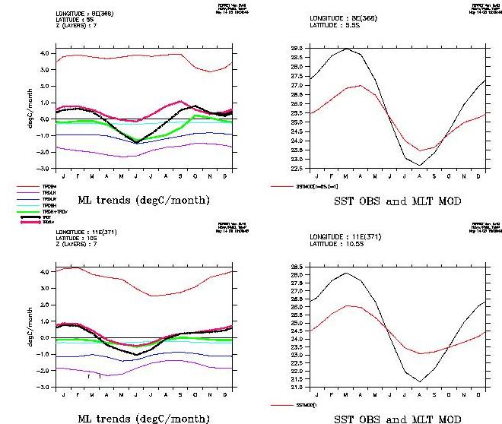

Figure 3: Left panels: contribution of incoming short wave radiation (thin red line), outgoing long wave radiation (thin purple line), latent heat flux (thin dark blue line), sensible heat flux (thin light blue line), vertical and horizontal oceanic processes (green line), net heat flux (red line) to the yearly cycle of cooling or warming of the ocean surface layer (black line). Units are in ºC per month. Top: northern proposed mooring, 5ºS-8ºE. Bottom: southern proposed mooring, 10ºS-11ºE. Right panel: modelled and observed surface temperature. (Alban Lazar, personal communication).

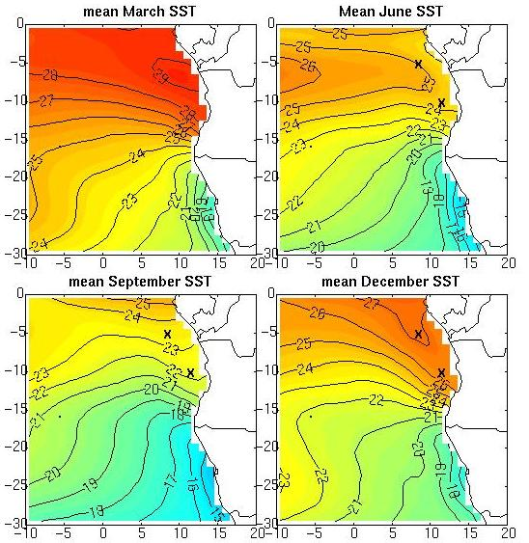

Figure 4: Mean sea surface temperature (1982-2002) for March, June, September and December and proposed location of ATLAS moorings at 5ºS-8ºE and 10ºS-11ºE.
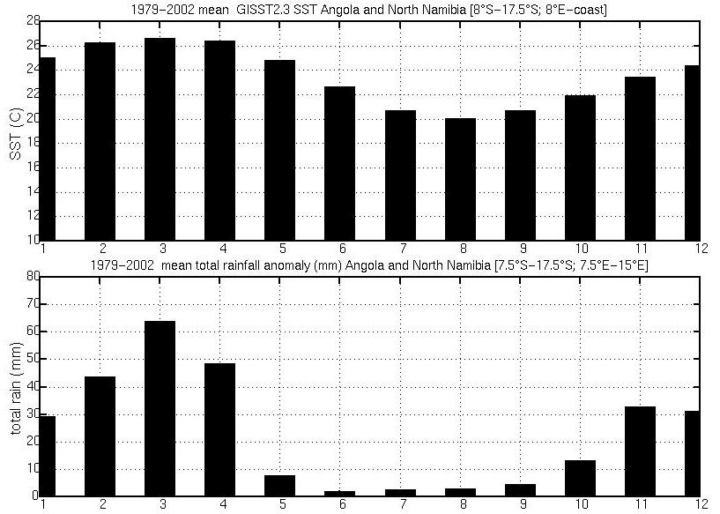

Figure 5: February to April mean sea surface temperature (top) and total rainfall for coastal and offshore Angola (bottom) and North Namibia. SST is averaged in domain [8°S-17.5°S; 8°E-Coast]; bottom: Total rainfall (mm) averaged in [7.5°S-15.5°S; 7.5°E-15°E];
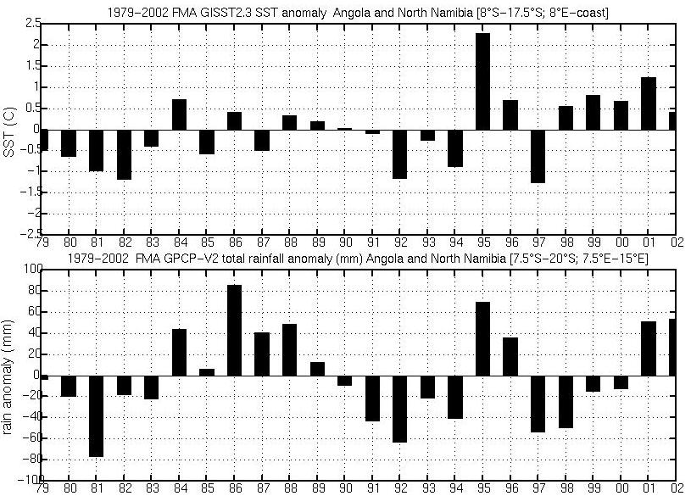

Figure 6: Top, mean FMA SST anomalies from 1979 to 2002 off coastal, offshore Angola/North Namibia; bottom: Total FMA rainfall anomalies (mm), same domain as in Figure 5.

Rouault et al. (2003) documented the impact of recent warm events of 1984, 1986, 1995 and 2001 (Figure 6 and Figure 8) on Southern African rainfall. During these events, positive anomalies reached a maximum during March/April with monthly mean SST reaching as high as 30°C along the coast of Angola. Cold events (1982, 1992 and 1997) are associated met with below average rainfall. It is not clear if the cold events are remotely forced or locally produced by the same weather system. An increase in high pressure can lead to both SST decrease and rainfall deficit. Figure 8 plots the precipitation anomalies for 4 warm events divided by the standard deviation at each grid point and highlights the relatively homogeneous rainfall responses to warm events. Seasonal anomalies of up to 2 standard deviations occur above the SSTA and neighbouring areas of Angola and Namibia. This is consistent with the earlier work by Hirst and Hastenrath (1983) and Nicholson and Entekhabi (1987).

Besides having a direct impact on fisheries and rainfall of Angola and Namibia, it may be possible that ocean conditions off Angola are also important for many Southern African countries. Although the western Indian Ocean is the principal source of moisture for summer rainfall over southern Africa, a secondary source is situated in the Atlantic Ocean off Angola. During January and February the mean flux is westerly off the tropical SE Atlantic with a convergence over Zambia with the mean easterly flux originating from the tropical Indian Ocean. Figure 7 shows the mean integrated moisture flux for January February, March, and April. The middle panel of Figure 8 shows the anomaly from this mean for 1984, 1986, 1995 and 2001. In 1995, the SE Atlantic SSTA was largest but the inflow into Angola / Namibia from the Indian Ocean was weaker than average. Rainfall was enhanced only by the Atlantic source. For 2001, there was a convergence in southern Zambia / northern Zimbabwe between the enhanced moisture flux from the SE Atlantic SSTA and that coming from the western Indian Ocean. Hence, the largest precipitation anomalies occurred over central southern Africa with those in western Angola / Namibia influenced only by the SE Atlantic moisture flux. By contrast, the moisture flux from the western Indian Ocean across low latitude southern Africa was enhanced in 1984 and 1986 with relative convergence over western Angola / Namibia. This, together with the increased unstable lower atmosphere and increased evaporation (i.e. latent heat flux) over the warm SE Atlantic SSTA, led to relatively large precipitation anomalies in this region. It is therefore important to quantify the local evaporation and atmospheric instability in the region of the SE Atlantic that could act to augment the precipitation derived from the Indian source. Again an ATLAS mooring is perfectly suited for that task.

In order to address the role of radiative or surface flux forcing vs. ocean dynamical role for SST anomalies and the preconditioning of the surface in response to flux anomalies, a study was carried out of NCEP turbulent fluxes (although these are not very accurate, that is the only available product with a resolution of 2.5 x 2.5 degree), 10 m wind, surface pressure, GISST SST and GPCP rainfall in the domain study 20º S-10º S and 8º E-coast for the mean of February March and May (Figure 11). The latent heat flux is quite substantial (mean 90 W.m² standard deviation: 13 W.m²) and dominates the turbulent heat fluxes, winds are moderate and steady (mean 4.85 m/s std 0.25) and mostly southeasterly (mean U= 0.75 mean V=4.8). Mean SST is 25.6 C and standard deviation 0.9 C. We calculated for each year since 1979 the anomaly divided by the standard deviation for the February, March and April average of sea level pressure, rainfall, SST, latent heat flux, wind speed, meridional wind, and zonal wind. Outstanding oceanic events are those inferior to -1 std (cold events) or superior to 1 std (warm events). 1984, 1995 and 2001 stand out as warm events. We know from the literature and observation that 1984 and 1995 are remotely forced. There is reason to believe that 2001 is also a Benguela Niño occasion (Rouault and Lutjeharms, 2003). 1995 and 2001 have the highest latent and sensible heat fluxes and 1984 is not far behind. The reason for those high fluxes is because the difference between the specific humidity of the air and the sea surface increases quickly when the SST increase during Benguela Niños leading to more evaporation (latent heat flux). Colder and drier air is advected from the South (Benguela Current, Namibia) by the Santa Helena high at that time of the year. The unexpected result is that the latent and sensible heat flux contribute to cool the warm events in 1994 1995 and 2001. In fact given the magnitude of the wind speed and its weak variability, specific humidity variability and SST rather than wind speed variability dominate the latent heat flux variability. Likewise the three major cold events of 1982, 1992 and 1997 have weaker than normal latent heat flux, even with stronger wind in 1992 or 1997. In conclusion the latent heat fluxes have a rather passive role and seem to act as a thermostat to regulate cold and warm events at the surface. They definitively did not create the higher than normal SST in 1984 and 1995. Moreover since the rain was greater than normal the solar radiation was probably having a cooling effect during warm events and a warming effect for cold event (below normal rainfall), acting in concert with the latent and sensible heat fluxes. Local upwelling and wind curl probably had a role in producing cold SST in 1997 and 1992, but wind did not have a major role in that region. 2001, a warm event, had upwelling favourable meridional wind and 1982, a cold event, had weaker than normal meridional wind. In fact 1982 also had weaker latent heat flux so the explanation for that cooling must come from ocean dynamics. This illustrates the complexity of the surface heat budget for that region. The flux data used have their limitations and we did not attempt to integrate the radiative budget from NCEP in the net heat budget due to the validity of the dataset.

Since ocean conditions strongly influence fisheries in the Angola/ Benguela ecosystem and Benguela Niños are an oceanographic phenomenon with relatively long lead times, better monitoring of the tropical SE Atlantic region is important and could have significant societal benefits. Monitoring of the warm event upstream could provide an early warning forecast system that could be beneficial to fisheries, agriculture and society.

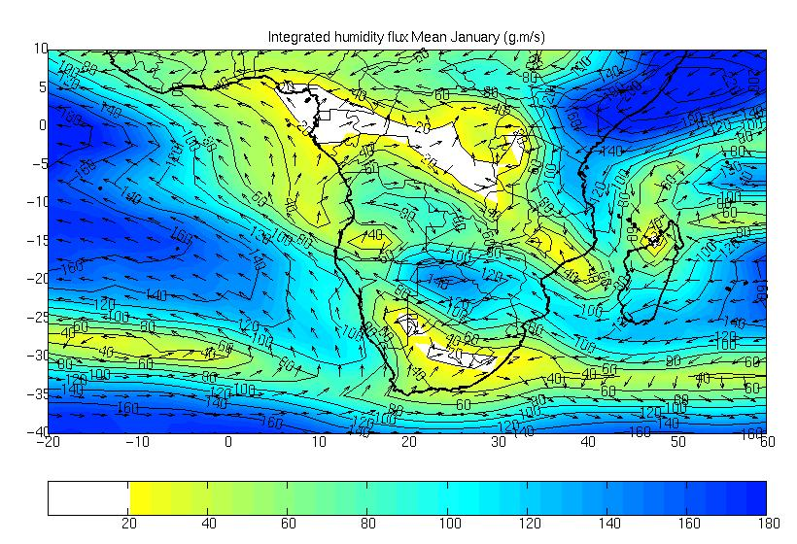
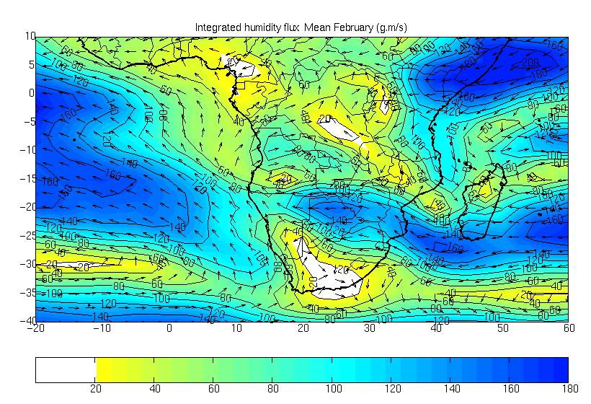
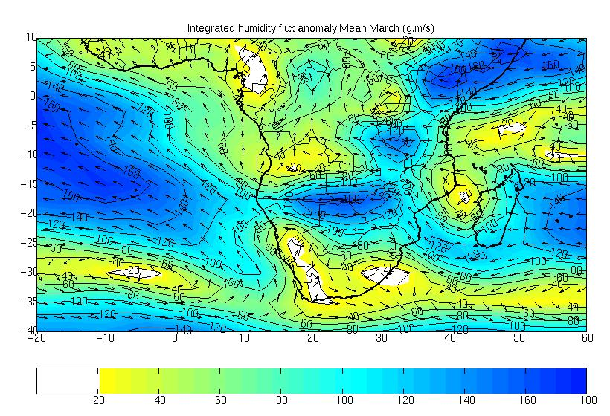
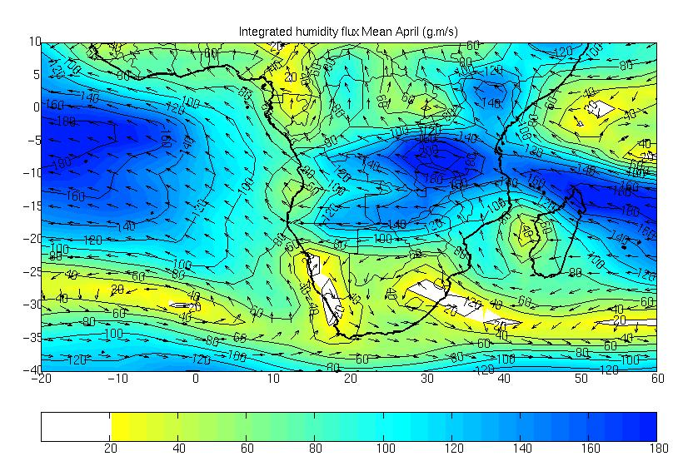

Figure 7: Mean 1968-2001 January, February, March and April integrated moisture flux from the surface to 300 H pa from NCEP reanalysis (g/kg.m/s).

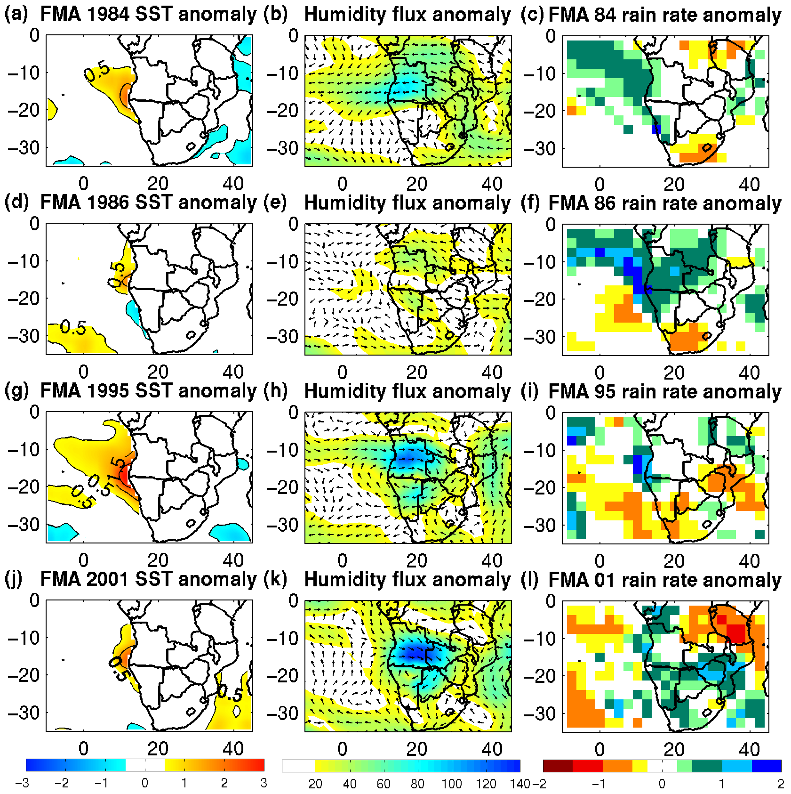

Figure 8: Left: mean FMA SST anomalies for 1984 (a); 1986(d) 1995(g) and 2001 (j).
Isocontours are at 0.5°C, 1.5°C and 2.5°C.
Middle: mean FMA integrated moisture flux anomalies (surface to 300 hPa) 1984 (b), 1986 (e) 1995 (h) and 2001 (k) in g/kg.m/s.
Right: mean FMA rain rate normalized anomalies for 1984 (c), 1986(f) 1995 (i) and 2001 (l). (Rain rate divided by standard deviation) From Rouault et al (2003).

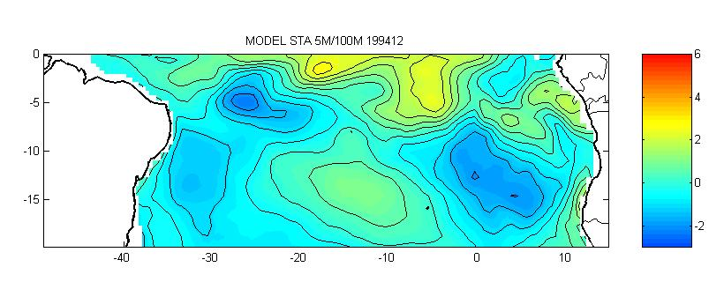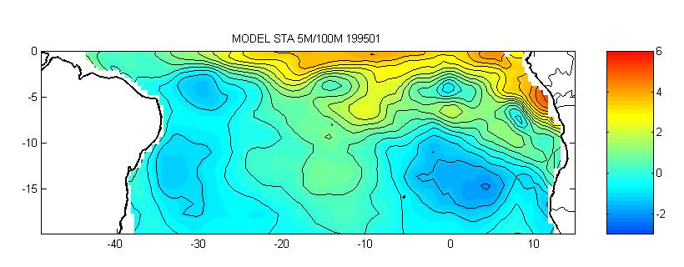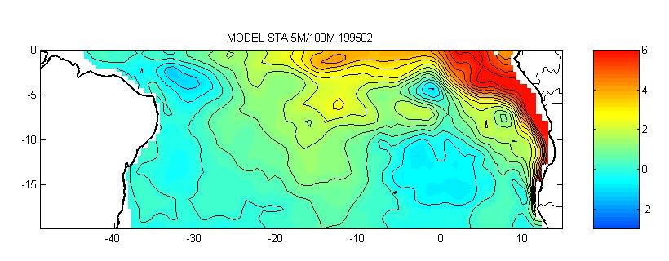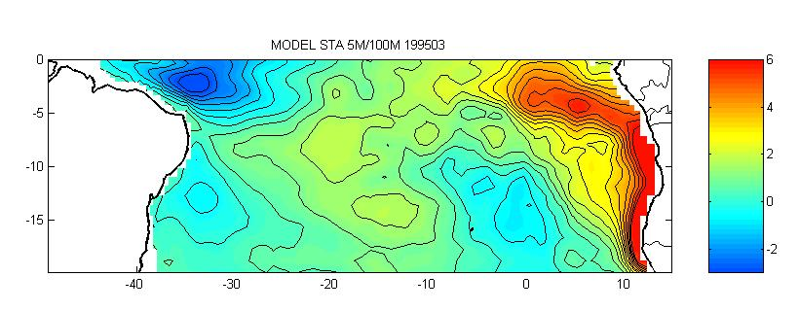
Figure 9: Sum of subsurface model temperature anomalies between 5 and 100m depths from December 94 to March 95. Courtesy of Pierre Florenchie (Florenchie et al. 2003 (b))

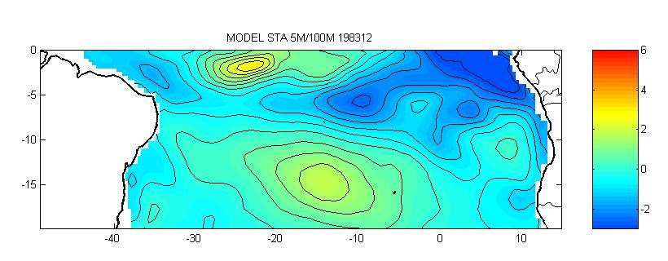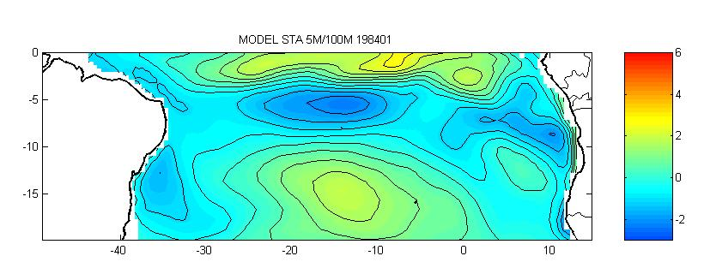
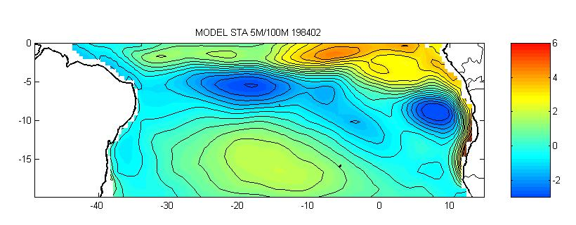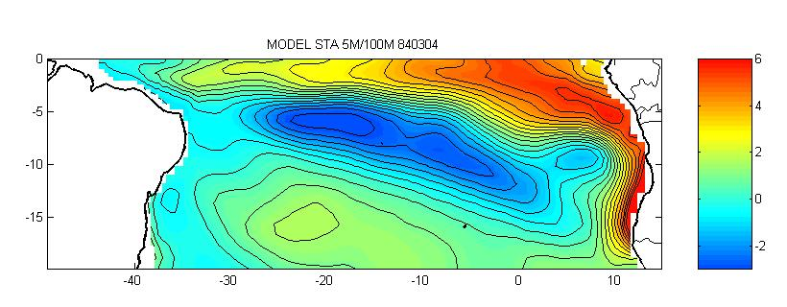
Figure 10: Sum of subsurface model temperature anomalies between 5 and 100m depths from December, January, February and April 84. Courtesy of Pierre Florenchie (Florenchie et al. 2003 (b))

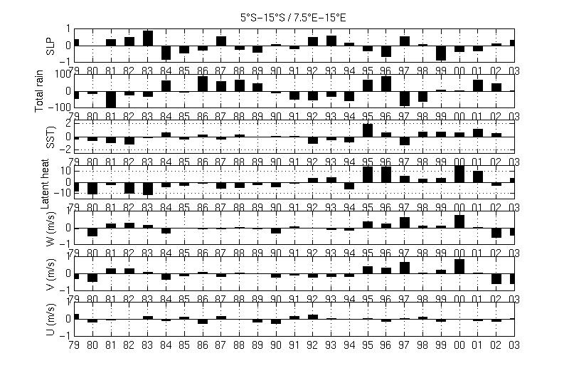
Figure 11: From top to bottom: Anomalies for 1979 - 2003 mean February-March-April in sea level atmospheric pressure (NCEP), total rainfall (GPCP), sea surface temperature (Hadley SST), latent heat flux (NCEP), wind speed (NCEP), meridional wind speed, zonal wind speed for the region 5º S 15º S 7.5º E 15º E.

3.2 Scientific objectives
PIRATA SE Extension general scientific objectives are:

- To monitor the surface and upper-ocean thermal structure in the Tropical South East Atlantic off Angola (5ºS-8ºE and 10ºS-11ºE) in real time.
- To validate regional or global ocean, atmosphere and coupled models.
- To serve as ground truth for satellite missions and to the development of blended satellite/in situ analyses.
- To serve as input to operational ocean model assimilation systems.
- To improve the description of temperature and salinity in the Tropical Southeast Atlantic and understand the mechanisms governing their variability.
- To help in determining the relationship between regional impacts of climate variations on fisheries, agriculture and society of the region.
- To gain new insights into ocean-atmosphere interaction and to improve the description of air-sea fluxes of momentum, heat, and moisture for the Tropical Southeast Atlantic.
- To complete the existing and future status of the observing system in the Tropical Atlantic.
- To help characterise seasonal and interannual variation in surface moisture fluxes, in particular those associated with rainfall variation in Southern Africa.

Figures 2 and 4 indicate that moorings deployed off Angola around locations 5ºS-8ºE and 10ºS-11ºE would fit into the original PIRATA array. Locations of proposed moorings are the natural continuation of the equatorial PIRATA moorings that were deployed to study the equatorial mode of variability in the Atlantic and its impact on climate. Figure 4 shows the mean SST with the location of the proposed moorings.

3.3 Data management

The PIRATA Original Array data management model will be adopted. Data from ATLAS mooring will be managed by PMEL (NOAA) and freely and openly accessible (internet and FTP). Data will be sent to the GTS (Global Transmission system) and displayed in real time on the PIRATA web site together with the other sites. More information can be found on the PIRATA SEE website at http://www.egs.uct.ac.za/~rouault/piratase.html

4. Implementation and resource

4.1 Countries and groups involved.
The PIRATA-SEE action committee drew up this resolution in November 1999 at SAMSS 2000 with the help of Janice Trotte (OIC/GOOS) and Jacques Servain (IRD, PIRATA chairman).
The Pilot Research Moored Array in the Tropical Atlantic (PIRATA) is an array of instrumented moored buoys located in the Atlantic between 15°N and 10°S (Servain et al, 1998). These buoys enable scientists to gain more information on the variability of sea temperatures, winds and other climate variables that affect the tropical Atlantic region. The ultimate objective of PIRATA is real-time ocean monitoring to enable resource prediction in the adjacent countries. PIRATA is a pilot project of the Global Ocean Observing System (GOOS). An extension of PIRATA in the South East Atlantic would have applications to marine ecosystem processes, fisheries-environment interaction, and rainfall forecast and climate variability. The PIRATA-SEE project would involve the participation of several institutions from Angola, Namibia and South Africa charged with the logistics, operation, and deployment of two ATLAS buoys in the tropical waters off the Angola Current and north of the Benguela Current. The infrastructure required for this effort is considerable, as are the benefits, the capacity building and training opportunities. The countries of the region would join the PIRATA partnership of countries, presently Brazil, France and the United States of America, and would contribute to and benefit from the total effort on PIRATA. Some of the key issues of implementation have been identified (e.g. ship's time, engineering, capacity building and location). The possibility of an alliance in securing the new buoy system between this PIRATA-SEE project and BENEFIT is also welcomed. The development of GOOS in the seas around Africa can be greatly aided by such strategic alliances between strong regional initiatives such as PIRATA and BENEFIT with overlapping and complementary objectives. The Institute for Maritime Technology of Cape Town (Pty) could provide the engineering support necessary for the success of the project. They currently provide support to the South African Navy. A feasibility study will be needed to provide detailed guidance on logistic issues and to motivate support from the BCLME.

During the feasibility study the PIRATA-SEE Committee whose names are mentioned below were consulted at length and they were very active in representing the countries and bodies to which they are affiliated. They contributed significantly to the feasibility study and this document was sent to them for comment during all phase of its development. The PIRATA-SEE Committee (established in November 1999) is composed of:

- Geoff Bailey: South Africa, Marine and Coastal Management, BENEFIT
- Geoff Brundrit: South Africa, Oceanography DPT, UCT, GOOS
- Quilanda Fidel: Angola, Instituto de Investigacao Pesqueira (IIP)
- Mark Jury: South Africa, Geography DPT, University of ZULULAND
- Mark Majodina: South Africa, South African Weather Service. Pretoria
- Chris Reason: South Africa, EGS & Oceanography DPT, UCT, CLIVAR (added in 2002)
- Mathieu Rouault: South Africa, PIRATA-SEE chairman, Oceanography DPT, UCT.
- Carl Wainman: South Africa, Institute of Marine and Technology

PIRATA-SEE web site: http://www.egs.uct.ac.za/~rouault/piratase.html. The outputs created for the feasibility study are available on that web site in the section “Feasibility study”.

BENEFIT: The Benguela Environment Fisheries Interaction and Training (BENEFIT) Program is a regional partnership between Namibia, Angola and South Africa focused on fisheries and the marine resources of the Benguela Current ecosystem off southwest Africa. A Secretariat was established in Namibia in 1998, with its principal office in Swakopmund, Namibia. http://www.benefit.org.na/

MCM: Marine and Coastal Management, formerly called Sea Fisheries Research Institute (SFRI): provide for responsible custodianship of South Africa's marine and coastal resources and ecosystems for the benefit of current and future generations of South Africans, based in Cape Town. http://www.environment.gov.za/mcm/

SAWS: South African Weather Service: http://www.weathersa.co.za

IMT: Institute of Marine and Technology: Initially work undertaken was aimed at naval operational research and the establishment of underwater technology. Over the years, capabilities have been developed to meet the growing demands of not only the South African Navy and other members of the maritime community. Today the Institute for Maritime Technology (Pty) Ltd. is a multi-disciplinary company specializing in technological research and development, as well as specialized products and services. http://www.imt.co.za/

UCT: Department of Oceanography, University of Cape Town: http://www.sea.uct.ac.za

GOOS: GOOS is a permanent global system for observations, modelling and analysis of marine and ocean variables worldwide. http://ioc.unesco.org/goos/

CLIVAR: CLIVAR is an international research program investigating climate variability and predictability on time-scales from months to decades and the response of the climate system to anthropogenic forcing. http://www.clivar.org/

4.2 - Identification of infrastructure needed for implementation

4.2.1 - Ship time

Possibly 10 days a year from an harbour located in the vicinity of the PIRATA-SEE region (10x US $10.000)
- Possibility of having the northern site of PIRATA-SEE (5°S-8°E) serviced by PIRATA-France during the EGEE cruises (i.e. starting in Pointe Noire, Congo, and when servicing the eastern side of the PIRATA original mooring): 2004 and 2005 or 2005 and 2006. The Northern site is on the ship track of two EGEE cruises.
- Possibility of having the French Navy research vessel Beautemps-Beaupres to deploy a mooring in 2004 or 2005 (possibility of a cruise, Cape Town to Dakar, not yet scheduled)
- Norwegian oceanographers to be contacted for BENEFIT cruises
- South African ship FRS Africana could be used during BENEFIT cruises in the region.

4.2.2 Laboratory.
Possible partnership between:
- Institute of Marine and Technology, Cape Town, South Africa
- Marine and Coastal Management, Cape Town, South Africa
- National Marine Information & Research Centre (NatMIRC, Namibia)
- BENEFIT: Angola, Namibia and South Africa
- PIRATA
To rely on PMEL for providing an ATLAS mooring, calibration and data management
To rely on PMEL and IRD for training and technical help during cruise.
The objective is to train 2 technicians from the region within a 3-year period.

4.3 Schedule of implementation
Plan A:
Pending results of the feasibility study and feedback from PIRATA:
Year 1: 2004 Deploy first mooring at first site.
Year 2: 2005: Mooring replacement at first site, deploy first mooring at second site.
Year 3: 2006: Mooring replacement at first site, mooring replacement at second site.
Year 4: 2007: Mooring replacement at first site, mooring replacement at second site.
Year 4: 2007: Evaluation of pilot extension project

Plan B: Demonstration project
Year 1: 2004: Deploy mooring on site if possible Northern site.
Year 1. 6 months later: Evaluation of demonstration project.
Year 2: Eventually replace mooring.

4. 4 Funding requirements/cost justification for plan A
Year 1 = 1 site instrumented (ATLAS)
Years 2, 3, 4 = 2 sites instrumented (ATLAS)

4.4.1 ATLAS cost
2 sites => 2 ATLAS + 2 ATLAS (for substitution) + 2 ATLAS (in case of technical failure and/or vandalism during the 4-year period) = total of 6 ATLAS for the 4 year pilot study

4-year total cost with the same price for each ATLAS unit as for PIRATA original array: US $50.000 x 6 = US $300 000

Year 1 = US $50.000
Year 2 = US $100.000
Year 3 = US $100.000
Year 4 = US $50.000

4.4.2 PMEL handling (calibration, refurbishment).

15.000 $ per year and per site = US $75.000
Year 1 = 0
Year 2 = US $15.000
Year 3 = US $30.000
Year 4 = US $30.000

4.4.3 Sea (floats and weight hard cores) and air (electronic) transportation of the material (from Seattle to South Africa’s harbours and return)
US $7.000
Year 1 = US $1.500
Year 2 = US $2.500
Years 3= US $1.500
Year 4 = US $1.500

4.4.4 Customs and Agent fees
US $4. 000
Years 1 to 4 = US $1.000 per year= 4 US $.000

4.4.5 Petty work at local lab (paints, tools)
US $4.000
Years 1, 2, 3, 4 = US $1.000 per year

4.4.6 Human travels per-diems for the 4 yearly cruises
US $24.000
2 technicians/engineers + 1 or 2 researchers + 1 or 2 students
Years 1 to 4 = US $6.000 per year

4.4.7 Technical Training (e.g. from CT to Seattle, travel + per-diems)
US $5.000
Year 1 = 1 technician/engineer (1 month at PMEL) = US $3.000
Year 1 = 0 (training on board during the 1st cruise)
Year 2 = 1 technician/engineer (3 weeks at PMEL) = US $2.000
Year 3, 4 = 0

4.4.8 Administration cost (secretary, communication)
US $4.000
Year 1 to 4 = US $1.000 per year

4.4.9 Participation to PIRATA meetings
US $12.000
Year 1 = US $3.000 (2 people)
Year 2 = US $3.000 (2 people)
Year 3 = US $3.000 (2 people)
Year 4 = US $3.000 (2 people)

4.4.10 Ship time

Pending upon the ship and the route (starting, arrival)
Rough estimation = 10 days x US $10.000 X 4 years = US $400.000

4.4.11 People Salary and student grants
US $166.000
Permanent researcher (1), 4 years: US $120.000
Engineer/ technician (2), 2 months a year, 4 years: US $16.000
Ph.D. Student (2), 3 years= US $30.000

4.4.12 Publications
US $10.000

Year 1 to 4= US $10.000

TABLE 1: Breakdown summary for plan A (Excluding Ships Time)

 | Year 1 | Year 2 | Year 3 | Year 4 | Total
ATLAS (at PMEL “cost price”) | 50 | 100 | 100 | 50 | 300
PMEL handling | 0 | 15 | 30 | 30 | 75
Sea & air transportation | 1.5 | 2.5 | 1.5 | 1.5 | 7
Custom & Agent fees | 1 | 1 | 1 | 1 | 4
Local handling | 1 | 1 | 1 | 1 | 4
Travels & per-diems (cruises) | 6 | 6 | 6 | 6 | 24
Training (ATLAS) | 3 | 0 | 2 | 0 | 5
Administration | 1 | 1 | 1 | 1 | 4
Travels (PIRATA & other meetings) | 3 | 3 | 3 | 3 | 12
Miscellaneous (publications, …) | 1 | 2 | 3 | 4 | 10
TOTAL (K US $) | 68 | 131 | 149 | 98 | 445
Salary costs (Researcher + Engineer) | 33 | 34 | 35 | 34 | 136
Student Grants (1 to 3) | 10 | 10 | 10 |  | 30

4. 5 Funding requirements/cost justification for plan B
Year 1, 2 = 1 site instrumented (ATLAS)

4.5.1 ATLAS cost
1 site => 1 ATLAS + 1 ATLAS (for substitution)
US $50.000 x 2 = US $100 000
Year 1 = US $100.000

4.5.2 PMEL handling (calibration, refurbishment).

US $15.000 per year and per site = US $30.000
Year 1 = US $15.000
Year 2 = US $15.000

4.5.3 Sea (floats and weight hard cores) and air (electronic) transportation of the material (from Seattle to South African harbours and back)
Year 1 = US $2.500
Year 2 = US $1.500
Total = US $4000

4.5.4 Customs and Agent fees
US $2. 000
Years 1 to 2 = US $1.000 per year= US $2.000

4.5.5 Petty work at local lab (paints, tools)
US $ 2.000
Years 1, 2, = US $1.000 per year

4.5.6 Human travel and per-diems for the 2 yearly cruises
US $12.000
2 technicians/engineers + 1 or 2 researchers + 1 or 2 students
Years 1 to 2 = US $ 6.000 per year

4.5.7 Technical Training (e.g. from CT to Seattle, travel + per-diems)
US $5.000
Year 1 = 1 technician/engineer (1 month at PMEL) = US $3.000
Year 2 = 1 technician/engineer (3 weeks at PMEL) = US $2.000

4.5.8 Administration cost (secretary, communication)
US $2.000
Year 1 to 2 = US $1.000 per year

4.5.9 Participation to PIRATA meetings
US $6.000
Year 1 = US $3.000 (2 people)
Year 2 = US $3.000 (2 people)

4.5.10 Ship time

Pending upon the ship and the route (starting, arrival)
Rough estimation = 10 days x US $10.000 X 2 years = US $200.000

4.5.11 People Salary and student grants
US $60.000

Researcher (Part Time) 2 year 50 000 $

Engineer/ technician (2), 2 months a year, 2 years: US $10.000

4.5.12 Publications
US $5.000

Year 1 to 2= US $5.000

TABLE 2: Breakdown summary for plan B (Excluding Ships Time)

 | Year 1 | Year 2 | Total
ATLAS (at PMEL “cost price”) | 100 | 0 | 100
PMEL handling | 15 | 15 | 30
Sea & air transportation | 2 | 2 | 4
Custom & Agent fees | 1 | 1 | 2
Local handling | 1 | 1 | 2
Travel & per-diems (cruises) | 6 | 6 | 12
Training (ATLAS) | 3 | 2 | 5
Administration | 1 | 1 | 2
Travels (PIRATA & other meetings) | 3 | 3 | 6
Miscellaneous (publications, …) | 2 | 3 | 5
TOTAL (K US $) | 134 | 34 | 168
Salary costs (Researcher + Engineer) | 30 | 30 | 60

4.6 Identification/source of funding
BCLME, foreign agencies.

5. Alternative solutions.

Alternative solutions to meet the science objective (Chapter 3.2) do exist (i.e. IMET mooring developed by Woods Hole Oceanographic Institute). The only private sector mooring that could be an alternative to ATLAS is the OCEANOR mooring. They are more expensive than ATLAS but most important those moorings do not come with technical help, a training program, calibration of sensors, direct transmission of data in real time, data available via ftp and displayed on a web site as one would get by participating in the PIRATA project. The region does not have the infrastructure to do proper calibration nor the technical level required to deploy, maintain or repair such alternative moorings. International oceanographic institutions have developed instrumented moorings to measure oceanic and meteorological variables (currents, temperature, salinity, pressure, and surface gravity wave spectra, winds, temperature, humidity, radiative and turbulent fluxes and precipitation) and it is beyond the scope of this study to provide a list of such moorings with a detailed costing. In many instances, securing those moorings would need some long term scientific collaboration between the foreign laboratories that will run the moorings and the local researchers.

A tide gauge array along the coast is complementary rather than an alternative solution. It is part of any observing system geared towards monitoring and forecasting coastal conditions. In fact, tide gauges were deployed during and as part of the PIRATA program in Sao Tome and Pointe Noire and ADCP moorings were deployed nearby PIRATA moorings. It is therefore recommended to deploy tide gauges and moored current meters at the coast in parallel to an extension. Tide gauges on their own will not meet the scientific objectives stated in Chapter 3.2 and have little forecast value.

For process study (with no real time data), the alternative to a mooring is a series of cruises off Angola undertaken every year at different times of the year with proper meteorological and radiation measurements, current and ocean measurements (CTD, XBT and ADCP) or to undertake a repeat line between Luanda and offshore. The advantage is that data is collected with no risk of vandalism to equipment.

The use of modelled data and satellite remote sensing to study past conditions is a good alternative to study past conditions. This was the approach used to tackle the feasibility study but it has also highlighted the present limitation of ocean model and satellite remote sensing. Moreover, to forecast ocean condition, it is essential to develop ocean models but they need to be fed with initial conditions derived from observation. Validation must occur and different models must be compared and tested against measurements. Drifter and ARGO type floats are also deployed worldwide partly to that extent. 1000 floats have been deployed thus far in the oceans with a total objective of 3000. This will bring better estimates of ocean conditions whether the BCLME adds a couple of floats or not. In fact it is recommended to contact foreign research body who are looking for ships of opportunity to deploy ARGO type floats and drifters at no cost to the region. Deploying floats and drifters is always recommended but floats or drifters are not an alternative to PIRATA SE extension to fulfil the scientific goal stated in Chapter 3.2 (Scientific objective). Drifter, floats, tide-gauges will be not be able to detect the changes propagating through the thermocline. Moreover it is also not possible to deploy floats near the coast because they will touch the bottom of the ocean or can run ashore. ARGO type floats cycle from 2000 m depth every 10 days which mean they stay idle for 10 days at 2000 m. They have a 4-5 year lifetime. Due to the short lead-time (one or two months) leading to Benguela Niños they cannot be used as efficiently as PIRATA for forecasting and monitoring Benguela Niños. Drifters have also been deployed in the tropical Atlantic. Floats or drifters do not have the necessary meteorological devices. Although they cannot replace an ATLAS mooring, drifter are not as expensive (a few thousands US $) and they are easy to deploy but as for the floats their trajectory cannot be controlled and they may run ashore or be displaced out of the Benguela/Angola current system. Floats cost approximately US $15 000.

The success of the El Niño forecasting system in the Pacific provides a good example of how funds are spent with roughly a third for the observing buoys (mainly ATLAS moorings), a third for modelling and a third for process and empirical studies. If there was an alternative to the 70 ATLAS mooring deployed in the Pacific, it would be implemented immediately due to the high cost of maintaining the TAO array of moorings in the Pacific.

An extension of the PIRATA original mooring array at key locations, around 5ºS-8ºE and 10ºS-11ºE (Figure 2 and 4) in the tropical SE Atlantic is therefore recommended.

6 Cost benefit analysis

According to Rodney Weiher, the National Oceanic and Atmospheric Administration's chief economist: “The annual economic benefit of El Niño and La Nina forecasting in the USA approaches US $1 billion a year for a damage of about US $30 billion. The difference in damages between the El Niño of '97 and '98 and the El Niño of '81 and '82 was about US $1.2 billion. That in part can be attributed to “…better forecasts and the actions people took” (Washington Times, 27 June 2003). In Angola, Namibia and South Africa, a large part the gross domestic product is weather-sensitive and can be directly impacted by abnormal warm or cold events in the oceans such as El Niño and La Nina in the Pacific, Benguela Niños in the Tropical Atlantic and also warm anomalies in the Indian Ocean. Benguela Niños impact Angolan and Namibian Fisheries but also because of higher temperature, refrigeration becomes more expensive and more difficult. Heavy rainfall during Benguela Niños could hamper the transport of fish. Cooling systems and air conditioning will require more energy. Retail and Insurance industries can also be affected. Floods are the cause of some the worst natural disasters in Angola.

It is difficult to do a proper cost benefit analysis based first on a forecasting system that does not yet exist. Instead, I will use the example of an observing and forecasting system in the USA, based on ocean conditions.

A cost benefit analysis of USA government-funded research on the El Niño weather phenomenon indicates that the annual rate of return on that taxpayer investment is at least double the US government's minimum acceptable standard. The study found that the Tropical Ocean Global Atmosphere (TOGA) climate research program was a successful scientific effort to understand and model the El Niño/Southern Oscillation (ENSO) weather phenomenon. It involved deployment of an array of ocean-observing buoys. TOGA provides an economic return on investment to the United States of at least 13 to 26 percent annually (Sassone and Weiher, 1997). The TAO observing buoy system is the basis of El Niño prediction. In 1995, the cost of TOGA was US $3.3 million for monitoring, US $4 million for process studies, US $2.2 million for modelling (Sassone et al, 1996). Estimated annual value of El Niño prediction for the northwestern Coho salmon fisheries only was US $1 million which is 3 % of the value of that stock. (Wehier and Kite-Powell, 1999). El Niño cost US $1.5 to US $1.7 billion to US agriculture and La Niña US $2.2 to US $6.5 billion. Estimated annual value of a perfect El Niño prediction for the US Agriculture was US $323 millions and US $240 millions for the corn storage industry (Solow et al. 1999). Already a substantial amount has been invested in the PIRATA array that is now complete.

To join PIRATA would reduce the cost of setting up the necessary observational system. By extending the array, the operational ocean model developed in Europe, US and South Africa would provide better forecasts for Angola Namibia and South Africa through data assimilation and validation. The output of these models is available in real time at the moment and needs to be evaluated.

To extend the array will give the region a substantial stake in the future global ocean forecasting system. At the moment foreign operational modelling programs are, or have spent, several hundred million dollars and employ a substantial amount of people to forecast ocean conditions. Adding the two moorings to link up with the closest PIRATA mooring will allow the region to benefit directly from years of research and development in mooring technology and modelling overseas. This will provide an extremely good return on investment if decision makers can use the information properly.

7. Review of PIRATA-SEE white paper.

A white paper similar to the first draft of that document was submitted to PIRATA Science Steering Committee to perform a preliminary review of the proposal according to guidelines. The proposal was reviewed by at least one external reviewer in each member country and proposing country based on evaluation criteria (see below). The reviews were distributed to PIRATA SSC at the end of June 2003. PIRATA SSC based on its own reading and external reviews will now accept, reject, or return for revision based on a simple majority within the SSC. The final decision on Implementation/Resources is to be decided by PIRATA Resource.

Science Evaluation Criteria

- Ability to complement the original goals and objectives of PIRATA pertaining to Tropical Atlantic Variability
- Relevance to climate variability and predictability
- Relevance to regional climate and applications
- Sound justification for array design (moorings, floats, locations, viability, etc.)
- Synergy (e.g., with other programs, time scales, etc.)
- Data management plan consistent with PIRATA data policy (e.g., free and open access, priority on real-time data)

Implementation/Resource Criteria

- Identification of infrastructure needed for implementation (ship time, laboratory, technical support, etc.)
- Implementation must occur on a not to interfere basis with the backbone
- Schedule of implementation
- Funding requirements/cost justification
- Identification/source of funding

Review #1 of PIRATA-SEE

Science evaluation

The proposal clearly demonstrates its relevance for climate variability in equatorial Africa, and possibly also further north. There is large climate variability in this region, which couples the ocean and the atmosphere (at least there are large signals in both domains, although it is not yet completely clear to which extent the atmospheric signal documented in the proposal is directly connected to the local SST variability, or if both are related to larger scale climate variability). These climate signals are yet poorly monitored as these regions have rather poor in situ data collection, although satellite measurements (both sea level, SST and rainfall from TRMM, scatterometer Winds…) provide part of the missing data. The subsurface ocean data (T and S) would certainly be very instrumental in complementing the other data (both XBTs and the PIRATA moorings of the current PIRATA array) collected up to now, and allowing a better understanding of the processes active in driving this variability. The meteorological measurements of rainfall and other air-sea fluxes will also be very valuable. The array design with two moorings seems sound. I expect that there might be complementary coastal data, which will be implemented (for instance in Pointe-Noire with a tide-gauge and surface measurements, as well as on Sao Tome), which will make the observing array rather complete. I see also the observing array a key in future projects on the African monsoon, as AMMA, which main field phase is currently scheduled in 2006. The data management proposed is clearly exposed and provides free and timely access in according with PIRATA data policy.

Implementation/Resource criteria

This section was also estimated very carefully. The basis of 6 moorings (50% loss) is unfortunately taught by the current experience of PIRATA in the Gulf of Guinea and therefore the funding request is based on realistic expectations. The infrastructure needed is well evaluated and identified (with the usual uncertainties for ship time, although It is reasonable to expect a number of cruises (France, Norway) in this area in the coming three years, and in particular in 2005 and 2006. The implementation would not interfere with the one of the backbone of PIRATA, and the schedule is relatively realistic (I get the impression that first deployment in end 2004-early 2005 might be more realistic than earlier on). The weakness of the proposal might be that the (reasonable) funding requested is still very uncertain. I suggested that if the overall reviews of the proposal are as positive as mine the PIRATA Resource Board actively seeks complementary sources of funding that the ones at the core of the project (BCLME, BENEFIT).

May, 17, 2003

Review #2

Comments on the proposal “PIRATA South East Extension”

This proposal for the deployment of moorings off southwestern Africa is well written and well justified. The scientists involved have outstanding credentials and there is no doubt that they will fulfil the goals of the proposal. The phenomena to be studied relate to the regional climate of the subtropical Atlantic and southern Africa, and are of the utmost importance to the inhabitants of those countries. This project gains significantly in importance when it is viewed in the context of other international programs. From such a broad perspective southwestern Africa is of special interest for at least two reasons. First of all it is an oceanic upwelling zone a highly productive part of the ocean which therefore is of great economic importance so that whatever is learnt off southwest Africa will shed light on the other major upwelling zones off Peru, California and northwestern Africa for example. A second reason why the southern subtropical Atlantic is of special interest is related to our planet’s global climate. The Atlantic Ocean, unlike the other two major ocean basins, imports heat. Part of it happens when warm eddies that the Agulhas Current sheds find their way around the southern tip of Africa into the Atlantic. This heat is ultimately lost in the far northern Atlantic where it profoundly affects the climate of Western Europe. What is the year-to-year variability of the northward flow of heat in the southern subtropical Atlantic? The studies that constitute PIRATA-SEE will contribute to answers to this question. I encourage the Principal Investigators to integrate this program into larger-scale efforts that deal with the whole Atlantic. At present, because of the importance of El Nino, there are programs that integrate all the measurements being taken in the Pacific in order to provide users with real-time maps of conditions in the Pacific, and with comprehensive data sets that permit studies of the heat budget etc. Every effort should be made to provide a similar service for those who are interested in and who are affected by changing conditions in the Atlantic Ocean. The involvement of meteorologists in PIRATA-SEE see is very encouraging. Internationally, attention had up to now focus mainly on the Pacific. Proposals such as this one promise to provide a much-needed balance by focusing on a part of the Atlantic which is important but which has not received much attention. I recommend generous support for this proposal.

May, 25, 2003

Review #3

Background

The Pilot Research Moored Array in the Tropical Atlantic (PIRATA) has been in existence for a number of years (Servain et al., 1998) and has abundantly proven the efficacy of the concept. It is now reaching a level of maturity where extensions to the initial configuration are being considered, particularly in the light of the international movement towards GOOS (Global Ocean Observation System). After a number of years of discussion and debate at PIRATA meetings, a proposal is now being put forward for a modest extension of the primary PIRATA array in a south-westerly direction. This document is an evaluation of this proposal following the review criteria set out by the PIRATA Science Steering Committee.

The author of this document has had an interest in this proposal from the first intimations of thinking in this direction. He has attended two PIRATA meetings (Abidjan, Cote d’Ivoire, 1998; Angra dos Reis, Brazil, 2003) to keep himself informed. He has not, however, been a member of the local PIRATA committee, nor will he benefit in a direct way from a decision to support the proposed south-westward extension of the current PIRATA array.

Ability to complement original goals and objectives of PIRATA

It has recently been shown quite unequivocally that variability of currents and hydrographic conditions in the tropical Atlantic have a direct and major influence on conditions off the coasts of Angola and Namibia (Florenchie et al., 2003). An investigation of the variability of the tropical Atlantic can in no way be arbitrarily restricted to a limited zonal band, especially if it can be shown that one of the major consequences of what happens here is observed just outside this band. There is therefore no doubt in my mind that the proposed extension will greatly enhance and complement the original aims of the PIRATA.

Relevance to climate variability and predictability

The proposers of the extension have, to my way of thinking, made an excellent case showing that monitoring of the upper ocean in the region that they are putting forward will give information on the Benguela Niño that cannot be gained in any other cost-effective manner. Since the Benguela Niño constitutes the most dramatic climatic variability in the ocean region off Angola and Namibia, the relevance of the extension to climate variability is not in doubt. Since the extension will nearly complete the known passage of thermal anomalies that cause the Benguela Niño, the chances are also very high that the proposed extension will enhance the possibility for the prediction of the Benguela Niño. Current thinking puts the maximum predictability at 2 months (Florenchie et al., 2003). Compared to the instrumentation that has been placed in the tropical Pacific to monitor the El Niño/La Niña phenomenon, the proposed extension to the monitor the Benguela Niño will be modest. It will however have the same relevance for climatic variability in the South Atlantic as moorings in the Pacific have for that ocean region.

Relevance to regional climate and applications

Rouault et al. (2003) have demonstrated that Benguela Niños have a marked effect on local rainfall. The proposers have furthermore shown that the effect of these warm events is not restricted to the coastal regions of Angola and Namibia, but involve greater parts of southern Africa as a whole. The relevance of the proposed extension to regional climate is therefore clear. Since a purposefully designed array, as is being proposed, will supply real time data, the use of such an array as an early warning system is also clear. There will therefore be a real and immediate application for the array and its data.

Sound justification for array design

The design of the moorings would be identical to those that have proven their ability in other regions, or more modern modifications of these. This is therefore entirely justified. The placing of the intended moorings may be up for debate. The current proposal placed them squarely in the known (Florenchie et al., 2003) path of the southward movement of the warm subsurface pulse constituting the Benguela Niño. One could argue that the southernmost mooring deployment should be in the region where the Benguela Niño outcrops, i.e. at the Angola-Benguela Front in order to monitor this front, but two arguments suffice against this view. First, data from such a location would be of no use as a predictor. Second, the behaviour of the Angola-Benguela Front and the Benguela Niño are easily monitored using satellite remote sensing and do not require a mooring as much as does the subsurface movement of warm water southward. In my judgment the proposed locations of the two moorings are therefore most likely optimal. My only concern would be that these would be the moorings closest to land of any that have been deployed thus far. The likelihood of vandalism might therefore be very high. Replacing the ATLAS moorings with subsurface moorings would get rid of this problem, but then the access to real time data for prediction would be lost.

Synergy

The proposed moorings will fit into the BCLME (Benguela Current Large Marine Ecosystem) and other international programs such as CLIVAR. It would contribute to the aims of GOOS. The timing is therefore ideal.

Data management, etc.

The practical aspects to the project are as well thought out at present as can be expected. My main concern in this regard would be the availability of ship’s time and naturally, the funding. However, the chances of sorting out these problems are much higher once the extension has been accepted by the PIRATA Science Steering Committee as a worthwhile project.

In short, I would like to give this exiting venture my firm support.

8. Acknowledgement

This study was done in consultation with many scientists and technicians during workshops, meetings and visits held around the world. Although the feasibility study started in 2003, work on the extension started in 1999 mainly in consultation with the PIRATA SEE committee and during numerous overseas workshops on PIRATA where foreign scientists and technicians were consulted. I want to acknowledge the direct or indirect input and advices made by Jacques Servain, Alban Lazar, Pierre Florenchie, Chris Reason, Mark Majodina, Carl Wainman, Quilanda Fidel, Mark Jury, Henry Mulenga, Vere Shannon, Johann Lutjeharms, Geoff Brundrit, Geoff Bailey, Frank Shillington, Larry Hutchings, Mike McPhaden, Michael Johnson, Janice Trotte, Christine Provost, Gilles Reverdin, George Philander, Bernard Bourles, Guy Caniaux, Serge Planton, Divino Moura, Paulo Nobre, Joao Lorenzetti, Tony Busalachi, Marjolaine Krug, Jacques Grelet, Fabrice Roubaud, Annie Kartavtseff, Linda Stratton, Brian Lake. Special thanks to Emlyn Balarin and Helen King. Thanks to the captain and the competent and friendly crew from the N/O Suroit. I want to extend my thanks to BENEFIT, UCT, IFREMER, IRD, IOC, WRC, NRF, CNRS, MCM, POGO and NOAA for financial contributions to those trips. Lastly but most importantly, I would like to thank the BCLME/UNOPS for funding this study.

9. Bibliography

Binet, D, Gobert, B. and Maloueki (2001). El Niño-like warm events in the Eastern Atlantic (6°N, 20°S) and fish availability from Congo to Angola (1964-1999). Aquat. Living Resour. 14, 99–113.

Boyer D.C., H.J. Boyer, I. Fossen and A. Kreiner (2000). Changes in abundance of the northern Benguela Sardine Stock during the decades 1990-2000 with comments on the relative importance of Fishing and the Environment. S. Afr. J. Mar Sci. 23:67-84.

Boyd A.J., J. Salat and M. Masó (1987). The seasonal intrusion of relatively saline water on the shelf off northern and central Namibia, The Benguela and Comparable Ecosystems. S. Afr. J. Mar. Sci. 5, 107-120.

Carton, J.A. and B. Huang (1994). Warm events in the tropical Atlantic. J. Phys. Oceanogr. 24, 888–903

Gammelsrød, T., Bartholomae, C.H., Boyer, D.C., Filipe, V.L.L. and M.J. O’Toole (1998). Intrusion of warm surface layer along the Angolan– Namibian coast in February–March: The 1995 Benguela Niño. S. Afr. J. Mar. Sci. 19, 41–56

Delécluse, P., Servain, J., Levy, C., Arpe, K, and L. Bengsston (1994). On the connection between the 1984 warm event and the 1982-1983 ENSO, Tellus, 46a, 448-464.

Florenchie, P., JRE Lutjeharms, C. Reason, S. Masson and M. Rouault (2003) Source of the Benguela Niños in the South Atlantic Ocean, Geophysical Research Letter, 30(5).

Florenchie, P., CJC Reason, JRE Lutjeharms, M. Rouault, C. Roy and S. Masson, Evolution of Interannual Warm and Cold events in the South-East Atlantic Ocean, accepted, J. Clim.

Foltz, G.R., S.A. Grodsky, J.A. Carton, and M.J. McPhaden (2003). Seasonal mixed layer heat budget of the tropical Atlantic Ocean. J. Geophys. Res.

Kalnay, E. et. al. (1996). The NCEP/NCAR, 40-Year Reanalysis Project. Bull. Amer. Meteor. Soc., 77, 437–471.

Hisard, P. (1980). Observation de reponse du type " El-Nino " dans l'Atlantique tropical Oriental-Golfe de Guinee. Ocean. Acta, 3, 69-78.

Hirst, A.C. and S. Hastenrath (1983). Atmosphere-ocean mechanisms of climate anomalies in the Angola–Tropical Atlantic sector, J. Phys. Oceanog. 13, 1146–1157.

Huang, B. and Shukla, J. (1997). Characteristics of the interannual and decadal variability in general circulation model of the tropical Atlantic ocean. J. Phys. Oceanogr., 27, 1693-1712.

Huffman, G. J., R. F. Adler, P. Arkin, A. Chang, R. Ferraro, A. Gruber, J. Janowiak, A. McNab, B.Rudolf, and U. Schneider (1997). The Global Precipitation Climatology Project (GPCP) combined Precipitation Data Sets", Bull. Amer. Meteor. Soc., 78(1), 5-20.

Lazar, A., T. Inui, P. Malanotte-Rizzoli, A. J. Busalacchi, L. Wang, and R. Murtugudde (2002). Seasonality of the ventilation of the tropical Atlantic thermocline in an ocean general circulation model, J. Geophys. Res., 107(C8), 3104, doi:10.1029/2000JC000667.

Mazeika P.A. (1968). Thermal domes in the Eastern Atlantic Ocean. Limnolo. Oceanogr., 12, 537-539.

Mohroltz, V., Schmidt, M. and J.R.E Lutjeharms (2001). The Hydrography and dynamics of the Angola-Benguela Frontal Zone and environment in April 1999. South African Journal of Sciences, 97, 199-208.

Nicholson, S.E. and D. Entekhabi(1987). The nature of rainfall variability in equatorial and southern Africa: Relationships with SST along the southwestern coast of Africa. J. Clim. and Applied Meteorology 26, 561–578.

Philander, S.G.H. (1986). Unusual Conditions in the tropical Atlantic., Nature. 321

Philander, S.G.H. (1990). El Nino La Nina and the Southern Oscillation, Academic Press, San Diego.

Reynolds, R. W. and T. M. Smith(1994). Improved global sea surface temperature analyses using optimum interpolation. J. Climate, 7, 929-948.

Rouault, M, P. Florenchie, N. Fauchereau, and C. J. C. Reason (2003). South East Atlantic Warm Events And Southern African Rainfall. Geophysical Research Letter, 30(5).

Rouault M and J.R.E. Lutjeharms (2003). Microwave satellite remote sensing of rainfall around Southern Africa, South African Journal of Science, in press

Sassone P and R F. Weiher, (1997) Cost Benefit Analysis of TOGA and the ENSO Observing System, In Operational Oceanography: The challenge for European Cooperation; J.H. Stel, ed Elsevier Solow et Co-Authors The Value of Improved ENSO prediction to U.S. Agriculture, Climatic Change 39:47-60 1998, In Improving El Nino Forecasting: the potential Economics Benefits US Dept of Commerce, NOAAA, Office of Policy and Strategy, Washington DC

Servain J, and Seva, (1987). On relationship between tropical Atlantic sea surface temperature, wind stress and regional precipitation indices: 1964:1984, Ocean-Air Interactions, 1, 183-190.

Servain, J., Busalacchi, A. J., McPhaden, M. J., Moura, A. D., Reverdin, G., Vianna, M., and S.E. Zebiak (1998). A Pilot Research Moored Array in the Tropical Atlantic (PIRATA). Bull. Amer. Meteor. Soc., 79, N° 10, 2019-2031.

Shannon, L.V., Boyd, A.J., Brundrit, G.B. and J. Taunton-Clark (1986). On the existence of an El Niño-type phenomenon in the Benguela system. J. Mar. Res. 44, 495–520.

Signorini, S.,R.G. Murtugudde, S. J. Christian, C. McClain and J. Picaut and A. Busalacchi (1999). Biological and physical signatures in the tropical and subtropical Atlantic. J. Geophys. Res., 104, 18367–18382.

Vauclair F., Du-Penhoat Y. (2001). Interannual variability of the upper layer of the tropical Atlantic ocean from in situ data between 1979 and 1999. Climate Dynamics, 17,527-546.

Voituriez, B. (1981). Les sous-courants equatoriaux nord et sud et la formation des domes thermiques tropicaux. Oceanol. Acta 4.

Yamagata, Toshio, Iizuka, Satoshi (1995). Simulation of the Tropical Thermal Domes in the Atlantic: A Seasonal Cycle Journal of Physical Oceanography 25: 2129-2140

Wagner, R. G. and da Silva, A. (1994). Surface conditions associated with anomalous rainfall in the Guinea region. Int. J. Climatol., 14, 179-199.

Weiher R.F. (1999). Improving El Nino Forecasting: the potential Economics Benefits US Dept of Commerce, NOAAA, Office of Policy and Strategy, Washington DC.

Wehier and Kite-Powell, (1999). Assessing the Economic Impacts of El Nino and Benefits
of improved Forecasts, In Improving El Nino Forecasting: the potential Economics Benefits US Dept of Commerce, NOAAA, Office of Policy and Strategy, Washington DC

Appendix 1: 2003 scientific publications and oral presentations

4 Peer-reviewed publications.

Rouault M and J.R.E. Lutjeharms, (2003) Microwave satellite remote sensing of rainfall around Southern Africa, South African Journal of Science, 99, 489-494.

Rouault, M, P. Florenchie, N. Fauchereau, C. J. C. Reason (2003) South East Atlantic Warm Events And Southern African Rainfall. Geophysical Research Letter, 29, 13, 10.1029/2002GL014663

Florenchie, P., JRE Lutjeharms, C.J.C Reason, S. Masson and M. Rouault (2003). Source of the Benguela Niños in the Atlantic Ocean, Geophysical Research Letter, Vol. 30 No. 10 10.1029/2003GL017172

Florenchie, P., CJC Reason, JRE Lutjeharms, M. Rouault, C. Roy and S. Masson (In Press) Evolution of Interannual Warm and Cold events in the South-East Atlantic Ocean. Journal of Climate.

11 Oral presentations in seminar, workshop and conferences

Rouault, M.: Scientific rational for the South East extension of the Pilot Research Moored Array in the Tropical Atlantic. Workshop on the use of PIRATA data. PARIS. October 2003.

Majodina Mark and Mathieu Rouault: the South East extension of the Pilot Research Moored Array in the Tropical Atlantic. GCOS Workshop in Niamey, Regional Workshop for West and Central Africa Niger 27-29 March 2003.

Rouault, M.: Why and where extend the Pilot Research Moored Array in the Tropical South East Atlantic. LEGI seminar, Grenoble, France, 16 April 2003.

Rouault, M.: Scientific rational for the South East extension of the Pilot Research Moored Array in the Tropical Atlantic. EGS Conference, Nice, France, 7/11 April 2003.

Rouault, M.: Scientific rational for the South East extension of the Pilot Research Moored Array in the Tropical Atlantic. LODYC seminar, Paris, France, 1 April 2003.

Rouault, M.: Deploying and recovering ATLAS mooring, Report on participation to PIRATA FR-11 cruise (Dakar to Lome), SANCOR seminar, UCT, Cape Town, 14 March 2003.

Rouault, M.: Scientific rational for the South East extension of the Pilot Research Moored Array in the Tropical Atlantic. FUNCEME seminar, Fortaleza, Brazil, 15 February 2003.

Rouault, M.: Status of the South East extension of the Pilot Research Moored Array in the Tropical Atlantic. PIRATA 9 and South Atlantic CLIVAR workshops, 3/8 February 2003, Agra, Brazil.

Rouault, M., P. Florenchie, N. Fauchereau, and C. J. C. Reason: South East Atlantic Warm Events And Southern African Rainfall. PIRATA 9 and South Atlantic CLIVAR workshops, 3/8 February 2003, Agra, Brazil.

Rouault, M.: Impact of cold and warm Atlantic Ocean events on Southern African Rainfall, a focus on 1997-2001, CLIVAR AFRICA workshop, 14-18 January 2003, Cape Town.

Rouault, M.: Status of the South East extension of the Pilot Research Moored Array in the Tropical Atlantic. January 2003, Cape Town.

Appendix 2: 2003 capacity building.

The author gave a 6 weeks class on ocean-atmosphere interaction and meteorology that was attended among others by two Namibian students (Josef Wedeinge and Benedict Dundee). The goal of the class was to teach students about some of the software needed for meteorological, climatological and oceanographic research. They were taught how to use and install this software (editors, data and image format, ftp transfer, web design, image manipulation etc). They were taught how to find the data they required, how to transfer the data, how to read the data, what is a data format, how to do their research remotely through specialised web sites, if they do not know how to program or if they want to do exploratory research. An extensive collection of web sites was provided and explored. At the same time, they were taught how to build their own web sites.

Benedict Dundee research project was on Benguela Niños and his web site and web project can be found at: http://www.egs.uct.ac.za/~benedict/

Installing, testing deploying and recovering an ATLAS mooring involves hundreds of different operations. Standing invitations to PIRATA in the Atlantic and TAO cruises have been sent to Southern scientists, technicians and students. This provides an excellent opportunity for all-round training and capacity building. Procedures have been well tested and improved over 15 years during TAO and PIRATA. There is a great deal of detail involved. Invitations for technical training at NOAA PMEL (Seattle) are open. Usually other operations such as recovering current meter moorings, interpreting acoustic Doppler current meter data and CTD’s are also done during the cruises and could provide an extra source of training. It is the various detail and numerous operations involved that make the deployment and recovery complexity.

Appendix 3: 2003 in kind contribution

The author sourced additional monies (40 000 Rands) ( IRD, IOC, NRF, CNRS, POGO) to fund four trips that were necessary to conduct the feasibility study. The author participated in a PIRATA cruise (Chapter 2), visited the chairman of PIRATA in Brazil to establish the cost (Chapter 4) and the adequacy of the extension with the PIRATA array. Dr Rouault participated in a South Atlantic CLIVAR workshop, the 2003 PIRATA workshop, and a workshop on “The Use of the PIRATA data”. He gave two seminars in France in leading oceanography DPT during a trip to France and had a paper in an international conference. This allowed him to talk at length with major key players and stakeholders about all issues pertaining to the feasibility study and alternatives to PIRATA with cost and technical issues. This also allowed the author to consult with international oceanographers (modellers, observationists and satellite remote sensing experts) and tackle the cost benefit aspect of the study (Chapter 7).

