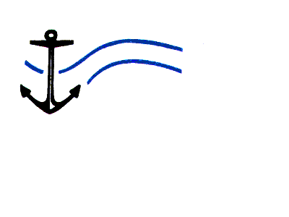

Centre for Marine Studies

Assessment of Key Transboundary Processes and Measurement Scales in Respect of Low Oxygen Water (LOW) Variability:
Implement the LOW Generation Areas That Provides Inputs to Transboundary Models in Project EV/LOW/2/03

BCLME Project EV/LOW/02/04 REPORT

BCLME Project number:
EV/LOW/02/04
Prepared for:
Benguela Current Large Marine Ecosystem Programme
Prepared by:
Centre for Marine Studies
University of Cape Town

South Africa
CSIR
P O Box 3207599
STELLENBOSCH
Republic of South Africa

Date: June 2006 (Revised May 2007)

Study carried out by:

Pedro M.S. Monteiro, CSIR, South Africa
Anél Viljoen, CSIR, South Africa
Anja van der Plas, MFMR, Nambia
Warren Joubert, CSIR, South Africa

Published by:
Centre for Marine Studies
University of Cape Town
Rondebosch 7700

Issued and printed by, also obtainable from:
Centre for Marine Studies
University of Cape Town
Rondebosch 7700

Acknowledgements:

- The St Helena Bay data used in this study was obtained in a project funded by the St Helena Bay Water Quality Forum Trust.
- CSIR for supporting the additional research areas through the STEP and SRP R&D programmes.

EXECUTIVE SUMMARY

Introduction
Low oxygen water (LOW) is an endemic characteristic of the Benguela system (Bailey, 1983; 1991; Chapman and Shannon, 1985; 1987; Monteiro et al., 2004). The ecological impacts of LOW were identified in the early work undertaken in the system (Copenhagen, 1953) and more recent research (Cockroft et al., 2000; Cockroft, 2001; Mathews and Pitcher, 1996). Its close association to the incidence of elevated sulphide concentrations was also noted in a qualitative sense early on (Marchand, 1928; Copenhagen, 1953; Hart and Currie, 1960) and more recently (Weeks and Bakun, 2004). The Namibian sub-system of the Benguela remains the most productive fishery but characterised by extreme fluctuations attributed to the cumulative effects of both hypoxia and over-fishing. The St Helena Bay – Namaqua retention zone plays an important role as a nursery for most of the pelagic fishery species as well as bottom dwelling rock lobster (Bakun, 1998; Roy, 1998). Events that resulted in significant losses of both demersal and bottom species have occurred in both the central (Namibia) and southern (South Africa) Benguela system (Cockroft et al., 2000). At present, stock assessment models treat environmental factors as random sources of mortality that can be parameterised by a mortality factor - this assumes that there are no systematic shifts in the forcing and response to LOW. Similarly, ecosystem models are typically less than sensitive to environmental forcing which can impact fisheries and ecosystem behaviour, distribution and mortality (Shannon and Jarre-Teichmann, 1999). The most recent time series data analysis supports the view that LOW variability is characterised by regime shifts in both remote forcing and local forcing factors which interact non-linearly to create LOW conditions and events of hitherto unpredicted magnitude (Monteiro et al., 2004). The BCLME Transboundary diagnostic analysis (TDA) identified LOW as one of the key environmental factors governing the variability and commercial viability of fisheries and ultimately the ecosystem (www.bclme.org). Its implementation plan requires that not only should the causes of LOW variability be understood but the BCLME should also invest in developing a forecasting capability which could assist the optimal ecosystem management, anticipate its impacts, provide better understanding of the underlying complexity and support fisheries management. The forecasting goal for LOW in the Benguela requires that the processes and the forcing scales that drive events and their variability be better characterized and understood.

The Context
The project brief evolved in two distinct phases:
- Initial Brief: the initial brief was largely based on historically based understanding of the problem of low oxygen in the Benguela.
- Additional Brief: the additional brief was an outcome of the Benguela Forecasting Workshop held in Cape Town in November 2004. This already took into consideration the outputs from the Low Oxygen Water Review (BCLME study report) and through the workshop discussion refined the objectives of the study.

Both briefs are laid out below but this study was primarily focussed by the refined brief from the November 2004 workshop.

The Original Brief
The variability of LOW events in the Benguela is governed by two main scales of forcing:
- hydrodynamic control through remotely sourced and physically advected LOW and,
- biogeochemical control through locally generated LOW. It is very likely that in different locations of the system at different periods that the relative importance of these two mechanisms will vary.

Understanding the nature and scales of this variability is a key first step towards a reliable early warning system. This project is specifically aimed at understanding the biogeochemical control. The aim of this project is to provide through sophisticated biogeochemical modelling a robust degree of understanding about the drivers, dynamics of local LOW generation to address the key questions set out by the brief. Answers to these key questions and integration with other complementary LOW projects will contribute to the three important policy actions of the BCLME – Strategic Action Plan (SAP).
- Development of an Early Warning System
- Improving predictability of extreme events
- Climate Change

Additional Brief: November 2004: Forecasting Workshop
The basis for the revised approach is set out in the publication (Monteiro et al., 2006) which synthesises the output from the workshop discussions. The two important features were:
- The formulation of the hypothesis for the coupled mechanism that lead to stranding events
- The definition of the 7 day time scale as being one amenable to forecasting

Risk Factors and system state thresholds

Southern Benguela

The most important risk factors that determine the ecosystem state in the Namaqua – St Helena system are the spatial and temporal characteristics of the wind. Simplifying the view: the system can exist in two states from an oxygen variability and ecosystem constraint perspective:

Hypoxic: high wind regime (High production – Low Oxygen)
Aerated: low wind regime (Low production – High Oxygen)

The initial assessment of the threshold is that a 20% reduction in 2002 wind strength could be assigned as a tipping point for the system. This needs to be investigated more closely to reduce the uncertainty of the threshold.

Central Benguela

The highest short term risk factor in the Central Benguela is the wind stress at Lüderitz. This risk factor operates in conjunction with the two other pre-conditioning factors: the equatorial forcing and the seasonal POC flux.

Future Climate Outlook Scenarios
One of the issues of greatest scientific and more recently political speculation is the question of whether low oxygen is responsible for a persistent trend in the shift of the rock lobster populations from the western Cape to southern Cape habitats . Climate change scenarios for the southern Benguela fall into two opposing outlooks:
Increased wind stress with warming which would strengthen the cool character of the upwelling system. This is forecast by present climate models on the basis that warming of the land mass increases the pressure gradients that drive the equatorward winds.

Reduced wind stress which would increase the 1980’s character of the system. This is outlook is based on the palaeo-record that shows that wind strength was highest during the cool periods over the past 200,000 years.

There is increasing evidence based on the paleo record to support the relaxation of the upwelling system through global warming. This suggests that the southern Benguela may shift towards a low productivity – high oxygen mode through increasingly longer or a higher frequency of 1980’s regimes.

Monitoring and Forecasting Strategy
One of the most important outcomes of this work was the detailed understanding of the processes and dynamical considerations that link wind forcing to low oxygen variability in the southern Benguela. The second important aspect that informs a monitoring strategy is that LOW variability is driven by regional scale wind forcing and not by remote basin scale boundary conditions.

Forecasting Approach
The approach to forecasting the evolution of LOW and its ecosystem / habitat consequences should follow an integrated modelling and observational plan. A two level forecasting system is proposed.
- Wind based early season and event scale forecasting of the risk
- An integrated operation modelling approach to forecast habitat scale outlook

SYNTHESIS OF ANSWERS TO KEY QUESTIONS FOR BOTH THE CENTRAL AND SOUTHERN BENGUELA

Initial Key Questions

- At the LOW generation areas, is the variability driven by internal forcing through POM export flux or boundary fluxes of oxygen in both horizontal and vertical scales?
Low oxygen variability in the southern Benguela is almost exclusively driven by internal physics and biogeochemistry. The most important characteristics of these internal dynamics are the seasonal scale build up of carbon export flux in the sediment and the event scale phasing of the active and relaxation events on the wind stress that govern ventilation rates. Overall hypoxia in the southern Benguela is driven by variability in vertical transport (upwelling) and mixing scales driven by wind stress. In the Central Benguela hypoxia variability is a more complex interaction between remote boundary conditions and seasonal scale phased forcing from two upwelling centres exposed to different boundary conditions. Interannual variability is therefore largely the result in changes in the seasonal forcing scales in contrast to the southern Benguela where interannual variability is the result of changes to the event or synoptic forcing scales. In both locations although POC fluxes are an essential element for the development of hypoxia, they do not modulate the variability. The variability is determined by the scales that drive ventilation.

- How susceptible is the LOW variability to the typical interannual variability in POC fluxes?
The role of POC in hypoxia variability in the Benguela is mainly one of pre-conditioning rather than a driver. This is especially so in the central Benguela where the variability is mainly driven by the wind stress at Lüderitz that governs the seasonal re-ventilation of the sub-thermocline waters on the shelf. The reason for this independence on POC fluxes is due to the advection of the equatorial hypoxia into the central Benguela through Cape Frio upwelling.

In the southern Benguela the decoupling of POC and hypoxia is not so extreme because the boundary conditions are more aerated and therefore require relatively higher rates of oxygen uptake driven by higher carbon export fluxes. Nevertheless the key role of POC is one of seasonal scale pre-conditioning rather than driving the event scale variability that strengthens the hypoxia. This is an important characteristic of the system because the carbon export flux is driven by upwelling and is dependent on wind stress. An important sensitivity was shown through the modelling experiments of pre-conditioning on wind stress. A possible tipping point lies at a wind speed of < 20% of the wind speed for the observed period of 2001 – 2002. Below this threshold the carbon export fluxes decrease sufficiently to make the oxygen sink flux smaller than the physical rate of ventilation through mixing.

- How does POM generation vary between the sub-systems? (Harmful Algal Blooms in Southern Benguela and Diatom production in Namibia)
POM generation is in both systems driven by diatom new production. The role of HAB (dinoflagellates) is specific to the southern Benguela and refers to the impact of HAB in the narrow inshore habitat during the relaxation phase.

- Does the dependence on transboundary links vary as a result of these differences?
The Namibian system is strongly dependent on trans-boundary links whereas the southern Benguela is almost completely independent. The Namibian system is strongly forced by the Equatorial system and its transboundary links are both coastal with the Angola system as well as oceanic through slope – shelf coupling.

Additional Key Questions

- Is a 7 day forecasting system feasible off South Africa?
This study has provided a basis to assess both the seasonal scale (medium term: months) risk as well as an event scale (7 day) forecast. Linking the two is important because the degree of seasonal risk governs the magnitude of the impact of the 7 day forecast.

- Is a 2 month forecasting system feasible off Namibia?
Although the new understanding of the dynamical consideration that link equatorial forcing to hypoxia in the central Benguela raised the possibility of a promising 2 month forecasting period, the complexity of the coupling has neutralized it. The role of the equatorial system is, like the POC in the southern Benguela, a preconditioning one where the actual driver is the re-ventilation from Lüderitz upwelling centre. The preconditioning remains an important part of the total forecasting picture because it adjusts the seasonal risk level. The actual forecast needs to focus on the forecast of the wind stress at the Lüderitz upwelling centre.

- Can such a forecasting system be operationalised?
A proposal was made as to how such a forecasting system may be constructed.

- Can this understanding explain past extreme events or conditions?
  - The Black Tide: the Black Tide of March 1994 was the result of a strong upwelling season after the quasi-decadal well aerated 1980’s associated with a protracted relaxation period. The protracted relaxation period allowed a very deep anoxia to develop that resulted in elevated rates of Sulphate reduction both in the sediments and the water column. The presence of reduced sulphide species in the surface layer would have been driven by methane ebulition from the sediments.

  - The 1980’s decadal anomaly: The 1980’s aerated anomaly was caused by a sharp drop in new production linked to a protracted reduction in the wind stress. The strong non-linearity between wind stress and new production was apparent in model experiments conducted with 20% and 50% reductions in the wind speed. The former reduced average seasonal new production by 80%. The sharp reduction in new carbon export fluxes reduced the seasonal build up of POM in the sediments so the reduction in oxygen fluxes during relaxation periods was not low enough to cause the system to become hypoxic.

  - The 1994 ecosystem wide catastrophic event in the Central Benguela was driven by the simultaneous strengthening of the equatorial forcing (warming at the ABF) and a weak ventilation wind stress at Lüderitz. Similarly, the northward expansion of the hake (paradoxus) biomass distribution in 1996 – 1998 was the result of a concomitant weakening of the equatorial forcing and a strengthening of the ventilation flux from Lüderitz.

CONTENTS

EXECUTIVE SUMMARY i
SYNTHESIS OF ANSWERS TO KEY QUESTIONS FOR BOTH THE CENTRAL AND SOUTHERN BENGUELA iv

CONTENTS i
FIGURES iii

1. INTRODUCTION 1
2. CONTEXT 2
2.1 The Original Brief 2
2.1.1 Key Questions 3
2.1.2 Operational Assumptions 3
2.1.3 Approach 4
2.2 Additional Brief: November 2004 5
2.2.1 Key Questions 5
3. METHODOLOGICAL DETAILS: 6
3.1 Hydrodynamic and Biogeochemical Models in the southern Benguela 6
3.2 Hydrodynamic Model Set up 7
3.2.1 Data Requirements 7
3.3 Set-up of the hydrodynamic model 15
3.3.1 Modelled Processes 15
3.4 Details of model setup 16
3.4.1 Hydrodynamic grid and bathymetry 16
3.4.2 Boundary conditions – water levels 18
3.4.3 Boundary conditions - temperature 18
3.4.4 Simulation period 20
3.5 Biogeochemical Model Set Up 20
3.5.1 State variables 22
3.5.2 Processes 22
3.5.3 Input Data 23
3.5.4 Initial Conditions 23
3.5.5 Boundary Conditions 24
3.5.6 Model verification 24
4. Modelling and Forecasting Hypoxia in the Southern Benguela 24
4.1 Hydrodynamic Model results 24
4.2 Biogeochemical Model Results 31
4.2.1 Key Processes and Model Verification 31
4.2.2 Temporal Temperature Variability 31
4.2.3 Temporal Oxygen Variability 36
4.2.4 Spatial - Temporal Variability 38
4.2.5 Summary 41
4.2.6 Variability of Primary Production 46
4.2.7 Oxygen Variability 51
4.3 Sensitivity Analysis 58
4.3.1 Boundary Conditions 59
4.3.2 Sensitivity to wind stress change 64
4.4 FORECASTING A STRANDING: BIOGEOCHEMICAL - ECOSYSTEM MODEL RESULTS 72
4.5 SYNTHESIS OF THE PROCESSES THAT GOVERN LOW VARIABILITY IN THE SOUTHERN BENGUELA 75
4.6 Habitat Constraints from LOW variability 75
4.7 Extreme Events in the Recent Past: Southern Benguela 76
4.7.1 What happened in the 1980’s? 76
4.7.2 What happened in March 1994? 78
4.8 Risk Factors and system state thresholds 79
4.9 Future Climate Outlook Scenarios 80
4.10 Monitoring and Forecasting Strategy 80
4.10.1 Key processes 80
4.10.2 Forecasting Approach 81
4.10.3 Wind based Forecasting 82
4.10.4 Integrated Modelling 82
4.10.5 Observations 82
4.10.6 Forcing 82
5. Hypoxia Variability in the Central Benguela: Namibian Shelf 83
5.1 Coupled physics and biogeochemistry 83
5.2 Hypoxia and changes to the fisheries ecosystem states 87
6. Synthesis of Answers to Key Questions for both the Central and Southern Benguela 90
6.1 Initial Key Questions 90
6.2 Additional Key Questions 91
7. BIBLIOGRAPHY 93

FIGURES

Figure 2-1: Position of the thermistor chain and the Cape St Martin wind station. 8
Figure 2-2: Temperature time series in St Helena Bay at four different depths, for mid January – mid February 2002. 9
Figure 2-3(a): Measured wind speed and direction at the St Helena Bay weather station for January 2002, indicating long periods of upwelling favourable southwesterly winds, followed by periods of relaxation. 11
Figure 2-3(b): Measured wind speed and direction at the St Helena Bay weather station for February 2002, indicating a strong upwelling event at the beginning of the
month. 12
Figure 2-3(c): Measured wind speed and direction at the St Helena Bay weather station for March 2002, indicating long periods of upwelling favourable southwesterly winds, followed by periods of relaxation. 13
Figure 2-3(d): Measured wind speed and direction at the St Helena Bay weather station for April 2002, indicating less persistant upwelling favourable southwesterly winds, and much lower wind speeds than the previous months. 14
Figure 2-4: Hydrodynamic model grid: Full domain (left) and zoomed into the St Helena Bay area (right). 17
Figure 2-5: Hydrodynamic model bathymetry: Full domain (left) and zoomed into the St Helena Bay area (right). 18
Figure 2-6: St Helena Bay Model Temperature Profile: Graph showing the vertical temperature profile that was initially applied throughout the St Helena Bay model domain, as well as at the boundaries. 19
Figure 2.7: The structural characteristics of the D3D-WAQ biogeochemical model. 21
Figure 3-1(a): Comparison between measured (red) and modelled (blue) temperatures at different depths in St Helena Bay for October to December 2002. 25
Figure 3-1(b): Comparison between measured (red) and modelled (blue) temperatures at different depths in St Helena Bay for January to April 2002. 26
Figure 3-2(a): Modelled surface temperature and currents along the West Coast during an active upwelling (2002/02/12) and consecutive relaxation (2002/02/15) phases. 27
Figure 3-2(b): Modelled vertical temperature section at Lamberts Bay during an upwelling (2002/02/12) and consecutive relaxation (2002/02/15) event. 28
Figure 3.3: Temperature time series from the surface layer and bottom layer in St Helena Bay (see Fig. 2.1 for location) over the Jan – Apr 2002 period. 33
Figure 3.4: Modelled temperature time series at two sites (Elands Bay: nearshore and SouthMidShelf in the core of the retention area) in the St Helena Bay – Namaqua system. 34
Figure 3.5a,b: Time series comparing the variability of stratification (T_{surface} – T_{bottom}) between modelled (top) and observed (bottom) data. 35
Figures 3.6a,b: The variability of dissolved oxygen from observed (top: a) and modelled data (bottom: b) at the same site in the St Helena – Namaqua system. 37
Figure 3.7: The observed temperature variability at the mooring site for the surface and bottom layers. It shows the period (28/1 – 11/2) covered by the ensuing spatial – temporal plots below. 39
Figures 3.8a-h: Vertical and Horizontal sections of temperature over the period: 28/1 – 11/2. 42
Figures 3.9a-h: Vertical and horizontal sections of phytoplankton production rates for the period 28/1 – 11/2. 47
Figures 3.10a-h: Vertical and horizontal sections for dissolved oxygen for the period 28/1 – 11/2. 54
Figures 3.11a-c: The time series of modelled dissolved oxygen variability at two locations: nearshore Elands Bay (a) and core of the retention zone SouthMidShelf (b) in the St Helena – Namaqua domain forced by three boundary conditions
(3, 5, 7 mgO₂L⁻¹). 61
Figure 3.12: Depicts the event and seasonal scale anomaly of oxygen concentrations observed at the boundary and those within the modelled domain (SouthMidShelf). 62
Figure 3.13: Plot of salinity – oxygen showing that the hypoxic conditions are associated with the Cape Basin SACW rather than the higher salinity Equatorial SACW. 63
Figure 3.14: Plot taken from the study of Johnson and Nelson, 1998 which contrasts the low upwelling volume transports at Cape Columbine during the 1980’s with those for the preceding period and show an increasing trend towards the higher wind stress 1990’s decade. 64
Figures 3.15a,b: Modelled time series plots of dissolved oxygen at two sites (Elands Bay and SouthMidShelf) for three wind scenarios. It shows that a small drop in wind speed (~20%) shifts the system into a different ecological state. 66
Figure 3.16: Plot showing the relatively high sensitivity of surface layer production rates to small drops in wind speed (20% - 50%). 67
Figures 3.17a,b: The sensitivity of the productivity rates in the surface layer to changes in wind stress are depicted in the modelled time series extracted at three bay sites for the three different wind scenarios. 69
Figures 3.18a,b: Daily averaged time series plots of phytoplankton biomass (gCm⁻³) and production rates (gCm⁻³d⁻¹) 70
Figures 3.19a,b: Nutrient (DIN) limitation plots showing how nutrient limitation escalates rapidly from > 0.8 to < 0.4 with relatively small decreases in wind speed (50%). 71
Figures 3.20a,b: Plot showing modelled time series of dissolved oxygen from the deep Bay area (a) and the shallow near shore zone (b). 73
Figures 3.21a-c: Progressive depth – time plots for temperature (a), salinity (b) and dissolved oxygen (c) contrasting the 1980’s and 1990’s decades. 77
Figure 3.22: Plot taken from the study of Johnson and Nelson, 1998 which contrasts the low upwelling volume transports at Cape Columbine during the 1980’s with those for the preceding period and show an increasing trend towards the higher wind stress 1990’s decade. 78

INTRODUCTION

Low oxygen water (LOW) is an endemic characteristic of the Benguela system (Bailey, 1983; 1991; Chapman and Shannon, 1985; 1987; Monteiro et al., 2004). The ecological impacts of LOW were identified in the early work undertaken in the system (Copenhagen, 1953) and more recent research (Cockroft et al., 2000; Cockroft, 2001; Mathews and Pitcher, 1996). Its close association to the incidence of elevated sulphide concentrations was also noted in a qualitative sense early on (Marchand, 1928; Copenhagen, 1953; Hart and Currie, 1960) and more recently (Weeks and Bakun, 2004). The Namibian sub-system of the Benguela remains the most productive fishery but characterised by extreme fluctuations attributed to the cumulative effects of both hypoxia and over-fishing. The St Helena Bay – Namaqua retention zone plays an important role as a nursery for most of the pelagic fishery species as well as bottom dwelling rock lobster (Bakun, 1998; Roy, 1998). Events that resulted in significant losses of both demersal and bottom species have occurred in both the central (Namibia) and southern (South Africa) Benguela system (Cockroft et al., 2000). At present, stock assessment models treat environmental factors as random sources of mortality that can be parameterised by a mortality factor - this assumes that there are no systematic shifts in the forcing and response to LOW. Similarly, ecosystem models are typically less than sensitive to environmental forcing which can impact fisheries and ecosystem behaviour, distribution and mortality (Shannon and Jarre-Teichmann, 1999). The most recent time series data analysis supports the view that LOW variability is characterised by regime shifts in both remote forcing and local forcing factors which interact non-linearly to create LOW conditions and events of hitherto unpredicted magnitude (Monteiro et al., 2004). The BCLME Transboundary diagnostic analysis (TDA) identified LOW as one of the key environmental factors governing the variability and commercial viability of fisheries and ultimately the ecosystem (www.bclme.org). Its implementation plan requires that not only should the causes of LOW variability be understood but the BCLME should also invest in developing a forecasting capability which could assist the optimal ecosystem management, anticipate its impacts, provide better understanding of the underlying complexity and support fisheries management. The forecasting goal for LOW in the Benguela requires that the processes and the forcing scales that drive events and their variability be better characterized and understood.

CONTEXT

The project brief evolved in two distinct phases:
- Initial Brief: the initial brief was largely based on historically based understanding of the problem of low oxygen in the Benguela.
- Additional Brief: the revised brief was an outcome of the Benguela Forecasting Workshop held in Cape Town in November 2004 (Shannon, LV., 2006; Monteiro et al., 2006b). This already took into consideration the outputs from the Low Oxygen Water Review (BCLME study report) and through the workshop discussion refined the objectives of the study.

Both briefs are laid out below.

The Original Brief

The variability of LOW events in the Benguela is governed by two main scales of forcing:
- hydrodynamic control through remotely sourced and physically advected LOW and,
- biogeochemical control through locally generated LOW.

It is very likely that in different locations of the system at different periods that the relative importance of these two mechanisms will vary. Understanding the nature and scales of this variability is a key first step towards a reliable early warning system. This proposal is specifically aimed at understanding the biogeochemical control. The aim of this proposal is to provide through sophisticated biogeochemical modelling a robust degree of understanding about the drivers, dynamics of local LOW generation to address the key questions set out by the brief. Answers to these key questions and integration with other complementary LOW projects will contribute to the three important policy actions of the BCLME – Strategic Action Plan (SAP).

- Development of an Early Warning System
- Improving predictability of extreme events
- Climate Change

The importance of using a combined modelling – measurement approach rather than a more traditional purely observational one is that it can both provide a grasp on the complexity of feedback processes and scales as well as contribute to a forecasting system.

Key Questions

- At the LOW generation areas, is the variability driven by internal forcing through POM export flux or boundary fluxes of oxygen in both horizontal and vertical scales?
- How susceptible is the LOW variability to the typical interannual variability in POC fluxes?
- How does POM generation vary between the sub-systems? (Harmful Algal Blooms in Southern Benguela and Diatom production in Namibia)
- Does the dependence on transboundary links vary as a result of these differences?
- What is the relative importance of the following natural processes and anthropogenic activity in varying the sediment – water fluxes of oxygen demand on a system-wide scale?
- What are the CO₂ fluxes across the air-sea interface and long term carbon burial fluxes in the upwelling system?
- Is there a consistent and large enough net burial flux to justify an evaluation of the economic value of the BCLME as a Carbon scavenging system?

Operational Assumptions

This project is one of the steps towards a LOW early warning system. Although it is being fast tracked by using an existing operational hydrodynamic model (Delft3D-FLOW) it assumed that:

- the ROMS facility with two way nesting will be developed in parallel
- the high resolution ROMS shelf model will be set up and verified
- the coupling between the ROMS and biogeochemical models will be implemented.

Approach

The approach of this proposal is aimed at providing the required understanding of the role of LOW generation centres within the Benguela sub-regions on LOW variability and its potential impact on fisheries. This is complementary to the parallel proposal for project EV - LOW - 02-03 which is focussed on hydrodynamic control.

One of the important modifications to the modelling approach was driven by the fact that the expected ROMS development aspects linked to the modelling facility were not implemented in phase with the work in this project. As a result, ROMS was not implemented and Delft3D-FLOW was used to replace it in the southern Benguela. The same modelling approach was not used in the northern Benguela because it was found to be driven by a more complex set of dynamics that were not sufficiently well understood to enable a worthwhile numerical model set up. The emphasis in the latter was therefore to focus on the development of testable hypotheses about the complex physics – biogeochemical linkages and test those hypotheses by providing coherent explanations for the extreme events that have been observed in the past 25 years.

The known dominant areas of LOW formation are the inner shelf areas of the central and southern regions as well as the Angola dome in the oceanic domain. This project is focussed on the shelf LOW generation areas in the Benguela:
- The inshore mud belt in the central Benguela
- The St. Helena bay system (Oliphants River – Cape Columbine)

While it is recognized that the Angola dome may also be an important sub-regional LOW generation centre its location off the shelf in an oceanic environment, its uncertain shelf links and the shortage of adequate model verification data make it more appropriate to investigate its role in the context of the larger system scale approach in LOW 02-03. Its role should also be better assessed in LOW 02-01. The approach that will be adopted by this consortium comprises four phases of execution:

Phase 1: | BCLME Forecasting Workshop Publication
Phase 2: | - Set up validated hydrodynamic domains and source all input data  - Set up, validate and run biogeochemical models
Phase 3: | Address the Key Questions
Phase 4: | Output Products

Additional Brief: November 2004

The basis for the additional approach is set out in the publication (Monteiro et al., 2006) which synthesises the output from the workshop discussions. The two important features were:
- The formulation of the hypothesis for the coupled mechanism that lead to stranding events
- The definition of the 7 day and 2 month time scales as being ones most amenable to forecasting

Key Questions

The outcome of the working group discussions are summarised in a series of key questions that were added to the ones defined earlier in the original brief.

- Is a 7 day forecasting system feasible for the southern Benguela?
- Is the 2 month forecasting system feasible for the Central Benguela?
- Can such a forecasting system be operationalised?
- Can this understanding explain past extreme events or conditions?
  - The Black Tide in the southern Benguela
  - The 1980’s decadal anomaly in the southern Benguela
  - The 1994 ecosystem scale impact of hypoxia on fisheries in the Central Benguela

METHODOLOGICAL DETAILS:

The modelling set up and running details set out below refer to its implementation in the southern Benguela. The Central Benguela was developed using an observation based approach which then allowed the same key questions to be addressed. The methodological details of the latter can be found in (Monteiro et al., 2006a; Monteiro et al., 2007a). Both methodologies addressed the key objective of this study: understand the mechanisms of local (shelf) formation of hypoxia such as to make it possible to work towards a forecasting system and climate change impact assessments.

Hydrodynamic and Biogeochemical Models in the southern Benguela

The study approach combined use of modelling platforms and observational data. The modelling platforms were:
- Hydrodynamic model: Delft3D Flow which simulated the advective and turbulence (vertical diffusion) elements of the system and transferred those as inputs to the biogeochemical model
- Biogeochemical model: Delft3D-WAQ uses the input from Flow to solve the advection – dispersion equations as well as the required biogeochemical processes.

The main reference data set was the yearlong mooring hourly time series from St Helena Bay (July 2001 – June 2002) which included:

- Temperature from thermistor chain with a 2m vertical resolution
- Salinity from the bottom mixed layer at 22m
- Oxygen from the bottom mixed layer at 22m

The hydrodynamic model was forced with a wind and solar radiation data sets sampled simultaneously at a sampling point located in Cape St Martin, north of Cape Columbine.

Hydrodynamic Model Set up

The modelling of the hydrodynamics of the St Helena / Lambert’s Bay area has been undertaken using the DELFT3D-FLOW model (WL|Delft Hydraulics, 2003).

Data Requirements

Bathymetry
A detailed bathymetry of the model domain was compiled by combining the following data sets:

S A Navy hydrographic chart of Olifantsrivier to Cape Columbine (SAN 117);
S A Navy hydrographic chart of Cape Columbine to Table Bay (SAN 118);
S A Navy hydrographic chart of St Helena Bay – Eastern part (SAN 1008) and
S A Navy hydrographic chart of St Helena Bay – Western part (SAN 1009).

Temperature
Time series of temperature data was collected by the CSIR at 2 m depth intervals by deploying a thermistor chain in 25 m depth in St Helena Bay. Figure 2-1 indicates the position of the thermistor chain. The data was collected for the period July 2001 to June 2002, with hourly intervals, and was used for model calibration purposes.

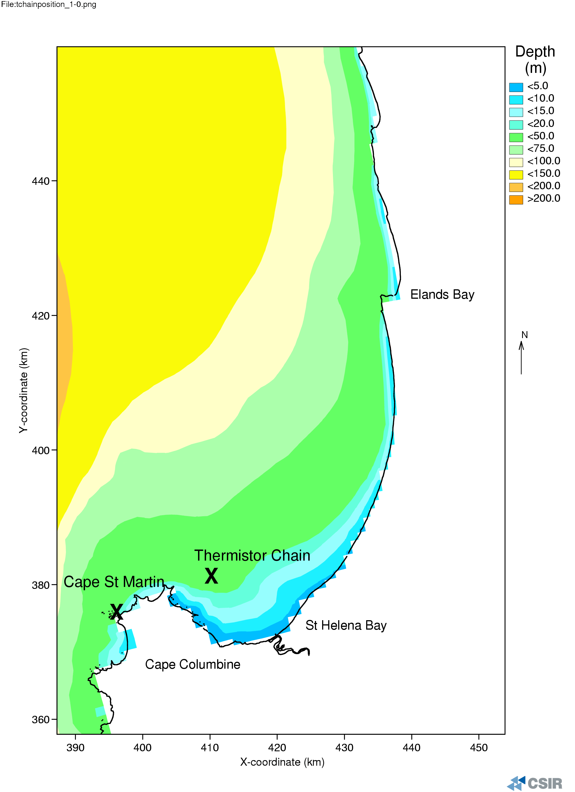

Figure 2-1: Position of the thermistor chain and the Cape St Martin wind station.

Figure 2-2 depicts temperature time series, measured by the thermistor chain, for the period 20 January – 15 February 2002, at depths of 0 m (surface), 10 m, 16 m and 25 m (bottom).

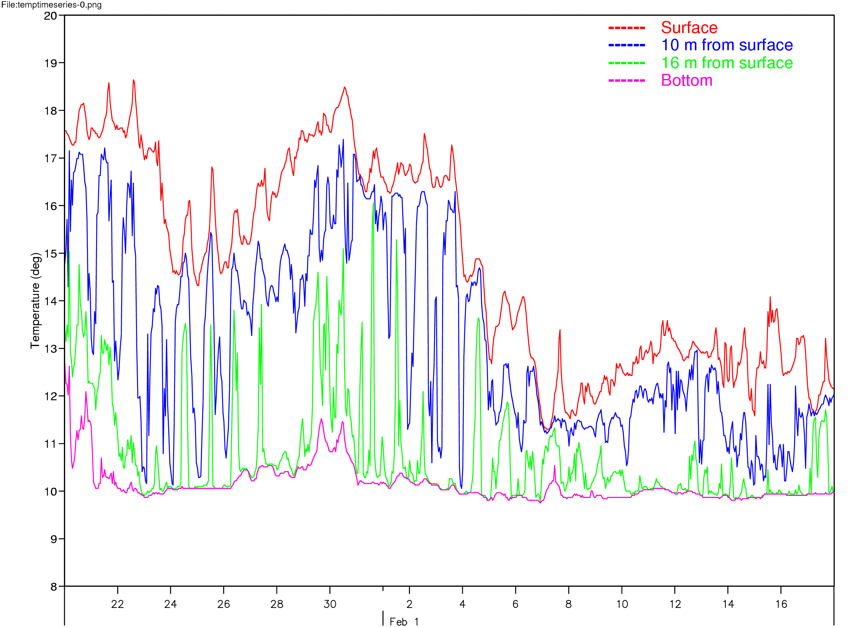

Figure 2-2: Temperature time series in St Helena Bay at four different depths,
for mid January – mid February 2002.

The above time series shows an upwelling event (around the 24th – 26th of January) during which southwesterly winds persist and cold bottom water is entrained into the surface layers, leading to a collapse of stratification and a cooling of surface water. Following the period of upwelling, the wind relaxes, leading to a relaxation event and a subsequent warming of the surface water. During this time, the water becomes stratified again. In early February, a strong southwesterly wind blows, leading to another upwelling event and another collapse in stratification.

Temperature data obtained from Hondeklip Bay was applied at the model’s northern and southern open boundaries (Monteiro, 1997). This data set was chosen because it was the best continuous data set available at the time when the St Helena Bay model was set up.

Wind

The wind data applied in the model runs are those measured with hourly intervals at the St Helena Bay weather station, situated at Cape St Martin (north of Cape Columbine, see Figure 2-1). The St Helena Bay weather station is situated within an abalone farm (close to the coast) at 32.43S 17.55E and uses a MCS (Mike Cotton Systems) wind station, which is set up 20 m above MSL. Delft3D requires wind speed and direction equivalent to 10 m above the ground, and the measured winds at the St Helena Bay weather station therefore had to be reduced from a 20 m height to a 10 m height. The following equation was used (American Petroleum Institute, 1991):

$$V(z_{R})=V(z_{M})/(\frac{z_{M}}{z_{R}})^{0\text{.}\text{125}}$$
where

$V(z_{R})$ = wind speed (m/s) at reference level (10 m above MSL)
$V(z_{M})$ = wind speed at measured level
$z_{M}$ = height above sea level at measured level
$z_{R}$ = height above sea level at reference level (10 m)

The adjusted wind speeds at 10 m above MSL were approximately 8% less than those measured at 20 m at the St Helena Bay weather station.

The measured wind speed and direction for January to April 2002 (adjusted to 10 m above MSL) are shown in Figures 2-3(a) - 2-3(d). Wind time series for October to December 2001 can be seen in Figures A-2(a) - A-2(c)

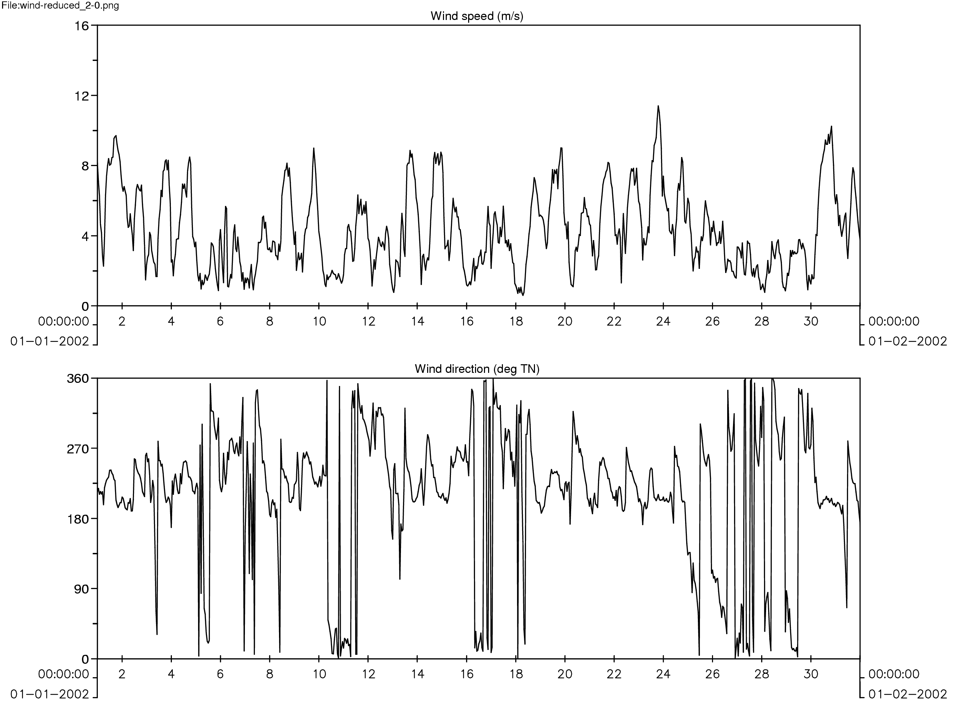

Figure 2-3(a): Measured wind speed and direction at the St Helena Bay weather station for January 2002, indicating long periods of upwelling favourable southwesterly winds, followed by periods of relaxation.

Upwelling leads to the entrainment of cold bottom water into the surface layers, leading to cooling of surface water. Relaxation of the wind leads to warming of surface water (see Figure 2-2).

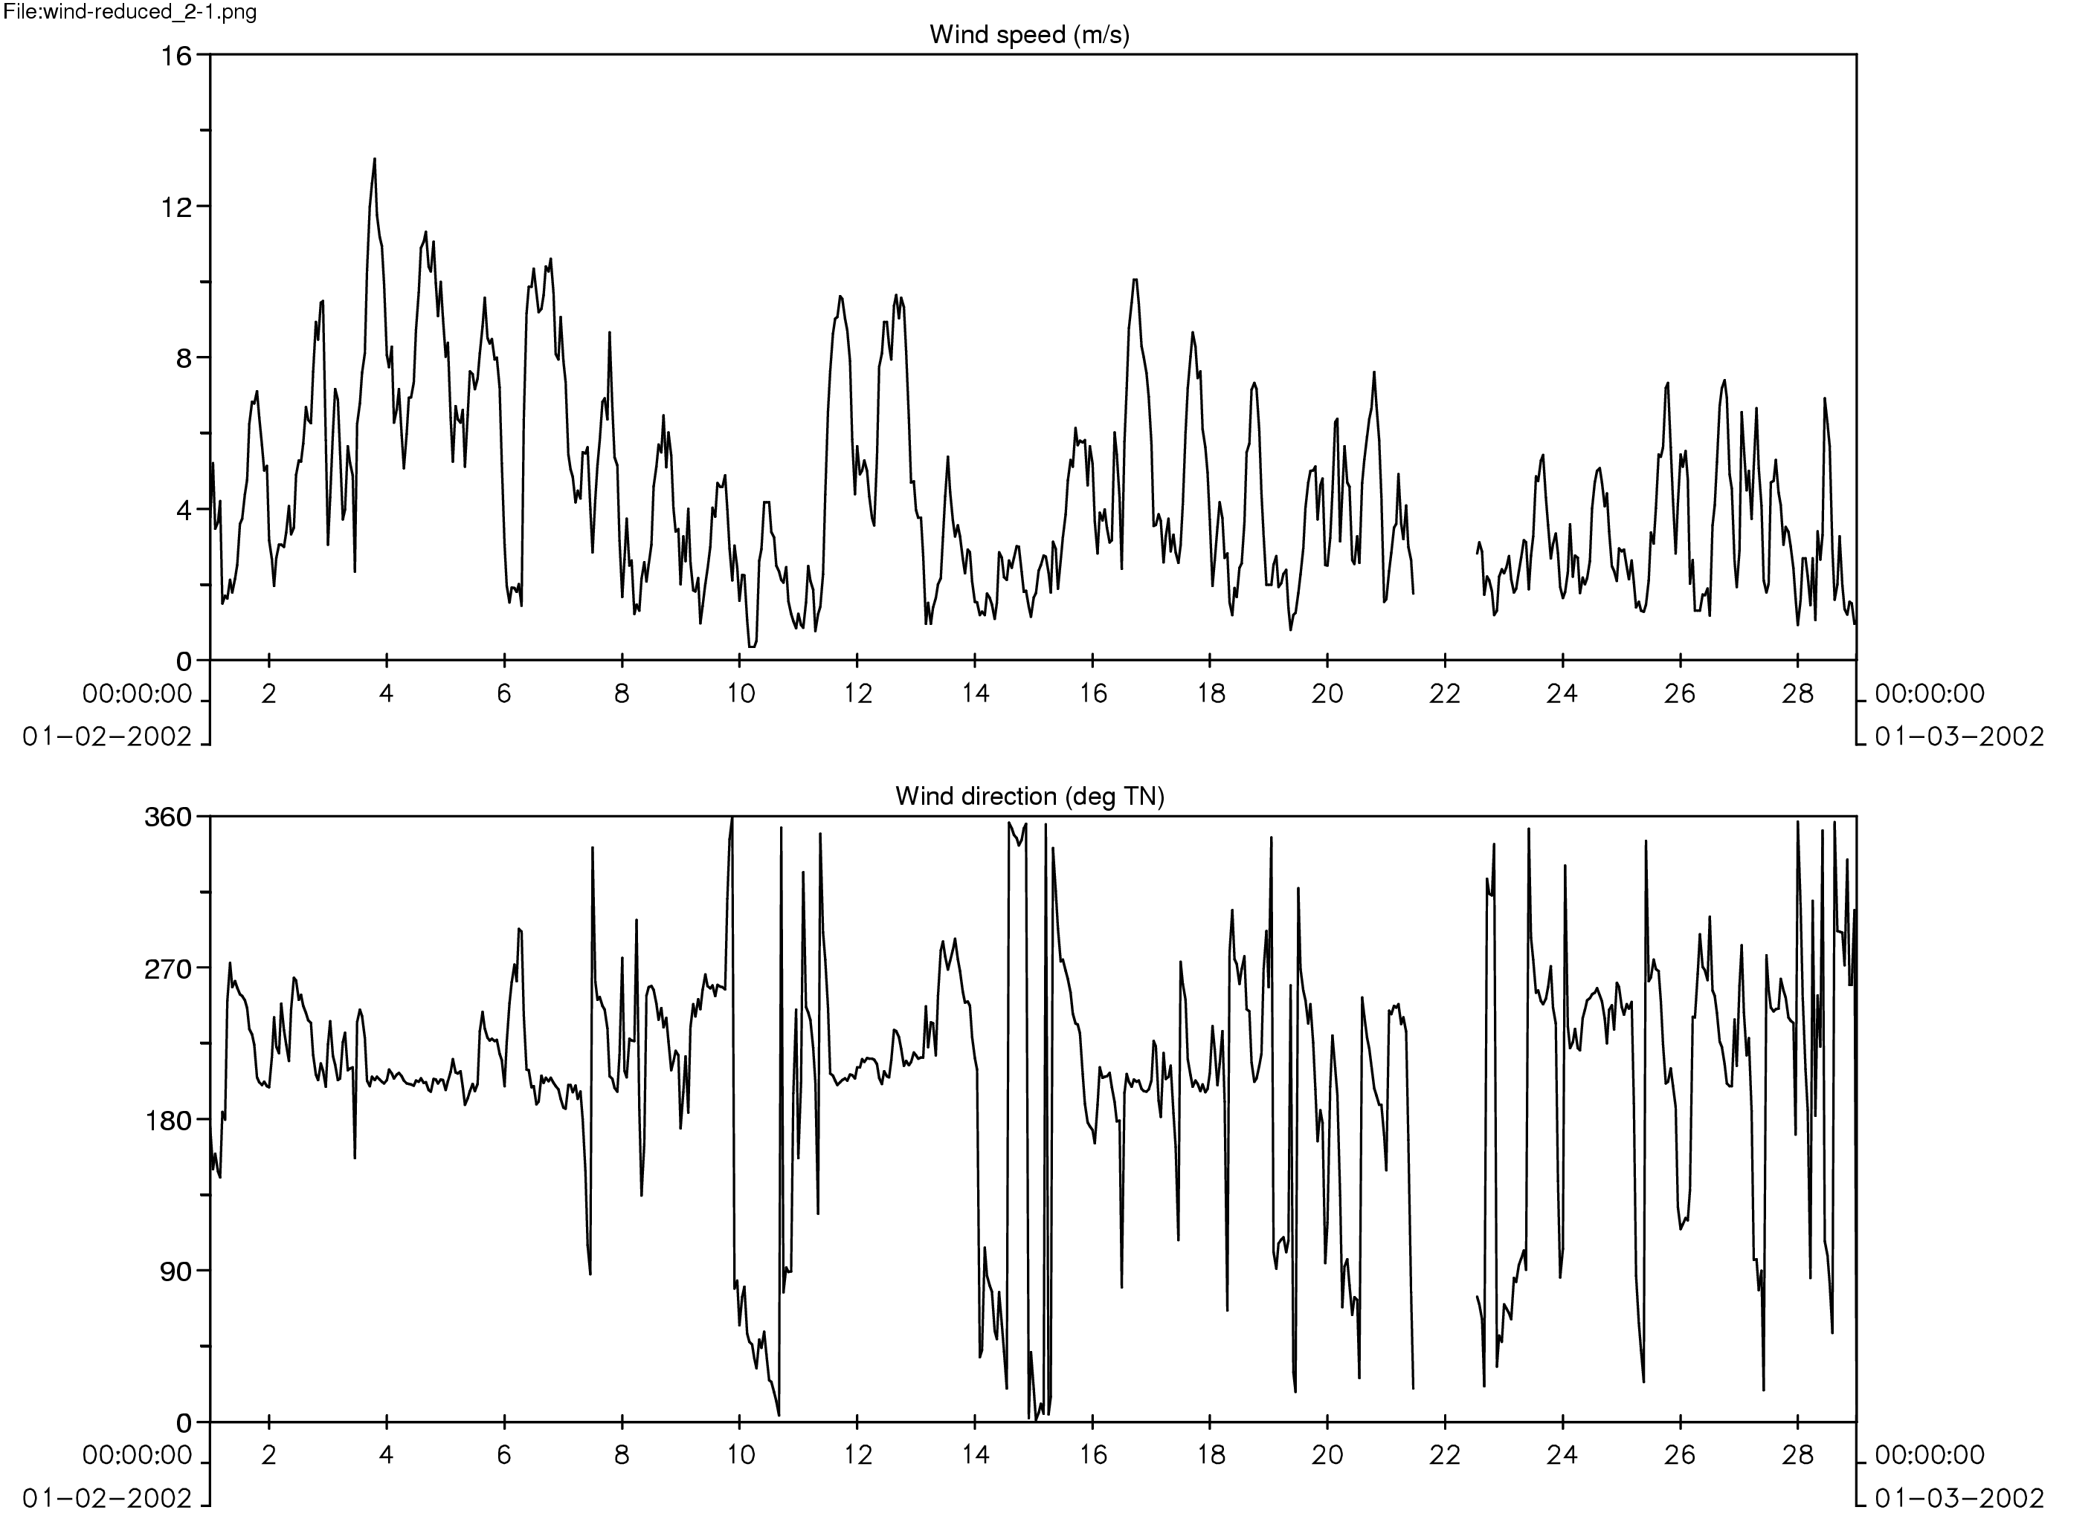

Figure 2-3(b): Measured wind speed and direction at the St Helena Bay weather station for February 2002, indicating a strong upwelling event at the beginning of the month.

Upwelling leads to the entrainment of cold bottom water into the surface layers, leading to cooling of surface water. Relaxation of the wind leads to warming of surface water
(see Figure 2-2).

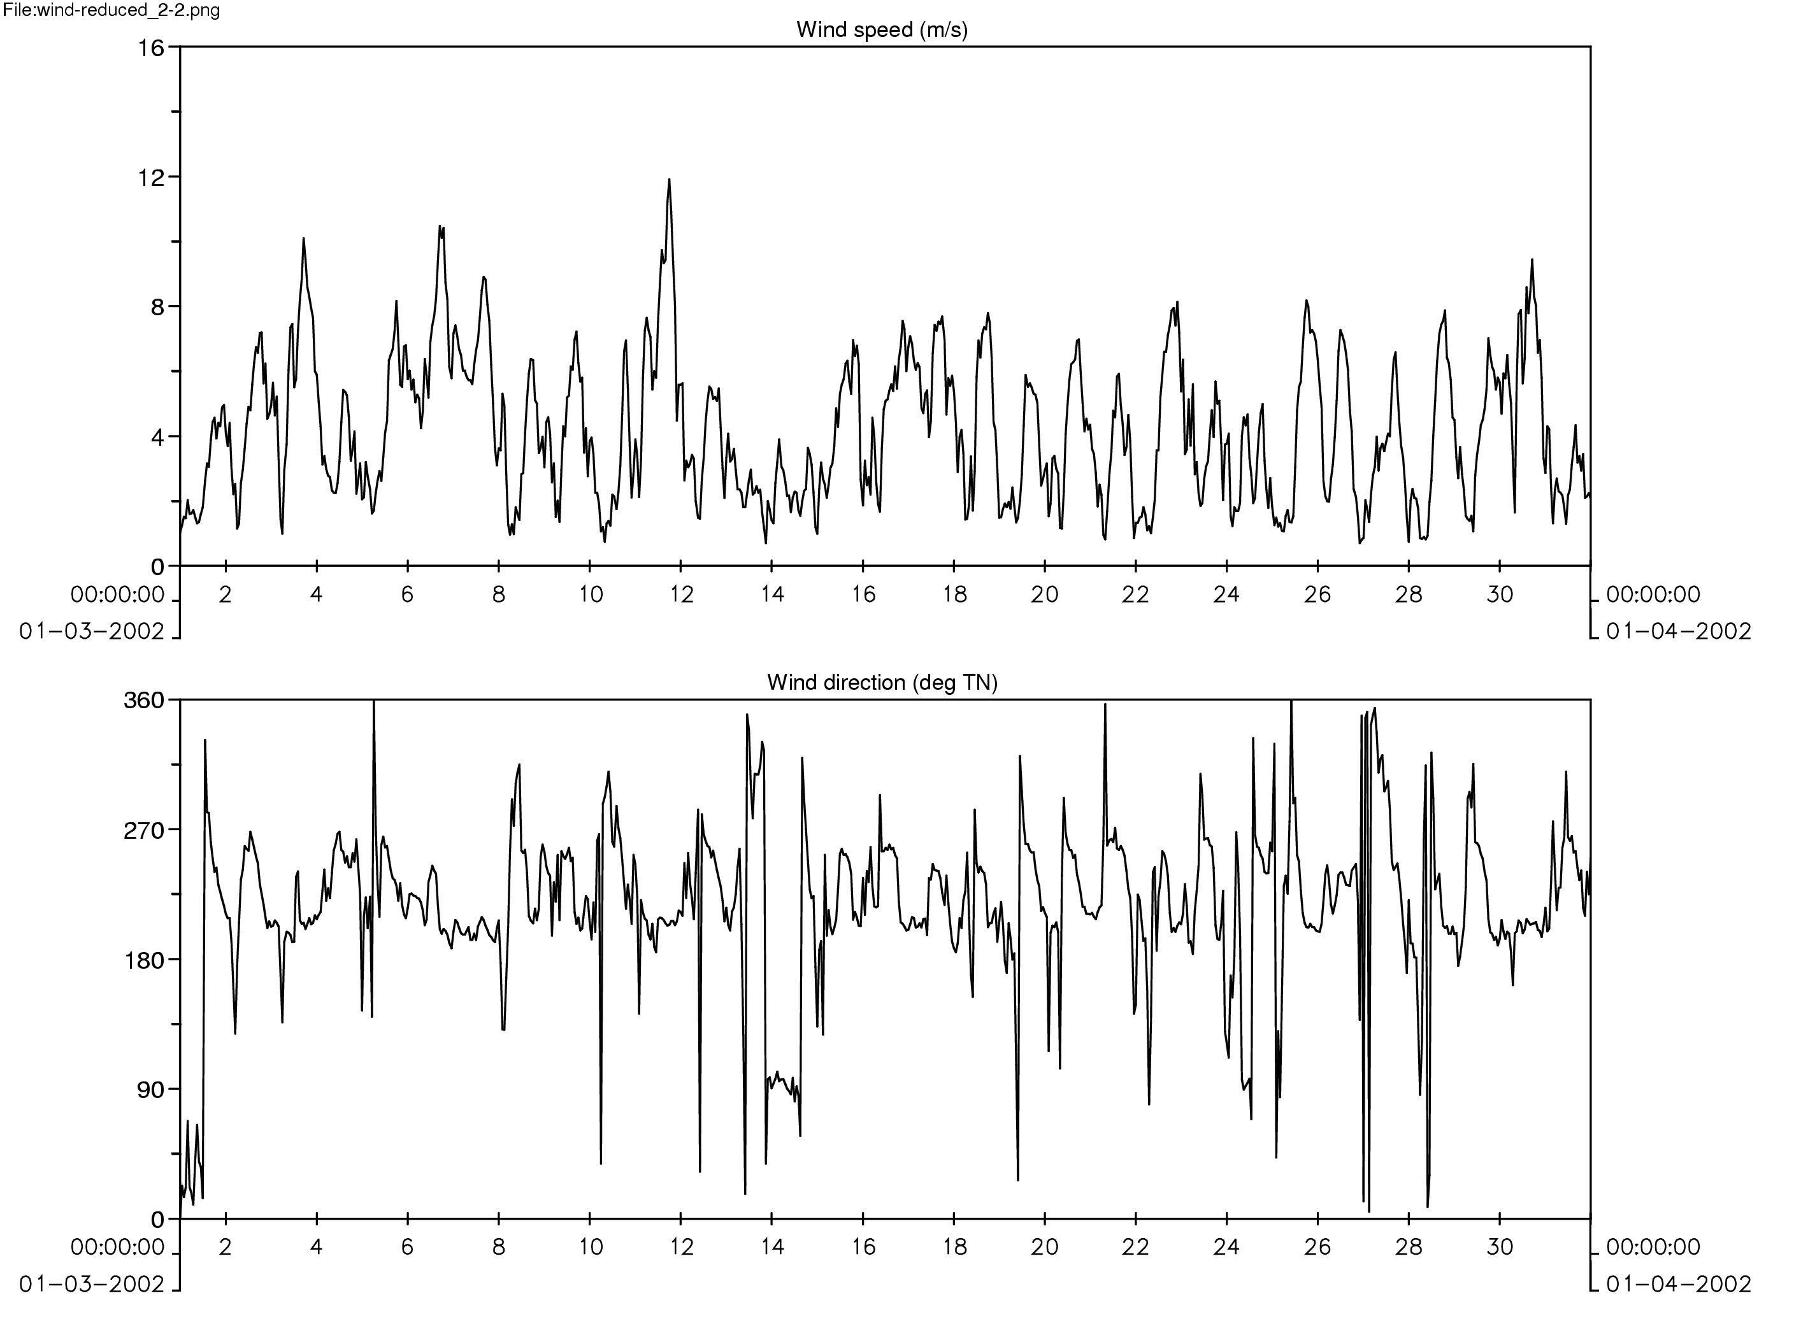

Figure 2-3(c): Measured wind speed and direction at the St Helena Bay weather station for March 2002, indicating long periods of upwelling favourable southwesterly winds, followed by periods of relaxation.

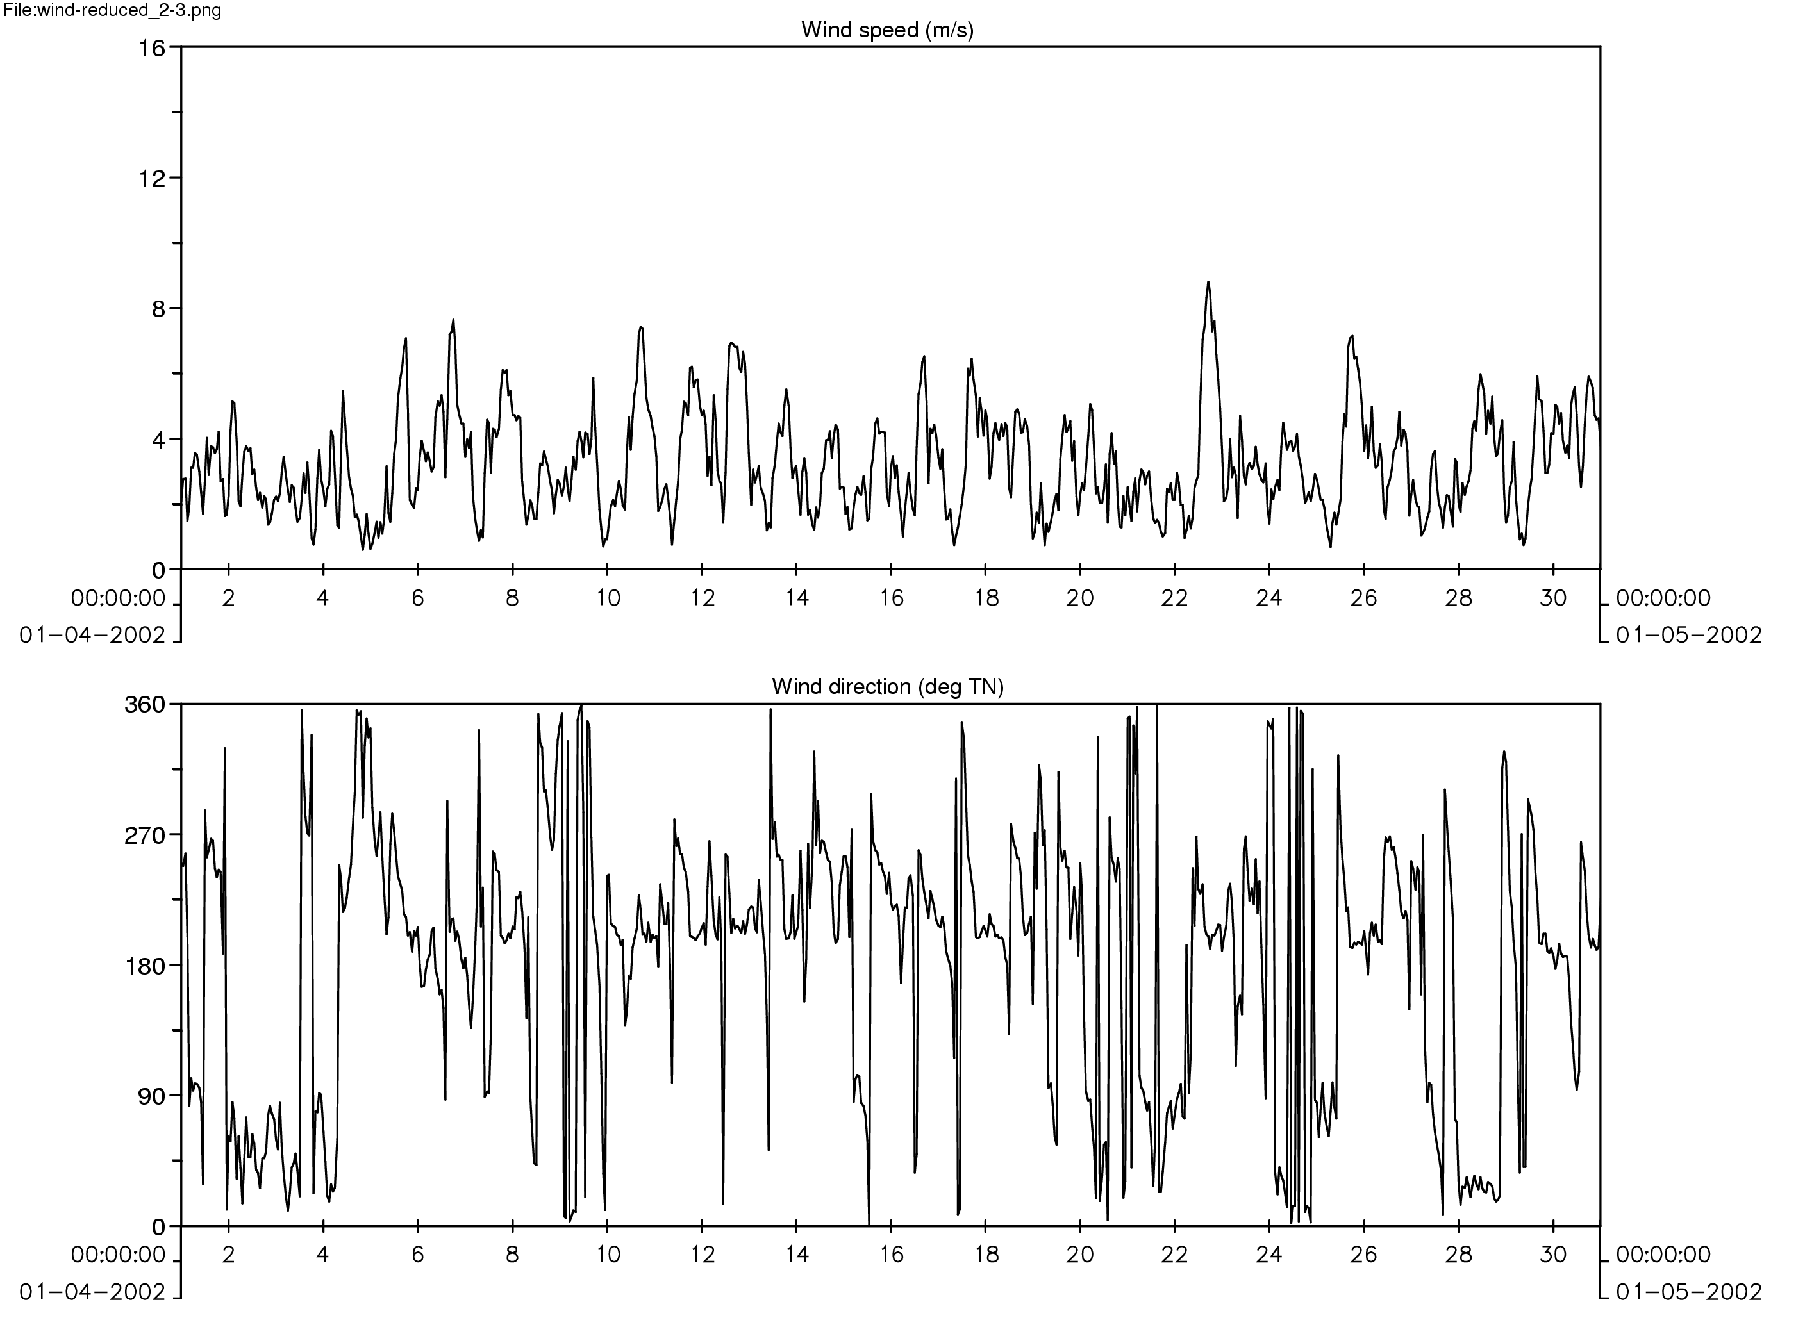

Figure 2-3(d): Measured wind speed and direction at the St Helena Bay weather station for April 2002, indicating less persistant upwelling favourable southwesterly winds, and much lower wind speeds than the previous months.

ATMOSPHERIC DATA SETS

Four data sets were necessary in order to include heat fluxes in the St Helena Bay model, namely: air temperature, humidity, cloudiness and net solar radiation.

Air temperature, humidity and cloudiness data were obtained from the South African Weather Services (SAWS). The net solar radiation was measured at the St Helena Bay weather station at Cape St Martin (Figure 2-1). A MCS 155-1 radiation sensor was used to measure the radiation, with a scan period of once per minute. The data that was applied in the St Helena Bay numerical model was hourly averages for radiation.

Set-up of the hydrodynamic model

Modelled Processes

Tides
Tides were included in the modelling via water level variations applied to the model boundary. This is the main driving force in the model.

Winds
Winds were included in the model calibration runs as well as in subsequent runs to simulate the hydrodynamic characteristics of St Helena Bay and the surrounding areas. Wind set up and Coriolis tilt effects on the water levels at the model boundaries were also taken into account during the predictions.

Temperature
Salinity was not modelled (a constant salinity was specified), but temperature was indeed one of the important processes included in the model. Consequently, the thermocline dynamics are explicitly included in the simulations.

Air sea interactions
Strong stratification is maintained by atmospheric heat fluxes into the surface waters and the inflow of cold bottom waters from upwelling on the adjacent open shelf. These processes control the thermocline dynamics and vertical mixing of the water column which, together with wind-and tidally-driven currents, ultimately determine the behaviour of biogeochemical parameters within the region. Heat fluxes were thus explicitly included in the modelling.

Note: Two major estuaries run into the ocean within the study area – The Great Berg Estuary and the Olifants Estuary. Compared to the large-scale marine processes that are being modelled and investigated, and because of the model period (summer), the freshwater run-off from these rivers is deemed insignificant. Therefore it was safe to assume that the river run-off in the vicinity of St Helena Bay and Olifants River mouth could be ignored for the purpose of this study. It should be noted that the run-off could become significant if a winter period is modelled. Waves were also not modelled, but this is a process that could possibly be tested in future.

Details of model setup

Hydrodynamic grid and bathymetry

To enable an accurate simulation of the circulation patterns in the St Helena Bay area, it is necessary to include in the model a sufficiently large model domain. Such a large domain will ensure that the internal processes in the St Helena Bay model are not influenced in a significant way by the specified boundary conditions. The hydrodynamic grid is irregularly spaced, orthogonal and curvilinear, and is shown in Figure 2-4. As far as possible, the curvilinear grid is designed to follow the shoreline of the ocean, thus promoting a smooth flow pattern in these areas. It has a cross-shore length scale of 120 km on average, and a alongshore length scale of 280 km, stretching from south of Saldanha Bay to north of Olifants River mouth.

The hydrodynamic grid has 80 x 57 lines and is designed so that the grid size at the offshore boundary is as large as 9 km x 12 km, but is refined to a small size of approximately 1.8 km x 1km in the vicinity of St Helena Bay and along the coast, where a fine resolution in the results is required. The model grid has 3078 active cells. In the vertical, 10 layers were used with the thickness of the vertical layers (from surface to bottom) being 10 %, 10 %, 10 %, 9 %, 7 %, 7 %, 7 %, 15 %, 15 % and 10 % of the local water depth. The layers were concentrated around the thermocline in order to resolve this area accurately.

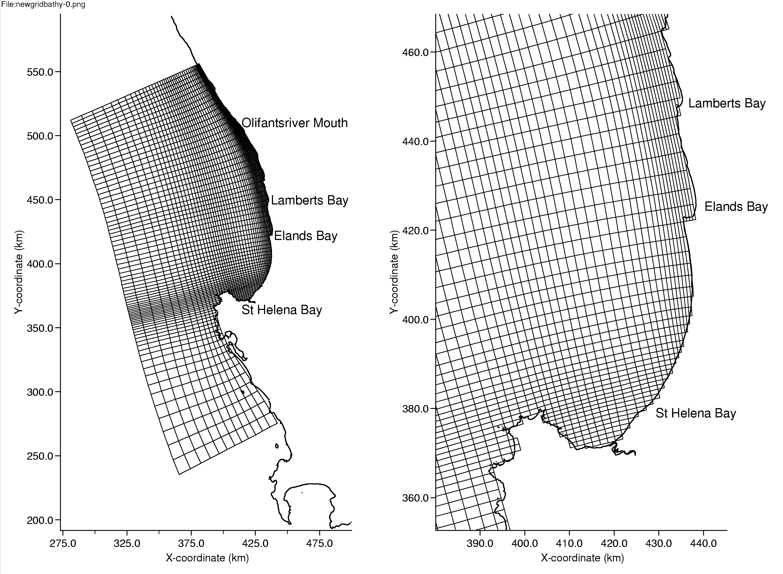

Figure 2-4: Hydrodynamic model grid: Full domain (left) and zoomed into the St Helena Bay area (right).

The x-y coordinate system used in the model is based on the Lo 19 coordinate system. A linear transformation is applied to the digitised SA Navy Chart depths (Section 2.3.1) to provide model coordinates (x_{model}, y_{model}) that are positive and increase from South to North and from West to East. The transformation used is:

x_{model} = 500 000 – y_{lo19}
y_{model} = 4 000 000 – x_{lo19}.

These depths are mapped onto the computational grid by using triangular interpolation as well as grid cell averaging. The resulting bathymetry for the model is shown in Figure 2-5.

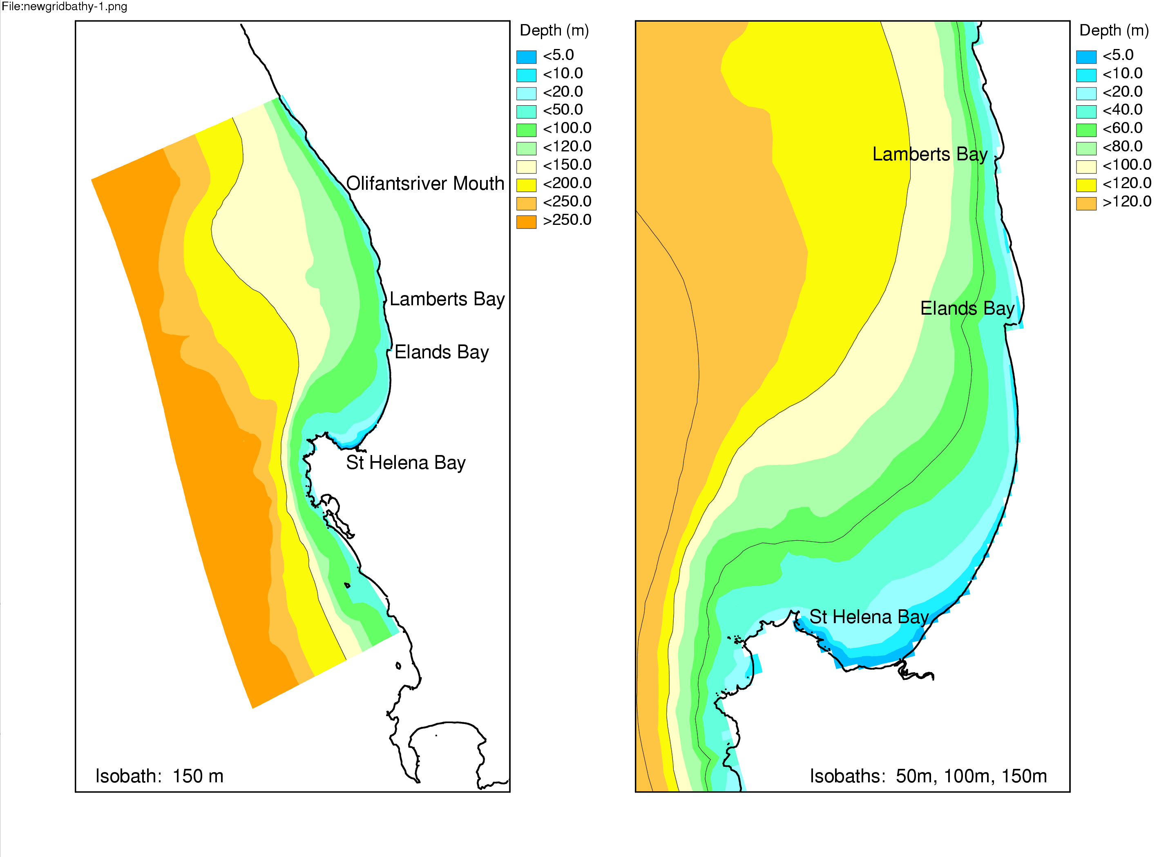
Figure 2-5: Hydrodynamic model bathymetry: Full domain (left) and zoomed into the St Helena Bay area (right).

Boundary conditions – water levels

The open boundaries in the sea are located along the three offshore edges of the model, which are the Southern, Western and Eastern boundaries (Figure 3-6(a)). For the simulations, water level time-series, which are based on the predicted tide, are specified at the open boundaries. The 8 largest amplitude tidal constituents along the West Coast (Saldanha Bay) were applied to predict the tide. The tide is specified in the model at 10 minute time intervals.

Boundary conditions - temperature

The approach for the St Helena Bay model was to specify an initial vertical temperature profile throughout the model domain as well as at the boundaries. Figure 2-6 shows the temperature profile that was chosen as an initial condition. This profile was obtained from Hondeklip Bay data (Monteiro, 1997), as was kept constant throughout the simulation.

Figure 2-6: St Helena Bay Model Temperature Profile: Graph showing the vertical temperature profile that was initially applied throughout the St Helena Bay model domain, as well as at the boundaries.

All model runs used a “cold start” with the flow velocity being zero everywhere. The initial sea level was set to a constant according to the initial tidal sea level specified at the open boundaries.

The relevant model parameters applied in the model are shown in Table 2-1.

Table 2-1: Hydrodynamic model parameters.

Parameter | Value
Timestep | 2 minutes
Horizontal eddy viscosity (V) | 1 m²/s
Bed friction formulation | Chezy
Roughness | 55
Extra drying/flooding procedure | Max
Threshold depth for drying/flooding | 1 m
Wind drag coefficient (C_{d}) | 0.0011 + 0.0065 x U₁₀

Simulation period

The simulation was undertaken for the four month period extending from October 2001 to April 2002. January to April are the months in which red tide occur most often, but the model period started three months earlier in order to obtain proper initial conditions at the beginning of January. In previous simulations the model period started ‘from cold’ in January, and the initial conditions did thus not include the history of the past few months.

Biogeochemical Model Set Up

The biogeochemical model adopted for this study was the D3D-WAQ model (Delft Hydraulics, 2003b), which is capable of integrating the complexity of dynamical variability linked to physics with the core processes that govern the biogeochemistry. It does not include the higher levels of the marine ecosystem (zooplankton, fish, mammals) but their contribution to the oxygen variability is very low even though their sensitivity to the habitat constraints imposed by LOW are high.

The core structural features of the model are depicted in Fig. 2.7 which shows the main model compartments and how they link up. The model deals with primary production (new and regenerated) and the remineralization explicitly. The latter parameterises the heterotrophic activity in both the water column and sediments.

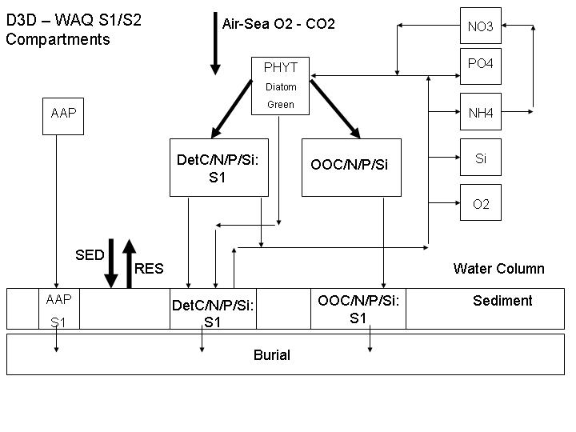
Figure 2.7: The structural characteristics of the D3D-WAQ biogeochemical model.

It deals with particle sedimentation and re-suspension explicitly using user defined critical shear stresses to define thresholds for deposition and re-suspension. The air – sea gas exchange functionality was the Wanninkoff, 1992 formulation which improves on gas exchange rates under high winds by parameterise momentum transfer.

State variables

1 'DetC': | Water Column Detritus Carbon
2 'DetN': | Water Column Detritus Nitrogen
3 'DIAT': | Diatom biomass
4 'NH4': | Ammonium
5 'NO3' | Nitrate
6 'Si' | Silicate
7 'OXY' | Dissolved Oxygen
8 'cTR1' | Conservative Tracer 1
9 'cTR2' | Conservative Tracer 2
10 'cTR3' | Conservative Tracer 3
11 'IM1' | Inorganic Suspended Particle
12 'DetCS1' | Detritus carbon in sediments (Layer 1)
13 'DetNS1' | Detritus nitrogen in sediments (Layer 1)
14 'DiatS1' | Diatoms in sediments
15 'IM1S1' | Inorganic particles in sediments

Processes

- Primary production
  - Light limitation
  - Nutrient limitation
- Phytoplankton mortality
- Light attenuation
- Nutrient uptake
- Re-mineralization (1st order formulation)
  - Water column
  - Sediments
- NH4 uptake preference index
- Sedimentation
- Resuspension
- Air – Sea gas exchange

Input Data

The input data into the biogeochemical model included the following:
- PAR for the simulation period which was extracted from measured solar radiation with the following corrections:
  - Factor 0.45 correction for energy of visible spectrum (PAR)
  - Factor 0.1 correction for albedo
- Wind speed: hourly data set used to drive the air – sea gas exchange for oxygen. Corrected for 10m height readings.
- Process parameters
- Bed shear stresses from water flow in D3D-Flow
- Temperature from D3D-Flow
- Salinity constant 34.8psu

Initial Conditions

The main simulation period was the Jan – Apr 2002 time scale. The initial conditions were set up by running the Oct – Dec period separately and using the final time step output as the initial condition for the Jan - Apr period. This applied to both water column and sediments. Realistic initial conditions were particularly important for the sediment depositional fluxes because that is the part of the signal that carries the memory of the preceding months since the start of the upwelling season.

Boundary Conditions

The approach used in this study was to define a domain that was large enough to allow the variability in the core area of interest (St Helena – Namaqua Shelf) to be largely independent of the boundary conditions. The importance of this kind of approach is not only for modelling reasons but also because it coincides with the generic definition of the system scale: a scale in which the internal fluxes within the system are much larger than the boundary fluxes.

The only boundary condition which posed a degree of uncertainty that needed to be explicitly constrained was dissolved oxygen but this is addressed in the following section under the heading of sensitivity analyses.

Model verification

The model was set up to run over the same period forced by observed winds and solar radiation. Oxygen observations were made 1 – 2 m off the bottom in 25m depth within St Helena bay (Fig.2.1). The time series against which the model outputs were verified covered the first quarter of 2002 (Jan – Apr). These model verification issues are addressed in the context of the results below.

Modelling and Forecasting Hypoxia in the Southern Benguela

The results are presented and discussed under the separate headings hydrodynamics and biogeochemistry. As explained earlier, the hydrodynamic model outputs were used as inputs for the biogeochemical model in so far as they provided the vertical and horizontal transport rates that drive the biogeochemical fluxes.

Hydrodynamic Model results

In order to look at the seasonal behaviour of the model, a comparison of the modelled and measured temperatures at the thermistor chain’s location for the period October to December 2002 and for January to April 2002 is shown in Figs. 3-1(a) and (b) respectively. The temperatures are given at four different depths (Surface, 10 m from the surface, 16 m from the surface, and bottom) in order to illustrate the temperature variations throughout the water column. In this figure, the dotted line represents the measured temperatures and the solid line represents the modelled temperatures. Note that the temperature measurements started a few days after the initialisation of the model simulation.

From the temperatures in Figure 3-1(a) it is immediately evident that the initial temperatures specified in the top layer of the model are too warm, while the initial temperatures in the deeper layers are too cold. Within approximately a month’s time the modelled temperatures start comparing well with the measurements. Overall, the model represents the 6 - 8 day event scale warming and cooling well, although the modelled temperatures seem to be slightly colder than the measured temperatures throughout the water column in November, and slightly warmer than the measurements during December, especially in the deeper layers. The modelled temperatures also show less diurnal variability than the measured temperatures.
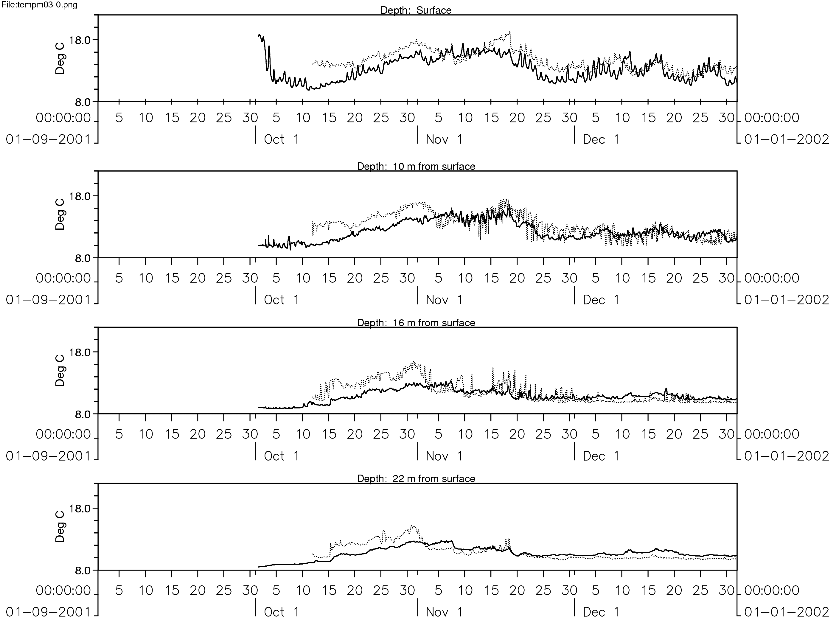

Figure 3-1(a): Comparison between measured (red) and modelled (blue) temperatures at different depths in St Helena Bay for October to December 2002.

For the period January to April 2002 (Figure 3-1(b), the modelled temperatures in the surface layer mostly display colder values than the measured temperatures throughout the water column, becoming warmer than the measurements from late March to end April 2002. In the deeper layers, the modelled temperatures are mostly warmer than the measured values. As seen in Figure 3-1(a), the diurnal variations in temperature are not well represented in the model results throughout the whole water column.

Overall, Figures 3-1(a) - (b) indicate that there is a relatively good concordance between measured and modelled temperatures. In general, the modelled temperatures in St Helena Bay are within 2°C - 3°C of the measured values from November 2001 to April 2002, which were considered sufficiently accurate for the present application.

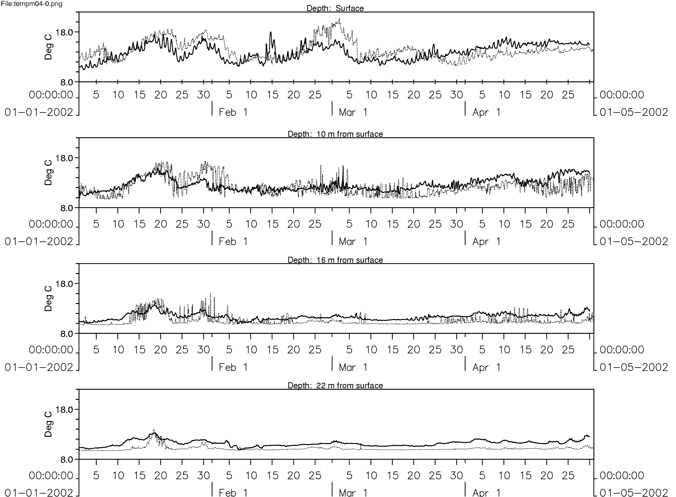

Figure 3-1(b): Comparison between measured (red) and modelled (blue) temperatures at different depths in St Helena Bay for January to April 2002.
In addition to the above figures, Figure 3.2(a) shows modelled surface temperatures and currents in the horizontal plane during an upwelling event (2002/02/12) and a consecutive relaxation event (2002/02/15). Figure 3.2(b) shows vertical sections at Lamberts Bay at the same times. The vertical sections stretch 20 km offshore (up to a maximum depth of approximately 90 m).

In the figures below the upwelling event is clearly visible in the horizontal and the vertical plane. During periods when a southwesterly wind blows, upwelling conditions develop around Cape Columbine and in St Helena Bay (Figure 3-2(a)). At times the wind event is so strong that cold, upwelled water is even noticed in the surface waters all along the coast north of St Helena Bay. The vertical sections in Figures 3-2(b) at Lamberts Bay show cold bottom water moving inshore and entraining towards the surface layers during an upwelling event. During a subsequent relaxation event, the offshore warm water moves inshore, “capping” the colder water and this results in re-stratification of the system.

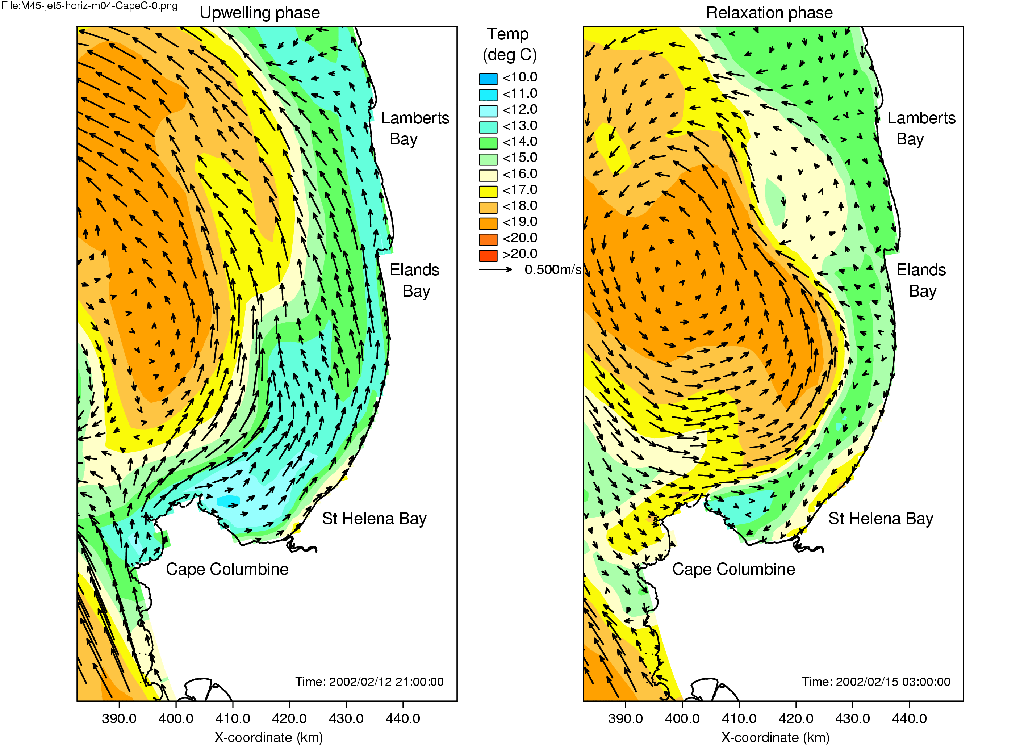
Figure 3-2(a): Modelled surface temperature and currents along the West Coast during an active upwelling (2002/02/12) and consecutive relaxation (2002/02/15) phases.

Note the strong equatorward flow during the active phase and the contrasting anti-cyclonic flow around the pool of warm water.

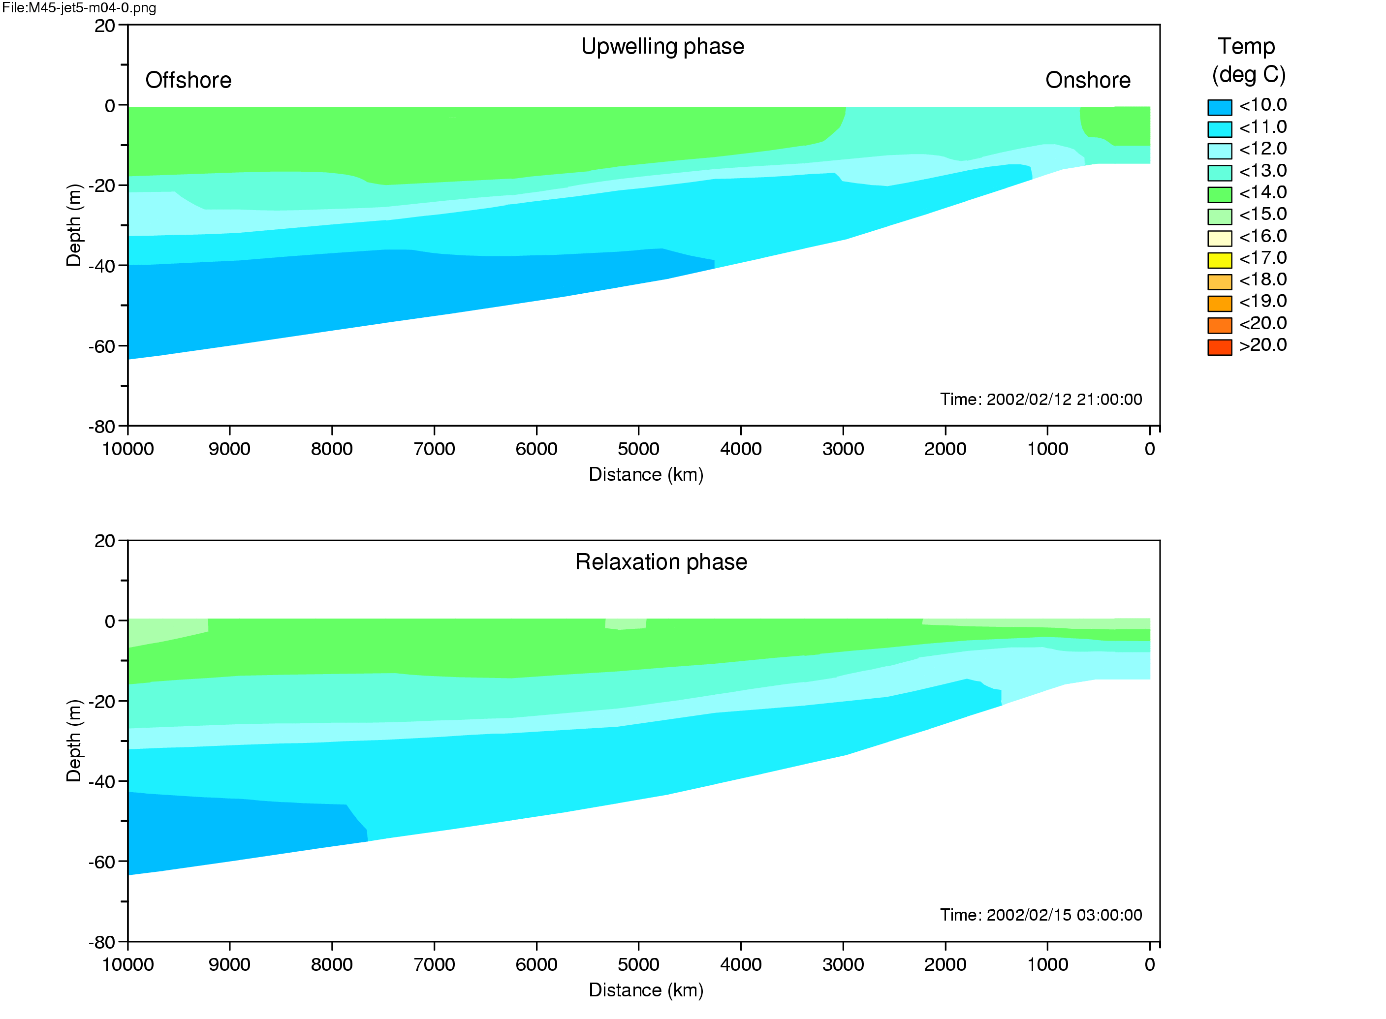
Figure 3-2(b): Modelled vertical temperature section at Lamberts Bay during an upwelling (2002/02/12) and consecutive relaxation (2002/02/15) event.

Setting up a numerical model requires several data sets. Regarding the wind data applied during the model simulation, Figs 2-3(a) – (d) gave a representation of the wind time series during the months of January – April 2002 (the simulation period) measured at Cape Columbine. The wind speed and direction play a key role in the development of upwelling events in the St Helena Bay region. Persistent southwesterly winds are upwelling favourable, while a reversal of the wind direction and lower wind speeds lead to relaxation conditions. During January 2002 the predominant wind direction was southwesterly, with speeds ranging between 2m/s and 10m/s (Figure 2-3(a)). A strong upwelling event was evident around the 24th of January, with a wind speed that reached 12m/s. The winds measured in February 2002 indicated more or less the same trends in wind speed and direction, with a strong upwelling event that stretched from the 3rd of February to the 7th of February (Figure 2-3(b)).

The possibility of using spatially-varying winds in the model simulations must be investigated, but in order to apply such winds in the model, good quality high resolution wind data is thought to be important. There is a need for better wind data, and the solution would be to use output from an atmospheric model, such as MM5.

Another data set that is important for the model simulations are accurate boundary conditions. For the purpose of this study, data measured at Hondeklip Bay was applied at the boundaries (and as initial conditions throughout the model domain), due to a lack of any better data. The use of simplified boundary data could be one of the causes of discrepancies between the measured and modelled temperatures. The most noticeable discrepancy between the measured and modelled temperature time series is that there are instances when the modelled temperatures are often colder than the measured temperatures. This discrepancy between the measured and modelled values can most probably be attributed to the fact that constant wind speed and direction is applied throughout the model domain for the purpose of this simulation; spatially-varying winds are thus not used. As a result, the model does not take account of the wind shadow that exists in the St Helena Bay area due to the presence of Cape Columbine. Larger wind speeds than the actual is thus being applied in the St Helena Bay area, leading to stronger entrainment of cold water into the surface layer, and thus colder temperatures in the model results.

In the vertical (on a seasonal scale), it is important that the model represents the overall behaviour in the vertical temperature structure (i.e. stratification and mixing processes) sufficiently well over the simulation period. The warming and cooling of the water as upwelling-relaxation events take place must be evident.

In Chapter 3, a time series of temperature at different depths in the water column for the seven month simulation period reveal that the model results compare relatively well with the measured results in terms of overall behaviour of the temperature structure. The model performs well in reproducing the seasonal variability in temperature, as well as the event scale variability. The model, however, did not reproduce the diurnal variability in the temperature in the surface layer as clearly as it appears in the measurements. A likely reason for this could be the fact that the modelled temperatures are average values per model layer, and not values at a specific point in depth.

The most possible reason for this discrepancy between the measured and modelled temperatures in the surface layers could once again be attributed to the fact that spatially-varying winds were not applied in the model. As stated before, an additional cause for the discrepancies could also be the static boundary conditions that are being applied in the model. Boundary values taken from data for January 2002 are being applied for the duration of the seven month model simulation (from October 2001 – April 2002).

There were instances when the model results were colder than the measured results; at times, however, the model results were warmer than the measured temperatures. The main differences in the deeper layers are attributed to high frequency inertial period variability in the strong thermocline. The sigma layer model schematization does not resolve the sharpness of the thermocline in the same way as observations so the high frequency variability is weaker.

From the 11th of February to the 14th of February, a relatively strong southwesterly wind persisted (Figure 2-3(b)), leading to upwelling around Cape Columbine. This upwelling event can be clearly seen in the measured temperatures shown in Figure 2-2, as cold bottom water protrude into the surface layers, leading to mixing and the subsequent cooling of the surface waters. Stratification collapses and the water column become mixed. On a spatial scale, the modelled surface temperature on the 12th of February as shown in Figure 3-2(a) indicates cold water around Cape Columbine and in St Helena Bay. In the vertical (Figure 3-2(b)), the cold bottom water has moved inshore and entrains towards the surface layers during the upwelling event.

The upwelling favourable wind dies down from the 14th to the 16th of February (Figure 2-3(b)), leading to a state of relaxation in the whole system. The system re-stratifies as the wind mixing ceases and as sun-warming takes place in the surface layers (Figure 2-2). On a spatial scale, the modelled surface temperature on the 15th of February as shown in Figure 3-2(a) indicates that the surface waters are relatively warm. In the vertical (Figure 3-2(b)), the offshore warm water has moved inshore and has ‘capped’ the colder water, leading to the restratification of the system.

Biogeochemical Model Results

The modelling and observational results used in this study are presented below under the following headings:

- Key Processes and Model verification
- Sensitivity to boundary conditions
- Sensitivity to wind forcing: past climate variability
- Ecosystem model outputs to develop robust forecasting

Key Processes and Model Verification

Temperature and oxygen from the St Helena Bay mooring (2001 – 2002) presented below are the two high resolution time series which offer the most rigorous check on the ability of the St Helena Bay – Namaqua ecosystem model to simulate the complex physical and biogeochemical feedbacks. The model data were extracted from locations in the domain that were spatially comparable to the observed mooring (SouthMidShelf) as well as at near shore sites (ElandBay) for which comparable observed data may not be available (see Fig. 2.1).

Temporal Temperature Variability

The observed and modelled temperature variability at the mooring (surface and bottom layers) are shown in Figs. 3.3 and Figs. 3.4a, b. The latter includes output from both the mooring position (SouthMidShelf) as well as a nearshore site (ElandsBay).

The data from both the mooring site and model show a remarkable coherence in scales of variability over the four month period (Jan – Apr 2002). Of particular importance in respect of oxygen biogeochemistry is the timing of the variability in response to the active and relaxation phases of the upwelling cycle (Monteiro and Largier, 1999; Probyn et al., 2000). The active phases are characterised by equatorward wind driven cooling whereas the relaxation phases by the warming trends resulting from quiescent wind periods. However, whereas the cooling in the bottom layer is driven by the inflow of cold upwelled waters, the surface layer cooling is characterised by wind driven entrainment of cold sub-thermocline waters (Monteiro and Spolander, 1997). This dynamical character in the physics of stratification and of a two layer circulation in the system is a key to the understanding of low oxygen variability as well as the ability to develop reliable forecasting. The data time series shows that the period was characterised by three significant relaxation periods (peaks: 22 Jan, 30 Jan, 3 Mar) and a slow warming through April (Fig. 3.3). The variability is characterised by large amplitude in the surface layer due to the combined effects of solar heat flux and mixing processes. The smaller amplitude in the bottom layer arises primarily by advection. The active cool phases are associated with strong equatorward wind events which entrain cold sub-thermocline waters and rapidly cool the surface layer (Monteiro and Spolander, 1997). These mixing – entrainment events are an important part of the biogeochemical cycle in the sense that they are the dominant mechanism to both deliver nutrients to the euphotic zone as well as oxygen to the hypoxic sub thermocline waters. One of the most important features of the relationship between wind and the nutrient fluxes is its non-linearity reflected in the Richardson number expression for mixing (Eq.3.1) (Pollard, 1973 in Spolander, 1996):

$R_{i}=\frac{{\text{gH}}_{i}\frac{Δρ}{ρ}}{{\left(Δu\right)}^{2}}$ Eq. 3.1

It shows that the vertical entrainment flux reflected by the R_{i} proxy is proportional to v². Two physical processes characterise the temperature variability:

- Mixing and stratification: predominantly surface layer
- Density driven horizontal advection of cold bottom water during the upwelling and relaxation phases: predominantly bottom layer

Figure 3.3: Temperature time series from the surface layer and bottom layer in St Helena Bay (see Fig. 2.1 for location) over the Jan – Apr 2002 period.

It shows the event scale warming and cooling of the surface layer driven by solar heating and wind driven entrainment in the surface layer and the advection controlled
variability in the bottom layer.

The modelled temperature record for the equivalent period and position shows strong coherence with observations across all the scales even though, especially in the bottom layer, it is about 0.5 – 1ºC warmer (Fig. 3.4a,b). The differences are attributed to model boundary conditions (they are fixed), the sigma layer system of the model as well as a residual uncertainty in the transfer of wind energy into water column mixing rates. A further consideration in respect of model limitations is the way it simulates horizontal gradients (fronts). Whereas vertical turbulent diffusion is simulated explicitly (κ-ε turbulence closure scheme), horizontal diffusion is fixed with a value which is determined by the domain resolution (10m²s⁻¹). However, it is not likely that this is a major source of uncertainty at the integrated domain scale but this may not be so at the local scale. Given these considerations, which would have to be addressed in the context of an operational model, the scales of model temperature variability are more than adequate for the purposes of this investigation. In both cases the system stratifies gradually in January. The stratification was disrupted by a strong equatorward wind event on 31 Jan - 2 Feb which rapidly weakened stratification until 6 February. The system then stratified over the month of February at rates which differed according to the finer scales of warm surface water advection and seasonal heating. The time series show that the February warming came earlier in the model than in the data possibly because of small differences in advective effects linked to the retention circulation. A second strong wind event weakened stratification again in mid March. The gradual warming in April reflects the effect of a decreasing solar heat flux in the autumn (Spolander, 1996).

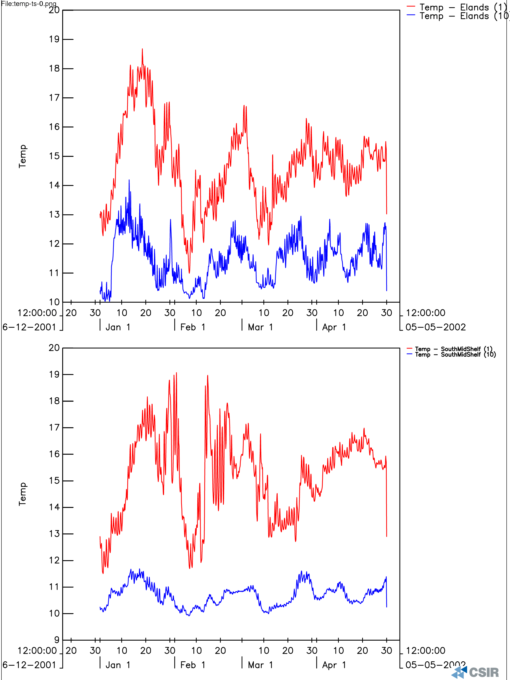

Figure 3.4: Modelled temperature time series at two sites (Elands Bay: nearshore and SouthMidShelf in the core of the retention area) in the St Helena Bay – Namaqua system.

The latter site corresponds to the observational site (Fig. 3.3).

Figure 3.5a,b: Time series comparing the variability of stratification (T_{surface} – T_{bottom}) between modelled (top) and observed (bottom) data.

It confirms that although there is some event scale differences in the magnitudes, the timing between the two is largely coherent. Stronger advective processes explain the apparent differences in mid-Feb.

The coherence of the observed and modelled systems is also highlighted by the plotted temperature difference between the surface and bottom layers (Fig. 3.5a, b). The modelled and observed data sets agree at the synoptic scale and particularly in the magnitude and timing of the temperature events. The modelled data anticipates the relaxation phase in February and the April warming runs 1 – 2ºC warmer than the data. Whereas the former is likely to be due to very localised advective effects related to residual warm surface water the latter is thought to be related to subtle shifts in the way the model deals with the heat balance in the upper and lower water column. These plots provide an indication that the model is getting the timing of events and the response of stratification correct to at least a first order. This is important because understanding the evolution of low oxygen in this system depends on the variability in stratification at all the scales (daily – seasonal).

Temporal Oxygen Variability

Oxygen variability reflects the more complex combined interactions on the vertical and horizontal scales: physically controlled air – sea flux, biogeochemical production and re-mineralization cycles and advection. These processes are occurring over a wide range of scales (daily – seasonal) where their phasing may differ but the seasonal trends are governed by the cumulative interaction of all these scales.

The observational time series is characterised by periods of anoxia (O₂ < 0.5mll⁻¹) and periods of relative hypoxia (O₂ > 0.5mll⁻¹) which correspond closely to the synoptic scale variability of temperature (Fig.3.6a). Two dominant fluxes determine the O₂ variability in the bottom layer; the biogeochemical sink driven by the remineralization of Particulate Organic Carbon (POC) in the sediments and the source driven by the physically forced turbulent mixing vertical flux and to a lesser extent horizontal advection. Overall, in periods of increasing stratification (relaxation phase) biogeochemical sink flux exceeds the source flux and the dissolved oxygen concentration decreases. Alternatively, during the active phase when wind induced mixing is strong, the physical source exceeds the biogeochemical sink and oxygen concentrations increase. The only anomaly in this series is the oxygen increase linked to the warming event on 18th Jan (Fig.3.6a). The explanation is that when a relaxation event is sufficiently large the increase in oxygen is not driven by the vertical mixing flux but by a horizontal advective flux. This horizontal flux is the result of the retreat of cold water out of the system and it replacement by warm and better aerated water from the upper layers (Monteiro and Largier, 1999).

Figures 3.6a,b: The variability of dissolved oxygen from observed (top: a) and modelled data (bottom: b) at the same site in the St Helena – Namaqua system.

The strong coherence in the event – seasonal scale variability supports the robustness of the model outputs.

The variability of modelled oxygen concentration variability was remarkably coherent with the observed one at the synoptic scale (Fig. 3.6b). The overall decreasing trend over the four month period in the data is reflected in the model results as are the responses to the event scale relaxation and active phases of the upwelling cycle. Of greatest significance is the model’s prediction of the events when the system switched into anoxia (O₂ < 0.5mll⁻¹) for short periods (30/1 – 5/2), (25/2 – 2/3) and the protracted anoxia over the month of April 2002. The early February and March events were the ones that led to significant rock lobster walkouts between Eland’s Bay and Dwarskersbos within the St Helena Bay system (Cockroft, Pers.Com. 2005).

The overall seasonal trend of decreasing oxygen concentrations in the benthic boundary layer reflects the combined effects of processes occurring over scales that vary from daily (new production; diurnal winds) to synoptic (stratification and advection). The robustness of the seasonal trend provides a degree of confidence about the degree of complexity in the model as well as the time and space resolution of its processes. The seasonal trend reflects the combined effects of accumulating production which increases the biogeochemical oxygen demand off the sediments and the evolution of stratification from an initial alternating states of strong and weak gradients to a state where the variability is absent (April) (Fig. 3.5a,b). This emphasises that the magnitude of the oxygen variability is strongly coupled with the phased nature of the active and relaxation periods of the upwelling cycle rather than just the wind stress. There is a critical time scale for both phases and for a typical active phase of 3 – 5 days, the longer the relaxation phase the deeper the anoxic state. This upper limit for the relaxation period such that anoxia is maximised is likely to be 10 – 15 days, the time scale for the complete consumption of the most labile fraction of the POC.

Spatial - Temporal Variability

The variability of temperature, ecosystem production rates and oxygen in both time and space (2DV – vertical and 2DH – horizontal) scales over an upwelling cycle (28/1 – 11/2) (Fig. 3.7) are summarised in the Figs (3.8a-h – 3.10a-h). In each case the selected series of model outputs correspond to each other in time and space making it possible to draw comparative analyses of the results. The temporal scale of all data sets is 28/1 – 11/2 with sampling at 14:00 on the following specific days: 28/1; 30/1; 1/2; 3/2; 5/2; 7/2; 9/2; 11/2. The temporal scale spans the phases of an upwelling cycle in the late summer and covers a period (30/1 – 1/2) during which there was a low oxygen event in the system, which resulted in a significant mortality of rock lobster (). In all cases the model plot pairs depict the vertical scale along a line immediately south of Elands bay and the horizontal scale depicts the surface layer (Model Layer 1) except in the case of oxygen where it depicts the bottom layer (Model Layer 10).

Figure 3.7: The observed temperature variability at the mooring site for the surface and bottom layers. It shows the period (28/1 – 11/2) covered by the ensuing spatial – temporal plots below.

The period starts at the peak of a relaxation event (maximum stratification) 28/1 – 30/1 which was terminated by a strong equatorward wind mixing event 31/1 – 6/2, which through deep mixing and entrainment weakened stratification and cooled the surface layer temperatures. This was followed by and a gradual relaxation period (7/2 – 11/2) (Fig.3.7). During the relaxation period two important circulation features develop which have a bearing in the event scale variability of oxygen in both the deep offshore and shallow near shore environments:

- The anti cyclonic gyre which intensifies the retention and warming character of the surface water (see Fig. 3.2).
- The narrow near shore poleward flow

The temperature series (Figs.3.8a-h) provides a view of how the system behaved over the selected upwelling cycle in the vertical and horizontal scales. The dynamical characters of the physical processes form an important basis to understand the biogeochemical responses and variability. The first two images (Fig.3.8a,b) show the temperature structure during the initial relaxation phase (28 – 30 Jan). They show that the 15ºC isotherm (characterises the thermocline) lies deeper than 15m although the overall upwelling baroclinic cross shelf gradient is maintained. The temperature section on 30 Jan shows the reversal of the baroclinic gradient close to shore which is associated with the narrow poleward flow which occurs during relaxation phase of the upwelling cycle. Overall this period was characterised by strong stratification especially in the central core of the domain and residual cool water from the previous upwelling cycle along the land boundary and the Cape Columbine upwelling plume (Fig.3.8a,b). The latter can be seen as cool water “plume” separating the warm water inside St Helena Bay and the warm water on the shelf.

The strong equatorward wind event which began on 31 Jan rapidly raised the thermocline in the near shore region and began intensifying the cold water signal from the Columbine plume (Fig.3.6c,d). The 15ºC isotherm shoals to < 5m (Fig.3.8c). By 3 Feb the cold ( < 14ºC) upwelled water has outcropped in the near shore region, the Columbine plume cools further as newly upwelled water mixes in but the Bay core remains warm and stratified. The stratified core begins to cool through mixing and entrainment by 4 March and on 5th the upper mixed layer has cooled by 2 – 4ºC (cf. Figs.3.8d and e). Persistent albeit lighter wind stress outcrops the Columbine upwelled water plume and the warm stratified water core of the Bay is contained between two bodies of newly upwelled water: the Columbine plume and the eastern boundary upwelled water strip (Fig.3.8f). The next relaxation phase of the upwelling cycle begins to impact on the bay characteristics on 9th (Fig. 3.8g). At this stage the water column within the bay is defined by very strong frontal structures linked to the cold water on either side of the warm water core. This strengthens the baroclinic anti-cyclonic circulation. This effect is further strengthened on 11th and with reduced wind mixing the surface water core begins to gradually warm and expand again (Fig. 3.8h).

Summary

To summarise the key physical scales that characterise the event scale:
- The upwelling cycle comprises two alternating phases which are essential for the development of seasonal and event scale hypoxia in the southern Benguela: the active phase and the relaxation phase.
- Relaxation phase: equatorward wind weakens; thermocline strengthens because of surface warming resulting from reduced cold water entrainment.
- Active Phase 1: the first part of the active phase is governed by advective scales and results in inshore flows of the sub-thermocline layer and equatorward flows in the surface layer (1 – 2 days)
- Active Phase 2: the second part of the active phase is characterised by increasing importance of vertical mixing processes which transport cold sub-thermocline waters into the surface layer and cool it.
- On a seasonal scale both the intensity and duration of each of these phases can vary significantly and in so doing modulate the ecosystem production and the hypoxia variability across all time and space scales.

Figures 3.8a-h: Vertical and Horizontal sections of temperature over the period:
28/1 – 11/2.

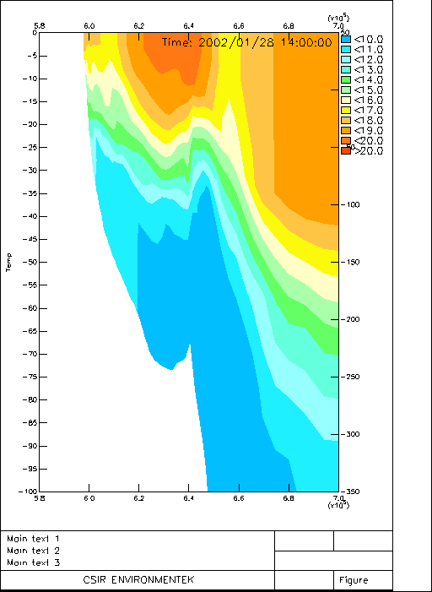 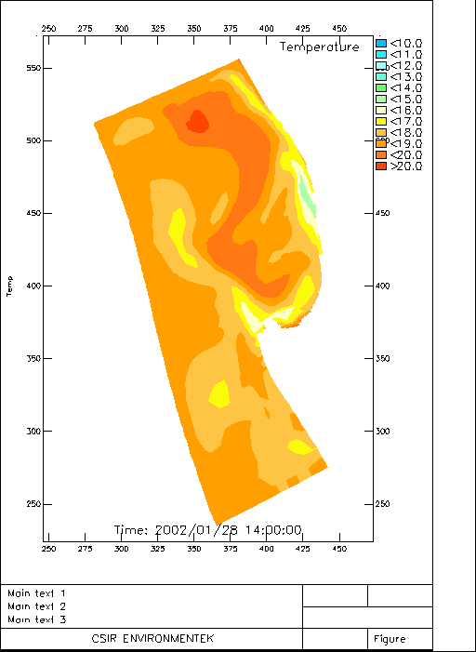Fig. 3.8a: 28-Jan

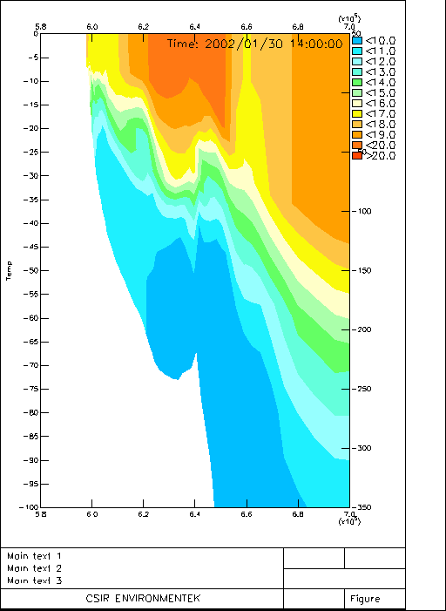 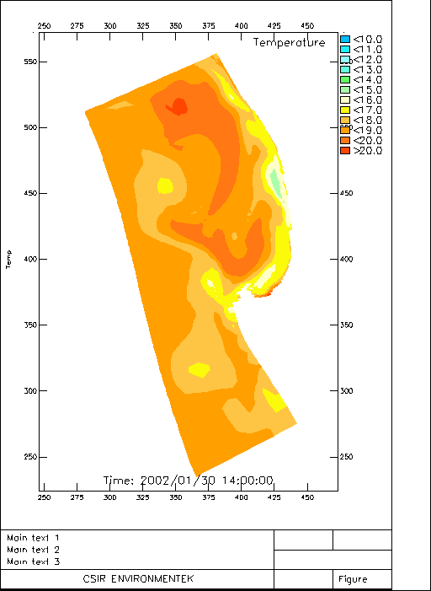Fig. 3.8b: 30-Jan
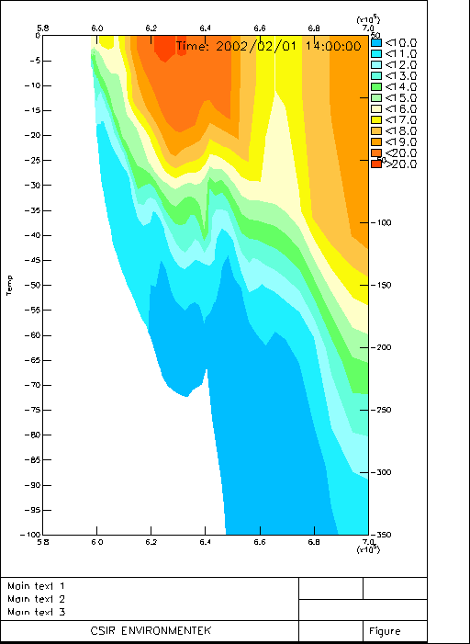 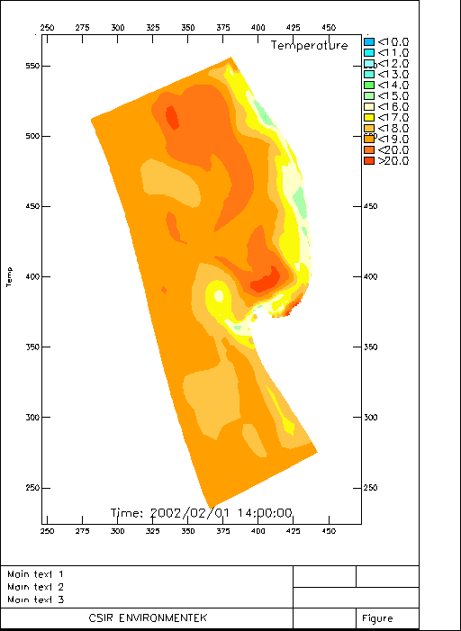Fig. 3.8c: 01-Feb

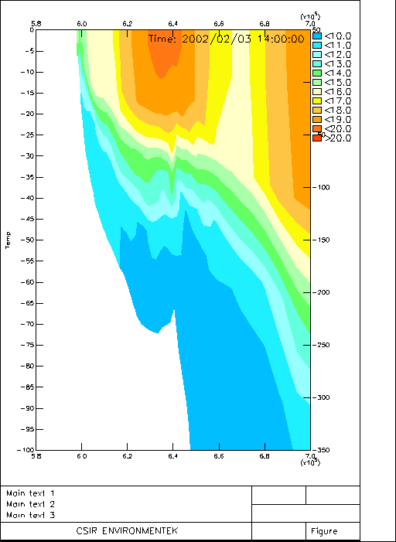 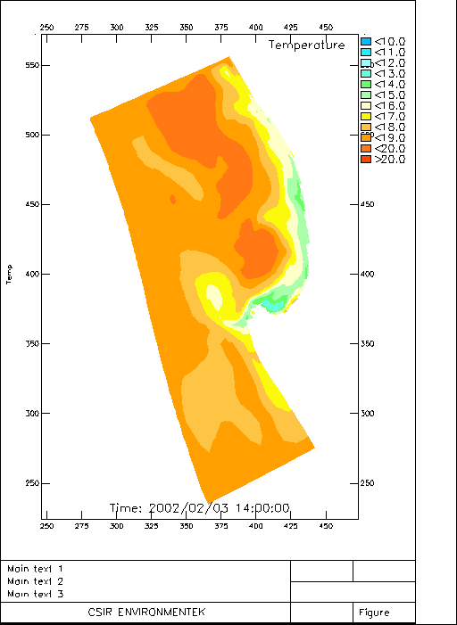 Fig. 3.8d: 03-Feb
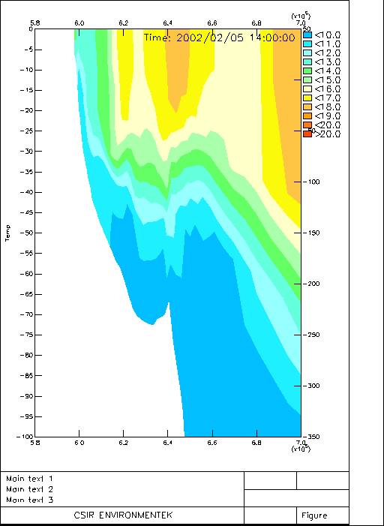 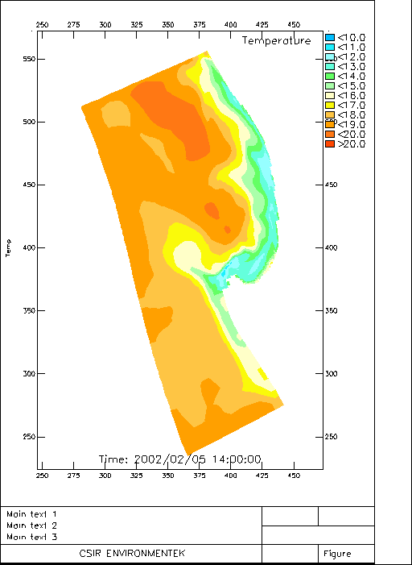 Fig. 3.8e: 05-Feb

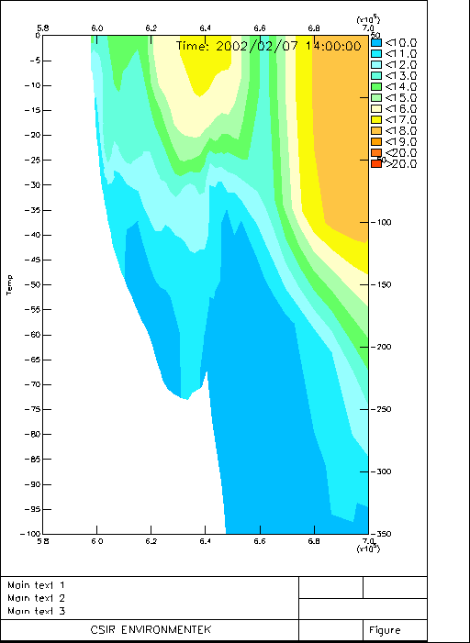 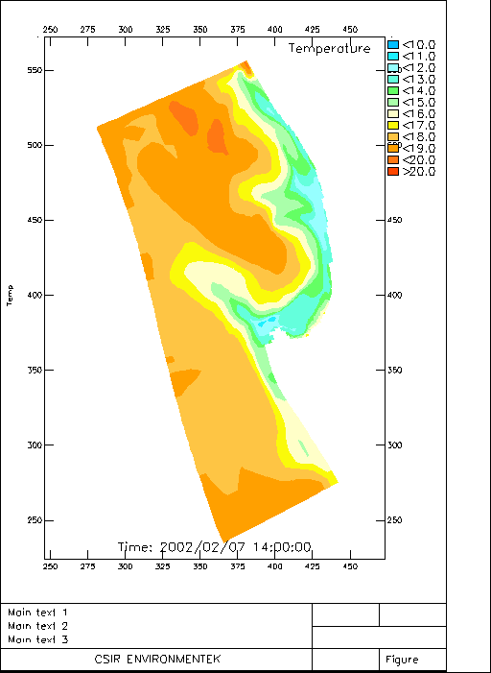 Fig. 3.8f: 07-Feb
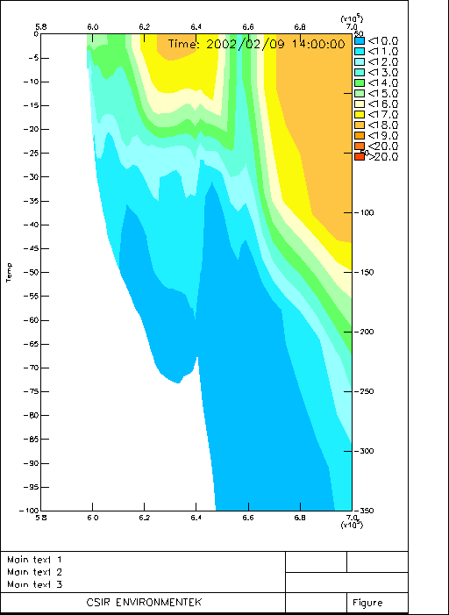 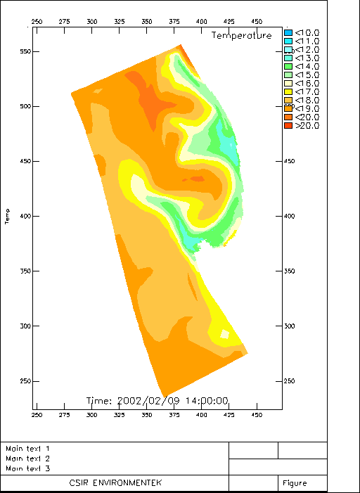Fig. 3.8g: 09-Feb

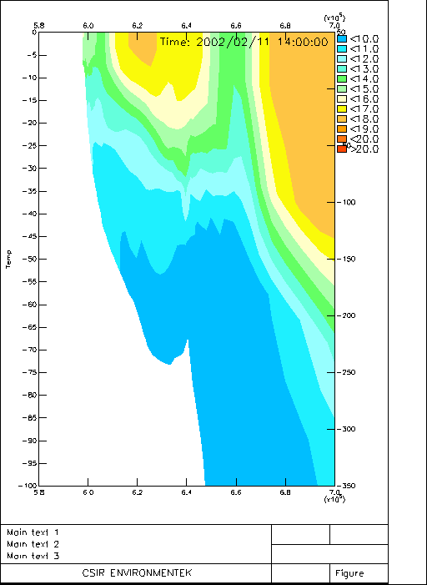 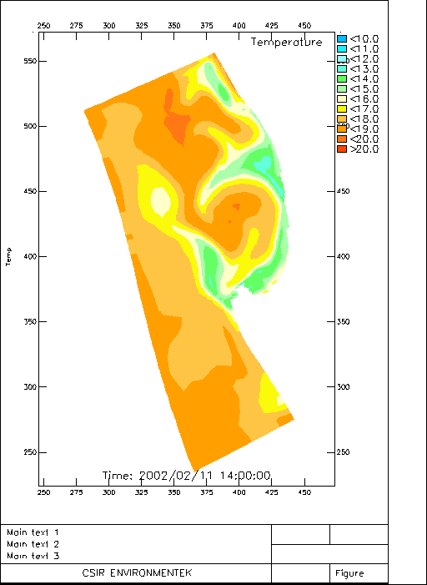 Fig. 3.8h: 11-Feb

Variability of Primary Production

Primary production in the Namaqua – St Helena Bay system is nutrient limited and its variability over an upwelling cycle follows the dynamics of this constraint closely. Three physically driven fluxes of nutrients govern primary production in the system:
- Outcropping of upwelled water at the eastern boundary and Columbine plume
- Turbulent mixing and entrainment across the thermocline in the retention zone
- Lateral turbulent horizontal diffusion across fronts linked to the Columbine plume and the one linked to the inshore upwelling.

During the initial relaxation phase, characterised by strong stratification, productivity is constrained largely to turbulent mixing across the thermal gradients (thermocline and fronts) and to a lesser extent in the Columbine plume where it is lower due to decreased nutrient flux and deeper mixing in the barotropic part of the system (Fig.3.9a). Production is therefore largely restricted to a sub-surface maximum where the minimum requirements of both light and nutrients are met. Nutrient fluxes are low and the Nitrogen (NO₃) is consumed in the vicinity of the thermocline as it enters the euphotic zone. Surface production is limited to a narrow inshore zone and the residual of the Columbine plume where vertical structure is weak. The reduced nutrient flux results in an increased sedimentation flux of senescent phytoplankton biomass which drives the export of POC into the sub-thermocline waters and sediments.

As the system shifts to the active phase the spatial and temporal characteristics of productivity develop in accordance to the dominance initially of advective scales (Figs. 3.9b-d) and subsequently vertical mixing (Figs. 3.9e,f). The horizontal advection of nutrients linked to the uplift of the thermocline and its outcropping near shore increases the new production fluxes in the near shore area (Fig. 3.9b-d). The spatial scale of this increased new production expands both along shore and offshore through displacement of the upwelling front and horizontal dispersion across the front. Increases advection and outcropping linked to the Columbine plume enhances the productivity response linked to that feature and its boundaries (Fig. 3.9d). As the vertical transport scales begin to dominate, primary production activity expands over the whole stratified retention zone (Figs. 3.9e,f). At this stage the new production fluxes reach a peak as all three production domains are active until the equatorward wind weakens and the system enters the next relaxation phase (Figs. 3.9g,h). The onset of relaxation is linked to increased stratification and reduced nitrogen fluxes which drives a bloom collapse first in the retention core domain and subsequently in the near shore zone and finally in the Columbine plume domain. New production fluxes are then once again reduced to a minimal level associated with a sub-surface bloom in the upper levels of the thermocline. The pulse of POC linked to the onset of the relaxation phase is a key element in the deepening of hypoxia / anoxia as stratification strengthens and reduces the vertical downward flux of oxygen from the surface layer.

Figures 3.9a-h: Vertical and horizontal sections of phytoplankton production rates for the period 28/1 – 11/2.

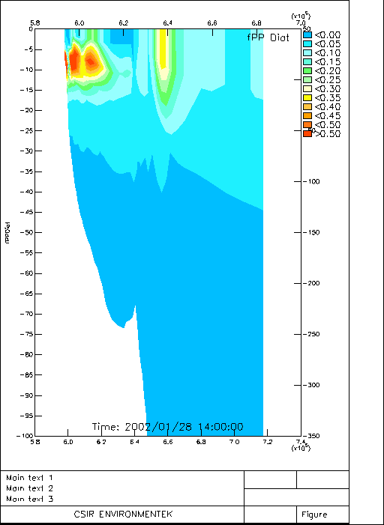 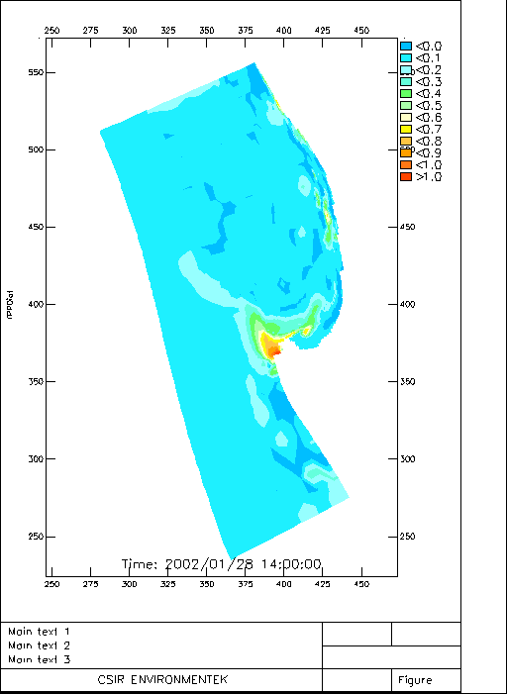Figs. 3.9a

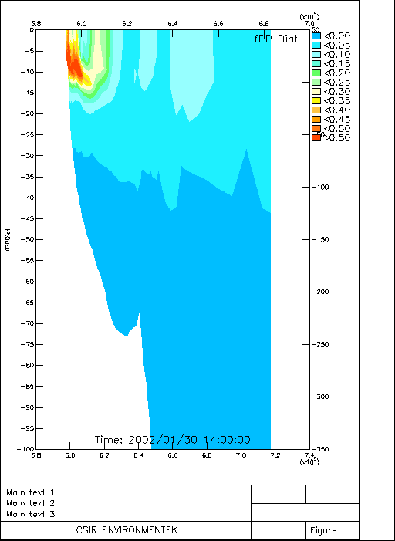 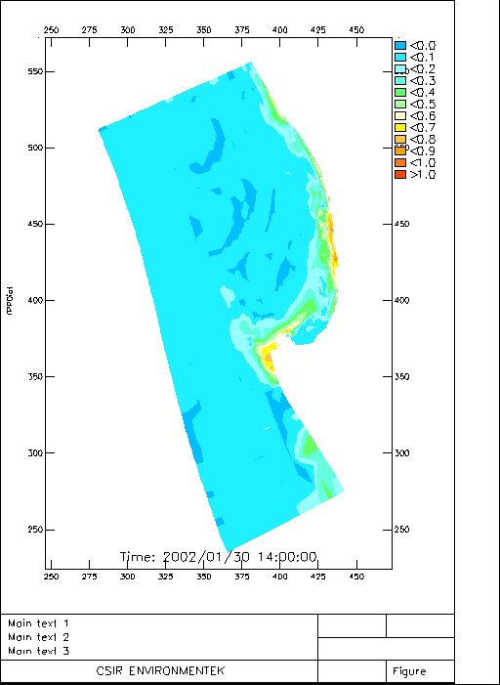 Figs. 3.9b

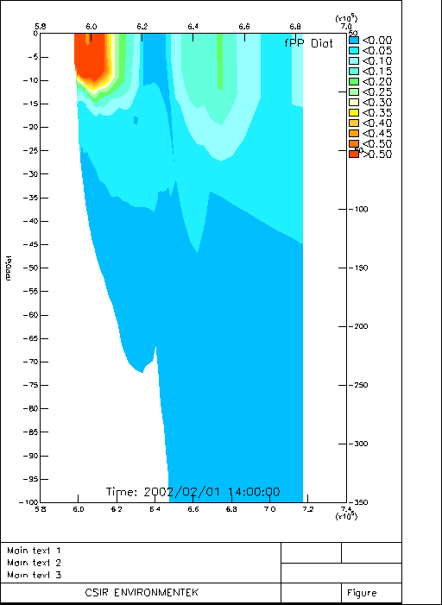 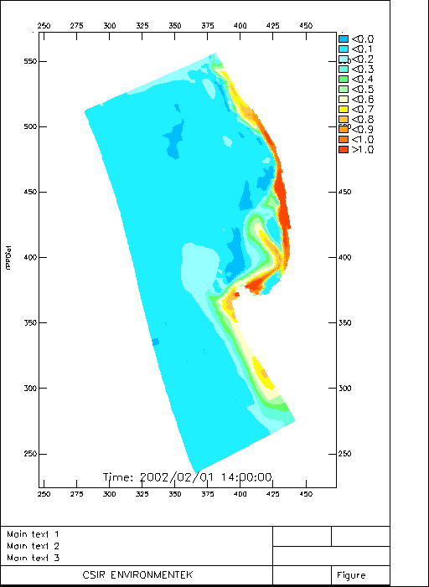 Figs. 3.9c

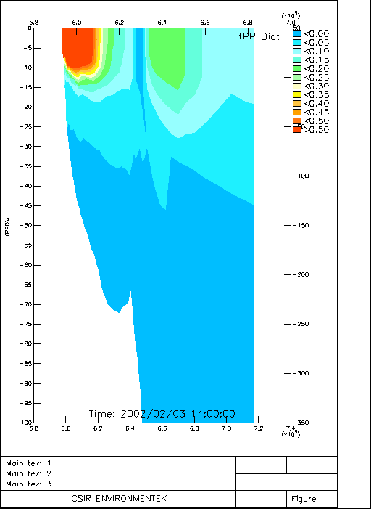 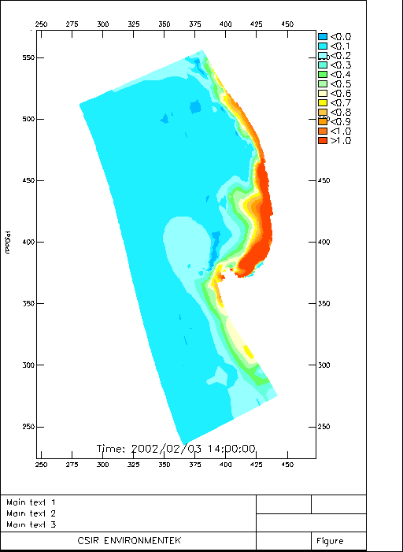 Figs. 3.9d

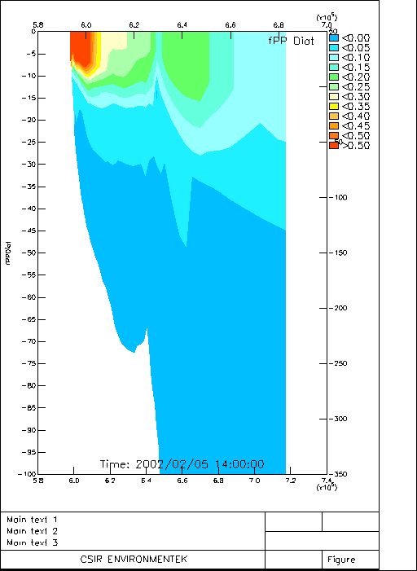 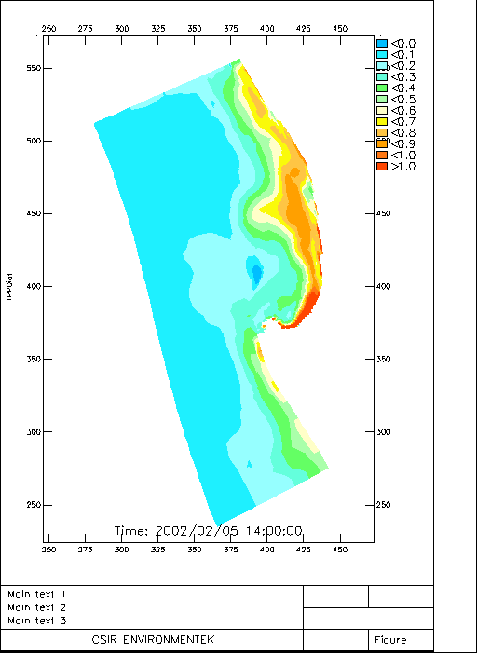 Figs. 3.9e

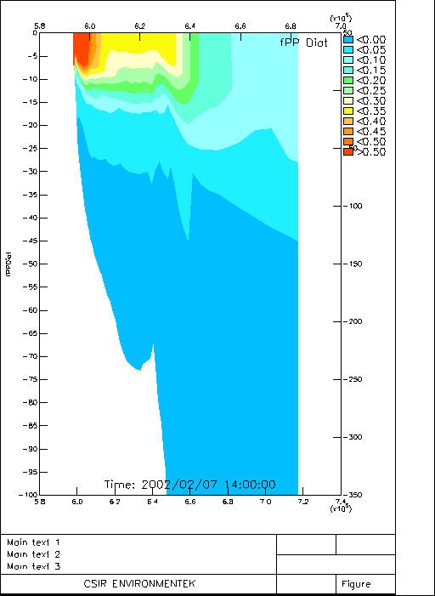 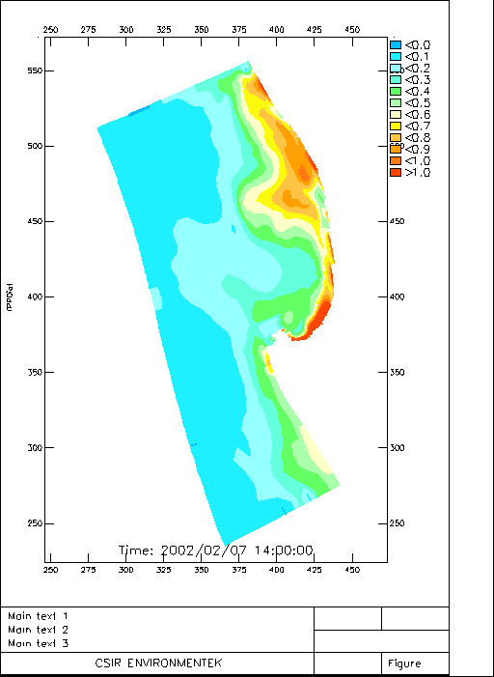 Figs. 3.9f

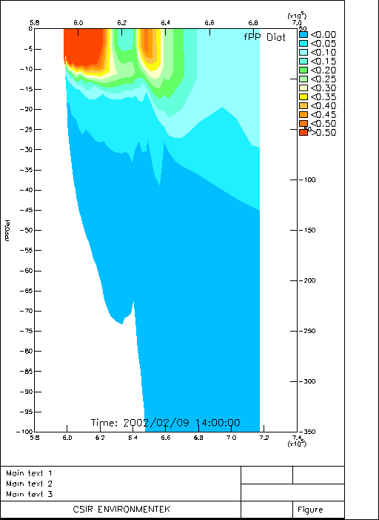 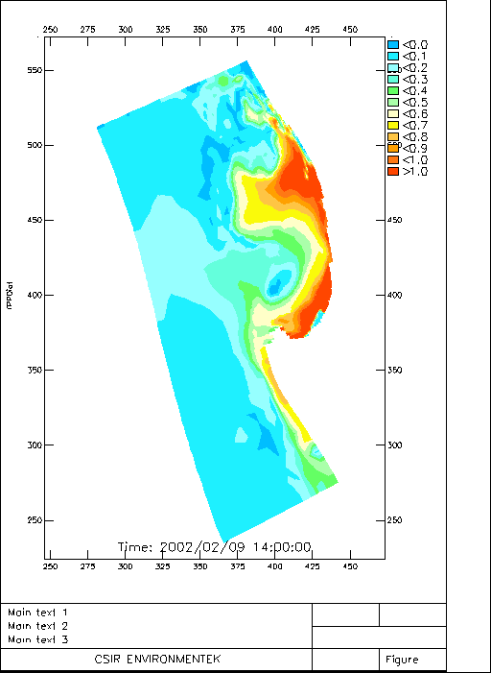 Figs. 3.9g

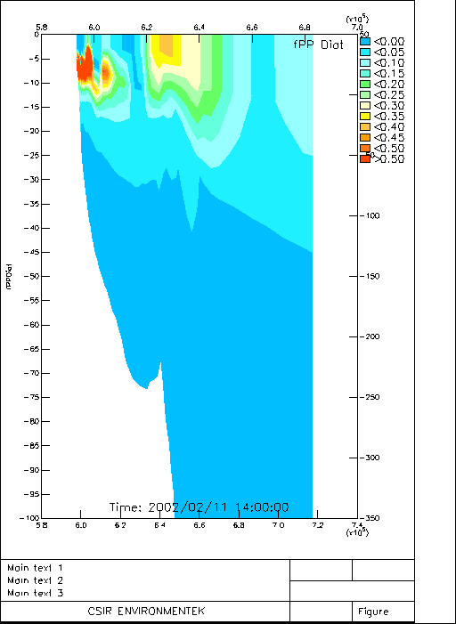 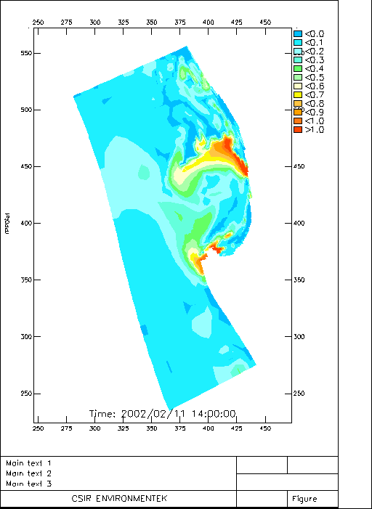 Figs. 3.9h

Oxygen Variability

Oxygen variability in the sub-thermocline waters of the Namaqua-St Helena system is governed by the balance between biologically (remineralization) driven demand and physical supply through turbulent diffusion on the vertical scale. The demand is governed by the spatial and temporal characteristics of new production fluxes and their bottom deposition while the supply is through dynamical characteristics of wind stress and stratification that together govern the rate of ventilation across the thermocline. Overall, physical dynamics govern the processes because wind driven upwelling drives the nutrient fluxes that modulate the biogeochemistry. The time lags between the quicker advection response to wind changes and the slower mixing and entrainment also play a key role in the spatial and temporal scales of variability. The rates of lateral advection in the active phase are initially greater than the rate of ventilation across the thermocline. This means that LOW formed by the combination of residual POC flux and stratification, strengthened during the relaxation phase, is initially advected towards the shallow waters at a much faster rate than the rate at which it is ventilated by the strong upwelling winds.

The sea bed POC depositional area where the main oxygen demand is concentrated is constrained by both the spatial extent of the surface carbon export production fluxes and the sea bed turbulence. The latter combines the effect of currents and wave induced turbulence. In this study, the effect of wave driven turbulence is absent which has a small impact is inshore area where oxygen demand is higher in the model. However this is a shallow area where stratification is weak and physical vertical gas transport rates are high so the effect is not of significance but would need to be addressed as part of any future operational plans. Of greatest importance are the temporal characteristics of the active upwelling (new production processes) and the relaxation (net oxygen demand) phases. These are defined by the following cumulative scales:
Diurnal scale (hours)
Event scale (days)
Seasonal scale (weeks – months)

These scales, which were discussed earlier in the time series plots, are now expanded to include integrated spatial and temporal scales of the relaxation and active phases of the upwelling cycle.

Initial Relaxation Phase 28 – 30 Jan

During this phase when equatorward wind stress is reduced and stratification intensifies, two important processes drive the deepening of sub-thermocline hypoxia:
- Increased stratification reduces the physical turbulent diffusion vertical flux of oxygen across the thermocline
- The same physical constraint limits nutrient flux to the euphotic zone that generates a strong sedimentation pulse of export particulate organic carbon (POC) as the previously active blooms collapse first through nutrient then light limitation.

The outcome is an expansion of the anoxic near bottom water column domain both in the vertical and horizontal scales while the narrow near shore domain remains well aerated (Figs. 3.10a,b). This is a phase during which oxygen demand from the sediments exceeds physical supply from the water column below the thermocline. This leads to a rapid deepening off the bottom of the hypoxic water body in a vertical scale (Figs. 3.10a,b). During the relaxation phase the thermocline lies deeper (> 10m) which creates a contrasting well oxygenated near shore benthic habitat with relatively warm surface layer water. The horizontal spatial extent of the sub-thermocline hypoxic / anoxic (O₂ < 1mll⁻¹) water body is governed by the dynamical character of the boundary where the physical supply of oxygen in advected water (3 – 4 mgl⁻¹) is balanced by the local biogeochemical demand (Fig. 3.10a,b).

Active Phase 31 Jan – 7 Feb

The active phase is defined by the strengthening of the equatorward wind stress (31/1 – 5/2) (Figs. 3.10d-f). As was the case with the temperature variability, the effect of this phase on the spatial characteristics of LOW develops over two stages:

1: initially, changes in the spatial characteristics are dominated by advective scales and the important result is the rapid shoaling of the well developed sub-thermocline LOW body towards the shore to a depth < 5m. This is clearly depicted in the period 1/2 - 3/2 where the narrow inshore aerated zone is reduced or completely absent (Figs. 3.10b,c).

2: the second stage, which emerges in the period 5/2 – 7/2, is the impact of vertical mixing on the spatial scale characteristics of the sub-thermocline hypoxia / anoxia. Wind mixing weakens the thermocline through entrainment of cold water into the surface layer, thus cooling it and increases the rate of vertical turbulent transport of oxygen into the sub-thermocline domain. The net effect is the re-aeration of the near shore (< 5m) and a short term weakening of the seasonal sub-thermocline low oxygen domain in the retention area (Figs. 3.10d-f).

Second Relaxation Phase: 9 – 11 Feb

The weakening of the wind stress and their shift to a poleward quadrant repeats the outcomes described earlier for the relaxation phase. The thermocline deepens in the near shore zone and reduces the turbulent mixing energy which enables the surface layer to warm and strengthen the stratification. This is depicted in the period 9/2 – 11/2 (Figs. 3.10g,h). The outcome is as before: the development of a well aerated near shore domain and the expansion of the seasonal sub-thermocline low oxygen domain in both the horizontal and vertical scales (Figs. 3.10g,h).

Figures 3.10a-h: Vertical and horizontal sections for dissolved oxygen for the period 28/1 – 11/2.

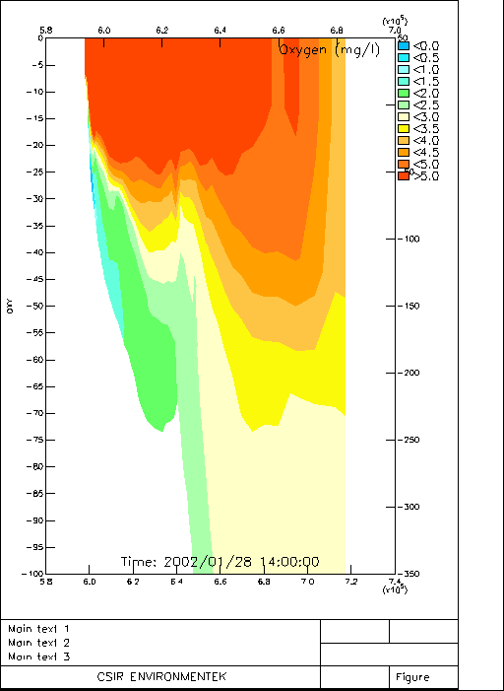 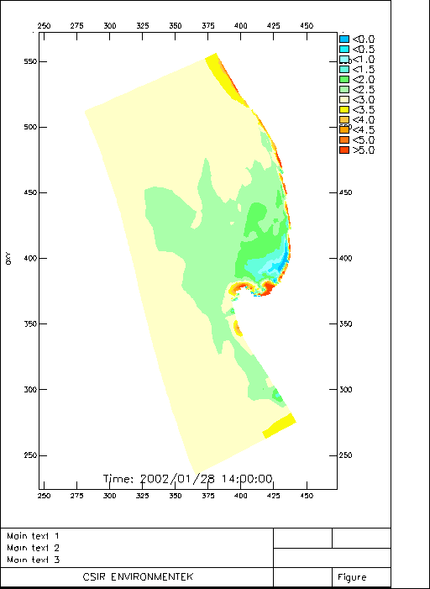 Figs. 3.10a

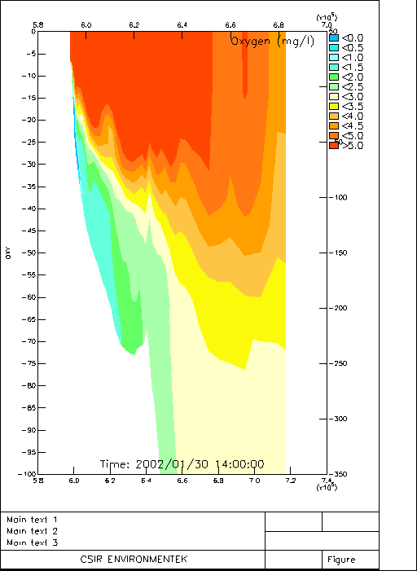 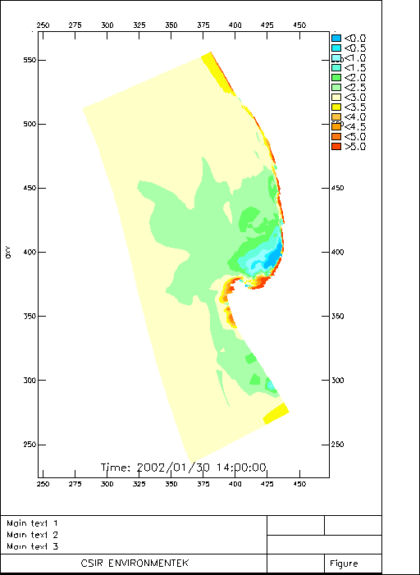 Figs. 3.10b
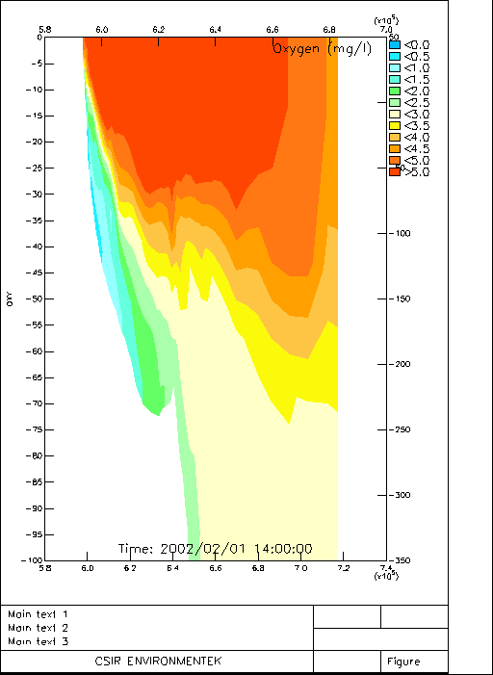 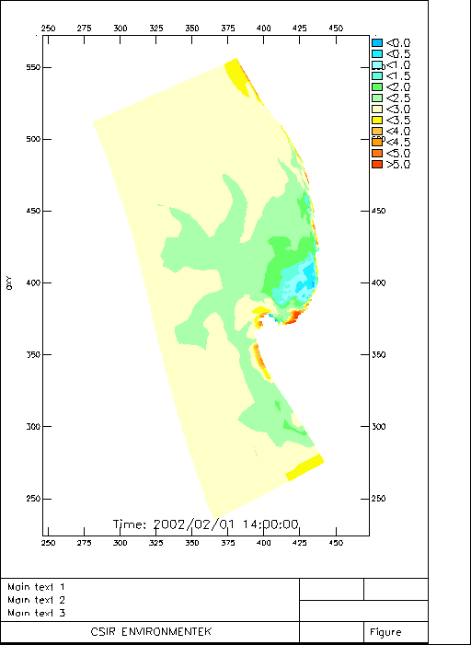 Figs. 3.10c

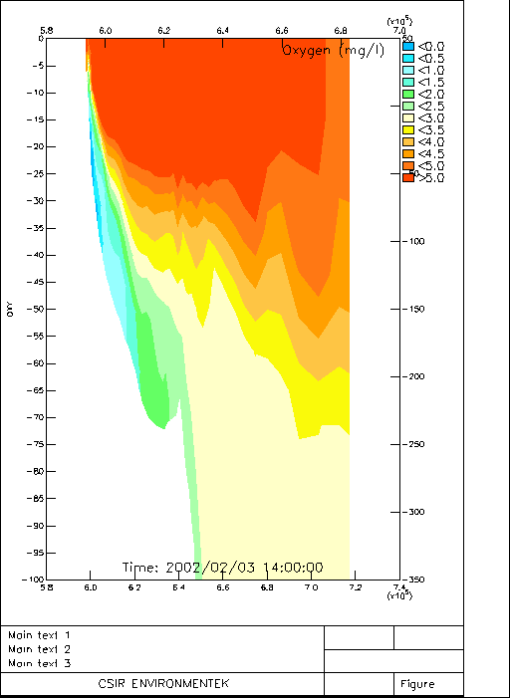 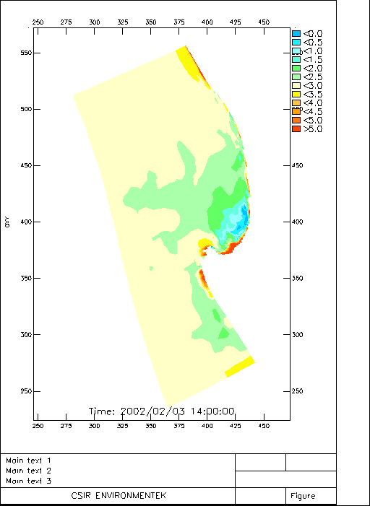 Figs. 3.10d
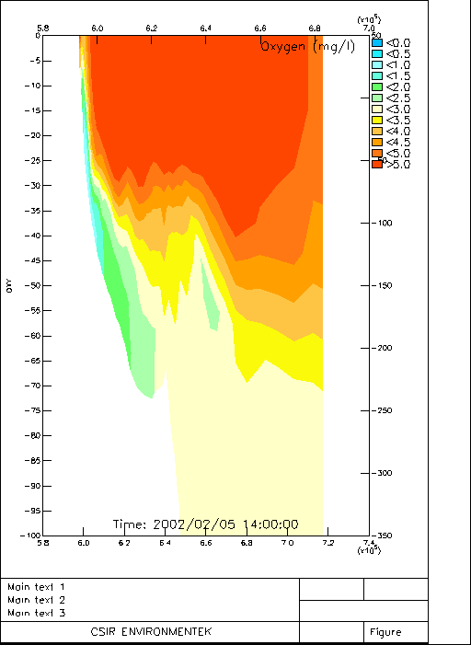 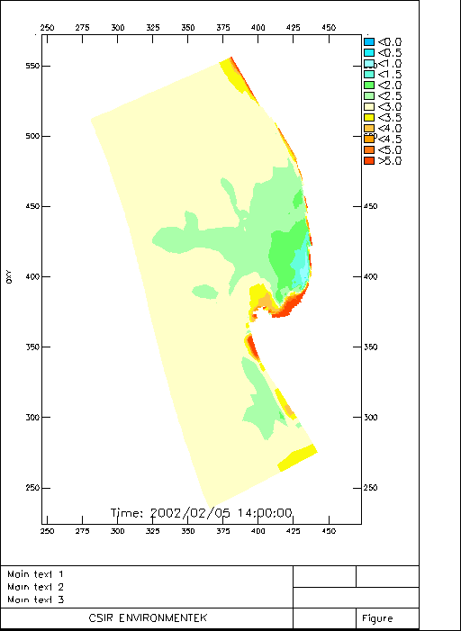 Figs. 3.10e

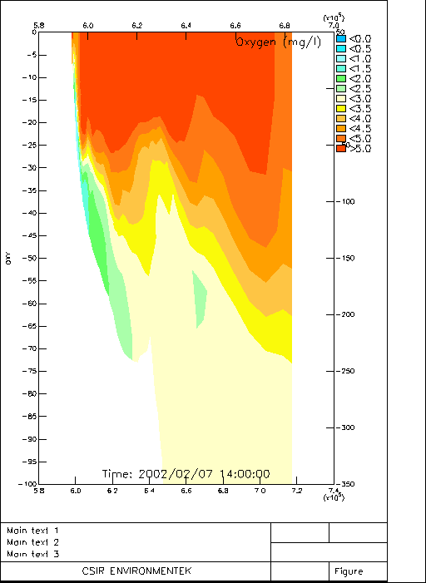 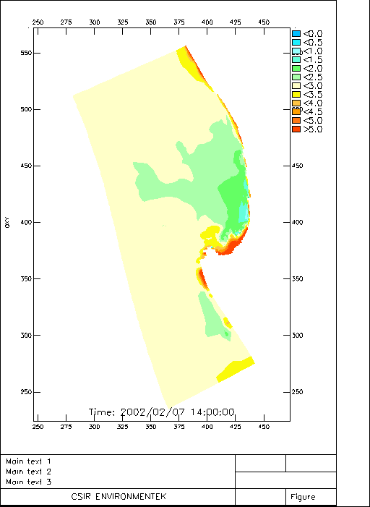 Figs. 3.10f

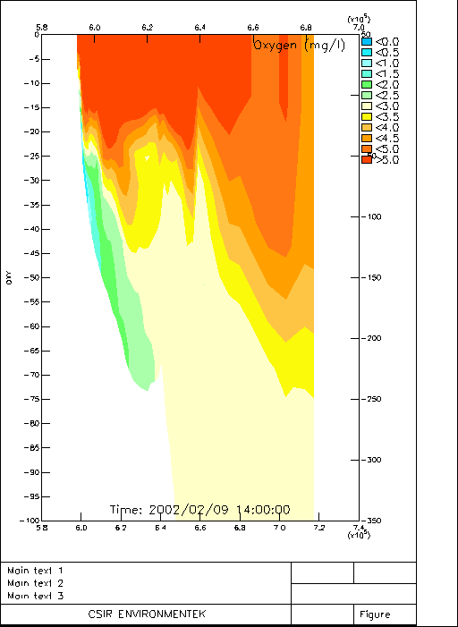 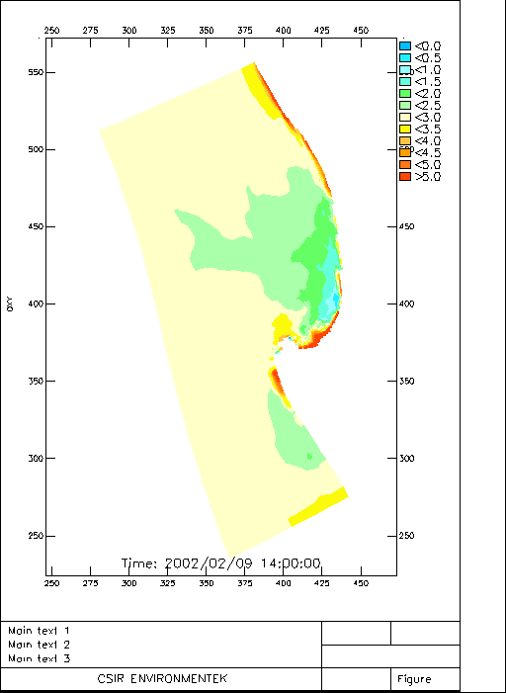 Figs. 3.10g

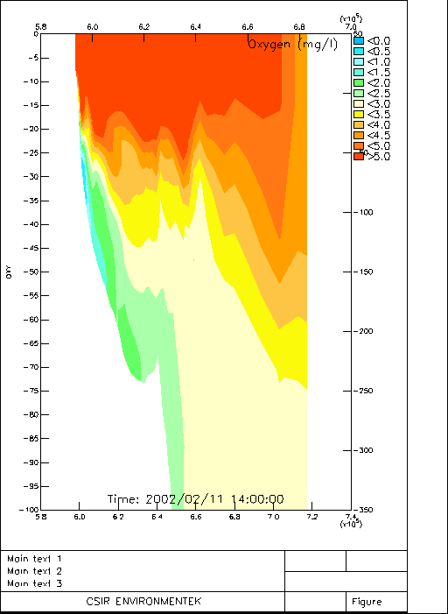 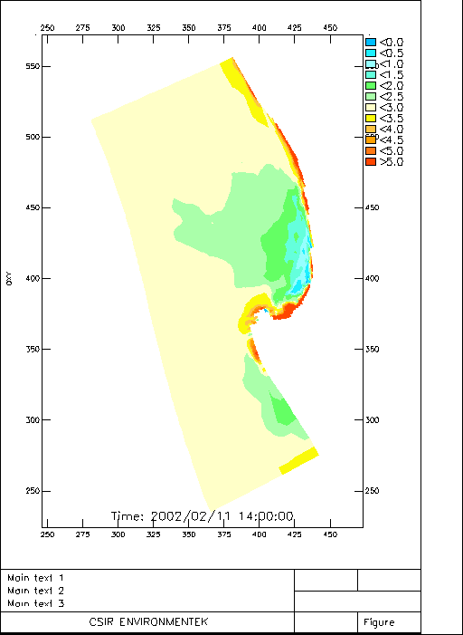 Figs. 3.10h

The model results above show how closely linked and important the phasing of the physical processes is to the onset, development and weakening of the seasonal hypoxia / anoxia in the southern Benguela. This understanding suggests that it is not only wind strength that is a key to understanding the variability but also the time scales of the active and relaxation phases, particularly the latter. Each of these phases has critical time scales that result in maximum or minimum development of hypoxic conditions at both the event and seasonal scales. These sensitivities are now discussed in more detail below.

The ecological vulnerability of the system in respect of low oxygen formation and its variability can be summarised into two main spatial-temporal categories:
- The seasonal LOW body which reduces the benthic and demersal habitats to a narrow near shore belt (< 5 km)
- The advection scale dominated part of the active phase which extends this hypoxia more strongly towards shore and further constrains the near shore habitat to < 500m.

It is the cumulative effect of the two scales that exposes the organisms, which include the economically important rock lobster fishery, to either s physical stranding due to tidal water level changes or the anoxia from the collapse of a HAB. Both are the final main cause of death to spatially constrained organisms but depend sensitively on the forcing from both seasonal and event scale LOW variability in the shelf domain.

Sensitivity Analysis

The sensitivity analysis carried out in the study was focussed on the responses of the oxygen variability to changes in forcing rather than the uncertainties in the parameterisation of the model. The two most important forcing factors were defined as:
- the sensitivity of oxygen variability within the model to the boundary conditions for oxygen concentrations
- the sensitivity of the oxygen variability to changes in wind stress and wind characteristics

Boundary Conditions

In modelling of coupled physical – biogeochemical systems one of the main sources of uncertainty is the sensitivity of internal responses to boundary conditions. Boundary conditions typically reflect some mean climatological scales and in theory, if placed far enough from the system process core, should have minimal influence. That is, at a certain minimum scale, internal dynamics become more important that boundary conditions. If oxygen concentration variability remains sensitive to boundary conditions, even for large system domains, two considerations arise:
- it increases the need to resolve the temporal and spatial scales of the boundary conditions and
- emphasises the importance of remote forcing as opposed to local generation of low oxygen variability

The importance of the oxygen boundary condition is that it scales the magnitude of the horizontal advection fluxes of dissolved oxygen into the sub-thermocline domain of the ecosystem model. The additional usefulness of this sensitivity analysis is that it also provides a measure of the sensitivity of the natural system (Namaqua – St Helena Bay) to changes in the remote forcing. This could be related to forced from the offshore boundary (Cape Basin) or poleward advection from Lüderitz.

Table 3.2: The oxygen concentrations used as boundary conditions in the model. The concentrations were fixed in time and depth. The concentrations are in mgO₂L⁻¹

Layer | BC3 | BC5 | BC7
1 | 3.00 | 5.00 | 7.00
2 | 3.00 | 5.00 | 7.00
3 | 3.00 | 5.00 | 7.00
4 | 3.00 | 5.00 | 7.00
5 | 3.00 | 5.00 | 7.00
6 | 3.00 | 5.00 | 7.00
7 | 3.00 | 5.00 | 7.00
8 | 3.00 | 5.00 | 7.00
9 | 3.00 | 5.00 | 7.00
10 | 3.00 | 5.00 | 7.00

The results of this sensitivity analysis are depicted in Fig. 3.11a-c. They show that the variability within the observational sites of Elands bay and the SouthMidShelf scale closely to the magnitude of the boundary conditions. They do not show a strong non-linearity that amplifies the differences in boundary conditions within the model domain. If anything the differences within the domain are slightly less than those of the boundary conditions. This is an important result because it indicates that although the boundary conditions have an impact on the magnitude of the oxygen concentrations, they do not amplify the signal nor modify the characteristics of the scales of variability. A change in boundary conditions from 5 - 3 mgl⁻¹ (difference of 2mgl⁻¹) results in a difference within the domain of 1.4 – 1.6mll⁻¹. The anomalies plotted in Fig. 3.12 show some differences initially (~ 1mgl⁻¹) which gradually decrease over the seasonal scale. The reason for these differences lies in the effect of the chosen boundary condition on the magnitude of the vertical gradients that determine the physical oxygen flux across the thermocline. A higher oxygen concentration at the boundary results in a weaker gradient and hence the smaller the flux. So, counter intuitively, the higher the boundary concentrations the greater the rate of decrease in oxygen concentration in the sub-thermocline waters.
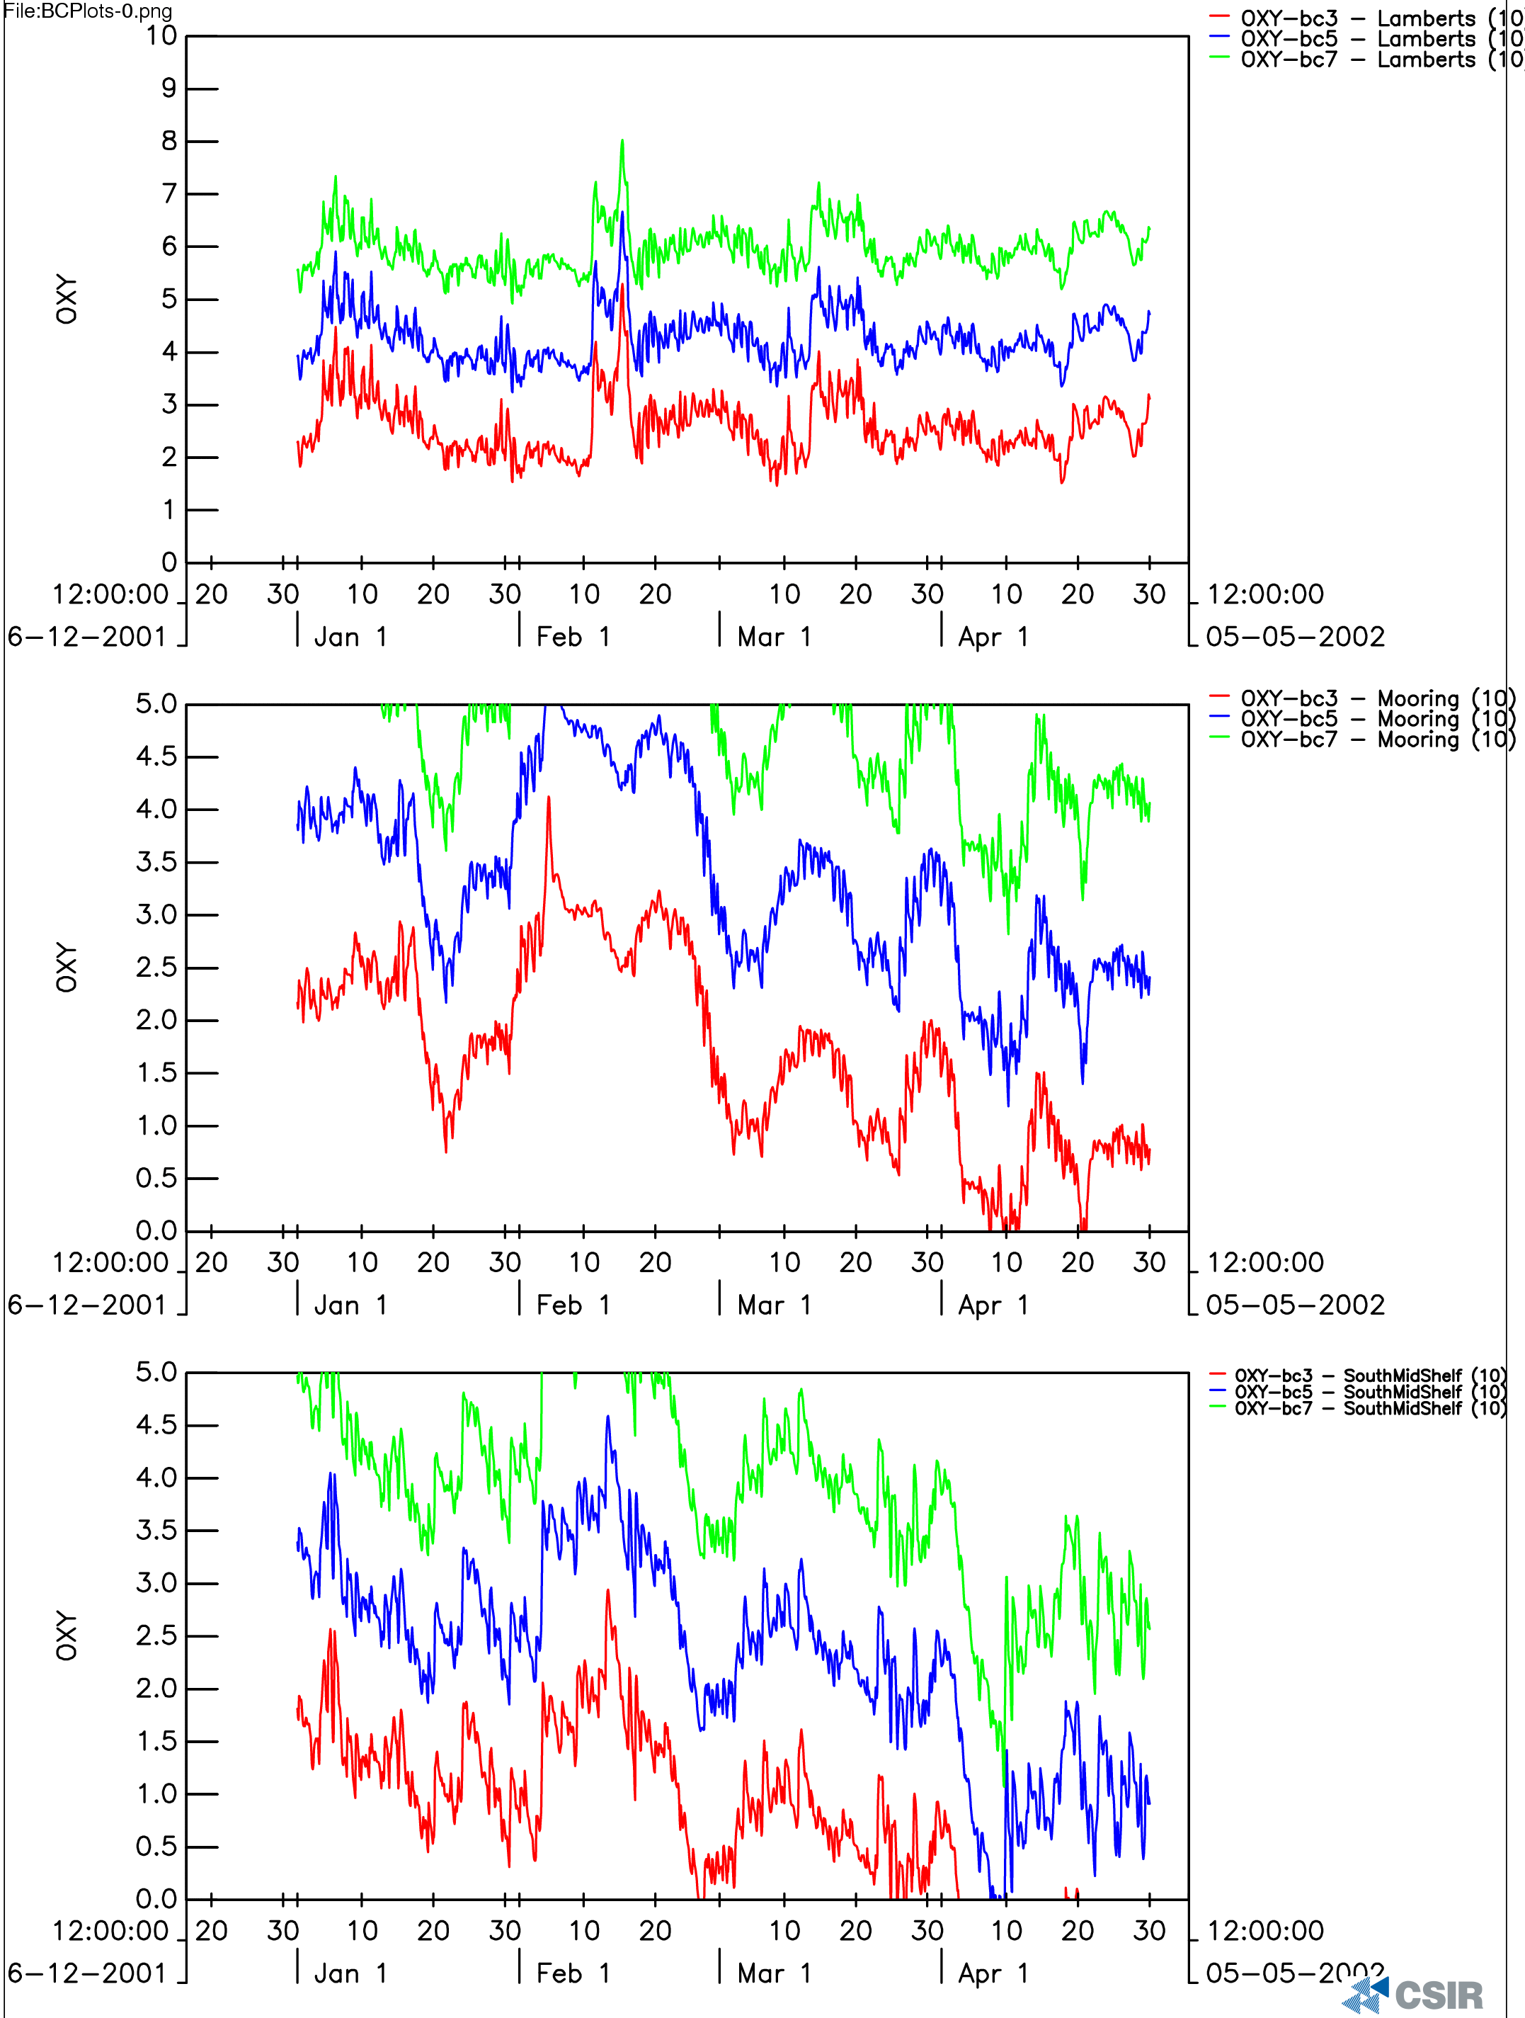

Figures 3.11a-c: The time series of modelled dissolved oxygen variability at three locations: nearshore Elands Bay (a) and core of the retention zone Mooring (b) and SouthMidShelf (c) in the St Helena – Namaqua domain forced by three boundary conditions (3, 5, 7 mgO₂L⁻¹).

Figure 3.12: Depicts the event and seasonal scale anomaly of oxygen concentrations observed at the boundary and those within the modelled domain (SouthMidShelf).

It shows that the seasonal and event scales are coherent for all boundary conditions. The increasing magnitude of the seasonal anomaly reflects the decrease in oxygen concentrations over the same time scale.

The sensitivity of the oxygen variability in the St Helena – Namaqua shelf to boundary conditions from the Lüderitz upwelling cell was one of the very strong hypotheses that the initial stages of this study. It was hypothesised that at certain times of the year (late summer) and interannually (extreme events) the Lüderitz “gate” opened and allowed hypoxic Namibian shelf water into the southern Benguela.

Although the model experiments showed there to be a limited sensitivity to remote boundary conditions the likelihood of such events was tested using a ten year oxygen – salinity data set from the St Helena – Namaqua system (Fig. 3.13). It shows that hypoxia in this system is associated with salinities below 35psu which largely excludes the Namibian shelf water whose salinities are > 35psu. This is supported by an analysis of salinity distribution in the Benguela shelf in relation to source waters (Duncombe-Rae, 2005) This provides observational support for the hypothesis that hypoxia in the southern Benguela is locally generated by shelf processes whose dynamical basis are the focus of this study.

Figure 3.13: Plot of salinity – oxygen showing that the hypoxic conditions are associated with the Cape Basin SACW rather than the higher salinity Equatorial SACW. This confirms that the hypoxic conditions in the southern Benguela are locally generated by the combined physics – biogeochemical processes rather than imported from the Namibian shelf as was thought to be the case.

Sensitivity to wind stress change

The sensitivity of the coupled physics – biological production processes to wind stress is perhaps the most critical element required to understand the interannual variability of low oxygen conditions and their habitat constraints in the southern Benguela. Model runs were set up with constant boundary conditions and varying wind regimes.

The objective of this sensitivity analysis was to test the hypothesis that the better aerated regime of the 1980’s in the St Helena – Namaqua system was due to decreased wind stress. This is supported initially by the observed decadal variability of wind stress (volume transport as a proxy) calculated based on observed wind velocities at Cape Columbine (Johnson and Nelson, 1999)(Fig. 3.14). It shows that the 1980’s, especially the 1983 – 1989 period were a low wind stress compared to the longer term record.

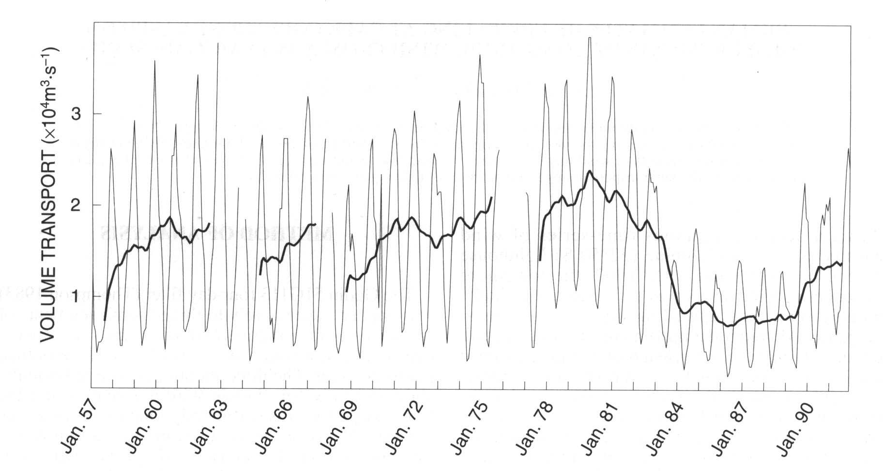

Figure 3.14: Plot taken from the study of Johnson and Nelson, 1999 which contrasts the low upwelling volume transports at Cape Columbine during the 1980’s with those for the preceding period and show an increasing trend towards the higher wind
stress 1990’s decade.

Ideally it would have been best to run the model with 1984 – 1986 wind data from Cape Columbine but those winds were not obtainable from marine and Coastal Management in a time frame that was meaningful to complete this work. The alternative approach adopted was to generate a synthetic wind time series which reflect different degrees of wind strength relative to a reference data set. The chosen approach was to reduce the Jan – Apr 1992 winds by fixed amounts throughout the time series. The wind regime scenarios were:

1: reference Jan – Apr 2002
2: reference reduced by 20%
3: reference reduced by 50%

The chosen boundary condition was an oxygen concentration of 5mgO₂L⁻¹ (3.6mll⁻¹).
The system response in respect of oxygen is shown in Fig.3.15 for two monitoring sites: Elands Bay representing the near shore habitats and SouthMidShelf location representing the main St Helena Bay system (see location in Fig. 2.1).

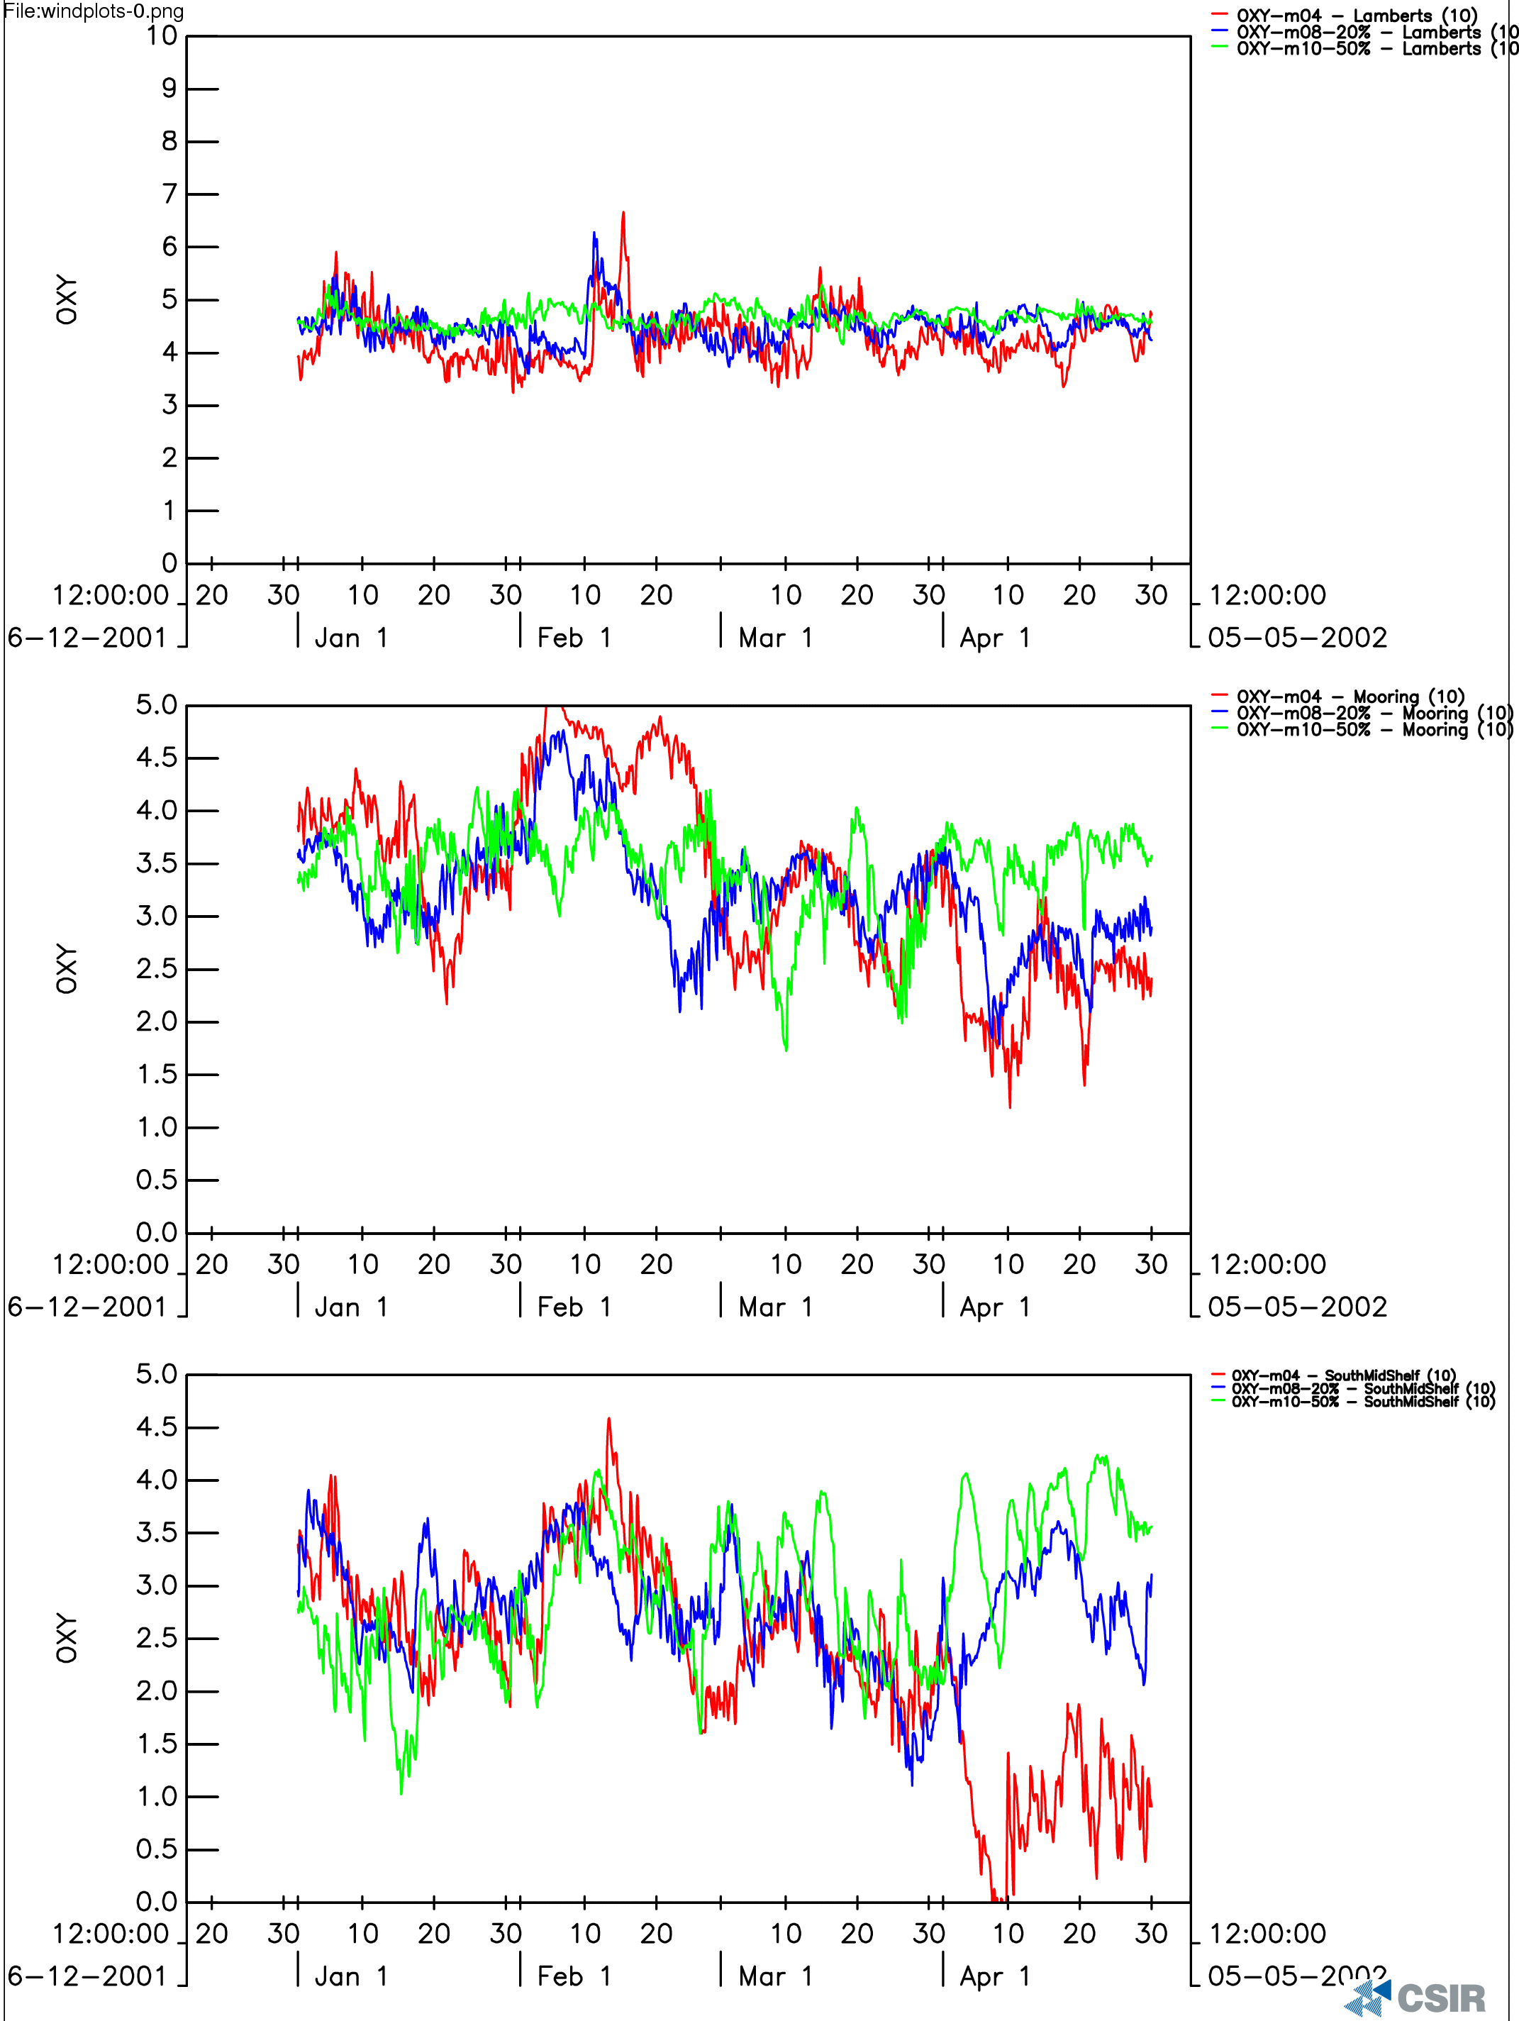

Figures 3.15a,b: Modelled time series plots of dissolved oxygen at three sites (Elands Bay, Mooring and SouthMidShelf) for three wind scenarios. It shows that a small drop in wind speed (~20%) shifts the system into a different ecological state.

Figure 3.16: Plot showing the relatively high sensitivity of surface layer production rates to small drops in wind speed (20% - 50%).

The results show that whereas the shallow areas have a minimal sensitivity to decreased wind stress, the deeper bay areas that hold the seasonal low oxygen reservoir are sensitive to relative small changes in wind stress. Low oxygen variability in deeper bay areas responds strongly to reduction in wind velocity in the range of less than 20 % of the reference 2002 winds (Fig. 3.15a,b). Increased wind strength is associated with deeper low oxygen conditions which would result in increased habitat constraints with the St Helena Bay – Namaqua system. Conversely, decreased equatorward wind speed, even by as little as 20%, leads to a significant aeration of the sub-thermocline waters within the system (Fig. 3.15a,b).

The non-linear decrease in new production is further emphasised by the time series of new production fluxes in the top layer (Layer 1) of the model at the near shore and mid-bay site (Fig. 3.17a,b). It shows that the productivity rates for the 20% wind speed reduction scenario are reduced by more than 20%, especially in the mid-bay station. The 50% wind speed reduction scenario drives a productivity rate which is a small fraction of the reference rates for 2002 (Fig. 3.17a,b). This non linearity is further emphasised by the time series of daily averaged biomass and production rates for the system under the three wind scenarios (Fig. 3.18a,b).

The explanation for this sensitive non-linear relationship is in the linkage of the wind through physical processes (upwelling and mixing / entrainment) to nutrient supply that then support new and regenerated production within the system. The main feedback of oxygen demand is driven by the carbon export flux that is retained and deposits within the system. The sensitivity of the system biogeochemistry to wind stress arises because of the way in which the retention nature of the circulation results in a persistent stratification throughout most of the summer turning it into a 2 layer stratified system. Productivity in the euphotic zone is then driven by two physical regimes:
- Outcropping of upwelled water which is spatially limited to the eastern (land) boundary of the system.
- Wind driven entrainment of sub-thermocline waters into the surface layer ()

The eastern boundary production fluxes are spatially and temporally constrained by the front and the upwelling cycles so its contribution to the total carbon export flux is small and localised in a zone of relatively high oxygen flux. Productivity in the surface layer of the bay body is spatially extensive but limited by the nutrient flux driven by the variability entrainment governed by wind stress and stratification strength. The spatial extent and magnitude of this depositional flux in the bay is largely controlled by benthic boundary layer turbulence variability that determines the bottom shear stresses. While bed shear stresses govern the spatial characteristics of the depositional zone, it is the new production fluxes that govern its magnitude and variability.

The nutrient (nitrogen) limitation effect is clearly seen in the variability of the nutrient limitation factor throughout the four month simulations in contrasting wind regime scenarios (Fig.3.19a,b). The nitrogen limitation function shows that whereas in the windier (2002) period the limitation factor was mostly above 0.9 which implies nearly sufficient nutrient supply flux, this decreased sharply to just a few short periods in which it reached 0.5 (Fig.3.19a,b). It is useful to compare the nitrogen limitation factor variability in the bat body (SouthMidShelf) and the eastern boundary (Elands Bay). It shows that the effect is visible but weaker at the eastern boundary.

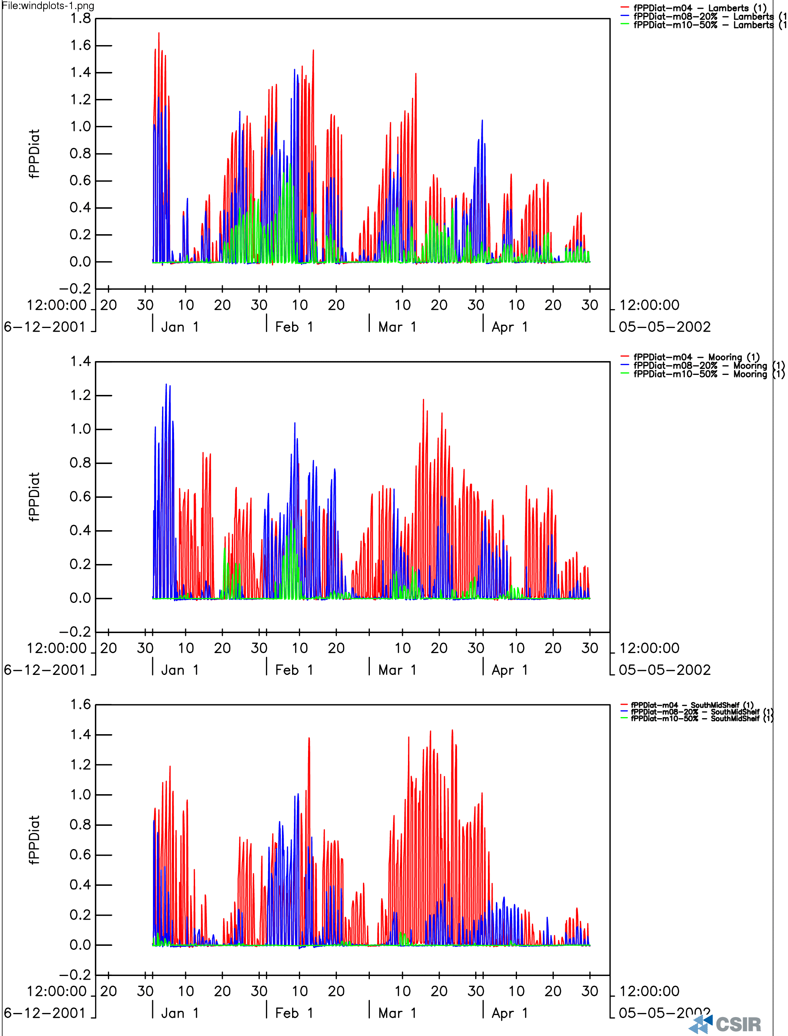

Figures 3.17a,b: The sensitivity of the productivity rates in the surface layer to changes in wind stress are depicted in the modelled time series extracted at three bay sites for the three different wind scenarios.

Figures 3.18a,b: Daily averaged time series plots of phytoplankton biomass (gCm⁻³) and production rates (gCm⁻³d⁻¹)

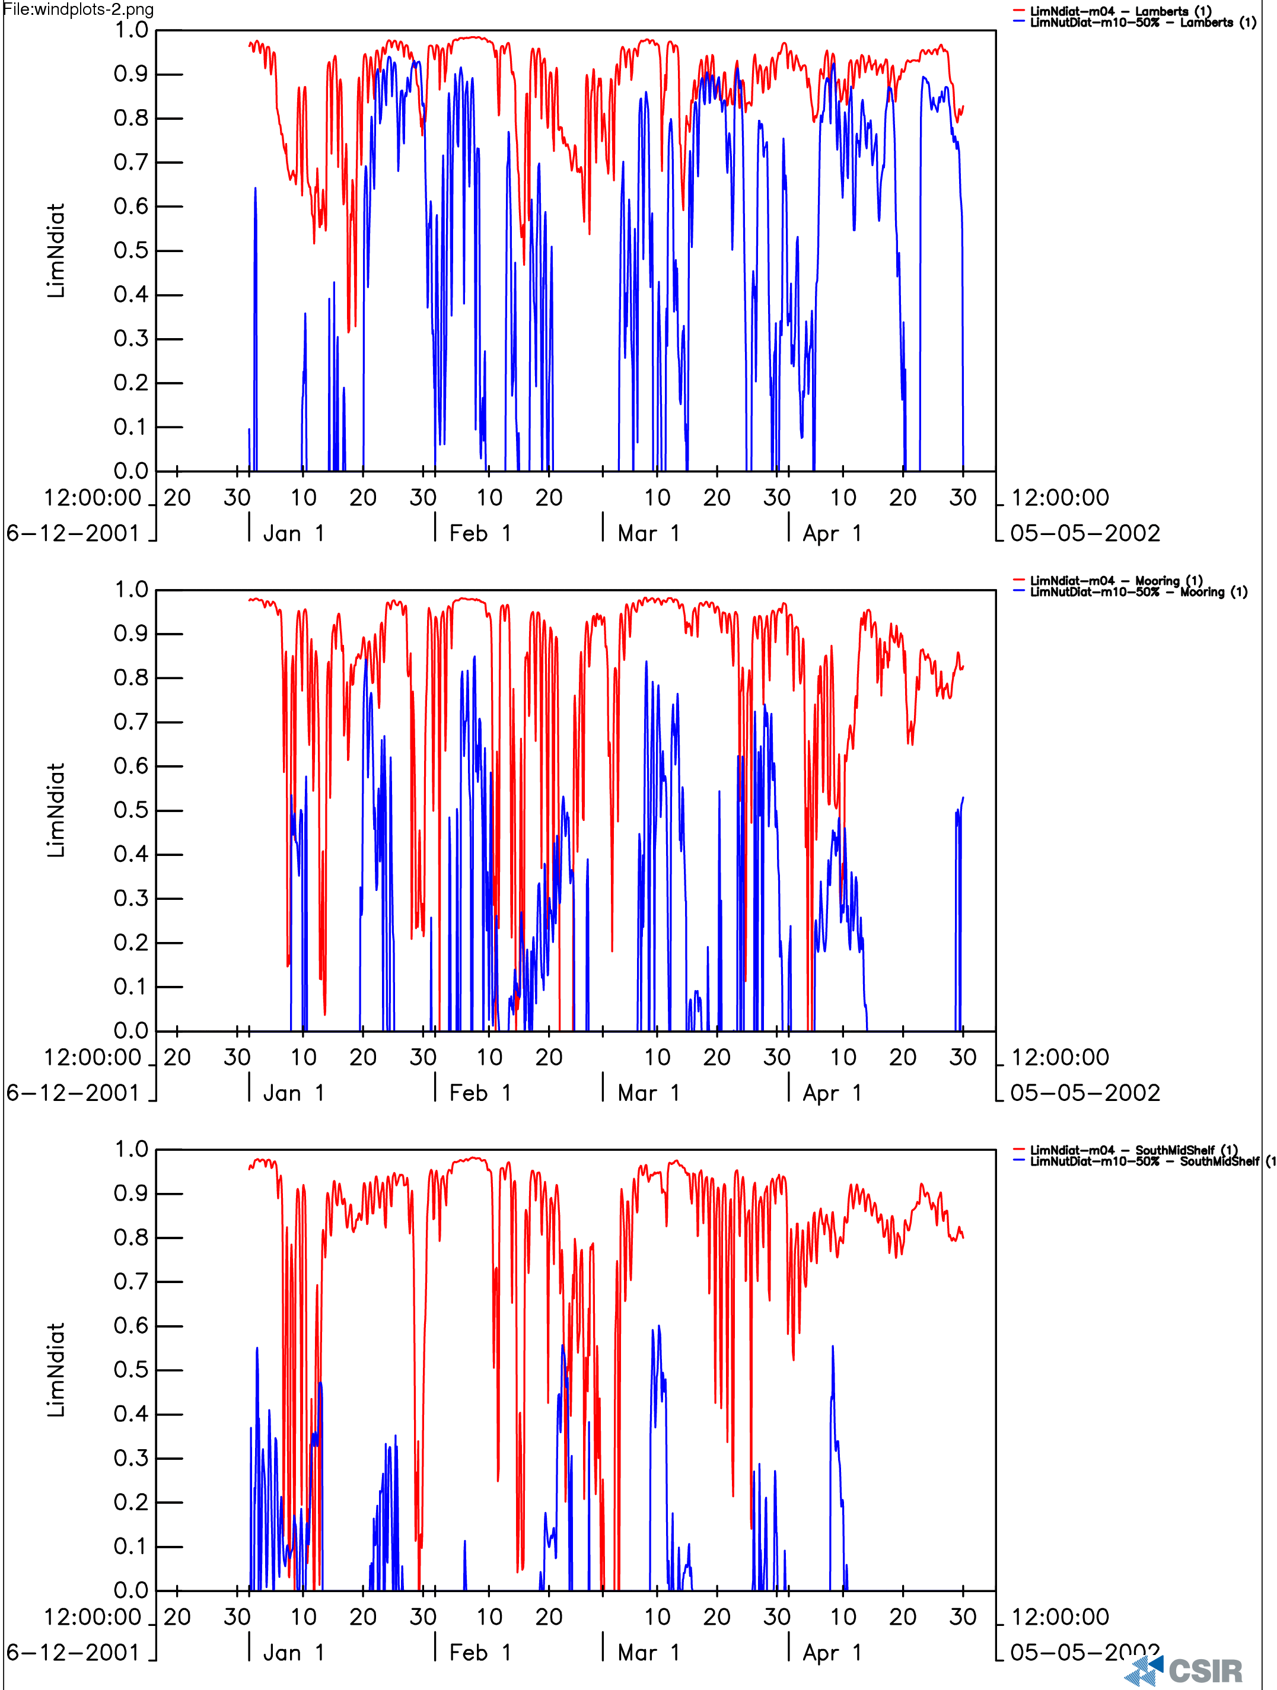

Figures 3.19a,b: Nutrient (DIN) limitation plots showing how nutrient limitation escalates rapidly from > 0.8 to < 0.4 with relatively small decreases in wind speed (50%).

This is particularly so in the stratified core of the system rather than in the shallow near shore environment.

FORECASTING A STRANDING: BIOGEOCHEMICAL - ECOSYSTEM MODEL RESULTS

The historical record from St Helena bay indicates that periodically bottom dwelling fauna such as rock lobsters are constrained so close to shore that they are left stranded out of the water at low tide (Cockroft et al., 2001). The key management question behind this study was whether it is possible to provide a 7 day forecast of the conditions that will lead to a stranding of rock lobster. The occurrence of two rock lobster stranding events in the period of Jan – Apr 2002 when a high resolution time series of both temperature and oxygen was collected allows the model results to be used to explore the question.

The stranding events occurred in the period 1 – 3 Feb and 1 – 3 March 2002 (Cockroft, pers.com.). These periods coincided with the event scale hypoxic / anoxic periods in the observed data and the modelled data from the core of the retention zone (Fig. 3.14). This would suggest that the stranding events are linked to the dynamics of the core of the seasonal hypoxia. However, the modelled data from the near shore zone where the stranding events occur shows a different dynamic. The variability in the near shore is governed by the decrease in dissolved oxygen driven by the advection of the seasonal low oxygen water onshore and by increases resulting from relaxation events. During the latter the near shore is characterised by oxygenated surface waters (Fig. 3.14a). The timing of the oxygen variability in near shore shows that modelled oxygen concentrations were not low at the time of the observed stranding events (Fig. 3.14b). The reason for this is that the stranding events in 2002 occurred, as they mostly do, during the relaxation phase of the upwelling cycle. This phase, as was discussed earlier, is when the pool of seasonal hypoxia retreats from the near shore zone and in so doing paradoxically reduces the stranding risk by expanding the aerated habitat area.

Figures 3.20a,b: Plot showing modelled time series of dissolved oxygen from the deep Bay area (a) and the shallow near shore zone (b).

They show that whereas the oxygen concentrations in the deep bay zone reduce during the relaxation phase, those in the near shore reduce during the active phase as the seasonal hypoxia pool is advected onshore by upwelling. It indicates that an additional mechanism needs to be invoked to account for the stranding events during the relaxation phase.

The additional mechanism that co-occurs with the relaxation is the advection of high densities of HAB into the narrow inshore habitat domain into which rock lobster have been concentrated (Pitcher et al., 2004). The HAB are advected by the narrow poleward current that develops and strengthens during the relaxation phase of the upwelling cycle (Viljoen, 2006). HAB are advected into an environment that is effectively nutrient depleted and the dense bloom dies off relatively rapidly over a period of 1 – 3 days. Although this occurs in a well mixed and shallow inshore water column the very high biomass (> 100ugL⁻¹ Chl-a) and low wind conditions of the relaxation phase result in a rapid oxygen depletion of the water column. This secondary step is not explicitly modelled but it explains how the stranding events occur in what should otherwise be adequate habitat conditions.

To summarise:

The understanding of the dynamical considerations behind the variability of low oxygen waters in the southern Benguela. This has provided strong support for the two-phased coupled seasonal hypoxia – event scale HAB as being the two necessary components on which to base a forecasting system on the following scales:
- Seasonal scale risk model
- Event scale 7 day forecast of stranding events

The elements of the forecasting system would be focussed by the following:

Decadal Scale
- Is this a low wind or high wind regime?

Seasonal Scale:
- Is the wind stress during the early upwelling season confirming that this year is correctly located in the expected wind regime?
- Use the spring – early summer wind stress to build up the correct biogeochemical initial conditions for the late summer in the operational model

Event Scale
- Run the operational model with forecast wind stress
- Monitor the presence of nearshore HAB at the northern boundaries
- Forecast the oxygen demand linked to the possible collapse of observed bloom biomass

SYNTHESIS OF THE PROCESSES THAT GOVERN LOW VARIABILITY IN THE SOUTHERN BENGUELA

The main drivers of low oxygen water variability in the southern Benguela system are regional rather than basin scale. Unlike the Central and Northern Benguela systems, the southern Benguela is not linked to the Equatorial system boundary conditions (Monteiro et al., 2006). The boundary condition to the southern Benguela is the well aerated Cape Basin South Atlantic Central Water (CB-SACW). This affords a greater degree of resilience to the system than that which is available to the Central and Northern Benguela. Two regional and local scale biogeochemical processes govern LOW variability:
- New production rates which provide the flux of POC to the sediment oxygen sink
- Wind driven mixing which governs the nutrient flux that supports new production

The first order driver of the variability of seasonal and interannual low oxygen waters are the characteristics of equatorward wind event scales: its strength, its frequency and its persistence.

The modelling approach used in this study to incorporate the spatial and temporal complexity of drivers was able to reproduce the event scale and seasonal scale variability of oxygen for the period Jan – Apr 2002 in St Helena bay. The most important outcome from this part of the work was that it showed that the variability in wind strength rather than the wind strength alone is the essential element to the development of low oxygen conditions.

Habitat Constraints from LOW variability

LOW variability imposes itself as a habitat constraint to bottom and sub-thermocline dwelling (demersal) organisms on two scales:
- Seasonal scale whereby the seasonal low oxygen waters that develop over the organic rich depositional zone exclude most hypoxia intolerant species from the core of the retention zone.
- The event scale whereby the active phase of the upwelling cycle advects LOW towards the shore and spatially constrains the aerated near shore environment.

A third mode (sub-event scale) of low oxygen impact on near shore habitat arises indirectly from the collapse of very large blooms of dinoflagellate phytoplankton (HAB) following their advection to the near shore and nutrient starvation through relaxation phase of the upwelling cycle. The impact of this mechanism depends strongly on the pre-conditioning by the earlier two.

Extreme Events in the Recent Past: Southern Benguela

Extreme conditions are useful in the sense that they provide insight into system states which are typically dominated by a reduced set of processes: lower complexity but typically of significant ecological consequences. Two quite different extreme events are worth investigating to test the robustness of the model formulated above even with the physical forcing extremes that define the extreme events. Extreme events pose a serious test to any generalised understanding of the way complex systems behave. Their exploration here serves the dual purpose of providing a view of the underlying causes and also to serve as a test of the robustness of the models.

What happened in the 1980’s?

The decade of the 1980’s was characterised by an unusual degree of aeration within the St Helena Bay – Namaqua system. An oxygen time series prepared as part of an earlier review of LOW variability showed that the Namaqua – St Helena domain remained unusually aerated in the decade 1984 – 1993 (Fig. 3.21).

As was explained earlier, the 1980’s decade was characterised by a sharp reduction in wind stress (Fig.3.22), which in terms of the model formulated by this study would have led to a significant reduction in the POC flux that supported the oxygen demand flux in the sediments. The reduction of the wind stress strengthens the thermocline, which although causing a reduction in the ventilation of sub-thermocline waters, causes a larger reduction in oxygen demand. The net effect is a change in state of the system from a seasonal hypoxia mode to a permanent aerated mode. The implications of this shift for ecosystem services are significant in the sense that they are a trade off between:
- Expansion of benthic and demersal habitat
- Reduction of productivity fluxes

Figures 3.21a-c: Progressive depth – time plots for temperature (a), salinity (b) and dissolved oxygen (c) contrasting the 1980’s and 1990’s decades.

It shows that the 1980’s were a more aerated period with no hypoxic events in the data as compared to the strong seasonal character of hypoxia in the 1990’s.

The decade of the 1980’s was an unusually low wind stress period in the southern Benguela system especially in the Namaqua – St Helena domain. The wind stress was not only low but the period of low wind stress lasted longer than any other period in the past 40 years (Johnson and Nelson, 1998) (Fig. 3.22). As was demonstrated earlier through the sensitivity analysis, the stratification, productivity and oxygen variability are very sensitively dependent on the wind velocity characteristics. The biogeochemical response in the form of hypoxia development depends on the nutrient flux supplied to the euphotic zone

Figure 3.22: Plot taken from the study of Johnson and Nelson, 1999 which contrasts the low upwelling volume transports at Cape Columbine during the 1980’s with those for the preceding period and show an increasing trend towards the higher wind stress 1990’s decade.

What happened in March 1994?

The extreme event in March 1994 (Mathews and Pitcher, 1996) occurred at the end of the decade long aerated period of the 1980’s. The extreme character of this event was measured by the degree of anoxia which extended throughout the water column as a result of very large sulphide fluxes. The formation of pyrites turned the water column colour black hence the expression “black tide”.

The year of 1994 marked the end of a transition (1993 – 1994) from a low wind – warm anomaly to a stronger wind – cold anomaly mode in the Cape Columbine upwelling centre. The net effect of the stronger winds is not only to increase the nutrient – new production fluxes but to strengthen the contrast of the event scale active – relaxation modes which are needed for the development of the seasonal hypoxia – anoxia conditions.

At this stage it is not clear what the specific process level explanation is for the particularly large anoxic event in 1994. The timing of the event was associated with a large HAB Prorocentrum micans (Mathews and Pitcher, 1996) but anoxia develops as a seasonal rather than an event scale response. Two hypotheses are proposed:

- That the 1993-1994 upwelling season was characterised by not only stronger upwelling winds but also more extended relaxation periods which then create the two pre-condition factors for deep anoxia.
- That the system ecology was also still adapting to the new mode and was only able to consume a smaller proportion of the new production flux leaving most of it to be consumed by the lower end microbiological of the hypoxic food web characterised by higher turnover rates

Risk Factors and system state thresholds

The most important risk factors that determine the ecosystem state in the Namaqua – St Helena system are the spatial and temporal characteristics of the wind. Simplifying the view: the system can exist in two states from an oxygen variability and ecosystem constraint perspective:

Hypoxic: high wind regime (High production – Low Oxygen)
Aerated: low wind regime (Low production – High Oxygen)

The initial assessment of the threshold is that a 20% reduction in 1992 wind strength could be assigned as a tipping point for the system. This needs to be investigated more closely to reduce the uncertainty of the threshold.

Future Climate Outlook Scenarios

One of the issues of greatest scientific and more recently political speculation is the question of whether low oxygen is responsible for a persistent trend in the shift of the rock lobster populations from the western Cape to southern Cape habitats. Climate change scenarios for the southern Benguela fall into two opposing outlooks:
- Increased wind stress with warming which would strengthen the cool character of the upwelling system. This is forecast by present climate models on the basis that warming of the land mass increases the pressure gradients that drive the equatorward winds.
- Reduced wind stress which would increase the 1980’s character of the system. This is outlook is based on the palaeo-record that shows that wind strength was highest during the cool periods over the past 200,000 years.

There is increasing evidence based on the paleo record to support the relaxation of the upwelling system through global warming (Pichevin et al., 2005)). This suggests that the southern Benguela may shift towards a low productivity – high oxygen mode through increasingly longer or a higher frequency of 1980’s regimes.

Monitoring and Forecasting Strategy

One of the most important outcomes of this work was the detailed understanding of the processes and dynamical considerations that link wind forcing to low oxygen variability in the southern Benguela. The second important aspect that informs a monitoring strategy is that LOW variability is driven by regional scale wind forcing and not by remote basin scale boundary conditions.

Key processes

Three important scales of wind forcing were identified:

Decadal Regime: this describes whether the wind forcing is in a low stress mode eg: 1980’s or in a high stress mode as in 1990’s.
Early season: if the regime model is correct then can the early season wind characteristics provide a refined prediction of the wind climate in the late summer?
Synoptic Scale: The synoptic character of the wind is a key to the development of anoxia because it forces the system through alternating phases of active upwelling that drives new production and relaxation that stops it and increases oxygen demand. The synoptic scale variability is a key to the poleward flow that advects HAB blooms into the near shore habitat.

Temperature: The variability of surface temperature on the horizontal scale provides important insight into the spatial extent of the stratified “lid” of the retention circulation zone as well as the extent to which the near shore is being impacted by advected hypoxic / anoxic waters.

Stratification: The strength of the stratification is a key factor governing both the nutrient fluxes as well as the ventilation of sub-thermocline waters. The key requirement for the development of LOW conditional is the variable phasing of strong and weak stratification. The observational requirements are for both strength and variability on a synoptic scale.

Algal Blooms: Algal blooms impact on LOW variability on two scales:
System scale: where the blooms govern the seasonal and synoptic progression of the core system hypoxia.
Synoptic scale: where high concentrations of HAB’s are advected into the near shore environment by the poleward flow

Forecasting Approach

The approach to forecasting the evolution of LOW and its ecosystem / habitat consequences should follow an integrated modelling and observational plan. A two level forecasting system is proposed.
- Wind based early season and event scale forecasting of the risk
- An integrated operation modelling approach to forecast habitat scale outlook

Wind based Forecasting

The combined analysis of the model results and historical wind record shows that the variability in the wind stress accounts for most of the variability in water column dissolved oxygen in the southern Benguela. It is proposed that a permanent weather station (wind, solar radiation, temperature) be located in the vicinity of Cape St Martin with a real time link to a processing centre. This processing centre would produce an ongoing seasonal and event scale forecast through a risk indicator

Integrated Modelling

Stand alone physical and biogeochemical / ecosystem models running on real time forcing and running 7 day forecasts.

Observations

The main purpose of observations is to:
- Force the models
- Verify / constrain the models

Forcing

Winds:
Solar radiation
Boundary conditions

Hypoxia Variability in the Central Benguela: Namibian Shelf

This much briefer overview of the work is linked to the following publications: (Monteiro et al., 2006a; Monteiro et al., 2007a) where all the details may be found.

Coupled physics and biogeochemistry

The dynamics that govern hypoxia / anoxia variability in the Central Benguela are dominated by advective scale processes in sharp contrast to the vertical mixing scales that characterise the southern Benguela (Monteiro et al., 2007a; Monteiro and Joubert, 2007). This is a key insight because it helps to understand the critical scales that not only govern extreme events but also where to look for the long term impacts of climate change. Seasonal and interannual hypoxia variability in the central Benguela is hypothesised to be represented by a model of four main factors that act dynamically (Monteiro et al., 2006a; Monteiro et al., 2007a):

- The different (t,S,O) characteristics of Equatorial and Cape Basin South Atlantic Central Water shelf boundary conditions at the Cape Frio and Lüderitz upwelling centres. (see Final Report for project EV/LOW/02/03)
- The late summer poleward flow along the central Benguela shelf from Cape Frio, which advects the Equatorial hypoxic boundary condition (This report and Monteiro et al., 2007a)
- The spring - early summer wind stress forced equatorward flow from Lüderitz, which drives the seasonal ventilation phase from the Cape Basin boundary condition into the shelf (This report and Monteiro et al., 2007a)
- The biogeochemical sediment flux of reduced metabolites that is driven by the seasonal export production but peaks in the winter period (Monteiro et al., 2006a; Joubert et al. 2007).

The work undertaken through this project showed that the two main upwelling centres of Lüderitz and Cape Frio are the shelf sources of the two water types but their inflows are seasonally phased (Monteiro et al., 2006). Phasing of the forcing from each upwelling centre combined with their different boundary conditions accounts for the seasonal scale of variability (Monteiro et al., 2006). Hypoxia intensifies in the later austral summer (Dec – May) when the shelf sub-thermocline poleward flow, which carries the equatorial boundary condition, strengthens. Hypoxia peaks through biogeochemical sediment flux enhancement in the early winter (Jun – Jul) and weakens in the austral spring (Aug – Nov) as a barotropic equatorward flow from Lüderitz strengthens (Monteiro et al., 2006). It is important to note that although the chronological seasonal sequence puts the aeration phase (spring) ahead of the hypoxia phase (autumn) , in reality the seasonal and interannual modulation is best understood as the hypoxia / anoxia of one upwelling season (Dec – May) being re-aerated by the aerated equatorward flow at the start of the following upwelling season (Jun – Nov). This suggests that the lags between these forcing cycles are an important property of the system dynamics. This linkage is coherent with a central part of the hypothesis that the coupled shelf boundary conditions and shelf physics explain most of the variability. Upwelling-driven shelf carbon export fluxes are a necessary factor but their role is limited in respect of modulating the seasonal cycle (Monteiro et al., 2006). This challenges the biogeochemical emphasis in understanding the nature and variability of hypoxia (Weeks et al., 2004; Bruchert et al., 2006). It suggests that the focus needs to shift to understanding the physics that governs the advective supply of electron acceptors (O₂, NO₃, SO₄). This is in contrast to the physics (eg: upwelling rates) that govern the supply of electron donating capacity (POM) in the form of export production typical of systems characterised by vertical ventilation fluxes. Better aerated years (1997 – 1998) are coherent with cooler and fresher conditions on the shelf when, according to the hypothesis the shelf domain is more strongly forced by the Lüderitz boundary condition (Monteiro et al., 2006; Monteiro et al., 2007a). This is emphasised by the increased ventilation flux of the Namibian shelf by a high wind stress period at the Lüderitz upwelling centre even though its concomitant effect is to increase carbon export fluxes. Similarly, periods of enhanced hypoxia - anoxia (1994 – 1995 and 2000 - 2001) are linked to elevated temperatures when the system experienced a predominance of the equatorial hypoxia characteristics (Monteiro et al., 2007a). Both periods correspond to recorded events of shelf anoxia such as a higher incidence of so called “sulphide eruptions” and in the case of the 1994 – 1995 period, linked with an apparently unusually severe impact on ecosystem function in 1994 (Woodhead et al., 1997; Weeks et al., 2004; Monteiro et al., 2006). This link raises a question about the interpretation of “sulphide eruptions” as being a response to upwelling driven fluxes of new production (Weeks et al., 2004) or alternative remote forcing (Emeis et al., 2004; Bruchert et al., 2006). Higher incidences of “sulphide eruptions” are linked to interannual scale periods of decreased upwelling intensity in the central Benguela (1994-1995 and 2000 – 2001). The explanation is that only in those periods does the external equatorial source of hypoxic water together with decreased ventilation from Lüderitz drive the redox levels down sufficiently to increase seasonal rates of methanogenesis that then lead to the local sub-sediment accumulations of methane that cause the eruptions (Emeis et al., 2004; Brüchert et al., 2006; Monteiro et al., 2006). Thus, above a certain threshold of carbon export flux, the variability of hypoxia and derivative biogeochemical outcomes such as methane eruptions are insensitive to seasonal and interannual changes in the flux of electron donating capacity.

The spatial and temporal characteristics of the seasonal and interannual extremes of the phasing of the two upwelling centres are summarised in Fig. 4a,b. The configuration that describes both the late summer and especially Benguela Niño conditions is Fig. 4a. It shows that not only is forcing from Lüderitz at its weakest but forcing from Cape Frio is strongest. The latter arises through the (seasonal and Benguela Niño) warming of the surface layer that increases baroclinicity in the northern Namibian shelf and strengthens the poleward flow on the shelf. The poleward transport of the equatorial hypoxic boundary conditions drives the shelf system into anoxia that is only offset by the magnitude of the wind stress at Lüderitz in the following upwelling season. If however wind stress in Lüderitz weakens under Benguela Niño conditions then the system can enter a protracted period of deep anoxia that gives rise to ecosystem scale impacts in the food web. These are the extreme conditions that characterised the 1994/95 and 2000/2001 periods when the shelf was dominated by the equatorial characteristics. In contrast during Benguela Niña conditions, the magnitude of the wind stress at Lüderitz peaks and induces a strong re-ventilation of the shelf so the system is then dominated by the characteristics of the Cape Basin South Atlantic Central Water. These are the conditions that defined the system in 1992/93 and 1997/98. Because of the interannual scale the impacts of these adjustments tend to propagate through the food web and emerge through changes in the indicators of long lived fish such as hake (see below).

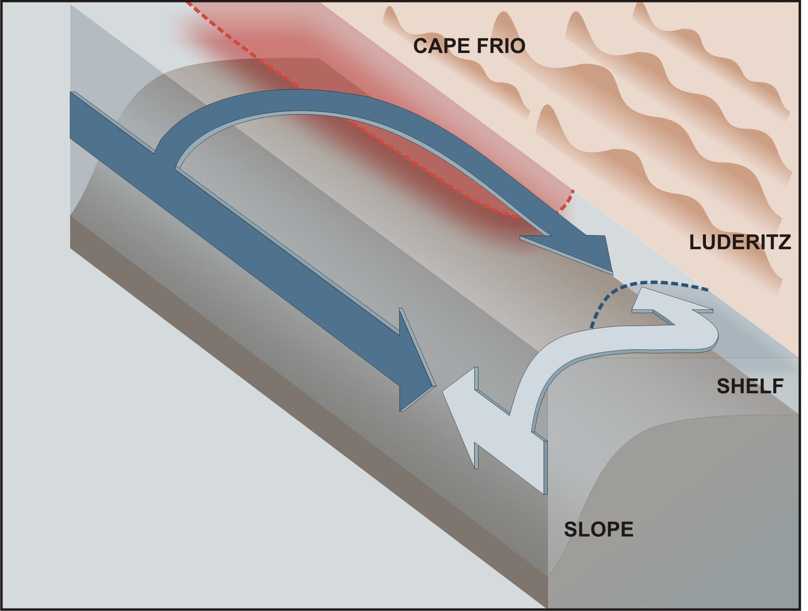
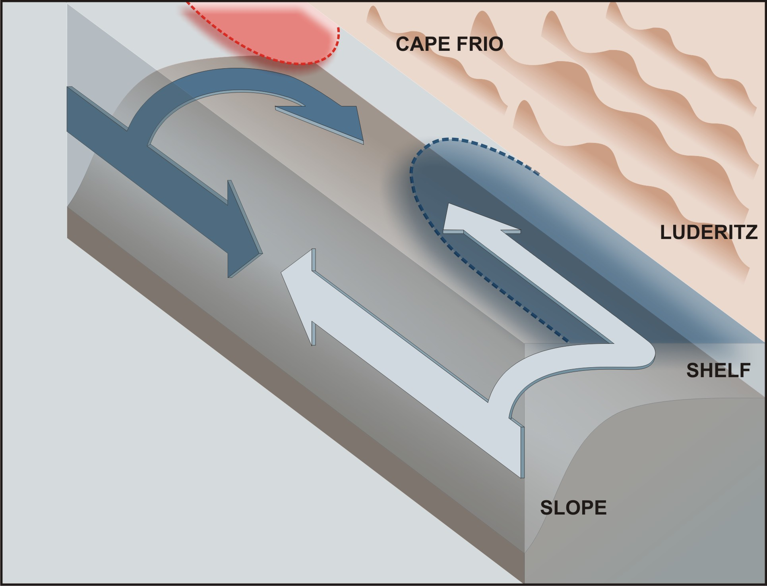

Figure. 4a,b: A conceptual model view of the two extreme conditions that give rise to deeply anoxic (a) and relatively aerated (b) conditions on the Nambian shelf. (see text for explanation)

Hypoxia and changes to the fisheries ecosystem states

On the basis of this study’s model, the net interannual cross shelf SST gradient predicts that 1984/85 and 1989/90 were periods of peak hypoxia with moderate intensity whereas 1994/95 was a hypoxia extreme event (Fig.3c). Similarly it suggests that 1982, 1986/87, 1992/93 and 1997/98 were periods of unusually intense aeration in the sub-thermocline waters of the Central Benguela and high fluxes of export production (Fig.3c). This hindcast index agrees with the observed data from the central shelf over the period 1994 – 1997 (Figs.2a,b,d) and provides a degree of explanation for more recent changes in the spatio-temporal characteristics of hake populations on the outer shelf - slope (M paradoxus) and mid-shelf (M. capensis) biomass in the central Benguela in the period 1990 – 1999 (Fig.5a,b) (Burmeister et al., 2001). The first robust feature of the hake data set (M. paradoxus) is that in most years the biomass density is largely concentrated south of 25ºS (Fig.5b). This reflects the habitat preference for the climatological boundary between the hypoxic equatorial waters and aerated Cape Basin Central Water on the slope and outer shelf (Fig.1). The differences in the characteristics of temporal variability between the two hake species reflect the differences in the oxygen regimes on the slope and mid-shelf. M. paradoxus on the slope uses Cape Basin Central Water domain south of 25ºS as a core habitat and advances equatorward in response to a coupled weakening of the equatorial forcing and strengthening of ventilation such as after 1996 (Fig.5a). M. capensis, a shelf resident species, on the other hand reflects the interannual variability of hypoxia on the shelf more sensitively and reflects a greater vulnerability to changes in the hypoxia dynamics. Each one has developed a resilience strategy in response to their primary domains: M. paradoxus uses the boundary between the equatorial and Cape Basin Central Waters to balance oxygen needs of a predator with a degree of hypoxia protection from larger oceanic predators (L. Hutchings pers.com). M. capensis, which cannot escape shelf hypoxia, evolved a physiological genetic adaptation that enables it to cope with the very serious habitat limitations imposed by hypoxia (Woodhead et al., 1997). Overall, the interannual biomass variability reflects a coherent response by the hake to changes in habitat suitability driven by changes in the intensity and spatial character of shelf hypoxia (Fig.5a.b). This suggests that hypoxia is the most important modulator of hake biomass possibly through its impact on habitat requirements for reproductive success.

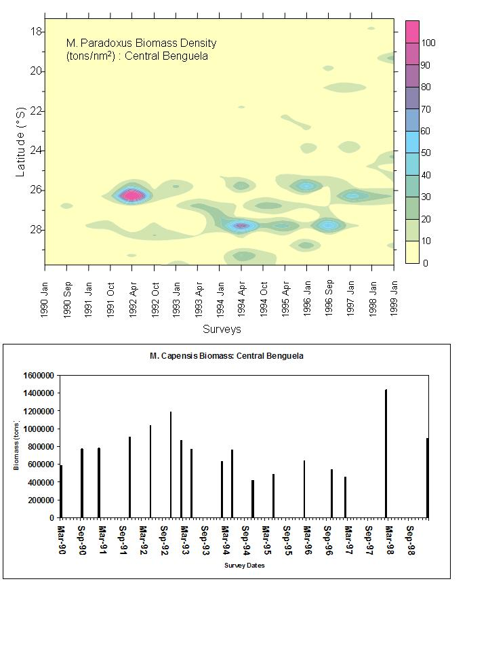
Fig. 5a,b: The interannual variability of biomass indicators for two hake species M. paradoxus (a) and M. capensis (b) in the decade of the 1990’s on the Namibian shelf (Nansen Surveys). (see text for explanation)

The depleted biomass density in 1990 – 1991 can be linked to the 1989 – 1991 peak hypoxia but recovers strongly during the better ventilated 1992 – 1993 period (Fig.3c cf. 6b). The strong Benguela Niño (1994 – 1995) hypoxic period is reflected by a southerly shift (28ºS) in the biomass density maximum on the slope whereas it is reflected by a sharp biomass drop in the shelf (Fig.5a,b). In contrast, the well aerated period 1997 – 1998 is marked by a strong northerly shift in the biomass density such that it spans virtually the entire Namibian slope - outer shelf and a sharp recovery in biomass on the shelf (Fig. 5a,b). The deterioration of the shelf habitat in 1994 was linked to a weakening of the ventilation flux from Lüderitz. This contrast is important because in providing an index for ecological states and sensitivity to hypoxia it makes the link between interannual shelf physics and ecosystem function which is a first step towards a degree of prediction. The Central Benguela has undergone a recognized ecological regime shift since the 1970’s as reflected by the replacement of sardines and anchovy with zooplanktivorous fish (Horse Mackerel, Goby) and jelly fish (van der Lingen et al., 2006). Partial recovery in the late 1980’s was observed to be terminated in the early 1990’s. While this evidence suggests that the ecosystem re-organized its energy flows as a result of the combined effects of natural hypoxia and fisheries, the dynamical insights provided by this study also suggest that, without a change in one of the forcing characteristics it is unlikely to exit this new stable state. The reason is that a 5 year period of system scale hypoxia intensification linked to the Benguela Niño does not allow it to exit the existing “stable state”. Part of the problem may also be that the random natural mortality factor in stock assessment models does not reflect mortality responses to hypoxia variability throughout the life cycle.

Synthesis of Answers to Key Questions for both the Central and Southern Benguela

Initial Key Questions

- At the LOW generation areas, is the variability driven by internal forcing through POM export flux or boundary fluxes of oxygen in both horizontal and vertical scales?
Low oxygen variability in the southern Benguela is almost exclusively driven by internal physics and biogeochemistry. The most important characteristics of these internal dynamics are the seasonal scale build up of carbon export flux in the sediment and the event scale phasing of the active and relaxation events on the wind stress that govern ventilation rates. Overall hypoxia in the southern Benguela is driven by variability in vertical transport (upwelling) and mixing scales driven by wind stress. In the Central Benguela hypoxia variability is a more complex interaction between remote boundary conditions and seasonal scale phased forcing from two upwelling centres exposed to different boundary conditions. Interannual variability is therefore largely the result in changes in the seasonal forcing scales in contrast to the southern Benguela where interannual variability is the result of changes to the event or synoptic forcing scales. In both locations, although POC fluxes are an essential element for the development of hypoxia, they do not modulate the variability. The variability is determined by the scales that drive ventilation.

- How susceptible is the LOW variability to the typical interannual variability in POC fluxes?
The role of POC in hypoxia variability in the Benguela is mainly one of pre-conditioning rather than a driver. This is especially so in the central Benguela where the variability is mainly driven by the wind stress at Lüderitz that governs the seasonal re-ventilation of the sub-thermocline waters on the shelf. The reason for this independence on POC fluxes is due to the advection of the equatorial hypoxia into the central Benguela through Cape Frio upwelling.

In the southern Benguela the decoupling of POC and hypoxia is not so extreme because the boundary conditions are more aerated and therefore require relatively higher rates of oxygen uptake driven by higher carbon export fluxes. Nevertheless the key role of POC is one of seasonal scale pre-conditioning rather than driving the event scale variability that strengthens the hypoxia. This is an important characteristic of the system because the carbon export flux is driven by upwelling and is dependent on wind stress. An important sensitivity was shown through the modelling experiments of pre-conditioning on wind stress. A possible tipping point lies at a wind speed of < 20% of the wind speed for the observed period of 2001 – 2002. Below this threshold the carbon export fluxes decrease sufficiently to make the oxygen sink flux smaller than the physical rate of ventilation through mixing.

- How does POM generation vary between the sub-systems? (Harmful Algal Blooms in Southern Benguela and Diatom production in Namibia)
POM generation is in both systems driven by diatom new production. The role of HAB (dinoflagellates) is specific to the southern Benguela and refers to the impact of HAB in the narrow inshore habitat during the relaxation phase.

- Does the dependence on transboundary links vary as a result of these differences?
The Namibian system is strongly dependent on trans-boundary links whereas the southern Benguela is almost completely independent. The Namibian system is strongly forced by the Equatorial system and its transboundary links are both coastal with the Angola system as well as oceanic through slope – shelf coupling.

Additional Key Questions

- Is a 7 day forecasting system feasible off South Africa?
This study has provided a basis to assess both the seasonal scale (medium term: months) risk as well as an event scale (7 day) forecast. Linking the two is important because the degree of seasonal risk governs the magnitude of the impact of the 7 day forecast.

- Is a 2 month forecasting system feasible off Namibia?
Although the new understanding of the dynamical consideration that link equatorial forcing to hypoxia in the central Benguela raised the possibility of a promising 2 month forecasting period, the complexity of the coupling has neutralized it. The role of the equatorial system is, like the POC in the southern Benguela, a preconditioning one where the actual driver is the re-ventilation from Lüderitz upwelling centre. The preconditioning remains an important part of the total forecasting picture because it adjusts the seasonal risk level. The actual forecast needs to focus on the forecast of the wind stress at the Lüderitz upwelling centre.

- Can such a forecasting system be operationalised?
A proposal was made as to how such a forecasting system may be constructed.

- Can this understanding explain past extreme events or conditions?
  - The Black Tide: the Black Tide of March 1994 was the result of a strong upwelling season after the quasi-decadal well aerated 1980’s associated with a protracted relaxation period. The protracted relaxation period allowed a very deep anoxia to develop that resulted in elevated rates of Sulphate reduction both in the sediments and the water column. The presence of reduced sulphide species in the surface layer would have been driven by methane ebulition from the sediments.
  - The 1980’s decadal anomaly: The 1980’s aerated anomaly was caused by a sharp drop in new production linked to a protracted reduction in the wind stress. The strong non-linearity between wind stress and new production was apparent in model experiments conducted with 20% and 50% reductions in the wind speed. The former reduced average seasonal new production by 80%. The sharp reduction in new carbon export fluxes reduced the seasonal build up of POM in the sediments so the reduction in oxygen fluxes during relaxation periods was not low enough to cause the system to become hypoxic.
  - The 1994 ecosystem wide catastrophic event in the Central Benguela was driven by the simultaneous strengthening of the equatorial forcing (warming at the ABF) and a weak ventilation wind stress at Lüderitz. Similarly, the northward expansion of the hake (M. paradoxus) biomass distribution in 1996 – 1998 was the result of a concomitant weakening of the equatorial forcing and a strengthening of the ventilation flux from Lüderitz.

BIBLIOGRAPHY

Bakun, A., 1998. Ocean triads and radical interdecadal stock variability: bane and boon for fisheries management. In: Pitcher, T., Hart, P.J.B., Pauly, D. (Eds.), Reinventing Fisheries Management. Chapman and Hall, pp. 331- 358.
Bailey, G. W., 1983. Pilot study of the vertical flux of POC and PON in St Helena Bay., South African Journal of Science, 79, 145-146.
Bailey, G. W., 1991. Organic carbon flux and development of oxygen deficiency on the modern Benguela continental shelf south of 22°S spatial and temporal variability. In Modern and Ancient Continental Shelf Anoxia. Edited by R.V. Tyson and T.H. Pearson. pp. 171-183.
Brüchert, V., Lass, U., Ender, R., DuBecke, A., Julies. E., Leipe, T., Zitzman, S., 2006. An integrated assessment of shelf anoxia and water column hydrogen sulphide in the Benguela coastal upwelling system.NATO series.
Burmeister, L.-M., Payne, A.I.L., Pillar, S.C., Crawford, R.J.M., 2001. Depth-stratified density estimates and distribution of the Cape hake Merluccius capensis and M. paradoxus off Namibia deduced from survey data, 1990-1999. South African Journal of Marine Science, Symposium: A Decade of Namibian Fisheries Science 23, pp. 347 – 356
Chapman, P. and Shannon, L. V., 1985. The Benguela Ecosystem Part II. Chemistry and Related Processes. Oceanography and Marine Biology: An Annual Review, 23, 183-251.
Chapman, P. and Shannon, L. V., 1987. Seasonality in the oxygen minimum layers at the extremities of the Benguela system. South African Journal of Marine Science, 5, 85-94.
Copenhagen, W.J., 1953. The periodic mortality of fish in the Walvis region; a phenomenon within the Benguela Current. Investigational Report of the Division of Fisheries South Africa, 14, 35pp.
Cockroft, A., Schoeman, D. S., Pitcher, G. C., Bailey, G. W., Van Zyl, D. C., 2000. A mass stranding of west coast rock lobster Jasus lalandii in Elands Bay, South Africa; causes, results and applications. In: The Biodiversity Crises and Crustaceans. Von Kaupel Klein J.C. and Schram, F.R. Crustacean Issues (eds). 11: 362 – 368.
Cockroft, A. C., 2001. Jasus lalandii “walkouts” or mass strandings in South Africa during the late 1990’s: an overview. Mar. Freshwater Res. 52: 1085-1093.
Duncombe Rae, C. M., 2005. A demonstration of the hydrographic partition of the Benguela upwelling ecosystem at 26°40'S. South African Journal of Marine Science, 27, 617-628
Emeis, K.-C., Bruchert, V.,Currie, B., Endler, R., Ferdelman, T., Kiessling, A., Liepe, T., Noli-Peard, K., Struck, U., Vogt, T., 2004. Shallow gas in shelf sediments of the Namibian Coastal upwelling ecosystem. Continental Shelf Research, 24, 627 – 642.
Hart, T. J., Currie. R.I, 1960. The Benguela Current. Discovery Reports 31: 123-298.
Johnson, A. S., Nelson, G., 1999. Ekman estimates of upwelling at Cape Columbine based on measurements of longshore wind from a 35 year time series. South African Journal of Marine Science. 21: 433 – 436.
Joubert, W.R., Monteiro, P.M.S., Roychoudhury, A.N., 2007. Seasonal scale decoupling of carbon export flux and sediment oxygen demand on the Namibian inner shelf, Submitted to Estuarine Coastal and Shelf Science,
Marchand, J. M., 1928. The Nature of the Sea-Floor Deposits in certain Regions of the West Coast. Fish and Marine Biological Survey, Department of Mines and Industries Annual Report 6(5): 1-11.
Mathews, S. G., Pitcher, G. C., 1996. Worst Recorded Marine Mortality on the South African Coast. In: Harmful and toxic algal blooms (Yasumoto, T., Oshima, Y. and Fukuyo, Y. eds.) Intergovernmental Oceanographic Commission of UNESCO, Paris. Pp 89 – 92.
Monteiro, P.M.S. (1997) The oceanography and biogeochemistry of CO2 in the Benguela upwelling system, PhD Thesis, University of Cape Town, South Africa.
Monteiro, P. M. S., Spolander, B., G. 1998 – Shellfish mariculture in the upwelling systems: estimates of nitrogen driven new production using two physical models. Journal of Shellfish Research 17 (1), 3e13.
Monteiro, P. M. S., Largier, J. L., 1999. Thermal stratification in Saldanha Bay, South Africa, and sub-tidal, density driven exchange with coastal waters of the Benguela upwelling system. Estuarine, Coastal and Shelf Science, 49(6): 877-890
Monteiro, P. M. S., Van Der Plas, A. K., Bailey, G. W., Fidel, Q., 2004. Low oxygen variability in the Benguela ecosystem: a review and new understanding. CSIR Report (Internationally Peer Reviewed), ENV-S-C 2004-075, 67pp.
Monteiro P.M.S., Roychoudhury, A., 2005. Spatial Characteristics of Sediment Trace Metals in an Eastern Boundary Upwelling Retention Area (St. Helena Bay, South Africa): A Hydrodynamic-Biological Pump Hypothesis. Estuarine, Coastal & Shelf Science.
Monteiro P.M.S., Van Der Plas, A.K. 2006 Low Oxygen Water (LOW) variability in the Benguela System. The Benguela: predicting a large marine ecosystem. V. Shannon, G. Hempel, P. Malanotte-Rizzoli, C. Moloney and J. Woods (Editors) Large Marine Ecosystems, Vol. 14: 91 - 109.
Monteiro, P. M. S., Van Der Plas, A., Bailey, G. W., Rizzoli, P., Duncombe Rae, C., Byrnes, D., Pitcher, G., Florenchie, P., Penven, P., Fitzpatrick, J., Lass, U., 2006, Low Oxygen Water (LOW) forcing scales amenable to forecasting in the Benguela ecosystem. The Benguela: predicting a large marine ecosystem. V. Shannon, G. Hempel, P. Malanotte-Rizzoli, C. Moloney and J. Woods (Editors) Large Marine Ecosystems, Vol. 14: 303 -316.
Monteiro, P.M.S., van der Plas, A.K., Mélice, J.-L., Florenchie, P., 2007. Dynamical characteristics of interannual hypoxia variability in a coastal upwelling system: climate and ecosystem state implications, Submitted to Deep Sea Research

Monteiro, P.M.S., Joubert, W.R. 2007. Event scale control of seasonal and interannual hypoxia variability in the southern Benguela upwelling system: understanding extreme events, In prep
Penven P., Roy C., Colin De Verdiere A., Largier J. L., 2000. Simulation of a coastal jet retention process using a barotropic model. Oceanologica Acta 23(5), 616-634
Pichevin, L., Cremer, M., Giraudeau, J., Bertrand, P., 2005. A 190 ky record of lithogenic grain-size on the Namibian slope: Forging a tight link between past wind-strength and coastal upwelling dynamics. Marine Geology 218, pp. 81 – 96.
Pitcher, G. C., Weeks, S. J. 2006. Variability and potential for prediction of Harmful Algal Blooms in the southern Benguela ecosystem. In: The Benguela: predicting a large marine ecosystem V. Shannon, G. Hempel, P. Malanotte-Rizzoli, C. Moloney and J. Woods (Editors) Large Marine Ecosystems, Vol. 14: 125 – 146.
Pitcher G., Boyd A. J., 1996. Across shelf and alongshore dinoflagellate distributions and mechanisms of red tide formation within the Benguela upwelling system. In: Harmful and toxic algal blooms (Yasumoto, T., Oshima, Y. and Fukuyo, Y. eds.) Intergovernmental Oceanographic Commission of UNESCO, Paris. Pp 243 – 246.
Probyn T. A., Pitcher, G, Monteiro P. M. S., Boyd A. J., Nelson G., 2000. Physical processes contributing to harmful algal blooms in Saldanha Bay, South Africa. South African Journal of Marine Science. 22: 285-298
Roy, C., 1998. Upwelling-induced retention area: a mechanism to link upwelling and retention processes. South African Journal of Marine Science 19, 89 - 98.
Shannon L. J., Jarre-Teichemann A. 1999 – A model of trophic flows in the northern Benguela upwelling system during the 1980’s. South African Journal of Marine Science 21: 349 – 366
SPOLANDER, B. 1996 – MSc Thesis, University of Cape Town
TOURATIER, F., FIELD, J. G., MOLONEY, C. L. 2003 – Simulated carbon and nitrogen flow of the planktonic food web during an upwelling relaxation period in St Helena Bay (southern Benguela ecosystem). Progress in Oceanography 58, 1 - 41
Van der Lingen, C.D., Freon, P., Hutchings, L., Roy, C., Bailey, G.W., Bartholomae, C., Cockroft, A.C., Field, J.G., Peard, K.R., van der Plas, A.K., 2006. Forecasting shelf process of relevance to living marine resources. In THE BENGUELA: PREDICTING A LARGE MARINE ECOSYSTEM. Elsevier Series, Large Marine Ecosystems Part III, Vol 14, 309 - 347
Viljoen, A., 2006. Investigation of the near shore episodic poleward current in the Southern Benguela, M.Sc thesis, University of Cape Town.
Waldron, H.N., Probyn, T. A. 1991 – Short term variability during an anchor station study in the southern Benguela upwelling system: nitrogen supply to the euphotic zone during a quiescent phase of the upwelling cycle. Progress in Oceanography 28, 153 - 166
Wanninkof, R.,1992. Relationship between wind speed and gas exchange over the ocean. Journal of Geophysical Research, 91, 7373 - 7382
Weeks, J.S., Currie, B., Bakun, A., Peard, K.R., 2003. Hydrogen sulphide eruptions in the Atlantic ocean off southern Africa: Implications of a new view based on SeaWiFS satellite imagery. Deep-sea Research I 51, 153 – 172
Woodhead, P. M., Hamukuaya, H., O’Toole, M. J. and McEnroe, M., 1998. Effects of oxygen depletion in shelf waters on hake populations off central and northern Namibia. In: International Symposium, Environmental variability in the South East Atlantic. Edited by L. V. Shannon and M. J. O’Toole), 10 pp. NATMIRC, Namibia.

