BCLME Project EV/HAB/02/05/

Development of an Operational Capacity for Real-time

Observations and Forecasting of Harmful Algal Blooms in the

Benguela Current Large Marine Ecosystem Region:

Detection of Harmful Algal Blooms through

Deployment of Bio-optical Moorings.

Progress Report 1
Stewart Bernard
January 2004

Buoy Construction and System Development

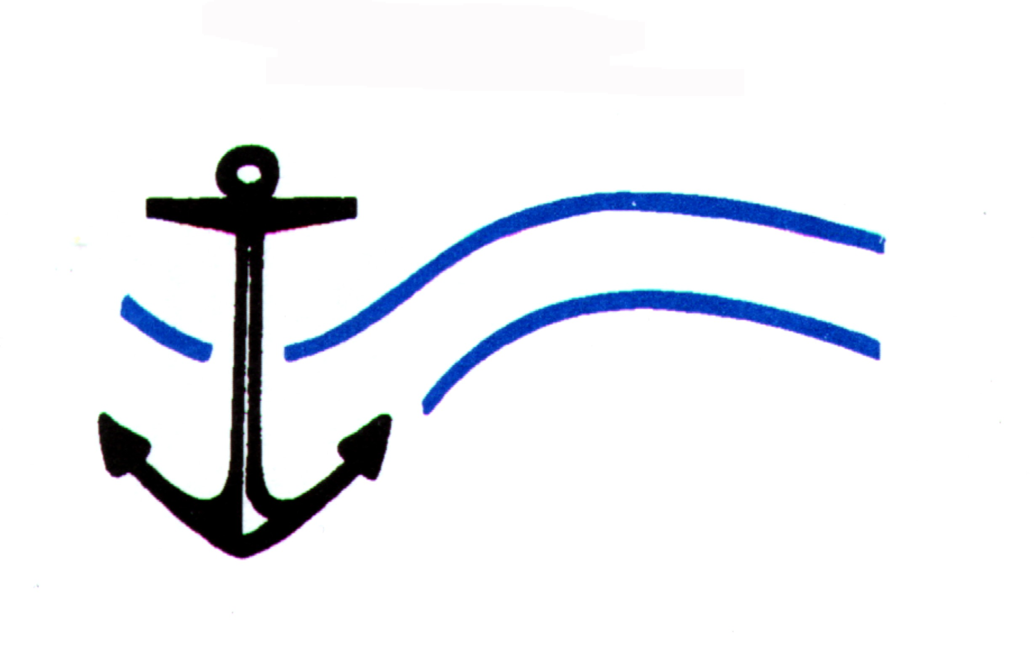
Centre for Marine Studies  University of Cape Town | Oceanography  University of Cape Town

Executive Summary

The sensor, control and telemetry systems, buoy bus, and mooring hardware are all in an advanced stage of construction, and should be ready for system integration and final testing in the first two weeks of February 2004. Deployment at the Namaqua shelf monitoring site is scheduled for the third week of February. In-kind support from Marine and Coastal Management, UCT Oceanography Department and Saturn Solutions (UK) has allowed significant value addition in the form of supplementary instrumentation: an algal fluorometer, a 50 m thermistor chain, and a surface mounted ADCP have all been integrated into the moorings control systems. Total in-kind support for the project is estimated at ZAR 475,000. The website domain, www.hab.org.za. is currently being registered and the website itself is under construction: a functional implementation is scheduled to come online for test purposes in mid February.
Table of Contents

Executive Summary 2

- Rationale 4
- Mooring development
  - Mooring design and construction 5
  - Instrument and control systems 8
  - Telemetry 10
  - Data processing and archiving 11
- Satellite data 11
- Website development 12
- Workplan 13
- Outlook 13
- Notation 15
Appendix I In-kind support 16

List of Figures

Figure 1 BOKKOM schematic 6
Figure 2 Mooring schematic 7
Figure 3 BOKKOM spar frame 7
Figure 4 Mock up of www.hab.org.za frontpage 12
Figure 5 Website navigation tree 13
1. Rationale

The Benguela system suffers from frequent occurrences of a variety of toxic and otherwise harmful algal blooms (HABs). Such blooms can have severe negative impacts on local marine ecosystems and communities, in addition to commercial marine concerns such as rock lobster and mariculture operations. Effective ecosystem management requires a greater understanding of the variability of HABs as ecologically prominent phenomena, and a means of monitoring critical system locations. Coastal management agencies would benefit greatly from a real time capability to detect precursive and formative bloom conditions, and to monitor the advective movement, growth and decay of surface blooms.

This project will seek to demonstrate the utility of real time bio-optical data as an integrated management tool for coastal agencies, and an early warning system with regard to HAB detection and ecosystem protection. Ocean colour data will be used in conjunction with numerical techniques recently developed at UCT to provide algal bio-mass and chemotaxonomic assemblage descriptor data. The real time availability of algal assemblage data on a variety of spatial scales, and with high temporal resolution, will provide a highly effective tool for the prediction, monitoring and ecological analyses of HABs in the Benguela system.

The primary focus of the project will be to construct, deploy and maintain a demonstration bio-optical mooring, to be located on the southern Benguela Namaqua shelf. Additional daily synoptic ocean colour data from the MERIS sensor, supplied under the auspices of the Coastwatch program by ACRI in France, will provide broader scale coverage of the system. Data will be disseminated in near real time via the project's web portal, which will provide additional public health and related educational material.

2. Mooring Development

2.1 Mooring Design & Construction
The mooring will consist of two modules: a surface mooring acting as a securely anchored tethering point, and the self-contained primary bio-optical buoy, designated as BOKKOM to reflect the marine heritage of the South African West Coast communities. Bus and sensor design has been based on the following considerations:

- The use of cost effective, robust and proven radiance/irradiance sensor systems capable of being field calibrated and configured in a measurement geometry appropriate to both in-situ and satellite analogous reflectance measurements

- An integrated bus/sensor configuration designed to minimise both sensor shading and the perturbation effects of surface waves, whilst simultaneously allowing for ease of deployment and calibration from small vessels.

- Data storage, communication and power configuration designed to provide on-board data and power backup systems, and easily configured autonomous interrogation and data analysis systems.

- Modular design allowing the use of proven sensor and control systems, in addition to ease and cost of construction and maintenance.

BOKKOM has been constructed as a 316 grade stainless steel spar buoy with polyurethane encapsulated closed cell polyethylene flotation (SPX33, Sondor Industries, Cape Town). Spar buoy construction was undertaken by Scientific Manufacturing CC (Cape Town, and flotation shaping and encapsulation by Western Cape Mouldings and Patterns Ltd (Cape Town). Schematics of BOKKOM (Figure 1), the complete mooring (Figure 2) and a photograph of the naked spar assembly (Figure 3) can be seen below.

Figure 1 Schematic of the bio-optical mooring BOKKOM, detailing sensor, power and control system configuration.
1.7 m
1.6 m
Figure 2 Schematic of the complete mooring, showing the auxiliary temperature and acoustic doppler current profiling sensors. The demonstration mooring will be located approximately 4 km directly offshore of Lamberts Bay.
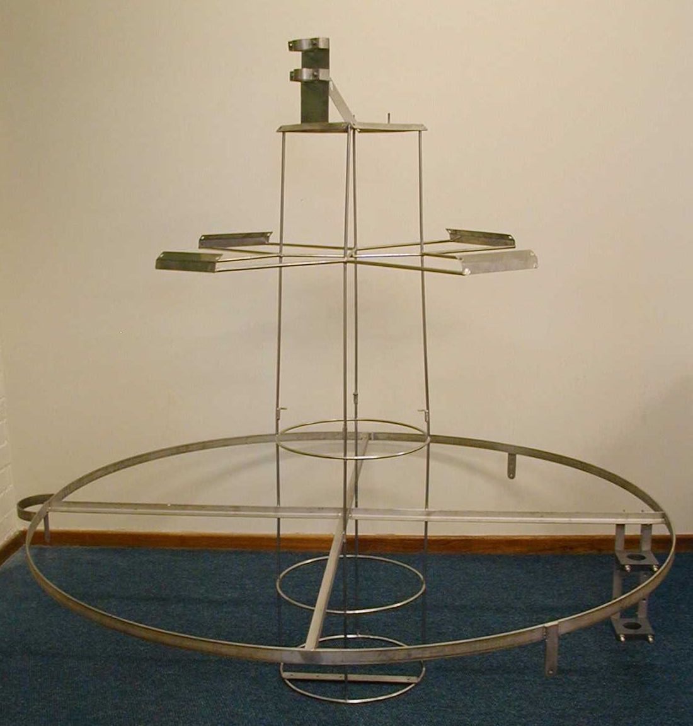

Figure 3 The spar buoy assembly prior to flotation encapsulation. The four solar panel mounts can be seen at the top of the main cage, and the radiance sensor mounting bottom right.
2.2 Instrument and Control Systems
The instrument package on the buoy consists of:

- 1 x OC5XCE Ocean-i Sensor Unit (with internal GSM modem)
(Saturn Solutions, UK)
- 1 x LeadTek GPS 9532
- 1 x RAMSES-ACC Irradiance Sensor
(Trios Optical Sensors, Germany)
- 1 x RAMSES-ARC Radiance Sensor
(Trios Optical Sensors, Germany)
- 1 x SCUFA II Fluorometer
(Turner Designs, USA)
- 1 x Templine 50m thermistor chain
(Apprise Technologies, USA)
- 1 x Workhorse Sentinel 300 Acoustic Doppler Current Profiler
(RD Instruments, USA)

The Ocean-i Sensor Unit is based around an Advantech PCM-7210 integrated Xscale single board computer running Windows CE 4.1 which controls the data sampling routine for the instruments, stores and transmits the data. All the instruments are connected to serial ports on the Ocean-i Sensor Unit and controlled using RS232. The data acquisition routine for the instruments is user programmable, though all instruments are required to start sampling at the same time and continue sampling for the same period. It is anticipated that data will be collected for 2 minutes every hour, on the hour whilst the buoy is deployed. (the data cycle.)

The Ocean-i Sensor Unit is designed principally around collecting and storing data from the RAMSES radiometers. Other instrument acquisitions and data storage have been designed around this. For each acquisition of radiometer data, 3 records of 528 bytes are written to the days data file: a header record, followed by a data record for each of the two radiometers. If radiometer data is not being collected (i.e. when it is dark) only 1 record, a header, is written to the data file for each acquisition. All data is stored in binary format, with a daily yy-MM-dd identifier. The radiometers are scheduled to collect data between 09:00 and 17:00. Outside this time period, the thermistors, SCUFA, ADCP and GPS continue to collect data and save it to the data file as a header record.

RAMSES Radiometers

The two radiometers are sent a start command at the beginning of each data cycle. They collect data for a varying length of time, depending on the integration time being used by the radiometer. Once data has been collected by the radiometers it is transmitted to Ocean-i, which issues another start command to the radiometers and then saves a header and the radiometer data to the data file. This continues until the end of the data cycle in order to collect radiometer data as fast as possible during the cycle. The radiometers automatically sleep between data cycles until they receive another start command.

GPS
At the start of each radiometer acquisition (or any instrument outside the scheduled radiometer times), the GPS is sent a command to retrieve the current latitude and longitude. This information is saved to the header record in the data file. The GPS is also used to update the time on the internal clock in Ocean-i at 00:30 every day if this option is selected.

ADCP
The ADCP is set up to collect data in 2 metre depth cells in 50m of water (24 depth cells). Data is collected for 1 minute 52.5 seconds (an ensemble) with 40 pings of 2.81 seconds per ensemble. At the start of a data cycle, Ocean-i transmits a ‘Wake-up’ command to the ADCP, followed by a ‘Start Pinging’ command. The ADCP internally averages the data collected during an ensemble and transmits a block of data to Ocean-i at the end of an ensemble that consists of the averaged velocity data for the ensemble as well as header information for the ADCP. When Ocean-i receives the data from the ADCP it writes it to the next header in the current data file. The ADCP is powered by internal batteries and automatically enters sleep mode to save power after 5 minutes of inactivity.

Templine Thermistor Chain
The thermistor chain takes approximately 10 seconds to retrieve data from the 17 thermistors. At the start of each data cycle the thermistors are sent a start command. When they have collected the temperature data they transmit it to Ocean-i. If the radiometers are acquiring within the scheduled period, this data is saved to the next header written in the data file. If the radiometers are not acquiring then a header is written to the data file when the thermistor data is received (ADCP and SCUFA data are added to the headers written by the thermistors when the radiometers are not acquiring). Once the thermistor data has been received by Ocean-i, another start command is issued to the thermistors until the end of the data cycle.

SCUFA
The SCUFA power is controlled by Ocean-i. At the start of a data cycle, power is turned on to the serial port that the SCUFA is attached to. The SCUFA then collects and transmits data continuously at a frequency of 1Hz. When a header is written to the data file, either by the radiometers or thermistors, the first data sample collected by the SCUFA is saved to the header. Therefore, the first acquisition from the SCUFA after it is powered up is saved to the first header written during the data cycle. After this SCUFA data is written to each header at the time of the radiometer or thermistor acquisition. At the end of a data cycle, power to the SCUFA is turned off by Ocean-i.

Console Software
The Ocean-i Console software can be run on any remote IBM compatible PC running Windows 98. This can be connected locally to Ocean-i via a serial port or remotely by dialing into Ocean-i using a modem. The Console software allows the user to change the configuration of the data cycle and the Ocean-i set-up and download data. Data is downloaded from Ocean-i by selecting the times and dates between which data is required using the Console software. This data is then requested from Ocean-i and saved to the PC running the Console software as an ASCII data file. The data files can then be viewed using the Console software and the radiometer data can be calibrated.

  - Telemetry
All telemetry hardware services, excluding the Comtech OEM modem in the Ocean-i system, have been provided by MTN. The system consists of a Nokia 30 modem for the main base station, a Sony Ericsson T610 handset for field operations, and appropriate SIM cards and airtime packages. All hardware are HSCSD (High Speed Circuit Switched Data) enabled, and preliminary tests indicate that a transfer speed of ~14 Kbps is possible. Potential transfer speeds have had bearing on the proposed data cycle, as it appears that a transfer rate of ~ 1Megabyte/day is the feasible maximum. Data will be downloaded initially four times per 24 hours, with the website reflecting a daily update. MTN have been extremely helpful and have offered a great deal of time and assistance to the project.

2.4 Data Processing & Archiving
Once data has been downloaded with the Console software, all processing and archiving will be made with Matlab R13 (The Mathworks). Processing will include applying appropriate offsets to optical data, time series analysis on single measurements to assess high frequency variability, application of the primary inverse reflectance algorithm to derive algal chlorophyll a concentrations, size and accessory pigmentation, and archiving of both raw and processed data. The reflectance data is the most processing intensive, and analogous schemes will be used to process and archive surface fluorescence data (SCUFA), temperature profile data (Templine) and current profiles (ADCP).

3. Satellite Data

An agreement has been reached with ACRI in Nice, allowing the project access to daily data from the Medium Resolution Imaging Spectrometer (MERIS) under the auspices of the European Space Agency's Coastwatch program. It is anticipated that both the standard Case 1 water chlorophyll a product, and experimental algal size and accessory pigment data from reflectance algorithms constructed at UCT will be used. ACRI are currently investigating the feasibility of providing concurrent sea surface temperature products, from the Envisat AATSR sensor, and fluorescence line height data, derived from MERIS data. Both of these products would be of great value to HAB monitoring efforts in a physically driven system such as the Benguela. The UCT inverse reflectance algorithms, offering algal size and alternative fluorescence data from MERIS, are in the process of being translated into a mixed language Fortran/Matlab environment, as the current Matlab code is too slow for routine image processing.
4. Website Development

Discussion with Marine and Coastal Management has led to the expansion of the website, with the intention of making the site the main resource centre for harmful algal bloom monitoring and research in Cape Town. M&CM will make in-kind contributions of educational material, and phytoplankton count and toxicity data emanating from their existing monitoring programs. The site is designed with a rapidly loading primary front page that can be used to quickly check the most contemporary mooring and monitoring data, and view any public health warnings. The rest of the web site will carry educational material pertaining to harmful algal blooms and ocean colour data, HAB related research material, and data from both the Namaqua mooring and ocean colour satellites.

A mock-up of the website front page is shown in Figure 4, and a navigational tree for the site is shown in figure 5.
Figure 4 Mock-up of the www.hab.org.za front page. The web site will offer mooring related data, satellite data, phytoplankton count and toxicity data, public health warnings, and educational material.
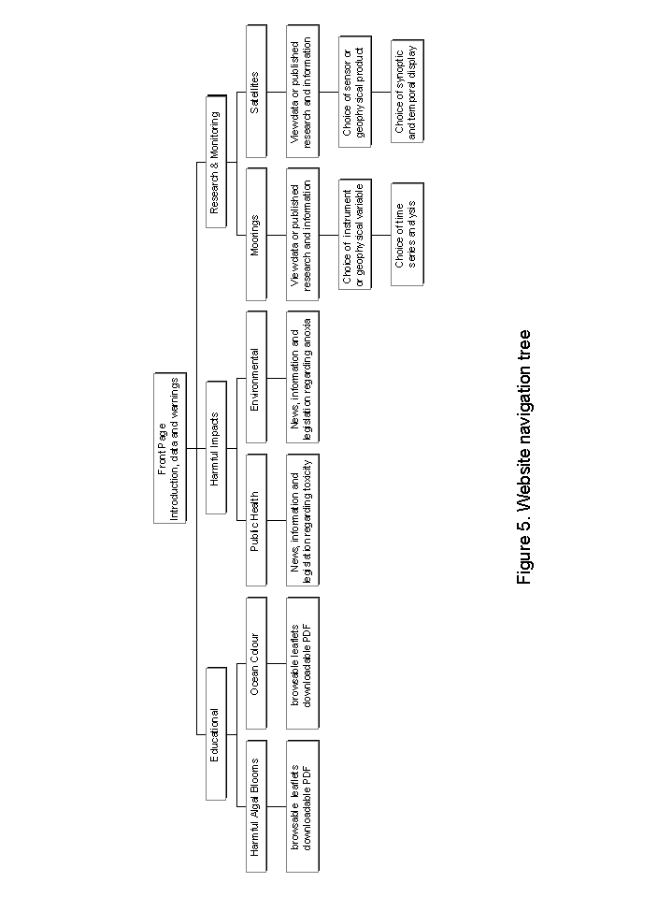
5. Workplan

Segment 1a August 2003 – October 2004 Activities

- Buoy configuration, design and subcontractor sourcing
- Purchasing of sensor, telemetry, power and bus components
- Construction of bus and system components

Segment 1b November 2003 – January 2004 Activities

- Construction of bus
- Instrument communication and integration
- Design of web site
- Interrogation and data storage software development

6. Outlook

The project schedule for the next six months will address the following:

- Final testing of the power and control systems of BOKKOM
- Deployment and field testing of the Namaqua mooring
- Initiation of monthly servicing cycle for the Namaqua mooring
- Creation of automated data processing and analysis code for routinely gathered BOKKOM data
- Translation of inverse reflectance algorithms and fluorescence line height algorithms into Fortran/Matlab for application to MERIS data.
7. Notation

AATSR Advanced Along Track Scanning Radiometer
ACRI Mecanique Des Fluides Observation De La Terre Sciences De L'Environnement

ADCP Acoustic Doppler Current Profiler
BOKKOM Name of the primary bio-optical mooring
GSM Global System for Mobile Communications
GPS Global Positioning System
HAB Harmful Algal Bloom
HSCSD High Speed Circuit Switched Data
M&CM Marine and Coastal Management
MERIS Medium Resolution Imaging Spectrometer
SCUFA Self Contained Underwater Fluorescence Apparatus
UCT University of Cape Town
Appendix I
In kind support and value additions

Marine and Coastal Management
RDI Sentinel 300 ADCP (moored instrument) ZAR 300,000
Turner Designs SCUFA (moored instrument) ZAR 80,000
Estimated boat time and logistical support ZAR 40,000

In addition to making supplementary mooring instrumentation available to the project, M&CM will provide boat time for mooring deployment and servicing, and has provided test facilities, technical and logistical support.

Oceanography Department, University of Cape Town
Apprise Technologies Templine Thermistor Chain ZAR 30,000

Saturn Solutions, UK (John Cheriton)
Communications and software development € 3,000

MTN (South Africa)

MTN have offered a great deal of technical support, and have offered to send an engineering team into the field during initial deployment to make any antennae/system adjustments necessary for signal optimisation.

Total Estimated In-kind support ZAR 475, 000

The supplementary moored instrumentation has been integrated into BOKKOM's sampling and telemetry systems and will be available in real-time - whilst such data do not constitute part of the project's specified deliverables they form a valuable part of the larger scale regional effort with regard to harmful algal bloom monitoring.

