BCLME Project EV/Angola/03/06

Upgrade Communication Systems for Angolan
BCLME core partner institutions

A project contracted to:
The Instituto de Investigação Marinha (IIM), Angola

By:
The United Nations Office for Project Services (UNOPS)

On behalf of:
The Benguela Current Large Marine Ecosystem Programme (BCLME)

Final Report
February 2005

PROJECT TEAM:
Nkosi Luyeye
(Principal Investigator)
and
Domingas Azevedo



EXECUTIVE SUMMARY

The BCLME Programme is a joint initiative of Angola, Namibia and South Africa to facilitate the integrated management, sustainable development and protection of the highly dynamic and productive Benguela Current Large Marine Ecosystem. However, regional co-operation is being hampered by the poor communications infrastructure in Angola. The long civil war left the country’s telephone network in a state of disrepair, compromising telephonic communication as well as e-mail and Internet access. This not only inhibits the ability of the Instituto de Investigação Marinha (IIM) - the principal BCLME institution in Angola – to communicate with its regional partners in Namibia and South Africa, but also negatively impacts the operational management of IIM, by limiting interaction between the organisation’s headquarters in Luanda and its research centres in Lobito and Namibe. The strengthening of institutional capacity was identified as a high priority in the BCLME Programme’s Strategic Action Plan.

The BCLME Programme therefore commissioned the current project “Upgrade communications systems for Angolan BCLME core partner institutions”. This report addresses the first phase of the project, during which the communication needs of IIM were assessed, and technical solutions to address those needs investigated. The facilities offered by various service providers were explored, and costs associated with telephony, satellite and wireless communications technology defined. Based on these findings, recommendations were made on the most cost-effective options for improving IIM’s communications systems. Implementation of these recommendations is expected to take place in Phase 2 of the project.

TABLE OF CONTENTS

EXECUTIVE SUMMARY
TABLE OF CONTENTS

1. INTRODUCTION 1
1.1 Scope of the study 1
1.2 Methodology 2

2. COMMUNICATIONS IN ANGOLA 3
2.1 Historical background 5
2.2 Overview of telecommunications technology in Angola 6
2.3 Telecommunications service providers in Angola 6

3. CURRENT SITUATION 9
3.1 IIM-Luanda 9
3.2 Regional Centre-Lobito 10
3.3 Regional Centre-Namibe 10

4. SOLUTIONS FOR UPGRADING COMMUNICATIONS 11
4.1 IIM-Luanda 11
4.2 Regional Centre-Lobito 13
4.3 Regional Centre-Namibe 14

5. RECOMMENDATIONS 15
5.1 IIM-Luanda 15
5.2 Regional Centre-Lobito 15
5.3 Regional Centre-Namibe 16

6. CONCLUSION 17

1. INTRODUCTION

The Benguela Current Large Marine Ecosystem (BCLME) is a highly dynamic and productive ecosystem bordering the countries of Angola, Namibia and South Africa on the south-western coast of Africa. The BCLME Programme is a joint initiative of the three countries to facilitate the integrated management, sustainable development and protection of this unique ecosystem. However, regional co-operation as well as national research capacity is hampered by the poor communications infrastructure in Angola. Much of the county’s telephone network was either destroyed by sabotage during the civil war, or fell into disrepair through lack of maintenance.

A need was therefore identified to upgrade the telephone, fax, e-mail and Internet capabilities of the Instituto de Investigação Marinha (IIM), the principal BCLME partner institution in Angola. The headquarters of IIM are in Luanda, but there are two regional research centres in Lobito and Namibe. A third centre is to be established in Cabinda to support monitoring activities related to oil production in Angolan waters.

  - Scope of the study

The primary objective of BCLME Project EV/ANGOLA/03/06 is to upgrade the communication system of IIM, allowing for reliable and cost-effective communications. The project is divided into two phases, with Phase 1 focussing on assessing the existing communications capacity and immediate needs, and investigating options for improvement. Implementation of the selected options will be the subject of Phase 2.

The current study addresses Phase 1 of the project. The Terms of Reference for Phase 1 outlined the following expectations of the Contractor:
- Prepare a comprehensive review of the communications needs of IIM, including those of the regional marine research centres of Namibe and Lobito
- Undertake an exhaustive search of the technical solutions available for satisfying these communications needs
- Evaluate the possible technical solutions, including technical feasibility, requirements of equipment and support personnel, reliability and cost
- Recommend the most cost-effective option.

The following elements fall within the definition of communication systems and capabilities:
- Telephone contacts
- Telefax communications
- E-mail
- Internet access
- Web-page for access to IIM´s information and data (where applicable).

The output required of Phase 1 was identified as:
A report listing the communication needs of IIM and the technical solutions available for satisfying these, including an evaluation of the possible alternatives. The report should take into consideration at least the following elements of each alternative solution:
  - Adequacy and reliability of the institutions/service providers involved
  - Cost and reliability of the equipment necessary
  - Running costs of the system
  - Maintenance requirements and local availability of maintenance services
  - Requirements of in-house support personnel.

This report represents the output of Phase 1 of the project.

1.2 Methodology

Data required for the project were collected over 4 months (ca. 120 person days) from both published and unpublished sources, including organisational profiles and Internet web sites. In addition, project team members visited a number of government institutions and private companies to collect relevant information and conduct interviews with key representatives of these institutions (Table 1). However, the availability of information, and the ability of these representatives to supply the required information, proved to be a major constraint.

Table 1: Synthesis of meetings with representatives of key government institutions and private companies. All meetings were attended by both members of the project team.
Name | Position/Area | Company | Province | Tel. Nos.
Diamantino R.S. Monteiro | General Director | MULTITEL | Luanda | 637100
Haymée Pérez Cogle | Technical Director | NEXUS | Luanda | 336533
Laurindo Sachimuna | Technical Director | Angola Telecom | Namibe | 22884
Sudika Santos | Sales Representative | SISTEC | Benguela (Lobito) | 325350
Cândido Neto | Technical Director | Angola Telecom | Luanda | 396890

The study comprised the following steps:
- Local Government institutions and private companies involved with communications in the three provinces were identified
- Data were collected on existing infrastructure and type of equipment
- Gaps and weaknesses, and requirements and opportunities for upgrading communications, were identified, after which recommendations were put forward as how best to address the identified problems and take advantage of available opportunities.

- COMMUNICATIONS IN ANGOLA

Angola is bordered by Namibia in the south, Zambia in the east, and the DRC in the north. The country is divided into 18 provinces, six of which are situated along the coastline (Figure 1). The current study focuses on three of these provinces, namely Luanda (IIM headquarters in the capital), Benguela (Regional Centre in Lobito) and Namibe (Regional Centre in Namibe).

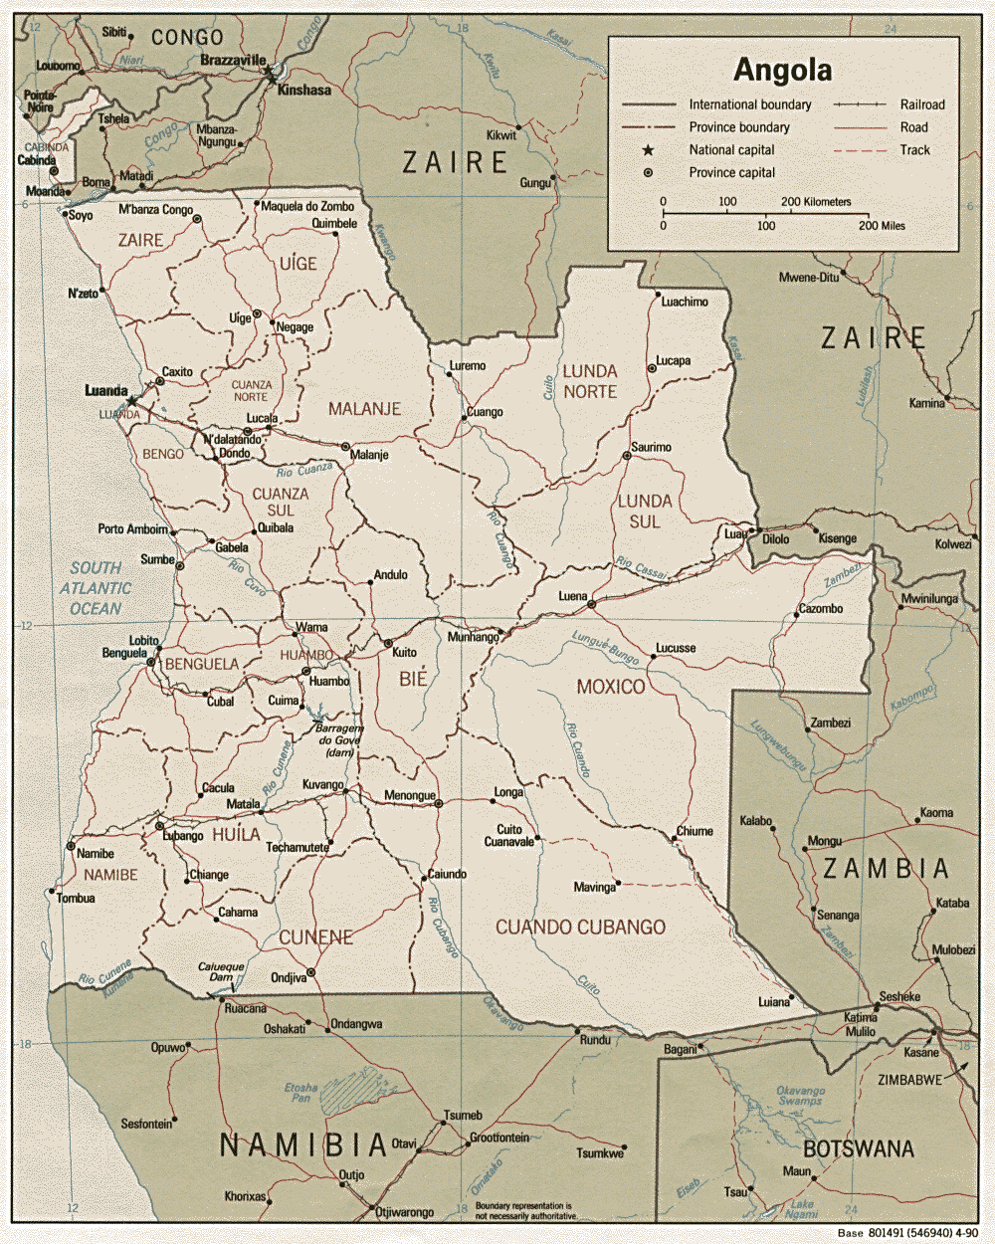

Figure 1: Map showing the 18 provinces of Angola. The IIM headquarters and two Regional Centres are situated in the coastal towns of Luanda, Lobito and Namibe respectively.

2.1 Historical background

By 1975, the year of independence, a telephone network had already been established in Luanda. The new Angolan government subsequently created three communication companies: the Angolan National Company of Post Office and Telegraph (ENCTA), the National Company of Telecommunications (Enatel), responsible for domestic communications, and the Public Company of Telecommunications (Eptel), responsible for international communications.

Eptel was created by the Bill 95/76 on the 23rd December 1976, following the acquisition of the Portuguese company, Radio Marconi, by the Angolan government. Before it began operating in 1977, all international communications were handled by the existing joint postal and telecommunications service.

Enatel was created by the Bill 17/80 on 13th February 1980, following the separation of the postal and telecommunications services. Until the creation of Angola Telecom in 1992, these two public companies provided the entire telecommunications service in Angola. All issues relating to telecommunications were regulated by the Ministry of Transport and Communications, as well as the guidelines of international organisations such as the International Union of Telecommunications (IUT).

Eptel and Enatel were merged by the Bill 10/92 on 6th March 1992 to create Angola Telecom, a parastatal company wholly owned by the Angolan government. It provides domestic and international telephonic services to both residential and corporate users.

In 1999, due to high demand from the local market, the Angolan Government privatised telecommunications. Bill 12/99 on 25th June 1999 established the Angolan National Institute of Communications (INACOM) as a public institution within the Ministry of Post Office and Telecommunications, but with financial and administrative autonomy. This Institute is responsible for regulating and monitoring all activities related to telecommunications in Angola.

2.2 Overview of telecommunications technology

2.2.1 FWA

Fixed Wireless Access (FWA) is the use of wireless technology to connect to the telephone network, without the need for copper cabling or satellite feeds. It uses a small, inexpensive microwave antenna attached to a radio at the client’s premises and linked to the base station tower via signal transmission through the air.

2.2.2 VSAT

Very Small Aperture Terminal (VSAT) consists of an outdoor transceiver that can send or receive signals to a satellite transponder, and an indoor device to interface the transceiver with the end user’s communications device. Each end user is connected via the satellite to a ground station computer, which acts as a hub for the system. Each transmission therefore goes from the end user via the satellite to the hub and back again to other users.

2.2.3 GSM

Global System for Mobile Communications (GSM) is the world’s most popular standard for mobile phones. More than one billion people use GSM phones as of 2005, making up about 70% of the world’s mobile phone market. GSM is a cellular network, which means that mobile phones connect to it by searching for cells in the immediate vicinity. Cell radius varies depending on antenna height, antenna gain and propagation conditions, but the longest distance the GSM specification supports in practical use is 35 km. Most GSM networks operate at frequencies of 900 MHz and/or 1800MHz.

2.3 Telecommunications service providers in Angola

Angola Telecom is by far the dominant player in telecommunications in Angola. However, some private enterprises provide landline and cellular telephone services. These include: MULTITEL, NEXUS, SISTEC, UNITEL and MOVICEL.

In addition, there are some small local enterprises licensed by INACOM for services such as maintenance, but not installation, of telecommunications systems.

Table 2: Government institutions and private companies involved with communications in the three provinces under study.
Province | Government Institutions | Private Companies
Luanda | Angola Telecom, INACOM | MULTITEL, NEXUS, SISTEC, UNITEL, MOVICEL
Benguela | Angola Telecom, INACOM | SISTEC, UNITEL, MOVICEL, NEXUS
Namibe | Angola Telecom, INACOM | SISTEC, UNITEL, MOVICEL, NEXUS

2.3.1 ANGOLA TELECOM

Angola Telecom has separate services for corporate and residential clients. This report focuses on corporate services, which include:
- VSAT
- Inmarsat
- Telex
- Internet.

Angola Telecom has a presence in all 18 provinces of Angola. E-mail and Internet services are provided through a joint-venture agreement with the private telecommunication companies licensed by INACOM.

2.3.2 MULTITEL

MULTITEL is a private telecommunications company licensed by INACOM. It was created in 2000 as a joint venture between Angola Telecom and Portugal Telecom Ventures SGPS SA. It provides Fixed Wireless Access (FWA) in the 3.5 GHz band and with a throughput of 128 kbps; as well as Internet and VSAT services. Installation of VSAT is quick and easy, and provides a high-quality voice communication system in areas lacking a telephone network. The company is currently operating only in Luanda, but will soon expand to other provinces, such as Benguela, Namibe and Kwanza Sul.

2.3.3 NEXUS

NEXUS Telecommunications and Services is the result of the merging of EBONet, Netangola and Telesel in 2003. The company supplies FWA that allows clients to communicate through mobile and landline telephones. It also has a system based on ADSL technology (Asymmetric Digital Subscriber Line) that allows:
- Broadband Internet access
- Installation of fixed telephone networks
- Installation of dedicated point to point circuit links.

The company also offers VSAT Internet “iWAY Africa” with an internal DW6000 Ku Band terminal, which allows 24-hour access to the Internet with a limited data throughput.

The above two services are only available in Luanda. However, NEXUS also provides VSAT-based 24-hour Internet access and VPN (Virtual Private Networks) to other provinces. A shared service using a VSAT parabolic reflector antenna of 1,2 m allows a maximum throughput of 256 kbps, while a dedicated service making use of a parabolic reflector antenna of 1,8 m provides a throughput of up to 8 Mbps.

2.3.4 SISTEC

SISTEC is a private company operating in ten provinces. It supplies FWA and VSAT, the latter using a DW4020 Ku Band terminal and allowing for 24-hour Internet access with a limited data throughput.

2.3.5 UNITEL

UNITEL is a private GSM operator with approximately 250 000 subscribers. It provides mobile phone services in at least 10 of the 18 provinces, including the coastal provinces of Cabinda, Luanda, Kwanza Sul, Benguela and Namibe.

2.3.6 MOVICEL

MOVICEL is a private GSM operator providing mobile phone services as an AMPS/CDMA operator under agreement to Angola Telecom. It operates in Luanda, Benguela, Bengo, Zaire and Huila.
3. CURRENT SITUATION

3.1 IIM-Luanda

Communications have long been a major difficulty at IIM’s head office in Luanda, as well as at the regional centres in Lobito and Namibe. However, a noticeable improvement occurred at the end of 2003, when the new Minister of Fisheries was appointed, and there is now a functioning communication system. E-mail and Internet access is provided through a Fixed Wireless Access system installed by MULTITEL. The system’s independence of the national telephone network is a major advantage. Some 16 PCs at IIM-Luanda are connected to the Internet through the small network installed on a 24 port switch.

MULTITEL provides 10 e-mail accounts for use by key staff. However, at present almost everyone uses private web-mail systems that are very costly in terms of bandwidth.

The initial installation of the FWA equipment was done at no charge, as this formed part of the leasing agreement for the contract subscription period. The only cost incurred is the monthly subscription fee of 917.00 USD, which includes ongoing technical support and maintenance.

Telephone and telefax facilities are used for other means for communication. However, communication with the regional centres and BCLME partners is hampered by the availability of telephone facilities for national and international calls (Table 3). There is only one fax machine at IIM-Luanda, situated in the office of the Director General.

Table 3: Availability of telephones at IIM-Luanda.
Accessability | Quantity
Local (intra phone) | 17
National | 3
International | 2

3.2 Regional Centre (RC) – Lobito

At present, communication problems at RC-Lobito are more severe than those at IIM-Luanda. There is only one PC with e-mail and Internet access, and this is located in the Director’s home, adjacent to the centre.

The system was installed by SISTEC, and is linked to a telephone installed by Angola Telecom. The installation cost of the e-mail and Internet system was 6 400.00 USD, and the monthly subscription is approximately 350.00 - 1 000.00 USD, depending on the number of telephone calls and time spent online.

3.3 Regional Centre (RC) – Namibe

Communications problems are most severe at RC-Namibe. The centre is situated on a hill approximately 2 km from the harbour, and is connected to the town by a rough gravel road. Electricity (220v, 60amp) is provided by the municipality, but the supply is erratic. A standby generator (50 kHz) starts automatically when the municipal supply fails.

A telephone and fax machine is available, but neither is functional. This is because the cable between the Research Centre and the town of Namibe has failed owing to lack of maintenance for more than a decade. There are only two cellphones available, one for the Director and another for the laboratory. An e-mail facility is installed at the Director’s home, about 5 km from the centre. This means that e-mail facilities are currently not available at RC-Namibe, although this is in the process of being addressed as part of a BCLME project and IIM’s Strategic Science Plan.

4. SOLUTIONS FOR UPGRADING COMMUNICATIONS

4.1 IIM-Luanda

Apart from MULTITEL, other service providers in Luanda are Angola Telecom, SISTEC and NEXUS. Angola Telecom provides normal telephone landlines, for which there is an installation fee as well as ongoing running costs. The installation fee depends on the number of landlines requested and the location of the institution within the city, which influences line availability. Typically it costs between 3 000.00 and 7 000.00 USD, including the equipment and its ongoing maintenance. Monthly bills for the subscription fee and telephone calls made usually vary between 500.00 and 3 000.00 USD.

SISTEC provides normal telephone landlines at the same charges as Angola Telecom. It also offers VSAT services for three different client types:
- SOHO = Small Office/Home Office: 1 to 4 PCs with shared links allowing maximum data throughput of 128 kbps, with usage limited to 1 GB per month.
- SE = Small Enterprise: This service applies to 5 to 8 PCs with shared links allowing maximum data throughput of 128 kbps, but with minimal debit of 2K (uplink) and 6K (downlink). Usage is limited to 4 GB per month.
- ME = Medium Enterprise: This service applies to 17 to 32 PCs with shared links allowing maximum data throughput of 256 kbps, but with minimal debit of 8K (uplink) and 24K (downlink). Usage is limited to 8 GB per month.
Costs associated with these services are shown in Table 4.

Table 4: Costs associated with VSAT services provided by SISTEC in Luanda.
EQUIPMENT | DESCRIPTION** | Qt | Unit (US$) | TOTAL
VSAT BAND  Ku DW 4000/4020 includes 5 e-mail accounts and Internet access | SOHO
 | Initial installation  Monthly subscription | 1  1 | 6 450.00  450.00 | 6 450.00  450.00
 | SE
 | Initial installation  Monthly subscription | 1  1 | 7 500.00  570.00 | 7 500.00  570.00
 | ME
 | Initial installation  Monthly subscription | 1  1 | 8 775.00  1 550.00 | 8 775.00  1 550.00
** The number of PCs and e-mail accounts can be altered on request.

NEXUS offers two main services, namely VSAT Internet “iWAY África” and FWA. The latter is only offered in Luanda; however VSAT is available countrywide, and more than 35 government and private institutions are currently using this communication system. The cost of the initial installation of the VSAT terminal DW 6000 is 3 850.00 USD. The service includes four or more e-mail accounts and Internet access. The subscription fee depends on the category requested (Table 5), i.e. Small Enterprise (SE), Small and Medium Enterprise (SME) and Medium Enterprise (ME).

Table 5: Subscription costs associated with VSAT services provided by NEXUS in Luanda.
Duration | Category | USD
3 months | SE | 1 560.00
6 months | SE | 2 964.00
12 months | SE | 5 850.00
Duration
3 months | SME | 2 700.00
6 months | SME | 4 950.00
12 months | SME | 9 450.00
Duration
3 months | ME | 4 500.00
6 months | ME | 8 550.00
12 months | ME | 16 650.00

4.2 RC-Lobito

In order to address the communications needs of RC-Lobito, the following actions are recommended:
- Install a dedicated fax landline
- Increase the number of telephone lines to improve e-mail and Internet access
- Change to a VSAT system
- Install an internal network (Intra-network).

The communications service providers operating in Lobito are Angola Telecom, SISTEC and NEXUS. The Angola Telecom service is unreliable, while SISTEC and NEXUS have robust systems with locally based maintenance staff. SISTEC adds a 3% surcharge to the prices applicable in Luanda (Table 4) for provincial services. The prices for services offered by NEXUS are presented in Table 6.

Table 6: Prices for the service (AFSAT) provided by NEXUS.
ITEM | Category | USD
Installation | Shared system | 1 500.00
Installation | Private system | 3 500.00
Duration
3 months | SE | 2 250.00
6 months | SE | 4 200.00
12 months | SE | 7 800.00
Duration
3 months | ME | 6 000.00
6 months | ME | 11 400.00
12 months | ME | 22 200.00

4.3 RC-Namibe
The schematic plan in Figure 2 shows the position of the existing non-functional telephone cable at RC-Namibe, and two possible routes for its replacement.
An estimate provided by Angola Telecom for replacing the system is shown in Table 7. SISTEC and NEXUS also operate in Namibe, providing the same services as in Lobito.

Figure 2: Schematic plan of possible routing of telephone cabling for RC-Namibe.

Table 7: Estimate by Angola Telecom for replacing the telephone system.
Nº | Designation | Quantity | Price (unit)
Nº | Designation | Quantity | Kwanzas | USD
1 | Cable (with 4 pairs) | 2000 m | 89 000.00 | 1 000.00
2 | Cable KVD (5 pairs) | 70 m | 14 000.00 | 140.00
 | Cramp | 20 boxes | 3 600.00 | 40.00
 | Isolating tape | 2 boxes | 3 600.00 | 40.00
 | Aerial connection | 160 m | 8 900.00 | 100.00
 | Telegraph post | 5 | 89 000.00 | 1 000.00
 | Hoops | 10 boxes | 18 000.00 | 200.00
 | Groove | 3 boxes | 14 00.00 | 150.00
 | Telephone | 5 | 45 000.00 | 500.00
 | Fax | 2 | 89 000.00 | 1 000.00
 | PBX (central) | 1 | 270 000.00 | 3 000.00
TOTAL |  |  |  | 7 170.00
* Note: The price is subject to inflation of the local currency

5. RECOMMENDATIONS

5.1 IIM-Luanda
It is recommended that the existing FWA system installed by MULTITEL for e-mail and Internet access is maintained, as it has performed well to date. However, telephonic communication needs to be improved. An additional three telephone lines for international calls, as well as a fax machine with a dedicated line, should be installed. This would cost approximately 1 300.00 USD, excluding operational charges.

5.2 RC-Lobito

The existing telephone line at RC-Lobito should be supplemented with two additional lines, and a PBX Telephone Exchange and fax machine installed. The cost of purchasing and installing this equipment would amount to approximately 6 500.00USD.

It is also recommended that a VSAT DW 6000 terminal is installed, as the VSAT system’s fixed rate for running costs is more cost-effective than landlines for e-mail and Internet access. The equipment can be purchased from NEXUS for 3 850.00 USD and installed for an additional 3 500.00 USD. Alternatively, the equipment can be leased, in which case only the installation cost of 3 500.00 USD and the operational costs apply (Table 8). The SE category and Option 1 would be most suitable for RC-Lobito.

Table 8: Operational costs for the VSAT service provided by NEXUS.
Designation |  | Option 1 | Option 2
Subscription | Category | Buying (USD) | Leasing (USD)
Duration
3 months | SE | 1 560.00 | 1 740.00
6 months | SE | 2 964.00 | 3 306.00
12 months | SE | 5 850.00 | 6 264.00
Duration
3 months | SME | 2 700.00 | 3 978.00
6 months | SME | 4 950.00 | 7 558.00
12 months | SME | 9 450.00 | 14 320.00
Duration
3 months | ME | 4 500.00 | 6 451.00
6 months | ME | 8 550.00 | 12 257.00
12 months | ME | 16 650.00 | 23 224.00

5.3 RC-Namibe
The old telephone system at RC-Namibe should be replaced as suggested by Angola Telecom (Figure 2 and Table 7), and a fax machine installed. For e-mail and Internet access, it is recommended that the same VSAT system is installed as for RC-Lobito (Table 8).
The total cost of upgrading the communication system for RC-Namibe would therefore amount to approximately 16 870.00 USD. This would include the purchase and installation of the VSAT equipment, the subscription for one year, and replacing the telephone system.

6. CONCLUSION

This assessment confirmed that the communication systems of IIM’s headquarters and regional centres are woefully inadequate, and need to be upgraded if Angola is to participate equitably in the BCLME Programme. Various options for improving the current situation have been explored, and recommendations made in this regard. The implementation of these recommendations is expected to take place in Phase 2 of the project.

