BCLME Project EV/PROVARE/06/01

Development of Satellite Remote Sensing Products

for Operational Application

Report 3
January 2007

Progress Report 1
Stewart Bernard
Christo Whittle
Ray Barlow
Tarron Lamont
Lionel Delaney

Benefit Environment Fisheries Interaction and Training Programme
Swakopmund, Namibia
Executive Summary

The project has made considerable progress with regard to both short term objectives and laying the ground for sustainable development of a regional remote sensing capability. Progress can be summarized as follows:

- The Remote Sensing Server for Marine Sciences has been running well since launch in July 2006, and has received wide spread use. Example usages include a variety of student projects at UCT and the Polytechnic of Namibia, and inclusion in Elsevier’s Encyclopedia of Ecology.
- Experimental ocean colour products have been disseminated through the hab.org.za web site, which currently provides algal descriptors for the Greater St. Helena and Walker Bay regions (in conjunction with the Frontier Programme, Department of Science and Technology)
- Validation analyses are in progress and approximately 50 MERIS and 120 MODIS radiometric match ups are expected over a cumulative 12 months of buoy data. A full technical report is scheduled for late 2007.
- The project has put a great deal of work into establishing international collaborations and will play a leading role in the GOOS/GEO ChlorOGIN pilot project, in addition to a wide variety of GOOS-Africa remote sensing pilot projects.
- Training is progressing well: two M.Sc students associated with the project have graduated; another has found permanent employment with the CSIR; the two directly supported students are making good progress; and project personnel will play a leading role in the forthcoming JRC sponsored Ocean Colour training course in Kenya
- The project has had many publications associated with it in 2006: seven papers in refereed journals and two book chapters. In addition project personnel have attended six international conferences and workshops.

Table of Contents

1. Maintenance and Evolvement of Remote Sensing Server
  - Server Usage and Feedback 4
  - Server Maintenance 7
  - Server Evolution and Refinement 8
2. Development of Processing Protocols, Products and Indices
2.1 MODIS-AQUA Data Processing Summary 9
2.2 NOAA-AVHRR Data Processing Summary 10
2.3 ENVISAT-MERIS Data Processing Summary 11
2.4 Development of Indices 12
2.5 MeteoSat Second Generation: Pilot Projects 15
2.6 Synergy with GOOS-Africa Remote Sensing Pilot Projects 17
3. Server Analysis Tools 18
4. Ocean Colour Validation 19
4.1 Continued Buoy Operations 21
5. Data Dissemination Systems 22
6. Training 24
6.1 PhD Progress Report: Tarron Lamont 24
6.2 M.Sc Progress Report: David Lionel Delaney 26
6.3 Indirect M.Sc Support: Lisl Robertson 30
6.4 Other Postgraduate Support 31
6.5 Training Courses 31
7. International and National Collaboration 32
8. Publications 33
9. Co-funding and In-Kind Contributions 35
1. Maintenance and Evolvement of Remote Sensing Server

One of the principal deliverables of the project is the Remote Sensing Server for Marine Sciences (http://www.rsmarinesa.org.za). This section describes take-up of the server from the marine science community and resultant feed-back, tasks performed in server maintenance, and ongoing work to evolve and refine the type of products available through the server.

  - Server Usage and Feedback

We have received very little user feedback via e-mail. It is clear that the site is being visited frequently because since going on line there has been an average of 265 hits per day, which does seem to indicate a large amount of interest amongst the user community. The exact demographic of this user community will be established by introducing a user survey page on the website. Data from the server has been used in a BCLME project, entitled “Assessing potential to produce final Ocean Colour Maps of Namibia’s Marine Environment”, from which we have received feedback in the form of a report and also some personal communication.

Vera de Cauwer, a lecturer at the Polytechnic of Namibia, lead a pilot project to produce a set of ocean colour maps for the Namibian marine region derived from MODIS Aqua data and to evaluate the resultant products in relation to similar products available from the Marine Remote Sensing Unit (MRSU) based at the University of Cape Town. Both chlorophyll-a products were also compared to in situ data. The main aim of the project was to demonstrate the ability of a Namibian tertiary institution to support the research activities of Namibia’s Ministry for Marine Fisheries and Resources (MFMR).

The software tools required for data processing and analysis included NASA’s SeaDAS and SeaSAT from the MRSU. MODIS aqua level 1 and level 2 products were downloaded from NASA’s Ocean Colour Site (http://oceancolor.gsfc.nasa.gov) and chlorophyll-a data for the Namibian marine region was included in the suite of outputs. Polytechnic Namibia’s chlorophyll-a product was compared to the standard chlorophyll-a product available from the MRSU (www.rsmarinesa.org.za), as well as the trial chlorophyll-a product produced with an experimental algorithm under development by Bertrand Saulquin. In situ data was available from two focus areas in the Namibian Exclusive Economic Zone: the Walvis Bay monitoring line at 23ºS and the area offshore of Lüderitz (~26.5ºS). Comparison of MODIS data produced at Namibia Polytechnic (solid lines), MODIS data from the MRSU and in situ data are shown in figures 1 and 2 below.

Figure 1. A comparison of MODIS data produced at Namibia Polytechnic (solid lines) with in situ data obtained from MFMR along the 23ºS monitoring line. There was a good overlap between the in situ values and the MODIS data for most of the station measurements considering the time interval between measurements and image acquisition, although several inshore MODIS-derived chlorophyll-a values were found to be extremely high (not representative of in situ sampling).

Figure 2. MODIS Aqua chlorophyll-a products obtained from the MRSU are represented by solid lines and the blue blocks represent in situ measurements along the 23ºS monitoring line provided by MFMR. Chlorophyll-a values obtained from the experimental algorithm (orange line) represents a reduction in concentration with respect to the standard MRSU chlorophyll-a product, with a greater concentration reduction observed for higher chlorophyll-a values.

This investigation resulted in constructive feedback about the applicability of data and tools available from the MRSU website to routine monitoring and trend investigation in the Namibian EEZ. Faster data download speeds were obtained from the MRSU server than for the NASA server. This is a significant benefit in a region where internet bandwith for data downloads is often a problem. The standard MRSU daily chlorophyll-a product is a mean composite of two MODIS Aqua overpasses acquired on the same day, thus providing an overall picture on days when one overpass provides only partial coverage of the northern Benguela region. Ms de Cauwer observed that the automatic creation of daily composites is advantageous for quick evaluations and operational use, but noted that a single overpass date and time is required for the comparison of satellite derived chl-a data to in situ samples. A more extensive comparison of in situ data and MRSU products is required to confirm the apparent improved chlorophyll-a concentration results obtained from the experimental algorithm. SeaSAT was easily installed and found to be user friendly and versatile for initial data analysis. However, users are limited by the inability to change the data scaling, projections or palettes. A more sophisticated GIS tool is required for detailed scientific analysis.

Christo Whittle performed an exercise to demonstrate the value of MODIS Aqua data obtained from the MRSU server to the ecosystem monitoring activities of Marine and Coastal management. The coastal configuration and widening shelf of St Helena Bay creates a relatively sheltered area which is a major nursery ground for the pelagic fisheries on the South African West Coast. Marine and Coastal Management conducts monthly research expeditions along the St Helena Bay Monitoring Line to attain seasonal and interannual information on the hydrology and productivity of the area as related to the young fish stages. Satellite data from the MRSU server will provide a useful addition to the information recovered from the routine hydrographic and biological sampling.

Daily Chl-a and SST MODIS Aqua binary data were downloaded from the MRSU server for the period January 2004 to April 2006. The binary data were imported into the Terascan satellite data analysis software package and composited into monthly means. SST and Chl-a data were then extracted from each station location along the St Helena Bay monitoring line to produce Hovmuller plots of the time series (figure 3). Summer solar insolation is evident offshore in the SST Hovmuller plot (SST>18ºC). Warmer inshore temperatures (SST>16ºC) are observed in the summer during all three years, with the most persistent inshore warm temperatures observed during December 2004 to March 2005. The highest Chl-a values are also observed during this period. There is no offshore temporal variability evident on the Chl-a Hovmuller plot. So, the data illustrate that higher inshore average Chl-a values were associated with higher inshore average SST values and that the highest mean production was measured in the summer of 2004/2005.

Figure 3. Hovmuller plots depicting two years of monthly mean SST and chl-a data on the St. Helena Bay Monitoring Line.

This exercise does not resolve the upwelling temporal event scale, and direct correlations between warm coastal waters and high production would be erroneous. However, the exercise does illustrate the ease with which binary satellite data could be imported into another remote sensing analysis software package and manipulated to produce plots for time series analysis. By selecting different temporal periods for composites (daily, 3-day, 5-day, etc), the higher spatial and temporal density in surface data would make a significant contribution to the SHBML.

  - Server Maintenance

The server has been maintained both remotely (Bertrand Saulquin from France) and locally (Marine Remote Sensing Unit, UCT). In general the server has been running very reliably, with occasional down-time resulting from power cuts in Cape Town, and the sporadic lack of availability of either the NASA ftp server or the UCT ftp proxy server. The following tasks have been performed since the server release in July 2006:

- Corrections of minor bugs on the processing chain and the web server.
- Daily supervision of running process and maintenance, using ssh remote connection from France.
- Reprocessing of all MODIS binary dataset (2006-2006), following the discovery of a minor bug in the binary data. Two stations in France were used for reprocessing the historical dataset.
- Transfer of New IFREMER CHL-a algorithm data to the server.
- Transfer of reprocessed data to the server.
- Supervision of semi-automatic data transfer routines.

  - Server Evolution and Refinement

The server currently provides both standard NASA Ocean Color Group (OCG) products (chlorophyll a concentrations and sea surface temperature), and chlorophyll a concentrations from an experimental IFREMER algorithm, all from the MODIS-Aqua satellite. Additional products currently being developed include those from MODIS-AQUA, MERIS, the AVHRR series and MSG. These products differ from the standard OCG products in that they have some degree of regional optimization; flagging and declouding procedures, and regionally specific algorithms (see Section 2).

The original project plan was to migrate the majority of these products to the RS server - however, there are several parallel developments that argue against an immediate migration:

- The ChlorOGIN project (see Sections 2.6 and 7) is an international GOOS/GEO pilot project that aims to use common dissemination platforms for ocean colour and SST products. The development of powerful, multi-functional servers allowing the dissemination of multi-scale products is a central ChlorOGIN theme, and it is very likely that there will be a considerable collaborative effort internationally to develop the required software. It is hoped that these ChlorOGIN servers will replace the current RS server, and there is a strong argument for directing resources into collaborative ChlorOGIN server development rather than developing ultimately redundant parallel dissemination software. ChorOGIN servers will benefit from adopting an internationally shared open-source architecture, provide greater synergy with international partners, provide immediate GOOS, GEO and IBSA tie-ins, and promote synergy with other LME programmes e.g. ASLME, GCLME.

- UCT is in the process of installing a Data Dissemination System (DDS) – an ESA sponsored satellite based system allowing for the broadcast of high volumes of MERIS data (see Section 5). This should allow the routine dissemination of processed MERIS data for the whole southern African region; however a considerable effort will be required to evolve the processing chains required for these large data volumes. There is a strong argument for delaying server dissemination of MERIS data until mature DDS-based processing chains are available.

- MSG derived products (see Section 2.5) are likely to be available more frequently than those from polar orbiting satellites, and potentially take a different form e.g. animations. The ability to disseminate these products will have to be specifically addressed during server development.

Ocean colour products other than from MODIS, specifically MERIS standard products and experimental products from the analytical reflectance algorithm, are currently being disseminated through the www.hab.org.za site (see Section 2.3).

2. Development of Regional Processing Protocols,
Products and Indices

2.1 MODIS-AQUA Data Processing Summary

The MODIS-AQUA satellite passes over the southern African region twice daily. Raw MODIS-AQUA data are acquired by the Satellite Applications Centre (SAC) on a daily basis. The raw data are then processed to a level 1A format and uploaded to an ftp site. The Marine Remote Sensing Unit, based at the University of Cape Town (UCT), accesses the ftp site and downloads the level 1A data daily. To assist with the download requirements, the ITCS department at UCT has arranged faster bandwidth access for the Unit between the hours of 10pm and 6am. At the current download rates, it takes an average of ~8 hours to download two MODIS-AQUA overpasses from SAC’s ftp site.

Once the level 1A data has been successfully downloaded, it is passed through two different processing procedures. The first procedure is referred to as the ‘quick-look procedure’. This procedure uses real-time/predicted attitude and ephemeris data to determine geolocation for the level 1A data. Real-time/predicted ephemeris data are known to frequently exceed an error of approximately 400m (has been observed to be as bad as 700m) in the geolocation. Once each overpass has been geolocated, a level 1B file is produced. The level 1B file is then used to produce a level 2 file which contains processed geophysical variables (only Chlorophyll-a and Sea Surface Temperature data are generated). During the quick-look processing, default parameters set in the SEADAS software, by the SEAWIFS team at NASA, are used to produce the level 2 file. No ancillary meteorological and ozone data are incorporated into the processing of the level 2 Chlorophyll-a (Chl-a) and Sea Surface Temperature (SST) products. No flagging of cloud- or otherwise contaminated pixels occurs during the quick-look processing. The Chl-a and SST products resulting from this procedure are mapped and stored as jpeg images. It should be noted that, due to the error in the real-time geolocation and because no contaminated data is flagged, these jpeg images should serve only as ‘quick-look’ images. The level 1B files generated during this procedure are not stored at all, while the level 2 files containing the geophysical variables are stored temporarily, until the ‘rigorous procedure’ can be applied to the data.

The second procedure is referred to as the ‘rigorous processing procedure’. This procedure uses corrected attitude and ephemeris data to determine accurate geolocation for the level 1A data. A level 1B file is produced with the corrected geolocation. The level 1B file is then used to generate a level 2 file, containing a suite of geophysical variables and reflectance data. The variables produced in the level 2 file depend on the requirements of the various stakeholders and users. Parameters within the SEAWIFS software are set so as to optimize the accuracy of data production for our region. Ancillary meteorological and ozone data, which assists in the identification of cloud- and otherwise contaminated data, is incorporated into the processing of the products contained in the level 2 file. At this point, the level 2 file is added to the scientific data archive. Flags are applied to the identified contamination, which is then removed, and the data are then mapped and exported as a flat binary file. Various post-processing scripts are applied to the binary output to remove any contamination that may have been missed by the level 2 flags. The processed binary output is then added to the scientific data archive, and can be used to produce jpeg images or time-series, as required by the various stakeholders and users. Because the corrected attitude and ephemeris data for any particular day only becomes available 1 to 2 days later, this procedure always lags about 2 days behind the ‘quick-look procedure’.

Currently, both the ‘quick-look’ and ‘rigorous’ processing procedures are deemed as necessary. The ‘quick-look’ procedure provides Chl-a and SST products as near-real time as possible, while the ‘rigorous’ procedure provides scientific quality data for incorporation into research and development of management tools.

2.2 NOAA-AVHRR Data Processing Summary

Two NOAA-17 (morning) and NOAA-18 (afternoon) overpasses are downloaded in level 1b format daily from SAC in the same way as MODIS AQUA data. At the MRSU, level 1B NOAA AVHRR data are processed using Terascan image processing software (http://www.seaspace.com/stations/software.php) for geolocation, computation of SST, and removal of cloud data. The Multichannel Sea Surface Temperature (MCSST) algorithm is used to compute SST with an approximate root mean square error for the AVHRR SST retrievals of the order of 0.5ºC. Subsequently, post-processing routines are applied to remove otherwise contaminated (e.g. dust) data. These are then stored as Terascan data format (tdf) files in the Scientific Data Archive. Figure 4 below illustrates the processing pathways for MODIS Aqua and NOAA AVHRR processing.

Figure 4. Processing pathways for NOAA AVHRR and MODIS AQUA processing at the Marine Remote Sensing Unit.

2.3 ENVISAT-MERIS Data Processing Summary

The Envisat satellite carries many sensors, all with competing demands, and this has resulted in compromises being made in terms of the original design of the MERIS mission. These compromises have resulted in a narrow swath width and lack of tilting ability, giving the MERIS sensor an effective revisit time of approximately two days and a greater predisposition to suffer from sun glint. However, the MERIS sensor appears to offer extremely high quality data in high biomass waters, with regard to both spectral band selection and radiometric accuracy, and furthermore is currently the only operational ocean colour sensor offering optimally atmospherically corrected data in near-real time.

Currently Level 1b (top of atmosphere radiances) and Level 2 (water-leaving reflectances, geophysical values) MERIS products are received from several sources: through an automated FTP subscription service set up by Brockmann Consult, and manually through the ESA’s rolling archive services. Level 2 files are currently processed using a combination of BEAM (Brockmann Consult, open source) and Matlab (The MathWorks). The only flag currently applied other than default cloud/land is the high sun glint flag; application of other algorithm quality flags in the Benguela result in unacceptable data losses. A better understanding of optimal flag application in the various southern African regions will be gained through operational use, and analysis of the validation match-up data set (see Section 4) should also result in considerable gains in this regard.

Default data products currently include: Algal 1 (Case 1 water algorithm) imagery for the southern Benguela region, and harmful algal bloom specific products for the St. Helena Bay and Walker Bay areas. These HAB products are derived from the application of an analytical reflectance algorithm (see project BCLME EV/HAB/02/05), and include more realistic estimates of Chl-a concentrations, an algal size descriptor, and algal fluorescence quantum yield. Imagery is currently disseminated through the www.hab.org.za web site, and are restricted to bitmaps only for the last three days.
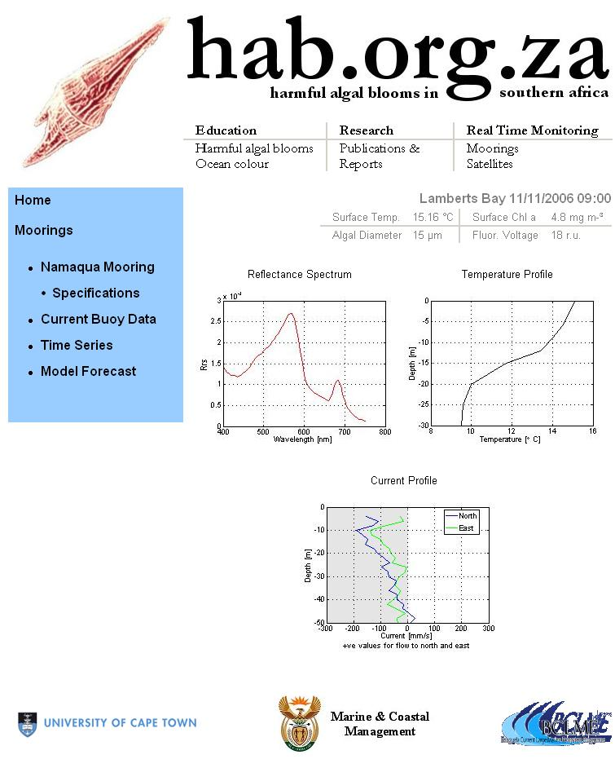
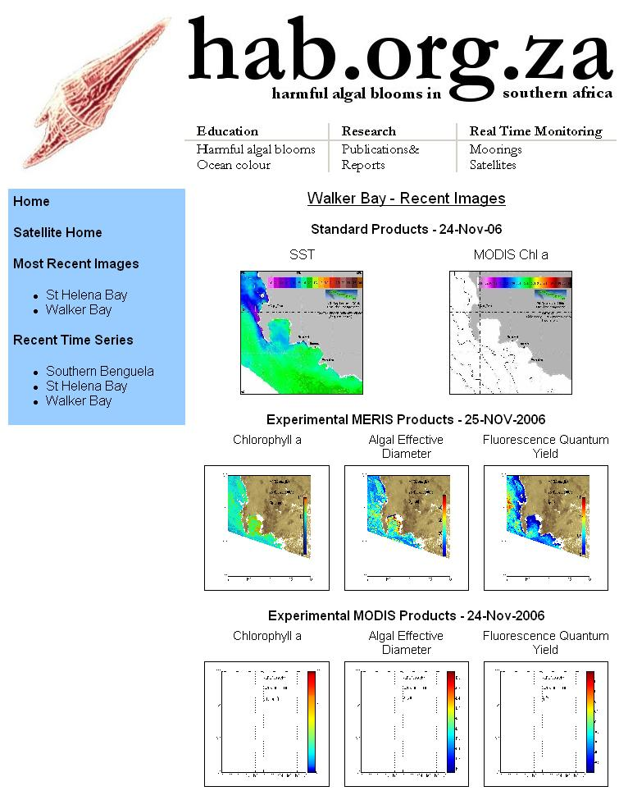
Figure 5. Screen shots from www.hab.org.za showing example satellite images for the Walker Bay region (left) and example snapshot data from the mooring off Lambert’s Bay (right).

2.4 Development of Indices

Three embayments on the south coast were selected to investigate upwelling variability along the South African south coast, as an initial setup in the development of regional upwelling indices. Daily NOAA AVHRR SST data were extracted at locations within Kleinbaai (34.62ºS; 19.35ºE), Mosselbaai (34.18ºS; 22.15ºE) and Port Elizabeth (33.97ºS; 25.58ºE) for the period 1 January 2001 to 31 December 2005 (figure 6).
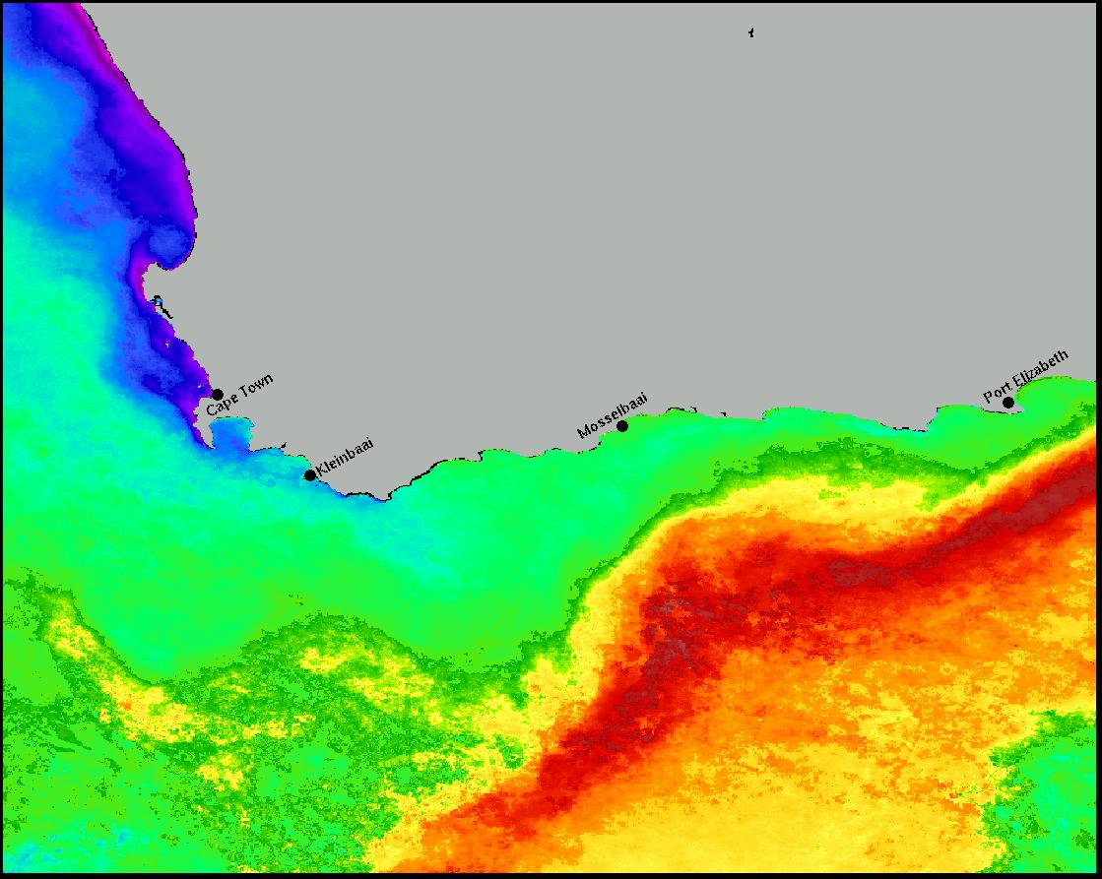
Figure 6. The locations of sites selected for a preliminary investigation of upwelling variability.

It was decided to produce an upwelling index for each of these embayments because their sheltered waters could provide a haven for aquaculture concerns. The productivity associated with the upwelling index is a key consideration when choosing an aquaculture site. The mean, minimum and maximum temperature observation for each month was extracted from the dataset and used to produce an upwelling index for each month. A ratio of monthly temperature range to monthly mean was then used as the monthly upwelling strength index.

Figure 7. Monthly mean SST at the Kleinbaai , Mosselbaai and Port Elizabeth sites between 2001 and 2005.

An examination of the monthly means (figure 7) revealed a clear seasonal cycle at all three locations with the warmest mean temperatures observed in austral summer. Monthly mean temperatures at Mosselbaai and Port Elizabeth are closely aligned and the seasonal oscillation of mean temperatures is ~6 months. Although summer and winter minima and maxima are evident at Kleinbaai, smaller mean temperature oscillations are embedded within the seasonal cycle. These results indicate that solar insolation plays the strongest role in the variability of mean temperatures observed at Mosselbaai and Port Elizabeth, whereas other factors contribute to increased mean temperature variability at Kleinbaai.

Figure 8. Monthly upwelling index for the same three sites, 2001 to 2005.

Except for an anomalously high upwelling index at Port Elizabeth for January 2001 and May 2004, both Mosselbaai and Port Elizabeth have very high variability in upwelling throughout the sampling period (figure 8). There is no clear seasonal oscillation in upwelling strength and the variability in upwelling strength at these two sites are of the same order. At Kleinbaai there is a clear seasonal cycle in upwelling strength, peaking in austral summer with upwelling strength oscillations of the same order as that of Port Elizabeth and Mosselbaai between seasons.

The monthly upwelling index calculated for this investigation illustrates a clear distinction in the factors influencing temperature variability at the selected sites. Kleinbaai forms part of the southern boundary of the Benguela Current Large Marine Ecosystem and experiences strong seasonal upwelling which modifies the solar insolation cycle observed in the monthly mean temperatures. By selecting more sites or extracting a continuous strip of data along the south coast, it would be possible to monitor the variability in monthly upwelling strength of the BCLME southern boundary routinely. Similar procedures could also be employed to monitor upwelling in the rest of the BCLME. Similar procedures will be employed in developing a preliminary monthly upwelling index for the MODIS Aqua data disseminated by the MRSU server.

2.5 MeteoSat Second Generation: Pilot Projects

Meteosat Second Generation (MSG) represents the next generation of European geostationary meteorological satellites. With a revisit time of 15 minutes, capturing images across 12 channels, and the ability to transmit data directly from the satellite to the end user, the MSG system represents a powerful new data source for a wide range of Earth science disciplines. In addition, MSG data are already received at UCT via EUMETSat, and the bandwidth related issues slowing development of automated processing chains for other sensors are thus avoided.

Kick Kellerman, a visiting M.Sc student from University College London, undertook a pilot project mid-2006, assessing the potential of MSG data to improve the understanding of coastal dynamics, and HAB development and transport, in the Greater St. Helena Bay region. This pilot project demonstrated that high frequency synoptic SST data offer a unique insight into the dynamics of coastal systems, as demonstrated in figure 9..

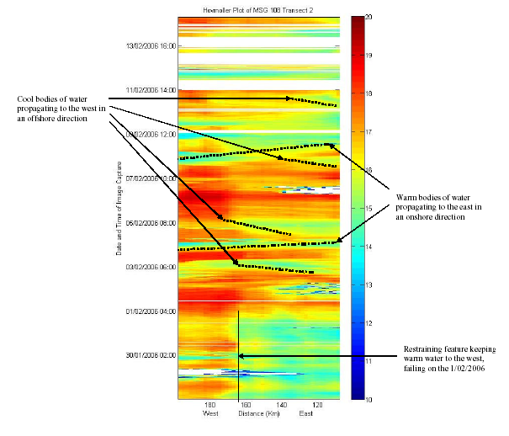
Figure 9. The above Hovmöller diagram is composed from a transect through St. Helena Bay. For the first 4 days a cool body of water can be seen constrained by a warm margin approximately 160km offshore, on 1/02/2006 this is broken and warm water extends into the bay. Two large westward propagations of warm water can be seen along with four partial offshore eastern propagations of cool water.

The project has since employed Raymond Roman for a five month period to further develop semi-automated MSG processing chains, as follows:

- Evaluation of the H-RIT/SST-PUMA and ILWIS software, and available Matlab based processing chains, for the generation of sample Sea Surface Temperature products from the MeteoSat Second Generation satellites in the southern Benguela.

- Demonstration of the utility of these products to examine high frequency SST variability using example periods from late summer 2005 & 2006 in the southern Benguela.

- Construction of a semi-automated processing chain for routine production of SST products from the MSG satellites, and a report detailing activities during the contract period and recommendations concerning the future evolution of fully automated processing chains

In addition, the project will undertake a preliminary validation using comparisons with both AVHRR data and in situ temperature measurements from several moorings. The in situ data will obviously be more representative of upper mixed layer temperature, rather than any of the actual SST related skin temperatures, but it will allow the generation of some preliminary confidence limits for the MSG data. Potential products will also be examined e.g. SST snapshots & animations, frontal detection with images & animations, and mean images with MSG-specific multi-image declouding. This activity forms part of the MSG-Africa pilot project under the GOOS-Africa Remote Sensing Group, and will be undertaken in collaboration with Marco Clerici (JRC, European Commission), Mbaye Diop (LERG, Senegal), David Kirugara (KMFRI, Kenya) and Ben Maathuis (ITC, Netherlands).

2.6 Synergy with GOOS-Africa Remote Sensing Pilot Projects

As a result of the GOOS/LME Leadership workshop, held in Cape Town in November 2006, the GOOS-Africa Remote Sensing Group was formed (convener Stewart Bernard). The Group produced a working document outlining five pilot projects (see Section 7):

- GEONETCast-Africa – GEONETCast is a GEO initiative that seeks to provide the means of disseminating earth observation data in the developing world through the provision of K- and C-band satellite reception systems. The project will seek to install several GEONETCast systems in Africa, whilst providing extended high quality training that allow local scientists to optimally use these systems.

- ChloroGIN-Africa – The Chlorophyll Ocean Global Integrated Network is a GOOS/GEO demonstration project that will provide partners with operational measurements of chlorophyll and supporting variables using both satellite and in situ platforms. ChlorOGIN-Africa will provide both full ChlorOGIN partners (currently Namibia, South Africa and Tanzania) and other African countries with remotely sensed and in situ ocean colour and SST products (see Section 1.3).

- MSG-Africa - The MeteoSat Second Generation-Africa project aims to build upon existing African projects to collaborate in developing common MSG processing chains, and provide operational access to MSG products (see Section 2.5).

- BILKO-Africa – The project will be implemented by the new African Bilko Executive Steering Committee (ABEST), and will prepare new lessons for BILKO: as an off-line server tool, for HAB applications, and four lessons for ASLME application (see Section 3).

- ALT/SAR-Africa – The project will examine the potential to provide operational sea state data (wind and waves).

Four of the GOOS-Africa pilot projects deliberately have direct synergies with the activities of this project, and the collaborative approach adopted (African and international) is expected to greatly enhance the outcome and sustainability of relevant project objectives.

3. Server Analysis Tools

Offline analysis tools are extremely useful in the context of the remote sensing server: they allow inexperienced users the ability to extract and manipulate available data, and they allow a smaller, faster web based front-end. The RS server currently offers a basic set of offline tools with SeaSat. However the decision has been made to not develop SeaSat any further, and adopt BILKO (UNESCO) as the primary offline tool. Bilko offers greater functionality and flexibility, is used widely internationally as a RS training tool, and thus has an active development and application community associated with it. There is also synergy with the GOOS/GEO ChlorOGIN project, which intends to adopt BILKO as an offline tool. In addition, BILKO is open source, has many lessons already written for it (figure10), and will have several more regionally focused southern African lessons written for it in support of server usage. These lessons will focus on usage with server data in the Benguela and Agulhas/Somali systems. There are additional synergies with the BILKO-Africa pilot project (GOOS-Africa), and several project members sit on the newly formed African Bilko Executive Steering Committee (ABEST).

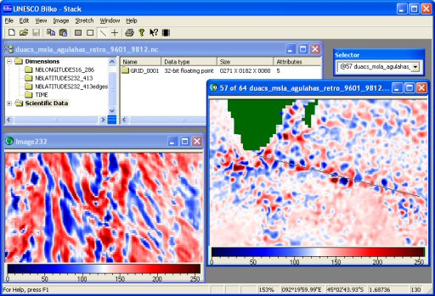

Figure 10. BILKO screenshot demonstrating Hovmuller analyses in the southern Indian ocean.

4. Ocean Colour Validation

The variety of marine ecosystems in southern African waters presents a number of challenges to ocean colour remote sensing in the region. The Benguela is made complex by both high biomass waters and highly variable atmospheric conditions associated with a long semi-desert coastline. The Agulhas system is characterized by the variable presence of deep sub-surface chlorophyll maxima, whilst east coast systems suffer from considerable sediment discharge.

Validation is required for effective use of ocean colour products: both radiometric validation i.e. analysis of the quality of the satellite received radiance signal and subsequent assessment of the atmospheric correction; and geophysical validation i.e. assessment of algorithm efficacy. Validation efforts to date have focused primarily on the southern Benguela - the southern Benguela Namaqua mooring is maintained as a collaborative validation facility by UCT and M&CM, offering automated sampling suitable for radiometric validation. Validation of algorithms and geophysical products requires in situ sampling, conducted on an ongoing basis during buoy servicing and dedicated scientific field experiments.

Current validation efforts can be summarised as follows:

- Twelve months of buoy data over a three year period have been processed to date (2004-2006). The radiometric data are sampled in two minute bursts every half-hour during daylight hours.
- Preliminary match-up extractions have been conducted and indicate that approximately four good radiometric match-ups a month can be obtained from MERIS and eight to twelve from MODIS (the relatively low number is predominantly due to the effects of cloud and sun-glint). Total radiometric match-ups of ~ 50 for MERIS and ~ 120 for MODIS are expected from the three year period.
- Approximately twenty full match-ups (with HPLC pigments, inherent optical properties, size distributions etc) for each sensor are expected from 2005/2006.
- Match-up extractions and analysis have been proceeding slowly due to the lack of published protocols for high biomass waters. Small scale patchiness and sub-pixel variability cause region-specific complexities as regards validation studies. Protocols relating to both patchiness and the processing of radiometric buoy data are being evolved, and it is anticipated that the match-up data sets will require several re-processing phases.

The project aims to have an initial analysis of radiometric match-ups completed by mid-2007. Preliminary validation analyses from specific periods have been presented to both NASA and ESA, and have generated a high degree of interest. The project will aim to have a technical report on validation activities in the southern Benguela completed end-2007. This will allow detailed feedback on the performance of atmospheric correction algorithms in the region. A long-term aim is a movement towards real-time validation analyses.
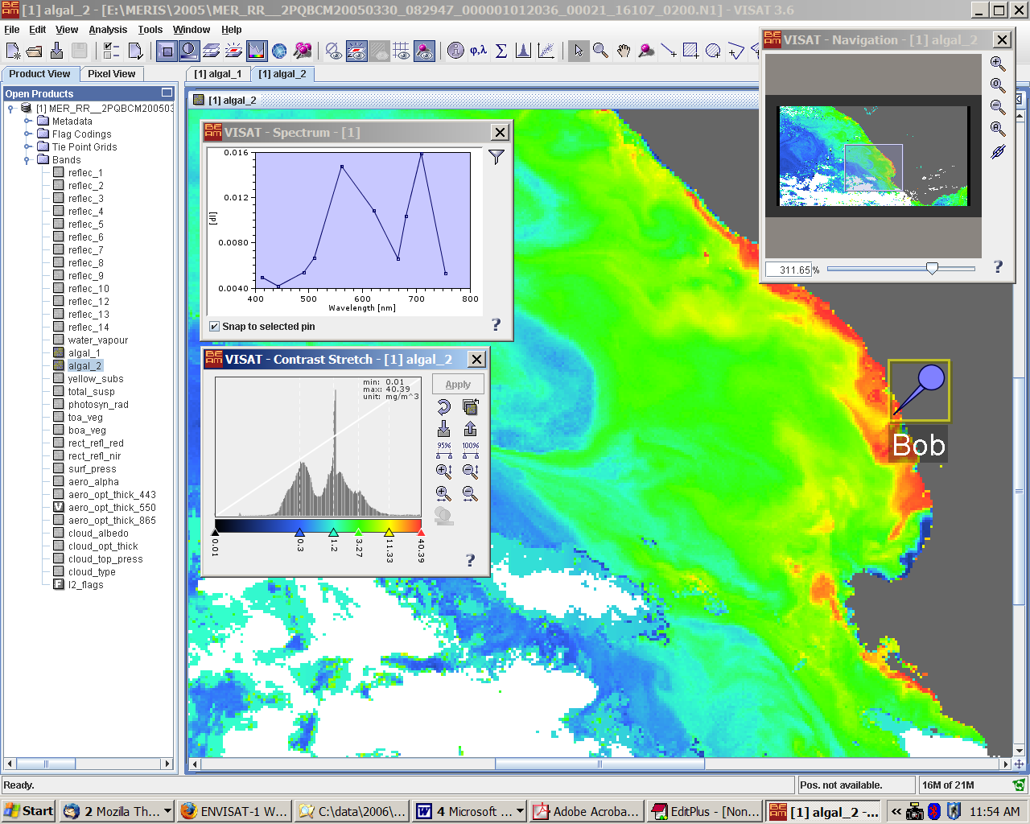
Figure 11. Sample extraction of water-leaving reflectance match-ups from MERIS and the Namaqua mooring, using the ESA’s BEAM software.
4.1 Buoy Operations & Analysis

All the data from the Namaqua mooring from 2004-2006 has been processed – an example of the monthly quick look images produced during processing can be seen in figure 12.
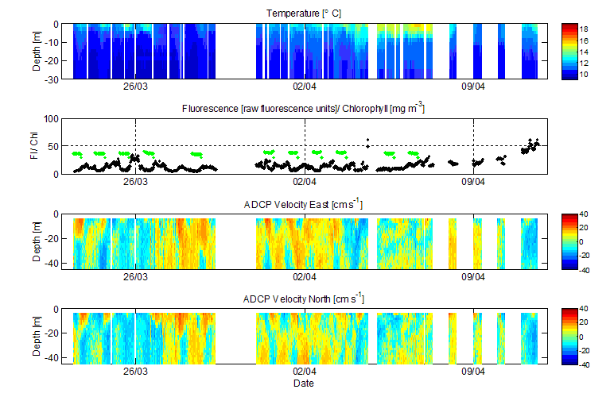
Figure 12. Monthly quicklook of processed BOB data, from March/April 2006. Data are temperature, fluorescence and radiometer derived Chl values, and ADCP east and north velocities.

Buoy operations in late 2006/early 2007 have been somewhat problematic for several reasons. The motherboard in the Ocean-i buoy controller developed sporadic problems from late October 2006, resulting in some data losses and an inability to communicate in real-time. A hardware fault on the board was identified in November, and a new board was ordered from the manufacturers. It is important to note that this is the last such board in existence, and that the Ocean-i controller will thus become obsolete when this last board ceases to operate. The new board was eventually made available in Cape Town in January. All the buoy instrumentation other than the radiometers were put into logging mode mid-November, which prevented further data losses at the expense of real-time data availability. Unfortunately, it was discovered on the January servicing trip that the mooring had been run down by an unidentified vessel. The remains of the mooring were discovered ~ 2 miles north-east of the original mooring position, riding off a single anchor. Fortunately the scientific buoy and sensors were recovered undamaged, but the marker buoy had been snapped in half, with the loss of the navigation light and radar reflector. The entire remains of the mooring were therefore recovered and transported back to Cape Town. The possibility of repair to the marker buoy is currently being assessed – a loaned marker buoy will temporarily be made available, which will be fitted with a new navigation light and radar reflector. The last available Ocean-i motherboard will be also be fitted to the scientific buoy, and it is hoped to redeploy the newly operational mooring in mid-March 2007.

A new backscattering sensor, the WetLabs BB2f, has been evaluated at sea; it appears to be performing well, and preliminary data show considerable promise. The sensor is seen as a replacement for the SCUFA fluorometer, and is a low cost sensor offering the potential for non-physiologically compromised algal biomass estimates, in addition to potential assemblage change indicators. Figure 10 shows a comparison between particulate backscatter and algal fluorescence, and similarly compares the spectral backscattering ratio of 470 nm /700 nm. This ratio appears to indicate that the three bloom events occurring in the trial period are composed of potentially two different assemblage types cf the change in backscattering ratio between events on 30th October and 10th November in Figure 13.
Figure 13. Preliminary data from the WetLabs BB2f sensor, from deployment on the Namaqua mooring in October/November 2006. The particulate backscatter is expected to provide a less physiologically compromised signal than older fluorescence-only sensors, and the spectral changes in backscattering have potential to provide information on the nature of the algal assemblage.

In addition to ocean colour validation, temperature data from the mooring will be used for the validation of MeteoSat Second Generation SST products (see Section 2.5)

5. Data Dissemination Systems

The lack of bandwidth available regionally continues to be a major hurdle with regard to processing high volumes of data from multiple sensors over the southern African region. A hardware-based means of overcoming bandwidth restrictions is the use of dedicated VSAT (Very Small Aperture Terminal) systems – satellite based ground stations using small antennae, independent of the national ground based internet backbone. VSAT systems will form the central dissemination mechanism of the GEONETCast system (see Section 2.6 and 7).

UCT already has a EUMETCast system receiving MSG data in the Environmental and Geographical Sciences (EGS) department. The system has only recently been used for marine applications (see Section 2.5), and has suffered from frequent data drop-outs due to inadequate storage and processing facilities. The project has provided additional hardware to EGS in order to make the EUMETCast system more robust – specifically to provide the project’s MSG pilot project with a more secure data stream.

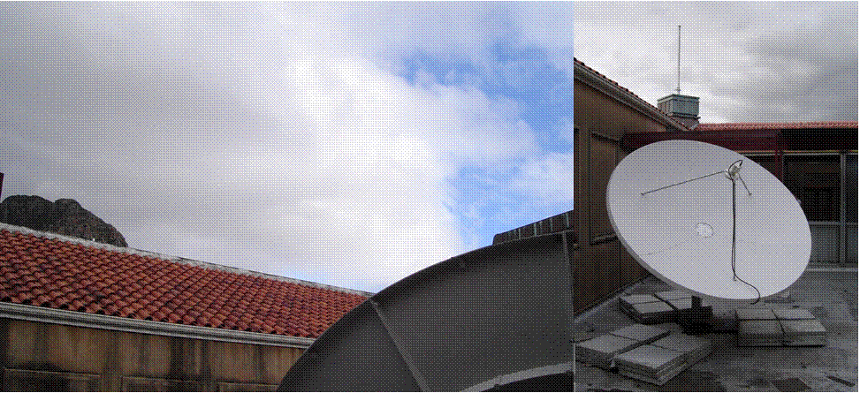
The sporadic local reception of MERIS data in near real-time has been a source of much frustration for several years. The project has sought to overcome this with the installation of a DDS (Data Dissemination System) in the Oceanography Department, jointly funded by the project, the Marine Remote Sensing Unit, and the Department itself. The DDS installation has also been supported by the ESA, who will remotely maintain the system and ensure timely and appropriate data delivery. The system consists of a 2.4 m roof-mounted antenna, linked to the Atlantic Bird 3 C-band communications satellite, and an internal RXPC unit (a rack mounted Linux box containing a Digital Video Broadcast card). The DDS is expected to become operational mid-March, and it is hoped that this system will allow the routine processing of near-real time MERIS data for the entire southern African region. In addition to securing the MERIS data stream, the DDS system will act as a trial node for the GEONETCast system, forming part of the GOOS GEONETCast-Africa pilot project.

Figure 14. The antenna of the ENVISAT DDS system mounted at UCT.

6. Training

The project directly supports two post-graduate students: Tarron Lamont who is undertaking a PhD examining the satellite application of primary production models; and Lionel Delaney, who is undertaking an M.Sc examining the use of coastal moorings to analyse the effects of internal waves on phytoplankton dynamics. The M.Sc is specifically designed, within the context of the broader project, to provide postgraduate training in the operation of the Namaqua mooring.

The project has also indirectly supported two M.Sc students who have successfully graduated, after working on buoy and remote sensing focused dissertations. These are Alexandra Fawcett and Christelle Balt (see Section 8).

6.1 PhD Progress Report: Tarron Lamont

Primary Production in the Benguela ecosystem
The Benguela ecosystem, along the southwestern coast of Africa, consists of the Benguela Current, which comprises the equatorward limb of the South Atlantic Subtropical gyre, and an upwelling system extending from about Cape Frio (18°S) to Cape Agulhas (34°S). It is one of the four major coastal upwelling systems of the global ocean and is unique in that it is bounded by warm water on both the equatorward and poleward ends. The intensity and extent of upwelling in the Benguela system is largely determined by the prevailing wind field, the orientation of the coastline, and the topography. The semi-permanent upwelling centre in the vicinity of Luderitz (27°S) is the most intense in the upwelling system and comprises an environmental barrier that essentially divides the Benguela into the Southern and Northern systems. As a consequence of upwelling, phytoplankton biomass and primary production is high. Production has been estimated at 1.2 gCm⁻²d⁻¹ and 2 gCm⁻²d⁻¹ for the Northern and Southern Benguela, respectively. Through the process of primary production, autotrophic organisms, including phytoplankton and bacteria, play a major role in a number of key marine issues, such as the global carbon cycle, marine food webs, etc. Marine phytoplankton fix large quantities of atmospheric CO₂ via exchange through the air-sea interface, transferring it to the deep ocean. They also form the basis of marine food webs which support fisheries globally. Coastal upwelling ecosystems constitute ~2-3% of the global ocean and yet, they are responsible for ~8% of the total global ocean primary production.

Primary production in the Benguela is expected to be highly variable in time and space, as phytoplankton communities are likely to exhibit high variability in their photosynthetic response due to the complex and dynamic water-column physics prevalent in the Benguela ecosystem. Primary production is an important parameter for the understanding of the biology and ecology of coastal ecosystems. Knowledge of this parameter would provide a useful tool for studying the biological variability of ecosystems in space and time. Use of this tool can be extended to fisheries management and stock assessment, and it can also be used in fisheries exploration.

The continuously evolving capabilities of satellite sensors and data processing procedures, presents a promising tool for the management of coastal resources, development and application of fisheries management and forecasting techniques. Satellite estimates of phytoplankton biomass and primary productivity provide a platform from which to describe the contribution of the oceanic biosphere to the global carbon cycle. Primary production is not only dependant on changes in phytoplankton biomass, but variations in photosynthetic parameters are also important. Photosynthetic rates are controlled by a variety of factors. Among these, irradiance is a key regulator. Knowledge of the variability in the relationship between photosynthesis and irradiance in natural phytoplankton populations allows for the determination of the influence of various environmental factors on the efficiency with which phytoplankton convert light into chemical energy. It also provides the parameters needed to estimate PP from satellite data. The Photosynthesis-Irradiance (P-E) relationship is crucial in measuring, modelling, predicting phytoplankton photosynthesis, and in evaluating the physiological state of phytoplankton. However, relatively few P-E measurements have been made in the Benguela ecosystem.

The primary aim of this project is to use current methods and new instrumentation to determine a suitable model for the estimation of primary production from satellite data, validate the satellite estimates using field data, and to use the output from this model to investigate the variability of primary production in the Benguela ecosystem.

The key questions include: 1) How do remote sensing estimates of bio-optical properties compare to in situ estimates?; 2) How do remote sensing estimates of primary production compare to in situ estimates?; 3) How do the proposed satellite models (bio-optical and primary production) compare to each other in terms of performance and complexity?; 4) What is the variability in bio-optical properties and primary production in the Benguela ecosystem?; 5) What is the influence of environmental parameters (temperature, irradiance, nutrients) on primary production and bio-optical properties in the Benguela system?

A combination of field measurements and remotely-sensed ocean colour data will be used to answer these questions. Regular in situ measurements will be obtained through participation in various research and routine cruises run by Marine & Coastal Management (MCM). Temperature, salinity, dissolved oxygen, fluorescence, photosynthetically available radiation (PAR), and surface irradiance will be obtained by hydrographic sampling (CTD). Water samples from various depths, determined from the fluorescence profile, will be collected and filtered for nutrient, phytoplankton absorption, and pigment analyses. Primary Production will be estimated from shipboard photosynthesis-irradiance (P-E) experiments. Remote sensing reflectance spectra will be obtained from a near-real time bio-optical buoy system moored off Lambert’s Bay. Various semi-analytical and analytical models (Garver-Siegel-Maritorena-2001 (GSM01) Semi-Analytical Bio-optical Model; Z.P. Lee Multi-band Quasi-Analytical Algorithm (QAA); Carder Semi-Analytical Bio-optical Model; Bernard Analytical Reflectance Model)
will be used to determine bio-optical properties from satellite ocean colour data. Outputs from these models will be compared and evaluated for the Benguela ecosystem, and will serve as inputs to various primary production algorithms (Vertically Generalized Production Model–VGPM; Wavelength-resolved, depth resolved model; Numerical integration of a Spectral model; Allometric/ Allo-Bio-optical Model of photosynthesis). The main outputs from this project are expected to be a database of in situ measurements of photosynthetic parameters and estimates of primary production, integrated water column production estimates, remote sensing reflectance spectra, and satellite maps of primary production. Results of this study will be published in peer-reviewed journals and presented at major national (e.g. SAMSS) and major international conferences (e.g. Ocean Optics, AARSE).

Progress thus far
During October 2006, sampling was conducted at 10 stations on the continental shelf in the Southern Benguela. Temperature, salinity, dissolved oxygen, fluorescence, photosynthetically available radiation (PAR), and surface irradiance were obtained by hydrographic sampling (CTD). Water samples from various depths, determined from the fluorescence profile, were collected and filtered for nutrient, phytoplankton absorption, and pigment analyses. Shipboard photosynthesis-irradiance (P-E) experiments were conducted at each station on water samples from 5 depths. Radiocarbon activity (¹⁴C disintegrations per minute - DPM) was determined on return to the Marine & Coastal Management (MCM) laboratory, on a Beckman liquid scintillation analyser using an internal standard to correct for quenching. Physical analysis of pigments has been completed. Nutrient and phytoplankton absorption analyses are yet to be done.

6.2 MSc Progress Report: David Lionel Delaney

The study is concerned with internal gravity waves off the west coast of South Africa, and the possible influence these waves could have on harmful algal blooms in the study area. An important aspect of the project is training on the operational use of the Namaqua mooring, thereby ensuring continuity in the expertise required to run such systems

Field measurements and data collection for the thesis are conducted with the experimental scientific buoy BOB, a component of the Namaqua mooring, located 3.5 km off shore from Lambert’s Bay. BOB, the successor to BOKKOM, has been run for the past two years as part of an operational oceanographic experiment to show the validity of scientific buoys in the operational detection of harmful algal blooms.

I joined the programme at the start of 2006 as part of my M.Sc training. Training in terms of buoy maintenance and operation included learning how to program scientific instruments and sensors on the buoy; uploading new BOB. operational software; data acquisition via semi real-time telemetry; downloading raw data directly from the instruments; and data processing using various software packages including MATLAB (The Mathworks).

Instruments on BOB include paired irradiance/radiance sensors, and Scufa and BB2F sensors that are used to measure particulates suspended in the water. A pressure sensor and a pitch and roll sensor measure buoy movement in the swell. An ADCP (Acoustic Doppler Current Profiler) installed on the buoy measures current velocity in three dimensions. Finally, a thermistor chain installed on the buoy measures water temperature at various depths.

Internal Gravity waves have a high Nyquest frequency; in other words, a high sampling resolution is required to resolve the internal gravity wave signal. For example, if the lowest period (T) of a signal is T = 12 minutes (as is the case for tidally forced internal gravity waves) Nyquest theory stipulates that an absolute minimum of T/2 sampling rate is required to resolve the signal in the data. Thus, the optimum sampling rate (R) required is R << T/2. In practise, a sampling resolution of 1 minute is needed to accurately resolve the internal gravity wave signal. The instruments on BOB could only sample at a maximum rate of once every 10 minutes, as the buoy’s power supply would not have lasted for the duration of the 2006 annual Lambert’s Bay field trip with a higher sampling resolution. However, Starmon temperature data loggers (self logging instruments, independent of the buoy’s operating system) were attached to the buoy’s thermistor chain, each with a sampling rate of 1 minute. The Starmon temperature data loggers proved invaluable in the acquired field trip data set, as they where the only instruments that accurately resolved the internal gravity wave signal. An example of the processed Starmon data is provided in figure 15.

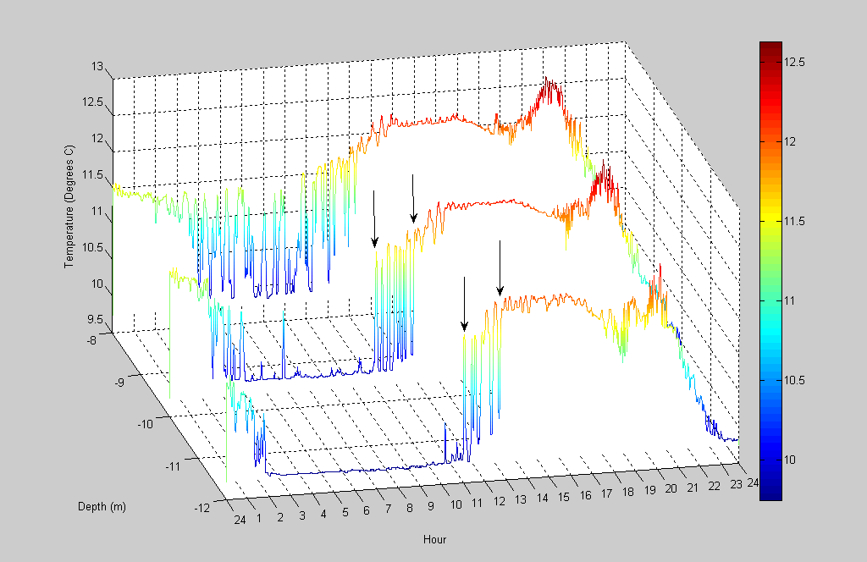

Figure 15. Starmon temperature (Cº) at 8m, 10m and 12m depth respectively for 13/03/2006. Areas between arrows indicate soliton packets containing internal gravity waves.

It can thus be surmised that internal gravity waves frequent the study area during internal wave ‘season’, which is during summer time when the water column is stratified. However, in terms of internal gravity wave influence on harmful algal blooms, one sampling session with 15 CTD casts over a 1 hour 45 minute period is the only processed data in terms of chlorophyll concentration with depth. A plot of this data is provided in figure 16, which shows the passage of two soliton troughs during the afore mentioned sampling period (CTD casts conducted from the ski-boat Ecklonia). The plot shows chlorophyll concentration (volts) with depth over time. There appears to be elevated chlorophyll concentrations in and around the soliton troughs (dark brown patches).

However, it would appear that sampling the influence internal gravity waves might have on harmful algal blooms is going to be very difficult due to the expense of having multiple Scufa/BB2F or any other particulate sensors sampling at depth in conjunction with the Starmon sensors.

Another method has to be surmised in forwarding this investigation. The answer lies in numerical modelling.

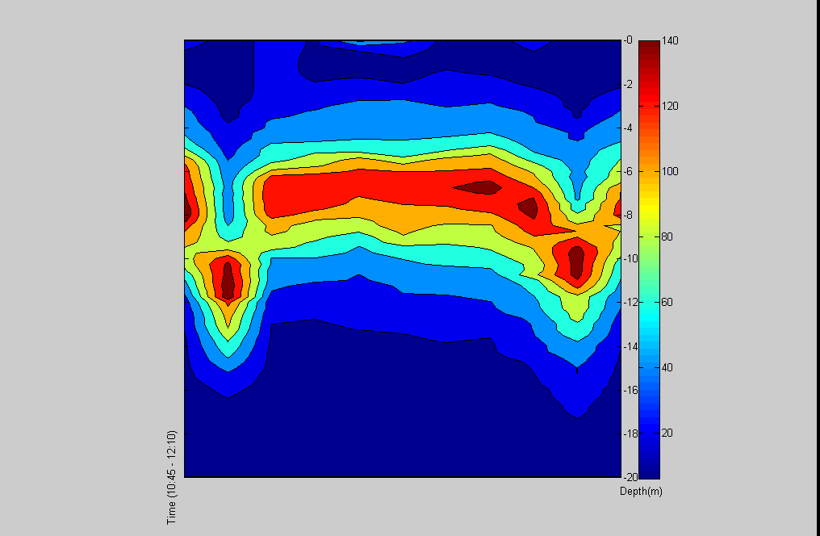

Figure 16. Relative chlorophyll concentration (Volts) with depth over time. Two soliton troughs were resolved in the CTD casts.

I am in the process of writing a two layer mathematical model that can resolve the internal gravity wave field, along with the corresponding flow velocities in the two layers (the layers are separated by an interface or the thermocline). Upon the construction of this model, which will be a MATLAB based program, I will be able to investigate what kind of bottom velocities are required in the lower layer to churn up cysts from the bottom sediment. If these bottom velocities then exceed the cyst falling velocities (computed via cyst diameters and densities) they will be suspended in the lower layer. An event that will entrain lower layer water into the upper layer (the required sunlight and heat is contained in the upper layer for cyst germination) will then be required. Breaking internal gravity waves are the only event turbulent enough to break a strongly stratified interface, which is usually the case in summer. When this interface is broken by such a turbulent event, bottom layer water along with the suspended cysts can now be entrained into the photic zone. Germination lag times and upper layer suspension times can then be brought into the model to investigate any influence internal gravity waves might have on harmful algal blooms.

The 2007 annual Lambert’s bay field trip will commence in March, where upon I will collect my second data set. The thesis will thus bring practical buoy operational/maintenance training; sampling and data acquisitioning/processing ; and finally a theoretical modeling framework together to demonstrate a new application for coastal monitoring buoys

6.3 Indirect M.Sc Support: Lisl Robertson

Lisl Robertson has begun a full-time M.Sc in 2007, supported by a bursary from Sumbandila (Sunspace, Department of Science and Technology) examining the potential use of the MSMI hyperspectral ocean colour sensor in the coastal zone. This project has several very positive aspects: it represents a greatly increased synergy between the future South African Space Agency and current marine remote sensing research efforts; and it may allow the semi-operational use of an ocean colour sensor due to be flown on a South African satellite. The project will have two primary focii: investigation of the ESA’s CHRIS/PROBA micro-satellite in the Benguela, and an analysis of ocean colour atmospheric correction models and the potential to evolve a regional atmospheric correction algorithm. There are several rationales to the project:

- Sensor inter-comparison between CHRIS/PROBA and MERIS: Experience with extensive use of MERIS data for this area of application provides a good basis from which to assess quality and sensitivity of the CHRIS sensor in comparison to MERIS in terms of both top of atmosphere and water-leaving radiances. TRIOS radiometers at the existing mooring provide in situ data for further comparisons.

- An examination of potential atmospheric correction algorithms for use with CHRIS/PROBA and the future MSMI mission. Little is known of the performance of the various atmospheric correction algorithms employed with currently operational ocean colour satellites, or even regional atmospheric variability with regard to the various aerosol components. The atmospheric correction is critically important to effective use of ocean colour data, and gaining expertise in this area is extremely important.

- Support for validation of European EO Missions: In situ data yielded from these highly productive waters presents an opportunity for valuable satellite data validation in high biomass situations. During the March/April period for which CHRIS data is requested, radiometry data will be supplemented by sample analyses of phytoplankton pigments by HPLC, IOPs, and assessment of particle size distribution and algal physiology. This period is therefore a good opportunity for the acquisition of a comprehensive database upon which to perform validation and comparative studies.

- Utilisation of the multi-angle capability of PROBA: Image sequences over our area of interest using the multi-angle capability will provide useful information concerning atmospheric correction procedures and will enable quantitative assessment of the influence of sun glint off the sea surface of this dynamic coastal system.

This research will be undertaken with the additional goal of using results from the investigations above towards assessing the feasibility of using the proposed hyperspectral instrument MSMI (small satellite sensor under development in RSA) for operational ocean and fresh water monitoring and coastal management applications.

6.4 Other Postgraduate Support

The project has also provided direct and indirect support for several other students. Mr Selwyn Bergman, an M.Sc student, has taken up employment at the CSIR and as such can be considered a success story of the project. Issufo Halo and Raymond Roman have been hired by the project in Mr Bergmans’s place to work on operational processing of NOAA-AVHRR data and an MSG pilot project respectively. The project also expects the arrival of a Ghanian intern, Mr. Kwame Agyekum, for a five month period. Mr Agyekum will be trained in the processing and application of MERIS data, and the use of the new ENVISAT DDS system at UCT. The internship is a result of the GOOS/LME Leadership workshop in 2006, and is an example of the burgeoning collaboration between African LME programmes.

6.5 Training Courses

The European Union’s Joint Research Centre will be running an ocean colour training course in Mombasa, Kenya, in September 2007. The course convener is Nicholas Hoepffner of the JRC. Stewart Bernard and Tarron Lamont will both be teaching at this course, and it was decided that southern African students should attend this course rather than the putative course scheduled for Cape Town in 2007. The project will partially fund two Namibian students, in collaboration with NatMirc and the Polytechnic of Namibia. The Project will also assist with funding for two Mozambican students in collaboration with the DelPHE programme (Development Partnerships in Higher Education, a joint British Council/ Department for International Development initiative), and facilitate the attendance of any other SADC students that may wish to attend the Course. A letter of motivation requesting that BCLME become an official course sponsor, through the provision of additional funding for studentships, will be submitted to BCLME shortly.
7. International and National Collaboration

Project personnel have attended several international workshops and conferences, with some very positive results. The ChlorOGIN project is of particular importance to the project and the continued development of remote sensing in the region. As the first ocean colour based GOOS & GEO pilot project, ChlorOGIN offers considerable leverage, and the ability to develop local remote sensing capability in collaboration. ChlorOGIN will also provide a robust platform for funding through both the European Union’s 7th Framework programme, and India-Brazil-South Africa (IBSA) trilateral funding The formation of the GOOS-Africa Remote Sensing Group also offers a great deal of potential for future collaborative development both within and beyond Africa. The following meetings were attended:

ChlorOGIN/ Extended Antares Network Workshop
Plymouth Marine Laboratory, September 2006
GOOS/GEO/IOCCG funding
Ray Barlow, Stewart Bernard, Tarron Lamont, Nande Nickanor
Outcome: Involvement in GOOS/GEO pilot project as primary southern African centre of expertise and remote sensing provider, establishment of future FP7 & IBSA collaborations with PML, JRC, INPE and INCOIS.

Indian Ocean Global Ocean Observing System IV
Zanzibar, October 2006
IOGOOS funding
Stewart Bernard
Outcome: presentation of ChlorOGIN project to IOGOOS members, and endorsement of ChlorOGIN as future primary RS provider in IOGOOS region.

International Ocean Colour Coordinating Group 12th Committee Meeting
Swakopmund, January 2007
IOCCG/Project funding
Ray Barlow, Stewart Bernard, Christo Whittle, Tarron Lamont, Nande Nickanor
Outcome: Stewart Bernard to replace Ray Barlow as rotating African IOCCG member; inclusion of project personnel in IOCCG Mombasa training course, advanced algorithm workshop, phytoplankton functional type working group.

GOOS/LME African Leadership Workshop
Cape Town, November 2006
Stewart Bernard, Ray Barlow, Christo Whittle, Nande Nickanor, Tarron Lamont
Outcome: formation of GOOS-Africa Remote Sensing Group with Stewart Bernard as convener, establishment of GOOS-Africa RS pilot projects, establishment of future GCLME collaboration.

All Africa Remote Sensing of Environment Conference
Cairo, August 2006
UNESCO/Project funding
Christo Whittle
Outcome: paper “Development of Satellite Remote Sensing Products and Services for Operational Application in the Management of Marine
Resources in Southern Africa”.

12th International Conference on Harmful Algae
Copenhagen, September 2006
Conference/Project funding
Alexandra Fawcett
Outcome: paper “Advection, stratification and harmful algal bloom development in the southern Benguela upwelling system”.

8. Publications

Refereed Journals

Aiken, J., J. R. Fishwick, S. Lavender, R. Barlow, G. F. Moore, H. Sessions, S. Bernard, J. Ras, and N. J. Hardman-Mountford 2006. Validation of MERIS reflectance and chlorophyll during the BENCAL cruise October, 2002: preliminary validation of new demonstration products for phytoplankton functional types and photosynthetic parameters. Int. J. Remote Sens., 27

Barlow. R., Louw, D., Balarin, M. & Alheit, J. 2006. Pigment signatures of phytoplankton composition in the northern Benguela ecosystem during spring. Afr. J. Mar. Sc. 28, 479-491.

Bernard S., T.A. Probyn and F.A. Shillington. 2007. “The use of equivalent size distributions of natural phytoplankton assemblages for optical modeling,” Opt. Expr., Vol. 15, Issue 5, pp. 1995-2007.

Fawcett A., S. Bernard, G.C. Pitcher, T.A. Probyn and A. Du Randt. 2006. “Real-time monitoring of harmful algal blooms in the southern Benguela,” Afr. J. Mar. Sc, 28(2), 257-260.

Fishwick, J., Aiken, J., Barlow, R., Sessions, H., Bernard, S., & Ras, J. 2006. Functional relationships and bio-optical properties derived from phytoplankton pigments, optical and photosynthetic parameters; a case study of the Benguela ecosystem. J. Mar. Biol. Ass. U.K. 86, 1267-1280.

Quirantes A., and S. Bernard. 2006. “Light scattering models for modelling algal particles as a collection of coated and/or nonspherical scatterers,” J. Quant. Spectros. Rad. Trans., 100, 315-324.

Weeks, S., Barlow, R., Roy, C. & Shillington, F. 2006. Remotely sensed variability of temperature and chlorophyll in the southern Benguela: upwelling frequency and phytoplankton response. Afr. J. Mar. Sc. 28, 493-509.

Pre-Publication
Fawcett A., G. Pitcher, S. Bernard, A. Cembella and R. Kudela. “Contrasting wind patterns and algal toxins in the southern Benguela upwelling system,” Marine Ecology Progress Series, (accepted)

Fawcett A., S. Bernard, G.C. Pitcher. “Development of cost-effective lightweight multi-sensor moorings for harmful algal bloom monitoring in the southern Benguela,” Sea Technology (in preparation)

Book Chapters
Bernard S., R. Kudela, P. Franks, W. Fennel, A. Kemp A. Fawcett and G.C. Pitcher. 2006. “Part III, Chapter 12: The requirements for forecasting harmful algal blooms in the Benguela,” In THE BENGUELA : PREDICTING A LARGE MARINE ECOSYSTEM. Large Marine Ecosystems. ISBN-13: 978-0-444-52759-2, Elsevier, 438 pages

Pitcher G.C., S. Bernard and A. Fawcett. In Press. Real Time Coastal Observing Systems for Ecosystem Dynamics and Harmful Algal Blooms: the Needs and Expectations of the User. In: Real Time Coastal Observing Systems for Ecosystem Dynamics and Harmful Algal Blooms , Eds: M. Babin, C.Roesler, J. Cullen. UNESCO series "Monographs on oceanographic methodology".

M.Sc Dissertations
Alexandra Fawcett. 2004-2006. M.Sc. Multi-sensor mooring development and its use to characterize physical processes relevant to harmful algal bloom dynamics in the St Helena Bay area, South Africa. Awarded November 2006. UCT.

Christelle Balt. 2004-2006. M.Sc. The Use of Sun-Induced Fluorescence to Remotely Characterise Phytoplankton Dynamics. Awarded November 2006. UCT.

9. In kind support and value additions

The project has received a great deal of support, both in-kind and direct, from a wide variety of sources. Estimated support costs totaling ~ ZAR1.1 million are given below.

Marine Remote Sensing Unit
Partial costs DDS system ZAR 20,000
Training costs Issufu Halo ZAR 12,000

Oceanography Department, University of Cape Town
Estimated diver time and logistical support ZAR 10,000
Partial costs DDS system ZAR 10,000
Equivalent staff cost Christo Whittle ZAR 35,000

Frontier (Department of Science and Technology)
Equivalent staff cost Stewart Bernard ZAR 50,000
Equivalent staff cost Christelle Balt ZAR 18,000

Marine and Coastal Management
RDI Sentinel 300 ADCP (moored instrument) ZAR 300,000
Turner Designs SCUFA (moored instrument) ZAR 160,000
Apprise Technologies Templine Thermistor Chain ZAR 30,000
Estimated boat time, logistical support, consumables ZAR 130,000
Equivalent staff cost Ray Barlow ZAR 20,000

GOOS/GEO/IOCCG/UNESCO
Travel costs ZAR 90,000

BENEFIT
Travel costs ZAR 8,000
Consumables ZAR 60,000

GCLME
Partial training support ZAR 36,000

12th International Conference on Harmful Algae
Travel costs ZAR 10,000

