Development of an Operational Capacity for Real-time Observation and Forecasting of Harmful Algal Blooms in the Benguela Current Large Marine Ecosystem Region: Utility of Models in Forecasting Harmful Algal Bloom Events

Second Progress Report for BCLME Project EV/HAB/02/06

RAF/00/G32 – Benguela Current Large Marine Ecosystem

Compiled by Dr. Pedro M.S. Monteiro

14 June 2004

for

United Nations Office for Project Services


Centre for Marine Studies
University of Cape Town

Introduction

Harmful algal blooms (HAB’s), which are endemic to the inner shelf near shore environments over the whole BCLME region, give rise to concerns about public health related to shell fish contamination, as well as ecological or ecosystem impacts related to oxygen depletion following the collapse of large blooms. In both cases, the variability of these impacts varies not only interannually, but seasonally and at the event scale as well.

In view of the socio-economic significance of the impacts of algal toxins on wild and farmed species and the subsequent oxygen depletion problems, it has become desirable to develop an early warning capability to help off set some of those costs.

As stated in the first Progress Report (19 December 2003), the objective of this proposal is to use a demonstration project approach to assess the feasibility of using numerical models in conjunction with other real time observations (such as optical moorings and remote sensing) to develop a generic capacity to anticipate the onset, development and fate of HAB events.

There are two complementary processes, which may govern the development of the very intense blooms in the Benguela. The first is the hydrodynamics-controlled transport and concentration of HAB cells along the near shore environment and thought to be closely linked to the upwelling cycle in the late summer period. The second suggests that the shift from diatoms to dinoflagellates is linked to a low, turbulence controlled rate of nutrient supply. This favours the success of species, such as dinoflagellates, that can most effectively overcome the need for vertical migration. The approach is that this proposal will focus primarily on the first hypothesis and only provide an assessment of the feasibility for the second.

In the first Progress Report the preliminary results of the first model set up for St Helena Bay, was summarized. The model domain extended from St Helena Bay northwards to beyond Lamberts Bay, and was calibrated against a year-long historical temperature time series collected in the period 2001 – 2002 and corresponding remote sensing thermal images. The model reflected both high and low frequency variability in the stratification – mixing regimes in the system, which is key to phytoplankton dynamics. The spatial and temporal characteristics of the modelled advection and temperature fields in the surface layer of St Helena Bay were verified against a time series of both thermal and ocean colour images, spanning the period of 24 January – 5 February 2002. Interesting was the changes that occur during the relaxation phases of the system, when warm water and the blooms move onshore and polewards, driven by a narrow jet current that has been measured in the system.

This work was presented to the GEOHAB meeting held in Lisbon in November 2003 and useful comments were received from the meeting. One of the most important insights from the meeting was how widespread the near shore poleward jet was in all upwelling systems and the recognized role it plays in transporting blooms. Although the near shore current was observed in various upwelling systems, this study was the only one that actually modelled its presence.

Phase 2 progress

Since the first Progress Report, alterations and improvements have been made to the St Helena Bay numerical model and additional modelling experiments have been undertaken. The grid domain was extended to include an area stretching from just south of Saldanha Bay to beyond Olifantsriviermond (a long shore distance of approximately 240 km). This was done to ensure that the St Helena Bay model results were not in any way influenced by boundary effects, as well as to make sure that all the remote processes that influence the hydrodynamics in St Helena Bay, are taken into account in the model. In the cross-shore direction, on average, a distance of approximately 120 km was included.

The focus of the modelling has primarily been on the nearshore area along the West Coast of South Africa. In light of this, the grid was refined to an average size of 400 –700 m in a bandwidth of 7 – 10 km nearshore, along the length of the model. This was done to accurately resolve the bathymetry in the region where the narrow coastal jet has been observed, so that this jet could be accurately modelled and closely studied.

Figure 1 shows the new hydrodynamic model grid as well as the bathymetry used in the new model.

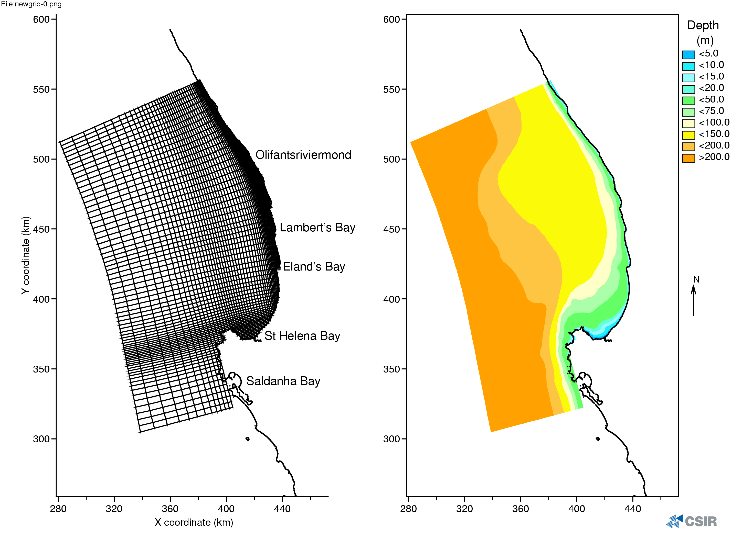
Figure 1 St Helena Bay modelling: Extended model grid and bathymetry.
(Note the refinement along the coast)

The new model was calibrated for the month January 2002 against the temperature time series collected in the period 2001 – 2002. Figure 2 shows a comparison between measured and modelled temperatures at depths of 0m (surface), 10 m, 16 m and 22 m from the surface. A good calibration was obtained, with the model once again accurately simulating high and low frequency variability in the stratification – mixing regimes in the system.
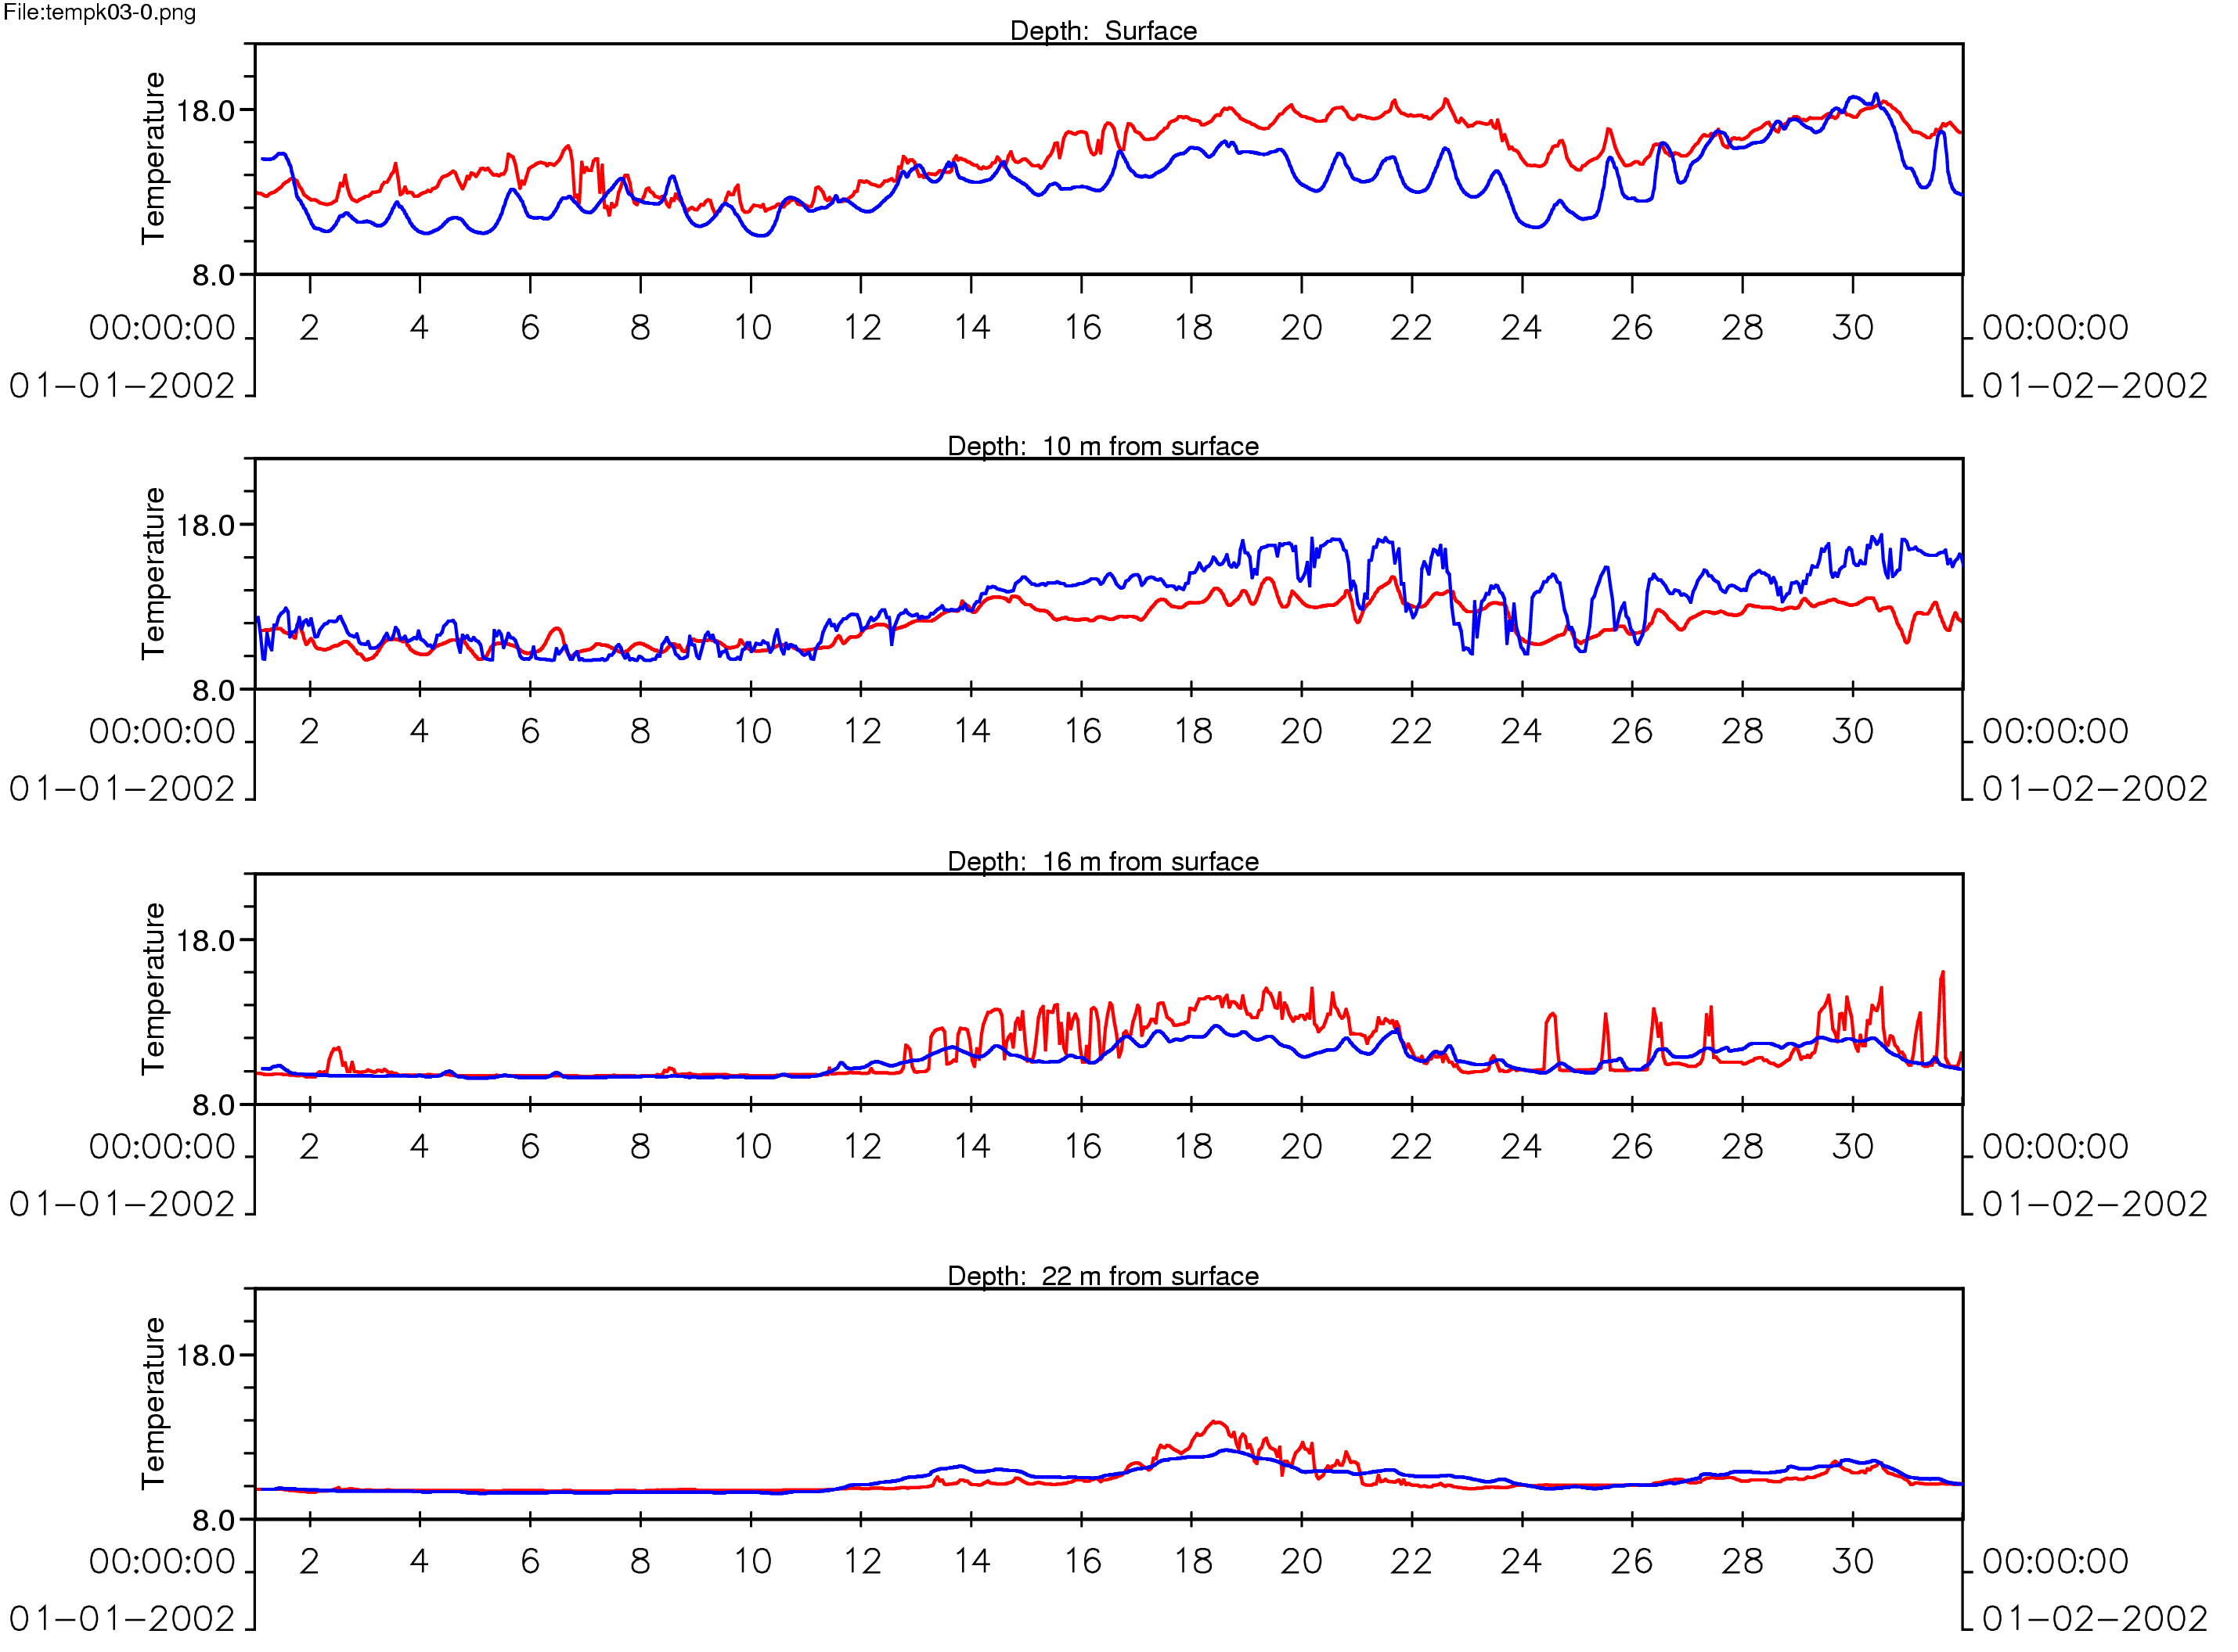
Figure 2 Time series of measured (red) and modelled (blue) temperature at four depths in the water column from St Helena bay for the month of January 2002.

The observed narrow coastal jet, simulated in our previous and present modelling studies, is being intensively studied by the junior modeller on the team as part of her MSc thesis commitment. An analytical model is being used to examine a hypothesis that could account for the formation and characteristics of a poleward surface current. Once the mechanisms are understood, this knowledge could be applied in the more complex St Helena Bay model.

Figures 3a - c show the modelled currents and temperatures in the St Helena Bay model, in the Lambert’s Bay / Eland’s Bay region, at different stages of an upwelling – relaxation cycle.
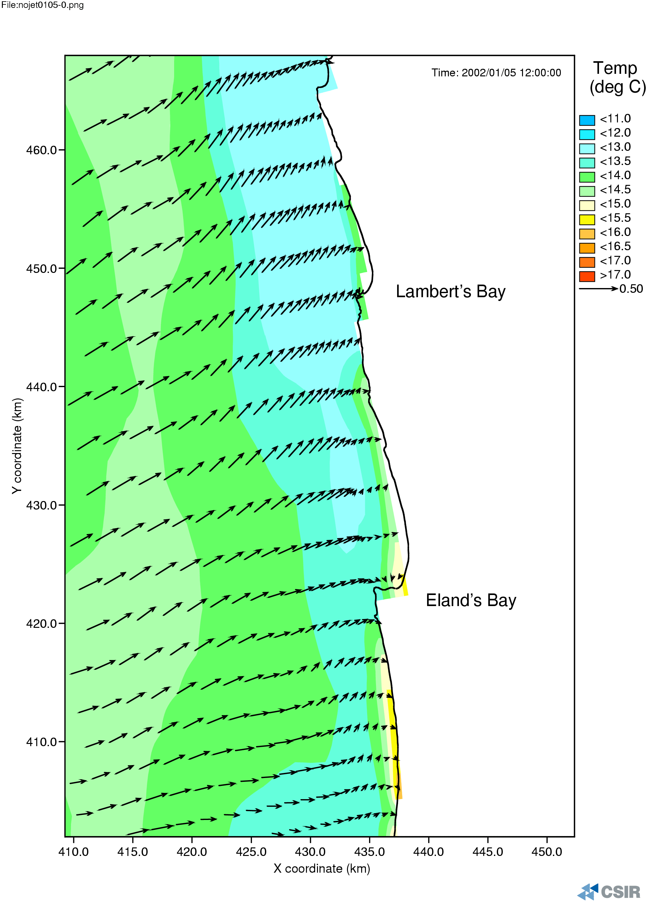
Figure 3a St Helena Bay model: Modelled temperatures and currents at the surface on 5 January 2002, 12:00.

Figure 3a shows the modelled temperatures and currents (at the surface) in the Lambert’s Bay / Eland’s Bay region on 5 January 2002, 12:00. At this stage, upwelling has taken place, with the nearshore water at a temperature of 12 - 13°C. From about 10 km offshore, the water is warmer (approximately 14.5 °C). No coastal jet is present.

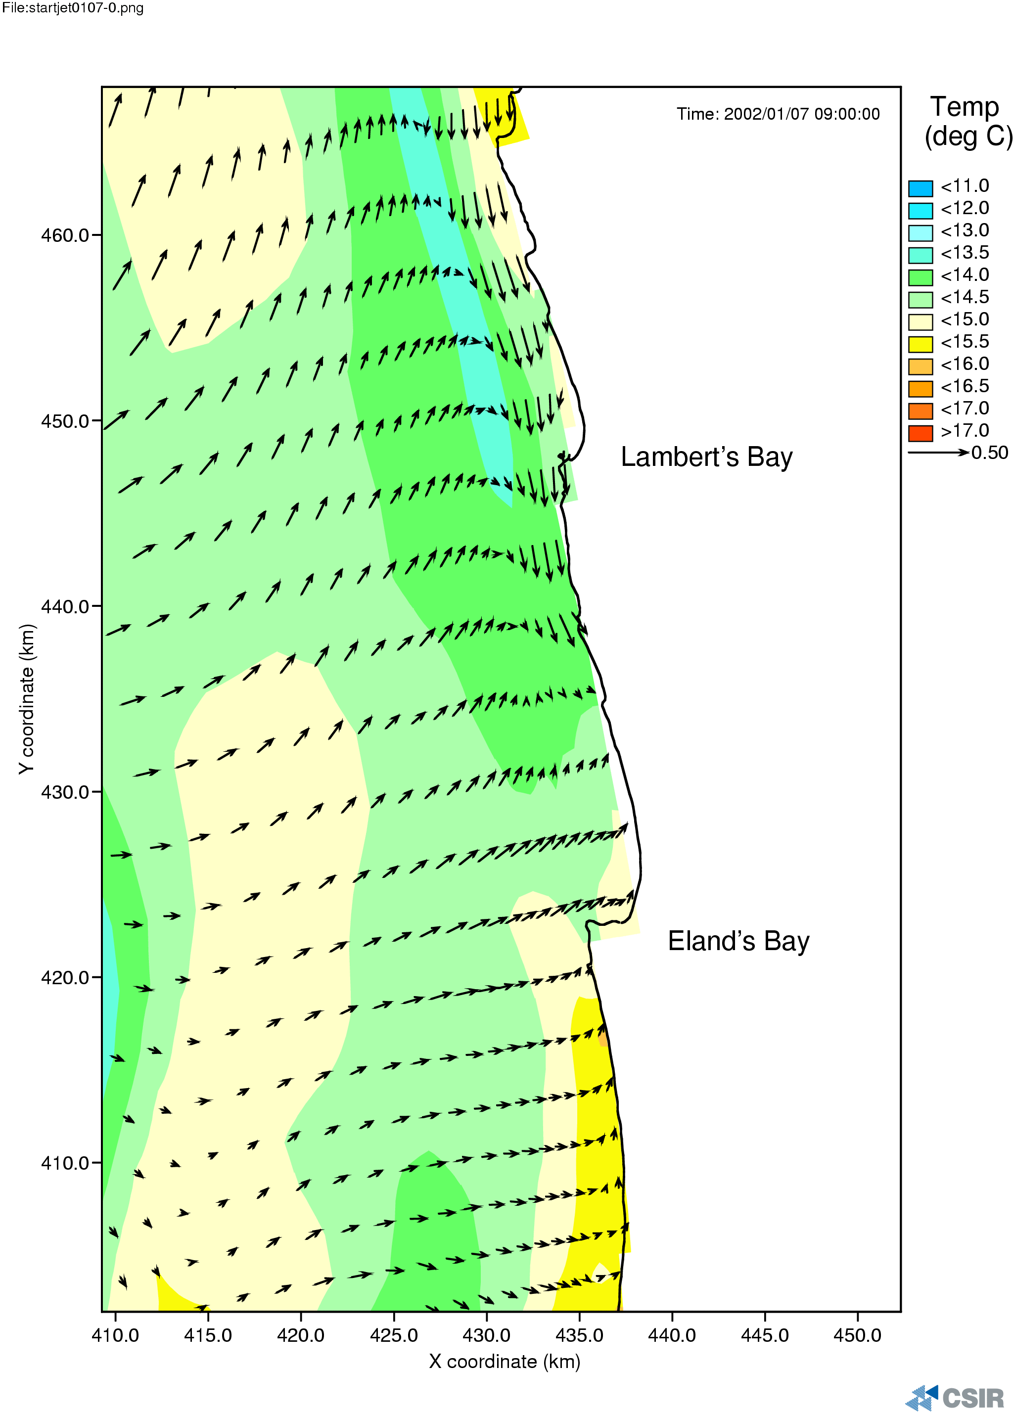
Figure 3b St Helena Bay model: Modelled temperatures and currents at the surface on 7 January 2002, 09:00.

Figure 3b shows the modelled temperatures and currents (at the surface) in the Lambert’s Bay / Eland’s Bay region on 7 January 2002, 09:00. At this time, relaxation has started to take place, with the warmer offshore water moving in toward the coast. A clear poleward, surface jet can be seen, as it starts to develop close to the coast towards the north of Lambert’s Bay. Note that this current is confined to the coast, only occurring in a narrow band of approximately 5 km.

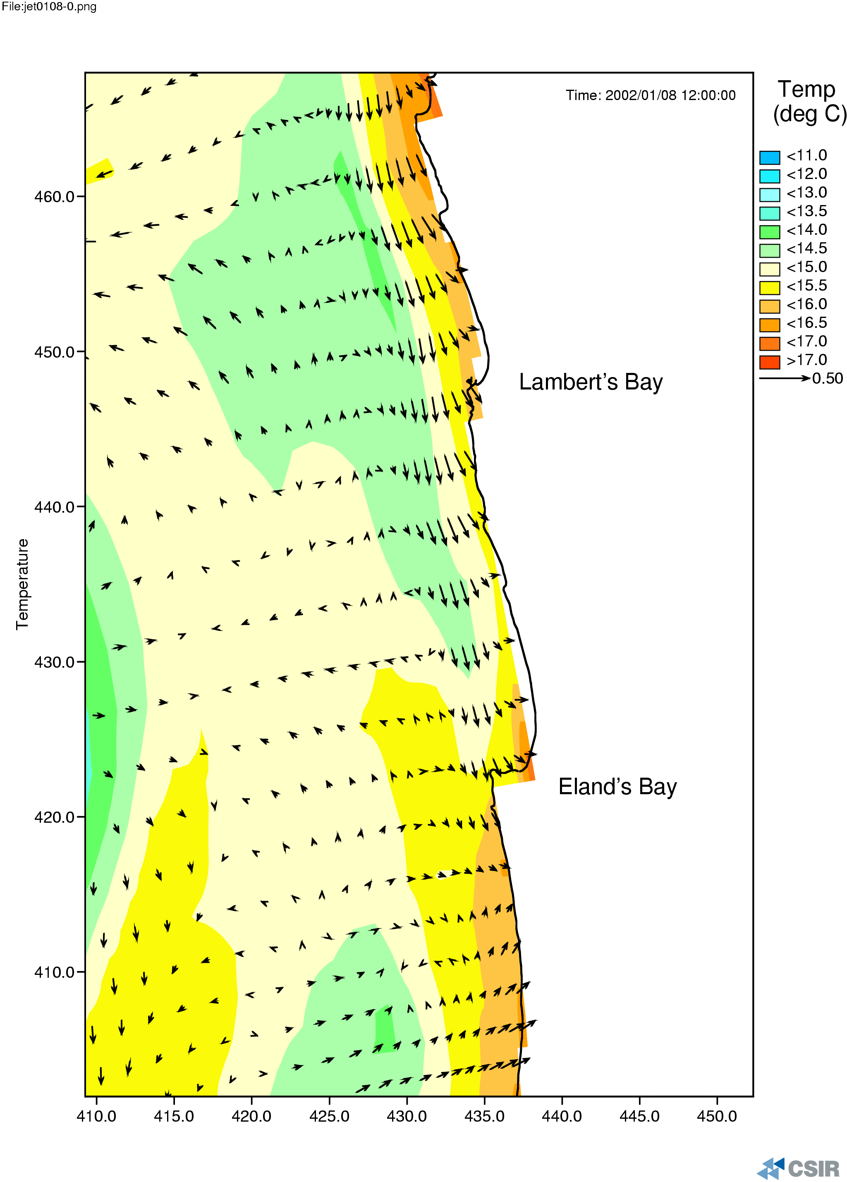
Figure 3c St Helena Bay model: Modelled temperatures and currents at the surface on 8 January 2002, 12:00.

Figure 3c shows the modelled temperatures and currents (at the surface) in the Lambert’s Bay / Eland’s Bay region on 8 January 2002, 12:00. At this time, a total state of relaxation takes place, with the inshore water reaching temperatures of between 15.5 and 17 °C. The coastal jet has developed even stronger and is now evident as far south as Eland’s Bay. Note that this current is still confined to the coast in a narrow band of approximately 5 km. The current speeds have values of 0.25 m/s on average.

Thus far, the origin of the nearshore, poleward surface current has not been clearly understood. It is believed, however, that this current transports the HAB’s southward into St Helena Bay, leading to lobster walkouts. Understanding the origin and dynamics of this current, that propagates the harmful algal blooms southward, can ultimately be used to further improve the efficiency of monitoring programs, as it will help us to predict when this would occur.

A HAB workshop is being planned for July 2004, during which invited specialists will discuss the research that has been done on HAB’s. During this workshop, the BCLME work will also be presented.

Summary

Project objectives and scientific advances

In summary, good progress has been made concerning the hydrodynamic modelling of St Helena Bay. The unexpected importance of the poleward coastal jet as a key part of the forecasting skill has shifted the milestones slightly for this phase of the project but it will not affect the overall outcomes. The extended model is providing reliable results in respect of observations and it is now ready to begin its hindcasting programme for the HAB programme. This will be initiated by a workshop where the three main strands of the forecasting system will be brought together and a plan for their integration will be discussed.

The following proposed tasks are still outstanding

Task | Completion | Comments
11: sensitivity analysis | underway | Sensitivity analyses showed that the model is very sensitive to the boundary conditions especially at the southern one. Data is being sourced from MCM to address this need.
12: Run model over periods that coincide with buoy and remote sensing | modified | A discussion of the stakeholder group resolved that the model would only be run for the 2002 HAB season period and verified against remote sensing and HAB oceanographic observations
13: workshop to assess progress | Completed (5-6 August) | The workshop recommended that the scientific plan be modified to produce a validated model run for the 2002 HAB season rather than the hindcasting of historical events. This arose because of the unexpected additional work that had to be undertaken to understand the dynamics of the narrow poleward surface jet.
14: + | underway

Integrated Hindcasting Workshop

The workshop that is being planned will also create an opportunity for scientists to discuss the progress that has been made thus far in understanding the origin and formation of HAB’s on the West Coast of South Africa and formulate a work plan to assess the effectiveness of the existing tools to hindcast recent significant events.

Capacity Building

Ms Anél Kemp is undertaking her MSc studies within the context of the project under the supervision of Prof. G Brundrit and Dr P Monteiro

