

Development of an Operational Capacity for Real-time Observation and Forecasting of Harmful Algal Blooms in the Benguela Current Large Marine Ecosystem Region: Utility of Models in Forecasting Harmful Algal Bloom Events

First Progress Report

Prepared by Dr Pedro Monteiro

19 December 2003

Reference: RAF/00/G32
BCLME Project EV/HAB/02/06

Contact person:  Dr Pedro Monteiro  Tel: 27 21-888 2437 Fax: 27 21-888 2693  Email: pmonteir@csir.co.za | Proposal prepared for:  Benguela Current Large Marine  Ecosystem Programme



Introduction

Harmful algal blooms (HAB’s), which are endemic to the inner shelf near shore environments over the whole BCLME region, give rise to concerns about public health related to shell fish contamination as well as ecological or ecosystem impacts related to oxygen depletion following the collapse of large blooms. In both cases, the variability of these impacts varies not only interannually but seasonally and at the event scale as well.

In view of the socio-economic significance of the impacts of algal toxins on wild and farmed species and the subsequent oxygen depletion problems it has become desirable to develop an early warning capability to help off set some of those costs.

The objective of this proposal is to use a demonstration project approach to assess the feasibility of using numerical models in conjunction with other real time observations such as optical moorings and remote sensing to develop a generic capacity to anticipate the onset, development and fate of HAB events.

There are two complementary processes, which may govern the development of the very intense blooms in the Benguela. The first is the hydrodynamics-controlled transport and concentration of HAB cells along the near shore environment and thought to be closely linked to the upwelling cycle in the late summer period. The second suggests that the shift from diatoms to dinoflagellates is linked to a low, turbulence controlled, rate of nutrient supply, which favours the success of species that can most effectively overcome the need for vertical migration such as dinoflagellates. The approach is that this proposal will focus primarily on the first hypothesis and only provide an assessment of the feasibility for the second.

The approach comprised four phases of which this reporting period covered the first phase.

Phase 1: Set up Hydrodynamic Domains and source all existing input data

The model domain will extend from St Helena Bay northwards to beyond Lamberts Bay and will be calibrated using existing datasets. This first model set up will be calibrated against a year-long historical temperature time series collected in the period 2001 – 2002 and corresponding remote sensing thermal images. Sensitivity analyses will be undertaken to test the impact of the main sources of uncertainty: the boundary conditions and the immediate lack of dynamically space varying winds.

In preparation for the hindcasting activity in Phase 2, the project team would meet to assess the available data from other associated projects and design the hindcast modelling scenarios.

This phase of the project also coincides with an important workshop of the GeoHab programme to plan a global initiative in this domain. It is expected that such a meeting will be an important capacity building experience for the junior modeller in the project as is therefore an important part of the approach.

The work plan made provision for the following tasks in the first quarter:

TASK | COMPLETED
Convene project team to assign activities for this phase | Yes
Source the input data for the hydrodynamics | Yes
Calibrate and verify the hydrodynamics for St Helena Bay | Yes
Set up the extended domain for St Helena Bay | Yes
Present the project at the GEOHAB meeting in Lisbon, Portugal | Yes

Preliminary Results

Calibration

Time series of measured (red) and modelled (blue) temperature at four depths in the water column from St Helena bay for the month of January 2002 are presented in the figure below. It shows that the model is reflecting both high and low frequency variability in the stratification – mixing regimes in the system, which are key to phytoplankton dynamics.
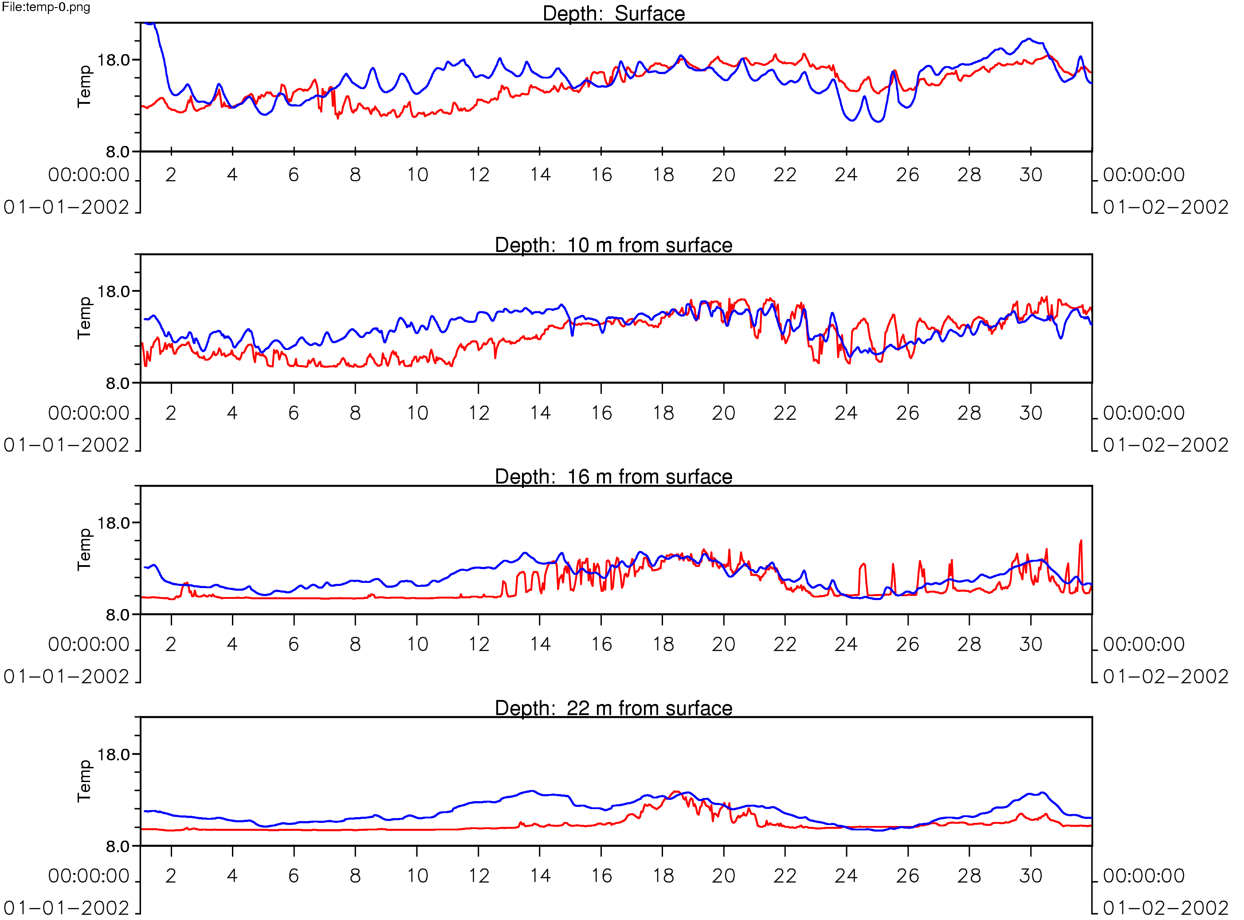

Verification of the advective dynamics in the Bay

The spatial and temporal characteristics of the modelled advection and temperature fields in the surface layer of St Helena Bay were verified against a time series of both thermal and ocean colour images spanning the period of 24 January – 5 February 2002 when there was both a large HAB bloom as well as a major rock lobster walk out associated with it. The wind regime during the simulation period is shown below. It shows the system ending an upwelling cycle leading to downwelling conditions and returning to upwelling conditions on 31/1/2002.

Wind Speed (m/s) (blue)
Wind Direction
(magenta)

Sub-sample of this comparison is shown below comparing NOAA AVHRR images with model produced circulation vectors and temperature. Note that the colour spectra of temperature do not match so it is important to compare actual temperature values:

The first pair on 24 Jan (overleaf top) shows the system at the end of an active upwelling cycle. It shows the upwelled water plume at Cape Columbine, upwelling along the Elands Bay – Lamberts Bay coast and a warm convergence / retention zone between the two. The second set of images (overleaf bottom) shows the changes that occur during the relaxation phase when the warm water and the blooms move onshore and polewards driven by a narrow jet current that has been measured in the system. Inside St Helena Bay retention is enhanced by inertial rotation of the currents. It was during this phase that the major rock lobster mortalities occurred. The final pair of images shows the system after it has returned to full upwelling conditions.

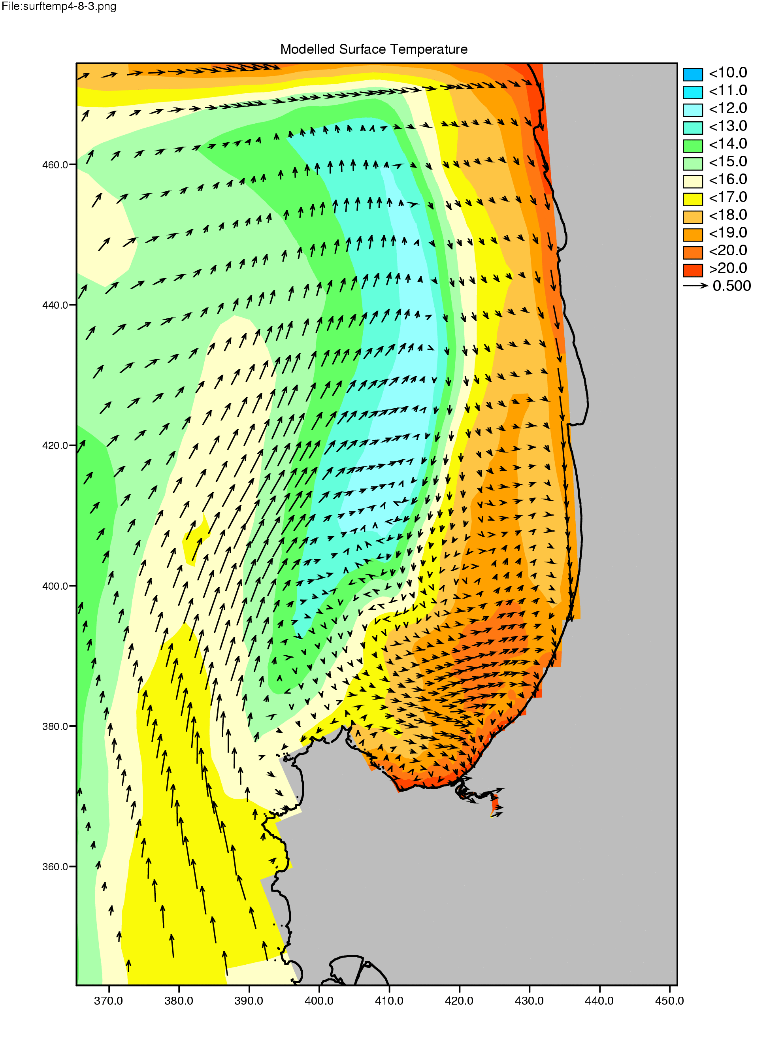
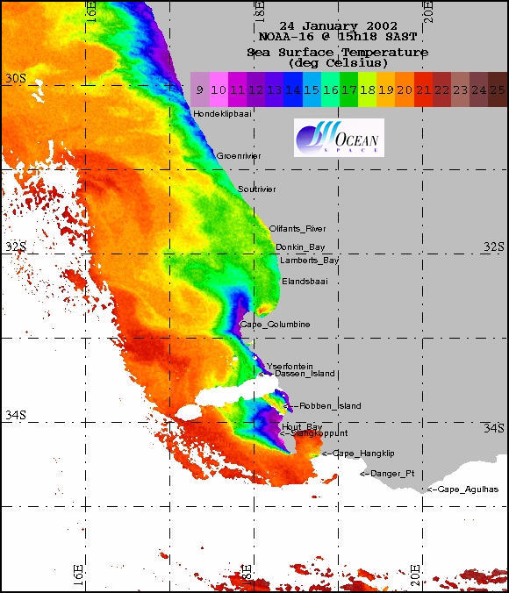
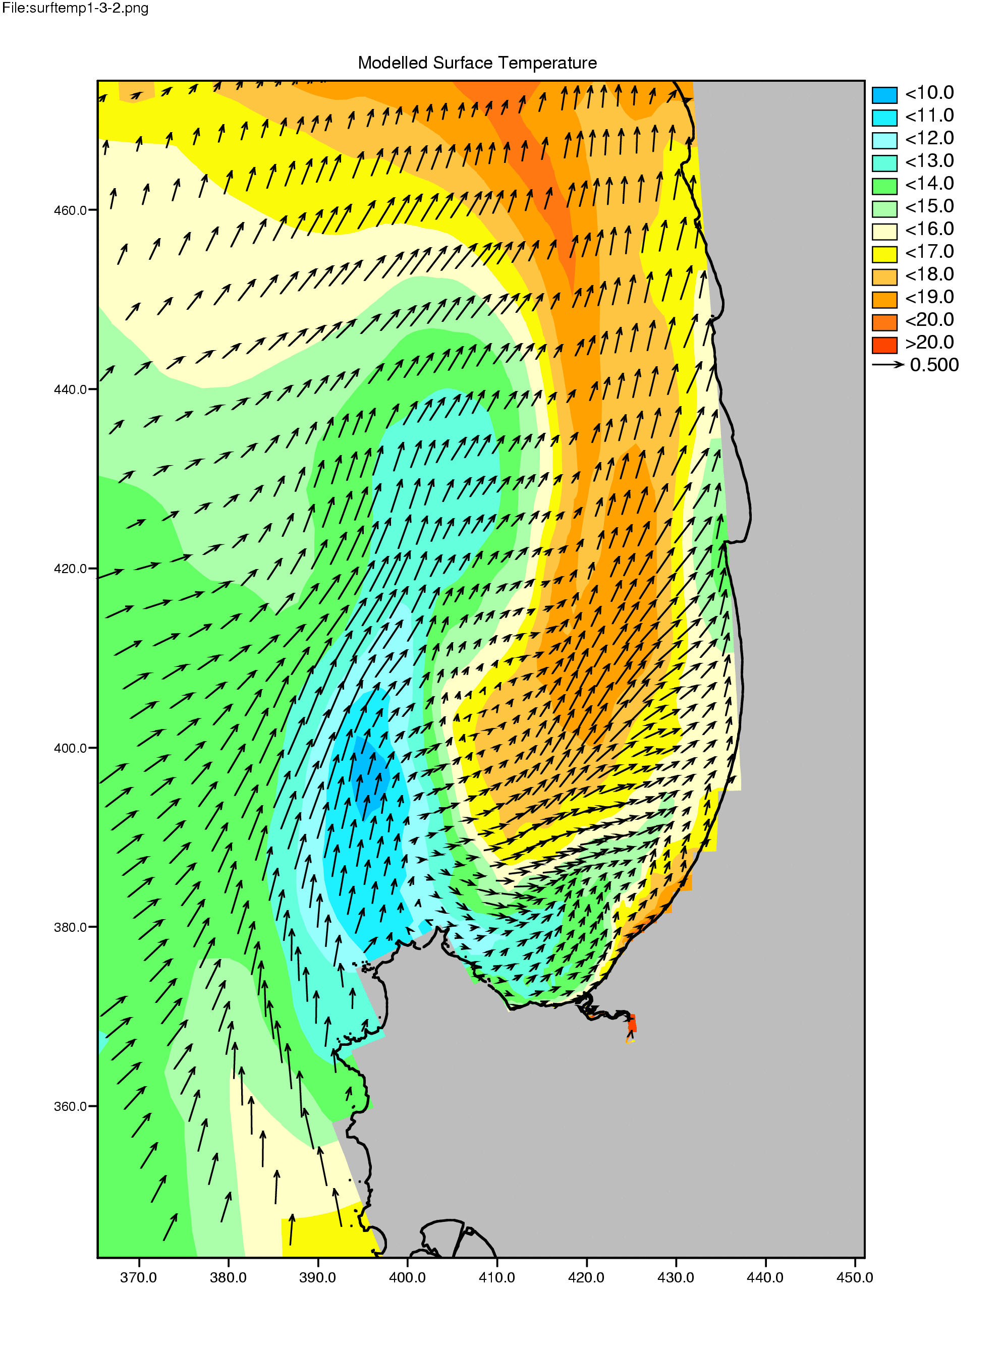
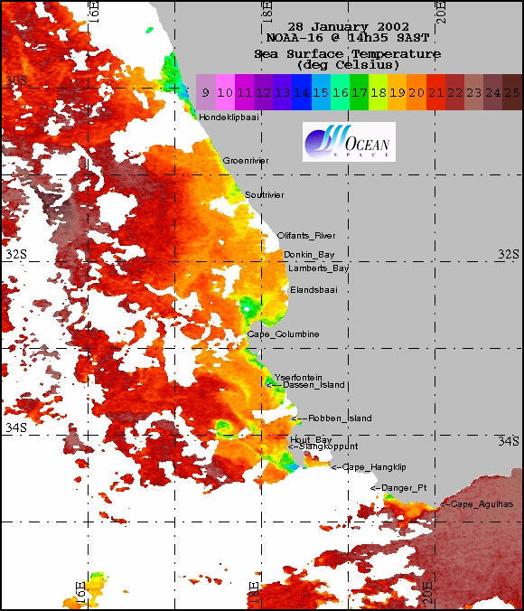

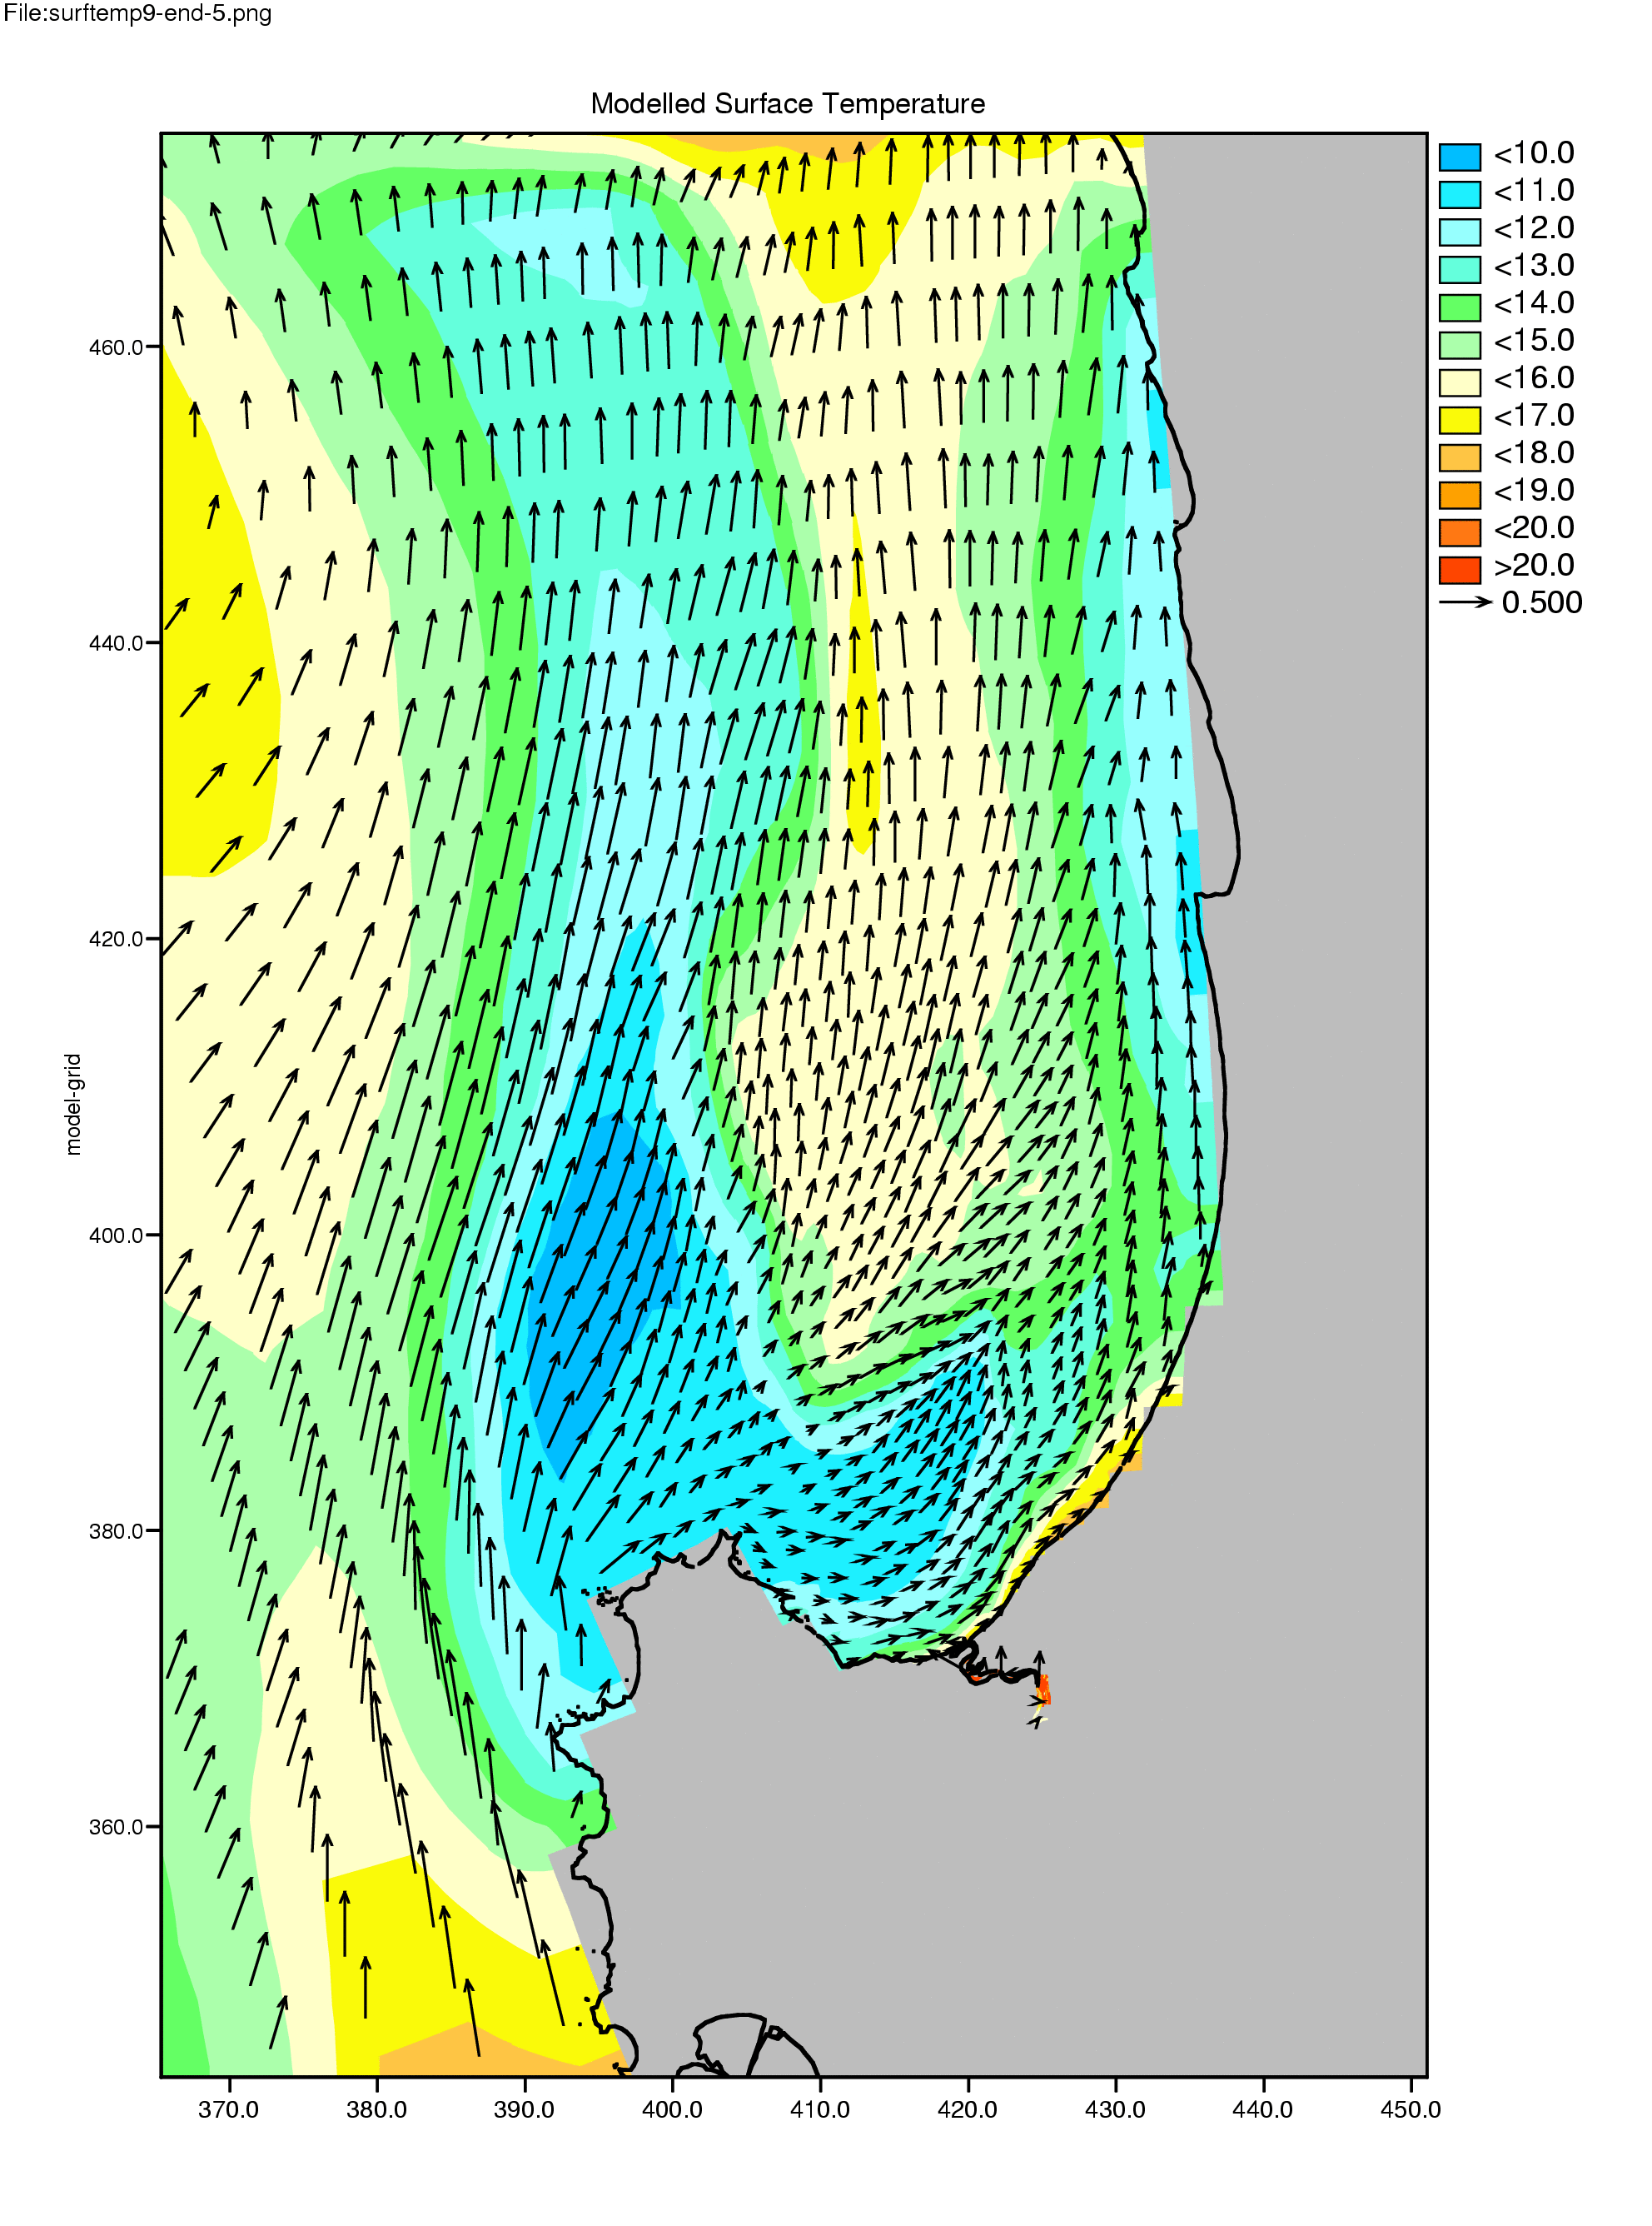
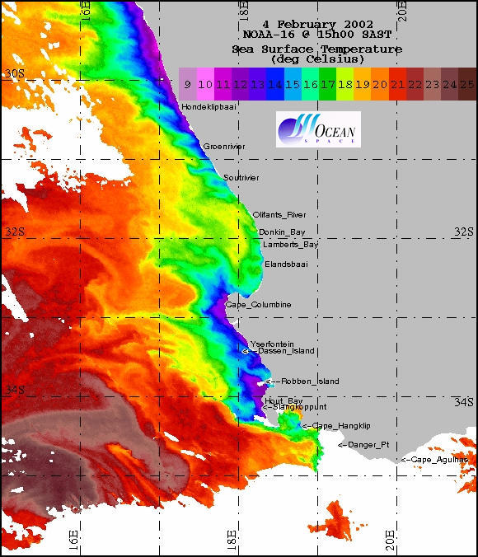

This promising outcome at this early stage of the project formed the basis for a number of sensitivity studies to be undertaken to constrain the main sources of uncertainty leading to the development of the early warning system.

This work was presented to the GEOHAB meeting held in Lisbon in November 2003 and useful comments were received from the meeting. Although this near shore current was observed in various upwelling systems this study was the only one that actually modelled its presence.

Overall, better than expected progress is being made in assessing the feasibility of these types of platforms as part of an early warning system not only for HABs but also for the linked Low Oxygen Water (LOW) Variability.

