BCLME Project EV/HAB/02/05/

Development of an Operational Capacity for Real-time

Observations and Forecasting of Harmful Algal Blooms in the

Benguela Current Large Marine Ecosystem Region:

Detection of Harmful Algal Blooms through

Deployment of Bio-optical Moorings.

Ref. RAF/00/G32 – Benguela Current Large Marine Ecosystem

Progress Report 2
Stewart Bernard and Alex Fawcett
July 2004

Operational Aspects of Moored Algal Monitoring Systems


Centre for Marine Studies  University of Cape Town | Oceanography  University of Cape Town

Executive Summary

The Namaqua mooring, consisting of two hyperspectral radiometric sensors, a fluorometer, a thermistor chain, a logging ADCP, and power, data and telemetry control systems was deployed in late February 2004. The mooring provided data in real time until mid June 2004, at which stage the principal buoy suffered irreparable damage and was withdrawn.

In it’s four months of operation the trial mooring has provided a unique data set of hyperspectral reflectance measurements and ancillary data relating to algal bio-mass and water column structure. Application of reflectance inversion algorithms to buoy data has allowed the derivation of algal bio-mass, size and accessory pigment descriptors in real time, and the mooring system was responsible for the early detection of at least three bloom events. The trial mooring has therefore unequivocally demonstrated the utility of lightweight bio-optical buoys as coastal monitoring tools, and an article outlining the successes of the trial mooring is currently being prepared for publication in Oceanography.

The initial mooring period has also been highly beneficial in that it has allowed clarification of the many and sometimes conflicting design criteria and operational needs of a lightweight optical buoy in a dynamic environment. Preliminary designs for the replacement buoy and mooring system are currently undergoing hydromechanical and stress simulation tests using finite element analyses, and construction of the new mooring system should begin in early August as a joint UCT/M&CM initiative. The new mooring system will be designed for force nine survival conditions whilst accommodating the complex design criteria of a lightweight multi-sensor platform.

In addition to the mooring system, the project has developed the hab.org.za web site, refined, tested and implemented the real time application of HAB oriented hyperspectral reflectance inversion algorithms, and has started receiving near real-time ocean colour data under the auspices of the Coastwatch programme. Ocean colour data are currently being received with a day lag for the Medium Resolution Imaging Spectrometer (MERIS, ESA) and the Moderate Resolution Imaging Spectrometer (MODIS, NASA).
Table of Contents

Executive Summary 2

- Rationale 4
- Bloom Detection and Algal Dynamics 5
- Radiometric Performance
  - Vicarious Calibration 9
  - Radiometric Stability 11
- Bus and System Performance 14
- Reflectance Algorithm Development and Performance 18
- Design of New Mooring System 24
- Web Site Development 26
- Workplan and Personnel Budget 28
- Outlook 28
- References 29
- Notation 30
Appendix 1: In kind contributions 31

List of Figures
Figure 1 Data set from initial mooring 6
Figure 2 Event scale data: April event 7
Figure 3 Event scale data: March event 8
Figure 4 Event scale data: May event 9
Figure 5 Vicarious radiometric calibration 10
Figure 6 Stability of radiometric sensors 13
Figure 7 Reflectance algorithm basis vectors 21
Figure 8 Reflectance algorithm performance 23
Figure 9 BOKKOM deployed 24
Figure 10 Schematic of new buoy design 25
Figure 11 Sample web pages 27
1. Rationale

The Benguela system suffers from frequent occurrences of a variety of toxic and otherwise harmful algal blooms (HABs). Such blooms can have severe negative impacts on local marine ecosystems and communities, in addition to commercial marine concerns such as rock lobster and mariculture operations. Effective ecosystem management requires a greater understanding of the variability of HABs as ecologically prominent phenomena, and a means of monitoring critical system locations. Coastal management agencies would benefit greatly from a real time capability to detect precursive and formative bloom conditions, and to monitor the advective movement, growth and decay of surface blooms.

This project will seek to demonstrate the utility of real time bio-optical data as an integrated management tool for coastal agencies, and an early warning system with regard to HAB detection and ecosystem protection. Ocean colour data will be used in conjunction with numerical techniques recently developed at UCT to provide algal bio-mass and chemotaxonomic assemblage descriptor data. The real time availability of algal assemblage data on a variety of spatial scales, and with high temporal resolution, will provide a highly effective tool for the prediction, monitoring and ecological analyses of HABs in the Benguela system.

The primary focus of the project will be to construct, deploy and maintain a demonstration bio-optical mooring, to be located on the southern Benguela Namaqua shelf. Additional daily synoptic ocean colour data from the MERIS sensor, supplied under the auspices of the Coastwatch program by ACRI in France, will provide broader scale coverage of the system. Data will be disseminated in near real time via the project's web portal, which will provide additional public health and related educational material.

2. Bloom Detection and Algal Dynamics

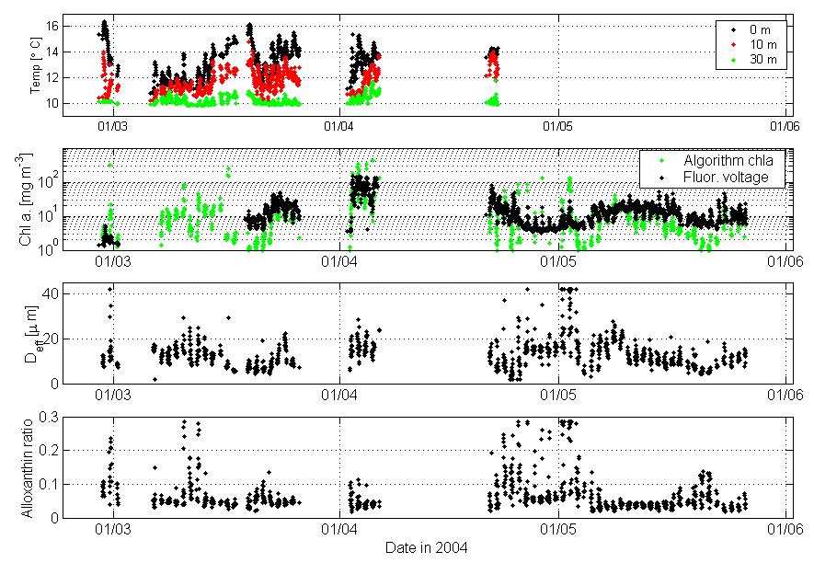
The buoy operated from 28th February to ~15th June, providing data until the 4th of June. Detailed discussions of the performance of the optical sensors, and configuration changes to buoy geometry, hardware and software systems, and payload are presented in Sections 3 and 4. A synopsis of the data set from the initial mooring period, following preliminary processing, is presented in Figure 1. The data show that, from the Eulerian perspective of the mooring, there were between three to five bloom events in the three month period presented. One of these events was an extensive bloom of the small dinoflagellate Prorocentrum triestenum, whilst it appears the remaining events were dominated by the photosynthetic ciliate Mesodinium rubrum, and occurred on a relatively small spatial scale. The typical co-occurrence of these high bio-mass surface expressions with elevated surface temperatures would indicate that surface advection plays an important role in bloom aggregation. Analyses of data on an event scale are presented in Figures 2 to 4.
Figure 1. Temperature, algorithm derived chl a and raw fluorescence voltage, and algorithm derived algal effective diameter and relative alloxanthin concentrations for the initial mooring period.

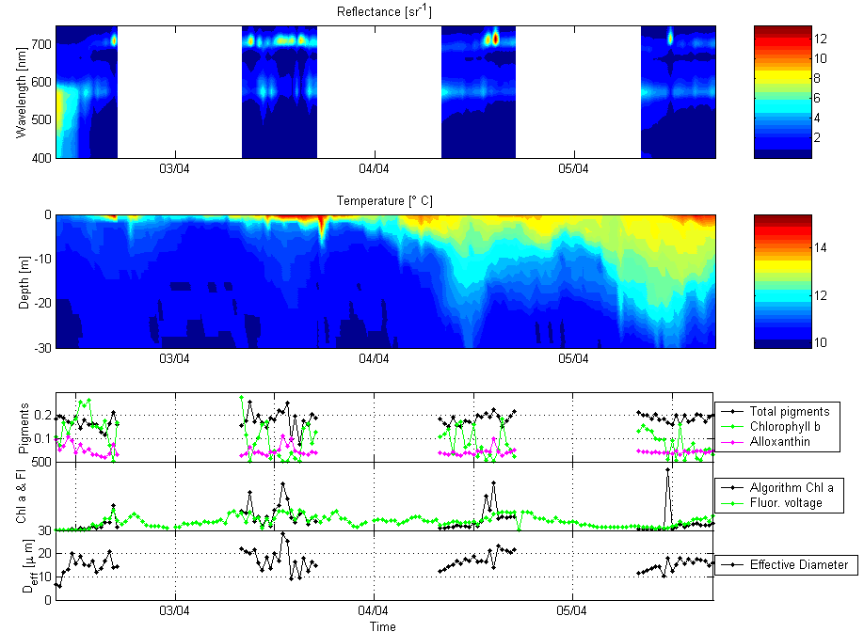
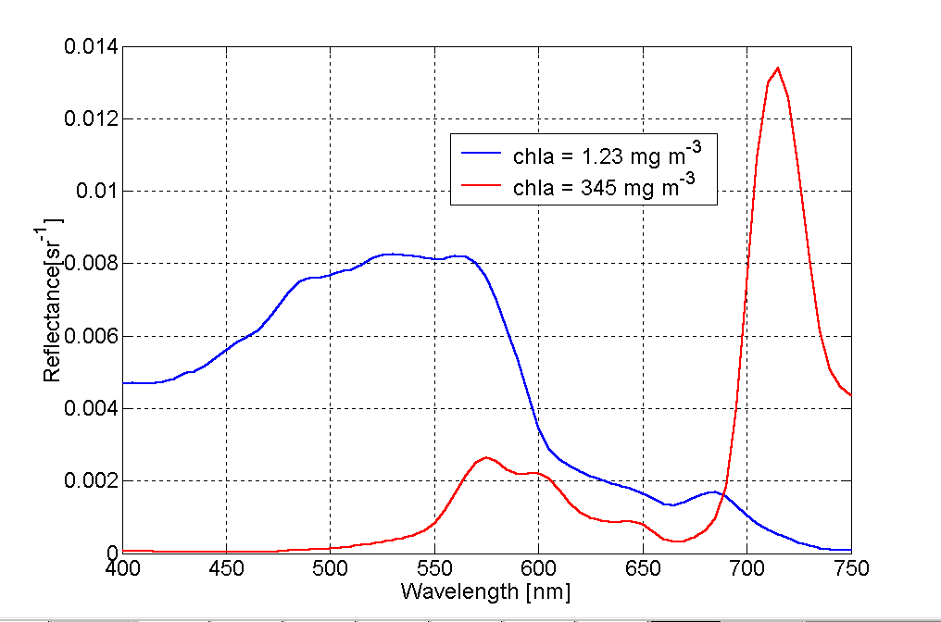
Figure 2. Buoy data from April 2nd to April 5th, showing the detection of an extraordinary bloom of the dinoflagellate Prorocentrum triestenum. The bloom reached cell concentrations of ~ 120 million cells/litre. Note the enhanced reflectance at red wavelengths for bloom waters associated with algal backscattering. The reflectance algorithm shows greatly elevated chlorophyll concentrations, low relative alloxanthin concentrations, and a relatively small cell size. This allows the inference that the bloom is composed of a small dinoflagellate species.

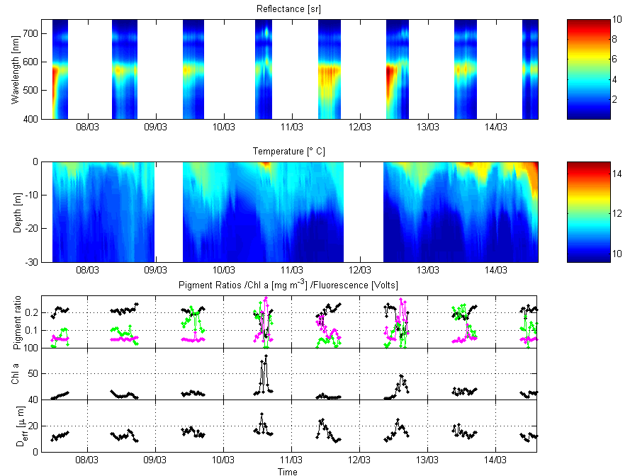
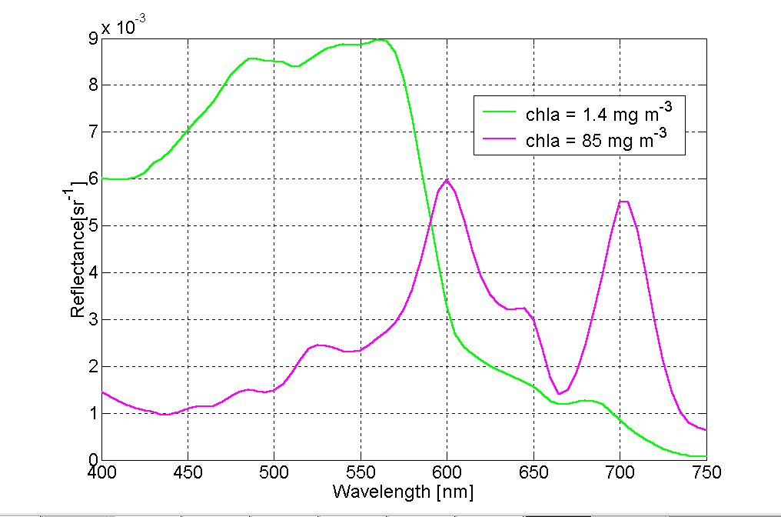
Figure 3. Buoy data from March 7th to March 15th, showing the detection of a bloom of the photosynthetic ciliate Mesodinium rubrum. Note the enhanced reflectance at red wavelengths, and the troughs at ~ 500 nm and 550 nm associated with the absorption of phycobiliproteins. The reflectance algorithm shows greatly elevated chlorophyll concentrations, and peaks in the relative alloxanthin concentration and cell size: these are consistent with the size and endosymbiont cryptophyte pigment content of M. rubrum
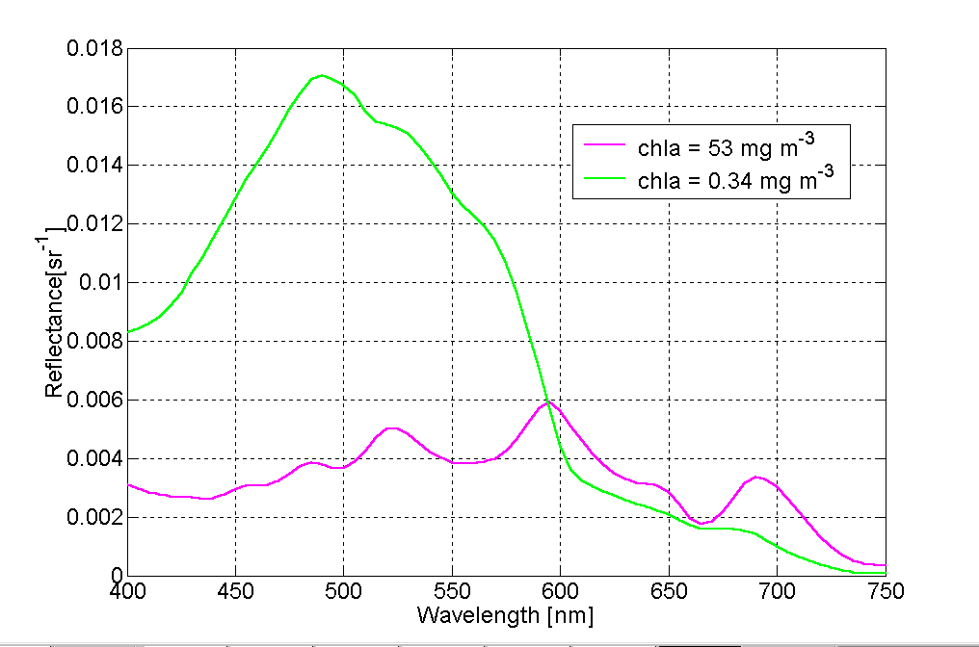
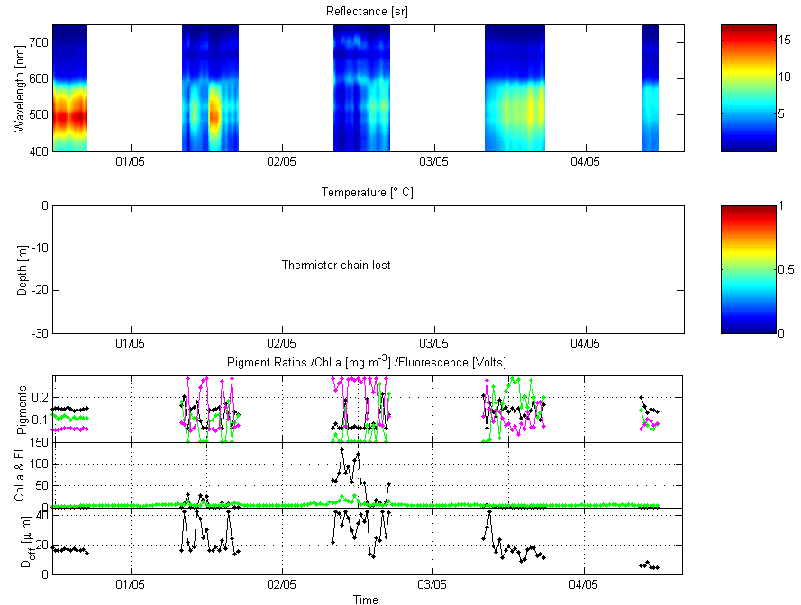
Figure 4. Buoy data from May 1st to May 5th, showing the detection of a suspected bloom of the photosynthetic ciliate Mesodinium rubrum. Note the enhanced reflectance at red wavelengths for bloom waters associated with algal backscattering, and the troughs at ~ 500 nm and 550 nm associated with the absorption of phycobiliproteins. The greatly elevated chlorophyll concentrations, and peaks in the relative alloxanthin concentration and cell size allow the inference that the organism is a large celled cryptophyte type and thus likely to be M. rubrum.
3. Radiometric Performance

Calibration of the radiometric sensors requires an extensive optical calibration facility not available in South Africa. The TRIOS radiometric sensors were calibrated in Oldenburg, Germany at the time of purchase in October 2003. Subsequent assessment of their radiometric performance can be carried out in two ways. A vicarious calibration can be made by coincident deployment with the M&CM Satlantic Hyperspectral Tethered Surface Radiometer Buoy (H-TSRB). In addition the project has a small portable field calibration device from TRIOS called a FieldCal – whilst this device is not considered stable enough for a full calibration, it is suitable for tracking radiometric drift.

3.1 Vicarious Calibration with the Satlantic H-TSRB

The Satlantic H-TSRB and the Bokkom TRIOS sensors are similarly configured hyperspectral radiometers, possessing similar geometries, spectral and radiometric specifications. However, accurate vicarious calibrations are difficult to make for several reasons:

- Perfectly coincident deployments are difficult – the waters of the southern Benguela are extremely heterogeneous spatially. Whilst all the radiometric match-ups presented below were measured within 15 minutes, and a ~200 m radius, these criteria are unlikely be stringent enough for all conditions. This is particularly true in bloom conditions
- The instruments differ slightly with regard to the viewing angle of the downward looking radiance sensor (H_TSRB=17º FOV, Bokkom=10º FOV), and the nominal depth of the radiance sensor (H_TSRB=0.66 m, Bokkom=0.4 m). These may lead to differences in the absolute radiances measured at depth due to the structure of the light field. Differences are likely to be exacerbated in very bright waters, due to FOV divergence, and in strongly attenuating high bio-mass waters due to depth differences.

Despite these caveats, the vicarious calibrations performed in February/March 2004 display a maximum 20% difference between the two instruments and allow a high degree of confidence in the radiometric performance of the Bokkom sensors. Match-up data are presented in Figure 5.
Figure 5. Radiometric match-ups between data from the Satlantic Hyperspectral Tethered Surface Radiometer Buoy (H-TSRB, solid lines) and data from Bokkom (filled circles). Data presented are upwelling radiance L_{u} at 0.66 m depth (H-TSRB) and 0.4 m depth (Bokkom), downwelling irradiance E_{d} in air, remotely sensed reflectance R_{rs} (with surface propagation by the reflectance algorithm), and the percentage difference in R_{rs} between the H-TSRB and Bokkom. Given the difficulties of making perfectly coincident measurements in the spatially heterogeneous waters of the southern Benguela, and the differing geometries and depth of the two upwelling radiance sensors, the comparison between the two radiometer systems is extremely good. There is little impact upon algorithm performance (<10%) associated with the reflectance values from the different radiometric systems.
3.2 Instrument Stability and Field Calibration

A TriOS FieldCAL unit purchased with the radiometers is used for assessing radiometric drift in the field. FieldCAL spectra were measured for both radiometers before the buoy was initially deployed and subsequently roughly once a month when servicing of the buoy was carried out. Calibration is carried out by attaching the FieldCal unit to the radiometer using the appropriate housing for the sensor, waiting for at least one minute after the FieldCAL unit has been turned on for the lamp to stabilise and then collecting and recording the spectra measured by the radiometer using Ocean-i. These spectra are then compared to the reference spectrum for the radiometer supplied with the FieldCal unit.

The lamp used in the FieldCAL unit only outputs sufficient energy for calibration between 430 and 730nm. This is a much smaller range than that of the radiometers, which sample from 350 to 950nm. As a result of this reduced range of the FieldCAL unit it is only possible to use the unit as a guide to whether there has been any major drift in the calibration of the radiometers, rather than as an absolute calibration which must be performed in a calibration laboratory.

The calibration data show that for both the radiance and irradiance sensors the measured spectra are generally within 5% of the reference spectrum (Figure 6). Although greater difference can be seen at 430nm, the absolute values being measured here are small. The differences between the measured and reference spectra can be largely attributed to the manner in which the calibration is performed. It was initially hoped that field calibration could be carried out before cleaning the sensors in order to give an idea of how dust, bio-fouling and other factors contributed to the measured spectra of the radiometers between servicing of the buoy. This was not possible as in retrieving the buoy and removing the sensors they inevitably ended up being cleaned before being calibrated. How well the sensors are cleaned before being calibrated has a direct impact on the drift of the measured spectra from the reference spectrum. In order for the lamp in the FieldCAL unit to give a stable output it is necessary to leave the lamp on for at least one minute before measurements are taken. In all cases the lamp was left on for a minute before sampling, however, in some cases it was left on for several minutes. This may also affect the measurements as the longer the lamp is on the more likely the output is to be stable and therefore measurements taken after a minute may be further out than measurements taken after 5 minutes. For this reason a standard routine should be introduced in which the lamp is always left on for the same period before sampling.

In addition, the nature of field calibration means that it is impossible to sample at a constant and specific temperature. The emission of the FieldCAL unit drops with increasing temperature and therefore the ambient temperature during sampling will have an effect on the measured calibration spectra. Some of the calibration spectra were measured late at night or first thing in the morning in Lamberts Bay when it is considerably cooler than the room temperature at which the reference spectrum is measured. Similarly other of the calibration spectra will have been measured at higher temperatures than room temperature, both of which will affect the values of the measured calibration spectra and so the amount of drift.

Despite the limiting conditions in the way in which measurements were made it can be concluded that generally less than 5% drift has occurred in the calibration of the radiometers, a portion of which may be due to the conditions in which calibration spectra were obtained. When taking future calibration measurements as much care as possible must be taken in trying to reproduce similar calibration conditions.

In conclusion, the TRIOS sensors appear to offer extremely good performance for their price. Comparisons with the vastly more expensive Satlantic radiometric indicate that the TRIOS sensors offer similar sensitivity and accuracy in both air and water. In addition the TRIOS sensors appear extremely robust, offering less than 5% drift in absolute radiometric units after four months in a very hostile environment.
Figure 6 Stability of the radiance (upper) and irradiance (lower) sensors as determined by the TRIOS FieldCal portable calibration unit.
7. Bus and System Performance - Bokkom Log

The trial deployment of an experimental instrument system will always result in numerous changes to instrument configuration. All changes made to the buoy bus, hardware, firmware, software, and payload are detailed below.

Date | Occurrence | Notes
28/02/04 | Bokkom deployed on mooring ~11:30 | Often find difficulty in dialing into buoy from house, no problem connecting when next to buoy at sea.
02/03/04 | Bokkom turned upside down on mooring. Taken back to shore to repair. | Wire strops to weight broken and weight lost. SCUFA removed from buoy as required elsewhere for continuous data.
03/03/04 | Upload new software to try and stop data logger missing acquisitions. | GPS battery failed so GPS lost settings. Alter software to stop GPS sending messages. Problems with prototype MUX board which controls power for data logger.
06/03/04 | Bokkom deployed on mooring ~10:25  No SCUFA | New 20kg weight attached to mooring using chains. Data logger still misses acquisitions during the night.
10/03/04 | Mesodinium patch seen in spectra from dialing into buoy. | Mesodinium observed from boat at sea.
15/03/04 | MTN upgraded Lamberts Bay Tower. | Considerably less difficulty experienced in connecting to buoy from house in Lamberts Bay.
16/03/04 | Software upgraded to use newer model SCUFA.
18/03/04 | Bokkom retrieved ~13:15 | Bio fouling on buoy spars and instruments. Weight chains very rusty. Spar where strop attaches buoy to mooring bent downwards. Upload new software to solve problem of data logger missing acquisitions and to control new SCUFA.  Zinc anodes attached to weight chains to prevent corrosion.
19/03/04 | Bokkom deployed on mooring ~08:30  SCUFA now on Bokkom. | Extra rope strop added from main mooring to next quadrant on Bokkom to try and reduce stress on spar frame.
26/03/04 | Unable to dial into Bokkom from Cape Town. ‘No carrier’ returned straight away by modem.
30/03/04 | Rock Lobster unit working in Lamberts Bay report that Bokkom is upside down.
01/04/04 | Bokkom upside down on mooring, retrieved ~07:30 and taken ashore. | Weight still hanging from 2 chains so Bokkom lying at an angle. One weight chain snapped near weight, causing buoy to turn over. Rope strop to main mooring chaffed through and sheared. Spar where strop attached to main mooring bent upwards due to buoy being inverted. GPS removed as unit rusty and no longer functions. Four 3.2kg dive weights attached to bottom of battery cage. Blocks of Sondor foam attached to spars under Solar Panels to try and get buoy to self-right.
02/04/04 | Bokkom redeployed on mooring ~09:10  New weight configuration.  Dial into buoy back in Cape Town in afternoon, red tide detected in spectra. High SCUFA readings, low reflectance spectra with high fluorescence peak. | Attached two extra rope strops with bungee cord to absorb stress to main mooring, one alongside existing strop and one to next quadrant of buoy to try and reduce stress on spar frame.  Test buoy for self-righting in harbour. Buoy lies horizontally on foam but does not right. Add three 1.5kg anodes to bottom of frame. Buoy now rights from horizontal but not if totally inverted.
03/04/04 | Dial in from Cape Town. Data logger often loses time and resets to 01/06/99 12:00 | Removal of damaged GPS means that if the data logger resets it has no way to reset the time and so resets to the default time. Often have to correct time manually when dialing in.
05/04/04 | Red tide detected when dialing into buoy.
06/04/04 | Unable to connect to buoy from Cape Town. Modem rings but no answer.
07/04/04 | Bokkom retrieved from mooring ~17:30  Red tide in Lamberts Bay – water sample taken, Prorocentrum gracile | Main mooring appears to be sinking, light only just visible above water surface.  Data logger appears to have had software problem. Logger lost instruments one by one.
08/04/04 | Bokkom left in Lamberts Bay. | Unable to make new MUX board work with data logger. Original board still works but has always been prototype and caused problems.  Decision taken not to re-deploy buoy due to main mooring sinking.
20/04/04 | Trip to Lamberts Bay to re-deploy Bokkom. | New MUX board installed in data logger. Extra flotation attached to existing flotation behind solar panels. Another two 3.5kg weights attached to bottom of frame. Total weight attached to frame approximately 20kg.
21/04/04 | Bokkom redeployed on mooring ~10:45 | Divers clean fouling off main mooring which was causing it to sink. Now floats with main floatation just above surface.
23/04/04 | Dial into buoy from Cape Town. No thermistor data.
10/05/04 | Possible red tide detected when dialing into Bokkom | SCUFA values high and reflectance spectra show high fluorescence peaks.
17/05/04 | Bokkom retrieved from mooring ~16:00 for routine servicing. | Thermistor chain has gone, possibly became wrapped around main mooring line and tension pulled thermistor chain out of thermistor box. Thermistor box full of water, electronics damaged.  Bio-fouling on buoy frame and instruments.  Uploaded new software to MUX board and data logger to set time from MUX board which should solve problem of time resetting to default time.
18/05/04 | Bokkom deployed on mooring ~14:20
19/05/04 | Unable to connect to Bokkom from Cape Town
26/05/04 | Bokkom retrieved from mooring ~15:15 and taken ashore. | Modem seems to have lost network. Once power is cycled modem finds network and it is possible to dial into buoy. Discussion with MTN reveals that a link break occurred between the Lamberts Bay tower and Cape Town around the time communication was lost with the buoy. Modem needs to be hard rebooted to find the network after a link break. Data logger had trouble setting time from MUX board. Install new software into MUX board to allow time to be set correctly.
28/05/04 | Bokkom redeployed on mooring ~09:30
05/06/04 | Unable to dial into Bokkom from Cape Town. | MTN report that another link break had occurred between the Lamberts Bay tower and Cape Town. Modem probably needs to be rebooted to find network but buoy is currently at sea.
17/06/04 | Bokkom retrieved | Bokkom suffered irreparable damage.

A number of difficulties have been encountered since Bokkom was initially deployed off Lamberts Bay in February 2004, summarised as follows.

During the first two weeks of the deployment a field trip to Lamberts Bay ensured that the buoy could be continuously monitored. Initially the software in the Ocean-i data logger missed a number of the half hourly two minute instrument acquisitions, particularly at night. This was resolved by upgrading the software in the data logger.
The cell phone signal strength in Lamberts Bay has a tendency to fluctuate, which can cause problems in connecting to the buoy remotely from the shore. During the first couple of weeks it was often difficult or impossible to connect to the buoy from shore though communication could always be established from a boat at sea where the signal strength is more reliable. MTN have been extremely helpful in providing advice and assistance in this regard. An upgrade to the Lamberts Bay tower meant that the reliability of remote connection from shore via cell phone was greatly improved.

The initial buoy configuration had a stabilising weight suspended 3m below the main buoy cage on three stainless steel wire strops. Early on in the deployment the wire strops parted due to chaffing at the attachment points and the weight was lost. As all three strops do not part at the same time, the weight is transferred to one side of the buoy structure causing the buoy to turn over. The weight strops were replaced with heavier duty chain with large o-rings to absorb some of the stress. Zinc anodes were added to the chain to reduce the rate of corrosion of the chain. However, eventually one of the chains parted, again causing the buoy to turn over. Subsequent to this a number of weights were attached directly to the bottom of the buoy cage to overcome the issue of the strops parting and inverting the buoy. Blocks of floatation were also attached to the buoy superstructure underneath the solar panels. This was to enable the buoy to right itself if it was knocked horizontal by waves or swell. Testing in the harbour showed that the initial weight attached was insufficient so more weight and flotation were added at a later stage to enable the buoy to self-right.

On several occasions it was not possible to connect to the buoy remotely from Cape Town. The modem returned ‘No carrier’ immediately, implying that there is no power to the modem or the modem is not connected to the network. On connecting to the modem, having retrieved the buoy, it seemed that the modem had lost its connection to the cell phone network and been unable to reestablish it. Cycling the power to the modem resulted in the network being found immediately. Discussion with MTN revealed that a link break had occurred in which the landline connection between the Lamberts Bay tower and Cape Town is lost. When this occurs most modems and cell phones need to be rebooted in order to find the network again. Although link breaks do not occur frequently it is important to set the modem up in a way in which it can reboot itself on a daily basis in order to reestablish connection to the network if it is lost.

5. Reflectance Algorithm Development and Performance

The reflectance inversion algorithms developed over the last few years in the Oceanography Department have been extensively refined. Important features of the new algorithm structure are:

- The algorithm now uses a full Aden-Kerker two layered spherical model code, in conjunction with chlorophyll specific particle size distributions, to calculate the absorbing and backscattering properties of algal populations.

- A more accurate radiative transfer scheme, needed to propagate subsurface radiance measurements to the surface to calculate reflectance values, has been implemented. The scheme is based on the model of Alberte & Mobley [2003] and requires only solar zenith angle as an additional input

- The key reflectance formulation that is solved by the non-linear simplex routine has been rewritten to allow the incorporation of the new Alberte & Mobley propagation scheme. The model now solves for the upwelling radiance at measurement depth rather than remotely sensed reflectance – this scheme allows for more accurate radiance propagation through the upper water column.

The reflectance algorithm is structured as follows. The reflectance approximation [Zaneveld 1995], commonly used for reflectance inversion algorithms [Roesler & Perry 1995, Roesler & Boss 2003] can be reformulated to explicitly solve for the upwelling radiance L_{u} measured at depth z :

(1)

where f/Q is an assumed constant (=0.085) describing the angular structure of the light field, η/τ is an assumed constant (=1.3612) describing the transmittance across the air-sea interface, b_{bt} is the total backscattering coefficient, a_{t} is the total absorption coefficient, E_{d} is the downwelling irradiance in air, and K_{u} is the diffuse attenuation coefficient for upwelling radiance. The spectral dependency of all terms on wavelength λ is implicit.

Total absorption and backscattering coefficients are the summed total of the principal optical constituents of the water column which are phytoplankton(a_{φ}, b_{bφ}), gelbstoff and detritus(a_{g}), seawater (a_{w},b_{bw}) and small particles (b_{bs}):

(2) (3)

The diffuse attenuation coefficient for upwelling radiance K_{u} is dependent upon the total absorption and backscattering coefficients, and solar zenith angle θ_{s}, using the formulation of Alberte & Mobley [2003]:

(4)

Phytoplankton Absorption and Backscattering Coefficients

It is the formulation of phytoplankton absorption and backscattering that is critical to the success of inverse reflectance algorithms of this type. Recent research [Bernard 2004] has demonstrated that:

- It is possible to represent the optical properties of complex phytoplankton size distributions with simple Standard distributions [Hansen & Travis 1974] providing the effective diameter and surface area are equivalent, and,

- Phytoplankton optical models employing a two layered spherical geometry provide reasonable approximations to the scattering properties of phytoplankton, allowing a complete description of the optical properties of any hypothetical algal population given effective size, assemblage type and bio-mass descriptors.

The algorithm uses optical efficiency factors for absorption and backscattering for three algal groups – chlorophyll b containing flagellates and chlorophytes, fucoxanthin/peridinin containing diatoms and dinoflagellates, and alloxanthin/phycoerythrin containing cryptophytes (or organisms associated with cryptophyte endosymbionts such as Mesodinium rubrum). Absorption and backscattering efficiency factors for size ranges of algae from 1 μm to 100 μm diameter are generated, based upon size and refractive index data from field measurements. These efficiency factors are used by the algorithm, in conjunction with intracellular chlorophyll a concentrations ci (kg m⁻³) and Standard size distributions, to calculate algal optical properties based on effective diameter, algal group and chlorophyll a concentrations. Standard size distributions are given by [Hansen &Travis 1974]:

$F (r) = N_{0} r^{[ ( 1 − 3 ν_{\text{eff}}) / ν_{\text{eff}}]}\text{exp}[ r /(r_{\text{eff}} ν_{\text{eff}})]$ (5)

where F(r) is the number of particles per unit volume per size bin, N_{o} is a scaling factor, ν_{eff} is the effective variance, and r_{eff} is the effective radius. Chlorophyll specific absorption coefficients (backscattering coefficients are calculated in an analogous manner) are given by:

$a (λ)=\frac{π}{4}{\bar{Q}}_{a} (λ) \int_{0}^{∞}{F(d)d^{2}d(d)}$ (6)
where a (λ) is the absorption coefficient (m⁻¹), ${\bar{Q}}_{a} (λ)$is the absorption efficiency factor (where the overbar signifies the mean of a particle population), d is the particle diameter (m), F(d)d(d) is the number of particles per unit volume in the size range d ± ½ d(d), and λ denotes wavelength (nm).

Sample chlorophyll specific absorption and backscattering coefficients can be seen in Figure 7.

Figure 7. Example algal inherent optical properties showing the changing characteristics of assemblage optics with varying size. a) Chlorophyll specific absorption and the effects of enhanced packaging with increasing cell size, b) Chlorophyll specific backscattering, showing reduction of backscatter magnitude and spectral flattening as cell size increases. Backscattering data are modelled using a two layered spherical geometry with the chloroplast as the outer layer.
a
Absorption and backscattering coefficients of other constituents

Combined gelbstoff/detritus absorption is represented by an exponential shape function:

$a_{g}(λ ) =a_{g}(\text{400} ) \text{exp} [−0\text{.}\text{017}(λ−\text{400})]$ (3)

where a_{g} (400) is solved for.

The absorption of seawater is given by the data of Pope & Fry [1987], whilst the backscattering of seawater is given by the data of Morel [1974]. Backscattering by small particles e.g. detrital, bacterial or lithogenic particles, is represented by a power law following a λ^{-1.2} relationship [Roesler & Perry 1995].

Algorithm Solution and Geophysical Products

The algorithm reaches an iterative solution through a non-linear solution of equation (1), using a Nelder-Mead type simplex search method. It is currently coded in Matlab R13 (The Mathworks). The current implementation of the algorithm solves for seven unknowns – chlorophyll a concentration, algal effective diameter, flagellate/diatom and dinoflagellate/cryptophyte relative composition, detrital/gelbstoff absorption and the backscattering of small particles.

Figure 8 demonstrates the ability of hyper- and multi-spectral implementations of the reflectance algorithm to derive the effective diameter of algal assemblages through a range of water types. In addition, the performance of the hyperspectral algorithm with regard to the identification of chlorophyll b containing assemblages is shown. Whilst the algorithm appears capable of identifying alloxanthin containing cryptophyte type assemblages e.g. Mesodinium rubrum, analysis of this aspect of algorithm performance must wait until the HPLC pigment analyses from 2004 field work are available in several months time.

Figure 8 Performance of the inverse reflectance algorithm with regard to a) Predicted effective diameter utilising 5 nm resolution hyperspectral data b) Predicted chlorophyll b (relative to chlorophyll a) utilising 5 nm resolution hyperspectral data c) Predicted effective diameter utilising the six visible SeaWiFS wavebands, and d) Predicted effective diameter utilising the eight MERIS visible wavebands. All spectral reflectance data are measured with the Satlantic HyperTRSB surface radiometer, measured algal size data are calculated from Coulter Multisizer measurements, and measured chlorophyll b values are derived from HPLC analyses.

6. Design of New Mooring System

Whilst the original buoy bus has provided a suitable platform for trial deployment, with a resultant three month data set, there are several design issues that need to be addressed. Chief amongst these are the requirement for enhanced seakeeping abilities, greater robustness, and a mooring geometry allowing ease of servicing and the ability to deploy a thermistor chain off the principal scientific buoy. In addition the buoy must be sufficiently lightweight to allow deployment and servicing from a small boat. The multi-sensor payload adds further design constraints associated with the various sensors. The upwelling radiance sensor must be vertically oriented, as close to the surface as possible, and not in shadow. The downwelling irradiance sensor must also be vertically oriented, coupled in a vertical axis to the radiance sensor, and be sufficiently removed from the surface boundary layer to remain dry in standard operating conditions. Finally, the ADCP (which also acts as ballast) must be close enough to the surface to allow measurement of surface currents, critical in bloom situations where a shallow pycnocline confines the majority of algal bio-mass to the upper few meters.
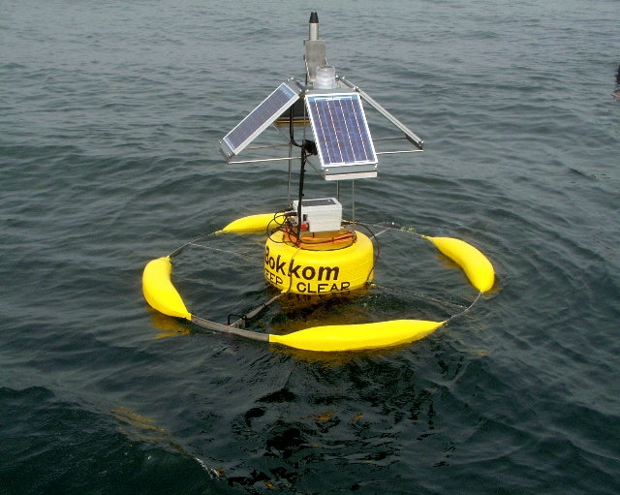

Figure 9. Bokkom in calm weather. The spread wetted surface area minimises radiometer shading and provides stability, and the large surface area presented by the solar panels provide optimum power efficiency. These attributes do not make for good seakeeping characteristics however.

A short draught pencil or spar buoy geometry on a two anchor tight line mooring appears to provide the best solution to this set of criteria. A preliminary design is presented in Figure 10 – the resonant frequencies, hydromechanical properties and stress limits of the principal buoy and entire mooring configuration are currently undergoing simulation analyses to assess suitability.

Figure 10. Sketch of the new principal scientific buoy, currently undergoing hydromechanical analyses by Finite Element Analysis Services.

7. Web Site Development

The web site has been developed to provide information and data related to harmful algal blooms and related research in the Benguela system. Initial pages for the web site have been developed and are currently stored on a local server for viewing and testing purposes. The site will be expanded to include further information and data as it becomes available. The home page contains a brief introduction to the site along with current news and harmful algal bloom or shellfish warnings, which will be provided by Marine and Coastal Management where applicable. The real time monitoring section of the site contains information about the Namaqua mooring, data from the mooring and satellite data from the MERIS and MODIS sensors. A snapshot of current data from the buoy is automatically uploaded to this section twice daily, displaying reflectance and temperature data along with chlorophyll a, algal size and accessory pigment data. Weekly time series data will be updated daily on a rolling basis with reflectance, temperature, chlorophyll, pigment and size data from the mooring. Due to the irreparable damage suffered by the mooring, example data is currently displayed for the snapshot and time series data.

Recent satellite images of the area, provided by ACRI under the Coastwatch programme, can be viewed as thumbnails and are expandable to full sized pop-up images for viewing and comparison. This page currently displays standard chlorophyll a geophysical products for the southern Benguela region from MERIS and MODIS. Fluorescence line height and experimental effective algal diameter and accessory pigment geophysical products will be displayed once they can be processed routinely.

Publications, reports and leaflets pertaining to harmful algal blooms and research carried out in the area are available for viewing and download as pdf files in the research section of the web site. In addition, the education section contains material relating to ocean colour and harmful algal blooms. The material in the ocean colour section is reproduced from The Living Ocean pages at the SeaWIFS Project, NASA with the kind permission of Gene Feldman.

Sample pages from the site can be seen in Figure 11 – the site can currently be accessed at http://sea.uct.ac.za/hab whilst domain registration is completed.

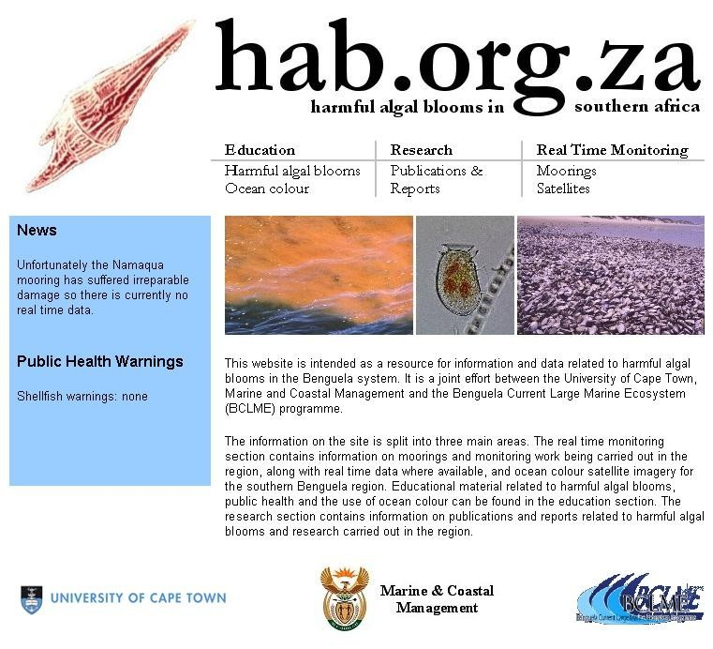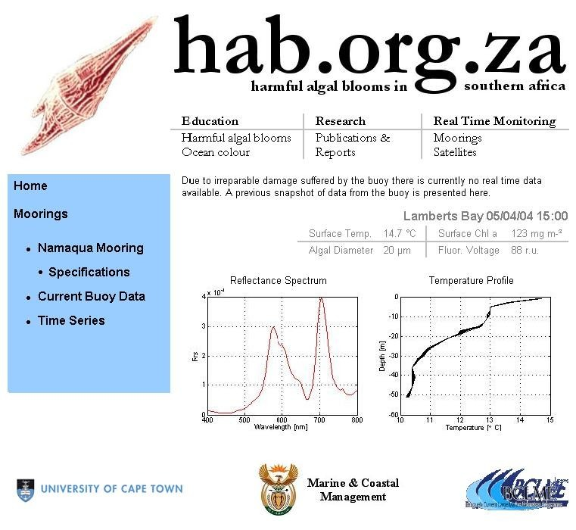

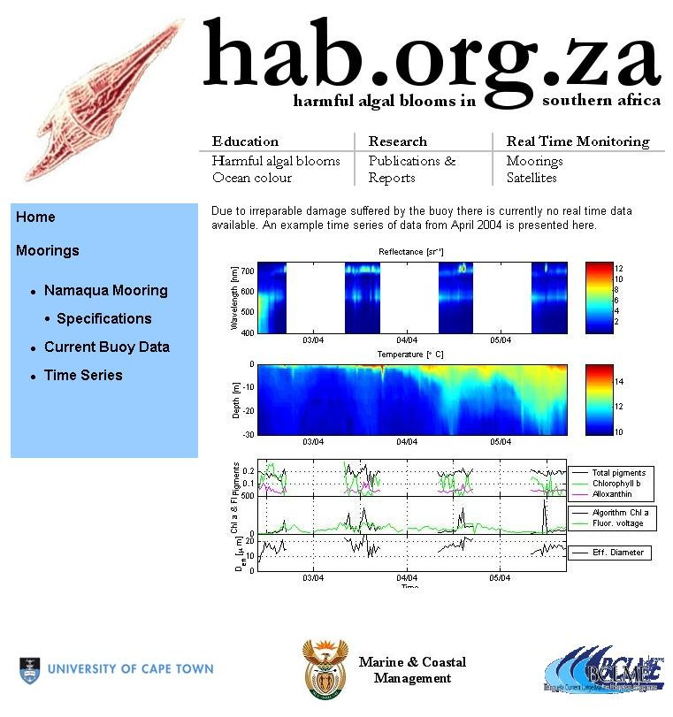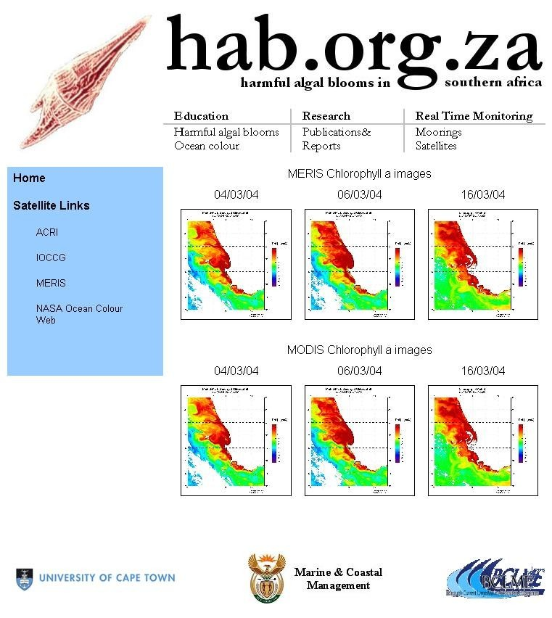

Figure 11 Sample pages of the hab.org.za web site, incuding the home page (upper left), the mooring snapshot page (upper right), the mooring time series page (lower left), and the satellite data page (lower right).

8. Workplan and Personnel Budget

Segment 3 August 2004 – January 2005 Activities

- Finalisation of new buoy design based on simulation analyses
- Bus construction and system integration of new scientific and marker buoys.
- Deployment and field testing of new mooring currently scheduled for late September 2004
- Implementation of HAB related experimental satellite products and distribution through web site.
- Publication of analyses of initial mooring period data and bio-optical methods

Segment 3 August 2004 – January 2005 Deliverables & Personnel Budget

- Progress Report 3: Bio-optical, ecological and time series analyses of cumulative data set, further operational aspects of mooring.

Project management work hours: 1008
M.Sc. work hours: 2016

9. Outlook
The project schedule for the next six months will address the following:

- Hydromechanical and stress analyses of the new buoy and mooring design
- Construction and testing of the new principal buoy
- Deployment and field testing of the new mooring
- Distribution of real time buoy geophysical products and near real time satellite ocean colour products through web site
- Documentation and publication of project results to date
- Initiation of system based approach focusing on potential data assimilation routes and forecasting
10. References

Alberte, A. and C.D. Mobley. 2003. An analytical model for subsurface irradiance and remote sensing reflectance in deep and shallow case-2 waters. Optics Express, 11(22), 2873-2890.

Bernard, S. 2004. The bio-optical detection of harmful algae. PhD thesis, University of Cape Town, in preparation.

Hansen, J.E. and L.D. Travis. 1974. Light scattering in planetary atmospheres. Space. Sci. Rev.16: 527-610.

Morel, A. 1974. Optical properties of pure water and pure sea water, Chapter 1 in Optical Aspects of Oceanography, Ed. N.G. Jerlov and E.S. Nielsen, Academic Press, New York, 1-24.

Pope, R.M. and E.S. Fry. 1997. Absorption spectrum (380 - 700 nm) of pure water. II. Integrating cavity measurements. Appl. Opt., 36, 8710-8723.

Roesler, C.S. and M.J. Perry. 1995. In situ phytoplankton absorption, fluorescence emission, and particulate backscattering spectra determined from reflectance. J. Geophys. Res. C100: 13 279 - 13 294.

Roesler, C.S. and E. Boss. 2003. Spectral beam attenuation coefficient retrieved from ocean colour inversion. Geophys. Res. Lett. 30(9): doi:10.1029/2002GL016185.

Zaneveld, J.R.V. 1995. A theoretical derivation of the dependence of the remotely sensed reflectance on the inherent optical properties. J. Geophys. Res., 100(C7), 13,135-13,142.
11. Notation

ACRI Mecanique Des Fluides Observation De La Terre Sciences De L'Environnement

ADCP Acoustic Doppler Current Profiler

BOKKOM Name of the primary bio-optical mooring

GSM Global System for Mobile Communications
GPS Global Positioning System

HAB Harmful Algal Bloom

HSCSD High Speed Circuit Switched Data

M&CM Marine and Coastal Management

MERIS Medium Resolution Imaging Spectrometer

MODIS Moderate Resolution Imaging Spectrometer

SCUFA Self Contained Underwater Fluorescence Apparatus

UCT University of Cape Town
Appendix I
In kind support and value additions

Marine and Coastal Management
RDI Sentinel 300 ADCP (moored instrument) ZAR 300,000
Turner Designs SCUFA (moored instrument) ZAR 160,000
Apprise Technologies Templine Thermistor Chain ZAR 30,000
Estimated boat time and logistical support ZAR 90,000

In addition to making supplementary mooring instrumentation available to the project, M&CM will provide boat time for mooring deployment and servicing, and has provided test facilities, technical and logistical support.

Oceanography Department, University of Cape Town
Apprise Technologies Templine Thermistor Chain ZAR 30,000
Estimated diver time and logistical support ZAR 10,000

Saturn Solutions, UK (John Cheriton)
Communications and software development € 5,000

MTN (South Africa)
MTN have offered a great deal of technical support, including sending an engineering team into the field during initial deployment to make local GSM upgrades. MTN have asked for a sponsorship submission and are currently considering material sponsorship of the project.

Total Estimated In-kind support ZAR 660, 000

