Progress Report 2:
BCLME Project EV/HAB/02/03

Investigation into the Diversity and Distribution of Cysts of Harmful Algal Blooms within the Benguela Current Large Marine Ecosystem Region

Ref. RAF/00/G32 – Benguela Current Large Marine Ecosystem

Project Period: 18 months
(1 August 2003 – 31 January 2005)

Submitted by: Dr L. B. Joyce
Date: 15 July 2004

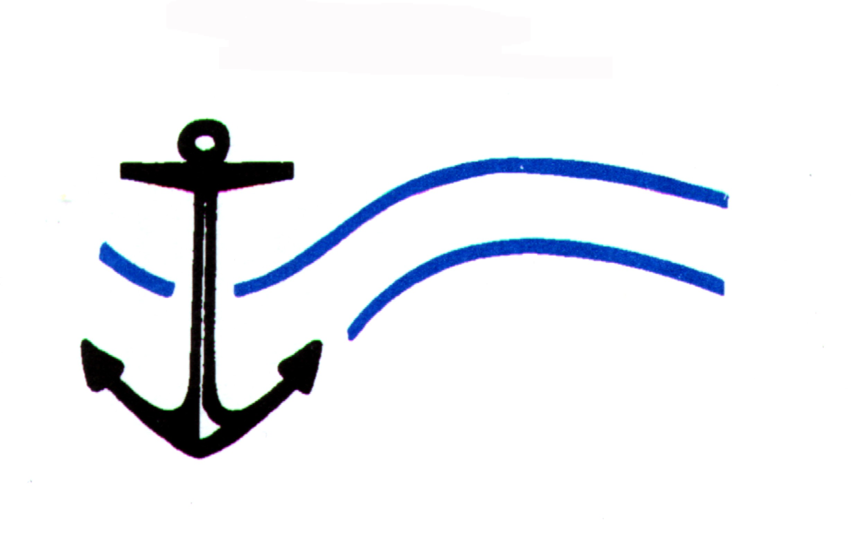
Centre for Marine Studies  University of Cape Town | Oceanography  University of Cape Town
Introduction
Harmful algal blooms (HABs) frequently occur within the BCLME region, in particular they are known to occur in coastal waters of South Africa and Namibia, and whilst there have been reports of red tides off Angola, there is in general a great disparity in the amount of available information about HABs within the majority of the BCLME region. Due to the absence of HAB monitoring programs in Angola and Namibia, the frequency, duration and extent of HABs is unknown, as are the species involved. Also, the diversity, abundance and distribution of cysts of HAB species, and the history of blooms are poorly established in the majority of the BCLME region.

Objectives of the project
This project will assess the diversity, distribution and abundance of cyst species within the sediments of the BCLME region. Particular attention will be paid to the cysts of HAB species. The specific outputs of the project will be;
1. An analysis of the distribution of cysts within the region, including the spatial limits of specific species, resulting in horizontal distribution maps of cyst species throughout the BCLME region.
2. Provide an indication of seed sources, and an indication of the variability in potential for future harmful blooms within the region.
3. An assessment of the vertical distribution and diversity of cysts within the sediments thereby providing a history of cyst deposition and establishing a history of blooms (cyst forming HAB species).

Scope of the project
- Sampling areas were sampled with the goal of providing sufficient resolution and replication for accurate mapping of cyst assemblages and densities.
- Samples were collected using ships of opportunity.
- For the analysis of surface cyst assemblages, distributions and abundances, sediment samples were collected via a grab sampler. Results will give an indication of potential seed sources, and an indication of the variability in potential for future harmful blooms within the region.
- For the analysis of vertical profiles of cyst assemblages and abundances within the sediments, samples were collected via a core sampler. Results will show the history of cyst deposition and establish bloom history.

Work completed
The collection of sediment samples, from the South African west coast, Namibian coast, and Angolan coast, has now been completed (see Fig 1). The analysis of half the samples collected has been completed (see Fig 1).

Preliminary Results
A detailed species list of cyst types found, so far, from South Africa and Namibia has been established (see Table 1). The Table clearly shows that several more species of cysts have been found along the Namibian coast than that of the South African coast. Photographs of some of the cyst types that have been found so far are shown in Plate 1. Three toxic cyst species have been found in the sediments; Alexandrium catenella, Protoceratium reticulatum and Lingulodinium polyedrum.
A major public health impact from HABs occurs when toxic species are filtered from the water by shellfish such as clams, mussels, oysters and scallops, which then accumulate the algal toxins to levels that are potentially lethal to humans or other consumers. One of these shellfish poisoning syndromes has been described as Paralytic Shellfish Poisoning (PSP).
A. catenella, which produces saxitoxin and several derivatives of this molecule, is responsible for outbreaks of PSP in the Benguela region. The symptoms of PSP include tingling and numbness of the mouth, lips and fingers, accompanied by general muscular weakness and incoordination. Acute doses inhibit respiration, and death may result from respiratory paralysis.
Cysts of A. catenella have been found in the southern Benguela and the northern Benguela regions, in sediments along the west coast of South Africa, and along the Namibian coast. It is still uncertain how far north A. catenella extends, this will only be determined when all sediment samples have been analysed. A distribution map of Alexandrium catenella has been produced for the region along the west coast of South Africa, and a preliminary distribution map has also been produced for the region along the Namibian coast (see Fig 2).
P. reticulatum and L. polyedrum are toxic dinoflagellates that produce yessotoxins (YTX). The toxic syndromes of YTX are not well defined in humans, but P. reticulatum has been associated with large mussel mortalities along the west coast of South Africa. The southern and northern extent of these species is as yet unknown, and will only be determined when all sediment samples have been analysed.

Work remaining
Analysis is underway on the remaining samples collected from Namibia and Angola (see Fig 1). Horizontal distribution maps of specific species, and vertical profiles of cyst assemblages from the west coast of South Africa, Namibia and Angola are in preparation.

Fig 1: Map of the BCLME region showing the locations of sediment sample collection (• sample analysis completed; • sample analysis still to be undertaken)
Table 1: Cyst types found in the sediments along the west coast of South Africa and the coast of Namibia (* Harmful species)

Cyst types |  | South Africa | Namibia
Biological name | Palaeontological name
Gonyaulacales
Gonyaulax sp. | Spiniferites delicatus | + | +
Gonyaulax spinifera complex | Spiniferites ramosus | + | +
Lingulodinium polyedrum * | Lingulodinium machaerophorum | + | +
Gonyaulax spinifera complex | Nematosphaeropsis sp. |  | +
Protoceratium reticulatum * | Operculodinium centrocarpum | + | +
Alexandrium catenella * | - | + | +
Gymnodiniales
Polykrikos kofoidii | - | + | +
Polykrikos schwartzii | - | + | +
Calcareous Peridiniales
Scrippsiella crystallina | - |  | +
Scrippsiella lachrymosa | - | + | +
Scrippsiella precaria | - |  | +
Scrippsiella ramonii | - |  | +
Scrippsiella trifida | - |  | +
Scrippsiella trochoidea | - | + | +
Scrippsiella sp. | - | + | +
Organic Peridiniales
Protoperidinium americanum | - | + | +
Protoperidinium avellanum | Brigantedinium cariacoense | + | +
Protoperidinium claudicans | Votadinium spinosum | + | +
Protoperidinium compressum | Stelladinium stellatum | + | +
Protoperidinium conicoides | Brigantedinium simplex | + | +
Protoperidinium conicum | Selenopemphix quanta | + | +
Protoperidinium denticulatum | Brigantedinium sp. | + | +
Protoperidinium leone | Quinquecuspis concreta | + | +
Protoperidinium oblongum | Votadinium calvum | + | +
Protoperidinium pentagonum | Trinovantedinium applanatum | + | +
Protoperidinium subinerme | Selenopemphix nephroides | + | +
Round Brown | - | + | +
Zygabikodinium lenticulatum | Dubridinium caperatum | + | +

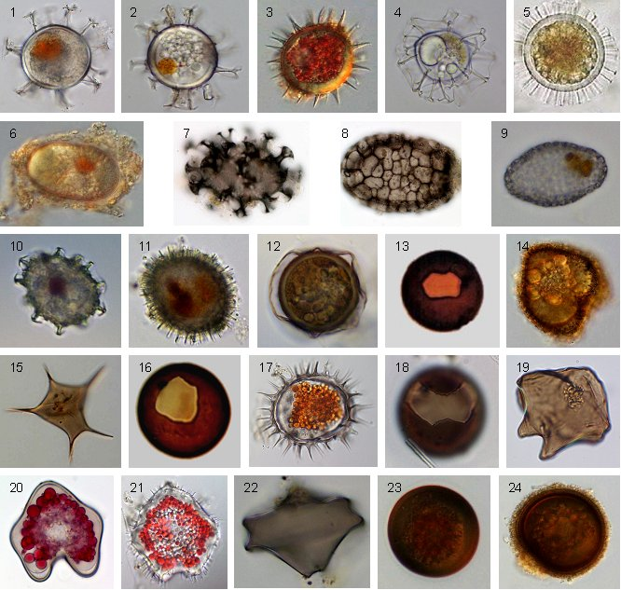

Plate 1. Dinoflagellate cysts found in surface sediments from the BCLME region.
1) Spiniferites delicatus. 2) Spiniferites ramosus. 3) Lingulodinium polyedrum.
4) Nematosphaeropsis sp. 5) Protoceratium reticulatum. 6) Alexandrium catenella.
7) Polykrikos kofoidii. 8) Polykrikos schwartzii. 9) Scrippsiella lachrymosa.
10) Scrippsiella trifida. 11) Scrippsiella trochoidea. 12) Protoperidinium americanum. 13) Protoperidinium avellanum. 14) Protoperidinium claudicans. 15) Protoperidinium compressum. 16) Protoperidinium conicoides. 17) Protoperidinium conicum.
18) Protoperidinium denticulatum. 19) Protoperidinium leone. 20) Protoperidinium oblongum. 21) Protoperidinium pentagonum. 22) Protoperidinium subinerme.
23) unidentified ‘round brown’ protoperidinioid cyst. 24) Zygabikodinium lenticulatum.

A
B

Fig 2. Horizontal distribution maps of the toxic dinoflagellate Alexandrium catenella.
A) Namibia. B) South Africa.

