Ref: RAF/00/G32 BCLME
BCLME Project EV/LS/02/06
Diagnosis of Large Scale South Atlantic Modes that Impact on the Transboundary Benguela Current Large Marine Ecosystem: Investigating the Potential for Improved Predictability and Sustainable Management

Variability in forcing, boundary conditions and modelling the northern Benguela region

Report 5

F. Colberg, and C. J. C. Reason

June 2006


Centre for Marine Studies  University of Cape Town | Oceanography  University of Cape Town

Contents

1. Introduction - 3 -
1.1 The Angola Benguela Frontal Zone (ABFZ) - 3 -
2. Regional Ocean Modelling System (ROMS) - 5 -
2.1 Model Description - 5 -
2.2 Model Configuration - 5 -
3. The reference experiment - 6 -
3.1 Comparison with observations - 6 -
3.2 The ABFZ and the atmospheric and oceanic mean state - 8 -
3.3 Summary and discussion - 12 -
4. Sensitivity of the position and intensity of the ABFZ to changes in windstress - 14 -
4.1 Description of the experiments - 14 -
4.2 Results - 15 -
5. Summary and discussion - 18 -
6. References - 21 -
Appendix 1: Figures - 25 -

1. Introduction

1.1 The Angola Benguela Frontal Zone (ABFZ)

A sharp thermal front situated at approximately 16°S was first reported by Hart and Currie (1960). While sailing southward along the coast from Lobito in Angola on the R.R.S William Scoresby, these authors registered a decrease in temperature from 27°C to 20.5°C within only one hour. Although the thermal gradient may have been anomalously strong (Shannon et al., 1986), the reported position of the front is in good agreement with observations thereafter (e.g. Shannon et al., 1987; Meeuwis and Lutjeharms, 1990; Shannon and Nelson, 1996; Kostianoy et al., 1999). Large scale characteristics of the ABFZ as described by Shannon et al. (1987) reveal a zonally orientated front, separating the waters of the opposing Benguela and Angola Currents with typical temperature gradients of 4°C per 1° of latitude. The front is particularly marked in the upper 50m, but may extend to a depth of 200m as suggested by salinity data. Persistent tongue like features of warm water between 12°S and 16°S exist due to the combined effect of poleward flow and coastal upwelling over a steeply shelving bottom. On the mesoscale there is evidence of two existing fronts in the area between 14°S and 18°S. While the southern most front may be associated with the Benguela upwelling system and hence marks the northern boundary of the Benguela system, the northern front relates to the Angola tongue, as its position coincides with the penetration of tropical and equatorial surface waters. The current system in the ABFZ is rather complex, as intense stratification occurs, particularly north of 16°S, and strong vertical shear in the currents is likely. Shannon et al. (1987) noted that the upper ocean currents will depend to a certain degree on the winds, but the dominant flow is determined by the interaction between the Benguela and Angola Currents. Variability in the ABFZ occurs in time and space.

There is a general seasonal shift of the front of about 2° of latitude. On time scales of days, migrations of 150km or more have been observed. Shannon et al. (1987) suggested that the front is maintained around 16°S due to a combination of factors. These include the coastline orientation, bathymetry, stratification and windstress. The coast changes its direction at Cape Frio and Porto Alexander, which has consequences for the upwelling. Also a dramatic change in the width of the shelf and the steepness of the continental slope is apparent between 15°S and 20°S. Changes in stratification and upwelling-favourable winds also exist between these latitudes.

Meeuwis and Lutjeharms (1990) investigated the ABFZ using satellite derived weekly maps of SST for the period of 1982 to 1985. They concluded that the ABFZ is a permanent feature at the sea surface between 14°S and 16°S. The front is most clearly defined in austral summer, when it reaches its southern most position, while it is less intense and positioned farthest north in winter. The frontal zone consists at times of double fronts, most commonly during summer. In contrast to Shannon et al. (1987), Meeuwis and Lutjeharms (1990) concluded that the position of the front is almost exclusively controlled by the opposing Angola and Benguela Currents. Strongest southward flow in summer is therefore accompanied by maximum temperature gradients within the front, which is also widest and extents farthest offshore during that season.

Short term variability of the ABFZ has been investigated by Kostianoy et al.(1999). They examined 72 days of thermal infra-red observations for the period April 1 to June 13, 1988. During that period, they observed the typical seasonally related northward propagation of both northern and southern borders of the front. The positions of the southern (northern) border changes from 18°S to 16.5°S (16°S to 15°S), with short term changes of about 1.5° superimposed. Short term movements of the front were best correlated with the pressure gradient associated with the South Atlantic Anticyclone (SAA). High SAA gradients were associated with a northward movement of the southern border of the ABFZ a day later and an increase in temperature.

Lass et al. (2000) examined hydrographic and current measurements in the area of the ABFZ from 20 April to 13 May 1997. They observed the position of the front at 16.5°S, separating a 40m thick layer of, warm and saline Angola Current water in the north from the cold and less saline water of the Benguela in the south. A poleward current was found to enter the study area through the northern boundary at 13.5°S. Furthermore, an eastward directed geostrophic current driven by the windstress curl entered the region from the northwest in the upper 400m bending southward at 15°S. Lass et al. (2000) suggested that this current is an important link between the cyclonic gyre in the Angola Dome area and the source region of the Benguela Current.

Variability on interannual to decadal time scales within the ABFZ has been observed by Veitch et al. (2005) who examined observational data for SST. It appears that anomalous southward positions of the ABFZ occur in conjunction with warm events such as Benguela Ninos and may be the result of coastally trapped waves, generated by wind anomalies in the tropical Atlantic.

Kim et al. (2003) indirectly showed that the thermal gradient associated with the front may vary on time scales of up to millennia. The authors reconstructed the associated trade wind intensity under the assumption that any changes in the winds may alter the strength of the front. The basic idea behind their study was that the southeast tradewinds influence heat transport from the South Atlantic subtropical zone into the western equatorial Atlantic by affecting the intensity of the South Equatorial Current (SEC, Johns et al., 1998). During stronger tradewinds the SEC is enhanced, hence leading to increased heat transport into the region north of the ABFZ. At the same time enhanced upwelling is also favoured by the stronger trade winds and thus leads to cooler temperatures towards the south of the ABFZ. Therefore, increased tradewinds trigger both cooling south of the ABFZ and warming to the north of it and thereby effectively enhancing the temperature gradient across the ABFZ.

2. Regional Ocean Modelling System (ROMS)

2.1 Model Description

The regional ocean modelling system (ROMS) solves the incompressible, hydrostatic, primitive equations of fluid dynamics with a free surface. The coordinates in the horizontal are curvilinear, while they are terrain following in the vertical. The prognostic variables are the surface elevation and the barotropic and baroclinic horizontal velocity components as well as the material properties temperature and salinity.

The open boundary conditions are a combination of outward radiation and flow-adaptive nudging towards prescribed external conditions (Marchesiello et al., 2001). The advection operator is third order, upstream biased, and designed to reduce dispersive errors. Excessive dissipation rates are needed to maintain smoothness, thereby effectively enhancing the resolution on a given grid (Shchepetkin and McWilliams, 1998).

The interior vertical mixing is calculated using the non-local K-Profile parameterization scheme (Large et al., 1994). A mode splitting technique separates the barotropic and baroclinic components. The time stepping scheme is a leapfrog/ Adams-Moulton predictor-corrector scheme, which is third order accurate in time.

2.2 Model Configuration

In this report the ROMS model is applied to the South East Atlantic region, with the aim of investigating the intra-annual to interannual variability within the Angola Benguela Frontal Zone. Possible mechanisms that are important in altering the frontal position and its intensity are also established. Thus, the model domain extends meridionally from 30°S to 7°N, including equatorial dynamics, and zonally from 5°W to 20°E. The horizontal grid spacing is 1/3°, which is high enough to sufficiently resolve the ABFZ, but at the same time allows for longer integrations at reasonable computational costs. The model has 32 vertical levels. The explicit lateral viscosity (diffusivity) is zero inside the model domain and increases within 200 km (i.e. the sponge layer width) of an open boundary and attains a maximum value of 2000m²/s (see also Penven et al., 2005a). The bottom topography is derived from a 2' resolution database (Smith and Sandwell, 1997). The model is nested within the ORCA2 model (as described above), which provided temperature and salinity for initialisation and the monthly climatology of temperature, salinity and velocities, as well as fresh water fluxes for the open boundaries and upper ocean forcing. Heat fluxes are taken from the NCEP/ NCAR reanalysis (Kalnay et al., 1996).

For the windstress a monthly mean climatology is computed from QuikSCAT satellite scatterometer data (Liu et al., 1998), covering the period from October 1999 till March 2003. The reference run is then integrated for 32 years.

A series of experiments have been conducted in order to investigate the response of the ABFZ towards changes in windstress. These experiments were each integrated for 10 years, and will be described in more detail in Section 4.

3. The Reference Experiment

3.1 Comparison with observations

Eddy Kinetic Energy
Figures 1a and 1b show the model annual mean eddy kinetic energy (EKE) and the EKE as derived from the AVISO dataset (Ducet et al., 2000), respectively. The model generally underestimates the EKE by at least 50%, which is to be expected as the model resolution is relatively coarse (1/3°) (see also Penven et al., 2005b). However, the positions of the main centres of high EKE, near the tropics and towards the west of the upwelling system, compare reasonably well with the observations. The area of high AVISO EKE stretching southward from the tropics along the Angolan coast (Figure 1b) is only partially indicated by the modelled EKE. Qualitatively it seems as if the model performs better in the southern half of the domain (southward of 15°S). The model EKE suggests the existence of a patch of high EKE near 12°S and 10°E, stretching towards the west, which is not apparent in the AVISO EKE.

Temperatures
The seasonal climatologies of model and World Ocean Atlas (WOA, Conkright et al., 2002) temperatures at a depth of 10m are shown in Figure 2. There is overall agreement in terms of spatial distribution and magnitude between the model temperature and the WOA fields. However, the WOA temperatures are somewhat cooler south of 15°S, and the isotherms are orientated differently. It appears that the upwelling related cooling in the Benguela system is more localised and confined nearer to the coast in the model output than in the WOA climatology. This result is expected as the WOA dataset does not explicitly resolve the upwelling areas and hence tends to produce a more offshore extent of cooler water. North of 15°S the model output compares well with the WOA data during JFM and OND, but during the other two seasons (AMJ, JAS), the model seems to be warmer near the coast. The model temperatures agree better with the NCEP/ NCAR ones consistent with the model forced by NCEP heat fluxes.

Larger differences between the model temperatures and the WOA ones are apparent at greater depth. Figure 3 shows the seasonal climatologies for the temperature at 75m depth. Similar to the EKE, the model and WOA temperatures compare fairly well in the southern part of the region, while in the northern part larger differences are evident. The most striking difference is the much deeper permanent cold tongue in the model. In the WOA data, the cold tongue becomes clearly visible below a depth of 30m. Vertical sections at 5°E of the annual mean of WOA and model temperatures (Figure 4) confirm this result and furthermore suggest that stronger vertical stratification exists north of 15°S for the WOA temperatures. Both model and observations show the doming of the thermocline between 5-20°S. In order to investigate whether differences between model and WOA temperatures are sensitive to the forcing, various experiments with different boundary conditions taken from the Simple Ocean Data Assimilation dataset (SODA1.2, Carton et al., 2005) and upper ocean forcing from the NCEP/ NCAR reanalysis and the Comprehensive Ocean-Atmosphere Data Set (COADS, Da Silva et al., 1994) have been conducted.

The experiments revealed that differences in upper ocean forcing have a rather weak impact on ocean temperatures and stratification in the northern half of the domain, hence the deeper lying cold tongue is apparent for all experiments (not shown). However, the doming of the thermocline between 5-20°S (not shown) is sensitive to upper ocean forcing, particularly to the applied windstress. Best agreement between the model and WOA temperatures occur when ROMS is forced with QuickSCAT or COADS winds. Furthermore, other regional models such as CLIPPER or TOTEM (both of which are configurations of the OPA) show the same warmer upper ocean compared to WOA (see e.g. Veitch, 2004). Other model experiments with ROMS that cover the whole tropical Atlantic and hence do not rely on modelled velocities for the boundary condition in the tropics, show the same problem (Queiroz, T. and Florenchie, P., personal communication). The model phenomenon of a too deep cold tongue may be related to the dynamics of the equatorial current system and the associated heat transport into the South East Atlantic. Experiments that do not involve the equatorial dynamics, i.e. have a northern boundary south of the equator, compare somewhat better with the WOA data. A north-south velocity section suggests that the modelled South Equatorial Under Current may be too shallow compared with observations (e.g. Molinari et al., 1981, and others).

Furthermore, the maximum flow of the modelled South Equatorial Under Current occurs during austral summer compared to austral spring in the observations. Both of these results support the idea that the model may have difficulties in representing the equatorial current system accurately and thereby altering the heat transport into the South East Atlantic. A similar problem in representing of the equatorial current system has been observed in the CLIPPER model (Veitch, 2004).

However, a general problem in the South East Atlantic is the rather sparse data coverage. Few cruises have been conducted in these regions, which clearly affects the quality of the WOA dataset here. The total number of observations that have been considered for the WOA is less than 50 for larger parts of the South Atlantic Ocean and the area of the permanent cold tongue (not shown). Furthermore, reliable radiation and turbulent heat fluxes are difficult to derive in this area, as strong and persistent cloud cover make satellite observations inaccurate. As a result, uncertainties in the NCEP flux data are inevitable and may contribute to model deficiencies. Given these uncertainties and the similarity of the ROMS temperatures to other models, it appears reasonable to proceed with the analysis using the model configuration given above.

3.2 The ABFZ and the atmospheric and oceanic mean state

Meridional Temperature Gradient and Upper Ocean Temperature
Since the aim of this chapter is to investigate variability within the ABFZ, it is important to note how well (or not) the front is modelled. In the following it will be assumed that the front can be identified from the meridional gradient of upper ocean temperature.

Figure 5a shows the annual mean meridional temperature gradient in the frontal area at a depth of 20m. Multiple fronts are evident between 12°S and 19°S. The strongest front (the middle front) is situated between 16°S and 17°S, and is in good agreement with observations of the typical position of the ABFZ from ship measurements and satellite imagery (e.g. Shannon and Nelson, 1996; Kostianoy et al., 1999; Lass et al., 2000; Veitch et al., 2005). The front is clearly defined up to 10°E, but can be traced farther westwards to at least 6°E. The frontal orientation appears to be in an east-west direction, consistent with satellite maps of SST for the period 1982 to 1985 (Meeuwis and Lutjeharms, 1990).

From the vertical north-south section at 11°E shown in Figure 5b it is evident that the middle front is well defined within the upper 50m, similar to the findings of Shannon et al. (1987), who examined vertical temperature and salinity profiles off southern Angola during 1968. However, the southernmost front, located between 18°S and 19°S, appears to extend to depths below 150m.

The meridional movement and intensity of the middle front during the annual cycle is more clearly shown in the Hovmöller diagram (Figure 5c) derived at a depth of 20m. In agreement with observations (Shannon et al., 1987; Meeuwis and Lutjeharms, 1990) the front is weakest and positioned farthest north in July. The southernmost position appears to be in early spring (October) and in January, which only partly agrees with observations, as most authors suggest that the front is furthest south during summer (Shannon and Nelson, 1996; Meeuwis and Lutjeharms, 1990). The difference between the southernmost position of the front in October and January is small. The front is strongest in late summer/ early autumn (March to April), which marks the beginning of the upwelling season off Namibia and is in good agreement with observations (e.g. Meeuwis and Lutjeharms, 1990; Shannon and Nelson, 1996; Kostianoy et al., 1999). Furthermore, Figure 5c suggests the occurrence of northward and southward lying fronts positioned at approximately 14°S and 18°S, respectively. Both of these fronts are most distinct during late summer/ early autumn, and hence coincide with strongest gradients of the middle front. Maximum values of the middle front suggest a temperature difference of more than 4°C per 1° of latitude and hence agree well with ship measurements and satellite data (Shannon et al., 1987; Meeuwis and Lutjeharms, 1990).

A Hovmöller plot for the upper ocean temperature is shown in Figure 6. The annual cycle, characterised by warmer upper ocean temperatures in summer and colder ones in winter is clearly evident. It is interesting to note that the northernmost position of the ABFZ in July does not agree with the coldest temperatures apparent in August. The 19°C isotherm may be indicative of the frontal position in winter, while the 22°C isotherm seems to approximate the frontal position in summer. Hence, during the annual cycle the mean temperature for the mid-frontal position in the model changes from 21-22°C in summer to 18-19°C in winter, spanning a temperature range of about 3°, which compares well with satellite data examined by Veitch et al. (2005).

Windstress, Curl and Volume Transport
The annual mean windstress derived from QuikSCAT for the ABFZ area is shown in Figure 7a. It reveals similar characteristics as described for example by Shannon and Nelson (1996); Lass et al. (2000). It is controlled mainly by the South Atlantic anticyclone and hence is southeasterly for most of the domain, with the strongest windstress near the ABFZ. Towards the north, the wind weakens and turns towards a more southerly/ southwesterly direction suggesting cyclonic windstress curl may be present (discussed below). Figure 7b depicts the Hovmöller plot for the meridional component of the windstress averaged between 11°E to 14°E. Maximum windstress occurs between 17°S and 18°S, with a semi-annual signal evident, leading to strongest northward directed windstress between April and June and a somewhat weaker maximum between July and November. This result is in good agreement with the alongshore windstress 40 miles offshore derived by Boyd (1987), who uses data from long term records of ship's weather reports that have been kept on at the Fleet Numerical Centre at Monterey, California. Maximum windstress in April and June agrees well with the northernmost position of the South Atlantic Anticyclone (see e.g. Tyson, 1986). The second maximum corresponds with the timing of the westernmost position of the South Atlantic Anticyclone. Furthermore, the maximum windstress in April and June agrees well with the strongest temperature gradients apparent within the ABFZ (Figure 5), suggesting possible connection between the front and the local wind forcing.

The annual mean windstress curl for the ABFZ region is shown in Figure 8a and it compares well with observations (e.g. Shannon and Nelson, 1996; Lass et al., 2000). Strongest negative curl is apparent at 17°S close to the coast. It stretches northwestward and is clearly visible up to at least 14°S. Negative curl favours Ekman pumping, which may reduce the sea surface height (SSH) in that area. The associated model SSH (Figure 7c) appears to possess a strong gradient in the region of strongest negative windstress curl, suggesting a possible connection between the applied windstress and the sea surface elevation and hence the position of the ABFZ. The Hovmöller plot for the curl of the windstress is shown in Figure 8b.

Similar to the windstress (Figure 7b), the curl shows a prominent semi-annual signal and is strongest between April and May and July and September. However, compared to the windstress, the strength of these two maxima are swapped, the curl of the windstress is weaker during the first half of the year and stronger thereafter. Furthermore, the band of maximum curl is located farther north compared to the windstress, since it is positioned between 16°S and 17°S. The Sverdrup balance due to the windstress curl has been derived. Figure 9a shows the meridional volume transport due to the windstress curl. A net southward transport is apparent in the areas corresponding to cyclonic windstress curl. Southward transport stretches in a roughly 4° wide band all the way along the coast from 30°S towards the ABFZ. This result implies that the poleward undercurrent beneath the Benguela Coastal Current (Shannon and Nelson, 1996) exists not only due to the dynamics of the upwelling system (e.g. McCreary et al., 1987; Clarke, 1989) but is also partly due to a Sverdrup response to the large scale atmospheric circulation. Strongest transport occurs near the well-known upwelling cell at 27°S (near Lüderitz) but also close to the ABFZ, implying strongest southward transport due to the windstress curl between 16°S and 17°S. Equatorward Sverdrup transport is generally weaker and mostly exists in the southeast, west of the coastal upwelling zone, where it contributes towards the northward flow of the Benguela Ocean Current.

The volume transport for the upper 500m is shown in Figure 9b. Within two degrees off the coast and north of 15°S the transport is generally southward, agreeing with the Sverdrup transport (Figure 9a) in both magnitude and spatial extent. However, strongest southward transport near the ABFZ is centred somewhat further north. Further offshore and south of 15°S, the transport is not as clearly defined and meridional transport alternates between northward and southward. A tendency towards positive, i.e. northward transports is visible, which is in agreement with the Sverdrup relation.

Velocities
The annual mean meridional geostrophic velocity associated with the sea surface elevation is shown in Figure 10a. Close to the coast, a northward directed jet-like current is visible, encountering a somewhat stronger southward current between 16°S and 17°S (the approximate position of the ABFZ). The northward directed jet is likely caused by upwelling close to the coast (see e.g. Philander and Yoon, 1982; McCreary et al., 1987), which reduces the sea surface elevation there, leading to an onshore pressure gradient, which in turn drives a geostrophic balanced coastal jet.

This picture is in agreement with the observations of e.g. Shannon et al. (1987). The upwelling mechanism does not necessarily depend on the curl of the windstress but rather on the alongshore winds apparent between 17°S and 18°S (Figure 7). These winds drive an offshore Ekman flow (not shown), which leads to divergence near the coast and requires upwelling due to mass conservation. A vertical temperature section (not shown) between 16°S and 17°S indeed shows signs of upwelling in that area supporting this idea. Farther offshore, southward flow dominates between 10°E and 11°E (Figure 10a), giving rise to the Angola tongue (e.g. Shannon et al., 1987). Westwards of 11°E, north and southward directed flows again oppose each other. These opposing flows are in agreement with the Sverdrup balance (Figure 9a). Therefore, within the frontal area, northward flow may be associated with (a) local upwelling close to the coast and (b) a large scale response further offshore due to the positive windstress curl. Similarly, the southward flow may be related to cyclonic windstress curl, which is prevalent north of about 15°S. However, closer to the coast, strongest southward flow exists just north of the maximum negative windstress curl, which may favour a lowered sea surface height due to upwelling, and hence may act to steer the prevailing currents.

A vertical section of meridional velocity close to the coast (Figure 10b) indicates that the northward flow is prominent up to a depth of 50m, in agreement with the vertical extent of the middle front (Figure 5b), highlighting the possible connection between the flow and the existence of the front.

The Hovmöller plot of the meridional geostrophic velocity close to the coast is shown in Figure 11 and displays alternating bands of northward and southward flow. Strongest northward flow within the middle front area (15-18°S) occurs during April, which coincides with strongest alongshore windstress and strong windstress curl (Figure 8b and 7b), suggesting that enhanced upwelling and thus a stronger onshore pressure gradient may be responsible for the maximum northward flow. Maximum southward flow is also evident during April and again between August and November, similar to that observed for the maximum windstress curl, hence suggesting a possible connection. The meridional movement of the opposing flow that characterises the annual cycle is in close agreement with the annual migration of the ABFZ. Furthermore, the northward flows, between 14-13°S and 20-19°S, are absent in early spring and winter, agreeing with the partial disappearance of the southern and northern front (Figure 5), respectively.

3.3 Summary and discussion

An analysis of the annual cycle of windstress and the model temperature, velocity and transport for the reference experiment has been discussed. The ABFZ is evident and it undergoes a seasonal variation in which it varies in strength and position, and such as, is in general agreement with observations (Shannon et al., 1987; Meeuwis and Lutjeharms, 1990). Apart from the middle front, the model develops a northern and southern front during late summer and early winter, as has been observed by Kostianoy et al. (1999). Meeuwis and Lutjeharms (1990) reported the occurrence of double fronts as a prominent feature mainly in summer. The middle front position of about 16.5°S is in good agreement with e.g. Veitch et al. (2005), although it should be noted that other authors (e.g. Meeuwis and Lutjeharms, 1990) suggested mean positions of the front further north at around 16°S. Possible reasons for this difference will be discussed in more detail in the next section.

The analysis suggests that the windstress and the windstress curl may potentially influence the position and strength of the ABFZ. The position of maximum windstress and windstress curl differ by about 1°, with the maximum windstress being located further towards the south, between 17°S and 18°S. Strongest temperature gradients occur in late summer/ early autumn (April), in conjunction with strongest southerly windstress. However, the northernmost position of the ABFZ occurs in winter (June, July), which is the time of rather weak windstress and windstress curl.

The corresponding model geostrophic velocities imply that the position of the front may be determined as the confluence zone of opposing north and southward flow. The flow fields may be controlled by the overlying windstress and its curl. Close to the coast, meridional winds appear to drive coastal upwelling and hence a geostrophic balanced equatorward jet, while further north the windstress curl may enhance the southward flow as suggested by the Sverdrup relation (see also Lass et al., 2000). Furthermore, Ekman pumping may alter the sea surface elevation and thus steering the geostrophic flow in a southeasterly direction. Strongest and weakest southward flow in the model agree with the northernmost and southernmost position of the ABFZ, respectively, while the strongest northward flow is in conjunction with the most intense temperature gradients.

The annual intensification of the middle front during autumn (April) is in agreement with strong alongshore windstress and enhanced northward flow, which indicates enhanced upwelling. Thus, cooler temperatures occur to the south of the ABFZ, leading to an increased meridional temperature gradient.

The above analysis suggests that the atmospheric circulation may be important in altering the position and strength of the ABFZ due to coastal upwelling and Ekman pumping. These results suggest that both windstress and windstress curl may be equally important in affecting the ABFZ. In the following section, this hypothesis will be explored further.

4. Sensitivity of the position and intensity of the ABFZ to changes in windstress

The previous section has shown that the modelled ABFZ is evident in the reference experiment and that it undergoes an annual cycle in which it varies in strength and position. The mean frontal position lies at 16.5°S. The following section tests the sensitivity of the strength and position of the ABFZ to changes in windstress forcing. Three sets of experiments with anomalous windstress have been conducted.

4.1 Description of the experiments

Set 1 consists of two experiments in which the magnitude of the windstress has been modified such as to simulate a stronger and weaker trade wind system, respectively. To do so, an ellipsoid-like shaped windstress anomaly (shown in Figure 12a) has been superimposed on the monthly climatological windstress. To avoid strong gradients, which may lead to unwanted divergence, the transition zone between the anomaly and the original windstress has been smoothed. The resulting values of the windstress and superimposed anomaly are 50% stronger (weaker) for experiment 1 (2). A stronger and weaker trade wind system has been observed for negative (positive) phases of ENSO (Reason et al., 2000; Colberg et al., 2004) and for the second South Atlantic leading mode. Thus, although the values chosen for the windstress anomaly may be unrealistically large, the results of the experiments could be interpreted as extreme cases of these events.

Set 2 also consists of two experiments, which aim to simulate an anomalous northward or southward position of the South Atlantic Anticyclone (SAA). To do this, the windstress has been shifted meridionally by 1.5° to the north and south of its mean position, respectively.

In the previous section, a possible connection between the windstress curl and the position and strength of the ABFZ has been suggested. It appeared that the negative curl may alter the sea surface height due to Ekman pumping thereby allowing the SECC to turn southeastwards and thus affect the confluence zone. However, from the reference run alone it is not possible to distinguish cause and effect. Therefore, these additional experiments are necessary in order to investigate the underlying mechanisms. If the proposed wind forcing mechanism is correct, then a shift in the mean winds should force a clear response within the ABFZ.

Set 3 consists of only one experiment. In order to assess the relative importance of the windstress curl, the winds have been modified in an area from 10°S to 22°S and 5°E to the coast in such a way that the resulting curl is close to zero (Figure 12b). The transition zone between the original windstress and the anomaly has been smoothed. It is important to extract the effect of the windstress curl and to test if a front can be establish without it. If a front occurs then this would clearly indicate that apart from the above proposed mechanism, other factors such as coastline orientation, alongshore windstress or bottom topography also contribute to the formation of the ABFZ.

4.2 Results

Temperature Gradient
Figures 13b to 13f display the resulting Hovmöller plots of the frontal position for the experiments described above and in the following section will be compared to the reference experiment (Figure 13a). The strengthening of the trade winds, as simulated in Experiment 1 of Set 1, results in a firmly established front (Figure 13b), which is positioned at around the same latitude as the front simulated by the reference experiment. However, the gradient is slightly stronger during the first half of the year, in agreement with Kim et al. (2003), who suggested that an enhanced trade wind system may lead to an intensification of the ABFZ, due to the combined effect of an enhanced heat transport into the tropical South Atlantic via the SEC and stronger upwelling. However, in the model, the gradient increases only marginally, because the idealised wind system does not affect the SEC due to the model setup. Figure 13b indicates a reduced meridional movement of the front throughout the year, with a smaller northward shift in June, but a slightly enhanced southward shift of the front in October. The position of the southern front does not change a great deal, but is slightly weaker than that of the reference experiment. The reduction of the trade winds (the second experiment of Set 1), leads to an almost absent front between 18°S and 15°S (Figure 13c), due to reduced upwelling and is in agreement with Kim et al. (2003). The weakish front is most pronounced during late summer through to late spring with associated temperature gradients about three times smaller than in the reference experiment. The front resulting from Experiment 1 of Set 2 (northward shifted mean winds, Figure 13d) is positioned between 15°S and 16°S. It is thus shifted northwards by slightly more than 1° compared to the reference experiment. Hence, it has responded almost linearly to the meridional shift in windstress of 1.5°. It is not as wide as the front of the reference experiment and is more intense throughout the year. Thus the front is more distinct. The southern front between 18°S and 19°S is evident throughout the year, but it has not changed its position in response to the anomalous windstress forcing. Maximum gradients in the front are apparent in late summer/ early autumn and it shows a meridional migration similar to the middle front. A weak northern front is also apparent throughout the year except for late winter/ early spring. A connection between large scale changes in windstress in the South East Atlantic and the ABFZ has been proposed by Shannon et al. (1987), who compared the position of the SAA using synoptic weather charts of the South African Weather Bureau, with daily surveys of the areas 15-17°S and 15-18°S during a week in July 1973 and January 1974. It was found that a more southerly position of the SAA corresponds to a period when the Angola tongue was progressing southwards and vice versa for a more northerly position of the SAA.

The southward shifted SAA (the second experiment of Set 2, Figure 13e), results in one visible weaker front that is positioned between 18°S and 20°S. The front responds to a southward shift of the SAA and is strongest during late summer/ early autumn (March-May). It attains its southernmost position during spring. The frontal system corresponding to the last experiment (no windstress curl) resembles that of Experiment 1 of Set 2 (northward shifted SAA). A southern and a middle front are obvious throughout the year, while an intermittent front in the north is apparent during late summer and autumn. However, the middle front is weaker than the one for Experiment 1 of Set 2 and positioned somewhat further north between 14°S and 15°S. The meridional migration is stronger, with northern (southern) most positions in December/ January (February) and June (October). Hence, a semi-annual signal is apparent. The southern front lies between 18°S and 19°S and attains its maximum intensity in summer and lags the seasonal migration of the middle front by one month. In order to assess the mechanisms potentially associated with the modelled fronts, the geostrophic velocities of windstress curl in each case are discussed next.

Geostrophic Velocities and windstress curl
Possible relationships between the upper ocean geostrophic currents and the overlying windstress curl for the experiments are indicated in Figures 14a to 14f. The flow pattern in the northern part of the region is similar for each experiment, except for the last one (no windstress curl). Thus, in the first 4 experiments the eastward owing South Equatorial Counter Current (SECC) is apparent somewhat north of 15°S, and turns into a southward direction between 8°E and 11°E, similar to the geostrophic currents derived from CDT measurements during 20 April and 13 May 1997 shown by Lass et al. (2000). The southward flow splits into an eastern and a western branch just to the north of maximum windstress curl. The western branch is steered into a southeastward direction following the maximum windstress curl towards the coast (Figures 14a to 14e). South of the maximum windstress curl, eastward flow becomes apparent between 10°E and 12°E for all experiments (Figures 14a to 14c and 14e to 14f), except for Experiment 2 of Set 2 (southward shifted SAA, Figure 14d). The eastward flow turns northward for Experiment 1 Set 1 (enhanced trades, Figure 14b), Experiment 1 Set 2 (northward shifted SAA, Figure 14d) and the last experiment (no windstress curl, Figure 14f), which is indicative of the presence of the equatorward coastal jet already discussed in the previous section. It thus opposes the southeastward directed flow described above. For Experiment 2 of Set 1 (Figure 14c), the eastward current turns poleward near the coast. It appears that the enhanced trade winds of Experiment 1 of Set 1 and the northward shift of the SAA of Experiment 1 of Set 2 Figures 14b and 14d) favour the development of a jet-like current structure with strong meridional flow. Reduced trades and a southward shifted SAA on the other hand (Figures 14c and 14e) seem to lead to the development of a much broader flow field, hence the velocities are more evenly distributed and the flow direction appears to be in a more southeastward direction.

The flow pattern for the last experiment (Figure 14f), differs from the other ones in that no southward flow is evident. Near the coast, a strong northward flow dominates, while an eastward flow is apparent farther offshore, implying that the SECC does not turn southward. In fact, it transforms into an equatorward current near 12°E. Since the imposed windstress favours upwelling all along the coast and is also much stronger in magnitude in the northern part of the shown region compared to the other experiments, the existence of the dominant northward directed flow pattern is not surprising. The enhanced northward flow implies that enhanced upwelling near the coast may lead to equatorward flow due to geostrophic adjustment as previously suggested. Due to the absence of any windstress curl in this experiment, no southward flow can be established, similarly to that shown for the California Current upwelling system (McCreary et al., 1987). However, the dominating northward flow also leads to apparent convergence near areas where the coastline changes direction, mainly near 15°S and 13°S, suggesting that these convergences may enable the development of a frontal system as observed for this experiment (Figure 13f).

Geostrophic Volume Transport for the upper 50m
Time and zonally averages of the geostrophic volume transport for the upper 50m, averaged between 11°E and 14°E, have been derived (Figures 15a and 15b) in order to investigate possible relations with the position of the ABFZ. Figure 15a shows the time and zonally averaged transports for the reference experiment, Experiment 1 of Set 1 (stronger trade winds) and Experiment 1 of Set 2 (northward shifted SAA), while Figure 15b shows the other experiments. It is evident that zero transport in Figure 15a always coincides with the mean position of the frontal zone as indicated in Figures 13a to 13f. Another feature is a local minimum in transport between 18°S and 19°S in all three experiments, indicating the mean position of the southern front. No such clear indication of the northern front is visible.

Figure 15b shows that for Experiment 2 of Set 1 (reduced trade winds) and Experiment 2 of Set 2 (southward shifted SAA) transports are much weaker and are close to zero north of 15°S. However, even for these experiments the zero transport south of 15°S may be indicative of the frontal areas, although the ABFZ is only weakly established. In contrast, the pattern for the last experiment (no windstress curl) differs remarkably from the others, suggesting that the dynamics have changed substantially. On the time average, no southward transport is apparent, instead the northward transport is almost doubled compared to the other experiments. The first local minimum north of 16°S appears to coincide with the middle front position, while the southern front is similar to the other experiments (the first minimum south of 16°S).

5. Summary and discussion

The sensitivity of the position and strength of the ABFZ has been investigated. Three sets of experiments with idealised windstress have been conducted. The first set aims to model a stronger/ weaker trade wind system, while the second set simulates anomalous north and southward positions of the SAA. The third set (consisting of only one experiment) investigates the regional ocean's response to windstress forcing with zero curl near the ABFZ. In the model, the intensity of the trade wind system has a negligible effect on the position of the front. However, in agreement with Kim et al. (2003), an increased frontal intensity is apparent for stronger winds, while reduced trade winds lead to a much weaker and almost absent frontal system. The increase (decrease) of the strength of the front is not linearly related to the anomalous intensity of the trade winds, implying that changes in the tropical current system due to anomalous windstress, which is not modelled here, may be important.

The position of the ABFZ responds to a meridional shift of the South Atlantic Anticyclone as suggested by Shannon et al. (1987). A northward (southward) shifted South Atlantic Anticyclone results in a correspondingly northward (southward) shift of the ABFZ. The intensity of the ABFZ also changes according to the anomalously shifted windstress with stronger (weaker) frontal gradients resulting from a northward (southward) shift of the SAA. The absence of windstress curl influences both the position and intensity of the ABFZ. The resulting middle front position is shifted northwards so that it coincides with an eastward change in the coastline orientation.

The model results suggest that the ABFZ is only well defined when there is equatorward geostrophic flow or geostrophic transport in the upper 50m. In the case of the experiment without any windstress curl, the frontal position is then given by the first local minimum of the flow (or transport) as shown in Figure 15b. This position agrees with an eastward bend of the coastline. A possible explanation may be that changes in upwelling due to the curvature of the coastline lead to convergence/ divergence of the northward flow field (as indicated in Figure 14f), and hence to changes in the associated heat transport, which may then favour a greater range of temperatures within a smaller area. For the other experiments, the frontal position is accurately defined as the confluence zone of opposing northward and southward flow (transport) near the coastline (Figures 15a and 15b). This result is also valid for the seasonal migration of the front, which follows the nodal line between the opposing flows.

The mechanisms responsible for the opposing geostrophic flow between near the coast depend on the windstress and windstress curl. Cyclonic windstress curl is associated with (a) Ekman pumping, that may alter the sea surface height, and (b) southward flow as suggested by the Sverdrup balance. Northward geostrophic flow on the other hand may be the result of the meridional windstress component, which causes upwelling near the coast, and hence changes the sea surface height. This requires a geostrophically adjusted equatorward flow.

The role of the windstress curl cannot be overemphasised. It plays the dominant role in steering the model SECC southward and southeastwards towards the coast, and thereby alters the position of the ABFZ. Therefore, no southward flow is apparent for the experiment with zero windstress curl and hence the position of the front may be derived from the relation between windstress and the coastline orientation. This result may help explain why larger changes in the frontal position only occur for experiments with (a) a north/ southward shifted South Atlantic Anticyclone and (b) zero windstress curl.

The experiments with a reduced trade wind system and southward shifted South Atlantic Anticyclone, only develop a weak front. This front is related to the absence of or only weakish equatorward flow, which in the case of the reduced trade wind system is clearly related to reduced upwelling. In the case of the southward shifted South Atlantic Anticyclone, upwelling is in fact favoured by the alongshore windstress, but cyclonic windstress curl and associated southward flow is stronger due to the southward shift and therefore reduces the northward coastal jet.

The model analysis has implications for the understanding of variability in the ABFZ. Several authors (e.g. Shannon et al., 1987) have suggested that windstress may play an important role in determine the position of the ABFZ. Results of the work presented here prove that the curl of the windstress is (when existent) the most important factor in determine the frontal position. However, the model results also suggest that windstress curl only modifies the position of the front and is not necessarily the cause, implying that alongshore winds, coastline orientation and bottom topography are also important and future work should focus on their influence on the ABFZ.

The results presented in this report reinforce results given in the previous reports since for example enhanced (reduced) trade winds, as modelled, are comparable to negative (positive) phases of ENSO (Colberg, et. al., 2004). Thus, the investigation implies a reduced (enhanced) ABFZ during El Nino (La Nina).
Ongoing studies should focus in more detail on the interaction between large scale modes and local forcings. Further investigations especially model simulations are therefore necessary. The model study presented here is an important first step in understanding variability in the South East Atlantic and would allow for easier interpretation of variability resulting from more complex forcings. Results of this study and others (e.g. Venegas et al., 1997; Sterl and Hazeleger , 2003) suggest, that South Atlantic upper ocean temperatures respond mainly to the overlying atmospheric circulation. Therefore a better monitoring of the South Atlantic Anticyclone should be of high priority. Investigations of possible impacts of other sources of variability on its strength and position are necessary in order to better understand South Atlantic climate variability.

6. References

Boyd, A. J. (1987), The oceanography of the Namibian shelf, Ph.D. thesis, University of Cape Town.

Carton, J. A., X. Cao, B. S. Giese, and A. M. da Silva (1996), Decadal and interannual SST variability in the Tropical Atlantic Ocean, J. Phys. Oceanogr., 26, 1165-1175.

Carton, J. A., B. S. Giese, and S. A. Grodsky (2005), Sea level rise and the warming
of the oceans in the Simple Ocean Data Assimilation (SODA) ocean reanalysis, J. Geophys. Res., 110.

Clarke, A. J. (1989), Poleward Flows along Eastern Ocean Boundaries, chap. Theoretical understanding of eastern ocean boundary poleward undercurrents ,pp.110-130, Springer-Verlag, Berlin.

Colberg, F., C. J. C. Reason, and K. Rodgers (2004), South Atlantic Response to El Nino-Southern Oscillation induced Climate Variability in an OGCM, J. Geophys. Res., 109, C12015, doi:10.1029/2004JC002301.

Conkright, M. E., R. A. Locarnini, H. E. Garcia, T. D. O'Brien, T. P. Boyer, C. Stephens, and J. I. Antonov (2002), World ocean atlas 2001: Objective analyses, data statistics, and figures, cd-rom documentation, Tech. rep., National Oceanographic Data Centre, Silver Spring, MD. Xlvi

Da Silva, A. M., C. C. Young, and S. Levitus (1994), Atlas of surface marine data 1994, vol. 1, algorithms and procedures, Tech. rep., U. S. Department of Commerce, NOAA.

Ducet, N., P. Y. Le Traon, and G. Reverdin (2000), Global high-resolution mapping of ocean circulation from TOPEX/Poseidon and ERS-1 and -2, J. Geophys. Res., 105, 19,477-19,498.

Florenchie, P., J. R. E. Lutjeharms, C. J. C. Reason, S. Masson, and M. Rouault (2003), The source of the Benguela Ninos in the South Atlantic Ocean, Geophys. Res. Lett., 30 (10), 1505, doi:10.1029/2003GLO17172.

Haarsma, R. J., E. J. D. Campos, W. Hazeleger, C. Severijns, A. R. Piola, and F. Molteni (2005), Dominant modes of variability in the South Atlantic: A study with a hierarchy of ocean-atmosphere models, J. Climate, Revised.

Hart, T. J., and R. I. Currie (1960), The Benguela Current, Discovery Rep., 31, 123-297.

He, R., Y. Liu, and R. H. Weisberg (2004), Coastal ocean wind fields gauged against the performance of an ocean circulation model, Geophys. Res. Lett., 31, LI4303, doi:10.1029/2003GL019261.

Johns, W. E., T. N. Lee, R. C. Beardsley, J. Candela, R. Limeburner, and B. Castro (1998), Annual cycle and variability of the North Brazil Current, J. Phys. Oceanogr., 28, 103-128.

Kim, J. H., R. R. Schneider, S. Mulitza, and P. J. Muller (2003), Reconstruction of SE trade-wind intensity based on sea-surface temperature gradients in the Southeast Atlantic over the last 25 Kyr, Geophys. Res. Lett., 30 (22), 2144, doi:10.1029/2003GL017557.

Kostianoy, A. G., and J. R. E. Lutjeharms (1999), Atmospheric Effects in the Angola Benguela Frontal Zone, J. Geophys. Res., 104 (9), 20,963-20,970.

Lass, H. U., M. Schmidt, V. Mohrholz, and G. Nausch (2000), Hydrographic and Current Measurements in the Area of the Angola-Benguela Front, J. Phys. Oceanogr., 30, 2589-2609.

McCreary, J. P., P. K. Kundu, and S.-Y. Chao (1987), On the dynamics of the California Current system, J. Mar. Res., 45, 1-32.

Meeuwis, J. M., and J. R. E. Lutjeharms (1990), Surface thermal characteristics of the Angola Benguela front, S. Afr. J. Mar. Sci, 9, 261-279.

Penven, P., V. Echevin, J. Pasapera, F. Colas, and J. Tamx (2005), Average circulation, seasonal cycle, and mesoscale dynamics of the Peru Current System: A modeling approach, J. Geophys. Res., 110, C10021, doi:10.1029/2005JC002945.

Philander, S. G. H., and J.-H. Yoon (1982), Eastern Boundary Currents and Coastal Upwelling, J. Phys. Oceanogr., 12, 862-879.

Picaut, J. (1985), Major dynamics affecting the eastern tropical Atlantic and Pacific oceans, CalCOFI Rep., Vol. XXVI.

Reason, C. J. C. (2000), Multidecadal climate variability in the subtropics/ midlatitudes of the southern hemisphere oceans, Tellus, 52A, 203-223.

Reason, C. J. C., R. J. Allan, J. A. Lindesay, and T. J. Ansell (2000), ENSO and climatic signals across the Indian Ocean basin in the global context: Part I, interannual composite patterns, Int. J. Climatol., 20, 1285-1327.

Ruiz-Barradas, A., J. A. Carton, and S. Nigam (2000), Structure of interannual to decadal climate variability in the tropical Atlantic sector, J. Climate, 13, 3285-3297.

Servain, J. (1991), Simple climate indices for the tropical Atlantic Ocean and some applications, J. Geophys. Res., pp. 15,137-15,146.

Shannon, L. V., and G. Nelson (1996), The South Atlantic: Present and Past Circulation, chap. The Benguela: Large Scale Features and Processes and System variability, pp. 163-210, Springer-Verlag, Berlin Heidelberg.

Shannon, L. V., A. J. Boyd, G. Brundrit, and J. Faunton-Clark (1986), On the existence of an El Nino type phenomenon in the Benguela system, J. Mar. Res, 44, 495-520.

Shannon, L. V., J. J. Agenbag, and M. E. L. Buys (1987), Large and Mesoscale Features of the Angola-Benguela front, S. Afr. J. Mar. Sci., 5, 11-34.

Sterl, A., and W. Hazeleger (2003), Coupled variability and air-sea interaction in the South Atlantic Ocean, Climate Dyn., 21, 559-571.

Tyson, P. D. (1986), Climate Change and Variability in Southern Africa, Oxford University Press., Cape Town.

Veitch, J. A. (2004), Numerical model investigation of near surface circulation features of the Angola Basin, Master's thesis, University of Cape Town.

Venegas, S. A., L. A. Mysak, and D. N. Straub (1997), Atmosphere-ocean coupled variability in the South Atlantic, J. Climate, 10, 2904-2920.

Veitch, J. A., P. Florenchie, and F. A. Shillington (2005), Seasonal and interannual fluctuations of the Angola-Benguela Frontal Zone (ABFZ) using 4.5 km resolution satellite imagery from 1982 to 1999, Int. J. Rem. Sens., Accepted.

Weare, B. C. (1977), Empirical orthogonal analysis of Atlantic Ocean surface temperatures, Quart. J. Roy. Meteorol. Soc., 103, 467-478.

Appendix 1: Figures
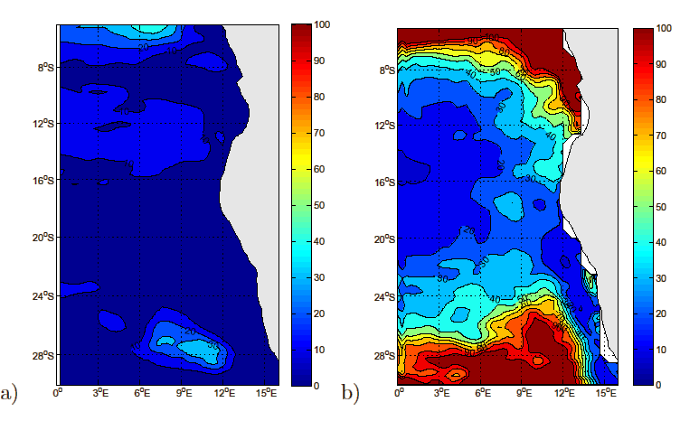
Figure 1: (a) Mean surface eddy kinetic energy for the model output, (b) Mean surface eddy kinetic energy derived from the AVISO sea surface height. The contour interval is 10 cm²/s².

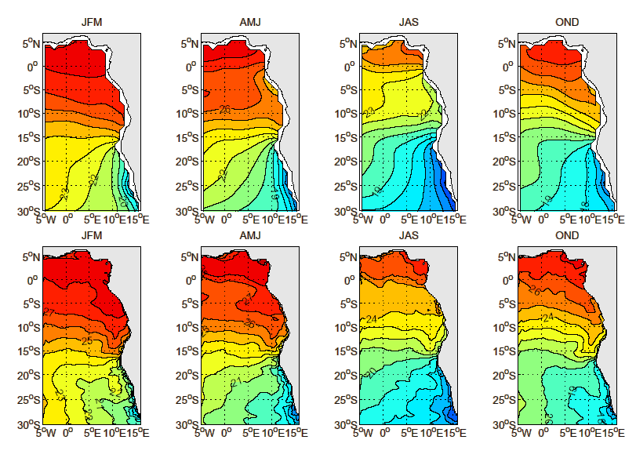
Figure 2: Seasonal climatology of ocean temperature at z = 10m. Upper: For the WOA dataset. Lower: For the ROMS model. The contour interval is 1°C.
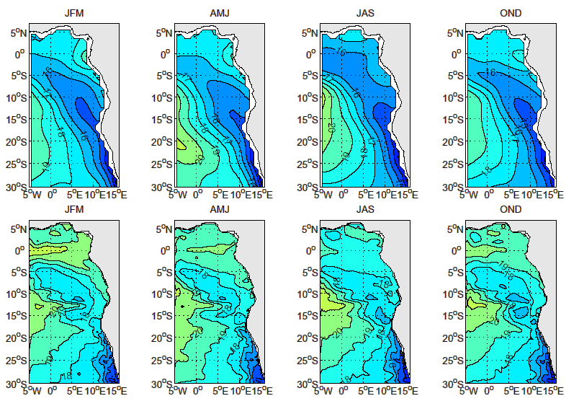
Figure 3: As Figure 2 but for z = 75m.
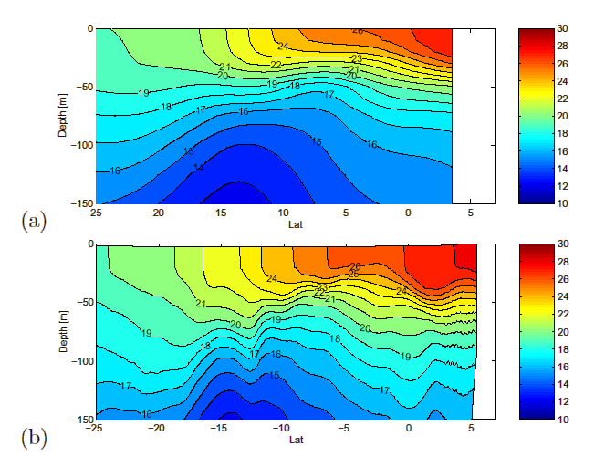
Figure 4: Annual mean temperature section at 5°E, (a) for the WOA dataset and (b) for the ROMS model. The contour interval is 1°C.
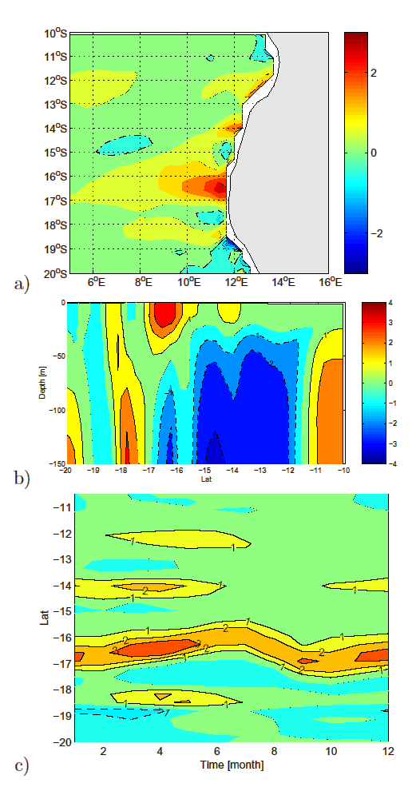
Figure 5: Annual mean of the model meridional temperature gradient (dT/dy) at 20m. (a) Horizontal plot, (b) vertical section at 11°E, and (c) Hovmöller plot at 20m depth, averaged between 11-14°E. Positive (negative) contour lines are solid (dashed) for (b) and (c), omitted for (a). The zero contour line is dashed – dotted for (a), omitted for (b) and (c). The contour interval is 1°C=100km.
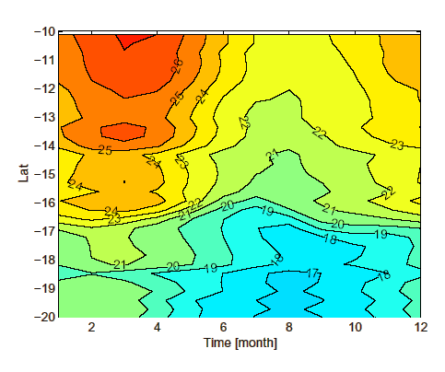
Figure 6: Hovmöller plot for the annual cycle of the ocean temperature at 20m depth, averaged between 11-14°E. The contour interval is 1°C.
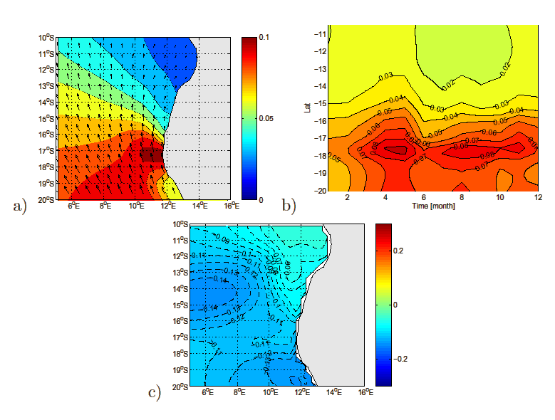
Figure 7: (a) Annual mean of the windstress, (b) Hovmöller plot for the annual cycle of the windstress close to coast, and (c) Annual mean of the sea surface height. The contour interval is 0.01Nm² for (a) and (b) and 0.01m for (c).
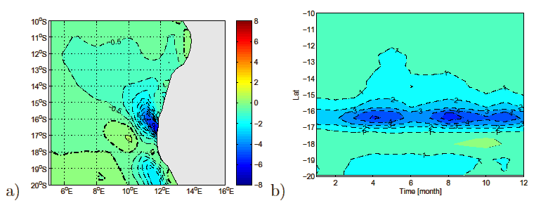
Figure 8: (a) Annual mean of the windstress curl, (b) Hovmöller plot for the annual cycle of the windstress curl close to coast. Positive (negative) contour lines are solid (dashed). The zero contour line is dashed - dotted. The contour interval is for (a) 0.5 x 10E7 Nm³ and (b) 10E7Nm³.

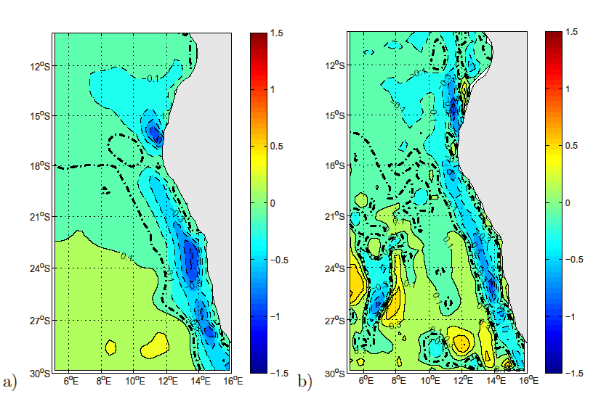
Figure 9: (a) Annual mean of the meridional Sverdrup transport, (b) integrated volume transport over the upper 500m as derived from the model output. Positive (negative) contour lines are solid (dashed). The zero contour line is dashed - dotted. The contour interval is 0.2Sv. (1Sv = 106m³/s).
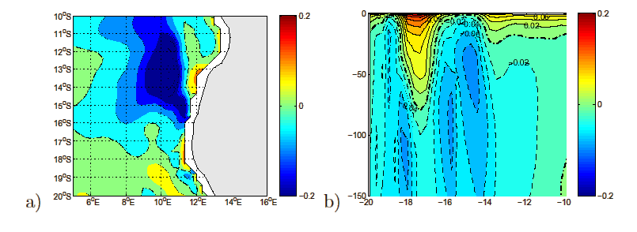
Figure 10: (a) Annual mean of the meridional geostrophic velocity, (b) vertical section of the meridional velocity, averaged between 11-14°E. Positive (negative) contour lines are solid (dashed). The zero contour line is dashed - dotted. The contour interval is 0.04m/s for (a) and 0.02m/s for (b).

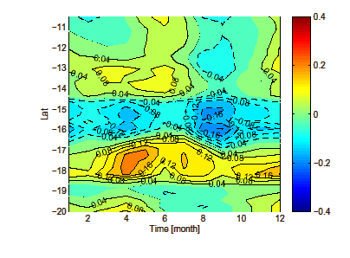
Figure 11: Hovmöller plot for the annual cycle of the meridional geostrophic velocity, averaged between 11-14°E. Positive (negative) contour lines are solid (dashed). The zero contour line is omitted. The contour interval is 0.04m/s.

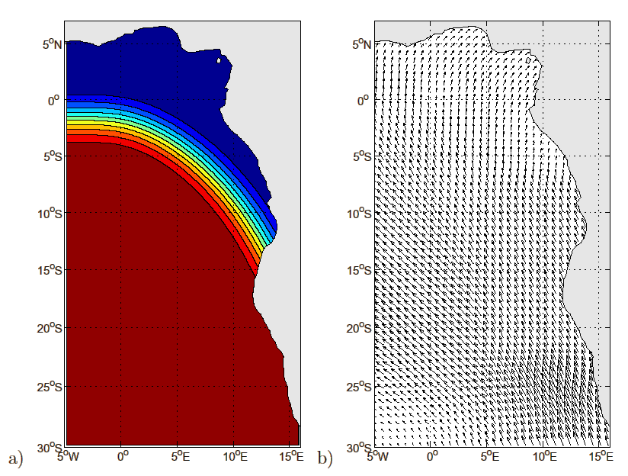
Figure 12: (a) Mask for the windstress anomaly used for the experiments of Set 1. Blue (red) areas indicate original windstress values (original windstress values that are enhanced or reduced by 50%), and (b) modified windstress for Experiment 1 of Set 3.
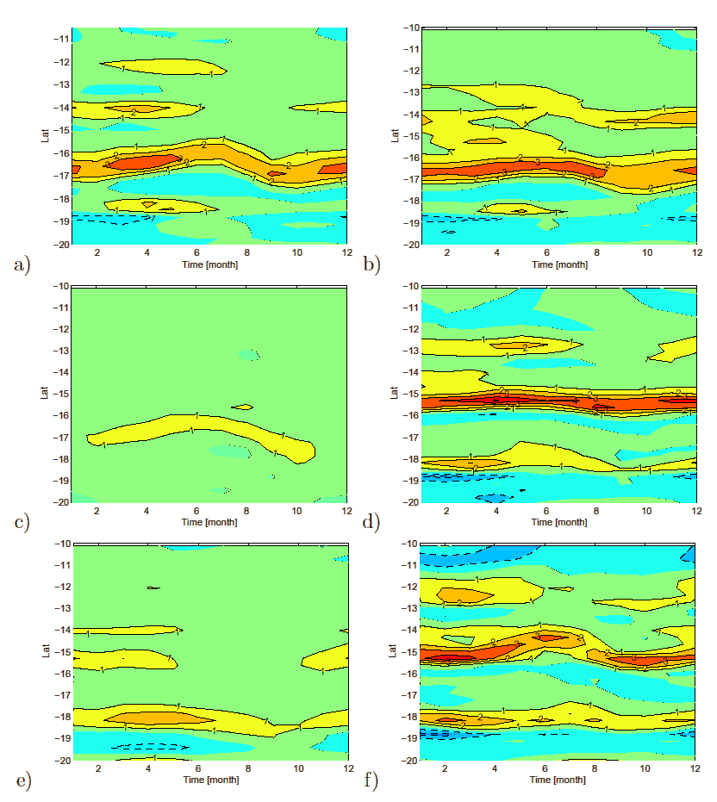

Figure 13: Hovmöller plot for the annual cycle of dT/dy, averaged between 11°E-14°E. For (a) Reference experiment (b) Experiment 1 of Set 1 (enhanced trade winds), (c) Experiment 2 of Set 1 (reduced trade winds), (d) Experiment 1 of Set 2 (northward shifted SAA), (e) Experiment 2 of Set 2 (southward shifted SAA), and (f) Experiment 1 of Set 3 (no windstress curl). Positive (negative) contour lines are solid (dashed). The zero contour line is omitted. The contour interval is 1°C=100km.
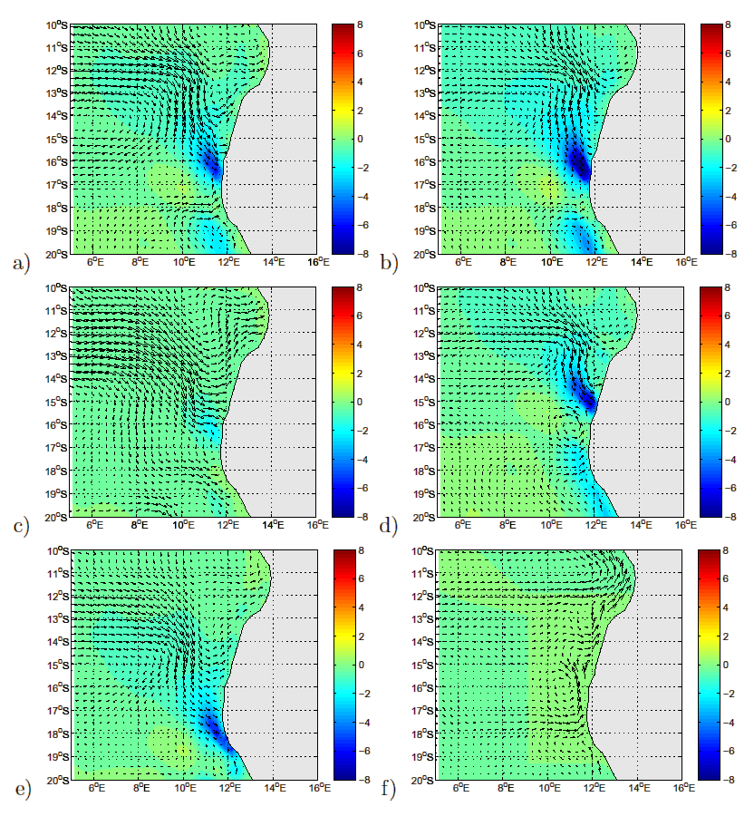
Figure 14: Annual mean of windstress curl with geostrophic velocities (arrows) superimposed. For (a) Reference experiment (b) Experiment 1 of Set 1 (enhanced trade winds), (c) Experiment 2 of Set 1 (reduced trade winds), (d) Experiment 1 of Set 2 (northward shifted SAA), (e) Experiment 2 of Set 2 (southward shifted SAA), and (f) Experiment 1 of Set 3 (no windstress curl). A colour scale in 10E7Nm³ is given to the right of each plot.

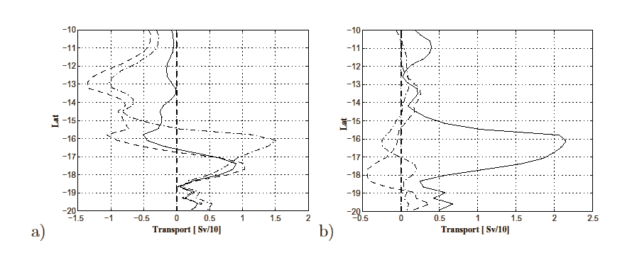
Figure 15: Time and zonally averaged transports for the conducted experiments. (a) Reference experiment (solid line), Experiment 1 of Set 1 (dashed line) and Experiment 1 of Set 2 (dashed - dotted line), and (b) Experiment 2 of Set 1 (dashed - dotted line), Experiment 2 of Set 2 (dashed line) and Experiment 1 of Set 3 (solid line).

