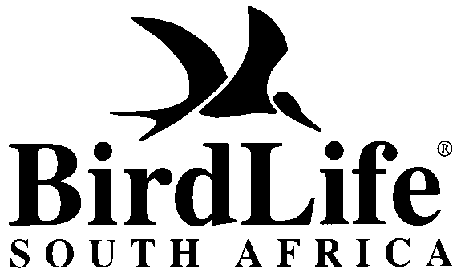

PRESS RELEASE

New report to reduce needless deaths of seabirds, sea turtles and sharks

WWF and BirdLife today released a new report that for the first time assesses the impact of longline fishing on vulnerable species of seabirds, sharks, and sea turtles in the Benguela Ecosystem, stretching up the west coasts of South Africa, Namibia and Angola. Despite global concern about the impact of fisheries on these species, over more than a decade, very few regional assessments such as this exist. The majority of albatross and sea turtle species and many shark species are listed as threatened with extinction by the IUCN, with fisheries impacts being cited as a major cause.

“This report provides a platform from which informed decisions can be made that will reduce the impact on these threatened species in the region,” says Samantha Petersen, manager of the BirdLife & WWF Responsible Fisheries Programme.

The reports estimates that as much as 34 000 seabirds, 4 200 sea turtles, and over 7 million sharks and skates are caught in longline fishing operations in the Benguela Current Large Marine Ecosystem (BCLME) annually.

“These impacts need to be taken seriously by the governments of South Africa, Namibia, and Angola, as well as relevant intergovernmental regional fisheries organisations, as part of their commitment to implement a new Ecosystem Approach to Fisheries” says Petersen.

The governments of the three countries have committed to a goal of implementing an Ecosystem Approach to Fisheries by 2010, as encouraged by the World Summit on Sustainable Development (WSSD).

The report also provides practical recommendations and guidelines for reducing these impacts. Among the guidelines is the recommended use of bird-scaring lines – essentially a marine scarecrow – that deter seabirds, including the endangered albatross, from diving onto the thousands of baited hooks set by longline vessels.

In an interesting social development partnership, bird-scaring lines are being constructed by the Ocean View Centre for Persons with Disability. It is estimated that lines made at the centre have already saved hundreds of birds.

The report makes specific recommendations for the three countries. In South Africa, a critical concern is the low level of compliance with fisheries permit conditions, which require fishers to use bird-scaring lines. However, in an encouraging recent development, the first fine of R2 500 was issued to a South African vessel that transgressed its bird-scaring line regulations.

Recommendations for Namibia are focussed on the need to include mitigation measures in fishing regulations and the need to collect further information. In Angola, where many of these species are actually targeted for consumption in artisinal fisheries; efforts should be focused on raising the level of awareness in coastal communities and the development of alternative sustainable livelihoods.

“The project has also been active in raising the level of awareness about this issue within the fishing industry and developed mechanisms for industry to be part of the solution”, says Petersen. Workshops, training programmes and face to face interaction with fishers, compliance officers, fisheries observers and other stakeholders have been the tools used to change mindsets.

One such mechanism is the WWF Smart Gear competition, which offers $50 000 in prize money for innovative ideas for reducing bycatch. The competition, now in its third year has drawn entries from across the globe. “Of particular importance has been the interest shown by the fishermen themselves in finding creative and practical solutions to reducing these impacts” says Aaniyah Omardien, head of the WWF Sanlam Marine Programme.

“It is very encouraging to see the growing support amongst fishers and fishing industry leaders for the need to reduce impacts on the marine ecosystem that underpins their business and livelihoods,” says Omardien.

Note to editors:
- For the full report Towards an Ecosystem Approach to Longline Fisheries in the Benguela: An assessment of impacts on seabirds, sea turtles and sharks go to www.wwf.org/marine
- Instructions for entering the Smart Gear competition are available at www.smartgear.org . Completed entries must be submitted by July 31.

For more information contact:
Samantha Petersen
BirdLife & WWF Responsible Fisheries Programme Manager
021 425 3440 or 073 237 8185
seabirds@birdlife.org.za

Dr. Deon Nel
WWF Aquatic Unit Manager
021 888 2800 or 082 8911038
dnel@wwf.org.za

